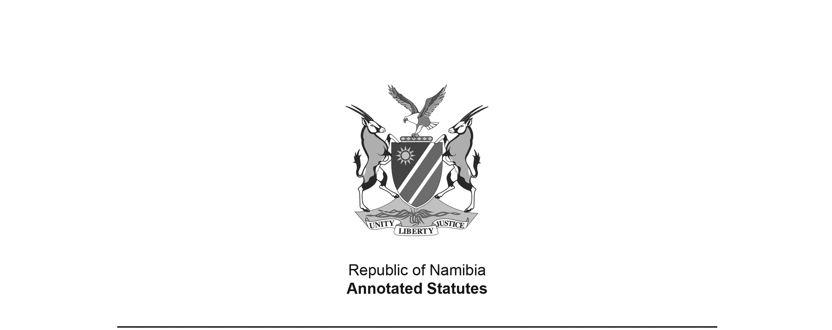
Tear-gas Act 16 of 1964 (RSA)
(RSA GG 738)
brought into force in South Africa and South West Africa
on 1 January 1965 by RSA Proc. R.225/1964 (RSA GG 894)
(see section 6 of Act)

APPLICABILITY TO SOUTH WEST AFRICA: Section 1 defines “Republic” to include “the territory of South West Africa”. Section 6 states “This Act shall apply also in the territory of South West Africa (including the Eastern Caprivi Zipfel referred to in section three of the South West Africa Affairs Amendment Act, 1951 (Act No. 55 of 1951)), and in relation to all persons in that portion of the said territory known as the ‘Rehoboth Gebiet’ and defined in the First Schedule to Proclamation No. 28 of 1923 of the said territory.” Although the wording of section 6 did not make amendments to the Act in South Africa automatically applicable to South West Africa, they would probably have been applicable by virtue of the definition of “Republic” in section 1. However, In any event, there were no amendments to the Act in South Africa prior to Namibian independence.

TRANSFER TO SOUTH WEST AFRICA: The administration of this Act was transferred to South West Africa by the Executive Powers (Justice) Transfer Proclamation, AG 33 of 1979, dated 12 November 1979. There were no amendments to the Act in South Africa after the date of transfer and prior to Namibian independence.

ACT

To provide for the control of the manufacture, importation and possession of tear-gas and articles used or intended to be used for releasing tear-gas and for other incidental matters.

(Afrikaans text signed by the State President)
(Assented to 22nd February, 1964)

ARRANGEMENT OF SECTIONS

1. Definitions
2. Prohibition of manufacture or importation of tear-gas or certain articles without a permit
3. Prohibition of possession of tear-gas and certain articles
4. Inspection of factory or place where tear-gas or certain articles are manufactured or stored
5. Offences
6. Application of Act to South-West Africa
7. Short title and date of commencement

BE IT ENACTED by the State President, the Senate and the House of Assembly of the Republic of South Africa, as follows:-

Definitions

1. In this Act, unless the context otherwise indicates ­

“Minister” means the Minister of Justice;

“Republic” includes the territory of South-West Africa;

“tear-gas” means any substance, whether a solid, liquid, vapour or gas, or any combination of such substances used or intended to be used as a lachrymator.

Prohibition of manufacture or importation of tear-gas or certain articles without a permit

2. (1) No person shall manufacture in or import into the Republic any tear-gas or any article used or intended to be used for releasing tear-gas, except under the authority of and in accordance with the restrictions or conditions stated in a permit issued by the Minister or any person authorized by him.

(2) The Minister or any person authorized by him may at any time cancel, amend or suspend any permit issued under sub-section (1), if he is satisfied that any restriction or condition attached to the permit has not been observed, or if the holder of the permit has been convicted of an offence under this Act, or if he deems it necessary or expedient in the public interest.

Prohibition of possession of tear-gas and certain articles

3. (1) No person shall be in possession of tear-gas or any article used or intended to be used for releasing tear-gas -

(a) unless he is the holder of a permit issued under section two or is in possession of the tear-gas or article while performing his duties in the service of any such holder; or

(b) unless he falls within any class or category of persons in respect of which the Minister has by notice in the Gazette granted permission to be in possession thereof.

(2) Any permission under paragraph (b) of sub-section (1) may be granted subject to such restrictions or conditions as may be specified in the notice and may at any time be withdrawn by the Minister by like notice.

Inspection of factory or place where tear-gas or certain articles are manufactured or stored

4. Any magistrate or police officer or any other person authorized by the Minister may at any time enter any premises used as a factory or place for the manufacture or storing of tear-gas or any article used or intended to be used for releasing tear-gas and may perform thereon such acts as he may deem it necessary in order to determine whether the provisions of this Act have been complied with.

Offences

5. Any person who -

(a) manufactures in or imports into the Republic any tear-gas or any article used or intended to be used for releasing tear-gas otherwise than under the authority of or in accordance with the restrictions or conditions stated in a permit issued under section two;

(b) is in possession of tear-gas or any article used or intended to be used for releasing tear-gas in contravention of the provisions of section three or, in the case of a person entitled to be in possession thereof by virtue of any permission granted under that section, fails to observe any restriction or condition attached to such permission;

(c) hinders, obstructs or delays any other person in the exercise of his powers under this Act,

is guilty of an offence and liable on conviction -

(i) in the case of an offence referred to in paragraph (a) or (b), to a fine not exceeding eight hundred rand or in default of payment to imprisonment for a period not exceeding two years or to both such fine and such imprisonment or to such imprisonment without the option of a fine;

(ii) in the case of any offence referred to in paragraph (c), to a fine not exceeding two hundred rand or in default of payment to imprisonment for a period not exceeding six months or to both such fine and such imprisonment or to such imprisonment without the option of a fine.

Application of Act to South-West Africa

6. This Act shall apply also in the territory of South-West Africa (including the Eastern Caprivi Zipfel referred to in section three of the South-West Africa Affairs Amendment Act, 1951 (Act No. 55 of 1951)), and in relation to all persons in that portion of the said territory known as the “Rehoboth Gebiet” and defined in the First Schedule to Proclamation No. 28 of 1923 of the said territory.

Short title and date of commencement

7. This Act shall be called the Tear-gas Act, 1964, and shall come into operation on a date to be fixed by the State President by proclamation in the Gazette.

