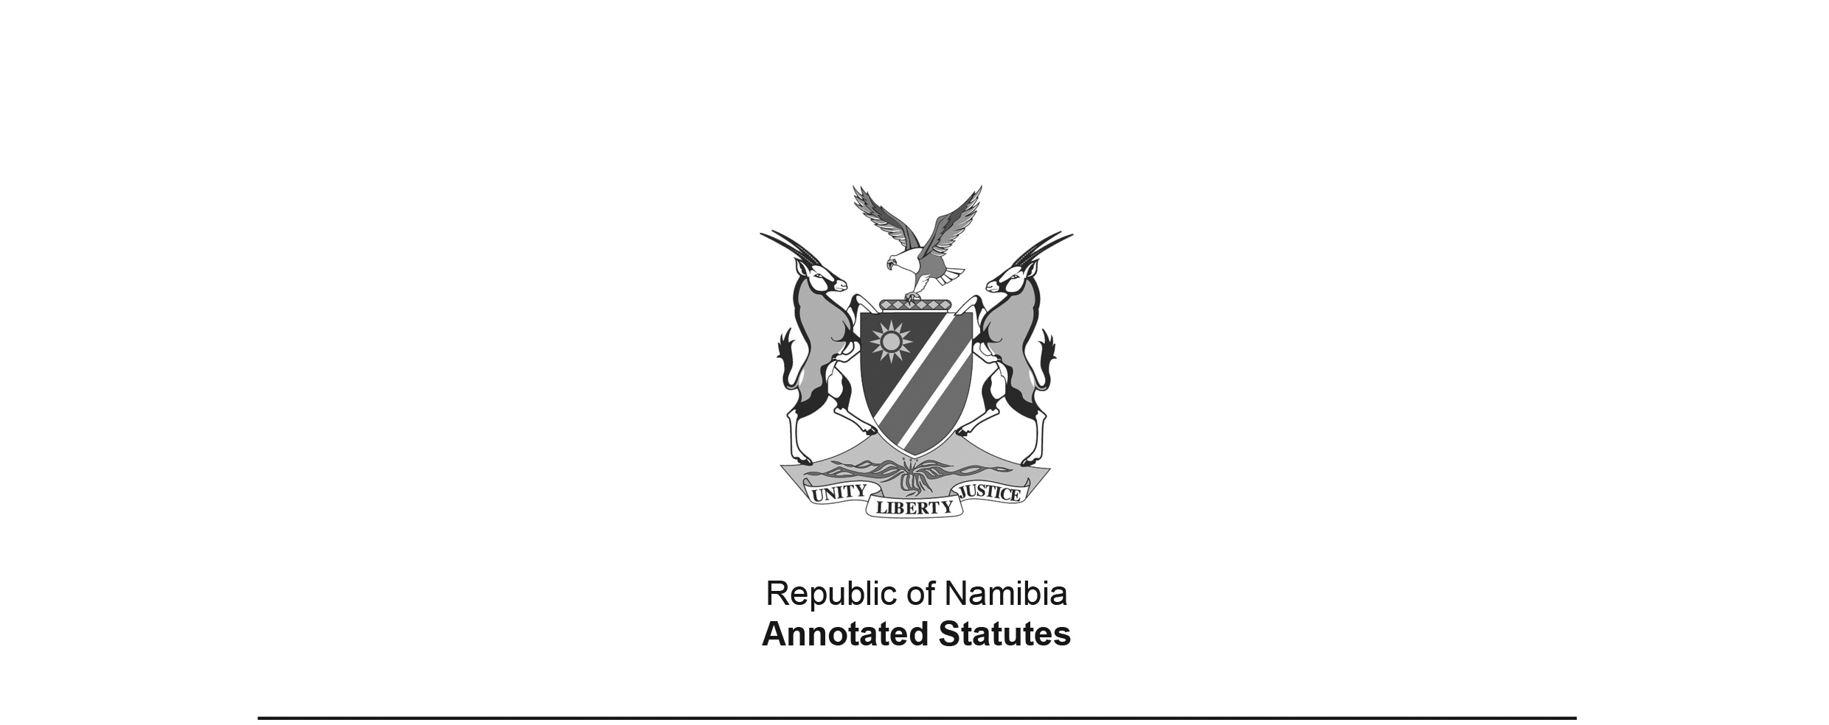
Second Law Amendment (Abolition of Discriminatory or Restrictive Laws for purposes of Free and Fair Election) Proclamation,
AG 25 of 1989
(OG 5758)
came into force generally on date of publication: 22 July 1989;
provisions relating section 5(1)(b) of the Income Tax Act 24 of 1981
deemed to have come into force on 1 April 1989 (section 2(2) of Proclamation)

as amended by

Police Act 19 of 1990 (GG 113)
came into force on date of publication: 3 December 1990
Note that the original GG 113 was replaced by another GG 113 with the same date; the correct version states at the top: “This Government Gazette replaces Government Gazette No. 113 of 3 December 1990.”
Namibia Central Intelligence Service Act 10 of 1997 (GG 1699)
brought into force on 5 June 1998 by Proc. 12/1998 (GG 1876)

PROCLAMATION

Repeal of laws which may abridge or inhibit the objective of a free and fair election for a Constituent Assembly, and amendment of certain laws in so far as they may abridge or inhibit such objective

(Approved by the State President on 17 July 1989)

ARRANGEMENT OF SECTIONS

1. Repeal and amendment of certain laws
2. Short title and commencment

Repeal and amendment of certain laws

1. The laws specified in the Annexure are hereby repealed or amended to the extent indicated in the third column of the Annexure.

Short title and commencement

2. (1) This Proclamation shall be called the Second Law Amendment (Abolition of Discriminatory or Restrictive Laws for purposes of Free and Fair Election) Proclamation, 1989.

(2) The provisions of this Proclamation, in so far as they relate to paragraph (b) of subsection (1) of section 5 of the Income Tax Act, 1981 (Act No. 24 of 1981), shall be deemed to have come into operation on 1 Apri l 1989.

ANNEXURE

LAWS REPEALED OR AMENDED
(Section 1)

Column 1 | Column 2 | Column 3
No. and year  of law | Title of law | Extent to which repealed or  amended
Proclamation No. 28 of 1923 by the Administrator | Rehoboth Community: Confirmation of Agreement | The repeal of sections 14 and 15
Proclamation No. 9 of 1928 by the Administrator | Rehoboth Gebiet Affairs Proclamation, 1928 | The repeal of sections 5, 6, 7, 9 and 10
Act No. 8 of 1953 of the Parliament of the Republic of South Africa | Criminal Law Amendment Act, 1953 | The repeal of sections 8 and 9
Act No. 7 of 1958 of the Parliament of the Republic of South Africa | Police Act, 1958 | (a) The repeal of section 27C; and  (b) the amendment of section 34 by the substitution for subsection (1) of the following subsection:  “(1)(a) Whenever there are not in any locality sufficient ordinary members of the Force available to perform police duties or any particular police duty therein, or to convey any person in lawful custody from such locality to any other place, the Administrator-Gcncral may appoint as temporary members to act as such, so many fit and proper persons as may be necessary for the performance of any such duty as aforesaid.  (b) Whenever there are not in any locality sufficient ordinary members of the Force available to perform any particular police duty therein, or to convey any person in lawful custody from such locality to any other place, a commissioned officer, magistrate, additional magistrate or assistant magistrate in that locality may, if authorized thereto by the Administrator-General, either generally or in any particular case, but subject to the provisions of paragraph (c), appoint as temporary members to act as such, so many fit and proper persons as may be necessary for the performance of any such duty as aforesaid.  (c) The power conferred by paragraph (b) shall not be exercised in such a manner that there serve under that paragraph at such locality at any time more than five temporary members.”
 | [deleted by Act 19 of 1990, which repealed the underlying law]
Act No. 102 of 1972 of the Parliament of the Republic of South Africa | General Law Amendment, 1972 | The repeal of section 30
Ordinance No. 21 of 1975 of the Legislative Assembly of the Territory of South West Africa | Education Ordinance, 1975 | The amendment of section 78 -  (a) by the deletion of paragraph (b) of subsection (1);  (b) by the deletion in paragraph (d) of subsection (3) of the words “and a copy of the notice referred to in subsection (2)”; and  (c) by the deletion of subsections (4). (5) and (6).
Act No. 2 of 1980 of the National Assembly of South West Africa | Government Service Act, 1980 | The amendment of section 17 by the deletion of paragraph (g) of subsection (1)
Proclamation AG. 8 of 1980 by the Administrator General | Representative Authorities Proclamation, 1980 | The amendment of the Schedule by the deletion of subitem (1) of item 12
Act No. 24 of 1981 of the National Assembly of South West Africa | Income Tax Act, 1981 | The amendment of section 5 by the deletion of paragraph (b) of subsection (1)
Act No. 19 of 1987 of the National Assembly | National Intelligence Act, 1987 | The amendment of section 3 by the deletion of paragraph (e) of subsection (1)
 | [deleted by Act 10 of 1997, which repealed the underlying law]
Government Notice  215 of 1987 | Regulations made under the National Education Act, 1980 (Act No. 30 of 1980) | The amendment of regulation 10 -  (a) by the deletion in paragraph (i) of subregulation (1) of the  words “or its image is prejudiced”; and  (b) by the deletion of paragraphs (j) and (k) of subregulation (1)

