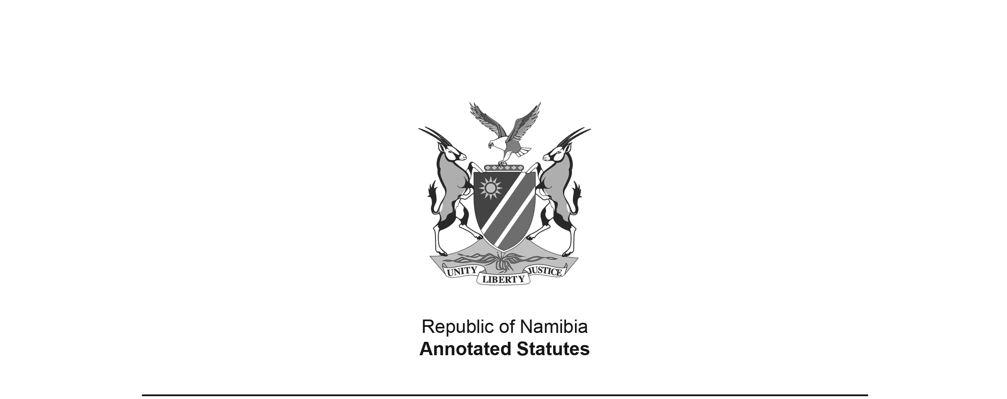
National Symbols of the Republic of Namibia
Act 17 of 2018
(GG 6807)
came into force on date of publication: 28 December 2018

ACT

To determine the national coat of arms, national anthem, national seal and presidential standard for the Republic of Namibia and for the use thereof; to determine the use of the national flag; and to provide for incidental matters.

(Signed by the President on 21 December 2018)

ARRANGEMENT OF SECTIONS

1. Definitions
2. National Coat of Arms
3. National Anthem
4. National Seal
5. Presidential Standard
6. Use and display of National Symbols
7. Regulations
8. Repeal of laws
9. Short title
Schedule 1: National Coat of Arms
Schedule 2: National Anthem
Schedule 3: National Seal
Schedule 4: Presidential Standard

BE IT ENACTED as passed by the Parliament, and assented to by the President, of the Republic of Namibia as follows -

Definitions

1. In this Act, unless the context otherwise indicates -

“Coat of Arms” means the National Coat of Arms of the Republic of Namibia referred to in Article 2(2) of the Namibian Constitution;

“flag” means the National Flag or the Presidential Standard;

“fly” means to hoist the National Flag or the Presidential Standard upon a flag pole or mount a flag upon a vehicle, either at the peak of the pole at half-staff or half-mast;

“government” means the offices, ministries and agencies of the Republic of Namibia established by Public Service Act, 1995 (Act No. 13 of 1995) or an authority that exercises its powers pursuant to any law, and includes the Namibian Defence Force, Namibian Police Force, Namibian Intelligence Service and Namibian Correctional Service;

[The word “the” is missing before “Public Service Act”.]

“Minister” means the Minister responsible for justice;

“National Anthem” means the national anthem of the Republic of Namibia referred to in Article 2(2) of the Namibian Constitution and section 3;

“National Flag” means the national flag referred to in Article 2(1) and Schedule 6 of the Namibian Constitution;

[“Article 2(1)” refers to Article 2(1) of the Namibian Constitution.]

“National Seal” means the national seal of the Republic of Namibia referred to in Article 2(2) and (3) of the Namibian Constitution and section 4;

“National Symbols” means the national flag, coat of arms, national anthem, national seal and the presidential standard referred to in section 5(1); and

“Presidential Standard” means the heraldic flag containing the coat of arms for use by the President and described in section 5.

National Coat of Arms

2. (1) The National Coat of Arms of the Republic of Namibia must be as described in Part A of Schedule 1 and depicted in the graphic representation set out in Part B of that Schedule.

(2) The National Coat of Arms must be used on all official correspondences of the Government of Republic of Namibia.

(3) The President may, by proclamation in the Gazette, permit any government office to use insignia other than the Coat of Arms upon official correspondences, or in conjunction with the Coat of Arms.

National Anthem

3. (1) The National Anthem of the Republic of Namibia consists of the lyrics set out in Part A of Schedule 2 and the melody, music and lyrics set out in Part B of Schedule 2 as composed and written by Axali Doëseb.

(2) The title of the National Anthem is, “Namibia Land of the Brave”.

(3) The melody, music and lyrics of the National Anthem are declared to be in the public domain.

National Seal

4. The National Seal consists of the elements set out in Article 2(3)(a) of the Namibian Constitution and must be as -

(a) described in Part A of Schedule 3; and

(b) depicted in the graphic representation set out in Part B of Schedule 3.

Presidential Standard

5. (1) The Presidential Standard is as -

(a) described in Part A of Schedule 4; and

(b) depicted in the graphic representation set out in Part B of Schedule 4.

(2) The Presidential Standard or a decal of that standard must be reserved for exclusive use by the President and must be -

(a) flown at any residence where the President resides or upon presidential vehicles or ships; or

(b) printed or imposed on aircraft and other modes of transport wherein the President is being transported.

Use and display of National Symbols

6. (1) The National Flag must be raised at sunrise and lowered at sunset.

(2) When the National Flag is flown with another flag or flags, of international bodies or other national flags, the National Flag must be flown on separate staffs, and must be hoisted first and lowered last.

(3) The National Flag must be displayed in buildings or raised in the open in front of the buildings of government offices and public enterprises as defined in section 1 of the Public Enterprises Governance Act, 2006 (Act No. 2 of 2006).

[Act 2 of 2006 has been replaced by the Public Enterprises Governance Act 1 of 2019.]

(4) The National Flag and Coat of Arms, in full or portions thereof, may be incorporated into any heraldic symbol, device, item or identification, authority or sign of dignity, coat of arms, seal, badge, logo, emblem, patches, banners, awards, citations, orders, decorations or insignia of any uniformed force or component of a government office or an agency of government established by law.

(5) A government office referred to in subsection (4) must submit an application for approval by the President, by proclamation in the Gazette, any heraldic symbol, device, item or identification, authority or sign of dignity, coat of arms, seal, badge, logo, emblem, patches, banners, awards, citations, orders, decorations or insignia which incorporates any portion of the National Flag and Coat of Arms.

(6) A person may not, without the prior written approval of the President or a person designated by the President for such purpose, use or display a National Symbol or any depiction so closely resembling a National Symbol, in a manner likely to cause confusion in connection with any trade, business, profession or occupation or in connection with any mark or description applied by him or her or in relation to, goods made, produced or sold by such person.

[The word “so” and the comma after the phrase ‘in relation to” are superfluous.]

(7) In granting approval under subsection (6) the President, or person designated by him or her, may impose conditions as he or she may consider fit.

(8) The Presidential Standard must be reserved for the exclusive use of the President and may not fly at half-mast.

(9) A person who -

(a) contravenes the provisions of subsection (6);

(b) commits an act, with intent to deceive or which act displays contempt, whether by words, either spoken or written, in relation to a National Symbol or which is likely to hold a National Symbol to ridicule,

commits an offence and on conviction liable to a fine not exceeding N$50 000 or to imprisonment for a period not exceeding five years or to both such fine and such imprisonment.

[The word “is” has been omitted before the word “liable”.]

(10) A court which convicts a person under subsection (9) may, in addition to the imposition of any sentence under that subsection order the confiscation by the State, of all or any part of the goods in respect of which the offence was committed.

[There should be a comma after the phrase “in addition to the imposition
of any sentence under that subsection” to offset that phrase properly.]

Regulations

7. (1) The Minister may make regulations -

(a) in relation to the flying of the National Flag, its orientation and its display with other flags;

(b) in relation to flag poles, how the National Flag must be flown in times of peace, in times of war or when there are visiting Heads of State from other countries;

(c) in relation to how long the National Flag will be flown at half mast during periods when national mourning has been declared by the President in terms of any law;

(d) relating to the use of the National Flag to cover the caskets of a person in respect of whom a period of mourning is declared;

(e) in relation to any pledge of allegiance, the content of the pledge, how it will be recited and where it must be recited; and

(f) in relation to, and for the purposes of determining, the use of any other National Symbol.

(2) A regulation made under this section may provide for the creation of offences and for penalties on contravention of, or failure to comply with, a fine not exceeding N$20 000 or imprisonment for a period not exceeding two years or both such fine and such imprisonment.

[There appear to be some words missing here; the intention seems to have been to refer to penalties for contravention of or failure to comply with one or more regulations.]

Repeal of laws

8. The National Coat of Arms of the Republic of Namibia Act, 1990 (Act No. 1 of 1990) and the National Anthem of the Republic of Namibia Act, 1991 (Act No. 20 of 1991) are repealed.

Short title

9. This Act is called the National Symbols of the Republic of Namibia Act, 2018.

SCHEDULE 1

PART A
NATIONAL COAT OF ARMS

Arms: Tierced per bend sinister fimbriated Argent; Azure, Gules and Vert; a bend sinister Gules, and in dexter chief a sun with twelve triangular rays Or, charged with an annulet Azure.

Torse: A traditional head-ring Vert charged with six lozenges conjoined Or.

Crest: African Fish Eagle (Haliaeetus vocifer) rising, head bowed above dexter chief with beak pointed between first and second lozenges in Torse, wings elevated and displayed Épandre, feet to ground, proper.

Supporters: Two Oryx gazelle forcené either side, attitude to dexter and to sinister, proper.

Compartment: A Namib sand-dune with a Welwitschia mirabilis in the foreground, with three cones below the base, proper.

Motto: The words: UNITY LIBERTY JUSTICE, in capital letters upon a banderole.

PART B
EMBLAZON OF COAT OF ARMS
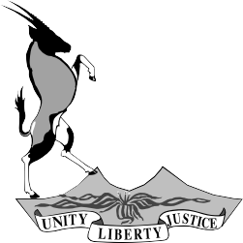
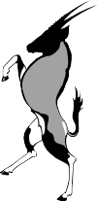
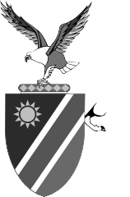

SCHEDULE 2

THE NATIONAL ANTHEM OF THE REPUBLIC OF NAMIBIA

PART A
NAMIBIA, LAND OF THE BRAVE: LYRICS
BY AXALI DOËSEB

Namibia land of the brave
Freedom fight we have won
Glory to their bravery
Whose blood waters our freedom.

We give our love and loyalty
Together in unity
Contrasting beautiful Namibia
Namibia our country

Beloved land [The line break after ‘Beloved land” may be in error since
of savannahs the next line is not capitalised. “Beloved land of
Hold high the banner of liberty savannahs” was presented as one line in the
National Anthem of the Republic of Namibia Act 20 of 1991.]
Chorus:
Namibia our country
Namibia motherland
We love thee

PART B
NAMIBIA, LAND OF THE BRAVE: MELODY, MUSIC AND LYRICS
BY AXALI DOËSEB

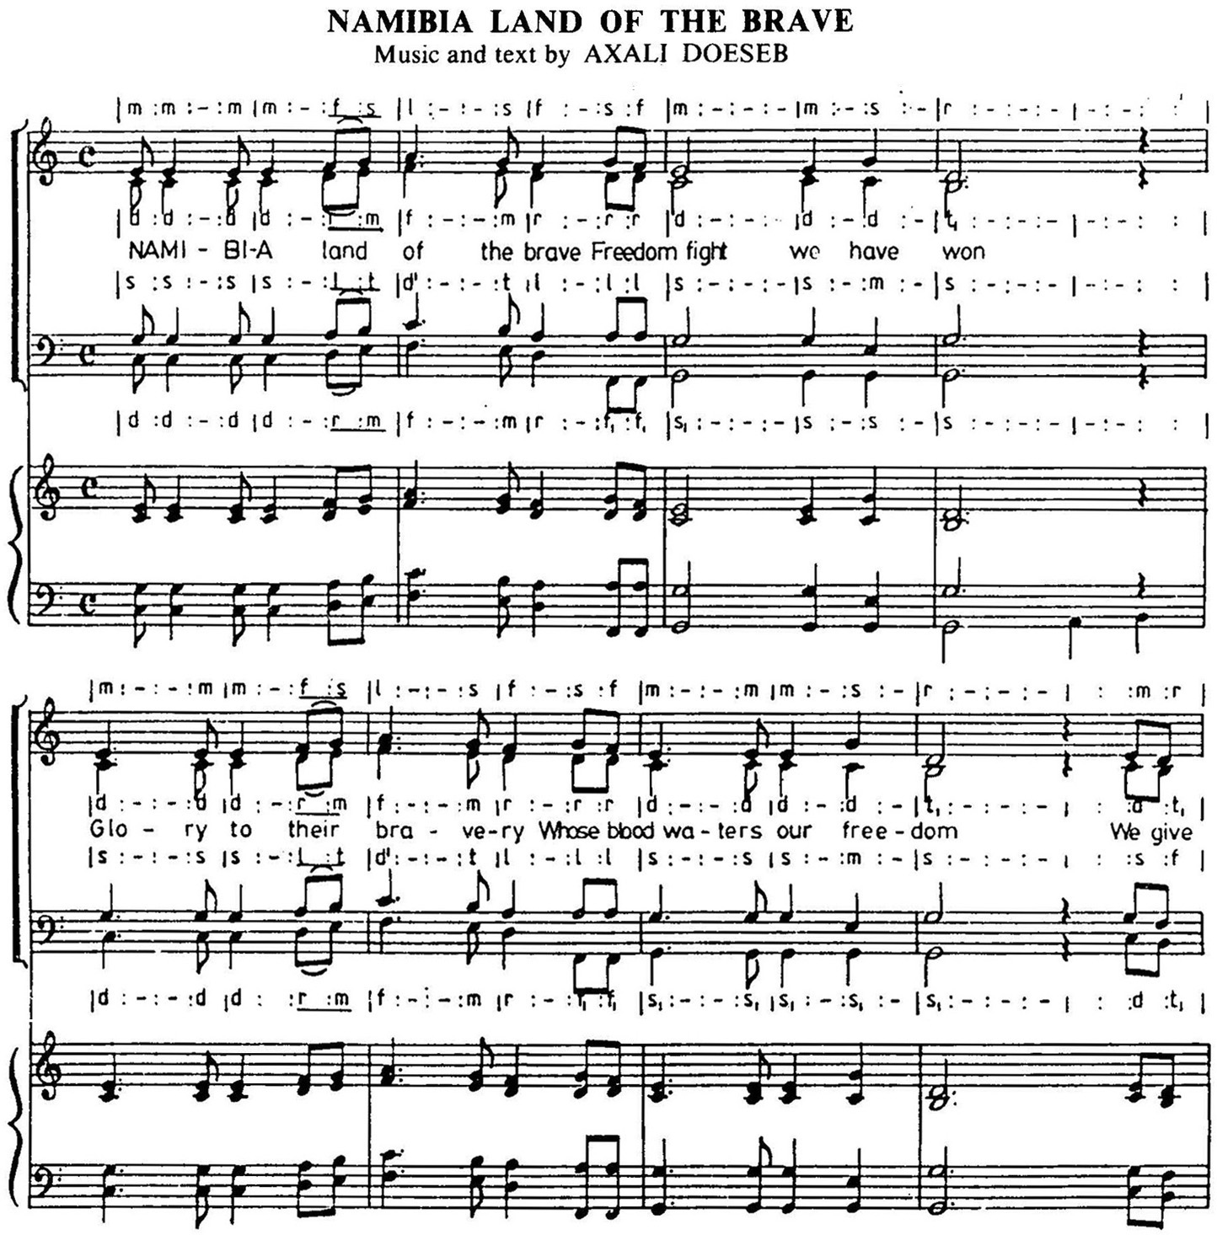

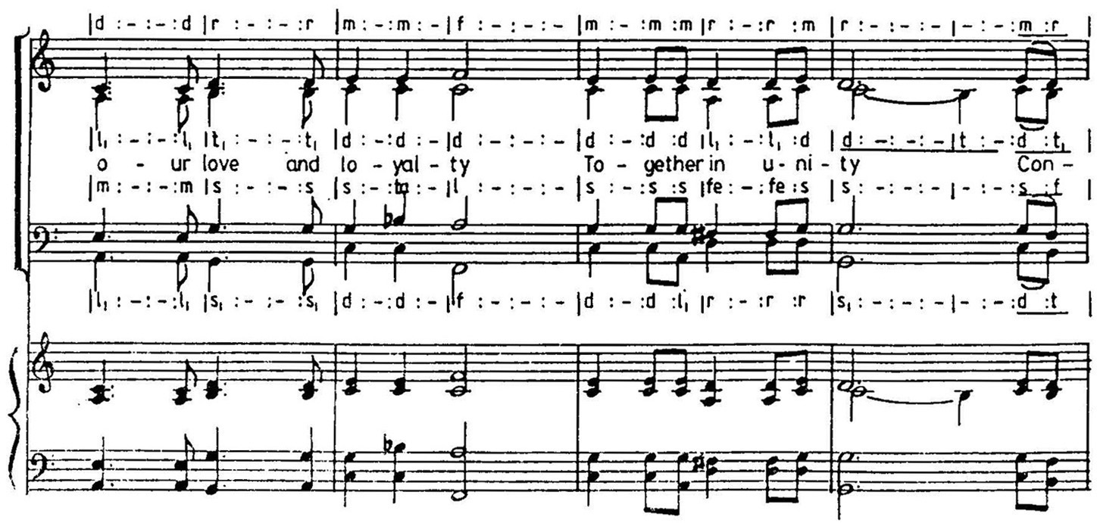
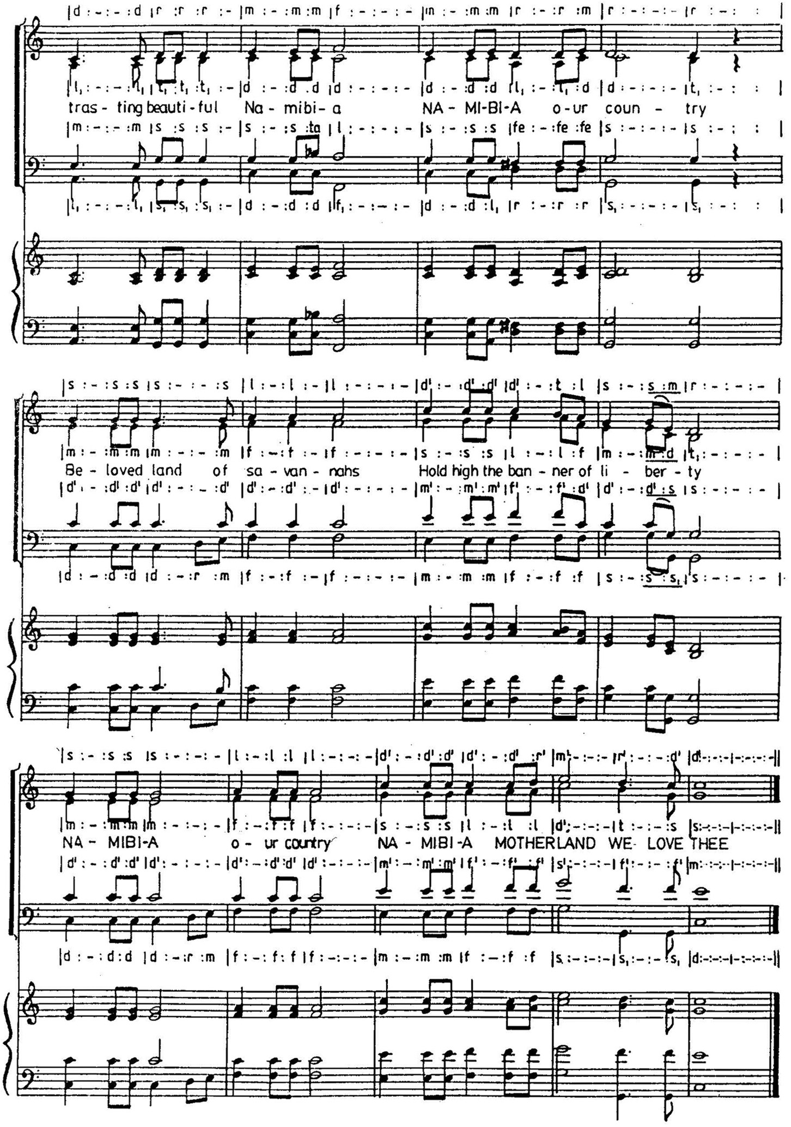

SCHEDULE 3

PART A
BLAZON OF NATIONAL SEAL

1. The National Seal of the Republic of Namibia must:

1.1 Not be tinctured; and

1.2 Be circular in form, with an outer circle and an inner circle in which the National Coat of Arms must be depicted in the middle.

2. The boundaries of the circles must be double margin, and in between the boundaries of the circles, the following will be inscribed:

2.1 The word ‘NAMIBIA’ in capital letters will be at the centre top;

2.2 The motto must be at the bottom with two black solid filled circular dots dividing the words of the motto; and

2.3 Two miniature suns with twelve triangular rays on either side and positioned in line with the body of the crest eagle of the Coat of Arms.

PART B
EMBLAZON OF NATIONAL SEAL
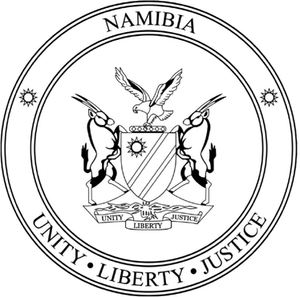

SCHEDULE 4

PART A PRESIDENTIAL STANDARD

Orientation:

1. A tinctured triangle Or, bearing the National Coat of Arms, pointing away from hoist;

2. Two smaller triangles, top Azure and bottom Vert, pointed to hoist; and

3. The height of the National Coat of Arms being one half the width of the flag, with its centre line positioned one third of the width of the flag, away from the hoist.

Dimension:

1. The Presidential Standard must be a rectangular flag; and

2. In proportion three in the length to two in the width.

Colours:

1. The Colours of the Presidential Standard must be the same as that of the National Flag of Namibia, namely:

 | Pantone: | Coates SP
Blue: | 294c | 5 809
Yellow (gold): | 116c | 1 802
Green: | 347c | 65
Red: | 186c | 35

PART B
SPECIFICATIONS OF PRESIDENTIAL STANDARD
