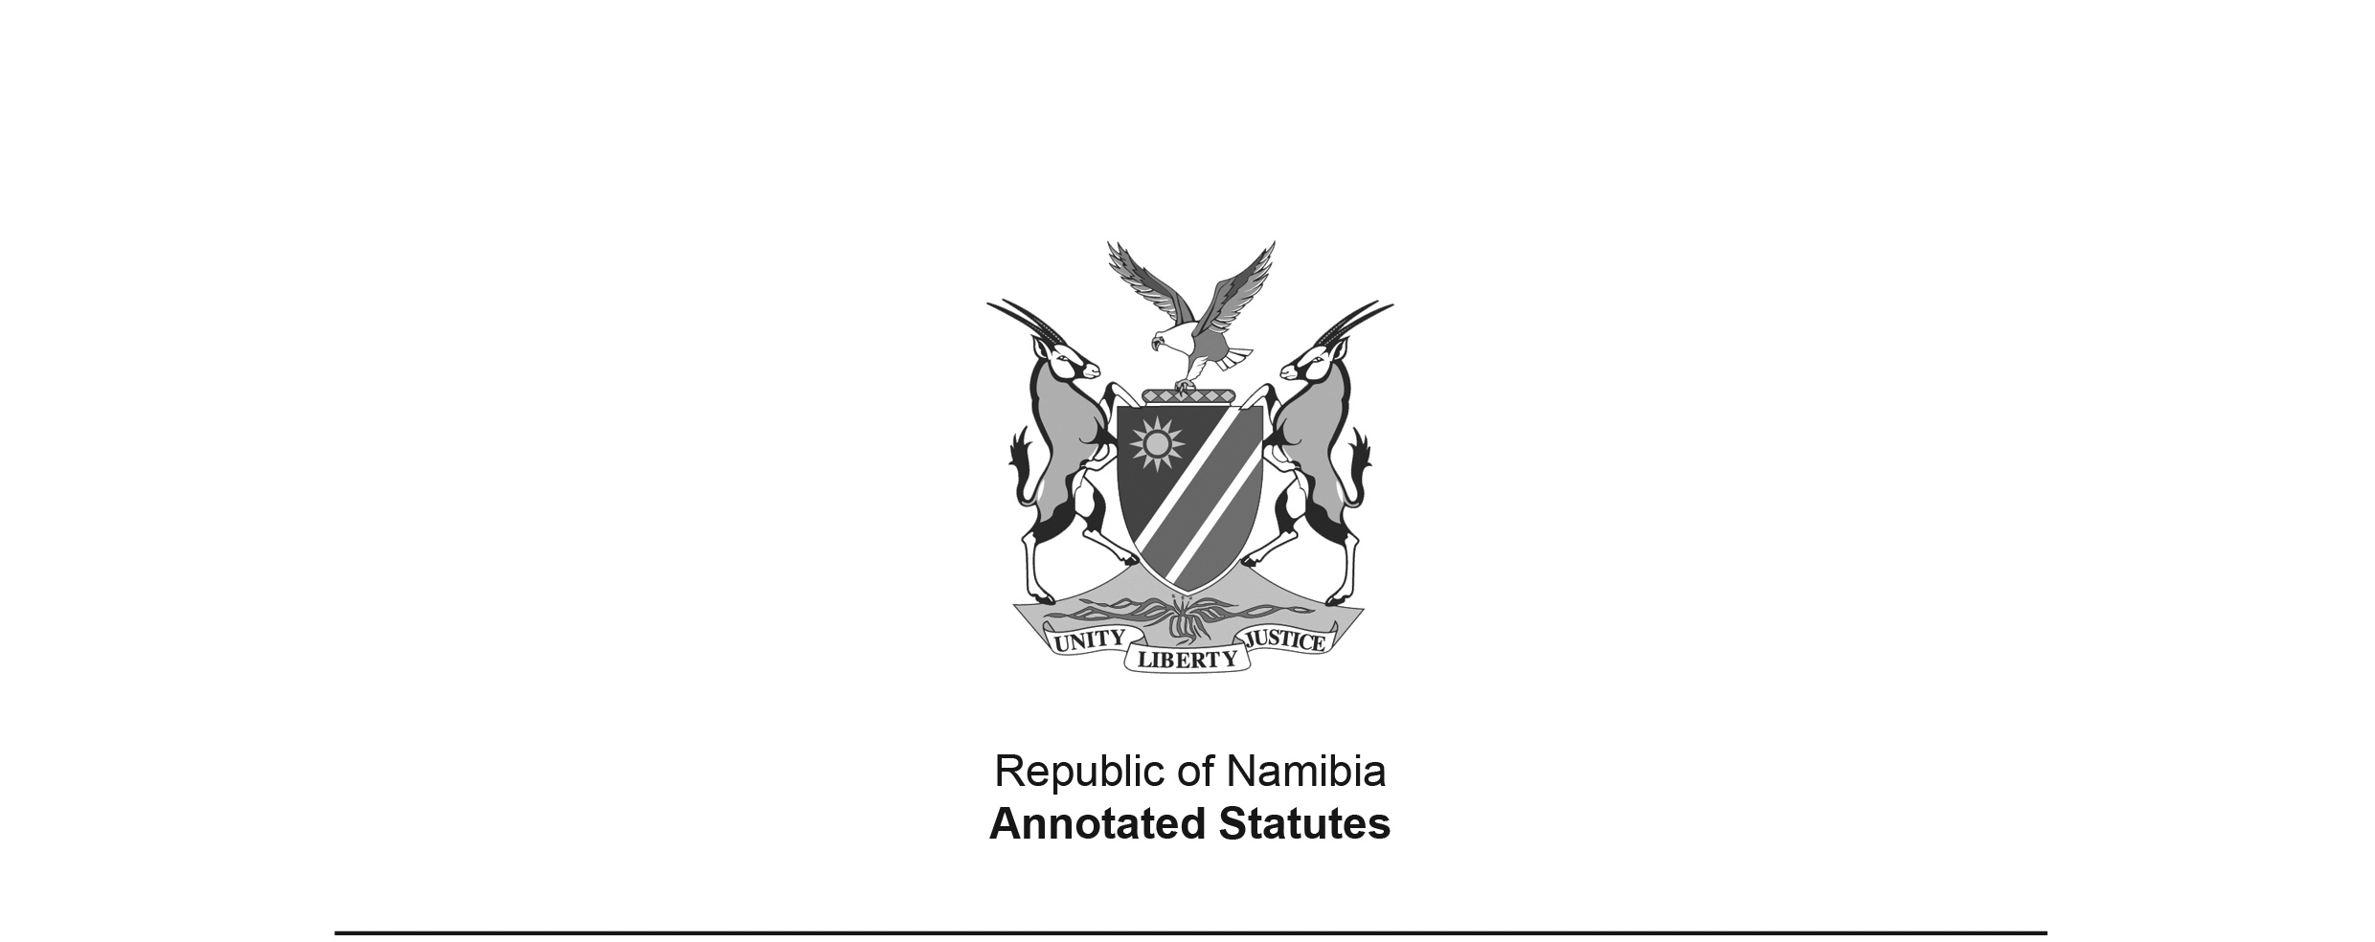National Anthem of the Republic of Namibia   
Act 20 of 1991

(GG 321)

came into force on date of publication: 17 December 1991

ACT

**To determine the National Anthem of the Republic of Namibia; to empower the President to make regulations in respect of the use thereof; and to provide for incidental matters.**

*(Signed by the President on 5 December 1991)*

ARRANGEMENT OF SECTIONS

Preamble

1. National Anthem

2. Offences and penalties

3. Regulations

4. Short title

FIRST SCHEDULE

THE NATIONAL ANTHEM OF THE REPUBLIC OF NAMIBIA

SECOND SCHEDULE

ASSIGNMENT TO THE REPUBLIC OF NAMIBIA OF   
THE COPYRIGHT IN “NAMIBIA LAND OF THE BRAVE”

**Preamble**

WHEREAS Article 2(2) of the Namibian Constitution requires a National Anthem for Namibia to be determined by the National Assembly;

AND WHEREAS the members of the National Assembly have unanimously expressed their approval of the composition of Axali Doeseb, entitled “NAMIBIA LAND OF THE BRAVE”, as the National Anthem of Namibia:

NOW THEREFORE BE IT ENACTEDby the National Assembly of the Republic of Namibia, as follows:-

**National Anthem**

**1.** The composition entitled “NAMIBIA LAND OF THE BRAVE”, of which the words and music are set out in the First Schedule, and the copyright of which vests in the Government of the Republic of Namibia by virtue of a deed of assignment of which a reproduction is set out in the Second Schedule, shall be the National Anthem of the Republic of Namibia.

**Offences and penalties**

**2.** Any person who does any act with intent to insult or which displays contempt for the National Anthem or which is likely to hold it up to ridicule, shall be guilty of an offence and liable on conviction to a fine not exceeding R20 000 or to imprisonment for a period not exceeding 5 years or to both such fine and such imprisonment.

**Regulations**

**3.** The President may by proclamation in the *Gazette* make regulations -

(a) prohibiting, restricting or regulating the use of the National Anthem, or the reproduction of the words or music thereof;

(b) constituting offences in relation to any matter referred to in paragraph (a) and prescribing penalties in respect thereof.

**Short title**

**4.** This Act shall be called the National Anthem of the Republic of Namibia Act, 1991.

FIRST SCHEDULE

THE NATIONAL ANTHEM OF THE REPUBLIC OF NAMIBIA

**NAMIBIA LAND OF THE BRAVE**

Namibia land of the brave

Freedom fight we have won

Glory to their bravery

Whose blood waters our freedom

We give our love and loyalty

Together in unity

Contrasting beautiful Namibia

Namibia our country

Beloved land of savannahs

Hold high the banner of liberty

Chorus:

Namibia our country

Namibia motherland

We love thee

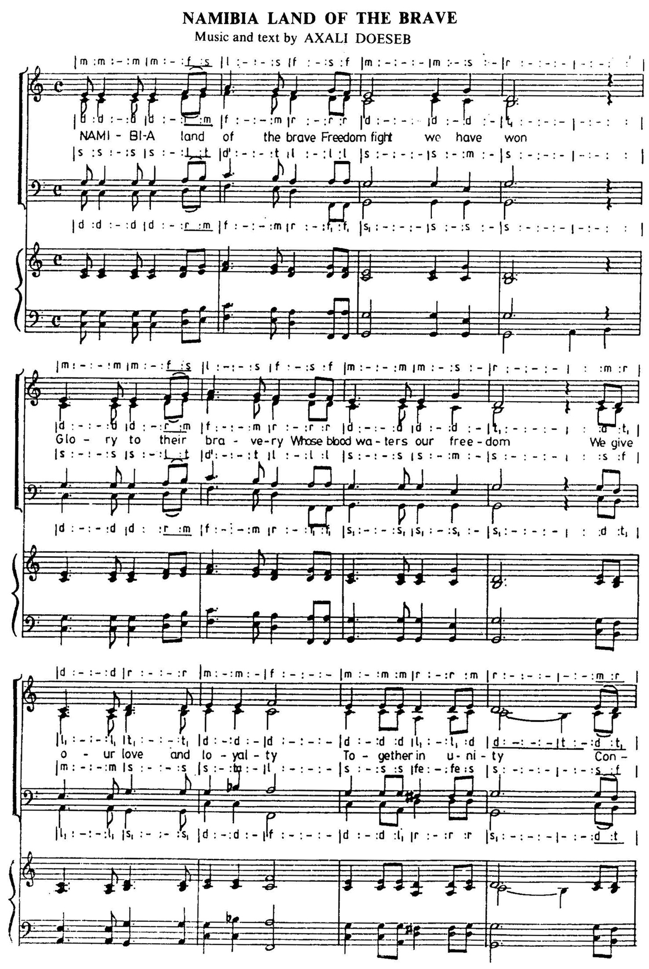

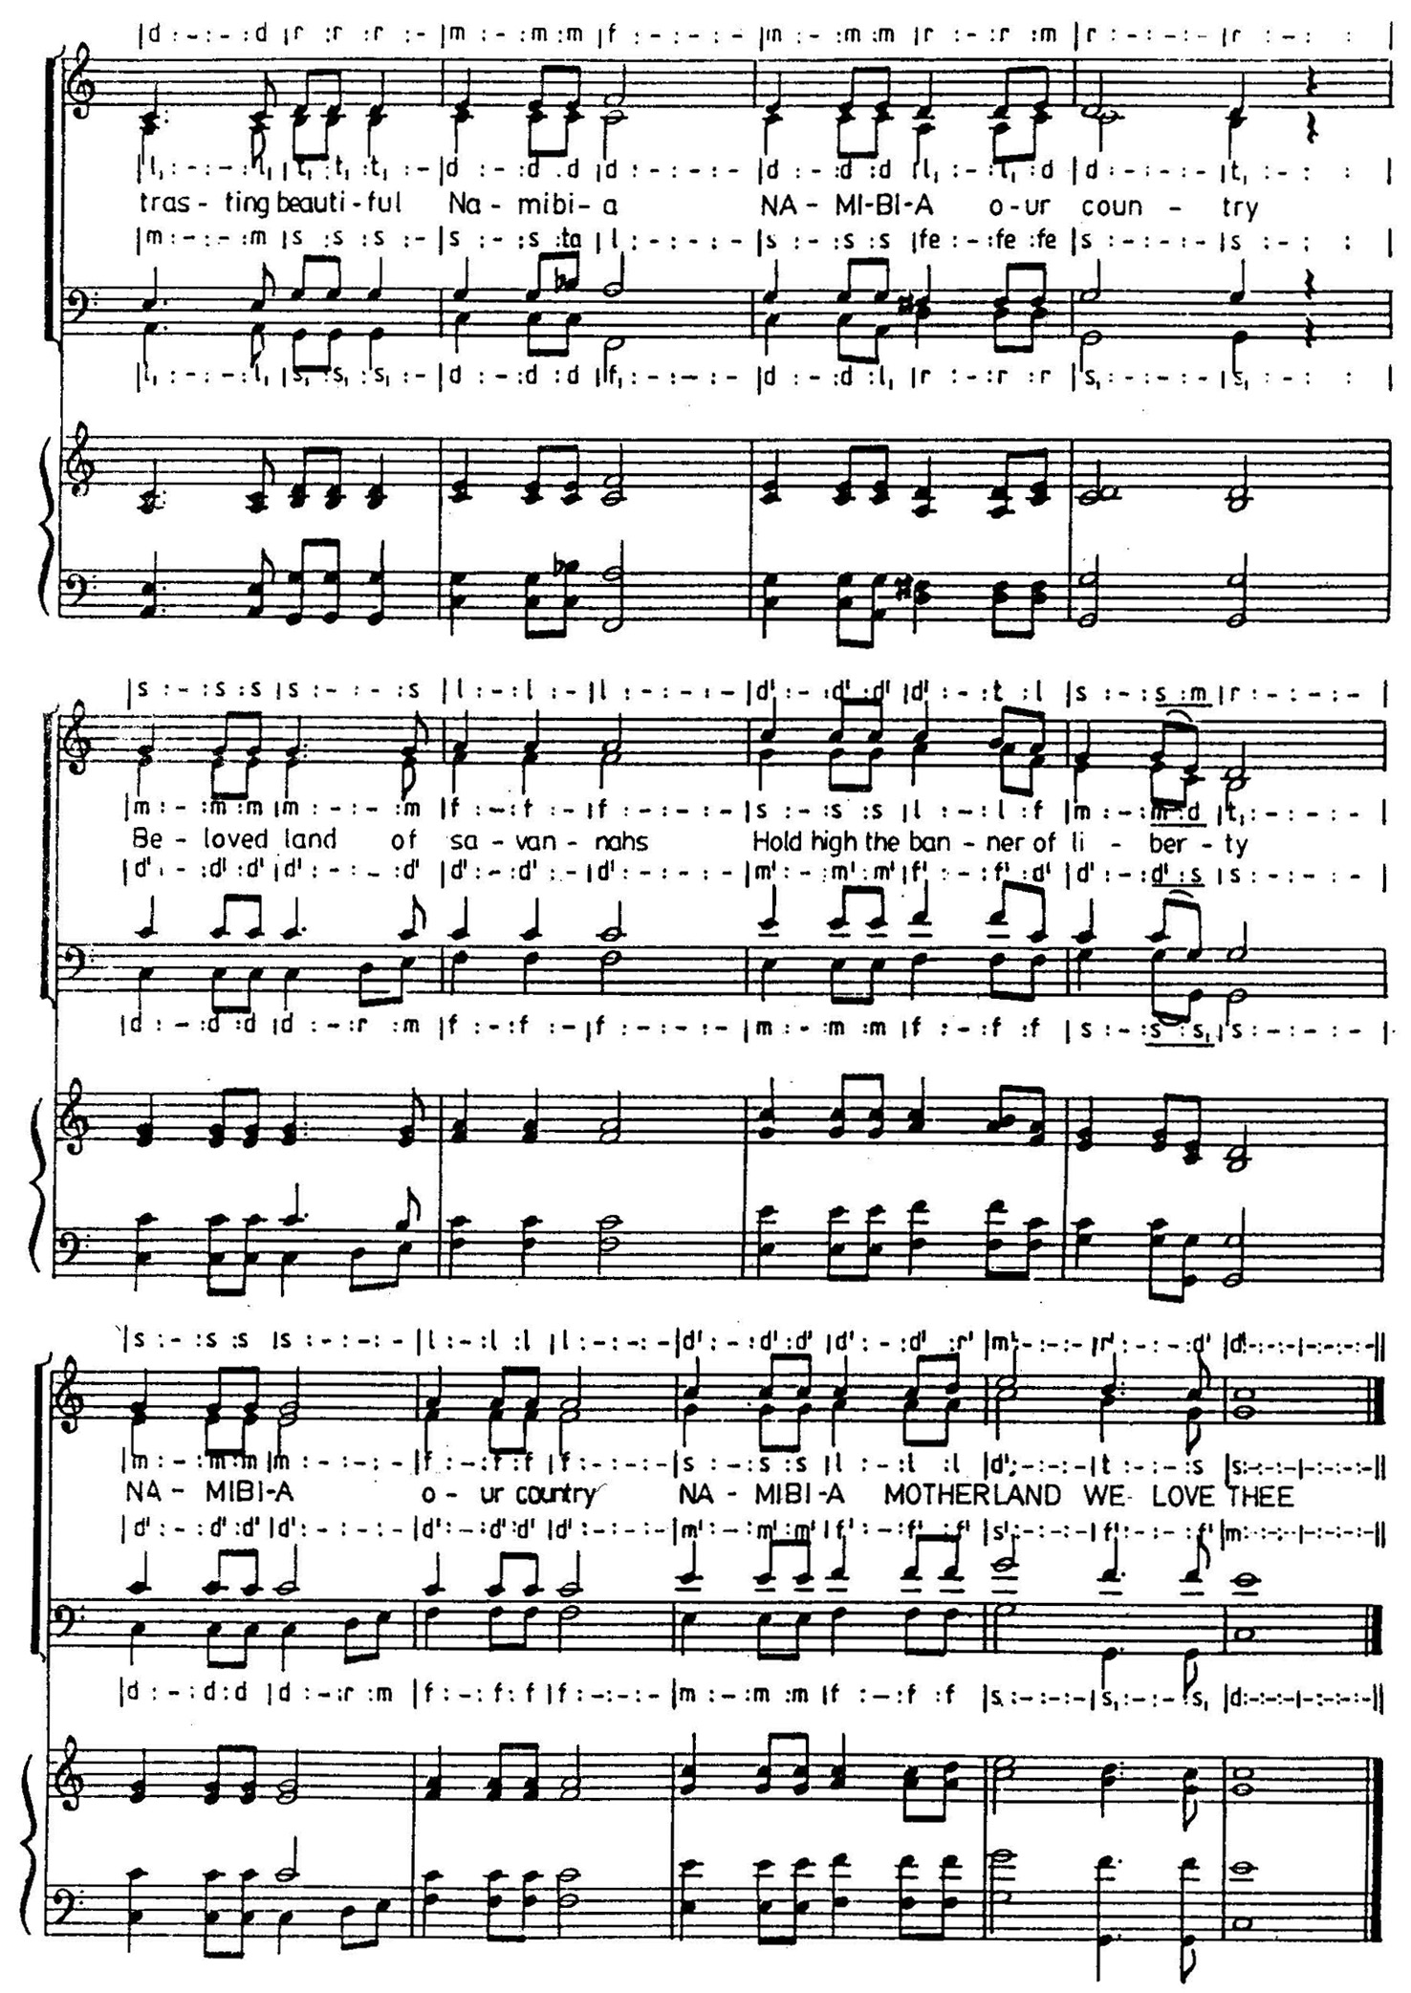

SECOND SCHEDULE

ASSIGNMENT TO THE REPUBLIC OF NAMIBIA OF THE

COPYRIGHT IN “NAMIBIA LAND OF THE BRAVE”

WHEREAS the Government of the Republic of Namibia has decided to adopt and declare the composition of Axali Doeseb entitled “NAMIBIA LAND OF THE BRAVE” as the National Anthem of the Republic of Namibia;

AND WHEREAS Axali Doeseb is desirous of assigning to the Government of the Republic of Namibia for the aforesaid purpose the copyrights in the words and music of the said composition.

NOW THEREFORE Axali Doeseb hereby assigns to the Government of the Republic of Namibia the respective copyrights in the words and music of the composition entitled “NAMIBIA LAND OF THE BRAVE”.

SIGNED at WINDHOEK this 18th day of September 1991.

(Sgd.) AXALI DOESEB

AS WITNESSES:

1. (Sgd.) HONOURABLE HIDIPO HAMUTENYA

National Symbols Sub-Committee: Chairman

2. (Sgd.) HONOURABLE ANDREW MATJILA

National Symbols Sub-Committee: Member