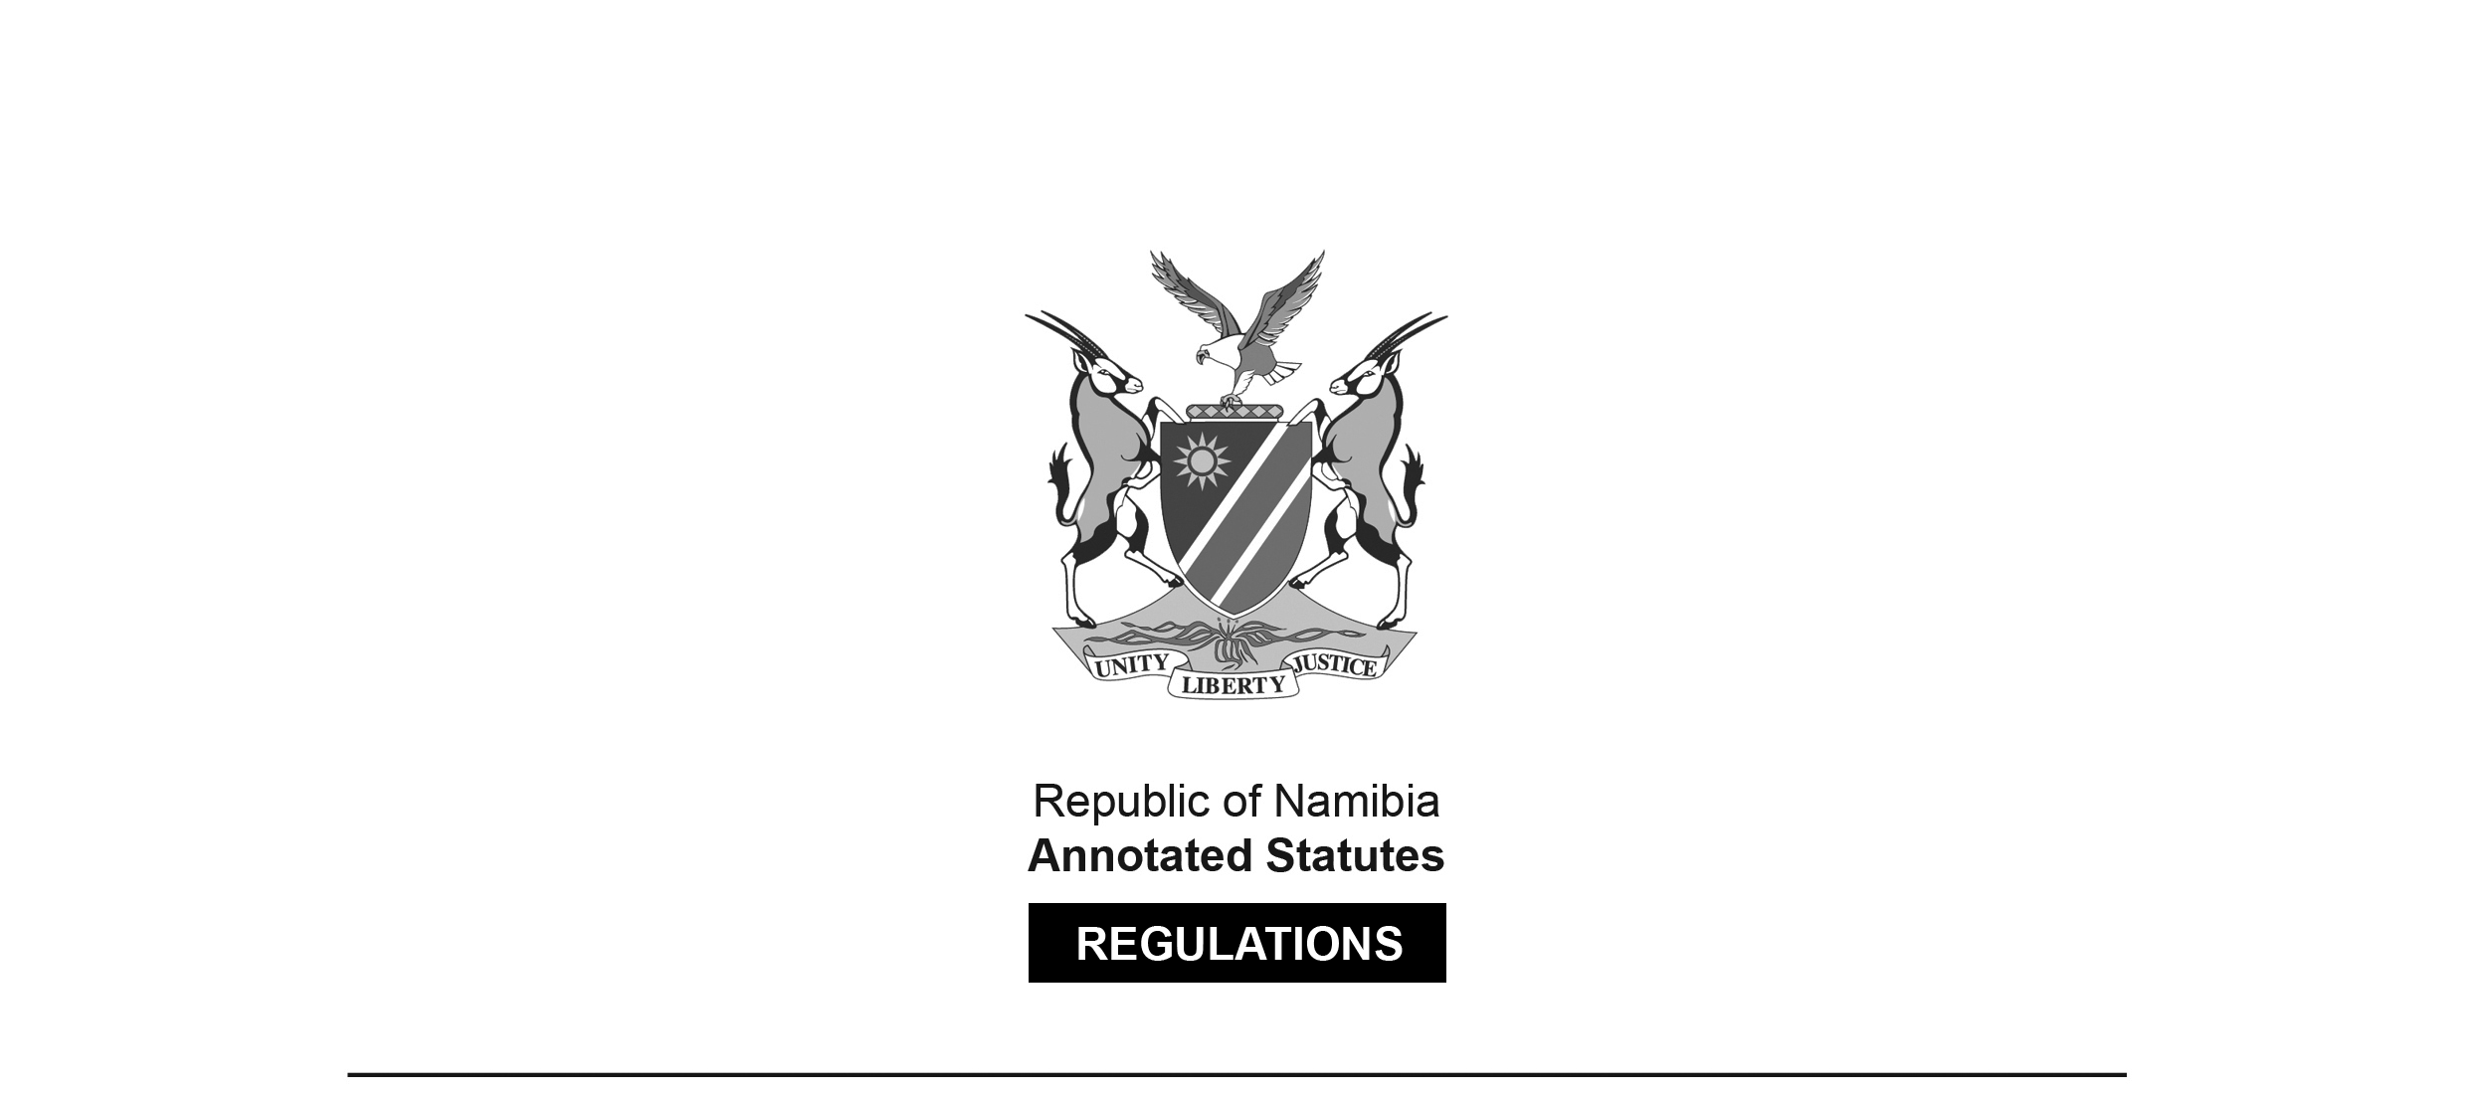

REGULATIONS MADE IN TERMS OF

Departure from Namibia Regulation   
Act 34 of 1955

section 9A

Departure Regulations

Government Notice 136 of 1994

([GG 895](http://www.lac.org.na/laws/1994/895.pdf))

came into force on date of publication: 29 July 1994

The Government Notice which issues these regulations   
repeals the regulations published in RSA GN R.827/1963.

as amended by

Government Notice 243 of 2013 **(**[GG 5284](http://www.lac.org.na/laws/2013/5284.pdf)**)**

came into force on date of publication: 16 September 2013

Government Notice 7 of 2020 **(**[GG 7099](http://www.lac.org.na/laws/2020/7099.pdf)**)**

came into force on date of publication: 21 January 2020

Government Notice 152 of 2025 **(**[GG 8688](http://www.lac.org.na/laws/2025/8688.pdf)**)**

came into force on date of publication: 15 July 2025

ARRANGEMENT OF REGULATIONS

1. Interpretation

2. Departure from Namibia

3. [Regulation 3 has no heading.]

4. Powers of Immigration Officer

5. Penalties

ANNEXURE A: [Annexure A is deleted by GN 152/2025.]

ANNEXURE B: Border Posts and Ports of Exit from Namibia

**Interpretation**

**1.** In these regulations, unless the context otherwise indicates, an expression in the Act has a corresponding meaning, and -

“conveyance” includes any vehicle, train, aircraft or ship;

“Immigration Control Act” means the Immigration Control Act, 1993 (Act 7 of 1993);

“immigration officer” means an immigration officer defined in the Immigration Control Act;

“port” means a port defined in the Immigration Control Act; and

“the Act” means the Departure from Namibia Regulation Act, 1955 (Act 34 of 1955).

**Departure from Namibia**

**2.** A person wishing to depart from Namibia, excluding a person referred to in paragraph (b) of section 2 of the Act shall at a port listed in Annexure “B”, present himself or herself to an immigration officer on duty at that port.

[Regulation 2 is substituted by GN 243/2013 and by GN 7/2020.

There should be a comma after the phrase “excluding a person referred to   
in paragraph (b) of section 2 of the Act” to offset that phrase properly.]

**3.** (1) A person referred to in regulation 2 shall, when presenting himself or herself to an immigration officer contemplated in that regulation -

(a) submit his or her passport or permit, as the case may be, to the immigration officer referred to in regulation 2;

(b)

[Paragraph (b) is deleted by GN 152/2025, which erroneously   
refers to the deletion of subregulation 3(b) instead of paragraph 3(1)(b)].

(c) allow the immigration officer to examine his or her luggage or the conveyance which he or she is traveling in.

(2) Subregulation (1)(b) does not apply to a person who is a Namibian citizen or a permanent resident of Namibia, except where the electronic border management system is not functioning at the time of processing that person’s departure from Namibia.

[Regulation 3 is substituted by GN 7/2020.]

**Powers of Immigration Officer**

**4.** An immigration officer may -

(a) refuse to allow any person who -

(i) is not in possession of a valid passport or permit issued or endorsed for such purpose; or

(ii) refuses to comply with the provisions of regulation 3, or fails to comply therewith to the satisfaction of such immigration officer,

to depart from Namibia; or

(b) seize any passport, permit or other document, if -

(i) he or she has reasonable grounds to believe that such passport, permit or document has been obtained by any fraudulent act or false representation, or is a forgery;

(ii) the passport, permit or document has been defaced or mutilated to such an extent that it, or any part thereof, is illegible;

(iii) any amendment or endorsement has been made to, or inserted in, the passport, permit or document by any person other than an official duly authorized to do so,

and may transmit such passport, permit or document to the authority which issued it or on behalf of which it was so issued.

**Penalties**

**5.** Any person who contravenes, or fails to comply with, the provisions of regulation 2 or 3 of these regulations shall be guilty of an offence and on conviction be liable to the fines prescribed by section 8(1)(c) of the Act.

**Annexure A**

[The unlabelled annexure in the original regulations was re-named   
as “Annexure A” by GN 243/2013 and deleted by GN 152/2025.]

**Annexure B**

[Annexure B is inserted by GN 243/2013 and substituted by GN 7/2020.]

BORDER POSTS AND PORTS OF EXIT FROM NAMIBIA

(Regulation 2)

**1. Erongo Region**

(a) Walvis Bay Airport

(b) Walvis Bay Harbour

**2. Kavango East Region**

(a) Mohembo Border Post

(b) Rundu Airport

(c) Sarusungu Border Post

**3. Kavango West Region**

(a) Katwitwi Border Post

(b) Nkurenkuru Border Post

**4. //Kharas Region**

(a) Border Post

[This was probably intended to be Ariamsvlei Border Post.]

(b) Ariamsvlei Keetmanshoop Airport

[This was probably intended to be Keetmanshoop Airport;   
the word “Ariamsvlei” appears to have been misplaced.]

(c) Klein Manasse Border Post

(d) Lüderitz Airport

(e) Lüderitz Harbour

(f) Mata-Mata Border Post

(g) Noordoewer Border Post

(h) Oranjemund Airport

(i) Oranjemund Border Post

(j) Senderlings Drift Border Post

(k) Veloorsdrift Border Post

**5. Khomas Region**

(a) Eros Airport

(b) Hosea Kutako International Airport

**6. Ohangwena Region**

Oshikango Border Post

**7. Omaheke Region**

(a) Gobabis Airport

(b) Trans-Kalahari Border Post

**8. Omusati Region**

(a) Omahenene Border Post

(b) Omuvelo waKashamane Border Post

(c) Ruacana Border Post

**9. Oshana Region**

Ondangwa Airport

**10. Otjozondjupa Region**

(a) Dobe Border Post

(b) Grootfontein Airport

**11. Zambezi Region**

(a) Impalila Island Border Post

(b) Kasika Border Post

(c) Katima Mulilo Border Post

(d) Luhonono Border Post

(e) Mpacha Airport

(f) Ngoma Border Post

(g) Singalamwe Border Post