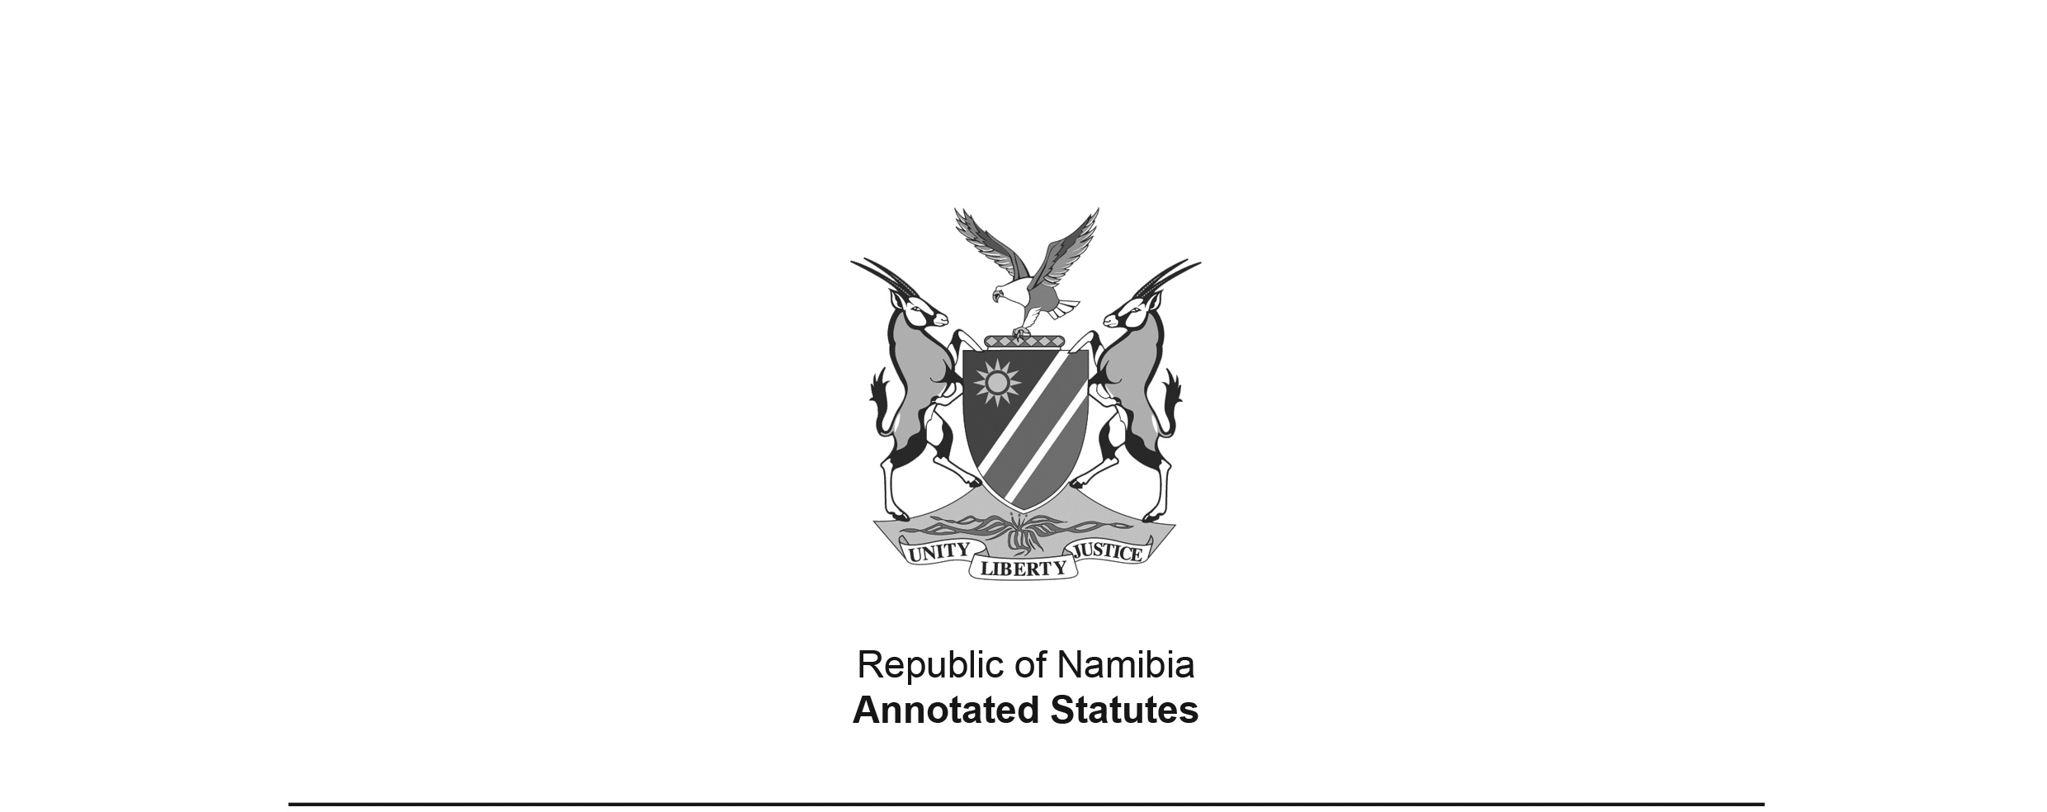

Criminal Procedure Act Repeal Act 14 of 2018   
**(**[GG 6804](http://www.lac.org.na/laws/2018/6804.pdf)**)**

came into force on date of publication: 28 December 2018

ACT

**To provide for the repeal of the Criminal Procedure Act, 2004; and to provide for incidental matters.**

*(Signed by the President on 21 December 2018)*

ARRANGEMENT OF SECTIONS

1. Repeal of Act No. 25 of 2004

2. Short title

**BE IT ENACTED** as passed by the Parliament, and assented to by the President, of the Republic of Namibia as follows:

**Repeal of Act No. 25 of 2004**

**1.** The Criminal Procedure Act, 2004 (Act No. 25 of 2004) is repealed.

**Short title**

**2.** This Act is called the Criminal Procedure Act Repeal Act, 2018.