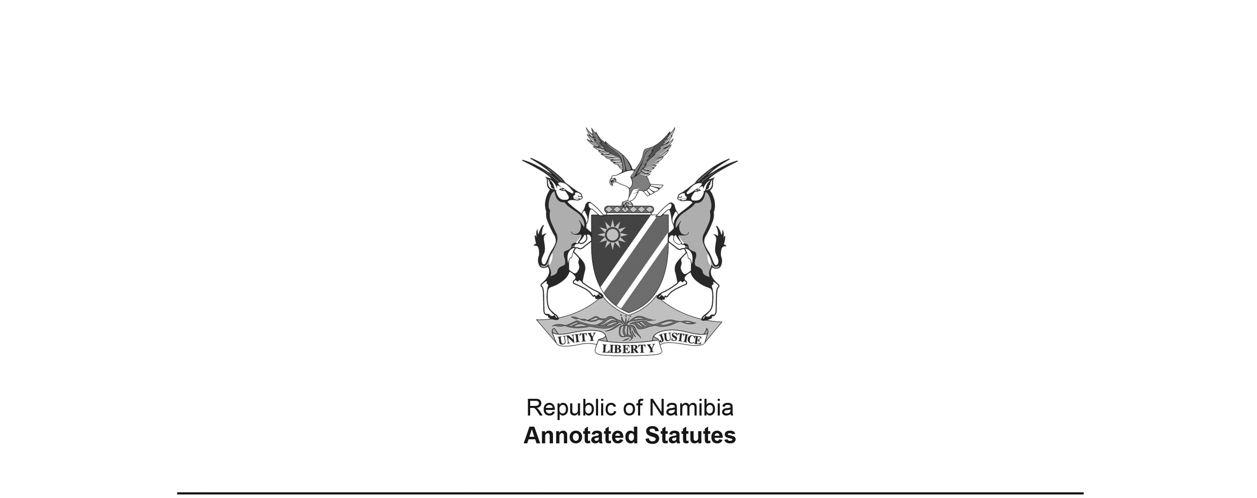
Appropriation Act 8 of 1993
(GG 691)
came into force on date of publication: 20 August 1993

ACT

To appropriate amounts of money to meet the financial requirements of the State during the financial year ending 31 March 1994.

(Signed by the President on 6 August 1993)

BE IT ENACTED by the Parliament of the Republic of Namibia, as follows:-

Appropriation of amounts of money for financial requirements of State

1. Subject to the provisions of the Finance Act, 1991 (Act 31 of 1991), there are hereby appropriated for the financial requirements of the State during the financial year ending 31 March 1994, as a charge to the State Revenue Fund, the amounts of money shown in the Schedule.

Short title

2. This Act shall be called the Appropriation Act, 1993.

SCHEDULE

 | VOTE | AMOUNT APPROPRIATED
NO. | TITLE
1 | President | 28 163 000
2 | Prime Minister | 108 305 000
3 | Parliament | 8 820 000
4 | Auditor-General | 3 994 000
5 | Civic Affairs | 17 299 000
6 | Police and Prisons | 154 973 000
7 | Foreign Affairs | 79 520 000
8 | Defence | 180 744 000
9 | Finance | 71 866 000
10 | Education and Culture | 789 772 000
11 | Youth and Sport | 9 291 000
12 | Information and Broadcasting | 59 975 000
13 | Health and Social Services | 440 237 000
14 | Labour and Manpower Development | 19 812 000
15 | Mines and Energy | 37 174 000
16 | Justice | 29 205 000
17 | Local Government and Housing | 118 695 000
18 | Wildlife, Conservation and Tourism | 46 513 000
19 | Trade and Industry | 12 948 000
20 | Agriculture and Rural Development | 167 714 000
21 | Water Affairs | 177 467 000
22 | Fisheries and Marine Resources | 38 014 000
23 | Works | 331 114 000
24 | Transport | 286 704 000
25 | Lands, Resettlement and Rehabilitation | 42 864 000
26 | National Planning Commission | 7 380 000
 | TOTAL | 3 268 563 000

