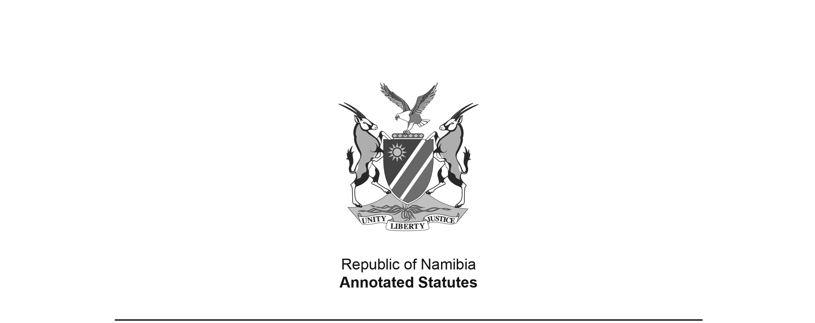

Appropriation Act 5 of 2012

(GG 4968)

came into force on date of publication: 15 June 2012

ACT

**To appropriate amounts of money to meet the financial requirements of the State during the financial year ending 31 March 2013.**

*(Signed by the President on 9 June 2012)*

**BE IT ENACTED** by the Parliament of the Republic of Namibia, as follows:

**Appropriation of amounts of money for financial requirements of State**

**1.** Subject to the State Finance Act, 1991 (Act No. 31 of 1991), the amounts of money shown in the Schedule are appropriated for the financial requirements of the State during the financial year ending 31 March 2013 as a charge to the State Revenue Fund.

**Short title**

**2.** This Act is called the Appropriation Act, 2012.

SCHEDULE

|  |  |  |
| --- | --- | --- |
| **Vote** | **Title** | **Amount N$** |
| 1 | President | 379,759,400 |
| 2 | Prime Minister | 251,658,400 |
| 3 | National Assembly | 115,332,800 |
| 4 | Auditor General | 80,670,000 |
| 5 | Home Affairs and Immigration | 254,314,500 |
| 6 | Police | 2,362,218,300 |
| 7 | Foreign Affairs | 542,853,400 |
| 8 | Defence | 3,414,538,400 |
| 9 | Finance | 3,294,888,200 |
| 10 | Education | 9,415,972,800 |
| 11 | National Council | 61,634,800 |
| 12 | Gender Equality and Child Welfare | 567,988,500 |
| 13 | Health and Social Services | 3,975,967,600 |
| 14 | Labour and Social Welfare | 1,328,864,100 |
| 15 | Mines and Energy | 194,397,700 |
| 16 | Justice | 444,336,400 |
| 17 | Regional and Local Government, Housing and Rural Development | 1,374,574,500 |
| 18 | Environment and Tourism | 572,450,135 |
| 19 | Trade and Industry | 727,859,800 |
| 20 | Agriculture, Water and Forestry | 2,034,233,049 |
| 21 | Prisons and Correctional Services  [The Ministry of Prisons and Correctional Services was dissolved in 2005, by Proc. 4/2005 (GG 3436), with prisons and correctional services then resorting under the Ministry of Safety and Security. Appropriation Acts after that date and prior to this Act continued to refer to allocations for “prisons and corrective services”, with the exception of Appropriation Act 4 of 2011 (GG 4733) which referred instead to “correctional service”. The Namibian Constitution Second Amendment Act 7 of 2010 (GG 4480) altered the term “prison service” in the Constitution to “correctional service”, and the term “Commissioner of Prisons” to “Commissioner-General of Correctional Service”. The Prisons Act 17 of 1998 (GG 1894) was repealed by the Correctional Service Act 9 of 2012 (GG 5008).] | 447,368,900 |
| 22 | Fisheries and Marine Resources | 257,463,300 |
| 23 | Works | 589,886,600 |
| 24 | Transport | 2,494,680,600 |
| 25 | Lands and Resettlement | 271,527,500 |
| 26 | National Planning Commission | 160,322,400 |
| 27 | Youth, National Service, Sport and Culture | 528,699,200 |
| 28 | Electoral Commission | 199,413,000 |
| 29 | Information and Communication Technology | 305,426,900 |
| 30 | Anti-Corruption Commission | 50,302,700 |
| 31 | Veterans Affairs | 1,061,099,000 |
|  | **Total** | **37,760,702,884** |