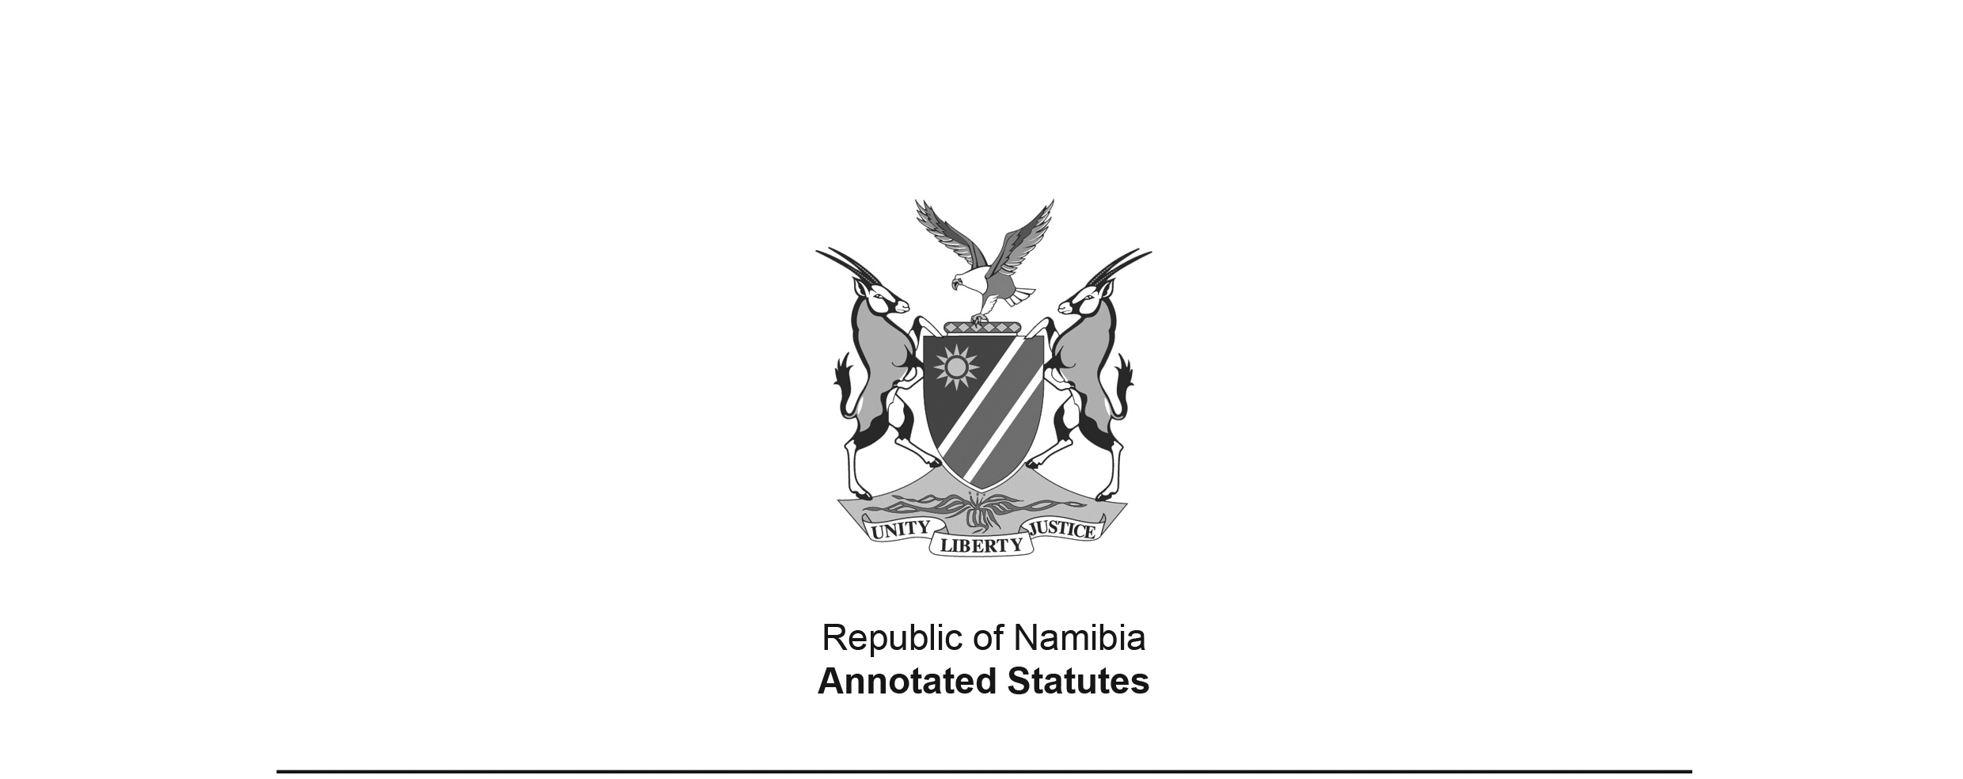
Aerodrome Ordinance 12 of 1963
(OG 2487)
came into force on date of publication: 28 June 1963

ORDINANCE

To provide for the establishment, management and maintenance of aerodromes and for matters incidental thereto.

(Assented to 27th June, 1963)
(English text signed by the Administrator)

ARRANGEMENT OF SECTIONS

[The provisions in this Ordinance have no headings.]

BE IT ORDAINED by the Legislative Assembly for the Territory of South West Africa, with the consent of the State President, in so far as such consent is necessary, previously obtained and communicated to the Legislative Assembly by message from the Administrator in accordance with the provisions of section twenty-six of the South West Africa Constitution Act, 1925 (Act 42 of 1925) of the Republic of South Africa, as follows:-

1. In this Ordinance unless the context otherwise indicates -

“aerodrome” means a defined area on any land or water or building intended to be used either wholly or in part for the arrival, departure or movement of aircraft, and includes any building, installation or equipment within any such area which is intended to be so used;

“aircraft” means any vehicle that can derive support in the atmosphere from the reaction of the air;

“regulation” means any regulation made under this ordinance;

“this ordinance” includes any regulations.

2. (1) The Administrator may out of moneys appropriated by the Legislative Assembly for the Territory for the purpose,

[There should be a comma after the word “may” to properly offset the phrase
“out of moneys appropriated by the Legislative Assembly for the purpose”.]

(a) establish, manage and maintain aerodromes;

(b) provide and maintain roads and approaches thereto, and apparatus and equipment therefor;

(c) construct and maintain drainage works for the control and disposal of water which would otherwise gather thereon; and

(d) acquire land and interests in and rights to and over land for any purpose contemplated in paragraph (a), (b) or (c).

(2) The provisions of any law governing the granting of authority for the issue of any licence for the carrying on of any trade or occupation, for the carrying on of which a licence is required in terms of any regulation made under paragraph (f) of sub-section (1) of section six, shall not apply to or in respect of any aerodrome established, managed and maintained in terms of this section.

3. (1) Any person duly authorized thereto in writing by the Administrator may enter any land or structure, after notice to the owner, lessee or occupier thereof, for the purpose of carrying out thereon or therein any such examination or survey as may be necessary to determine its suitability for any of the purposes mentioned in section two or of performing thereon or therein any other act which he is authorized to perform thereon or therein by this ordinance.

(2) Any person who hinders or obstructs any person in the exercise of his powers or the performance of his duties under sub-section (1) shall be guilty of an offence, and shall be liable on conviction to a fine not exceeding four hundred rand or in default of payment, to imprisonment for a period not exceeding six months, or to both such fine and such imprisonment.

4. For the purpose of the construction, maintenance repair of any aerodromes contemplated in section two and access roads thereto or the installation of any apparatus and equipment connected therewith, the Administrator may, through his representatives, officers or conlessee or occupier of such land, remove any material therefrom which may be required for such construction, maintenance, repair or installation and for this purpose he may build and maintain any access roads as he may consider necessary: Provided that -

[The word “or” should appear between the words
“maintenance” and “repair” in their first appearance in section 4:
“For the purpose of the construction, maintenance or repair of any aerodromes…” .
The word “conlessee” appears to be in error; it should perhaps read “lessee”.]

(a) nothing shall be removed from any garden or other land usually cultivated, nor from any place within three hundred yards of any house, nor within fifty yards of any kraal;

(b) every excavation be filled up again or properly fenced-off or otherwise made safe for human beings and animals;

(c) the Administrator, his representatives, officers or contractors in exercising these powers take every care to prevent damage, injury, loss or inconvenience to the owner, lessee or occupier concerned;

(d) compensation, at a rate as may be agreed upon by the owner, lessee or occupier concerned and the Administrator, or, failing such agreement as may be determined by arbitration in terms of the provisions of the Arbitration Proclamation, 1926 (Proclamation 3 of 1926), shall be paid for such area of land as is used in making excavations for the obtaining of any materials therefrom or for any improvements to or on such land.

[The Arbitration Proclamation 3 of 1926 has been
replaced by the Arbitration Act 42 of 1965.]

5. All moneys received under this Ordinance shall be paid into the Territory Revenue Fund.

6. (1) The Administrator may make regulations relating to the control and management of any aerodrome established, managed and maintained in terms of the provisions of section two, including -

(a) the prevention of damage to any runway, taxiway or other works or property connected with such aerodrome;

(b) the prohibition or the regulation of vehicular or other traffic within such aerodrome, the parking of vehicles therein, the demarcation of places, and the imposition of fees, for such parking, the manner of payment of such fees, and the meaning of the word “park” for the purposes of this paragraph;

(c) the control of aircraft on such aerodrome while such aircraft are not subject to the control of the air traffic control service operating at such aerodrome;

(d) the prevention of damage to aircraft on such aerodrome and the protection of freight carried by such aircraft ;

(e) the removal of aircraft hulks and aircraft wreckage likely to obstruct any runway or taxiway on such aerodrome, the imposition and recovery of charges for the right to leave an aircraft hulk or any aircraft wreckage on any such aerodrome, and the saving of life in the case of aircraft accidents;

(f) the granting of licences to handling, forwarding, passenger or freight agents or other persons trading, or carrying on any occupation, on such aerodrome, and the fees to be paid in respect of each such licence;

(g) the prohibition of smoking on such aerodrome or any part thereof;

(h) the discretionary rights and powers which may be exercised in relation to the admission of the public to, or their exclusion from, such aerodrome or any part thereof, the imposition of charges for such admission, exemption from payment or variation as to the payment of such charges, and the designation of the person who shall decide during which periods those charges shall be payable;

(i) the prohibition or the regulation of the admission of any animal or class of animal to such aerodrome or any part thereof;

(j) the prevention of the commission of any nuisance in or on such aerodrome and, generally, the promotion and ensuring of good sanitation, cleanliness and decency therein or thereon;

(k) the regulation of the handling and storing of goods at such aerodrome, the charges to be made for handling or storing goods and for their care or custody, the terms and conditions upon which they shall be received, the disposal of unclaimed goods, and exemption from payment or variation as to the payment of such charges;

(l) the conditions under which and the times when dangerous or offensive classes of goods may be transported or handled at such aerodrome, the prohibition of the transport or handling of those classes of goods, and provision for or sanctioning of the removal or destruction of such goods;

(m) the use of land forming part of such aerodrome for sites for the bulk storage of oil, liquid fuel and other inflammable substances, or for pipe lines, power lines and the like, and whether such lines shall be overhead or underground;

(n) the installation, maintenance and control of automatic vending, weighing, novelty and similar machines on such aerodrome and the charges to be paid in respect of each such machine;

and generally, for such other matters as he may deem necessary for the better control and management of any such aerodromes.

(2) Different regulations may be made under subsection (1) in respect of different aerodromes established, managed and maintained under the provisions of section two.

(3) No fees, rates of compensation or charges or, where applicable, exemption from payment or variation as to the payment of such fees or charges, shall be prescribed or provided for under sub-section (1) except after consultation with the Treasury of the Territory.

(4) Any regulation made under this Ordinance may prescribe penalties for the contravention thereof or failure to comply therewith and the mode of enforcing such penalties, and may also impose different penalties in case of a second or subsequent contravention or non-compliance, but no such penalty shall exceed the penalties mentioned in section three.

7. The provisions of this Ordinance shall be operative subject to the provisions of the Aviation Act, 1962 (Act 74 of 1962), as amended from time to time, of the Parliament of the Republic of South Africa and any regulations made thereunder.

[The Aviation Act 74 of 1962 was repealed
by the Civil Aviation Act 6 of 2016.]

8. This Ordinance shall be called the Aerodrome Ordinance, 1963.

