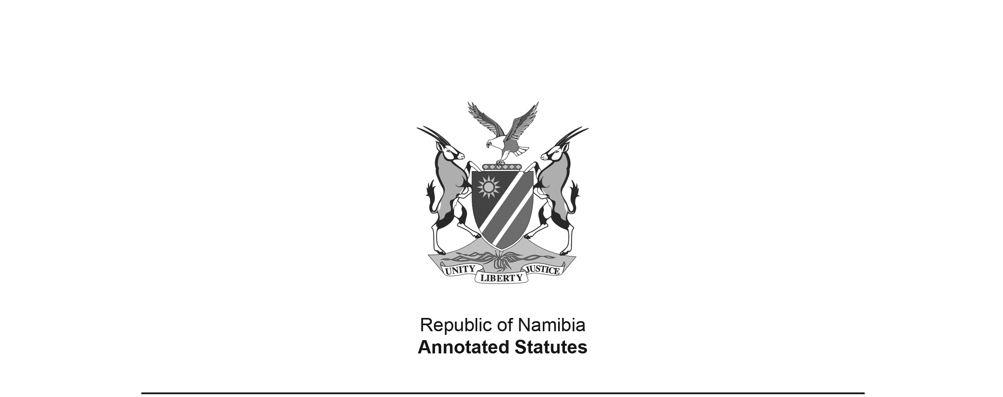
Additional Appropriation Act 16 of 1997
(GG 1763)
came into force on date of publication: 29 December 1997

ACT

To appropriate amounts of money to meet the financial requirements of the State during the financial year ending 31 March 1998.

(Signed by the President on 19 December 1997)

BE IT ENACTED by the Parliament of the Republic of Namibia, as follows:-

Appropriation of amounts of money for financial requirements of the State

1. Subject to the provisions of the State Finance Act, 1991 (Act No. 31 of 1991), there are hereby appropriated for the financial requirements of the State during the financial year ending 31 March 1998, as a charge to the State Revenue Fund, the additional amounts of money shown in the Schedule.

Short title

2. This Act shall be called the Additional Appropriation Act, 1997.

SCHEDULE

VOTE  NO. | TITLE | AMOUNT APPROPRIATED  N$
01 | President | 1 600 000
02 | Prime Minister | 10 000 000
03 | Parliament | 9 000 000
04 | Auditor-General | 195 000
05 | Civic Affairs | -
06 | Police | 60 500 000
07 | Foreign Affairs | 5 000 000
08 | Defence | 3 700 000
09 | Finance | 120 500 000
10 | Basic Education | 54 444 000
11 | Youth and Sport | -
12 | Information and Broadcasting | 5 000 000
13 | Health and Social Services | 1 600 000
14 | Labour | 1 000 000
15 | Mines and Energy | 12 937 000
16 | Justice | 4 950 000
17 | Regional and Local Government and Housing | 6 500 000
18 | Environment and Tourism | 9 000 000
19 | Trade and Industry | -
20 | Agriculture, Water and Rural Development | 21 700 000
21 | Prisons and Correctional Services | 8 000 000
22 | Fisheries and Marine Resources | 4 574 000
23 | Works | 23 777 000
24 | Transport | 20 844 000
25 | Lands, Resettlement and Rehabilitation | 15 000 000
26 | National Planning Commission | -
27 | Higher Education, Vocational Training, Science and Technology | 3 837 000
 | TOTAL | 403 658 000

