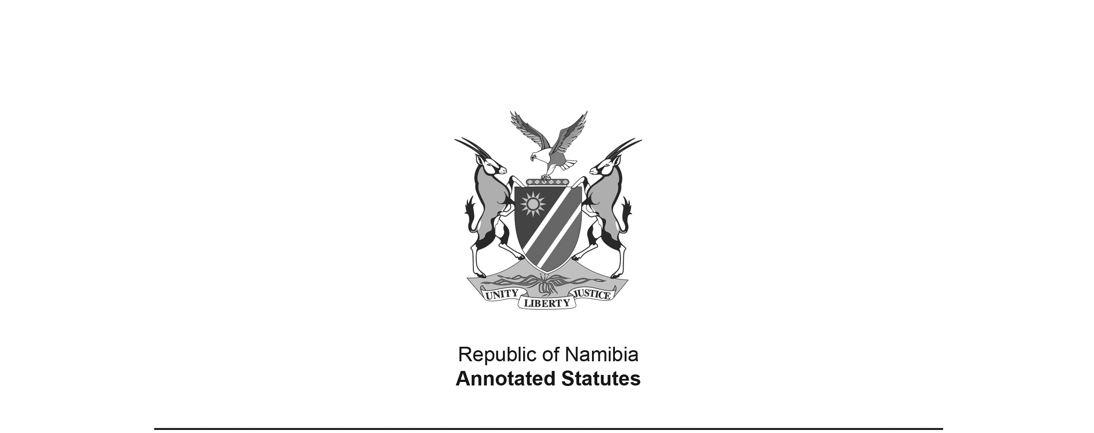
Additional Appropriation Act 1 of 1991
(GG 168)
came into force on date of publication: 26 March 1991

ACT

To appropriate additional amounts of money to meet the financial requirements of the State during the financial year ending 31 March 1991.

(Signed by the President on 20 March 1991)

BE IT ENACTED by the National Assembly of the Republic of Namibia, as follows:-

Appropriation of amounts of money for requirements of State

1. Subject to the provisions of the State Finance Act, 1982 (Act 1 of 1982), there are hereby appropriated for the financial requirements of the State during the financial year ending 31 March 1991, as a charge to the State Revenue Fund, the additional amounts of money shown in the Schedule.

Short title

2. This Act shall be called the Additional Appropriation Act, 1991.

SCHEDULE

 | VOTE | AMOUNT APPROPRIATED  R
No. | Title
1 | PRESIDENT | 75 000
3 | PRIME MINISTER | 13 471 000
4 | CIVIC AFFAIRS | 490 000
5 | POLICE AND PRISONS | 22 253 000
6 | FOREIGN AFFAIRS | 7 836 000
8 | FINANCE | 17 058 000
9 | EDUCATION, CULTURE, YOUTH AND SPORT | 64 903 000
11 | HEALTH AND SOCIAL SERVICES | 976 000
13 | MINES AND ENERGY | 11 000 000
16 | WILDLIFE, CONSERVATION AND TOURISM | 3 858 000
18 | AGRICULTURE AND RURAL DEVELOPMENT | 15 460 000
20 | WORKS | 3 390 000
22 | COMMUNICATION | 3 906 000
 | TOTAL | 164 676 000

