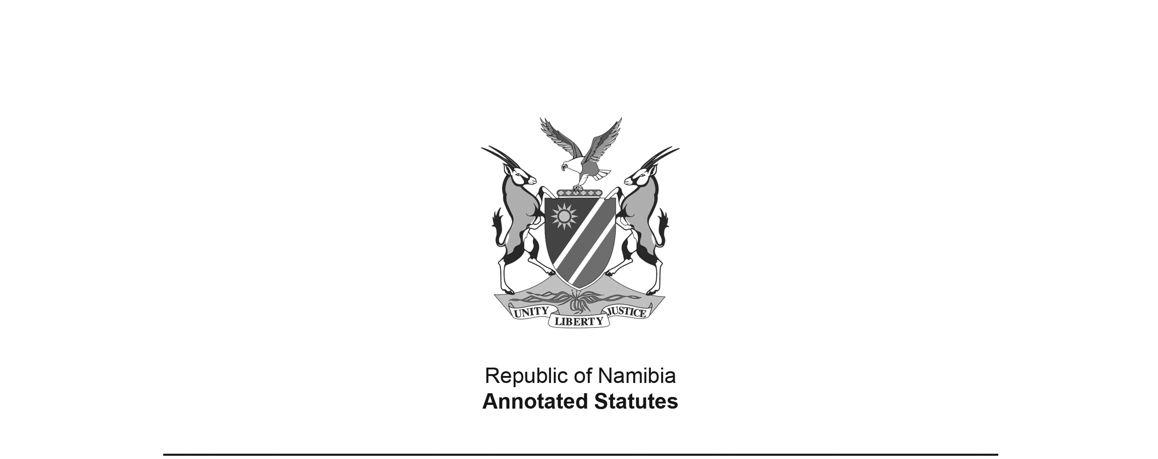
Abattoirs Restriction Proclamation 8 of 1944
(OG 1097)
came into force on date of publication: 15 February 1944

PROCLAMATION

BY HIS HONOUR PETRUS IMKER HOOGENHOUT,
ADMINISTRATOR OF SOUTH WEST AFRICA

[This Proclamation has no long title.
The date of signature appears at the bottom of the Proclamation.]

ARRANGEMENT OF SECTIONS

[The provisions in this Proclamation have no headings.]

WHEREAS it is desirable to prohibit the slaughter of animals, other than stock commonly used for human consumption, in abattoirs in the Territory;

NOW THEREFORE, under and by virtue of the powers in me vested, I do hereby proclaim, declare and make known as follows:-

1. In this Proclamation unless inconsistent with the context -

“abattoir” shall mean and include any slaughterhouse site and any other site, together with all buildings, spaces and lairages within any such sites, which have been approved under any Municipal Regulation or under any other law for the purpose of slaughtering animals; and

“stock” shall mean and include every bull, cow, heifer, ox, calf, sheep, lamb, goat, kid or pig.

2. (1) No person shall, without the prior consent of the Secretary in writing, slaughter any animal other than stock at any abattoir.

(2) Any person who contravenes the provisions of this section shall be guilty of an offence and liable on conviction to a fine not exceeding one hundred pounds or in default of payment to imprisonment with or without hard labour for a period not exceeding six months.

[A fine not exceeding one hundred pounds is equivalent to a fine not exceeding N$200.]

3. This Proclamation shall be called the Abattoir Restriction Proclamation, 1944.

GOD SAVE THE KING.

Given under my hand and seal at Windhoek, this 28th day of January, 1944.

P.I. HOOGENHOUT
Administrator

