LEVY IMPOSED IN TERMS OF

Vocational Education and Training Act 1 of 2008
section 35(1) and (4) read with section 41

Imposition of Vocational Education
and Training Levy on Employers
Government Notice 67 of 2021
(GG 7498)
came into force on date of publication: 1 April 2021

The Government Notice which issues this levy repeals the levy imposed by GN 6/2014,
and the amendments to that levy contained in GN 248/2016 and GN 290/2018. This levy is
included in the regulations database even though it is not technically a set of regulations.

ARRANGEMENT OF REGULATIONS

1. Definitions
2. Imposition of levy
3. Description of employers who must pay levy
4. Exemption of employers from payment of levy
5. Rate on which levy is payable
6. Payment of levy
7. Body to which levy is paid and manner of payment
8. Furnishing of information by employers
9. Levy as debt due to National Training Fund

ANNEXURE A: Monthly Levy Submission Form (Paragraph 6)

ANNEXURE B: Levy Registration Form (Paragraph 8)

ANNEXURE C: Framework for the Exemption of Employers from Payment
of the Vocational Education and Training Levy

Definitions

1. In this notice a word or expression to which a meaning has been assigned in the Act has that meaning and, unless the context otherwise indicates -

“employee” means an employee as defined in section 1 of the Labour Act, 2007 (Act No. 11 of 2007);

“payroll” means the total annual remuneration paid or payable by an employer to its employees during any financial year;

“remuneration” means remuneration as defined in Part I of Schedule 2 of the Income Tax Act, 1981 (Act No. 24 of 1981); and

“the Act” means the Vocational Education and Training Act, 2008 (Act No. 1 of 2008).

Imposition of levy

2. Subject to paragraph 3, a vocational education and training levy is payable by every employer, excluding the employers provided for in paragraph 4.

Description of employers who must pay levy

3. An employer with an annual payroll of N$1 000 000 or more must pay the levy.

Exemption of employers from payment of levy

4. (1) The following employers are exempted from payment of the levy -

(a) the State;

(b) regional councils as defined in section 1 of the Regional Councils Act, 1992 (Act No. 22 of 1992);

(c) local authorities established by the Local Authorities Act, 1992 (Act No. 23 of 1992) except those referred to in Part I of Schedule 1 of that Act;

(d) employers, whether or not supported wholly or partly by grants from public funds, that meet the criteria for -

(i) public educational institutions;

(ii) faith-based organisations;

(iii) charitable organisations;

(iv) private education and training institutions;

(v) diplomatic and consular missions and offices of representatives of other states;

(vi) donor organisations and their agencies;

(vii) non-profit making voluntary organisations or non-government organisations; or

(viii) non-profit making non-voluntary organisations.

(2) In order to qualify for exemption, the employers referred to in subparagraph (1) must meet the criteria described in the Framework for the Exemption of Employers from Payment of the Vocational Education and Training Levy set out in Annexure C.

(3) An institution or employer not mentioned in subparagraph (1) may apply in writing to the Minister for exemption from paying the levy.

Rate on which levy is payable

5. The rate of the levy is 1% of the amount of the annual payroll of the employer concerned.

Payment of levy

6. (1) The levy referred to in paragraph 5 must be paid and reflect in the National Training Fund bank account on or before the 20th day of each month.

(2) Every payment of the levy referred to in subparagraph (1) must be accompanied by -

(a) a completed monthly return form provided by the NTA as set out in Annexure A; and

(b) evidence of monthly payroll as set out in Annexure A.

(3) If -

(a) an employer is required to pay the levy and fails to submit a monthly return form;

(b) the NTA is not satisfied with the information provided in the return form; or

(c) an employer has failed to pay the levy in terms of the Act,

the NTA may make a reasonable estimate, based on information provided on Annexure B, of the amount of any levy payable and issue to the employer a notice of assessment for the unpaid amount and in respect of the failure contemplated in subparagraph (a), impose a penalty of N$250 on every late monthly return form.

(4) An employer to whom a notice of assessment is issued in terms of subparagraph (3) must pay the amount of the assessment concerned unless the employer has -

(a) after receiving the assessment submitted a monthly return form;

(b) given proof to the NTA that the submitted monthly return form is correct; and

(c) paid the levy in terms of the Act.

(5) An employer may submit an amended monthly return form as follows -

(a) in respect of periods preceding the date of publication of this Notice in the Gazette, within six months of such date of publication;

(b) after the date of publication of this Notice in the Gazette, within the financial year concerned; and

(c) for declarations for the month of March, on or before 30th April of the following financial year.

Body to which levy is paid and manner of payment

7. An employer who is required to pay the levy in terms of this notice must pay the levy to the NTA into the National Training Fund bank account by -

(a) electronic funds transfer; or

(b) bank deposit.

Furnishing of information by employers

8. (1) An employer who is required to pay the levy must, within 30 days of publication of this Notice in the Gazette, complete the levy registration form in the form of Annexure B.

(2) An employer with a subsidiary establishment must complete a levy registration form in the form of Annexure B in respect of such subsidiary.

Levy as debt due to National Training Fund

9. On the date of publication of this Notice in the Gazette, a levy that is due and payable is a debt to the National Training Fund and may be recovered by the NTA in the manner set out in section 40 of the Act.

ANNEXURES A-B

To view content without printing, scroll down.

To print at full scale (A4), double-click the icon below.

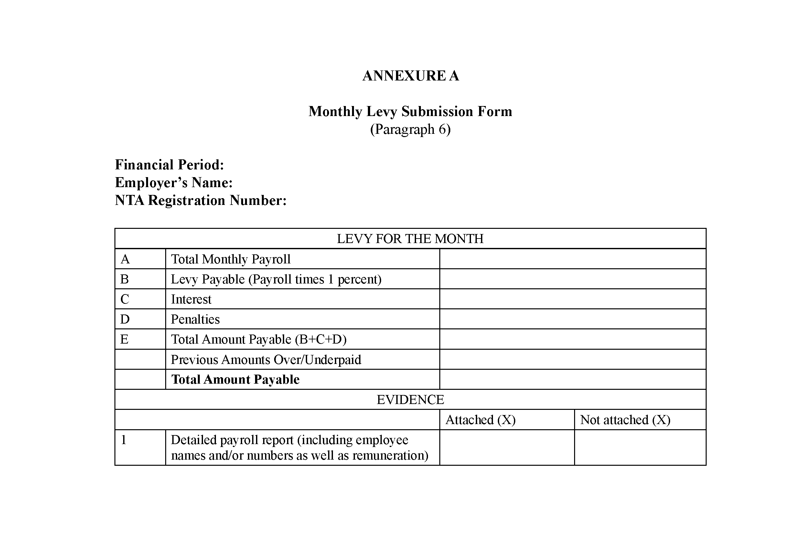

ANNEXURE C

FRAMEWORK FOR THE EXEMPTION OF EMPLOYERS FROM PAYMENT
OF THE VOCATIONAL EDUCATION AND TRAINING LEVY

1. The State

The Republic of Namibia is a sovereign, secular, democratic and unitary State founded upon the principles of democracy, the rule of law and justice for all. The State is exempt from payment of the Vocational Education and Training Levy (“VET levy”). In accordance with the doctrine of separation of powers, this category of employers will include, and “State” means, the three organs of the State being the Executive, Legislature and Judiciary, specifically:

(i) Offices, Ministries and Agencies as contemplated in the Public Service Act, 1995 (Act No. 13 of 1995);

(ii) the Cabinet;

(iii) the National Assembly;

(iv) the National Council; and

(v) the Judiciary.

For purposes of the VET levy, public enterprises as defined in the Public Enterprises Governance Act, 2019 (Act No. 1 of 2019), are excluded from the definition of State.

Regional and Local Authorities, are also excluded from the definition of State and are dealt with under item 2 and item 3, respectively.

[The comma after “Regional and Local Authorities” is superfluous.]

2. Regional Councils

“Regional Council”, means a regional council as is established in accordance with Article 103 of the Namibian Constitution and as defined in section 1 of the Regional Councils Act, 1992 (Act No. 22 of 1992), and are exempted from payment of the VET levy.

[The comma after “Regional Councils” is superfluous.]

3. Local Authorities (except those listed in Part I of Schedule 1 of the Local Authorities Act, 1992)

In terms of section 3(1) of the Local Authorities Act, 1992 (Act No. 23 of 1992), the Minister responsible for urban and rural development may establish by notice in the Gazette any area specified in the notice as the area of a local authority, and declare the area to be a municipality, town or village under the name specified in the notice. All categories of local authorities, except those referred to in Part I of Schedule 1 to that Act, are exempt from payment of the VET levy.

4. Public Educational Institutions

“Public educational institutions” mean entities that provide instructional services or education-related services to individuals and other educational institutions that are owned and funded by government and devoted to the promotion of a particular cause or program that is of an educational character.

5. Faith-Based Organisations

“Faith-based organisations” are organisations affiliated with or based on religion or a religious group, including associations not for gain incorporated in terms of section 21 of the Companies Act, 2004 (Act No. 28 of 2004). Faith-based organisations must meet the following criteria in order to be exempt from payment of the VET levy:

5.1 The main objective of the organisation is the promotion of faith-based activities or religion and includes churches and mosques.

5.2 The organisation should have a written constitution stating that it is a faith-based organisation and adhere to religious tenets.

5.3 The written constitution must provide that any profits or income derived by the organisation must be applied only to promote the main objective of the organisation as set out therein and not for distribution to its members.

6. Charitable Organisations

6.1. Subject to subitem 6.2, a “charitable organisation” means a group of people or organisation having its main objective as the voluntary provision of support, fund raising and donation of things, including money, to vulnerable or disadvantaged groups or individuals and carries on or intends to carry on charitable activities, and includes, but is not limited to, a welfare organisation that has been registered in terms of section 19 of the National Welfare Act, 1965 (Act No. 79 of 1965), which charitable organisation, is formed around a common purpose, e.g. promotion of non-violence or helping children, community-based development, welfare or similar.

[The word “as” should appear before the phrase “its main objective” rather than after that phrase. The phrase “carries on or intends to carry on charitable activities” should be “carrying on or intending to carry on charitable activities” to fit the preceding sentence structure. The comma between the phrase “charitable organisation” and the phrase “is formed around a common purpose”
is superfluous.]

6.2. A charitable organisation, including the aforementioned welfare organisation, must meet the following criteria in order to be exempt from the payment of the VET levy:

6.2.1 The organisation should have a written constitution.

6.2.2 The organisation is in terms of its constitution required to utilise any property or income solely in the furtherance of its aims and objects and is prohibited from transferring any portion thereof, directly or indirectly, in any manner whatsoever so as to profit any person other than by way of the payment in good faith of reasonable remuneration to any officer or employee of the organisation or institution for any services actually rendered to such organisation or institution.

6.2.3 The members of the organisation are not entitled to any distribution nor profits of the organisation.

6.2.4 The organisation should have members that are helping defined individuals or groups of societies as set out in the written constitution.

6.2.5 If required, the organisation must be registered with the relevant authority concerned.

7. Private Educational and Training Institutions

Educational institutions are entities that provide and promote instructional services or education-related services to individuals or other educational institutions. An education institution is classified as private if it is controlled and managed by a non-governmental organisation, or if the governing board of such institution consists mostly of members not selected by a public agency. Private educational and training institutions generate their funding from fees from students and some government subventions. Private educational and training institutions must meet the following criteria in order to be exempt from payment of the VET levy:

7.1 The core business of the institution must be education and training as stated in the constitution or founding document of the institution.

7.2 The institution must be registered with all the relevant authorities (i.e. Ministry of Education, Arts and Culture, National Council for Higher Education, Namibia Training Authority etc.).

8. Diplomatic Missions and Consular Missions and Office of a Representative of another State

The persons listed in section 2(1) of the Diplomatic Privileges Act, 1951 (Act No. 71 of 1951) are exempt from payment of the VET levy.

9. Donor Organisations and their agencies

Organisations whose main objective is to provide developmental aid are generally regarded as donor organisations. Developmental aid is granted by governments and other agencies to support the economic, environmental, social, and political development of developing countries. All donor organisations are exempt from paying the VET levy.

10. Non-Profit Making Voluntary or Non-Governmental Organisations

A non-profit making voluntary organisation is an organisation whose main objective is to provide a service for the promotion of the arts, science, recreation or any other cultural or social activity or communal or group interest acting in a voluntary and non-profit making capacity. A non-profit making non-governmental organisation (NGO) is any non-profit, voluntary citizens’ group which is organised on a local, national or international level, some organised around specific issues, such as human rights, environment or health. NGOs are task-oriented and driven by people with a common interest and perform a variety of services and humanitarian functions, bring citizen concerns to government, advocate and monitor policies and encourage political participation through provision of information. Non-profit making voluntary and non-governmental organisations are required to meet the following criteria in order to be exempt from payment of the VET levy:

10.1 The organisation must have a written constitution.

10.2 If required, the organisation must be registered with the relevant authority concerned.

10.3 The organisation must have members that are helping defined individuals or groups of societies as set out in the written constitution.

10.4 The written constitution must provide that any profits or income derived by the organisation must be applied only to promote the main objective of the organisation as set out therein and not for distribution to its members.

11. Non-Profit Making Non-Voluntary Organisations

A non-profit making non-voluntary organisation is an organisation whose main objective is to provide a service for the promotion of the arts, science, professions, recreation or any other cultural or social activity or communal or group interest acting in a non-voluntary and non-profit making capacity. Non-profit making non-voluntary organisations are required to meet the following criteria in order to be exempt from payment of the VET levy:

11.1 The organisation must be established by an Act of Parliament.

11.2 If required, the organisation must be registered with the relevant authority concerned.

11.3 Membership to the organisation should be compulsory (non-voluntary).

[The phase “Membership to” should be “Membership in”.]

11.4 The organisation must be involved in skills development.

11.5 The members of the organisation should be beneficiaries to such skills development initiatives.

