REGULATIONS MADE IN TERMS OF

Veterinary and Veterinary Para-Professions
Act 1 of 2013
section 73

Regulations relating to Veterinary and
Veterinary Para-Professions
Government Notice 17 of 2014
(GG 5415)
came into force on date of publication: 27 February 2014

The Government Notice which publishes these regulations notes that they were made in consultation with the Namibian Veterinary Council. This Government Notice, as amended by
GN 218/2017 (GG 6384), repeals the following regulations with effect from 27 February 2017:
AG GN 76/1985 (OG 5042), as amended by GN 96/1997 (GG 1557), GN 133/2002 (GG 2776) and
GN 57/2008 (GG 4005). These previous regulations were issued under the Veterinary and
Para-Veterinary Professions Proclamation 14 of 1984 (OG 4915). They survived in terms of
section 75(2) of the Veterinary and Veterinary Para-Professions Act 1 of 2013, which provided
that regulations made under the previous law remained in force unless inconsistent with
the new Act or explicitly set aside or repealed.

as amended by

Government Notice 249 of 2015 (GG 5865)
came into force on date of publication: 30 October 2015
Government Notice 269 of 2016 (GG 6171)
came into force on date of publication: 15 November 2016
Government Notice 218 of 2017 (GG 6384)
came into force on date of publication: 15 August 2017
(amends only the enacting formula in GN 17/2014)
Government Notice 54 of 2018 (GG 6554)
came into force on date of publication: 28 August 2018
Government Notice 97 of 2020 (GG 7163)
came into force on date of publication: 1 April 2020
Government Notice 57 of 2022 (GG 7751)
came into force on date of publication: 18 February 2022

The amendments to the regulations all note that they were
made in consultation with the Namibian Veterinary Council.

ARRANGEMENT OF REGULATIONS

Part 1

[This Part heading, which is capitalised in the Government Gazette
as reproduced above, is omitted in the body of the regulations.]

1. Definitions

PART 2
NOMINATION OF CANDIDATES AND ELECTION OF MEMBERS OF COUNCIL

[In the body of the regulations, this Part is labelled as “PART 1”.]

2. Calling for nomination of candidates
3. Submission of nominations
4. Acceptance of nominations
5. Notice of election
6. Death of candidates
7. Issuing of ballot papers
8. Voting directions
9. Ballot boxes
10. Grounds for rejection of ballot papers
11. Examination of documents
12. Examination of ballot papers
13. Determination of result of election
14. Announcement of elected members of Council
15. Preservation of election documents
16. Report on election
17. Declaration of secrecy

PART 3
REGISTRATION OF PERSONS, CLOSE CORPORATIONS AND PRIVATE COMPANIES

[In the body of the regulations, this Part is labelled as “PART 2”.]

18. Qualifications and curriculum requirements for registration as veterinarian
19. Examinations for qualifications for registration as veterinarian
20. Application for registration as veterinarian
21. Qualifications for registration as veterinary specialist
22. Application for registration as veterinary specialist
23. Application for registration of additional qualifications, professional categories and additional professional categories
24. Application for registration of additional professional category, wildlife
25. Qualifications for registration as veterinary para-professional
26. Curriculum requirements for registration as veterinary nurse
27. Examinations for qualifications for registration as veterinary nurse
28. Application for registration as veterinary nurse
29. Curriculum requirements for registration as veterinary health technician or veterinary technologist
30. Examinations for qualifications for registration as veterinary health technician or veterinary technologist
31. Application for registration as veterinary health technician or veterinary technologist
32. Curriculum requirements for registration as veterinary laboratory scientist
33. Examinations for qualifications for registration as veterinary laboratory scientist
34. Application for registration as veterinary laboratory scientist
35. Application for registration as veterinary para-professional, wildlife, equine dental technician, physiotherapist, chiropractitioner or assisted animal reproduction
36. Examinations for registration as veterinary para-professional, wildlife, equine dental technician, physiotherapist, chiropractitioner or assisted animal reproduction
37. Curriculum requirements for registration as veterinary para-professional, wildlife
38. Curriculum requirements for registration as veterinary para-professional, physiotherapist or chiropractitioner
39 Curriculum requirements for registration as Veterinary para-professional, Equine dental technician
40. Curriculum requirements for registration as Veterinary para-professional, assisted animal reproduction
41. Registration of veterinary para-professional
42. Registration of students
43. Registration by close corporation
44. Registration by private company
45. Maintenance of registration
46. Alteration of registration
47. Entries in registers
48. Allocation of designations

PART 4
SUMMONS TO APPEAR AT INQUIRIES

[In the body of the regulations, this Part is labelled as “PART 3”.]

49. Manner of summoning
50. Service of summons
51. Lodging of complaints
52. Preliminary investigation
53, Inquiry into professional conduct
54. Procedure at inquiry into professional conduct
55. Consideration by Council
56. Accessibility into inquiry into professional conduct

PART 5
CONTINUING PROFESSIONAL DEVELOPMENT

[In the body of the regulations, this Part is labelled as “PART 4”.]

57. Requirements
58. Quantity of CPD
59. Accreditation and monitoring of CPD activities
60. Structured activities relating to system of point allocation
61. Other activities relating to system of point allocation
62. Level of participation
63. Recording of CPD
64. Deferment of compliance
65. Non-compliance

PART 6
REGISTRATION OF VETERINARY PRACTICES AND
VETERINARY PARA-PROFESSIONAL PRACTICES

[In the body of the regulations, this Part is labelled as “PART 5”.]

66. Registration of veterinary facilities and veterinary para-professional facility
67. Maintenance of registration of veterinary facility and veterinary para-professional facility
68. Alteration of registration of veterinary facility and veterinary para-professional facility

PART 7
GENERAL PROVISIONS

[In the body of the regulations, this Part is labelled as “PART 6”.]

69. Examination fees
70. Payment of fees
71. Offences and penalties

Annexure A: Nomination of a candidate for election of members of the Namibian Veterinary Council
Annexure B: Declaration by a person casting a vote during an election of members of the Namibian Veterinary Council
Annexure C: Application for registration as veterinarian
Annexure D: Application for registration as veterinary specialist
Annexure E: Application for registration as veterinary nurse
Annexure F: Application for registration as veterinary health technician
Annexure G: Application for registration as veterinary technologist
Annexure H: Application for registration as veterinary laboratory scientist
Annexure I: Application for registration as veterinary para-professional
Annexure J: Application for registration as student
Annexure K: Application for registration by close corporation to conduct business as a veterinarian or a veterinary para-professional
Annexure L: Application for registration by a private company to conduct business as a veterinarian or a veterinary para-professional
Annexure M: Application for registration of additional qualification, another professional category or additional professional category
Annexure N: Namibian Veterinary Council: Summons to appear at inquiry
Annexure O: Application for registration of veterinary practice or veterinary para- professional practice

Table 1: Qualifications for registration as veterinarian
Table 2: Subject courses for qualification as veterinarian
Table 3: Fees payable
Table 4: Qualifications and specialities for registration as veterinary specialist
Table 5: Qualifications for registration as veterinary para-professional
Table 6: Subject courses for qualification as veterinary nurse
Table 7: Subject courses for qualification as veterinary health technician or veterinary technologist
Table 8: Subject courses for qualification as veterinary laboratory scientist
Table 9: Subject courses for qualification as veterinary para-professional (wildlife)
Table 10: Subject courses for qualification as veterinary para-professional (physiotherapist or chiropractitioner)
Table 11: Subject courses for qualification as veterinary para-professional (equine dental technician)
Table 12: Subject courses for qualification as veterinary para-professional (assisted animal reproduction)
Table 13: Entries in registers

Definitions

1. In these regulations, unless the context otherwise indicates, a word or expression to which a meaning has been assigned in the Act has a corresponding meaning, and -

“accredited service provider” means a person, organisation or institution that has obtained approval from the Council for a course to be presented for continuing professional development purposes in terms of section 33 of the Act;

“assessment test” means the formal evaluation of a continuing professional development activity by the service provider with feedback to the participant;

“ballot paper” means a ballot paper which complies with the requirements set out in regulation 7;

“CPD” means continuing professional development;

“documents envelope” means an envelope which complies with the requirements set out in regulation 7;

“election” means an election held in terms of these regulations to elect the members of the Council referred to in section 5 of the Act;

“identification statement” means an envelope which complies with the requirements set out in regulation 7(5);

“monitoring” means the evaluation of continuing professional development activities, content and notes to ensure that the activities are completed and of an acceptable standard;

“nomination day” means the final day for the submission of nominations for a particular election, which is the 28th day after the date of publication of a notice in terms of regulation 2;

“nomination form” means the nomination form provided for in regulation 3(1)(a);

“polling day” means the final day for the submission of ballot papers, which is the 28th day after the date of issue of a notice by the Registrar in terms of regulation 5;

“registration number”, for the purposes of an election, the registration of a person or the registration of a practice in terms of the Act, means the registration number recorded on the certificate of registration of a person who is registered in terms of this Act to practise as a veterinary profession or a veterinary para-profession;

“the Act” means the Veterinary and Veterinary Para-Professions Act 2013 (Act No. 1 of 2013);

“veterinary health technician” means and includes an animal health technician and a person who is registered in terms of the Act to practice the veterinary para-profession of veterinary or animal health technician;

“veterinarian” means a person practising a veterinary profession as a veterinarian or veterinary specialist and who is registered in terms of the Act;

“veterinary laboratory scientist” means a person who is registered in terms of the Act to practice the veterinary para-profession of veterinary laboratory scientist;

“veterinary nurse” means a person who is registered in terms of the Act to practice the veterinary para-profession of veterinary nurse;

“veterinary para-professional services” includes performing of a clinical examination or restricted non-invasive procedure on an animal, including the ordering or performing of tests or special examinations, the advising, administering or prescribing of veterinary treatment; under direction of a registered veterinarian, including the tuition or the giving of professional advice derived from the knowledge, skills, resources, attitudes and competence attained from the completion of a veterinary para-professional qualification accepted by the Council for registration and practise;

“veterinary professional services” includes the performing of a clinical examination or surgical or dental operation, or any veterinary procedure, both on an animal or in the laboratory, the ordering or performing of tests or special examinations, the diagnosing of any physiological or pathological conditions, the advising, administering or prescribing of veterinary treatment and medicines, or certifying the health status of an animal or group of animals; including the tuition or the giving of professional advice derived from the knowledge, skills, resources, attitudes and competence attained from the completion of a veterinary qualification accepted by the Council for registration and the practise of a veterinary profession;

“veterinary technologist” means a person who is registered in terms of the Act to practice the veterinary para-profession of veterinary technologist; and

“voter” means a person who is entitled to vote in terms of section 5(4) of the Act;

“wildlife veterinarian” means a person practicing a veterinary profession as a veterinarian or veterinary specialist, who has an additional professional category, wildlife, registered in terms of the Act, and his or her professional activity includes the possession, handling and administering of certain Schedule 5 medicines as specified in the Medicines and Related Substances Control Act, 2008 (Act No. 13 of 2008).

[The reference to the Medicines and Related Substances Control Act is incorrect; it is Act 13 of 2003, not 2008. However, it came into force on 25 July 2008 (GN 177/2008, GG 4088).]

PART I
NOMINATION OF CANDIDATE AND ELECTION OF MEMBERS OF COUNCIL

Calling for nomination of candidates

2. (1) The Registrar must after the commencement of the Act and when an election is necessary -

(a) publish a notice in the Gazette that he or she awaits nominations of candidates for the election concerned; and

(b) publish such intention in a newspaper and in a form of communication as the Council may determine.

(2) A notice referred to in subregulation (1) must specify -

(a) the number of vacancies on the Council; and

(b) the nomination day.

(3) Council must publish such notice referred to in subregulation (1) three months prior to the expiry of the term of office of a member.

(4) An eligible voter is entitled to nominate an equal number of candidates to the vacancies specified in terms of subregulation (2)(a).

Submission of nominations

3. (1) A nomination of a candidate must -

(a) be made on a form set out in Annexure A; and

(b) be lodged with the Registrar before 16.00 hours on the nomination day.

(2) A separate nomination form must be used for the nomination of each candidate.

(3) Every nomination form must be completed and signed by the person who is nominated as a candidate and two persons who nominated him or her.

Acceptance of nominations

4. (1) The Registrar must accept the nomination of a person as a candidate for an election if he or she is satisfied that -

(a) the nomination complies with the requirements set out in regulation 3;

(b) the nominating person is an eligible voter; and

(c) the nominated person qualifies in terms of section 5 of the Act for election as a member of the Council.

(2) Where the Registrar refuses to accept the nomination of a person as a candidate for an election, he or she must notify in writing the nominated person and nominating person, of the grounds of refusal.

(3) The nomination received for the vacancy specified in the notice is considered as the nomination for the vacancy.

(4) Where the number of candidates accepted for nomination, is equal or less than the number of vacancy for elected members of the Council on the nomination day -

(a) the candidate is considered to be elected as a member of the Council; and

(b) the election of the candidate as a member of the Council must be made known in the manner referred to in regulation 14.

(5) The Registrar must call for new nominations, in terms of regulation 2 where there are vacancies after filling of vacancies in terms of subregulation (4).

Notice of election

5. (1) Where the number of candidates for an election exceed the number of vacancies for elected members of the Council on the nomination day concerned, the Registrar must issue a notice to the effect that an election is to be held.

[The verb “exceed” should be “exceeds” to be grammatically correct (“number… exceeds”).]

(2) A notice referred to in subregulation (1) must -

(a) be issued within 30 days of the nomination day concerned;

(b) contain the full names and residential addresses and the election manifests not exceeding two hundred words, of each candidate, and it must include the following information of the candidate -

(i) academic qualification;

(ii) career record;

(iii) special interest;

(iv) public and professional service; and

(v) a mission statement;

(c) specify the number of vacancies for which a member of the Council is elected; and

(d) specify the polling day concerned.

(3) Where a vacancy for an elected member of the Council occurs between a nomination day and the date of compilation of a notice referred to in subregulation (1) -

(a) regulation 4(4) applies with the necessary changes if the number of candidates is equal to or less than the number of vacancies, for elected members of the Council; and

(b) such vacancy must otherwise be included in the number of vacancies specified in terms of subregulation (2)(c).

(4) The Registrar must within 48 hours of the date of issue of a notice referred to in subregulation (1) send a copy, at his or her permanent postal address as entered in the register by ordinary post and any other form of communication determined by the Council, to every person who on that date is registered in terms of the Act to practise as a veterinary profession or a veterinary para-profession.

Death of candidates

6. Where a candidate for an election dies before or on the polling day of the election -

(a) regulation 4(4) applies where the remaining number of candidates is equal to or less than the number of vacancies for elected members of the Council; and

(b) the election concerned must proceed as if the candidate concerned has not died, but any vote recorded in favour of the deceased candidate during the election concerned must be disregarded in determining the result of that election.

Issuing of ballot papers

7. (1) A copy of a notice referred to in regulation 5(1) which is sent to a person in terms of regulation 5(4) must be accompanied by -

(a) a ballot paper;

(b) voting directions;

(c) a ballot envelope;

(d) an identification statement; and

(e) a documents envelope.

(2) A ballot paper must -

(a) indicate the full names of the candidates for the election concerned in alphabetical order of surnames;

(b) contain a blank outlined square with dimensions of at least 10mm by 10mm opposite the name of each candidate; and

(c) contain an indication -

(i) that it is a ballot paper for the election of members of the Council; and

(ii) of the number of members of the Council to be elected during that election.

(3) A ballot envelope must have a gummed flap with which it can be sealed after a completed ballot paper has been placed.

(4) The voting directions referred to in subregulation (1)(b) must indicate how a person must proceed to cast his or her vote and return the ballot paper concerned to the Registrar and must contain a quotation of regulation 8.

(5) An identification statement must contain a declaration in the form set out in Annexure B.

(6) A documents envelope must -

(a) be large enough to place a ballot envelope and an identification statement;

(b) have a gummed flap with which it can be sealed after a ballot envelope and an identification statement has been placed; and

(c) be addressed to the Registrar.

(7) If the Registrar after consideration of a written application by a person to whom a ballot paper has been issued in terms of these regulations, is satisfied that the documents referred to in subregulation (1) are lost or destroyed, the Registrar must issue a fresh ballot paper and accompanying documents to the person concerned.

Voting directions

8. (1) Every voter is entitled to vote during an election for one or more candidates seeking election.

(2) The number of members of the Council to be elected is indicated on the accompanying ballot paper.

(3) A voter may cast only one vote in favour of each candidate of his or her choice by -

(a) marking on the ballot paper with a cross or any other mark denoting a clear choice for a particular candidate and within the outlined blank square provided on the ballot paper;

(b) folding such ballot paper with the face inward placing it in the ballot envelope;

(c) sealing the ballot envelope by sticking the gummed flap;

(d) making the declaration referred to in regulation 7(5) by completing and signing the identification statement;

(e) placing the identification statement together with the sealed ballot envelope in the documents envelope; and

(f) sealing the documents envelope by sticking the gummed flap and sending it to the Registrar by post or delivering it by hand.

(4) A documents envelope which is sent to or delivered to the Registrar in terms of subregulation (3) must reach the Registrar before 16h00 on the polling day.

Ballot boxes

9. (1) The Registrar must soon after the date of issue of a notice referred to in regulation 5(1), prepare a ballot box for the election concerned.

(2) A ballot box must be sealed while it is empty by a commissioner of oaths to ensure that any ballot envelope placed in there may not be removed except by breaking the seal.

(3) A commissioner of oaths referred to in subregulation (2) must provide the Registrar with a written statement regarding the sealing of the ballot box concerned.

(4) A sealed ballot referred to in subregulation (2) must be placed in a safe place until it is opened by the Registrar in such a manner as to ensure that access is limited to when placing ballot envelopes for the election concerned in terms of regulation 11(1)(e).

Examination of documents

10. (1) The Registrar must -

(a) open each documents envelope received and record the date of receipt on the ballot envelope;

(b) ensure that each documents envelope contains an identification statement and that the declaration has been made;

(c) compare the particulars furnished in each such declaration with the applicable register and the list referred to in paragraph (d);

(d) record a list that the person by whom such declaration has been made, had cast his or her vote; and

(e) place the ballot envelope in the ballot box referred to in regulation 9 after the Registrar has enclosed it in terms of subregulation (2).

(2) Where the Registrar has rejected a ballot paper in terms of regulation 11 he or she must endorse with the word “Spoilt” on the ballot envelope in which that ballot paper is contained and record the regulation under which it is rejected.

Grounds for the rejection of ballot papers

11. (1) The Registrar must reject a ballot paper where -

(a) it is not contained in a sealed ballot envelope when it is received by the Registrar;

(b) the declaration on the identification statement is not completed or is completed in such a manner that it is not possible for the Registrar to determine the identity of the voter with reference to the register kept by the Registrar;

(c) the declaration on the identification statement has not been signed by the voter;

(d) the person by whom the declaration on the identification statement concerned has been made -

(i) is not an enfranchised voter; or

(ii) has already cast a vote;

(e) a cross or mark made in terms of regulation 8(4)(a) extends beyond the outline of a square on the ballot paper to such extent that it is not possible for the Registrar to determine without reasonable doubt in favour of which candidate the vote concerned has been cast;

(f) the number of candidates opposite whose names crosses or marks referred to in regulation 8(4)(a) are made, exceeds the number of members of the Council to be elected during the election concerned.

(2) Where a ballot paper is received by the Registrar after 16h00 on the polling day of an election, the Registrar must -

(a) endorse the ballot envelope in which the ballot paper is contained with the expression “Received too late in terms of regulation 10(2)(a)” without opening the ballot envelope; and

(b) preserve it in terms of regulation 15(2).

Examination of ballot papers

12. (1) The Registrar and the Chief Veterinary Officer must, soon after 08h30 on the first working day following the polling day after an election, break the seal on a ballot box referred to in regulation 9 and remove the contents of that ballot box in a room -

(a) which is clear of any ballot papers for the election; and

(b) where it is accessed only by the Registrar, or his representative.

(2) After breaking the seal on a ballot box in terms of subregulation (1), a person may not -

(a) bring into the room -

(i) any unused ballot paper; or

(ii) a ballot paper received by the Registrar after the closing time on the polling day;

(b) remove any ballot envelope or ballot paper from the room concerned; or

(c) alter any ballot paper in any way.

(3) The Registrar must -

(a) divide the ballot envelopes into those endorsed in terms of regulation 11(2) and those which have not been endorsed; and

(b) open the ballot envelopes which have not been endorsed and examine the ballot papers contained in there.

(4) Where the Registrar after an examination referred to in subregulation (3), is satisfied that a ballot paper is rejected on the grounds referred to in regulation 10(1)(e) or (f), he or she must -

(a) endorse the ballot paper and the ballot envelope, with the word “Spoilt” and record why it is rejected; and

(b) keep it with the ballot envelopes endorsed in terms of regulation 11(2) and keep it as provided for in terms of regulation 15(2).

(5) Every candidate is personally or through an authorised representative entitled to be present at and peruse any act performed in terms of this regulation or regulation 13.

Determination of result of election

13. (1) The Registrar must use the valid ballot papers to determine the number of votes recorded in favour of each candidate during the election.

(2) The candidate who gets the most votes fills the vacancy.

(3) The Registrar must choose a winner from a person picked by random selection where an equal number of votes is recorded on two or more candidates during an election provided for in subregulation (1).

Announcement of elected members of Council

14. (1) After filling the vacancies of elected members a notice must be issued in terms of section 5(8).

(2) The Registrar must notify each elected person in writing of his or her election as a member of the Council.

Preservation of election documents

15. (1) The Registrar must keep all documents relating to the election in separate packages clearly marked with dates of the nomination day and the polling day and seal it in a package.

(2) Unless the Registrar is directed by a competent court he or she must keep the package referred to in subregulation (1), unopened for a period of at least three years after the date of publication in the Gazette of the notice referred to in regulation 14(1).

Report on election

16. (1) The Registrar must soon after an election, report to the Council on the number of -

(a) persons nominated as candidates for the election concerned;

(b) nominations that is rejected and the grounds for refusal; and

(c) ballot papers -

(i) issued by the Registrar for the election;

(ii) submitted to the Registrar; and

(iii) rejected in terms of regulation 10.

(2) A person may not disclose particulars referred to in subregulation (1) and regulation 14 with regard to the result of an election, except in terms of this Act, or unless the person is directed by a competent court.

Declaration of secrecy

17. (1) The Registrar, must as soon as possible after the election, introduce the new members of council to the Minister for swearing in.

(2) A sworn in councillor must keep the proceedings of the Council confidential in terms of section 13(10).

PART 2
REGISTRATION OF PERSONS, CLOSE CORPORATIONS AND PRIVATE COMPANIES

Qualifications and curriculum requirements for registration as veterinarian

18. (1) A person is registered to practice as a veterinarian if -

(a) he or she is a holder of a degree specified and approved by council after consultation with the Minister and obtained from an institution approved by Council after a successful audit based on guidelines in Column 1 of Table 1; and

(b) the degree is granted after examination by the educational institution indicated in column 2 of that Table.

(2) The curriculum of any educational institution which offers a degree, diploma and certificate referred to in subregulation (1) must -

(a) comprise of at least five academic years of study as a registered veterinary student; and

(b) may include, the subject courses specified in Table 2.

(3) The allocation or grouping of subjects or parts must be determined by the educational institution concerned, but the correlation of subject matter must be done throughout the curriculum and training must be given in each field.

(4) For the purpose of registration as a veterinarian, Council may rely on an audit of a veterinary faculty conducted by another statutory body registering veterinarians in accepting a holder of a degree from such an institution with satisfactory results.

Examinations for qualifications for registration as veterinarian

19. (1) The examination for a degree, diploma or certificate referred to in regulation 18(1) must include examination in all courses specified in Table 2 marked at the end of the year by at least two examiners, one of whom is not involved in the teaching of the subject to the candidate.

(2) A person writing an examination passes such a subject when he or she attains a minimum of at least 50%, or the equivalent of 50% in the marking system employed by an educational institution, of the maximum marks obtainable in the examination for the subject.

Application for registration as veterinarian

20. (1) A person who desires to be registered as a veterinarian must on a form as set out in Annexure C submit an application to the Registrar, accompanied by -

(a) a certified copy of the certificate of birth, identity document showing his or her correct names;

(b) a letter of good professional standing issued by the body registering veterinarians in the country where he or she is registered, if not yet registered, a testimonial from the dean of the faculty or institution where he or she obtained qualifications referred to in paragraph (c);

(c) a certified copy of the degree, diploma or certificate in English or translated into English by a certified translator entitling him or her to register as a veterinary specialist or a veterinarian in terms of the Act accepted in terms of section 28(1) of the Act;

(d) his or her recent colour passport photograph;

(e) his or her signed and dated curriculum vitae;

(f) a certificate from the police in the country where he or she resides proving that he or she has no criminal record; and

(g) an application fee or proof of payment to the Council, specified in paragraph 1(a) of Table 3.

(2) Council may, for the purpose of determining whether or not to register a person from an institution not listed in Table 1, rely on examinations conducted by other statutory bodies registering veterinarians, or an examination determined by Council as provided for in section 27(1)(a) of the Act, provided that the candidate has passed the subject courses listed in Table 2.

(3) The Council must register a person referred to in subregulation (1) as a veterinarian if he or she complies with the relevant requirements of the Act and these regulations.

Qualifications for registration as veterinary specialist

21. A person holding a Masters degree (M. Med.) Vet-degree, or a Doctorate (PhD), or an equivalent qualification obtained after examination from an educational institution referred to in column 2 of Table 1 or from another institution at the discretion of the Council when considering the application may register him or her in terms of the Act to practise as veterinary specialist indicated in Column 1 of Table 4 and to use the designation indicated in Column 2 of Table 4.

Application for registration as veterinary specialist

22. (1) A person who desires to be registered a veterinary specialist must apply on a form set out in Annexure D and submit to the Registrar, accompanied by -

(a) a certified copy of his or her certificate of birth;

(b) a letter of good professional standing issued by the body registering veterinarians or veterinary specialists in the country where he or she is registered;

(c) a testimonial from the dean of the faculty or institution where he or she obtained his or her qualification referred to in paragraph (d) if not yet registered;

(d) a certified copy of the degree, diploma or certificate in English or translated into English by a certified translator entitling him or her to register as a veterinary specialist or a veterinarian in terms of the Act accepted in terms of section 28(1) of the Act;

(e) proof of recognised experience in the area of speciality;

(f) his or her recent colour passport photograph;

(g) his or her signed and dated curriculum vitae;

(h) a certificate proving that he or she has no criminal record from the police in the country where he or she resides; and

(i) the applicable application fee specified in paragraph 1(b) of Table 3.

(2) The Council may for the purpose of determining whether or not to register a person rely on examinations conducted by other statutory bodies registering veterinary specialists.

(3) A person who qualifies for unconditional registration as a veterinarian in terms of the Act may be registered as a veterinary specialist.

(4) Council must register a person referred to in subregulation (1) as a veterinary specialist if he or she complies with the requirements of the Act and these regulations.

Application for registration of additional qualifications, professional categories and additional professional categories

23. (1) A registered person who desires to register for additional qualification in terms of section 32(2) of the Act, must apply on a form set out in Annexure M and submit it to the Registrar.

(2) The application form referred to in subregulation (1) must be accompanied by -

(a) a certified copy of the qualification to be registered; and

(b) the applicable application fee or proof of payment to the Council, in terms of paragraph 1(g) of Table 3.

(2) The Council must register an additional qualification, another professional category or additional professional category as provided for in subregulation (1) if a person complies with the relevant requirements of the Act and these regulations.

Application for registration of additional professional category, wildlife

24. (1) A person must apply for permission to use one or more of Schedule 5 medicines provided for in the Medicines and Related Substances Control Act, 2003 (Act No. 13 of 2003), to pursue his or her work concerning chemical immobilization of wildlife, must be in possession of a current registration with the Namibian Veterinary Council.

(2) The application in terms of subregulation (1) must be made on an application form as set out in Annexure M.

(3) A person submitting such an application to the Registrar must be accompanied by -

(a) proof of successful attendance at an accredited game capture course with prior consent of course content approved by the Namibian Veterinary Council;

(b) a register of schedule of medicines in terms of the Medicines and Related Substances Control Act, 2003 (Act No. 13 of 2003);

(c) an indication of standard operating procedure of his or her emergency contingency action plan dealing with accidental human exposure of such medicines;

(d) proof of passing an examination specified by Council in order to determine if he or she has acquired standard, skill and competence relating to the professional category, wildlife; and

(e) payment of the application fee specified in paragraph 1(g) of Table 3.

(4) The Council may for the purpose of determining whether or not to register a person rely on examinations conducted by other statutory bodies registering wildlife veterinarians or an equivalent to a veterinary wildlife specialists.

[The closing term in subregulation (4) should be “to a veterinary wildlife
specialist” (singular) or “to veterinary wildlife specialists” (plural).]

(5) A person practicing wildlife medicine under Proclamation AG 14 of 1984, before the promulgation of the Act, may apply for exemption from subregulation 2 by providing a testimonial from a colleague registered in Namibia who holds the additional professional category, wildlife, stating that he or she has observed the applicant in practice of chemical immobilisation of wild animals this provision is valid for a period of three months after publication of these Regulations.

(6) A person who qualifies for unconditional registration as a veterinarian or veterinary specialist in terms of the Act may be registered with the additional professional category, wildlife.

(7) Council must register a person referred to in sub-regulation (3) where he or she complies with the requirements of the Act and these regulations for the professional category concerned.

Qualifications for registration as veterinary para-professional

25. The holder of a degree, diploma or a certificate specified in Column 1 of Table 5, granted after examination by an educational institution is entitled to be registered in terms of the Act to practise as a veterinary para-professional indicated in Column 2 of Table 5 and to use the designation indicated in Column 3 of Table 5.

Curriculum requirements for registration as veterinary nurse

26. A person applying to be registered as a veterinary nurse must provide proof that he or she has gone through -

(a) the study for qualification as a veterinary nurse in terms of regulation 25;

(b) has completed at least two academic years of study as a registered veterinary nursing student; and

(c) has completed subject courses, but not limited to, those specified in Table 6.

Examinations for qualifications for registration as veterinary nurse

27. (1) The examination for a degree, diploma or certificate referred to in regulation 28 for qualification as a veterinary nurse must include examination in all the subject courses specified in Table 6.

(2) At least two examiners, one of whom is not involved in the teaching of the subject to the candidate, must participate in the evaluation of each final year subject.

(3) A person passes an examination in a subject if he or she attains at least 50%, or the equivalent of 50% in the marking system employed by an educational institution, of the maximum marks obtainable in the examination for the subject is obtained.

Application for registration as veterinary nurse

28. (1) A person who desires to be registered as a veterinary nurse must apply on a form set out in Annexure E and submit to the Registrar, accompanied by -

(a) his or her certified copy of the certificate of birth or identity document;

(b) a letter of good professional standing issued by the body registering veterinary nurses in the country where he or she is registered;

(c) a testimonial from the dean of the faculty or institution where the he or she obtained qualifications referred to in paragraph (d) if not yet registered;

(d) a certified copy of the degree, diploma or certificate in English or a translation into English by a certified translator, entitling him or her to be registered as a veterinary nurse in terms of section 28;

(e) his or her recent colour passport sized photograph;

(f) his or her signed and dated curriculum vitae;

(g) a certificate of no criminal record from the police in the country where he or she resides; and

(h) the applicable application fee or proof of payment to the Council, specified in paragraph 1(c) of Table 3.

(2) The Council may for the purpose of determining whether or not to register a person, rely on examinations conducted by other bodies registering veterinary nurses, or an examination set by council.

(3) The Council must register a person referred to in subregulation (1) as a veterinary nurse if he or she complies with the relevant requirements of the Act and these regulations.

Curriculum requirements for registration as veterinary health technician and veterinary technologist

29. The curriculum of an educational institution that offers a course for study for qualification as a veterinary, animal health technician or veterinary technologist in terms of regulation 25 must comprise of -

[The word “comprise” should not be followed by the word “of”.]
(a) a course out line taken in at least three academic years of study as a registered veterinary health technician student;

[The word “outline” should appear as one word rather than two words.]

(b) subject courses, specified in Table 7; and

(c) for registration as a veterinary technologist additional skills as outlined in Table 7.

[There should be a comma after the word “technologist”.]

Examinations for qualifications for registration as veterinary health technician or veterinary technologist

30. (1) A person applying for approval of examinations for a degree, diploma or certificate referred to in regulation 25 for qualification as a veterinary health technician or veterinary technologist must include examination in all the subject courses specified in Table 7.

(2) At least two examiners, one of whom was not involved in the teaching of the subject to the candidate, must participate in the evaluation of each final year subject.

(3) A candidate passes an examination in a subject, if at least 50% or the equivalent of 50% in the marking system employed by an educational institution of the maximum marks obtainable in the examination for the subject is obtained.

Application for registration as veterinary health technician or veterinary technologist

31. (1) A person who desires to be registered as a veterinary health technician or veterinary technologist must apply on a form set out in Annexure F and submit it to the Registrar, accompanied by -

(a) his or her certified copy of the certificate of birth or identity document;

(b) a letter of good professional standing issued by the body registering veterinary health technicians in the country where he or she is registered;

(c) if not yet registered, a testimonial from the dean of the faculty or institution where he or she obtained qualification referred to in paragraph (d);

(d) a certified copy of the degree, diploma or certificate in English or a translation into English by a certified translator entitling him or her to register as a veterinary health technician or veterinary technologist in terms of the Act;

(e) his or her recent colour passport photograph;

(f) his or her signed and dated curriculum vitae;

(g) a certificate of no criminal record from the police in the country where he or she resides; and

(h) an application fee specified in paragraph 1(c) of Table 3.

(2) The Council may for the purpose of determining whether or not to register a person applying in terms of sub regulation (1) rely on examinations conducted by other statutory bodies registering veterinary health technicians or veterinary technologists, or an examination set by council.

(3) The Council must register a person referred to in subregulation (1) as a veterinary health technician or a veterinary health technician if he or she complies with the relevant requirements of the Act and these regulations.

Curriculum requirements for registration as veterinary laboratory scientist

32. The curriculum of any educational institution that offers a course for study for qualification as a chemist, biologist, microbiologist, parasitologist, biotechnologist or related discipline in terms of regulation 24 must comprise of -

(a) a completion of at least four academic years of study at a tertiary institution, including all practical components, as a science student; and

(b) appropriate subject courses but not limited to those specified in Table 8.

Examinations for qualifications for registration as veterinary laboratory scientist

33. (1) The examinations for a degree, diploma or certificate referred to in regulation 25 for qualification as a veterinary laboratory scientist must include examination in all the subject courses specified in Table 8 and any other as determined by the Council.

(2) At least two examiners, one of whom was not involved in the teaching of the subject to the candidate, must participate in the evaluation of the elected area of specialisation.

(3) A candidate passes an examination in a subject he or she has attained at least 50%, or the equivalent of 50% in the marking system employed by an educational institution, of the maximum marks obtainable in the examination for the subject is obtained.

Application for registration as veterinary laboratory scientist

34. (1) A person who desires to be registered as a veterinary laboratory scientist must apply on a form as set out in Annexure H and submit it to the Registrar, accompanied by -

(a) a certified copy of his or her certificate of birth or the identity document;

(b) a letter of good professional standing issued by the body registering veterinary laboratory scientists in the country where the applicant is registered;

(c) if not yet registered, a testimonial from the dean of the faculty or institution where he or she obtained his or her qualification referred to in paragraph (d);

(d) a certified copy of his or her degree, diploma or certificate in English or a translation into English by a certified translator entitling him or her to be registered as a veterinary laboratory diagnostician in terms of the Act, or section 28(1) of the Act for the purpose of such registration as a holder;

(e) his or her recent colour passport photograph;

(f) his or her signed and dated curriculum vitae;

(g) a certificate of no criminal record from the police in the country where he or she resides; and

(g) the application fee specified in paragraph 1(c) of Table 3.

[The last paragraph above should be labelled (h) instead of (g).]

(2) Council may for the purpose of determining whether or not to register a person rely on examinations conducted by other bodies having an agreement with council.

(3) Council must register a person referred to in subregulation (1) as a veterinary laboratory scientist if he or she complies with the relevant requirements of the Act and these regulations.

Application for registration as veterinary para-professional: wildlife, equine dental technician, physiotherapist, chiropractitioner or osteopath, or assisted livestock reproduction

35. A person applying for registration as a veterinary para-professional specified in category wildlife, equine dental technician, physiotherapist, chiropractitioner osteopath or assisted livestock reproduction must submit an application on a form provided for in Annexure I to the registrar, stating which category he or she is applying for, accompanied with -

(a) his or her certified copy of the certificate of birth or an identity document;

(b) a letter of good professional standing issued by the body registering the para- professional category in the country where the applicant is registered;

(c) if not registered, a testimonial from the dean or head of the faculty or institution where he or she obtained his or her qualification referred to in paragraph (d);

(d) his or her certified copy of degree, diploma or certificate and documents in English or translated into English by a certified translator entitling him or her to register as a veterinary para-professional in terms of section 28 the Act;

(e) his or her recent colour passport photograph;

(f) his or her signed and dated curriculum vitae;

(g) a certificate of no criminal record from the police in the country where he or she resides; and

(h) the applicable application fee, specified in paragraph 1(c) of Table 3.

Examination for registration as veterinary para-professional: wildlife, equine dental technician, physiotherapist, or assisted livestock reproduction

36. In considering an application council may rely on examinations conducted by other statutory bodies registering veterinary para-professionals, or an examination expressly determined for that purpose by Council.

Curriculum requirements for registration as veterinary para-professional, wildlife

37. (1) The curriculum of an educational institution or other registered body offering a course for study for qualification as a veterinary para-professional, wildlife in terms of regulation 25 must comprise of -

(a) the completion of at least one continuous week of study, including all practical components, in a course offered by veterinary specialists or veterinarians registered with an additional professional category, wildlife in the field of game capture or immobilisation of wildlife; and

(b) any appropriate subject courses specified in but not limited to those specified in Table 9.

Curriculum requirements for registration as veterinary para-professional, physiotherapist or chiropractitioner

38. (1) The curriculum of an educational institution that offers a course for study for qualification as a veterinary physiotherapist, chiropractitioner or osteopath in terms of regulation 25 must comprise of -

(a) the completion of at least three semesters of academic study, including all practical components, as a student in that discipline; and

(b) appropriate subject courses as specified but not limited to those specified in Table 10.

Curriculum requirements for registration as veterinary para-professional equine dental technician

39. (1) The curriculum of an educational institution that offers a course for study for qualification as an equine dental technician in terms of regulation 25 must comprise of -

(a) the completion of at least one semester of academic study, including all practical components, as an equine dental technician student; and

(b) appropriate subject courses but not limited to those specified in Table 11.

Curriculum requirements for registration as veterinary para-professional in assisted livestock reproduction, artificial insemination, breeding synchronisation, semen freezing and pregnancy determination

40. (1) A pre-requisite for registration as a veterinary para-professional, assisted livestock reproduction is registration as an artificial inseminator under the Livestock Improvement Act, 1998 (Act No. 62 of 1998) with possession of a valid registered artificial insemination certificate issued by the Registrar.

(2) The curriculum of any educational institution that offers a course for study for qualification as a veterinary para-professional, assisted livestock reproduction, in terms of regulation 24 must comprise of -

(a) the completion of at least one specialised academic year of study, including all practical components, included in or subsequent to a diploma or certificate agriculture or animal health or related discipline; and

(b) appropriate subject courses, but not limited to, those specified in Table 12.

Registration of veterinary para-professional

41. A person referred to in subregulation (1) must be registered by Council as a veterinary para-professional if he or she complies with the relevant requirements of the Act and these regulations.

Registration of students

42. (1) Subject to subregulation (3), every person who is enrolled at an educational institution as a student for a degree, diploma or certificate referred to in regulation 18, 21, 23, 25, 28,31, 34, 37, 38, 39 or 40 and who desires to undergo practical training in Namibia, must apply on a form set out in Annexure J and submit it to the Registrar, accompanied by -

(a) his or her certified copy of a certificate of birth or identity document;

(b) his or her certified copy of -

(i) the matriculation certificate;

(ii) certificate of exemption; or

(iii) other similar certificate issued to him or her;

(c) a certified copy of documentary evidence by an educational institution to confirm the enrolment for the appropriate degree, diploma or certificate;

(d) a certified copy of documentary evidence with proof of intention to undergo practical training;

(e) his or her recent colour passport photograph;

(f) his or her signed and dated curriculum vitae;

(g) a certificate from the police in the country where he or she resides that he or she has no criminal record; and

(h) the application fee or proof of payment to the council, specified in paragraph 1(d) of Table 3.

(2) A person referred to in subregulation (1) must be registered before he or she commences with practical training contemplated in that subregulation.

(3) The Council may for the purpose of determining whether or not to register a person, rely on examinations conducted by other statutory bodies registering veterinary para-professionals.

(4) The Council must register a person referred to in subregulation (1) as a student if the applicant complies with the requirements of the Act and these regulations for registration.

(5) Subregulations (1), (2), (3) and (4) do not apply to a student who is already registered in terms of the Act to practise as a veterinary profession or a veterinary para-profession.

Registration by close corporation

43. (1) A close corporation that applies for registration as provided for in section 36 of the Act to conduct business as a veterinarian or a veterinary para-professional must apply on a form set out in Annexure K and submit it to the Registrar, accompanied by -

(a) a certified copy of the founding statement or amended founding statement of the close corporation;

(b) a certified copy of a certificate of birth or identity document of the manager of the close corporation;

(c) a certified copy of proof of citizenship or permanent residence in Namibia of the manager of the close corporation; and

(d) the applicable application fee or proof of payment to the Council, specified in paragraph 1(e) of Table 3.

(2) The Council must register a corporation referred to in subregulation (1) as a close corporation conducting the business of a veterinarian or a veterinary para-professional if the it complies with the relevant requirements of the Act and these regulations.

(3) For purposes of this regulation “manager of the close corporation” means the manager contemplated in section 37(1) (c) of the Act.

Registration by private company

44. (1) A private company applying for registration in terms section 37 of the Act to conduct business as a veterinarian or a veterinary para-professional, must apply on a form set out in Annexure L and submit it to the Registrar, accompanied by -

(a) a certified copy of the memorandum of articles of association or a certificate of incorporation of the private company;

(b) a certified copy of a certificate of birth or similar evidence of the age and correct names and the identity document of the managing director of the private company;

(c) a certified copy of proof of citizenship or permanent residence in Namibia of the managing director of the private company; and

(d) the application fee or proof of payment to the Council, specified in paragraph 1(f) of Table 3.

(2) If the applicant complies with the relevant requirements of the Act and these regulations Council must register such applicant referred to in subregulation (1) as a private company conducting the business of a veterinarian or a veterinary para-professional.

(3) For purposes of this regulation “managing director of the private company” means the manager contemplated in section 42(1) (c) of the Act.

Maintenance of registration

45. (1) The maintenance fee is paid annually to the Council -

(a) by a person specified in paragraph 2(a) and (b) of Table 3 and who is registered in terms of the Act as a veterinarian or veterinary specialist, unless he or she qualifies as a pensioner;

(b) by a person specified in paragraph 2(c) of Table 3 who is registered in terms of the Act as a veterinary para-professional, unless he or she qualifies as a pensioner;

(c) by a student specified in paragraph 2(d) of Table 3 who is registered in terms of the Act;

(d) by a close corporation specified in paragraph 2(e) of Table 3 registered as such in terms of the Act;

(e) by a private company specified in paragraph 2(f) of Table 3 who is registered as such in terms of the Act;

(f) for the registration of an additional qualification, another professional category or additional professional category specified in paragraph 2(g) of Table 3;

(g) by a person specified in paragraph 2(i) of Table 3 who is registered in terms of the Act as a veterinarian or veterinary specialist or a veterinary para-professional and is over the age of 60 years.

(2) The first annual payment of the maintenance fee referred to in subregulation (1) must be made in case of a person who is registered in terms of the Act -

(a) on or before 1 April of the year following the year in which an applicable certificate of registration has been issued to the person; and

(b) on or before 1 April following the date of commencement of the Act.

(3) Subsequent payment of a maintenance fee referred to in subregulation (1) must be made annually before or on 1 April of the year concerned.

(4) The maintenance fee referred to in subregulation (1)(c) is payable by a person who is registered in terms of the Act as a student for the duration of his enrolment at an educational institution as a student for a degree, diploma or certificate referred to in regulation 18, 21, 23, 25, 28, 31, 34, 39, 40 or 41.

Alteration of registration

46. (1) An application in terms of section 34 of the Act for the alteration of the registration of a person who is registered in terms of the Act to practise a particular veterinary profession or veterinary para-profession, or of the field of specialisation of veterinary specialist who is registered with a particular speciality must -

(a) be made on a form set out in Annexure C, D, E, F, G, H, I or M, and be submitted to the Registrar; and

(b) indicate in an attachment in what respect the existing registration must be altered.

(2) A person applying in terms of subregulation (1) must be accompanied by -

(a) a certified copy of such degree, diploma certificate or other certificate;

(b) the certificate of registration which has previously been issued to him or her in terms of the Act or the Veterinary and Para-Veterinary Professions Proclamation, 1984 (Proclamation No. AG. 14 of 1984); and

(c) subject to section 34(3) of the Act accompanied by the application fee or proof of payment to the Council, specified in paragraph 3 of Table 3.

(3) The Council must register a person referred to in subregulation (1) if he or she complies with the relevant requirements of the Act and these regulations.

Entries in registers

47. (1) The Council must keep in a register referred to in terms of section 21 of the Act particulars in -

(a) paragraph 1 of Table 13 for a veterinarian;

(b) paragraph 2 of Table 13 for a veterinary specialist;

(c) paragraph 3 of Table 13 for a veterinary para-profession;

(d) paragraph 4 of Table 13 for a student;

(e) paragraph 5 of Table 13 for a close corporation;

(f) paragraph 6 of Table 13 for a private company;

(g) paragraph 7 of Table 13 for a veterinary practice; and

(h) paragraph 8 of Table 13 for a veterinary para-professional practice.

(2) Where a change occurs in respect of particulars referred to in subregulation (1), the person or a company must in writing notify the Registrar of such changes.

(3) A new degree, diploma or certificate accepted in terms of section 24 or section 28 of the Act may be entered in a register only where -

(a) it has been granted to the holder by an educational institution after examination;

(b) the holder has applied in writing to the Council for the particulars concerned to be entered in the applicable register; and

(c) the application is accompanied by -

(i) a certified copy of the degree, diploma or certificate concerned; and

(ii) the application fee or proof of payment to Council, specified in paragraph 4 of Table 3.

Allocation of designations

48. (1) A designation as a “veterinarian”, “veterinary surgeon”, “animal surgeon”, “animal practitioner” and “veterinary assistant” must be reserved for allocation to persons who are registered in terms of the Act to practise the veterinary profession of veterinarian.

(2) The designations specified in Column 2 of Table 4 is reserved for allocation to persons who are registered in terms of the Act to practise the veterinary profession of veterinary specialist with the speciality indicated in Column 1 of that Table.

(3) The designations specified in Column 3 of Table 5 is reserved for allocation to persons who are registered in terms of the Act to practise the veterinary para-profession indicated in Column 2 of that Table.

PART 3
SUMMONS TO APPEAR AT INQUIRIES AND COMPLAINTS HANDLING

Manner of summoning

49. (1) The Council must summon a person for the purposes of an inquiry referred to in section 57 of the Act by means of a written notice in the form set out in Annexure N to appear before the Council to examine or to produce a book, document or record.

(2) The Registrar with the direction of Council may issue summons referred to in subregulation (1) in the manner referred to in regulation 51.

(3) The applicable witness fee prescribed in terms of section 51 of the Magistrates’ Court Act, 1944 (Act No. 32 of 1944), is payable by Council to a person referred to in subregulation (1).

Service of summons

50. (1) A summons referred to in regulation 49(1) must be served by -

(a) forwarding it by registered post to the person concerned;

(b) delivering it to the person concerned in person or to his or her duly authorised representative;

(c) delivering it at the residence or place of business of the person concerned to some person who is apparently not less than 16 years of age and apparently resides or is employed at such business;

(d) delivering it at the place of employment of the person concerned or to a person in authority or person in charge of employment of the person concerned; or

(e) in the case of a close corporation or a private company, at the registered office of the close corporation or private company concerned.

(2) When the service of a summons is effected in terms of subregulation (1)(a), the person by whom it is served must -

(a) place the summons concerned in an envelope which is addressed to the person concerned, and post it by pre-paid registered letter; and

(b) at the time of registration apply for an acknowledgement by the addressee of the receipt as provided in the laws governing the registration of pre-paid registered letters but -

(i) an acknowledgement of receipt obtained showing that the summons has been delivered, is prima facie proof that the summons has been received; and

(ii) if no such acknowledgement is received, this fact must be recorded on a copy of the summons concerned by the person by whom it has been served.

(3) When serving of a summons is effected in terms of subregulation (1)(b), (c), (d) or (e), the person by whom it is delivered, must immediately after delivery make an entry on a copy of that summons indicating the -

(a) manner in which the summons is delivered;

(b) person to whom it has been served;

(c) place at which it is served; and

(d) date and time which the summons has been delivered.

(4) The entries referred to in subregulation (3) must be signed by the person who has delivered the summons.

Lodging of complaints

51. A complaint must be in writing in the form of an affidavit and addressed to the Registrar.

Preliminary investigation

52. (1) On receipt of a complaint, the Registrar must bring it to the attention of the veterinarian against whom a complaint has been made.

(2) The Registrar must inform the person to whom a complaint is directed to reply in writing by a typewritten explanation, in the form of an affidavit, within 30 days from receipt of the request.

(3) The affidavit may be used in evidence against him or her and the respondent must be informed of his or her right to refuse to answer any allegations which incriminates him or her and he or she is entitled to seek legal representation prior to filing such an affidavit.

(4) On receipt of the explanation or if an explanation is not received the Registrar must submit a report to the investigation committee established in terms of section 15 of the Act.

(5) The registrar or the investigation committee may at any stage cause further investigation to be made and warn him or her of the provisions of subregulation (2) and (3).

(6) Where an investigation committee resolves that a complaint, even if substantiated, does not constitute unprofessional, improper or disgraceful conduct it may take action as it may think fit and report such action to the Council.

(7) Where the complainant is not satisfied with the outcome of the investigation committee the evidence at hand must be referred to Council for a decision whether or not an inquiry into professional conduct must be held.

(8) Where necessary an investigation committee may direct the Registrar to arrange for the holding of an inquiry into professional conduct.

Inquiry into professional conduct

53. (1) On receipt of a directive to hold an inquiry into professional conduct the Registrar must -

(a) summon the person referred to in subregulation 52(2) by means of a notice in writing not less than 21 days before the commencement of the inquiry on a form as set out in Annexure N informing him or her;

(i) where and when the inquiry is to be held; and

(ii) inform him or her of the charge.

[Although the paragraph above is labelled as “(a)”,
there are no other paragraphs in this subregulation.]

(2) The notice must -

(a) be served on the person referred to in subregulation (1); or

(b) send to him or her by registered post, in terms of regulation 51.

Procedure at inquiry into professional conduct

54. (1) A disciplinary committee conducting an inquiry into professional may appoint an impartial person with the knowledge of law with at least five years experience to preside over the inquiry.

(2) The disciplinary committee must conduct the hearing in terms of section 56 of the Act with the following procedure-

(a) a charge is put to the respondent against whom a complaint is laid by the committee, and the committe asks whether he pleads guilty or not guilty to the charge;

[The word “committee” is misspelt in its second use in paragraph (a), as reproduced above.]

(b) the response to the charge must be recorded in writing;

(c) the complainant must be given the opportunity to state his or her case and lead evidence in support;

(d) the respondent or his or her legal representative is given an opportunity of stating his or her case and of leading evidence;

(e) the disciplinary committee may, in its discretion, allow further evidence to be led or a witness to be recalled by either the complainant or the respondent or his or her legal representative or by both after their cases are closed;

(f) after the parties have closed their cases, the inquiry body may in its discretion call further witnesses or recall a witness to be questioned by a member of the disciplinary committee and by the complainant and respondent or his or her legal representative;

(g) after all evidence is given, the complainant is allowed to address the disciplinary committee on the evidence and the legal position;

(h) the respondent or his or her legal representative is allowed to address the disciplinary committee, and the complainant in reply;

(i) a witness may be called in to give evidence and after the evidence of a witness is given, the respondent or the complaint or his or her legal representative is entitled to cross-examine the witness, and the chairperson of the disciplinary committee may put questions to the witness and allow other members of the disciplinary committee to put questions to the witness;

(j) re-examination is carried out to clear any questions arising from questions put by the chairperson and other members of the disciplinary committee;

(k) the person who leads the evidence is entitled to re-examine the witness, but must confine his or her re-examination to matters on which the witness has been cross examined or on which the chairperson or other members of the disciplinary committee put questions to the witness;

(l) if the respondent, his or her legal representative are not present at the inquiry into professional conduct, it must proceed in the respondents’ absence and a plea of not guilty entered, unless the respondent has in writing pleaded guilty to the charge against him or her, in which event it must enter as his or her plea;

(m) all oral evidence must be taken on oath or affirmation by the chairperson of the disciplinary committee; or

(n) evidence on affidavit is admissible but the opposing party may object to such evidence if he or she is not given the opportunity of cross-examining the witness.

(3) Upon the conclusion of a case the disciplinary committee must deliberate on the matter in camera.

(4) Where the respondent is found not guilty of the charge he or she must be informed in writing.

(5) The disciplinary committee may make a finding of not guilty even if the respondent has pleaded guilty.

(6) Where the disciplinary committee, regarding any charge, determined that sufficient facts have been proven to its satisfaction to support the charge, it must decide whether evidence constitutes unprofessional, improper or disgraceful conduct and it must announce its finding.

(7) Where the respondent is found guilty complainant must furnish details to the disciplinary committee of previous convictions of the respondent under the Act, if any, and may address the disciplinary committee and lead evidence regarding a suitable penalty to be imposed.

(8) The respondent or his or her legal representative may address the disciplinary committee and give evidence in mitigation of the penalty to be imposed and the witnesses concerned may be questioned by the pro forma complainant and members of the disciplinary committee.

(9) The disciplinary committee must deliberate in camera upon the penalty to be imposed, and the chairperson must inform the respondent of its decision regarding the penalty.

Consideration by Council

55. (1) Where the disciplinary committee imposes a penalty, the respondent or his or her legal representative may make representations to the Council regarding the exercise of its discretion.

(2) The representations must be in writing in the form of a written memorandum addressed to the Registrar for submission to Council.

(3) The Registrar must receive all representations before a date which the chairperson of the disciplinary committee must announce at the time of the communication referred to in regulation 54(8).

(4) After receipt of a representation in terms of sub regulation (2), the Council may vary, confirm or refuse to confirm the representation of the disciplinary committee or may refer the case to the disciplinary committee for further consideration.

(5) The finding and the penalty imposed by the Council on the respondent must be communicated to the parties concerned, soon after by the Registrar or at a later date in a letter as the Council may direct.

Accessibility to inquiry into professional conduct

56. (1) The proceedings at an inquiry into professional conduct must be open to the public but -

(a) a decision of the disciplinary committee in respect of any point arising in connection with or in the course of an inquiry must be taken in camera;

(b) the evidence adduced during an inquiry into professional conduct may, on good cause shown, in the discretion of the inquiry body, be heard in camera; and

(c) the disciplinary committee may in its discretion, order that a person may not publish any information revealing the identity of any other person other than the respondent.

PART 4
CONTINUING PROFESSIONAL DEVELOPMENT

Requirements of continuing professional development

57. (1) A veterinary professional and veterinary para-professional registered before the date of commencement of the Act and who practises or render veterinary professional services or veterinary para-professional services must comply with the system of continuing professional development referred to as “CPD” in this part, as a prerequisite to retain registration in terms of the Act.

(2) A veterinary professional and veterinary para-professional who register after the date of commencement of the Act must enter the system of CPD on 1 April of the year following the date of registration.

(3) Non-practising veterinary professionals and veterinary para-professionals are exempt from submitting a summary of their activities to the Council in terms of regulation 58(2), but on the commencement of the practice or rendering of veterinary professional services or veterinary para-professional services, such veterinary professionals and veterinary para-professionals must ensure that their CPD points are current and compliant with these regulations.

(4) A veterinary professional and veterinary para-professional is enrolled for formal educational programmes at tertiary institutions registered with the National Council for Higher Education established under section 4 of the Higher Education Act, 2003 (Act No. 26 of 2003), leading to a level 6 or higher qualification registered on the National Qualifications Framework contemplated in section 3(a) of the Namibia Qualifications Authority Act, 1996 (Act No. 29 of 1996), is not required to accumulate any CPD points while enrolled and active in such a programme, but -

(a) he or she must enter the system of CPD on 1 April of the year following the date of completion of or deregistration from the educational programme concerned; and

(b) proof of enrolment is submitted to the Council together with the annual summary referred to in regulation 63(2).

Quantity of CPD

58. (1) A veterinary professional who enter the CPD systems must accumulate not less than 60 points, of which at least 20 points is structured activities, within every three-year cycle from commencement of the CPD system.

(2) A veterinary para-professional who enters the CPD systems must accumulate not less than 30 points, of which at least 10 points is structured activities, within every three-year cycle from commencement of the CPD system.

Accreditation and monitoring of CPD activities

59. (1) The following structured CPD activities are to be accredited by the Council -

(a) CPD courses and conferences presented by universities;

(b) veterinary professional associations;

(c) regulatory bodies;

(d) accredited service providers which helps the chosen field of veterinary work; and

(e) written assessment tests on veterinary literature.

(2) The activities of the CPD must be subject to monitoring by the Council.

Structured activities relating to system of point allocation

60. (1) One point is allocated per hour or part of it for the first two hours and any additional points are allocated per completed hour of formal lectures or practical demonstrations for the following structured activities -

(a) CPD courses and conferences presented by universities, veterinary professional associations, regulatory bodies and accredited service providers, augmenting the chosen field of veterinary work; and

(b) CPD courses and conferences including scientific lectures, seminars or educational programs presented in foreign countries or by other professional groups in Namibia which are not mainstream veterinary CPD activities and include medical, dental, public health and regulatory activities,

but that the activity augments, the chosen field of veterinary work and the program and attendance certificate must be submitted to the Council together with the annual summary referred to in regulation 63(2).

(2) A person is allocated the following point -

(a) one point for each questionnaire passed of a written assessment test on veterinary literature; or

(b) one point for the first hour of lectures or practical demonstrations presented for each course in veterinary, veterinary para-disciplines or closely related disciplines for undergraduates, and two points are allocated for the first hour of postgraduate lectures.

(c) two points -

(i) per day or part for preparing, conducting or monitoring examinations of tertiary institutions or examinations of the Council, or recognised providers in veterinary, veterinary para-professional or closely related disciplines conducted by bodies registering veterinary professionals and veterinary para-professionals, with a maximum of 10 points to be accumulated in any three-year cycle;

(ii) for the review of each scientific article or book of a veterinary nature or of direct importance to veterinary science;

(iii) per day or part for the preparation and presentation or defence of veterinary related policy or curriculum documents with a maximum of 10 points accumulated in any three-year cycle;

(iv) for the first presentation or paper for the lay press and lectures for the general public on veterinary or closely related matters per topic; or

(v) for every day or part with a maximum of 10 points accumulated in a year cycle for service as a tribunal member on a disciplinary committee or any other veterinary related investigative body or as an expert witness in any court case.

(5) A person is allocated three points allocated for the first preparation and presentation of a non-refereed one-hour lecture or a scientific paper per topic.

(6) A person is allocated five points -

(a) to the first preparation and presentation of a refereed one-hour lecture or a scientific paper per topic; and

(b) for a promoter of a Masters degree on completion by a Masters dissertation.

(7) A person is allocated 10 points as a promoter of a PhD degree on completion of a PhD thesis by a student.

(8) The Council must determine the allocation of points for the following activities -

(a) formal educational programme provided by any tertiary institution registered with the National Council for Higher Education referred to in regulation 58(4), leading to a level six or higher qualification registered on the National Qualifications Framework referred to but not related to veterinary work, but proof of enrolment and further information as required must be submitted to Council together with the annual summary referred to in regulation 63(2); and

(b) the educational and learning programmes including any correspondence course, comprising of audio or video tapes, compact discs or web based packages accessed via printed or electronic format.

Other activities relating to system of point allocation

61. A person is allocated one point -

(a) to both the instructor and trainee for each week of in-practice training and instruction with a maximum of 20 points accumulated in any three-year cycle, but full details of the in-practice training and instruction must be recorded;

(b) for each day of supervision of an undergraduate veterinary or veterinary para student registered in terms of the Act, with a maximum of 20 points accumulated in any three-year cycle, but full details of supervision must be recorded;

(c) for every two hours of documented discussion between professional colleagues, but an attendance register must be kept of meetings;

(d) for every two hours of reading relevant literature with a maximum of 15 points accumulated in a three-year cycle and the date, time spent and literature read must be recorded;

(e) for every two hours of participation in any correspondence course, audio or video tape, compact disc or web based package accessed via printed or electronic medium with a maximum of 15 points accumulated in a three-year cycle, but full details must be recorded; and

(f) per hour or part of the first two hours, and after that additional points are allocated per completed hour of formal lectures or practical demonstrations of any non-veterinary course attended to improve personal or managerial skills that assist in providing better service in the veterinarian’s related field of work with a maximum of 10 points to be accumulated in any three-year cycle, but the programme must be submitted to the Council together with the annual summary referred to in regulation 63(2).

Level of participation and recording of CPD

62. (1) Every veterinary professional and veterinary para-professional who practices the veterinary profession or veterinary para-profession must -

(a) participate in CPD activities commensurate with the requirements; and

(b) maintain contemporary expertise in the relevant veterinary profession, speciality of registration or veterinary para-profession.

Recording of CPD

63. (1) A veterinary professional or veterinary para-professional participating in the CPD system must retain documentary proof of participation and progress of structured activities and a record including the nature, scope and duration of unstructured activities.

(2) A veterinary professional or veterinary para-professional participating in the CPD system must annually when payment of the annual maintenance fee is due, submit a summary of all activities to the Council on a form provided by the Registrar.

(3) All records required in terms of this Part must be retained for a period of six years.

Deferment of compliance

64. A deferment of compliance with the requirements of CPD may be granted after a written application and submission of adequate reasons for such request and subject to such requirements as the Council may determine and grant to a veterinary professional or a veterinary para-professional.

Non-compliance

65. If veterinary professional or veterinary para-professional fails to comply with a requirement specified in this Part within the prescribed period Council may impose any one or more of the following conditions -

(a) grant the veterinary professional deferment for a period determined by Council;

(b) require the veterinary professional to follow a remedial programme of continued education and training as specified by the Council;

(c) require the veterinary professional to write an examination as determined by the Council; or

(d) remove the name of the veterinary professional from the relevant register.

PART 5
REGISTRATION OF VETERINARY FACILITIES AND
VETERINARY PARA-PROFESSIONAL FACILITIES

Registration of veterinary professional facilities and veterinary para-professional facilities

66. (1) Every veterinary professional facility, state veterinary and veterinary para- professional facility and veterinary education institution must be registered in terms of the Act and comply with the minimum standards of such facilities as contained in rules made by Council.

(2) The following must apply for the registration on a form set out in Annexure O -

(a) a veterinary professional;

(b) a veterinary professional practice;

(c) a veterinary para-professional practice;

(d) a close corporation; or

(e) private company.

(3) An application in terms of subregulation (2) must be accompanied by -

(a) a copy of the building plans;

(b) detailed information relating to -

(i) veterinary consulting rooms;

(ii) veterinary clinic;

(iii) veterinary hospital;

(iv) private diagnostic laboratory;

(v) veterinary consultancy;

(vi) veterinary mobile clinic;

(vii) ad hoc veterinary clinic;

(viii) veterinary production and / or equine practice; and

(ix) veterinary wildlife practice;

(c) the applicable application fee or proof of payment to Council, specified in paragraph 1(h) of Table 3.

(4) An application for registration of all veterinary facilities maintained by the State may be made by the Chief Veterinary Officer in the case of State Veterinary Facilities.

(5) The council must register a veterinary facility or a veterinary para-professional facility if the application complies with the relevant requirements of the Act.

(6) These regulations and the registered facility must display the registration certificate in a prominent place in view of the public.

Maintenance of registration of veterinary professional facility and veterinary para-professional facility

67. (1) The maintenance fee specified in paragraph 2(h) of Table 3 is annually payable to the Council by every veterinary professional, veterinary para-professional, close corporation or private company or veterinary education institution who has a registered veterinary professional practice or a veterinary para-professional practice in terms of the Act.

(2) The first annual payment of the maintenance fee must be made on or before 1 April of the year following the year in which an applicable certificate of registration is issued in respect of the practice concerned.

(3) Further payment of a maintenance fee referred to in subregulation (2) must be paid annually before or on 1 April of the year concerned.

Alteration of registration of veterinary professional facility and veterinary para-professional facility

68. (1) Where particulars relating to a veterinary professional practice or a veterinary para-professional practice have changed, every veterinary professional, veterinary para-professional, close corporation or private company who has registered a veterinary professional practice or a veterinary para-professional practice in terms of the Act must -

(a) on a form in Annexure O apply to the council through the registrar for alteration of the registration of the practice concerned; and

(b) indicate in an attachment in what respect the existing registration must be altered.

(2) An application referred to in subregulation (1) must -

(a) if it arises from a change in the lay-out or structure of any building on the premises concerned, be accompanied by a certified copy of the amended building plans in respect of the practice;

(b) if it arises from a change in the type of practice, be accompanied by information relating to the new type of practice,

(c) be accompanied by the certificate of registration which has previously been issued in respect of the practice concerned in terms of the Act or, if applicable, the Veterinary and Para-Veterinary Professions Proclamation, 1984 (Proclamation No. AG. 14 of 1984); and

(d) be accompanied by the applicable application fee or proof of payment to council, specified in paragraph (3)(d) of Table 3.

(3) The Council must register an application referred to in subregulation (1) if the applicant complies with the relevant requirements of the Act and these regulations.

PART 6
GENERAL PROVISIONS

Examination fees

69. The fees set out in paragraphs 5.1 and 5.2 of Table 3 are payable in respect of examinations conducted by the Council.

Payment of fees

70. (1) Postage on and delivery costs of an application or other document which is submitted or furnished in terms of these regulations must be prepaid by the sender.

(2) An amount which is payable in terms of these regulations may be paid by cheque, electronic banking, or direct bank transfer made out in favour of the Namibian Veterinary Council, but if the fee is delivered by hand to the registrar, it may be paid in cash.

(3) The Council may not refund a fee paid in terms of these regulations.

Offences and penalties

71. A person who -

(a) contravenes regulation 12(2) or 16(2);

(b) refuses or fails to comply with regulation 46(2); or

(c) who does practice as a veterinary professional or veterinary para-professional without registration in terms of these regulations,

commits an offence and is on conviction liable to a fine not exceeding N$4 000 or to imprisonment for a period not exceeding 12 months, or to both such fine and such imprisonment.

ANNEXURES AND TABLES

To view content without printing, scroll down.

To print at full scale (A4), double-click the icon below.

[Table 1 is substituted by GN 249/2015.
This Government Notice erroneously states that it is amending
“section 18(1)” of the regulations. Table 1 pertains to regulation 18(1).
Table 1 is again substituted by GN 97/2020.]

[Table 3 is substituted by GN 269/2016, GN 54/2018 and GN 57/2022.]

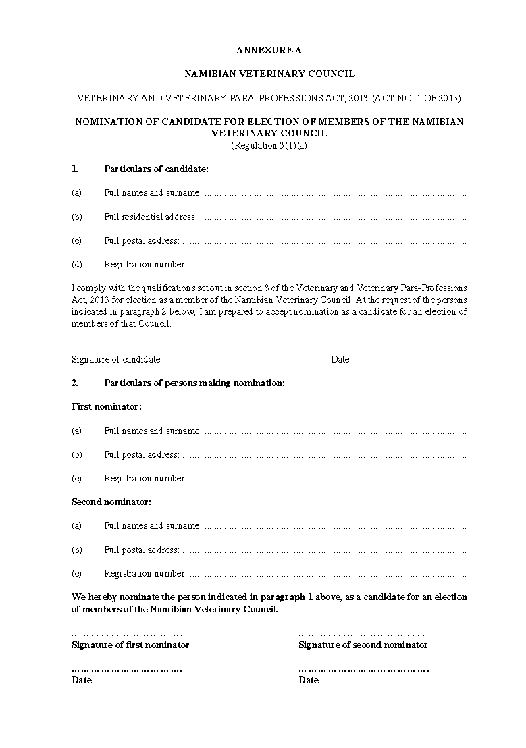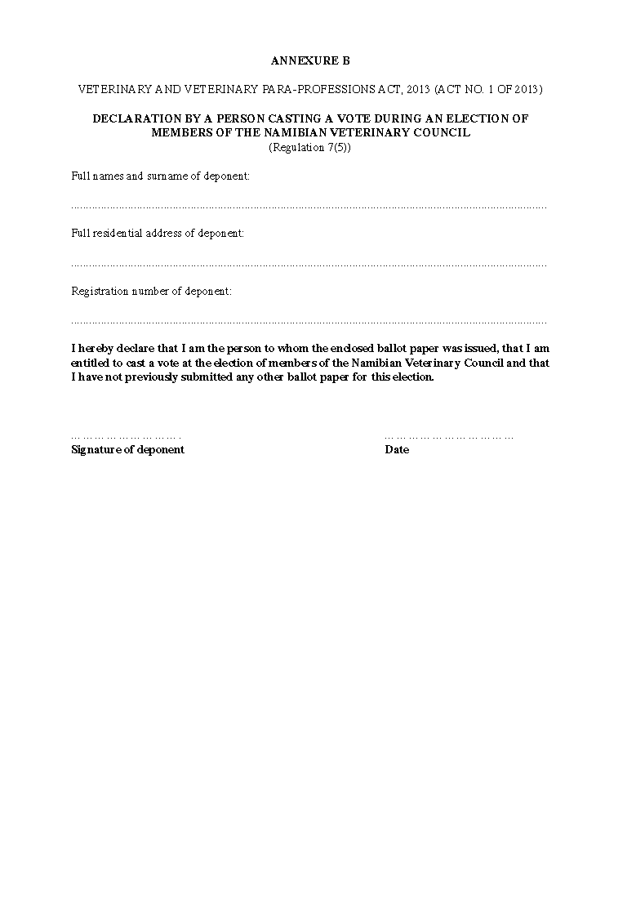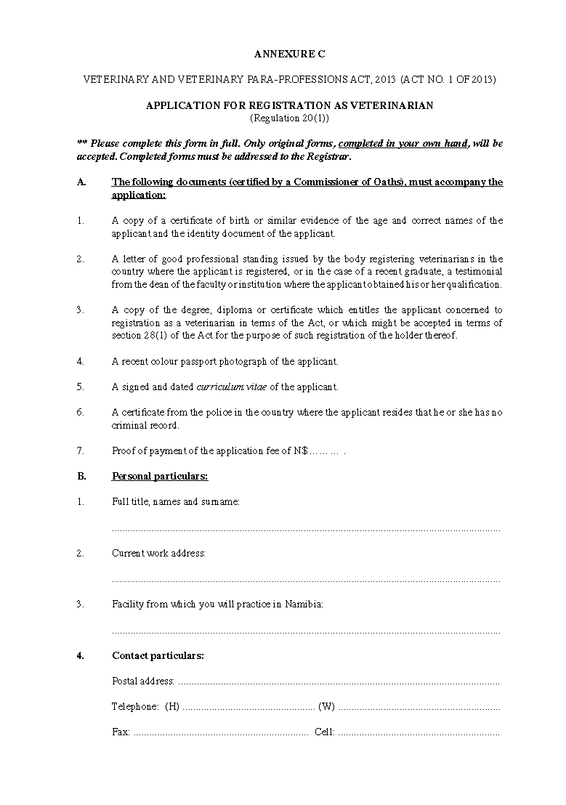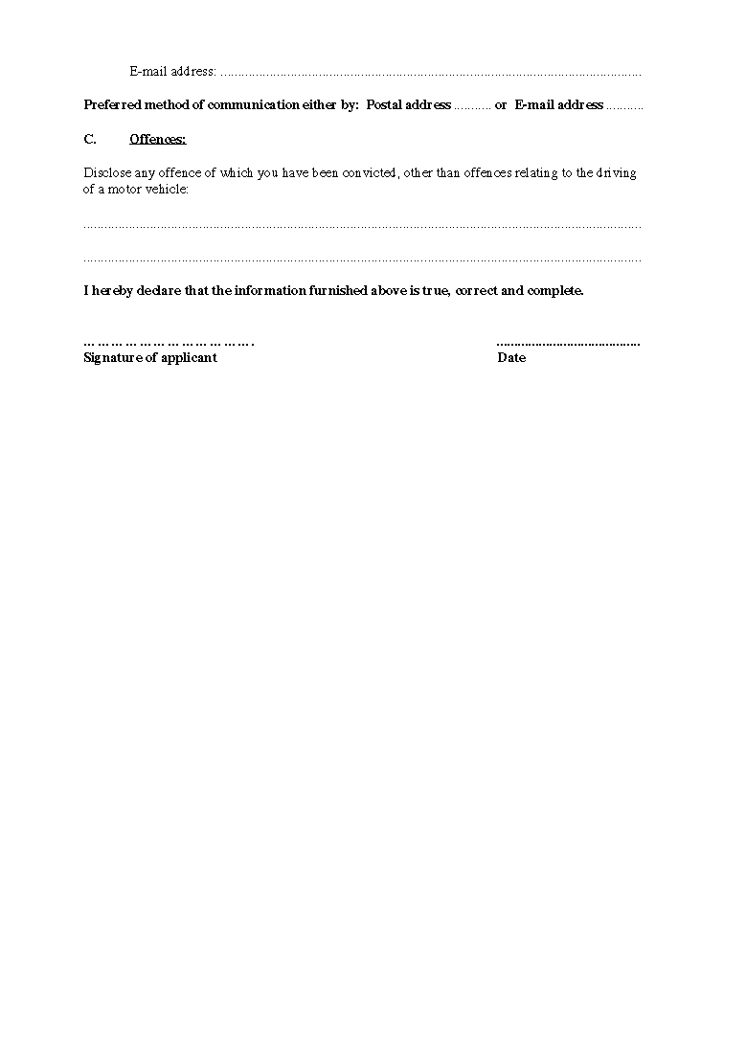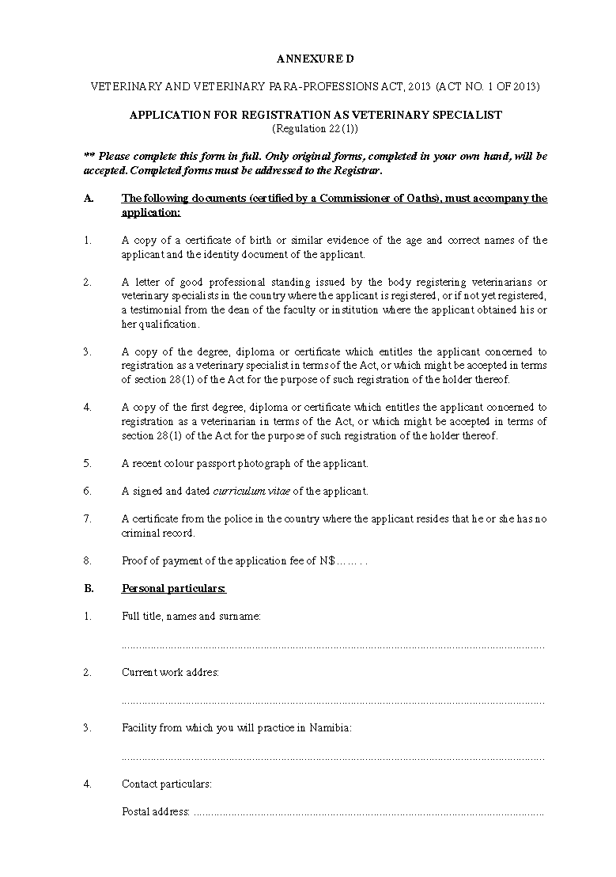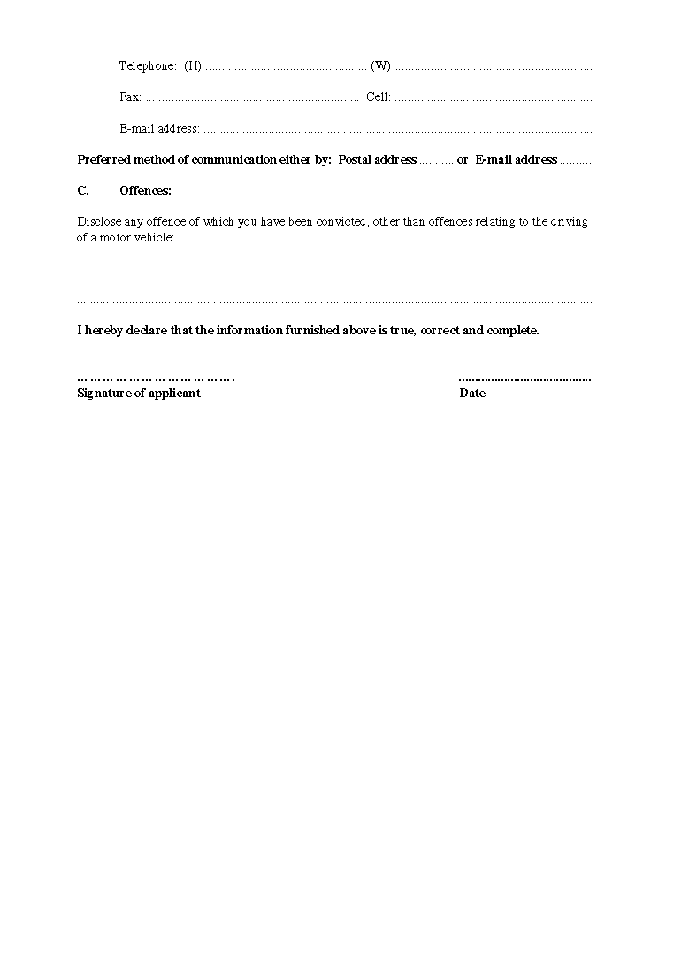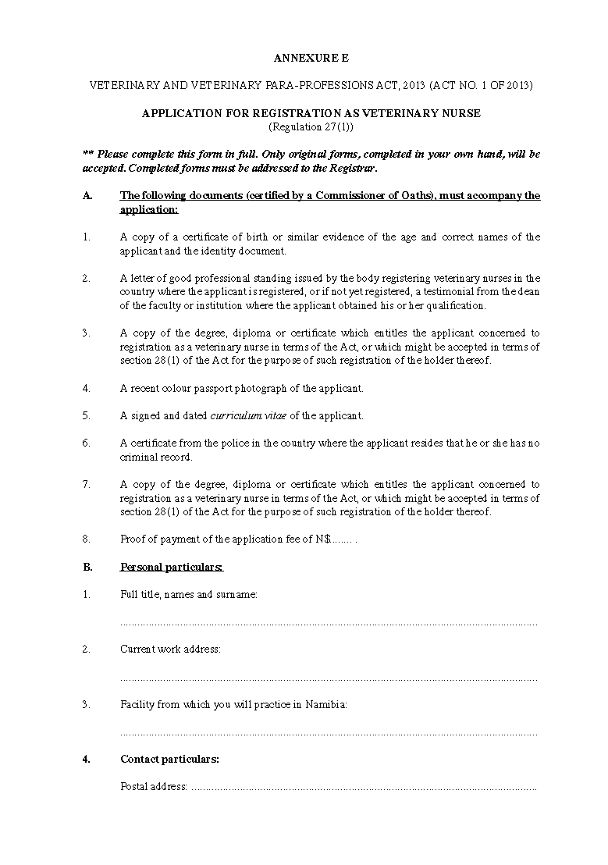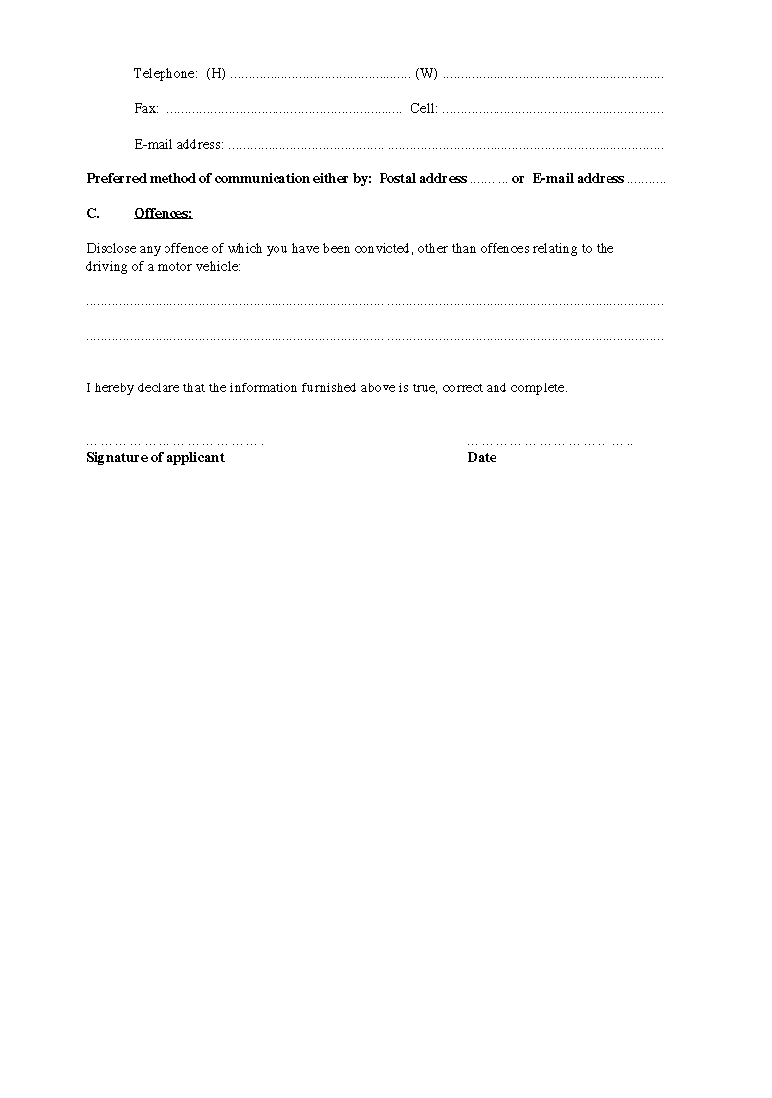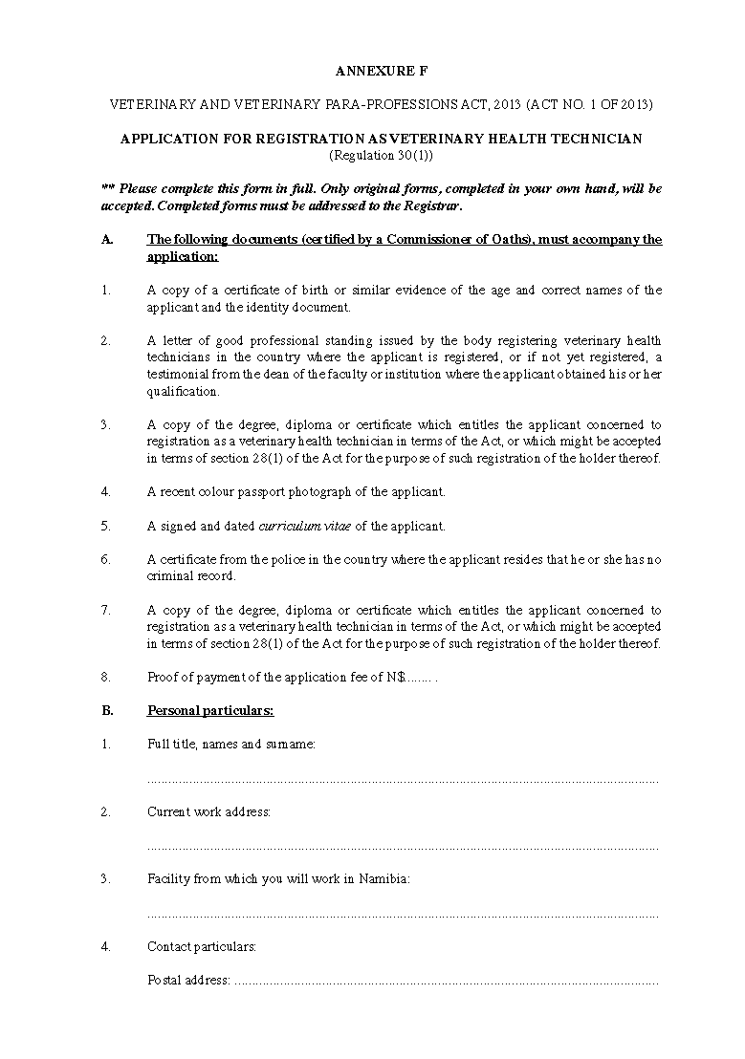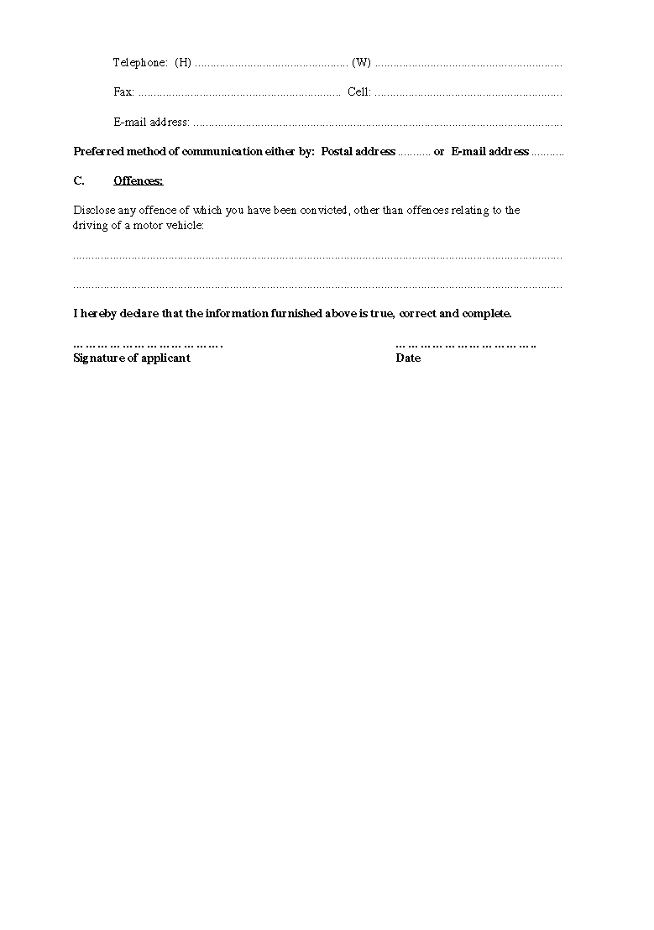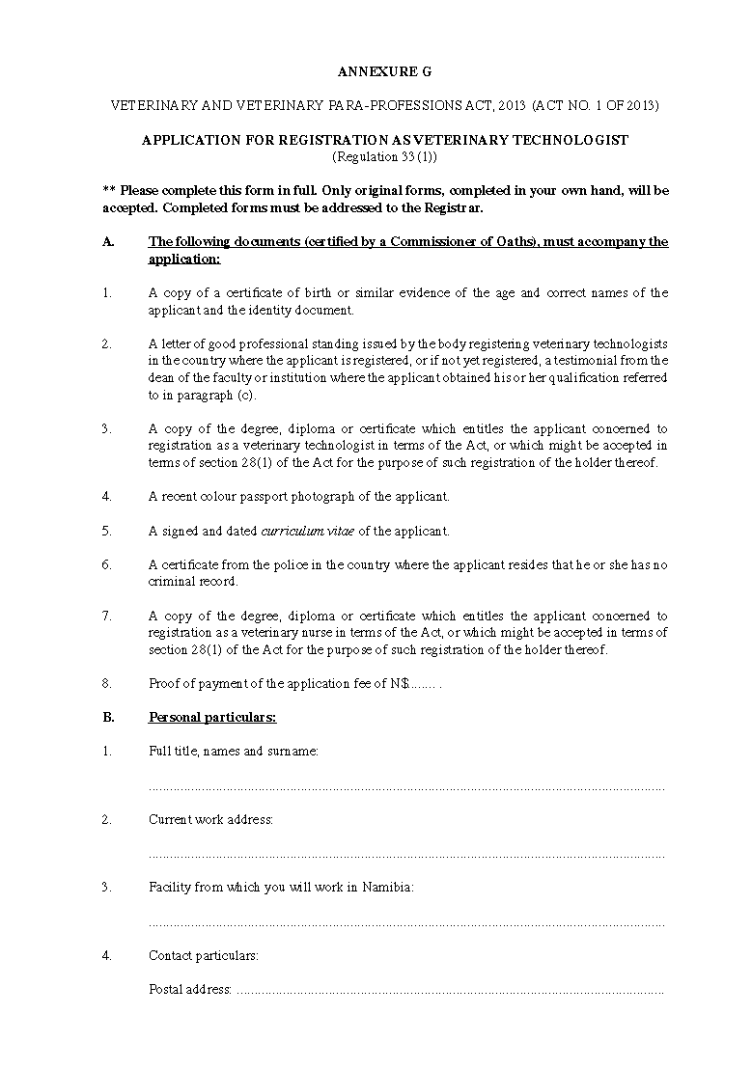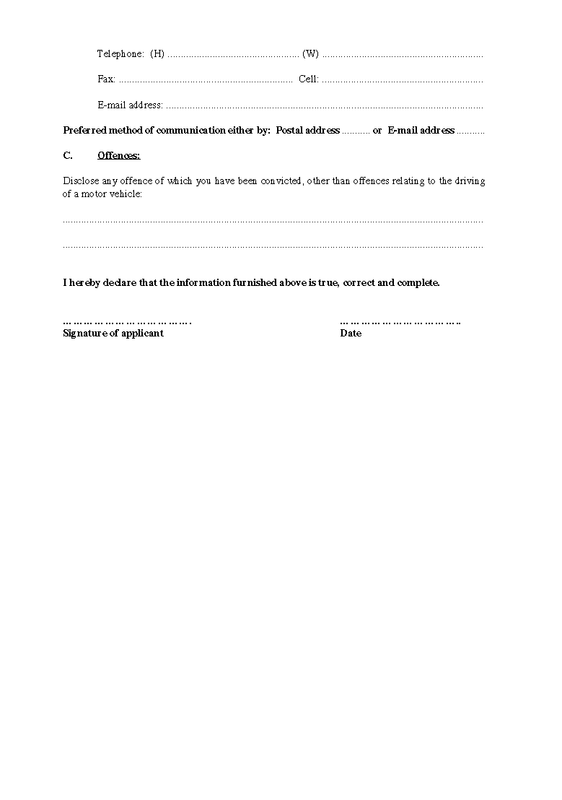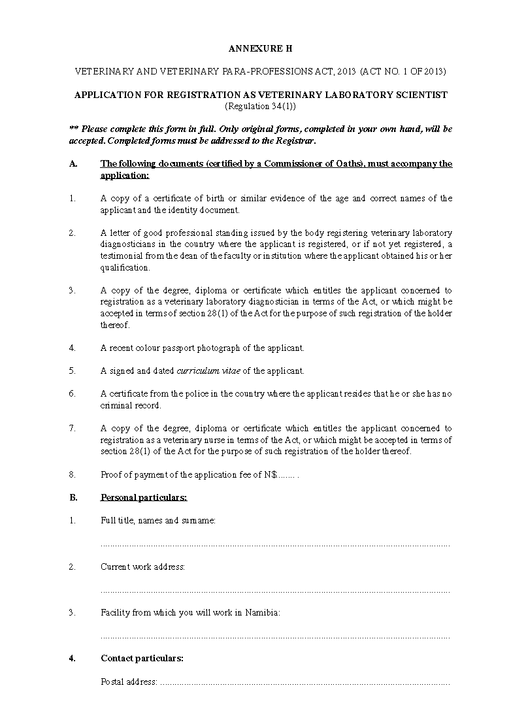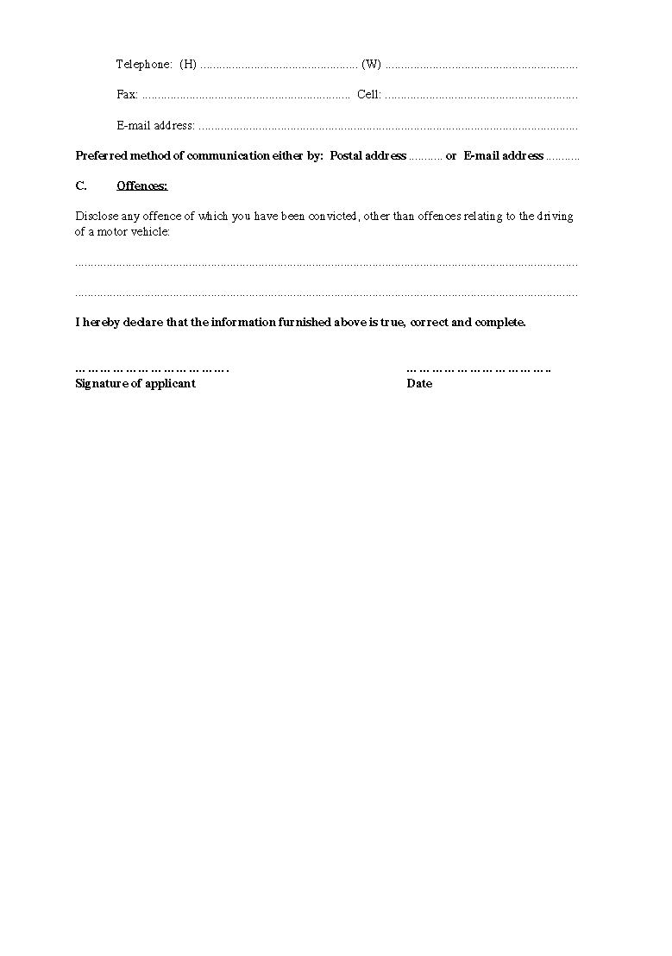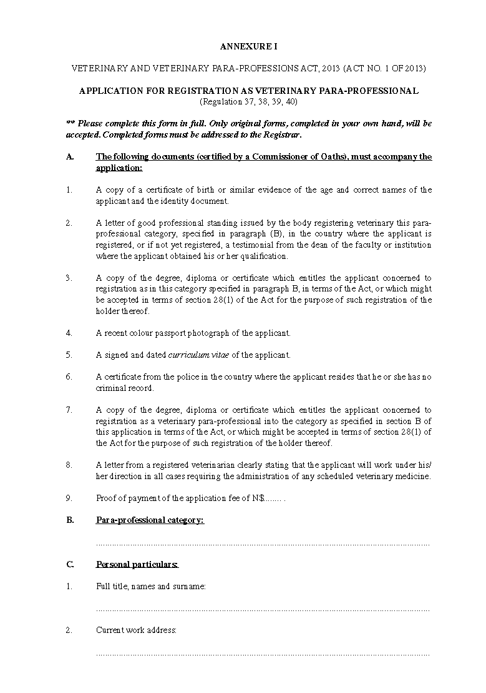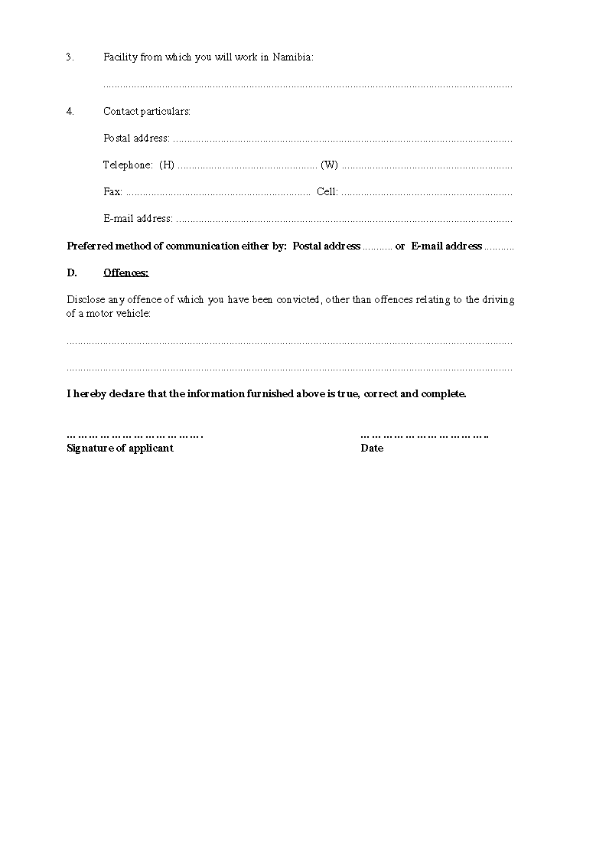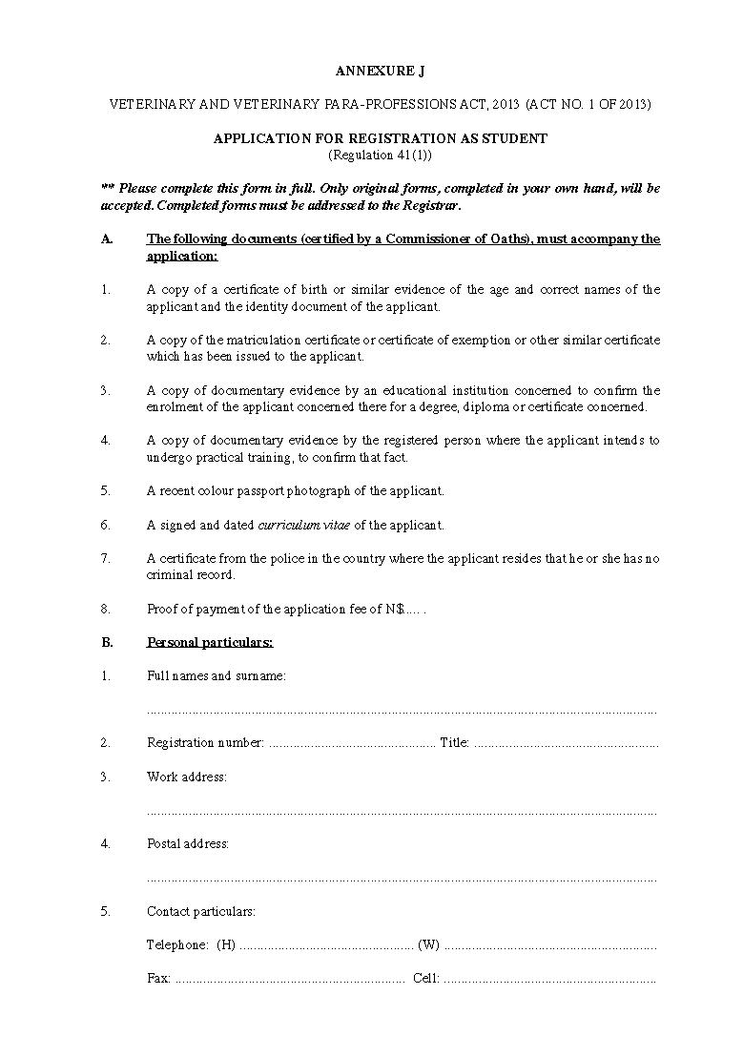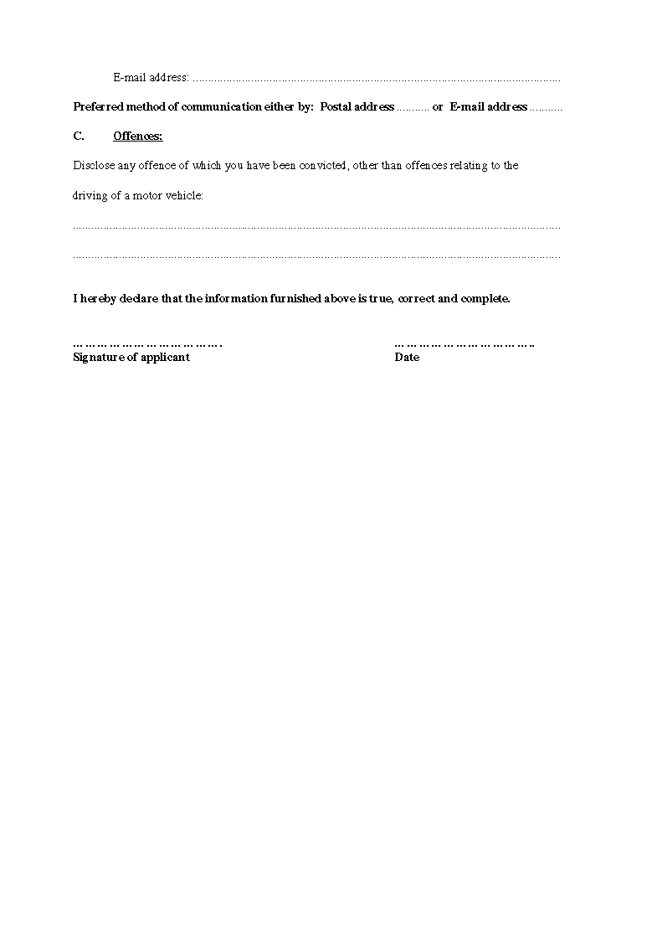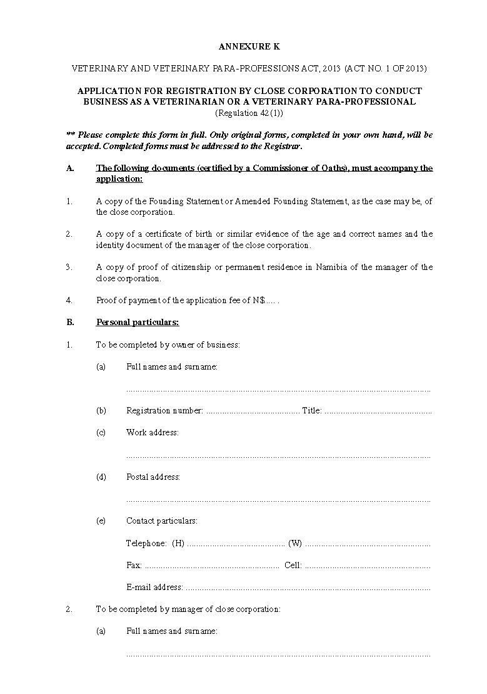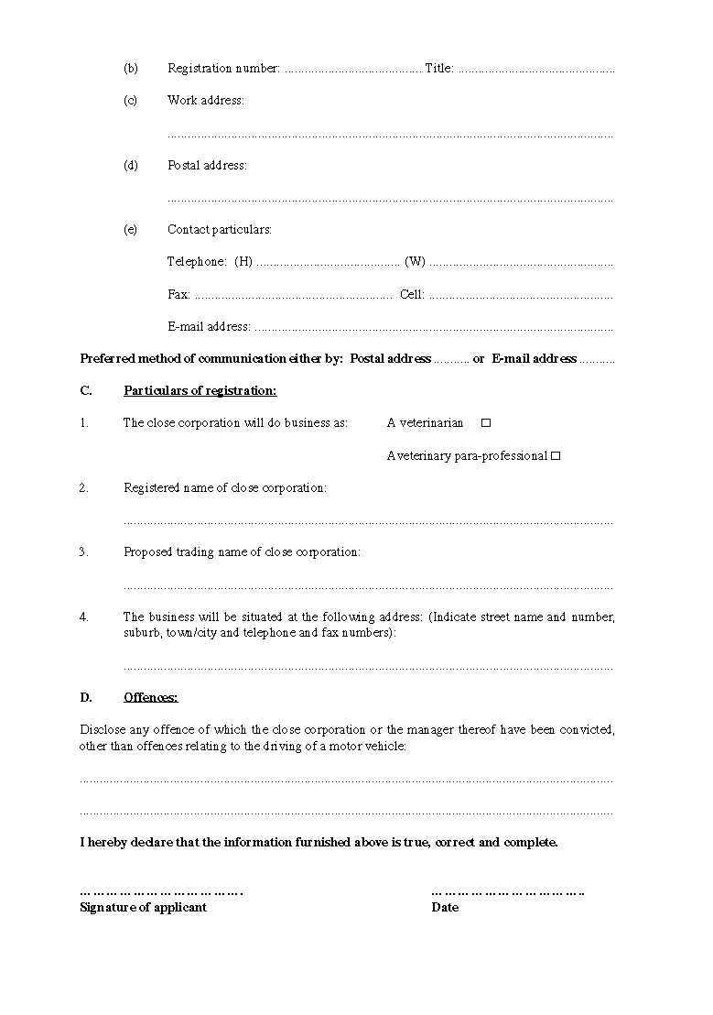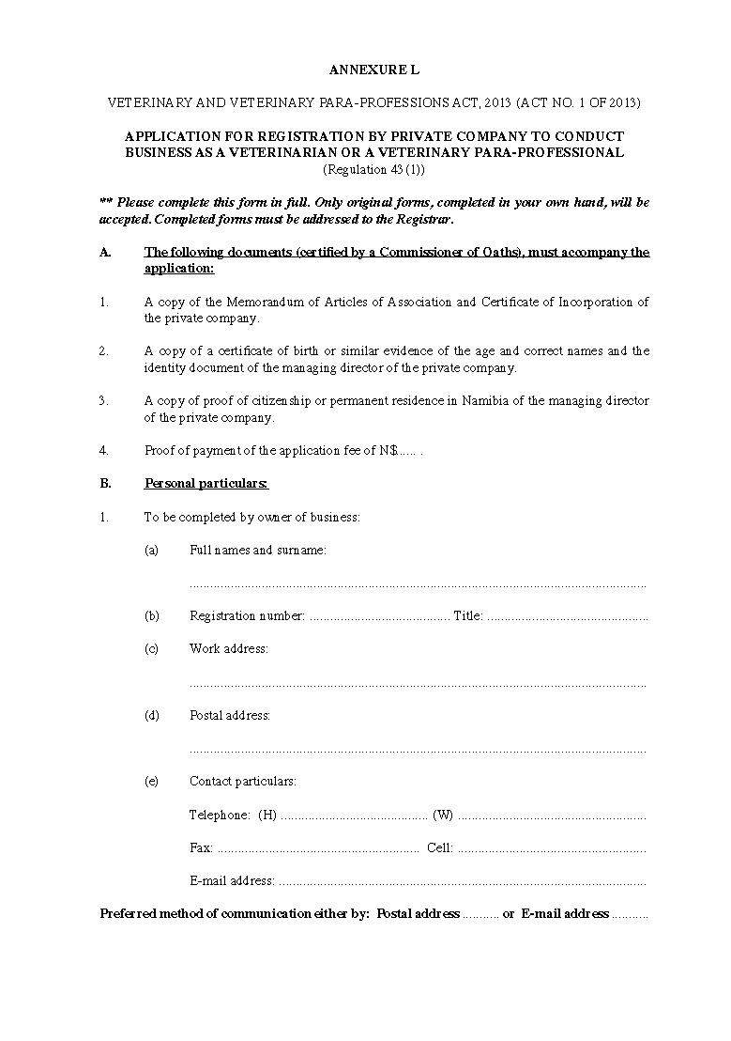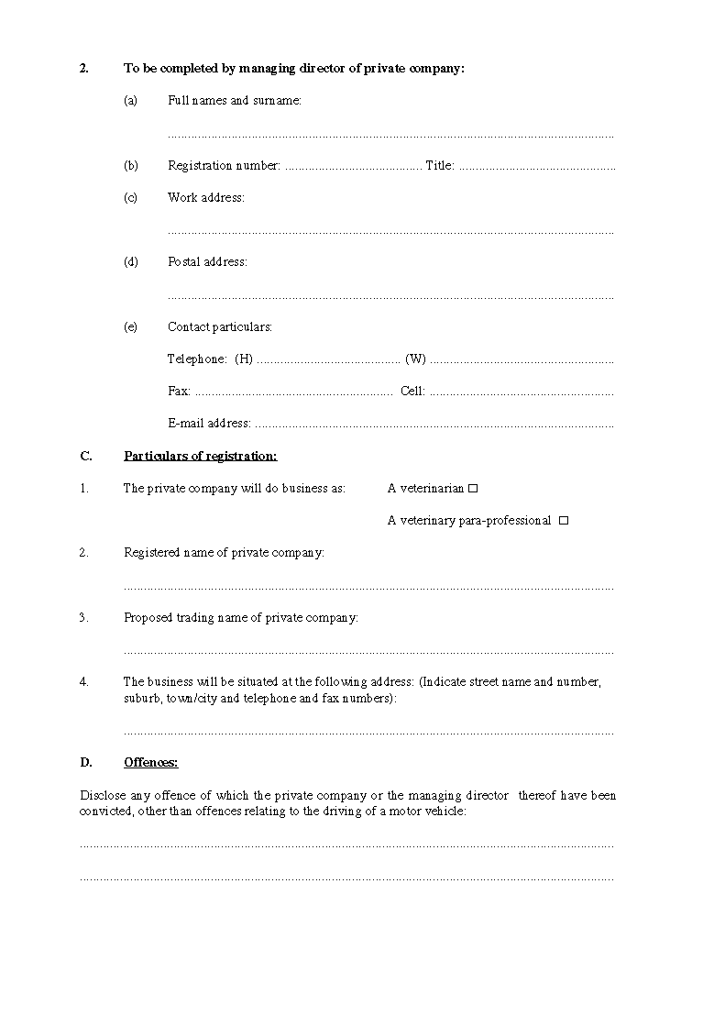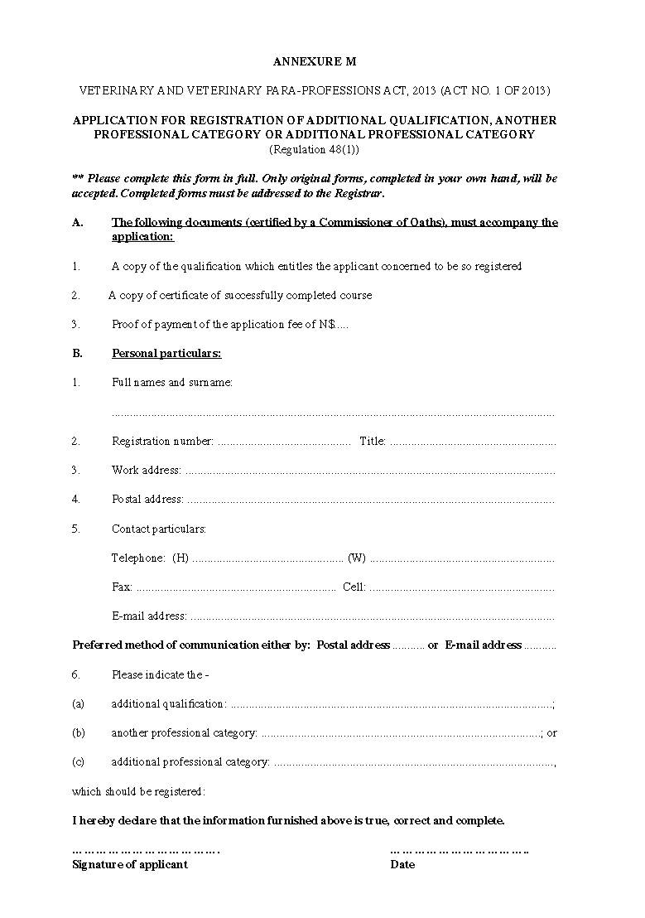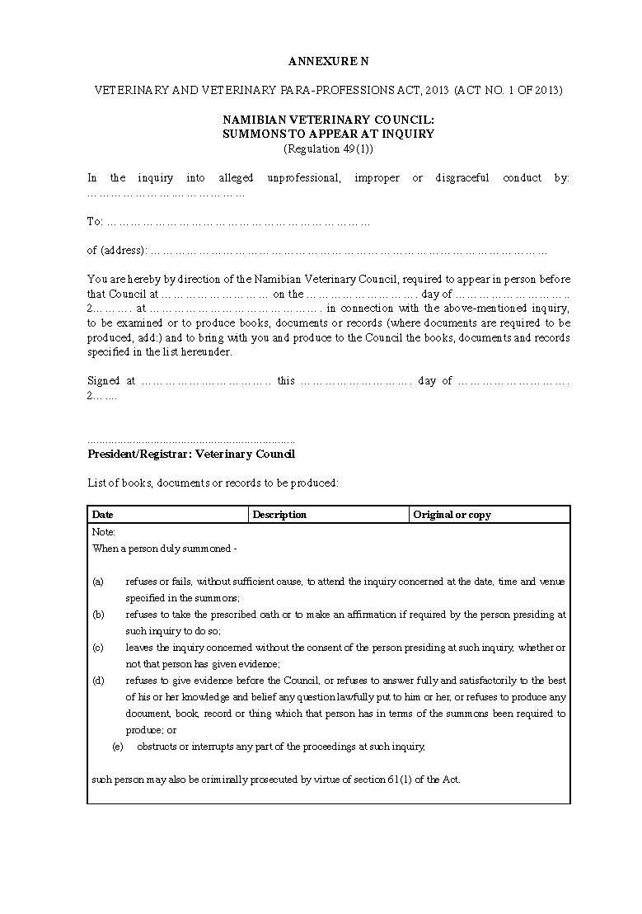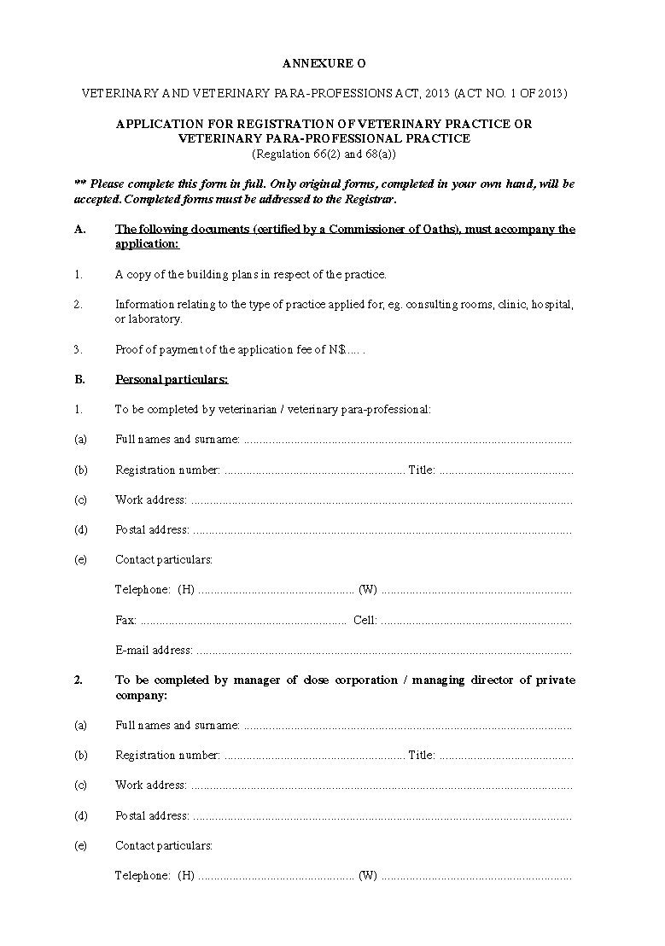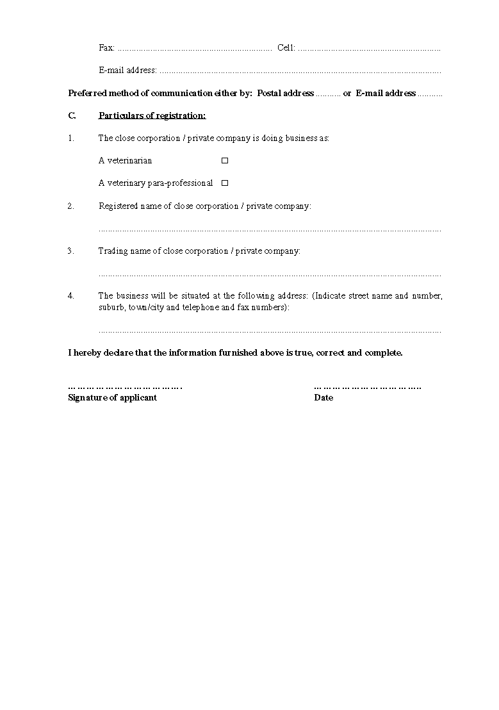

[Table 1 is substituted by GN 249/2015.
This Government Notice erroneously states that it is amending
“section 18(1)” of the regulations. Table 1 pertains to regulation 18(1).
Table 1 is again substituted by GN 97/2020.]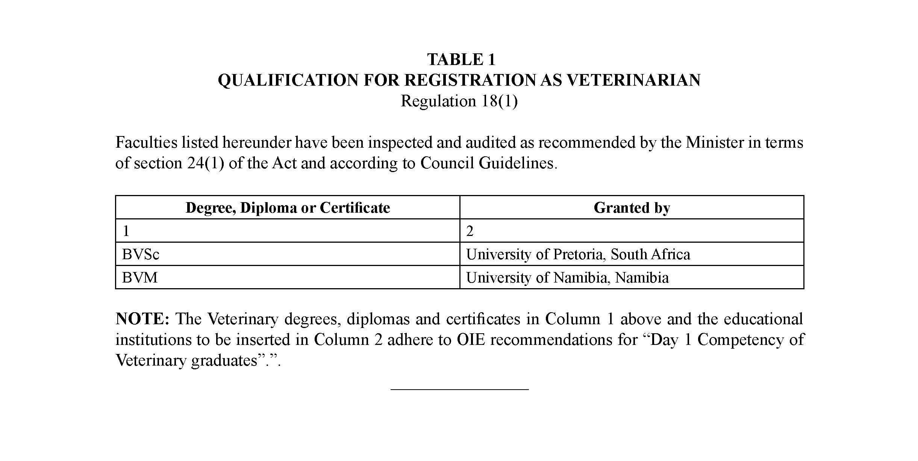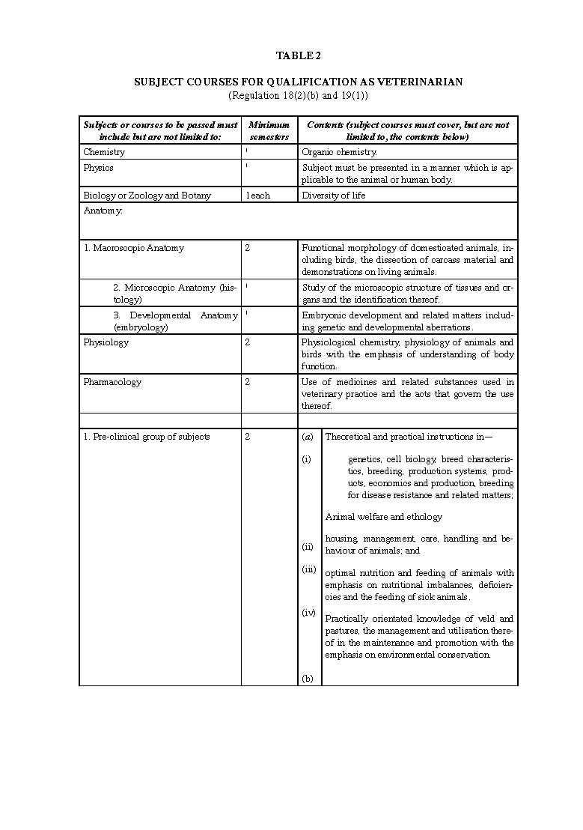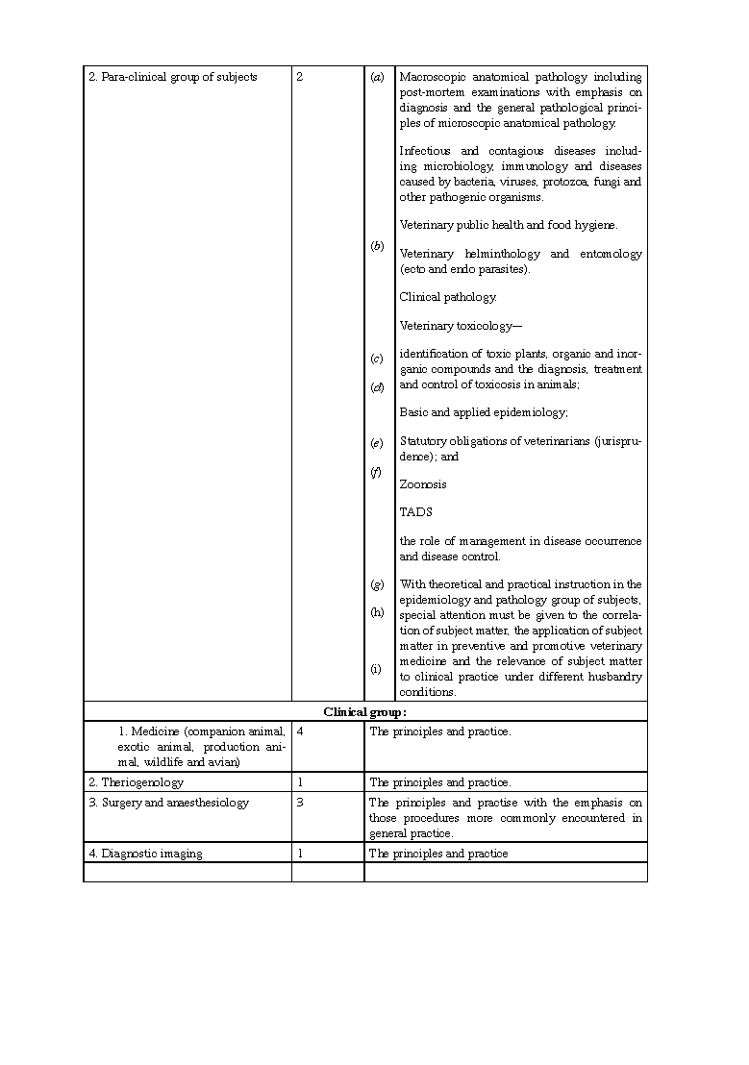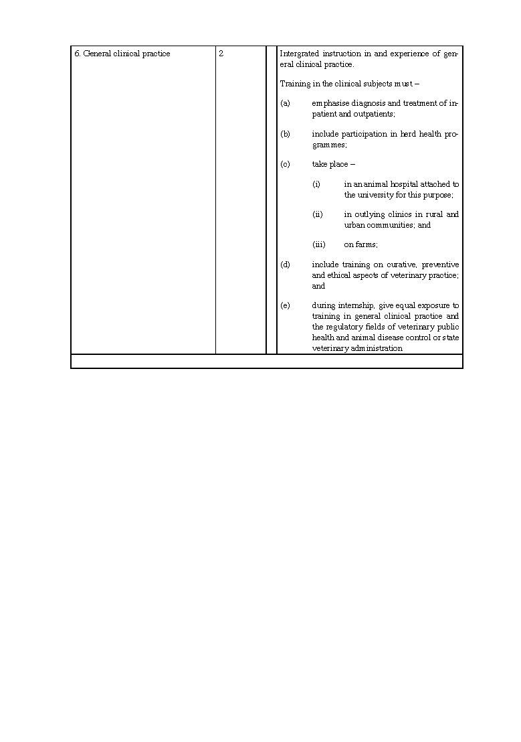

[Table 3 is substituted by GN 269/2016, GN 54/2018 and GN 57/2022.]

