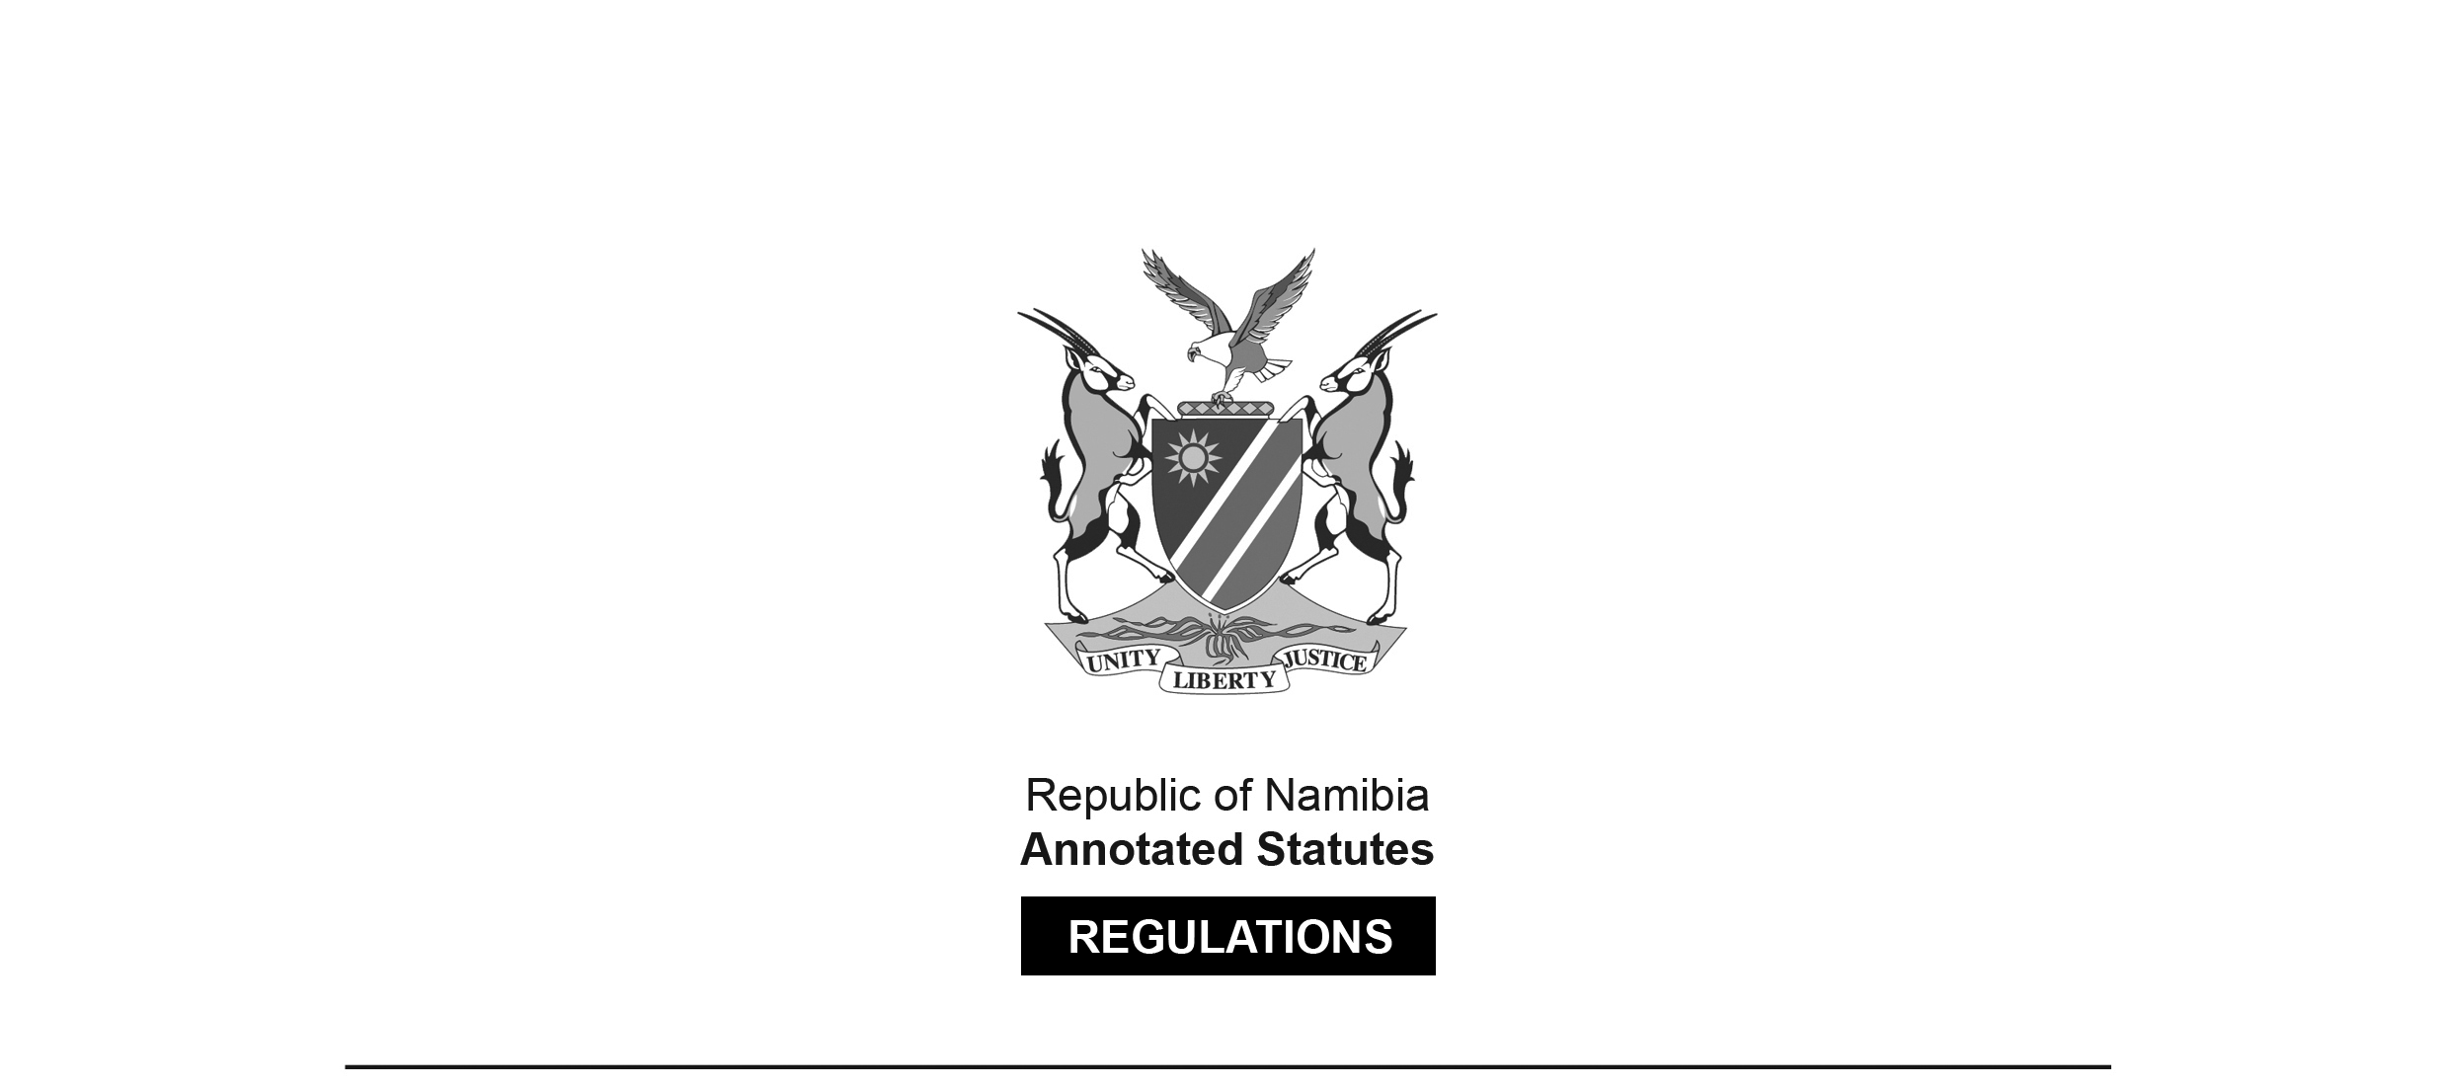

REGULATIONS MADE IN TERMS OF

Tobacco Products Control Act 1 of 2010

section 37(1)

General Regulations

Government Notice 35 of 2014

(GG 5430)

came into force on date of publication: 27 March 2014,   
with certain exceptions (Regulation 17)

Regulations 2, 3, 4, 10 and 12 came into force 12 months from the date of   
commencement of the Act (1 April 2014) in the case of wholesalers of tobacco products

Regulations 2, 3, 4, 10 and 12 came into force 18 months from the date of   
commencement of the Act (1 April 2014) in the case of retailers of tobacco products.

Regulations 5, 6, 7, 8, 9, and 15 came into force three months   
from the date of commencement of the Act (1 April 2014).

**ARRANGEMENT OF REGULATIONS**

Regulation

1. Definitions

2. Pictures, warnings and statements

3. Print and appearance of pictures, warnings and statements

4. Pictures, warnings and statements not to be removable

5. Signs indicating availability of tobacco products

6. Signs at point of sale to contain warning and size thereof

7. Availability of tobacco products to persons under age of 18 years

8. Signs indicating prohibition of smoking of tobacco products

9. Duties and responsibilities of owners or persons in charge of places or areas referred to in section 22(1)

10. Packaging of tobacco products

11. Existing contracts, undertakings or agreements

12. Measures to prevent illicit trade in tobacco products

13. Maximum tar and nicotine yield of cigarettes

14. Determination of amount of tar and nicotine in smoke of cigarette

15. Distance of smoking of tobacco products from public place

16. Offences and penalties

17. Postponement of commencement of certain regulations

Annexure 1

Annexure 2

Annexure 2

**Definitions**

**1.** In these regulations any word or expression to which a meaning has been given in the Act bears that meaning and unless the context otherwise indicates “the Act” means the Tobacco Products Control Act, 2010 (Act No. 1 of 2010).

**Pictures, warnings and statements**

**2.** (1) Every package in which a tobacco product is sold on retail basis must as closely as possible resemble the design set out in Annexure 1 and must contain the information specified in this regulation.

(2) A package referred to in subregulation (1) must reflect -

(a) one picture set out in Annexure 2, with one of the warnings set out in that Annexure printed thereunder; and

(b) the statement “This product contains nicotine, tar and other harmful chemicals”.

(3) A picture and a warning referred to in subregulation (2) must -

(a) be positioned in the manner; and

(b) fill the area on the package, as described in Annexure 1.

(4) A package referred to in subregulation (1) may not bear or display any wording such as “mild”, “low tar” or “light”, or any other word, term or sign that directly or indirectly creates an impression that a particular tobacco product or brand is less harmful than others.

**Print and appearance of pictures, warnings and statements**

**3.** (1) A warning referred to in regulation 2(1)(a) to be reflected on a package in terms of that regulation must be -

(a) in the official language of Namibia;

(b) in Helvetica type;

(c) in black, red or blue print on a white background;

(d) in upper-case lettering;

(e) centred within the area in which it is displayed and the text of the message must occupy not less than 60% and not more than 70% of the area in which it is displayed;

(f) surrounded by a border that -

(i) is the same colour as the print used for the text of the warning; and

(ii) outlines the area in which the warning is displayed without encroaching on that area.

(2) A picture and a warning must be rotated as equal as possible across all tobacco products and different brands and in any case on every successive 50 packages of each brand of the product and must be randomly distributed in all areas within Namibia.

(3) The area to be occupied by the warnings referred to in subregulation (1) and by the statement referred to in regulation 2(1)(b) may not contain any matter other than that required by these regulations.

**Pictures, warnings and statements not to be removable**

**4.** The pictures, warnings and statements to be reflected on a package in terms of regulation 2 must be of such a nature that it cannot be -

(a) removed from the package; and

(b) destroyed or become unreadable when the package is opened in any normal way.

**Signs indicating availability of tobacco products**

**5.** A retailer of tobacco products may indicate the availability of tobacco products and the price thereof only by means of a sign at the point of sale that -

(a) is placed on the shelf or portion thereof where tobacco products are stacked;

(b) bears only the name of the product and its retail cost; and

(c) is in a colouring similar to the rest of the pricing labels of all other products in that retail outlet.

**Signs at point of sale to contain warning and size thereof**

**6.** (1) A sign that indicates the availability of tobacco products and their price -

(a) must contain a warning set out in Annexure 2 in letters that are at least 2 cm in height and 1.5 cm in width; and

(b) may not exceed one square metre in size.

(2) The warning referred to in subregulation (1)(a) must appear at the top of the sign and across its full width.

**Availability of tobacco products to persons under age of 18 years**

**7.** (1) Pursuant to section 18(2) and 18(3) of the Act a retailer of tobacco products must display prominently at the point of sale a sign which -

(a) bears the wording “We cannot, by law, sell tobacco products to anyone under the age of 18 years”; and

(b) is of a size not less than 210 millimetres by 297 millimetres (“A4 size”).

(2) The letters of the wording referred to in subregulation (1) must -

(a) be at least 2 cm in height and 1.5 cm in width; and

(b) be in red coloured Helvetica font on a white background.

**Signs indicating prohibition of smoking of tobacco products**

**8.** (1) The owner of or person in charge of a place or an area contemplated in section 22(1) of the Act must prominently at every entrance to such place or area display a sign which -

(a) bears the wording “Smoking of Tobacco Products Prohibited”; and

(b) is of a size not less than 210 millimetres by 297 millimetres (“A4 size”).

(2) The letters of the wording referred to in subregulation (1) must -

(a) be at least 2 cm in height and 1.5 cm in width; and

(b) be in red coloured Helvetica font on a white background.

**Duties and responsibilities of owners or persons in charge of places or areas referred to in section 22(1)**

**9.** In addition to regulation 8, the owner of or person in charge of a place or an area contemplated in section 22(1) -

(a) must next to or underneath every sign referred to in regulation 8(1) prominently display the provisions of sections 22 and 29 of the Act, as close as possible to the form and size which it has been printed in the *Gazette*;

(b) must next to or underneath every sign referred to in paragraph (a) prominently display -

(i) one picture set out in Annexure 2; and

(ii) one of the warnings set out in Annexure 2 printed thereunder;

(c) may not allow smoking in any form in the place or area concerned;

(d) must point out to persons who smoke in the place or area concerned that smoking is prohibited;

(e) must, if a person to whom it has been pointed out that smoking is prohibited in the place or area concerned does not refrain from smoking, lay a complaint against such person;

(f) must provide supportive training to his or her employees on how to deal with clients that smoke in the place or area concerned; and

(g) must guide clients on how to lodge complaints if there has been a contravention of the Act in respect of the place or area concerned.

**Packaging of tobacco products**

**10.** Tobacco products in the form of -

(a) cigarettes must be sold in a package containing at least 20 cigarettes, but single sticks of cigarettes may be sold if they are in a package which reflects the warning referred to in regulation 2(1)(a) and the statements referred to in regulation 2(1)(b);

(b) loose tobacco intended to be smoked or other tobacco products which are not intended to be smoked, must be in a package containing at least 12.5g.

**Existing contracts, undertakings or agreements**

**11.** (1) Existing contracts, undertakings or agreements for or in relation to -

(a) the advertising of tobacco products, if any; and

(b) the organisation, sponsorship or promotion of any organised activity, if any, in Namibia by any manufacturer, importer, distributor or retailer of any tobacco product,

which existed and were binding on the date of coming into operation of the Act may, subject to subregulation (2), continue for a period not exceeding six months from that date.

(2) The parties to any contract, undertaking or agreement referred to in subregulation (1) must, within one month of the date of coming into operation of the Act, submit to the Permanent Secretary -

(a) a certified copy of the contract, undertaking or agreement; or

(b) if the contract, undertaking or agreement is not in writing, sworn statements, by both parties, to the effect that they have entered into a contract, undertaking or agreement, and setting out the terms of the contract, undertaking or agreement.

**Measures to prevent illicit trade in tobacco products**

**12.** (1) A person may not sell or import for sale any tobacco products unless the package -

(a) bears the statements -

(i) “Sales only allowed in Namibia”; and

(ii) “Manufactured in ‘name of country’”, indicating the country of origin of the product,

in Helvetica typeface in upper-case letters;

(b) bears the statements in paragraph (a)(i) and (ii) above -

(i) in black letters on a white background; and

(ii) appearing on either of the side panels of the package and occupying at least 60% of the display area; and

(c) complies with regulations 2, 3 and 4.

(2) Tobacco products in transit through Namibia must

(a) have on the package concerned printed information relating to -

(i) the shipment route and date;

(ii) the shipment destination;

(iii) the final destination for sale referred to in section 17(1) of the Act;

(iv) the point of departure and consignee; and

(v) a batch or serial number; and

(b) be accompanied by a consignment note or other similar document containing the information referred to in paragraphs (a).

**Maximum tar and nicotine yield of cigarettes**

**13.** The tar yield of cigarettes marketed in Namibia may not be greater than 12 mg per cigarette and the nicotine yield not greater than 1.2 mg per cigarette.

**Determination of amount of tar and nicotine in smoke of cigarette**

**14.** The amount of tar and nicotine in the smoke of a cigarette is determined in accordance with Annexure 3.

**Distance of smoking of tobacco products from public place**

**15.** Pursuant to section 22(1)(b) of the Act a person may not smoke a tobacco product within a distance of two metres from -

(a) a window of;

(b) a ventilation inlet of;

(c) a doorway to; or

(d) the entrance into, a public place.

**Offences and penalties**

**16.** Any person who contravenes or fails to comply with regulation 2, 3, 4, 5, 6, 7, 8, 9, 10, 11(2), 12, 13 or 15 commits an offence and is liable on conviction to a fine not exceeding N$4000 or to imprisonment for a period not exceeding one year or to both such fine and such imprisonment.

**Postponement of commencement of certain regulations**

**17.** Regulations -

(a) 2, 3, 4, 10 and 12 come into operation -

(i) in the case of wholesalers of tobacco products, on a date 12 months from the date of commencement of the Act; and

(ii) in the case of retailers of tobacco products, on a date 18 months from the date of commencement of the Act;

(b) 5, 6, 7, 8, 9 and 15 come into operation on a date three months from the date of commencement of the Act.

ANNEXURES

To view content without printing, scroll down.

To print at full scale (A4), double-click the icon below.



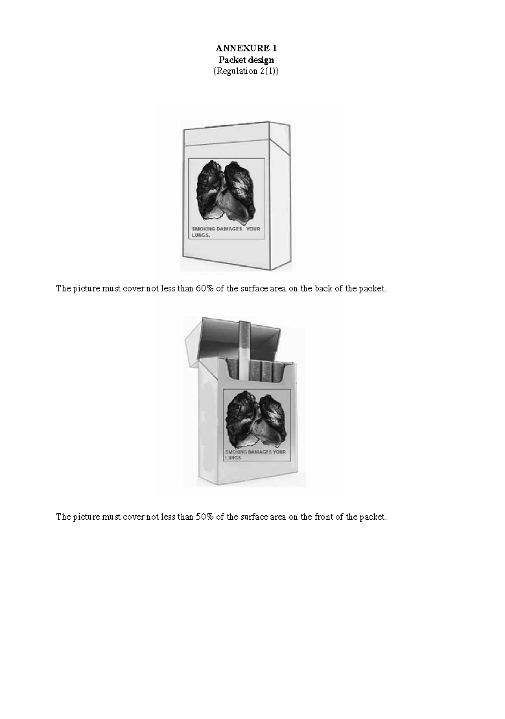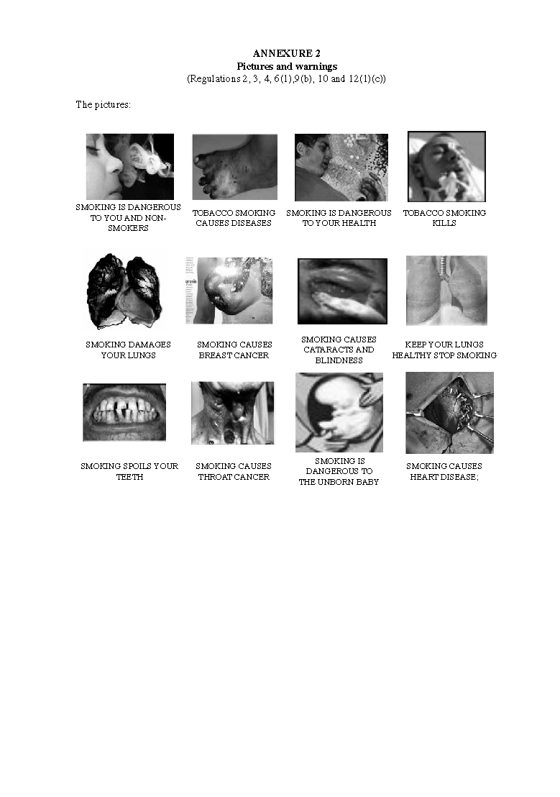

ANNEXURE 3

**Determination of amount of tar and nicotine in smoke of cigarette**

(Regulation 14)

1. The amount of tar and nicotine in the smoke of a cigarette must, for the purposes of this Annexure, be determined in accordance with the International Standards Organisation’s methods ISO 4387, 3308, 7210, 3402, 8243, 10315, 3400, 10362-1, 10362-2, 2971, 6488 and 6565, as amended from time to time.

2. The tests will be carried out at a laboratory nominated by the Tobacco Products Control Committee as mandated by the Minister, but in all respects at the expense of the manufacturer or importer.