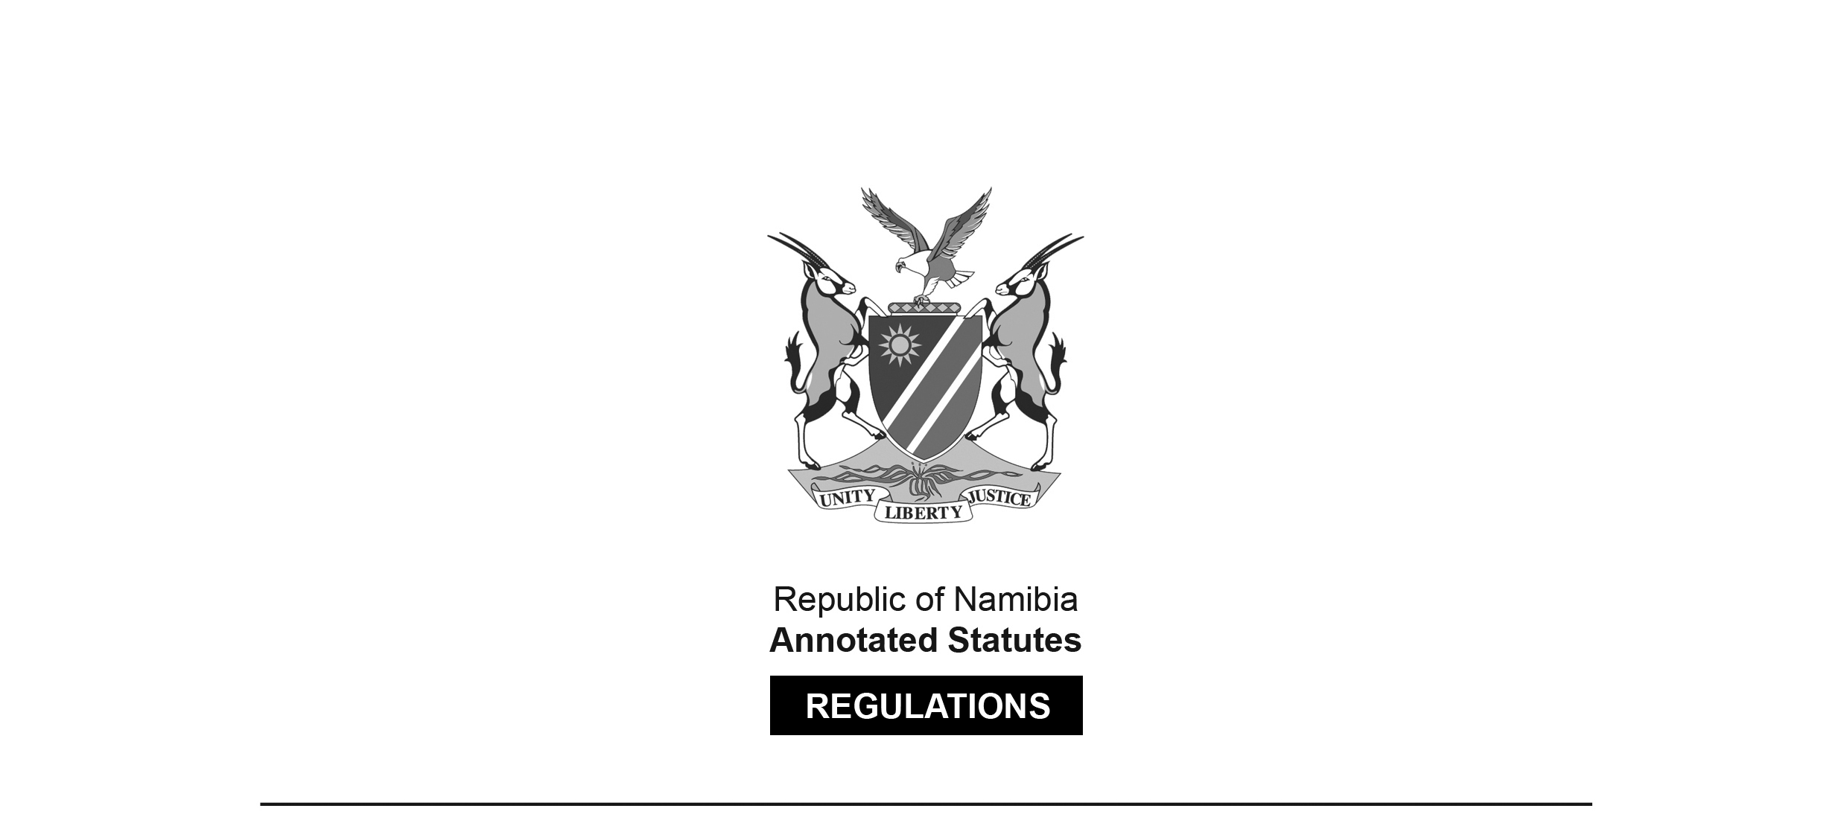

REGULATIONS MADE IN TERMS OF

Standards Act 18 of 2005

section 34(1)(a)

Cement Regulations

Government Notice 45 of 2020

(GG 7125)

came into effect on 12 May 2020 (GN 45/2020)

The Government Notice containing these regulations   
repeals the regulations published under GN 259/2019 (GG 6993).

The Government Notice which publishes these regulations notes that   
they were made after consultation with the Namibian Standards Institution, and that compliance with the regulations has been made compulsory in terms of section 20(6) of the Standards Act, which states: “Compliance with a Namibian standard set, established and issued by the NSI under   
this section is not compulsory, but compliance with such a standard may be   
declared compulsory by the Minister by regulation.”

ARRANGEMENT OF REGULATIONS

1. Definitions

2. Purpose of regulations

3. Requirements for cement

4. Requirements for registration of manufacturing facility

5. Cement manufacturer in Namibia

6. Cement manufacturer outside Namibia

7. Modification of requirements

8. Mutual recognition agreement

9. Surveillance

10. Mark of conformity

Annexure 1: Markings that must appear on packing

[Annexure 1 is actually named “Markings that must appear on packaging”.]

Annexure 2: Application process

Annexure 3: Application process under mutual recognition agreement

**Definitions**

**1.** In these regulations, a word or an expression to which a meaning has been given in the Act has that meaning, and unless context otherwise indicates -

[The word “the” appears to have been omitted before the word “context”.]

“applicant” means a manufacturer or an importer who applies for the registration of a manufacturing facility under these regulations;

“cement” means a hydraulic binder used for construction purposes as described in NAMS/EN 197-1;

“certification body” means a body that is recognised or appointed in a foreign country, that assesses the manufacturer or the importer, and the conformity of cement in accordance with the standards provided for in these regulations;

“certificate of conformity” means a document issued by the NSI attesting that the quality or safety of the products conforms to the requirements of NAMS/EN 197-1;

“common cement” means any one of the 27 types of cement listed in Table 1 of NAMS/EN 197-1;

“importer” means a person who imports cement into Namibia;

“intermediary” means a person who takes from the manufacturer or the importer, certified cement bearing the conformity mark and, takes full responsibility for maintaining, in a cement handling facility, all aspects of the quality of the cement and who supplies the cement onwards to another person;

[The comma after the word “and” is superfluous.]

“licence” means an authorisation given to a foreign cement manufacturer by the NSI to import cement products into Namibia;

“manufacturer” means an entity, including a factory that produces, blends or packages cement;

“mutual recognition agreement” means an agreement under which two or more countries or conformity assessment bodies agree to recognise one another’s conformity assessments procedures and results;

[The last phrase should be either “conformity assessments, procedures and results” (three different things) or “conformity assessment procedures and results” (two different things).   
The context suggests that the latter option was intended.]

“NAMS/EN 197-1” means the latest edition of the Namibian Standard titled ‘Cement - Part 1: Composition, Specification and Conformity Criteria for Common Cements’, issued by the NSI;

“NAMS/EN 197-2” means the latest edition of the Namibian Standard titled ‘Cement - Part 2: Conformity Evaluation’, issued by the NSI;

“prescribed fee” means the relevant fee payable by the applicant to NSI for service rendered or to be rendered in accordance with these regulations, and such fee is set out in the Rules Relating to Fees for Services Rendered by the Namibian Standards Institution published in General Notice No. 190 of 22 May 2018;

[The rules referred to are contained in *Government Gazette* 6599.]

“regulator” means the NSI, which is the institution that has the authority to monitor the cement industry in Namibia for the purpose of ensuring compliance with these regulations;

“standard” means a document approved by the NSI or a body recognised in another country, which provides for common and repeated use, rules, guidelines or characteristics for products or related processes and production methods, with which compliance is not mandatory and for the purpose of these regulations, a standard includes the NAMS/EN 197-1 and NAMS/EN 197-2;

“sulfate resisting common cement” means one of the seven products in the family of sulfate resisting common cements listed in Table 2 of NAMS/EN 197-1;

“the Act” means the Standards Act, 2005 (Act No. 18 of 2005); and

“trade” includes to sell, distribute, exchange or otherwise deal in cement in return for anything of value.

**Purpose of regulations**

**2.** The purpose of these regulations is to -

(a) lay down product characteristics or their related processes and production methods, including the applicable administrative provisions with which compliance is mandatory;

(b) include the terminology, symbols, packaging, marking or labelling requirements as they apply to a product, process or production process; and

(c) compel an importer or intermediary to meet the requirements of an intermediary as defined in Clause 9 of NAMS/EN 197-2 which deals with the requirements for dispatching centres.

**Requirements for cement**

**3.** (1) A person may not trade in cement in Namibia or import cement into Namibia, unless that cement complies with the requirements of NAMS/EN 197-1.

(2) A person who trades in or imports cement that does not comply with the requirements in subregulation (1) commits an offence and on conviction is liable to a fine not exceeding N$5 000 or to imprisonment for a period not exceeding six months, or both such fine and such imprisonment.

(3) A manufacturer or an importer must apply to the regulator, on a form obtainable from the regulator and pay the prescribed fee, for the certification of each cement type and strength class of such cement intended for use in Namibia.

[There should be a comma after the phrase “on a form obtainable   
from the regulator” to offset that phrase properly.]

(4) An application made under subregulation (3) must follow the procedure illustrated in Annexure B of NAMS/EN 197-2.

(5) If the regulator is satisfied that the cement conforms to the requirements of NAMS/ EN 197-1, the regulator must issue a -

(a) certificate of conformity for cement manufactured in Namibia, in terms of Clause 8 of NAMS/EN 197-2, if the requirements of regulation 5(5) are met; or

(b) licence for cement manufactured outside Namibia, if the requirements of regulation 6(5) are met.

(6) The certificate of conformity or licence, issued under subregulation (5), remains effective for three years, as long as the cement continues to conform to the requirements mentioned in that subregulation in any subsequent conformity test.

(7) The regulator may cancel the certificate of conformity or licence, if the cement no longer conforms to the requirements of NAMS/EN 197-1.

(8) The manufacturer or importer must ensure that the cement packaging -

(a) is marked in accordance with the requirements of the latest edition of the SADCMEL Document 1 and Document 4; and

(b) meets all the requirements in Annexure 1.

(9) The manufacturer or importer must take corrective action as stipulated in Clause 4.3.2 of the NAMS/EN 197-2 and immediately report to the regulator any failure to conform to the requirements of these regulations.

(10) A report under subregulation (9) must -

(a) be in written form; and

(b) contain the details of the failure of conformity of whatever nature.

(11) The regulator must be kept informed of any corrective actions and findings the manufacturer or importer takes or finds to address the failure to conform.

(12) A manufacturer or an importer who fails to comply with the requirements of subregulation (8) commits an offence and on conviction is liable to a fine not exceeding N$5 000 or to imprisonment for a period not exceeding six months, or to both such fine and such imprisonment.

**Requirements for registration of manufacturing facility**

**4.** (1) A manufacturer or an importer on behalf of a manufacturer, must apply to the regulator, on a form obtainable from the regulator and pay the prescribed fee, for registration of the manufacturing facility to ensure conformity to the standards set out in the NAMS/EN 197-1 and NAMS/EN 197-2.

[There should be a comma after the phrase “on a form obtainable   
from the regulator” to offset that phrase properly.]

(2) The application referred to in subregulation (1) must include the following -

(a) details of the type and class of cement to be manufactured in the facility for which registration is sought, and the standards to which it conforms;

(b) details of the manufacturing facility for which registration is sought;

(c) a copy of a recent cement test report which must be generated by a laboratory that meets the requirements of the latest edition of the ISO/IEC 17025: International Standard on General Requirements for the Competence of Testing and Calibration Laboratories, and which report must not be older than two months; and

(d) markings and other information to be printed on the package of the cement with a breakdown of any codes indicating the factory or packing plant of origin and the date of packaging, including the requirements of Annexure 1.

(3) On receipt of an application, the regulator must assess such application in terms of regulation 5 or 6.

(4) A manufacturer or an importer who imports or trades in cement that is from a manufacturing facility that is not registered in terms of these regulations commits an offence and on conviction is liable to a fine not exceeding N$5 000 or to imprisonment for a period not exceeding six months, or to both such fine and such imprisonment.

**Cement manufacturer in Namibia**

**5.** (1) If an application made under regulation 4(1) is for a manufacturing facility located in Namibia, the applicant must pay the prescribed fee to inspect the local cement manufacturing facility.

(2) The application referred to in subregulation (1) must follow the process illustrated in Annexure 2.

(3) On receipt of an application, the regulator must assess such application form and conduct an inspection of the manufacturing facility and collect samples of cement from such manufacturing facility.

(4) After considering the application made under regulation 4(1), the regulator may -

(a) approve the application and issue a certificate of conformity for the cement, which is valid for three years, if all the requirements of subregulation (5) are met; or

(b) reject the application and in writing request the applicant to take corrective steps referred to in regulation 3(9).

(5) The regulator may only issue a certificate of conformity, referred to in regulation 3(5)(a) and in subregulation (4)(a), to the applicant if the manufacturing facility meets the requirements of regulation 4(1) and the cement products meet the requirements stipulated in regulation 3.

(6) If the applicant takes corrective action referred to in subregulation (4)(b), and the regulator subsequently approves the application, the regulator may issue a certificate of conformity as stipulated in subregulation (4)(a).

**Cement manufacturer outside Namibia**

**6.** (1) If an application made under regulation 4(1) is for a manufacturing facility located outside Namibia, the applicant must pay the prescribed fee to inspect that cement manufacturing facility.

(2) The application referred to in subregulation (1) must follow the process illustrated in Annexure 2.

(3) On receipt of an application, the regulator must assess such application form and conduct an inspection of the manufacturing facility and collect samples of cement from such manufacturing facility.

(4) After considering the application made under regulation 4(1), the regulator may -

(a) approve the application and issue a licence for the cement, which is valid for three years, if all the requirements of subregulation (5) are met; or

(b) reject the application and in writing request the applicant to take corrective steps referred to in regulation 3(9).

(5) The regulator may only issue a licence, referred to in regulation 3(5)(b) and in subregulation (4)(a), to the applicant if the manufacturing facility meets the requirements of regulation 4(1) and the cement products meet all the requirements stipulated in regulation 3.

(6) If the applicant takes corrective action referred to in subregulation (4)(b), and the regulator subsequently approves the application, the regulator may issue a licence as stipulated in subregulation (4)(a).

(7) The regulator must assign a unique number to each licence in respect of each manufacturer approved.

(8) The licence is the sole proof of registration by the regulator for cement manufactured outside Namibia and is valid for three years.

**Modification of requirements**

**7.** For the purposes of these regulations, the requirements specified under Clause 9.2 and Clause 9.3 of NAMS/EN 197-2 are modified as follows:

(a) an intermediary may only be exempted from meeting the requirements specified in clause 9.2.2 of NAMS/EN 197-2; and

(b) the test results of samples taken from the intermediary must, in addition to any other results required by the standards, represent the ability of the manufacturer to comply with the requirements of Clause 9.3 of NAMS/EN 197-2.

**Mutual recognition agreement**

**8.** (1) If a mutual recognition agreement exists between the regulator and a certification body or regulatory body in the country of origin of cement, the regulator may accept evaluation results of that cement if those standards are equivalent to NAMS/EN 197-1 and the criteria used to perform conformity assessment is equivalent to NAMS/EN 197-2.

[The verb “is” should be “are” to match the plural noun “criteria”.]

(2) The application procedure for importing cement into Namibia where a mutual recognition agreement exists, is illustrated by Annexure 3.

(3) An importer must apply to the regulator using forms obtainable from the regulator and pay the prescribed fee for issuance of the attestation of conformity letter.

(4) On receipt of an application made under subregulation (3) the regulator may issue the attestation letter per consignment to be imported into Namibia and the attestation letter is valid for 21 days.

(5) The regulator may conduct a physical verification of the quantity and cement type imported.

**Surveillance**

**9.** (1) The regulator must collect a minimum of six samples annually of each approved cement either from a depot, at point of entry into Namibia or manufacturing facility in Namibia and test the samples to confirm continuous compliance with the requirements of these regulations.

(2) The regulator must conduct -

(a) on-site surveillance inspections for Namibian or foreign manufacturers in the first and second year of certification or registration; and

(b) a re-certification or re-registration inspection in the third year.

**Mark of conformity**

**10.** (1) The manufacturer must affix an NSI standard mark of conformity for a cement product manufactured in Namibia and registered in terms of these regulations by the regulator on the packaging of the certified cement.

(2) A manufacturer who fails to affix the mark of conformity referred to in subregulation (1) commits an offence and on conviction is liable to a fine not exceeding N$5 000 or to imprisonment for a period not exceeding six months, or both such fine and such imprisonment.

**ANNEXURE 1**

**Markings that must appear on packaging**

**1.** The manufacturer must be guided by NAMS/EN 197-1 and NAMS/EN 197-2 or equivalent for the use of cement in compiling design mixes because guidelines and the information appearing on a bag of cement must not be misleading to the user.

**2.** (1) The information required in subparagraph (2) must be printed, the print must be at least 6mm high, legibly and indelibly on each bag in the English language.

[The sentence structure in subregulation 1 is problematic;

it is reproduced here as it appears in the *Government Gazette*.]

(2) The following information must be attached to or accompany the cement bags:

(a) the manufacturer’s name, trademark and physical address;

(b) identity of the factory, which may be in code, where the cement was produced;

(c) the standard designation in accordance with Clause 8 of NAMS/EN 197-1;

(d) a date or code that provides traceability to the date of packing or dispatch in the case of bulk cement;

(e) the standard under which the cement was manufactured;

(f) manufacturers’ guidelines for the use of the type and grade of cement and precautions to be observed in its use;

(g) NSI Standard Mark of Conformity for cement products produced in Namibia; and

(h) a statement of quantity as prescribed in the latest edition of the SADCMEL Document 1 and Document 4.

**ANNEXURE 2**

**Application Process**

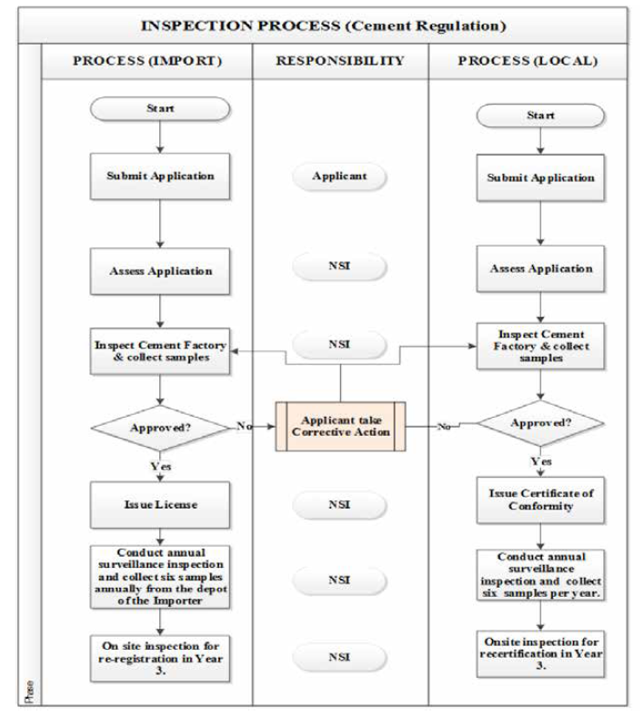

**ANNEXURE 3**

**Application Process under Mutual Recognition Agreement**

