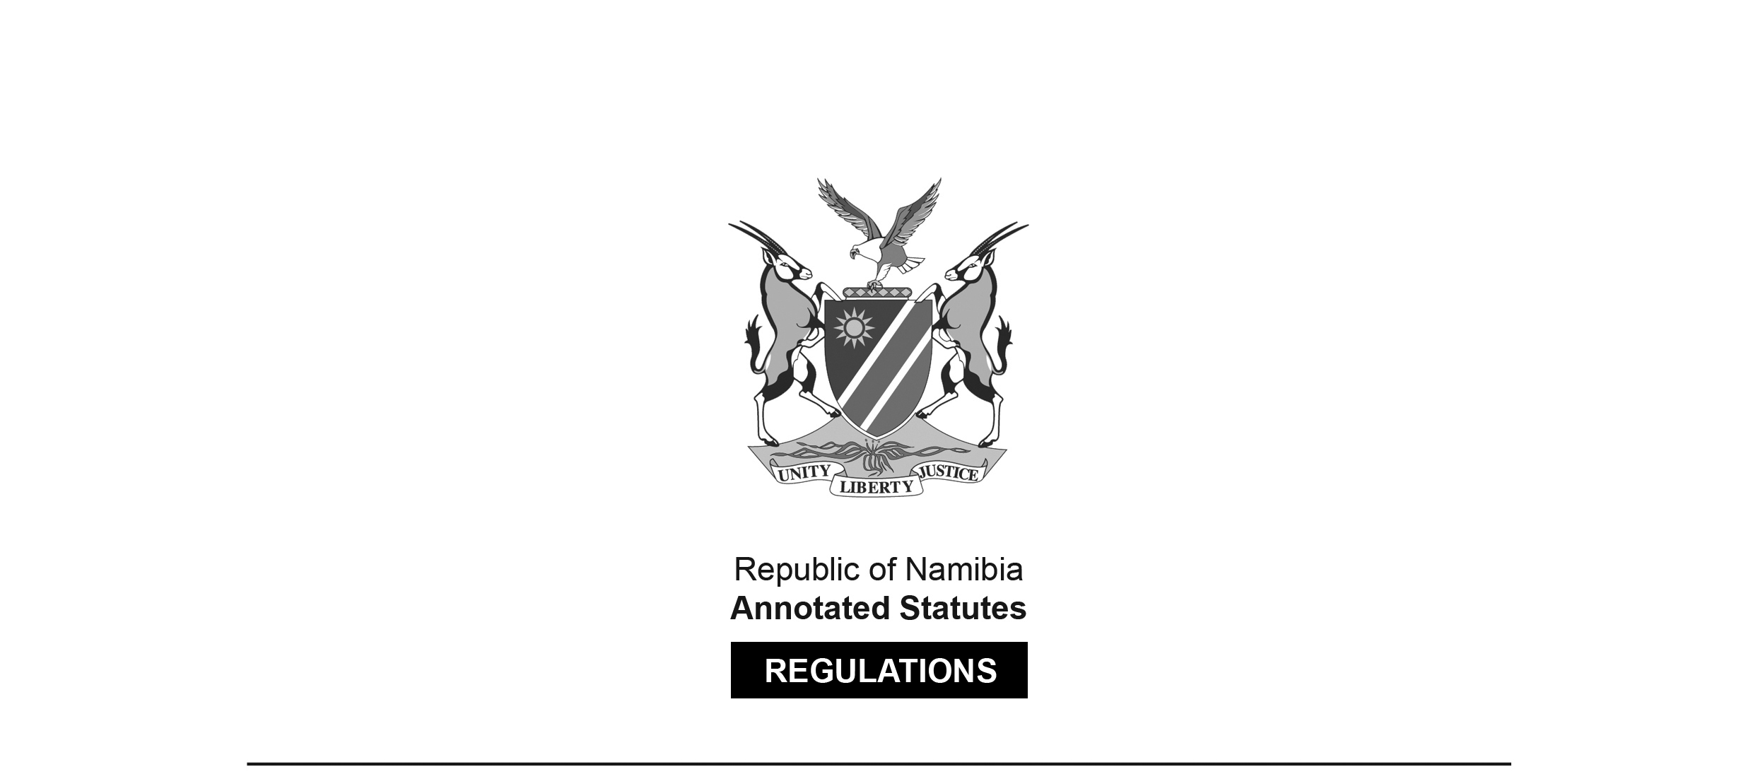
REGULATIONS MADE IN TERMS OF

Social Work and Psychology Act 6 of 2004
section 56

Regulations relating to the Minimum Requirements of Study
for Registration as a Social Worker
Government Notice 118 of 2016
(GG 6030)
came into force on date of publication: 8 June 2016

The Government Notice which publishes these regulations notes that they were
made on the recommendation of the Social Work and Psychology Council of Namibia.
It also withdraws GN 34/2007 (GG 3795).

ARRANGEMENT OF REGULATIONS

1. Definitions
2. Minimum requirements of study for registration as a social worker
3. Recognition of qualification by Council

Definitions

1. In these regulations, unless the context otherwise indicates, a word or expression defined in the Act has that meaning, and -

“the Act” means the Social Work and Psychology Act, 2004 (Act No. 6 of 2004).

Minimum requirements of study for registration as a social worker

2. (1) Subject to compliance with the other requirements prescribed by or under the Act, a person may be registered as a social worker, if that person is the holder of any of the following qualifications:

Qualification | Educational Institution and Country
 | Republic of Namibia
A four year Bachelors Degree of Arts in Social Work | University of Namibia
 | Republic of South Africa
A four year Bachelors Degree in Social Work | University of Cape Town
A four year Bachelors Degree in Social Work | University of KwaZulu-Natal (Formerly University of Natal; University of Durban Westville)
A four year Bachelors Degree in Social Work | University of Pretoria (Formerly  University of Pretoria; Mamelodi Campus of Vista University)
A four year Bachelors Degree in Social Work | Nelson Mandela Metropolitan (Formerly University of Port Elizabeth; Port Elizabeth Campus of Vista University; Port Elizabeth Technikon)
A four year Bachelors Degree in Social Work | North West University (Formerly Potchefstroom University of Christian Higher Education; University of the North West; Sebokeng Campus of Vista University)
A four year Bachelors Degree in Social Work | University of Johannesburg (Formerly Rand Afrikaans University; East Rand and Soweto Campus of Vista University; Technikon Witwatersrand)
A four year Bachelors Degree in Social Work | University of Stellenbosch
A four year Bachelors Degree in Social Work | Walter Sisulu University of Technology and Science (Formerly University of Transkei; Border Technikon; Eastern Cape Technikon)
A four year Bachelors Degree in Social Work | University of South Africa
A four year Bachelors Degree in Social Work | University of Limpopo (Formerly University of South Africa; University of the North)
A four year Bachelors Degree in Social Work | University of the Free State (Formerly University of the Orange Free State; Qwa Qwa Campus of the North; Bloemfontein Campus of Vista University)
A four year Bachelors Degree in Social Work | University of Venda for Science and Technology
A four year Bachelors Degree in Social Work | University of the Western Cape
A four year Bachelors Degree in Social Work | University of Witwatersand
A four year Bachelors Degree in Social Work | University of Zululand
A four year Bachelors Degree in Social Work | University of Fort Hare (Formerly University of Fort Hare; East London Campus of Rhodes University)
 | Republic of Zambia
A four year Bachelors Degree in Social Work | University of Zambia
 | Republic of Zimbabwe
A four year Bachelors Degree in Social Work | University of Zimbabwe

(2) Any person who is not the holder of a qualification prescribed by subregulation (1), may be registered as a social worker, subject to regulation 3 and to comply with the other requirements prescribed by or under the Act, if he or she is the holder of a -

(a) Bachelors Degree in Social Work, obtained at an educational institution approved by the Council after receiving full time education, tuition and training in social work for a period of not less than four years at that educational institution; or

(b) Diploma in Social Work, obtained at an educational institution approved by the Council after receiving full time education, tuition and training in social work for a period of not less than three years at that educational institution, if that qualification has been obtained before 31 December 2013, subject to subregulation (3) of this regulation.

(3) The education, tuition and training prescribed by subregulation (2) must include education, tuition and training in the following main subjects -

(a) social work IV;

(b) (i) psychology III; or

(ii) sociology III; and

(c) applied social work IV in or relating to social work.

Recognition of qualification by Council

3. The Council may recognise, for the purpose of the registration of a person as a social worker, a qualification prescribed by of regulation 2(2), if -

(a) the educational institution at which that person obtained that qualification is approved by the Council for that purpose;

(b) the registration authority responsible for the registration of a person to practise the profession of social work in the country in which that person obtained that qualification, recognises that qualification for registration to practise the profession of social work in that country; and

(c) that person complies with the other requirements for registration as a social worker prescribed by or under the Act.

