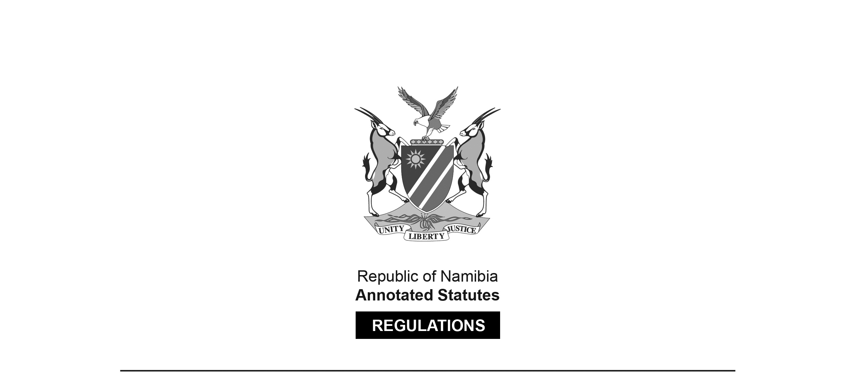

REGULATIONS MADE IN TERMS OF

Social Work and Psychology Act 6 of 2004

section 56 read with section 42(1)(d)

Maximum Fine that Council or Professional   
Conduct Committee may Impose

Government Notice 157 of 2014

(GG 5559)

came into force on date of publication: 15 September 2014

The Government Notice which publishes these regulations notes that they were   
made on the recommendation of the Social Work and Psychology Council of Namibia.

ARRANGEMENT OF REGULATIONS

1. Definitions

2. Maximum fine that may be imposed by Council or professional conduct committee

**Definitions**

**1.** In these regulations, unless the context otherwise indicates, a word or expression

defined in the Act has that meaning, and

“the Act” means the Social Work and Psychology Act, 2004 (Act No. 6 of 2004).

**Maximum fine that may be imposed by Council or professional conduct committee**

**2.** Under section 42(1)(d) of the Act, the Council or the professional conduct committee

may impose a fine not exceeding the amount of N$70,000.00.