

REGULATIONS MADE IN TERMS OF

Sectional Titles Act 2 of 2009

section 56(1)

Sectional Titles Regulations

Government Notice 223 of 2014

([GG 5604](http://www.lac.org.na/laws/2014/5604.pdf))

came into force on date of publication: 31 October 2014

The Government Notice which publishes these regulations notes that they   
were made on the recommendation of the Sectional Titles Regulation Board. It also   
repeals “the Regulations made under the Sectional Titles Act, 1971 (Act No. 66 of 1971)   
and all the amendments to those regulations, if any”.

as amended by

Government Notice 165 of 2023 **(**[GG 8108](http://www.lac.org.na/laws/2023/8108.pdf)**)**

came into force on date of publication: 8 June 2023

ARRANGEMENT OF REGULATIONS

1. Definitions

2. Draft sectional plans

3. Submission of draft sectional plan to Surveyor-General

4. Field measurements

5. Accuracy and correctness of draft sectional plan

6. Application for opening of sectional title register

7. Certificate of registered sectional title

8. Registration of sectional plan

9. Sectional title registers

10. Certificate of real right

11. Alteration, amendment or substitution of registered sectional plan

12. Registration of transfer of ownership and registration of other rights in respect of parts of buildings

13. Conveyancer to prepare deeds and sign certificate

14. Certificate by legal practitioner, notary, conveyancer or empowered person

15. Acceptance of responsibility

16. Dealings with common property

17. Draft sectional plan of subdivision

18. Registration of subdivision of section

19. Draft sectional plan of consolidation

20. Registration of consolidation of sections

21. Draft sectional plan for extension of section

22. Registration of sectional plan of extension of section

23. Draft sectional plan for extension of development scheme

24. Registration of extension of development scheme

25. Draft sectional plan for extension of common property

26. Registration of plan of extension of common property

27. Exclusive use areas

28. Certificate of real right

29. Substitution of, addition to, amendment or repeal of rules

30. Destruction of or damage to building and transfer of interest

31. Sectional mortgage bonds

32. Fees of office

33. Tariff of conveyancing, notarial and other legal practitioners fees

34. Fees to be paid to land surveyors and architects

35. Endorsement or entries on registered deeds or other documents or in registers

36. Powers and duties of arbitrators and procedures to be followed at arbitration proceedings

37. Files for conveyancers

38. Certified copies

39. Examination in connection with preparation of sectional plans

40. Extension of period referred to in section 61(1)(d) of Act

Annexure 1

Annexure 2

Annexure 3

Annexure 4

Annexure 5

Annexure 6

**Definitions**

**1.** In these regulations a word or expression to which a meaning has been assigned in the Act bears that meaning, and unless the context otherwise indicates -

“Committee” means the Sectional Titles Examination Committee established by regulation 39(2);

“sectional title file” means the file referred to in regulation 9(1); and

“the Act” means the Sectional Titles Act, 2009, (Act No. 2 of 2009).

**Draft sectional plans**

**2.** (1) For a draft sectional plan to be approved by the Surveyor-General and registered in a deeds registry it must comply with the following requirements -

(a) it is prepared on a sheet that is of durable and good quality and approved by the Surveyor-General of any of the following sizes -

(i) 297 mm x 210 mm;

(ii) 297 mm x 420 mm; or

(iii) 297 mm x 841 mm,

and is in black ink of good quality, but any departure from these requirements must, prior to the departure be approved by the Surveyor-General in writing;

(b) only one side of the sheet may be used;

(c) the binding margin must be along the 297 mm side and sheets larger than 297 x 210 mm must be folded to that size with the folds clear of the binding margin;

(d) margin are is 40 mm wide along the 297 mm binding side of the sheets and 10 mm wide along the other sides are provided and subject to paragraph (h), the margins are left free of any writing or drawing;

(e) all linear measurements recorded on the plan are in metres to two decimal places;

(f) if angles or angles of direction are required to be shown on the plan, they must be expressed to the nearest 10 seconds;

(g) the scale to which any plan is prepared is either 1 /1 000, 1/1 250, 1/1 500, 1/2 000, 1/2 500, 1/3 000, 1/4 000, 1/5 000, 1/6000 or 1/7500 or is to any of the scales above in which the denominator can be multiplied or divided by 10 to any integral power, but -

(i) the size of the figure on the plan must be sufficiently large to show all the required details; and

(ii) block plans, floor plans and cross-sections of a building may be shown on more than one sheet if necessary.

(h) any addition, alteration or interlineation on a draft sectional plan is initialled by the preparer and for this purpose the margin on the right hand side of the sheet opposite the addition, alteration or interlineation is used;

(i) the buildings on the draft sectional plan are consecutively numbered, commencing with the figure “1”.

(j) all sections in a development scheme are consecutively numbered on the draft sectional plan, commencing with the figure “1”;

(k) the number allocated to a section on the draft sectional plan is allocated to all parts of that section;

(l) the numbers allocated to sections on a draft sectional plan of subdivision, plan of consolidation or of extension, continue from the last number allocated in respect of the development scheme, but if a section is extended, it retains the same number;

(m) an exclusive use area is uniquely numbered;

(n) if the boundaries of a section or of a part of the section cannot be defined by reference to its floor, walls and ceiling, the boundaries are defined in a manner acceptable to the Surveyor-General;

(o) the common boundary between an exclusive use area created in terms of section 28(1), 28(9) or 61(3) of the Act and a section or common property is -

(i) in the case of physical features, the median line of the dividing floor, wall, ceiling, fence or other similar feature, unless boundaries have been described in a different manner on the draft sectional plan; and

(ii) a boundary which is not a physical feature, described in a manner acceptable to the Surveyor-General or in terms of beacons determined in accordance with the Land Survey Act, which beacons is described, and sufficient data is given on such plan to define the area and to determine the location thereof in relation to the building, section or boundaries of the land concerned;

(p) each sheet contains -

(i) the title of the sheet;

(ii) the sheet number and, in addition thereto, an indication of the number of sheets of which the draft sectional plan will consist, as follows:

“Sheet …………… of …………………… sheets”;

(iii) the name and address of the architect or land surveyor concerned, or if the architect or land surveyor is practicing with a firm of architects or land surveyors, the name of the architect or land surveyor concerned and the name and address of the firm, all in block letters, the signature of the architect or land surveyor and his or her professional designation;

(iv) the date on which the architect or land surveyor signed the sheet;

(v) a space for the approval certificate of the Surveyor-General; and

(vi) such notes as the architect or land surveyor may wish to make.

(2) Subject to subregulation (3), a draft sectional plan consists of the following sheets which, subject to the Act and subregulation (4), contain the following particulars namely -

(a) the first sheet, which is substantially in the form of Form 1 in Annexure 1 and which contains, in addition to the particulars prescribed by subregulation (1)(p), the following -

(i) the name of the development scheme;

(ii) the description of the land as reflected on the relevant approved general plan or approved diagram;

(iii) the number of the relevant approved general plan or of the approved diagram of the land;

(iv) the number of the section or part of a section in a building, but if a building consists only of common property, it is so described;

(v) any encroachment on the land to which the development scheme relates;

(vi) a certificate signed by the architect or land surveyor stating that the draft sectional plan has been prepared from actual measurements taken by him or her or under his or her directions, but if the responsibility for the preparation of the draft sectional plan is carried by more than one person, each of the architect or land surveyor must affix a certificate to this sheet, and the certificate states to what extent the person who signed the certificate accepts responsibility for the preparation of the draft sectional plan;

(vii) a caveat, if a developer reserves himself or herself the right under section 26 of the Act to erect a further building or buildings or horizontally or vertically extend an existing building;

(viii) the name of the local authority concerned;

(ix) the sheet number on which exclusive use areas are found;

(x) space for -

(aa) the signature of the registrar and his or her reference number;

(bb) the signature of the Surveyor-General and his or her reference number;

(b) a sheet on which a block plan is prepared which must contain, in addition to complying with section 7(3)(a) of the Act and subregulation (1)(n) -

(i) a description of contiguous land and the names of contiguous streets, if any;

(ii) the position at ground level of the external surfaces of the walls of all buildings shown by a solid line, together with the horizontal distances between each rectilinear cadastral boundary and the buildings nearest to the boundary, but if the external surfaces of any walls are interrupted at ground level by features such as archways, doorways or similar openings, the external surfaces must be shown by a solid line;

(iii) the greatest extent to which the external surfaces excluding roof overhangs, unless the overhang encroaches over the cadastral boundary, protrude beyond the external surfaces of the building at ground level shown by distinctive broken lines, together with the horizontal distance between each rectilinear cadastral boundary and the nearest protrusion to the boundary, but if a basement area determined by the internal surfaces of the walls projects beyond the external surface of the building at ground level, the projection is shown separately by a distinctive broken line and a brief description is given of all parts of the building indicated by a distinctive broken line;

(iv) any encroachment on the land to which the development scheme relates;

(v) any servitude burdening the land reflected on the relevant approved diagram or general plan;

(vi) a sign indicating the true north direction; and

(vii) an exclusive use area as referred to in subregulation (1)(m) which is delineated by means of distinctive broken lines and expresses the area to the nearest square metre, but if details cannot be shown clearly on the sheet the details are shown in an inset or on an additional sheet as contemplated in paragraph (e);

(c) a sheet on which the diagrammatic floor plan in respect of each storey in the building referred to in section 7(3)(c) and (d) of the Act are shown and which contains, in addition to the particulars mentioned in subregulation (1)(n) -

(i) the boundaries of the sections shown in a solid line;

(ii) the common property areas by means of distinctive broken lines;

(iii) an indication of the position of the diagrammatic cross-sections when required in terms of subregulation (4);

(iv) the number of each section or part of the section;

(v) a sign indicating the true north direction;

(vi) the other information as may be necessary to define each section; and

(vii) an exclusive use area referred to in subregulation (1)(m), which -

(aa) is be delineated by means of distinctive broken lines; and

(bb) expresses the area to the nearest square metre,

but if sufficient details cannot be shown clearly on the sheet concerned, the details are shown in an inset or on an additional sheet as contemplated in paragraph (e);

(d) a sheet containing in numerical sequence -

(i) the floor areas of the sections referred to in section 7(3)(e) of the Act; and

(ii) the participation quotas in respect of the sections in the schedule as referred to in section 7(3)(g) of the Act, but the participation quotas of the separate sections are made up in such a way that the total participation quota is equal to 100.0000;

(e) a sheet containing the insets referred to in paragraph (b)(vii) and (c)(vii).

[The singular word “paragraph” should be the plural word “paragraphs”.]

(3) If a draft sectional plan is intended for the purposes of -

(a) a subdivision, consolidation or extension of a section or sections;

(b) the extension of a development scheme or common property;

(c) ceding the right to the exclusive use of a part or parts of a common property as contemplated in section 28(2) of the Act;

(d) the amendment of a development scheme due to the destruction of or damage to a building or buildings; or

(e) the amendment of a sectional plan in terms of section 14(1) of the Act,

it needs only comprise the sheets as are affected by the amendments and the heading of the plan is styled as an amending sectional plan.

[The phrase “it needs” should be “it need” (subjunctive tense) to fit correctly   
with the opening phrase beginning with “If”.]

(4) If uncertainty or ambiguity about the boundaries of a section exists, a draft sectional plan must contain an additional sheet that contain -

[The verb “contain” should be “contains” to accord with the subject “sheet”.]

(a) diagrammatic cross-sections of the building or buildings of every floor in the building or buildings, detailed sufficiently to indicate the boundaries or every section; and

(b) in addition to the particulars mentioned in subregulation (1)(n) -

(i) the number of the building and the name or number of every floor; and

(ii) such other information as may be necessary to define every section.

(5) The developer must furnish the architect or land surveyor with all documents and particulars required by the architect or land surveyor to prepare the draft sectional plan.

(6) The Surveyor-General may refuse to approve a draft sectional plan if he or she is of the opinion -

(a) that the plan is dilapidated or has been prepared in a careless manner or that the appearance is spoilt by multiple additions, alterations or interlineations; or

(b) that the writing or any drawing on the plan does not, owing to faintness or any other reason, ensure durability.

**Submission of draft sectional plan to Surveyor-General**

**3.** (1) The submission of a draft sectional plan to the Surveyor-General in terms of section 6(1)(a) of the Act for its approval is in the form of Form 2 in Annexure 1, and is accompanied by -

(a) one paper copy and two copies on durable drawing material of the draft sectional plan concerned; and

(b) a certificate by the architect or land surveyor stating that the boundaries of the sections and common property are physically defined as contemplated in the Act.

(2) In addition to the requirements of section 9(2)(a) of the Act, the submission referred to in subregulation (1) is accompanied by the plans and other documents listed in Form 2 in Annexure 1.

(3) The field book or field plan must contain the record of all measurements made in the field.

(4) The records relating to the drafting of the draft sectional plan include -

(a) the calculations of the dimensions of the sections to the median lines from the field instruments;

(b) sufficient calculations or evidence to indicate how the area of each section or exclusive use area was determined and checked;

(c) a list of co-ordinates of at least two corners or identified permanent features of each building and the distances between the corners or features must be adequate to provide an accurate determination of the position of each building and the co- ordinates concerned may be listed on the copy of the block plan; and

(d) on the block plan references to two legally established beacons in terms of the Land Survey Act, 1993 (Act No. 33 of 1993) on which the survey was based.

**Field measurements**

**4.** (1) Measurements by a land surveyor or architect for the preparation of a draft sectional plan made in the field are made correct to two decimal places of a metre and recorded in the field book or on the field plan at the time of the measurement in the field.

(2) A land surveyor or architect must make sufficient measurements to enable all median dimensions to be calculated and checked in order to be consistent with the dimensions of the building as a whole and to have the sections and other details on the draft sectional plan correctly depicted.

(3) The Land Survey Act and the regulations made under that Act apply to the manner in which and the accuracy to which the survey of buildings and exclusive use areas, of which the boundaries are not represented by physical features of a permanent nature, are performed.

**Accuracy and correctness of draft sectional plan**

**5.** (1) The Surveyor-General may at any time examine in any appropriate manner the accuracy or correctness of a draft sectional plan or any measurement recorded by a land surveyor or architect.

(2) If the Surveyor-General finds a draft sectional plan or measurement referred to in subregulation (1) to be inaccurate or incorrect, the Surveyor-General may -

(a) refer the defective or incorrect plan back to the land surveyor or architect concerned to make corrections on the existing plan and to initial at the corrections; or

(b) require that a correction plan be submitted.

**Application for opening of sectional title register**

**6.** (1) An application for the opening of a sectional title register in terms of section 11(1)(a) of the Act is in the form of Form 3 in Annexure 1.

(2) The registrar must suitably endorse the title deed referred to in section 11(3)(c) of the Act to indicate that the land described is subject to a development scheme and is registered in the sectional title register, but if a conveyancer submits to the registrar a certificate to the effect that the title deed is not available, the registrar must -

(a) endorse the registry duplicate of the title deed in accordance with this subregulation; and

(b) make an endorsement similar to the endorsement in terms of paragraph (a) on the original title deed if the original title deed is at any time lodged with the registrar for any purpose.

(3) The schedule referred to in section 11(3)(b) of the Act must contain, in addition to the particulars prescribed in that section -

(i) the name of the development scheme concerned;

(ii) the full name and address of the developer concerned;

(iii) the number of the title deed of the land in question; and

(iv) in the event of land defined on an approved diagram, the number of the title deed with which the diagram is filed.

**Certificate of registered sectional title**

**7.** (1) A certificate of registered sectional title referred to in section 11(3)(f) of the Act is -

(a) in the form of Form 4 in Annexure 1 and typed or printed -

(i) on paper of durable and good quality of the size known as A4 standard paper;

(ii) in letters and numbers of not less than two millimetres in size; and

(iii) in black ink of a good quality, as approved by the registrar;

(b) signed and dated by the registrar; and

(c) sealed with the seal of office of the registrar.

(2) The registrar must reject a certificate of registered sectional title lodged with him or her which does not comply with subregulation (1).

(3) Subject to subregulation (4), a certificate of registered sectional title is lodged with the registrar in duplicate.

(4) If a procedure is followed in a deeds registry of reproducing deeds and documents electronically and of keeping the electronic reproduction instead of the actual deed or documents, it is not necessary, despite anything to the contrary in these regulations, to lodge a duplicate original of the deed or document for filing in the deeds registry.

(5) Upon registration the deed or document referred to in subregulation (4) is considered to be the copy filed in the deeds registry until such time as the reproduction of the deed or document is filed in lieu, but this subregulation does not apply in a deeds registry until the registrar of deeds has instructed the deputy registrar of the office concerned in writing.

(6) This regulation applies with the necessary changes to any certificate of registered sectional title or sectional title deed issued under any other provision of the Act.

**Registration of sectional plan**

**8.** (1) The distinctive number referred to in section 12(1)(a) of the Act is allotted consecutively, commencing each year with the number “1”.

(2) The number referred to in subregulation (1) is followed by -

(a) a slash; and

(b) the year in which the sectional plan is registered.

(3) The registrar may refuse to register a sectional plan if he or she is of the opinion that the plan -

(a) has a shoddy, shaddy, ragged or inferior appearance;

[The non-existent word “shaddy” may be a misspelling of the word “shabby”.]

(b) has been prepared in a careless or unprofessional manner;

(c) has its appearance spoilt by multiple additions, alterations or interlineations; or

(d) due to the writing or any drawing on the plan is not, owing to faintness or any other reason, secured for durability.

**Sectional title registers**

**9.** (1) The sectional title register referred to in section 12(1)(b) of the Act is opened by means of a sectional title file in the form of Form 5 in Annexure 1.

(2) The same number is allotted to both the sectional title file and the sectional plan concerned.

(3) In the sectional title file is filed -

(a) the documents referred to in section 11(3) of the Act, with the exception of -

(i) the certificate of registered sectional title;

(ii) the copy of the title deed of the land for the owner; and

(iii) the bond;

(b) the copy of any notice to the Surveyor-General and to the local authority concerned of the registration or cancellation of the registration of a sectional plan or of the reversion of land to the land register; and

(c) correspondence relating to the development scheme.

(4) If a procedure of -

(a) reproducing documents and of keeping the reproduction instead of the original documents; and

(b) maintaining a register as referred to in section 12(1)(c) of the Act,

in a deeds registry is followed, the sectional title file referred to in subregulation (3) may be substituted by such reproduction and such register.

(5) Despite subregulation (4), the sectional title file may be maintained for certain documents if the registrar so determines.

**Certificate of real right**

**10.** (1) The certificate of real right referred to in section 12(1)(e)(i) of the Act is in the form of Form 6 in Annexure 1.

(2) The certificate of real right referred to in section 26(9) of the Act is -

(a) in the form of Form 7 in Annexure 1; and

(b) accompanied by the written consent of -

(i) all the members of the body corporate; and

(ii) every holder of a bond over a unit in the development scheme.

(3) The certificate of real right referred to in section 12(1)(e)(ii) of the Act is in the form of Form 8 in Annexure 1.

**Alteration, amendment or substitution of registered sectional plan**

**11.** (1) Regulation 2 applies with the necessary changes to a sectional plan which is to be altered, amended or substituted for a registered sectional plan.

(2) The registrar must forward a copy of a sectional plan which is altered, amended or substituted for a registered sectional plan to the local authority concerned.

(3) If the registrar alters, amends, endorses or makes entries on a relevant sectional title deed as contemplated in section 14(8) of the Act, he or she must endorse that the alteration, amendment, endorsement or entry has been made in accordance with an alteration, amendment or substitution of the registered sectional plan.

(4) If the registration of a sectional plan is cancelled on the application of the developer in terms of section 14(10) of the Act, the registrar must make the necessary endorsement on -

(a) each of the relevant sectional title deeds;

(b) the titles to any real rights; and

(c) the schedule referred to in section 11(3)(b) of the Act.

(5) If the registration of a sectional plan is cancelled, the registrar must make the alterations, amendments, endorsements and entries in the relevant land register and records which are necessary to effect the reversion of the land to the land register.

(6) Any entry referred to in subregulation (5) contains a reference to the number of the relevant sectional plan.

(7) If the registration of a sectional plan is cancelled, the registrar must revive the developer’s title deed of the land referred to in section 11(3)(c) of the Act by making an appropriate endorsement on the title deed under his or her signature and the date of the endorsement if a certificate of registered title referred to in section 14(8) of the Act is not issued by him or her.

**Registration of transfer of ownership and registration of other rights in respect of parts of buildings**

**12.** (1) The registrar must issue simultaneously with the establishment of a body corporate in terms of section 38(1) of the Act a certificate in the form of Form 9 in Annexure 1, but on application made by a body corporate in respect of which the certificate has not been issued prior to the commencement of the Act, the registrar may issue the certificate after the date of establishment of the body corporate.

(2) A conveyancer concerned must prepare a draft certificate in the form referred to in subregulation (1) and lodged it with the registrar in duplicate.

(3) The -

(a) original certificate referred to in subregulation (1) is filed in the sectional title file; and

(b) duplicate is delivered to the conveyancer concerned.

(4) Once a certificate in terms of subregulation (1) has been issued, no further such certificate may be issued in respect of the building concerned, but if required, the registrar may issue a copy of the original certificate, certified by him or her as a true copy of the original.

(5) The deed of transfer referred to in section 17(1)(a) of the Act is in the form of Form 10 in Annexure 1.

(6) An application referred to in section 17(5) of the Act is in the form of Form 11 in Annexure 1.

(7) A certificate of registered sectional title referred to in section 17(5) of the Act is in the form of Form 12 in Annexure 1.

**Conveyancer must prepare deeds and sign certificate**

**13.** (1) Every deed of transfer, certificate of title, certificate of registration or sectional mortgage bond is prepared by a conveyancer or other person authorised by any law who must make and sign a certificate in the upper right hand corner on the first page of the document concerned in the form below:

“Prepared by me

……………………

**CONVEYANCER/OTHER AUTHORISED PERSON**

*Note: 1. Omit particulars not applicable and amend where necessary.*

*2. Surname and initials must be in block letters.*”.

(2) Subject to subregulation (3) -

(a) a conveyancer or other person authorised by any law who prepares a deed of transfer, certificate or sectional mortgage bond referred to in subregulation (1) must initial all alterations or interlineations in the deed of transfer, certificate or sectional mortgage bond and every page not requiring a signature; and

(b) the registrar may not accept a deed of transfer, certificate or sectional mortgage bond for execution or registration, if it does not bear the certificate and is not so initialled.

(3) If in the case of a deed of transfer, certificate or sectional mortgage bond referred to in subregulation (1), an alteration or interlineation is not initialled as contemplated in subregulation (2), the alteration or delineation may be initialled by the conveyancer executing the deed of transfer, certificate or sectional mortgage bond if, in the opinion of the registrar, the initialling by the conveyancer who prepared the deed of transfer, certificate or sectional mortgage bond is not required.

**Certificate by legal practitioner, notary, conveyancer or authorised person**

**14.** (1) Subject to subregulations (3) and (4), a power of attorney, application or consent required for the performance of an act of registration in a deeds registry and tendered for registration or filing of record in a deeds registry is prepared by a practicing legal practitioner, notary, conveyancer or other person authorised by any law who must make and sign a certificate in the upper right hand corner on the first page of the document concerned in the form below:

“Prepared by me

……………………

**LEGAL PRACTITIONER/NOTARY/CONVEYANCER/OTHER AUTHORISED PERSON**

*Note: 1. Omit particulars not applicable, and amend where necessary.*

*2. Surname and initials in block letters.*”.

(2) A person who has prepared a document referred to in subregulation (1) must initial any alteration or interlineation in the document.

(3) Subregulation (1) does not prevent a legal practitioner, notary or conveyancer or other person authorised by any law in the employ of the State from preparing in the course of his or her employment any document mentioned.

(4) If a certificate referred to in subregulation (1) is signed by a legal practitioner or notary, the fact that the signatory is a practicing legal practitioner or notary is confirmed by a practicing conveyancer who must countersign the certificate by making and signing the following certificate:

“Countersigned by me

……………………………………

**CONVEYANCER**

……………………………………………

*(Surname and initials in block letters)*”.

**Acceptance of responsibility**

**15.** The person preparing and signing the documents referred to in regulation 13(1) and 14(1) accepts responsibility for the correctness of the facts stated in the deeds or documents concerned or which are relevant in connection with the registration or filing to the effect that -

(a) all copies of the deeds or documents intended for execution or registration are identical at the date of lodgement;

(b) in the case of a deed of transfer, certificate of title or certificate of registration, all the applicable conditions of title have been correctly brought forward in that deed of transfer, certificate of title or certificate of registration;

(c) in the case of a document referred to in regulation 14(1) signed by a person in his or her capacity as executor, administrator, trustee, tutor, curator, liquidator or judicial manager from the perusal of documents evidencing the appointment exhibited to him or her, the person has in fact been appointed in that capacity and acts in accordance with the powers granted to him or her and that any surety required has been furnished to the Master of the High Court;

(d) to the best of his or her knowledge and belief and after due enquiry has been made -

(i) the names, identity number or date of birth and marital status of any natural person being a party to a deed or document and in the case of any other person or a trust, its name and registered number, if any, of the person or trust, are correctly reflected in that deed or document;

(ii) in the case of a document referred to in regulation 14(1) -

(aa) the necessary authority has been obtained for the signing of the document in a representative capacity on behalf of a company, close corporation, trust, church, association, society or other body of persons or an institution;

(bb) the transaction as stated, is authorised by and in accordance with the constitution, regulation, founding statement or trust instrument of a trust, of any church, association, close corporation, society, trust or other body of persons, or any institution other than a company being party to the document; or

(e) if the person signs the preparation certificate on a deed of transfer, certificate of title, certificate of registration or a sectional mortgage bond, the person accepts responsibility that the particulars in the deed referred to in paragraph (d)(i) have been brought forward correctly from the special power of attorney or application.

**Dealings with common property**

**16.** (1) Simultaneously with the registration of a transfer referred to in section 19(3)

(a) or 21(6) of the Act, the registrar must make an endorsement under his or her signature on the schedule of conditions referred to in section 11(3)(b) of the Act.

(2) A sectional title deed registered pursuant to section 19(3) or 21(6) of the Act must simultaneously be re-registered as a deed of transfer under the Deeds Registries Act in the form of Form 13 in Annexure 1.

(3) The registrar must register a cession of a servitude or other real right in terms of section 21 of the Act by virtue of a deed of cession in the form of Form 14 in Annexure 1.

**Draft sectional plan of subdivision**

**17.** Regulation 2 applies with the necessary changes to a draft sectional plan of subdivision.

**Registration of subdivision of section**

**18.** (1) An application for registration of a sectional plan of subdivision is in the form of Form 15 in Annexure 1.

(2) When registering a sectional plan of subdivision under section 23(3) of the Act, the registrar must allot a distinctive number to it and endorse the number on the plan.

(3) The certificate of registered sectional title referred to in section 23(5) of the Act is in the form of Form 16 in Annexure 1.

(4) If the registrar has issued a sectional title deed under section 23(5) of the Act in lieu of the sectional title deed referred to in section 23(2) of the Act, the registrar must cancel the last mentioned sectional title deed.

(5) The registrar must furnish the local authority concerned with a copy of the registered sectional plan of subdivision.

**Draft sectional plan of consolidation**

**19.** Regulation 2 applies with the necessary changes to a draft sectional plan of consolidation.

**Registration of consolidation of sections**

**20.** (1) An application for registration of a sectional plan of consolidation is in the form of Form 15 in Annexure 1.

(2) When registering a sectional plan of consolidation under section 24(3) of the Act, the registrar must allot a distinctive number and endorse the number on the plan.

(3) The certificate of registered sectional title referred to in section 24(5) of the Act, must be in the form of Form 17 in Annexure 1.

(4) If the registrar has issued a sectional title deed under section 24(5) of the Act in lieu of the sectional title deeds referred to in section 24(2)(b) of the Act, the registrar must cancel the last mentioned sectional title deeds.

(5) The registrar must furnish the local authority concerned with a copy of the registered sectional plan of consolidation.

**Draft sectional plan for extension of section**

**21.** Regulation 2 applies with the necessary changes to a draft sectional plan of extension of a section.

**Registration of extension of section**

**22.** (1) An application for registration of a sectional plan of extension of a section is in the form of Form 15 in Annexure 1.

(2) When registering a sectional plan of extension of a section under section 25(6) of the Act the registrar must allot a distinctive number and endorse the number on the plan.

(3) The registrar must furnish the local authority concerned with a copy of the registered sectional plan of extension of a section.

**Draft sectional plan for extension of development scheme**

**23.** Regulation 2 applies with the necessary changes to a draft sectional plan of extension of a development scheme.

**Registration of extension of development scheme**

**24.** (1) An application for registration of a sectional plan of extension of a development scheme is in the form of Form 15 in Annexure 1.

(2) When registering a sectional plan of extension of a development scheme under section 26(17) of the Act, the Registrar must allot a distinctive number and endorse the number on the plan.

(3) The certificate of registered sectional title referred to in section 26(17)(c) of the Act is in the form of Form 4 in Annexure 1.

(4) The registrar must furnish the local authority concerned with a copy of the registered sectional plan of extension of a development scheme.

**Draft sectional plan for extension of common property**

**25.** Regulation 2 applies with the necessary changes to a draft sectional plan of extension of the common property.

**Registration of plan of extension of common property**

**26.** (1) An application for registration of a sectional plan of extension of the common property is in the form of Form 15 in Annexure 1.

(2) When registering a sectional plan of extension of the common property under section 27(6) of the Act, the registrar must allot a distinctive number and endorse the number on the plan.

(3) The registrar must furnish the local authority concerned with a copy of the registered sectional plan of extension of the common property.

**Exclusive use areas**

**27.** (1) The exclusive use areas referred to in section 7(3)(f) of the Act, are numbered and described in separate paragraphs in the certificate of real rights referred to in section 12(1)(e)(ii) of the Act, if there is more than one such area.

(2) Simultaneously with the transfer of a right to an exclusive use area referred to in section 28(10) and 61(3) of the Act, the registrar must -

(a) make an endorsement under his or her signature on the schedule of conditions referred to in section 11(3)(b) of the Act; and

(b) notify the Surveyor-General accordingly.

(3) Subregulation (1) applies with the necessary changes to a transfer, cancellation or mortgage of any exclusive use area.

**Certificate of real right**

**28.** The registrar may not issue a certificate of real right as contemplated in section 26(11) or section 28(7) of the Act, unless a conveyancer certifies that -

(a) no unit in the development scheme has been alienated; or

(b) if a unit has been alienated, the developer has stated to the owner that application has been made for the issuing of a certificate of real right in terms of section 26(11) and section 28(7) of the Act.

**Substitution of, addition to, amendment or repeal of rules**

**29.** (1) After a resolution has been taken by a body corporate to substitute, add to, amend or repeal rules as contemplated in section 37(4) of the Act, the body corporate must cause Form 18 in Annexure 1 to be duly completed by two trustees.

(2) The form referred to in subregulation (1), together with the text of the new rules, is delivered to or sent by registered post to the registrar within 14 days after the resolution has been taken.

**Destruction of or damage to building and transfer of interest**

**30.** (1) When a building or buildings are deemed to be destroyed as contemplated in section 51 of the Act and a development scheme has been authorised as provided for in section 51(3) of the Act, the body corporate must notify the registrar accordingly in the form of Form 19 in Annexure 1.

(2) A notification referred to in subregulation (1) is accompanied by -

(a) a schedule referred to in section 7(3)(g) of the Act which excludes reference to any section which has been destroyed; and

(b) the affected title of the owner of the unit or holder of any real rights together with the consent of the holder of any mortgage bond or holder of any real rights for disposal.

(3) The registrar must effect the transfer of the interest of the owners referred to in section 51(3)(b) of the Act by making appropriate endorsements on the relevant deeds.

(4) The registrar must advise the Surveyor-General and the local authority concerned of any registration pursuant to section 51 of the Act, which advice is accompanied by -

(a) a copy of the schedule referred to in subregulation (2), in the case of the local authority; and

(b) by the original of the schedule, in the case of the Surveyor-General.

(5) On receipt of any advice referred to in subregulation (4), the Surveyor-General must make the required amendments and endorsements on the sectional plan and the deeds registry copy thereof.

**Sectional mortgage bonds**

**31.** A sectional mortgage bond hypothecating -

(a) a unit held under a sectional title deed;

(b) an exclusive use area; or

(c) the right to extend a development scheme held under a certificate of real right, is -

(i) in the form of Form 20 in Annexure 1;

(ii) prepared by a conveyancer and signed by the mortgagor or his or her duly authorised agent, in the presence of a conveyancer; and

(iii) in the form suitably adapted when hypothecating land held under a sectional title deed or a registered notarial lease or sublease or other registered real right.

**Fees of office**

**32.** (1) The fees of office to be charged in respect of any act, matter or thing required to be done in or in relation to a deeds registry in terms of the Act are set out in Annexure 2.

(2) The fees of office to be charged in respect of any act, matter or thing required or permitted to be done in relation to the office of the Surveyor-General are set out in Annexure 3.

(3) The fees of office referred to in subregulations (1) or (2) are paid in cash, by postal order, cheque or in such other manner determined by the Registrar or Surveyor-General.

**Tariff of conveyancing, notarial and other legal practitioners fees**

**33.** The fees and charges of -

(a) conveyancers and notaries public in connection with the preparation, passing and registration of deeds or other documents registered or filed or intended for registration or filing in a deeds registry; and

(b) any other legal practitioners in connection with the preliminary work required for the purpose of any such deed or other document,

in terms of the Act are set out in Annexure 4, but the registrar may tax a bill for wasted costs and the fees allowed in connection with the wasted costs are in the discretion of the registrar.

**Fees to be paid to land surveyors and architects**

**34.** (1) The fees to be paid to a land surveyor or an architect for preparation of a draft sectional plan or sectional plan or other plan are set out in Annexure 5.

(2) The Surveyor-General must perform, in cases of dispute, all the functions of a taxing master of the court in relation to fees charged by land surveyors or architects for performing acts which may be performed under the Act by land surveyors or architects in connection with the preparation of any draft sectional plan, sectional plan or other plan.

(3) An account submitted for taxation -

(a) discloses the items by virtue of which the amounts stated are claimed, and is drawn in accordance with the form as approved by the Surveyor-General; and

(b) is accompanied by a signed written statement by the disputing party setting out the items disputed.

**Endorsement or entries on registered deeds or other documents or in registers**

**35.** Endorsements or entries required by these regulations to be made on registered deeds or other documents or in registers -

(a) may be made by means of a rubber stamp or in handwriting or typewriting, and

(b) is signed and dated by the registrar, who -

(i) must below his or her signature state the office held by him or her; and

(ii) must initial any alteration or interlineation or an endorsement or entry.

**Powers and duties of arbitrators and procedures to be followed in arbitration proceedings**

**36.** The Arbitration Act, 1965 (Act No. 42 of 1965), in so far as it is not inconsistent with the Act, applies with the necessary changes with reference to the powers and duties of arbitrators appointed under section 58(1) of that Act and the procedure to be followed in arbitration proceedings under that Act.

**Files for conveyancers**

**3**7. (1) Every conveyancer must keep in his or her file the respective documents set out in Annexure 6 in respect of the following transactions -

(a) the transfers of ownership and other rights in terms of section 17(1) of the Act;

(b) the transfers of ownership in terms of sections 19(3), 21(6) and 36(4) of the Act; and

(c) the sectional mortgage bonds referred to in section (17)(1)(c) of the Act in respect of which he or she has signed the bond as the preparer.

(2) A conveyancer who has prepared the documents referred to in subregulation (1) must retain the file concerned with the documents concerned relating to the transaction concerned for a period of at least 6 years after the date of registration of a document.

(3) Every conveyancer must take the reasonable precautions for the safe custody of the file referred to in subregulation (2) he or she thinks necessary.

**Certified copies**

**38.** (1) A certified copy of an approved sectional plan -

(a) may only be issued by the Surveyor-General; and

(b) may not be issued prior to the registration,

unless, subject to subregulation (2), the written consent of the architect or the land surveyor concerned or any person legally entitled to act on behalf of the architect or the land surveyor, is produced to the Surveyor-General.

(2) The written consent referred to in subregulation (1) is not required if the Surveyor- General has been supplied with proof that the architect or the land surveyor concerned has unreasonably withheld his or her consent or has failed to respond in a reasonable time to a notice requesting authorisation for the issue of a certified copy.

**Examination in connection with preparation of sectional plans**

**39.** (1) The syllabus for the examination referred to in section 7(2)(a) of the Act consists of -

(a) comprehensive knowledge of all matters provided for by the Act and these regulations;

(b) knowledge of all matters relating to the registration or cancellation of real rights in land in respect of grants, transfers, leases, subdivisions, consolidations, servitudes, mortgage bonds, buildings regulations as determined by the Surveyor-General and town planning schemes; and

(c) comprehensive knowledge of all matters relating to the duties, responsibilities and professional conduct of land surveyors and architects as provided for in the Professional Land Surveyors’, Technical Surveyors’ and Survey Technicians’ Act, 1993 (Act No. 32 of 1993) and the Architects’ and Quantity Surveyors’ Act, 1979 (Act No. 13 of 1979).

(2) There is established a committee to be known as the Sectional Titles Examination Committee which consists of the following members -

(a) the Surveyor-General, who is the chairperson;

(b) one person nominated by the Namibian Council for Professional Land Surveyors and Technical Surveyors and who is appointed by the Minister; and

(c) one person nominated by the Namibian Council for Architects and who is appointed by the Minister.

(3) All meetings of the Committee are held at the date, time and place as the Chairperson may determine.

(4) Two members of the Committee form a quorum for any meeting.

(5) The Committee may determine the procedure of its meetings.

(6) A resolution of the Committee in writing and signed by at least two members is valid where no meeting was held to pass the resolution.

(7) The functions of the Committee in respect of the examination referred to in section 7(2)(a) are to -

(a) appoint an examiner and a moderator;

(b) make arrangements with the Namibian Council for Professional Land Surveyors and Technical Surveyors and the Namibian Council for Architects regarding the date, time, place, fees and other matters incidental to the conducting of the examination; and

(c) determine the pass mark and the duration of paper.

(8) The examiner and the moderator appointed in terms of subregulation (7)(a) must make the examination results available to the Surveyor-General.

(9) If the examiner and the moderator does not agree with regard to the examination answers or the marking of the examination papers, the final decision regarding a correct answer and whether a candidate has passed the examination or not vests in the Surveyor-General.

(10) The Surveyor-General must enter the names of all land surveyors and architects who have passed the examination referred to in section 7(2)(a) of the Act into a register kept and maintained by him or her for that purpose.

**Extension of period**

**40.** The period referred to in section 61(1)(d) of the Act is extended to 30 months.

**ANNEXURES**

To view content without printing, scroll down.

To print at full scale (A4), double-click the icon below.



Annexures 2-6 appear below Annexure 1.

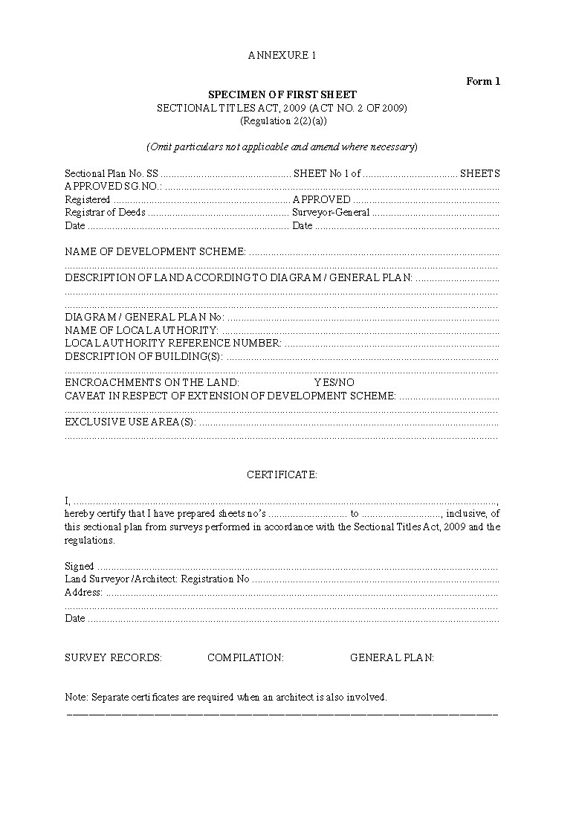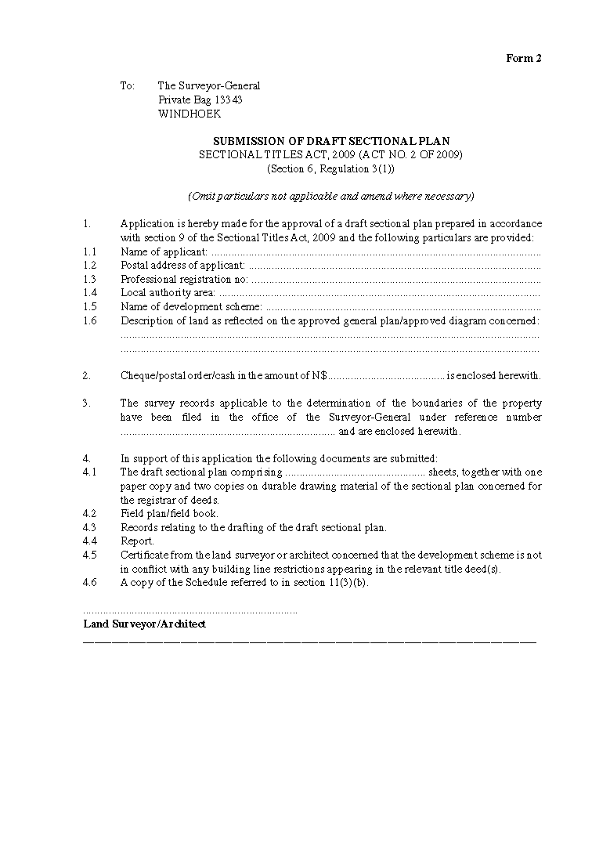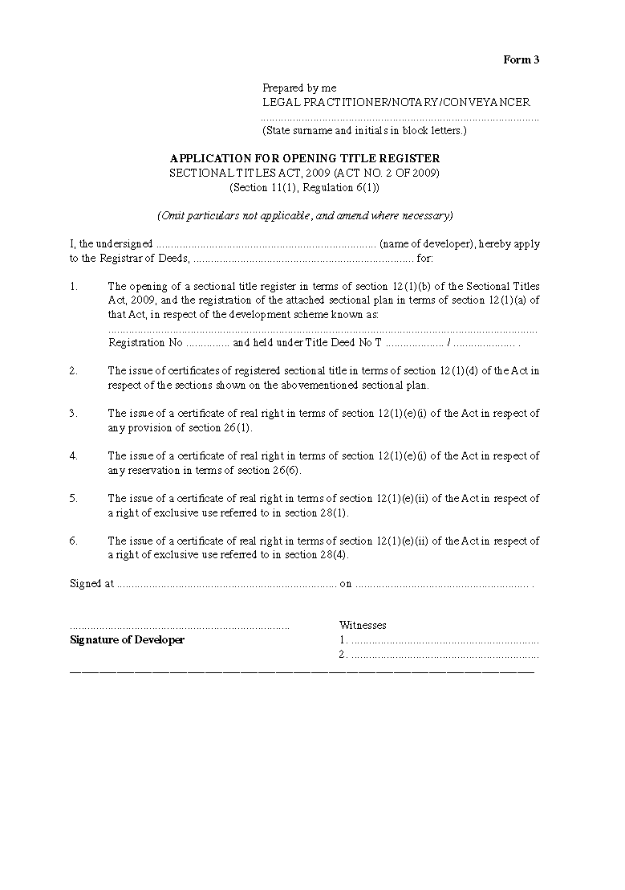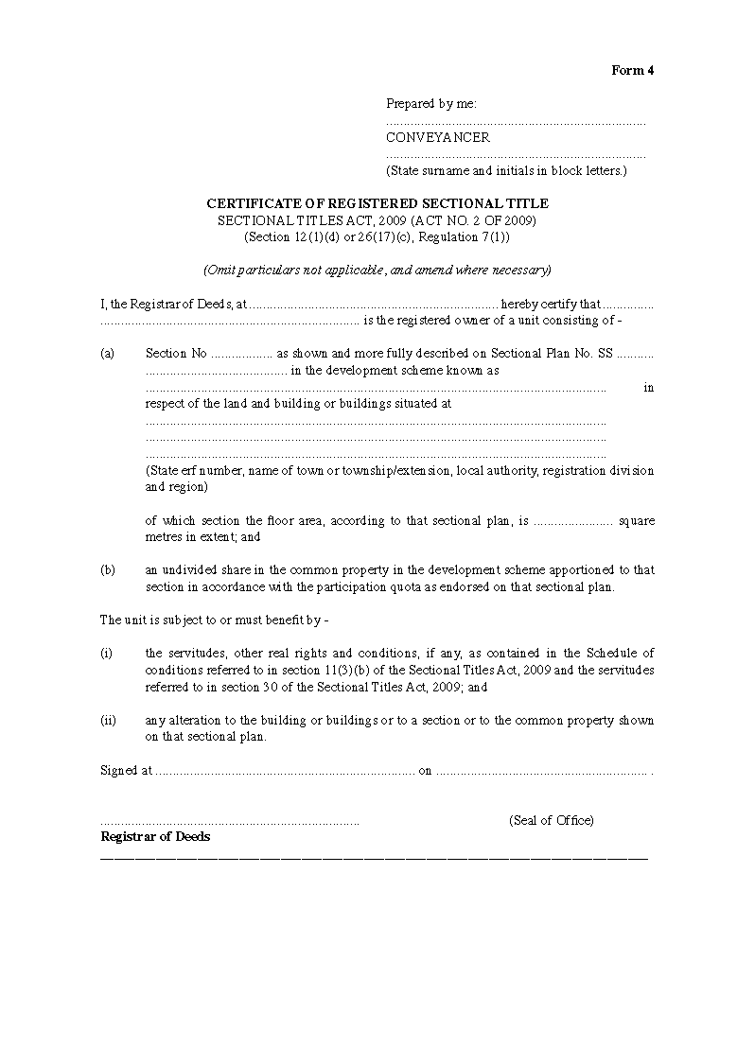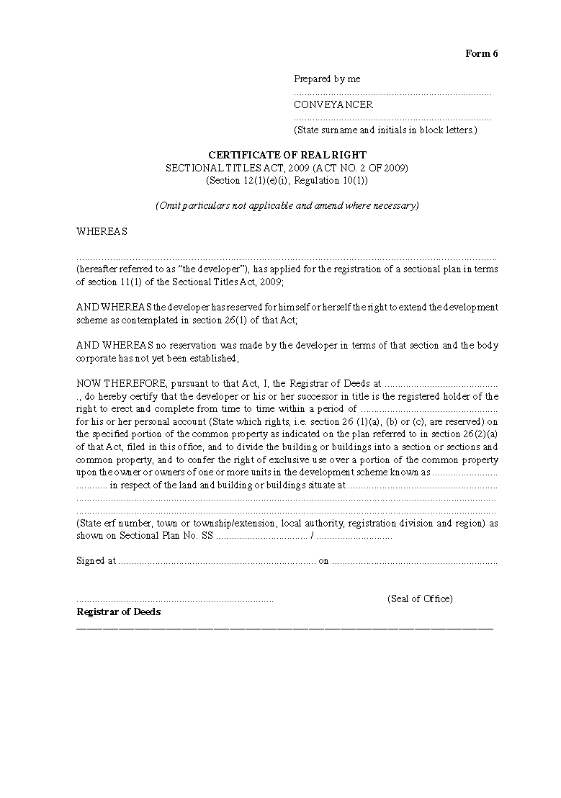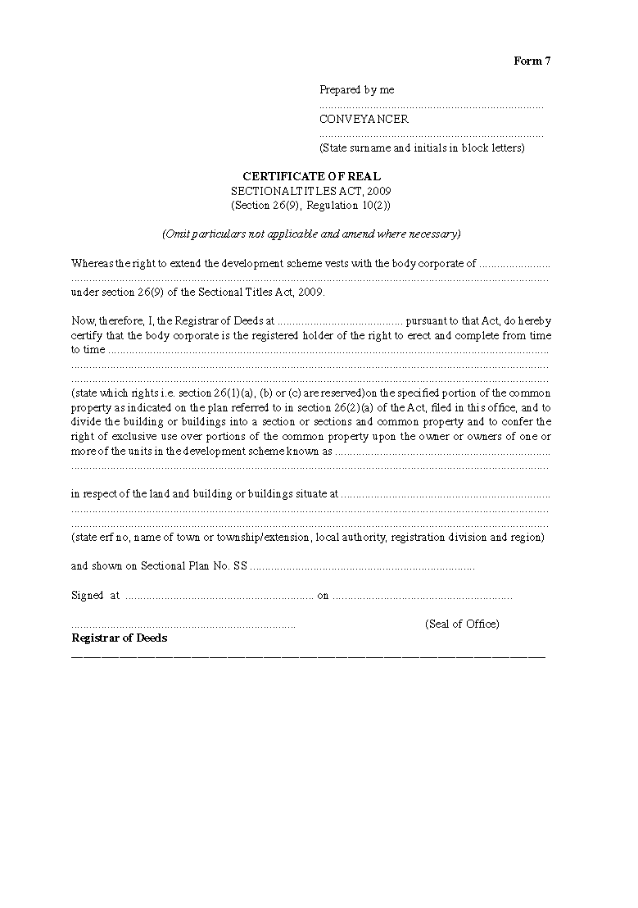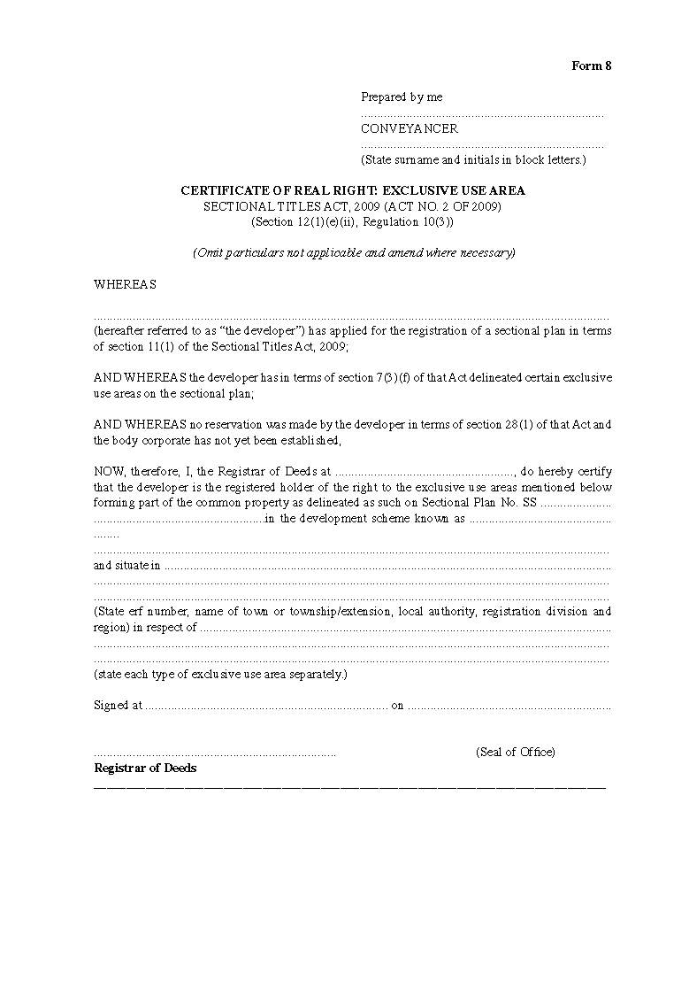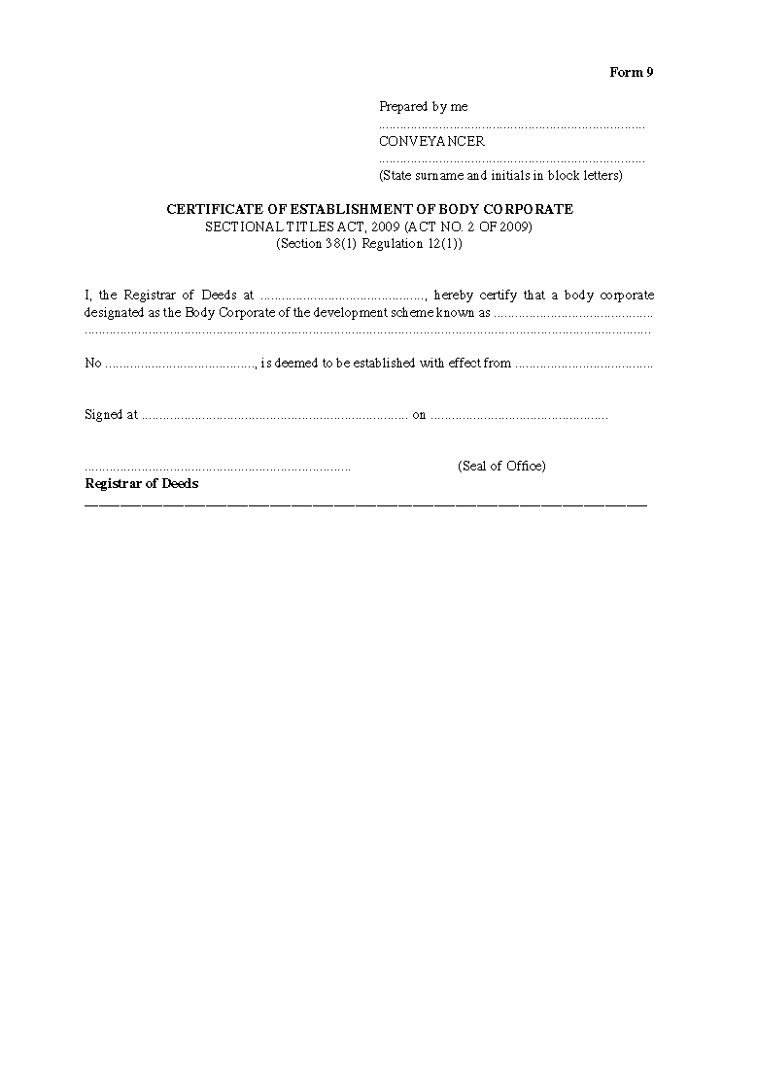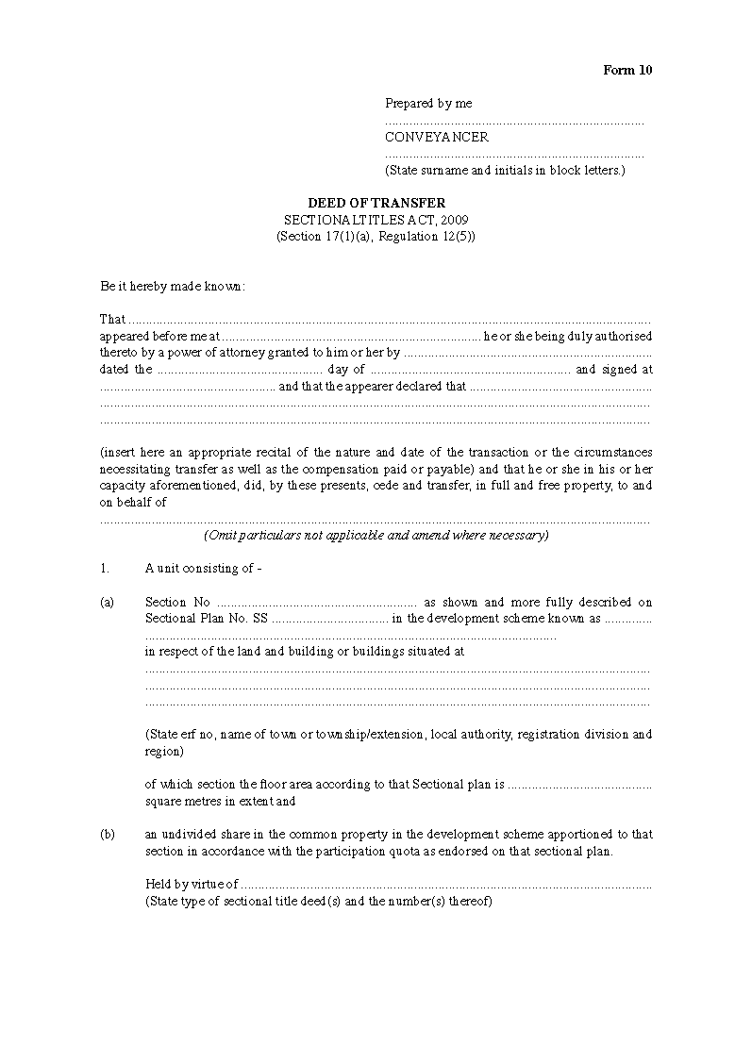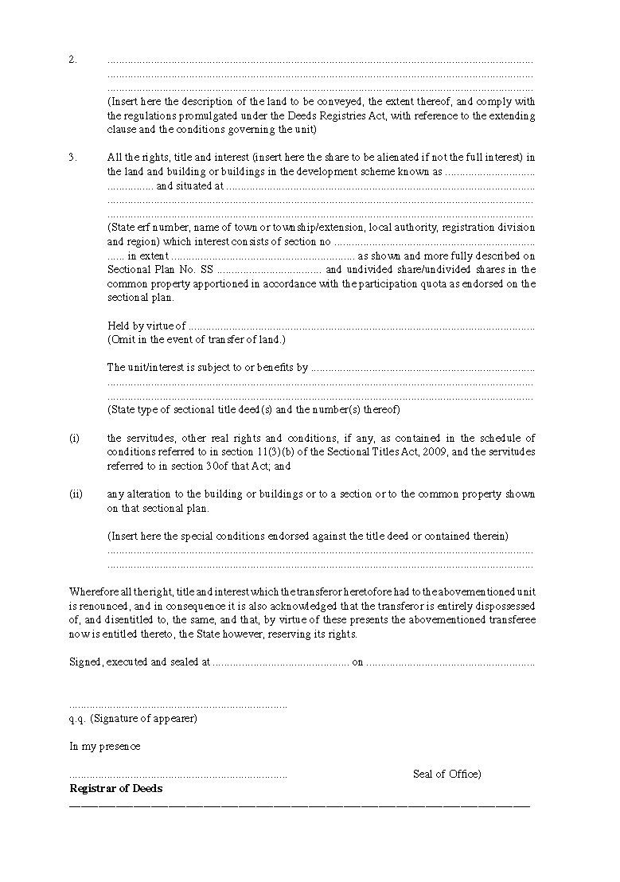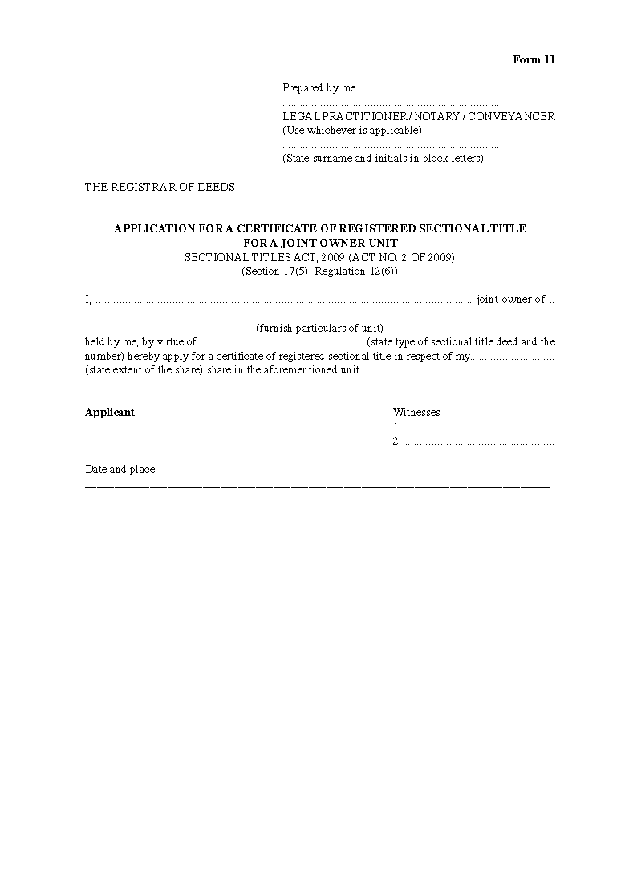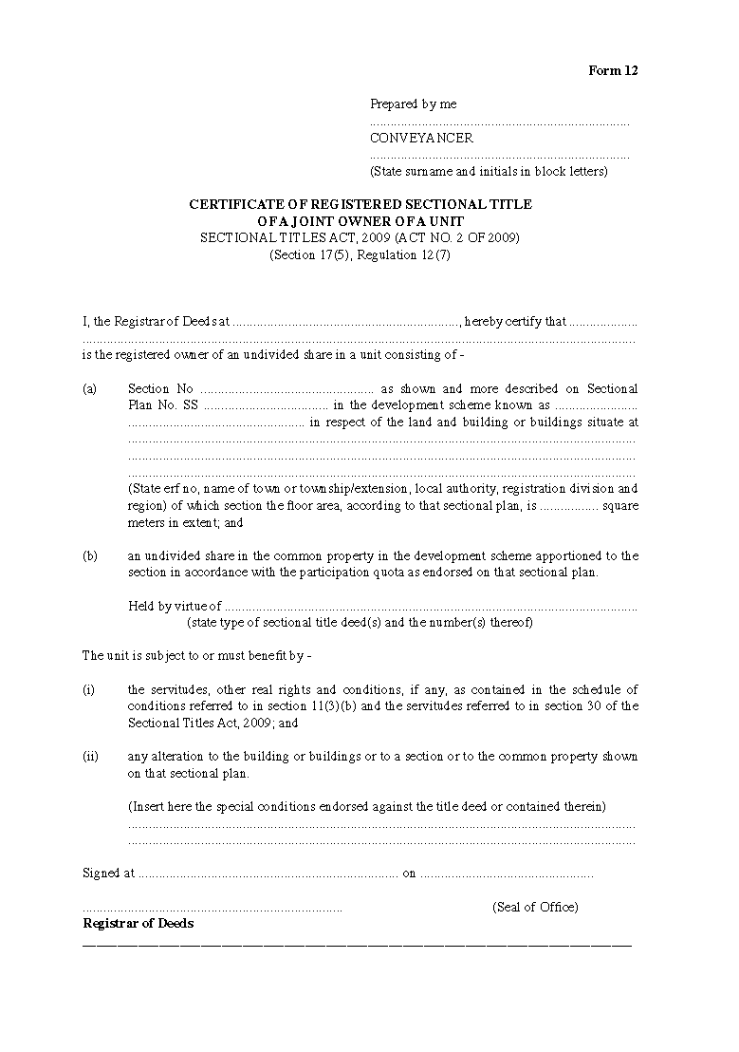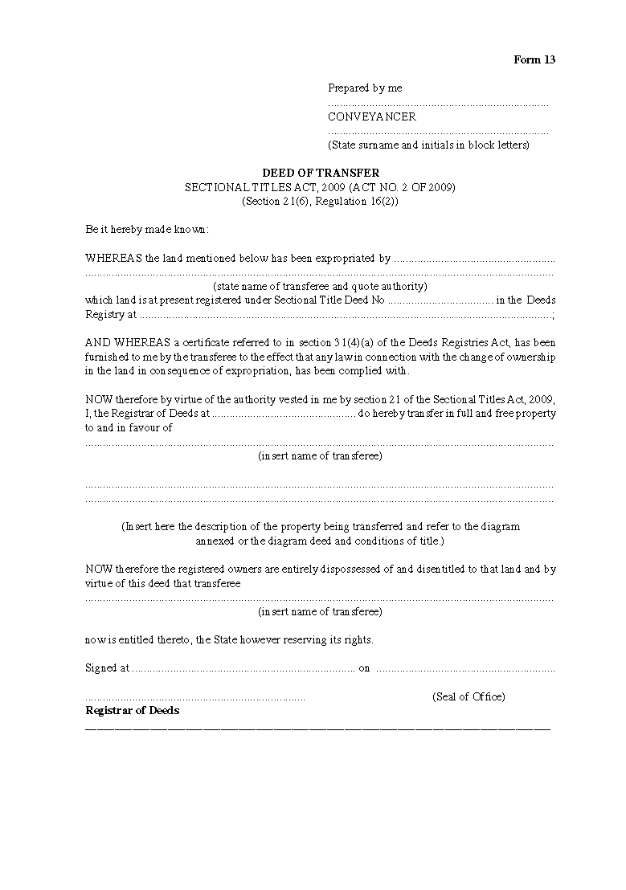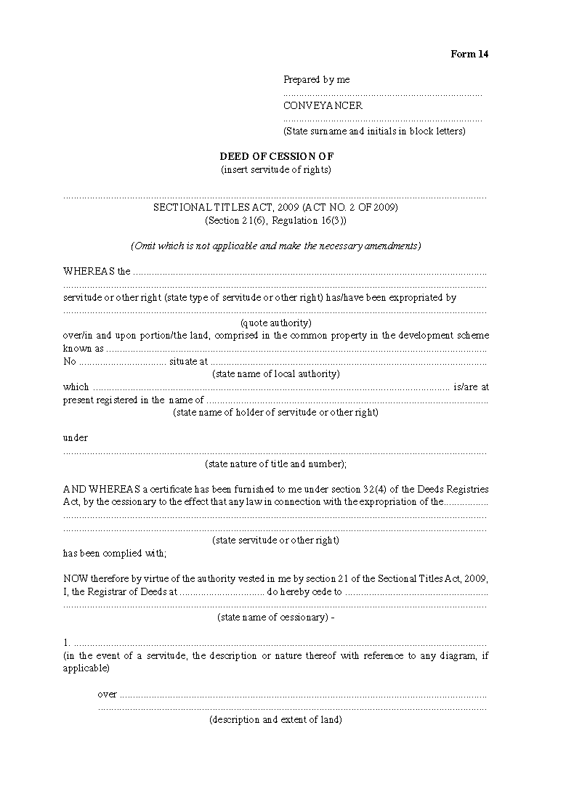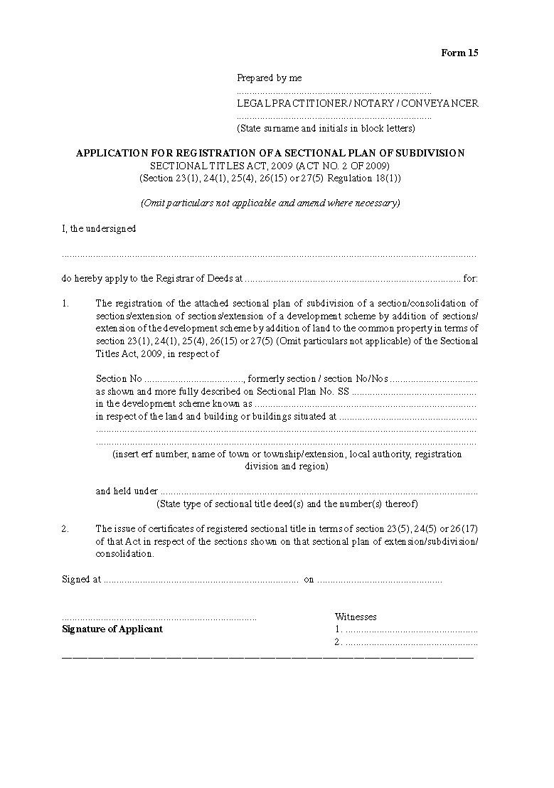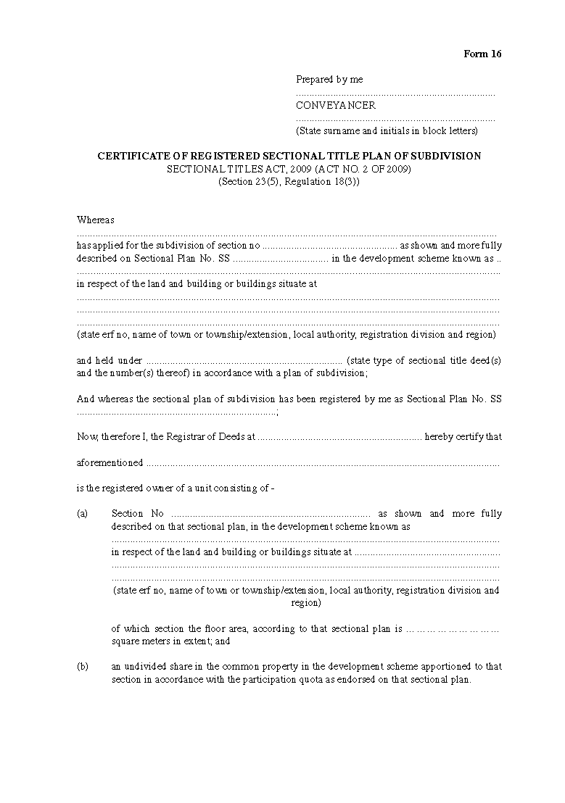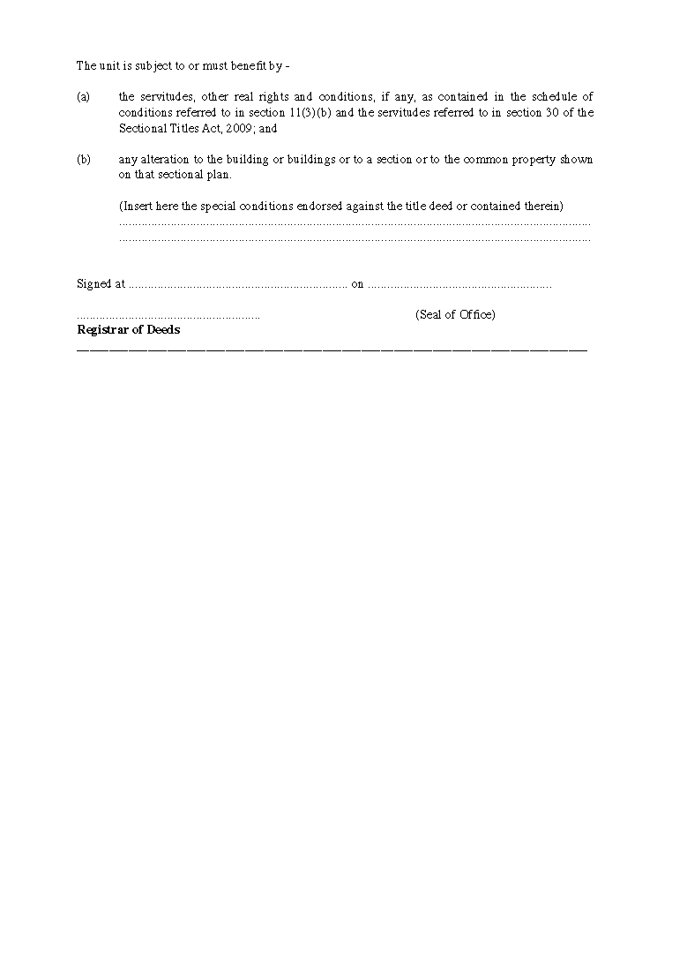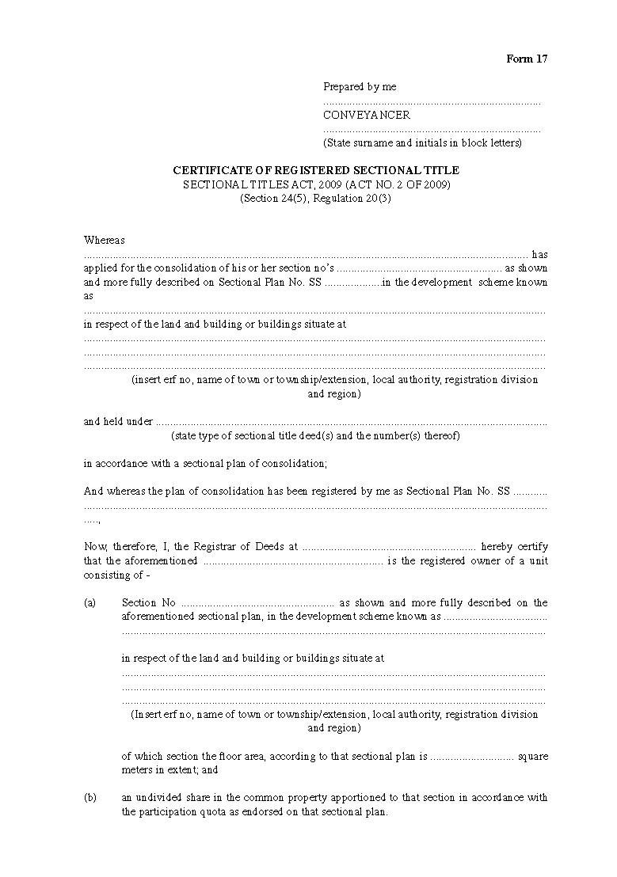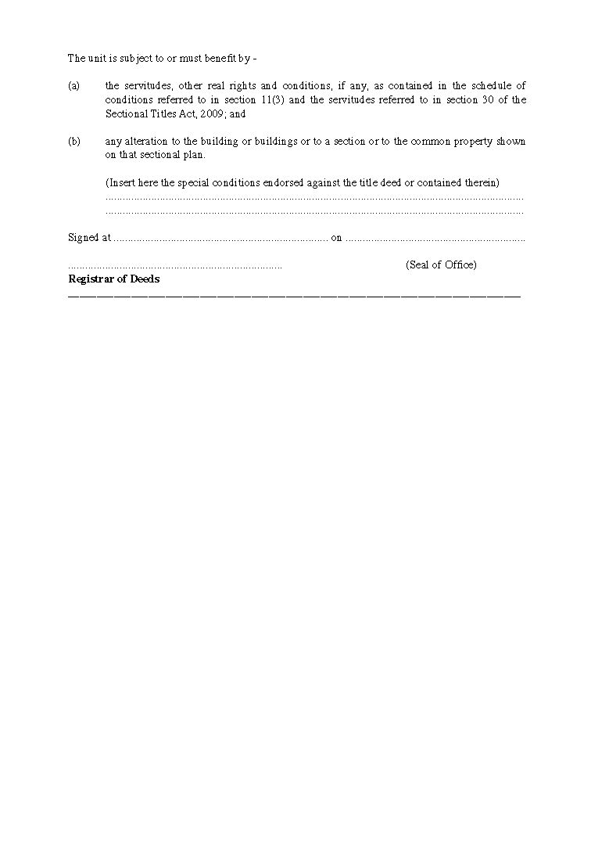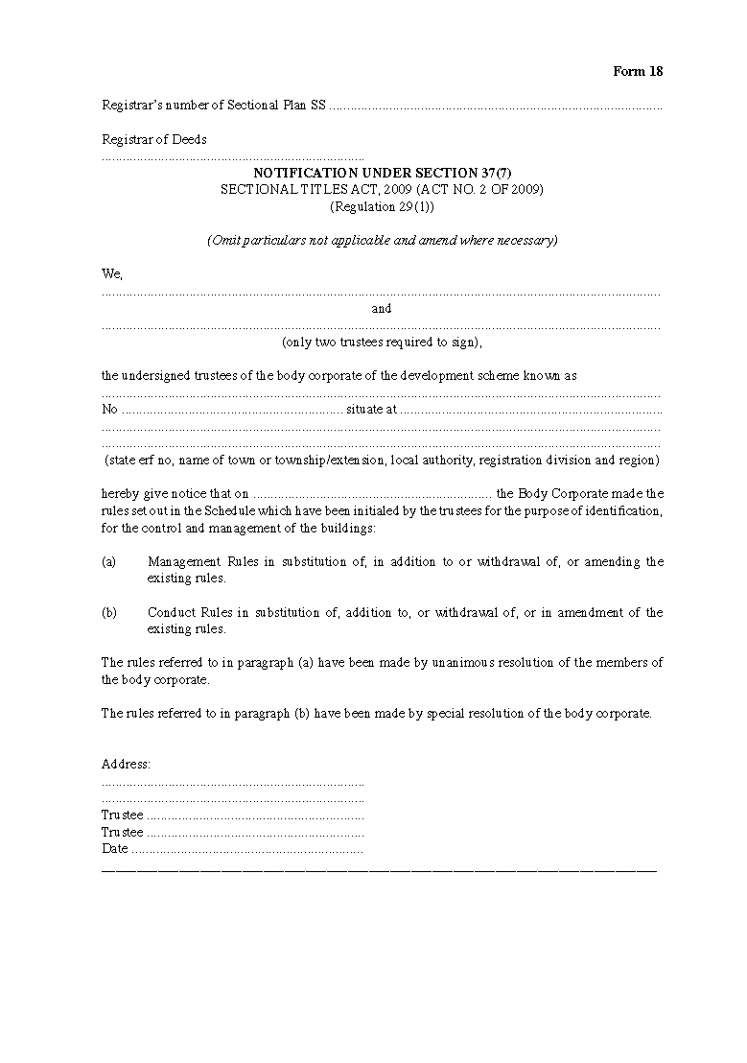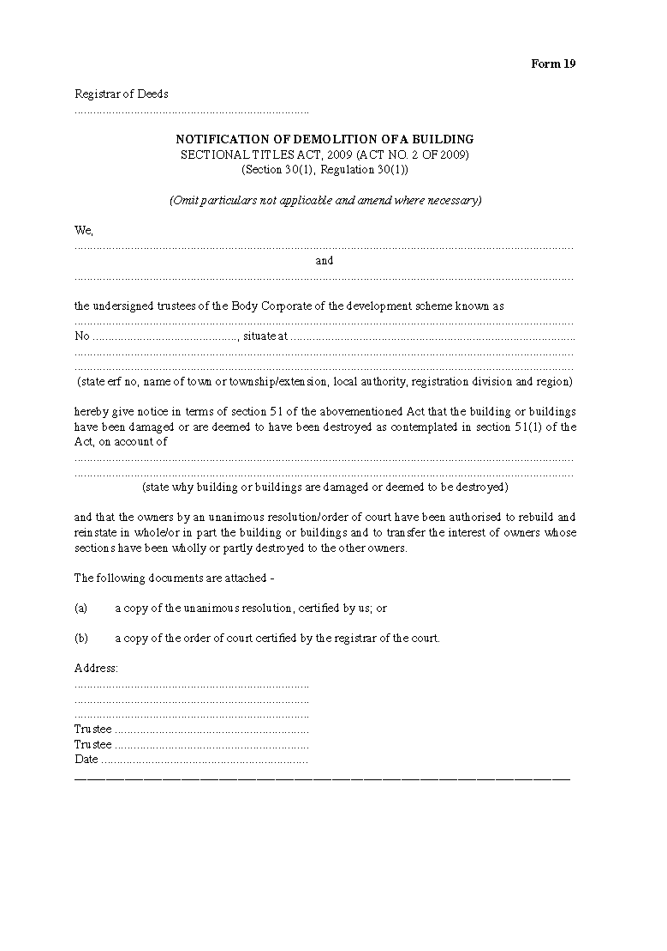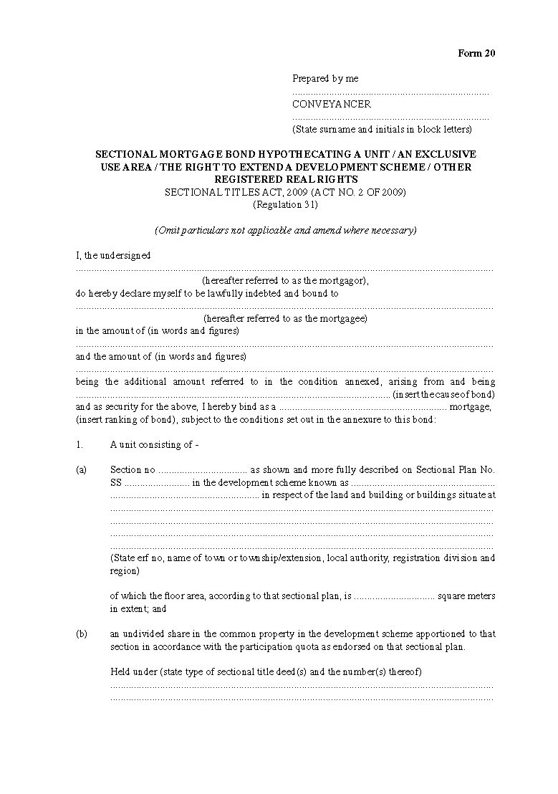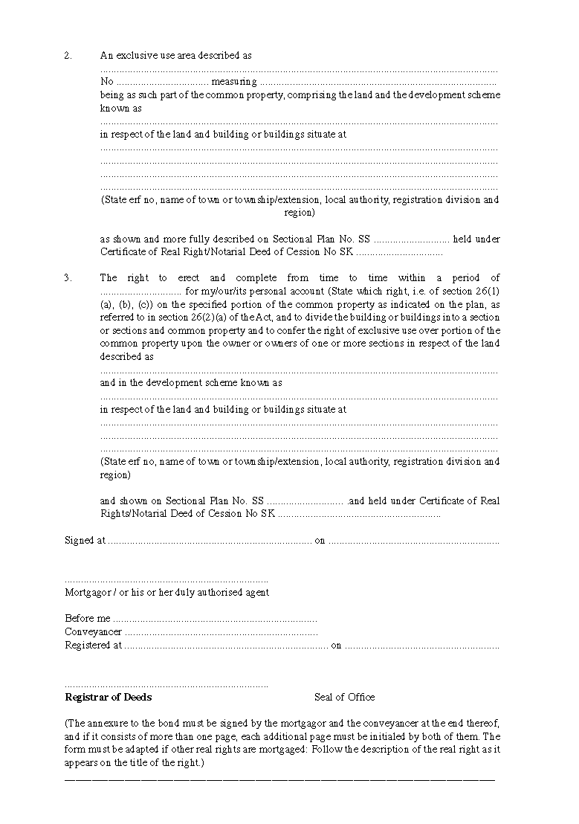

ANNEXURE 2

**FEES OF OFFICE: DEEDS REGISTRY**

SECTIONAL TITLES ACT, 2009 (ACT NO. 2 OF 2009)

(Regulation 32(1))

[Annexure 2 is substituted by GN 165/2023.]

|  |  |
| --- | --- |
|  | **N$** |
| 1.For the opening of a sectional title register - |  |
| (a) for the main file | 400 |
| (b) for each sub-file | 70 |
| 2.For the registration of a sectional plan, a plan of subdivision of a section, a plan of consolidation of sections, a plan in respect of the extension of sections, a plan in respect of extension of schemes and a plan of exclusive use areas | 400 |
| 3.For the cancellation of the registration of any sectional plan or exclusive use area | 200 |
| 4.For the registration of a deed of transfer | 400 |
| 5.For the registration of a bond securing immovable property | 400 |
| 6.For the registration of any notarial lease | 400 |
| 7. For the registration of any notarial cancellation or modification of any notarial lease | 400 |
| 8. For the registration of a certificate of registered sectional title | 400 |
| 9. For the registration of a deed of cession | 400 |
| 10. For the registration of a notarial bond or a cession of a bond | 400 |
| 11. For the registration of any notarial sublease and any notarial cession of any notarial lease or sublease | 400 |
| 12. For the registration of any notarial cancellation or modification of a notarial lease | 400 |
| 13. For the cancellation of the registration of any notarial lease or sublease which has lapsed by effluxion of time, on production of proof that the notarial lease or sublease has so lapsed | 200 |
| 14. For the cancellation or modification of a real right embodied in a notarial deed | 200 |
| 15. For each act of registration in relation to a sectional mortgage bond, of - |  |
| (a) a cancellation; |  |
| (b) a cancellation of a cession; |  |
| (c) a modification referred to in section 17(1)(c) of the Act | 200 |
| 16. For the cancellation of the registration of a section and the amendment of the sectional plan accordingly in terms of section 19(4) of the Act | 200 |
| 17. For the cancellation of sectional title deeds when the whole of land is transferred as referred to in section 19 of the Act, for each sectional title deed cancelled | 200 |
| 18. To revert land transferred pursuant to section 19 of the Act to the land register, including the noting of the reversion of the registered sectional plan and on the transferee’s certificate of registered sectional title and the issue to the transferee of a certificate of registered title; and if more than 10 sectional title deeds have to be cancelled as referred to in section 19(17) of the Act, for each such title deed above 10 | 650 |
| 19. For endorsing on a developer’s sectional title deeds the fact of the alienation in one transaction of the whole of the developer’s interest in land and the building or buildings thereon or of a share in the whole of such interest, for each endorsement | 200 |
| 20. For the making of a reference on the schedule referred to in section 11(3)(e) of the Act to special rules made for the control and management of a building or the addition, amendment or repeal of any rule | 150 |
| 21. For the making of an entry on a sectional plan of a notification referred to in section 52(1) of the Act | 70 |
| 22. For the making of an endorsement referred to in section 52(4) of the Act on the registered sectional plan and on the sectional title deeds of the owner of land - |  |
| (a) on the registered sectional plan 70 | 70 |
| (b) on each sectional title deed | 70 |
| 23. For a report to the court in connection with any application or action made by the registrar | 300 |
| 24. For a certified copy of - |  |
| (a) a deed, bond or document filed of record in a deeds registry and issued in terms of regulation 51 or 52 of the Deeds Registries Regulations made under the Deeds Registries Act, 1937 (Act No. 47 of 1937) and published in Government Notice No. 180 of 1 July 1996 (in this Annexure called “the Deeds Registries Regulations”), per deed, bond or document | 115 |
| (b) a deed filed of record in a deeds registry and issued in terms of regulation 53 of the Deeds Registries Regulations, per deed | 700 |
| 25. For the registration of any notarial deed not provided for in this Annexure | 200 |
| 26. For any endorsement, note or act of registration not provided for | 70 |
| 27. For the issue of a certificate compiled by the registrar on request from information contained in the registers or records preserved in the deeds registry, per certificate | 200 |
| 28. (a) For a search of any index to any register for each enquiry relating to a person, property or deed | 40 |
| (b) for obtaining a computer print or transmission by facsimile of copies for each enquiry relating to a person, property or deed | 40 |
| (c) for inspection of any one deed, document or folio, including any continuation thereof, of any register of the documents relating to any one property | 40 |
| (d) for inspection of any one file | 40 |
| (e) for any continuous search for information for each hour or part thereof | 300 |
| (f) for any search not specially provided for, a fee to be determined by the registrar, provided that the minimum fees must be: | 40 |
| 29. For furnishing to a local authority council or a regional council or any private stakeholder or statutory body or organ of the state a return containing particulars of properties transferred or mortgage bonds, per property contained in such return | 20 |
| 30. For the examination and registration of any deed or document which has been rejected by the registrar of deeds and relodged by the conveyancer or notary public, as the case may be | 250 |
| 31. For the taxation of a bill of fees: 5 per cent (5%) of the fees allowed; excluding any disbursements for transfer duty, stamp duty and fees of office  *EXEMPTION: No fees of office are payable in respect of the recording referred to in section 3(1)(w) of the Deeds Registries Act, 1937 (Act No. 47 of 1937) | |

ANNEXURE 3

**FEES OF OFFICE: SURVEYOR GENERAL**

SECTIONAL TITLES ACT, 2009 (ACT NO. 2 OF 2009)

(Regulation 32(2))

[Annexure 3 is substituted by GN 165/2023.]

|  |  |
| --- | --- |
|  | **N$** |
| 1. (a) For the examination, approval and certification of a sectional plan, including the additional copies thereof as may be prescribed by law and certification of a plan which has been lodged by the land surveyor or the architect, as the case may be | 2 500 |
| (b) For the examination, approval and certification of a plan which has been rejected by the Surveyor-General and re-lodged by the land surveyor or the architect, as the case may be | 1 250 |
| 2. (a) For the examination, approval and certification of a diagram of exclusive use area, irrespective of the number of copies required | 500 |
| (b) For the examination, approval and certification of a diagram which has been rejected by the Surveyor-General and re-lodged by the land surveyor | 250 |
| 3.For certifying a copy of a diagram of exclusive use area or sectional plan Submitted for certification, per sheet - |  |
| (a) A4 Paper Size 80 | 80 |
| (b) A3 Paper Size 100 | 100 |
| (c) A2 Paper Size 120 | 120 |
| (d) A1 Paper Size 140 | 140 |
| (e) A0 Paper Size | 160 |
| 4. For faxing or emailing information on an A4 size sheet | 50 |
| 5. For the preparation of a report or statement intended to be used in legal proceedings. | 925 per hour |
| 12. For any work or service not specified in this Annexure | 925 per hour |
| *“N.B.” The fees prescribed under paragraph[s] 1(b) and 2(b) are borne directly by Land Surveyors and Architects as punitive measures against sub-standard work. They must not be passed-on to clients.* | |

ANNEXURE 4

**TARIFF OF CONVEYANCING, NOTARIAL AND OTHER   
LEGAL PRACTITIONERS FEES**

SECTIONAL TITLES ACT, 2009 (ACT NO. 2 OF 2009)

(Regulation 33)

[Annexure 4 is substituted by GN 165/2023.]

**General**

**1.** (1) The fees specified in this Tariff include the fees for all correspondence and also include the fees for -

(a) the taking and giving of instructions, including the perusal of deeds of sale;

(b) the preparation and attendance on signature of powers of attorney, declarations, affidavits, conveyancers’ certificates, resolutions and other necessary preliminary and ancillary documents;

(c) the payment of transfer duty and of any moneys due to the body corporate;

(d) the obtaining or making of all clearance or other certificates;

(e) the obtaining of endorsements or copies of documents from the office of the Master or other public offices;

(f) the perusal of memoranda and articles of association, constitutions, identity documents and trust deeds;

(g) the making of all necessary financial arrangements, including the provision and checking of guarantees and attending on payment in terms thereof;

(h) the drawing and preparation of any document, including all copies thereof, required for execution or registration at a deeds registry and the obtaining of registration thereof, arranging simultaneous lodgement and registration with another conveyancer or other conveyancers, where necessary;

(i) the giving of all references required by the deeds registry; and

(j) all attendances at the deeds registry, but does not include –

(i) any attendance in connection with the drawing and execution of deeds of sale, deeds of donation, partition agreements, amendments to the rules for bodies corporate, special developers conditions, deeds of suretyship, acknowledgements of debt, rules for the body corporate or documents of a similar nature;

(ii) any separate act or registration of any other documents which may be necessary before or in connection with the act of registration;

(iii) any attendance in connection with the resolution of a dispute between the transferor and the transferee arising from a deed of sale or any of the other documents referred to in paragraph (a) or from whatsoever cause; and

(iv) any attendance arising from negotiations between the parties resulting in a further agreement or addendum or amendment to an existing agreement.

(2) If the work necessary to perform any act under the Act or these Regulations is partly performed by one legal practitioner, conveyancer, or notary (hereafter called “the instructed” legal practitioner, conveyancer, or notary), on the instructions received from another legal practitioner, conveyancer, or notary (hereafter called “the instructing” legal practitioner, conveyancer, or notary), both the instructed and instructing legal practitioner, conveyancer or notary are entitled to a fee, apportioned as set out in the relevant Part in item 2 and payable out of the total fee.

(3) If this Tariff provides for a specific or proportionate fee for lodgement, the fee is the fee payable by the instructing legal practitioner, conveyancer, or notary to the instructed legal practitioner, conveyancer, or notary, for all attendances in connection with the lodgement (and where necessary, registration), of any document, including arranging simultaneous lodgements, giving necessary references and all other attendances and correspondence in connection with the lodgement and registration and is payable out of the total fee.

(4) For the purpose of this tariff -

(a) “a folio” means a 100 printed or written words or figures or part thereof, and four figures are deemed to be one word;

(b) “value of the property” means -

(i) if transfer duty is payable, the purchase price of the property or the amount on which transfer duty is payable, whichever amount is the higher;

(ii) if no transfer duty is payable in terms of section 9(2) of the Transfer Duty Act, 1993 (Act No. 14 of 1993), the purchase price of the property or the declared value as determined under that Act, whichever amount is the higher;

(iii) if no transfer duty is payable in terms of any provision of section 9 of the Transfer Duty Act, 1993, other than section 9(2), but an official valuation (be it from a regional council, village council, town council or municipal council or from the Master of the High Court), is available, the valuation or the consideration paid, whichever amount is the higher, provided that if no official valuation is available, it is considered to be the fair value of the property as defined in the Transfer Duty Act, 1993;

(iv) where no consideration is payable in respect of the acquisition of the property and no regional council, village council, town council or municipal council or other official valuation is available, the value is deemed to be not less than N$200 000;

(v) the local authority valuation if available, alternatively the fair market value where the property has either been sold in execution, or by public auction at the instance of a liquidator or trustee and the purchase price was less than the valuation.

**Fees**

**2.** The fees and charges payable to conveyancers, notaries public and other legal practitioners are as follows:

**Part I: Application for the opening of a sectional title register**

|  |  |
| --- | --- |
| (a) For preparing and drawing an application for the opening of a sectional title register, perusing sectional plan, drawing certificates of registered sectional title, correspondence and attendance on all matters referred to in section 11 of the Act, but excluding the drawing of the consents of bondholders or holders of other real rights, or searches in a deeds registry or other public office or of the rules of the body corporate: | |
| (i) A basic fee of | N$ 3 000 |
| (ii) For each section | N$ 300 |
| (iii) If the instructed conveyancer also draws the certificate of registered sectional title, for each section | N$ 150 |
| (b) Apportionment of the fees set out in this Part: | |
| (i) For lodgement | 20% |
| Plus for each section | N$ 40 |
| If the instructed conveyancer also draws the certificate of registered sectional title, for each section | N$ 150 |
| (ii) If the instructed conveyancer, in addition to the work contemplated in subparagraph (i), issues a certificate referred to in section 11(3)(b) of the Act, he or she is in addition to the fee prescribed in that paragraph, entitled to a further sum out of the total fee assessed according to the length and complexity of the search in question and in consultation with the instructing legal practitioner. |  |

**Part II: Transfer of ownership**

|  |  |
| --- | --- |
| (a) For registration of transfer of ownership of a unit or land held under a sectional title deed, the fee is as set out in of Schedule 1 to this Annexure in respect of the purchase price or value of the transaction as shown in that Schedule: Provided that in the case of a conveyance in terms of which a certificate is issued by the appropriate governmental or other institution to the effect that the property in question is of a low cost housing nature, the fee is 60% of the amount set out in of Schedule 1 of this Annexure. | |
| (b) For more than one section included in the same transaction, for each additional section an additional fee of | N$ 150 |
| *(****Note:*** *If transfer of ownership is registered as a result of expropriation under any law or if a person becomes entitled to deal with a unit or land as if he or she had taken formal transfer into his or her name by virtue of an endorsement by the Registrar, the fee is 60% of the relevant amount set out in of Schedule 1 of this Annexure.)* | |
| (c) Apportionment of the fees set out in paragraphs (a) and (b): | |
| (i) For lodgement, of the total fee | 20% |
| (ii) If the instructed conveyancer, in addition to the work contemplated in subparagraph (i), also prepares the deed of transfer referred to in section 17(10) of the Act, the conveyancer is in addition to the fee prescribed in that paragraph entitled to a further 60% of the total fee. |  |

**Part III: Partition transfers**

|  |  |
| --- | --- |
| (a) For the drawing and registration of each deed of partition transfer, including all preliminary and other work in connection therewith, but excluding attendances in connection with the framing of any provisional agreement | N$ 3 000 |
| (b) For more than one section or subdivision transferred in any one deed of transfer, for each additional section or subdivision an additional fee of | N$ 100 |
| (c) Apportionment of the fees set out in paragraphs (a) and (b): | |
| (i) For lodgement, of the total fee | 20% |
| (ii) If the instructed conveyancer, in addition to the work contemplated in subparagraph (i), also prepares the deed of transfer referred to in section 17(1) of the Act, the conveyancer is in addition to the fee prescribed in that paragraph entitled to a further 60% of the total fee. |  |

**Part IV: Transfer by endorsement in terms of Administration of Estates Act, 1965**

|  |  |
| --- | --- |
| (a) For drawing all necessary documents, obtaining necessary ancillary documents, consents and certificates from the Master of the High Court, and all necessary attendances and correspondence in connection therewith, including obtaining registration | N$ 600 |
| (b) Apportionment of the fees set out in paragraph (a): | |
| For lodgement | 20% |

**Part V: Subdivision, consolidation and extension of sections or schemes**

|  |  |
| --- | --- |
| (a) For drawing and submitting an application for sub-division and preparing certificates of registered sectional title, together with supporting documents, perusing plan of subdivision or consolidation, obtaining registration, correspondence and attendance on all matters referred to in section 22 and, in the case of a subdivision of a section, section 23 of the Act, and in the case of extension of a section, section 25,26 or 27 of the Act, but excluding the drawing of the consents of bond holders or holders of other real rights | N$ 2 000 |
| (b) If subdivision into more than two sections is required, for each additional section | N$ 250 |
| (c) Apportionment of the fees set out in paragraphs (a) and (b): | |
| (i) For lodgement | 20% |
| (ii) Plus for each section | N$ 100 |

**Part VI: Application for sectional title deed in respect of undivided share in unit**

|  |  |
| --- | --- |
| (a) For preparing a certificate of registered sectional title in respect of undivided share, including application, correspondence and attendances on all matters referred to in section 17(5) of the Act | N$ 1 400 |
| (b) Apportionment of the fees set out in paragraph (a) - | |
| (i) for lodgement | 20% |
| (ii) if the instructed conveyancer, in addition to the work contemplated in subparagraph (i), also draws the certificate of registered sectional title, the conveyancer is entitled to 60% of the total fee. |  |

**Part VII: Application for certificate of registered sectional title for portion of common property**

|  |  |
| --- | --- |
| (a) For preparing a certificate of registered sectional title, including application in respect of a portion of land comprised in common property, correspondence and attendances on all matters referred to in section 19(3) of the Act | N$ 1 400 |
| (b) Apportionment of the fees set out in paragraph (a) - | |
| (i) for lodgement | 20% |
| (ii) if the instructed conveyancer, in addition to the work contemplated in subparagraph (i), also draws the certificate of registered sectional title, the conveyancer is entitled to 60% of the total fee. |  |

**Part VIII: Reversion from sectional title register to land register**

|  |  |
| --- | --- |
| (a) For attending to all matters referred to in section 19(4) and (17) of the Act: | |
| (i) A basic fee of | N$ 2 200 |
| (ii) For each section | N$ 100 |
| (b) Apportionment of the fees set out in paragraph (a) - | |
| (i) for lodgement | 20% |
| Plus for each section | 40% |
| (ii) if the instructed conveyancer, in addition to the work contemplated in subparagraph (i), also draws the documents referred to in section 19(4) and (17) of the Act | N$ 1 400 |
| Plus for each section | N$ 100 |

**Part IX: Sectional Mortgage Bonds**

|  |  |
| --- | --- |
| (a) For registration of any sectional mortgage bond or surety bond other than a bond referred to in paragraph (b) of this Part, including the drawing of all necessary documents and the obtaining of necessary ancillary documents, the fee is as set out in Schedule 2 to this Annexure in respect of an amount of the bond as shown in that Schedule. Provided that for all bonds where the amount is N$500 000 or less and a certificate is issued by the appropriate governmental or other institution to the effect that the property in question is of a low cost housing nature, the fee is 60% of the amount set out in Schedule 2 of this Annexure. | |
| (b) For any collateral bond passed as additional security for another bond between the same parties the fee is 60% of the fee set out in Schedule 2 to this Annexure. | |
| (c) For more than one unit included in a bond referred to in paragraph (a) or (b) of this Part, for each additional unit an additional fee of | N$ 200 |
| (d) For purposes of determining a fee charged under paragraph (a) of this Part, the amount of the bond on which stamp duty is being levied, must be used, and in the event of a bond exempted from stamp duty, the amount on which stamp duty would have been levied had the bond in question not been exempted, must be used. | |
| (e) Apportionment of fees set out in this Part – | |
| (i) for lodgement, of the total fee | 20% |
| (ii) if the instructed conveyancer, in addition to the work contemplated in subparagraph (i), also signs the bond as preparer and files the same in the conveyancers’ file in terms of regulation 36(1)(c), the conveyancer is in addition to the fee prescribed in that paragraph entitled to a further 50% of the total fee. |  |

**Part X: Cession, cancellation or modification of bonds**

|  |  |
| --- | --- |
| (a) (i) For drawing a consent to cancellation of a bond, consent to cancellation of a cession of a bond, release of property or person from a bond, consent to reduction of cover, consent to part payment of capital, framing waiver of preference in regard to the ranking of a bond, waiver of preference in respect of real rights in land, consent of a mortgagee, usufructuary, lessee or holder of any other limited interest required by the Act or these Regulations and not otherwise provided for in this Annexure (not notarial) and attending registration thereof, including instructions, correspondence and all relevant attendances, except attendances at the office of the Master of the High Court | N$ 1 800 |
| Provided that in cases where there are no financial arrangements to be made by the conveyancer, the fee is | N$ 800 |
| (ii) For attending to all matters referred to in subparagraph (i) in respect of any second or subsequent bond when any relevant document has been drawn by the same conveyancer who drew the corresponding document or documents in connection with the first bond between the same parties over the same property, and the documents are or can be lodged simultaneously as a set, per bond | N$ 360 |
| (iii) For every additional unit included in a release contemplated in subparagraph (i) after the first two units, an additional fee of | N$ 200 |
| (b) For drawing a cession of bond or application for endorsement, including instructions and drawing consent of mortgagor where necessary, attendances on mortgagor and mortgagee, correspondence and all relevant attendances including registration, but excluding attendances on the office of the Master of the High Court | N$ 1 200 |
| Provided that in cases where there are no financial arrangements to be made by the conveyancer, the fee is | N$ 800 |
| (c) For drawing consents to substitution under section 57 of the Deeds Registries Act, 1937 (Act No. 47 of 1937) including instructions, all attendances on mortgagee and new debtor, correspondence and miscellaneous attendances, including registration, but excluding attendances on the Office of the Master of the High Court, the fee is 60% of the fees for bonds as set out in Schedule 2 of this Annexure. | |
| (d) If any of the documents referred to in this Part are required to be signed by more than one mortgagee, mortgagor, usufructuary, lessee or holder for any other limited interest, for each such additional person after the first, an additional fee of | N$ 120 |
| (e) If it is necessary to attend the office of the Master of the High Court in connection with any matter referred to in subparagraph (i) of paragraph (a) or (b), the following additional fees are allowed: | |
| (i) for obtaining any certificate of the Master of the High Court, per estate for any number of such certificates which are or can be applied for simultaneously | N$ 470 |
| (ii) for obtaining copies of all necessary documents which are or can be included in one application, per estate | N$ 300 |
| (f) For drawing consents to substitutions in terms of section 24bis(3), 45(2)(b) or 45bis(2) of the Deeds Registries Act, 1937 (Act No. 47 of 1937) including instruction, all attendances on mortgagee and new debtor, correspondence and miscellaneous attendances, including registration but excluding attendances at the office of the Master of the High Court | N$ 1 200 |
| Provided that in cases where there are no financial arrangements to be made by the conveyancer, the fee is | N$ 800 |
| (g) Apportionment of the fees set out in this Part - | |
| (i) for lodgement | 20% |
| (ii) for each further bond | N$ 150 |

**Part XI: Notarial Deeds**

|  |  |
| --- | --- |
| (a) For framing any notarial lease, sublease, servitude or other notarial deed and obtaining registration thereof, a fee assessed according to the length and complexity thereof, with a minimum fee of | N$ 2 300 |
| (b) For drawing any notarial waiver of preference by mortgagee, usufructuary, or other holder of a limited interest, or other notarial consent required under the Act or these Regulations and obtaining registration thereof | N$ 2 300 |
| (c) Apportionment of fees set out in this Part - | |
| (i) for lodgement, of the total fee | 20% |
| (ii) if the instructed notary, in addition to the work contemplated in subparagraph (i), also executed the deed as notary, he or she is entitled to 60% of the total fee. |  |

**Part XII: Miscellaneous**

|  |  |
| --- | --- |
| (a) For attendance on behalf of a transferor or transferee, mortgagor or mortgagee, supervising the registration of the transfer or bond or supervising the bond when the documents are prepared and lodged by another conveyancer, including all instructions, correspondence and miscellaneous attendances relevant to the supervision - | |
| (i) if the value of the property or the amount of bond does not exceed N$200 000 | N$ 460 |
| (ii) if the value of the property or the amount of the bond exceeds N$200 000 | N$ 920 |
| (b) (i) For attendance and searching at the deeds registry for information required in respect of any deed or matter registered under the Act, other than information required for preparation of a document otherwise provided for in this Annexure, including instructions, correspondence and relevant attendances, per quarter hour or part thereof | N$ 260 |
| (ii) Reporting per folio | N$ 100 |
| (iii) For attendance and searching at the deeds registry for research and searching for the necessary information in connection with the opening of the register and registration of the sectional plans, including correspondence and all relevant attendances per quarter hour or part thereof | N$ 260 |
| (iv) Reporting per folio | N$ 100 |
| (c) For drawing any certificate by a conveyancer with regard to servitudes, other real rights or conditions if not otherwise provided for in this Annexure | N$ 220 |
| (d) For drawing a certificate of establishment of any body corporate under section 38(1) of the Act, lodging the same, including all correspondence and attendances in connection therewith | N$ 220 |
| (e) For drawing a consent required in terms of section 26 of the Act, including all correspondence and attendances in connection therewith, including lodging | N$ 1 200 |
| (f) For any matter not herein provided, the fee charged in respect thereof, and the apportionment of the fee is in accordance with the tariff of fees prescribed by regulation 65 of the Deeds Registries Regulations. | |
| (g) Apportionment of fees set out in this Part: |  |
| (i) In respect of paragraphs (a), (b) and (c): (No apportionment)  *(Remark: Note 2 below may apply in circumstances contemplated in that note)* | |
| (ii) In respect of paragraph (d): | |
| For lodgement | N$ 60 |
| For drawing certificate and lodgement | N$ 120 |
| (iii) In respect of paragraph (e): |  |
| For lodgement | N$ 120 |
| *(****Note:*** 1. *Fees and percentages specified are nett and are not subject to any allowance, the customary one-third allowance having been taken into account in the apportionments.*  *2.*  *If the instructing legal practitioner, conveyancer or notary merely takes instructions from his or her client and thereafter sends his or her whole file to the instructed legal practitioner, conveyancer or notary, who then does all the work, the former is as a general rule entitled to 15% and the latter to 85%, of the total fee).* | |

**Application of fees for preliminary work**

**3.** If a legal practitioner, conveyancer or notary attending to the preliminary work in connection with any conveyancing matter requests another legal practitioner, conveyancer or notary to do part of that preliminary work, the former must pay the latter from his or her share of the fees, the following:

|  |  |
| --- | --- |
| (a) For obtaining all necessary endorsements from the Master of the High Court for any number of certificates which are or can be applied for simultaneously, per estate | N$ 240 |
| (b) For obtaining copies of documents required for lodgement in a deeds registry which are or can be included in one application (exclusive of searches), per application | N$ 75 |
| (c) For obtaining a clearance or other similar certificate from a public or local authority or a body corporate, per certificate | N$ 120 |
| (d) For attending to the payment of transfer duty, stamp duty and obtaining endorsements of certificates referred to in section 17 of the Act | N$ 120 |
| (e) For any other attendance, per half hour or part thereof | N$ 120 |
| (f) For drawing any document, per folio or part thereof | N$ 60 |
| (g) For perusing and certifying guarantee for payment | N$ 120 |

*(****Note****: The above fees are nett and are not subject to any allowance, the customary one-third allowance having been taken into account).*

**Wasted costs**

**4.** The following is a guideline for the apportionment of fees where a mandate is terminated at any stage before execution or registration, as the case may be:

|  |  |
| --- | --- |
|  | **Total fee** |
| (a) For attendances on taking instructions and planning of the transaction, 20% of prescribed fee | 20% |
| (b) For drawing preliminary documents, an additional 20% of prescribed fee | 40% |
| (c) For attendances on signatures of preliminary documents, an additional 10% of prescribed fee | 50% |
| (d) For attendances on completion of all necessary financial arrangements before lodgement, an additional 20% of prescribed fee | 70% |
| (e) For drawing and preparing a deed for execution or document of registration, an additional 10% of prescribed fee | 80% |
| (f) For lodgement, an additional 10% of prescribed fee | 90% |

**Application of this tariff**

[This provision should be numbered as “5.” instead of “3.”.]

**3.** (1) The fees referred to in -

(a) Schedule 1 below are payable in respect of the conveyance of immovable property;

(b) Schedule 2 below are payable in respect of the registration of mortgage bonds.

(2) This tariff of fees applies only in relation to any act -

(a) in respect of which the fees referred to in this tariff are payable; and

(b) which is performed by a legal practitioner, conveyancer or notary public in connection with any transaction in respect of which he or she received an instruction on or after the date of commencement of these regulations.

**SCHEDULE 1**

The fees for registration of immovable property are as follows:

(a) where the value of the property is less than N$100 000, the fee is N$3 000;

(b) where the value of the property is N$100 000 or more, but less than N$300 000, the fee is N$4 500;

(c) where the value of the property is N$300 000 or more, but less than N$500 000, the fee is N$6 000;

(d) where the value of the property is N$500 000 or more, but less than N$600 000, the fee is N$6 800;

(e) where the value of the property is N$600 000 or more, but less than N$1 000 000, the fee is N$10 260 plus N$1 200 per N$100 000 or part thereof above N$600 000;

(f) where the value of the property is N$1 000 000 or more, but less than N$5 000 000, the fee is N$16 260 plus N$1 200 per N$200 000 or part thereof above N$1 000 000;

(g) where the value of the property is N$5 000 000 or more, the fee is N$40 260 plus N$1 600 per N$500 000 or part thereof above N$5 000 000.

**SCHEDULE 2**

The fees for the registration of a bond are as follows:

(a) where the amount of the bond is less than N$100 000, the fee is N$2 500;

(b) where the amount of the bond is N$100 000 or more, but less than N$300 000, the fee is N$3 500;

(c) where the amount of the bond is N$300 000 or more, but less than N$500 000, the fee is N$5 000;

(d) where the amount of the bond is N$500 0000 or more, but less than N$600 000, the fee is N$6 000;

[The amount “N$500 0000” was probably intended to be “N$500 000”.]

(e) where the amount of the bond is N$600 000 or more, but less than N$1 000 000, the fee is N$10 0000 plus N$1 000 per N$100 000 or part thereof above N$600 000;

[The amount “N$10 0000” was probably intended to be “N$10 000”.]

(f) where the amount of the bond is N$1 000 000 or more, but less than N$5 000 000, the fee is N$15 000 plus N$ 1 000 per N$200 000 or part thereof above N$1 000 000;

(g) where the amount of the bond is N$5 000 000 or more, the fee is N$35 000 plus N$1 400 per N$500 000 or part thereof above N$5 000 000.

***Note:*** *The above recommended tariff of fees is exclusive of VAT and office fees.*

ANNEXURE 5

**FEES PAYABLE TO LAND SURVEYORS AND ARCHITECTS FOR PREPARATION**

**OF DRAFT SECTIONAL PLAN, SECTIONAL PLAN OR OTHER PLAN**

SECTIONAL TITLES ACT, 2009 (ACT NO. 2 OF 2009)

(Sections 6 and 26, Regulation 34(1))

[Annexure 5 is substituted by GN 165/2023.]

1. For Sheet 1:

An amount of N$3 730, plus -

(a) N$150 per building being described;

(b) N$150 for a caveat, if applicable; and

(c) N$375 for each reference to previous phases, if applicable.

2. For Sheet 2 (Block Plan), excluding the determination of cadastral boundaries:

An amount of N$3 730, plus -

(a) N$352 per building depicted thereon;

(b) N$14 per square metre of the total area of the depicted common property buildings;

(c) N$2 140 if exclusive use areas on the ground are depicted on this sheet.

***Note:*** *For the determination of the cadastral boundaries and the placement/relocation of the property beacons the recommended Land Survey Act tariff is applicable.*

3. For floor plans:

An amount of N$3 730, plus N$18 per square metre for all sections of floor area as depicted on the participation quota schedule plus the amounts under item 4.

4. For the participation quota schedule:

An amount of N$3 995, plus N$150 per section depicted thereon.

5. For exclusive use plans:

(a) For exclusive use areas where the boundaries thereof are determined by buildings or physical features:

An amount of N$3 145 per exclusive use area sheet, plus N$22 per square metre of the total area of the depicted exclusive use areas.

(b) For exclusive use areas where the boundaries thereof are neither determined by buildings, nor physical features:

An amount of N$3 145 per exclusive use area sheet, plus N$40 per square metre of the total area of the depicted exclusive use areas.

***Note:*** *For exclusive use areas which are bigger than 200 square metres, the recommended Tariff of Fees published for work done in terms of the Land Survey Act is applicable in respect of the determination of this amount.*

6. For cross-sections:

An amount of N$3 130 per building where cross-sections are considered necessary, plus -

(a) N$198 per floor shown on such cross-sections; and

(b) N$16 per section depicted thereon.

7. For any matter relating to the preparation of a draft sectional plan not herein mentioned, the following fees are charged:

(a) For a principal or partner, N$925 per hour;

(b) For qualified staff, N$775 per hour;

(c) For unskilled staff, N$650 per hour.

8. General:

8.1 The fees referred to in paragraphs 1 to 7, inclusive, may be increased or decreased by up to 20% depending on the ease or difficulty of access, regular or irregular buildings, curvilinear, walls or obstructions.

8.2 Direct expenses incurred, such as plan printing costs and material and dispatching costs may be recovered at cost plus 10%.

8.3 Travelling and subsistence costs must be charged according to the Land Survey Act.

***Note:*** *1. The above recommended tariff of fees is exclusive of VAT and office fees.*

*2. The fees specified include the taking of instructions and attendance in the office of the Surveyor General or the office of the local authority.*

ANNEXURE 6

**DOCUMENTS TO BE KEPT IN CONVEYANCERS’ FILES**

SECTIONAL TITLES ACT, 2009 (ACT NO. 2 OF 2009)

(Regulation 37)

1. In the case of a transfer of ownership or alienation in terms of sections 17 and 36(4) of the Act:

(a) The original or duplicate original of the conveyancer’s certificate under sections 17(3) and 36(4) of the Act.

(b) If applicable, the power of attorney conferring authority to act in respect of the transaction.

(c) The clearance certificate or other certificate issued by the body corporate to the effect that on date of registration of the relevant transfer all moneys due to the body corporate have been paid or that provision has been made to the satisfaction of the body corporate for the payment thereof.

(d) Any other document deemed necessary by the conveyance relating to the status, authority of capacity of the transferor or the transferee.

2. In the case of a sectional mortgage bond:

(a) The Power of attorney conferring authority on the conveyancer to act in respect of the transaction, unless the authority is contained in the bond.

(b) Any other documents, including powers of attorney, deemed necessary by the conveyancer and relating to the status, authority of capacity of the mortgagor or his or her agent or of the mortgagee or his or her agent or of the conveyancer.