

REGULATIONS MADE IN TERMS OF

Public Procurement Act 15 of 2015

section 79

**Public Procurement Regulations**

Government Notice 47 of 2017

([GG 6255](http://www.lac.org.na/laws/2017/6255.pdf))

came into effect from 1 April 2017 (GN 47/2017)

as amended by

Government Notice 129 of 2017 **(**[GG 6315](http://www.lac.org.na/laws/2017/6315.pdf)**)**

came into force on date of publication: 1 June 2017

Government Notice 78 of 2018 **(**[GG 6576](http://www.lac.org.na/laws/2018/6576.pdf)**)**

came into force on date of publication: 20 April 2018

Government Notice 297 of 2023 **(**[GG 8214](https://www.lac.org.na/laws/2023/8214.pdf)**)**

came into force on date of publication: 15 September 2023

*Radial Truss Industries (Pty) Ltd v Chairperson of the Central Procurement Board of Namibia* 2021 (3) NR 752 (HC) finds regulation 38 null and void to the extent that it conflicts with the Act. This problem was addressed by the addition of section 55(4A)-(4D) to the Act by the Public Procurement Amendment Act 3 of 2022 ([GG 7874](http://www.lac.org.na/laws/2022/7874.pdf)), which was brought into force in relevant part   
by GN 318/2022 ([GG 7923](http://www.lac.org.na/laws/2022/7923.pdf)). See *Motor Vehicle Accident Fund v Public Procurement Review Panel & Others* 2023 (1) NR 148 (HC) at para 35.

ARRANGEMENT OF REGULATIONS

PART 1

PRELIMINARY

1. Definitions

PART 2

PROCUREMENT THRESHOLDS

2. Procurement thresholds by public entities

3. Procurement thresholds for procurement methods

4. Threshold for purposes of section 5 of Act

PART 2A

INVITATION FOR APPLICATIONS, CONSTITUTION OF   
RECRUITMENT COMMITTEE, INTERVIEWING AND RECOMMENDATION

[Part 2A, comprising regulations 4A-4D, is inserted by GN 129/2017.]

4A. Invitation for applications

4B. Constitution of recruitment committee

4C. Evaluation of applications and shortlisting of applicants

4D. Interviewing of shortlisted applicants and recommendation to Minister

PART 3

INTERNAL ORGANISATIONAL STRUCTURES

5. Internal organisational structure

6. Procedures and processes for procurement committee

7. Procedures and processes for bid evaluation committee

8. Procedures and processes for procurement management unit

9. Meetings of committees

10. Proceedings of internal organisational structure

11. Constitution of procurement committee

12. Constitution of procurement management unit

13. Constitution of bid evaluation committee

PART 4

METHODS OF PROCUREMENT

14. Pre-approved supplier eligibility lists

15. Request for sealed quotations

16. Requirements, procedures and conditions when using sealed quotations

17. Requirements, procedures and conditions when using emergency procurement

18. Requirements, proceduress and conditions when using direct procurement

[The word “procedures” is misspelt in the *Government Gazette*, as reproduced above.]

19. Procedures for using electronic reverse auction

20. Record for small value procurement

21. Expression of interests in consultancy services

PART 5

QUALIFICATIONS CONCERNING BIDDERS AND SUPPLIERS

22. Procedure for submission of bids when using agent

23. Involvement of major subcontractors by bidders or suppliers

24. Qualification requirements when supplying certain goods

25. Technical capacity to perform goods contract

26. Authorisation by manufacturer

27. After sale service

28. Qualification requirement for contractors of works

29. Technical capacity to perform works contract

30. Qualification requirements for procurement of services

31. Technical capacity to perform consultant service contract and non-consultant service contracts

32. Economic and financial standing information

PART 6

BIDDING PROCESS

33. Bidding documents

33A. Standard rates for bidding documents

[Regulation 33A is inserted by GN 78/2018.]

34. Request for clarification of bidding document

35. Minimum period for submission of bids

36. Other methods for submission of bids

37. Bid security or bid securing declaration

37A. Standard rates for bid security

[Regulation 37A is inserted by GN 78/2018.]

38. Notice of selection of procurement contract

38A.Standard rates for performance security

[Regulation 38A is inserted by GN 78/2018.]

39. Notice of procurement award

PART 7

PROCUREMENT CONTRACTS

40. Contents of procurement contracts

41. Contract price adjustment

42. Application for review

PART 8

REVIEW PROCEEDINGS

43. Additional information, documents or evidence

44. Review proceedings

45. Keeping of review register

PART 9

PROCUREMENT INTERGRITY

[The word “INTEGRITY” is misspelt in the *Government Gazette*, as reproduced above.]

46. Application for suspension or debarment

47. Consideration and determination of request for suspension or debarment

48. Suspension or debarment proceedings

49. Effect of suspension or debarment

50. Disclosure of suspension or debarment

51. Register of suspension and debarment

PART 10

PREFERENCES

52. National preferences

53. Exclusive preference to local suppliers

54. Registration of bidders and suppliers

55. Partnership between Namibian bidders and suppliers and foreign entities

56. Bid securing declaration for preferences

PART 11

GENERAL PROVISIONS

57. Service of documents

58. Oath of office

Annexure 1: Procurement thresholds for public entities

Annexure 2: Procurement thresholds for procurement methods

Annexure 3: Procurement thresholds for purposes of section 5 of Act

Annexure 4: Bid securing declaration

Annexure 4A: Standard rates for the purchase of bidding documents

Annexure 4B: Standard rates for bid security

Annexure 4C: Standard rates for performance security

[Annexures 4A, 4B and 4C are inserted by GN 78/2018.]

Annexure 5: Notice for selection of award

Annexure 6: Oath or solemn affirmation of members of Board or Review Panel

Annexure 7: Amounts for purposes of exclusive preference to local suppliers

Annexure 8: Registration of bidders and suppliers to be eligible for preference

[These regulations are reproduced as they appear in the *Government Gazette*. Articles such as “a” and “the” seem to have been omitted in several places (with these not being individually indicated herein), and the terms “ex-officio” and “ex officio” are both used in the regulations.]

PART 1

PRELIMINARY

**Definitions**

**1.** (1) In these regulations a word or an expression to which a meaning has been assigned in the Act has that meaning, and unless the context otherwise indicates -

“agent” means a person, firm or company who or that undertakes agency of a Namibian or foreign person, firm or company in Namibia;

“bid securing declaration” means a bid securing declaration referred to in section 45 of the Act;

“recruitment committee” means the recruitment committee referred to in section 11(1)(c) of the Act;

[The definition of “recruitment committee” is inserted by GN 129/2017.]

“standstill period” means a period of seven days referred to in section 55(5) of the Act within which other bidders, other than the successful bidder, may make an application for review for the selection of the successful bidder for the award; and

“the Act” means the Public Procurement Act, 2015 (Act No. 15 of 2015).

(2) For the purposes of these regulations, unless the context otherwise indicates, any reference to a public entity under these regulations, includes the Board.

PART 2

PROCUREMENT THRESHOLDS

**Procurement thresholds by public entities**

**2.** (1) The Board must conduct the bidding process on behalf of a public entity for the award of a contract that exceed the threshold for such public entity as specified in Annexure 1.

(2) A public entity must conduct its own bidding process for the award of a contract that is within the threshold as specified in Annexure 1.

(3) For the purposes of procurement, public entities are categorised into Category 1 to Category 3, as specified in Annexure 1, to enable the Board to conduct the bidding process on behalf of public entities for the award of contracts of different procurement values.

**Procurement thresholds for choice of procurement methods**

**3.** A public entity, as a choice of procurement method, may use -

(a) an open international bidding as contemplated in section 30 of the Act, if the estimated value of the procurement exceeds;

(b) restricted bidding as contemplated in section 31 of the Act, if the estimated value of the procurement does not exceed;

(c) request for sealed quotations as contemplated in section 32 of the Act, if the estimated value of the procurement does not exceed;

(d) request for proposal as contemplated in section 35 of the Act, if the estimated value of procurement is above; or

(e) small value procurement as contemplated in section 38 of the Act, if the estimated value of procurement does not exceed,

the threshold specified in Annexure 2.

**Threshold for purposes of section 5 of Act**

**4.** The threshold for the purposes of section 5(2) of the Act, if an entity is declared a public entity under that section, is set out in Annexure 3.

PART 2A

INVITATION FOR APPLICATIONS, CONSTITUTION OF   
RECRUITMENT COMMITTEE, INTERVIEWING AND RECOMMENDATION

[Part 2A, comprising regulations 4A-4D, is inserted by GN 129/2017.]

**Invitation for applications**

**4A.** (1) The Minister must, in at least two daily newspapers circulating widely in Namibia, invite persons who meet the requirements of section 11 of the Act and not disqualified from being appointed as members of the Board in terms of section 14 of the Act to apply for appointment as members of the Board.

(2) An application referred to in subregulation (1) -

(a) is made in writing; and

(b) is submitted to the Minister within a period specified in the invitation referred to in that subregulation.

(3) Before the closing date of the applications under subregulation (1), the Minister must constitute a recruitment committee under regulation 4B for the purposes of evaluation of applications, shortlisting and interviewing of applicants.

[Regulation 4A is inserted by GN 129/2017.]

**Constitution of recruitment committee**

**4B**. (1) The recruitment committee consists of seven persons appointed by the Minister in terms of subregulation (3).

(2) For the purposes of subsection (1), the Minister must request relevant institutions to nominate suitable and qualified persons to be considered for appointment as members of the recruitment committee.

(3) On receipt of the nominees under subregulation (2), the Minister must -

(a) consider the nominees and appoint seven persons as members of the recruitment committee, but must ensure gender balance in the membership; and

(b) appoint one of the members appointed under paragraph (a) as chairperson of the recruitment committee.

(4) If no -

(a) person or sufficient number of persons; or

(b) suitable and qualified persons,

are nominated under subregulation (2), the Minister may appoint a suitable and qualified person as a member of the recruitment committee.

[Regulation 4B is inserted by GN 129/2017.]

**Evaluation of applications and shortlisting of applicants**

**4C.** (1) The recruitment committee must evaluate the applications received under regulation 4A within seven days after the closing date of the applications under that regulation.

(2) If -

(a) no person;

(b) less than 12 persons; or

(c) no suitable, qualified fit and proper person having knowledge and experience relevant to the functions of the Board as required by section 11 of the Act,

applied under regulation 4A, the recruitment committee, must inform the Minister accordingly and the Minister may -

(i) re-invite for applications under regulation 4A for appointment as members of the Board; or

(ii) nominate suitable, qualified, fit and proper person to be interviewed by the recruitment committee for appointment as members of the Board.

(3) After having evaluated the applications submitted under subregulation (1) or (2), the recruitment committee must shortlist not more than 18 applicants to be interviewed by the recruitment committee.

(4) When shortlisting applicants under subregulation (3), the recruitment committee must have regard to the requirements of section 11(1)(a) which requires not more than five members to be of the same sex.

(5) The recruitment committee may only shortlist applicants who comply with section 11 of the Act and not disqualified from being appointed as members of the Board in terms of section 14 of the Act.

[Regulation 4C is inserted by GN 129/2017.]

**Interviewing of shortlisted applicants and recommendation to Minister**

**4D.** (1) The recruitment committee must within 14 days after the shortlisting of applicants in terms of regulation 4C conduct interviews for the shortlisted applicants.

(2) When interviewing the applicants under subregulation (1), the recruitment committee must act efficiently, effectively, transparently, openly and with integrity.

(3) When conducting an interview for the applicants, the recruitment committee must have regard to the -

(a) suitability, qualifications, knowledge and experience of an applicant in matters relating to procurement;

(b) knowledge of the applicant in the -

(i) functioning of the Namibian public procurement system, issues and trends relating to the supply, delivery of goods, works and services; and

(ii) public procurement principles and cycle, with special focus on supervision, monitoring, evaluation and procurement contract management;

(c) standard of professionalism of the applicant;

(d) management capacity of the applicant; and

(e) integrity and impartiality of the applicant.

(4) After interviewing the applicants, the recruitment committee must within two days -

(a) select not less than 10 applicants who passed the interview and who in the opinion of the recruitment committee are suitable, qualified, fit and proper persons having knowledge and experience relevant to the functions of the Board; and

(b) recommend the applicants selected under paragraph (a) to the Minister for appointment as members of the Board.

(5) The Minister may -

(a) from the list of selected applicants recommended to him or her in terms of subregulation (4), appoint persons who are suitably qualified as members of the Board in terms of section 11 of the Act;

(b) refer the list of selected applicants referred to in paragraph (a) back to the recruitment committee with recommendations to reconsider; or

(c) cancel the whole recruitment process and restart the process in terms of regulations 4A and 4B.

[Subregulation (5) is substituted by GN 297/2023.]

[Regulation 4D is inserted by GN 129/2017.]

PART 3

INTERNAL ORGANISATIONAL STRUCTURES

**Internal organisational structure**

**5.** (1) In addition to a procurement committee and procurement management unit referred to in section 25(1) of the Act, an internal organisational structure of a public entity must also include a bid evaluation committee.

(2) Section 10(1) and (2) of the Act applies with necessary changes to a person appointed or designated as part of the internal organisational structure.

(3) A member of an internal structure appointed or designated under these regulations must enter into a performance agreement with the accounting officer within 30 days of being designated or appointed.

**Procedures and processes for procurement committee**

**6.** (1) A procurement committee oversees the procurement process conducted by a public entity.

(2) A procurement committee, in accordance with the provisions of the Act, must -

(a) recommend to the accounting officer the bidding process of a public entity;

(b) review the evaluation of pre-qualification or bid for procurement made and submitted to it by the bid evaluation committee;

(c) attend to clarification of the issues pertaining to bidding during bidding stage and evaluation stage;

(d) ensure that the implementation of the procurement contract is made in accordance with the provisions of the Act and procurement contract;

(e) review and recommend to the accounting officer submission made for variations, addenda or amendments in accordance with the provisions of the Act;

(f) recommend to the accounting officer the approval for the award of the procurement contract; and

(g) annually submit to the accounting officer a list of procurement contracts awarded by the public entity.

(3) An accounting officer may accept the recommendation for the award of the procurement contract made under subregulation (2)(f) or request the bid evaluation committee to re-evaluate the bids submitted to the public entity and to re-submit to the procurement committee for reconsideration and recommendation.

**Procedures and processes for bid evaluation committee**

**7.** (1) The bid evaluation committee must, with the approval of the accounting officer and on the request by the procurement committee -

(a) provide clarification on the contents of the evaluation reports referred to in section 26(4) of the Act; and

(b) may review the evaluation report referred to in paragraph (a) on a specific ground backed by the contents of the bidding documents and in accordance with the Act.

(2) The bid evaluation committee must commence with the process of examination and evaluation of bids in accordance with section 52 of the Act within five days after the opening of bids.

(3) The process of examination and evaluation of bids referred to in subregulation (2) must be completed within 14 days after the opening of the bids or such other period as a public entity may extend, but not exceeding 30 days.

**Procedures and processes for procurement management unit**

**8.** (1) The procurement management unit is responsible for conducting and management of procurement activities of a public entity from the initiation of the procurement to the award of the procurement contract, but the procurement management unit is not responsible for the evaluation of bids or awarding or termination of procurement contracts.

(2) The procurement management unit must -

(a) support the functioning of the procurement committee and provide secretarial services and technical input to the procurement committee;

(b) serve as the channel of communication for the public entity procurement;

(c) handle complaints by suppliers, contractors or consultants and submit to the accounting officer a report on how such complaints have been or are to be resolved;

(d) prepare an annual procurement plan that a public entity intend to carry out during the financial year which includes -

[The verb “intend” should be “intends” to be grammatically correct.]

(i) types and quantity of the goods, works or services to be procured by the public entity;

(ii) a schedule of the planned delivery, implementation or completion dates for goods, works or services required by the public entity;

(iii) an indication of whether goods, works or services is procured within a year or under a multi-year arrangement;

[The verb “is” should be “are” to be grammatically correct.]

(iv) an indication of possible packages of procurement and the value or an estimate of the value of each package of goods, works or services required to be produced;

(v) an indication of possible pre-qualification proceedings;

(vi) an indication of which items can be aggregated for procurement as a single package or for procurement through an applicable arrangement for common- user items;

(vii) an indication of the budget available and source of funding for the procurement of the goods, works or services;

(viii) an indication of the appropriate procurement method for each procurement requirement; and

(ix) such other information as may be required by accounting officer or the Policy Unit;

(e) initiate a procurement activity on receipt of a purchase requisition approved by the accounting officer; and

(f) implement procurement policy decisions of a public entity and decisions made by the Review Panel.

(3) In addition to an annual procurement plan referred to in subregulation (2), the procurement management unit must prepare an individual procurement plan for each individual procurement and the individual procurement plan must take into account -

(a) the identification and assessment of the need for procurement;

(b) the estimate of the time required for each stage in the procurement process;

(c) the identification of the amount and source of funding;

(d) the acquisition history for similar goods, works or services;

(e) the estimation for the cost of the proposed procurement;

(f) possible aggregation of procurement requirement taking into account factors such as achieving economies of scale in purchasing, optimised use of procurement and contract administration resources; and

(g) the selection of appropriate procurement method in accordance with section 27 of the Act and the reason for the selection of the procurement method.

(4) The procurement management unit must maintain and keep records of procurement of a public entity in accordance with the provisions of the Act.

(5) The procurement management unit must -

(a) monitor every stage of the procurement process and ensure delivery of procurement contracts in accordance with the Act;

(b) initiate necessary action against defaulting suppliers and contracts; and

(c) provide timely procurement reports to the accounting officer and the Policy Unit, which report must include -

(i) the date of signature of the procurement contract;

(ii) goods, works or services procured;

(iii) estimated value of the procurement;

(iv) name of supplier or contractor; and

(v) total sum of procurement contract awarded during a specified period.

**Meetings of committees**

**9.** (1) For the purposes of this regulation, “committee” means a -

(a) procurement committee; or

(b) bid evaluation committee.

(2) The first meeting of a committee is held at such place and date as the accounting officer may determine, and the chairperson of committee must convene other meetings at any time as the chairperson may determine in order to discuss procurement matters of a public entity.

(3) The accounting officer may in writing request any matter pertaining to the functions of a committee to be placed on the agenda of a meeting of the committee for consideration.

(4) The majority of members of a committee present at a meeting of the committee, which members must include the chairperson, deputy chairperson and financial advisor or their alternate members constitute a quorum at the meeting.

[There should be a comma after the phrase “alternative members”.]

(5) If a quorum cannot be obtained at a meeting of a committee, the meeting is adjourned to a time and date determined by the chairperson of a committee.

(6) A decision of the majority of the members present and voting at a meeting of a committee constitutes a decision of the committee, and in the event of an equality of votes, the chairperson has a casting vote in addition to his or her deliberative vote.

(7) The secretary of a committee must take minutes of the meeting of the committee and such minutes must be approved by the members of the committee and original copy of the minutes must be kept by the committee.

(8) The copy of the minutes referred to in subregulation (7) and other records pertaining to procurement are open for inspection by the Policy Unit.

(9) The chairperson of a committee presides at meetings of the committee and in his or her absence the deputy chairperson presides at the meeting.

**Proceedings of internal organisational structure**

**10.** (1) A public entity must ensure that bids received from bidders are kept in a secured manner and that the bids are only opened in accordance with section 51 of the Act.

(2) For the purposes of subregulation (1), a public entity must maintain a securely- locked bid box into which bidders must deposit their bids.

(3) If the size of the bid makes it impossible to place them in the box referred to in subregulation (2), the bidder must hand over the bid to the secretary of the procurement committee who must ensure that the bids are kept in a safe and secure place where only authorised persons have access.

**Constitution of procurement committee**

**11.** (1) An accounting officer, pursuant to subsection (1)(a) of section 25 of the Act and subject to subsection (2) of that section, must constitute a procurement committee after consultation with the Policy Unit.

(2) A procurement committee must consist of not less than three and not more than five members and must include -

(a) a financial advisor or manager responsible for finance;

(b) one or more other persons at management level and their alternates appointed in writing by the accounting officer; and

(c) the head of the procurement management unit who is an ex-officio member and who acts as secretary to the committee.

(3) An accounting officer must, from among the persons referred to in subregulation (2) (b), appoint a chairperson and deputy chairperson of a procurement committee.

(4) If an accounting officer is unable to constitute a procurement committee due to the size of the public entity, the accounting officer must consult the Policy Unit and request the Policy Unit to recommend persons from other procurement committees to be appointed by the accounting officer as members of the procurement committee.

(5) Subject to the approval of the Policy Unit, an accounting officer may appoint more than one procurement committee for different threshold or categories of procurement with a view to achieve efficiency and effectiveness.

(6) A member of a procurement committee or an alternate member is appointed -

(a) for a term of three years and is eligible for reappointment at the expiry of his or her term, except for an ex officio member; and

(b) with regards to his or her -

(i) experience or technical and professional competence;

(ii) procurement skills and knowledge required for the performance of the functions of the procurement committee; and

(iii) proven integrity and sound decision-making abilities.

(7) In appointing the members of a procurement committee or alternate members, an accounting officer must seek to establish a balance of skills and experience among the members and their alternates in order to ensure that the procurement committee -

(a) has an appropriate level of seniority and experience in decision-making;

(b) includes persons with knowledge and experience in public procurement and other relevant professional disciplines; and

(c) includes persons with knowledge and experience of the operations of a public entity.

(8) An accounting officer must, when appointing members or alternate members of a procurement committee, ensure -

(a) the continuity and rotation in the membership of the procurement committee; and

(b) that the term of office of appointed members does not exceed three years without being renewed.

(9) A procurement committee may seek technical advice from -

(a) experts or staff members of the procurement management unit within the public entity with the prior approval of the accounting officer; or

(b) the Policy Unit through the office of the accounting officer.

**Constitution of procurement management unit**

**12.** (1) The accounting officer, pursuant to subsection (1)(a) of section 25 of the Act and subject to subsection (2) of that section, must constitute a procurement management unit after consultation with the Policy Unit.

(2) A procurement management unit consists of a head and supporting staff or in small public entity, a person responsible for procurement.

(3) The persons referred to in subregulation (2) must have -

(a) technical and professional competence;

(b) procurement knowledge and skills; and

(c) integrity and sound decision-making abilities.

(4) The size of the procurement management unit and the level of seniority of the staff in a public entity must be proportionate to the value and volume of procurement in that public entity.

**Constitution of bid evaluation committee**

**13.** Subject to section 26 of the Act, the accounting officer, when establishing an *ad hoc* bid evaluation committee under that section, must appoint not less than three and not more than seven members as members of the bid evaluation committee, after consultation with the Policy Unit.

PART 4

METHODS OF PROCUREMENT

**Pre-approved supplier eligibility lists**

**14.** (1) When drawing up a pre-approved supplier eligibility list for the purpose of section 31(1)(c) of the Act, a public entity must ensure that -

(a) names of suppliers to be included on pre-approved supplier eligibility list are received at any time from the interested party and is entered into the list as soon as possible after receipt of the names;

[The verb “is” should be “are” to be grammatically correct.]

(b) the -

(i) existing pre-approved supplier eligibility list referred to in subregulation (1);

(ii) conditions to be complied with for a supplier to be eligible for the inclusion in the list;

(iii) verification of the conditions referred to in paragraph (ii);

(iv) validity period for the name of the supplier to remain in the list;

(v) procedure for entry of names of the suppliers into the list;

(vi) removal of entry from or into the list,

are regularly communicated to the interested parties; and

(c) a supplier whose name is entered into the list is notified of the inclusion into, or removal from, the list.

(2) A pre-approved supplier eligibility list referred to in subregulation (1) is -

(a) in a form of a hard copy or in an electronic format;

(b) drawn up and maintained in a way that is easily retrievable by the users; and

(c) regularly reviewed and updated.

**Request for sealed quotations**

**15.** (1) In addition to the statement of the requirements by a public entity for a request for sealed quotations under section 32 of the Act, such requirements of the request must also contain -

(a) any specific aspect of a special requirements;

[The word “requirements” should be singular: “a special requirement”.]

(b) required components of the bid price;

(c) the validity period of the quotation;

(d) whether a quotation to be issued is for one item or all the items procured, where more than one type of an item is being procured; and

(e) the deadline for submission of a quotation.

(2) The request for sealed quotation referred to in subregulation (1) must for the purposes of price comparison -

(a) inform interested parties that prices are to be converted to a local currency at the exchange rate prevailing on the last day of the submission of a quotation; and

(b) be signed on behalf of a public entity.

**Requirements, procedures and conditions when using sealed quotations**

**16.** (1) The lowest priced quotation obtained from among the quotations that complied with the technical and commercial terms in a request for sealed quotation is selected and a purchase order is issued and delivered to it.

(2) A purchase order of a public entity issued and delivered under subregulation (1) constitutes an acceptance of a quotation of a successful bidder and forms a binding contract.

(3) A bidder or supplier to whom a purchase order is issued and delivered under subregulation (1) -

(a) must confirm the purchase order within three days of receipt of the purchase order;

(b) may not change or alter the terms of the purchase order; and

(c) must undertake to deliver the goods or services on or before the date set in the purchase order for delivery of the goods or services.

(4) Section 63(1)(a) of the Act applies with the necessary changes to a purchase order issued under this regulation.

**Requirements, procedures and conditions when using emergency procurement**

**17.** In a case of emergency procurement as contemplated in section 33 of the Act, a public entity must limit the procurement of goods, works or services to the quantity and duration needed to deal with the emergency.

**Requirements, procedures and conditions when using direct procurement**

**18.** Before choosing direct procurement as a choice of procurement method as contemplated in section 36 of the Act, a public entity must ascertain whether -

(a) goods to be procured cannot be procured using other procurement methods as contemplated in section 27 of the Act;

(b) the supplier is able to perform in terms of the procurement contract to be entered between the parties;

(c) the quality and technical aspect of the proposal of the supplier meet the requirements of the public entity; and

(d) the price to be paid to the supplier is fair and reasonable.

**Procedures for using electronic reverse auction**

**19.** (1) Subject to section 37 of the Act and where a public entity in awarding a procurement contract intends to use the electronic reverse auction as a phase in any procurement method provided for in the Act, the public entity must notify the bidders or suppliers that the electronic reverse auction will be used in a specified phase of a specified procurement method and of -

(a) the formula to be used in the evaluation procedure during the electronic reverse auction;

(b) how the electronic reverse auction can be accessed, including appropriate information regarding connection to the electronic reverse auction site;

(c) the deadline by which the suppliers or contractors must register for the electronic reverse auction and requirements for registration;

(d) the date and time of the opening of the electronic reverse auction and requirements for the identification of bidders at the opening of the auction;

(e) the criteria governing the closing of the electronic reverse auction;

(f) any other procedure relating to the conduct of the electronic reverse auction, including information that is made available to the bidders during the electronic reverse auction and the conditions under which the bidders are able to bid; and

(g) any other information that the public entity may wish to communicate to the bidders.

(2) Where an evaluation of bids other than the evaluation of the proceedings of the electronic reverse auction has taken place, the notification of the bidders or suppliers in terms of subregulation (1) must be accompanied by the outcome of that evaluation as relevant to the bidders or supplier to which the invitation is addressed.

(3) During the electronic reverse auction -

(a) all bidders or suppliers have equal and continuous opportunity to present their bids;

(b) there is automatic evaluation of all bids in accordance with the criteria, procedure and formula provided to suppliers or contractors;

(c) each bidder receives promptly and sufficient information pertaining to the proceedings of the electronic reverse auction on a continuous basis during the electronic reverse auction allowing the bidder or suppliers to determine the standing of its bid against other bids;

[The word “promptly” should be “prompt”, or else the phrase in question should read   
“each bidder promptly receives sufficient information….]

(d) there is no communication between the procuring entity and the bidders or among the bidders other than as provided for in paragraphs (a) and (c); and

(e) the procuring entity may not disclose the identity of a bidder during the electronic reverse auction to the public.

(4) The electronic reverse auction is closed in accordance with the criteria specified to suppliers or contractors under subregulation (2).

(5) A public entity -

(a) must suspend or terminate the auction in the case of failure in its communication system that put at risk the proper conduct of the electronic reverse auction or for other reasons stipulated in the rules for the conduct of the auction communicated to the bidders; and

(b) may not disclose the identity of any bidder in the case of suspension or termination of the auction.

(6) The bidder that bids at the lowest price at the closure of the electronic reverse auction is the successful bid, unless otherwise provided for in the invitation.

**Record for small value procurement**

**20.** (1) A procurement management unit must maintain a procurement file for every procurement effected through small value procurement procedure in accordance with section 38 of the Act.

(2) The procurement file maintained in terms of subregulation (1) must contain quotations obtained in respect of a small value procurement and a report prepared and duly signed by the accounting officer which contains data that proved decisive for the procedure and choice of bidder, including -

(a) the basic elements of the offer, such as price, payment model, timeframe for delivery; and

(b) such other data necessary for procurement.

**Expression of interests in consultancy services**

**21.** (1) A public entity when requesting short-listed consultants to express their interests as contemplated in section 35(3)(b) of the Act, the request must, if applicable, include -

[There is a grammatical problem with the introductory phrase. It was possibly intended to say:

“When a public entity is requesting short-listed consultants to express their interests as contemplated in section 35(3)(b) of the Act, the request must, if applicable, include –”.]

(a) a description of the services of a consultant;

(b) a description of the background of the assignment;

(c) objectives, goals and scope of the assignment, including a list of existing relevant studies and basic data, to facilitate the preparation of the proposal by the consultant;

(d) scope of work and tasks to be performed and the deliverables to be submitted, for example, reports, data, map surveys;

(e) outline of any transfer of knowledge or training that is required, including details of number of staff to be trained;

(f) functions and qualifications of key personnel and an estimate of the level of key staff inputs required of the consultants;

(g) location where the services are to be provided;

(h) required period when the services are to be provided;

(i) anticipated date on which the selected bidder must be expected to commence with the work;

(j) inputs to be supplied by the public entity such as services, information, facilities or equipment;

(k) reporting requirements and procedures;

(l) the identification and contact information for the public entity;

(m) an identification and general description of the assignment or project in question, including the working location and any project identification code;

(n) the date of issue of the notice and the closing date and instructions for submission of the expression of interest;

(o) any source of funding;

(p) the projected period for implementation and completion of the assignment;

(q) the qualification criteria to be met to be short-listed for consultancy services;

(r) a profile of the company, its organisation and staffing;

(s) in the case of associations between two or more firms, the name, address and profile of the participating firm and nature of the association such as joint venture, or subcontract agreement;

(t) identification of any lead firm;

(u) details of experience or similar assignments undertaken in the previous five years, including their locations;

(v) the focus on the role of a firm in similar assignments in the region or elsewhere;

(w) the curriculum vitae of staff who could be available to work on the assignment;

(x) in the case of individual consultant, the curriculum vitae of the consultant;

(y) a statement that short-listed consultants will be invited to submit proposals; and

(z) the number of copies of the requested information to be submitted, the address to which submission is to be made and the address from which additional information may be obtained.

(2) A public entity must give a consultant who intends to express his or her interest under section 35 of the Act at least 15 days from the date of publication of the notice to submit the proposal to the public entity.

(3) A public entity must in writing notify a consultant who has expressed his or her interest to participate in the procurement and who has been shortlisted.

PART 5

QUALIFICATIONS CONCERNING BIDDERS AND SUPPLIERS

**Procedure for submission of bids when using agent**

**22.** (1) A bidder submitting a bid to a public entity must disclose whether an agent is appointed in Namibia to render agency services on behalf of the bidder.

(2) Where an agent is appointed as disclosed in terms of subregulation (1), a bidder must disclose to a public entity -

(a) the name and address of the agent;

(b) the amount payable to the agent as commission;

(c) the type of currency to be used in paying out such commission;

(d) the mode of payment of such commission;

(e) the tax registration number of the agent in Namibia;

(f) the acceptance letter by the agent; and

(g) any other conditions agreed with the agent.

**Involvement of major subcontractors by bidders or suppliers**

**23.** (1) A bidder or supplier must disclose to a public entity any major subcontractors that the bidder or supplier intends to involve in the performance of a procurement contract.

(2) A public entity may review a subcontractor engaged under subregulation (1) and approve the engagement of such subcontractor or reject the engagement of a subcontractor if the public entity considers -

(a) the involvement of a subcontractor as critical due to the complexity and magnitude of the procurement contract and work or services to be rendered by the subcontractor; or

(b) that the subcontractor has been suspended, debarred or disqualified as a bidder or supplier from participating in procurement proceedings under section 68 of the Act.

(3) Regulation 22(2) applies with necessary changes to this regulation.

**Qualification requirements when supplying certain goods**

**24.** A public entity may in the bid document require that bidders or suppliers bidding to supply certain goods must provide a public entity with -

(a) manufacturing record, technical competence, financial capability and competence of professionals involved in the installation of such goods; and

(b) a catalogue or list of the product offered for a specific period, its maintainability, service and spare parts availability.

**Technical capacity to perform goods contract**

**25.** (1) A bidder or supplier must furnish evidence of his or her technical capability according to the nature, quantity or importance and use of the goods by one or more of the following means -

(a) a list of the principal deliveries effected in the past three years with the sums, dates and recipients, whether public or private, involved;

(b) where the goods to be supplied are complex or exceptional, and the bidder is not known, a check carried out by the public entity or on its behalf by a qualified official body of the country in which the bidder is established on the production capacities of the supplier;

(c) certificates drawn up by official quality control institutes or agencies of recognised competence attesting the conformity of the goods clearly identified by references to specifications or standards on the basis of inspection of the specified goods such as -

(i) samples, descriptions or photographs, the authenticity of which must be certified if the public entity so requests; and

(ii) an indication of the proportion of the contract which the bidder intends possibly to subcontract.

(2) In procedures for awarding public contracts including supplies requiring installation of work, the provision of services and the execution of works, the ability of bidders to provide the service or to execute the installation or the work may be evaluated in particular with regard to their skills, efficiency, experience and reliability.

**Authorisation by manufacturer**

**26.** If a bid document requires that certification or authorisation be given by the manufacturer or supplier of certain goods to be procured, a bidder must submit to a public entity documentary proof that the bidder is duly authorised by such manufacturer or supplier to supply or install such goods, equipment or machinery in Namibia.

**After sale service**

**27.** A bidder not having a place of business in Namibia must establish to the satisfication of a public entity that if a procurement contract is awarded to that bidder -

[The word “satisfaction” is misspelt in the *Government Gazette*, as reproduced above.]

(a) the bidder is represented or will be represented by an agent in Namibia within 30 days of the award of procurement contract; and

(b) the agent is equipped and able to carry out the maintenance, repair and spare parts stocking obligations as contained in a procurement contract or technical specifications.

**Qualification requirements for contractors of works**

**28.** (1) In the case of works, the qualification requirements must cover technical, personnel, financial, equipment capabilities as well as past performance, including disclosure of any matter where the bidder has been taken to court or before arbitration proceedings for performing substandard work.

(2) If prequalification proceedings are held, the prequalification documents or the bidding documents may require a bidder to demonstrate that -

(a) regarding the general experience of the bidder, it has been actively engaged in civil works construction for a specified period as prime contractor, management contractor, partner in a joint venture or as a subcontractor;

(b) regarding its particular experience, the bidder has conducted similar construction activities and has successfully completed the specified number of contracts of a nature, complexity and construction technology similar to the proposed contract during a specified period as a prime contractor, management contractor, partner in a joint venture or as a subcontractor;

(c) regarding its financial capabilities, the bidder has access to, or has available, liquid assets, unencumbered real assets, lines of credit and other financial means, independent of any contractual advance payment, sufficient to meet the construction cash flow requirements for the proposed contract in the event of stoppage, start-up or other delays in payment, as well as to meet the cash flow requirements on works currently in progress and for future commitments;

(d) regarding its personnel capabilities, the bidder has made provision for suitably qualified personnel to fill the key positions listed in the bidding documents, as required during contract implementation; and

(e) regarding its equipment capabilities, the bidder owns or has assured access, through hire, lease, purchase agreement, other commercial means or approved subcontracting, to key items of equipment in full working order as listed in the bidding documents or prequalification documents, if applicable, and that the equipment will be available for timely use in the proposed contract.

**Technical capacity to perform works contract**

**29.** Evidence of the technical capability of a bidder must, according to the nature, quantity or importance and use of the works, be furnished by one or more of the following means -

(a) in the case of procurement of works, a list of the works carried out over the past five years, indicating the value, date and site of the works and specifying whether the work were carried out according to the rules of the trade and properly completed;

[The verb “were” should be “was” to be grammatically correct.]

(b) an indication of the proportion of the contract which the bidder intends possibly to subcontract;

(c) a statement of the tools, plant or technical equipment available to the bidder for carrying out the contract; or

(d) a statement of the average annual manpower of the contractor and the number of managerial staff for the last three years.

**Qualification requirements for procurement of services**

**30.** In the case of consultants the qualification requirements must cover academic and practical experience of key staff, institutional experience of the firm and past performance and litigation background.

**Technical capacity to perform consultant and non-consultant service contracts**

**31.** Evidence of the technical capability by a consultant or service provider may, according to the nature, quantity or importance and use of the services, be furnished by one or more of the following means -

(a) a list of the main services of a similar size and nature provided in the past three years, with the sums, dates and recipients involved, whether public or private;

(b) an indication of the proportion of the contract which the bidder intends to subcontract;

(c) a statement of the tools, plant or technical equipment available to the service provider for carrying out the contract; or

(d) a statement of the average annual manpower of the service provider and the number of managerial staff for the last three years.

**Economic and financial standing information**

**32.** Supporting documents to prove economic and financial standing may include -

(a) statements from the bankers of a bidder;

(b) statement of accounts or extracts from such accounts relating to the business of the bidder;

(c) statements of liabilities and assets and profit and loss;

(d) a statement of the overall inventory turnover of the business of the bidder and the turnover in respect of construction in the previous three financial years of the bidder; and

(e) other information needed to assess the economic and financial standing of a bidder.

PART 6

BIDDING PROCESS

**Bidding documents**

**33.** (1) In addition to the particulars referred to in section 43(2) of the Act, a bidding document may include -

(a) a copy of the invitation to bid;

(b) instructions for the preparation of bids;

(c) requirement for bidders to provide samples;

(d) requirement for the bidders to submit a table of spare parts recommended by the manufacturer along with the stock number for each item, the quantity, unit price and an indication of any escalation of prices for spare parts after the contractually guaranteed period for spare-parts prices;

(e) requirement that the bidder must state in the bid, the country of origin of the supplier or manufacturer, the name of the manufacturer or supplier, the brand name, model and catalogue number;

(f) if alternatives to the characteristics of the goods, works, services, contractual terms and conditions or other requirements set forth in the bidding documents are permitted, a statement to that effect and a description of the manner in which alternative bids are to be evaluated and compared;

(g) if bidders are permitted to submit bids for only a portion of the goods, works or services to be procured, a description of the portion for which bids may be submitted;

(h) the manner in which the bid price is to be formulated and expressed, including a statement as to whether the price is to cover elements other than the cost of the goods, works or services such as any transportation and insurance charges, customs duties and taxes;

(i) whether the price is to be fixed or adjustable and, if so, the formula applicable and the use of standard trade terms such as the incoterms;

(j) requirements that the currency in which the bid price is to be expressed is in Namibia Dollar;

(k) requirement of the public entity with respect to the issuer and the nature, form, amount and other principal terms and conditions of a bid and any performance security to be provided by the successful bidder;

(l) where a bid security is required, a requirement that -

(i) a bid security in the form of a bank guarantee must be issued by a commercial bank in order to be acceptable by a public entity;

(ii) in the case of foreign bank guarantee to be provided by the bidder, there must be a counter guarantee from a commercial bank having its place of business in Namibia; and

(iii) withdrawal or modification of the bid after the deadline for submission of bids will result in forfeiture of the bid security amount;

(m) the manner, place and deadline for the submission of bids;

(n) the manner in which the bidders may seek clarifications of bidding documents or whether the public entity intends to hold a meeting of bidders in order to clarify the bidding document, including if applicable, the arrangement of site visits;

(o) the bid validity period;

(p) the place, date and time for the opening of bids and the procedure for opening bids;

(q) the criteria and methodology to be used by the public entity for the examination, evaluation, comparison and determination of the successful bidder;

(r) the currency that will be used for the purpose of comparing bids, the exchange rate that will be used for the conversion of bids into that currency or a statement that the selling rate for that currency published by a specified financial institution or international news media prevailing on the date of the opening of bids will be used;

(s) the functional title, address and contact information of one or more employees of the public entity who are authorised to directly communicate with the bidders in connection with the procurement proceedings;

(t) provisions relating to review that may be made under sections 55 or 59 of the Act;

(u) a statement that the public entity reserves the right to cancel the bidding process in accordance with section 54 of the Act;

(v) in the absence of pre-qualification, the criteria and methodology for the evaluation of the qualifications of bidders;

(w) any formalities required for the execution of a procurement contract;

(x) the requirements as to documentary evidence or other information that must be submitted by a bidder to demonstrate his or her eligibility and qualifications;

(y) schedule of requirements and technical specifications describing the nature and required technical and quality characteristics of the goods, works or services to be procured, including -

(i) technical specifications or desired function or performance, plans, drawings and designs;

(ii) the bill of quantities, in the case of a unit price works contract;

(iii) the quantity of the goods;

(iv) any incidental services to be performed;

(v) the location where the goods are to be delivered, works are to be carried out or the services to be rendered;

(vi) the required time, if applicable, when the goods are to be delivered, when works are to be carried out or when services are to be rendered;

(vii) any warranty and maintenance requirements;

(viii) the tests, standards and methods to be employed to judge the conformity of goods or works with technical specifications provided in the bidding documents; and

(ix) any requirement that supplies, materials, spare parts must be brand new and original; or

(z) any other requirements in conformity with the Act that a bid document may include.

**Standard rates for bidding documents**

**33A.** Standards rates that are payable for the purchase of bidding documents are those which are set out in Colum 2 of Annexure 4A.

[Regulation 33A is inserted by GN 77/2018. The word “Column”   
is misspelt in the *Government Gazette*, as reproduced above.]

**Request for clarification of bidding document**

**34.** (1) A bidder may request a public entity to give clarification to a provision contained in a bid document to enable the bidder to bid.

(2) A bidder requesting a public entity to give clarification under subregulation (1) must submit such request in writing to the public entity -

(a) in the case of procurement method involving competition between bidders, 14 days prior to the deadline for the submission of bids; or

(b) in the case of procurement method not involving competition, seven days prior to the deadline for the submission of bids.

(3) The public entity in writing must, within three working days of receipt of the request for clarification under subregulation (1), give clarification to the bidder who request for the clarification and -

(a) communicate the clarification to other bidders to whom a public entity has provided a bid document; and

(b) modify the bid document to ensure that the clarification is communicated to other bidders yet to obtain a bid document,

without disclosing the bidder who requested for the clarification under subregulation (1).

(4) Despite subregulation (3)(b) and at any time prior to the deadline for the submission of bids, the public entity may on its own initiative or as a result of a request for clarification under subregulation (1) modify the bidding document.

(5) The modification made to the bidding document must be communicated to the bidders to whom the public entity has provided the bidding document.

**Minimum period for submission of bids**

**35.** For the purposes of section 47 of the Act, a public entity may not set a deadline for the submission of bids, applications for pre-qualification and expression of interest which is less than 30 days from the date of publication of such invitation.

**Other methods for submission of bids**

**36.** In addition to other methods of submission of bids that the bidding document may provide as contemplated in section 46(2) of the Act, the bidding documents may also authorise the submission of bids by way of facsimile or other electronic means as may be specified in a bidding document.

**Bid security or bid securing declaration**

**37.** (1) A public entity -

(a) must include in a bidding document the requirements for a bid security where -

(i) the value of the procurement contract exceeds N$500 000; or

(ii) time is of the essence and failure of the successful bidder to sign the procurement contract would result in delay; or

(b) may include in a bidding document the requirements for a bid securing declaration where the value of the procurement contract is below N$500 000.

(2) A public entity may, with the consent of the bidders, confirm the acceptance of the bid security with a proposed issuer or confirmer of the bid security.

(3) Despite subregulation (2), a public entity may reject a bid security provided by a bidder if the issuer or confirmer has become insolvent or otherwise lacks creditworthiness and the bidder must then provide the public entity with an acceptable bid security.

(4) Where a bid security is issued by a foreign bank, the bidder in whose favour such bid security is given must provide a public entity with a counter-guarantee from a commercial bank from Namibia.

(5) A bid securing declaration is made in the form set out in Annexure 4.

**Standard rates for bid security**

**37A.** Standard rates that are payable as bid security are those which are set out in Column 2 of Annexure 4B.

[Regulation 37A is inserted by GN 78/2018.]

**Notice of selection of procurement contract**

**38.** (1) A notice for the selection of an award of a procurement contract to the successful bidder and other bidders as contemplated in section 55 of the Act is made in the form set out in Annexure 5.

(2) In addition to other details referred to in subsection (4) of section 55 of the Act, the notice referred to in subregulation (1) must inform the bidders -

(a) of the amount offered by the successful bidder and accepted by the public entity;

(b) of the date and time when the standstill period commences and ends;

(c) that a bidder who intends to request a public entity to reconsider its selection for the award to apply for the review of the selection for the award within a standstill period; and

(d) that failure to request a public entity to reconsider its selection for award under paragraph (c) will result in the awarding of the contract to the successful bidder as contemplated in subsection (5) of that section within seven days from the standstill period.

[*Radial Truss Industries (Pty) Ltd v Chairperson of the Central Procurement Board of Namibia* 2021 (3) NR 752 (HC) holds that regulation 38 is null and void to the extent that it conflicts with the Act.   
The Court found that it is impermissible for the regulation to create a right for an unsucessful bidder to request the Board for a “reconsideration” of its selection for award given that the Act provides only for reviews of the Board’s selections for award by a review panel appointed by the Minister; the Board has no power under the Act to review its own decisions.]

(3) The Board or a procurement committee must assess the review made by a bidder under subregulation (2), and the Board or procurement committee may -

(a) refer the matter to the bid evaluation committee, if the Board or procurement committee is of the view that the outcome of the review warrant a re-evaluation of the bids;

[The verb “warrant” should be “warrants” to be grammatically correct.]

(b) make other orders as the Board or procurement committee may considers necessary; or

[The phrase “may considers” should be “may consider” to be grammatically correct.]

(c) recommend to the accounting officer that the award of the procurement contract to be made to the successful bidder selected under section 55 of the Act.

(4) A bidder to whom a procurement contract is awarded fails to sign a contract or to provide the required security for the performance of the contract within a period 30 days from the date of the notification of the award or such further period as may be extended by the public entity, the public entity must select another bidder from amongst the remaining valid bidders as contemplated in section 55(7) of the Act.

[The word “of” is missing in the phrase “a period of 30 days”. There is also a structural problem with the subregulation; it may have been intended to begin with the word “If….”.]

(5) A notice referred to in subregulation (1) is served to the successful bidder and other bidders under that subregulation by registered mail, e-mail facsimile or other electronic means determined by the Board or a procurement committee.

[There should be a comma between the words “e-mail” and “facsimile”.]

**Standard rates for performance security**

**38A.** Standard rates that are payable as performance security are those which are set out in Column 2 of Annexure 4C.

[Regulation 38A is inserted by GN 78/2018.]

**Notice of procurement award**

**39.** (1) For the purposes of section 55(8) of the Act, a public entity must publish on its website and on any other print media widely circulated in Namibia a notice of every procurement together with the executive summary of the bid evaluation report within seven days of the procurement award.

(2) The notice referred to in subregulation (1) must include the subject matter of the procurement or disposal, the name and address of the successful bidder and the contract price.

PART 7

PROCUREMENT CONTRACTS

**Contents of procurement contracts**

**40.** Subject to section 62 of the Act, a procurement contract may include provisions -

(a) relating to the administration of procurement contract;

(b) relating to the furnishing of reports by a contractor, consultant or supplier to a public entity relating to the execution of the procurement contract;

(c) outlining stages of how payment is to be made or effected;

(d) relating to the withholding of payment or call for performance security in accordance with the provisions for procurement contract;

(e) stating that goods, machinery or equipment to be deliver be inspected, sampled and tested by the public entity and rejection of such good, machinery or equipment if they are not in accordance with the agreed standard or specification and who incurs any cost sustained by a party;

[The word “deliver” should be “delivered”.]

(f) for the accounting officer to appoint inspection and acceptance committee -

(i) to conduct the inspection of goods delivered by a contractor or supplier on behalf of a public entity;

(ii) to ensure that goods supplied or deliver are in accordance with the provisions of the procurement contract; and

[The verb “deliver” should be “delivered” to be grammatically correct.]

(iii) to visit and inspect any site where work is being carried on by a contractor;

(g) on how disputes between the parties is to be resolved;

(h) on consequences of failure by a party to perform under the procurement contract;

(i) relating to the adjustment of contract price;

(j) relating to amendment of the contract;

(k) on how the procurement contract enters into force; or

(l) that the procurement contract be signed by both parties to the contract;

**Contract price adjustment**

**41.** (1) Subject to section 62(3) of the Act, a public entity may not adjust the price stated in the procurement contract unless the procurement contract -

(a) permits the price adjustment;

(b) states the circumstance for the adjustment of the contract price; and

(c) provides for the formula or method for the determination of the adjustment of the contract price.

(2) Where provision is made in the bidding document or procurement contract for foreign currency fluctuations the upward risk adjustment of such fluctuation is with the bidder, supplier, contractor or consultant.

(3) Pursuant to section 62(3) of the Act, the adjustment of the contract price adjustment may not exceed 15 per cent as contemplated in that section, except where the adjustment is effected for reason specified in section 36(2)(b) or (c) of the Act.

PART 8

REVIEW PROCEEDINGS

**Application for review**

**42.** (1) A supplier or bidder who wishes to lodge an application for review under section 59 of the Act must, within 7 days of receipt of the decision or an action taken by a public entity, apply to the Review Panel for review.

(2) An application for review contemplated in subregulation (1) must -

(a) contain the grounds for review as well as any supporting documents on which the supplier or bidder rely on; and

(b) be accompanied by an application fee of N$5 000.

(3) The supplier or bidder must lodge the review application with the Review Panel and serve copies of the review application on a public entity referred to in subregulation (1) and on any other interested person.

(4) Upon being served with the copies of the review application under subregulation (3), the public entity or any other interested person must within two days file with the Review Panel a replying affidavit to the allegations made by a bidder or supplier.

(5) The Review Panel may at any time prior to the date of the hearing of a review application at its own initiative or on application by a person and if it is convenient to do so -

(a) allow a number of persons who has a claim for review against a public entity or any other interested persons to join the review proceedings as applicants against the same defendant or as defendants against the same applicant; or

(b) where separate review applications have been instituted and after notifying all interested parties, consolidate the review applications as one action.

**Additional information, documents or evidence**

**43.** (1) On receipt of a replying affidavit by a public entity or any other interested party in terms of regulation 42, the Review Panel may at any time before the date of hearing of a review application request any party to the review application to furnish the Review Panel with any additional information, document or evidence relating to the application for review within a period specified by the Review Panel.

(2) Additional information, documents or evidence referred to in subregulation (1) may include -

(a) the bid or proposal submitted by the applicant;

(b) the bid or proposal of the bidder that is being considered for award or whose bid or proposal is being reviewed;

(c) all qualification assessment and evaluation documents;

(d) the invitation to bid or request for proposals, including the specifications;

(e) the abstract of bids or proposals;

(f) requests for clarification of the bidding documents or request for proposals and responses for such clarification; and

(g) any other relevant documents that the Review Panel may request.

(3) In appropriate cases, the Review Panel may request the applicant to produce relevant documents that are not in the custody of a public entity.

(4) The Review Panel may request or allow the submission of additional statements by the parties and by other parties not participating in the application for review as may be necessary for the fair resolution of the review application.

**Review proceedings**

**44.** The proceedings before the Review Panel are conducted in such a manner as the Review Panel considers most suitable to resolve the issues before the Review Panel.

**Keeping of review register**

**45.** (1) A staff member assisting the Review Panel in the performance of its administrative functions referred to in section 58(8) of the Act must keep a register of review application in the form determined by the Review Panel.

(2) The register of review application referred to in subregulation (1) must contain the following particulars -

(a) the number allocated to the review application;

(b) names of the parties;

(c) the decision or action reviewed;

(d) the date and place of hearing of review;

(e) the decision of the review panel;

(f) any subsequent proceedings in connection with the review; and

(g) any other matter which the Review Panel may determine.

PART 9

PROCUREMENT INTEGRITY

**Application for suspension or debarment**

**46.** (1) A request by a public entity for the debarment of a potential bidder or supplier from participation in procurement proceedings is made to the Review Panel by means of a factual record developed by the public entity that proposes the action as contemplated in section 68(2)(a) of the Act.

(2) A request for the debarment under subregulation (1) may include a request that the potential bidder or supplier be suspended from participating in procurement pending the completion of debarment proceedings.

(3) A request for the debarment under subregulation (1) must -

(a) specify full names and address of the potential bidder or supplier to be debarred;

(b) recommend the period of debarment which period may not exceed five year;

[The word “year” should be “years” (plural).]

(c) specify the grounds for the request for the debarment; and

(d) be accompanied by a factual record referred to in section 68(2)(a) of the Act which includes evidence and information known by the public entity against the potential bidder or supplier relating to the request for debarment.

**Consideration and determination of request for suspension or debarment**

**47.** (1) If the Review Panel considers that there are grounds for suspension or debarment, the Review Panel must notify the bidder or supplier of a request for suspension or debarment made by a public entity.

(2) A notice referred to in subregulation (1) must -

(a) inform bidder or supplier that a public entity has requested the Review Panel to debar the bidder or supplier;

(b) inform the bidder or supplier whether the public entity is requesting the bidder or supplier to be suspended pending the completion of debarment proceedings;

(c) specify the grounds for the proposed debarment and, if applicable, the grounds for suspension;

(d) be accompanied by a copy of the request for suspension or debarment and the factual record by the public entity; and

(e) inform the bidder or supplier to make written representations under oath within a reasonable time specified in the notice and serve a copy of such representation to the Policy Unit.

(3) The Review Panel must consider the request for suspension or debarment and representations made by the bidder or supplier and may -

(a) suspend the bidder or supplier subject to section 68(4) of the Act; or

(b) debar the bidder or supplier.

(4) If the Review Panel decides to suspend or debar a bidder or supplier under subregulation (3), the Review Panel must notify the bidder or supplier of its decision to so suspend or debar the bidder or supplier, including the period for which the bidder or supplier is debarred from participating in procurement.

(5) For the purposes of subsection (5) of section 68 of the Act, the maximum time for the Review Panel to issue a decision under that subsection is 60 days from the date which a public entity made a proposal to suspend under subsection (4) of that section.

**Suspension or debarment proceedings**

**48.** (1) The suspension or debarment proceedings are conducted in such a manner as the Review Panel may considers most suitable and the Review Panel may call for oral evidence to be made by the parties to the suspension or debarment proceedings.

[The phrase “may considers” should be “may consider” to be grammatically correct.]

(2) The Review Panel must keep the records of the determination of a suspension or debarment made by the Review Panel.

**Effect of suspension or debarment**

**49.** (1) The effect of suspension or debarment is that a public entity may not -

(a) solicit or accept bids, proposals or quotations from a suspended or debarred bidder; or

(b) consider bids, proposals or quotations submitted by a suspended or debarred bidder or supplier.

(2) A suspension or debarment of a potential bidder or supplier under the Act does not affect an existing procurement contract entered into between the bidder or supplier and a public entity.

**Disclosure of suspension or debarment**

**50.** A decision of the Review Panel in respect of a suspension or debarment of a bidder or supplier must be published on the website of the Policy Unit or in any manner as the Policy Unit may determine in order to inform other public entities that the bidder or supplier is suspended or debarred from participating in procurement.

**Register of suspension or debarment**

**51.** (1) The Policy Unit must keep and maintain a register of bidders or suppliers suspended or debarred by the Review Panel in a manner that such register is accessible to any person who wishes to inspect that register.

(2) The Policy Unit, in the register kept and established under subregulation (1), must specify -

(a) the name and address of a bidder or supplier suspended or debarred;

(b) the grounds for debarment or suspension of a bidder or supplier; and

(c) the period for which the bidder or supplier is debarred from participating in procurement.

PART 10

PREFERENCES

**National preferences**

**52.** (1) A public entity may -

(a) give preferential treatment in the allocation of procurement contract as contemplated in section 2(b)(iv) of the Act to a person referred to in that section; or

(b) limit participation in procurement proceedings on the basis of citizenship as contemplated in section 71 of the Act,

if the criteria set out in subsection (3) of section 71 of the Act are met.

(2) In addition to subsection (1), a public entity may give preferential treatment or limit participation under that subregulation if a person -

(a) has the necessary qualifications, capability, experience and, if applicable, resources, equipment or facilities to provide goods, works or render services intended to be procured;

(b) has the legal capacity to enter into procurement contract;

(c) has not been declared insolvent or bankrupt or is not under curatorship or being wounded up under any law;

(d) has not been debarred from participating in procurement proceedings under section 68 of the Act; and

(e) is registered in terms of regulation 54.

(3) A public entity when procuring on the basis of preference must take into account certain categories of economic sector or business activities reserved exclusive to certain categories of investors under section 8 of the Namibia Investment Promotion Act, 2016 (Act No. 9 of 2016).

[The word “exclusive” should be “exclusively”.]

**Exclusive preference to local suppliers**

**53.** For the purposes of section 72(1) of the Act, the procurement of goods or services reserved exclusively for category of local suppliers under that section may not exceed the amount specified in Annexure 7.

**Registration of bidders and suppliers**

**54.** (1) In order to be eligible to participate under national preference or exclusive preference to local suppliers, the Minister may from time to time invite bidders and suppliers who meet the criteria set in regulation 52 to apply for registration with the Policy Unit in the form set out in Annexure 8.

(2) In addition to the registration referred to in subregulation (1) and for the purpose of understanding the procurement market, the Policy Unit must establish and maintain a register of bidders and suppliers and post particulars as contained in the register on its electronic database or portal which particulars include -

(a) reliable and up-to-date information on the competency of bidders and suppliers in the market and the structure of the market for various services, supplies or specialties; and

(b) a record of current or past contracts and performance by bidders and suppliers.

(3) A public entity when applying exclusive preference to local suppliers as contemplated in section 72 of the Act may use the register of bidders and suppliers referred to in subregulation (2) to determine whether a bidder or supplier qualifies for exclusive preference.

**Partnership between Namibian bidders and supplier and foreign entities**

**55.** (1) For the purposes of section 71(4) of the Act, public entities must encourage and promote joint ventures arrangements between foreign entities and Namibian bidders and partnerships in the bidding process and for the period of the execution of procurement contracts by setting a proper weight in the criteria for the evaluation in the procurement plan referred to in section 25(4)(a) of the Act.

(2) For the purpose of subregulation (1), a public entity must consider and give more weight to entities that demonstrate that more than 60 percent of key employees are Namibians.

**Bid securing declaration for preferences**

**56.** (1) A public entity may not require an entity referred to in sections 2(b), 71(3) or categories of local suppliers referred to in section 72(1) to provide a bid security if such award is made for the purposes of preferences under the Act.

(2) Despite subregulation (1), a public entity may request a bidder to whom an award is made under that subregulation to complete and sign the bid securing declaration in the form of Annexure 4.

PART 11

GENERAL PROVISIONS

**Service of documents**

**57.** (1) Unless otherwise stated by the Act, a notice, order or other document required to be served, delivered or submitted to the Review Panel, public entity or any other person in terms of these regulations is served, delivered or submitted in the manner provided for by subregulation (2).

(2) A notice, order or other document required to be served or delivered to any person in terms of these regulations may be served -

(a) by delivering it personally to such person or the person’s duly authorised agent;

(b) where a postal address is given, by sending it by registered post to that address;

(c) where a facsimile number has been given, by transmitting it by facsimile to that address;

(d) by delivering it at the person’s place of residence or place of employment or place of business to a person apparently 16 years of age or older and apparently residing or employed there; or

(e) in the case of a juristic person, at its local office or principal place of business to a director, secretary or any other person responsible for the management of the juristic person.

(3) Service may be proved -

(a) in any case, by an acknowledgment of service signed by the person to be served;

(b) by a written statement of the person who made the service; or

(c) service by registered post may be proved by a signed post-office receipt showing that the letter was send.

[Paragraph (c) does not fit with the introductory phrase of subregulation (3), and the verb   
“send” is grammatically incorrect. Paragraph (c) may have been intended to read:

“(c) in the case of service by registered post, by a signed post-office   
receipt showing that the letter was sent”.]

**Oath of office**

**58.** (1) A member of the Board or Review Panel must subscribe to the oath or solemn affirmation as contained in Annexure 6.

(2) The subscription of an oath by members of the Board or Review Panel is made before a judge of the High Court of Namibia designated by the Judge President.

ANNEXURES

To view content without printing, scroll down.

To print at full scale (A4), double-click the icon below.



[Annexures 4A, 4B and 4C inserted by GN 78/2018]

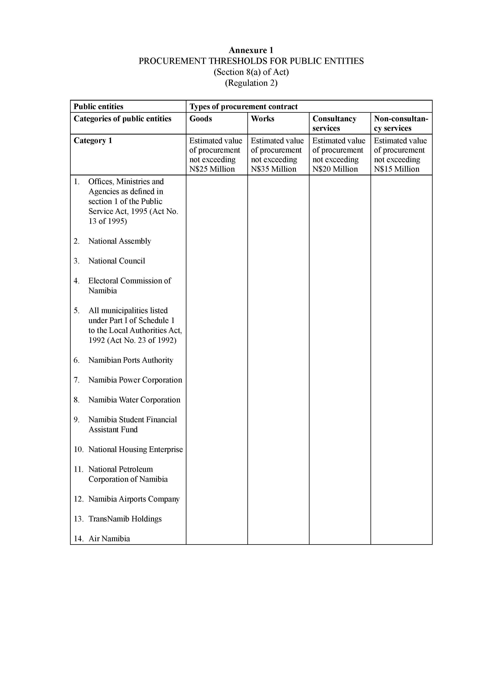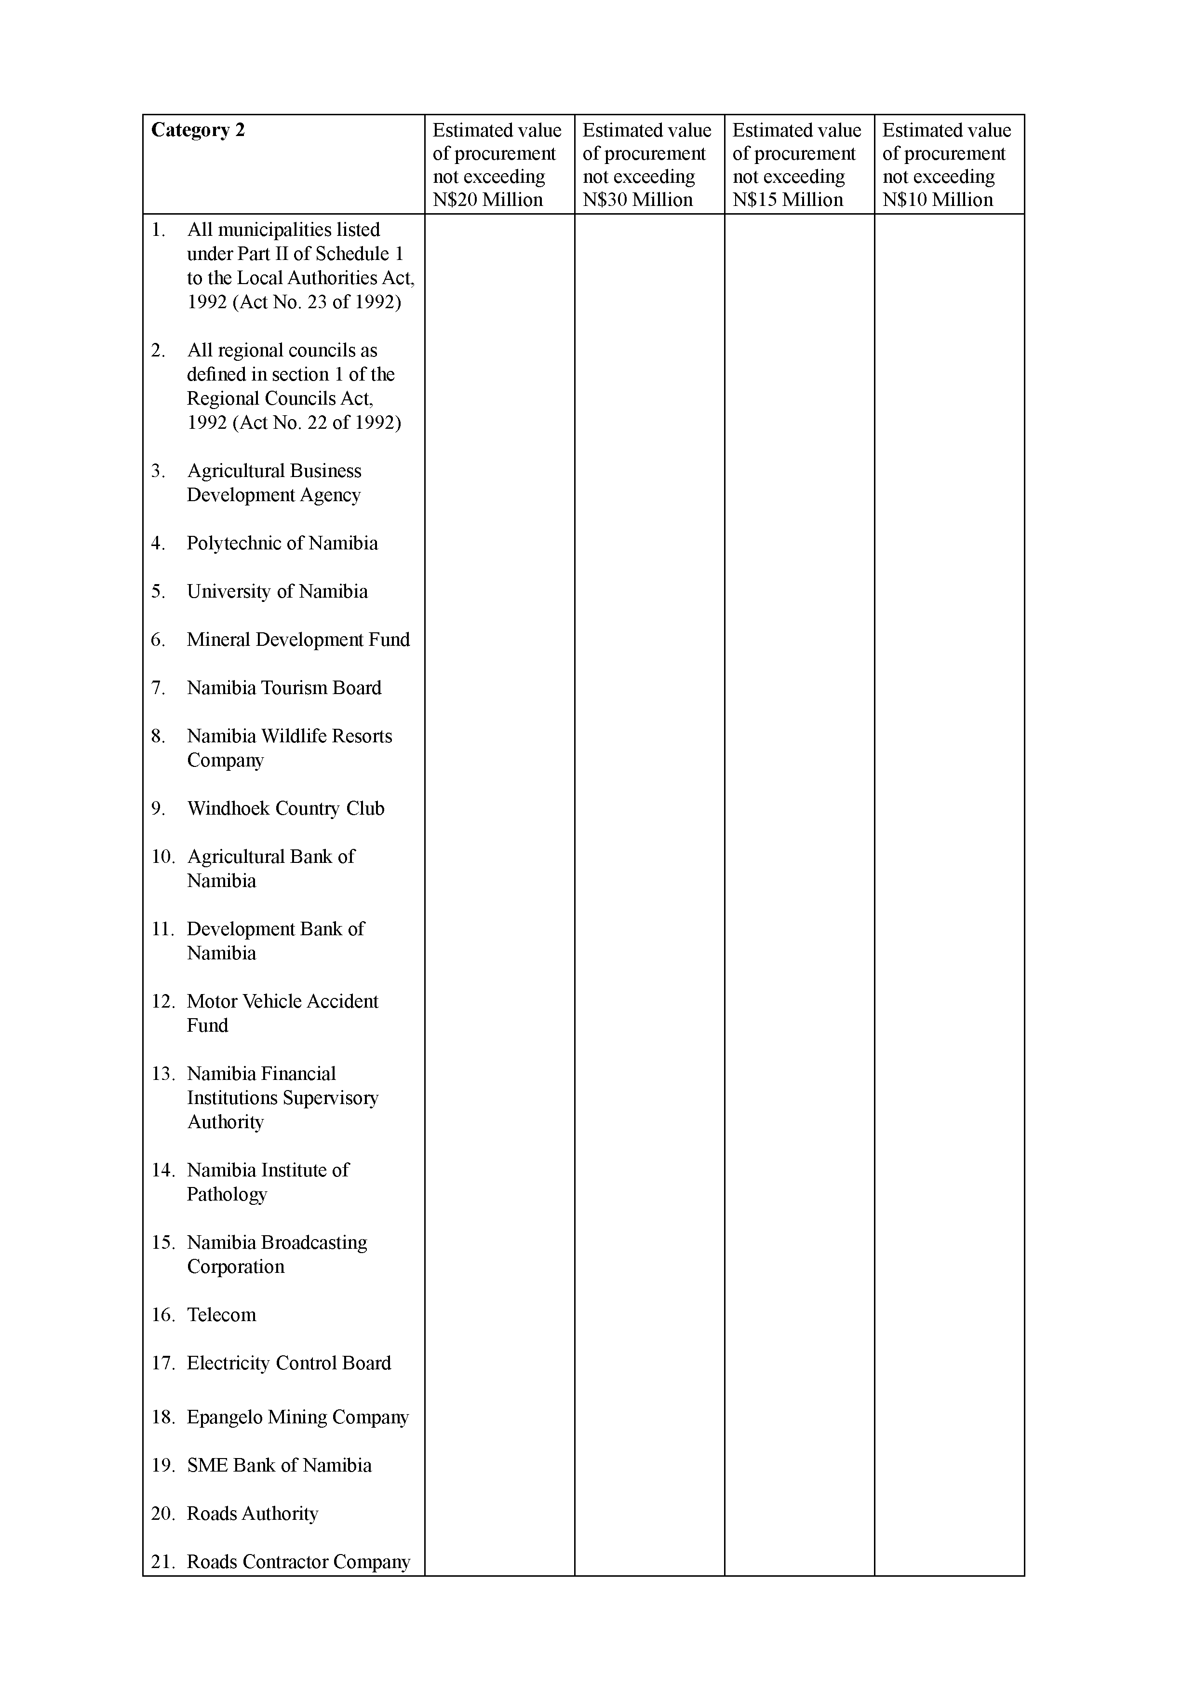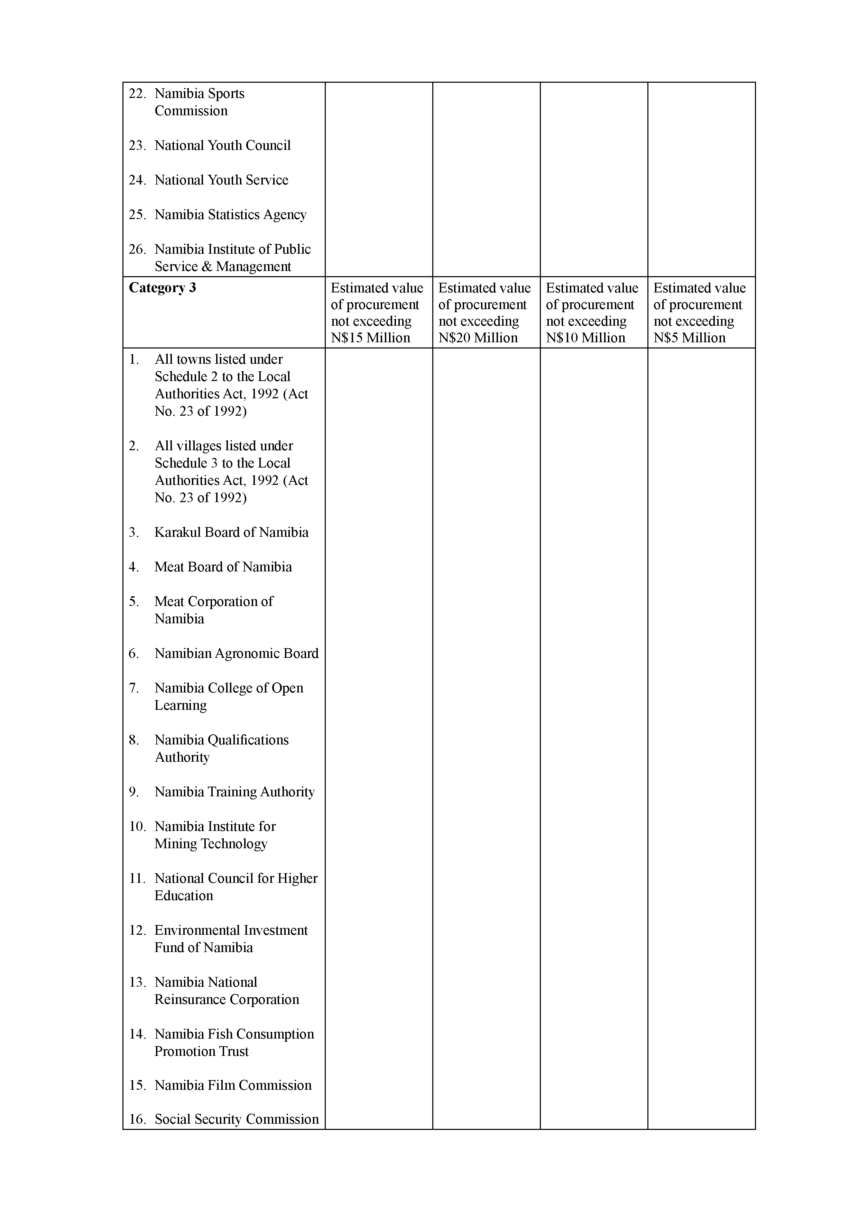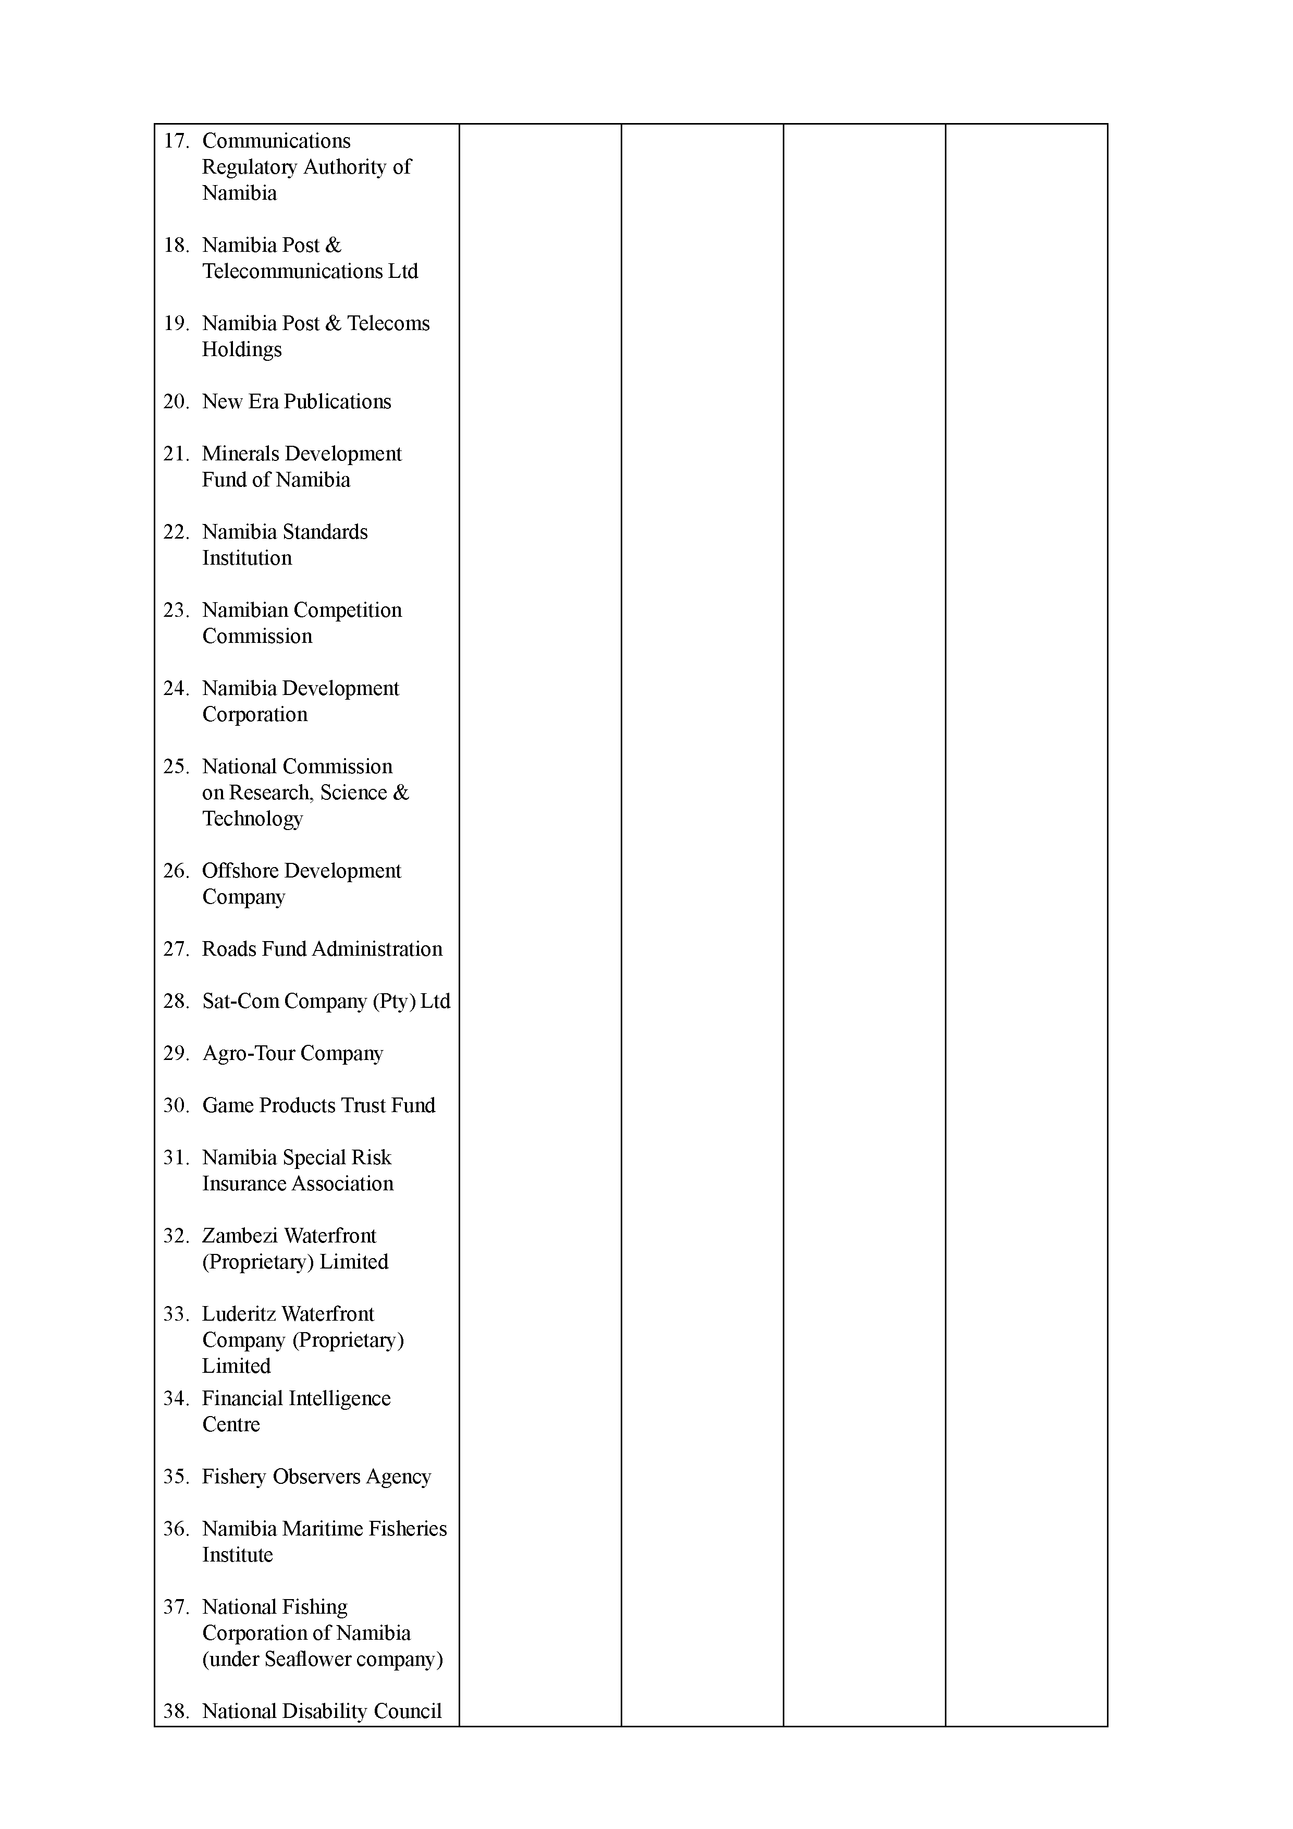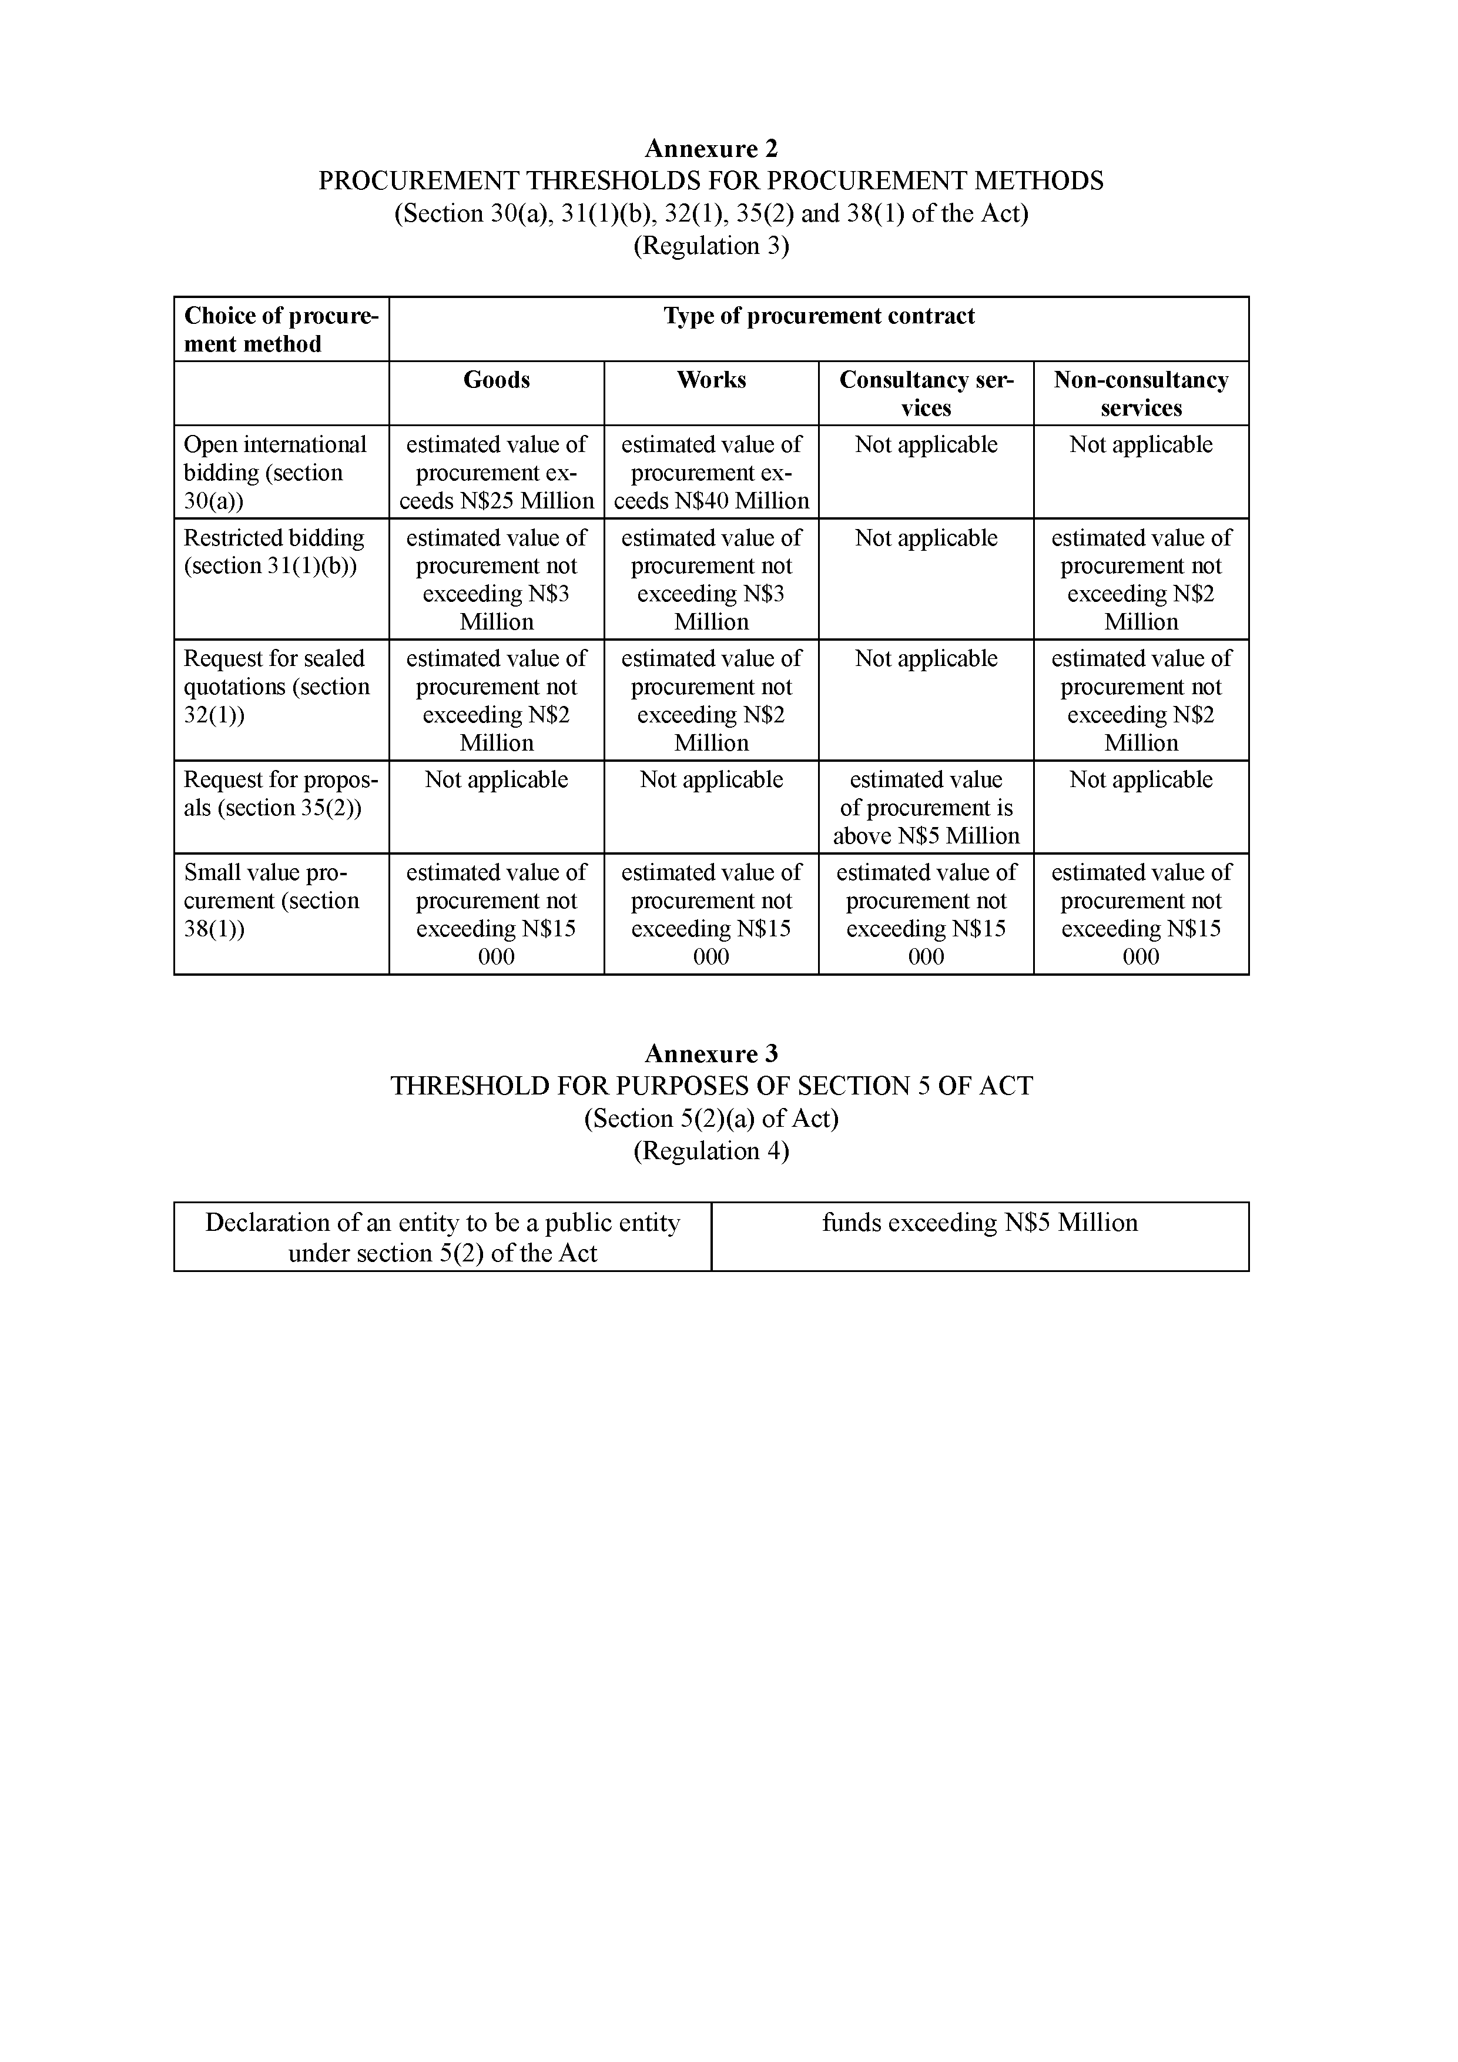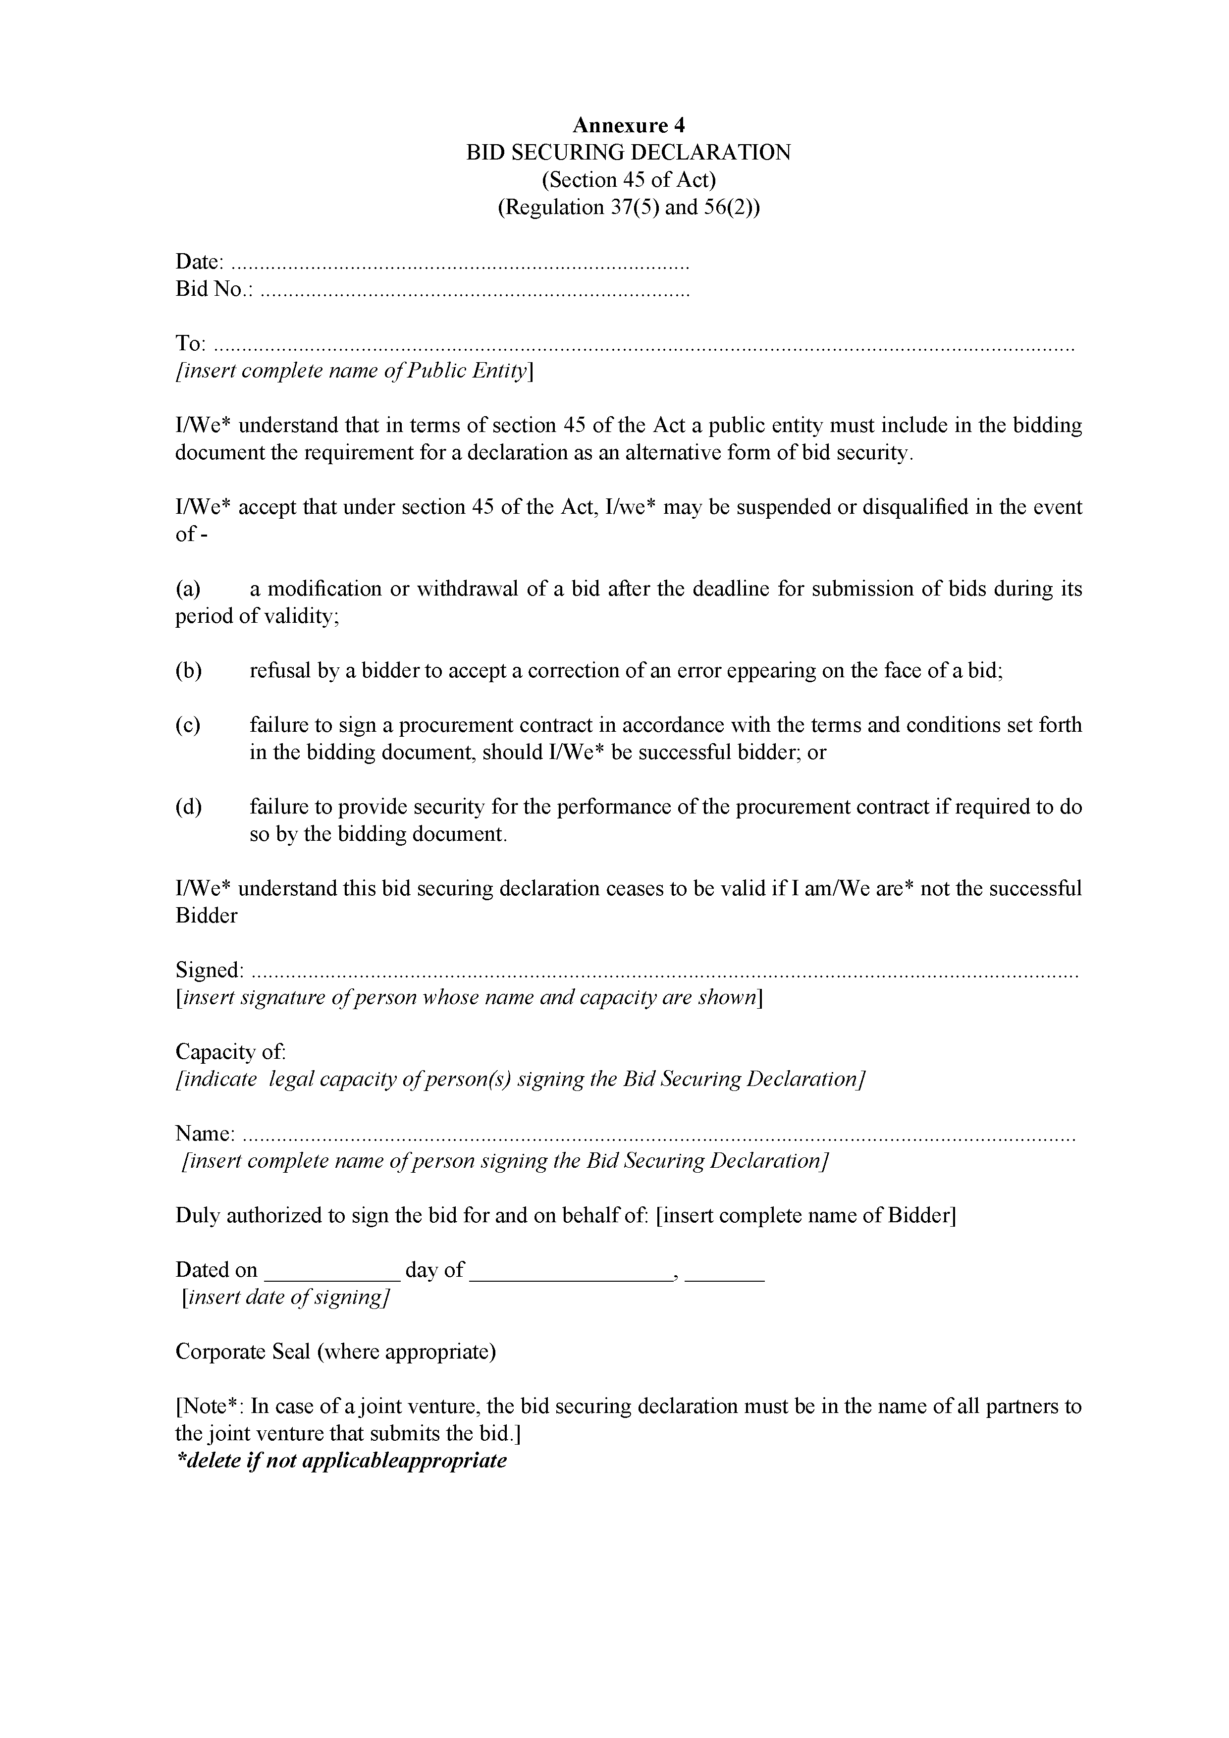

[Annexures 4A, 4B and 4C inserted by GN 78/2018]

ANNEXURE 4A

STANDARD RATES FOR THE PURCHASE OF BIDDING DOCUMENTS

(Regulation 33A)

|  |  |
| --- | --- |
| **Column 1**  **Procurement Methods** | **Column 2**  **Fee to be charged**  **for bidding document** |
| All Methods listed under Section 27(1) and 64(2) except  Open Advertised Bidding | Free |
| Open Advertised Bidding | |
| - Procurement contracts with an estimated value not exceeding N$1 000 000.00 | N$100.00 |
| - Procurement contracts with an estimated value above N$1 000 000.00 and not exceeding N$20 000 000.00 | N$300.00 |
| - Procurement contracts with an estimated value above N$20 000 000.00 and not exceeding N$100 000 000.00 | N$600.00 |
| - Procurement contracts with an estimated value above N$100 000 000.00 and not exceeding N$500 000 000.00 | N$1 000.00 |
| - Procurement contracts with an estimated value above N$500 000 000.00 and not exceeding N$2 000 000 000.00 | N$3 000.00 |
| - Procurement contracts with an estimated value above N$2 000 000 000.00 | N$6 000.00 |

ANNEXURE 4B

STANDARD RATES FOR BID SECURITY

(Regulation 37A)

|  |  |
| --- | --- |
| **Column 1**  **Security Type** | **Column 2**  **Rate** |
| Bid Security | 0.5% - 2% of bid price/estimated budget |

ANNEXURE 4C

STANDARD RATES FOR PERFORMANCE SECURITY

(Regulation 38A)

|  |  |
| --- | --- |
| **Column 1**  **Security Type** | **Column 2**  **Rate** |
| Performance Security | 10% - 15% of contract value |

