

REGULATIONS MADE IN TERMS OF

Petroleum Products and Energy Act 13 of 1990

section 19A

Regulations on the Funding of Approved Agencies, 2005

Government Notice 30 of 2005

(GG 3397)

came into force on date of publication: 18 March 2005

The Government Notice which issues these regulations withdraws   
the regulations on the same topic published in GN 230/2004 (GG 3307).

Government Notice 247/2013 (GG 5287) purports to amend the regulations in   
GN 230/2004 which were withdrawn by these regulations. It may be that the intent was to   
amend these regulations, but this cannot be ascertained for certain from the text of the amendments. The individual amendments are therefore presented in annotation notes.   
GN 247/2013 came into force on its date of publication, 18 September 2013.

ARRANGEMENT OF REGULATIONS

1. Definitions

2. Application for funding

3. Funding on initiative of Minister

4. Assessment of projects for funding

5. Consideration of application for funding

6. General conditions applicable for funding of approved agencies

7. Duties of Council with regard to projects

8. Recovery of money

9. Short title

ANNEXURE A - Application for funding

ANNEXURE B - Details of directors, other partners or members, as the case may be, of applicant

[A second “ANNEXURE B – Application for loan” is inserted by GN 247/2013,   
if that amendment was intended to apply to these regulations.]

**Definitions**

**1.** In these regulations, unless the context otherwise indicates, a word or expression defined in the Act has the same meaning, and -

“applicant” includes a person tendering for a project, or identified by the Council under regulation 3;

“benefits” means the benefits in economic terms to be derived from any project;

“funding” includes any funding, contribution or any other type of financial assistance applied for or approved by the Council in relation to a project;

“project” means any project, or activity for or in connection with or relating to the purchase, acquisition, distribution, sale, saving, development, conservation, storage or utilisation of any energy source, or to research in connection with any energy source.

[GN 247/2013, if it was intended to apply to these regulations, inserts regulation 1A:

**Types of funding**

**1A.**  (1) The funding that may be made available from the Fund as contemplated in section 11(2)(b) or (c) of the Act may be in the form of a grant or a loan.

(2) If the funding is in the form of a grant, the recipient is not required to pay back the grant amount.

(3) If the funding is in the form of a loan, the recipient must pay back the loan amount on such terms and conditions, and over such period determined by the Minister.

(4) After an application for a loan is granted by the Minister, the Council and the applicant must enter into an agreement for the repayment of the loan.

(5) The minimum period of repayment of the loan is five years and the maximum period is 25 years.

(6) The interest rate payable on the loan referred in subregulation (4) must be fixed between the rate of 2.5% and 5% per annum.]

**Application for funding**

**2.** (1) Any institution of State, body or person, including any body corporate or association of persons, desiring to apply for approval as eligible for funding from the Fund in respect of a project or activity may do so by duly completing the Form contained in Annexure A and lodging such application with the Council together with the information referred to in subregulation (2).

[GN 247/2013, if it was intended to apply to these regulations, substitutes subregulation (1):

(1) Any institution of State, body or person, including anybody corporate or association of persons, desiring to apply for approval as eligible for funding from the Fund in respect of project or activity may do so by duly completing -

(a) in the case of application of a grant, the form contained in Annexure A; or

(b) in the case of application of a loan, the forms contained in Annexure B,

and lodging such application with the Council together with the information referred to in subregulation (2).]

(2) An application referred to in subregulation (1) must be accompanied by -

(a) full details of the proposed project, including the energy source to which the project relates and a summary of the nature of the project;

(b) the projected duration of the project;

(c) a detailed proposed budget for the project, and where the duration of a project is anticipated to extend over more than one financial year of the Fund, the budget must clearly indicate the amounts to be expended with regard to each financial year or part thereof;

(d) sufficient descriptive information to demonstrate the net benefits of the project for the specific energy source to which the project relates;

(e) the amount and nature of funding applied for from the Fund;

(f) the proposed outputs of the project and, where applicable and possible, the time during the project at which the outputs would be delivered;

(g) any insurance coverage or guarantee to be provided by the applicant;

(h) any other financial assistance available to or at the disposal of the applicant for purposes of such project;

(i) the estimated value of assets, equipment, human resources and other resources which would be available for use in connection with such project and which may affect the amount of funding required;

(j) any other factors which may affect the implementation of the proposed project and the measures to be taken to mitigate the effects of such factors;

[GN 247/2013, if it was intended to apply to these regulations, inserts paragraph (jj) which should end with a semicolon if the place for insertion has been interpreted correctly:

(jj) in case of a loan, the capacity or capability of the applicant to repay the loan together with interest as determined under regulation 1A.]

(k) such additional information as the Council may require.

(3) The Council may request an applicant to provide supplementary or supportive particulars with regard to any matter referred to in subregulation (2).

(4) The Council may determine the form of and the information to be included in the budget referred to in subregulation (2)(c).

**Funding on initiative of Minister**

**3.** (1) The Minister may request the Council to identify to him or her any institution of State, body or person, including any body corporate or association of persons for funding from the Fund in respect of a project which the Minister proposed to be funded from the Fund or the Minister may do so on his or her own initiative.

(2) Where the Council, under subregulation (1), has identified an institution, body or person, the Council must investigate and assess the proposed project to estimate the net benefits and outputs of the project for the sector to which the project relates and submit a report to the Minister together with full details of the project and estimate of the anticipated cost thereof for approval.

(3) If the Minister approves a project but does not approve the institution, body or person identified by the Council, the Council may -

(a) call interested institutions, bodies or persons to take up the approved project by way of public tender;

(b) identify a specific institution, body or person that possesses the necessary and relevant expertise and ability to undertake the project.

(4) In calling for public tender referred to in subregulation (3)(a) and considering the awarding of such tender, the Council must act in a transparent manner and may not unduly discriminate against any institution, body or person.

(5) Any institution, body or person identified under subregulation (1) or (3)(b), or tendering for a proposed project under subregulation (3)(a), must submit to the Council the applicable information referred to in regulation 2(2).

**Assessment of projects for funding**

**4.** (1) In determining if a project should be funded and the amount and nature of funding to be made available for a project under regulation 2 the Council must take into consideration the information referred to in regulation 2, in so far as it is applicable, and -

(a) the proposed net benefits and outputs to be derived from the project for the energy sector in question and whether such benefits and outputs are economically justifiable in view of the amount of funding to be made available;

(b) the availability of funds as contemplated in section 11(1) of the Act;

(c) the amount of funding to be made available in respect of every project during that financial year;

(d) the avoidance of substantial increases in levies or the introduction of new levies in one year;

(e) the maintenance of a reasonable stability in energy levies; and

(f) benefits or any other advantages of the proposed project for previously disadvantaged communities or persons.

[GN 247/2013, if it was intended to apply to these regulations, inserts paragraph (g); if this is the case, then paragraph (j) should end with a semicolon rather than a full stop now that it is no   
longer the last paragraph in subregulation (4):

(g) if the funding is in the form of a loan, the capacity or capability of the applicant to pay the loan on terms and conditions determined under regulation 1A.]

(2) In assessing a project for funding, the Council -

(a) must consult with such persons as the Minister may determine;

(b) may consult with such persons as the Council may consider necessary, and may further invite any person to a meeting of the Council with a view to such person clarifying aspects of the project and must act in a transparent manner.

**Consideration of application for funding**

**5.** (1) The Minister may, after consideration of any application made in terms of regulation 2, approve such application, with or without amendments, or reject such application.

(2) Where the Minister rejects an application he or she must provide the applicant with written reasons for such rejection.

**General conditions applicable to funding of approved agencies**

**6.** The following general conditions apply to all projects funded in terms of these regulations, namely -

(a) except with the prior written permission of the Council, money acquired from the Fund for a project may only be expended in accordance with the budget of the approved project;

(b) any amount of money acquired from the Fund for a project which is to be repaid, and which is not repaid on the due date shall be subject to the payment of interest on the amount so due;

(c) there shall be periodic reporting on a project at such intervals as may be determined by the Council and in the form determined by the Council; and

(d) all books of account relating to the project may be inspected by the Council at such intervals and in such manner as the Council may determine.

**Duties of Council with regard to projects**

**7.** (1) The Council shall oversee all projects funded from the Fund and shall ensure that money from the Fund is expended in accordance with the budget of the approved project.

(2) The Council shall review all projects funded from the Fund after their completion in order to determine whether the proposed net benefits and outputs have been realised.

(3) All records received by or produced by the Council in terms of these regulations shall be retained by the Council for a period of five years before such records are disposed of.

**Recovery of money**

**8.** (1) The Council may, by notice in writing, require any institution, body or person to which or to whom money was paid from the Fund to repay, within the period specified in the notice, any amount so paid, if the Council is satisfied that there was an overpayment or that money was for any reason wrongly paid to such institution, body or person.

(2) The Council may, by notice in writing, require an approved agency to pay to the Council, within the period specified in the notice, an amount equal to the amount of the money paid or payable under these regulations in respect of a project if the approved agency has acted in breach of a condition applicable to approved agency or in breach of an agreement between the Council and approved agency.

(3) An amount payable to the Fund under this regulation may be recovered by the Permanent Secretary: Mines and Energy, as a debt due to the Fund, in any court of competent jurisdiction.

**Short title**

**9.** These regulations are called the Regulations on the Funding of Approved Agencies, 2005.

ANNEXUREs

To view content without printing, scroll down.

To print at full scale (A4), double-click the icon below.



[ANNEXURE A contains FORM FAA/1. ANNEXURE B contains FORM FAA/1A.

A second “ANNEXURE B” containing FORM FAA/2 is inserted by GN 247/2013,   
if that amendment was intended to apply to these regulations. This second Annexure B   
is provided below, in case it was intended to be part of these regulations.]



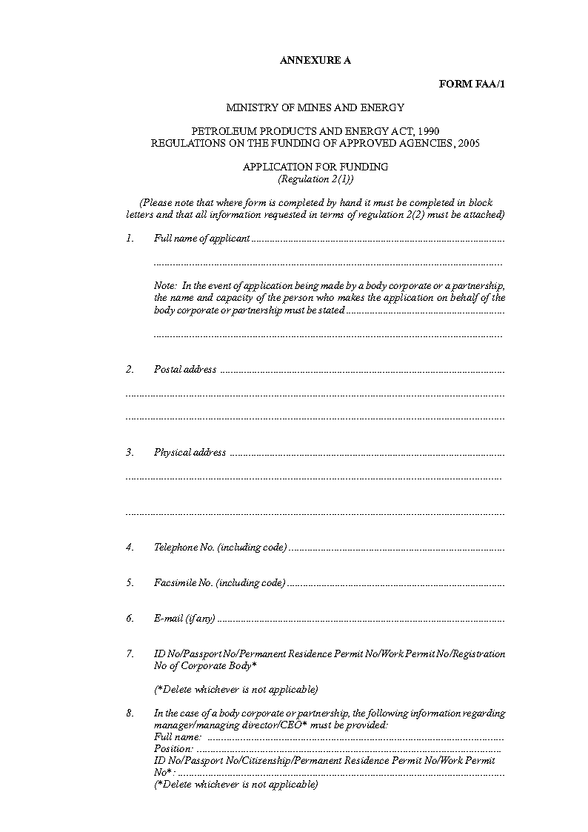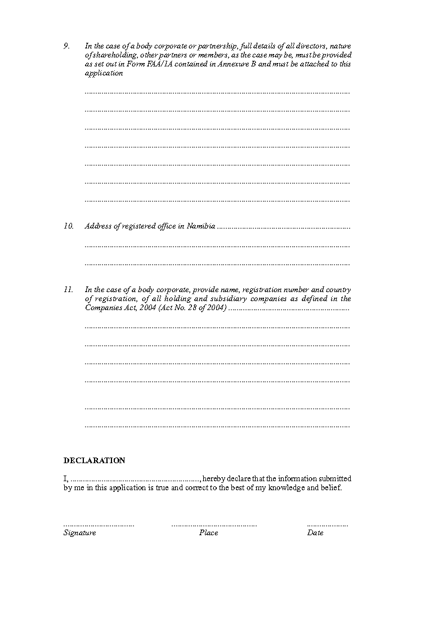

[A second “ANNEXURE B” containing FORM FAA/2 is inserted by GN 247/2013,   
if that amendment was intended to apply to these regulations. This second Annexure B   
is provided below, in case it was intended to be part of these regulations.]

