

REGULATIONS MADE IN TERMS OF

Nature Conservation Ordinance 4 of 1975

section 84

**Regulations Relating to Nature Conservation**

Government Notice 240 of 1976

**(**[**OG 3556**](http://www.lac.org.na/laws/1976/og3556.pdf)**)**

**came into force on date of publication: 25 August 1976**

**These regulations were made by the Executive Committee**

**in terms of section 84 of the Nature Conservation Ordinance 4 of 1975.**

**Note that they repeal the regulations promulgated in GN 51/1968,   
GN 186/1968, GN 7/1969, GN 52/1971, GN 53/1971 and GN 39/1974.**

**as amended by**

**Government Notice 256 of 1976 (**[**OG 3563**](http://www.lac.org.na/laws/1976/og3563.pdf)**)**

**applicable with effect from 1 April 1977 (GN 256/1976);**

**amendment made by ~~the~~ Executive Committee**

**Government Notice 112 of 1977 (**[**OG 3599**](http://www.lac.org.na/laws/1977/og3599.pdf)**)**

**came into force on date of publication: 15 March 1977;**

**amendment made by Executive Committee**

**Government Notice 248 of 1977 (**[**OG 3638**](http://www.lac.org.na/laws/1977/og3638.pdf)**)**

**came into force on date of publication: 15 July 1977**

**amendment made by Executive Committee**

**Government Notice 302 of 1977 (**[**OG 3644**](http://www.lac.org.na/laws/1977/og3644.pdf)**)**

**came into force on date of publication: 1 September 1977;**

**amended by GN 32/1978 (**[**OG 3705**](http://www.lac.org.na/laws/1978/og3705.pdf)**) (which came into force   
on its date of publication: 15 February 1978);**

**both made by Executive Committee**

**Government Notice 314 of 1977 (**[**OG 3647**](http://www.lac.org.na/laws/1977/og3647.pdf)**)**

**came into force on date of publication: 15 September 1977;**

**amendment made by Executive Committee**

**Government Notice 364 of 1977 (**[**OG 3659**](http://www.lac.org.na/laws/1977/og3659.pdf)**)**

**came into force on date of publication: 15 October 1977;**

**amendment made by Executive Committee**

**Government Notice 114 of 1978 (**[**OG 3741**](http://www.lac.org.na/laws/1978/og3741.pdf)**)**

**came into force on date of publication: 1 May 1978;**

**amendment made by Executive Committee**

**Government Notice 190 of 1978 (**[**OG 3798**](http://www.lac.org.na/laws/1978/og3798.pdf)**)**

**came into force on date of publication: 1 August 1978;**

**amendment made by Executive Committee**

**Government Notice 247 of 1978 (**[**OG 3845**](http://www.lac.org.na/laws/1978/og3845.pdf)**)**

**came into force on date of publication: 13 October 1978;**

**amendment made by Executive Committee**

**Government Notice 10 of 1979 (**[**OG 3894**](http://www.lac.org.na/laws/1979/og3894.pdf)**)**

**came into force on date of publication: 1 February 1979;**

**amendment made by Executive Committee**

**Government Notice 50 of 1979 (**[**OG 3916**](http://www.lac.org.na/laws/1979/og3916.pdf)**)**

**came into force on date of publication: 15 March 1979;**

**amendment made by Executive Committee**

**Government Notice 56 of 1979 (**[**OG 3916**](http://www.lac.org.na/laws/1979/og3916.pdf)**)**

**came into force on date of publication: 15 March 1979;**

**amendment made by Executive Committee**

**Government Notice AG 8 of 1981 (**[**OG 4368**](http://www.lac.org.na/laws/1981/og4368.pdf)**)**

**came into force on 1 February 1981 pursuant to   
commencement provision of AG GN 8/1981;**

**amendment made by ~~the~~ Administrator-General**

**Government Notice AG 41 of 1982 (**[**OG 4609**](http://www.lac.org.na/laws/1982/og4609.pdf)**)**

**came into force on date of publication: 26 March 1982;**

**amendment made by ~~the~~ Council of Ministers**

**Government Notice AG 23 of 1983 (**[**OG 4741**](http://www.lac.org.na/laws/1983/og4741.pdf)**)**

came into force on date of publication: 1 February 1983;

**amendment made by ~~the~~ Administrator-General**

**Government Notice AG 49 of 1983 (**[**OG 4752**](http://www.lac.org.na/laws/1983/og4752.pdf)**)**

**came into force on date of publication: 1 March 1983;**

**amendment made by ~~the~~ Administrator-General**

**Government Notice AG 61 of 1983 (**[**OG 4757**](http://www.lac.org.na/laws/1983/og4757.pdf)**)**

**applicable with effect from 1 April 1983 (AG GN 61/1983);**

**amendment made by Administrator-General**

**Government Notice AG 72 of 1984 (**[**OG 4901**](http://www.lac.org.na/laws/1984/og4901.pdf)**)**

**applicable with effect from 25 May 1984 (AG GN 72/1984);**

**amendment made by Administrator-General**

**Government Notice AG 36 of 1985 (**[**OG 5019**](http://www.lac.org.na/laws/1985/og5019.pdf)**)**

**came into force on date of publication: 30 March 1985**

**amendment made by the Administrator-General**

**Government Notice 3 of 1985 (**[**OG 5064**](http://www.lac.org.na/laws/1985/og5064.pdf)**)**

**came into force on date of publication: 1 July 1985;**

**amendment made by Cabinet**

**Government Notice 101 of 1985 (**[**OG 5125**](http://www.lac.org.na/laws/1985/og5125.pdf)**)**

**came into force on date of publication: 1 November 1985;**

**amendment made by Cabinet**

**Government Notice 121 of 1985 (**[**OG 5134**](http://www.lac.org.na/laws/1985/og5134.pdf)**)**

**came into force on date of publication: 2 December 1985;**

**amendment made by Cabinet**

**Government Notice 122 of 1986 (**[**OG 5219**](http://www.lac.org.na/laws/1986/og5219.pdf)**)**

**came into force on date of publication: 4 June 1986;**

**amendment made by Cabinet**

**Government Notice 242 of 1986 (**[**OG 5297**](http://www.lac.org.na/laws/1986/og5297.pdf)**)**

**came into force on date of publication: 1 December 1986;**

**amendment made by Cabinet**

**Government Notice 81 of 1987 (**[**OG 5365**](http://www.lac.org.na/laws/1987/og5365.pdf)**)**

**came into force on date of publication: 15 May 1987;**

**amendment made by Cabinet**

**Government Notice 89 of 1988 (**[**OG 5547**](http://www.lac.org.na/laws/1988/og5547.pdf)**)**

**came into force on date of publication: 23 May 1988;**

**amendment made by Cabinet**

**Government Notice AG 37 of 1989 (**[**OG 5733**](http://www.lac.org.na/laws/1989/og5733.pdf)**)**

**applicable with effect from 28 May 1989 (AG GN 37/1989);**

**amendment made by Administrator-General**

**Government Notice AG 44 of 1989 (**[**OG 5751**](http://www.lac.org.na/laws/1989/og5751.pdf)**)**

**deemed to have come into force on 28 May 1989 (AG GN 44/1989);**

**amendment made by Administrator-General**

**Government Notice 152 of 1993 (**[**GG 765**](http://www.lac.org.na/laws/1993/765.pdf)**)**

**came into force on date of publication: 15 December 1993;**

**amendment made by President**

**Government Notice 304 of 1996 (**[**GG 1446**](http://www.lac.org.na/laws/1996/1446.pdf)**)**

**came into force on date of publication: 18 November 1996**

**amendment made by ~~the~~ Minister of Environment and Tourism;**

**withdrawn and replaced by GN 83/1997, which appears to replicate   
GN 304/1996 except for some minor format changes**

**Government Notice 83 of 1997 (**[**GG 1554**](http://www.lac.org.na/laws/1997/1554.pdf)**)**

**came into force on date of publication: 12 May 1997;**

**amendment made by Minister of Environment and Tourism**

**Government Notice 119 of 1997 (**[**GG 1580**](http://www.lac.org.na/laws/1997/1580.pdf)**)**

**came into force on date of publication: 18 June 1997;**

**amendment made by Minister of Environment and Tourism**

**Government Notice 59 of 2009 (**[**GG 4236**](http://www.lac.org.na/laws/2009/4236.pdf)**)**

**came into force on date of publication: 1 April 2009;**

**amendment made by Minister of Environment and Tourism**

**Government Notice 9 of 2010 (**[**GG 4416**](http://www.lac.org.na/laws/2010/4416.pdf)**)**

**came into force on date of publication: 29 January 2010;**

**amendment made by Minister of Environment and Tourism;**

**as amended by** Government Notice 19 of 2016 **(**[**GG 5936**](http://www.lac.org.na/laws/2016/5936.pdf)**), which**

**came into force on its date of publication: 27 January 2016 and was   
made by the Minister of Environment and Tourism   
in terms of section 84 read with section 27 and 36**

**Government Notice 210 of 2012 (**[**GG 5015**](http://www.lac.org.na/laws/2016/5015.pdf)**)**

**came into force on date of publication: 15 August 2012;**

**amendment made by Minister of Environment and Tourism**

**Government Notice 85 of 2017 (**[**GG 6285**](http://www.lac.org.na/laws/2017/6285.pdf)**)**

**came into force on date of publication: 13 April 2017;**

**amendment made by Minister of Environment and Tourism**

**in terms of section 84(1)(y), read with subsection 84(3) and section 17(2)(b)**

**Government Notice 94 of 2018 (**[**GG 6605**](http://www.lac.org.na/laws/2018/6605.pdf)**)**

**came into force on date of publication: 30 May 2018;**

**amendment made by Minister of Environment and Tourism**

**Government Notice 25 of 2021 (**[**GG**](http://www.lac.org.na/laws/2018/6605.pdf) [**7460**](http://www.lac.org.na/laws/2021/7460.pdf)**)**

**applicable with effect from 1 January 2021;**

**amendment made by Minister of Environment and Tourism   
in terms of section 84(1)(b)(iii)**

**ARRANGEMENT OF REGULATIONS**

Definitions

CHAPTER I

TARIFFS

1. [no regulation heading]

2. **[deleted]**

3. [no regulation heading]

4. [no regulation heading]

5. [no regulation heading]

6. [no regulation heading]

7. [no regulation heading]

8.[no regulation heading]

CHAPTER II

REGULATIONS RELATING TO GAME PARKS

GENERAL REGULATIONS APPLICABLE TO ALL GAME PARKS

9. [no regulation heading]

9A. [no regulation heading]

10. [no regulation heading]

11. [no regulation heading]

12. [no regulation heading]

13. [no regulation heading]

14. [no regulation heading]

15. [no regulation heading]

16. [no regulation heading]

17. [no regulation heading]

18. [no regulation heading]

19. [no regulation heading]

20. [no regulation heading]

21. [no regulation heading]

22. [no regulation heading]

23. [no regulation heading]

24. [no regulation heading]

25. [no regulation heading]

25A. [no regulation heading]

SPECIAL REGULATIONS RELATING TO CERTAIN GAME PARKS

(A) DAAN VILJOEN GAME PARK

26. [no regulation heading]

27. [no regulation heading]

(B) NAMIB DESERT PARK

28. [no regulation heading]

29. [no regulation heading]

30. [no regulation heading]

(C) ETOSHA NATIONAL PARK

31. [no regulation heading]

32. [no regulation heading]

33. [no regulation heading]

34. [no regulation heading]

(D) HARDAP RECREATION RESORT

35. [no regulation heading]

(E) SKELETON COAST PARK

36. [no regulation heading]

(F) NAUKLUFT MOUNTAIN ZEBRA PARK

[The Afrikaans version of the *Official* *Gazette* uses the letter (F)   
in the subpart heading; the English version does not.]

36A. [no regulation heading]

36B. [no regulation heading]

(G) GROSS BARMEN

36C [no regulation heading]

36D. [no regulation heading]

36E. [no regulation heading]

(H) DOROB NATIONAL PARK

36F. [no regulation heading]

CHAPTER III

SWIMMING BATHS IN GAME PARKS

37. [no regulation heading]

38. [no regulation heading]

39. [no regulation heading]

40. [no regulation heading]

41. [no regulation heading]

42. [no regulation heading]

43. [no regulation heading]

44. [no regulation heading]

45. [no regulation heading]

46. [no regulation heading]

47. [no regulation heading]

48. [no regulation heading]

49. [no regulation heading]

50. [no regulation heading]

51. [no regulation heading]

CHAPTER IV

USE OF BOATS ON DAMS IN GAME PARKS

52. [no regulation heading]

53. [no regulation heading]

54. [no regulation heading]

55. [no regulation heading]

55. [no regulation heading]

56. [no regulation heading]

57. [no regulation heading]

58. [no regulation heading]

59. [no regulation heading]

CHAPTER V

INLAND FISHERIES

60. [no regulation heading]

61. [no regulation heading]

62. [no regulation heading]

63. [no regulation heading]

64. [no regulation heading]

65. [no regulation heading]

CHAPTER VI

GAME AND OTHER WILD ANIMALS

66. [no regulation heading]

67. [no regulation heading]

68. [no regulation heading]

69. [no regulation heading]

70. [no regulation heading]

71. [no regulation heading]

72. [no regulation heading]

73. [no regulation heading]

74. [no regulation heading]

75. [no regulation heading]

76. [no regulation heading]

77. [no regulation heading]

78. [no regulation heading]

79. [no regulation heading]

80. [no regulation heading]

81. [no regulation heading]

82. [no regulation heading]

83. [no regulation heading]

84. [no regulation heading]

85. [no regulation heading]

SCHEDULE: Indigenous birds which may be kept in terms of a permit

CHAPTER VII

GAME DEALERS

86. [no regulation heading]

87. [no regulation heading]

88. [no regulation heading]

89. [no regulation heading]

CHAPTER VIII

GAME SKINS

90. [no regulation heading]

91. [no regulation heading]

92. [no regulation heading]

CHAPTER IX

PROTECTED PLANTS AND NURSERIES

93. [no regulation heading]

94. [no regulation heading]

CHAPTER X

REGISTRATION OF CAGE BIRD SOCIETIES

95. [no regulation heading]

96. [no regulation heading]

97. [no regulation heading]

98. [no regulation heading]

99. [no regulation heading]

100. [no regulation heading]

CHAPTER XI

HUNTING OF GAME FOR THE SAKE OF TROPHIES

101. Registration fees

102. Registration of hunting farm

103. Remuneration which may be accepted

104. Provision of accommodation

[The words “Provision” and “accommodation” are   
misspelt in the *Official Gazette,* but corrected here.]

105. Provision of liquor

106. Advertising of hunting of game for the sake of trophies

107. Registration of professional hunters

108. Registration as hunting guide

108A. Registration of Master Hunting Guide

108B. Additional registration as a bow hunting guide

109. Accommodation of trophy hunter

110. Transport of trophy hunters

110A. Bow hunting of game for the sake of trophies

111. Trophy hunter shall be accompanied by professional hunter, master hunting guide or hunting guide

112. Relative of trophy hunter

113. Vehicles

114. Hunting of game and wild animals

114A. Leopard trophy hunting quota

114B. Application for predator trophy hunting permit

114C. Conditions of predator trophy hunting permit

114D. Condition regarding skin and skull of the hunted predator

115. Trophy permits and permit fees

116. Closed season for the hunting of game or wild animals for the sake of trophy hunting

117. Returns to be submitted

118. Withdrawal of registration as hunting farm, professional hunter and hunting guide

CHAPTER XIA

TROPHY MANUFACTURERS’ AND TROPHY DEALER’S LICENCES

118A. [no regulation heading]

118B. [no regulation heading]

118C. [no regulation heading]

118D. [no regulation heading]

118E. [no regulation heading]

118F. [no regulation heading]

118G. [no regulation heading]

118H. [no regulation heading]

118I. [no regulation heading]

CHAPTER XIB

CONDITIONS FOR EXPORT OF TROPHIES

118J. [no regulation heading]

118K. **[deleted]**

CHAPTER XII

HUNTING AT NIGHT FOR COMMERCIAL PURPOSES

119. [no regulation heading]

120. [no regulation heading]

121. [no regulation heading]

122. [no regulation heading]

123. [no regulation heading]

124. [no regulation heading]

125. [no regulation heading]

126. [no regulation heading]

127. [no regulation heading]

128. [no regulation heading]

CHAPTER XIIA

HUNTING OF HUNTABLE GAME AND EXPORT OF GAME AND GAME MEAT

128A. [no regulation heading]

128B. [deleted by GN 152/1993, but amended by GN 59/2009 as if it were still in force]

CHAPTER XIII

SEA BIRD GUANO

129. [no regulation heading]

130. [no regulation heading]

131. [no regulation heading]

132. [no regulation heading]

133. [no regulation heading]

134. [no regulation heading]

135. [no regulation heading]

136. [no regulation heading]

137. [no regulation heading]

138. [no regulation heading]

139. [no regulation heading]

140. [no regulation heading]

CHAPTER XIV

DECLARATION OF PRIVATE GAME PARKS AND NATURE RESERVES

141. [no regulation heading]

CHAPTER XV

REGISTRATION OF SUCCULENT SOCIETIES

142. [no regulation heading]

143. [no regulation heading]

144. [no regulation heading]

145. [no regulation heading]

146. [no regulation heading]

CHAPTER XVI

GAME-PROOF FENCES

147. [no regulation heading]

148. [no regulation heading]

149. [no regulation heading]

CHAPTER XVII

RECOGNITION AND REGISTRATION OF ASSOCIATIONS

150. [no regulation heading]

151. [no regulation heading]

152. [no regulation heading]

153. [no regulation heading]

154. [no regulation heading]

155. [no regulation heading]

CHAPTER XVII A

REGISTERS RELATING TO COYOTE GETTERS

155A. [no regulation heading]

CHAPTER XVII B

CONSERVANCIES AND WILDLIFE COUNCILS

155B. Application for declaration of an area as a conservancy

CHAPTER XVII C

WILDLIFE COUNCILS

155C. Establishment of wildlife councils

CHAPTER XVIII

REPEAL OF REGULATIONS

156. [no regulation heading]

**SCHEDULES**

Schedule A

Schedule B

[Schedule C deleted by GN AG 44/1989]

Schedule D

Schedule E

Schedule F

Schedule G

**ANNEXURES – FORMS**

1. Application for declaration of a conservancy

2. Certificate of approval of a conservancy

3. Certificate of establishment of a wildlife council

**Numbers and words in dates such as 30th and thirtieth**

**are used interchangeably throughout the regulations.**

**The words “fire-arms” and “firearms”, “Namib-Naukluft” and “Namib Naukluft” and   
“Gross-Barmen” and “Gross Barmen” are used interchangeably with and   
without hyphens throughout the regulations.**

DEFINITIONS

[The definitions in the original regulations appeared in alphabetical order only in the Afrikaans version of the text. They have been alphabetised here in English for ease of reference.]

In these regulations, unless the context otherwise indicates -

“Ai-Ais Hot Springs” means the Ai-Ais Hot Springs described in paragraph 4 of the Schedule to Proclamation 19 of l968;

“block reservations” means reservations of accommodation for 16 or more persons of 1 year and older or of five or more accommodation units;

“boat” means any device which has been designed or is used for sailing in or on water but does not include a raft;

“bow hunting guide” means any professional hunter, master hunting guide or hunting guide, as the case may be, registered as a bow hunting guide under regulation 108B;

[definition of “bow hunting guide” inserted by GN 119/1997]

“canoe” means any boat which has been designed to be operated by means of oars and which has no means of mechanical drive whatsoever;

“Cape Cross Seal Reserve” means the Cape Cross Seal Reserve as described in the Schedule to Proclamation 37 of 1969;

“Caprivi Game Park” means the Caprivi Game Park as described in paragraph 2 of the Schedule to Proclamation 19 of 1968,

“construction”, for the purposes of the Special Regulations Relating to Certain Game Parks contained in Chapter II of these regulations, means the building, erection or establishment of a facility, structure or infrastructure and includes any actions in preparation of undertaking any such construction activities;

[definition of “construction” inserted by GN 210/2012]

“controlled game product” means a controlled game product as defined in section 1 of the Controlled Game Products Proclamation, 1980 (Proclamation AG. 42 of 1980);

[The definition of “controlled game product” is inserted by AG GN 41/1982.   
The Controlled Game Products Proclamation AG. 42 of 1980 has been repealed   
by the Controlled Wildlife Products and Trade Act 9 of 2008.]

“cropping unit” means a motor vehicle used for the purpose of night cropping and manned by at least -

(i) a licensed motor driver;

(ii) a marksman; and

(iii) at least one light operator;

[The definition of “cropping unit” is inserted by GN 113/1978. This amendment erroneously indicates that it pertains to regulation 1, but it clearly pertains to the definitions which appear before regulation 1.]

“Daan Viljoen Game Park” means the Daan Viljoen Game Park as described in paragraph 1 of the Schedule to Proclamation 19 of 1968;

“dangerous animal” means a wild animal which, in its normal natural state, is dangerous to man;

“Dorob National Park” means the Dorob National Park as described in Government Notice No. 266 of 1 December 2010;

[definition of “Dorob National Park” inserted by GN 210/2012]

“environment”, for the purposes of the Special Regulations Relating to Certain Game Parks contained in Chapter II of these regulations, means the complex of natural and anthropogenic factors and elements that are mutually interrelated and affect the ecological equilibrium and the quality of life, including the natural environment such as land, water and air, all organic and inorganic material, living organisms and the human environment, such as landscape, natural, cultural, historical, aesthetic; economic and social heritage and values; and

[definition of “environment” inserted by GN 210/2012;   
punctuation reproduced as in *Government Gazette*]

“Etosha National Park” means the Etosha National Park referred to in section 13 of the Ordinance;

“game cropping team” means a game cropping team registered or provisionally registered in terms of this regulation;

[The definition of “game cropping team” is substituted by GN 113/1978. This amendment erroneously indicates that it pertains to regulation 1, while it clearly pertains to   
the definitions which appear before regulation 1.]

“game park” means the Naukluft Mountain Zebra Park, the Daan Viljoen Game Park, the Namib Desert Park, the Etosha National Park, the Hardap Recreation Resort, the Skeleton Coast Park, the Ai-Ais Hot Springs, the Gross Barmen Hot Springs, the Caprivi Game Park, the Von Bach Recreation Resort, the Cape Cross Seal Reserve, the South West Nature Park, or the Waterberg Plateau Park, as the case may be;

“Gross Barmen Hot Springs” means the Gross Barmen Hot Springs as described in paragraph 6 of the Schedule to Proclamation 19 of 1968;

“guest farm” means an accommodation establishment which has been registered as a guest farm in terms of the Accommodation Establishments and Tourism Ordinance, 1973 (Ordinance 20 of 1973);

“Hardap Recreation Resort” means the Hardap Recreation Resort as described in paragraph 3 of the Schedule to Proclamation 19 of 1968;

“hitch-hiker” means a person who, at his own request, is given a lift and transported by a passing motorist;

“hunting farm” means farm which has been registered as a hunting farm in terms of these regulations;

[The word “a” or the word “any” should appear before the word “farm”.]

“hunting guide” means any person who has been registered as a hunting guide in terms of these regulations;

“indigenous bird” means any bird which normally occurs in the Territory of South West Africa or any part thereof;

“inland waters” means all waters excluding the sea;

“master hunting guide” means any person who has been registered as a master hunting guide in terms of these regulations;

[definition of “master hunting guide” inserted by GN 89/1988]

“motorboat” means any boat which in any manner whatsoever is propelled by motors and includes any boat which is temporarily or normally equipped with an outboard motor;

“Namib Desert Park” means the Namib Desert Park as described in paragraph 7 of the Schedule to Proclamation 19 of 1968 as amended by Government Notice 69 of 1968;

“narcotic” means any medium which can be used to immobilise game or any other wild animal;

“narcotic apparatus” means any narcosis gun, pistol or bow which can be used to immobilise game or any other wild animal;

“Naukluft Mountain Zebra Park” means the Naukluft Mountain Zebra Park as described in paragraph 8 of the Schedule to Proclamation 19 of 1968;

“night cropping” as far as Chapter XII of these regulations is concerned means a hunt taking place between half an hour after sunset and half an hour before sunrise in terms of a permit authorised by the Executive Committee;

“predator”, in relation to regulations 114A, 114B and 114C, means a cheetah, leopard or lion;

[definition of “predator” inserted by GN 9/2010]

“professional hunter” means a person who is registered as a professional hunter in terms of these regulations;

“raft” means a flat floating structure of wood or any other materials for the transport of people, animals or goods and which is normally not equipped with any means of propelling;

“relative” means in connection with the owner or lessee of a farm or land, the parent, child, uncle, aunt, nephew or niece and brother or sister of such owner or lessee;

“rest camp” means an area in a game park which is mainly reserved and equipped for the temporary residence of visitors;

“safari undertaking” means an accommodation establishment which is registered in terms of the provisions of the Accommodation Establishments and Tourism Ordinance, 1973 (Ordinance 20 of 1973) as a safari undertaking;

“Sandvis” means the entire coastal area of the Namib Desert Park, 1,6 kilometres wide measured from the low water mark off-shore and in-shore;

“season” means the period in any year determined by the Executive Committee during which sea bird guano may be collected on the platforms;

“Skeleton Coast Park” means the Skeleton Coast Park as described in the Schedule to Proclamation 82 of 1971;

“skin buyer” means any person, firm or body who, for his own benefit or on behalf of another person, firm or body, buys, exchanges, or takes into custody the skins of game or other wild animals;

“South West Nature Reserve” means the South West Nature Reserve as described in Proclamation 89 of 1970;

“the angling area” means that portion of the Skeleton Coast Park adjacent to the Atlantic Ocean which stretches from a point on the low-water mark 20 kilometres south of the existing officially designated camping area at the place known as Torra Bay to a point on the low-watermark to the north of the said camping area and due west of the southern bank of the most southern course of the Unjab River and from the low-water mark of the Atlantic Ocean 1,5 kilometres inland and which is indicated by notice boards;

[definition of “the angling area” substituted by GN 242/1986]

“the Ordinance” means the Nature Conservation Ordinance, 1975 (Ordinance 4 of 1975);

“touring group quarter” means that accommodation in a rest camp which is specially equipped for touring groups;

“trophy dealer’s licence” means the licence contemplated in section 36(2A)(b) of the Ordinance;

[definition of “trophy dealer’s licence” inserted by AG GN 41/1982]

“trophy hunter” means the holder of a permit referred to in section 36 of the Ordinance, who hunts the game mentioned in such permit for the sake of trophies;

“trophy hunting guide” means a hunting guide, master hunting guide or professional hunter;

[definition of “trophy hunting guide” inserted by GN 9/2010]

“trophy manufacturer’s licence” means the licence contemplated in section 36(2A)(a) of the Ordinance;

[definition of “trophy manufacturer’s licence” inserted by AG GN 41/1982]

“Von Bach Recreation Resort” means the Von Bach Recreation Resort as described in the Schedule to Proclamation 67 of 1972;

“vehicle”, for the purposes of the Special Regulations Relating to Certain Game Parks contained in Chapter II of these regulations, means a bicycle, trailer, motor vehicle, buzz-bike; power driven cycle, quad bike, motor cycle, sand board, sand ski, paraglider, hand glider, wind-propelled vehicle, vessel, motorboat, canoe, kayak, hovercraft, jet ski or any other kind of motorized or non-motorised conveyance, but does not include a wheelchair;

[The definition of “vehicle” is inserted by GN 210/2012. The list of vehicles   
is reproduced with hyphenation and spacing as in the *Government Gazette.*]

“Waterberg Plateau Park” means the Waterberg Plateau Park as described in the Schedule to Proclamation 49 of 1972,

and any other word or expression to which a meaning is attached in the Ordinance shall have a similar meaning.

CHAPTER I

TARIFFS

**1.** Notwithstanding anything to the contrary in these regulations, the fees per person, in respect of the different game parks and protected areas indicated hereunder, shall be paid for permission to enter the game parks or protected areas concerned -

|  |  |  |
| --- | --- | --- |
| **Game Parks / Protected Area** | **Fees Structure** | **Total Park Entrance Fee (N$)** |
| Ai-/Ais Game Park,  Cape Cross Seal Reserve,  Dorob National Park,  Etosha National Park,  Namib Naukluft Park,  Tsau /Khaeb (Sperrgebiet) National Park,  Skeleton Coast Park,  Waterberg Plateau | **Persons aged 8 years and below** |  |
|  | All nationalities | Nil |
|  | **Persons aged above 8 years and  below 16 years** |  |
|  | Namibians and Namibian Residents | Nil |
|  | SADC nationals | 50 |
|  | Other foreign nationals | 100 |
|  | **Persons aged 16 years old and above** |  |
|  | Namibians and Namibian Residents | 50 |
|  | SADC nationals | 100 |
|  | Other foreign nationals | 150 |
|  | **Vehicles** |  |
|  | 10 seats or less | 50 |
|  | 11 - 25 seats | 100 |
|  | 26 - 50 seats | 400 |
|  | 51 plus seats | 700 |
| Bwabwata National Park,  Mudumu National Park,  Khaudum National Park,  Nkasa Rupara National Park,  Mangetti National Park,  Popa Falls Game Park,  Daan Viljoen Game Park,  Hardap Game Park,  Naute Game Park,  Von Bach Game Park | **Persons aged 8 years and below** |  |
|  | All nationalities | Nil |
|  | **Persons aged above 8 years and  below 16 years** |  |
|  | Namibians and Namibian Residents | Nil |
|  | SADC nationals | 30 |
|  | Other foreign nationals | 60 |
|  | **Persons aged 16 years and above** |  |
|  | Namibians and Namibian Residents | 30 |
|  | SADC nationals | 70 |
|  | Other foreign nationals | 100 |
|  | **Vehicles** |  |
|  | 10 seats or less | 50 |
|  | 11 - 25 seats | 100 |
|  | 26 - 50 seats | 400 |
|  | 51 plus seats | 700 |

[regulation 1 substituted by GN 302/1977 as amended by GN 32/1978; amended by GN 114/1978;   
and substituted by AG GN 8/1981, AG GN 61/1983 and GN 25/2021]

**2.**

[regulation 2 deleted by GN 302/1977 as amended by GN 32/1978]

**3.** (1) (a) Accommodation and camping places in a game park may be booked, nor earlier than 1 year before the first day for which the accommodation is required, by applying in writing to the Booking Office, Administration of South West Africa, Private Bag 13267, Windhoek (hereinafter called the booking office) for the specific accommodation required.

[The word “nor” should be “not”.]

(b) (i) Accommodation, except rooms known as ski-cabins (hereafter called ski-cabins) and tents, in the Etosha National Park may during the official school vacations of the schools in South West Africa be booked for at most 3 nights in succession at each rest camp: Provided that if after expiration of such period no new application for the accommodation occupied in terms of such booking is received, such accommodation may be booked for further periods not exceeding 3 nights per rest camp.

(ii) Ski-cabins, tents and camping sites in the Etosha National Park may, during the official school vacations of the schools in South West Africa, be booked for at most 7 nights in succession per rest camp: Provided that if after expiration of such period no new application is received for the ski-cabins, tents or camping sites occupied in terms of such booking, such ski-cabins, tents or camping sites may be booked for further periods not exceeding 7 nights per rest camp.

(iii) Flats, caravans and tents at the Ai-Ais and Gross Barmen Hot Springs may, during the official school holidays of the schools in South West Africa be booked for at most 10 nights in succession.

(2) (a) Priority shall be given to applications for block bookings received before the last day of May of any year for the following tourist season, in the following order of preference:

(i) weekly tours

(ii) fortnightly tours

(iii) monthly tours

(iv) occasional tours

[There should be a full stop at the end of paragraph (iv).]

(b) Applications for block bookings received after the date determined in paragraph (a) shall be considered only after the ordinary applications have been dealt with, if sufficient accommodation is at that stage still available.

(3) As soon as accommodation and camping places have been booked the applicant shall be informed thereof and all the fees payable in terms of these regulations shall then be paid in advance within the period determined in such notice, otherwise the booking shall lapse.

**4.** (1) Subject to the provisions of subregulations (2), (2A), (2B), (3), (4), (5) and (6), the fees indicated hereunder in respect of the specific accommodation to be occupied, shall be paid for permission to stay in a game park:

|  |  |  |  |
| --- | --- | --- | --- |
| Type of accommodation | Number  beds | Place | Tariff  per day |
|  |  |  |  |
| Luxury flat with facilities | 4 | Namutoni | R30,00 |
| Bungalow with facilities | 6 | Okaukuejo | R25,00 |
| Bungalow with facilities | 5 | Halali | R25,00 |
| Bungalow with facilities | 5 | Hardap | R25,00 |
| Bungalow with facilities | 5 | Daan Viljoen | R25,00 |
| Flat with facilities | 5 | Gross-Barmen | R25,00 |
| Flat with facilities | 5 | Terrace Bay | R25,00 |
| Flat with facilities | 4 | Namutoni | R25,00 |
| Flat with facilities | 4 | Ai-Ais | R15,00 |
| Bungalow | 6 | Okaukuejo | R15,00 |
| Bungalow | 6 | Möwe Bay | R14,00 |
| Bungalow | 5 | Okaukuejo | R16,50 |
| Bungalow | 5 | Halali | R16,50 |
| Bungalow | 5 | Hardap | R17,50 |
| Bungalow | 4 | Gross-Barmen | R10,00 |
| Bungalow | 3 | Hardap | R14,00 |
| Bungalow | 3 | Gross-Barmen | R14,00 |
| Bungalow | 3 | Okaukuejo | R8,50 |
| Bungalow | 3 | Halali | R8,50 |
| Bungalow | 3 | Daan Viljoen | R9,00 |
| Bungalow | 2 | Daan Viljoen | R7,50 |
| Flat | 5 | Gross-Barmen | R18,00 |
| Flat | 4 | Ai-Ais | R12,50 |
| Room | 10 | Halali | R15,50 |
| Room | 10 | Hardap | R15,00 |
| Room | 8 | Okaukuejo | R13,00 |
| Room | 4 | Namutoni | R12,50 |
| Room | 4 | Duwisib | R10,00 |
| Room | 3 | Namutoni | R8,50 |
| Room | 3 | Möwe Bay | R7,50 |
| Room | 2 | Okaukuejo | R12,00 |
| Room | 2 | Halali | R12,00 |
| Room with facilities | 2 | Namutoni | R12,00 |
| Room (also known as Touriset) | 2 | Namutoni | R12,00 |
| Room | 2 | Namutoni | R5,00 |
| Room | 2 | Duwisib | R12,00 |
| Room | 2 | Terrace Bay | R12,00 |
| Room | 2 | Halali | R6,00 |
| Room | 2 | Hardap | R6,00 |
| Room | 2 | Möwe Bay | R5,50 |
| Ski-cabin | 2 | Namutoni | R5,00 |
| Caravan | 4 | Ai-Ais | R10,00 |
| Mobile Home | 4 | Namutoni | R15,00 |
| Tent | 4 | Okaukuejo | R7,50 |
| Tent | 4 | Halali | R7,50 |
| Tent | 4 | Ai-Ais | R7,50 |
| Tent | 3 | Torra Bay | R5,00 |
| House | 8 | Arbeit Adelt | R25,00 |
| House | 8 | Tswams-West | R25,00 |
| House | 8 | Felseneck | R25,00 |
| House | 6 | Panorama | R20,00 |
| House | 4 | Middelpos | R17,50 |

[subregulation (1) substituted by GN 256/1976; amended by GN 112/1977 and GN 314/1977;   
and substituted by GN 10/1979, AG GN 8/1981 and AG GN 61/1983;   
table of fees substituted by AG GN 72/1984]

(2) (a) The fee payable by a person for permission to stay in a boat house in a game park per day is R6,00.

(b) (i) The fee payable by any person for permission to stay overnight in his own tent or caravan on a camping site in a game park shall be calculated per camping site per day according to the scale of tariffs hereunder and subject to the provisions of subregulations (2A):

[The plural word “subregulations” should be   
the singular word “subregulation”.]

|  |  |
| --- | --- |
| Ai-Ais Hot Springs | R6,00 |
| Hardap Recreation Resort | R6,00 |
| Daan Viljoen Game Park | R6,00 |
| Gross-Barmen Hot Springs | R6,00 |
| Von Bach Recreation Resort | R2,50 |
| National Etosha Game Park | R6,00 |
| Gobabeb | R6,00 |
| Naukluft, Die Valle and Tsams Ost | R11,00 per multiple of 3 persons   to a maximum of 30 persons |
| Sesriem | R6,00 |
| Torra Bay | R2,00 |
| Namib Naukluft Park | R2,00 |
| Other camping areas: |  |
| If a camping area has basic facilities  (i.e. fresh water and toilet facilities) | R2,50 |
| If the camping area does not have such basic facilities | R1,50 |

[subparagraph (i) substituted by GN 121/1985]

(ii) The permission referred to in subparagraph (i) authorises a person to occupy a camping site with one motor vehicle and one tent or with one motor vehicle and one caravan (with or without side tent) and, except in the instances where tariffs are prescribed for a larger number of persons, not more than eight persons may occupy such tent or caravan (with or without side tent).

(c) The fee payable for permission for day camping in a game park which has basic facilities at its disposal shall be, per camping site per day - R5,00

If the camping area has only basic facilities (i.e. fresh water and toilet facilities) at its disposal - R2,00

If the camping area does not have such basic facilities at its disposal - R1,50

(d) The fees payable for permission to make use of the following facilities in the game parks concerned are as follows:

|  |  |
| --- | --- |
|  | Tariff per day |
|  |  |
| Daan Viljoen Game Park |  |
| “Die Es” | R60,00 |
| “Die Kraal” | R30,00 |
|  |  |
| Gross-Barmen |  |
| Conference Hall | R20,00 |

(e) The fee payable for permission to undertake walking tours in the following game parks, are, irrespective of the duration of the tour -

Fish River Canyon, per person enterance to Ai-Ais included R2,50

[The word “entrance” is misspelt in the   
*Official Gazette* as reproduced above.]

Ugab River, per person R20,00

[subregulation (2) substituted by GN 256/1976; amended by GN 112/1977;   
and substituted by GN 10/1979, AG GN 8/1981 and AG GN 61/1983]

(2A) (a) The fees payable for permission to camp at the camping site in the Naukluft Mountain Sebra Park amounts to R20,80 per group per day: Provided that no group shall occupy the camping site for longer than three nights in succession.

(b) No group referred to in paragraph (a) shall consist of less than 3 or more than 20 persons.

[Subregulation (2A) is inserted by GN 112/1977. The word “Zebra” in paragraph (a) is misspelt in the *Official Gazette*, as reproduced above. (“Sebra” is the singular Afrikaans word for “Zebra”). The tariff in paragraph (a) is amended by GN 10/1979.]

(2B) If the rooms at Terrace Bay and Duwisib are used on an all inclusive basis, the fee payable for permission to occupy such rooms shall be calculated according to the scale of tariffs hereunder:

If the room is occupied by one person of 6 years or older - R30,00 per day

If the room is occupied by two persons of 6 years or older - R50,00 per day

For each child under the age of 6 years who occupies the room together with a person or persons as described above, additional to the appropriate fee fixed above - R10,00 per day.

[subregulation (2B) inserted by GN 10/1979 and

substituted by AG GN 8/1981 and by AG GN 61/1983]

(3) The fees payable for permission for a servant to stay in a game park shall be 50 cents per person per night irrespective of the type of accommodation provided.

(4) Notwithstanding the provisions of this regulation the fees payable by an officer or employee of the Administration or the State, who has to execute official duties on behalf of the Administration in a game park and for that purpose has to stay in such game park and whose headquarters are elsewhere than in such game park, shall for permission to stay in such game park, be determined according to the tariff scale hereunder:

Officers and employees with a basic yearly salary of -

R7 380 and less R3,00 per day

More than R7 380 - R11 700 R4,00 per day

More than R11 700 R5,00 per day

Provided that, if the tariff payable by an officer or employee in terms of this subregulation is higher than the normal tariff payable in terms of subregulations (1) and (2), or if the total tariff payable in terms of this subregulation by two or more officers or employees sharing an accommodation unit, is higher than the normal tariff payable in terms of subregulations (1) and (2) the lower tariff shall be charged.

(5) The fees payable for permission to stay in the Gobabeb Desert Research Station shall be determined according to the following tariff scale:

(a) Resedential staff of the Council for Scientific and Industrial Research or other bodies approved by the Administrator-General:

Per 3-roomed dwelling house R50,00 per month

Per 3-roomed flat R30,00 per month

Per 1-roomed flat R20,00 per month

Per caravan R15,00 per month

(b) Persons who are not residential staff as referred to in paragraph (a) and are not in full-time government service and who work at Gobabeb - R 2,00 per person per day.

(c) The wifes of persons referred to in paragraph (b), - R2,00 per person per day.

[Subregulation (5) is substituted by AG GN 61/1983. The word “Residential” is misspelt   
in paragraph (a) in the *Official Gazette,* as reproduced above. The word “wives”   
is misspelt in paragraph (c) in the *Official Gazette,* as reproduced above.]

(6) The gees payable by a person for permission to keep his own boat in a boat house in the Hardap Recreation Resort, shall be -

R2,50 per boat house per week or part thereof

R10,00 per boat house per month.

[Subregulation (6) is substituted by AG GN 61/1983.   
The word “fees” is misspelt in the *Official Gazette* as reproduced above.]

(7)

[subregulation (7) deleted by GN 314/1977]

**5.** (1) A person who has reserved accommodation, camping sites or caravan stands in a game park may cancel or amend such accommodation, camping sites or caravan stands by notifying the booking office in writing thereof and, in the case of a cancellation or a partial cancellation, claim the fees paid in respect of the cancelled accommodation back from the Administration: Provided that a cancellation fee calculated according to the scale hereunder shall be retained by the Administration:

Per booking in respect of accommodation units only or a combination of accommodation units and camping sites or caravan stands …………... R3,00

Per booking of camping sites or caravan stands only …………….…... R2,00

[tariffs in subregulation (1) amended by GN 10/1979 and by AG GN 61/1983]

(2) Any claim for the refund of fees in terms of the provisions of subregulation (1) shall be done in writing at the booking office and shall be accompanied by the original receipt issued in respect of the payment concerned.

**6.** (1) Officers and employees of the Administration may, in cases of emergencies, provide tow-in services or emergency repairs to motor vehicles which become out of order in a game park at the risk of the rourist.

[The word “tourist” is misspelt in the *Official Gazette,* as reproduced above.]

(2) All the material required for the rendering of such service or the execution of such work shall be supplied by the person who wishes such service to be rendered or such work to be done.

(3) The fees to be paid therefor are -

(a) in the case of the repair of punctures R1,00 per tyre and a further R0,50 per patch;

(b) in the case of towing-in service R0,50 per kilometre;

(c) in the case of the repair of mechanical defects, R12,00 per hour or part thereof.

[subregulation (3) amended by GN 10/1979 and substituted by AG GN 61/1983]

**7.** If available, the following items, services or facilities may be provided to visitors to a game park against payment of the fees indicated opposite each item, service or facility:

|  |  |
| --- | --- |
| deck chairs, each per day | R0,50 |
| tennis-rackets, each per day | R0,50 |
| Flat-irons, each per day | R0,50 |
| “jukskeie”, per pair | R0,50 |
| mineral baths, per bath per session | R0,50 |
| gas stoves, each | R1,00 |
| set of cooking and cutlery, per day | R2,00 |
| Transport between airstrip and rest camp at Terrace Bay | R0,50 per person with a  minimum of R1,50 per trip |
| in the Etosha National Park | R1,00 per person per trip |
| at Ai-Ais | R25,00 per trip |

[Regulation 7 is substituted by GN 10/1979 (although the English version of the   
*Official Gazette* incorrectly refers to regulation 5) and by AG GN 61/1983.]

**8.** Notwithstanding anything to the contrary in this Chapter a discount of 25% shall be given to a person who can furnish written proof that he receives an old-age pension or is entitled thereto, in respect of the following:

(i) permission to enter the under-mentioned game parks;

(ii) occupation of accommodation in the under-mentioned game parks;

(iii) the use of items or facilities made available in terms of regulation 7 to such persons in the under-mentioned game parks:

Ai-Ais Hot Springs

Gross Barmen Hot Springs.

[regulation 8 substituted by GN 364/1977]

CHAPTER II

REGULATIONS RELATING TO GAME PARKS

GENERAL REGULATIONS APPLICABLE TO ALL GAME PARKS

**9.** Without the written approval of the Executive Committee no person except an officer of the Nature Conservation and Tourism Division of the Administration, acting directly in the execution of his duties or in the exercising of his powers, shall in a game park -

(a) drive a vehicle at any place other than a road which is indicated by a road sign;

(b) drive a vehicle on a road in respect of which, in any manner whatsoever, it is indicated that it is closed;

(c) drive faster than 60 kilometres per hour on any road outside any camping site or rest camp: Provided that the provisions of this paragraph shall not be applicable to any proclaimed thoroughfare in the Namib Desert Park or the Skelton Coast Park;

[paragraph (c) amended by GN 190/1978]

(d) drive a vehicle faster than 20 kilometres per hour within the terrain of any officially designated camping site or rest camp;

(e) drive or park a vehicle in such a way that it causes inconvenience to any other person;

(f) throw away a burning or smoldering object or put or leave it at a place where it may possibly ignite another object or cause such object to be ignited;

(g) roll or throw a stone from any mountain or height or allow it to be thus rolled or thrown;

(h) relieve himself anywhere except in the sanitary conveniences provided therefor;

(i) make any fire at any place other than at the officially designated fire-places provided for that purpose;

(j) make an exceptionally large fire at the officially designated fire-places;

(k) throw away, put or leave refuse or rubbish at any place other than in the containers provided therefor;

(l) contaminate drinking water in any manner whatsoever;

(m) tamper with any water installation;

(n) wash clothes or any other object in the water of any lagoon, dam, river or any other water-course;

(o) use soap or any other washing agent for any purpose whatsoever in the water of a lagoon, dam, river or any other water-course;

(p) throw stones, rubbish, bottles, tins, refuse, oil or any other offensive or dangerous object, material or liquid into the water of a lagoon, dam, river or other water-course or allow it to land therein;

(q) present public entertainment or collect money from the public;

(r) trade or distribute any pamphlet, book, handbill or any other written or printed document;

(s) organise, hold or address any meeting or assembly;

(t) at any time make in the opinion of the officer in charge, unnecessary or undue noise or cause or allow such noise to be made, which may disturb any other person or the game;

(u) do or allow anything which may constitute a nuisance or hindrance to the public;

(v) take an unsealed fire-arm or air gun in; and

(w) draw a caravan at places or on roads where it is prohibited as indicated by notice boards.

**9A.** (1) No person shall enter a game park or nature reserve with a plastic bag.

(2) Notwithstanding subregulation (1), a person may enter a game park or nature reserve with a plastic bag -

(a) designed to be used for the disposal of waste;

(b) designed for agricultural purposes;

(c) used for sampling or analysis;

(d) that constitutes, or forms an integral part of, the packaging in which goods are sealed prior to sale in the local market or for export; or

(e) that is a transparent resealable bag.

(3) A person who contravenes subregulation (1) commits an offence and is liable to a fine not exceeding N$500 or to imprisonment not exceeding 6 months or to both such fine and such imprisonment.

[regulation 9A inserted by GN 85/2017]

**10.** No person shall, without the permission of the Executive Committee, subject to such conditions as it may deem fit -

(a) take photos or films for commercial purposes in a game park;

(b) make use of blinds or hides in a game park.

**11.** Any person entering a. game park shall, if it is practically possible, report immediately to the nearest officer attached to the management of that game park.

**12.** Any person who enters a game park shall comply with the conditions on which leave to enter that game park and reside therein was granted to him and shall obey any legal order given to him by an officer.

**13.** No person aged 16 years or younger shall be admitted to a game park, unless he is accompanied by an adult who shall be held responsible for him/her.

**14.** (1) Any person who makes use of or occupies Administration property in a game park shall, to the satisfaction of the officer under whose control such property is, take reasonable and proper care when using or occupying such property and shall leave or return it in the same condition in which he received it.

(2) If any such property is damaged it shall be reported immediately to the officer under whose control it is, and the compensation determined by him shall be paid immediately.

**15.** No person shall remove anything whatsoever from any accommodation referred to in regulation 14.

**16.** Tickets or receipts issued as proof of payment for accommodation or camping sites, any service rendered or any article which has been supplied by an officer in a game park shall be retained by the person to whom it was issued until he leaves the game park and shall be produced to an officer on request.

[The phrase “it was” should be “they were” to accord with the subject “Tickets or receipts”.]

**17.** No person shall occupy a camping site or accommodation unless such camping site or accommodation has been allocated to him by an officer.

**18.** Accommodation and camping sites in game parks shall be vacated before 10h00 on the day following the last day for which it was reserved.

**19.** No person shall give any tip or intoxicating liquor to a camp servant.

**20.** No person shall leave a defect vehicle or the wreck of a vehicle in a game park for a period of longer than 7 days after the vehicle became defect or was involved in an accident: Provided that the Administration may remove such defect vehicle or wreck after the expiration of such period and recover the cost involved from the owner thereof.

[The word “defect” should be “defective” throughout this provision.]

**21.** No person shall enter that part of a game park where the residence of an officer or employee of the Administration is situated or camp or stay there without the permission of the officer in charge of the nearest rest camp or another officer authorised by him to grant such permission.

**22**. (1) An officer in a game park who bears the rank of nature conservator or tourist officer or higher rank may order any person who, in his opinion, commits or has committed an offence in that game park or has, in the opinion of such officer, given offence to another person, to leave that game park and such person shall leave that game park immediately thereafter.

(2) Any person who has been ordered in terms of subregulation (1) to leave a game park, may not enter a game park within a period of six months thereafter except under and by virtue of the special authorisation of the Executive Committee which shall only be granted after consideration of a complete report on the order which was given in terms of subregulation (1) and the incident which led to it.

**23.** (1) Any person entering a game park does so wholly at his own risk.

(2) The Administration shall not be liable for any damage suffered on account of injuries to persons, whether fatal or not, which occurred in any manner whatsoever in a game park.

(3) The Administration shall not be liable for any loss of or damage to property suffered in a game park or caused on account of fire, theft, the neglect or design of any person or through the action of any animal in a game park.

(4) The provisions of subregulations (2) and (3) above do not indemnify the Administration against the negligent or wilful action of officers of the Nature Conservation and Tourism Division in the execution of their duties.

**24.** For the purposes of the provisions of section 18(2) of the Ordinance, the Namib Desert Park has been declared a prescribed game park and all proclaimed roads therein prescribed routes.

**25.** (1) No hitch-hiker shall enter a game park.

(2) If a hitch-hiker enters a game park despite the prohibition in subregulation (1) and without the knowledge of the Administration, the person who brings such hitch-hiker into such game park, shall be fully responsible for such hitch-hiker and shall take care that such hitch-hiker is properly accommodated as long as he sojourns in such game park and that such hitch-hiker leaves the game park before or simultaneously with him.

**25A.** (1) No person shall, except in an emergency, land or take off in a game park in any aircraft or helicopter, except on a landing field designated by the Secretary for Agriculture and Nature Conservation and subject to such conditions as he may determine.

(2) No person, except an officer or employee acting on the authority of the said Secretary, shall fly over a game park at an altitude of less than 1 000 metres, except for the purpose of lawfully landing therein or lawfully taking off therefrom.

[regulation 25A inserted by GN 101/1985]

SPECIAL REGULATIONS RELATING TO CERTAIN GAME PARKS

[The headings naming individual game parks are consistently preceded with numbers in brackets in the Afrikaans version of the original regulations. That style has been applied throughout,   
even though the English version of the original regulations and some of the amendments   
are inconsistent with regard to heading format.]

(A) DAAN VILJOEN GAME PARK

**26.** (1) Without the written approval of the Executive Committee, no person, except an officer, shall enter the game park at any time between sunset and sunrise: Provided that any person who reserved accommodation in the game park for longer than one night, may enter the game park until 22h00.

(2) Without the written approval of the Executive Committee no person shall -

(a) enter the game park by motor cycle, scooter or power-driven cycle;

[The term “motor cycle” is usually written as “motorcycle”.]

(b) within the game park -

(i)

[subparagraph (i) deleted by GN 190/1978]

(ii)

[subparagraph (ii) deleted by GN 190/1978]

(iii) gather fire wood;

[The term “fire wood” is usually written as “firewood”.]

(iv) sail with anything on the dams or swim therein;

(v) enter dangerous places where it is prohibited by means of notice boards;

[The semicolon at the end of paragraph (v) should be   
a full stop; there are no additional provisions.]

**27.** Any person without permission to stay overnight in the game park, shall leave the game park before 24h00.

[regulation 27 amended by GN 81/1987 to change 22h00 to 24h00]

(B) NAMIB DESERT PARK

**28.** Without the written permission of the Executive Committee, no person except an officer acting directly in the execution of his duties or the exercise of his powers shall -

(a) drive a vehicle between 21h00 and 05h00 on any road in the Namib Desert Park which is not a proclaimed thoroughfare;

(b) (i) visit Sandvis or be or stay there at any time between 20h00 and 05h00;

[the words “or on Sundays” deleted from the end   
of subparagraph (i) by GN 242/1986]

(ii) visit Sandvis overland or in a vehicle which is not four-wheel-driven, or which is not specially equipped for travel in heavy sand or with a carrying capacity of more than 1400 kilogram or go further south with a vehicle than the point indicated by means of notice boards;

[The singular word “kilogram” should be the plural word “kilograms”.]

(c) gather firewood in the Namib Desert Park;

(d) throw away or place or get rid of fish, any part of a fish, fish bait, refuse or rubbish at any other place or by any other means than by placing it in the holders or refuse bins provided therefor unless by putting it on a vehicle and removing it from the game park;

(e) break a bottle at any place in the Namib Desert Park or cause or allow it to break and leave the pieces there;

(f) place, leave or throw out hooks or lines with bait at any place in the Namib Desert Park for any purpose other than that of angling;

(g) from the beach at Sandvis -

(i) catch fish with any kind of net or for commercial purposes;

(ii) catch fish except by means of a fishing rod and reel;

(iii) use more than one fishing rod per angler or more than two hooks per line;

(iv) angle in the lagoon;

(v) catch and keep, give away, present, sell, display for sale or be in possession of any fish of the kinds which are mentioned hereunder, which is smaller than the size mentioned for that kind of fish and if fish smaller than the size referred to is caught, it shall be placed back into the sea without delay and without causing any further injuries:

Dassie, Black tail or Kolstert *(Diplodus sargus)*: 15 cm

Shad or Chad *(Pomatomus saltator)*: 30 cm

Galjoen *(Coracinus capensis)*: 20 cm

Geelbek or Cape Salmon *(Atractoscion aequidens)*: 40 cm

Hottentot *(Pachymetopon blochii)*: 22 cm

Kabeljou, Cob or Kob or Salmon-Bass *(Argyrosomus hololepidotus)*: 40 cm

Mullett *(Mugil spp.)*: 15 cm

Snoek *(Thyrsites atun):* 60 cm

Sole *(Super)(Austroglosus micro lepis):* 30 cm

Stockfish *(Merluccius capensis)*: 50 cm

White Steenbras *(Lithognathus aureti):* 30 cm

White Stumpnose *(Rhabdosargus spp.):* 20 cm

Garrick *(Lichia amia)*: 38 cm

(h) (i) collect or remove any mussels or “polycheate” worms or blood worms from Sandvis;

(ii) use a boat or raft on the lagoon at Sandvis.

**29.** No person except an officer acting directly in the execution of his duties or the exercise of his powers shall visit the research station at Gobabeb without the written permission of the Executive Committee.

**30.** A document indicating that a person has the permission referred to in section 18(1) of the Ordinance to visit Sandvis shall at all times be in his posession while he visits Sandvis and shall, on request, be shown to an officer.

[The word “possession” is misspelt in the *Official Gazette,* as reproduced above.]

(C) ETOSHA NATIONAL PARK

**31.** (1) The portion of the Etosha National Park lying to the east of an imaginary north-south line running through the centre of the water-hole known as Springbokfontein shall, subject to the provisions of these regulations, be open to visitors throughout the year.

(2) The tourist season during which the remaining portion of the Etosha National Park may be visited, shall begin on the second Friday of March and shall end on the 31st day of October of each year: Provided that the Cabinet may, if it is in its opinion expedient, allow any person also to visit the portion of the Etosha National Park contemplated in this subregulation during the closed season, subject to the conditions he may impose.

[Regulation 31 is substituted by GN 3/1985. The pronoun “he” near the end   
of subregulation (2) should be “it” to accord with the subject “Cabinet”.]

**32.** Without the written permission of the Executive Committee no person except an officer acting directly in the execution of his duties or the exercise of his powers, shall -

(a) stay overnight at any other place in the game park except a rest camp: Provided that if a person must on account of unavoidable circumstances stay overnight at any place in the game park other than a rest camp, it shall be reported at the first possible occasion to an officer;

(b) enter or travel in the Etosha National Park during the period between sunset and sunrise.

**33.** Without the written permission of the Executive Committee, no person except an officer acting directly in the execution of his duties or the exercise of his powers shall at any place in the Etosha National Park other than in a rest camp or a camping site -

(a) be outside his vehicle or put more than his head outside his vehicle except for a good reason which he must be able to prove;

(b) use a radio, record player or tape recorder in such a way that it may disturb other people or the game or allow it to be used in such a way.

**34.** Without special permission granted by the Executive Committee subject to the conditions it may impose in its discretion, no person shall -

(a) enter the Etosha National Park in any other manner than by motor vehicle or aeroplane; Provided that -

(i) no person shall be allowed in the game park in an open vehicle or in the back of an open truck, unless such vehicle or truck is, in the opinion of the officer in charge at the entrance gate or any other officer with a higher rank in the game park, fitted with a sufficient trellis or other sufficient safety device;

(ii) the length of any such motor vehicle shall not exceed 12,5 m, the width thereof shall not exceed 2,5 m and the height thereof shall not exceed 4,1 m;

(iii) the axle load of any such vehicle shall not exceed 8 200 kilogram;

[The singular word “kilogram” should be the plural word “kilograms”.]

(iv) such motor vehicle shall not transport more than 20 passengers;

(b) (i) land by aeroplane at any other place in the Etosha National Park than on a landing strip or aerodrome constructed by the Administration for that purpose;

(ii) fly over the Etosha National Park in such a way that the game are chased away or disturbed in any other way.

(D) HARDAP RECREATION RESORT

**35.** Without the written permission of the Executive Committee, no person except an officer acting directly in the execution of his duties or the exercise of his powers shall enter that portion of the Hardap Recreation Resort which has been set aside for game and indicated as such, before sunrise or after sunset: Provided that -

(a) any person without permission to stay overnight in the remaining portion of the Hardap Recreation Resort, shall leave it before 23h00;

(b) any person who has permission to stay overnight in the remaining portion of the Hardap Recreation Resort, shall not leave it before 06h00.

(2) Without the written permission of the Executive Committee, no person shall -

(a) enter the recreation resort by motor cycle, scooter or power cycle;

[The term “motor cycle” is usually written as “motorcycle”.]

(b) gather firewood in the recreation resort;

(c) swim in the dam in the recreation resort.

(E) SKELETON COAST PARK

**36.** Without the written permission of the Executive Committee, no person except an officer acting directly in the execution of his duties or in the exercise of his powers, shall -

(a) drive a vehicle in the Skeleton Coast Park on any road which is not a proclaimed thoroughfare between 22h00 and 06h00;

(b) throw away, place or get rid of fish, any part of a fish, bait, refuse or rubbish at any other place than in the containers or dust bins provided for that purpose unless by placing it on a vehicle and removing it from the game park;

(c) break a bottle at any place in the park or cause or allow it to be broken and leave the pieces there;

(d) place, throw out or leave hooks or lines with bait at any place in the park where it may be picked up by sea birds for any other purpose than angling;

(e) stay overnight at any place in the park, whether inside or outside the angling area other than on an officially designated camping site;

(f) turn up at camping sites after 22h00 or leave them before 06h00;

(g) clean fish at any place in the park other than that specially provided therefor;

(h) relieve himself at any place within the camping area in the park other than in the officially designated sanitary conveniences;

[There is no paragraph labelled as (i) in the *Official Gazette.*]

(j) erect any building or construction in the park, without the permission of the officer on duty;

(k) fail or neglect to break down and remove any building or construction erected by him on his departure;

(l) kill or butcher any slaughter animal or poultry except at the officially designated slaughter places.

[The full stop at the end of paragraph (l) should be a semi-colon.]

(m) leave the rest camp at Terrace Bay or the camping site at Torra Bay after 15h00 with the purpose of going to Swakopmund, or across the control point at the Uchab River after 15h00 with the purpose of going to the rest camp at Terrace Bay or the camping site at Torra Bay;

[paragraph (m) inserted by GN 50/1979]

(n) if he is camping at Torra Bay, enter the angling area at Terrace Bay unless a permit to visit Terrace Bay has been obtained in advance;

[paragraph (n) inserted by GN 50/1979]

(o) enter the angling area at Terrace Bay by vehicle or travel in the angling area by vehicle except on the road constructed for this purpose and which is indicated by a notice board;

[paragraph (o) inserted by GN 50/1979]

(p) opposite of the angling area at Terrace Bay move further than one kilometre east of the main thoroughfare;

[paragraph (p) inserted by GN 50/1979]

(q) spend the night at Terrace Bay in the angling area;

[paragraph (q) inserted by GN 50/1979]

(r) prepare food of any kind in any room (except in a luxury dwelling house) at Terrace Bay;

[paragraph (r) inserted by GN 50/1979]

(s) boil water in any manner and for any purpose whatsoever in any room (except in a luxury dwelling house) at Terrace Bay;

[paragraph (s) inserted by GN 50/1979]

(t) fish in any manner other than with a rod, reel, line and hook in the Skeleton Coast Park;

[paragraph (t) inserted by GN 50/1979]

(u) use more than two hooks on any line when angling in the Skeleton Coast Park;

[paragraph (u) inserted by GN 50/1979]

(v) in the Skeleton Coast Park angle in any place other than the angling area;

[paragraph (v) inserted by GN 50/1979]

(w) enter the Skeleton Coast Park by motorcycle, as described in the Road Traffic Ordinance, 1967 (Ordinance 30 of 1967) or ride a motorcycle there;

[Paragraph (w) is inserted by GN 50/1979.   
The Road Traffic Ordinance 30 of 1967 has been repealed   
by the Road Traffic and Transport Act 22 of 1999.]

(x) make any fire at any place other than at the officially designated fire-places provided for that purpose.

[paragraph (x) inserted by GN 50/1979]

(y) if he is visiting the Unjab-delta, drive a vehicle at any place within the Unjab-delta or walk at any place within the Unjab-delta other than within that area demarcated by notice boards for walking purposes;

[Paragraph (y) is inserted by GN 242/198. The full stop at the end of paragraph (x)   
should have been changed to a semi-colon when paragraph (y) was inserted.]

(z) if he is visiting the dunes east of the camping area at Torra Bay, drive a vehicle at any place other than within the area demarcated by notice boards for that purpose.

[paragraph (z) inserted by GN 242/1986]

(F)NAUKLUFT MOUNTAIN ZEBRA PARK:

[This subpart heading is inserted by GN 112/1977, without any lettering.   
The appropriate letter “(F)” has been inserted here for convenience.]

**36A.** Without the permission of the Executive Committee no person shall enter the game park with a motor cycle, power-driven cycle or scooter.

[Regulation 36A is inserted by GN 112/1977.   
The term “motor cycle” is usually written as “motorcycle”.]

**36B.** No person shall -

(a) collect firewood in the game park;

(b) enter the game park before sunrise or leave it after sunset;

(c) leave the camping site after sunset;

(d) overnight at any other place than the officially designated camping site.

[regulation 36B inserted by GN 112/1977]

(G) GROSS BARMEN HOT SPRING:

**36C.** (1) Without the written permission of the Executive Committee no person except an officer acting directly in the execution of his duties or the exercise of his powers shall -

(a) enter the game park before sunrise or leave it after sunset: Provided that any person to whom permission has been granted to overnight in the game park, may enter it at any time;

(b) leave the game park before 07h00.

(2) Any person without permission to overnight in the game park shall leave the park before 23h00.

[regulation 36C inserted by GN 112/1977]

**36D.** Without the written approval of the Executive Committee no person shall -

(a) enter the game park by motor cycle, scooter or power-driven cycle;

[The term “motor cycle” is usually written as “motorcycle”.]

(b) collect firewood in the game park;

(c) swim in the dam;

(d) sail on the dam with a boat, raft, air mattress, inner tube or any other vessel;

(e) tamper with any installation;

(f) camp at any other place than a camping site which has been allocated to him by the officer in charge of the rest camp or another officer authorised thereto by him;

(g) mutilate any tree, building, stone or any other object by carving, engraving or painting any mark thereon;

(h) allow any servant to overnight at any place other than a place reserved by the Executive Committee for the exclusive use of such servants;

(i) allow any servant to make use of the scullery or laundry.

[regulation 36D inserted by GN 112/1977]

**36E.** The officer in charge of a rest camp may refuse any person permission to overnight or stay in the game park if-

(a) sufficient and suitable facilities are not available;

(b) such person in the opinion of the officer referred to -

(i) is under the influence of narcotic liquor or narcotics or any other agent which has a narcotic effect; or

(ii) behaves himself in a boisterous or offensive manner.

[regulation 36E inserted by GN 112/1977]

(H) DOROB NATIONAL PARK

[The format of this subpart heading has been harmonised with the other similar subpart headings.   
It is bold in the *Government Gazette*, with “H.” instead of “(H)” at the front.]

**36F.** (1) Any person who enters the Dorob National Park shall at all times, while within that park -

(a) comply with the provisions of the Ordinance and these regulations;

(b) adhere to signposts, signboards, pamphlets or other communications relating to that park; and

(c) obey any legal order or instruction given by an officer of that park.

(2) Any person to whom a permit, licence or registration has been issued or to whom any document of approval, permission or exemption has been granted, in relation to the Dorob National Park, must retain such permit, licence, registration, approval, permission or exemption until such time that such person exits the Dorob National Park.

(3) A person may not enter by foot or by means of using a wheelchair, whether motorized or not, any area which is, in any manner, indicated to be closed or exclusionary to the public, except with the written permission of the Minister.

(4) A person entering the Dorob National Park, if he or she is in possession of a domestic animal -

(a) must ensure that such animal is at all times under his or her control;

(b) is accountable for the actions of such animal;

(c) must ensure that, where such animal relieves itself, all faeces is promptly removed and properly disposed of;

(d) must ensure that such animal does not cause any inconvenience, nuisance or injury to any other person or animal; and

(e) must ensure that such animal does not cause any damage or disruption to any plant or animal or to any aspect of the environment,

but no domestic animal may, without the written permission of the Minister, be brought into any area which is, in any manner, indicated to be closed or exclusionary to the public.

(5) No person, except an officer of the Dorob National Park acting directly in the execution of his or her duties or in the exercising of his or her powers, may, without the written permission of the Minister and subject to such conditions, requirements or restrictions as the Minister may consider necessary -

(a) enter the Dorob National Park with a vehicle; or

(b) drive or use a vehicle in the Dorob National Park,

other than on a proclaimed road.

(6) A person to whom the Minister has granted written permission, in terms of subregulation (5), may only enter, drive or use such vehicle in accordance with the conditions set out in such written permission.

(7) A person, other than an officer of the Dorob National Park acting directly in the execution of his or her duties or in the exercising of his or her powers, may not drive or use any vehicle within the Dorob National Park -

(a) anywhere that is not a proclaimed road between the hours of 21h00 and 05h00; or

(c) in any area that is in any manner indicated to be closed or exclusionary to the public.

[Paragraph (b) is incorrectly labelled as (c) in the *Government* *Gazette,* as reproduced above.]

(8) Permission to drive a vehicle within the Dorob National Park, as contemplated in subregulation (6), may only be granted to a person who has a valid driver’s licence, for that particular type of vehicle, and such person shall not drive such vehicle while under the influence of alcohol or other narcotic substance, or in any manner drive such vehicle so as to cause a threat to human life or damage to any property or to the environment.

(9) A person may not, in the Dorob National Park -

(a) in an area designated as a camping site, bring into or be in possession of any sling, catapult or air gun;

(b) drive or use a buzz-bike, power driven cycle, quad bike or motor cycle within an area designated for camping sites;

[The list of vehicles in paragraph (b) is reproduced   
with hyphenation and spacing as in the *Government Gazette.*]

(c) drive a vehicle faster than 20 kilometers per hour n any place within a camping site or within a 50 meter radius of the camping site;

(d) drive or use a vehicle on any portion of the beach that is situated between a camping site and the ocean;

(e) angle on the beach in such a way as to cause inconvenience to any other person;

(f) pollute or degrade the environment; or

(g) without the written permission of the Minister -

(i) collect or remove any shell, shell grit, sand, rock or stone or gather any firewood;

(ii) use water or electricity in excessive quantities or for any purpose other than for reasonable domestic use;

(iii) undertake any construction activities, other than those considered necessary for the control, management or maintenance of that park, under section 17(2)(a) of the Ordinance.

(10) A person, other than an officer of the Dorob National Park acting directly in the execution of his or her duties or in the exercising of his or her powers, may not, in the Dorob National Park, without the written permission of the Minister -

(a) kill, injure, hunt, capture, disturb or feed any wild animal or remove any part of any wild animal, whether dead or alive;

(b) remove, destroy, damage or disturb any egg, nest or burrow;

(c) pick, collect, mutilate, destroy, damage, tamper with, disturb or remove any tree, plant, shrub, herb, mineral or any other object, or part thereof, of a botanical, zoological, geological, archaeological, historical or any other scientific interest;

(d) possess or use any weapon, explosive, trap or poison; or

(e) remove, interfere with, damage, destroy, soil or mutilate any form of State property.

(11) A person, other than an officer of the Dorob National Park acting directly in the execution of his or her duties or in the exercising of his or her powers, may not, in the Dorob National Park, without the written permission of the Minister and subject to such conditions, requirements or restrictions, as the Minister my consider necessary -

[The word “may” in the phrase “may consider necessary” is   
misspelt in the *Government Gazette*, as reproduced above.]

(a) carry on, transact or conduct any trade, business or tourism;

(b) hold any organized competition or event; or

(c) engage in any kind of commercial activity.

[regulation 36F inserted by GN 210/2012]

CHAPTER III

SWIMMING BATHS IN GAME PARKS

**37.** No person shall enter a swimming bath without the permission of the officer in charge thereof.

**38.** The Executive Committee may close a swimming bath to the public at any time if it is deemed necessary for the purpose of maintenance, upkeep or cleaning services.

**39.** (1) The Executive Committee may close a swimming bath at any time to the general public and lease it to a swimming club, school or other organisation for the purpose of the exercising of organised swimming sports or water polo.

(2) The general public may at any time when a swimming bath is closed in terms of subregulation (1) enter such swimming bath as spectators or as bathers on the conditions of admission determined by the organisers of such sports or the said swimming club, school or other organisation with the permission of the Executive Committee.

**40.** No person shall in a violent or improper manner attempt to obtain entry to a swimming bath or to any change room, cubicle or partition which forms part thereof or belongs thereto.

**41.** (1) The officer in charge of a swimming bath shall be entitled to deny entry thereto to any person who obviously belongs to a group or class other than the group or class for whose exclusive use the swimming bath is reserved and if such person has already obtained entry, he may order such person to leave the swimming bath forthwith.

(2) Any person ordered in terms of subregulation (1) to leave a swimming bath, shall obey such order immediately.

**42.** Any person who has paid for admission to a swimming bath, and is afterwards ordered to leave the swimming bath, shall not be entitled to claim his admission fee back.

**43.** No person shall enter any change room, cubicle, or other room in or at a swimming bath which has been set aside for use by the opposite sex without the approval of the officer in charge of the swimming bath.

**44.** (1) No person shall enter a cubicle, change room, bathroom or other room in or at a swimming bath which has been granted to another person or persons or encroach in any way upon the privacy of the person or persons to whom it was so granted.

(2) No person shall enter or use a sauna in or at a swimming bath unless it has been reserved in advance for him by the officer in charge of the swimming bath or his representative.

(3) No person shall use or occupy a sauna reserved in terms of subregulation (2) for a longer period than the period for which it has been reserved.

**45.** No person shall bathe in a swimming bath unless he has washed himself sufficiently and properly in the shower baths which have been provided for that purpose.

**46.** (1) No person shall -

(a) bathe in any swimming bath unless he is dressed in a bathing costume which is, in the opinion of the officer in charge of such swimming bath, a proper bathing costume;

(b) appear in or at a swimming bath at a place which is visible to the public, unless he is dressed in such a bathing costume or other proper and sufficient clothing;

[The semi-colon at the end of paragraph (b) should be   
a full stop; there are no additional provisions.]

(2) The officer in charge of a swimming bath may order any person who, in his opinion contravenes the provisions of subregulation (1) or fails to comply therewith, to leave such swimming bath immediately: Provided that such expulsion shall not exempt such person from prosecution for any offence under the Ordinance or these regulations.

**47.** No person shall, in or at any swimming bath -

(a) damage, soil or deface any change room, bathroom, cubicle, sanitary convenience, fence or any part of, or facilities in, such swimming bath.

[The full stop at the end of paragraph (a) should be a semi-colon.]

(b) cause any nuisance or write, draw or scratch on any wall or other part of such swimming bath.

[The full stop at the end of paragraph (b) should be a semi-colon.]

(c) hinder, injure or molest any other person by way of riotous, improper, unseemly or annoying conduct or obstruct any officer in the exercise of his duties or use improper or slanderous language or conduct himself in an improper or offensive manner.

[The full stop at the end of paragraph (c) should be a semi-colon.]

(d) spit in the water or use any soap or other preparation or substance which could cloud or pollute or render it unsuitable for use by other bathers;

(e) be in possession of any container made of glass or metal or bring it onto the premises of the swimming bath.

**48.** (1) No person shall bring liquor or narcotics into any swimming bath or onto the fenced-in premises of such swimming bath or consume such liquor or narcotics therein or thereon.

(2) No person under the influence of liquor or narcotics shall enter a swimming bath or be on the fenced-in premises of a swimming bath and the officer in charge of the swimming bath may order any person who is in his opinion under the influence of liquor or narcotics to leave such swimming bath or the fenced-in premises thereof forthwith.

**49.** The officer in charge of a swimming bath may refuse admission to such swimming bath to any person who in his opinion is suffering from an infectious or contagious disease or has an open wound, or order him to leave such swimming bath forthwith.

**50.** (1) Subject to the provisions of regulation 39(1) no person shall play any game in or at a swimming bath or make use of the swimming bath in such a way that it may injure or cause inconvenience to other bathers or spectators.

(2) No person shall use a surfboard, canoe, boat, float, inflatable mattress, inner tube or any other object which may cause injury or which may be an inconvenience to others in or at a swimming bath without the express permission of the officer in charge of such swimming bath granted subject to the conditions he may determine.

**51.** Children, six years old or younger shall, while they are on the swimming bath premises, be under the continuous supervision of an adult person.

CHAPTER IV

USE OF BOATS ON DAMS IN GAME PARKS

**52.** No person shall in, on or at a dam in a game park -

(a) place any boat or raft in the water or allow it to be placed in the water, without the permission of the officer on duty or in charge of that dam;

(b) use a boat which is in the opinion of the officer on duty at or in charge of that dam, unsuitable for use on that dam;

(c) carry or allow more persons in a boat than the maximum number -

(i) which has been prescribed by the manufacturers of that boat;

(ii) which has been determined by the officer on duty at or in charge of that dam in the absence of a prescription referred to in subparagraph (i).

(d) use or handle a boat in a negligent, reckless or careless manner;

(e) exceed the speeds indicated by any speed restriction signs on a dam with a boat on that dam;

(f) damage any anchored boat or interfere or tamper therewith or do anything which may result in the damaging, destruction or unauthorised removal of such boat from its anchorage.

[The full stop at the end of paragraph (f) should be a semi-colon.]

(g) use a boat during the period from half an hour after sunset until half an hour before sunrise without the written permission of the officer on duty at or in charge of such dam;

(h) use a boat in or on a part of that dam which is excluded from such use by a notice;

(i) control, drive, handle or be in charge of a boat if he is under the age of 14 years;

(j) allow a person who is under the age of 14 years to control, drive, handle or be in charge of a boat;

(k) leave a boat while such boat is moving;

(l) go aboard a boat -

(i) if the weather conditions in the opinion of the officer on duty at or in charge of that dam, are dangerous.

[The full stop at the end of subparagraph (i) should be a semi-colon.]

(ii) while he is under the influence of liquor or a narcotic which has an anaesthetic effect;

(iii) if his presence aboard that boat, in the opinion of the officer on duty at or in charge of that dam, may possibly prejudice or endanger the safety or convenience of any other person aboard that boat;

(iv) without the person in charge of that boat.

(m) do anything whatsoever which, in the opinion of the officer on duty at or in charge of that dam, may obstruct an anchorage or foreshore or the entrance to such anchorage or foreshore;

(n) pick up a person out of the water into a motorboat while the propellor or propellors of such motorboat is/are turning;

[The words “propeller” and “propellers” are misspelt in the *Official Gazette*, as reproduced above.]

(o) drive or move a motorboat nearer than 30 metres to any swimmer, skier who is not connected to such motor boat or a boat without motors or an angler.

[The terms “motorboat” and “motor boat” are used   
alternatively in paragraph (o), as reproduced above.]

**53.** Any person who controls, drives or handles a boat on a dam in a game park, or is in charge thereof, shall -

(a) overtake and pass another boat on the starboard side of such boat;

(b) allow any other boat to pass on the starboard side of his boat;

(c) when he leaves the quay, slipway or anchorage give priority to boats in commission on the dam;

(d) when he leaves the quay, slipway or anchorage give priority to boats which are approaching the quay, slipway or anchorage;

(e) obey a storm signal immediately.

**54.** Any person who controls, drives or handles a motorboat on a dam in a game park or is in charge thereof, shall -

(a) signal his intention to change his direction when he intends to do so to boats following him and shall have priority above such boats;

(b) at all times give priority to boats without motors;

**55.** Every motorboat which is used on a dam in a game park, shall be fitted with a rear view mirror.

**56.** Any person who skis on a dam in a game park shall wear a safety belt when he so skis.

**57.** With the exception of a canoe, every boat shall, when used on a dam in a game park, have the following on board:

(i) at least two suitable and effective oars and shall also be fitted with a sufficient number of effective rowlocks or tholes;

(ii) effective life-saving equipment which is sufficient for the safety of the maximum number of persons referred to in regulation 52;

(iii) pumping or bailing apparatus.

**58.** Any costs incurred by the Administration in connection with the salvaging of a boat in a dam may be recovered from the owner of that boat or the person who controlled, drove or handled it or was in charge thereof.

**59.** The owner of or the person who is in charge of a boat in or on a dam or the person who drives or handles such boat thereon shall at all times obey and execute a reasonable order given to him by the person on duty at or in charge of that dam.

CHAPTER V

INLAND FISHERIES

**60.** A permit to angle in inland waters, as referred to in section 67 of the Ordinance, costs R2,00, is valid for a period of 12 months and is issued by the Executive Committee or a person authorized thereto by it.

[tariff in regulation 60 amended by GN 89/1988]

**61.** Without the written permission of the Executive Committee no person shall -

(a) clean fish closer than 50 metres to any inland waters;

(b) throw away or leave fish or any part of a fish or anything whatsoever remaining from a fish which has been cleaned otherwise than prescribed in regulation 28(d).

**62.** (1) A person who, in inland waters, catches any fish which is smaller than the length indicated hereunder in respect of that kind of fish, shall place it back into the water in which it was caught without delay and without the infliction of any further injuries unless he has obtained permission from the Executive Committee beforehand to retain such fish -

Yellow fish (all species) 30 cm

Kurper (all species) 20 cm

Carp (all species) 25 cm

Bass (all species) 25 cm

Barbel (all species) 35 cm

(2) The length of such fish shall be measured over the shortest distance between the tip of the snout and the fork of the tail.

**63.** Any person who catches more than 10 fishes of the kinds mentioned hereunder in inland waters per day, shall immediately return every fish in excess of 10 which he catches, and without the infliction of further injuries, to the waters in which it was caught.

Yellow fish (all species)

White fish (all species)

Kurper (all species)

Carp (all species)

Bass (all species)

Barbel (all species)

**64.** (1) The Executive Committee may grant exemption from any or all the provisions of this chapter to the participants in *bona fide* angling competitions.

(2) Such exemption is only valid for the duration of such angling competition.

**65.** The Executive Committee may, by notice in the Official Gazette, prohibit any catching of fish in such inland waters as described in that notice for such period as determined therein

[“*Official Gazette*” should be in italics.]

CHAPTER VI

GAME AND OTHER WILD ANIMALS

**66.** Any person who keeps game or any other wild animal in terms of a permit shall provide such game or other wild animal -

(a) daily with food which is in the opinion of the Executive Committee suitable and sufficient for such game or other wild animal;

(b) at all times with clean drinking water which is free of algae.

**67.** The cage in which game or any other wild animal is kept under a permit, shall -

(a) at all times be kept clean and hygienic;

(b) be provided with such ventilation, light and shelter against heat, cold and rough weather as is, in the opinion of the Executive Committee necessary and sufficient for such game or other wild animal.

[There should be a comma after the phrase “in the opinion of   
the Executive Committee” to offset that phrase properly.]

**68.** Any person who keeps game or any other wild animal in terms of a permit, shall ensure that such game or other wild animal -

(a) can sleep according to its natural habits;

(b) at all times is provided with sufficient and suitable water in which it can bathe according to its natural habits.

**69.** Unless such game or other wild animal is transported in terms of the provisions of regulation 82 no person who keeps game or any other wild animals in terms of a permit shall keep such game or other wild animals in any cage which is smaller than the measurements indicated hereunder in respect of the cages in which that game or other wild animals may be kept: Provided that, where domesticated animals are kept together with such game or other wild animals in the same cage, space shall be allowed for them according to the spaces indicated hereunder for game or wild animals of corresponding sizes:

(a) 40 square metres floor space for every elephant, hippopotamus, rhinosceros or giraffe;

[The word “rhinoceros” is misspelt in the *Official Gazette,* as reproduced above.]

(b) (i) 20 square metres floor space of which at least 25% consists of an easily drainable water pool filled to a depth of at least 1 metre for 4 crocodiles or fewer than 4 crocodiles;

(ii) every side of such cage shall be at least 4 metres long;

(iii) 5 square metres additional floor space of which at least 25% consists of an easily drainable water pool filled to a depth of at least 0,75 metre for every crocodile more than 4;

(c) 20 square metres floor space for every zebra, every ostrich or every antelope larger than an impala;

(d) 10 square metres floor space for every impala and every antelope smaller than an impala;

(e) 10 square metres floor space for every lion, leopard, cheetah hyena, seal, antbear or aardwolf;

[There should be a comma between the words “cheetah” and “hyena”.]

(f) 7 square metres floor space for every carnivore except those already mentioned in this regulation, every pig except an ant-eater and every scaly ant-eater

(g) 1 square metre floor space for every genet cat, suricate or mongoose;

(h) 0,5 square metres floor space for every rodent, hedgehog, hyrax or reptile except a mountain tortoise, crocodile, monitor or python: Provided that the total floor space of the cage shall not be less than two square metres;

(i) 1 square metre floor space for every mountain tortoise, python and monitor: Provided that the total floor space of such cage shall not be less than 2 square metres;

(j) (i) 28 cubic metres space for 2 apes (primates) or fewer than 2 such apes;

(ii) 4 cubic metres additional space for every such ape more than 2;

(k) (i) for every bird which can fly (excluding aquatic birds and exotic parrots, exotic budgies and exotic canaries which are kept indoors) 0,25 cubic metres space in a cage with a total space of at least 3 cubic metres and every side at least 1,4 metres long;

(ii) the provisions of subparagraph (i) are not applicable to a cage which is exclusively used for breeding purposes or for the display of birds at a show: Provided that a maximum of 2 birds may be kept in such cage for breeding purposes;

(iii) the provisions of subparagraph (i) are not applicable in respect of birds kept in cages for sale: Provided that the space of such cage shall not be less than 0,03 cubic metres and that only one such bird shall be kept in such cage;

(l) (i) 14 square metres floor space of which at least 25% shall consist of an easily drainable water pool filled to a depth of at least 0,3 metres for 5 aquatic birds or fewer than 5 aquatic birds;

(ii) no side of such cage shall be less than 3 metres long;

(iii) 2 square metres additional floor space of which at least 25% shall consist of an easily drainable pool filled to a depth of at least 0,25 metres for every aquatic bird more than 5;

(m) for every game or wild animal which is not mentioned in this regulation, the measurements determined by the Executive Committee.

**70.** (1) Any person who keeps a dangerous animal shall keep such dangerous animal in a cage from which it will not be able to break out or escape.

(2) Such cage shall be manufactured from iron trellis, wooden poles, bricks or any other material approved by the Executive Committee.

(3) If such cage is immovable -

(a) the floor thereof shall be covered with a layer of cement;

(b) the entire fence thereof shall be sunk into the ground to a depth of at least 0,75 metres; or

(c) to the satisfaction of the Executive Committee be built in such a manner that such dangerous animal cannot escape from it.

(4) Such cage shall be provided with a further fence which -

(a) surrounds the cage entirely;

(b) is throughout at least 1,5 metres away from such cage;

(c) is made in such a manner that no person can normally pass over, under or through it;

**71.** No permit shall be granted for the import or keeping of any kind of bird which is declared a problem animal.

**72.** The Executive Committee may, in its discretion, prohibit the import, keeping and release of any exotic bird on account of its scarcity, potential danger or for any other reason.

**73.** No indigenous birds which are not mentioned in the Schedule to this Chapter may be kept by any person other than a licensed game dealer: Provided that the Executive Committee may grant special permits for the temporary keeping of injured or otherwise helpless or non-selfsupporting birds.

[Regulation 73 is amended by GN 364/1977, which substitutes   
the word “indigenous” for the word “exotic”. The word “non-selfsupporting”   
should be written as non-self-supporting”.]

**74.** No indigenous bird, whether caught in nature or bred in captivity or brought up may be sold or exported, except by a licensed game dealer: Provided that a person who has been authorised to keep such bird, may be granted a permit by the Executive Committee to export it to the Republic of South Africa.

**75.** Exchanges of indigenous birds which were bred in captivity may take place between members of registered cage bird societies within the Territory.

**76.** No indigenous bird may be released, set free or be allowed to escape at any place except the place where it was caught, or, in the case of birds bred in captivity at the place of origin of its parents or predecessors: Provided that the Executive Committee may, in its descretion, under special circumstances grant a permit for such release or setting free at any other place.

[The word “discretion” is misspelt in the *Official Gazette,* as reproduced above.]

**77**. Exotic birds may be exchanged or donated by their owners, provided that:

(a) the owner and receiver are both in posession of valid permits for the keeping of the species or, in terms of section 40(1)(e) of the Ordinance are exempted from permit control;

[The word “possession” is misspelt in the *Official Gazette,* as reproduced above.]

(b) both are members of a registered cage bird society.

**78.** No person shall keep any game or other wild animal on a wire, chain, rope or strap.

**79.** No person, except the owner thereof, may keep a ringed bird.

**80.** (1) Only equipment by which birds will normally not be injured, shall be used for the catching of birds: Provided that the Executive Committee may authorise the use of nets for the catching of birds for scientific purposes.

(2) Every application for the issue of a permit to catch or keep birds shall contain the following information:

(a) the ordinary as well as the scientific name of every kind of bird which will be caught or kept;

(b) the number of birds of every kind which will be caught or kept;

(c) the place where the birds will be obtained, caught or kept.

(3) Every application referred to in subregulation (2) in respect of the cathing of birds shall be accompanied by the written permission of the owner or occupier of the land to the effect that the birds mentioned in the application may be caught on that land.

[The word “catching” is misspelt in the *Official Gazette,* as reproduced above.]

**81.** (1) Subject to the provisions of regulation 73, no person except a game dealer shall keep more than 5 pairs of tortoises or birds of any kind.

(2) For the purposes of this regulation a person shall also mean a family living on the same premises.

**82.** (1) A person transporting live game or any other wild animal shall transport it in such a manner that -

(a) it cannot escape from the vehicle in or on which it is transported;

(b) it is not subjected to the sustaining of injuries;

(c) it cannot injure any other game or wild animal which is transported together with it;

(d) it can get sufficient rest during the journey.

(2) The provisions of regulations 66 and 67 are *mutatis mutandis* applicable in respect of any live game or wild animal which is transported.

**83.** A person who keeps any game or any other wild animal in terms of a permit shall keep a register as prescribed in regulation 87.

**84.** For the purposes of this chapter “permit” means a permit issued in terms of the provisions of section 40(1)(a) of the Ordinance.

**85.** The Director may, in his discretion, grant exemption from any or all the provisions of these regulations which apply to the transport and keeping of game or wild animals to any *bona fide* circus or in respect of game or wild animals which are displayed at a show approved by the Executive Committee.

SCHEDULE

INDIGENOUS BIRDS WHICH MAY BE KEPT

IN TERMS OF A PERMIT

*Scientific name English Afrikaans*

Struthionidae Ostriches Volstruise

Anatidae Ducks and Geese Eende en Ganse

Phasianidae Pheasants and Quails Fisante en Kwartels

Numididae Guinea Fowl Taren tale

Turnicidae Button-Quails Kwarteltjies

Pteroclidae Sandgrouse Sandpatryse

Columbidae Pigeons & Doves Duiwe

Psittacidae Parrots, Parakeets Papegaaie, Parakiete

Capitonidae Barbets Houtkappers

Corvidae Crows Kraaie

Pycnonotidae Bulbuls Tiptols

Sturnidae Starlings Spreeus

Ploceidae Weaver-finches Vinke

Fringillidae Canaries Kanaries

Buntings Streepkoppies

CHAPTER VII

GAME DEALERS

**86.** No application for a game dealer’s licence shall be considered unless -

(a) the applicant proves to the satisfaction of the Executive Committee that he is a *bona fide* game dealer or intends to become one;

(b) the applicant, in the opinion of the Executive Committee, possesses sufficient capital, knowledge and experience in connection with the capture, transport, care and keeping of game and other wild animals.

**87.** (1) A licensed game dealer shall keep a register (which shall be bound in book form and of which the pages shall be numbered numerically) in which the following particulars shall be entered:

(a) In respect of game or other wild animals obtained by him -

(i) the species and number of game or other wild animals so obtained;

(ii) the manner in which they were obtained;

(iii) the name and address of the person or body from whom they were obtained, if obtained from another person or body and the date of the transaction;

(iv) the number and date of the permit of the person or body authorising him to sell, donate or exchange such game or other wild animal;

(b) any increase by means of breeding and the species of game or other wild animal, the date, the sex and the number concerned;

(c) in respect of game or other wild animals which have been sold, disposed of or otherwise alienated by him -

(i) the date, species and number of game or other wild animals so sold, disposed of or alienated;

(ii) the name and address of the person or body to whom they were so sold, disposed of or alienated;

(d) in respect of a decrease in the number of game or other wild animals in any other manner than that referred to in paragraph (c) -

(i) the date, manner and reason for such decrease;

(ii) the species and number of game or other wild animals concerned;

(e) the species and number of game or other wild animals kept by him after every such increase and after every such decrease.

(2) The particulars mentioned in subregulation (1) and the date on which the incident or transaction concerned took place shall be entered in the register within 7 days after such incident or transaction took place.

**88.** No bird shall be caught during the breeding time of that specific bird species unless such bird is kept legally at the time of the capture.

**89.** No game or wild animals except game or wild animals already kept in quarantine camps shall, without the written authority of the Executive Committee -

(a) be captured during the period 1 October to 31 January in that part of the Territory which is situated north of the southern east-west game-proof fence;

(b) be captured during the period 1 November to 31 March in that part of the Territory which is situated south of the southern east-west game-proof fence.

CHAPTER VIII

GAME SKINS

**90.** (1) Every dealer in skins of game or other wild animals and every tannery shall keep a register in duplicate in a form which is approved by the Executive Committee on every premises on which the skins of game or other wild animals are kept and no page shall be removed from such register.

(2) The following particulars shall be entered by a skin buyer in such register within 24 hours after every transaction into which he enters:

(a) The name and address of every person from whom such skin was bought or otherwise acquired as well as the name and number of his farm;

(b) the name and address of every person or body to whom such skins were sold, disposed of or otherwise alienated;

(c) in respect of every transaction referred to in paragraphs (a) and (b) -

(i) the date on which it took place;

(ii) the kind and number of skins which are concerned;

(iii) the invoice or receipt number concerned;

(iv) the number and date of issue of the permit in respect of protected and specially protected game;

(v) the number and date of the export permit in respect of skins which are being exported from the Territory.

**91.** Every travelling skin buyer shall at all times when he is on tour for the purpose of buying such skins or of obtaining them otherwise or when he has skins in his possession or is transporting them, have a register in a form approved by the Executive Committee with him and enter the particulars referred to in regulation 90(2) therein immediately after every transaction.

**92.** (1) Every person in charge of a depot where the skins of game or other wild animals are kept, purchased, taken in or handled for or on behalf of any person, firm or body shall keep a register in a form approved by the Executive Committee on the premises where such skins are kept.

(2) The particulars referred to in regulation 90(2) shall be entered in such register within 24 hours after such skins have been received, purchased, taken in or handled.

CHAPTER IX

PROTECTED PLANTS AND NURSERIES

**93.** (1) Any person who desires the issue to him of a permit referred to in Chapter VI of the Ordinance in terms of which authority is granted to him to pick protected plants or to sell protected plants or to donate them to another person or to transport, import or export protected plants from the Territory, shall apply therefor in writing to the Executive Committee.

(2) Such application shall be done in a form approved by the Executive Committee.

(3) Every such application shall reach the Executive Committee at least 14 days before the permit applied for is required.

**94.** (1) The owner or person in control of a nursery shall keep an invoice book in which the following particulars are entered in respect of all protected plants sold, donated or otherwise disposed of or alienated by him:

(a) The name and address of the person to whom such protected plants were sold, donated or otherwise disposed of or alienated;

(b) the species and number of each plant so sold, donated or otherwise disposed of or alienated;

(c) the date on which such plants were sold, donated or otherwise disposed of or alienated.

(2) Invoices in which the particulars referred to in subregulation (1) are indicated shall be completed in duplicate immediately after any plants were sold, donated or otherwise disposed of or alienated.

(3) The original invoice shall be handed to the person to whom the plants to which it refers were sold, donated or otherwise disposed of or alienated.

(4) No duplicate may be removed from an invoice book referred to in subregulation (1).

(5) The invoice book referred to shall be kept safely by the owner or person in control of a nursery for a period of at least 12 months from the date of completion of the last invoice therein.

(6) Such invoice book shall at all reasonable times be available for inspection by a nature conservator acting by virtue of his office.

CHAPTER X

REGISTRATION OF CAGE BIRD SOCIETIES

**95.** (1) Whenever a society consisting of at least 12 members of which each is at least 17 years old or older, is founded for the purpose of keeping or breeding wild birds or promoting the protection thereof, such society may, with the approval of the Executive Committee, be registered as a cage bird society.

(2) More than one such society may be registered in any town or city in the Territory.

**96.** An application for registration of a cage bird society shall be submitted in writing to the Director and shall be accompanied by a copy of such society's constitution.

**97.** When the Executive Committee has approved the registration of a cage bird society -

(a) it shall have the following information entered in a register kept for that purpose:

(i) The name of the society;

(ii) the place where such society was founded;

(iii) the names and addresses of the chairman and secretary of the society;

(iv) the names and addresses of the founder members of the society.

(b) it shall, by notice in the *Official Gazette*, make known that such society has been registered and the place where such society was registered, and the place where such society was founded, shall also be made known in such notice.

**98.** If the Executive Commission is of the opinion that a cage bird society does not comply with the provisions of the Ordinance or its constitution, or does not satisfactorily conform to the purpose for which it was founded, it may withdraw the registration of such society by notice in the *Official Gazette*.

**99.** (1) The constitution of a cage bird society shall state the name of the society as well as the place where it was founded and shall stipulate -

(a) that the business of such society is managed by a committee consisting of the chairman, the secretary and three additional members elected by the members of the society from its own ranks;

(b) the manner in which the joining and membership fees shall be paid by members of the society;

[paragraph (b) substituted by GN 248/1977]

(c) that at least one general meeting of the members of the society shall be held in every calendar year;

(d) the manner in which the funds of the society shall be managed and the purposes for which they may be used;

(e) that, when such society dissolves or ceases to exist, its funds shall be dealt with as determined by the Executive Committee;

(f) that such society shall submit a report to the Director before or on the 30th day of June of each year regarding its work and activities during the preceding calendar year;

[paragraph (f) substituted by GN 248/1977]

(g) subject to the provisions of subregulation (2) the manner in which such constitution may be amended;

(h) that provision may be made in respect of any other matter which the Executive Committee considers necessary or advisable.

(2) The constitution of a cage bird society shall not be amended except with the approval of the Executive Committee.

**100.** Every registered cage bird society shall keep proper records as approved by the Executive Committee in respect of the names and addresses of its members and the places where their birds are kept as well as in respect of every transaction between members or between members and other bodies where any birds are subject to permits concerned.

CHAPTER XI

HUNTING OF GAME FOR THE SAKE

OF TROPHIES

[Chapter XI, comprising regulations 101-118, is substituted by AG GN 23/1983,   
which contains the following transitional provision:

“2. Any registration which has been made or registration certificate which has been issued under the provisions of Chapter XI of the regulations published under Government Notice 240 of 1976 before the coming into operation of these regulations [the substitutions contained in AG GN 23/1983] and in force immediately prior to such commencement, shall be deemed to have been made or issued under the provisions of Chapter XI of the said regulations as amended by these regulations. and shall, unless withdrawn under regulation 118, remain in force up to and including 31 March 1983.”]

**Registration fees**

**101.** The relevant fees in Schedule D are payable when any registration certificate is issued or renewed in terms of this Chapter.

[regulation 101 substituted by AG GN 23/1983 and by GN 59/2009]

**Registration of hunting farm**

**102.** (1) The owner of a farm may apply in writing to the Administrator-General for the registration of such farm as a hunting farm for the species of game mentioned in the application.

(2) When application is made, the Administrator-General may require that the following information be submitted:

(a) the species of game occuring on the farm;

[The word “occurring” is misspelt in the *Official Gazette*, as reproduced above.]

(b) the number of every such species of game;

(c) which species of game will be hunted; and

(d) whether the farm is fully fenced and type of fence it is fenced in with.

(3) The Administrator-General may, in its discretion, grant or reject such application in respect of that species of game as it deems fit: Profided that -

[The word “Provided” is misspelt in the *Official Gazette*, as reproduced above.

The Administrator-General should be referred to as “him or her” rather than “it”.]

(a) no farm shall be registered as a hunting farm -

(i) unless such farm is fenced in with an adequate fence;

(ii) if such farm or part of such farm is a private game park or private nature reserve; and

(b) the Administrator-General may place a restriction on the number of game of a species which may be hunted on such hunting farm in a given period.

(4) When the Administrator-General has approved the registration as a hunting farm, it shall register the farm as such.

[The Administrator-General should be referred to as “him or her” rather than “it”.]

(5) When the farm has been registered as a hunting farm in terms of subregulation (4), the Director shall issue a registration certificate which indicates which species of game may be hunted and he shall cause the name of such farm and the species of game which may be hunted to be entered in a register which shall be kept for that purpose.

(6) Such registration and registration certificate shall be valid for the period from the first day of April in any year until the thirty-first day of March in the succeeding year or, if issued after the first day of April in any year and before the thirty-first day of March in the succeeding year, from the day of registration until the said thirty-first day of March.

[regulation 102 substituted by AG GN 23/1983]

**Remuneration which may be accepted**

**103.** The owner or lessee of a hunting farm may claim payment from a trophy hunter for or in respect of only -

(a) accomodation;

[The word “accommodation” is misspelt in the *Official Gazette*, as reproduced above.]

(b) transport;

(c) meals;

(d) skinning service;

(e) tracking services;

(f) hunting guides;

(g) handling services;

(h) trophies,

actually supplied to such trophy hunter: Provided that if game or a wild animal which is being hunted for the purpose of a trophy is wounded by a trophy hunter without any doubt and such game or wild animal cannot be traced as has been agreed upon with the owner or lessee of the hunting farm concerned, payment to an amount agreed upon beforehand with the trophy hunter, may be claimed and received from such trophy hunter for the game or wild animal thus wounded but it shall not exceed the amount, similarly agreed upon beforehand with the trophy hunter, which may be claimed or received for the particular trophy itself if it were found.

[regulation 103 amended by GN 56/1979 and substituted by AG GN 23/1983]

**Privision of accomodation**

[The words “Provision” and “accommodation” are   
misspelt in the *Official Gazette*, as reproduced above.]

**104.** (1) The owner or lessee of a hunting farm may provide trophy hunters with accomodation only if he has at his disposal -

[The word “*accommodation*” is misspelt in the *Official Gazette*, as reproduced above.]

(a) a room with -

(i) one or two standard size beds;

(ii) wall-to-wall carpet, or a bed mat for each such bed;

(iii) a lockable wardrobe; or

(b) a tent which is in good condition with -

(i) one or two standard size beds;

(ii) canvas or similar material as floor mat with a bed mat for each bed;

(iii) a lockable wardrobe; and

(c) bathing. washing and toilet facilities which are in the opinion of the Administrator-General suitable and sufficient.

(2) A maximum of -

(a) four trophy hunters; or

(b) two trophy hunters and their families; or

(c) one trophy hunter and one other person and their families,

may be accommodated simultaneously on a hunting farm.

[subregulation (2) amended by GN 89/1988]

(3) The owner or lessee of a hunting farm shall keep or cause to be kept a guest register in the form approved by the Administrator-General and shall on the arrival of any trophy hunter enter the prescribed particulars in respect of such trophy hunter in such register, or cause such particulars to be entered in such register.

[regulation 104 amended by GN 50/1979 and substituted by AG GN 23/1983]

**Provision of liquor**

**105.** The owner or lessee of a hunting farm, excluding a guest farm which has been registered as a hunting farm and has an onconsumption licence, shall not sell any intoxicating liquor to a trophy hunter or any other person referred to in regulation 104(2).

[Regulation 105 is substituted by AG GN 23/1983.   
The term “onconsumption” should be written as “on-consumption”.]

**Advertising of hunting of game for the sake of trophies**

**106.** (1) No person may advertise the hunting of game or wild animals for the purpose of trophies in the Territory unless he is the owner or lessee of a hunting farm. or unless he is the owner or manager of a guest farm or safari undertaking.

(2) No advertisement, brochure or pamphlet in which or through which the hunting of game or wild animals for the purpose of trophies is advertised shall be printed or distributed before it has been approved in writing by the Director.

[The word “Director” is substituted for the word “Administrator General” by ~~AN~~ GN 89/1988.]

(3) Such an advertisement, brochure or pamphlet shall state all the services offered by the advertiser.

[subregulation (3) inserted by ~~AG~~ GN 89/1988]

[regulation 106 substituted by AG GN 23/1983]

**Registration of professional hunters**

**107.** (1) Any male person who is permanently resident in the Territory and who -

(a) is the owner of a safari undertaking or guest farm; or

(b) is in the full-time employment of a safari undertaking or guest farm and -

(i) has in terms of regulation 114(2) completed at least two years practical training as a trainee hunter; or

(ii) has been registered as a master hunting guide for a period of at least two years and has led at least twelve hunting expeditions in that capacity,

may apply to the Director to be registered as a professional hunter.

[subregulation (1) substituted by GN 89/1988 and amended by GN 119/1997]

(2) The Director may direct one or more nature conservators or other competent persons to test the applicant’s -

[introductory phrase of subregulation (2) amended by GN 119/1997]

(a) knowledge of game and their anatomy and habits;

(b) ability to distinguish between the tracks of different types of game;

(c) ability to track;

(d) ability to distinguish between the male and female of an animal species;

(e) ability as a marksman and his knowledge of ballistics and the safe handling of fire-arms;

(f) ability to stalk game successfully and to put the hunter in a suitable position to shoot it;

(g) knowledge of at least one of the official languages, his ability to read, speak and write that language, and his knowledge of at least one other language;

[The term “official languages” refers to the period before independence when   
English and Afrikaans were both official languages of “South West Africa”. The   
only official language of Namibia is English (Namibian Constitution, Art 3(1)).]

(h) ability to estimate the value of a trophy;

(i) knowledge of those provisions of the Accommodation Establishments and Tourism Ordinance, 1973 (Ordinance 20 of 1973) applicable to safari undertakings;

(j) knowledge of those privisions of the Ordinance that have a bearing on the hunting of game;

[The word “provisions” is misspelt in the *Official Gazette*, as reproduced above.]

(k) ability to erect and manage a safari camp;

(l) ability to communicate with all classes of people;

(m) physical fitness;

(n) knowledge of the Territory and local conditions including stock disease control measures;

(o) knowledge of the handling of trophies;

(p) ability to measure trophies according to the South West African formula for the measurement of trophies and the Safari Club International and Roland Ward standards;

[paragraph (p) substituted by GN 89/1988]

(q) knowledge of first-aid and ability to apply such knowledge,

[The comma at the end of paragraph (q) should be a semi-colon.]

(r) knowledge in relation to the hunting of elephant, buffalo, lion and leopard,

[paragraph (r) inserted by GN 88/1988]

(s) knowledge relating to ethical conduct for hunting.

[Paragraph (s) is inserted by GN 94/2018. The comma at the end of paragraph (r)   
should have been changed to a semicolon along with this insertion, and   
the full stop at the end of paragraph (s) should be a comma.]

and his general skill and competence in connection therewith, and report to it in connection therewith.

(3) If the Director, after consideration of the report referred to in subregulation (2), is satisfied that the applicant is competent to be registered as a professional hunter, the Director shall register the applicant as a professional hunter: Provided that -

[introductory phrase of subregulation (3) amended by GN 119/1997]

(a) the Director may, if it is deemed necessary or expedient, act without such report or without a report regarding any matter mentioned in subregulation (2);

[paragraph (a) substituted by GN 119/1997]

(b) no person who has been convicted of a contravention of section 26, 27, 28, 30, 32 or 45 of the Ordinance or regulation 109 or 116 of these regulations or a similar provision of the laws of the Republic of South Africa or any other state within the preceding three years, shall be registered as a professional hunter;

(c) not more than three professional hunters shall be registered in respect of any guest farm.

[paragraph (c) substituted by GN 89/1988]

(d)

[paragraph (d) deleted by GN 89/1988]

(4) When a person has been registered as a professional hunter in terms of subregulation (3), the Director shall issue such person with a registration certificate which shall indicate by which safari undertaking or guest farm he is employed and his name shall be entered in a register which shall be kept for that purpose.

(5) Such registration and registration certificate shall be valid for the period from the first day of April in any year until the thirty-first day of March in the succeeding year or, if issued after the first day of April in any year and before the thirty-first day of March in the succeeding year, from the day of registration until the said thirty-first day of March.

(5A) The registration and registration certificate referred to in subregulation (5) may be renewed by the Director, if a person to whom a registration certificate issued under subregulation (4) -

(a) has applied to the Director for his or her registration and certificate to be renewed;

(b) has paid the renewal fees set out in Schedule D; and

(c) has undergone a training course on ethical conduct for hunting to be conducted -

(i) by the Directorate or by a person appointed by the Director; and

(ii) on a date, time and place to be communicated to the professional hunters in writing and in at least one daily newspaper widely circulating throughout Namibia.

[subregulation (5A) inserted by GN 94/2018]

(5B) The Minister may from time to time request that all professional hunters must undergo the ethical conduct training referred to in subregulation (5A)(c), and -

(a) the professional hunter must be informed in a manner referred to in that subregulation; and

(b) if a person fails or refuses to undergo that training the Director may refuse to renew the registration and registration certificate.

[subregulation (5B) inserted by GN 94/2018]

(6)

[subregulation (6) deleted by GN 89/1988]

(7) (a) When a professional hunter resigns or is dismissed from the safari undertaking or guest farm where he was employed, he shall inform the Director in writing thereof within 30 days after such resignation or dismissal.

(b) The owner or manager of a safari undertaking or guest farm shall within seven days after a professional hunter in the employ of such safari undertaking or guest farm resigned or was dismissed, inform the Director in writing of such resignation or dismissal and furnish all the reasons which led to the resignation or dismissal of such professional hunter.

(8) (a) Subject to the provisions of paragraph (c), no professional hunter who has resigned or has been dismissed from the service of a safari undertaking or guest farm, shall perform any of his functions as a professional hunter before he has again taken up full-time employment with a safari undertaking or guest farm, and has been authorised thereto in writing by the Director.

[paragraph (a) substituted by GN 89/1988]

(b) Such authorisation shall only be granted of the owner or manager of a safari undertaking or the owner of the guest farm has submitted a certificate to the Director that such professional hunter has so been employed by him.

(c) If a professional hunter who has resigned or has been dismissed from the service of a safari undertaking or guest farm, does not take up full-time employment with a safari undertaking or guest farm within 60 days after such resignation or dismissal, his registration as professional hunter shall lapse.

[paragraph (c) substituted by GN 89/1988]

(d) A professional hunter may, with his consent and with the written approval of the Director, be seconded temporarily, but not for more than three months per year, to the service of any other safari undertaking or guest farm than the one with which he is employed.

[paragraph (d) inserted by GN 89/1988]

(9) The Administrator-General may place a restriction on the number of professional hunters which may be registered in the Territory.

[regulation 107 substituted by AG GN 23/1983]

**Registration as hunting guide**

**108.** (1) The owner or lessee of a hunting farm or guest farm as well as the wife or any child of such owner or lessee, or the manager of such hunting or guest farm may apply to the Director for registration as a hunting guide: Provided that -

[introductory phrase of subregulation (1) amended by GN 119/1997]

(a) no such manager may be registered as a hunting guide -

(i) unless he is resident on such hunting or guest farm or on one of such hunting or guest farms of which he is the manager;

(ii) if he fulfils the function of manager for more than one such owner or lessee;

(b) no person -

(i) under the age of 18 years; or

(ii) who is not permanently resident within the Territory,

shall be registered as a hunting guide.

[paragraph (b) substituted by GN 89/1988]

(2) The Director may direct one or more nature conservators or other competent persons to test the applicant’s -

[introductory phrase of subregulation (2) substituted by GN 119/1997]

(a) knowledge of game and its habits;

(b) ability to track;

(c) ability to distinguish between the male and female of any animal species;

(d) knowledge of first-aid and ability to apply such knowledge;

(e) knowledge of the safe handling of fire-arms;

(f) ability to stalk game successfully and to put the hunter in a suitable position to shoot it;

(g) knowledge of the official language of Namibia;

[paragraph (g) substituted by GN 119/1997]

(h) ability to estimate the value of trophies;

(i) knowledge of those provisions of the Ordinance and the regulations promulgated in terms thereof that have a bearing on the hunting of game;

(j) knowledge of the handling of trophies;

(k) knowledge of stock disease control measures;

(l) ability to measure trophies according to the South West African formula for the measurement of trophies, and the Safari Club International and Roland Ward standards;

[paragraph (l) substituted by GN 89/1988]

(m) ability as a marksman on game,

(n) knowledge relating to ethical conduct for hunting.

[Paragraph (n) is inserted by GN 94/2018. The comma at the end of paragraph (m)   
should have been changed to a semicolon along with this insertion, and   
the full stop at the end of paragraph (n) should be a comma.]

and his general skill and competence in connection therewith and to report to it in connection therewith.

(3) If the Director, after consideration of the report referred to in subregulation (2), is satisfied that the applicant is competent to be registered as a hunting guide, the Director shall register the applicant as a hunting guide: Provided that -

[introductory phrase of subregulation (3) amended by GN 119/1997]

(a) the Director may, if it is deemed necessary or expedient, act without such report or without a report regarding any matter referred to in subregulation (2);

[paragraph (a) substituted by GN 119/1997]

(b) no person who has been convicted of a contravention of section 26, 27, 28, 30, 32 or 45 of the Ordinance or regulation 109 or 116 of these regulations or a similar provision of the laws of the Republic of South Africa or any other state within the preceding three years, shall be registered as a hunting guide;

(c)

[paragraph (c) deleted by GN 89/1988]

(d)

[paragraph (d) deleted by GN 89/1988]

(4) When a person has been registered in terms of subregulation (3) as a hunting guide the Director shall issue such person with a registration certificate and his name shall be entered in a register kept for this purpose.

(5) Such register and registration certificate -

(a) shall be valid for the period from the first day of April in any year until the thirty-first day of March in the succeeding year or, if issued after the first day of April in any year and before the thirty-first day of March in the succeeding year, from the day of registration until the said thirty-first day of March;

(b) shall lapse as soon as the hunting guide no longer qualifies in terms of subregulation (1) to be registered as a hunting guide.

(5A) The registration and registration certificate referred to in subregulation (5) may be renewed by the Director, if a person to whom a registration certificate issued under subregulation (4) -

(a) has applied to the Director for his or her registration and certificate to be renewed;

(b) has paid the renewal fees set out in Schedule D; and

(c) has undergone a training course on ethical conduct for hunting to be conducted -

(i) by the Directorate or by a person appointed by the Director; and

(ii) on a date, time and place to be communicated to the hunting guide in writing and in at least one daily newspaper circulating widely throughout Namibia.

[subregulation (5A) inserted by GN 94/2018]

(5B) The Minister may from time to time request that all hunting guides must undergo the ethical conduct training referred to in subregulation (5A)(c), and -

(a) the hunting guides must be informed in a manner referred to in that subregulation; and

(b) if a person fails or refuses to undergo that training the Director may refuse to renew the registration and registration certificate.

[subregulation (5B) inserted by GN 94/2018]

(6) The powers of a hunting guide shall be limited to the hunting or guest farm in respect of which he has been registered as a hunting guide.

[subregulation (6) substituted by GN 89/1988]

[regulation 108 amended by GN 248/1977 and substituted by AG GN 23/1983]

**Registration of Master Hunting Guide**

**108A**. (1) Any person who has been registered as a hunting guide for a period of at least two years and who has led at least twelve hunting expeditions in that capacity, may apply to the Director to be registered as a master hunting guide.

[subregulation (1) substituted by GN 119/1997]

(2) The Director may direct one or more nature conservators or other competent persons to re-examine the applicant’s ability and knowledge in relation to the matters referred to in regulation 108(2) and his or her general skills and competence in connection with such matters, and to report to the Director the result of such examination.

[subregulation (2) substituted by GN 119/1997]

(3) The provisions of subregulations (3), (4), (5), (5A) and (5B) of regulation 108 shall apply *mutatis mutandis* in relation to the registration of a person as a master hunting guide in terms of subregulation (1).

[subregulation (3) substituted by GN 94/2018]

(4) The powers of a master hunting guide shall be limited to the hunting or guest farm in respect of which he or she is registered as a master hunting guide and, with the approval of the Director, a maximum of ten other hunting farms.

[subregulation (4) substituted by GN 94/2018]

[regulation 108A inserted by GN 89/1988]

**Additional registration as a bow hunting guide**

**108B.** (1) No person shall conduct bow hunting expeditions unless he or she is registered as a bow hunting guide under these regulations.

(2) Any person registered or applying for registration as a professional hunter, a master hunting guide or a hunting guide and who wishes to conduct bow hunting expeditions, shall, in the form determined by the Director, apply to the Director for additional registration as a bow hunting guide.

(3) The Director may upon receipt of an application contemplated in subregulation (2), direct a nature conservator and one or more persons nominated by the Namibia Professional Hunting Association, or such other competent person or persons as the Director may determine, to test and examine any applicant contemplated in subregulation (2) relating to his or her -

(a) facilities to accommodate the practical needs of bow hunters;

(b) knowledge pertaining to -

(i) all equipment usually required to execute bow hunting successfully;

(ii) the ballistics of bow hunting equipment;

(iii) the requirements and restrictions relating to the use of bow hunting equipment; and

(iv) the ethics of, and the applicant's general skills and competence relating to, bow hunting,

and to make a written report to the Director relating to the results of such tests and examinations.

(4) If the Director, after consideration of the report contemplated in subregulation (3), is satisfied that the applicant is competent and qualified to be registered as a bow hunting guide, the Director shall, in addition to the applicant's registration as a professional hunter, master hunting guide or hunting guide, as the case may be-

(a) register the applicant as a bow hunting guide; and

(b) subject to subregulation (5), issue, in the form the Director may determine, a registration certificate in the name of the person registered as contemplated in paragraph (a).

(5) Subregulations (3), (4), (5), (7), (8) and (9) of regulation 107 shall *mutatis mutandis* apply to a person registered as a bow hunting guide.

[regulation 108B inserted by GN 119/1997]

**Accommodation of trophy hunter**

**109.** (1) Subject to the provisions of regulation 112 no person may accommodate a trophy hunter for the purposes of trophy hunting unless the place where such trophy hunter is accommodated is registered in terms of the Accommodation Establishments and Tourism Ordinance, 1973 (Ordinance 20 of 1973) as an accommodation establishment, or registered as a hunting farm in terms of these regulations.

(2) No professional hunter shall during a hunting expedition for purposes of trophy hunting accommodate a trophy hunter in accommodation of a lower standard than that for which his safari undertaking or guest farm has been registered.

[subregulation (2) inserted by GN 89/1988]

[regulation 109 substituted by AG GN 23/1983]

**Transport of trophy hunters**

**110.** No person except a professional hunter, master hunding guide, hunting guide or public transport service may transport a trophy hunter in the Territory for the purpose of trophy hunting: Provided that the wife or child of a hunting guide, master hunding guide or professional hunter may transport trophy hunters to and from the hunting farm if he or she is in possession of the necessary driver’s licence.

[The term “master hunting guide” is misspelt in GN 89/1988,as reproduced above.]

[regulation 110 substituted by AG GN 23/1983 and amended by GN 89/1988]

**Bow hunting of game for the sake of trophies**

**110A.** (1) The Minister may, when he or she under section 36(1)(a) of the Ordinance grants a permit to any person to hunt game for the sake of trophies, stipulate that the species of game, huntable game birds or other wild animals specified in such permit, may, subject to the further provisions of the Ordinance and to the conditions contained in the permit, be hunted by means of bow hunting.

(2) No -

(a) person shall hunt any game, bird or other wild animal by means of bow hunting, unless in terms of a permit contemplated in subregulation (1); and

(b) game, bird or other wild animal, excluding the game, huntable game birds or other wild animals listed in subregulation (10) or (11), shall, for the purpose of bow hunting, be specified in a permit referred to in paragraph (a).

(3) No bow or related bow hunting equipment, excluding a bow or the bow hunting equipment which conform to the specifications prescribed by subregulation (4), (5), (6), (7), (8) or (9), as the case may be, shall be used by any person for the purpose of bow hunting of any game or huntable game birds or other wild animals for the sake of trophies as contemplated in these regulations.

(4) A bow contemplated in subregulation (3) shall be either -

(a) a long bow, being a straight, one piece or take-down bow;

(b) a recurved bow, being a bow with curved tipped limbs which bend away from the archer when the bow is held in the shooting position; or

(c) a compound bow, being a bow which uses a cable and pulleys to increase its power or the velocity of the arrow shot from it, by means of the storing of energy,

and shall not include a cross-bow.

(5) An arrow shall have a shaft made of aluminium, wood, glass fibre, carbon or carbon compounds, with a minimum length of 500 millimetres.

(6) A broad head attached to the front end of the shaft of an arrow shall, subject to subregulation (8), be a pointed device made of steel, shall consist of at least two smoothly sharpened cutting edges with a length of 26 millimeters or more and, at the end of the broad head which is attached to the shaft of the arrow, with a width of, or if the broad head consists of more than two cutting edges, with a diameter of, 26 millimetres or more.

(7) No broad head referred to in subregulation (6) or (8) shall -

(a) have barbs of any kind whatsoever;

(b) have serrated edges; or

(c) be used in conjunction with, or have applied to it, any poison or narcotic.

(8) Notwithstanding subregulation (6), special arrow points known as “judo points”, “blunt points” or “bird points” may, instead of broad heads, be used on arrows for the bow hunting of any rodent or of any huntable game bird.

(9) No person shall, when bow hunting for the sake of trophies, use any bow hunting equipment of which the arrow, when propelled from the bow -

(a) has an energy of less than 33,9 joules (25 ft. lbs.), and has a weight of less than 22,68 gram (350 grain), when hunting any of the small game;

(b) has an energy of less than 54,24 joules (40 ft. lbs.), and has a weight of less than 25,92 gram (400 grain), when hunting any of the medium game; or

(c) has an energy of less than 88,13 joule (65 ft. lbs.), and has a weight of less than 29,16 gram (450 grain), when hunting any of the big game,

listed in subregulation (10).

(10) The following kinds of game or other wild animals may, for the sake of trophies, but subject to subregulation (9), be hunted by means of bow hunting:

|  |  |  |
| --- | --- | --- |
| **SMALL GAME** | **MEDIUM GAME** | **BIG GAME** |
| African wildcat  *(Felis lybica);* | baboon  *(Papio ursinus );* | eland  *(Taurotragus oryx);* |
| blesbok  *(Damaliscus Dorcas phillipsi);* | cheetah  *(Acinonyx jubatus);* | gemsbok  *(Oryx gazella);* |
| bontebok  *(Damaliscus Dorcas dorcas);* | nyala  *(Tragelaphus angasii);* | giraffe  *(Giraffa camelopardalis);* |
| bosbok  *(Tragelaphus scriptus);* | spotted hyena  *(Crocuta crocuta);* | hartebeest  *(Alcelaphus buselaphus);* |
| caracal  *(Felis caracal)* | warthog  *(Phacochoerus aethiopicus).* | kudu  *(Tragelaphus strepsiceros);* |
| dassie (rock-rabbit)  *(Procavia capensis)* |  | roan antelope  *(Hippotragus equinus);* |
| dik-dik  *(Madoqua kirkii);* |  | sable antelope  *(Hipotragus niger);* |
| duiker (common)  *(Sylvicapra grimmia);* |  | tsessebe  *(Damaliscus lunatus);* |
| huntable game birds as  specified in subregulation (11); |  | waterbok  *(Kobus ellipsiprymnus);* |
| jackal (black-backed)  *(Canis mesomelas);* |  | wildebeest species  *(Connochaetes taurinus)*  *(Connochaetes gnou);* |
| klipspringer  *(Oreotragus oreotragus);* |  | zebra species  *(Equus zebra hartmannae)*  *(Equus zebra burchelli).* |
| lechwe  *(Kobus leche);* |  |  |
| porcupine  *(Hystrix africae-australis);* |  |  |
| rabbit/hare species  *(Pedetes capensis)*  *(Lepus saxatiles)*  *(Lepus capensis);* |  |  |
| springbok  *(Antidorcas marsupialis);* |  |  |
| steenbok  *(Raphiceros campestris).* |  |  |

(11) The following huntable game birds may be hunted by means of bow hunting for the sake of trophies:

(a) Guinea fowl (*Numida meleagris*)

(b) Namaqua sandgrouse (*Pterocles namaqua*)

(c) Kurrichane button quail (*Turnix sylvatica*)

(d) Common quail (*Coturnix coturnix*)

(e) Harlequin quail (*Coturnix delegorguei*)

(f) Crested francolin (*Francolinus sephaena*)

(g) Redbilled francolin (*Francolinus adspersus*)

(h) Swainson’s francolin (*Francolinus swainsonii*)

(i) Orange River francolin (*Francolinus levaillantoides*)

(j) White-faced duck (*Dendrocygna viduata*)

(k) Egyptian goose (*Alopochen aegyptiacus*)

(l) Cape teal (*Anas capensis*)

(m) Hottentot teal (*Anas hottentota*)

(n) Redbilled teal (*Anas erythrorhyncha*)

(o) Turtle dove (*Streptopelia capicola*)

(p) Laughing dove (*Streptopelia senegalensis*)

(q) Rock pigeon (*Columba guinea*)

(r) Burchell’s sandgrouse (*Pterocles burchelli*)

(s) Double banded sandgrouse (*Pterocles bicinctus*).

[regulation 110A inserted by GN 119/1997]

**Trophy hunter shall be accompanied by professional hunter, master hunting guide or hunting guide**

**111.** No trophy hunter may hunt any game; huntable game birds or wild animals unless he or she is accompanied by a professional hunter, master hunting guide or hunting guide, or, when he or she is so bow-hunting, by a bow hunting guide.

[Regulation 111 is substituted by AG GN 23/1983; amended along with its heading by the addition of the term “master hunting guide” by GN 89/1988; and substituted by GN 119/1997. The semicolon after “the opening phrase “No trophy hunter may hunt any game” should be a comma.]

**Relative of trophy hunter**

**112.** Notwithstanding anything to the contrary in these regulations but subject to the provisions of the Ordinance, a trophy hunter may be accommodated and transported by his relative and may hunt game or wild animals for the sake of trophies on a farm of which such relative is the owner or lessee: Provided that -

(a) such trophy hunter shall, when on a hunt, be accompanied by such relative or the parent or child above the age of 18 years of such relative, who resides permanently on such land;

(b) not more than two such relatives may hunt game or wild animals for the sake of trophies on such land during one year;

(c) such relative shall have the necessary permit to hunt for the sake of trophies.

[regulation 112 substituted by AG GN 23/1983]

**Vehicles**

**113.** Vehicles used for or in relation to the transport of trophy hunters shall be suitable for the routes which are followed.

[regulation 113 substituted by AG GN 23/1983]

**Hunting of game and wild animals**

**114.** (1) (a) No person shall hunt game or wild animals or permit them to be hunted for the sake of trophies on land which has not been registered as a hunting farm unless such game or wild animals are hunted under the supervision of a professional hunter.

(b) A professional hunter, master hunting guide, hunting guide or bow hunting guide shall not allow a trophy hunter to hunt any game, huntable game birds or wild animals for the sake of trophies, with the exception of proclaimed problem animals or such game, huntable game birds or wild animals as may be hunted under a permit granted under section 36 of the Ordinance.

[paragraph (b) amended by GN 89/1988 and substituted by GN 119/1997]

(2) A professional hunter may train a person who is in his full-time employ as a professional hunter and take such trainee along on hunting trips: Provided that such trainee hunter shall not be considered a professional hunter for the purposes of these regulations: Provided further that such professional hunter, when he employs such trainee hunter or commences to train such person, shall notify the Director immediately of the name, age, nationality and residential address of such person.

(3) Subject to subregulation (2), no professional hunter, master hunting guide, hunting guide or bow hunting guide shall during a hunting expedition be accompanied by more than five persons, which shall include trackers and skinners, and not more than two trophy hunters.

[subregulation (3) amended by GN 89/1988 and substituted by GN 119/1997]

(4) Subject to the provisions of these regulations no person may undertake two hunts simultaneously on the same hunting farm unless such hunting farm is larger than 7 000 hectares and the Director has granted his written permission thereto beforehand: Provided that no more than two hunts may be undertaken simultaneously on any hunting farm larger than 7 000 hectares.

(5) No professional hunter, master hunting guide, hunting guide or bow hunting guide shall accompany or convey a trophy hunter, and no trophy hunter shall go on a hunting expedition, unless such professional hunter, master hunting guide, hunting guide or bow hunting guide, and such trophy hunter, are fully insured against personal liability for an amount of not less than N$500 000, which insurance policy contract shall be submitted to the Director for perusal and approval prior to the commencement of the hunting expedition.

[subregulation (5) amended by GN 89/1988 and substituted by GN 119/1997]

[regulation 114 amended by GN 50/1979 and substituted by AG GN 23/1983]

**Leopard trophy hunting quota**

**114A.** (1) Only a trophy hunting operator registered with NTB and the Ministry may apply for leopard trophy hunting quota.

[The article “a” should appear before the phrase “leopard trophy hunting quota”.]

(2) A person who wants a leopard trophy hunting quota must apply by fully completing the application form in Schedule E.

(3) An applicant may only be allocated a maximum of two leopard trophy hunting quotas per trophy hunting season in a form of leopard trophy hunting quota tag, which tag -

(a) is issued by the Permit Office;

(b) reflects the trophy hunting quota Number; and

[The word “number” should not be capitalised.]

(c) is valid for a specific trophy hunting season;

(d) leopard trophy hunting quota tag is not transferable.

[The wording of paragraph (d) does not fit the introductory phrase in subregulation (3);   
the phrase “leopard trophy hunting quota tag” is unnecessarily repeated.]

(4) The Ministry allocates leopard trophy hunting quotas based on the size of land (2500ha is the cut off limit) and any relevant scientific information available such as estimated population size, trophy size and trends, hunting success rate, density and habitat, and communal conservancies and hunting concessions on State land are not included.

(5) Applications for leopard trophy hunting quotas for the following trophy hunting season end on 30 September in each year.

(6) Leopard trophy hunting tags are allocated and handed over to successful applicants from 31 October until 30 January.

(7) The cost for a leopard trophy hunting tag is as set out in Schedule D paragraph (d).

[regulation 114A inserted by GN 9/2010, as amended by GN 19/2016,   
which adds paragraph (d) to subregulation (3)]

**Application for predator trophy hunting permit**

**114B.** (1) A person who wants a predator trophy hunting permit must apply by fully completing the application form in Schedule F.

(2) Only fully completed application form for a predator trophy hunting permit is processed, and it is the duty of the applicant to ensure that his or her application form is completed in full.

[The article “a” should appear before the phrase “fully completed application form”.]

(3) An application for a predator trophy hunting permit must be submitted to the Permit Office of the Ministry 14 days before the hunt commences.

(4) When applying for a predator trophy hunting permit for a leopard, an applicant must have a leopard trophy hunting quota tag available.

(5) A copy of the passport or identity document of a trophy hunter must be attached to the application for a predator trophy hunting permit.

[regulation 114B inserted by GN 9/2010]

**Conditions of predator trophy hunting permit**

**114C.** (1) A trophy hunter, trophy hunting guide and trophy hunting operator must read and acknowledge and sign the predator trophy hunting permit conditions before the hunt commences.

(2) A predator trophy hunting permit must be obtained before the hunt for a predator commences and must be in the physical possession of the trophy hunting guide while the predator is being hunted.

(3) The trophy hunting operator concerned must give notice of the predator hunt to the regional office of the Ministry seven days before the hunt commences.

(4) A predator trophy hunting permit is -

(a) issued to a trophy hunter;

(b) non-transferable; and

(c) valid for a period specified in the permit.

(5) Predators may only be hunted for trophies under the following conditions -

(a) only free roaming, self-sustaining and adult predators may be hunted as trophies with a minimum skull measurement of 27cm for a cheetah, 32cm for a leopard and 52cm for a lion;

(b) a female leopard may not be hunted as trophy;

(c) a predator may not be shot in any form of confinement or in a trap or in an area which is smaller than 1000ha;

(d) a predator may be baited, but a live animal may not be used as bait;

(e) a predator may not be shot within a range of 1km of any other predator kept in captivity in any form;

(f) a predator may be stalked, tracked or ambushed, but dogs or horses may not be used for that purpose or for hunting;

(g) predator trophy hunting may not take place during the period between 30 minutes after sunset in any day and 30 minutes before sunrise the following day and artificial light is prohibited;

(h) a predator may not be shot from a moving vehicle or chased in any way with an aircraft;

(i) a predator may not be hunted unless it belongs to a wild and sustainable population (It exists as a naturally interacting member of a wild and sustainable population in an area large enough for it to breed, forage and hunt freely and where there is a natural state of balance between forage, predator and prey);

(j) a predator bred in captivity may not be trophy hunted;

(k) a predator to be hunted may not be drugged in any form;

(l) a canned hunting (any restriction of an animal’s natural movement for the purpose of trophy hunting) in any form is illegal;

(m) a predator may only be hunted in areas as specified on the predator trophy hunting permit;

(n) once the predator has been killed, the following must occur -

(i) the following photos must be taken immediately after the hunt, at the location where the predator was killed -

(aa) the predator lying on its right showing the feet;

(bb) the predator lying on its left showing the feet;

(cc) a close-up photo from the front showing the face of the predator, clearly depicting facial features: nose, eyes, and mouth, and a visible leopard hunting quota tag number, in case of a leopard; and

(dd) a close-up photo of the trophy hunter and trophy hunting guide posing with predator, with all four legs of the predator stretched out for clear visibility of genital feature such as scrotum and visible leopard hunting quota tag number;

(ii) the trophy hunter and trophy hunting guide must sign all the photos on the reverse side;

(o) the recording sheet of the predator trophy hunting permit in Schedule G has to be filled in, in permanent ink, immediately after the hunt;

[GN 19/2016 contains the following statement in respect of paragraph (o),   
but it is not clear if this is supposed to be an amendment to subparagraph (o);   
it appears to be merely an explanatory note.]

“The RECORD SHEET (SCHEDULE G) of the Regulation Relating to Nature Conservation: Nature Conservation Ordinance, 1975 is the [sic] proposed to be replaced by the new record sheet as attached.”]

(p) the trophy hunter and trophy hunting guide must sign on the reverse side of the predator trophy hunting permit with the following statement:

*“We hereby individually and collectively declare that the predator recorded and photographed was hunted, shot and killed by us in full accordance with all the predator trophy hunting permit conditions.”*;

(q) a telephonic report must be given to the staff member responsible for the predator trophy hunting permit register in the Permit Office in Windhoek within 72 hours of the predator being killed, and full details of the predator trophy hunting permit must be provided;

(r) an unsuccessful predator hunt has to be reported to the Permit Office in Windhoek within 72 hours after the trophy hunting permit has expired;

(s) no application for subsequent predator trophy hunting permit from a trophy hunting operator may be processed if the Permit Office has not received the report on the previous permit issued to his or her client (trophy hunter);

(t) the original predator trophy hunting permit with full details as described in paragraph (u) must be handed in to the Taxidermist or shipping agent with the trophy;

(u) an application for a permit to export a predator trophy must be handed in at the Permit Office in Windhoek and must be accompanied by -

(i) a copy of the passport of the trophy hunter and of a page thereof with an immigration stamp indicating the date of entry;

(ii) the original predator trophy hunting permit;

(iii) the trophy hunting quota tag, in case of a leopard;

(iv) the recording sheet; and

(v) the original photos printed on photo paper (glossy paper) referred to in paragraph (n): and

[The colon before the word “and” should be a semi-colon.]

(v) export permit may not be issued if the conditions in paragraph (u) have not been met.

[The article “an” should appear before the phrase “export permit”.   
The boxed text below is reproduced as it appears in GN 9/2010.]

|  |
| --- |
| *Any contravention or non compliance with any regulation or permit condition is dealt with in accordance with the Nature Conservation Ordinance, 1975 (Ordinance No. 4 of 1975), especially sections 84(5), 86, 87, 88 and 89.* |

[Regulation 114C is inserted by GN 9/2010, as amended by GN 19/2016,   
which adds subparagraph (5)(n)(i)(dd) and subparagraph (5)(u)(v).]

**Condition regarding skin and skull of the hunted predator**

**114D.** (1) (a) scrotum of the hunted predator must be left attached to the skin to confirm the sex of the animal.

(b) skin found without an obvious scrotum attached will be treated as female and will not be allowed to be exported.

(c) skin of the hunted predator must be brought to MET office (CITES Office) for tagging and inspection before the export permit can be issued.

(d) skull of the hunted predator must be brought to MET office (CITES Office) for SCI measurements before the export permit can be issued

[Regulation 114D is inserted by GN 19/2016, which amends GN 9/2010. The style has been amended to match the style of this document. There are no subregulations additional to subregulation (1) in GN 19/2016, and there appear to be some introductory words missing from the provision. The singular word “Condition” in the regulation heading was probably intended to be the plural word “Conditions”. There is no full stop at the end of paragraph (d),   
but there are no other words in the *Government Gazette*.]

**Trophy permits and permit fees**

**115.** (1) A permit for the hunting of game or other wild animals for the sake of trophies shall be issued only to a professional hunter, a master hunting guide or a hunting guide, or if such game or other wild animals are to be hunted by means of bow hunting, to a bow hunting guide, who applies therefor in writing: Provided that a hunting guide or master hunting guide shall not take out any permit for the hunting of game or wild animals for trophy purposes on any farm other than that on which he is authorised in terms of regulation 108(6) or 108A(4), as the case may be, to exercise his powers.

[subregulation (1) substituted by GN 89/1988 and amended by GN 119/1997]

(2) The fees for the issue of biltong hunting permit or trophy hunting permit are in Schedule D: Provided that no permit fees are charged in respect of problem animals.

[Subregulation (2) is substituted by AG GN 49/1983, GN 89/1988 and GN 59/2009.

The article “a” should appear before the phrase “biltong hunting permit or trophy hunting permit”; alternatively the word “permit” in both of its appearances   
in that phrase should be the plural “permits”.]

(3) Trophy permits shall not be transferable.

[section 115 amended by GN 50/1979 and substituted by AG GN 23/1983]

**Closed season for the hunting of game or wild animals for the sake of a trophy**

**116.** No game or wild animals shall be hunted for the sake of trophies during the months December and January.

[regulation 116 amended by GN 50/1979 and substituted by AG GN 23/1983]

**Returns to be submitted**

**117.** (1) Not later than the end of November of every calendar year every professional hunter, master hunting guide and hunting guide shall submit a written return to the Director in which the following is stated -

(a) the number of safaris or hunting expeditions led by him during the year;

(b) the date or dates on which each such safari or hunting expedition took place and the name, number and registration division of every farm which was hunted on during such safaris or hunting expeditions;

(c) the number of each species of game or wild animals hunted under his supervision for the sake of trophies during that year;

(d) the name and country of origin of each hunter who accompanied him on safaris or hunting expeditions during the year;

(e) which trophies fell within the South West African formula for the measurement of trophies;

(f) all trophy measurement, measured according to the Safari Club International standard.

[Subregulation (1) is substituted by GN 89/1988. The singular word “measurement”   
in paragraph (f) was probably intended to be the plural word “measurements”.]

(2) Every professional hunter, master hunting guide or hunting guide who wilfully furnishes incorrect information in such return or fails to furnish any information referred to in this regulation shall be guilty of an offence.

[Subregulation (2) is amended by GN 89/1988. The direction is to insert the words “master hunting guide” after the words "hunting guide", but the intention was probably to insert these words after the words “professional hunter” as in other similar provisions. The placement of the words here has been actioned on the basis of what seems to have been intended.]

[regulation 117 substituted by AG GN 23/1983]

**Withdrawal of registration as hunting farm, professional hunter and hunting guide**

**118.** The Executive Committee may at any time -

(a) order a re-examination of the competence of a professional hunter, master hunting guide, hunting guide or bow hunting guide, as the case may be, or the suitability of a hunting farm, and may withdraw the registration of such professional hunter, master hunting guide, hunting guide, bow hunting guide or hunting farm if he or she or it no longer complies with the requirements prescribed by this Chapter;

[paragraph (a) amended by GN 89/1988 and substituted by GN 119/1997]

(b) withdraw the registration of a professional hunter, master hunting guide, hunting guide or bow hunting guide if he or she is found guilty of -

(i) a contravention of any of the provisions of the Ordinance;

(ii) the distribution of misleading information; or

(iii) the marring of the image of the trophy hunting industry or of the country through his actions.

[paragraph (b) amended by GN 89/1988 and by GN 119/1997,   
which substitutes the introductory phrase]

[regulation 118 substituted by AG GN 23/1983]

CHAPTER XIA

TROPHY MANUFACTURER’S AND TROPHY DEALER’S LICENCES

[Chapter XIA, comprising regulations 118A-118I, inserted by AG GN 41/1982]

**118A**. (1) Application for a trophy manufacturer’s licence shall be made in the form set out in Schedule A.

(2) A trophy manufacturer’s licence shall be issued only to a person -

(a) who, in the opinion of the Council of Ministers, is capable of manufacturing articles of high quality from trophies; and

(b) who is the holder of a General Dealer’s Licence referred to in Item 9 of Part I of the First Schedule to the Licences Consolidation Ordinance, 1935 (Ordinance 13 of 1935).

[The Licences Consolidation Ordinance 13 of 1935 was repealed   
by the Trades and Occupational Licences Repeal Act 10 of 1995 (GG 1070).]

(3) The Director may test any person who applies for a trophy manufacturer's licence in such manner as he may deem fit, or cause such person to be so tested in order to determine whether he is capable of manufacturing articles of high quality from trophies and may make recommendations to the Council of Ministers in that regard.

(4) A trophy manufacturer’s licence -

(a) shall be issued against payment of fees in Schedule D;

[paragraph (a) substituted by GN 59/2009]

(b) shall be so issued in the form set out in Schedule B;

(c) shall not be transferable;

(d) shall be valid for the period from the first day of April in any year until the thirty-first day of March in the succeeding year or, if issued after the first day of April in any year but before the thirty-first day of March in the succeeding year, from the day of issue until the said thirty-first day of March;

(e) may be renewed annually against payment of fees in Schedule D;

[paragraph (e) substituted by GN 59/2009]

(f) authorises the holder of such licence to carry on the business authorised by such licence on the premises mentioned in such licence only.

[regulation 118A inserted by AG GN 41/1982]

**118B.** (1) The holder of a trophy manufacturer’s licence shall keep a register in which there shall be entered daily after the close of business -

(a) in respect of every unadapted trophy acquired by him which is a controlled game product -

(i) the kind of trophy so acquired;

(ii) the number of every such kind of trophy so acquired;

(iii) every figure and every letter appearing on such trophy;

(iv) the name and residential address of the person from whom every such trophy was acquired;

(v) the date on which such trophy was acquired;

(vi) the number of the permit under which the person from whom every such trophy was acquired, had been allowed to possess such trophy;

(b) in respect of every unadapted trophy acquired by him which is not a controlled game product -

(i) the kind of trophy so acquired;

(ii) the number of every such kind of trophy so acquired;

(iii) the name and residential address of the person from whom every such trophy was acquired;

(iv) the date on which every such trophy was acquired;

(v) in the case of any such trophy which is the raw skin of specially protected or protected game, the number of the permit referred to in section 50A of the Ordinance authorising him to possess such trophy;

(c) in respect of every trophy referred to in paragraph (a) or (b) which had been adapted by him -

(i) the kind of trophy so adapted;

(ii) the number or every such kind of trophy so adapted;

(iii) every kind of article manufactured from such trophy;

(iv) the number of every such kind of article manufactured from such trophy;

(v) the kind and number of every article referred to in subparagraph (iii) sold by him;

(d) in respect of every trophy referred to in paragraph (a) or (b) sold or otherwise disposed of or alienated by him in its unadapted form -

(i) the kind of trophy so sold, disposed of or alienated;

(ii) the number of every such kind of trophy so sold, disposed of or alienated;

(iii) every figure and every letter appearing on every such trophy which is a controlled game product;

(iv) the name and residential address of the person to whom such trophy was so sold, disposed of or alienated;

(v) if such trophy is a controlled game product, the number of the permit authorising the person to whom such trophy was so sold, disposed of or alienated, to possess such trophy;

(vi) if such trophy was sold, the number of the invoice which refers to such sale or, if it was not sold, the manner in which it was disposed of or alienated.

(2) (a) The register referred to in subregulation (1) shall be bound in book form and the pages thereof shall be numbered numerically and it shall be submitted to the Director before the keeping thereof is to be commenced.

(b) The Director may order any changes which he deems necessary to any register submitted to him in terms of paragraph (a).

(3) When the kind of any trophy is entered in terms of this regulation -

(a) that part of the body mentioned in the definition of “trophy” in section 1 of the Ordinance which constitutes such trophy; and

(b) the kind of game of which it is such a part of the body,

shall be recorded.

[regulation 118B inserted by AG GN 41/1982]

**118C.** (1) Application for a trophy dealer’s licence shall be made in the form set out in Schedule A.

(2) A trophy dealer’s licence shall be issued only to a person who is the holder of a General Dealer’s Licence referred to in Item 9 of Part I of the First Schedule to the Licences Consolidation Ordinance, 1935 (Ordinance 13 of 1935).

[The Licences Consolidation Ordinance 13 of 1935 was repealed   
by the Trades and Occupational Licences Repeal Act 10 of 1995 (GG 1070).]

(3) A trophy dealer’s licence -

(a) shall be issued against payment of fees in Schedule D;

[paragraph (a) substituted by GN 59/2009]

(b) shall be so issued in the form set out in Schedule B;

(c) shall not be transferable;

(d) shall be valid for the period from the first day of April -in any year until the thirty-first day of March in the succeeding year or if issued after the first day of April in any year but before the thirty first day of March in the succeeding year, from the day of issue until the said thirty-first day of March;

(e) may be renewed annually against payment of fees in Schedule D;

[paragraph (e) substituted by GN 59/2009]

(f) authorises the holder of such licence to carry on the business authorised by such licence on the premises mentioned in such licence only.

[regulation 118C inserted by AG GN 41/1982]

**118D.** (1) The holder of a trophy dealer’s licence shall keep a register in which there shall be entered daily after the close of business -

(a) in respect of every trophy acquired by him which is a controlled game product and every adapted trophy acquired by him which had been manufactured from a controlled game product -

(i) the kind of trophy or adapted trophy so acquired;

(ii) the number of every such kind of trophy or adapted trophy so acquired;

(iii) every figure and every letter appearing on every such trophy or adapted trophy;

(iv) the name and residential address of the person from whom every such trophy or adapted trophy was acquired;

(v) the date on which such trophy or adapted trophy was acquired;

(vi) in the case of any such trophy, the number of the permit under which the person from whom such trophy was acquired had been allowed to possess such trophy;

(b) in respect of every trophy and every adapted trophy acquired by him which is not a controlled game product or had not been manufactured from a controlled game product -

(i) the kind of trophy or adapted trophy so acquired;

(ii) the number of any such kind of trophy or adapted trophy so acquired;

(iii) the name and residential address of the person from whom every such trophy or adapted trophy was acquired;

(iv) the date on which every such trophy or adapted trophy was acquired;

(v) in the case of any such trophy or adapted trophy which is the skin or is manufactured from the skin of specially protected or protected game, the number of the permit referred to in section 50A of the Ordinance authorising him to possess such trophy or adapted trophy;

(c) in respect of every adapted trophy referred to in paragraph (a) or (b) sold or otherwise disposed of or alienated by him -

(i) the kind of adapted trophy so sold, disposed of or alienated;

(ii) the number of every such kind of adapted trophy so sold, disposed of or alienated;

(iii) in the case of every such adapted trophy manufactured from a controlled game product -

(aa) every figure and every letter appearing on such adapted trophy;

(bb) the name and residential address of the person to whom such adapted trophy had been so sold, disposed of or alienated;

(d) in respect of every trophy referred to in paragraph (a) or (b) sold or otherwise disposed of or alienated by him in its unadapted form -

(i) the kind of trophy so sold, disposed of or alienated;

(ii) the number of every such kind of trophy so sold, disposed of or alienated:

(iii) every figure and every letter appearing on every such trophy which is a controlled game product;

(iv) the name and residential address of the person to whom such trophy was so sold, disposed of or alienated;

(v) if such trophy is a controlled game product, the number of the permit authorising the person to whom such trophy was so sold, disposed of or alienated. to possess such trophy;

(vi) if such trophy was sold, the number of the invoice which refers to such sale, or, if it was not sold, the manner in which it was disposed of or alienated.

(2) (a) The register referred to in subregulation (1) shall be bound in book form and the pages thereof shall be numbered numerically and it shall be submitted to the Director before the keeping thereof is to be commenced.

(b) The Director may order any changes which he deems necessary to any register submitted to him in terms of paragraph (a).

(3) When the kind of any trophy is entered in terms of this regulation -

(a) that part of the body mentioned in the definition of “trophy” in section 1 of the Ordinance which constitutes such trophy; and

(b) the kind of game of which it is such a part of the body,

shall be recorded.

[regulation 118D inserted by AG GN 41/1982]

**118E.** The holder of every trophy manufacturer’s licence and every trophy dealer’s licence shall pack all trophies and all adapted trophies in his possession, except any such trophies and adapted trophies displayed for sale in any display-window or in any room specially set apart for the carrying out of sales, together according to their kinds in such a manner that it can be counted and inspected easily.

[Regulation 118E is inserted by AG GN 41/1982. The pronoun “it”   
should be “they” to be grammatically correct, since it refers to trophies.]

**118F.** Whenever the holder of any trophy manufacturer’s licence manufactures any article from an elephant tusk or any part of an elephant tusk he shall -

(a) attach to such article a label stating that that article was manufactured from genuine elephant tusk; and

(b) where the manufacture of the article concerned comprises the cutting out or carving out of anything on the said elephant tusk or part of an elephant tusk, also cut out or carve out thereon his name or a mark approved for that purpose by the Director.

[regulation 118F inserted by AG GN 41/1982]

**118G.** Whenever the holder of a trophy manufacturer’s licence or a trophy dealer’s licence sells an elephant tusk to any person whether such elephant tusk is totally unadapted or has been adapted in any respect, he shall deliver to the person to whom he. sells such elephant tusk a certificate -

(a) stating whether such elephant tusk at the time of such sale is unadapted or has been adapted in any respect;

(b) stating the mass of such elephant tusk;

(c) stating every figure and every letter appearing on such elephant tusk;

(d) in which, if such elephant tusk has been adapted in any respect a description of such adaptation is given.

[regulation 118G inserted by AG GN 41/1982]

**118H.** The holder of any trophy manufacturer’s licence or any trophy dealer’s licence who sells or otherwise disposes of or alienates any trophy which is a controlled game product or the raw skin of any specially protected or protected game shall, at the time of delivery of such trophy submit the permit authorising him to possess such trophy to the person to whom he delivers it and request him to endorse on the back of such permit in ink or ink pencil -

[There should be a comma after the phrase “at the time of   
delivery of such trophy” to offset that phrase properly.]

(a) the kind of such trophy so delivered;

(b) the number of every such kind of trophy so delivered;

(c) his full residential address; and

(d) the date of such delivery,

and to sign his name next to it.

[regulation 118H inserted by AG GN 41/1982]

**118I.** The holder of any trophy manufacturer’s licence or any trophy dealer’s licence shall not deliver any trophy which is a controlled game product to any other person unless such other person is in possession of a permit issued under section 2 of the Controlled Game Products Proclamation, 1980 (Proclamation AG. 42 of 1980), authorising such other person to possess such trophy and shows such permit to him.

[Regulation 118I is inserted by AG GN 41/1982. The Controlled Game Products Proclamation   
AG. 42 of 1980 has been repealed by the Controlled Wildlife Products and Trade Act 9 of 2008.]

CHAPTER XIB

CONDITIONS FOR EXPORT OF TROPHIES

[Chapter XIB, comprising regulations 118J-118K, inserted by AG GN 41/1982]

**118J.** (1) Any person who exports trophies from the territory shall, if such trophies is being packed in a container -

[The verb “is” should be “are” to be grammatically correct.]

(a) pack all trophies of every particular kind together and separately from every other kind of trophies in such container;

(b) endorse the number and date of the permission referred to in section 36(2) of the Ordinance authorising him so to export such trophies in a conspicuous place on such container;

(c) in addition to such other documents and information as is or has to be in such container, put in such container a document stating -

(i) the name and address of the person transmitting such trophies;

(ii) the name and address of the person to whom such trophies are being transmitted;

(iii) the kinds of trophies in the container and the number every such kind; and

(iv) the number and date of the permission referred to in section 36(2) of the Ordinance authorising him so to export such trophies

and signed by the person transmitting the trophies.

(2) When stating the kind of any trophy in terms of this regulation -

(a) that part of the body mentioned in the definition of “trophy” in section 1 of the Ordinance which constitutes such trophy; and

(b) the kind of game of which it is such a trophy,

shall be so stated.

[regulation 118J inserted by AG GN 41/1982]

**118K.**

[regulation 118K inserted by AG GN 41/1982 and deleted by GN AG 44/1989]

CHAPTER XII

HUNTING AT NIGHT FOR COMMERCIAL PURPOSES

[Chapter XII, comprising regulations 119-128, substituted by GN 247/1978]

**119.** The owner or lessee of a farm or piece of land -

(a) who may sell game or game meat coming from such farm -

(i) owning to the provisions of section 47 of the Ordinance; or

(ii) owing to permission granted to him by the Executive Committee by virtue of the provisions of section 47 of the Ordinance; and

(b) to whom the Executive Committee has, by virtue of section 38 of the Ordinance, granted permission to hunt at least 50 head of small game or at least 20 head of big game;

may, subject to any provision to the contrary imposed by the Executive Committee, employ a game cropping team registered or provisionally registered by virtue of these regulations to hunt the said game for him or on his behalf: Provided that all such game be thus hunted within the time determined by the Director and mentioned in the permission referred to in paragraph (b).

[regulation 119 substituted by GN 247/1978]

**120.** (1) Any group of persons intending to act as a game cropping team may apply to the Executive Committee to be registered as a game cropping team.

(2) In such application -

(a) must be stated -

(i) the names of all the persons in such a group who intend acting as marksmen and the names of all the persons in such a group who intend acting as light operators;

(ii) the name of the person nominated by such group of persons from their midst to be team leader; and

(iii) the name of the person nominated by such group of persons from their midst to be assistant team leader: Provided that, should the said group consist of 6 or more cropping units, the name of 1 additional assistant team leader for each full 3 cropping units more than 3 shall be thus stated; and

(b) details must be supplied in respect of -

(i) vehicles which are available;

(ii) the licensed motor drivers available to drive such vehicles;

(iii) the available firearms, with special mention of the velocity of each such firearm and the magnifying ability of the telescope with which such firearm has been fitted; and

(iv) the lights which are available.

(3) Such application must be signed by the person nominated as team leader and must be submitted to the Director.

[regulation 120 substituted by GN 247/1978]

**121.** (1) The Executive Committee may refuse any application by virtue of regulation 120 as it deems fit, or provisionally register as a game cropping team the group of persons making such application: Provided that the Executive Committee does not provisionally register any group of persons as a game cropping team unless it is satisfied that such a group of persons -

(a) consists of at least 3 cropping units; and

(b) has at its disposal a suitable team leader; and

(c) has at its disposal a suitable motor vehicle for each marksman; and

(d) has at its disposal a licensed motor driver for each such motor vehicle; and

(e) for every marksman has at its disposal a firearm -

(i) of which the bullet has, at the mouth of the barrel, a velocity which complies with the provisions of section 42 of the Ordinance; and

(ii) which has been fitted with a telescope which magnifies at least 4 times; and

(f) for every marksman has at its disposal at least one shooting lamp of at least 55 watts which can concentrate its light efficiently up to a distance of at least 200 metres; and

(g) for every vehicle referred to in paragraph (c), has at its disposal a separate amber-coloured flashing-light which, when hunting is in progress, can be displayed on the vehicle in such a way that it is visible from all sides.

(2) To every game cropping team which is provisionally registered by virtue of this regulation, the Director issues a provisional registration certificate in which -

(a) the names of the team leader and every assistant team leader of such game cropping team;

(b) the name of every marksman in such game cropping team;

(c) the name of every light operator in such game cropping team; and

(d) the period of time, determined by virtue of subregulation (3), for which such provisional registration is valid,

are stated.

(3) A provisional registration by virtue of this regulation is valid for the period which is determined by the Executive Committee: Provided that any period thus determined shall not exceed 2 months.

(4) Every registration under this regulation is subject to the condition that the game cropping team which has been registered as such may act only under the supervision of a nature conservator when hunting game by virtue of this Chapter.

[regulation 121 substituted by GN 247/1978]

**122.** (1) The Executive Committee has every game cropping team which has been provisionally registered by virtue of regulation 121 tested before termination of the validity of such provisional registration in order to determine whether such game cropping team and the marksmen and light operators in it meet the conditions for registration by virtue of these regulations.

(2) The test referred to is carried out -

(a) by an officer or officers of the Nature Conservation and Tourism Division appointed by the Director; and

(b) on a date or dates determined by the Director in collaboration with the team leader of the game cropping team concerned, which date or dates must be prior to the termination of validity of such provisional registration.

(3) If the Executive Committee is satisfied, on account of the reports concerning the tests referred to which have been submitted to it, that such game cropping team -

(a) has a suitable team leader at its disposal;

(b) has at its disposal at least 3 marksmen who are able and qualified to -

(i) distinguish between different species of game with the help of artificial light;

(ii) shoot at least 95% head and neck shots at night;

(iii) determine conditions which influence accuracy and to adjust for them;

(iv) efficiently bleed game carcases, remove their intestines hygienically under veld conditions and hygienically close the carcass once more; and

(v) safely handle firearms;

(c) for each marksman referred to in paragraph (b) has at its disposal at least one light operator who is able and qualified to -

(i) locate game and force it to a standstill by means of artificial light;

(ii) distinguish between different species of game by means of artificial light; and

(iii) bleed game carcases efficiently, hygienically remove their intestines under veld conditions and hygienically close the carcass once more;

(d) is able and qualified to act efficiently and safely as a unit when hunting; and

(e) has at its disposal the equipment referred to in paragraphs (c), (d), (e) and (f) of subregulation (1) of regulation 121,

the Executive Committee approves the registration of such game cropping team and of each marksman and light operator in such game cropping team.

(4) When the Executive Committee has approved the registration of a game cropping team -

(a) the Director enters -

(i) the name of such game cropping team;

(ii) the names of the team leader and each assistant team leader of such game cropping team;

(iii) the names of all the marksmen in such game cropping team who have during a test by virtue of this regulation met the conditions set out in subregulation (3)(b); and;

(iv) the names of all the light operators in such team who have during a test in accordance with this regulation met the conditions set out in subregulation (3)(c),

in a register he keeps for this purpose,

(b) the Director shall -

(i) against payment of a registration fee in Schedule D, issue to the game cropping team a registration certificate in which the details referred to in paragraph (a) are stated;

[subparagraph (i) substituted by GN 59/2009]

(ii) issue to every person whose name has by virtue of paragraph (a)(iii) or (iv) been entered in the register referred to in paragraph (a), a certificate in which -

(aa) his name;

(bb) the name of the game cropping team of which he is a member; and

(cc) the capacity in which he may act,

are stated.

[subregulation (b) substituted by AG GN 36/1985]

(5) A certificate issued to a person by virtue of subregulation (4)(b)(ii) authorises such person to act in the capacity referred to in such certificate as a member of any game cropping team other than that stated on such certificate: Provided that, should such a person permanently join any game cropping team other than that stated on such certificate, he shall notify the Director thereof in writing and shall submit the certificate referred to the Director for endorsement to this effect.

(6) A registration certificate issued to a game cropping team by virtue of subregulation (4)(b)(i), expires on 30 March following the date of issue thereof, but may, against payment of the registration fee in Schedule D, be renewed annually on or before 30 April.

[subregulation (6) inserted by AG GN 36/1985 and substituted by GN 59/2009]

[regulation 122 substituted by GN 247/1978]

**123.** (1) The leader of a game cropping team may be replaced only with the approval of the Executive Committee.

(2) When -

(a) any assistant team leader of a game cropping team is replaced; or

(b) any marksman or light operator of a game cropping team permanently leaves such game cropping team; or

(c) someone permanently joins a game cropping team as a marksman or light operator,

the team leader of such game cropping team shall, subject to the provisions of subregulation (3), notify the Director thereof in writing, and submit the registration certificate or provisional registration certificate issued to such game cropping team to the Director for endorsement to this effect.

(3) (a) When somebody whose name does not appear on a registration certificate or provisional registration certificate desires to join a game cropping team, the team leader of such game cropping team shall apply in writing to the Executive Committee to have such person admitted to such game cropping team.

(b) In such application must be stated -

(i) the name of the person concerned, and whether he intends to act as a marksman or light operator; and

(ii) if the person concerned intends acting as a marksman, whether the team has at its disposal for the said intending marksman the equipment referred to in paragraphs (c), (d), (e) and (f) of subregulation (1) of regulation 121.

(c) The Executive Committee may refuse any application by virtue of this subregulation as it deems fit, or provisionally admit as a member of a game cropping team the person for whose admittance application is made: Provided that -

(i) no-one is thus admitted as a marksman unless the Executive Committee is satisfied that the game cropping team concerned has at its disposal for such person the equipment mentioned in paragraphs (c), (d), (e) and (f) of subregulation (1) of regulation 121;

(ii) not more than -

(aa) two persons who have thus been admitted as marksmen;

(bb) four persons who have thus been admitted as light operators,

may simultaneously be such members of such a game cropping team.

(d) If someone is provisionally admitted as a member of a game cropping team by virtue of this regulation, the Director issues to the team leader of such game cropping team a certificate in which

(i) the name of the person concerned;

(ii) the fact that he has been provisionally admitted to the game cropping team concerned; and

(iii) the period of time determined by virtue of paragraph (e) for which such provisional admittance is valid,

are stated.

(e) Provisional admittance to a game cropping team by virtue of this regulation is valid for the period which the Executive Committee determines: Provided that any period thus determined shall not exceed 2 months.

(f) The Executive Committee has every person tested who has been admitted provisionally to a game cropping team before the termination of the validity of the said provisional admittance in order to determine whether the said person -

(i) meets the conditions set out in regulation 122(3)(b), when he has been admitted as a marksman; and

(ii) meets the conditions set out in regulation 122(3)(c), when he has been admitted as a light operator.

(g) The said test is carried out -

(i) by an officer or officers of the Nature Conservation and Tourism Division nominated by the Director; and

(ii) on a date or dates determined by the Director in collaboration with the leader of the game cropping team concerned, which date or dates shall be prior to the termination of validity of such provisional registration.

(h) If on the strength of the reports concerning the test submitted to it, the Executive Committee is satisfied that the person thus tested -

(i) satisfies the qualifications set out in regulation 122 (3)(b), if he is a marksman; and

(ii) satisfies the qualifications set out in regulation 122(3)(c), if he is a light operator;

it approves the admittance of the said person to the game cropping team concerned: Provided that the Executive Committee does not approve any such admittance as a marksman, unless the said game cropping team has at its disposal the necessary equipment and at least one light operator for the said marksman.

(i) When the Executive Committee has approved the admittance of a person to a game cropping team -

(i) the Director enters in the register referred to in regulation 122(4)(a) the name of the said person according to the capacity in which he has been admitted to the game cropping team concerned opposite the name of such game cropping team;

(ii) the Director accordingly notifies the leader of the game cropping team concerned in writing and requests the said team leader to submit to him within the time specified by him the registration certificate of such game cropping team so as to endorse it accordingly; and

(iii) the Director issues to the person thus admitted a certificate *mutatis mutandis* in accordance with regulation 122(4)(b)(ii).

[regulation 123 substituted by GN 247/1978]

**124.** (1) The team leader, or in his absence the assistant team leader, or, if there is more than one assistant team leader, the assistant team leader nominated by the team leader, is in control of the activities of a game cropping team hunting game in terms of this chapter.

(2) The team leader or assistant team leader referred to in subregulation (1) shall, when game is being thus hunted, see to it that -

(a) the provisions of the Ordinance and of these regulations; and

(b) the conditions to which any approval granted to hunt the said game is subject; and

(c) the conditions to which the registration of such game cropping team is subject

are strictly complied with.

(3) The team leader or assistant team leader in terms of subregulation (1) has the power to -

(a) forbid the members of the said game cropping team to use liquor or drugs having a narcotic effect while thus hunting game;

(b) forbid any member of the game cropping team who, in the opinion of the said team leader or assistant team leader, while thus hunting game -

(i) is under the influence of liquor or drugs having a norcotic effect;

[The word “narcotic” is misspelt in the *Official Gazette* as reproduced above.]

(ii) uses liquor or drugs having a narcotic effect contrary to a ban imposed by the said team leader or assistant team leader in terms of paragraph (a);

(iii) acts in a reckless or negligent manner, thereby jeopardising or possibly jeopardising life or property;

(iv) contravenes any provision of the Ordinance or of these regulations or the conditions of the permission under which the game is being thus hunted or to which the registration of the game cropping team is subject;

(v) shoots a higher percentage of body shots than 10%;

to further take part in the night cropping operations or interfere therewith in any way.

(4) Any member of a game cropping team who disregards a lawful instruction of the team leader referred to in subregulation (1) or of an assistant team leader, or of a nature conservator, is guilty of an offence.

(5) (a) The team leader referred to in subregulation (1) or assistant team leader shall, within 5 days of any action by him by virtue of subregulation (3)(b), report to the Director in writing concerning such action.

(b) The report referred to in paragraph (a) shall contain full details concerning the causes which led to such action.

(6) The team leader of a game cropping team shall, within 10 days of the completion of a night cropping, submit a statement to the Director in which -

(a) the make and registration number of each vehicle used for this purpose;

(b) the odometer reading of each such vehicle at the beginning and at the end of the night cropping;

(c) the name of every person who took part in the night cropping as a driver or a marksman, light operator or helper on every vehicle referred to in paragraph (a);

(d) the place where the night cropping occurred and the duration thereof, as well as the number of the permit by which the night cropping was authorised;

(e) in respect of each marksman referred to in paragraph (c) -

(i) the calibre of every firearm used by such marksman and the number of rounds of ammunition fired by each such firearm;

(ii) the total number of buck shot by such marksman; and

(iii) the number of-

(aa) head shots;

(bb) neck shots;

(cc) body shots;

fired by such marksman; and

(f) in respect of every buck shot by every marksman referred to in paragraph (c) -

(i) the time at which it was shot;

(ii) the odometer reading of the vehicle when it was shot;

(iii) its estimated age;

(iv) its species; and

(v) its sex and in the event of its being female -

(aa) whether it was in milk or not; and

(bb) whether it was pregnant or not, and in the event of its being pregnant also the size of the foetus.

[There appear to be some missing words; the introductory phrase of subregulation (6)   
read together with the various paragraphs does not form a complete sentence.]

(7) A person who neglects to supply or to submit a report, statement, details or information which he must supply or submit by virtue of this regulation within the time allowed therefor, or who purposefully thus supplies false details or information, is guilty of an offence.

[regulation 124 substituted by GN 247/1978]

**125.** (1) Each permission granted by virtue of section 38 of the Ordinance to have game hunted in accordance with the provisions of this Chapter is subject to the condition that the game which may be hunted by virtue of such permission be hunted within the period of time the Director determines, and if the said game is thus hunted for marketing outside the Territory, also to the further conditions -

(a) that the carcases of all game hunted thus shall be inspected by the Deputy Director of Veterinary Services in South West Africa or someone under his control nominated thereto by him, within the period of time determined by him; and

(b) that all prescriptions and instructions issued in connection with the handling of the said carcases and their intestines by the person carrying out the inspection referred to in paragraph (a) shall be strictly complied with.

(2)

[subregulation (2) inserted by GN 122/1986 and deleted by GN 89/1988]

[regulation 125 substituted by GN 247/1978]

**126.** (1) Should the Director instruct it, a night cropping takes place under the supervision of a nature conservator.

(2) A nature conservator under whose supervision a night cropping takes place may at any time during a night cropping inspect the equipment of the game cropping team which takes part in it and the activities which have a bearing on such night cropping, and accompany any vehicle used for the purposes of such night cropping in order to determine whether the provisions of the Ordinance or these regulations or any conditions imposed thereunder or by virtue thereof which have a bearing on such night cropping, are complied with.

(3) A nature conservator under whose supervision a night cropping takes place may -

(a) prohibit any person he considers to be a danger to other persons taking part in a night cropping from being present at such night cropping;

(b) terminate such night cropping at any time should any provision of the Ordinance or the regulations, or any condition laid down under or by virtue of the Ordinance or the regulations which relate to such night cropping, not be complied with.

(4) A nature conservator referred to in subsection (3) shall report to the Director any action taken by him by virtue of the said subsection within 12 hours thereafter.

[regulation 126 substituted by GN 247/1978]

**127.** (1) A game cropping team may hunt game which it must hunt owing to an employment referred to in regulation 119 or any other agreement or otherwise for or on behalf of the owner or lessee of a farm or land only at night.

(2) The team leader of a game cropping team shall continuously have in his possession the registration certificate or provisional registration certificate, as the case may be, which has been issued to such game cropping team, while such game cropping team is carrying out a night cropping, and shall show such certificate to a nature conservator who requests him to do so, at any time during a night cropping.

(3) A member of a game cropping team to whom a registration certificate has been issued by virtue of this Chapter, shall always have such registration certificate in his possession while he is taking part in a night cropping, and shall show such certificate to any nature conservator who requests him to do so during a night cropping.

(4) There may be -

(a) no more than 1 car driver, 1 marksman, 2 light operators and 2 helpers when small game is hunted;

(b) no more than1 car driver, 1 marksman, 2 light operators and 4 helpers when big game is hunted,

on any vehicle taking part in a night cropping: Provided that -

(i) the provisions of this section do not prohibit the owner (or his manager) or the lessee of the farm or land on which such night cropping takes place, the team leader or an assistant team leader from the game cropping team in question, or any nature conservator from being on or being allowed on such vehicle;

(ii) the team leader of the game cropping team concerned may with the previously-obtained permission of the Director allow the number of other persons approved by the Director on any such vehicle.

(5) No-one may at any time during a night cropping have in his possession or have or allow in or on any vehicle under his control, a revolver or a pistol or another firearm which he is forbidden to use in hunting the game which is hunted during such night cropping.

(6) The flashing-light referred to in regulation 121(1)(f) shall, subject to the provisions of the Road Traffic Ordinance, 1967 (Ordinance 30 of 1967) and the regulations promulgated and in force by virtue thereof, be switched on at all times when a vehicle used in a night cropping is stationary in the veld.

[The Road Traffic Ordinance 30 of 1967 has been repealed   
by the Road Traffic and Transport Act 22 of 1999.]

[regulation 127 substituted by GN 247/1978]

**128.** The Executive Committee may at any time withdraw the registration of a member of a game cropping team if it is convinced that such member has, during a night cropping, -

(a) been under the influence of liquor or a drug having a narcotic effect;

(b) contravened or ignored a lawful instruction issued to him by a nature conservator or by the team leader or assistant team leader controlling such game cropping team;

(c) contravened or neglected to obey any provision of the Ordinance or these regulations or any conditions of the permission under which the game is thus hunted, or to which the registration of the game cropping team is subject;

(d) shot more than 10% body shots;

(e) supplied false information for or in any statement or report which is required under or by virtue of the Ordinance or these regulations;

(f) shown recklessness or negligence by which lives or property was jeopardised or could have been jeopardised.

[regulation 128 substituted by GN 247/1978]

CHAPTER XIIA

HUNTING OF HUNTABLE GAME

AND EXPORT OF GAME AND GAME MEAT

[Chapter XIIA, comprising regulations 128A and 128B, inserted by GN 89/1988]

**128A.** (1) Any person who requires a permit for the hunting of huntable game as required by subsection (1)(a) of section 30 of the Ordinance, shall apply therefore in writing and shall attach to such application the written authority referred to in subsection (1)(b) of that section.

(2)

[subregulation (2), setting the permit fee at R25,00, deleted by AG GN 37/1989]

[regulation 128A inserted by GN 89/1988]

**128B.** (1) Any person who requires a permit referred to in section 49(1) of the Ordinance for the export of live game or wild animals or the carcasses or raw skins of game or wild animals or the raw meat thereof otherwise than in the form of the whole carcass of the animal, shall apply therefor in writing and in such application provide the following information:

(a) the name and the home and postal address of the applicant;

(b) the name and address of the person to whom such live game or wild animals, carcasses, raw skins or raw meat will be exported;

(c) the name of the owner or lessee of each farm, and the name, number and registration division of each such farm, from which such live game or wild animals, carcasses, raw skins or raw meat originated or, if bought from a licensed game dealer or licensed butcher, the name and address of such game dealer or butcher;

(b) in relation to the live game or wild animals, carcasses, raw skins or raw meat to be exported:

[The lettering of paragraph (d) is incorrect in the *Official Gazette*, as reproduced above.]

(i) in the case of live game or wild animals or the carcasses of game or wild animals, the species of such game or wild animals and the number of each species;

(ii) in the case of the raw skins of game or wild animals, the species, and the number of each such speices, from which such skins originated; and

[The word “species” is misspelt in subparagraph (ii) in the *Official Gazette*, as reproduced above.]

(iii) in the case of the raw meat of game or wild animals to be exported otherwise than in the form of the whole carcass of the animal, the species, and the number of each such species, from which such meat originated.

(2) (a) Any person who applies for a permit for the export of live game or wild animals or the carcasses thereof or the raw meat thereof otherwise than in the form of the whole carcass of the animal, shall, when he so applies -

(i) if such live game or wild animals, carcasses or raw meat have been bought by him in accordance with the provisions of subsection (2) of section 47 of the Ordinance, produce the document referred to in subsection (3)(a) of that section; or

(ii) if the game or wild animals from which such carcasses or raw meat originated, have been hunted by him, produce the permit, written authority or written permission under which such game or wild animals were hunted.

(b) No permit referred to in subregulation (1) shall be issued to any person in respect of any live game or wild animals or the carcasses or raw meat of any game or wild animals, unless such live game or wild animals or the game or wild animals from which such carcasses or raw meat originated have been lawfully caught, hunted or purchased in accordance with the provisions of the Ordinance.

(3) The permit fees for the exportation of the carcass or the raw meat of game or wild animals are in Schedule D.

[Regulation 128B is inserted by GN 89/198 and deleted by GN 152/1993, but subregulation (3)   
is amended by GN 59/2009 as if it were still in force. The regulation is presented in   
green type here, since its status is unclear.]

CHAPTER XIII

SEA BIRD GUANO

**129.** Without the approval of the Executive Committee no person shall collect sea bird guano: Provided that if such guano is obtained from a platform in the Atlantic Ocean, and the permission of the Minister of Economic Affairs is required, such permission shall be obtained beforehand: Provided further that the provisions of this regulation shall not be applicable to any approval or concession in this connection granted in terms of any other legislation, which is still in force at the time of the promulgation of these regulations, for the duration of the validity of such approval or concession.

**130.** An application for such approval (hereinafter referred to as a concession) shall be done in a form as determined by the Executive Committee.

**131.** A concession to collect sea bird guano shall be granted in respect of such place (hereinafter referred to as the concession area) and for such period as determined by the Executive Committee but not for longer than five years at a time and shall not be transferable.

**132.** A royalty of R1,00 in respect of every metric ton of sea bird guano shall be payable by the concession holder to the Administration of South West Africa. Such royalty shall be payable annually before 31 December.

**133.** Every concession holder shall inform the Director of Nature Conservation and Tourism of the date on which he intends starting collecting sea bird guano in his concession area, as well as the expected duration of such collecting, at least 21 days before he commences such collecting.

**134.** Every concession holder shall, after expiry of every season but not later than 30 November of every year, submit a return in metric tons of the mass of the sea bird guano collected in his concession area during the year.

**135.** No person except nature conservators on duty or research officers of the Nature Conservation and Tourism Branch, shall enter any concession area without the permission of the concession holder: Provided that any such research officer shall inform the concession holder at least 10 days before such entry of his intention to enter the relative concession area.

**136.** Every concession holder shall, to the satisfaction of the Director, place notice boards to the effect that it is private property and that entry is prohibited, at every entry to the concession area.

**137.** Without the approval of the Executive Committee no person shall disturb or scare away any birds in any concession area.

**138.** Without the approval of the Executive Committee no person shall, whether for scientific purposes or otherwise, kill, collect or destroy any bird or the nest or egg of any such bird in any concession area.

**139.** Without the permission of the Executive Committee no person shall -

(a) enlarge or make any concession area (including a platform) smaller or alter it in any way;

(b) use or apply chemical agents which may possibly have a detrimental effect on the birds or their eggs in a concession area.

**140.** A concession may be terminated -

(a) by 30 days written notice by the concession holder;

(b) by six months written notice by the Executive Committee;

(c) summarily by order of the Executive Committee if the concession holder is found guilty of an offence in terms of any one of these regulations.

CHAPTER XIV

DECLARATION OF PRIVATE GAME PARKS

AND NATURE RESERVES

**141.** When an area is declared a private game park or a private nature reserve, the owner shall erect and maintain notice boards at all entrances to the private game park or nature reserve according to the following specifications and wording:

(a) The notice boards shall be at least 1 m x 1,25 m large;

(b) the letters shall be black and the background yellow;

(c) with the exception of the name of the private game park or the private nature reserve, the letters shall be at least 40 mm high;

(d) the name of the private game park or private nature reserve shall be written at least 115 mm high;

(e) the wording of the notice shall be written as follows on the boards:

…………………… PRIVATE WILDTUIN / NATUURRESERWE

PRIVATE GAME PARK / NATURE RESERVE

PRIVATER WILDPARK / PRIVATES NATURRESERVAT.

OORTREDERS SAL VER VOLG WORD

TRESPASSERS WILL BE PROSECUTED

ZUWIDERHANDLUNGEN BEl STRAFE VERBOTEN

GOEWERMENTSKENNISGEWING

GOVERNMENT NOTICE: . . . . . . . . . . . . . 19 . . . .

REGIERUNGSBEKANNTMACHUNG

CHAPTER XV

REGISTRATION OF SUCCULENT SOCIETIES

**142.** When a society of at least 12 members who are at least 17 years of age is founded for the purpose of keeping, growing or protecting protected plants, such society may, with the approval of the Executive Committee, be registered as a succulent society.

**143.** An application for registration as a succulent society shall be submitted in writing to the Director together with a copy of the constitution of such society.

**144.** When the Executive Committee has approved the registration of a succulent society -

(1) it shall have the following information entered in a register kept for that purpose:

(i) The name of the relative society;

(ii) the place where such society was founded;

(iii) the names and addresses of the chairman and the secretary of such society;

(iv) the names of the original members of the society; and

(2) it shall make known by notice in the Official Gazette that such society has been registered at the place indicated in the notice.

[“*Official Gazette*” should be in italics.]

**145.** If the Executive Committee is of the opinion that a succulent society is failing to comply with the provisions of the Ordinance or its constitution or does not satisfactorily conform to the purpose for which it was founded, it may withdraw the registration of such society by notice in the *Official Gazette.*

**146.** (1) The constitution of a succulent society shall state the name of the society and shall provide -

(a) that the business of such society shall be managed by a committee consisting of at least the chairman, the secretary and at least three other members of the society elected by the members of such society;

(b) the manner in which the joining and membership fees shall be paid by members of the society;

[paragraph (b) is substituted by GN 248/1977]

(c) that at least one general meeting of the members of such society shall be held in every calendar year;

(d) the manner in which the funds of the society shall be managed and the purposes for which they may be applied;

(e) that, when such society ceases to exist, its funds shall be dealt with as directed by the Executive Committee;

(f) that such society shall before or on the thirtieth day of June in every year submit a report to the Executive Committee on its work and activities during the preceding calendar year;

[paragraph (f) is substituted by GN 248/1977]

(g) the manner in which such constitution can be amended;

(h) that provision can be made in respect of any other matter which the Executive Committee deems necessary.

(2) The constitution of a succulent society shall not be amended without the permission of the Executive Committee.

CHAPTER XVI

GAME-PROOF FENCES

**147.** In respect of springbok, gemsbok, hartebeest, zebra, blue wildebeest, ostrich, warthog, duiker, steenbok, klipspringer, blesbok and deer a game-proof fence shall comply with the following standards:

It shall be -

(1) a fence -

(i) which is at least 1,20 metres high;

[subparagraph (i) amended by GN 89/1988]

(ii) with straining posts of iron or treated wood which

(a) are planted in at the most 500 metres from each other;

(b) are planted in to a depth of at least 900 millimetres: Provided that in hard rock formation such straining posts may be planted in to a depth of less than 900 millimetres (but not less than 600 millimetres) on condition that they are solidly embedded;

(c) in the case of treated wooden poles, have a thickness of at least 150 millimetres at the thinnest end;

(d) in the case of iron posts, have a mass of at least 21 kilograms each: Provided that steel sleepers used by the South African Railways and which are in a good condition and which have a mass of less than 21 kilograms may be used as straining posts;

(e) which are anchored in such a way that the wires of the fence are kept taut at all times;

(iii) with middle posts of iron or treated wood which -

(a) are planted in at the most 20 metres from each other or from the nearest straining post;

(b) are planted in to a depth of at least 600 millimetres: Provided that, in hard rock formation, such middle posts may be planted in to a depth of less than 600 millimetres (but not less than 200 millimetres) on condition that they are solidly embedded;

(c) in the case of treated wooden posts have a thickness of at least 100 millimetres at the thinnest end;

(d) in the case of iron posts, are of the I, Y or bell type;

(iv) with droppers of iron, recycled plastic or treated wood: Provided that, in the case of droppers of treated wood, such droppers shall have a thickness of at least 35 millimetres at the thinnest end and in the case of recycled plastic, such droppers shall have a thickness of at least 28 millimetres.

[Paragraph (iv) is amended by GN 304/1996, which was withdrawn by GN 83/1997,   
and then identically amended by GN 83/1997. The full stop at the end   
of paragraph (iv) should be a semi-colon.]

(v) which contains at least ten galvanized strands or galvanised steel barbed wire strands which-

the first strand is not more than 50 mm from the ground;

the second strand is not more than 100 mm the first strand;

the third strand is not more than 100 mm from second strand;

the fourth strand is not more than 100 mm from third strand;

the fifth strand is nor more than 100 mm from fourth strand;

the sixth strand is not more than 110 mm from fifth strand;

the seventh strand is not more than 150 mm the sixth strand;

the eighth strand is not more than 150 mm from seventh strand;

the ninth strand is not more than 150 mm from eighth strand;

the tenth strand is not more than 200 mm from ninth strand; and

[paragraph (v) amended by GN 89/1988]

(vi) which is kept in a good state of repair or

(2) a jackal-proof fence as defined in section 2 of the Fencing Proclamation, 1921 (Proclamation 57 of 1921) or a jackal-proof fence erected in accordance with the following standards -

[introductory phrase of subregulation (2) substituted by GN 89/1988]

(i) with height, straining posts, middle posts and droppers as prescribed in subregulation (1);

(ii) to which wire-netting with a width of at least 1200 millimetres has been affixed, of which at least 1500 millimetres has been dug into the ground straight down or which has been folded down and packed firmly with stones;

(iii) of which the wire-netting has been affixed to at least three galvanised steel wires or galvanised steel barbed wires of which one is positioned at the top of the wire-netting one in the middle of the wire-netting and one immediately above the natural ground level;

(iv) to which, furthermore, at least another three galvanised steel wire strands or galvanised steel barbed wire strands have been affixed in such a manner that -

(a) the first strand is not more than 170 millimetres from the top of the wire-netting; and

(b) the remaining strands are spaced in such a manner that they are not more than 200 millimetres from each other and from the first strand.

**148.** In respect of adapted rhinosceros, giraffe, eland, kudu, impala as well as exotic game with the exception of blesbuck and deer a game-proof fence shall comply with the following standards:

[The word “rhinoceros” is misspelt in the *Official Gazette,* as reproduced above.]

It shall be a fence -

(i) which is at least 2,3 metres high;

[paragraph (i) amended by GN 89/1988]

(ii) with straining posts and middle posts as prescribed in regulation 147;

(iii) with droppers of iron, recycled plastic or treated wood, provided that -

(aa) in the case of treated wood, such droppers shall have a thickness of at least 50 rnillimetres at the thinnest end;

(bb) in the case of recycled plastic, such droppers shall have a thickness of at least 35 millimetres;

(cc) droppers shall be attached, if staggered, at the most two meters from each other and, if not staggered, at the most 1,5 metres from each other.

[Paragraph (iii) is amended by GN 304/1996, which was withdrawn by GN 83/1997,   
and then identically amended by GN 83/1997. The full stop at the end   
of paragraph (iv) should be a semi-colon.]

(iv) with, up to a height of at least 1,20 metres, galvanised steel or steel barbed wire strands put up in accordance with the provisions of regulation 147(1)(v) and, for the remainder of the prescribed height, at least five steel or steel barbed wire strands put up not more than 200 mm from each, excluding the top strand which may be put up not more than 300 mm from the next strand; and

[paragraph (iv) substituted by GN 89/1988]

(v) which is kept in a good state of repair.

**149.** In respect of a fence for the adaptation of rhinosceros a game-proof fence shall comply with the following standards:

[The word “rhinoceros” is misspelt in the *Official Gazette,* as reproduced above.]

It shall be a fence -

(i) which is at least 2 metres high;

(ii) with straining posts of iron which -

(a) have a mass of at least 180 kilograms each;

(b) which have been planted in 100 metres from each other at the most and not less than 1 metre deep;

(c) which have been anchored at both sides;

(d) in the case of corner posts, which have been set in concrete;

(iii) with middle posts of iron or treated wood which -

(a) in the case of iron posts, have a mass of at least 100 kilograms each;

(b) in the case of treated wooden posts, have a thickness of at least 100 millimetres at the thinnest end,

[The comma at the end of paragraph (b) should be a semi-colon.]

(c) have been planted in at the most 10 metres from each other.

(iv) with droppers of treated wood which have thickness of at least 60 millimetres at the thinnest end;

(v) with cables with a thickness of at least 15 millimetres, and steel wire strands or steel barbed strands affixed alternatively so that -

(a) the first strand is 150 millimetres ground;

(b) the first cable is 130 millimetres from the strand;

(c) the second strand is 130 millimetres from first cable;

(d) the second cable is 130 millimetres from second strand;

(e) the third strand is 130 millimetres from second cable;

(f) the third cable is 130 millimetres from the strand;

(g) the fourth strand is 130 millimetres from third cable;

(h) the fourth cable is 130 millimetres from fourth strand

and all the remaining strands and cables spaced in such a manner that the space between the strands and cables is in no case more than 155 millimetres;

(vi) of which all the posts and the droppers are affixed to the wires with wire of which the thickness is least 4 millimetres;

(vii) of which all the cable joints are affixed with clamps; and

(viii) which is kept in a good state of repair.

CHAPTER XVII

RECOGNITION AND REGISTRATION OF ASSOCIATIONS

**150.** (1) When an association consisting of at least 12 members, each of the age of 17 years or older, is established for the purpose of -

(a) protecting or utilising nature or any facet thereof;

(b) conducting or promoting the sport of hunting such association may, with the approval of the Executive Committee, be registered;

[The semi-colon at the end of paragraph (b) should be a full stop.]

**151.** An application for registration mentioned in regulation 150 shall be submitted in writing to the Director, and shall be accompanied by a copy of the association’s constitution.

**152.** Whenever the Executive Committee has approved the registration of an association, it shall have -

(a) the following particulars entered in a register maintained for the purpose:

(i) the name of the association;

(ii) the place where the association has been established;

(iii) the names and addresses of the chairman and the secretary of the association;

(iv) the names of the founder members of the association;

(b) it published by notice in the *Official Gazette* that such association has been registered, and such notice shall state the place where such association has been established.

**153.** Should the Executive Committee be of the opinion that an association does not comply with the provisions of the Ordinance or its constitution, or does not satisfactorily conform to the purpose for which it has been established, it may suspend the registration of such association by notice in the *Official Gazette.*

**154.** (1) The constitution of an association shall indicate the name of the association, as well as the place where it has been established, and shall provide -

(a) that the affairs of such association shall be managed by a committee consisting of the chairman, the secretary and (any number of) additional members elected by members of the association from their own ranks;

(b) the manner in which the joining and membership fees shall be paid by members of the association;

[paragraph (b) substituted by GN 248/1977]

(c) that at least one general meeting of the members of the association shall be held in every calendar year;

(d) for the way in which the funds of the association are managed and the purposes for which the funds are applied;

(e) that, whenever the association dissolves or ceases to exist, the funds shall be dealt with as directed by the Executive Committee;

(f) that the association shall submit a report to the Director before or on the 30th day of June of each year regarding its work and activities during the preceding calendar year;

[paragraph (f) substituted by GN 248/1977]

(g) subject to the provisions of subregulation (2), for the way in which the constitution may be amended;

(h) that the association may suspend a member should such member at any time by a court of law be found guilty of a contravention of a provision of any law having the protection of game, fish and plants as its object;

(i) that provision may be made in respect of any other matter which the Executive Committee may find necessary or desirable.

(2) The constitution of an association shall not be amended without the approval of the Executive Committee.

**155.** Every registered association shall maintain proper record, as approved by the Executive Committee, in respect of the names and addresses of its members.

CHAPTER XVII A

REGISTERS RELATING TO COYOTE GETTERS

[Chapter XVII A, comprising regulation 155A, inserted by GN 50/1979]

**155A.** (1) A person who has been granted permission, by virtue of section 58 of the Ordinance, to import, manufacture, sell, offer for sale or possess to sell coyote getters or cartridges for them, shall keep a register in which he shall note or have noted the following details in respect of every transaction:

(a) the date of the transaction;

(b) the nature of the transaction;

(c) the nature or a description of the type of coyote getter involved in the transaction;

(d) the number of coyote getters and the number of cartridges for them which are involved in the transaction;

(e) the full name and address of the person from whom or the body from which the coyote getters or cartridges concerned have been obtained, or to whom they have been sold, disposed of or supplied;

(f) the number and date of issue of the certificate of competence held by the person to whom the coyote getters or cartridges concerned have been sold, disposed of or supplied;

(g) the signature of the person referred to in paragraph (f);

(h) the total number of coyote getters and cartridges for them which he has at his disposal after the transaction in question.

(2) The register shall be bound in book form and its pages numbered consecutively.

(3) The details referred to in subregulation (1) shall be entered in the register within 24 hours after a transaction has taken place.

(4) For the purposes of this regulation “transaction” shall mean -

(a) the importing into the Territory, manufacture, purchase or obtaining in any other manner;

(b) the selling, donation or supply in any other manner

of coyote getters or cartridges for them both.

[regulation 155A inserted by GN 50/1979]

CHAPTER XVII B

CONSERVANCIES AND WILDLIFE COUNCILS

[Chapter XVII B, comprising regulation 155B, inserted by GN 304/1996, which was   
withdrawn by GN 83/1997, and then identically inserted by GN 83/1997]

**Application for declaration of an area as a conservancy**

**155B.** (1) An application made to the Minister in terms of section 24A(1) of the Ordinance for declaration of an area as a conservancy shall be made on Form 1, and shall be submitted to the Permanent Secretary.

(2) The committee making the application referred to in subregulation (1) shall submit with such application a register compiled by that committee containing the names, identification numbers and addresses of the members of the community residing in the area to which the application relates, and who are represented by that committee.

(3) The relevant constitution required by section 24A(1)(b) of the Ordinance to accompany an application referred to in subregulation (1) shall be dated and signed by the chairperson of the committee making the application, and shall provide for -

(a) the objectives of the committee as a conservancy committee, including the sustainable management and utilisation of game within the physical boundaries of the conservancy in accordance with a game management and utilisation plan, and the equitable distribution of the benefits derived therefrom;

(b) the procedure for the election and removal of members of the conservancy committee;

(c) the powers and responsibilities of the conservancy committee, including powers to enter into agreements relating to consumptive and non-consumptive use of game;

(d) provisions relating to the holding of -

(i) meetings of the conservancy committee; and

(ii) annual general meetings and ordinary meetings with the community it represents; and

(iii) the recording of the proceedings at any such meeting;

(e) the criteria and procedure for being recognised as a member of the community represented by the conservancy committee, provided that no-one may be excluded from membership on the grounds of ethnicity or gender;

(f) the rights and obligations of members of the community;

(g) the procedure for members of the community to decide on the policy to be followed by the conservancy committee in the equitable distribution of benefits;

(h) provision for the management of the conservancy committee’s finances, including -

(i) the appointment of a person with adequate experience in financial matters and of book keeping as treasurer of the conservancy committee, who shall report to the annual general meeting of the community on the income received and the manner in which it has been utilised by such conservancy committee;

[The phrase “book keeping” should appear as one word: “bookkeeping”]

(ii) the keeping of proper accounting records and books of account, and the preparation of annual financial statements;

(iii) the opening of a bank account in the name of the conservancy with a financial institution approved by the Permanent Secretary;

(iv) a procedure for determining the manner in which the moneys derived from the consumptive or non-consumptive use of game by the conservancy committee shall be appropriated;

(i) a procedure for dispute resolution;

(j) a procedure for the amendment of such constitution; and

(k) in general, such other matters as the committee in question may deem necessary.

(4) The statement required in terms of section 24A(1)(c) of the Ordinance to accompany the application referred to in subregulation (1) shall include a sketch plan setting out the physical geographic boundaries and the approximate extent of the area in respect of which the application is made.

(5) If the Minister has approved any application referred to in subregulation (1), and has -

(a) under section 24A(2)(i) of the Ordinance recognised the committee which has made the application in question as the conservancy committee for the area in respect of which the application was made; and

(b) under section 24A(2)(ii) of that Ordinance declared by notice in the *Gazette* the area in question as a conservancy,

the Permanent Secretary shall issue to the committee in question a certificate of declaration as prescribed in Form 2.

(6) The Permanent Secretary shall -

(a) forward for information a copy of every certificate issued under subregulation (5) to the Permanent Secretaries of the Ministries of Lands, Resettlement and Rehabilitation and Regional and Local Government and Housing; and

(b) keep or cause a register to be kept of declared conservancies and their recognised conservancy committees.

(7) A conservancy committee that is desirous to be disestablished shall in writing apply for such disestablishment to the Minister, giving reasons for such application.

(8) A treasurer appointed by the conservancy committee as contemplated in subregulation (3)(h)(i) shall be approved by the Permanent Secretary.

(9) The accounting records and books of account of the conservancy shall on request of the Permanent Secretary be submitted to him or her for inspection.

(10) For the purposes of this regulation “community” means the community represented by the conservancy committee concerned, the members of which are indicated in the register referred to in subregulation (2).

[regulation 155B inserted by GN 304/1996, which was   
withdrawn by GN 83/1997, and then identically inserted by GN 83/1997   
(except for one format correction made by GN 83/1997)]

CHAPTER XVII C

WILDLIFE COUNCILS

[Chapter XVII C, comprising regulation 155C, inserted by GN 304/1996,   
which was withdrawn by GN 83/1997, and then identically inserted by GN 83/1997]

**Establishment of wildlife councils**

**155C.** (1) The Minister shall convene, if he or she intends to establish under section 24B(1) of the Ordinance a wildlife council for a community residing on communal land, a meeting to make such intention known to the members of the community in question, and have consultations with such members with regard to the functions and objectives of such intended wildlife council.

(2) A meeting contemplated in subregulation (1) shall be convened by giving notice thereof -

(a) at the Office of the Regional Council of the area for which the intended wildlife council is to be established; and

(b) in one newspaper circulating in the area in question.

(3) Any person with an interest in such meeting may attend such meeting.

(4) The Minister may under section 24B(1) of the Ordinance establish a wildlife council for a community referred to in subregulation (1), if he or she is satisfied, after the consultations contemplated in that subregulation, that such community together with a wildlife council, has the ability to manage and utilise in a sustainable manner the game in the area in which it resides.

(5) The Permanent Secretary shall with regard to a wildlife council established under section 24B(1) of the Ordinance -

(a) issue to such wildlife council a certificate of establishment on Form 3;

(b) note the particulars of such wildlife council in a register of such councils to be kept by him or her; and

(c) forward for information a copy of the certificate referred to in paragraph (a) to the Permanent Secretaries of the Ministries of Lands, Resettlement and Rehabilitation and Regional and Local Government and Housing.

(6) The notice referred to in section 24B(2) of the Ordinance shall, in addition to the requirements set out in that section, also set out the objectives and functions of the wildlife council in question, and the restrictions or conditions, if any, determined by the Minister under that section.

(7) A wildlife council shall consist of the following members, namely -

(a) the governor of the region in which the wildlife council has been established, or a person designated by him or her;

(b) two staff members in the Ministry of Environment and Tourism designated by the Minister; and

(c) five other members appointed by the Minister, of whom-

(i) one shall be a person nominated for appointment by the traditional authority established in terms of section 2 of the Traditional Authorities Act 1995, (Act 17 of 1995) for the area in which the wildlife council has been established; and

(ii) four shall be persons nominated for appointment by members of the community for which the council has been established.

(8) For the purposes of the nomination of persons referred to in subregulation (7)(c)(i) or (ii), the Minister shall in writing request the traditional authority or community in question, as the case may be, to nominate such number of persons as members of the wildlife council concerned as may be specified in such request, and to submit such nomination to the Minister within such period as may be so specified.

(9) The Minister may appoint any member contemplated in subregulation (7)(c), if no nomination is submitted to him or her within the period specified by the relevant request made by him or her under subregulation (8).

(10) A member of a wildlife council referred to in subregulation (7)(c) shall hold office for a period of three years or such shorter period as the Minister may in any particular case determine, but such member shall, at the expiration of his or her period of office, be eligible for reappointment as such a member.

(11) The Minister shall designate one of the members of the wildlife council to be the chairperson thereof for such period as the Minister may determine.

(12) A member of a wildlife council referred to in subregulation (7)(b) or (c) shall vacate his or her office, if -

(a) he or she is by reason of his or her physical or mental illness incapable of acting as member of the council;

(b) he or she is convicted of an offence and sentenced to imprisonment without the option of a fine;

(c) he or she in writing resigns from the wildlife council after giving the Minister at least one month’s written notice of his or her intention to do so;

(d) he or she has absented himself or herself from three consecutive meetings of the council without permission of the chairperson of the wildlife council.

(13) If a member of the wildlife council dies or vacates his or her office, the vacancy shall be filled for the unexpired portion of the period of office of that member in the manner contemplated in subregulation (7).

(14) (a) A wildlife council shall meet at least three times a year.

(b) The quorum for a meeting of such council shall be five of its members.

(c) The chairperson shall preside over, and determine the procedure to be followed at, meetings of such council.

(d) The decision of a majority of the members present at the meeting of the wildlife council shall constitute a decision of that council, and in the event of an equality of votes on any matter, the chairperson shall have a casting vote, in addition to his or her deliberative vote.

(e) Minutes shall be kept of all meetings of the wildlife council and made available on request to any person requiring a copy thereof.

(15) The funds of the wildlife council shall consist of-

(a) income derived in terms of the provisions of section 24B(4) of the Ordinance; and

(b) such other moneys as may from time to time accrue, become payable, or be donated to it.

(16) Upon establishment the wildlife council shall-

(a) appoint a person with adequate experience in financial matters and book keeping, and who shall be approved by the Permanent Secretary, as treasurer of the wildlife council;

[The phrase “book keeping” should appear as one word: “bookkeeping”]

(b) keep proper accounting records and books of account;

(c) submit annually to the Permanent Secretary the annual financial statements of the wildlife council, as audited by an auditor who has been registered under the Public Accountants’ and Auditors’ Act, (Act 51 of 1951);

(d) deal with all moneys received by the wildlife council in such manner as may be determined by the Minister; and

(e) comply with such other conditions or restrictions as the Minister may impose on such wildlife council.

(17) No funds of the wildlife council referred to in subregulation (15) shall be expended or distributed without the approval of the Minister: Provided that the wildlife council may without the approval of the Minister pay out of its funds any amount to defray its operational expenses.

(18) (a) A wild council shall keep a register of wildlife utilised within its area of jurisdiction.

[The phrase “wild council” should be “wildlife council”.]

(b) The register shall contain particulars of the total number of wildlife utilised according to species.

[regulation 155C, inserted by GN 304/1996, which was withdrawn   
by GN 83/1997, and then identically inserted by GN 83/1997]

[An Annexure containing three forms relevant to this Chapter is inserted by GN 304/1996, which was withdrawn by GN 83/1997, and then identically inserted by GN 83/1997. There are no directions on where to place this Annexure, so it has been inserted at the end of the Regulations. ]

CHAPTER XVIII

REPEAL OF REGULATIONS

**156.** The regulations promulgated under Government Notices 51 of 1986, 186 of 1968, 7 of 1969, 52 of 1971, 53 of 1971 and 39 of 1974 are hereby repealed.

**SCHEDULES**

To print at full scale (A4), double-click the icons below.

**SCHEDULES A and B**



[Schedules A-B inserted by AG GN 41/1982]

[Schedule C inserted by AG GN 41/1982 and

deleted by GN AG 44/1989]

**SCHEDULE D**



[Schedule D inserted by GN 59/2009 and amended by GN 9/2010]

**SCHEDULE E-F**



[Schedules E-F inserted by GN 9/2010]

**SCHEDULE G**



[Schedule G inserted by GN 9/2010, and substituted by   
the amendments to GN 9/2010 in GN 19/2016]

**ANNEXURES**

**FORMS**

**INDEX TO FORMS**

1. Application for declaration of a conservancy.

2. Certificate of approval of a conservancy.

3. Certificate of establishment of a wildlife council.

[Forms 1-3 inserted by GN 304/1996, which was withdrawn by GN 83/1997,  
 and identically inserted by GN 83/1997]



SCHEDULES A and B

[Schedules A-B inserted by AG GN 41/1982]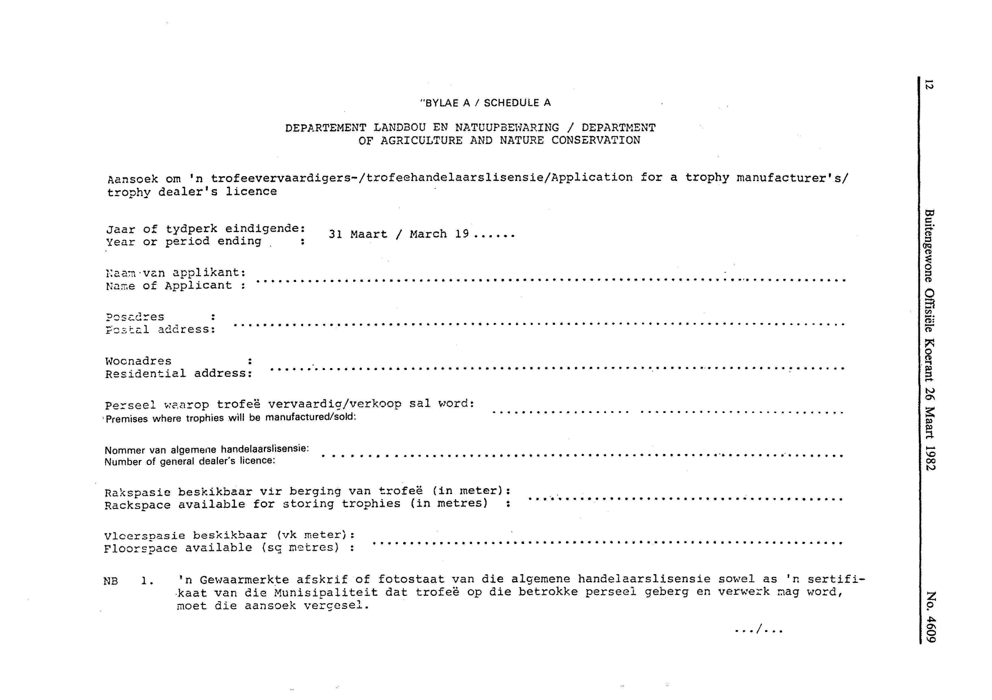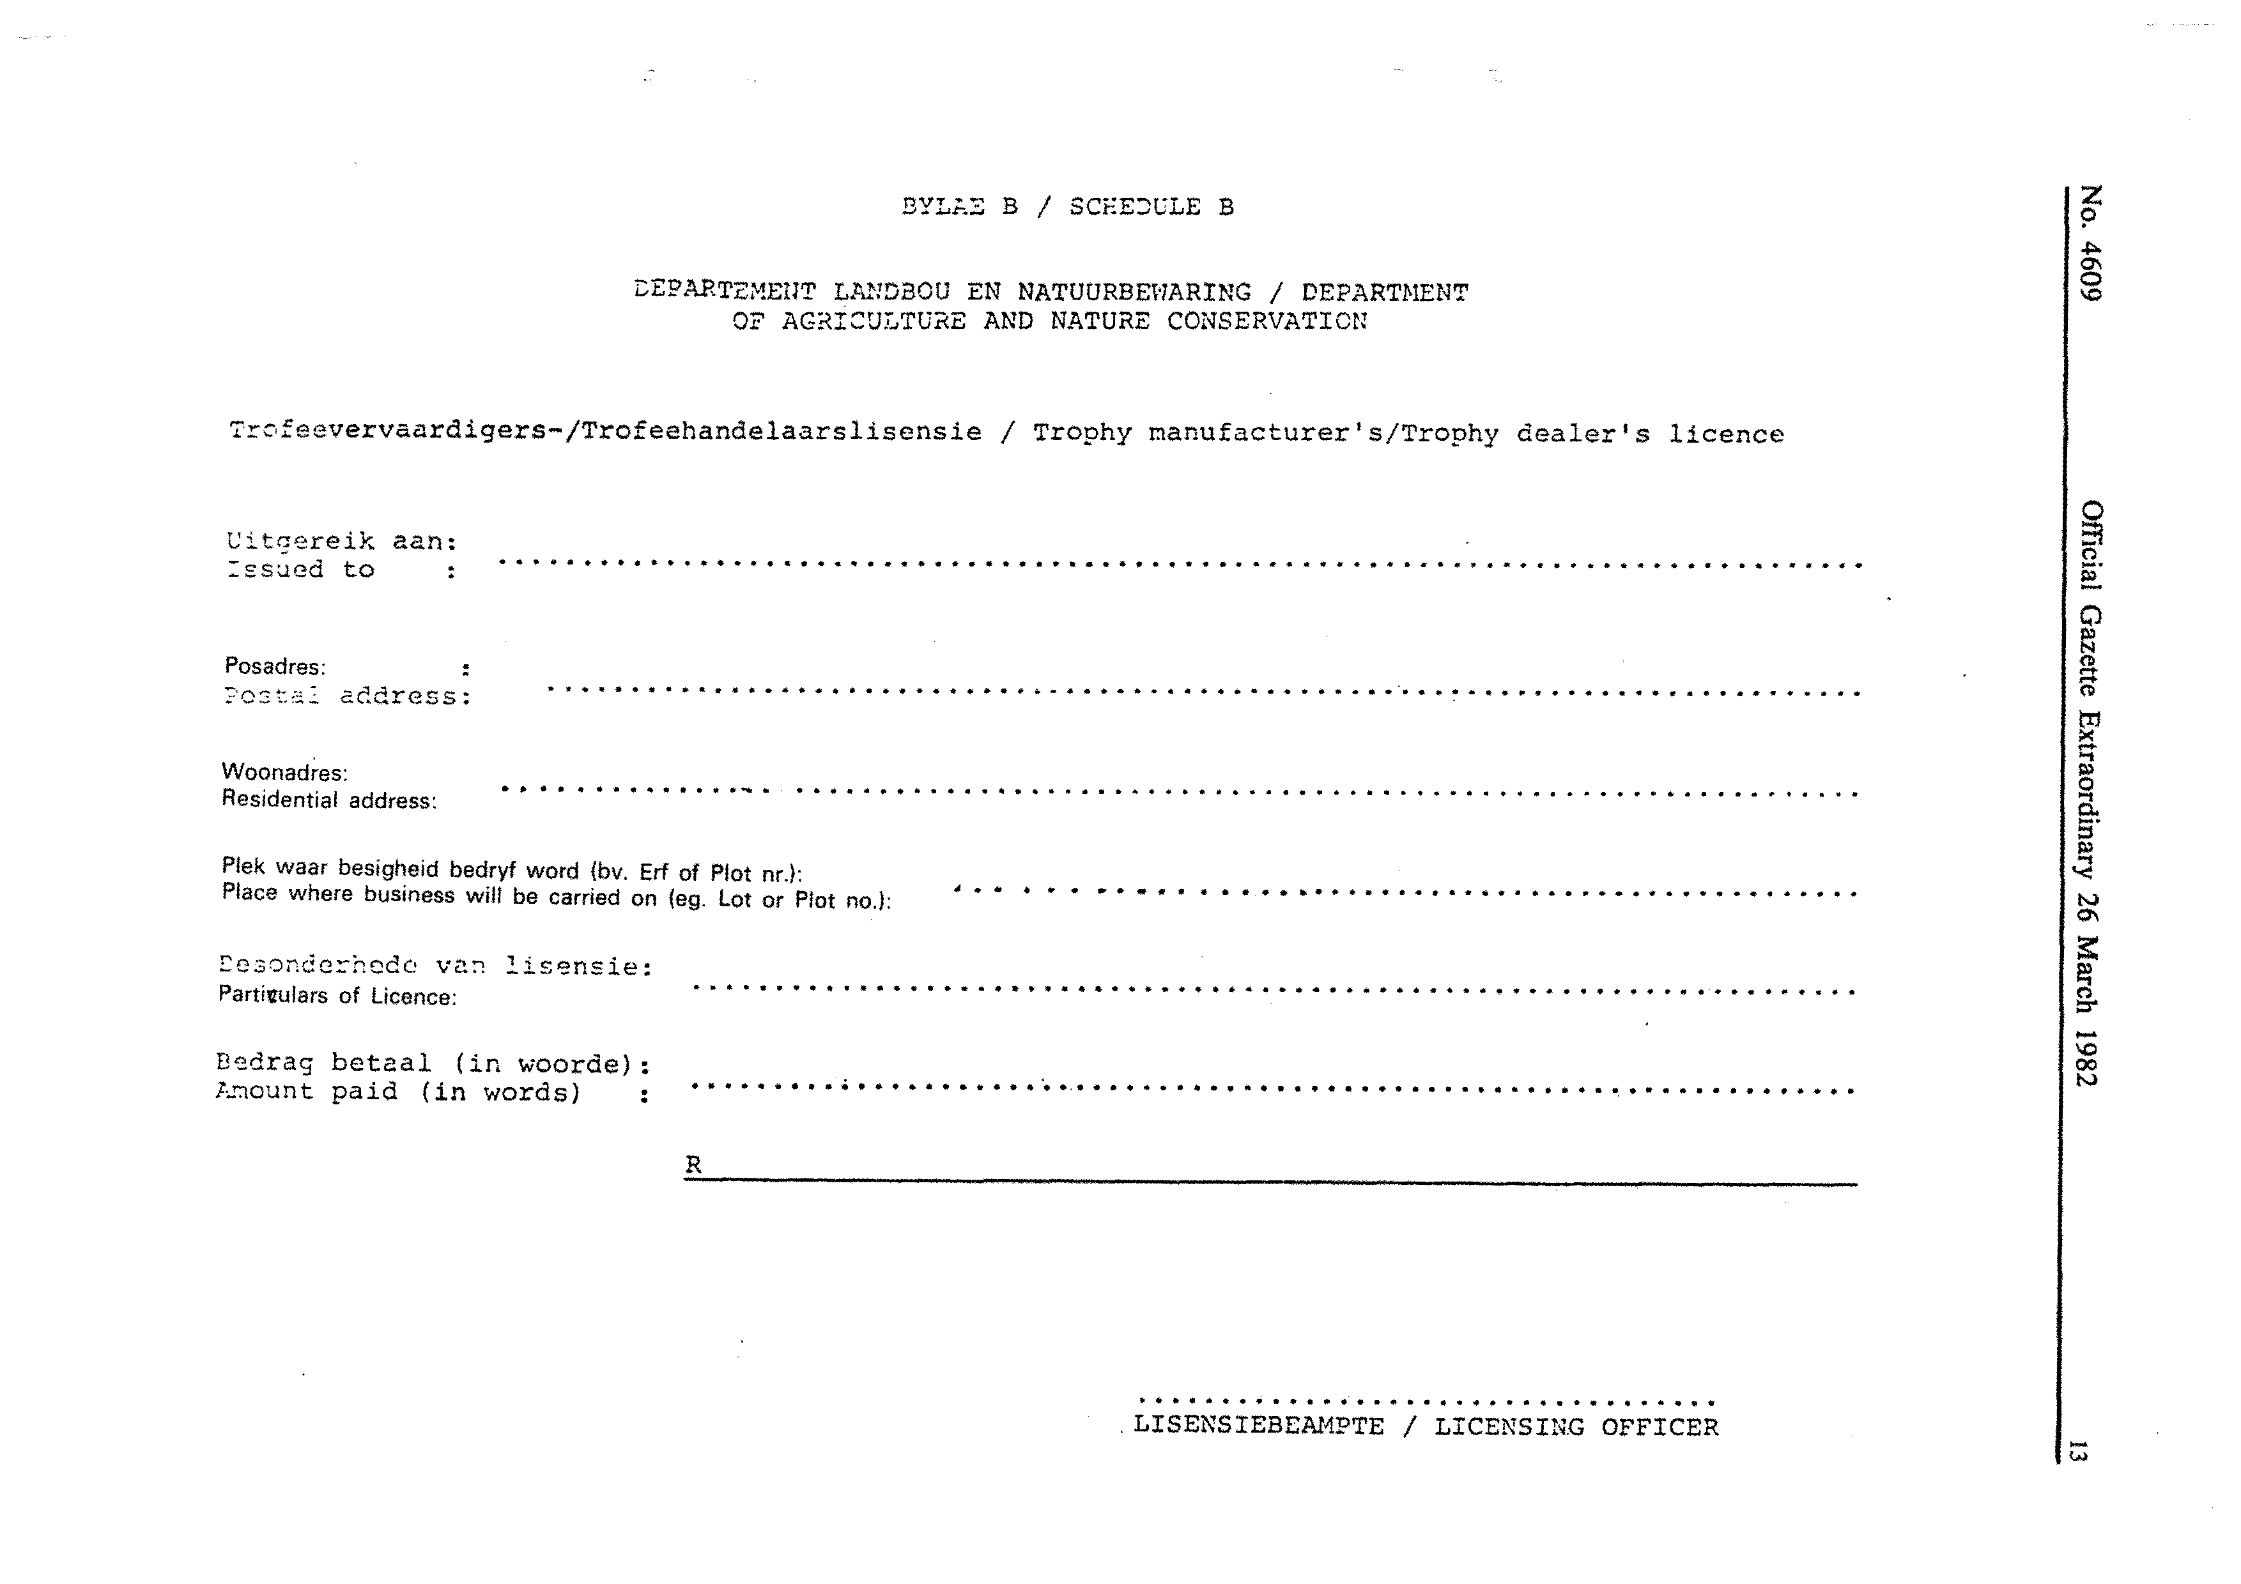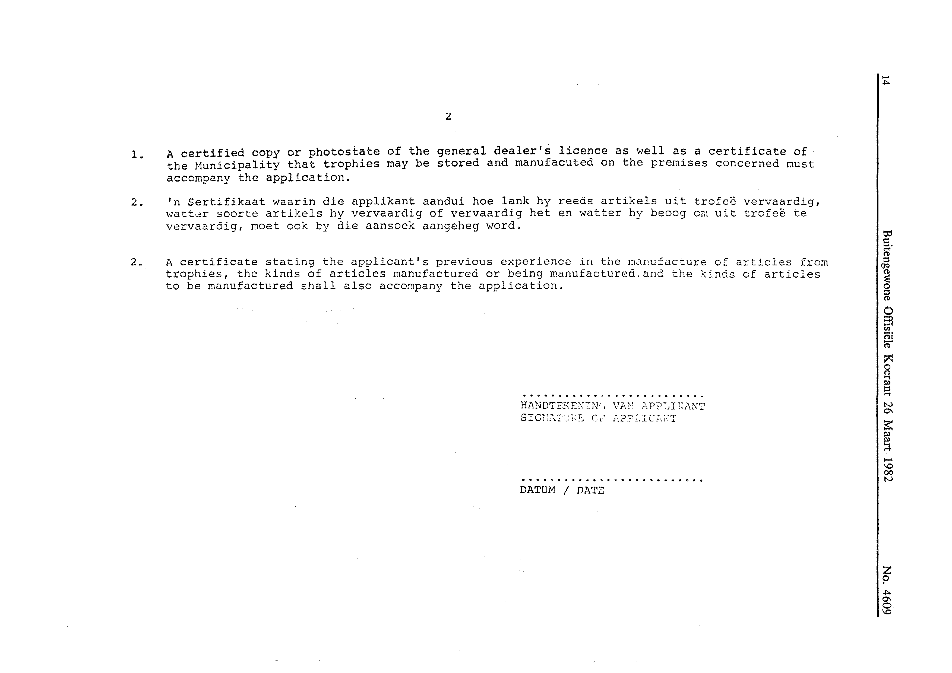

[Schedule D inserted by GN 59/2009 and amended by GN 9/2010]

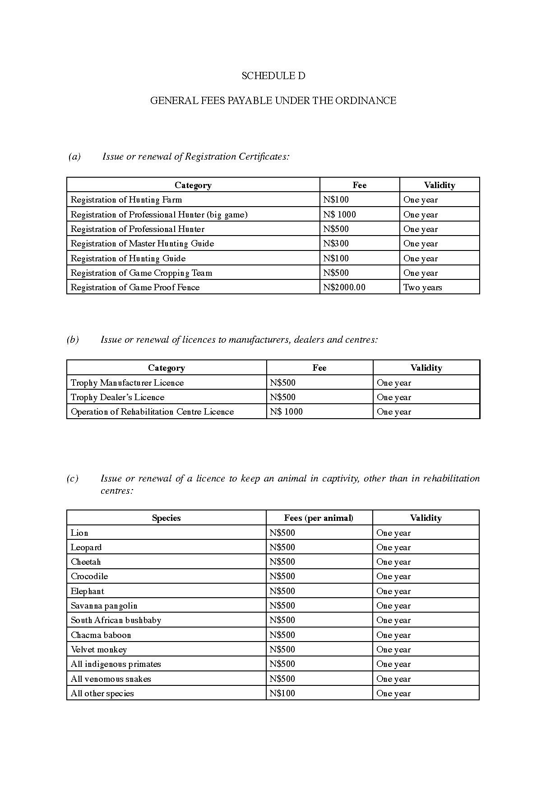

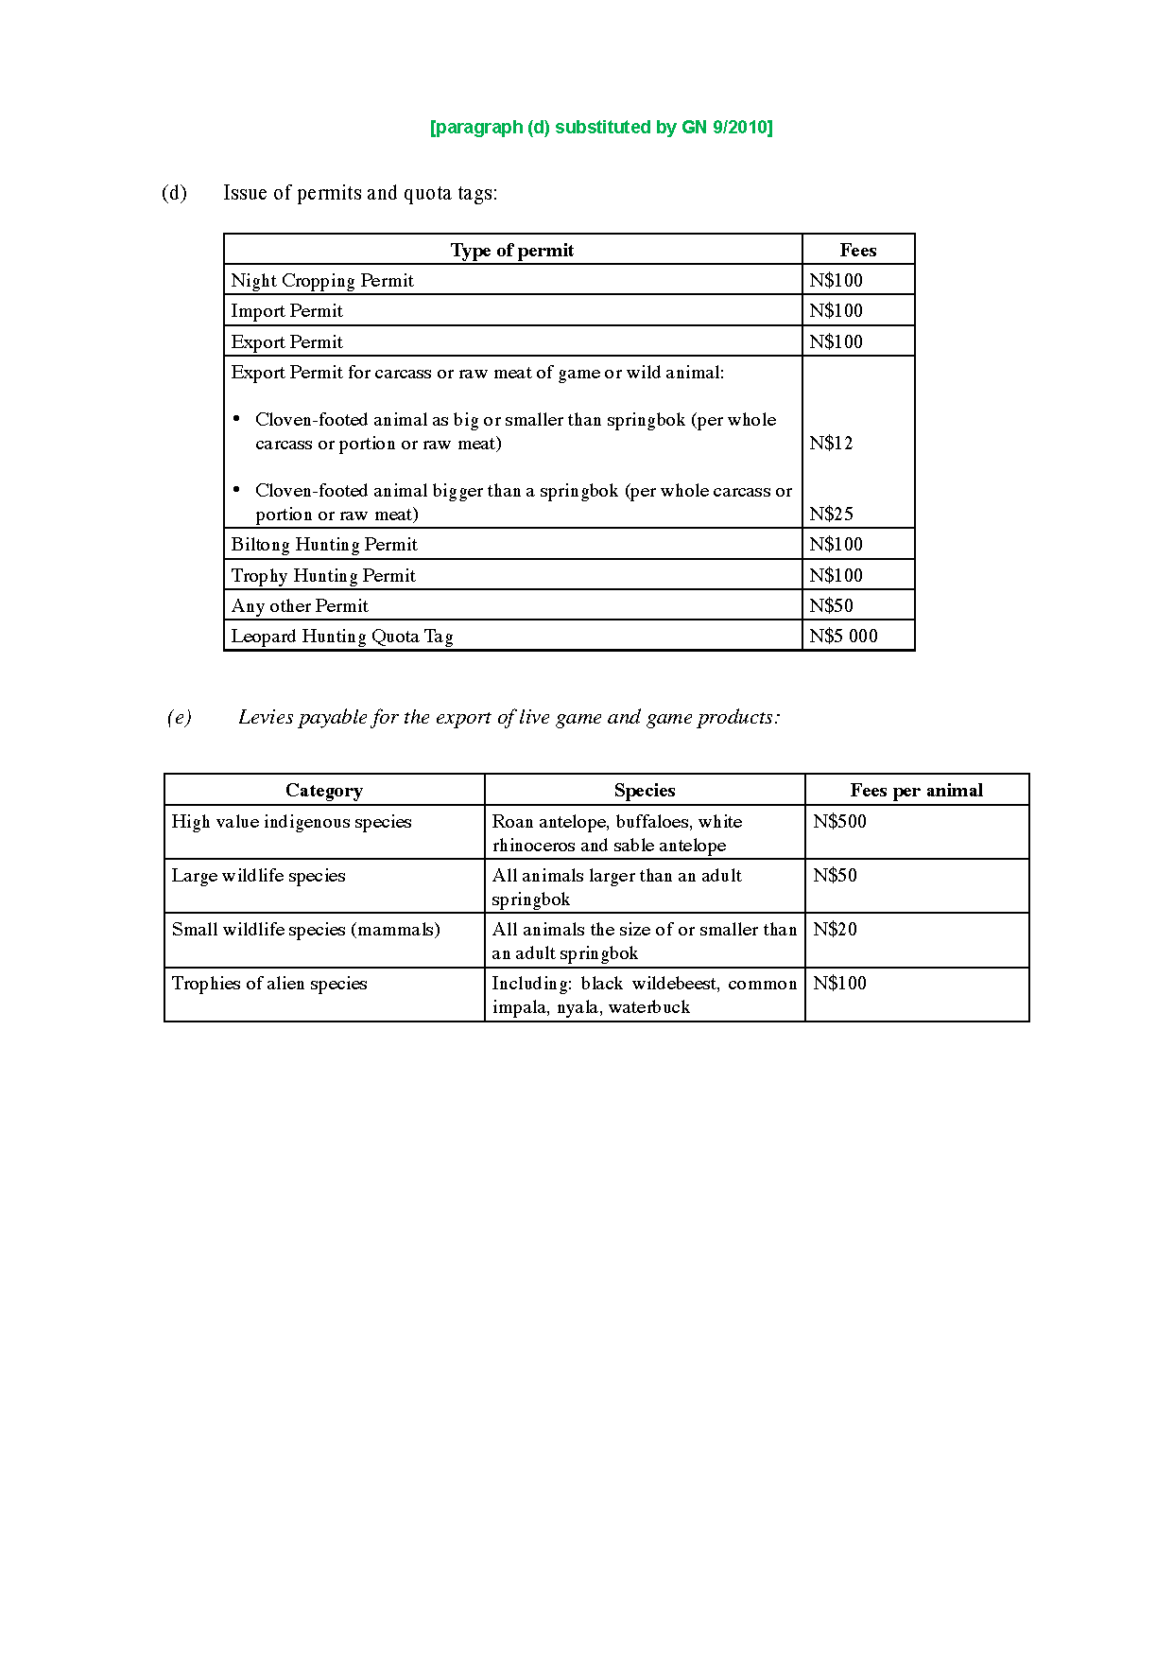

[Schedules E-F inserted by GN 9/2010]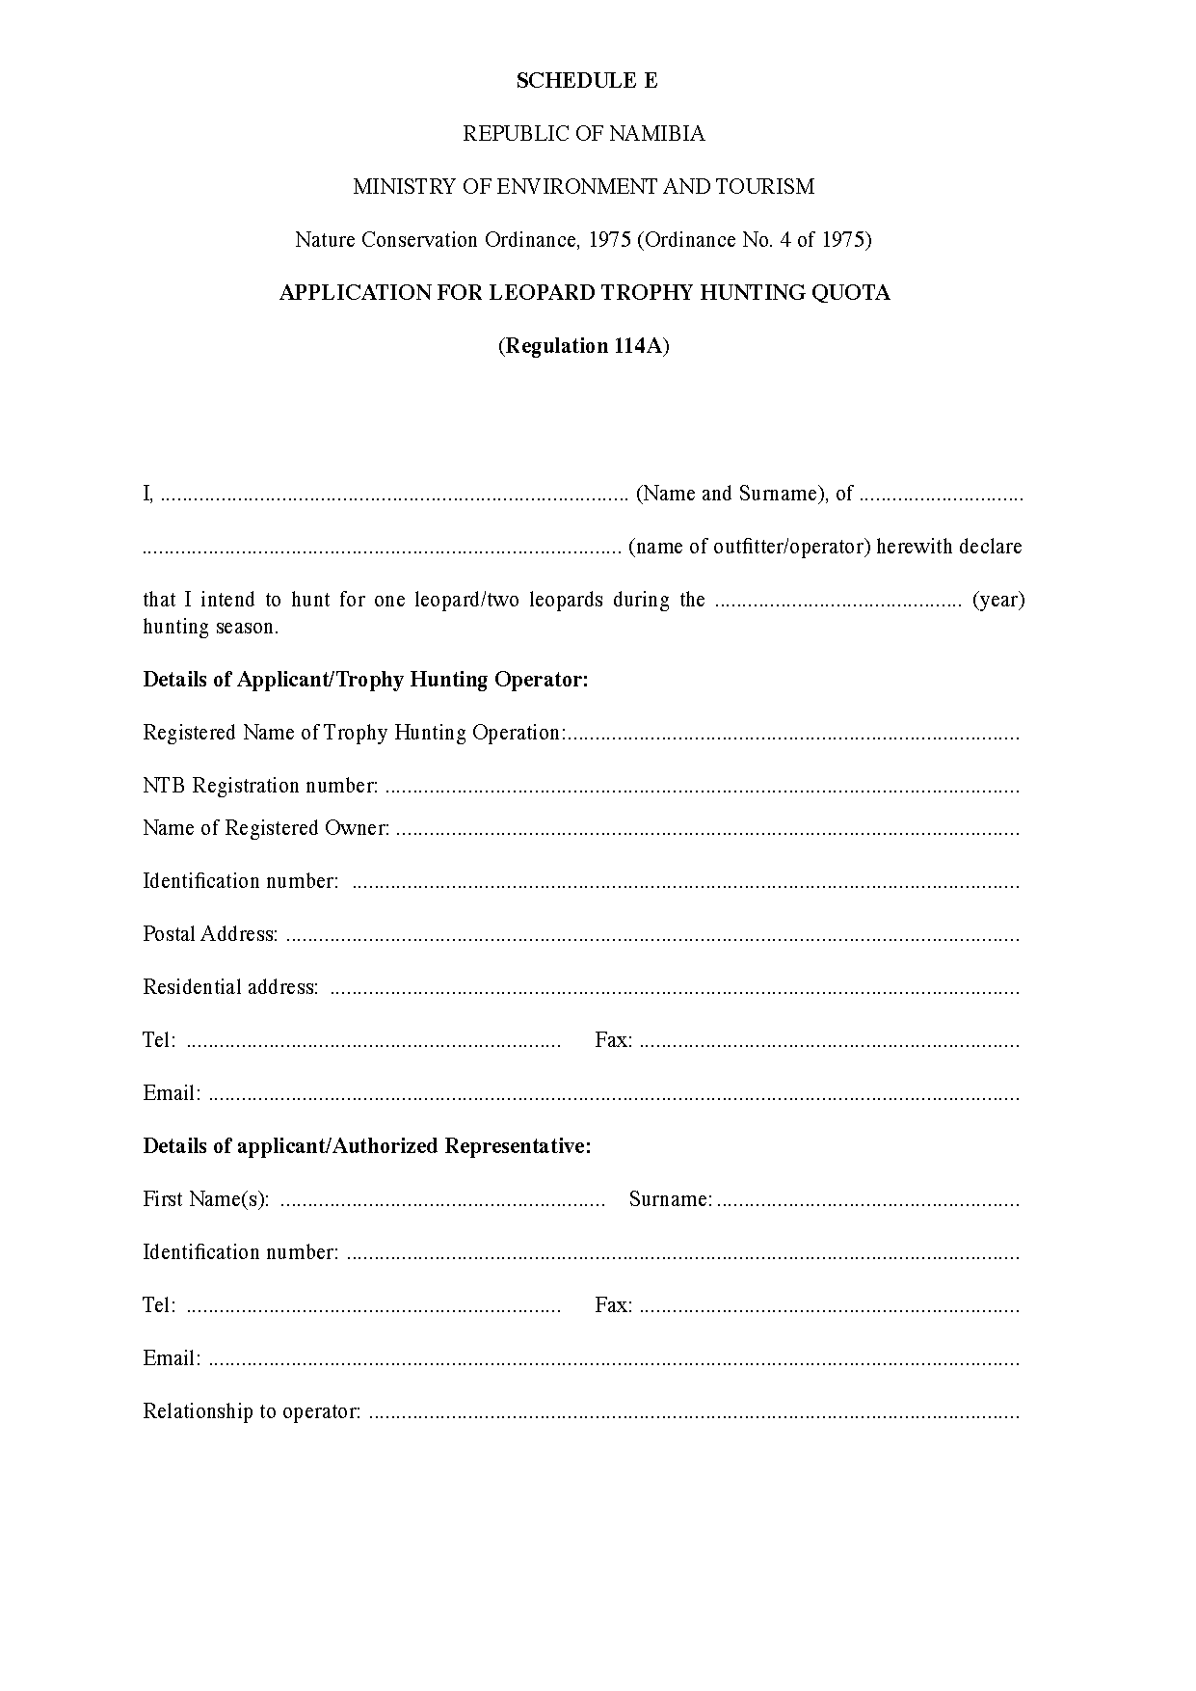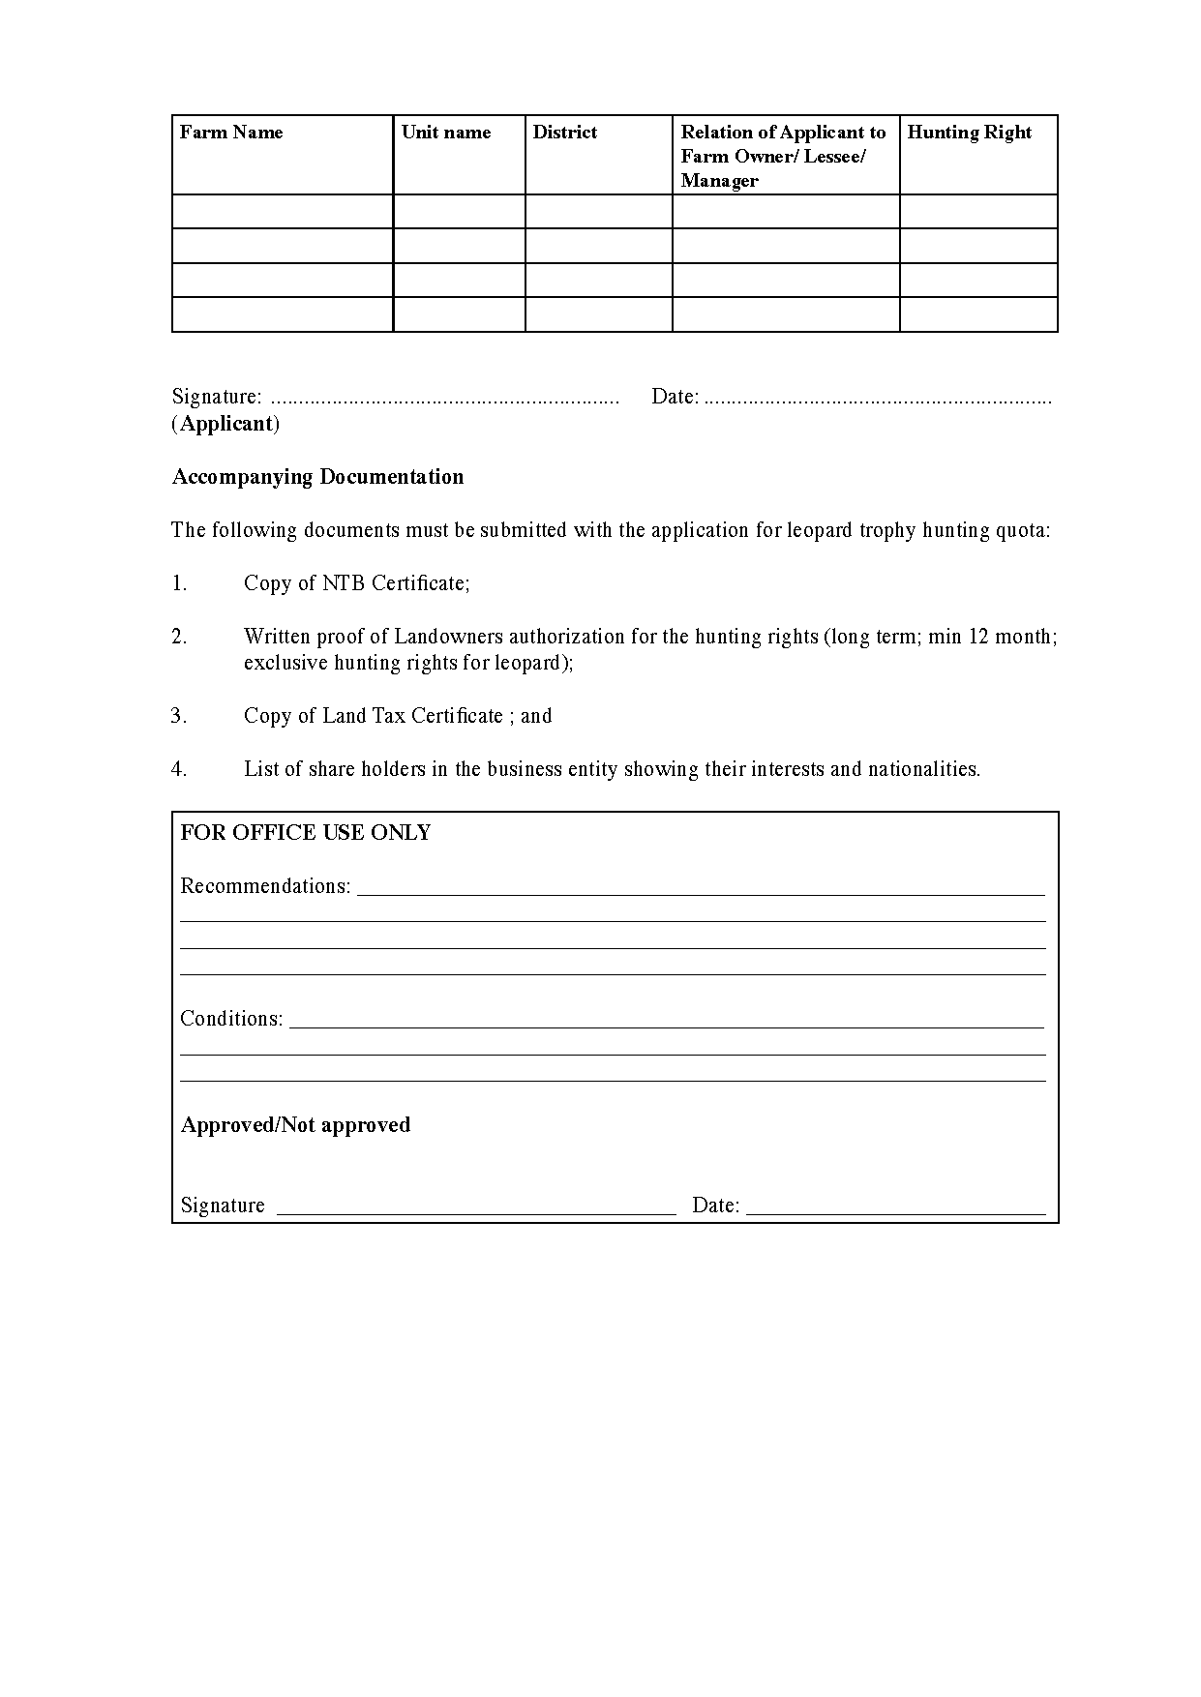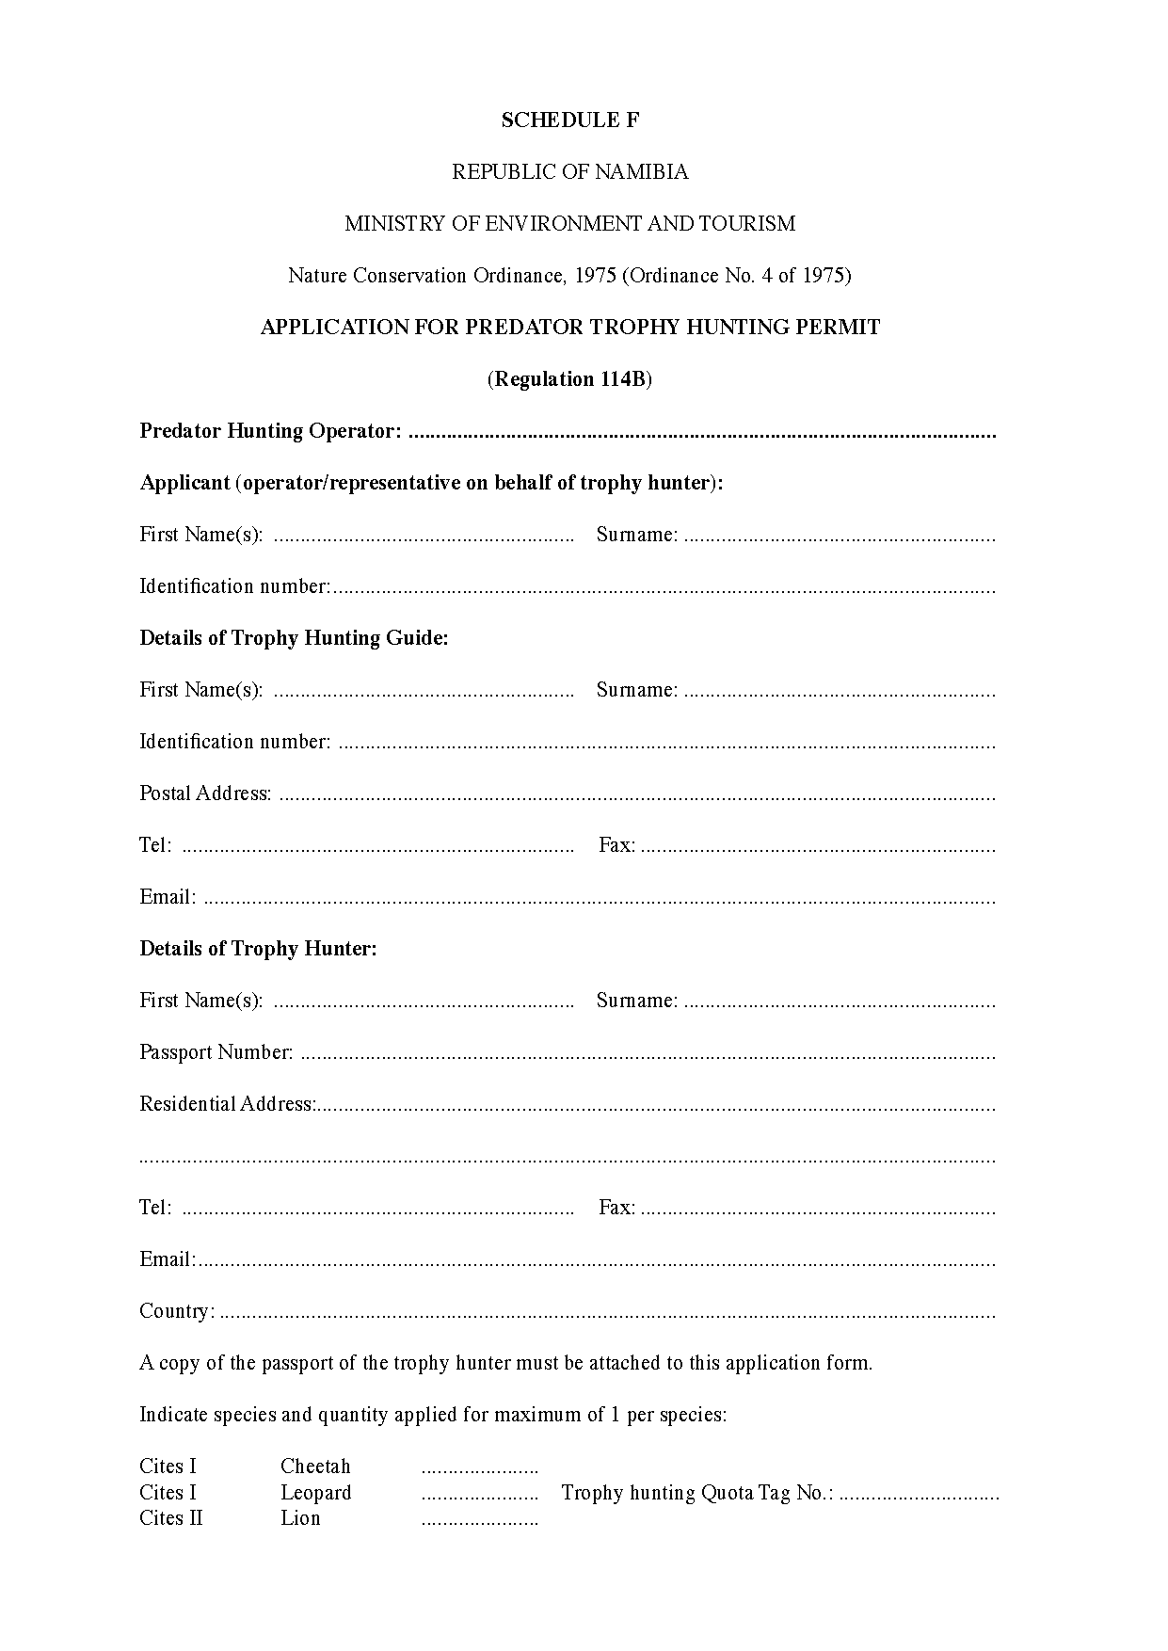

[Schedule G inserted by GN 9/2010, and substituted by   
the amendments to GN 9/2010 in GN 19/2016]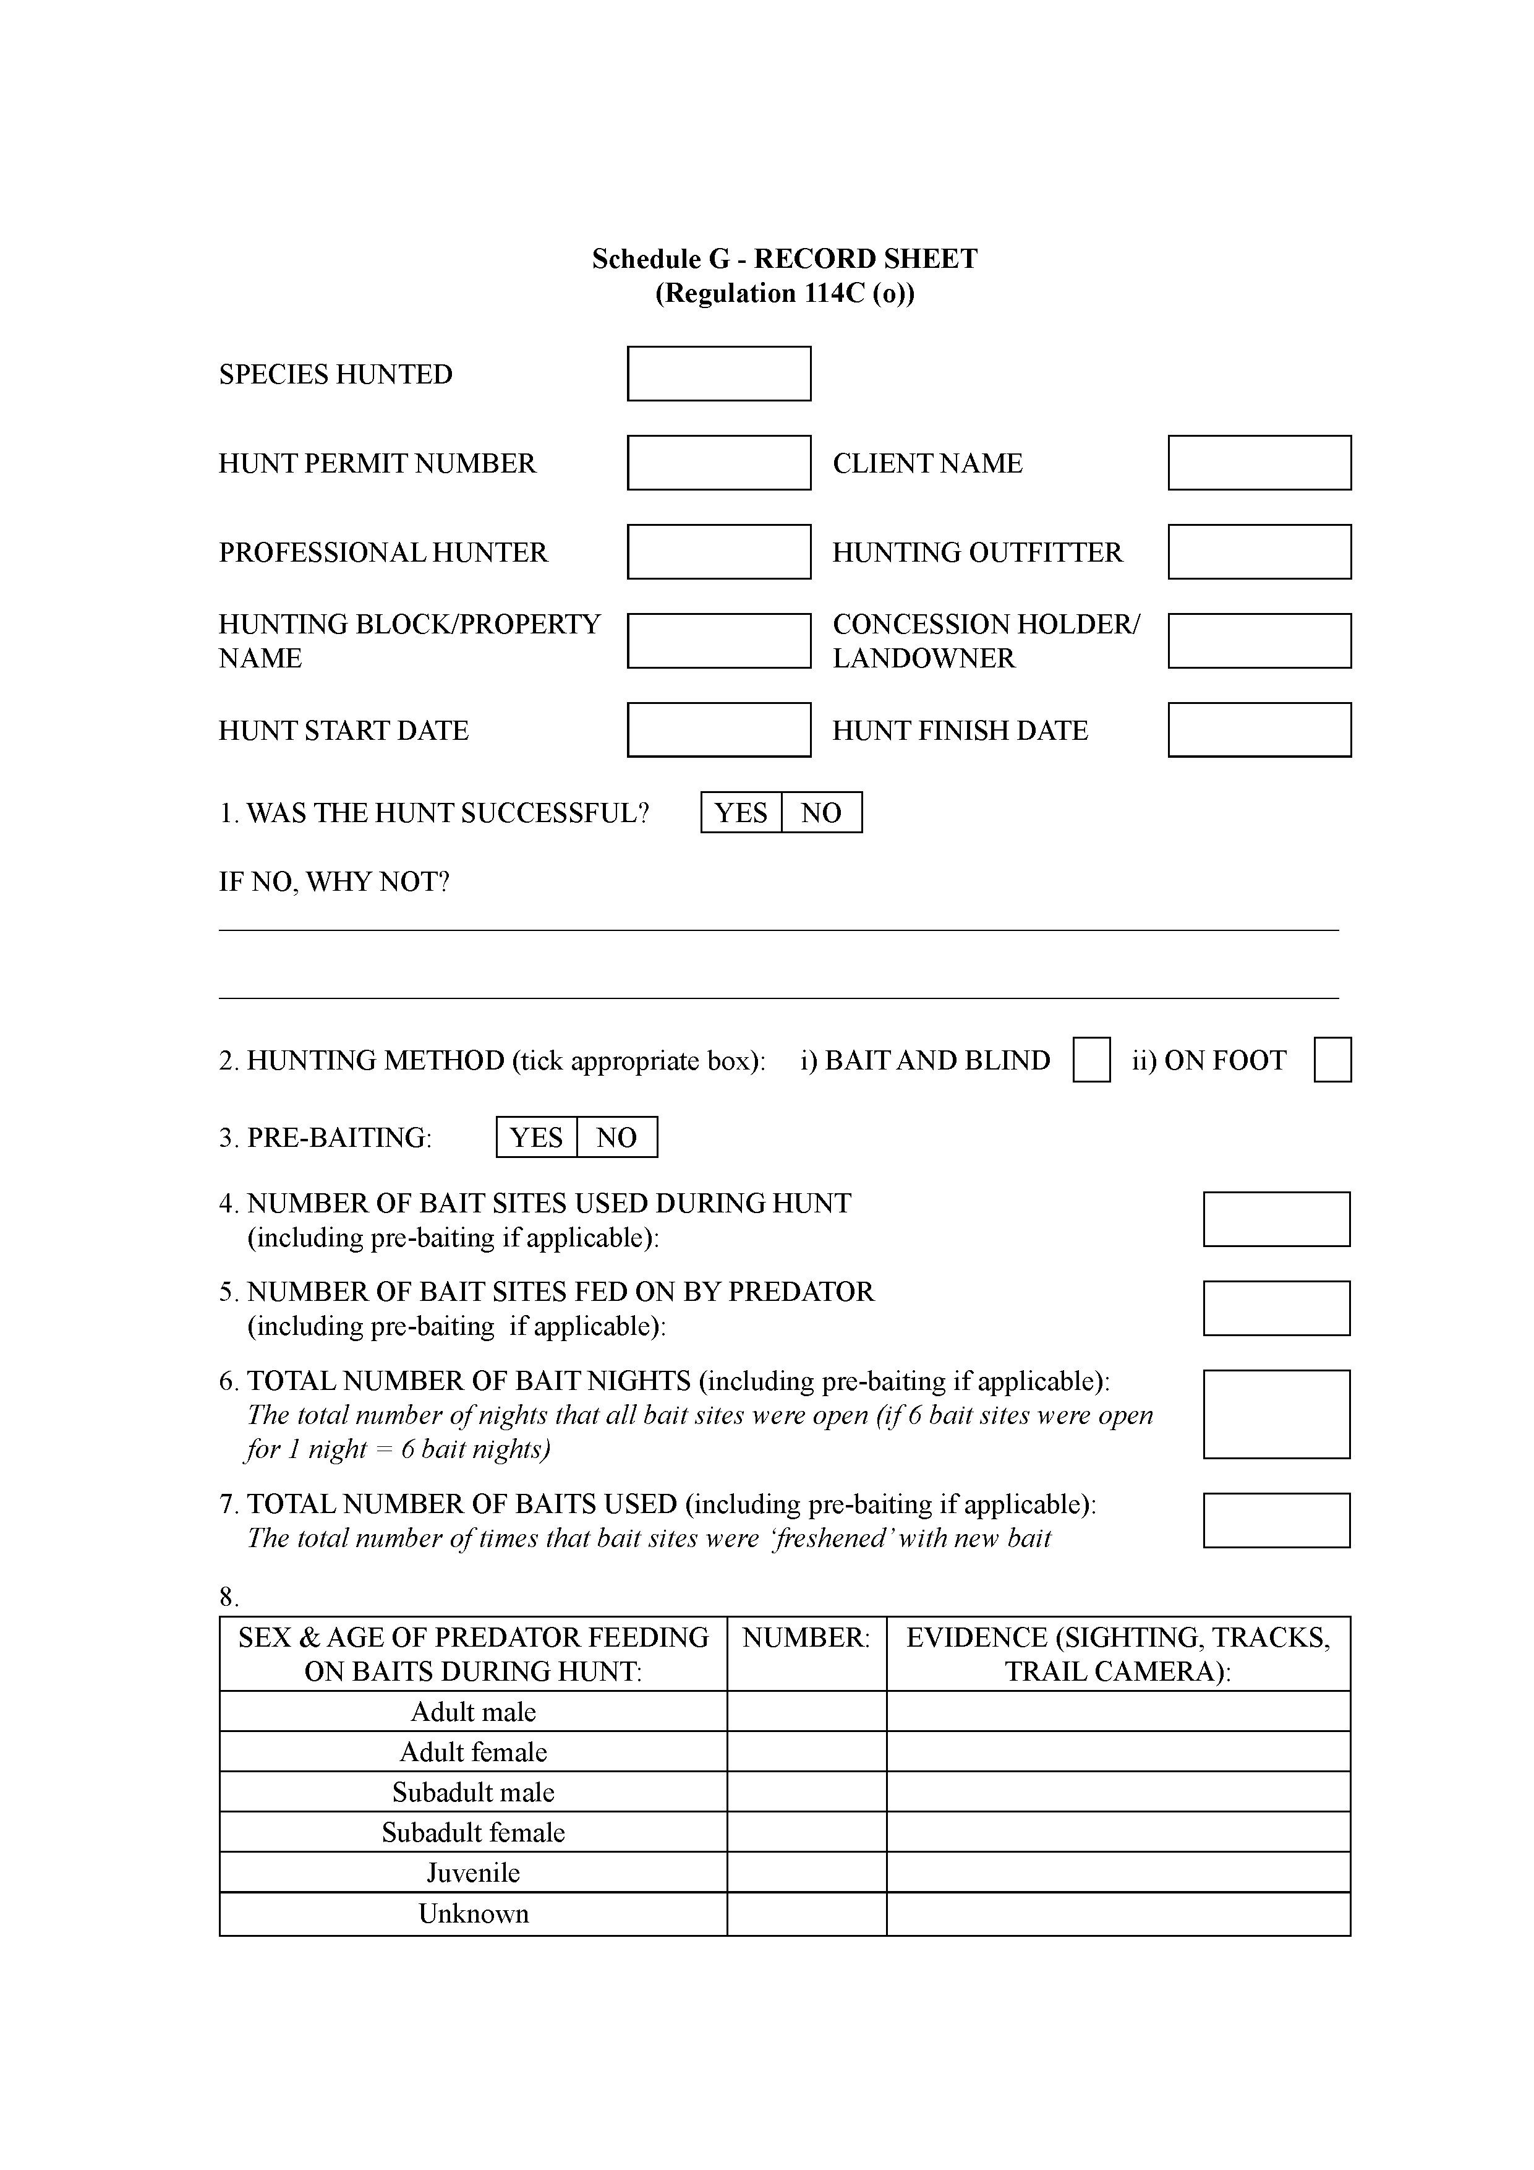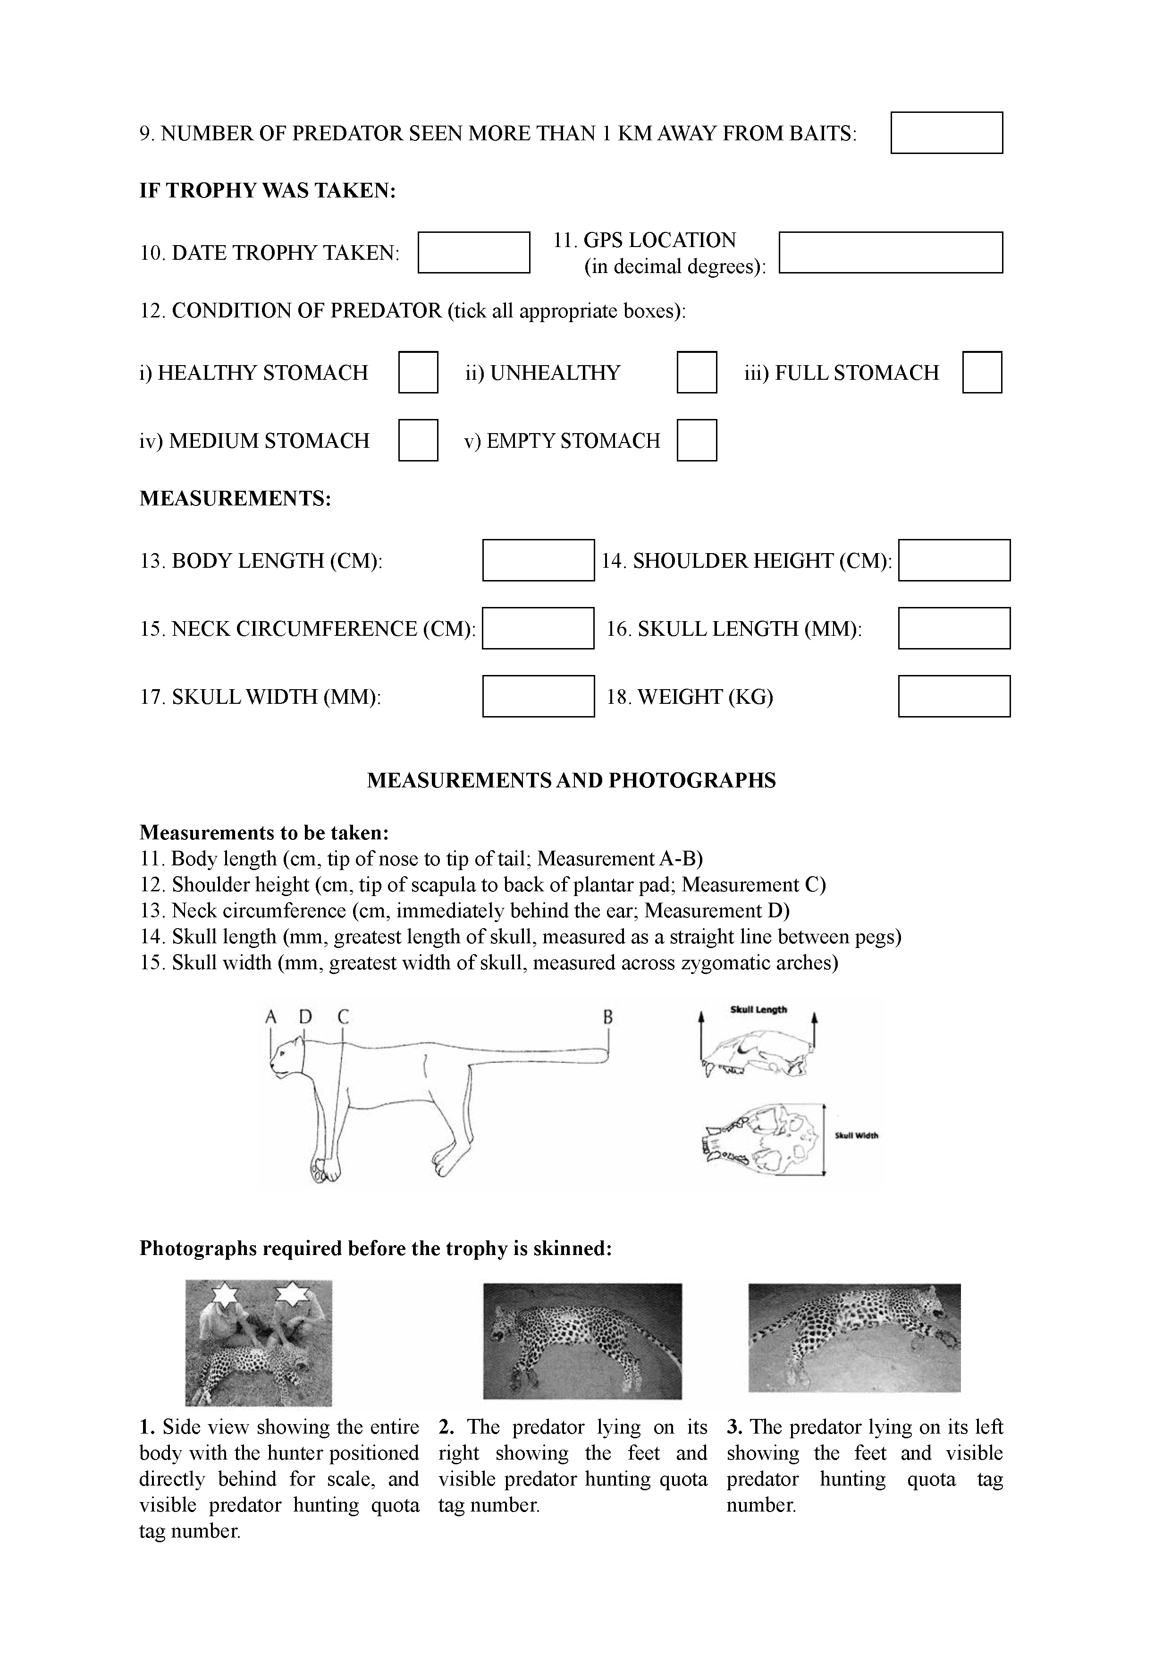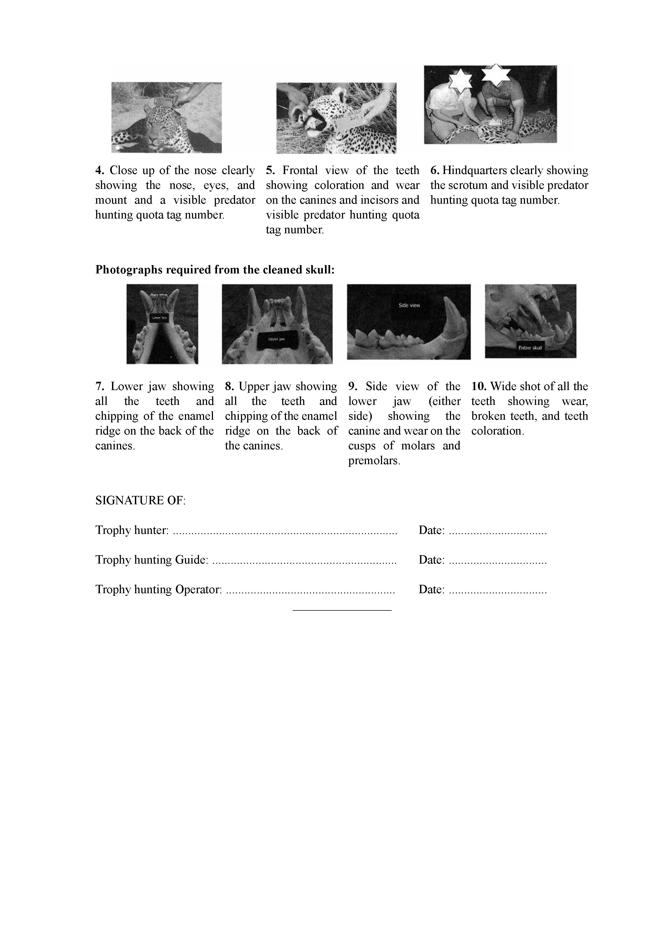

[Forms 1-3 inserted by GN 304/1996, which was withdrawn by GN 83/1997,  
 and identically inserted by GN 83/1997]