

REGULATIONS MADE IN TERMS OF

Namibia Refugees (Recognition and Control)   
Act 2 of 1999

section 31

Namibia Refugees (Recognition and Control) Regulations

Government Notice 236 of 2000

([GG 2412](http://www.lac.org.na/laws/2000/2412.pdf))

came into force on date of publication: 22 September 2000

as amended by

Government Notice 156 of 2021 **(**[GG 7](http://www.lac.org.na/laws/2021/7583.pdf)583**)**

came into force on date of publication: 19 July 2021

ARRANGEMENT OF REGULATIONS

1. Definitions

2. Application for refugee status

3. Loss of refugee status

4. Temporary identification documents

5. Issue of identity cards

6. Travel documents

7. Register of recognized refugees and protected persons

8. Withdrawal of refugee status

9. Detention or expulsion of recognized refugees and protected persons

10. Other functions of Committee

11. Subcommittees of Committee

12. Reception areas and refugee settlements

13. Employment of recognized refugees and protected persons

14. Offences and penalties

15. Serving of documents

16. Compliance with Article 35 of the UN Convention on Refugees, 1951, and Article II of the Protocol on Refugees, 1967.

17. Short title

ANNEXURE A

APPLICATION FORM FOR REFUGE STATUS

ANNEXURE B

TEMPORARY IDENTIFICATION DOCUMENT

ANNEXURE *A*B

DATA UPDATE ACQUISITION APPLICATION FORM,

DUPLICATE OR CORRECTION

[Annexure *A*B inserted by GN 156/2021]

ANNEXURE c

IDENTITY CARD

[Annexure C substituted by GN 156/2021]

ANNEXURE d

NOTICE OF INTENTION TO WITHDRAW REFUGEE STATUS

ANNEXURE e

NOTICE OF INTENTION TO DETAIN OR EXPEL   
RECOGNIZED REFUGEE/PROTECTED PERSON

ANNEXURE f

ORDER OF DETENTION

ANNEXURE g

ORDER OF EXPULSION

**Definitions**

**1.** In these regulations any word or expression to which a meaning has been assigned in the Act, shall have the meaning so assigned to it and, unless the context otherwise indicates -

“the Act” means the Namibia Refugees (Recognition and Control) Act, 1999 (Act No. 2 of 1999).

**Application for refugee status**

**2.** An application for refugee status contemplated in section 13(1) of the Act shall be made to an authorized officer on a form similar to the form contained in Annexure A, and shall contain all the required information.

**Loss of refugee status**

**3.** Where a recognized refugee loses his or her refugee status in terms of section 5 of the Act, the Commissioner shall by written notice, served in accordance with the provisions of regulation 15, notify such recognized refugee of his or her loss of refugee status, and shall in particular specify in that notice the reasons for such loss of refugee status.

**Temporary identification documents**

**4.** (1) The Commissioner shall issue to each person who has applied in terms of section 13(1) of the Act for refugee status, and to every member of the family of such person, a temporary identification document substantially in the form as set out in the Annexure B.

(2) Every person to whom a temporary identification document has been issued in terms of subregulation (1), shall at all times carry on his or her person or have readily available in his or her immediate vicinity such identification document.

**Issue of identity cards**

**5.** (1) The Commissioner shall, on application in the form set out in Annexure *A*B, issue to -

(a) each person who has been granted refugee status in terms of section 13(4)(a) of the Act; and

(b) every member of the family of such recognised refugee who has entered Namibia, an identity card substantially in the form as set out in Annexure C.

(2) A person who has been issued with an identity card in terms of subregulation (1) shall, at all times carry on him or her the identity card or, have the identity card readily available in his or her immediate vicinity.

[The punctuation in this provision is reproduced as it appears in the *Government Gazette*.]

(3) An identity document referred to in subregulation (1) shall -

(a) be predominantly yellow in colour; and

(b) contain -

(i) the signature or mark of the person to whom it was issued;

(ii) a machine readable zone; and

(iii) a quick response code.

(4) The Commissioner shall issue an identity card to a person who has applied for an identity card under subregulation (1) free of charge if -

(a) it is a first issuance;

(b) the person was issued with the identity card five years earlier; or

(c) it is an update of a photo, signature or surname of the applicant on the identity card that the applicant currently holds.

(5) An applicant who applies for a duplicate of the identity card shall pay the following fees:

(a) first duplicate N$150.00;

(b) second duplicate N$300.00;

(c) third duplicate N$450.00;

(d) fourth duplicate N$600.00; and

(e) fifth duplicate and subsequent duplicates N$750.00.

[regulation 5 substituted by GN 156/2021]

**Travel documents**

**6**. (1) If a recognised refugee or protected person intends to travel outside Namibia he or she shall apply in the form available at the Ministry, to the Commissioner for the Commissioner to issue the applicant with a travel document.

(2) On receipt of an application made in terms of subregulation (1), the Commissioner shall, if he or she is satisfied as to the purposes of the intended travelling outside Namibia, issue a travel document to such applicant.

(3) If the Commissioner is not satisfied as contemplated in subregulation (2), he or she shall, in writing, notify the applicant of the decision taken and provide reasons of the Commissioner’s decision.

[The phrase “reasons of the Commissioner’s decision” should be  
 “reasons for the Commissioner’s decision”.]

(4) The Commissioner shall keep and maintain a register of all the recognised refugees and protected persons who have, in accordance with subregulation (2), been issued with travel documents.

(5) A person who applies for a travel document as contemplated in subregulation (1) shall pay a fee of N$400 if it is a first time application or a renewal of a travel document.

(6) Despite subregulation (5), a person who has been issued with a travel document as contemplated in subregulation (1), and whose travel document has either been lost or damaged, shall pay a fee of N$800 to be issued with a new travel document.

[regulation 6 substituted by GN 156/2021]

**Register of recognized refugees and protected persons**

**7.** (1) The Commissioner shall keep proper record, or cause proper record to be kept, of all applications for the granting of refugee status transmitted to him or her in terms of section 13(2)(c) of the Act, including particulars as to how every application was disposed of.

(2) The Commissioner shall maintain a register in which shall, in respect of every recognized refugee and protected person, be entered the following particulars:

(a) Full names and address;

(b) registration number;

(c) nationality or citizenship;

(d) sex;

(e) marital status;

(f) date of birth;

(g) occupation, trade or profession;

(h) names of dependants (where applicable);

(i) date of entry into Namibia;

(j) date of becoming a recognized refugee or protected person; and

(k) such additional particulars relating to the registration of recognized refugees and protected persons as the Commissioner may consider necessary.

**Withdrawal of refugee status**

**8.** A notice of intention to withdraw a person’s refugee status, as contemplated in section 23(2)(b) of the Act, shall be substantially in the form as set out in Annexure D.

**Detention or expulsion of recognized refugees and protected persons**

**9.** (1) A notice of intention to detain or expel a recognized refugee or protected person, as contemplated in section 24(3)(b) of the Act, shall be substantially in the form as set out in Annexure E.

(2) An order -

(a) for the detention of a recognized refugee or protected person, as contemplated in section 24(7)(a) of the Act, shall be substantially in the form as set out in the Annexure F;

(b) for the expulsion of a recognized refugee or protected person, as contemplated in the said section 24(7)(a), shall be substantially in the form as set out in the Annexure G.

(3) Notwithstanding the provisions of regulation 15, an order of detention or expulsion referred to in subregulation (2) shall be served personally on the recognized refugee or protected person concerned.

**Other functions of Committee**

**10.** In addition to any other powers conferred or duties imposed upon the Committee by or under the Act, the Committee shall be responsible for -

(a) creating or providing, with the concurrence of the Minister, suitable temporary reception centres and facilities at which refugees would be accommodated before being transferred to the reception area or refugee settlement in which they are pursuant to an order made under section 20(1) of the Act required to reside;

(b) ensuring that adequate provision is made to feed, accommodate and provide health and sanitary care to refugees;

(c) investigating complaints regarding any ill-treatment of refugees by governmental authorities;

(d) assisting skilled recognized refugees and protected persons in seeking gainful employment in Namibia;

(e) promoting gainful agricultural activity and other income generating activities by recognized refugees and protected persons in reception areas and refugee settlements; and

(f) promoting education and training skills among recognized refugees and protected persons in reception areas and refugee settlements.

**Subcommittees of Committee**

**11.** (1) A subcommittee appointed under section 11(1) of the Act shall consist of -

(a) at least one member of the Committee, nominated by the Committee for that purpose; and

(b) one or more other persons, not being a member or members of the Committee, appointed by the Committee:

Provided that, if a member of the Committee appointed as such in terms of section 7(2)(f) of the Act is nominated as a member of a subcommittee, he or she shall hold observer status with no voting right and act only in an advisory capacity.

(2) The Committee shall designate one of the members of the subcommittee as chairperson thereof.

(3) A subcommittee shall meet at such intervals as determined by its activities and the dates for the completion of its tasks.

(4) The Committee may direct a subcommittee to call an urgent meeting to resolve any matter determined by the Committee.

(5) The majority of the members of a subcommittee shall constitute a quorum for any meeting of the subcommittee.

(6) The chairperson of the Committee may attend any meeting of a subcommittee and shall be entitled to take part in the proceedings at such meeting.

(7) If consensus cannot be reached on any matter under consideration by any subcommittee, the matter shall be referred to the Committee for decision.

(8) A subcommittee shall cause proper record to be kept of the proceedings at its meetings, and the Committee may at any time request that such record be submitted to it by the subcommittee for inspection.

**Reception areas and refugee settlements**

**12.** The authorized officer or any other person in charge of a reception area or refugee settlement shall -

(a) maintain a register of all persons who have pursuant to an order or a permit made or issued under section 20 of the Act been admitted to the reception area or refugee settlement under his or her control; and

(b) submit monthly returns to the Commissioner containing such information relating to the reception area or refugee settlement under his or her control as the Commissioner may consider necessary to effectively perform his or her functions under the Act or these regulations.

**Employment of recognized refugees and protected persons**

**13.** In the employment of persons who are not Namibian citizens, every employer shall, with due regard to efficiency, economy and practicability, give preference to applicants who -

(a) are recognized refugees or protected persons; and

(b) possess the qualifications, expertise and experience required for such employment.

Provided that those recognized refugees or protected persons have, except to the extent otherwise provided in paragraph 2 of Article 17 of UN Convention on Refugees, 1951, complied with the requirements of Part V of the Immigration Control Act in so far as those requirements relate to employment in Namibia.

**Offences and penalties**

**14.** Any person who -

(a) contravenes or fails to comply with a provision of regulation 4(2), 5(2) or 13; or

(b) for the purposes of being granted refugee status in terms of the Act, whether for himself or herself or for any other person, makes a false statement or representation, or furnishes any false information, to an authorized officer or any other person knowing such statement, representation or information to be false or misleading in any material respect or not believing it to be true,

shall be guilty of an offence and on conviction be liable to a fine not exceeding N$2 000 or to imprisonment for a period not exceeding six months or to both such fine and such imprisonment.

**Serving of documents**

**15.** Unless otherwise provided in the Act, a notice, order or other document which is required in terms of the Act or these regulations to be served on or delivered to a person, will have been properly served or delivered if it has been either -

(a) served on or delivered to that person personally; or

(b) sent by registered post to that person’s last known address; or

(c) published in the *Gazette.*

**Compliance with Article 35 of the UN Convention on Refugees, 1951, and Article II of   
the Protocol on Refugees, 1967**

**16.** The Commissioner shall periodically or otherwise and before the dates or within the period determined by the Minister furnish the representative in Namibia of the United Nations High Commissioner for Refugees with information relating to -

(a) applications for the granting of refugee status;

(b) persons who have been granted refugee status;

(c) members of the families of recognized refugees;

(d) the withdrawal of refugee status;

(e) the detention or expulsion of recognized refugees and protected persons;

(f) the treatment and welfare of refugees;

(g) the implementation of the Conventions; and

(h) such additional information as the Minister may determine or as such representative may reasonable require.

[The word “reasonable” in paragraph (h) should be “reasonably”.]

**Short title**

**17.** These regulations shall be called the Namibia Refugees (Recognition and Control) Regulations, 2000.

ANNEXUREs

To view content without printing, scroll down.

To print at full scale (A4), double-click the icon below.



[Annexure *A*B inserted by GN 156/2021]

[Annexure C substituted by GN 156/2021]

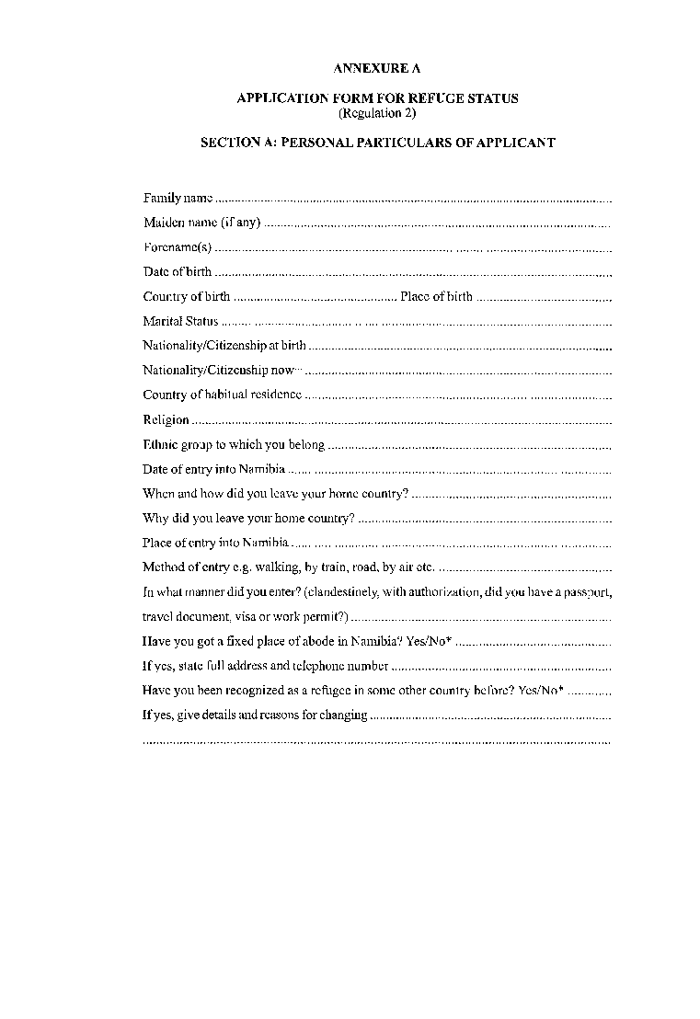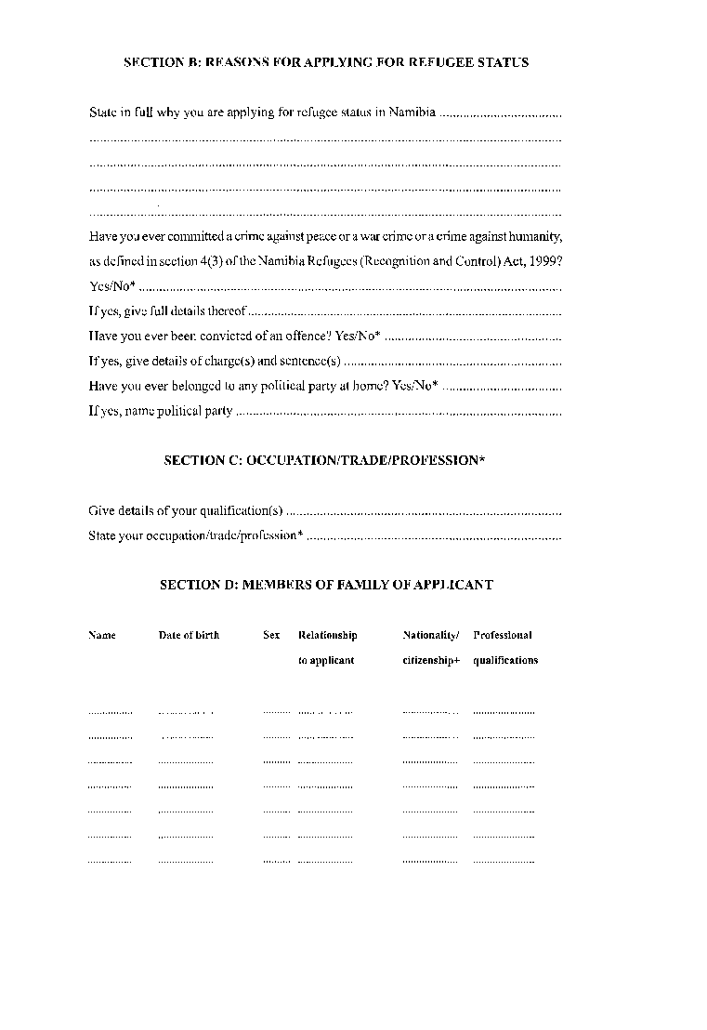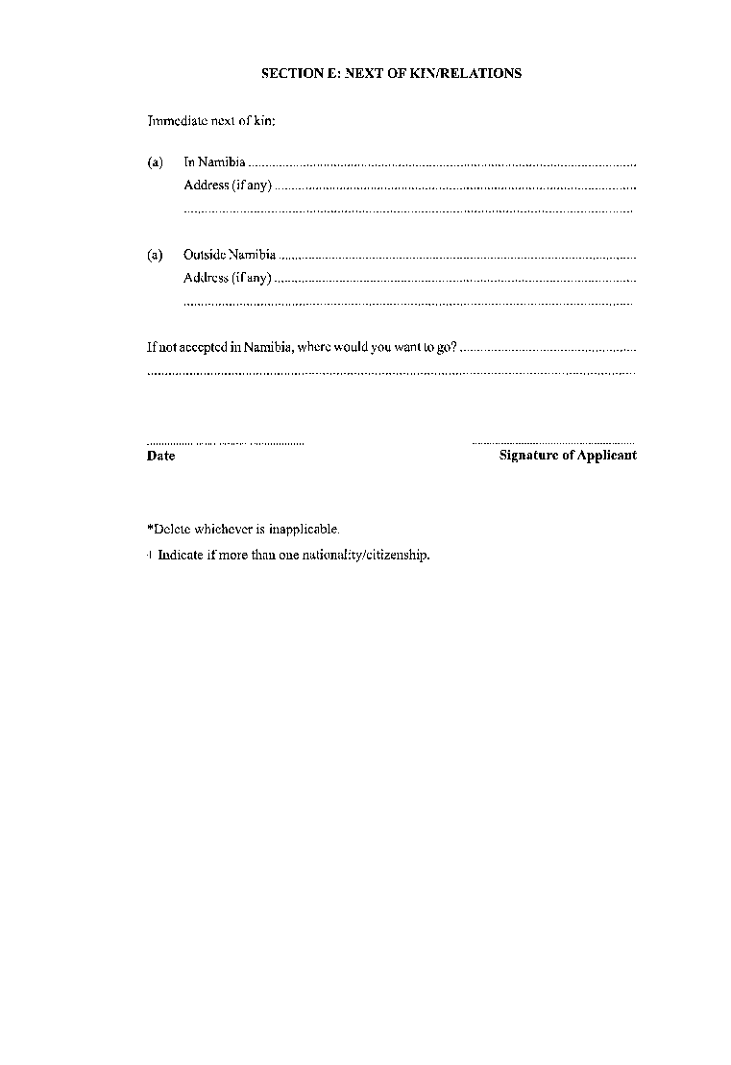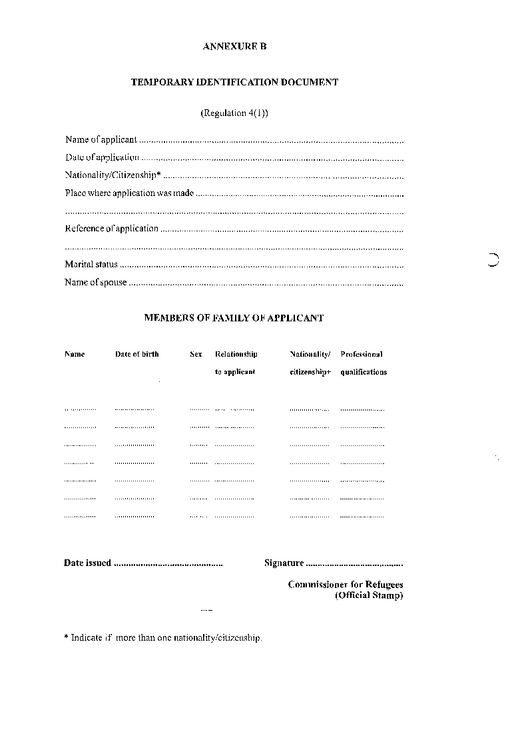

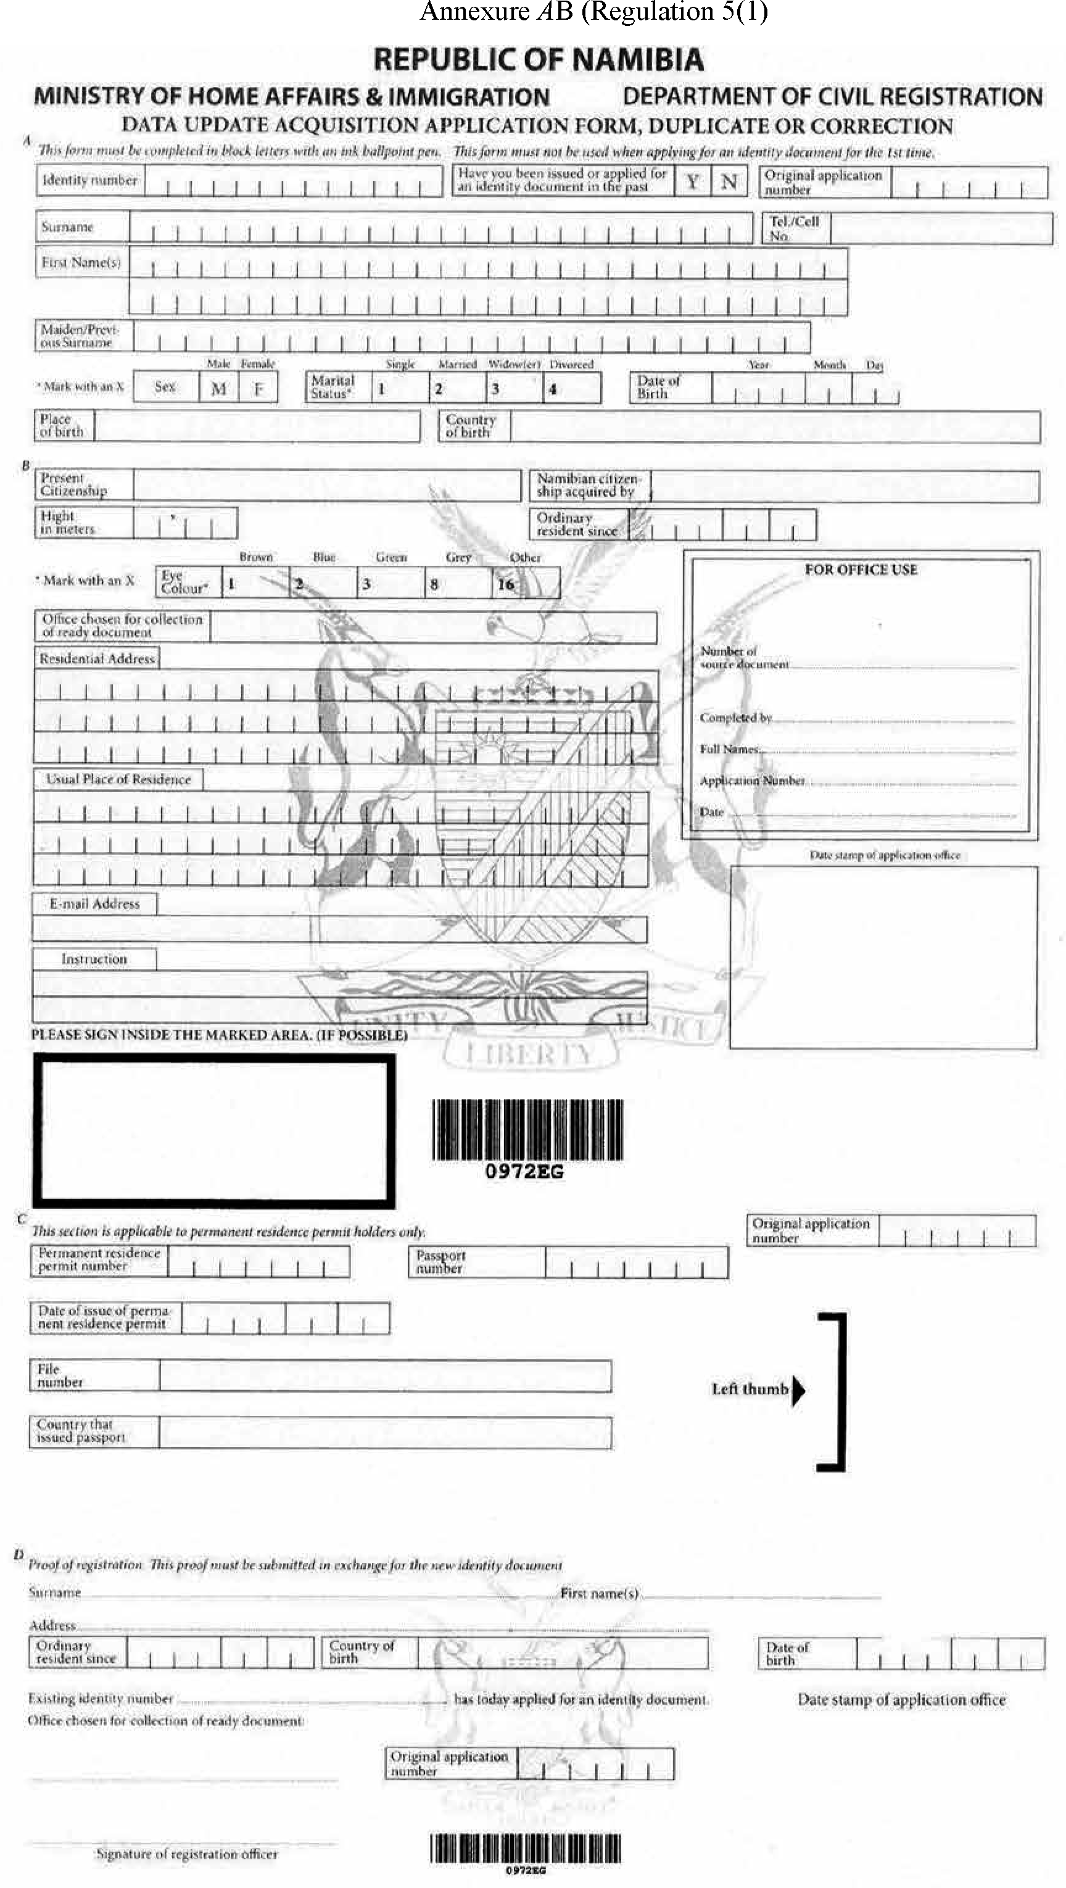[Annexure *A*B inserted by GN 156/2021]

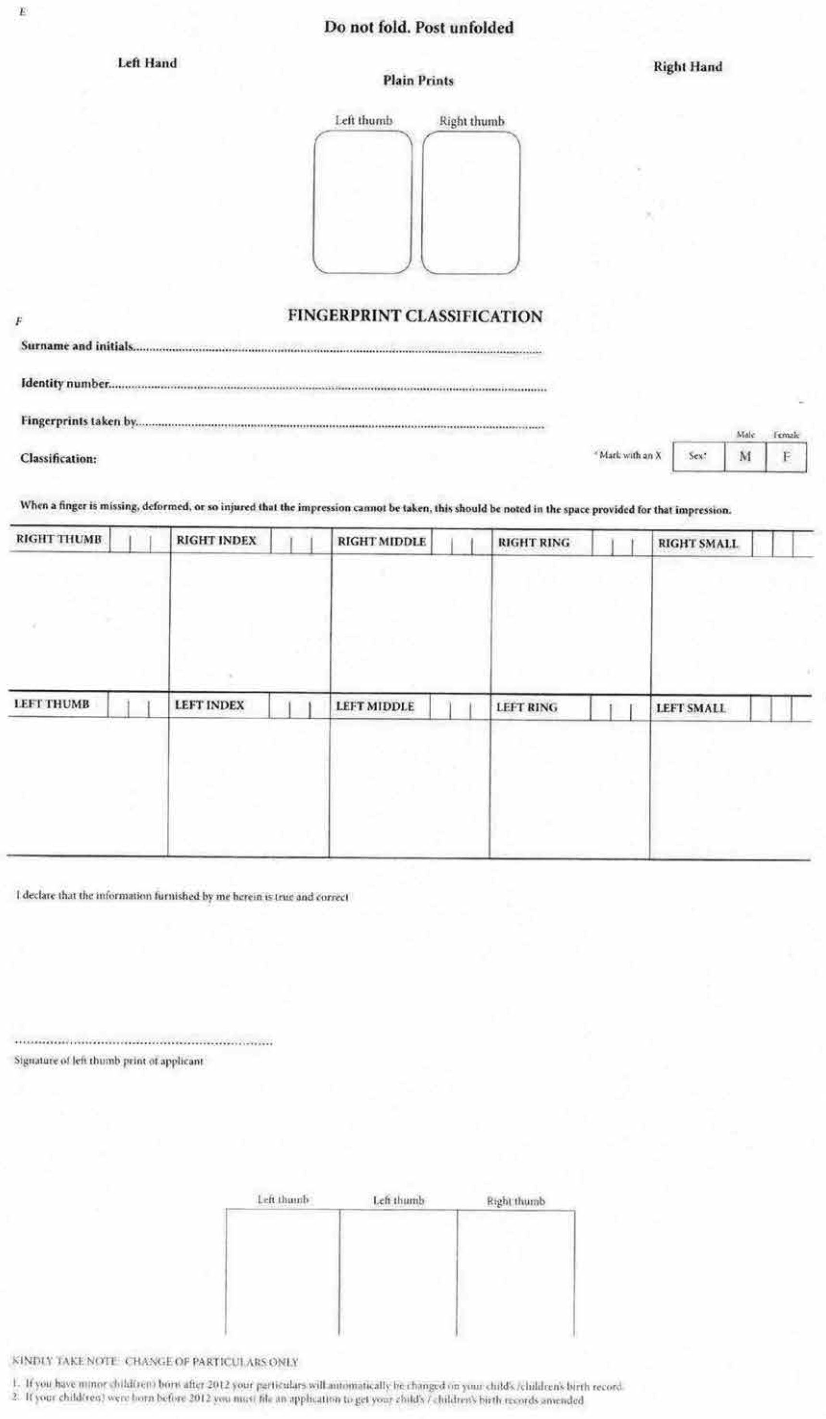

[Annexure C substituted by GN 156/2021]

