

REGULATIONS MADE IN TERMS OF

Namibia Qualifications Authority Act 29 of 1996

section 14

Regulations setting-up the National Qualifications

Framework for Namibia

Government Notice 125 of 2006

(GG 3685)

came into force on date of publication: 28 August 2006

The Government Notice which publishes these regulations notes that they were made   
on the recommendation of the Council of the National Qualifications Authority.   
The word “setting-up” in the title should not be hyphenated.

ARRANGEMENT OF REGULATIONS

1. Definitions

2. Establishment of the NQF

3. Components of the NQF

4. The NQF Classification System

5. NQF credits

6. Use of “National” and “Namibia”

7. Registration on the NQF

8. Application for registration

9. Registration

10. Appeals to the Minister

**ANNEXURES**

Annexure A Level Descriptors for the National Qualifications Framework

Annexure B NQF Classification System

Annexure C Qualification types

Annexure D Criteria for the Use of ‘National’ and ‘Namibia’

Annexure E Application for registration of qualification

Annexure F Application for registration of unit standard

Annexure G Criteria for the Registration of Qualifications

Annexure H Criteria for the Registration of Unit Standards

**Definitions**

**1**. In these regulations a word or expression to which a meaning has been given in the Act bears that meaning, and unless the context otherwise indicates -

“accredited body” means any person, organisation or institution accredited by the Namibia Qualifications Authority (NQA) pursuant to Regulations for the Accreditation of Persons, Institutions or Organisations published in Government Notice No. 124 of 28 August 2006;

“NQF” means the Namibia Qualifications Framework established in terms of regulation 2;

“NQF Classification System” means the classification system set out in Annexure B; “outcome of learning” means an ability of an individual in terms of specific knowledge, understanding, skills and attributes attained as a result of a period of formal or non-formal learning;

“qualification” means any award which represents the attainment, following robust assessment processes, of a coherent cluster of specified outcomes of learning to prescribed standards of performance;

“recognised national body” means any body recognised by the NQA as meeting the criteria specified in regulation 7(2);

“registration quality” means full compliance with criteria established by the NQA under these regulations for the registration of qualifications and unit standards on the NQF;

“the Act” means the Namibia Qualifications Authority Act, 1996 (Act No 29 of 1996); and

“unit standard” means a qualification component that may be formally recognised as an award independently of the award of the qualification and which qualification meets the criteria specified in Annexure H.

**Establishment of NQF**

**2**. The National Qualifications Framework is established and it shall consist of the components specified in regulations 3 and 4.

**Components of the NQF**

**3**. (1) The NQF shall consist of 10 levels each defined by a set of descriptors as described in Annexure A.

(2) The NQF shall consist of qualifications duly recognised by the NQA as being of registration quality and that meet the criteria for any one of the following qualification types as defined and elaborated in Annexure C:

(a) certificates;

(b) diplomas;

(c) bachelor degree;

(d) bachelor honours degree;

(e) professional bachelor degree;

(f) masters degree; and

(g) doctoral degree.

(4) The National Qualifications Framework shall further consist of unit standards duly recognised by the NQA as being of registration quality.

**The NQF Classification System**

**4**. (1) The NQF shall consist of a number of fields of learning as determined by the Council and subfields and domains known as the NQF Classification System.

(2) Qualifications and unit standards shall be placed on the NQF according to their level and an approved item from the NQF Classification System.

**NQF credits**

**5**. The quantum of learning recognised through qualifications and unit standards registered on the NQF shall be measured in terms of NQF credits where one credit equates to 10 hours of notional learning time which is inclusive of directed and self-directed learning and assessment.

**Use of “National” and “Namibia”**

**6**. The terms ‘National’ and ‘Namibia’ when used in conjunction with the name of a qualification or unit standard are protected NQF terms and may only be used in naming a qualification or unit standard developed in and for a context that meets the criteria specified in Annexure D.

**Registration on the NQF**

**7**. (1) An accredited body or a recognised national body may develop a qualification or qualifications or any associated unit standards and have such qualification or unit standards registered on the NQF.

(2) A body not an accredited body may be recognised by the NQA as able to submit national qualifications or unit standards where such a body may readily be acknowledged as having standing in the relevant economic sector or discipline area, such standing being indicated by any or all of the following:

(a) a legislative authority to act within the sphere of competence, perhaps in a governance, registration or other regulatory role;

(b) an electoral system for representation of the body that includes principal participants in the sector or discipline area;

(c) the existence of sufficient evidence that the group is a reflection of, or has the potential to reflect, the interests of significant stakeholders including workers, learners, employers, professional bodies, educators, trainers or the State in qualifications and unit standards setting;

(d) the group is purposely convened by the NQA to develop unit standards or qualifications for a sector or discipline area.

(3) Any body so recognised under subregulation (2) must have or have access to sufficient and sustainable means to co-ordinate qualification and unit standard setting, consultation and endorsement.

(4) Any body so recognised under subregulation (2) must have or have access to sufficient and sustainable means to co-ordinate and facilitate quality assurance of assessment and participation in accreditation.

**Application for registration**

**8**. (1) An accredited body or a recognised national body that wishes to register -

(a) a qualification on the NQF shall make an application on the form Annexure E.

(b) a unit standard on the NQF shall make an application on the form Annexure F.

(2) An application referred to in subregulation (1) shall be submitted to the Director.

(3) A qualification submitted for registration shall be in compliance with technical criteria set out in the Criteria for the Registration of Qualifications set out in Annexure G.

(4) Any unit standard submitted for registration shall be in compliance with technical criteria set out in Criteria for the Registration of Unit Standards set out in Annexure H.

**Registration**

**9**. (1) The Director shall consider the application made in terms of regulation 8 and shall carry out any such investigation as may be directed by the Council and it shall advise the Council on the suitability of the application.

(2) The Council may, on receipt of advice from the Director -

(a) approve, subject to any conditions which it considers necessary, the registration of all qualifications and unit standards on the NQF; or

(b) refuse the application and provide reasons for the refusal to the applicant.

(2) The NQA shall manage any additions, alterations or deletions to or from the NQF Classification System.

**Appeals to Minister**

**10**. (1) An accredited body or body aggrieved by the decision of the NQA made in terms of these regulations may , within 14 days of receipt of a decision of the NQA and in writing, appeal against that decision to the Minister.

(2) An appeal shall contain the grounds for the appeal as well as any supporting documentation on which such an appeal is based.

(3) The person appealing shall serve copies of the appeal on the NQA and on any other interested person and both shall have the right to reply to each ground of appeal raised and such reply shall also be served on the appellant.

(4) The Minister shall consider the appeal as well as the reply and make a decision which is just and appropriate in the circumstances.

**ANNEXURES**

Annexure A Level Descriptors for the National Qualifications Framework

Annexure B NQF Classification System

Annexure C Qualification types

Annexure D Criteria for the Use of ‘National’ and ‘Namibia’

Annexure E Application for registration of qualification

Annexure F Application for registration of unit standard

Annexure G Criteria for the Registration of Qualifications

Annexure H Criteria for the Registration of Unit Standards

ANNEXURE A

LEVEL DESCRIPTORS FOR THE NATIONAL QUALIFICATIONS FRAMEWORK

|  |  |
| --- | --- |
| **Level** | **Descriptor** |
| **10** | Comprehensive, systematic and in-depth mastery of a discipline/field’s knowledge, research, analytical and/or creative requirements. Able to contribute ideas and to debate at the cutting edge of an area of specialisation.  Highest level of research capabilities and/or in the creation of new knowledge, art or work.  Provide through publication and/or presentation an original contribution to knowledge through research or scholarship, as judged by independent experts and peers applying international standards. |
| **9** | Comprehensive and systematic knowledge in a discipline or field with specialist knowledge in an area at the forefront of that discipline or field.  Capacity for self-directed study and the ability to work independently. Planning and carrying out of a substantial piece of original research or scholarship to internationally recognised standards and involving a high order of skill in analysis and critical evaluation.  Identification, analysis and proposed responses to real world or complex issues and problems drawing systematically and creatively on the principles, theories and methodologies of a particular discipline.  Advanced information retrieval, processing, analytical, synthesising and independent evaluation of quantitative and qualitative data.  Able to present and communicate academic or professional work effectively, catering for a wide range of specialist and non-specialist audiences and/or in diverse genres. |
| **8** | Deepened, comprehensive and systematic expertise in a particular discipline. Developed research capacity using a coherent and critical understanding of the principles, theories and methodologies of a particular discipline.  Selects research methods, techniques and technologies appropriate to a particular problem. Efficient and effective information retrieval and processing skills, involving critical analysis and independent evaluation of quantitative and qualitative data.  Engages with current research and scholarly or professional literature. Able to present and communicate academic or professional work effectively, catering for a wide range of audiences and/or in diverse genres. |
| **7** | Knowledge of a major discipline with areas of specialisation in depth. Analysis, transformation and evaluation of abstract data and concepts in the creation of appropriate responses to resolve given or contextual abstract problems.  Carry out processes that require a command of highly specialised technical or scholastic and basic research skills across a major discipline and which involve the full range of procedures in a major discipline. Application in complex, variable and specialised contexts.  Planning, resourcing and managing processes within broad parameters and functions with complete accountability for determining, achieving and evaluating personal and/ or group outcomes. |
| **6** | Demonstrates focussed knowledge and skills in a particular field using general principles and application and/or some specialised knowledge with depth in more than one area. Analysis, reformatting and evaluation of a wide range of information used in the formulation of appropriate responses to resolve both concrete and abstract problems.  Carry out processes that require a command of wide-ranging highly specialised technical or scholastic skills and/or which involve a wide choice of standard and non-standard procedures, often in non-standard combinations, often in highly variable routine and non-routine contexts.  Manages processes within broad parameters for defined activities. Complete accountability for determining and achieving personal and/or group outcomes. |
| **5** | Broad, general knowledge based on general principle in a specific area with substantial depth in some aspects. Analytical interpretation of a wide range of data and the determination of appropriate methods and procedures in response to a range of concrete problems with some theoretical elements.  Carry out processes that require a wide range of specialised technical or scholastic skills involving a wide choice of standard and non-standard procedures. Employed in a variety of routine and non-routine contexts.  Self-directed and sometimes directive activity within broad general guidelines or functions. Full responsibility for the nature, quantity and quality of outcomes, with possible responsibility for the achievement of group outcome. |
| **4** | Employing a broad knowledge base incorporating some theoretical concepts or in-depth applied knowledge and skills in a specific area. Analytical interpretation of information. Making informed judgement and offers a range of sometimes innovative responses to concrete but often unfamiliar problems.  Carry out processes that require a wide range of technical or scholastic skills and/or that offer a considerable choice of procedures. Often employed in a variety of familiar and unfamiliar contexts.  Applied in self-directed activity under broad guidance and evaluation. Complete responsibility for quantity and quality of output, with possible responsibility for the quantity and quality of the output of others. |
| **3** | Employing some relevant theoretical knowledge and interpretation of available information. Uses discretion and judgement over a range of known responses to familiar problems.  Carry out processes that require a range of well-developed skills and offer a significant choice of procedures within a range of familiar contexts.  Applied in directed activity with some autonomy. Under general supervision and quality checking, though with significant responsibility for the quantity and quality of output, with possible responsibility for the output of others. |
| **2** | Employs basic operational knowledge using readily available information. Uses known solutions to familiar problems with little generation of new ideas.  Carry out processes that are moderate in range, are established and familiar and offer a clear choice of routine responses.  Applied in directed activity under general supervision and quality control. Some responsibility for quantity and quality, with possible responsibility for guiding others. |
| **1** | Employs recall and a narrow range of knowledge and cognitive skills. No generation of new ideas.  Carry out processes that are limited in range, repetitive and familiar, and employed within closely defined contexts.  Applied in directed activity under close supervision with no responsibility for the work or learning of others. |

ANNEXURE B

THE CLASSIFICATION SYSTEM FOR THE REGISTRATION OF UNIT STANDARDS AND NAMING OF NATIONAL QUALIFICATIONS ON THE NATIONAL QUALIFICATIONS FRAMEWORK OF NAMIBIA

**INTRODUCTION**

This document presents information on the structure and management of a NQF Classification System. This system is a key structural dimension of the National Qualifications System in Namibia.

The NQF Classification System was approved by the Council of the Namibia Qualifications Authority 14 April 2005.

**THE NEED FOR A CLASSIFICATION SYSTEM**

Qualifications will be placed on the NQF according to their level of certification and principal subject area. The scope of subject areas covered by a comprehensive NQF requires a mechanism to:

* establish some consistency in the understanding of what is included within each subject area, and
* to enable people to readily locate qualifications that may be of interest to them.

The proposed NQF Classification System will enable such consistency and accession capabilities.

Consistency of understanding of the scope of learning outcomes recognised by a qualification will be further enhanced by requiring the naming of national qualifications to include an approved item from the NQF Classification System. Registration criteria for national qualifications require qualifications to be named according to the following convention:

Course <Qualification Type> in/of <Classification System Item>

There may be free text preceding and following the above format so long as the free text does not diminish or mislead as to the meaningfulness of the qualification title.

Education and training institutions or organisations may wish to express the scope of services for which they seek accreditation in broad terms rather than by specific courses. The NQF Classification System offers a coherent mechanism through which a scope of accreditation could be expressed in terms of learning outcomes rather than course delivery. For example, a provider may apply for accreditation for:

All unit standards in the Subfield of Livestock Farming up to Level 5.

or

Programmes associated with the Subfield of Horticulture to Level 5 and the Domain Sports Turf to Level 3.

Such specification may limit the need for continual application for expansions of accreditation. The NQA will have been assured that the quality management systems had sufficient capacity to cope with any programme within the scope defined.

Qualification developers may wish to enable their qualifications to recognise diverse attainment contexts through elective sets of required outcomes of learning. The NQF Classification System provides a coherent mechanism to express such elective requirements. For example, the qualification requirements might include the following statement:

To gain this qualification:

● Credit is required for all unit standards in the Compulsory List A; and

● a minimum of 15 credits up to Level 4 are required from the Subfields in Elective List B.

A Classification System that provides clarity regarding the scope of subject coverage of qualifications will be able to be used, particularly at the broadest level of the System, to share and/or compare learning and qualification attainment data with other agencies within Namibia (the Department of Statistics for Census purposes, for example) and with other countries.

A need for such comparison may be amplified with the actualisation of a Regional Qualifications Framework envisaged by the Southern African Development Community (SADC).

**THE NQF CLASSIFICATION SYSTEM**

The NQF Classification System shall have three tiers:

1. FIELDS of learning, being the broadest aggregation of learning outcomes with a coherent alignment,

2. Subfields of learning, being logical sub categorisations of FIELDS, and

3. Domains of learning, being the smallest coherent aggregation of learning outcomes, having a more narrow and specific alignment.

Unit standards will be registered in a Domain.

To illustrate the three tiers described above, the following, hypothetical example is given.

The FIELD of Agriculture and Nature Conservation could be divided into Subfields

such as:

Horticulture

Forestry and Wood Technology

Livestock

Arable Farming

Fisheries

Wildlife Management

The Subfield of Livestock could be divided into domains such as:

cattle raising

dairying

sheep farming

shearing

pig raising

goat farming

animal husbandry

etc.

A unit standard, *Milk cattle by hand* would be registered on the NQF in the domain of cattle raising. This domain would be a logical place for people to search for such a unit standard.

Fields of learning have been determined by the Council of the NQA and may only be amended by them. This tight control is to protect the viability of the NQF Classification System to act as a mechanism for data sharing between agencies and countries. Such sharing is generally viable at the broadest categorisation of any taxonomy.

The following twelve FIELDS have been approved as the broadest categorisation of learning outcomes on the NQF in Namibia:

**FIELDS of Learning**

|  |  |
| --- | --- |
| * Agriculture and Nature Conservation * Business, Commerce and Management Studies * Communication Studies and Language * Culture and the Arts * Education, Training and Development * Manufacturing, Engineering and Technology | * Human and Social Studies * Law, Military Science and Security * Health Sciences and Social Services * Physical, Mathematical and Computer Sciences * Physical Planning and Construction * Services and Life Sciences |

Note: The above FIELDS have a nomenclature that closely aligns with those used in Botswana and South African qualification systems.

Subfields and domains shall be nominated by qualification developers and/or recognised national bodies developing unit standards. The approval and subsequent management of the NQF Classification System shall be the responsibility of the Standard Setting section of the NQA.

The Standard Setting section of the NQA shall ensure that nominated Subfields and/or domains retain high levels of obvious coherence with higher tiers of the NQF Classification System. They will also look to ensure that the nominated nomenclature is likely to be understood by the wider public and that there is no unnecessary duplication of terms.

Management of the NQF Classification System shall be guided by the rules shown in Appendix A.

**SUBJECT NOMENCLATURE IN HIGHER EDUCATION QUALIFICATIONS**

It is common for higher education qualifications to include, in their titles, a:

Designator - the broad area of learning recognised by the qualification, eg, a Bachelor

*of* Arts;

Qualifier - the specialist area of learning recognised by the qualification, eg, a Bachelor of Arts *in* Anthropology.

It is common for the Designator to be prefixed by ‘of’ and for the Qualifier to be prefixed by ‘in’. Additional sub-qualifiers may be added to show increasing subdivisions.

The qualifier used must have a coherent alignment with the outcomes of learning covered by the qualification, especially those making up a sizeable part of the highest level of outcomes in the qualification.

In general, the minimum volume associated with this subject area is 50 - 66% of the outcomes of learning at the highest level.

As the use of Designators and Qualifiers assist commonality of understanding of qualification coverage across institutions, the assignation of allowable names is usually controlled by a central body.

The NQF is a unifying tool for qualifications in Namibia. As the NQF Classification System is to be used to describe learning areas covered by the NQF, the existing system of Designators and Qualifiers will be incorporated within the Classification System.

As the trends of globalisation and internationalisation of qualifications and associated delivery seems greatest in higher education, it is important for the Designators and Qualifiers to be a transparent feature within the NQF Classification System.

Designators shall be treated as special cases of Subfields - *Designator Subfields* and will be grouped independently of other Subfields within a FIELD.

The Council of the NQA shall, following a submission from a higher education qualification developer and following consultation with relevant stakeholders, approve Designator Subfields and place these within or across relevant FIELDS of the NQF Classification System.

Care will be taken to ensure there is no unnecessary duplication of names with existing Subfields and that the name represents a meaningful description of the relevant outcomes of learning.

Qualification developers may submit a name for a Qualifier when lodging a qualification for registration on the NQF. The NQA Council will approve such a Qualifier so long as there was a coherent and meaningful alignment with one of the approved Designator Subfields, and unnecessary duplication with any existing domains was avoided.

The Qualifier will be treated as a domain of a Subfield - a qualifier domain, and would be grouped independently of other domains within a Subfield.

**APPENDIX A - MANAGEMENT OF THE NQF CLASSIFICATION SYSTEM**

The Broad FIELDS of the NQF Classification System have been determined by the Council of the NQA in establishing the NQF. These FIELDS may only be altered with the approval of the Council.

Subfields and domains will be added and amended as the NQF grows and evolves. The following criteria shall guide the management of additions, deletions and alterations to the NQF Classification System.

Change requests shall be made using the prescribed form (attached).

**ADDING ITEMS TO THE CLASSIFICATION SYSTEM**

The addition of a new item(s) on the NQF Classification System may be required when a new category of learning or work performance is:

● identified in the unit standards analysis process

● identified in the qualification design process

● requested by an industry sector as existing items are no longer fit for all purposes

● identified through a review of unit standards or qualifications, and/or

● proposed by the NQA to eliminate duplications and overlaps.

Before submitting a new item(s), there must be a check that the proposed category:

● conforms to the definitions of one of the two relevant levels of the classification system

● contains more than one domain or coherent subject division if a Subfield is proposed

● contains more than one unit standard (usually 10 - 30) if a domain is proposed

● is unique, i.e., it doesn’t duplicate an existing category name

● is specific to the higher category (ie, the relationship is obvious) in which it will be placed (applies also to unit standards), and

● is meaningful to the industry sector or qualification developer as a descriptor for the cluster of unit standards or domains.

**DELETING ITEMS FROM THE CLASSIFICATION SYSTEM**

The deletion of an existing item(s) from the NQF Classification System may be required when the category of learning or work performance is:

● identified in the unit standards analysis or qualification design process as no longer being needed

● identified by an industry sector or qualification developer as an existing item no longer fit for purpose

● identified as no longer required through a review of unit standards or qualifications, and

● proposed by the NQA section to eliminate duplications and overlaps.

Deleting an item will have an impact as the classification item may have a number of uses. Before submitting a request for a deletion of an existing item an Impact Report should be completed. This report must detail:

● the likely consequences on unit standard registrations, qualification structures, and institutions” accreditations, and

● suggested actions to deal with any consequences.

A check must be made to see if any registered or draft unit standards and qualifications are in the category that is proposed to be deleted. If the category is empty, then the recommendation to delete will likely be able to be actioned quickly.

If the category is not empty, then a new home for any unit standards or qualifications in the category proposed for deletion must be suggested. A timeframe for moving the unit standards or qualifications into their new ‘home’ must also be provided.

A check must be made to see if any qualifications are affected by the proposed deletion. Alterations to the existence or placement of classification items may affect the integrity of a qualification; particularly where the qualification specifies required credits by a NQF Classification System category (ie x credits from domain Y. Deleting Y will affect learner ability to meet the requirements of the qualification).

If the integrity of any qualification is not affected by the proposed deletion, the recommendation to delete can likely be actioned quickly.

If the integrity of any qualification is likely to be affected, then a plan to restore the integrity of affected qualifications must be suggested by the group suggesting the deletion. The feasibility of the plan must be checked by the NQA before the deletion could be approved.

A check must be made with the NQA to determine the number of current accreditations that include the category proposed for deletion.

If there are no current accreditations inclusive of the category, then the recommendation to delete can likely be actioned quickly.

If accreditations exist for the category proposed for deletion, then a plan to protect the accreditation status of institutions and individuals must be attached to of included in the Impact Report. The NQA must check the feasibility of managing any accreditation transfers before changing the classification item.

**MOVING EXISTING CLASSIFICATION ITEMS**

As the NQF develops, an industry sector or qualification developer will perhaps gain a better appreciation of its own sector. They may find that some classifications (probably domains) are better placed under a different Subfield.

The actions are the same as for deletions of Subfields or domains. A key requirement is the assurance that any accreditations are shifted as well and that the integrity of any affected qualifications is upheld.

**RENAMING AN EXISTING CLASSIFICATION**

The triggers for renaming Subfields or domains are similar to those outlined for adding items.

Any renaming of Subfields or domains must meet the general requirements for classification categories.

It is unclear if any NQF-related database systems will likely be able to readily action the effects of any renaming. There should, therefore, be some consideration of the complexity of any renaming in documentation related to qualifications, unit standards, accreditations, assessment guides and other unit standard support documents. These documents may have to be amended immediately or, preferably, at the next scheduled review of the affected unit standards or qualifications. This comment must be made in the impact report.

ANNEXURE b

Appendix B

To view content without printing, scroll down.

To print at full scale (A4), double-click the icon below.



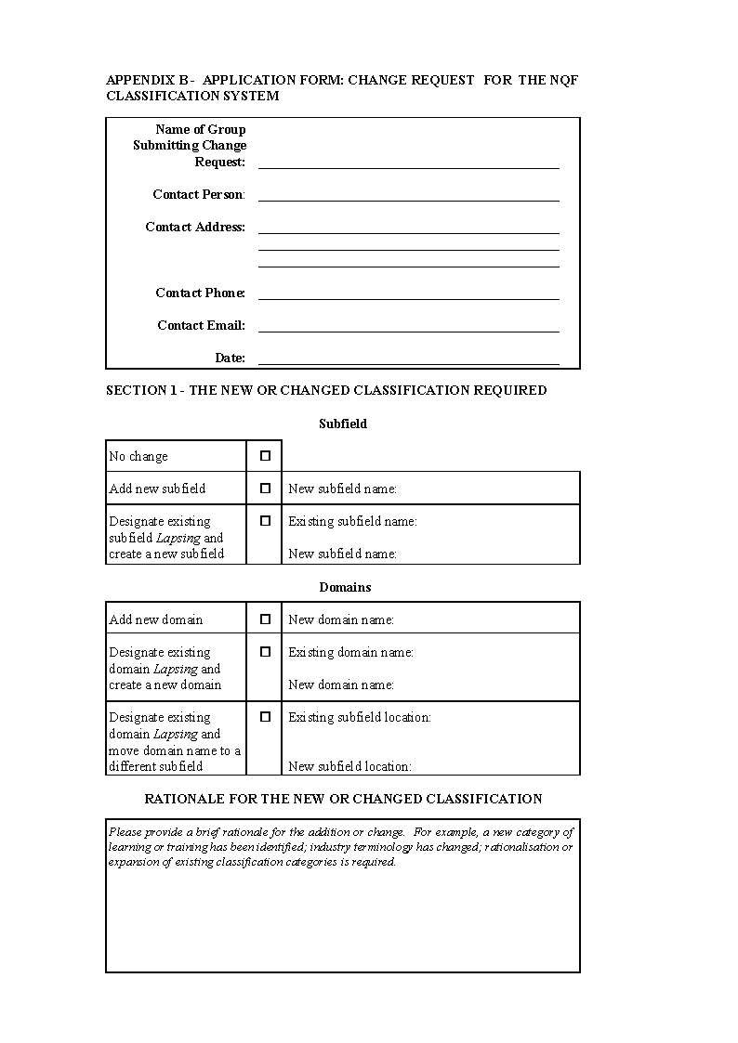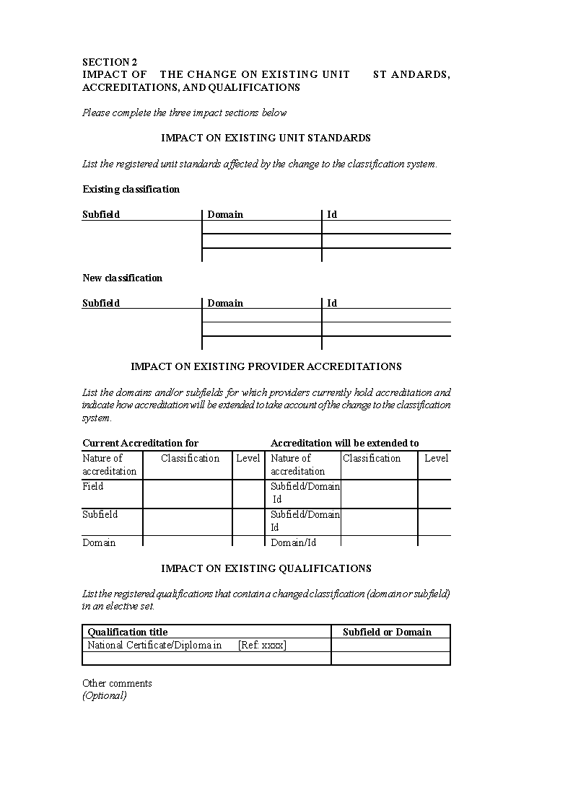

ANNEXURE C

DEFINITIONS OF QUALIFICATION TYPES ON THE NATIONAL QUALIFICATIONS FRAMEWORK

Three broad types of qualifications are able to be placed on the NQF:

● Degree

● Diplomas

● Certificates

Each type is distinguished by the following, broad characteristics:

A *degree* is generally awarded on the basis of the satisfactory completion of a course of advanced learning that is taught mainly by people engaged in research and that gives an emphasis to general principles and basic knowledge as the basis for self-directed work and learning.

Five broad types of degrees are available:

Doctoral

Masters

Bachelor Honours

Professional Bachelor

Bachelors

The distinguishing features that characterise each and which may represent a standard to be met for any qualification to carry any of the above terms are provided and in some aspects discussed in the following sections.

The distinguishing features of these *broad categories* only have been described.

Often such degrees are represented as a number of subject specialisms of the broad category, ie, a Bachelor of <Specialism>. Any specialism must firstly, however, meet the agreed standard for the relevant broad type of degree.

A *diploma* is generally awarded following the satisfactory attainment of a sizeable, coherent cluster of outcomes of learning requiring a high level of demand and aligned with one or more learning areas. Diplomas generally require the attainment of a volume of learning smaller than that required for the award of a degree.

Diplomas may be an integral component of a degree and/or standalone from any other qualification.

Diplomas may be awarded across more than one level of the NQF between Levels 5 and 8 inclusive. Distinguishing between diplomas certificated at different levels may be achieved by the inclusion in the Level in the title.

The award of a certificate generally follows the attainment of a meaningful and coherent cluster of outcomes of learning associated with one or more areas of learning. The volume of attainment recognised by a Certificate is generally less than that required for the award of a diploma.

Certificates may be an integral component of a degree and/or diploma and/or may be a stand alone [stand-alone] qualification.

Certificates may be awarded at more than one level of the NQF between Levels 1 and 8 inclusive. Distinguishing between Certificates at different awarding levels may be achieved by the inclusion of the Level in the title.

Each qualification type is further characterised by specific criteria representing a standard that must be complied with if any qualification is to be specified as a particular type. These specific criteria are as on the following pages.

**CERTIFICATES**

Qualifications carrying the name *Certificate* generally recognise ability or preparedness for both employment and further education and training.

Such qualifications recognise proven ability in a coherent cluster of outcomes of learning pertinent to a work role or a recognisable and meaningful milestone on an education and training pathway.

Where Certificates are awardable at a level in advance of the level of certification of a Bachelor degree - *Post Graduate Certificate* - such qualifications often recognise ongoing professional development or continuing professional development in the same subject as an earlier degree. Such qualifications broaden, extend and/or deepen currently recognised knowledge and skills.

Certificates may be awarded at Levels 1 to 8.

A *minimum* of 40 NQF credits are required of which a *minimum* of 40 must be at or above the level of certification.

**DIPLOMAS**

Qualifications carrying the name *Diploma* recognise:

● preparedness of learners for self-directed application of skills and knowledge

● capacity for initiative and judgement across a broad range of educational and vocational areas, and

● capacity for initiative and judgement in technical, professional, and/or management roles.

The knowledge, understanding and skills recognised in a diploma qualification are generally an extension of that recognised in prior qualifications or experience.

Diploma qualifications issued in advance of the level of certification of a Bachelor Degree - a *Post Graduate Diploma* - recognise:

● an extended and deepened level of knowledge and skills that build on those developed in the principal subjects of an earlier degree (or other degree)

● awareness and familiarity, through a systematic and current survey, of current thinking and research in a particular body of knowledge, and

● instruction in relevant research methodologies.

A lower qualification may not be awarded for early exit from a Diploma programme except where exit represents the attainment of another qualification.

Diplomas may be registered at Levels 5 to 8.

A *minimum* of 120 NQF credits are required of which a *minimum* of 72 must be at or above the level of certification.

**BACHELOR DEGREE**

A Bachelor’s degree represent a systematic, well-rounded and coherent introduction to the broad knowledge, ideas, principles, concepts, chief research methods and problem- solving techniques of a recognised major subject (or subjects, in the case of a double degree or a double major).

It generally involves at least one sequential study programme in which content is progressively developed to the point where a candidate is prepared for postgraduate study and supervised research. It prepares a candidate for advanced study as well as directed research and scholarship in the major subject(s) of the degree.

A qualification carrying the name Bachelor must be taught mainly by people engaged in research.

The qualification must require:

● an emphasis to the general principles, concepts, chief research methods, problem- solving techniques and basic knowledge of an area(s) of learning

● development and use of ability in self-directed work and learning

● the use of skills needed to acquire, understand and assess information from a range of sources

● intellectual independence, critical thinking and analytical rigor, and

● advanced communication and collaborative skills.

A lower qualification may not be awarded for early exit from a Bachelor degree programme except where exit represents the attainment of another qualification.

Bachelor Degrees will be awarded at Level 7.

A minimum of 360 NQF credits is required from Level 4 and above.

A minimum of 72 NQF credits (60% of a full year of study) must come from Level 7.

The number of contributing credits from Level 4 is restricted to a maximum of 40 credits.

**BACHELOR HONOURS DEGREE**

Bachelor Honours degrees represent an initial post graduate specialisation qualification building on a Bachelor degree in the same cognate area, often preparing people for research-based post graduate study.

Bachelor Honours degrees must:

● consolidate and deepen expertise in a particular discipline beyond that recognised in a Bachelor programme

● develop research capacity in the methodology and techniques of that discipline

● demand a high level of theoretical engagement and intellectual independence, and

● require the conduct and reporting of supervised research representing a minimum of 25% of the total credits at the level of certification.

A lower qualification may not be awarded for early exit from a Bachelor Honours degree programme except where exit represents the attainment of another qualification.

Bachelor Honours degrees shall be awarded at Level 8.

A *minimum* of 120 NQF credits at Level 8 *in addition* to those required to attain a Bachelor Degree are required.

A *minimum* of 30 of these Level 8 credits must be research related.

**PROFESSIONAL BACHELOR DEGREE**

Professional Bachelor degrees represent substantial attainment of a body of outcomes of learning greater than and in advance of a Bachelor degree. Such degrees normally contain a substantial element of ‘learning by doing’ and often focus on preparation for entry into a professional field of practice.

Professional Bachelor degrees must:

● build to a level of conceptual sophistication, specialised knowledge and intellectual autonomy (similar to that described for Bachelor Honours degrees)

● include a terminal project or other supervised practice-based exercise(s) intended to demonstrate readiness for employment in the professional or occupational field of the qualification, and

● require performance in accordance with a regulatory framework administered by a regulatory or professional body (and thus have the direct recognition and endorsement of that body).

A lower qualification may not be awarded for early exit from a Professional Bachelor degree programme except where exit represents the attainment of another qualification.

A Professional Bachelor Degree shall be awarded at Level 8.

A *minimum* of 480 NQF credits at Level 4 and above are required of which a *minimum* of 120 credits must be at level 8.

The number of contributing credits from Level 4 is restricted to a *maximum* of 40 credits.

**MASTERS DEGREES**

Degrees at a Masterate level are normally designed to build on the principal subject(s) of a qualifying degree or qualification that itself contains a significant research component or preparattion at an advanced level of the National Qualifications Framework. Alternatively, a Masters degree may build on relevant knowledge and skills derived from occupational experience.

[The word “preparation” is misspelt in the *Government Gazette*, as reproduced above.]

Masterate degrees are generally intended to prepare researchers who can contribute to the advancement of knowledge and/or prepare people for advanced and specialised employment.

Typically, Masterate degrees require people to:

● demonstrate mastery of theoretically sophisticated subject matter

● evaluate critically the findings and discussions in the literature

● to research, analyse and argue from evidence; to apply knowledge to new situations, and

● engage in rigorous intellectual analysis, criticism and problem-solving.

Masterate degrees must contain a significant element of supervised research. The results of this research would normally be embodied in a thesis, dissertation or substantial research paper, but in some cases be incorporated in a series of papers. Where a number of papers are involved, the research component must be a minimum of 25% of the credits required for the award of the qualification.

The research component must be at the level of certification.

The research should demonstrate a capacity in the candidate for independent thinking. Creative work may also contribute to the research output.

A lower qualification may not be awarded for early exit from a Masters degree programme except where exit represents the attainment of another qualification.

Masters degrees shall be awarded at Level 9.

A *minimum* of 240 NQF credits at or above Level 9 are required. A *minimum* of 25% of these credits must be awarded on the basis of a thesis or creative work.

**DOCTORAL DEGREES**

A Doctoral degree is the highest qualification awarded within the National Qualifications Framework. Such degrees may be:

● a pure research degree - a Doctor of Philosophy or

● a practice-oriented degree - a Named Doctorate or Professional Doctorate (eg Ed.D, DMus)

● a degree based on coursework, examination and dissertation.

Degrees carrying the term ‘Doctor” in the title must:

[The *Government Gazette* uses an opening single quotation mark and a closing   
double quotation mark around the word “Doctor”, as reproduced above.]

● refer to a research or practice degree that is at a significantly higher level and of significantly higher status than a masterate

● normally represent the culmination of a structured sequence of instruction at educational institutions that starts at bachelor degree level and reaches a stage beyond masterate when the student becomes an increasingly independent scholar and makes a substantial and original contribution to knowledge. Coursework may apply but should:

● only contribute to the preparation for research, except in the case of a Named Doctorate;

● be at a level above that of masterate qualifications; and

● not normally cover more than one full-time academic year (ie, no more than the equivalent of 120 NQF credits).

● require the development of the learner under the guidance of recognised experts in the field of study and under circumstances which allow the student access to appropriate research resources, and

● be awarded on the basis of an original and substantial contribution to knowledge in the form of a thesis as judged by independent experts applying contemporary international standards.

The thesis should constitute the entire body of work that will be assessed (except in the case of a Named Doctorate where it must contribute to a minimum of 2/3rds of the final award - generally a minimum of 240 NQF credits). Learners in the visual or performing arts may present a creative work in place of the thesis.

A lower qualification may not be awarded for early exit from a Doctoral degree programme except where exit represents the attainment of another qualification.

Research Doctoral degrees may not be attained through credit accumulation.

Higher Doctorates and Honorary Doctorates shall not constitute part of the National Qualifications Framework.

Doctorates shall be awarded at Level 10.

In credit terms, a Doctoral degree would carry a value of a *minimum* of 60 NQF credits, all of which would be Level 10.

ANNEXURE D

CRITERIA FOR THE USE OF ‘NATIONAL’ AND ‘NAMIBIA’ IN THE TITLES OF QUALIFICATIONS ON THE NATIONAL QUALIFICATIONS FRAMEWORK

The use of the terms ‘Namibia’ and ‘National’ are protected within the National Qualifications Framework when used to name qualifications. Their use may only be included in the following situations:

1. A recognised national body has endorsed the designed qualification as:

● representing the combination of outcomes of learning that reflect the economic, social, technological and/or cultural needs of Namibia;

● being the only qualification that will be readily recognised by national stakeholders as representing satisfactory attainment, and

● being the template against which programmes should be developed by individual education and training providers to build and enhance the abilities of learners towards certification in that area of learning.

2. The qualification is intended for the public domain - it is able to be awarded by any appropriately accredited education and training provider who complies with and meets any national assessment arrangements stipulated for the award of that qualification.

3. The Namibia Qualifications Authority has authorised such use.

The terms ‘Namibia’ and ‘National’ are deemed to have the same meaning when used in qualification titles.

The terms ‘Namibia’ or ‘National’ may be only used for one, uniquely titled qualification.

AnNEXURES E-F

To view content without printing, scroll down.

To print at full scale (A4), double-click the icon below.



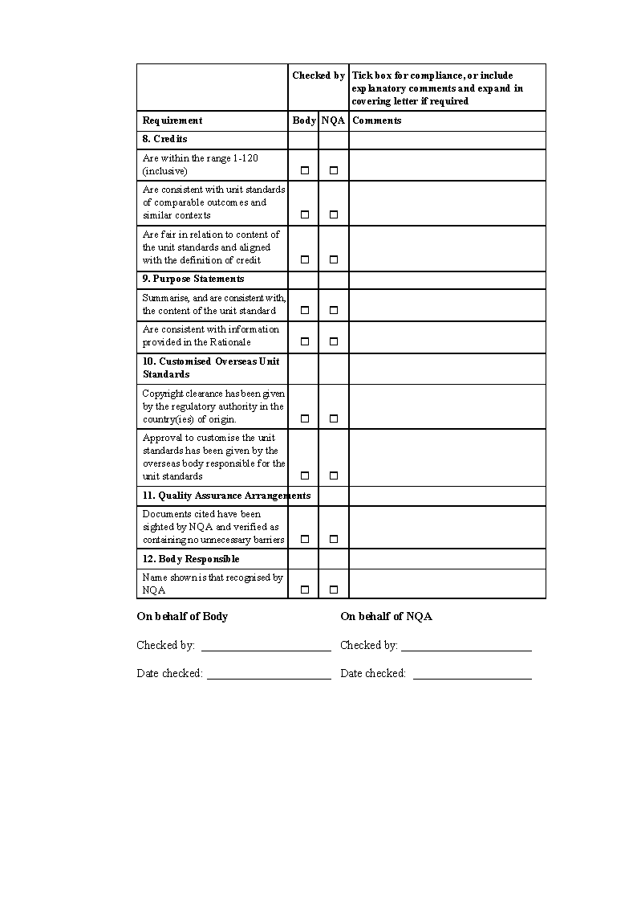

ANNEXURE G

CRITERIA FOR THE REGISTRATION OF QUALIFICATIONS ON THE NATIONAL QUALIFICATIONS FRAMEWORK

**INTRODUCTION**

This document provides information to persons, groups, organisations and institutions wishing to develop qualifications for registration on the Namibia National Qualifications Framework (NQF). More specifically, this document provides the criteria that will be applied by the Namibia Qualifications Authority (NQA) in making registration decisions in relation to qualifications submitted to it.

The information and criteria contained in this document refer to the quality assurance of qualifications to be registered on the NQF. These qualifications may either be:

● whole, portal qualifications that are awarded in their entirety when all requirements have been met, or

● qualifications awarded following the accumulation of specified, separately awarded qualification components (unit standards) also registered on the NQF.

These qualifications may be:

● Certificates

● Diplomas, or

● Degrees.

Unit standards are nationally prescribed qualification components separately registered on the NQF and able to be awarded independently of the award of a qualification. Information on the development of unit standards and the criteria to be met for their registration is contained in Annexure as the *Criteria for the Registration of Unit Standards on the National Qualifications Framework in Namibia.*

These Criteria for the Registration of Qualifications on the National Qualifications Framework in Namibia were approved by the Council of the NQA on 14 April 2005.

**THE PURPOSE OF QUALIFICATIONS**

Qualifications are awarded at the end of learning. They are awarded following robust assessment of the abilities of persons who have undertaken formal and/or informal learning in relation to specified knowledge, understanding, skills and personal attributes at a specific level or levels of complexity and demand.

Qualifications formally recognise attainment of the results or outcomes of learning. In expressing a qualification, a qualification developer and relevant stakeholders and social partners are defining an end point or milestone in a learning or career pathway. This definition is in terms of abilities, and the performances and criteria that must be met in order for those abilities to be formally recognised through certification. The qualification represents a required destination for learning - and proof of having arrived at that destination.

Qualification attainment requires effort and sacrifice. Attainment represents successful completion of a challenging amount of learning required to take the next step in a learning or career pathway.

Qualifications give an emphasis to specifying the relevant and meaningful outcomes of learning that must be attained in order to be deemed ‘qualified’. A qualification does not specify how these required abilities are to be developed. Qualifications represent the award given at the end of a curriculum that sets out the learning pathway and the nature of the learning.

There may be many pathways to the attainment of a specific qualification. In many cases, people will have enrolled in formal programmes or courses in education or training institutions and/or in structured workplace learning. These programmes or courses may utilise different teaching and learning methodologies, progression sequences, and learning contexts. Others may have followed less formal pathways, involving self-directed, non-formal, and/or prior learning.

Provider programmes and courses will not be registered on the NQF. Programmes and courses are pathways towards the award of a qualification, they are not themselves qualifications.

Formal learning pathways will be quality assured against criteria established by the NQA for the accreditation of people, institutions and organisations wishing to offer specific education and training services. The development, implementation, and review of courses and programmes are given particular attention in those criteria.

Assurance of the quality of non-formal learning will be available through assessment against registered unit standards and national assessment arrangements (Moderation) specified for NQF qualifications and unit standards.

GENERAL REQUIREMENTS FOR THE REGISTRATION OF QUALIFICATIONS

**KEY PRINCIPLES**

To become registered, qualifications must fit within the broad principles of the National Qualifications Framework (NQF) and any regulations made in relation to awards placed on the Framework. These broad principles, stated in 1999, include:

**Comprehensiveness** through the recognition of all learning and encompassing all qualifications attained in the country.

**Recognition** of the individual’s right and desire to access lifelong learning by providing for different pathways to achieve success.

**Quality** in education and training through the development of standards- based qualifications that will recognise outcomes, no matter how achieved.

**Redress** of past injustices through, amongst other methods, the recognition of prior learning.

**Relevance** of education and training by relating standards to the competencies required to fulfil the roles and/or functions of a job on a certain level in a career structure.

**Democratisation** of education and training by providing for the stakeholders in education and training to participate in the system in a meaningful manner.

**Integration** of the education and training systems to facilitate the movement of learners both horizontally and vertically in the framework and to prevent learners being locked into dead-end programmes.

**Good practice** Cognisant of the broad principles above, qualifications in Namibia must demonstrate adherence to good practice principles in the statement and development of qualifications. Qualifications must be:

|  |  |  |
| --- | --- | --- |
|  | **meaningful, useful**  **and used** | They should:  ● accurately report the attainment of required outcomes of learning |
|  |  | ● make a difference to the lives and opportunities of the holders of each qualification, and |
|  |  | ● be useful to the diverse applications of qualifications by employers, professional bodies, and education and training providers. |
|  | **supported** | Relevant stakeholders and users of the qualification should give their support, preferably endorsement, to the registration of the qualification. |
|  | **clearly expressed** | Information should: |
|  |  | ● enable people to make informed decisions about the comparability and difference between qualifications of a similar nature |
|  |  | ● enable people to make informed choices about which qualification they should pursue, and |
|  |  | ● be described in such a way that they are: |
|  |  | ● accessible to the public in general, and |
|  |  | ● clear and easy to understand in terms of what is required to attain the qualification. |
|  | **comparable in value** | They must meet agreed standards for qualifications such that each represents demands similar to those of other qualifications of the same, broad type. |
|  | **challenging** | Each qualification should require effort and sacrifice in attainment, yet offer people fair and reasonable opportunities to demonstrate their abilities, including recognition of any prior learning and/or current competence. |
|  | **accessible** | Qualification requirements should optimise: |
|  |  | ● access to those seeking the qualification |
|  |  | ● progression through the qualification, and |
|  |  | ● articulation and the transfer of learning to other qualifications, both vertically and horizontally. |

**awarded following**

**assessment** The award must follow rigorous assessment against transparent awarding criteria and use systems inclusive of measures to ensure fairness, validity and consistency of assessment approach and decisions.

**comprehensive** Requirements should recognise the attainment of generic and transferable knowledge and skills as well as industry or discipline area-specific knowledge, understanding, skills and personal attributes.

**enabling of innovation** Requirements should allow for creative, flexible, diverse, innovative and evolving approaches to teaching, learning and assessment.

**attainable** Requirements must be fair and achievable and not impose or involve unreasonable barriers to access or attainment on the basis of gender, ethnicity, beliefs, orientations, health condition or circumstance.

**EXPRESSION OF OUTCOMES OF LEARNING**

The recognition of outcomes of learning enables the recognition of a person’s ability independent of the place, method and time of learning. The emphasis is placed on what the person knows, understands, can do and be rather than the relative merits of a particular mode or place of learning.

Qualifications will likely consist of the recognition of more than one outcome of learning. However, the sum of parts will not necessarily equal the whole.

It is important that the outcomes of learning represented by the whole qualification be considered as important as the accumulation of the parts.

Therefore, a statement of what the wholeness of a qualification represents must be stated.

Outcomes of learning will be expressed in a broad sense through the National Qualifications Framework Level Descriptors

Further, more detailed descriptions of outcomes should be expressed, as specifically as possible, so as to:

● improve understanding about the qualification

● accurately describe achievement and the basis of ‘successful completion’

● allow meaningful comparisons to be made with other qualifications, and the identification of any significant difference between similar qualifications, and

● enable the transparent operation of a fair system of credit transfer between qualifications.

Elaborating on the details of outcomes of learning is achievable through the specification of the criteria that will underpin the basis of any award of the qualification or its components.

The degree of specificity and informative-ness of these awarding criteria will likely enhance understanding, determinations of comparability, and contribution to fair transfer of credit.

Where outcomes are expressed as unit standards, additional specificity is not required to be given in the qualification document other than through listing the relevant unit standards.

**QUALIFICATION TYPE**

Qualifications on the NQF will carry ONE of the following terms as its titles:

1. Certificate

2. Diploma

3. Bachelor

4. Bachelor Honours

5. Professional Bachelor

6. Masters, or

7. Doctor.

Each of the qualification types listed above is defined by a ‘standard’. Identifying and specifying standards for qualification types generally involves reference to:

1. Broad statements of the abilities being recognised.

These are generally expressed in terms of descriptors for defined levels of a qualifications framework.

2. The volume or quantum of learning - the sum of all teaching and learning effort - involved in total and for parts of the qualification where relevant.

Commonly, the quantum of learning is expressed in a common measurement unit - a qualification credit.

3. Specific broad abilities or particular curriculum or assessment features particular to that type of qualification.

These characteristics are broadly stated, and may make reference to such things as research or work-placement requirements. The purpose of the qualification type may also be indicated.

Qualifications submitted must meet the definitions for one of the types of qualifications able to be registered on the NQF.

**INFORMATION REQUIRED IN QUALIFICATIONS**

The public expression of qualifications must be inclusive of:

● the full title of the qualification

● the level(s) and volumes of teaching and learning effort required by the qualification and any component

● the broad area(s) of learning covered by the qualification

● a clear and informative rationale of the need for and uses of the qualification. Such rationale would normally be inclusive of:

o descriptions of any relationships with other qualifications in terms of logical progressions, articulation arrangements, pre or co-requisites

o the outcome(s) of learning recognised by the qualification as a whole

● the outcomes of learning that make up the qualification

● rules or regulations pertaining to the attainment of the qualification, particularly where optional or elective components are made available

● the awarding criteria that are the basis for awarding the qualification and its components

● any reasonable and justified entry restrictions or limitations

● any credit transfer, articulation and/or recognition of prior learning arrangements

● any national or other assessment and/or moderation requirements

● any special requirements for the delivery of programmes related to the qualification, and

● the name of the body who developed the qualification.

The public expression of any qualification must be a clear, honest and accurate representation of the value of the qualification and what is required to attain it. The qualification must also be expressed in a manner that complies with any format requirements specified by the NQA where these enable registration on the NQF.

Qualification documents shall be prepared in the English language. Where expertise is readily available and accessibility will be enhanced in doing so, the qualification document may also be written in another language commonly used in Namibia. Any translation must not lessen the qualification requirements stated in the English version.

Qualifications submitted for registration must be of ‘registrable’ quality. They must comply fully with the General and Specific Requirements for Qualifications specified by the Namibia Qualifications Authority.

Qualifications submitted for registration must be of publishable quality - free from spelling, punctuation, and grammatical errors, consistent in their expression, and meet any specified formatting requirements set by the NQA (refer Appendix A).

The Namibia Qualifications Authority will maintain a register or listing of all qualifications approved by it for registration on the National Qualifications Framework. Such a register shall contain the above information and/or direct persons to such publicly accessible information.

**CERTIFICATION OF QUALIFICATIONS**

Qualification certificates should:

● clearly and accurately state:

* the full name of the qualification
* the name of the person, inclusive of their date of birth and/or Identity Number, to whom the qualification has been awarded
* the date of the award, and

● refer by name, seal (where applicable), and/or coding identifier to the awarding body and any relevant quality assurance body; and display the signatures of relevant persons from such bodies.

Qualification certificates must contain sufficient security features to minimise unauthorised duplication and/or aid the identification of false copies of the certificate.

Security features would include such things as the use of watermarks, invisible UV features, embossment, numbering, anti-copying format and colouring, etc.

Certification should also be accompanied by the provision of an informative transcript of attainments making up the whole qualification.

In the case of national qualifications made up of unit standards, the NQA “s Record of Learning shall constitute this transcript.

**DEVELOPMENT OF QUALIFICATIONS**

Processes leading to the development of a new or revised qualification must:

● be inclusive of the meaningful involvement of relevant stakeholders and social partners[1], and

● be inclusive of the support for, and preferably endorsement of the qualification’s coverage and structure by such stakeholders and social partners.

Developing qualifications is an activity that sits firmly as a responsibility of the industry or profession that requires such qualifications for formal recognition and/or selection purposes. Where a provider institution wishes to develop a qualification, it should ensure that the qualification will be accepted by industry or the professions for any entry purposes.

Groups submitting qualifications must represent and/or gain the support of national stakeholder interests. Such interests will generally be held by employers, employee organisations, education and training providers relevant to the sector, professional or registration associations and bodies, and relevant government departments and agencies.

In many cases, the development of qualifications will be prompted and overseen or managed by a national body recognised by the NQA. Qualifications carrying the term ‘National’ or ‘Namibia’ in its title must be submitted by a recognised national body.

[The plural noun “qualifications” does not match the singular pronoun “its”.]

As well as management of qualification development processes each national body will ensure that any unit standards developed for their sphere of responsibility reflect national requirements and remain fit to meet current and future employment trends within the sector.

A recognised national body would be one that has explicit credibility as being able to represent the interests of national stakeholders and relevant social partners, such national standing being indicated by any or all of the following:

● a legislative authority to act within the sphere of competence, perhaps in a governance, registration or other regulatory role;

● an electoral system for representation that includes principal participants in the sector and/or discipline area;

● the existence of a robust mechanism(s) to determine and reflect the interests of significant stakeholders (particularly workers and/or learners; employers, professional bodies, educators and trainers, and the state) in qualifications (and/or unit standards) setting.

National consultation is a requirement for the registration of qualifications. This is to ensure that the qualifications reflect and have the general endorsement of all relevant stakeholder interests.

Groups submitting qualifications will need to present:

● a list of identified stakeholder interest

● how these stakeholders were included in the development and/or endorsement process, and

● provide assurances that the views of these interested parties had been taken into account in the development of the qualifications.

The NQA is able to assist qualification development through the provision of technical advice and guidance. It does not have the subject matter expertise to set specific qualifications on behalf of different sectors.

Processes leading to the development of a new or revised qualification must involve rigorous internal quality assurance processes by the qualification developer. These internal processes may be inclusive of persons or organisations external to the qualification developer.

Processes leading to the development of a new or revised qualification must be consistent with the broad principles underpinning the National Qualifications Framework.

Qualifications must be fit for purpose. Periodic reviews of each qualification will ensure that this is so. The normal registration period is for a maximum of five years, by which time the qualification should have been reviewed.

**CREDIT RECOGNITION AND TRANSFER**

Qualifications may state credit recognition and transfer provisions so long as such arrangements are between:

● other qualifications registered on the NQF, and/or

● qualifications or registered components registered on other national qualification frameworks administered by a national body similar to the NQA, and that use registration criteria comparable to those used by the NQA.

The arrangements must enable a ready determination of the comparability of the features of qualifications in terms of common information points.

The application of credit recognition and transfer arrangements should provide learners with greater flexibility in meeting qualification requirements. It is possible for such arrangements to offer:

● credit awards, and/or

● credit exemptions.

Any credit transfer arrangement must not lower the quality of NQF qualifications. Credit transfer from qualification systems outside of Namibia should retain the relevance of the award of the qualification for the Namibia context.

**RESTRICTIONS ON USE OF ‘NAMIBIA’ AND ‘NATIONAL’ IN QUALIFICATION TITLES**

The use of the terms ‘Namibia’ and ‘National’ are protected within the National Qualifications Framework when used to name qualifications. Their use may only be included in the following situations:

1. A recognised national body has endorsed the designed qualification as:

● representing the combination of outcomes of learning that reflect the economic, social, technological and/or cultural needs of Namibia;

● being the only qualification that will be readily recognised by national stakeholders as representing satisfactory attainment, and

● being the template against which programmes should be developed by individual education and training providers to build and enhance the abilities of learners towards certification in that area of learning.

2. The qualification is intended for the public domain - it is able to be awarded by any appropriately accredited education and training provider who complies with and meets any national assessment arrangements stipulated for the award of that qualification.

3. The Namibia Qualifications Authority has authorised such use.

The terms ‘Namibia’ and ‘National’ are deemed to have the same meaning when used in qualification titles.

The terms ‘Namibia’ or ‘National’ may be only used for one, uniquely titled qualification.

SPECIFIC CRITERIA FOR THE REGISTRATION OF QUALIFICATIONS

**RATIONALE**

Each qualification submitted for registration has a clear and meaningful purpose. The rationale for each qualification is documented and submitted at the same time as the qualification is submitted.

A summary of the rationale appears as a “purpose statement” within the qualification document.

The rationale contains the following:

● statement of aims and objectives, including:

- contribution to national economic, social, cultural and/or technological goals

- contribution to the quality and coherence of education and training in Namibia, and

- identification of target candidates

● evidence of demand for the qualification, and

● evidence of consultation with and confirmed support from key, national employment and/or interest groups.

The attainment of goals, objectives and targets stated in the rationale will be evaluated as part of the quality assurance processes in the re-registration of the qualification.

**QUALIFICATION TITLES**

The title of a qualification is:

● concise

● distinctive

● appropriate to its subject area

● not misleading, and

● clearly indicative of the content of the qualification.

The qualification title specifies the nomenclature for one of the NQF qualification types in its name.

The title of a qualification states a NQF Classification System category of where the qualification contents could be found or placed on the NQF, and that clearly states the predominant subject area covered by the qualification.

Where the qualification is a Certificate or Diploma, the Level of certification is included in the title.

Additional, free text is included as part of the Titles where necessary or useful to enhance people’s understanding of the coverage of the qualification. Such additional text may refer to:

● significant discipline area or work area subsets

● a type of Certificate or Diploma

● Strand names recognising specific skill sets.

Strand names are listed in the order in which they appear in the specification of qualification requirements.

Additional or qualifying text is not misleading as to the nature or coverage of the qualification.

Names of trademarked products, training and assessment material, provider bodies, or commercial organisations are not permitted in qualification titles.

**QUALIFICATION STRUCTURE**

The total number of NQF credits required to achieve the qualification is shown.

Where these NQF credits are from more than one level of the NQF, the numbers of

credits at each level are shown.

Where the qualification contains compulsory, elective and/or strand clusters of outcomes, the number and level of credits in each set are shown.

Where the qualification draws upon credits from registered unit standards or outcome statements from more than one national standard setting body or qualification developer recognised by the NQA, the relevant bodies are listed.

**EXPRESSIONS OF OUTCOMES OF LEARNING**

Achievement represented by the qualification is expressed as outcomes of learning and/ or work performances or tasks stated as outcomes of learning.

The descriptions of outcomes of learning accurately define achievement and improve the general public’s understanding of the qualification and its relationships with other awards.

What the whole qualification represents in terms of the application of knowledge, skills and attributes encompassed by the qualification is stated, most probably in a Purpose Statement.

The component outcomes of learning of the qualification that, in their combination, make up the wholeness of the qualification are stated in the Qualification Requirements.

Outcomes of learning:

● are expressed as specifically as possible and, unless the components are NQF unit standards, supported by publicly accessible details

● improve understanding about the qualification and accurately describe achievement

● allow meaningful comparisons to be made with other qualifications, and the identification of any significant difference between similar qualifications, and

● are of sufficient detail to enable the transparent operation of a fair system of credit transfer between qualifications.

Where registered NQF unit standards are identified as component outcomes, the following information is shown:

● the identification number

● the Subfield and domain in which the unit standard is registered

● unit standard title

● level, and

● NQF credit value.

Where component outcomes of learning are not expressed as NQF unit standards, each outcome is:

● stated as an outcome of learning (verb in active voice, noun, and, perhaps, context)

● assigned a credit value consistent with similar outcome of learning statements, and

● aligned with a stated NQF Level.

The publicly accessible details of the component outcomes of learning, other than when expressed as unit standards, provide an indication of the criteria that represent what must be done by a person to be recognised as having appropriately demonstrated their ability for each outcome of learning.

**STATEMENTS OF PURPOSE OF A QUALIFICATION**

A purpose statement provides clear information about the qualification for potential candidates, users and society in general.

The purpose statement may, in doing this, accurately summarise the rationale submitted for the qualification.

The purpose statement gives reasons for any instance where the qualification is structured with strands and/or optional sets.

Significant relationships with other qualifications are stated in the purpose statement. Any prerequisite qualifications are clearly mentioned.

Where there are entry restrictions or guidance notes as to the context in which learning and/or assessment must take place, these are stated in the purpose statement.

Any restriction on entry to seeking the award, or in attaining the qualification, is justified and is not unreasonable.

Any requirements for industry or regulatory registration or licensing that are additional to the award of the qualification are mentioned in the purpose statement.

**REQUIREMENTS FOR THE AWARD OF THE QUALIFICATION**

The qualification requirements transparently describe what a person must do in order to be awarded the qualification.

The requirements are coherent, and simply state:

● the clear and consistent specification of achievable rules (of combination)

● any prerequisite qualification(s)

● the minimum number of NQF credits and/or unit standards and/or outcomes required for each elective set, and/or

● any other minimum or maximum credit or level requirements.

The qualification sets are listed in the following order:

Compulsory requirements

Elective requirements

Optional requirements (eg, specialisation strands)

For qualifications showing specialist strands, the sets are listed in the following order:

Core Compulsory

Core Elective

Strand Compulsory

Strand Elective

The components of each set are listed in detail and in a sensible and logical order.

Lists of unit standards:

● refer only to registered NQF unit standards

● show the current identification number, title, level and NQF credit value

● are grouped according to NQF Classification System category

● are listed in numeric order within a NQF Classification System category, and

● are listed before any outcome statements that are not NQF unit standards.

Lists of outcome statements that are not registered unit standards:

● state each as an outcome of learning, and

● show a level and NQF credit value.

Where elective credits are specified as being able to be achieved through gaining credits for unspecified unit standards from named FIELDS, Subfields and/or domains, the NQF Classification System categories are tabled alphabetically in order of their status in the classification hierarchy.

**CREDIT RECOGNITION AND TRANSFER ARRANGEMENTS**

Unit standard-based qualifications are attainable, regardless of any other credit recognition arrangements, through credit from registered unit standards alone.

Credit transfer from-non unit standards expressed outcomes for registered unit standards, from other national qualification systems, or from other registered qualifications are not more than 50% of the qualification’s requirements.

Recognised credits in any stated arrangements are derived from qualification systems comparable to the NQF.

Recognised credits in any stated arrangements represent a clear match with the outcomes of learning and attainment criteria for those outcomes for which credits can be replaced or exempted.

**SPECIAL ARRANGEMENTS FOR ASSESSMENT AND DELIVERY**

Special arrangements for any assessment of the qualification as a whole and/or its component outcomes are stated (or complementary documents cited).

The assessment arrangements for the qualification and/or its components include provisions for external quality assurance (moderation) or control.

Special arrangements for the design and/or delivery of programmes of learning aligned to the qualification and/or its component outcomes are stated (or complementary documents cited).

Special arrangements do not represent unreasonable barriers to the assessment of outcomes and/or the provision of learning aligned with the qualification where it is clear that the qualification is intended for multiple providers.

**TRANSITION ARRANGEMENTS**

No learner is unreasonably disadvantaged by:

● the replacement of an existing qualification by a new qualification

● the review of a registered qualification and/or its registered components, or

● the replacement or discontinuance of a NQF qualification.

Measures are taken to protect the interests of learners and are documented as transition arrangements.

As a minimum, these arrangements show:

● any time limits for the completion of existing learning programmes or pathways

● any credit transfer arrangements

● any credit exemption arrangements

● an appeals mechanism, and

● how the arrangements shall be managed.

**REVIEWS OF QUALIFICATIONS**

NQF qualifications are reviewed regularly. Reviews must, as a minimum, take place at least every five years.

Reviewed qualifications must meet the same quality criteria as new qualifications if they are to be re-registered.

A review of a qualification must include consultation with relevant industry persons and related stakeholders.

A Review Report for publication must accompany an application for the re-registration of any qualification. The report must include:

● reasons for the review or revision of the qualification(s)

● a brief outline of who was involved in the review

● a brief outline of how the review was conducted

● a summary of the main changes to the structure and/or requirements, and

● a statement of any transition arrangements arising from the changes made to any qualification.

ANNEXURE g

Appendix A

To view content without printing, scroll down.

To print at full scale (A4), double-click the icon below.



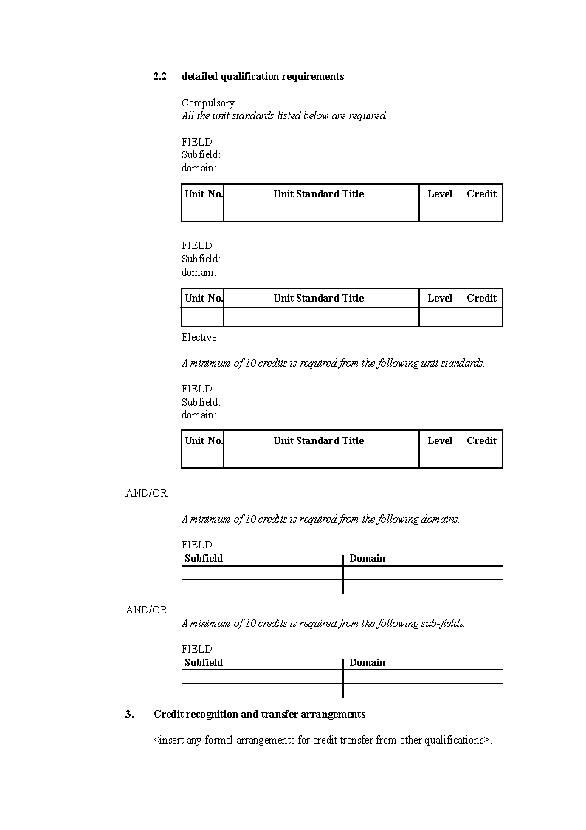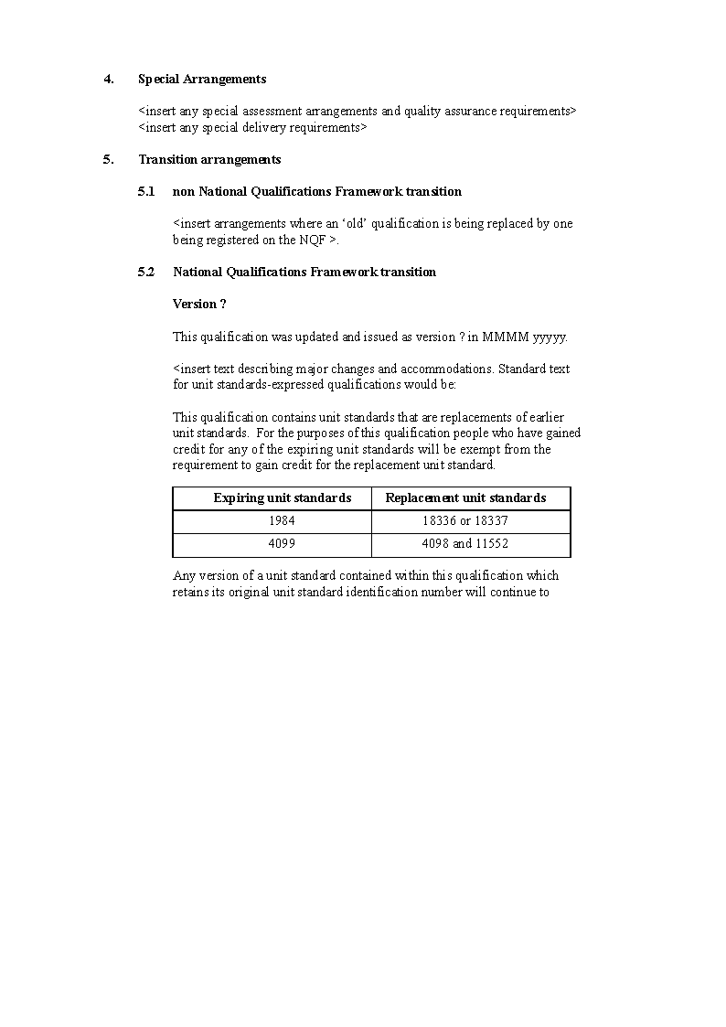

APPENDIX B - CREDIT VALUES

A common feature of qualification systems being developed in many countries is the use of an accepted mechanism that recognises the quantum of learning attained or contained in a qualification. This mechanism acts as a form of currency in that it is the medium of exchange when learners transfer their attainment from one qualification to another under ‘credit’ transfer arrangements. The credits act as forms of tokens or coupons. Collect enough of the right sort of coupons, and you will be awarded a qualification.

The mechanism of credit also acts a store of value, enabling consistent comparisons of qualifications and outcomes of learning that appear similar.

There is growing acceptance of an international credit value where one credit represents about 10 hours of notional learning time.

Learning time is not a measure of delivery time. It is an estimation of the time it takes a learner typical of the cohort who would normally seek a particular award (a qualification or unit standard) to achieve the performance requirements for that award.

Attainment is generally taken to mean an ability to consistently meet the stated requirements in repeated performances - not the first time they achieve the requirements.

Learning time should include all relevant learning activities that contribute to the attainment of the outcomes of learning. Such activities could include:

● Formal, directed learning including classes, training sessions, coaching, seminars and tutorials

● Practical work in laboratories or at other locations

● Information retrieval, eg from libraries or through the Web

● Self-directed study, such as private study, revision, remedial work

● Work-based activities that lead to formal assessment

● Practice - gaining, applying and refining skills

● Undertaking all forms of assessment, and

● Counselling, mentoring, reflection.

Learning time is notional as it is not linked to any one individual learner. A learner who achieves the required performances in more time than anticipated for the ‘average learner’ will not receive more credits - they will only receive that number of credits deemed appropriate by the qualification developer or national standard setter. Similarly, a learner who achieves the requirements in less time than the average learner will not be awarded less credit - they will receive the stated credits.

ANNEXURE H

CRITERIA FOR THE REGISTRATION OF UNIT STANDARDS ON THE NATIONAL QUALIFICATIONS FRAMEWORK IN NAMIBIA

**INTRODUCTION**

The Namibian Qualifications Authority Act No 29 of 1996 requires the Namibia Qualifications Authority to establish a National Qualifications Framework (section 3 (a)).The Act also requires the Namibia Qualifications Authority (NQA), amongst other objects, to:

● set the occupational standards for any occupation, job, post, or position in any career structure;

● set the curriculum standards required for achieving the occupational standards;

● promote the development of, and to analyse, benchmarks of acceptable performance norms for any occupation, job, or position;

● evaluate and recognise competencies learnt outside of formal learning;

● advise any person, body, institution, organisation or interest group on matters pertaining to qualifications and national standards for qualifications; and

● be a forum for matters pertaining to qualifications.

In the NQA Act, ‘occupational standards’ are defined as “a statement by the NQA describing the competencies required to fulfil the duties of an occupation, job, post, or position, and the criteria to be used to determine that such competencies have been achieved”.

Since the promulgation of the Act, statements of required outcomes (competencies) and their associated performance criteria have now assumed a new nomenclature[2] - the term ‘unit standard’ is now used to refer to such standards.

The NQA Act defines ‘curriculum standards’ as “a statement by the NQA describing a course of study leading to a qualification”. Since 1996, there have been considerable advances in understandings of ‘qualification frameworks’ and accreditation practices related to such frameworks:

● the emergent concept of outcomes of learning and assessment based on standards linked to such outcomes of learning. Emphasis now falls on the statement and quality assurance of the outcomes of education and training, often with a greater emphasis than on the inputs to education and training services;

● the grant of accreditation is increasingly focussed on organisational quality management systems that generate good courses rather than approving each separate course.

A consequence of the above trends has been a reduction in the specification of national curriculum documents and/or prescribed learning activities for particular qualifications - rather, the emphasis on outcomes has led to the specification of the unit standards for a particular national qualification.

Where the registration of any qualification on the NQF is intended to be accessible by more than one institution there is a need for workable and realistic statements of:

a) Specific details of any accreditation-related requirements - contributing to the consistency of the inputs to learning; and

b) Mechanisms to ensure consistency in assessment and assessment decisions - contributing to the reported outcomes of learning across all institutions being comparable.

The term ‘curriculum standards’ can now be interpreted as being the documentation of (a) and (b) above. These supporting and specific quality assurance requirements must be submitted at the time any unit standard or qualification is submitted for registration on the NQF.

Where occupational standards are accompanied by the specification of national accreditation and assessment requirements (curriculum standards), the result will be a ‘national standard’ as defined in the Act.

**USE OF THIS DOCUMENT**

This document details the quality criteria to be met for the registration of unit standards on the National Qualifications Framework. National groups wishing to develop unit standards should use these criteria to ensure that the unit standards submitted by them are of registrable quality.

These Criteria for the Registration of Unit Standards on the National Qualifications Framework in Namibia were approved by the Council of the NQA on 14 April 2005.

**THE USES OF UNIT STANDARDS**

Unit standards are registered components of national qualifications. Each represents an outcome of learning and/or a work activity that is a significant part of what a qualification certificates. Unit standards state:

● the outcome(s) of learning and/or work activity needing to be formally assessed;

● the proof of performance a candidate must produce and/or demonstrate if they are to receive formal recognition of their knowledge and skills;

● the quality of this required evidence, representing what national stakeholders consider being acceptable performance;

● the context, parameters and limitations to and/or of any required performance;

● references to quality assurance systems that support the unit standard as a description of the standard of performance needed for certification.

Unit standards represent an ‘award’, signifying that a person has been formally assessed and has attained a nationally agreed standard of performance. They are registered on the National Qualifications Framework (NQF) to enable national recording of their being attained. People are able to receive national recognition for both their whole qualification and what they specifically did to receive the qualification. Should someone not complete a whole qualification, they will gain recognition for the outcomes of learning and/or work activities that they are able to perform.

Unit standards provide the basis for the design of assessment activities and the making of assessment decisions. The intended audience are informed assessors - skilled assessors with knowledge, or access to specialist knowledge in the subject area being assessed - and candidates who have completed relevant learning and who wish to self-assess their readiness for formal assessment.

Unit standards are not directly used in the delivery of learning or training. As they describe performance required by national stakeholder groups, unit standards can be used to inform the design of learning and training programmes and activities.

**GROUPS SUBMITTING UNIT STANDARDS**

Developing unit standards is an activity that sits firmly as a responsibility of the industry or profession that requires national performance benchmarks for certification. The NQA is able to assist through the provision of technical advice and guidance - but it does not have the subject matter expertise to set national standards on behalf of different sectors.

Groups submitting unit standards must represent and/or gain the support of national stakeholder interests. Such interests will generally be employers, employee organisations, education and training providers relevant to the sector, professional or registration associations and bodies, and relevant government departments and agencies.

As the unit standards must reflect ‘industry’ requirements, representation from employer or professional association groups should be predominant.

In most cases, the development of unit standards will be prompted and overseen or managed by a national body recognised by the NQA. As well as management of standard setting processes each national body will ensure that all unit standards developed for their sphere of responsibility reflect national requirements and remain fit to meet current and future employment trends within the sector.

There are a number of functions which the NQA may require of national bodies in relation to qualification development and the setting of standards. The NQA will likely expect each body to:

a. identify qualification and career progressions within the specified sphere of competence for the particular body;

b. co-ordinate national qualification design and unit standards generation by fit-for-purpose bodies;

c. co-ordinate broad stakeholder consultation;

d. recommend national qualifications and unit standards for registration on the NQF;

e. co-ordinate the supply of sector experts to participate in accreditation and quality audit actions;

f. co-ordinate the development and availability of national assessment arrangements and any curriculum guidance;

g. collaborate with other national standard setting bodies on matters of mutual interest;

h. liaise with provider organisations within their sphere of competence to inform and become aware of new or emerging matters;

i. promote the utilisation of NQF structures and systems within their sphere of competence, and encouraging the uptake of the NQF qualifications and unit standards by whatever means is appropriate;

j. provide policy advice and comment to the NQA on matters pertaining to qualifications and the quality of the provision of associated programmes and courses;

k. provide information to the NQA on labour market and skills trends and issues that could be relevant to qualifications and the quality of education and training courses and programmes.

Bodies promoting and overseeing the development of unit standards should ideally be made up of people who:

● represent those stakeholders and parties who should be represented as they have interest in national standards;

● have credibility within the sector - they have wide acceptance as being able to represent and reflect the needs of the sector;

● have a broad understanding of the current and future skill needs and employment trends in their sector - they have a strategic vision of and for their sector;

● can source, point to, acquire and/or guide others to the means to achieve the objects of the national group;

● have a sound understanding of the BIG PICTURE - how the NQF and the quality assurance arrangements interact and relate to their sector needs;

● have energy, commitment and passion towards the enhancement of the quality of the human resources, both current and future, in their sector and who want to see change and enhancement happen;

● have the confidence and competence to make decisions and “sign-off” the unit standards as being what their sector needs and wants.

The NQA will recognise bodies capable of submitting unit standards if:

1) They are readily acknowledged as having standing in the economic sector and/or discipline area, such standing being indicated by any or all of the following:

a. a legislative authority to act within the sphere of competence, perhaps in a governance, registration or other regulatory role;

b. an electoral system for representation that includes principal participants in the sector and/or discipline area;

c. the existence of sufficient evidence that the group is a reflection of, or has the potential to reflect, the interests of significant stakeholders (particularly workers and/or learners; employers, professional bodies, educators and trainers, and the state) in qualifications and unit standards setting;

d. the group is purposely convened by the NQA to develop unit standards for a particular area.

2) The group has or access to sufficient and sustainable means to co-ordinate qualification and unit standard setting, consultation and endorsement;

3) The group has or access to sufficient and sustainable means to co-ordinate and facilitate quality assurance of assessment and participation in accreditation.

The NQA may extend its recognition to bodies in three ways:

1. proactively recognise existing bodies and invite them to accept the roles associated with unit standard development and implementation;

2. accept and consider letters of application from bodies seeking such recognition; and/or

3. imply recognition through the registration of national qualifications and unit standards from such bodies.

Recognition shall be demonstrated by formal letter to the body concerned and publicly through the updated publication of a list of Recognised National Bodies on the NQA website and/or other media.

National consultation is a requirement for the registration of unit standards. This is to ensure that the unit standards reflect and have the general endorsement of all relevant stakeholder interests. Groups submitting unit standards will need to present a list of identified stakeholder interests, how these were included in the development and/or endorsement process, and provide assurances that the views of these interested parties had been taken into account in the development of the unit standards.

**GENERAL QUALITY REQUIREMENTS**

To become registered, unit standards must fit within the broad principles of the National Qualifications Framework (NQF) and any regulations made in relation to awards placed on the Framework.

Awards on the NQF must encourage people into education and training. Access to having knowledge and skill nationally recognised should be made as easy as possible without compromising the national credibility of the award.

Unit standards registered on the NQF must reflect outcomes of learning and/or work activities that are relevant and appropriate to the Namibian context.

Unit standards registered on the NQF must demonstrate internationally regarded characteristics of ‘good’ qualifications or awards. These characteristics include:

● there is a clear purpose - the qualification contributes to the national economic, social, technological, and cultural goals and objectives and represents meaningful attainment for learners and employers, and has been endorsed as such by relevant stakeholders (see Specific Requirements - Rationale and Appendix A);

● the expression of outcomes of learning and/or work performance that are achievable, manageable, coherent, assessable, and consistent with sound assessment practice;

● internal coherence - the composition and contents of the qualification must be simply stated, make sense, and clearly relate to the purpose;

● the recognition of broad, transferable and generic skills as well as requirements specific to an occupation or profession;

● the provision of clear entry and exit points for learners and successful ‘graduates’;

● the specification of any quality assurance requirements in relation to assessment and the development of programmes and courses;

● the provision of information about relationships with other awards; and

● the clear and open documentation of the above, and statements about what learners must do to attain the qualification.

The requirements of each unit standard must not prevent someone from seeking assessment because of their gender, ethnic origin, special needs, location, or because of unreasonable cost.

Unit standards submitted for registration must be of ‘registrable’ quality. They must comply fully with the General and Specific Requirements for unit standards specified by the Namibia Qualifications Authority.

Unit standards submitted for registration must be of publishable quality - free from spelling, punctuation, and grammatical errors, consistent in their expression, and meet any specified formatting requirements (refer Appendix A).

Unit standards must be fit for purpose. Periodic reviews of each unit standard will ensure that this is so. The normal registration period is three years for new unit standards and five years for reviewed ones, although variations on these times are possible.

Unit standards shall be prepared in the English language. Where expertise is available, and accessibility will be enhanced as a result, the unit standards may also be published in another language in common usage in Namibia. Any translation must not, however, diminish the requirements or standards expressed in the English version.

SPECIFIC QUALITY REQUIREMENTS

**RATIONALE**

Unit standards submitted for registration must have a clear and meaningful purpose. The rationale for a unit standard or batch(s) of unit standards must be documented.

The rationale must contain the following:

a. statement of aims and objectives, including:

i. contribution to national economic, social, cultural and/or technological goals;

ii. contribution to the quality and coherence of education and/or training in Namibia;

iii. identification of target candidates for the unit standards;

b. evidence of demand for the unit standards (and any associated qualifications);

c. evidence of consultation with and confirmed support from key, national employment and/or interest groups.

The attainment of goals, objectives and targets stated in the rationale will be evaluated as part of the quality assurance processes in the re-registration of the unit standards.

**TITLES**

The title of a unit standard accurately and concisely describes an outcome of learning and/or work activity that needs to be achieved and formally recognised for a specific purpose.

Titles must:

● describe a meaningful outcome attributable to an individual;

● be unique - the wording must be different from any other unit standard;

● be precise descriptions and not mislead or over -represent the abilities of the person holding credits for the unit standard;

● be written as a Verb in the active voice, noun, and conditions and/or context consistent with the classification category in which the unit standard is located;

● not include items from the Range in which performance of the Title may be demonstrated.

A full list of titles (grouped according to [proposed] classification category) and levels must be provided at the time of submission of the unit standards for registration.

**ELEMENTS**

Elements break the outcome of learning and/or work activity that will be formally recognised into sub outcomes that assist in explaining the title. When put together, the elements equate with the outcome of learning and/or work activity described in the title. Elements may also make assessment of the title outcome more manageable and valid.

In single element unit standards the element and the title must be the same. Element(s) must:

● represent outcomes of learning and/or work activities that are demonstrable and assessable;

● be in a format similar to the title - Verb in the active voice, noun;

● expand on, and be consistent with, the title;

● be clear and unambiguous, using language which has meaning for those people who will use the unit standard;

● not be optional.

**PERFORMANCE CRITERIA**

Performance criteria describe the evidence that must be considered in making an assessment decision. How well this evidence must be demonstrated is also stated. Collectively, the performance criteria represent what national stakeholders consider is an informed assessment decision that an element has been achieved.

Performance criteria must:

● be expressions of evidence. They are not written as assessment tasks or instructions to assessors about the way to conduct assessment;

● give informative guidance to assessors and candidates as to what evidence is required;

● provide sufficient detail for valid and consistent assessment decisions to be made;

● collectively indicate the level or quality of performance required;

● refer to essential activities and/or results related to the outcome being assessed;

● not introduce new aspects of performance which are not implied by the element. There is no requirement that performance criteria be limited to single sentences.

Where the desired quality of evidence is better expressed in ways other than the written word, developers of unit standards are invited to contact the Namibia Qualifications Authority to discuss the feasibility of using alternative forms of expression.

**RANGE**

Range statements indicate the breadth or limits of performance contexts applicable to any element or the title. Range statements are limited to the outcomes of learning and/or work activity being assessed (the titles or elements).

Range statements must:

● be written in the Special Notes section if they apply to all elements of the unit standard;

● be written immediately below the relevant element or incorporated into the element text;

● clearly distinguish the items that must be considered and the nature of such consideration.

**SPECIAL NOTES**

Special Notes may be used to:

a. provide additional information that may assist in the interpretation of the unit standard;

b. give useful assessment and required evidence guidance to learners and assessors;

c. indicate any pre-requisite or co-requisite unit standards where the holding of such prior credits is essential for such reasons as health and safety (and not merely reflect attainment progression)

d. provide definitions of any specialist terms or words being used in a special context;

e. refer to other documentation that could also assist in defining the quality of candidate performance required, such as legislation, codes of practice, national curriculum statements, and texts.

The following apply in the expression of Special Notes:

● if there is more than one special note, the notes must be numbered and may be grouped under appropriate headings;

● references must be restricted to publications which clarify the quality of candidate performance, and be accessible (be in the public domain) to candidates, assessors, and providers;

● references must be cited fully showing, as a minimum, author, title, publisher, place of publication, date of publication;

● where acts, codes, or regulations are included, formal names and date of enactment must be shown;

● references to other unit standards must specify their identification numbers;

● definitions or translations of terms must be included where the term is being used outside of normal usage or where definitions assist in clarifying the standard;

● terms being defined must be differentiated in some way from ordinary text, for example italics, and be clearly and simply expressed;

● the intended purpose of each special note must be clear.

Where there are no Special Notes, this should be signalled by inserting ‘None’ alongside the relevant heading on the unit standard.

**PURPOSE STATEMENT**

A Purpose statement indicates the intended uses of the unit standard and may summarise:

a. what outcomes of learning are formally recognised by the unit standard;

b. the target group who may find these outcomes useful to attain; and

c. what qualifications, or other purposes, the attainment of the outcomes could be used for.

Any summarised information must:

● be consistent with the content of the unit standard;

● be consistent with the rationale for the unit standard.

**REGISTRATION NUMBER**

Each unit standard will have a unique numeric identifier. The Namibia Qualifications Authority will insert this ID number. (When developing the unit standards, developers should use their own coding system to easily distinguish each unit standard).

**CLASSIFICATION**

The classification system for the NQF comprises three tiers: FIELDS, Subfields, and domains. The classification system gives order to the way unit standards are placed on the NQF and the way national qualifications are named. The system also provides a means for institutions to define the scope of their accreditation.

Unit standards are registered within a domain, which in turn is registered within a Subfield of the NQF. These classifications are shown on the unit standard.

FIELDS are approved by the Council of the Namibia Qualifications Authority and may only be changed with their consent. Developers of unit standards may, however, nominate Subfield and domain names and seek approval of these from the Namibia Qualifications Authority.

The following apply in relation to classifications:

● the content of the unit standards are transparently aligned with the DOMAIN in which they are placed;

● domains and Subfields must be registered as part of the NQF Classification System before unit standards are submitted for registration;

● domains are logical and obvious subdivisions of a specific Subfield and encompass logical clusters of unit standards;

● Subfields are logical and obvious subdivisions of a specific Field and encompass logical clusters of domains.

**LEVEL**

Unit standards will be registered at one of the levels of the NQF.

The following apply to the assigning of levels to unit standards:

● the level assigned to the unit standard must provide a best match between the descriptors and the outcome and performance requirements of the unit standard.

**CREDIT VALUE**

NQF Credits allocated to a unit standard must reflect the notional learning time it is expected to take candidates to repeatedly meet the outcome and performance requirements in the unit standard. Notional learning time includes time:

a. spent in structured tuition and self-directed learning and practice;

b. taken to gather and provide evidence for assessment purposes; and

c. taken for assessment in all the outcomes and contexts.

One NQF Credit represents a notional 10 hours of learning, practice, and assessment time with respect to the outcomes and contexts of the unit standard.

NQF Credits allocated must:

● be whole numbers and no more than 120;

● be consistent with unit standards with comparable outcomes, evidence demands and contexts.

**REGISTRATION DATES**

Registration dates give an indication of the currency of the unit standard and when the unit standard is likely to be reviewed.

The Namibia Qualifications Authority will insert the relevant dates at the time of registration.

Registration will be for a period not exceeding five years.

**QUALITY ASSURANCE ARRANGEMENTS**

This section of the unit standard is available to direct users towards:

a. the availability of any additional guidance material related to the unit standard(s);

b. documentation of any national assessment requirements (including national moderation systems);

c. any special provider/assessment centre accreditation requirements additional to those required by the Namibia Qualifications Authority.

It is likely that any arrangements will relate to all unit standards within a domain or Subfield, or a national qualification and will be detailed in named, supplementary documentation.

Documentation relating to national assessment arrangements must be provided at the time of submitting the unit standards for registration. The documentation may cover, as relevant:

a. any external assessment arrangements

b. any arrangements to ensure the consistency of internal assessments

c. arrangements for candidates with special assessment requirements

d. unit standards for which evidence must be derived from actual workplace performance

e. unit standards for which evidence could be derived from simulated workplace situations, and the characteristics of a “realistic work environment”

f. opportunities for graded assessment decisions, and the indicators reflecting different bands and that provide the basis for differentiating performance.

Documentation relating to any specialised accreditation requirements must be provided at the time of submitting the unit standards for registration. The documentation may provide information, as relevant, on:

a. preferred involvement by sector representatives in the accreditation processes

b. involvement of people from the sector in the design, development and evaluation of programmes of learning linked to the unit standards

c. teaching and/or assessing staff qualifications and/or experience

d. necessary, specialist resources, equipment and facilities

e. required off-site learning and/or assessment activities or relationships.

The specification of special assessment and/or accreditation requirements:

● must not add unnecessary barriers to institutions wanting to develop programmes based on the unit standards and/or to assess against the unit standards;

● should be cost effective to implement;

● should be manageable within the resources available to the sector and the NQA.

**BODY RESPONSIBLE FOR THE UNIT STANDARD**

The name of the body recognised by the Namibia Qualifications Authority as being responsible for the development and review of the unit standard will be shown.

The name of the body shown:

● must be that to which the Namibia Qualifications Authority has given recognition for setting and/or managing unit standards for the applicable sector.

**UNIT STANDARDS FROM OTHER FRAMEWORKS**

Some sectors may wish to use unit standards registered on other national qualification systems as the basis for making assessment decisions. This may be useful where mutual recognition of skills and/or qualifications will facilitate the movement of labour or promote international benchmarking.

To assist international benchmarking and alignment, the Namibia Qualifications Authority has based its Quality Criteria for Registration of Unit Standards on the National Qualifications Framework in Namibia on the specifications and criteria used by other international training and qualification bodies.

Overseas unit standards could be placed on the NQF, but they must meet the General Requirements for registration on the NQF. This will likely mean a need for some form of customisation to align with the Namibia context.

Although the overseas unit standards will have met quality criteria similar to the requirements set by the Namibia Qualifications Authority, customisation of the unit standards could alter compliance with the quality criteria set by the other nation(s). The Namibia Qualifications Authority will, therefore, treat these unit standards in the same way as any other unit standard developed for the NQF.

The overseas unit standard will become a NQF standard and must be identifiable as belonging to the NQF. Registration information (level, credit, classifications, ID) will have to conform to the requirements of the NQF.

Where an overseas unit standard is used, the Namibia Qualifications Authority will need to be satisfied that:

● authorisation for its reproduction and/or customisation has been given by the appropriate body in the country of source;

● the unit standard has been endorsed by national stakeholders as representing Namibia requirements and is suitable for Namibia conditions;

● the unit standard is of ‘registerable’ quality.

Bodies intending to submit overseas unit standards for registration on the NQF should contact the Namibia Qualifications Authority in the early stages of development to confirm quality and format requirements.

**REVIEW AND REVISION OF UNIT STANDARDS**

Unit standards must be regularly reviewed (within five years of each period of registration) to ensure that they continue to specify requirements that reflect the current needs of the sector(s) for which they are applicable.

Unit standards may be revised at any time to correct any inaccuracy in content, format, or punctuation.

Reviewed and revised unit standards must meet the same quality criteria as new unit standards if they are to be re-registered.

An application for re-registration must be accompanied by a Review Report for publication. This report must include, without being overly detailed, the following:

● the reason for the review and a brief outline of the review process;

● a summary of the main changes made;

● a list of the unit standards, in table format, with the changes to titles, levels or credits shown in bold, and including the review category (information on review categories is still under development by the Namibia Qualifications Authority) ascribed to each unit standard;

● the transition arrangements from the old to the new unit standards, if any unit standards are replaced or withdrawn.

An assurance is also required that the review of any national assessment and/or moderation arrangements has informed the review of the unit standards.

The Namibia Qualifications Authority is committed to minimising any adverse impact of reviews and revisions on learners and providers.

The report must also clearly outline the impact, if any, on:

● existing provider accreditations

● currently registered qualifications that the unit standards are a part of.

ANNEXURE h

Appendix A

To view content without printing, scroll down.

To print at full scale (A4), double-click the icon below.



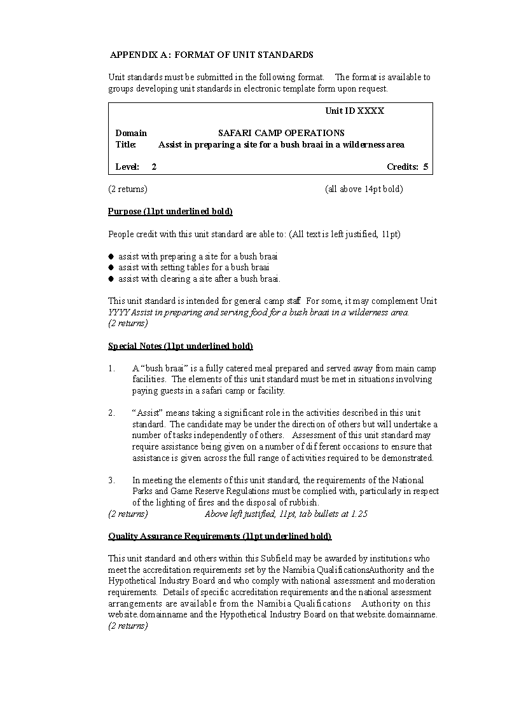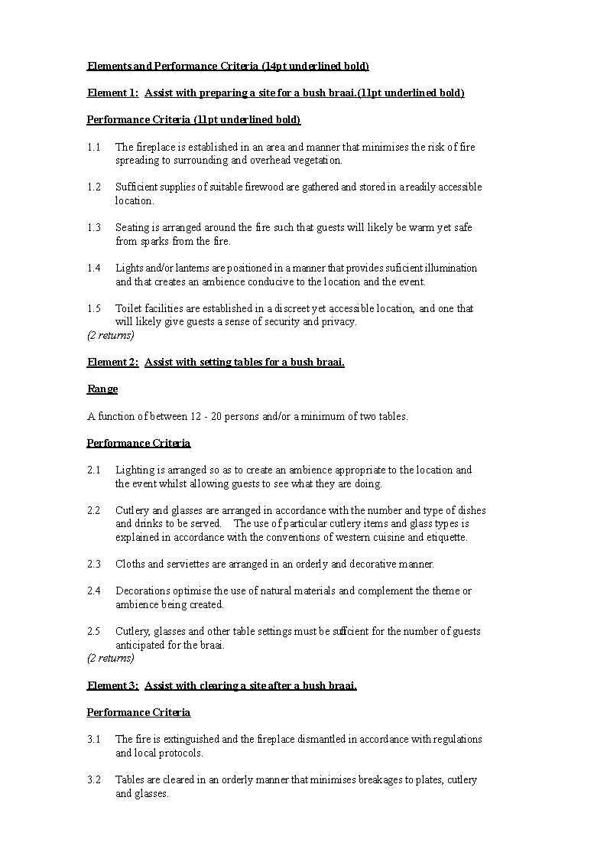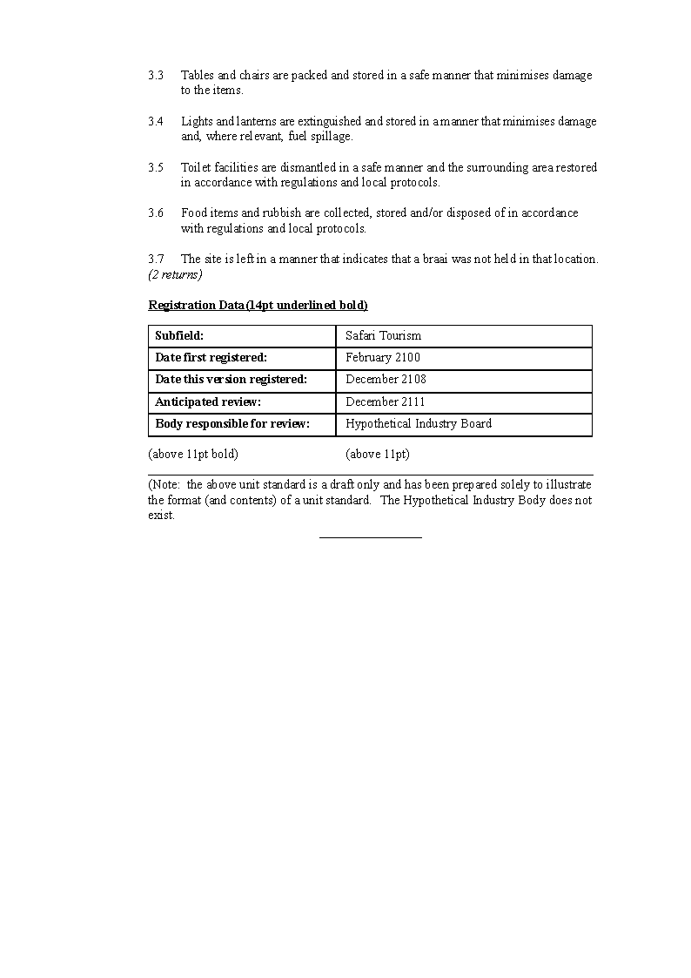

1. Because of agreed SADC conventions regarding skills recognition and the mobility of labour within the SADC region, groups outside Namibia will likely need to be included as relevant stakeholders. This inclusion may also be necessary where there is [are] substantial trans-national characteristics in a particular industry sector.
2. There will be some qualifactions registered on the NQF that represent the requirements of an occupation, job, ost, or position that will not be represented as unit standards-based qualifications. These ‘portal’ qualifications will only be awarded once all requirements have been met. The requirements cannot be awarded separately and independently. It is a NQF requirement that such qualifications clearly express the outcomes to be achieved and the criteria that will represent performance that represent the ‘attainment standard’. Thus, ‘occupational standards’ may be interpreted as being either *unit standards and/or national qualifications.*

   [The word “qualifications” is misspelt in the opening phrase of the footnote, as reproduced above.   
   The letter “p” appears to be missing from the word “post” in the first sentence of the footnote.]