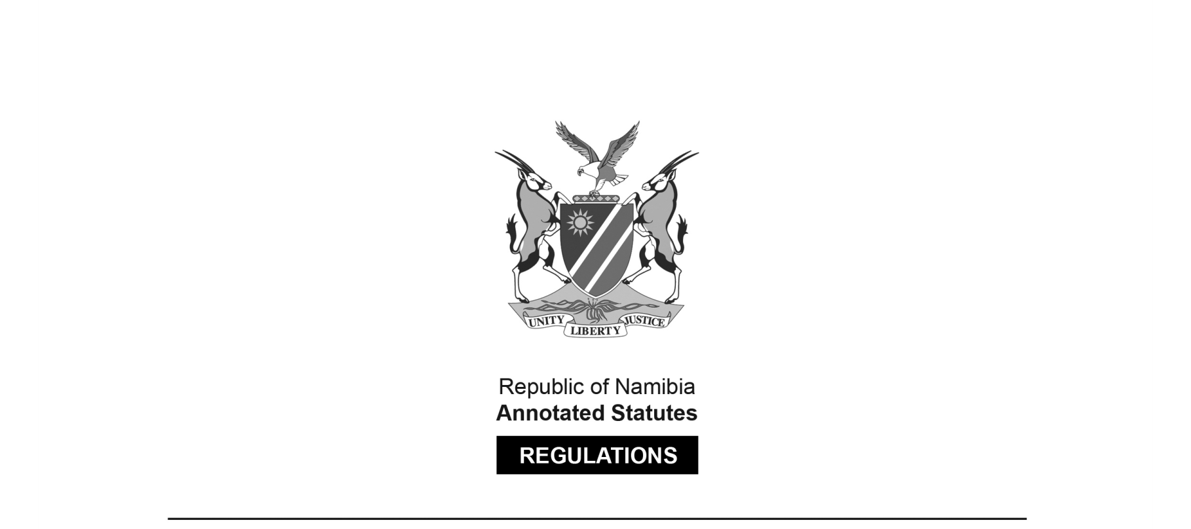
REGULATIONS MADE IN TERMS OF

Municipal Dog Tax Ordinance 13 of 1967
section 15

Regulations on Municipal Dog Tax (Maximum Amount) Government Notice 145 of 1980
(OG 4243)
came into force on date of publication: 15 August 1980

as amended by

Government Notice AG 7 of 1985 (OG 4992)
came into force on date of publication: 2 January 1985
Government Notice 36 of 1986 (OG 5175)
came into force on date of publication: 1 March 1986
Government Notice 60 of 1987 (OG 5348)
came into force on date of publication: 15 April 1987

ARRANGEMENT OF REGULATIONS

1. Definitions
2. Maximum amount

Definitions

1. In these Regulations, unless the context indicates otherwise, “the Ordinance” means the Municipal Dog Tax Ordinance, 1967 (Ordinance 13 of 1967), and any other word or expression shall have the meaning assigned thereto in the Ordinance.

Maximum amount

2. In determining the amount of tax in respect of every dog, whether spayed or not, the maximum amount in terms of section 3(3) of the Ordinance shall be R30.

[regulation 2 amended by AG GN 7/1985 and by GN 36/1986,
and substituted by GN 60/1987]

