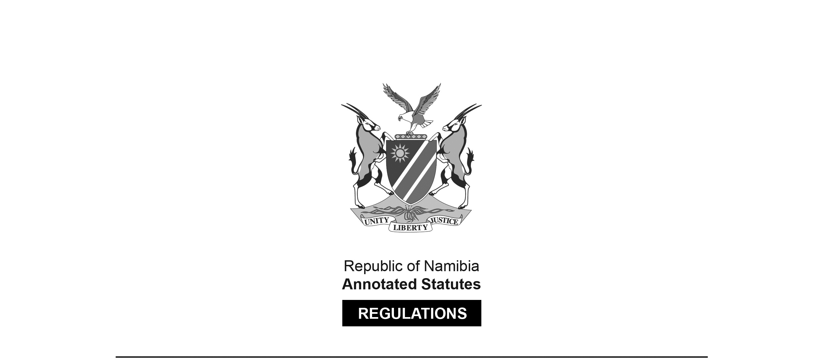

REGULATIONS MADE IN TERMS OF

Motor Vehicle Accident Fund Act 10 of 2007

section 35

Motor Vehicle Accident Fund Regulations

Government Notice 104 of 2008

(GG 4040)

came into force on date of publication: 2 May 2008

The Government Notice which publishes these regulations notes that they were made   
on the recommendation of the Board of the Motor Vehicle Accident Fund. This Government Notice also repeals GN 208/2001 (GG 2627) and GN 5/2003 (GG 2893). These previous regulations were issued in terms of the Motor Vehicle Accidents Fund Act 4 of 2001. There was no savings clause in the Motor Vehicle Accident Fund Act 10 of 2007 giving them continued applicability.

ARRANGEMENT OF REGULATIONS

1. Definitions

2. Procedure for making claims

3. Claim by service provider

4. Delivery of documents

5. Notice by driver or owner

6. Determination to ward benefits

7. Injury Grant

8. Medical costs

9. Reports

Annexure A: Forms

Annexure B: Compensation for Injury Guide

**Definitions**

**1.** In these regulations a word or expression defined in the Act has that meaning, and unless the context otherwise indicates -

“authorised agent” means a person who has been duly authorized by the Fund in terms of an agency agreement to provide services on behalf of the Fund;

“the Act” means the Motor Vehicle Accident Fund Act, 2007 (Act No. 10 of 2007).

**Procedure for making claims**

**2.** (1) A person who wants to claim benefits under section 28 of the Act must complete form MVAF 1 and submit it to the Fund in accordance with that section.

(2) A claim under subregulation (1) must be accompanied by the documents and information stipulated in the claim form.

(3) Where the claimant, on account of injury or other incapacity, is unable to complete the claim form, it may be completed -

(a) in the case of a minor, by his or her legal guardian; or

(b) in the case of a person for whom a curator has been appointed, by the curator of such person.

(4) A claim under subregulation (1) must be accompanied by a police report on form MVAF 1, and that report must -

(a) be completed by the police officer or the official of the Fund, who attended the scene of the motor vehicle accident; or

(b) be completed by the investigating officer who investigated the case;

(c) if the officials referred to in paragraph (a) and (b) fail to complete the report within a reasonable time after being requested, and it appears that the claim may become prescribed in terms of the Act, be completed by a police officer who has acquainted himself or herself with the contents of the docket.

(5) A claim under subregulation (1) must be accompanied by a medical report on form MVAF 1, and that report must -

(a) be completed by the medical practitioner who treated the injured person or the deceased for the injuries which gave rise to the claim;

(b) be completed by -

(i) the medical superintendent or a representative of the medical superintendent; or

(ii) a person in charge of the hospital or health facility where the injured or deceased was treated for the injuries which gave rise to the claim;

(c) be completed by a medical practitioner who has acquainted himself or herself with the cause of death or the nature of the injuries and the treatment or other medical services given to the deceased or injured person, if the medical practitioner referred to in paragraph (a) or the medical superintendent or the other person referred to in paragraph (b) fails to complete the report within a reasonable time after being requested and it appears that the claim may become prescribed in terms of the Act.

(6) Where a person in relation to whom a claim is made under the Act died prior to receiving treatment, the claimant is not obliged to produce the medical report referred to in subregulation (2), but the claim must be accompanied by -

(a) a copy of the inquest proceedings, if an inquest was held;

(b) a copy of the charge sheet pertaining to the motor vehicle accident, if any person was charged in respect of the accident; and

(c) any other information which the Fund considers relevant to the cause of death.

(7) The Fund is not liable to reimburse the costs of a report commissioned by a claimant and compiled by an expert for the purposes of substantiating a claim, unless the claimant has prior approval of the Fund, in which case the Fund must reimburse the costs involved in accordance with a tariff communicated to the claimant prior to commissioning the report.

(8) On receipt of a claim made under this regulation, the Fund may -

(a) allow the claim, and in writing inform the claimant or the person referred to in subregulation (3) of its decision;

(b) allow part of the claim, and in writing inform the claimant or the person referred to in subregulation (3) of its decision; or

(c) repudiate the claim, and in writing inform the claimant or the person referred to in subregulation (3) of its decision and the reasons for the decision.

**Claim by service provider**

**3.** A person or entity claiming payment for goods or services provided to a person entitled to benefits in terms section 24(3) of the Act, must do so by submitting a duly completed form MVAF 2 with such supporting documentation as is required in terms thereof.

**Delivery of documents**

**4.** (1) Whenever a document requires delivery in terms of these regulations, it must be delivered by registered mail, electronic mail or facsimile or to the recipient personally by a staff member of the Fund or authorised agent.

(2) Whenever a document, other than a claim form with the attachments thereto, requires submission to the Fund or authorised agent in terms of these regulations, it must be delivered by registered mail, electronic mail or facsimile or delivered by hand at the Head Office or branch office of the Fund or authorised agent’s office.

(3) Whenever a claim form, together with the attachments thereto, requires submission to the Fund or its duly authorised agent in terms of these regulations it must be delivered by registered mail or hand delivered at the Head Office or branch office of the Fund or authorised agent’s office.

**Notice of accident by driver or owner**

**5.** Whenever a driver or owner notifies the Fund of a motor vehicle accident in accordance with section 30 of the Act, he or she must do so by duly completing a notice of accident on form MVAF 3 and deliver it to the Fund.

**Determination to award benefits**

**6.** (1) Whenever the Fund makes a determination to award a benefit, it must communicate its determination by delivery of a notice to the claimant.

(2) The notice must indicate -

(a) the section of the Act under which the benefit is awarded;

(b) the nature of the benefit;

(c) the amount or value of the benefit;

(d) that the claimant has a right to make amendments to any treatment, rehabilitation of life enhancement plan awarded as a benefit subject to any increase in costs being for the claimant’s account in accordance with section 25(7) of the Act; and

(e) such other details as to fully inform the claimant of the award.

(3) Where an award is an undertaking to provide payment for future medical treatment, rehabilitation or life enhancement assistance, a written plan of the benefit must be annexed and must indicate -

(a) the nature and extent of future medical treatment, rehabilitation programs and goods and services to be provided; and

(b) the dates on which the claimant must be re-assessed in terms of section 25(6) of the Act.

(4) The Fund has access to all records of treatment and medical reports on the condition of a claimant under a treatment, rehabilitation or life enhancement plan.

(5) Where the Fund has a claimant reassessed in terms of section 25(6) of the Act it must communicate its determination by delivery of a notice to the claimant, which notice must contain information referred to in subregulation (3).

(6) Where the claimant is dissatisfied with the determination referred to in subregulation (5), subregulation (8) applies.

(7) Where an award is a funeral benefit in terms of section 25(1)(h) of the Act, it is paid in an amount of $N 7 000 without requiring proof of the actual costs incurred, and the person who may claim the benefit must be a spouse, child, parent or sibling of the deceased, or executor of the deceased estate, and such claim is made on form MVAF 4.

(8) Where a claimant responds to a notice of award by indicating that he or she is dissatisfied with the award, the Fund must deliver a Notice of Dissatisfaction, form MVAF 5, to such claimant for completion by the claimant and draw his or her attention to sections 25(8) and 32(5) and (6) of the Act.

(9) Where the Fund makes an award that is subject to the limitation set in section 27(1)(g), the Fund must implement the award until such time as the value of any other benefit receivable has been established and must then cease or reduce payment of the benefit if this is necessary to give full effect to the limitation.

**Injury Grant**

**7.** (1) A cash grant as compensation for injury awarded in terms of section 25(1)(c) of the Act must be calculated in terms of the Compensation for Injury Guide in Annexure B.

(2) In determining the amounts payable in terms of the Compensation for Injury Guide in Annexure B, the Minister must be satisfied that they are fair, reasonable and just having regard to the overall circumstances of Namibians and the resources of the Fund.

(3) Where an injury, including consequence of injury, is not specifically listed in the Compensation for Injury Guide the award must be that which reasonably equates to an injury or combination of injuries as listed in the Compensation for Injury Guide in Annexure B.

**Medical costs**

**8.** (1) Reimbursement and disbursement of and payment for the costs of medical treatment, rehabilitation and life enhancement assistance in terms of section 25(1)(d)(e)(f)(g) and (i) of the Act are made in accordance with the hospital and treatment tariffs as agreed between service providers and the Fund.

[There should be commas separating the paragraph references   
in the cross-reference: “section 25(1)(d), (e), (f), (g) and (i)”.]

(2) The tariff is applicable to all procedures, whether or not the procedure is done outside the borders of Namibia, unless the procedure is not available in Namibia in which event the total cost of the procedure is paid by the Fund subject to the limitation set out in section 24(4)(a) of the Act.

**Reports**

**9.** For purposes of keeping proper records of the Fund, the Chief Executive Officer of the Fund must complete or cause to be completed a report that includes -

(a) the type of injuries sustained in motor vehicle accidents;

(b) the number of injured persons treated;

(c) the average cost of treating each type of injury;

(d) recovery periods for each type of injury;

(e) the number of rehabilitated and unrehabilitated persons resulting from motor vehicle accidents;

(f) the number of permanently disabled patients resulting from motor vehicle accidents;

(g) the geographical, age, sex and time of day distribution of motor vehicle accidents; and

(h) the causes of motor vehicle accidents.

**ANNEXURE A**

**FORMS**

|  |  |  |  |
| --- | --- | --- | --- |
| **Form** | **Title** | **Section** | **Regulation** |
| MVAF 1 | Claim for Benefits | 24 and 25 | 2 |
| MVAF 2 | Claim by Service Provider | 24(3) | 3 |
| MVAF 3 | Notice of Accident | 30 | 5 |
| MVAF 4 | Claim for Funeral Grant | 25 | 6 |
| MVAF 5 | Notice of Dissatisfaction | 32(6) | 6 |

FORMS

To view content without printing, scroll down.

To print at full scale (A4), double-click the icon below.



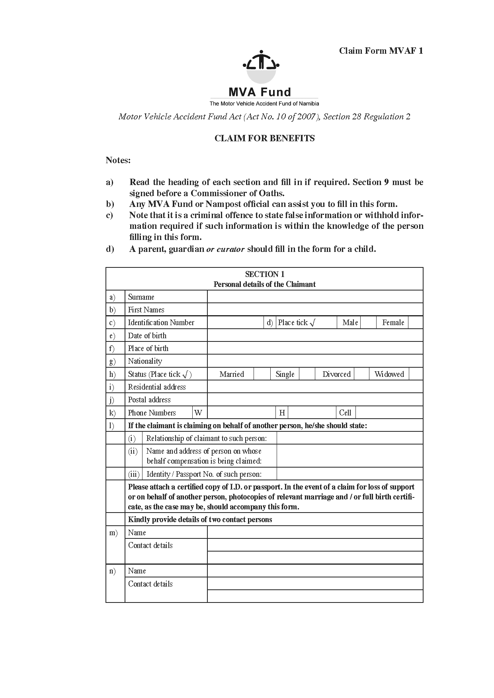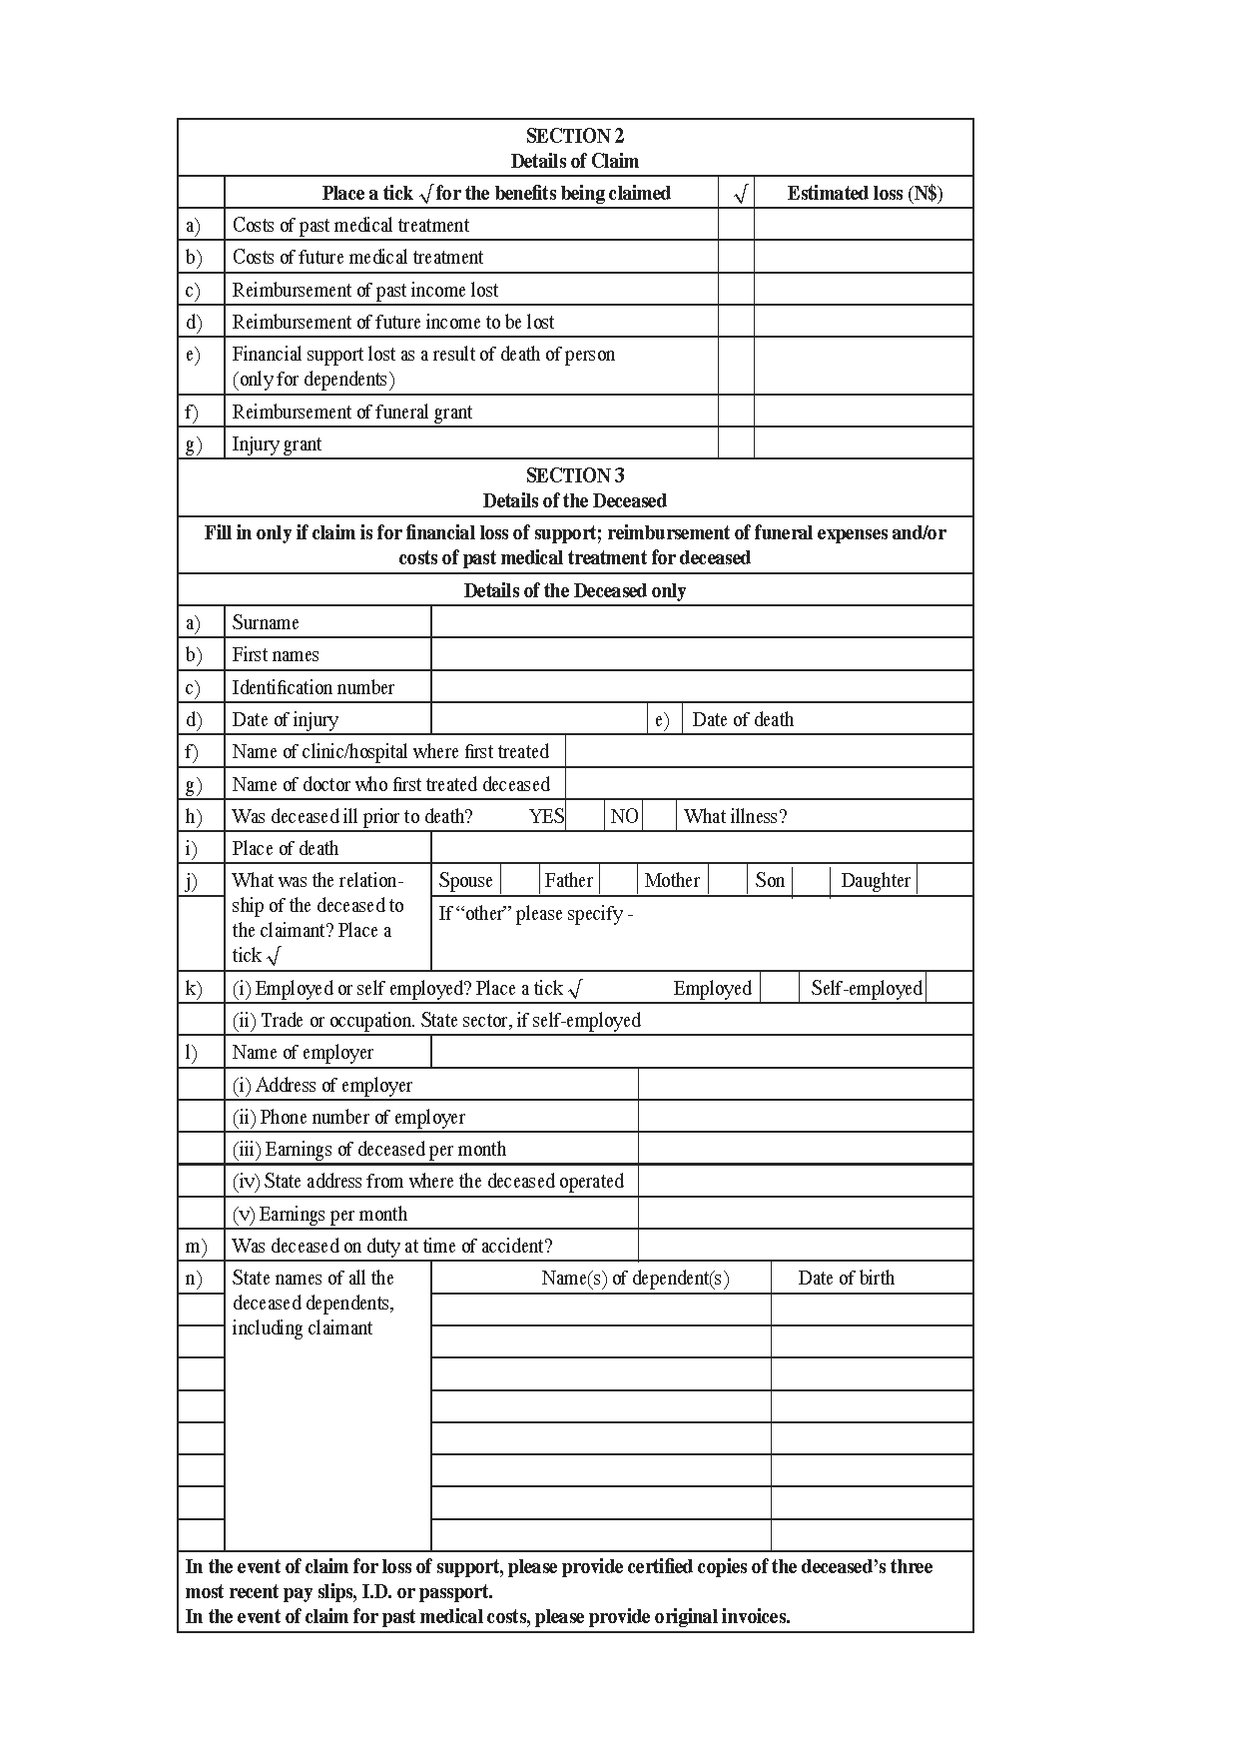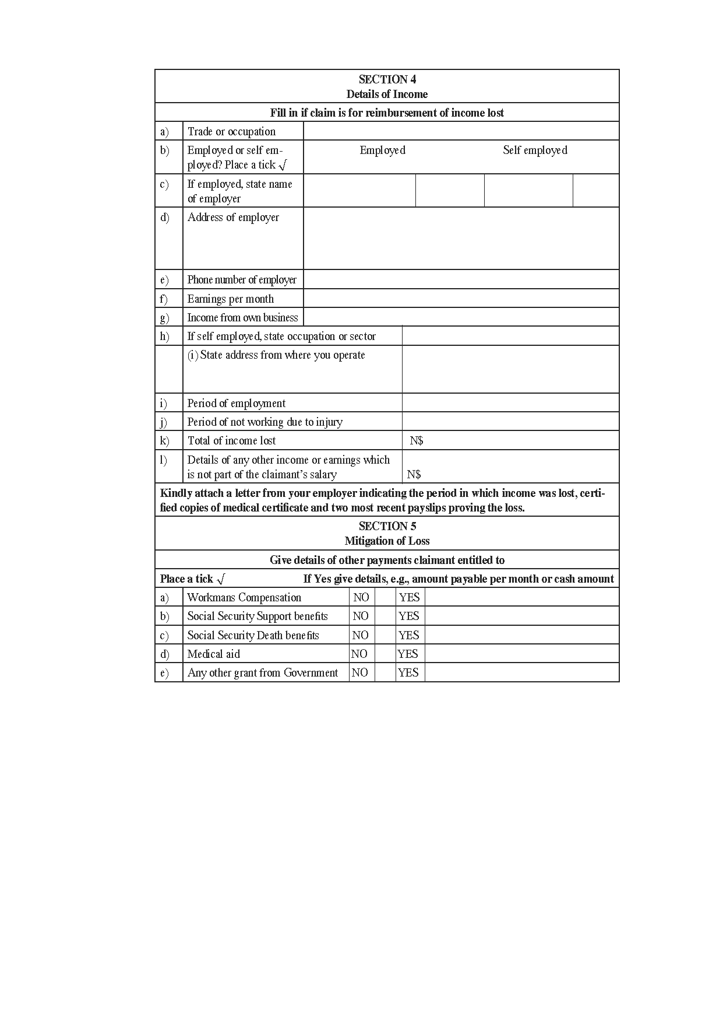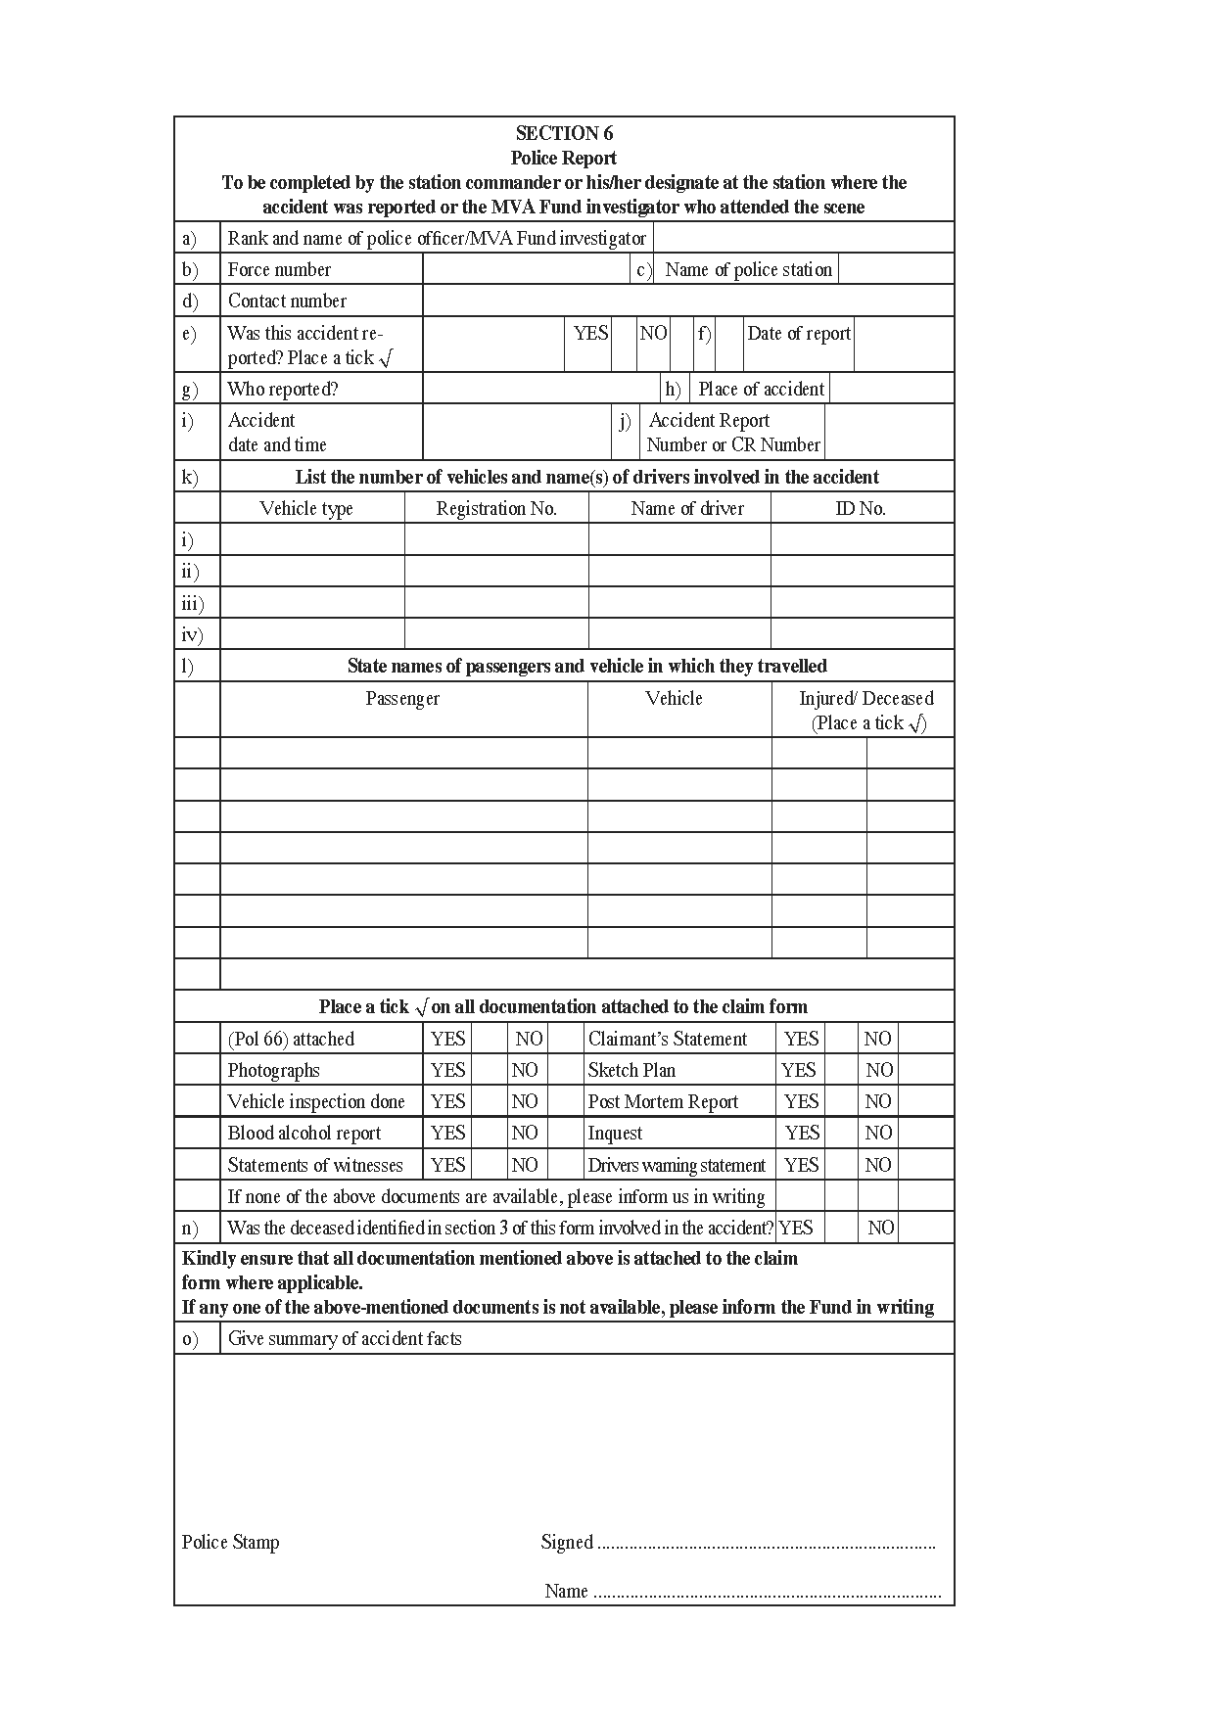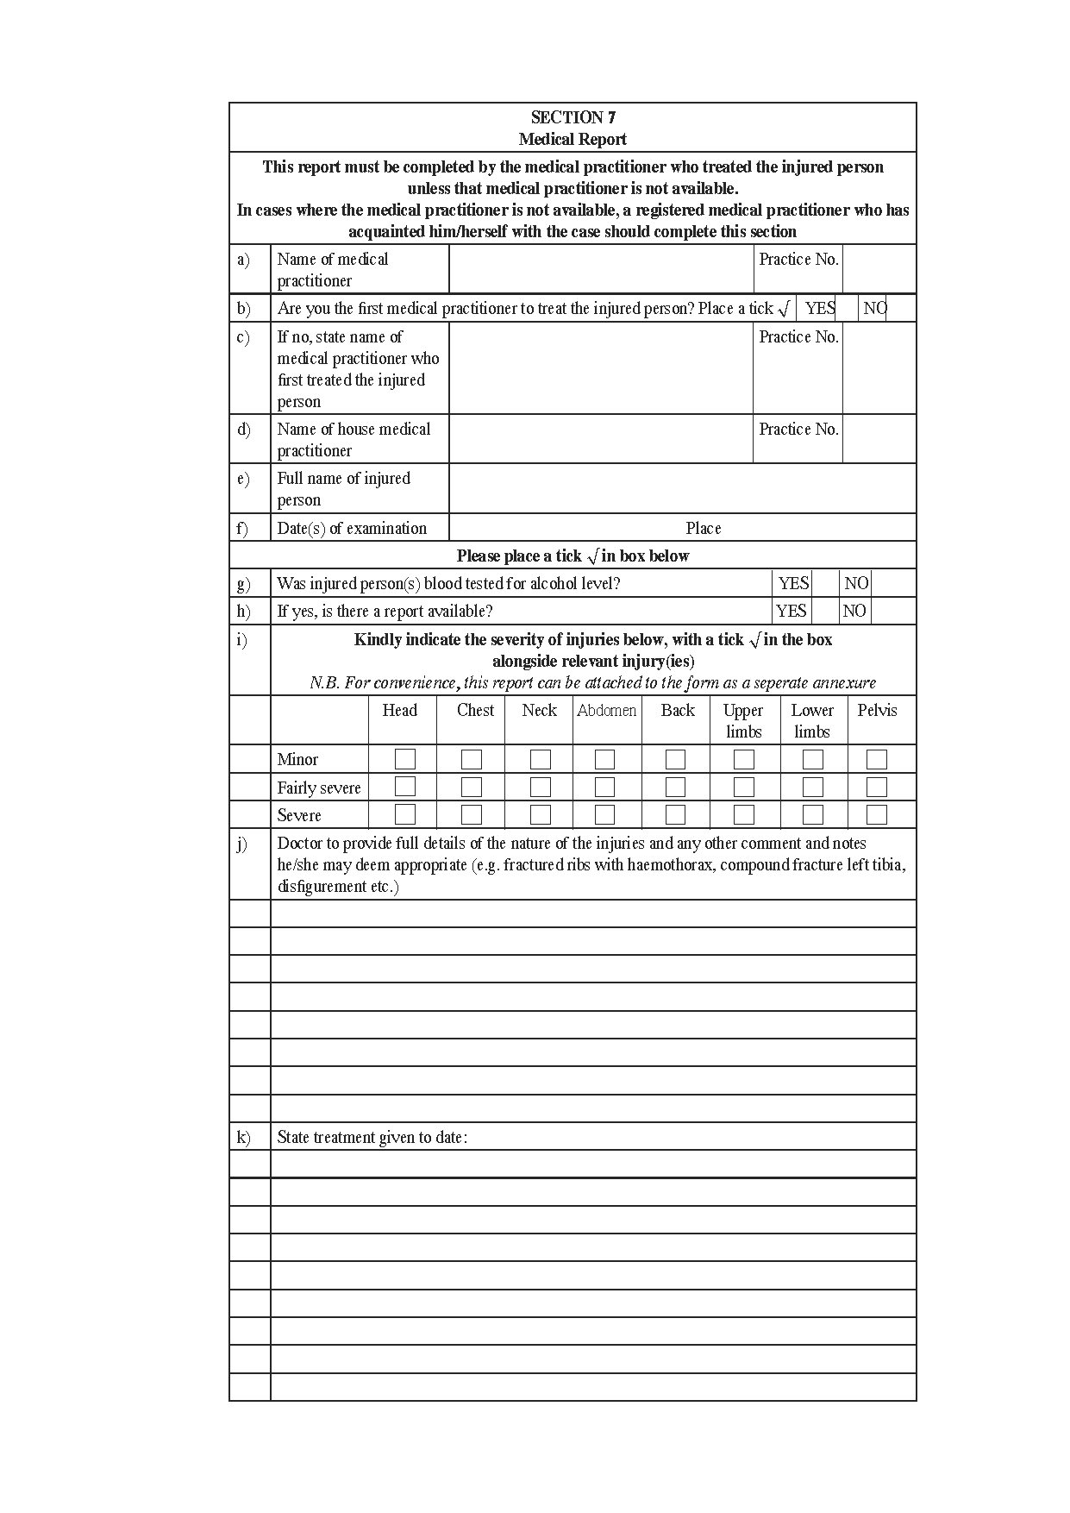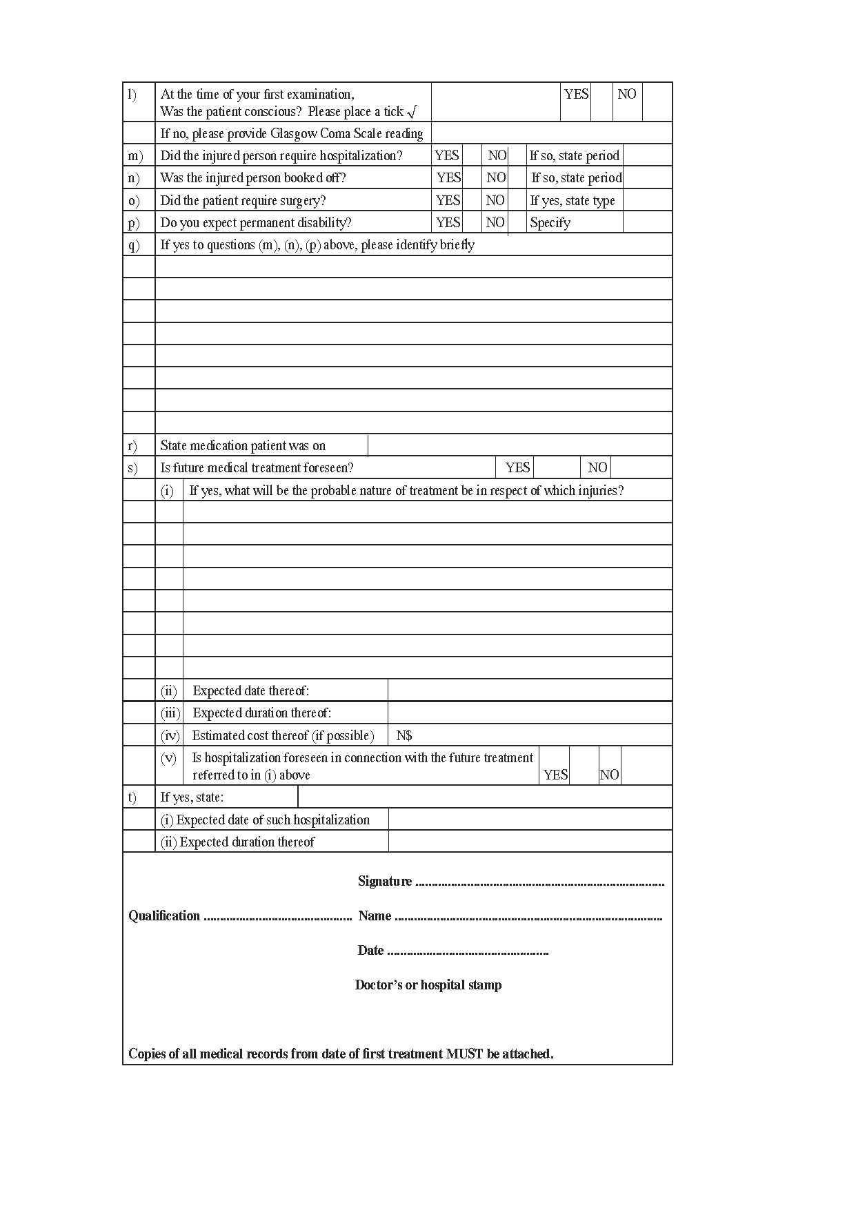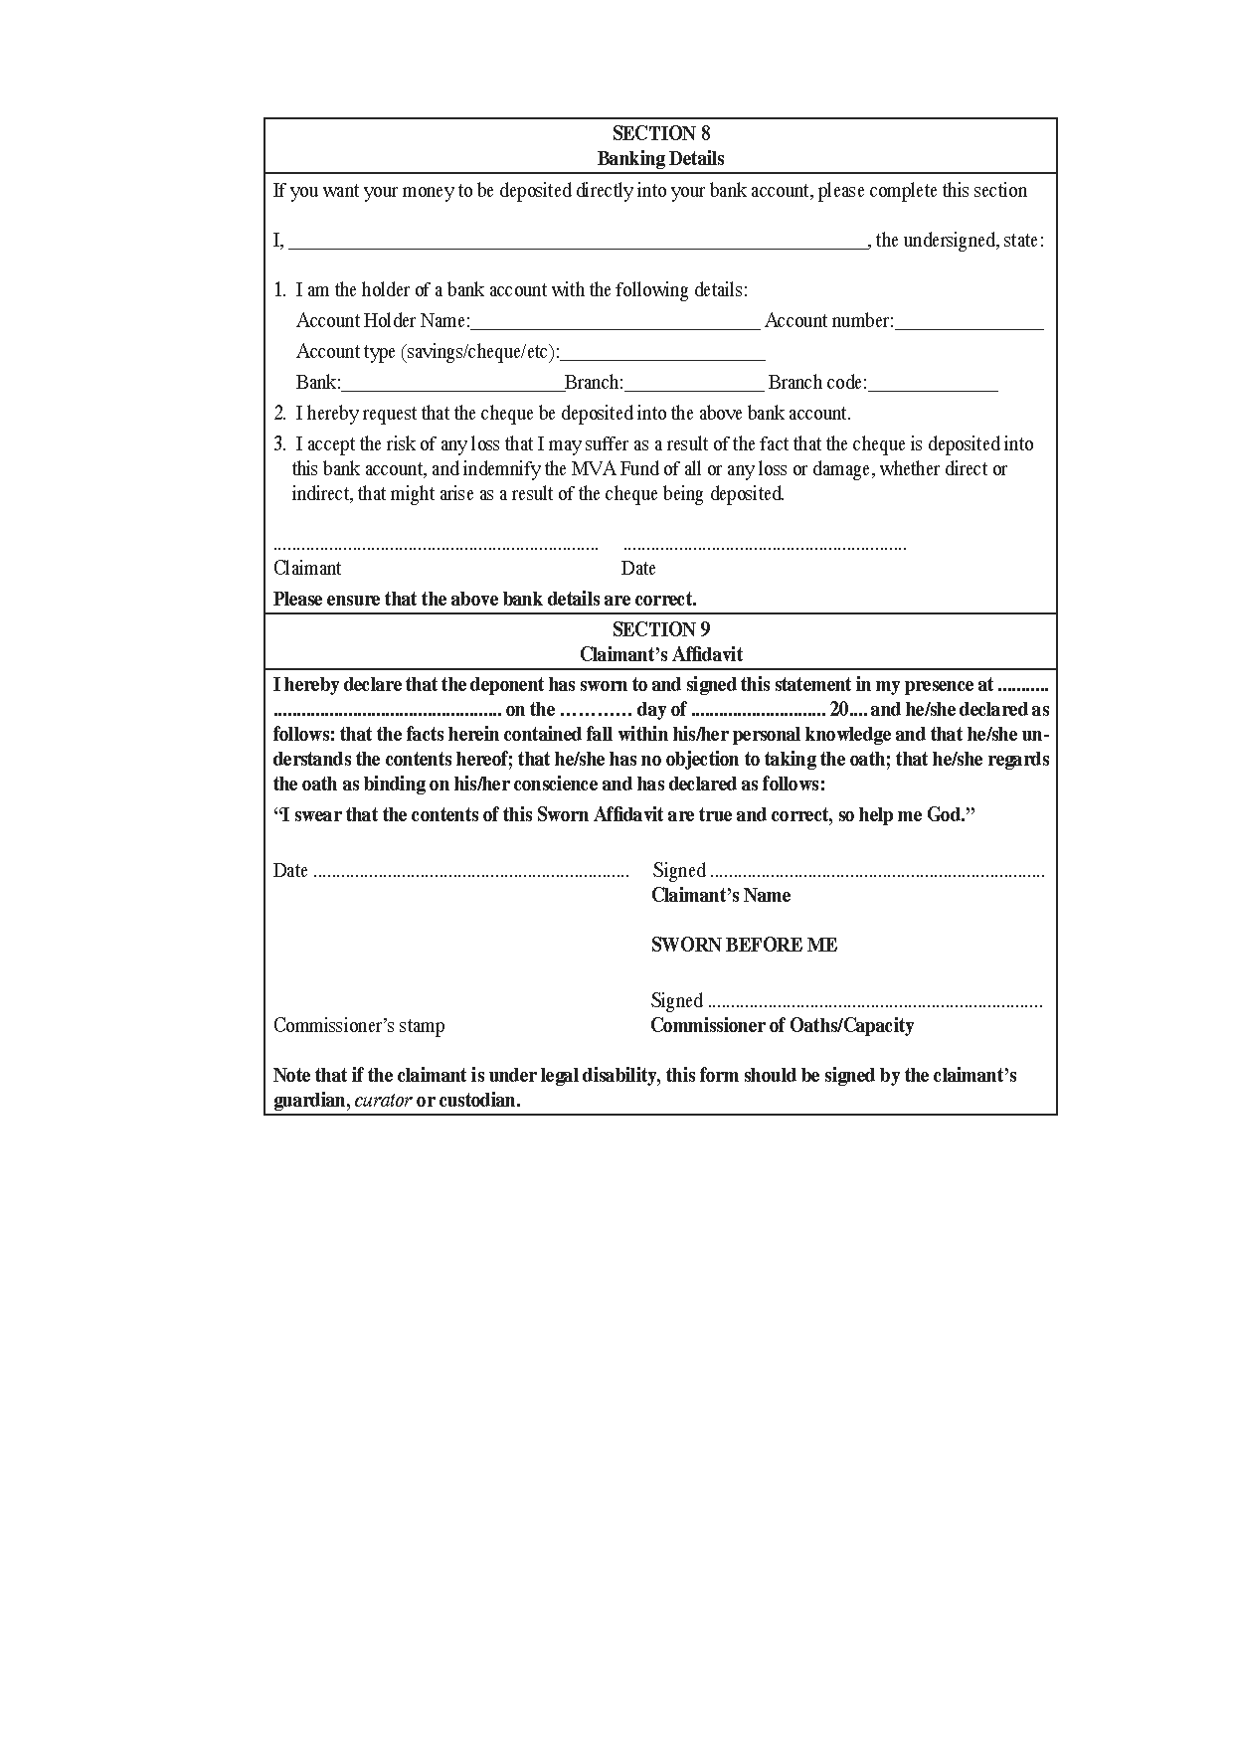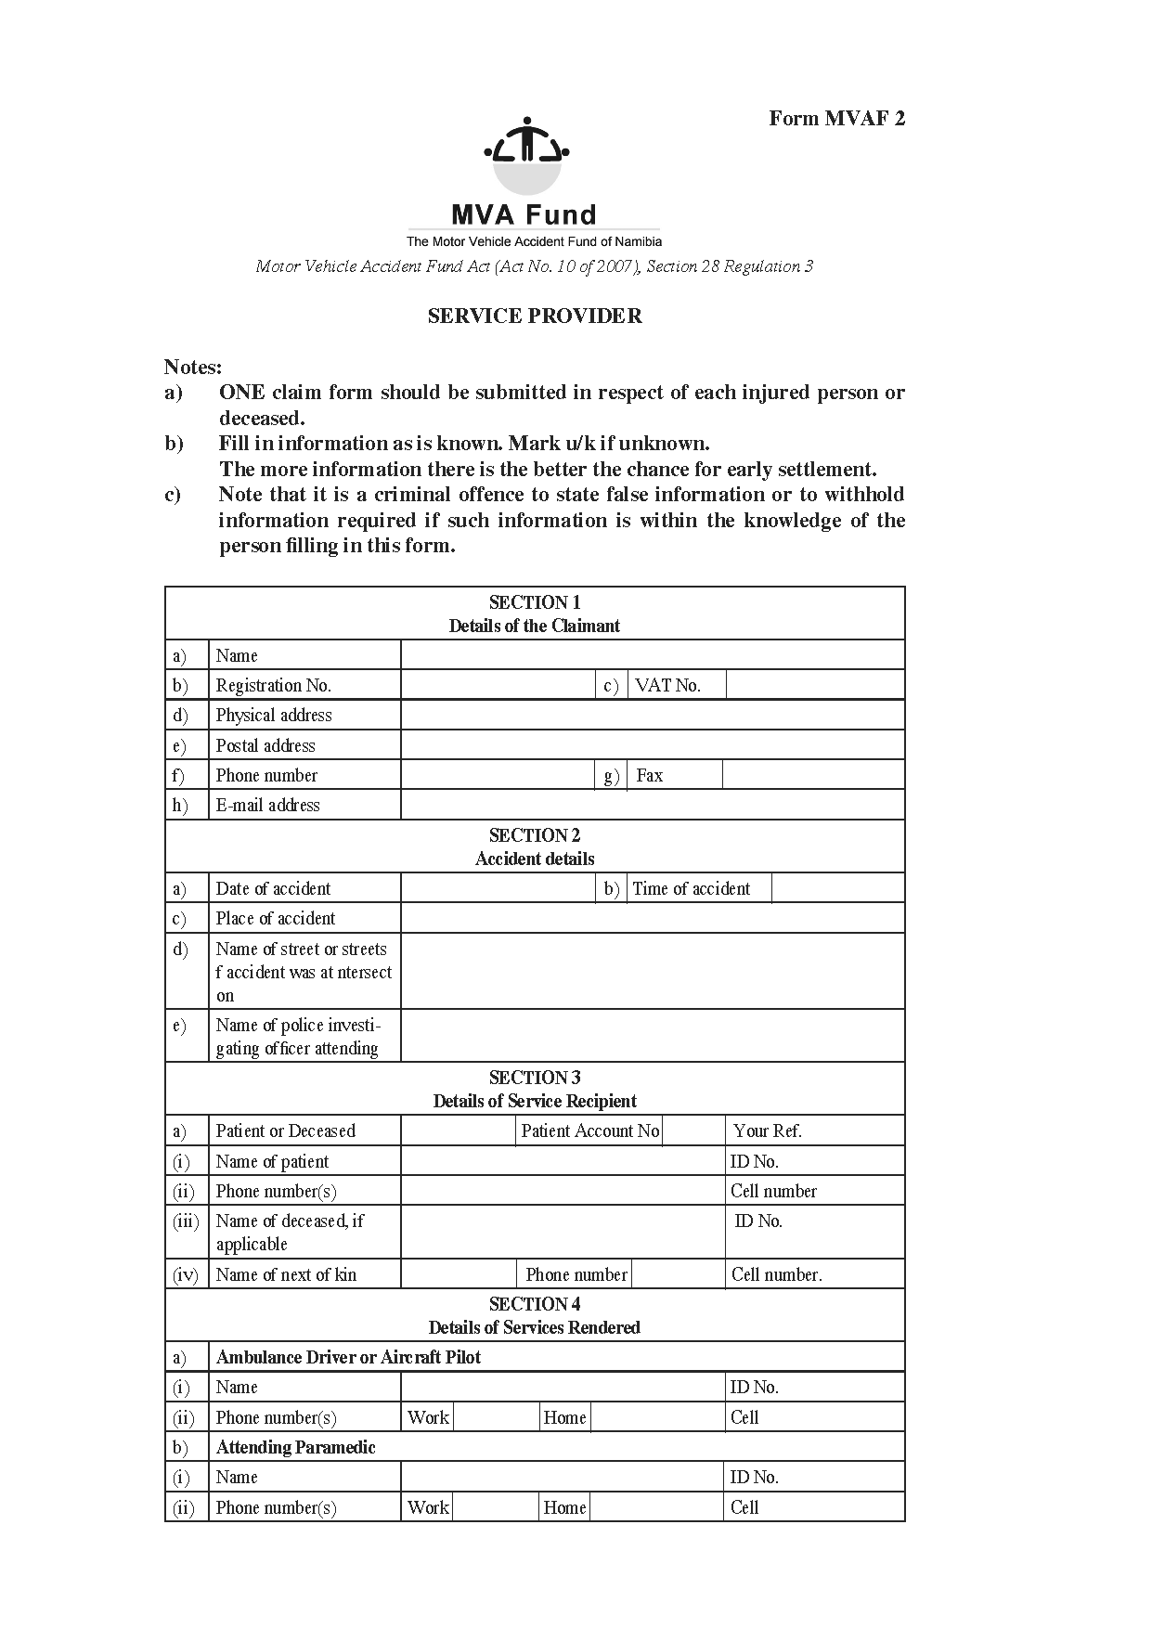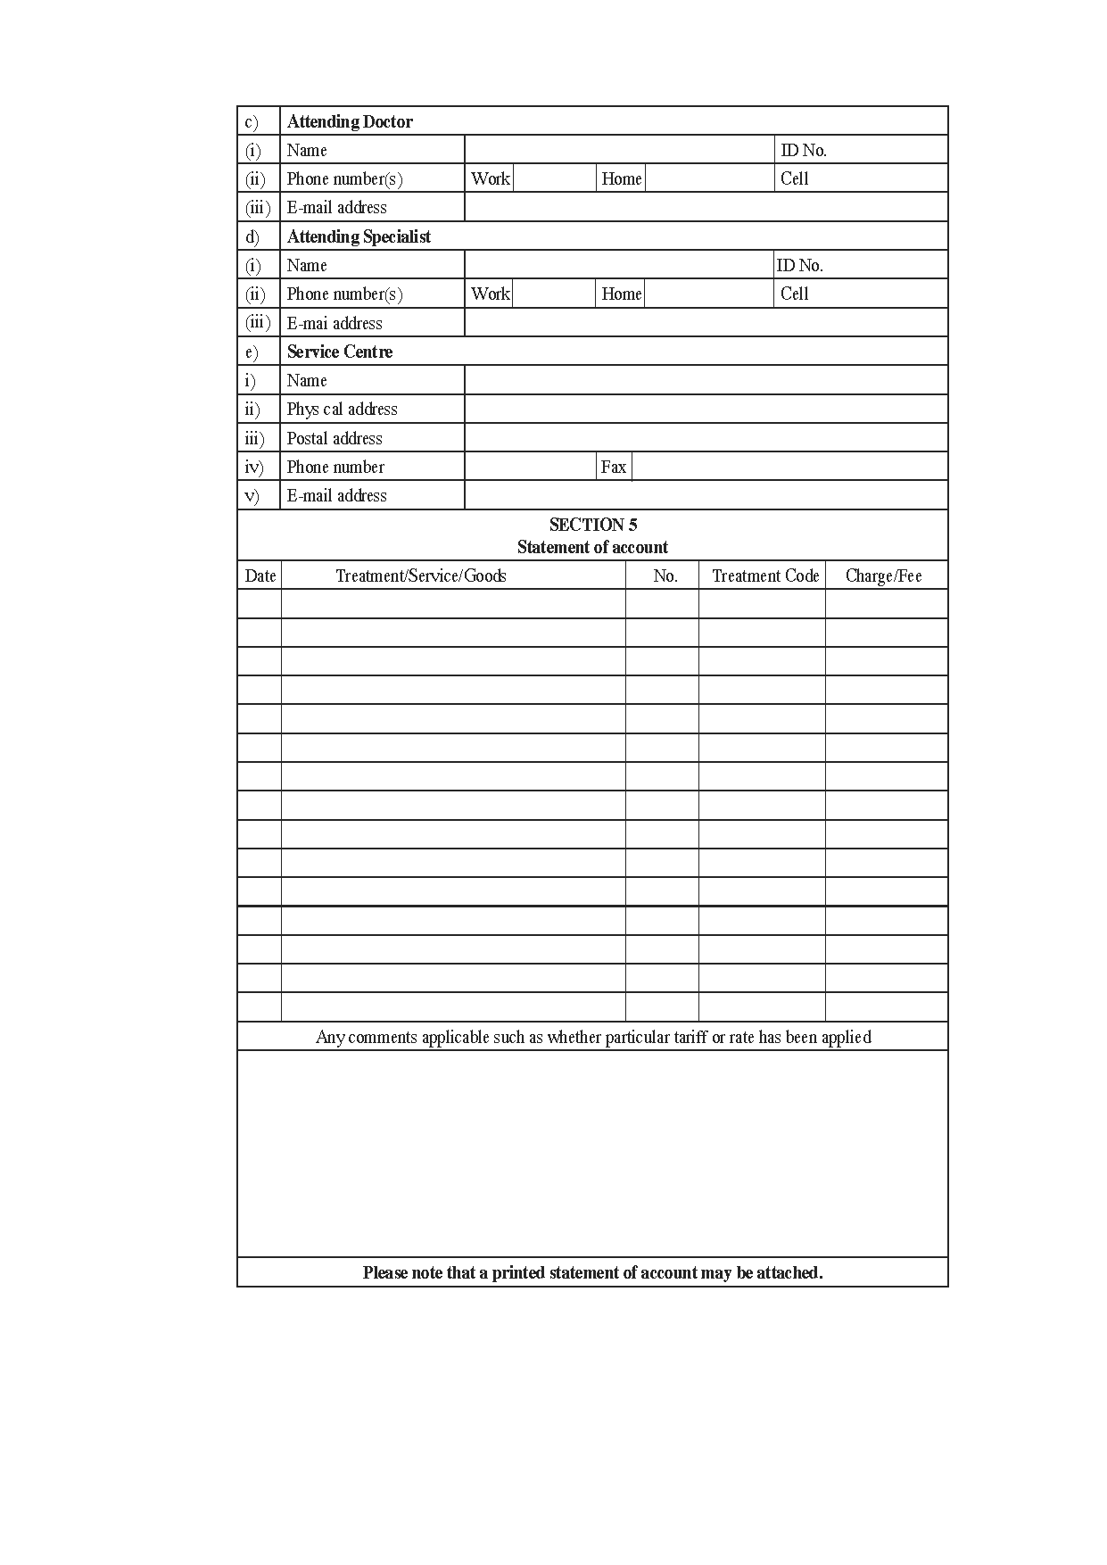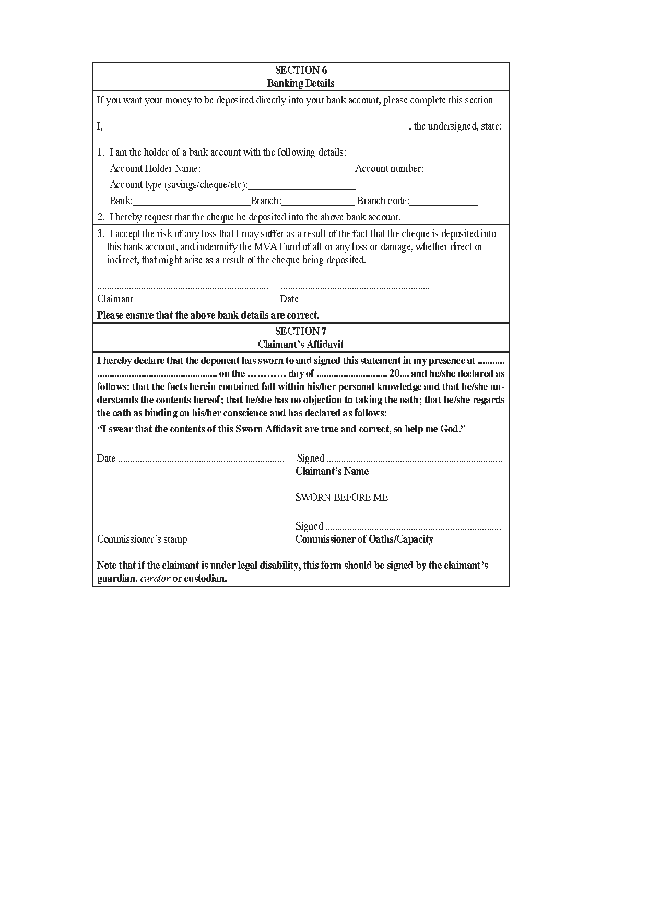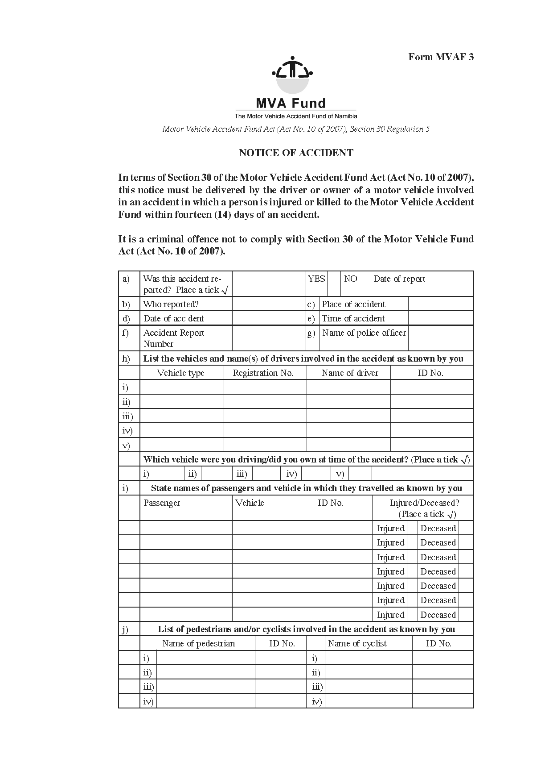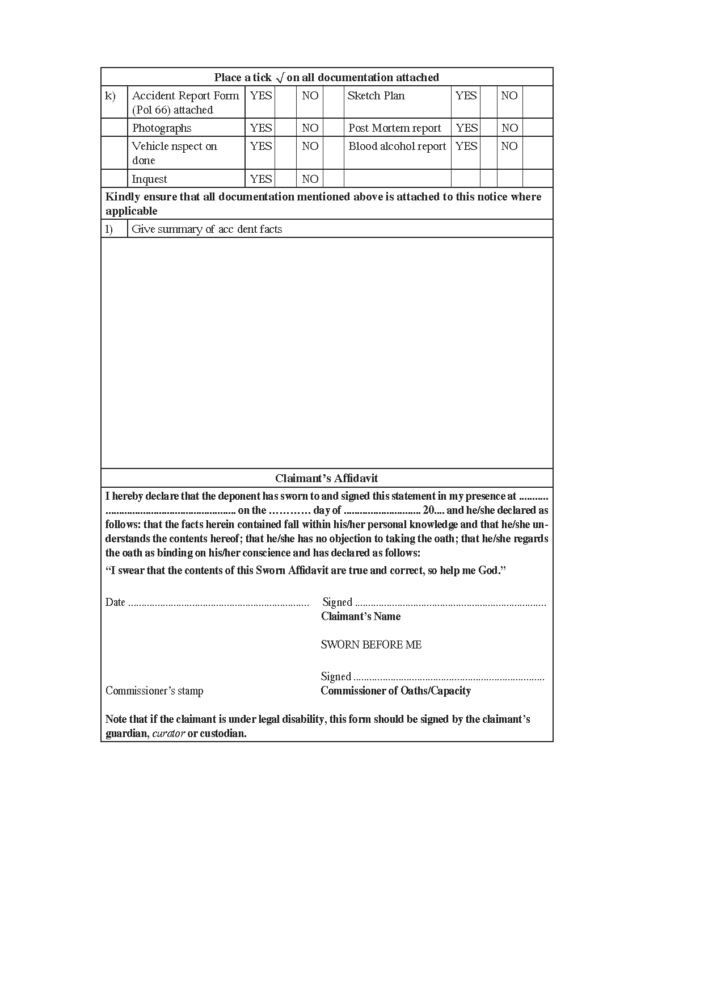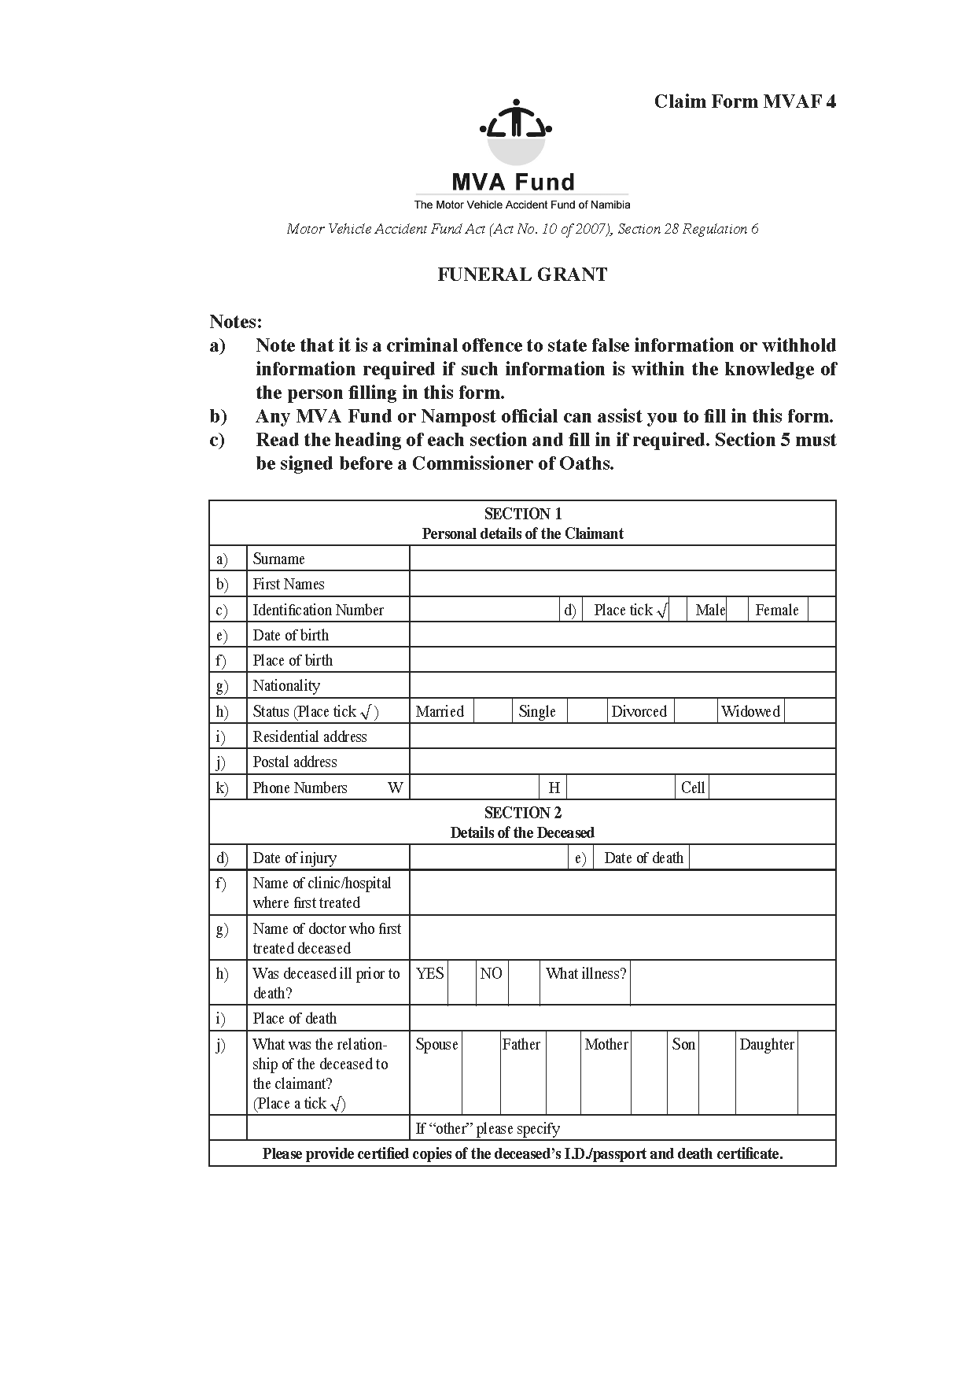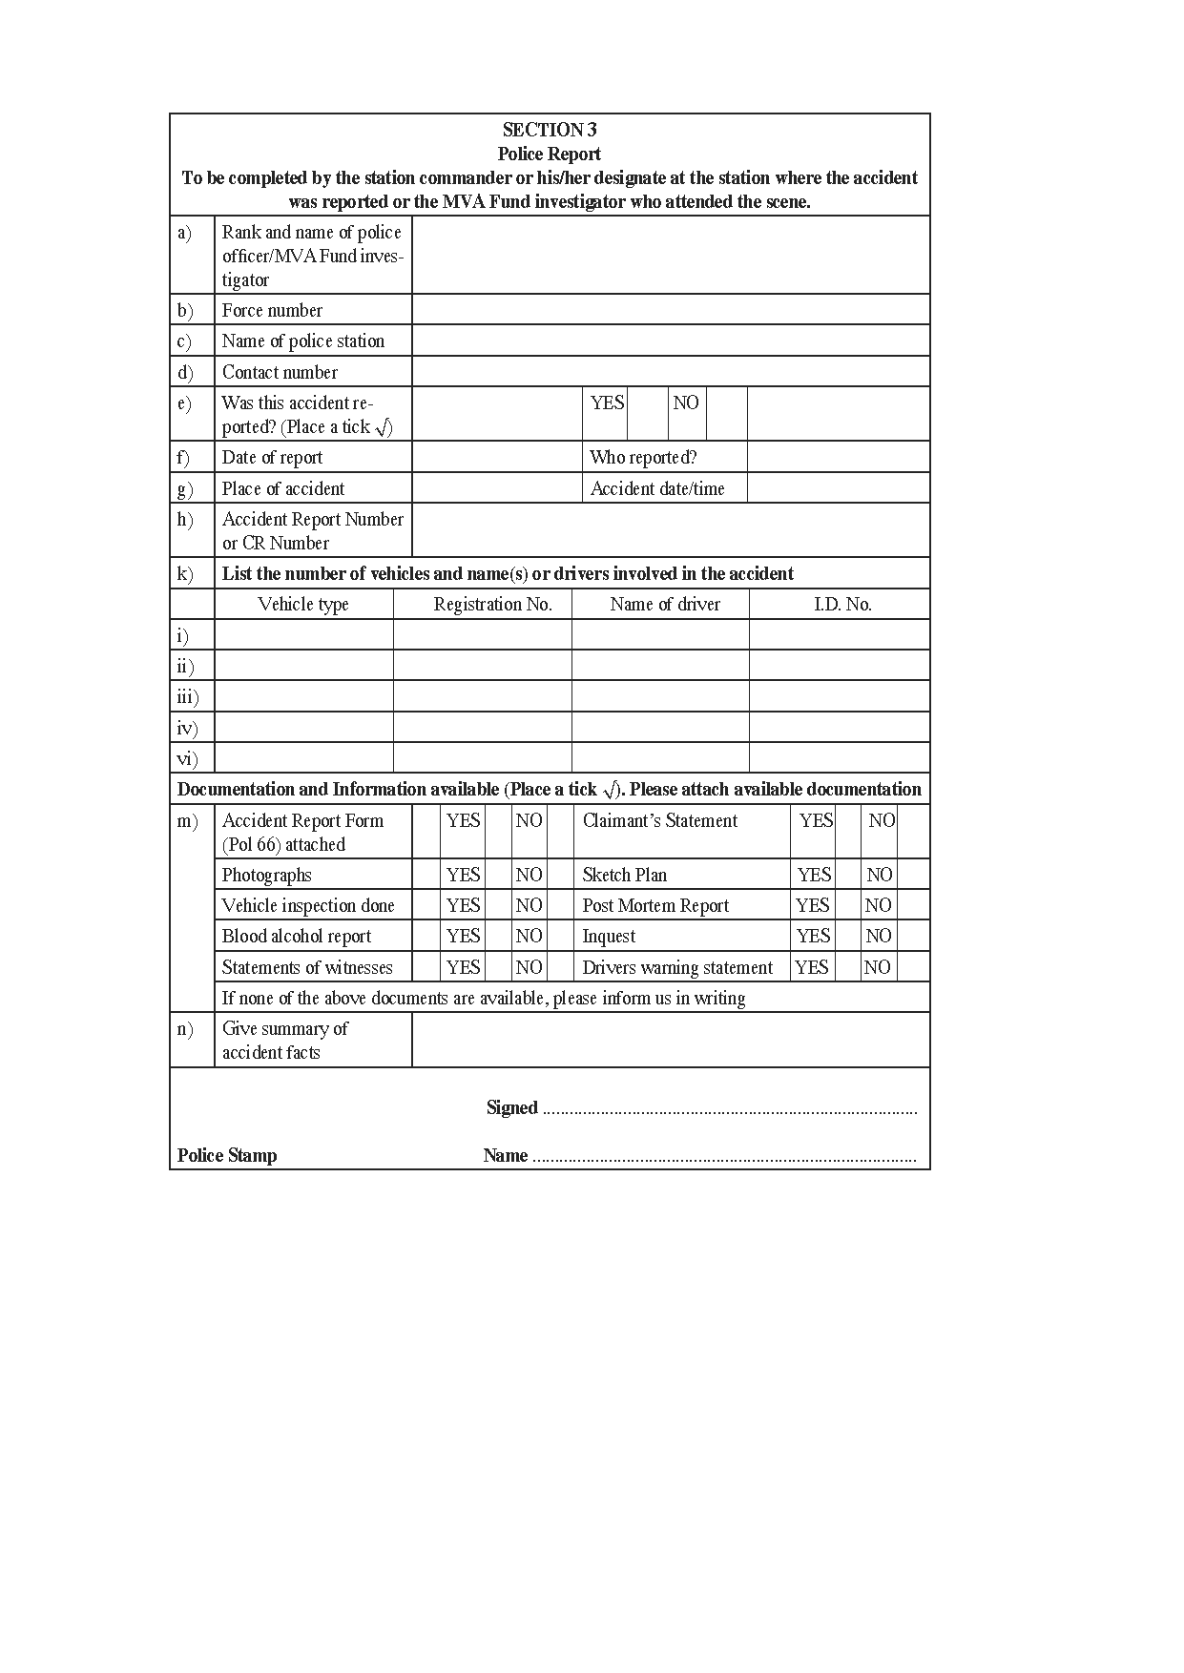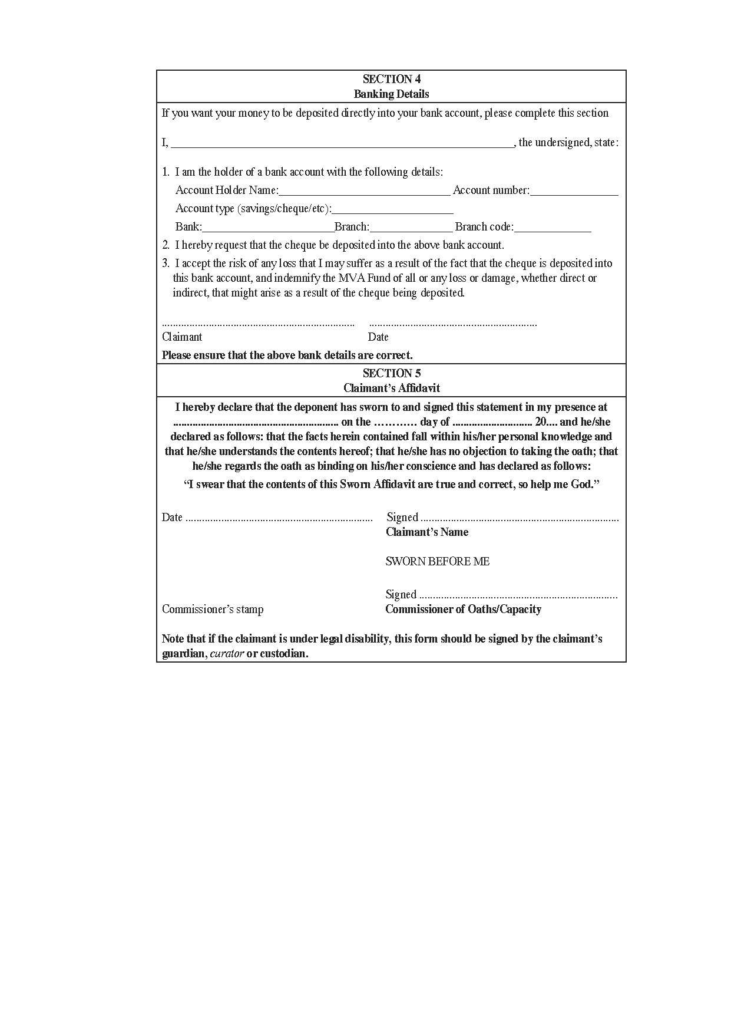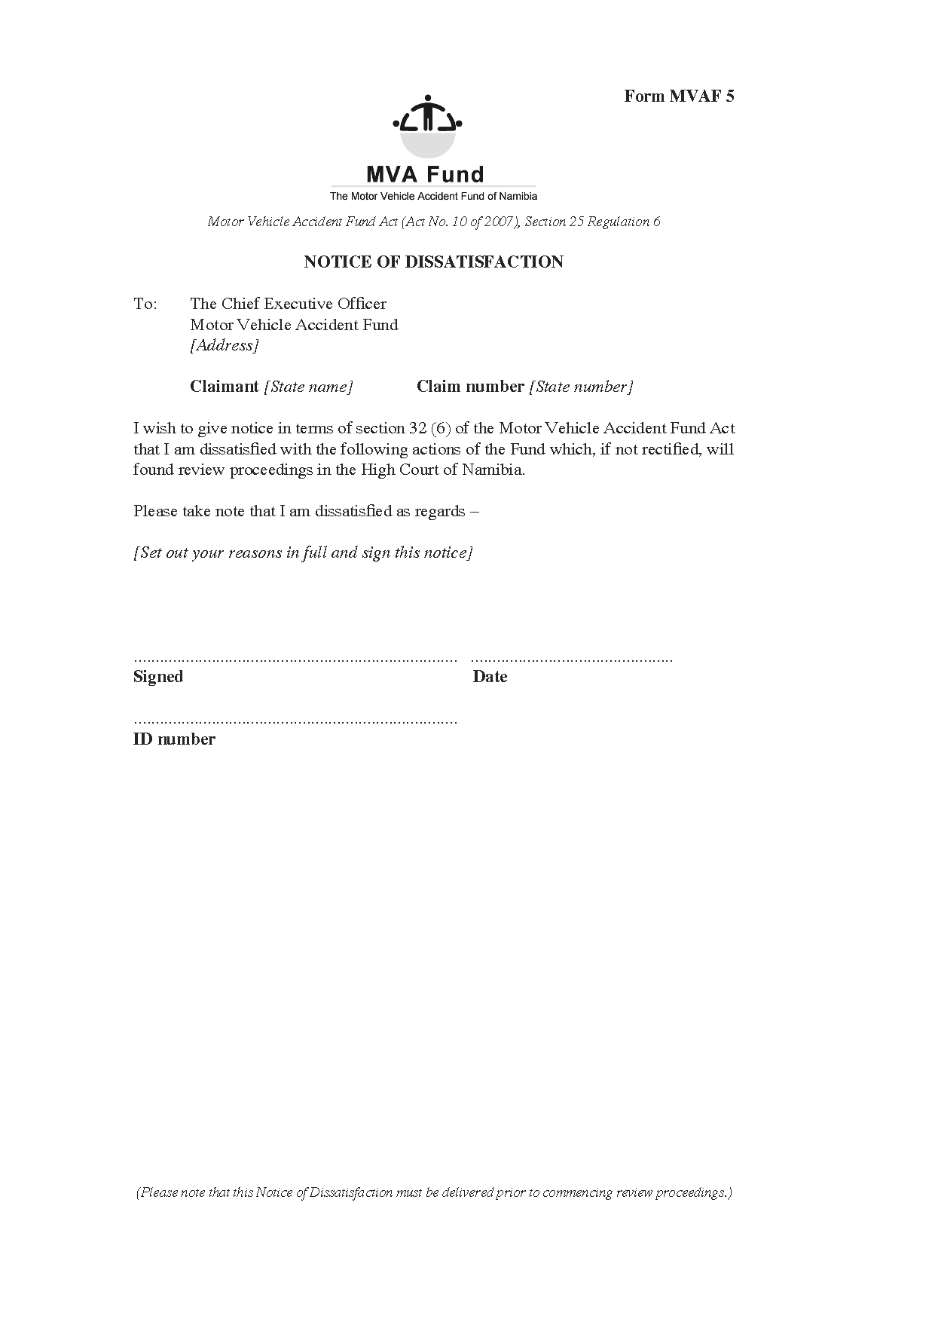

ANNEXURE B

**Motor Vehicle Accident Fund Act (Act No. 10 of 2007), Section 25(1)(c), Regulation 7**

COMPENSATION FOR INJURY GUIDE

[Capitalisation throughout the Table is reproduced as it appears in the *Government Gazette*.]

| **QUANTUM LIST FOR INJURY PROFILING IN NAMIBIA** | **CODE** | **MINOR + MINOR WITH AFTER EFFECTS** | **CODE** | **MODER- ATE + MODER- ATE WITH AFTER EFFECTS** | **CODE** | **SEVERE + SEVERE WITH AFTER EFFECTS** |
| --- | --- | --- | --- | --- | --- | --- |
| **HEAD INJURIES** | | | | | | |
| **1. FRACTURES** | | | | | | |
| Skull Base | **1101** | 8470 | **1201** | 10890 | **1301** | 12100 |
| Parietal and/or Frontal Bones | **1102** | 7260 | **1202** | 8470 | **1302** | 9680 |
| Malor/Zygoma | **1103** | 4235 | **1203** | 6050 | **1303** | 6050 |
| Nose | **1104** | 1815 | **1204** | 8470 | **1304** | 10890 |
| Orbital/peri-orbital | **1105** | 1210 | **1205** | 4840 | **1305** | 12100 |
| Maxilla | **1106** | 4840 | **1206** | 7260 | **1306** | 12100 |
| Mandible | **1107** | 2420 | **1207** | 4840 | **1307** | 10890 |
| Tooth | **1108** | 605 | **1208** | 1815 | **1308** | 3025 |
| **2. DISLOCATIONS** | | | | | | |
| Mandible | **2101** | 1210 | **2201** | 3630 | **2301** | 6050 |
| **3. DISLOCATION & FRACTURES** | | | | | | |
| Mandible | **3101** | 3025 | **3201** | 4840 | **3301** | 10890 |
| **4. AMPUTATION** | | | | | | |
| Tooth | **4101** | 605 | **4201** | 1210 | **4301** | 3025 |
| **5. HAEMORRHAGE** | | | | | | |
| Subdural | **5101** | 7260 | **5201** | 18150 | **5301** | 96800 |
| Brain | **5102** | 7260 | **5202** | 18150 | **5302** | 96800 |
| Epistaxis | **5103** | 550 | **5203** | 1100 | **5303** | 1650 |
| **6. SOFT TISSUE INJURIES** | | | | | | |
| Bruising | **6101** | 605 | **6201** | 1210 | **6301** | 2420 |
| Abrasions | **6102** | 605 | **6202** | 1210 | **6302** | 30250 |
| Lacerations small/minor  – no stitches required | **6103** | 605 | **6203** | 3630 | **6303** | 6050 |
| Degloving of scalp | **6104** | 2420 | **6204** | 6050 | **6304** | 30250 |
| Contusion/concussion | **6105** | 2420 | **6205** | 3630 | **6305** | 6050 |
| Removal of foreign bodies | **6106** | 1210 | **6206** | 2420 | **6306** | 3630 |
| **7. PAIN** |  |  |  |  |  |  |
| No other injury | **7101** | 665.5 | **7201** | 1996.5 | **7301** | 3327.5 |
| Permanent (other injuries recovered fully) | **7102** | 3327.5 | **7202** | 3993 | **7302** | 6655 |
| **Central Nervous System** | | | | | | |
| **1. PAIN** | | | | | | |
| No other injury | **7119** | 605 | **7219** | 1815 | **7319** | 3025 |
| Permanent (other injuries recovered fully) | **7120** | 3025 | **7220** | 4235 | **7320** | 6050 |
| **2. LOSS OF SENSES** | | | | | | |
| Impairment of vision | **9101** | 1-33% | **9201** | 34-66% | **9301** | 67-100% |
| Loss of one eye | **9102** | 73150 | **9202** |  | **9302** |  |
| Total loss of visual field | **9103** | 110000 | **9203** |  | **9303** |  |
| Impairment of hearing | **9104** | 1-33% | **9204** | 34-66% | **9304** | 67-100% |
| Loss of hearing in one ear | **9105** |  | **9205** |  | **9305** | 33000 |
| Total loss of hearing | **9106** |  | **9206** |  | **9306** | 50000 |
| Loss of olfactory sense | **9107** | 6050 | **9207** | 9680 | **9307** | 11000 |
| Hemi paresis | **9108** |  | **9208** |  | **9308** | 49500 |
| Paraplegia | **9109** |  | **9209** |  | **9309** | 110000 |
| Quadriplegia | **9110** |  | **9210** |  | **9310** | 110000 |
| Brain damage | **9111** |  | **9211** |  | **9311** | 110000 |
| Post traumatic stress syndrome | **9112** | 18150 | **9212** | 30250 | **9312** | 33000 |
| Anxiety attacks/reactive depression | **9113** | 6050 | **9213** | 12100 | **9313** | 18150 |
| Epileptic post traumatic | **9114** | 30250 | **9214** | 42350 | **9314** | 60500 |
| Major depression | **9115** | 18150 | **9215** | 30250 | **9315** | 33000 |
| **SPINAL CORD** | | | | | | |
| **1. FRACTURES** | | | | | | |
| Cervical vertebrae | **1109** | 8470 | **1209** | 25410 | **1309** | 48400 |
| Thorax/ Back | **1110** | 4840 | **1210** | 12100 | **1310** | 48400 |
| Dorsal/and or lumbar vertebrae | **1111** | 9680 | **1211** | 21780 | **1311** | 36300 |
| Coccyx | **1112** | 2420 | **1212** | 4840 | **1312** | 10890 |
| **2. DISLOCATIONS** | | | | | | |
| Neck (whiplash) | **2102** | 3630 | **2202** | 12100 | **2302** | 30250 |
| Back 2 | **103** | 9680 | **2203** | 18150 | **2303** | 36300 |
| **3. DISLOCATION & FRACTURES** | | | | | | |
| Neck 3 | **102** | 19965 | **3202** | 33275 | **3302** | 59895 |
| Back | **3103** | 19965 | **3203** | 33275 | **3303** | 59895 |
| **4. AMPUTATION** | | | | | | |
| coccyx | **4102** | 6655 | **4202** | 9317 | **4302** | 11979 |
| **5. HAEMORRHAGE** | | | | | | |
| Muscle | **5104** | 1210 | **5204** | 2420 | **5304** | 12100 |
| Epidural | **5105** | 4840 | **5205** | 8470 | **5305** | 12100 |
| **6. SOFT TISSUE INJURIES** | | | | | | |
| Bruising | **6107** | 605 | **6207** | 1210 | **6307** | 2420 |
| Abrasions | **6108** | 605 | **6208** | 1210 | **6308** | 2420 |
| Lacerations small/minor  – no stitches required | **6109** | 605 | **6209** | 3630 | **6309** | 6050 |
| Laceration major/large  – stitches required | **6110** | 1815 | **6210** | 3630 | **6310** | 6050 |
| Contusion | **6111** | 605 | **6211** | 1210 | **6311** | 3025 |
| Contractures | **6112** | 6050 | **6212** | 9680 | **6312** | 12100 |
| **7. PAIN** |  |  |  |  |  |  |
| No other injury | **7103** | 605 | **7203** | 1815 | **7303** | 3025 |
| Permanent (other injuries |  |  |  |  |  |  |
| recovered fully) | **7104** | 3025 | **7204** | 3630 | **7304** | 6050 |
| **UPPER EXTREMITIES** | | | | | | |
| **1. FRACTURES** | | | | | | |
| Clavicle | **1113** | 4840 | **1213** | 8470 | **1313** | 9680 |
| Scapula | **1114 4** | 840 | **1214** | 8470 | **1314** | 9680 |
| Humerus | **1115 4** | 840 | **1215** | 12100 | **1315** | 36300 |
| Radius | **1116** | 4840 | **1216** | 10890 | **1316** | 21780 |
| Ulna | **1117** | 4840 | **1217** | 10890 | **1317** | 21780 |
| Radius and Ulna | **1118** | 7260 | **1218** | 18150 | **1318** | 30250 |
| Olecranon (elbow) | **1119** | 7260 | **1219** | 18150 | **1319 3** | 0250 |
| Wrist | **1120** | 4235 | **1220** | 9680 | **1320** | 12100 |
| Metacarpal | **1121** | 2420 | **1221** | 3630 | **1321** | 4235 |
| Finger | **1122** | 1815 | **1222** | 3630 | **1322** | 4840 |
| Thumb | **1123** | 3630 | **1223** | 12100 | **1323** | 18150 |
| **2. DISLOCATIONS** | | | | | | |
| Shoulder | **2104** | 7260 | **2204** | 14520 | **2304** | 16940 |
| Elbow | **2105** | 7260 | **2205** | 12100 | **2305** | 24200 |
| Wrist | **2106** | 4840 | **2206** | 10890 | **2306** | 16940 |
| Fingers | **2107** | 968 | **2207** | 1815 | **2307** | 2420 |
| **3. DISLOCATION & FRACTURES** | | | | | | |
| Shoulder | **3104** | 8470 | **3204** | 14520 | **3304** | 36300 |
| Elbow | **3105** | 10890 | **3205** | 14520 | **3305** | 30250 |
| Wrist | **3106** | 6050 | **3206** | 12100 | **3306** | 18150 |
| Fingers | **3107** | 1815 | **3207** | 3025 | **3307** | 3630 |
| **4. AMPUTATION** | | | | | | |
| Finger | **4103** | 8470 | **4203** | 12100 | **4303** | 18150 |
| Thumb | **4104** | 14520 | **4204** | 18150 | **4304** | 24200 |
| Other fingers | **4105** | 4840 | **4205** | 7260 | **4305** | 9680 |
| Below elbow | **4106** | 48400 | **4206** | 48400 | **4306** | 48400 |
| Above elbow | **4107** | 60500 | **4207** | 60500 | **4307** | 60500 |
| **5. HAEMORRHAGE** | | | | | | |
| Muscle | **5106** | 1210 | **5206** | 6050 | **5306** | 18150 |
| Nails | **5107** | 242 | **5207** | 605 | **5307** | 968 |
| **6. SOFT TISSUE INJURIES** | | | | | | |
| Bruising | **6113** | 605 | **6213** | 1210 | **6313** | 2420 |
| Abrasions | **6114** | 605 | **6214** | 1100 | **6314** | 2420 |
| Lacerations small/minor  – no stitches required | **6115** | 605 | **6215** | 3630 | **6315** | 6050 |
| Lacerations large/major  – stitches required | **6116** | 2420 | **6216** | 3630 | **6316** | 6050 |
| Contractures | **6117** | 6050 | **6217** | 9680 | **6317** | 12100 |
| **7. PAIN** | | | | | | |
| No other injury | **7105** | 605 | **7205** | 1815 | **7305** | 3025 |
| Permanent (other injuries recovered fully) | **7106** | 3025 | **7206** | 4235 | **7306** | 6050 |
| **Chest and Chest Cavity** | | | | | | |
| **1. FRACTURES** | | | | | | |
| Sternum 1 | **124** | 6050 | **1224** | 9680 | **1324** | 12100 |
| Rib | **1125** | 1815 | **1225** | 6050 | **1325** | 10890 |
| **2. HAEMORRHAGE** | | | | | | |
| Pleura | **5108** | 6050 | **5208** | 10890 | **5308** | 22990 |
| Haemothorax | **5109** | 8470 | **5209** | 10890 | **5309** | 30250 |
| **3. SOFT TISSUE INJURIES** | | | | | | |
| Pneumothorax | **6118** | 6050 | **6218** | 9680 | **6318** | 18150 |
| Bruising | **6119** | 605 | **6219** | 1210 | **6319** | 2420 |
| Abrasions | **6120** | 605 | **6220** | 1210 | **6320** | 2420 |
| Lacerations small/minor  – no stitches required | **6121** | 605 | **6221** | 3630 | **6321** | 6050 |
| Lacerations large/major  – stitches required | **6122** | 1815 | **6222** | 3630 | **6322** | 6050 |
| Contusion | **6123** | 605 | **6223** | 1210 | **6323** | 3025 |
| **4. PAIN** | | | | | | |
| No other injury | **7107** | 605 | **7207** | 1815 | **7307** | 3025 |
| Permanent (other injuries recovered fully) | **7108** | 3025 | **7208** | 4235 | **7308** | 6050 |
| **5. HAEMORRHAGE** | | | | | | |
| Muscle | **5113** | 1815 | **5213** | 2420 | **5313** | 3025 |
| Haemothorax | **5114** | 8470 | **5214** | 10890 | **5314** | 22990 |
| Pulmonary thrombosis/ |  |  |  |  |  |  |
| embolism fat embolism | **5115** | 12100 | **5215** | 18150 | **5315** | 30250 |
| **6. AMPUTATION** | | | | | | |
| Lung | **4111** | 48400 | **4211** | 48400 | **4311** | 48400 |
| **7. SOFT TISSUE INJURIES** | | | | | | |
| Lung | **6135** | 6050 | **6235** | 9680 | **6335** | 12100 |
| Pleura | **6136** | 12100 | **6236** | 18150 | **6336** | 24200 |
| Diaphragm | **6137** | 9680 | **6237** | 14520 | **6337** | 19360 |
| Contusion | **6138** | 1815 | **6238** | 3630 | **6338** | 6050 |
| **Cardiovascular system** | | | | | | |
| **1. HAEMORRHAGE** | | | | | | |
| Anaemia | **5122** | 6050 | **5222** | 9075 | **5322** | 12100 |
| **2. SOFT TISSUE INJURIES** | | | | | | |
| Contusion | **6151** | 4840 | **6251** | 10890 | **6351** | 33000 |
| Tamponade | **6152** | 7260 | **6252** | 18150 | **6352** | 33000 |
| Rupture large arteries and veins | **6153** | 7260 | **6253** | 18150 | **6353** | 33000 |
| Skin (augmentary system)  [The other columns in this row are blank in the *Gazette*.] |  |  |  |  |  |  |
| **1. SOFT TISSUE INJURIES** | | | | | | |
| No lesion/scar present. No treatment necessary. Little or no limitation exists in the performance of the activities of daily living, although unavoidable contact with specific irritant or allergic sub stances might temporarily increase the extent of limitat  [This text is cut off in the *Gazette* as reproduced above.] | **6154** | 605 | **6254** | 968 | **6354** | 1210 |
| Minimal lesion/scar. Minor treatment necessary (creams and ointment). | **6155** | 968 | **6255** | 1210 | **6355** | 1815 |
| Moderate lesion/scar. Surgical/ chemical treatment is required – may include intermittent courses of parenteral steroids. Limitation of many daily activities. | **6156** | 1210 | **6256** | 1815 | **6356** | 3025 |
| Widespread severe lesions/ scars. Extensive surgical/ chemical treatment is required, It may also include the possibility that no treatment can be given for these lesions/ scars (irreparable). Treatment may require confinement at home or other domicile. | **6157** | 30250 | **6257** | 48400 | **6357** | 66000 |
| Noticeable scarring, alteration of the shape of the facial features or loss of hair which cannot be replaced without difficulty. | **6158** | 36300 | **6258** | 54450 | **6358** | 88000 |
| Substantial scarring, burns or alteration of the shape of facial features. | **6159** | 60500 | **6259** | 84700 | **6359** | 99000 |
| Major disfigurement caused by scarring, burns, etc., which affect or partially obliterate the shape of facial features. | **6160** | 77000 | **6260** | 88000 | **6360** | 99000 |
| Gross disfigurement with obliteration of features and normal skin appearance due to burns, multiple scars or other causes. | **6161** | 88000 | **6261** | 99000 | **6361** | 110000 |
| **Reproductive system and abdominal organs** | | | | | | |
| **Male reproductive system** | | | | | | |
| **1. AMPUTATION** | | | | | | |
| Loss of penis and/or partial loss resulting in impotence | **4112** | 12100 | **4212** | 19800 | **4312** | 27500 |
| Loss of both testes | **4113** | 24200 | **4213** | 36300 | **4313** | 44000 |
| Loss of one testicle | **4114** | 12100 | **4214** | 18150 | **4314** | 22000 |
| **2. SOFT TISSUE INJURIES** | | | | | | |
| Urethral stricture or other impairment requiring ongoing treatment | **6163** | 22000 | **6263** | 33000 | **6363** | 40000 |
| **Female reproductive system** | | | | | | |
| **3. SOFT TISSUE INJURIES** | | | | | | |
| Sterility due to traumatic causes, including radiation and exposure to toxic chemicals | **6164** | 18150 | **6264** | 24200 | **6364** | 27500 |
| Injuries to the urinary bladder | **6165** | 6050 | **6265** | 24200 | **6365** | 88000 |
| Hysterotomy/hysterectomy/ LSCS | **6166** | 24200 | **6266** | 0 | **6366** | 0 |
| Termination of pregnancy | **6167** | 24200 | **6267** | 36300 | **6367** | 44000 |
| IUD | **6168** | 24200 | **6268** | 36300 | **6368** | 44000 |
| Placenta Abruption | **6169** | 24200 | **6269** | 36300 | **6369** | 44000 |
| Urethral stricture or other impairment requiring ongoing treatment | **6171** | 24200 | **6271** | 36300 | **6371** | 44000 |
| Direct trauma to vagina and vulva resulting in sexual dysfunction | **6172** | 18150 | **6272** | 24200 | **6372** | 30250 |
| **Abdominal organs** |  |  |  |  |  |  |
| **4. HAEMORRHAGE** | | | | | | |
| Intestines | **5116** | 6050 | **5216** | 14520 | **5316** | 21780 |
| Liver | **5117** | 7260 | **5217** | 12100 | **5317** | 24200 |
| Spleen | **5118** | 12100 | **5218** | 19250 | **5318** | 30250 |
| Kidneys | **5119** | 12100 | **5219** | 24200 | **5319** | 36300 |
| Peritoneum | **5120** | 12100 | **5220** | 24200 | **5320** | 36300 |
| Stomach | **5121** | 12100 | **5221** | 24200 | **5321** | 36300 |
| **5. SOFT TISSUE INJURIES** | | | | | | |
| Contusion | **6139** | 1815 | **6239** | 3630 | **6339** | 6050 |
| Kidney transplant | **6140** | 0 | **6240** | 60500 | **6340** | 110000 |
| Rupture liver | **6141** | 7260 | **6241** | 12100 | **6341** | 24200 |
| Kidney rupture | **6142** | 6050 | **6242** | 12100 | **6342** | 18150 |
| Removal kidney | **6143** | 12100 | **6243** | 18150 | **6343** | 55000 |
| Spleen rupture | **6144** | 6050 | **6244** | 12100 | **6344** | 18150 |
| Removal spleen | **6145** | 18150 | **6245** | 30250 | **6345** | 38500 |
| Stomach rupture | **6146** | 6050 | **6246** | 12100 | **6346** | 18150 |
| Removal stomach | **6147** | 60500 | **6247** | 60500 | **6347** | 55000 |
| Intestines rupture 6 | **148** | 6050 | **6248** | 12100 | **6348** | 18150 |
| Removal intestines small | **6149** | 18150 | **6249** | 30250 | **6349** | 42350 |
| Removal intestines large | **6150** | 18150 | **6250** | 30250 | **6350** | 42350 |
| Oesophagotomy |  | 0 |  | 0 | **8301** | 55000 |
| Gastrostomy |  | 0 |  | 0 | **8302** | 55000 |
| Jejunostomy |  | 0 |  | 0 | **8303** | 55000 |
| Ileostomy |  | 0 |  | 0 | **8304** | 55000 |
| Tracheostomy |  | 0 | **8205** | 27500 | **8305** | 55000 |
| Colostomy |  | 0 | **8206** | 27500 | **8306** | 55000 |
| **Pelvis and pelvic area** | | | | | | |
| **1. FRACTURES** | | | | | | |
| Iliac, sacrum, pubis, schium | **1140** | 12100 | **1240** | 18150 | **1340** | 30250 |
| Acetabulum | **1141** | 16940 | **1241** | 25410 | **1341** | 48400 |
| **2. DISLOCATIONS** | | | | | | |
| Iliac, sacrum, pubis, ischium | **2111** | 9680 | **2211** | 22990 | **2311** | 36300 |
| Acetabulum | **2112** | 9680 | **2212** | 22990 | **2312** | 36300 |
| **3. DISLOCATION & FRACTURES** | | | | | | |
| Iliac/sacrum | **3111** | 14520 | **3211** | 26136 | **3311** | 42350 |
| Acetabulum | **3112** | 18150 | **3212** | 53240 | **3311** | 60500 |
| **4. HAEMORRHAGE** | | | | | | |
| Muscle | **5112** | 1210 | **5212** | 7260 | **5312** | 12100 |
| **5. SOFT TISSUE INJURIES** | | | | | | |
| Bruising | **6130** | 605 | **6230** | 1210 | **6330** | 2420 |
| Abrasions | **6131** | 605 | **6231** | 1210 | **6331** | 2420 |
| Lacerations small/minor  – no stitches required | **6132** | 605 | **6232** | 3630 | **6332** | 6050 |
| Lacerations large/major  – stitches required | **6133** | 1815 | **6233** | 3630 | **6333** | 6050 |
| Contusion | **6134** | 1815 | **6234** | 3630 | **6334** | 6050 |
| **6. PAIN** | | | | | | |
| No other injury | **7111** | 605 | **7211** | 1815 | **7311** | 3025 |
| Permanent (other injuries recovered fully) | **7112** | 3025 | **7212** | 4235 | **7312** | 6050 |
| **Lower extremities** | | | | | | |
| **1. FRACTURES** | | | | | | |
| Femur | **1126** | 10890 | **1226** | 18150 | **1326** | 36300 |
| Patella | **1127** | 6050 | **1227** | 10890 | **1327** | 14520 |
| Tibia and fibula | **1128** | 13310 | **1228** | 19360 | **1328** | 24200 |
| Tibia | **1129** | 8470 | **1229** | 12100 | **1329** | 19360 |
| Fibula | **1130** | 3630 | **1230** | 7260 | **1330** | 9680 |
| Ankle joint | **1132** | 9680 | **1232** | 21780 | **1332** | 30250 |
| Achilles tendon | **1133** | 8470 | **1233** | 12100 | **1333** | 19360 |
| Malleolus medial | **1134** | 6050 | **1234** | 9680 | **1334** | 14520 |
| Malleolus lateral | **1135** | 3630 | **1235** | 7260 | **1335** | 9680 |
| Heel (calcaneus/talus) | **1136** | 6050 | **1236** | 13068 | **1336** | 18150 |
| Metatarsus | **1137** | 3630 | **1237** | 4840 | **1337** | 6050 |
| Big toe | **1138** | 1815 | **1238** | 3630 | **1338** | 4840 |
| Other toe(s) | **1139** | 968 | **1239** | 2178 | **1339** | 3025 |
| **2. DISLOCATIONS** | | | | | | |
| Hip | **2108** | 9680 | **2208** | 22990 | **2308** | 36300 |
| Knee cartilage or ligaments | **2109** | 7260 | **2209** | 12100 | **2309** | 30250 |
| Ankle | **2110** | 6050 | **2210** | 10890 | **2310** | 24200 |
| **3. DISLOCATION & FRACTURES** | | | | | | |
| Knee | **3108** | 13310 | **3208** | 21780 | **3308** | 38720 |
| Ankle | **3109** | 9680 | **3209** | 14520 | **3309** | 30250 |
| Hip | **3110** | 18150 | **3210** | 24200 | **3310** | 30250 |
| **4. AMPUTATION** | | | | | | |
| Big toe | **4107** | 12100 | **4207** | 15730 | **4307** | 20570 |
| other toe(s) | **4108** | 3630 | **4208** | 6050 | **4308** | 8470 |
| Below knee | **4109** | 60500 | **4209** | 60500 | **4309** | 60500 |
| Above knee | **4110** | 96800 | **4210** | 96800 | **4310** | 96800 |
| **5. HAEMORRHAGE** | | | | | | |
| Muscle | **5110** | 2420 | **5210** | 6050 | **5310** | 18150 |
| Knee | **5111** | 2420 | **5211** | 6050 | **5311** | 18150 |
| **6. SOFT TISSUE INJURIES** | | | | | | |
| Bruising | **6124** | 605 | **6224** | 1210 | **6324** | 2420 |
| Abrasions | **6125** | 605 | **6225** | 1210 | **6325** | 2420 |
| Lacerations small/minor  – no stitches required | **6126** | 605 | **6226** | 3630 | **6326** | 6050 |
| Lacerations large/major  – stitches required | **6127** | 1815 | **6227** | 3630 | **6327** | 6050 |
| Contusion | **6128** | 1815 | **6228** | 3630 | **6328** | 6050 |
| Contractures | **6129** | 6050 | **6229** | 9680 | **6329** | 12100 |
| **7. PAIN** | | | | | | |
| No other injury | **7109** | 605 | **7209** | 1815 | **7309** | 3025 |
| Permanent (other injuries recovered fully) | **7110** | 3025 | **7210** | 4235 | **7310** | 6050 |