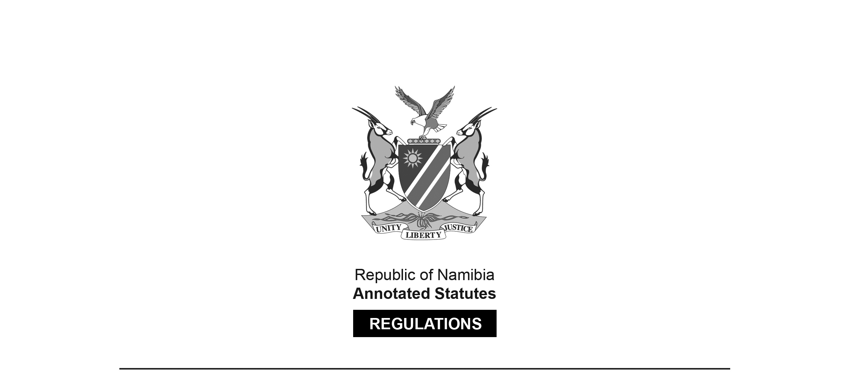

REGULATIONS MADE IN TERMS OF

Microlending Act 7 of 2018

section 36(1)(e)

Regulations relating to Maximum Penalty Interest Chargeable by Microlenders in Event of Default by Borrowers

Government Notice 263 of 2018

(GG 6736)

came into force on date of publication: 15 October 2018

ARRANGEMENT OF REGULATIONS

1. Definitions

2. Maximum penalty interest chargeable by microlenders in event of default by borrowers

**Definitions**

**1.** In these regulations a word or an expression to which a meaning has been assigned in the Microlending Act, 2018 (Act No. 7 of 2018) bears that meaning.

**Maximum penalty interest chargeable by microlenders in event of default by borrowers**

**2.** (1) A microlender may not, in connection with any microlending transaction, stipulate for, demand or receive a penalty interest in excess of five percent per month on the arrear instalment in the event of a default by a borrower.

(2) Despite subregulation (1), a microlender may not, in connection with a microlending transaction, charge the penalty interest referred to in that subregulation for a period of more than three months.