

REGULATIONS MADE IN TERMS OF

Medicines and Related Substances Control   
Act 13 of 2003

section 44

Regulations relating to Medicines and Related Substances

Government Notice 178 of 2008

([GG 4088](http://www.lac.org.na/laws/2008/4088.pdf))

came into force on date of publication: 25 July 2008

The Government Notice which publishes these regulations notes that they were made   
after consultation with the Namibia Medicines Regulatory Council.

as amended by

Government Notice 28 of 2015 **(**[GG 5681](http://www.lac.org.na/laws/2015/5681.pdf)**)**

came into force on date of publication: 27 February 2015

The Government Notice which publishes these amendments notes that they were made   
after consultation with the Namibia Medicines Regulatory Council.

Government Notice 316 of 2015 **(**[GG 5915](http://www.lac.org.na/laws/2015/5915.pdf)**)**

fees effective from 1 April 2016

The Government Notice which publishes these amendments notes that they were made   
after consultation with the Namibia Medicines Regulatory Council   
and in consultation with the minister responsible for finance.

Government Notice 66 of 2019 **(**[GG 6868](http://www.lac.org.na/laws/2019/6868.pdf)**)**

came into force on date of publication: 1 April 2019

The Government Notice which publishes these amendments notes that they were made   
after consultation with the Namibia Medicines Regulatory Council.

Government Notice 202 of 2019 **(**[GG 6958](http://www.lac.org.na/laws/2019/6958.pdf)**)**

came into force on date of publication: 22 July 2019

The Government Notice which publishes these amendments notes that they were made   
after consultation with the Namibia Medicines Regulatory Council.

Government Notice 219 of 2020 **(**[GG 7321](http://www.lac.org.na/laws/2020/7321.pdf)**)**

came into force on date of publication: 1 September 2020

The Government Notice which publishes these amendments notes that they were made   
after consultation with the Namibia Medicines Regulatory Council.

Government Notice 178 of 2021 **(**[GG 7608](http://www.lac.org.na/laws/2021/7608.pdf)**)**

came into force on date of publication: 24 August 2021

The Government Notice which publishes these amendments notes that they were made   
after consultation with the Namibia Medicines Regulatory Council and in consultation with the Minister responsible for Finance.

Government Notice 57 of 2023 **(**[GG 8057](http://www.lac.org.na/laws/2023/8057.pdf)**)**

came into force on date of publication: 31 March 2023

The Government Notice which publishes these amendments notes that they were made   
on the recommendation of the Namibia Medicines Regulatory Council.

These regulations were initially ruled invalid in *Medical Association of Namibia Ltd & Another v Minister of Health and Social Services & Others*, 2010 (2) NR 660 (HC). However, this holding was overruled by *Minister of Health and Social Services & Others v Medical Association of Namibia Ltd & Another* 2012 (2) NR 566 (SC), which found the regulations to be generally valid, with the exception of regulation 34(3)(a), (c), (d) and (e), which were declared invalid as being   
*ultra vires* the powers of the Minister under the Act.

ARRANGEMENT OF REGULATIONS

1. Definitions

2. Division of medicines into categories for purpose of registration

3. Persons who may apply for registration of a medicine

4. Application for registration of a medicine

5. Samples, labels and other things to accompany application for registration of medicines

6. Reference numbers of applications

7. Information to appear in appropriate medicines register

8. Application for amendment of medicines register

9. Certificate of registration

10. Application for transfer of certificate of registration

11. Labelling of medicine intended for administration to humans

12. Package inserts of medicines for human use

13. Patient information leaflet

14 Labelling of veterinary medicines

15. Package inserts for veterinary medicines

16. Advertising of medicines

17. Informing Council of adverse reactions which occur during the use of a medicine and of substandard medicines

18. Notice of particulars of applications received for registration of medicines

19. Compounding of medicines by pharmacist for sale in the retail trade

20. Method of taking samples by inspector and form of certificate where inspector has taken samples

21. Seizure and disposal of medicine or scheduled substance

22. Analysis of samples

23. Requirements for prescription for a medicine or a scheduled substance

24. Records of medicines and scheduled substances dispensed on prescription

25. Prescription books or other permanent records in respect of sales of Schedule 1, Schedule 2 and Schedule 3 substances

26. Records in respect of Schedule 4 substances and specified Schedule 3 substances for use by manufacturer, wholesaler, importer or exporter

27. Registers and prescription books or other permanent records in respect of Schedule 4 substances

28. Import permits for Schedule 4 substances or specified Schedule 3 substances

29. Export permits for Schedule 4 substances or specified Schedule 3 substances

30. Manufacturing permits for Schedule 4 substances or specified Schedule 3 substances

31. Permits for cultivation or collection of plants from which Schedule 4 substances or specified Schedule 3 substances can be extracted, derived, produced or manufactured

32. Returns to be submitted in respect of Schedule 4 substances and specified Schedule 3 substances

33. Destruction and disposal of medicines and scheduled substances

34. Licenses and permits

35. Application for registration of premises used for manufacturing of medicines and renewal of licence

36. Obtaining of pethidine or preparations or mixtures thereof and other scheduled substances by a registered nurse or a registered midwife

37. Import and export of medicines or scheduled substances

38. Possession of certain scheduled substances by persons entering or departing from Namibia

39. Transmission of Schedule 4 substances and specified Schedule 3 substances by post

40. Transmission of scheduled substances through Namibia

41. Control of medicines and scheduled substances in hospitals

42. Re-packing of medicines into patient ready packs

43. Minimum standards for good manufacturing practices to be followed in the manufacture of medicines

44. Purchase, acquisition, keeping, or use of scheduled substances by master of a vessel or officer in charge of an aircraft

45. Expedited registration process for medicines for human use

45A. Registration process for locally manufactured medicines for human use

[regulation 45A inserted by GN 219/2020]

46. Application for sale of an unregistered medicine in terms of section 27 of the Act

47. Fees

48. Penalties

49. Procedures at meetings of Council

50. Procedures at meetings of executive committee

51. Procedures at meetings of veterinary medicines committee

52. Procedures at meetings of other committees

53. Appeal against decision of Council

54. Repeal of regulations

Annexure I Pharmacological classification of categorised medicines

Annexure II

[Annexure II deleted by GN 28/2015]

Annexure III Medicines register for medicines which are not veterinary medicines or complementary medicines

Annexure IV Veterinary medicines register

Annexure V Complementary medicines register

Annexure VI Application for amendment of entry in register

Annexure VII Certificate of registration

Annexure VIII Application for approval of transfer of certificate of registration

Annexure IX Report of adverse drug reaction

Annexure X Certificate by inspector

Annexure XI Certificate by analyst

Annexure XII Schedule 4 substances register and prescription book

Annexure XIII Application for permit to import a Schedule 4 substance or a specified Schedule 3 substance

Annexure XIV Import/Export* permit for a Schedule 4 substance or a specified Schedule 3 substance

Annexure XV Application for permit to export a Schedule 4 substance or a specified Schedule 3 substance

Annexure XVI Application for permit to manufacture a Schedule 4 substance or a specified Schedule 3 substance

Annexure XVII Permit to manufacture a Schedule 4 substance or a specified Schedule 3 substance

Annexure XVIII Application for permit to cultivate or collect plants or a portion of a plant from which a Schedule 4 substance or a specified Schedule 3 substance can be extracted, derived, produced, or manufactured

Annexure XIX Permit to cultivate or collect plants or a portion of a plant from which a Schedule 4 substance or a specified Schedule 3 substance can be extracted, derived, produced, or manufactured

Annexure XX Certificate of destruction and disposal of scheduled substances and medicines

Annexure XXI Application for licence in terms of section 31(1), (2) or (3)

Annexure XXII Licence issued in terms of section 31(1) of the Act

Annexure XXIII Licence issued in terms of section 31(2) of the Act

Annexure XXIV Licence issued in terms of section 31(3) of the Act

Annexure XXV Application for permit in terms of section 31(4)

Annexure XXVI Permit issued in terms of section 31(4)

Annexure XXVII Application for licence in terms of section 31(5)

Annexure XXVIII Licence issued in terms of section 31(5)

Annexure XXIX Application for registration of premises used for manufacturing of medicines

Annexure XXX Licence in respect of registration of premises used for manufacturing of medicines

Annexure XXXI Application for renewal of licence in respect of registration of premises used for manufacturing of medicines

Annexure XXXII Scheduled substances for use by registered nurse or midwife

Annexure XXXIII Application by registered nurse or midwife to purchase, acquire or keep for administration in a midwifery case the scheduled substances set out in Annexure XXIX.

Annexure XXXIV Permit for scheduled substances for use by registered nurse or midwife

Annexure XXXV Register of Scheduled substances to be kept by registered nurse or midwife

Annexure XXXVI Application for sale of unregistered medicine

[Annexure XXXVI substituted by GN 202/2019]

Annexure XXXVI(A) Application for sale of unregistered medicine: Veterinary medicine

[Annexure XXXVI(A) inserted by GN 202/2019]

Annexure XXXVII Authorisation for the sale of unregistered medicines in terms of section 27 of the Act

[Annexure XXXVII substituted by GN 202/2019]

Annexure XXXVII(A) Authorisation for the sale of an unregistered medicine in terms of section 27 of the Act: Veterinary medicine

[Annexure XXXVII(A) inserted by GN 202/2019]

Annexure XXXVIII Fees

[Annexure XXXVIII substituted by GN 316/2015 and by GN 178/2021]

**Definitions**

**1.** In these regulations, unless the context otherwise indicates, any word or expression to which a meaning is assigned in the Act bears that meaning, and -

“appropriate medicines register” means -

(a) a medicines register referred to in section 17(1)(a) of the Act;

(b) a veterinary medicines register referred to in section 17(1)(b) of the Act;

(c) a complementary medicines register referred to in section 17(1)(c) of the Act; or

(d) any other register referred to in section 17(1)(d) of the Act,

as the case may be;

“approved name”, in relation to an active ingredient of a medicine, means the internationally recognised non-proprietary name of such ingredient or such other name as the Council may determine;

“approved package insert,” means a package insert approved by the Council upon application made under regulation 4;

“batch”, in relation to any medicine, means a defined quantity of a medicine manufactured in a single manufacturing cycle and which has homogenous properties;

“batch number”, means the number or other cypher allocated to a batch of a medicine by the manufacturer;

“business address”, in relation to a business carried on in Namibia, means the full physical address of the premises where that business is carried on;

“clinical trial”, means any investigation in human subjects intended to discover or verify the clinical, pharmacological or other pharmacodynamic effects of a medicine or to study the absorption, distribution, metabolism and excretion of a medicine with the object of ascertaining its safety and efficacy in respect of humans;

“expiry date”, in relation to any batch of a medicine, means the date beyond which a manufacturer of that medicine does not guarantee that such medicine will retain its potency, purity, bioavailability and other properties;

“legibility of at least N.6”, means the legibility of printing in 6 pt. type size, using ‘Times Roman’ or ‘Helvetica’ typeface in black ink on white paper or the equivalent thereof;

“legibility of at least N.12”, means the legibility of printing in 12 pt. type size, using ‘Times Roman’ or ‘Helvetica’ typeface in black ink on white paper or the equivalent thereof;

“medicines regulatory authority”, means the authority in a country responsible for enforcement of the laws relating to the registration and the control of medicines;

“package insert”, means the document containing information regarding a medicine referred to in regulation 12 or 15, as the case may be;

“proprietary name”, in relation to a medicine, means the name which is unique to a particular medicine and by which it is generally identified and which, in the case of a registered medicine, is the name approved by the Council in respect of that specific medicine in terms of section 19(8) of the Act;

“registered midwife”, means a registered midwife as defined in section 1 of the Nursing Act, 2004 (Act No. 8 of 2004);

“scheduling status”, in relation to a medicine, means the status of the medicine concerned according to the Schedule that it is classified as, as contemplated in section 29(1) of the Act; and

“the Act”, means the Medicines and Related Substances Control Act, 2003 (Act No. 13 of 2003).

**Division of medicines into categories for purpose of registration**

**2.** (1) For the purpose of registration of medicines as contemplated in section 19 of the Act, all medicines are divided into three basic categories, namely -

(a) Category A, in respect of medicines which are intended for use in humans and which are, without further manipulation, ready for administration, including packaged preparations where only a vehicle is added to the effective medicine;

(b) Category B, in respect of medicines which cannot normally be administered without further manipulation; and

(c) Category C, in respect of medicines intended for veterinary use and which are, without further manipulation, ready for administration, including packaged preparations where only a vehicle is added to the effective medicine.

(2) Medicines falling under the categories referred to in subregulation (1) are further subdivided into the pharmacological classes and into the medicine’s principal pharmacological purpose or therapeutic effect, as set out in Annexure I to these regulations.

(3) For the purposes of subregulation (1)(a) and (c) “vehicle” means an inert substance with which a medicine is mixed to facilitate the measurement and administration or application of that medicine.

**Persons who may apply for registration of a medicine**

**3.** (1) Only -

(a) a person residing and doing business in Namibia;

(b) the manufacturer of a medicine manufactured in a country outside Namibia by virtue of a registration with the medicines regulatory authority of that country;

(c) a nominee residing in Namibia of a manufacturer referred to in paragraph (b) and authorised by the manufacturer;

(d) a subsidiary of a manufacturer referred to in paragraph (b) doing business in a country outside Namibia, provided the subsidiary -

(i) applies for the registration of medicines owned by the manufacturer; and

(ii) submits proof that the manufacturer partly or wholly owns the subsidiary; or

(e) the holder of a permit issued under section 31(4) of the Act to manufacture and sell a medicine or a scheduled substance,

may apply for the registration of a medicine as contemplated in section 19 of the Act.

(2) An applicant referred to in subregulation (1)(d) must produce satisfactory proof to the Council -

(a) of his or her or its registration as a pharmaceutical manufacturer by the medicines regulatory authority of the country where the medicine is manufactured; and

(b) that he or she or it holds a current certificate of good manufacturing practice issued by that medicines regulatory authority.

(3) With reference to an applicant referred to in subregulation (1)(b) and (d), the Council may make such investigations or cause such investigations to be made, as it considers necessary to establish any fact contemplated in subregulation (2).

(4) An applicant referred to in subregulation (1) must in such application provide the name, business address and telephone number of a pharmacist or other technical representative, with appropriate knowledge of all aspects of the medicine in respect of which registration is applied for, who is responsible for liaising with the Council.

(5) An applicant referred to in subregulation (1) who is not resident in Namibia must appoint a local representative, which may be the nominee contemplated in subregulation (1)(c), who may act in respect of medicines and scheduled substances as contemplated in the Act.

(6) A local representative referred to in subregulation (5) must have legal authorization from the applicant concerned to take responsibility for the medicine in respect of which registration is applied for on behalf of the applicant concerned and will be answerable to the Council in respect of the quality, safety and efficacy of the medicine concerned.

**Application for registration of a medicine**

**4.** Subject to regulation 5, an application for the registration of a medicine must be submitted to the Registrar in the form known as Namibia Common Technical Document, available at the office of the Council, together with as many copies thereof as the Council may from time to time determine.

[regulation 4 substituted by GN 28/2015]

**Samples, labels and other things to accompany application for registration of medicines**

**5.** An application for the registration of a medicine must further be accompanied by -

(a) one sample of the medicine in the smallest of each of the package forms available for sale to the public or if such product is not yet so available, one sample in a container in which the applicant intends to make it available for sale to the public;

[paragraph (a) substituted by GN 57/2023]

(b) samples of all advertising material, package inserts and patient information leaflets which may be in draft form indicating the information which the applicant intends to use;

(c) if so requested by the Council or the Registrar, additional samples to the sample referred to in paragraph (a) of the raw materials used in the manufacturing of the medicine and reference standards used in the testing of the final product;

[paragraph (c) substituted by GN 57/2023]

(d) a proposed label for use on the medicines;

(e) a certified copy of the manufacturing licence from the medicines regulatory authority of the country of origin of the medicine concerned together with proof of current good manufacturing practices certification from the country of origin and by a medicines regulatory authority recognised by the Council;

[paragraph (e) substituted by GN 57/2023]

(f) proof of existence of a manufacturing site, in the form of a site master file; and

(g) in the case of a Schedule 3 or a Schedule 4 substance, a certified copy of a permit to manufacture such substances.

**Reference numbers of applications**

**6.** The Registrar -

(a) must allocate a reference number to each application for the registration of a medicine, and

(b) must record all reference numbers referred to in paragraph (a) in a register to be kept by him or her for that purpose.

**Information to appear in appropriate medicines register**

**7.** A -

(a) medicines register relating to medicines which are not veterinary medicines or complementary medicines must be kept in the form as set out in Annexure III to these regulations;

(b) veterinary medicines register relating to veterinary medicines must be kept in the form as set out in Annexure IV to these regulations;

(c) complementary medicines register relating to complementary medicines must be kept in the form as set out in Annexure V to these regulations,

and must contain the particulars required in the Annexure concerned.

**Application for amendment of medicines register**

**8.** (1) An application in terms of section 20 of the Act to have an entry in the medicines register amended must be in the form set out in Annexure VI to these regulations and must contain -

(a) the name of the medicine approved by the Council under section 19(8) of the Act;

(b) the registration number allocated to the medicine under section 19(9) of the Act;

(c) the name of the applicant or holder of the certificate of registration;

(d) the date of registration of the medicine;

(e) the entry in the appropriate medicines register for which amendment is being applied for; and

(f) the reasons for the amendment concerned.

(2) The Registrar may make such investigations, or cause such investigations to be made or call for such additional information, as he or she considers necessary to establish whether or not the amendment concerned should be approved.

(3) An amendment contemplated in this regulation may not be introduced to the medicine concerned before -

(a) such amendment has been approved by the Council; and

(b) the appropriate medicines register has been amended accordingly.

**Certificate of registration**

**9.** A certificate of registration contemplated in section 19(7)(b) of the Act must be in the form as set out in Annexure VII to these regulations.

**Application for transfer of certificate of registration**

**10.** An application contemplated in section 21(1) of the Act for approval to transfer a certificate of registration to a person qualified in terms of that subsection must be in the form as set out in Annexure VIII to these regulations and must contain -

(a) in respect of the holder of the certificate concerned -

(i) the name of the medicine approved by the Council under section 19(8) of the Act;

(ii) the registration number allocated to the medicine under section 19(9) of the Act;

(iii) the name of the holder of the certificate of registration concerned; and

(iv) the date of registration of the medicine concerned in terms of section 19 of the Act; and

(b) in respect of the person to whom the certificate concerned has to be transferred -

(i) the name and business address of the person to whom the certificate is to be transferred;

(ii) if application is made on behalf of a body corporate, the name and business address of such body corporate and proof of its incorporation or registration, as the case may be; and

(iii) proof that such person qualifies in terms of the Act as a person to whom such certificate may be transferred.

**Labelling of medicines intended for administration to humans**

**11.** (1) Subject to subregulations (2), (3) and (4), the immediate container of every medicine in which medicine intended for administration to humans is sold must have a label attached thereto, upon which the following particulars pertaining to the contents of such package must appear in clearly legible indelible letters in the official language:

(a) the proprietary name of the medicine, if any;

(b) the registration number of the medicine allocated in terms of section 19(9) of the Act or, in the case of a medicine in respect of which an application for registration has been submitted in accordance with section 19 of the Act, the reference number allocated to such application by the Registrar as contemplated in regulation 6, followed by the expression “(Act No. 13 of 2003)”;

(c) the dosage form of the medicine;

(d) the international non-proprietary or approved name of each active ingredient of the medicine and the quantity thereof contained in a dosage unit or per suitable mass or volume unit in lettering which may not be less than -

(i) in the case of a medicine containing only one active ingredient, the size of the largest lettering used for the said proprietary name, and be displayed adjacent to such name; or

(ii) in the case of a medicine which contains more than one active ingredient, one half the size of the largest lettering which is used for the said proprietary name,

but the lettering must have a legibility of at least N.6;

(e) the approved name and percentage of any bacteriostatic or bactericidal agent which has been added to the medicine as a preservative;

(f) in the case of a medicine for oral or parenteral administration, the quantity of ethyl alcohol, if any, contained in the medicine, expressed as a percentage of the total volume of the medicine;

(g) the content of the medicine package expressed in the appropriate unit or volume of the medicine;

(h) if practicable, the indications for use of the medicine;

(i) if practicable, the recommended dosage of the medicine;

(j) if applicable, the instruction “Shake the bottle before use”;

(k) in the case of a medicine intended for injection by a particular route of administration only, that route of administration by means of suitable words or abbreviations;

(l) in the case of a medicine classified as a scheduled substance as contemplated in section 29(1) of the Act, the letter “NS” followed by the number of the relevant Schedule, in a legibility of at least N.6, and surrounded by a square border;

[paragraph (l) substituted by GN 66/2019]

(m) the batch number of the medicine;

(n)

[paragraph (n) deleted by GN 66/2019]

(o) the expiry date of the medicine;

(p)

[paragraph (p) deleted by GN 66/2019]

(q) the requirements regarding the manner in which the medicine must be stored, with specific reference to the applicable storage temperature and other precautions required for the preservation of the medicine;

(r) if applicable, the statement “For external use only”;

(s) the warning “Keep out of the reach of children”;

(t) in the case of eye drops or artificial tear solutions in respect of which evidence concerning the self-sterilising ability of the medicine has not been approved by the Council, the warning “Do not use more than 30 days after opening”;

(u) any specified warning which, in terms of section 19(11) of the Act, has to be given on the label of a particular medicine as a condition of registration of that medicine;

(v) in the case of a medicine which contains tartrazine, the warning “Contains TARTRAZINE”;

(w) in the case of a medicine which contains paracetamol, the warning “Contains PARACETAMOL”; and

(x) in the case of a medicine which contains aspirin, the warning “ASPIRIN should not be administered to children below the age of 16 years.”.

(2) If the medicine package bears both an immediate container label and an outer label, subregulation (1) applies to the outer label as well, but it is then sufficient to state on the immediate container label -

(a) in the case of medicines intended for administration by injection and having a total volume not exceeding 5 ml, the details prescribed in paragraphs (a), (c), (d), (k), (m), (n) and (o) of subregulation (1);

(b) in the case of an ointment, cream, gel or powder having a net mass not exceeding 10 grams, the details prescribed in paragraphs (b), (d), (e), (m), (n), and (o) of subregulation (1);

(c) in the case of a liquid, solution or suspension having a total volume more than 1 ml, but not exceeding 15 ml, the details prescribed in paragraphs (a), (b), (c), (d), (l), (m), (n), (o) and (s) of subregulation (1);

(d) in the case of a liquid, solution or suspension having a total volume not exceeding 1 ml, the details prescribed in paragraphs (a) and (o) of subregulation (1); and

(e) in the case of a medicine packed in blister or similar packaging, the details prescribed in paragraphs (a), (d), (m), (n) and (o) of subregulation (1), repeated as frequently as is practicable.

(3) The Council may, on application to it by an applicant, authorize -

(a) the inclusion, on the label of a medicine, of any specified information which is not required by this regulation to be so included; or

(b) the deviation, on the label of a medicine, of any specified information which is required by this regulation, or prescribed as a condition of registration, to be so included.

(4) Subregulation (1) does not apply to -

(a) any medicine sold in accordance with section 18(5) of the Act;

(b) any medicine sold by -

(i) a person licenced under section 31(1) of the Act to prescribe and sell a medicine referred to in that section to his or her own patients;

(ii) a pharmacist licenced under section 31(2) of the Act to prescribe and sell a medicine referred to in that section to his or her own patients; or

(iii) a medical practitioner, dentist or veterinarian licenced under section 31(3) of the Act to prescribe and sell a medicine referred to in that section to his or her own patients,

if such medicine is labelled according to regulation 34(4)(e); or

(c) any medicine sold in accordance with a prescription issued by a medical practitioner, dentist or veterinarian for the treatment of a particular patient, if such medicine is sold in a package to which is attached a label containing -

(i) the name and strength of the medicine or the name and strength of each active ingredient or constituent medicine;

(ii) the quantity of the medicine sold;

(iii) the name of the patient;

(iv) the directions with regard to the manner in which such medicine should be used;

(v) the name and business address of the medical practitioner, dentist, veterinarian, pharmacist, pharmacy or hospital or any health facility selling such medicine;

(vi) the dispensing date; and

(vii) a reference number linking the medicine to a patient record.

**Package inserts of medicines for human use**

**12.** (1) Subject to such exclusions made by the Minister as contemplated in section 45 of the Act in respect of the medicine concerned and to subregulation (2), each package of a medicine for human use must be accompanied by a package insert approved by the Council, on application made in terms of regulation 4, either as a separate entity or as an integral part of the package and on which is printed in the official language and in type having a legibility of at least N.6, under the headings and in the format specified in this regulation, only the following particulars relating to such medicine -

(a) the scheduling status;

(b) the proprietary name, if any;

(c) the dosage form;

(d) the approved name of each active ingredient and the quantity thereof contained in a dosage unit or per suitable mass or volume unit of the medicine;

(e) the approved name and quantity of any bacteriostatic or bactericidal agent which has been added to the medicine as a preservative;

(f) in the case of a medicine for oral or parental administration, the quantity of ethyl alcohol, if any, included in the medicine, expressed as a percentage of the total volume of the medicine;

(g) in the case of a medicine which contains TARTRAZINE, the warning “Contains TARTRAZINE”;

(h) the category and pharmacological classification as contemplated in regulation 2 and Annexure I to these regulations, respectively;

(i) the pharmacological action;

(j) the pharmacokinetic and pharmacodynamic properties;

(k) the indications as approved by the Council in terms of section 19(4) of the Act;

(l) the contra-indications;

(m) the interaction with other drugs;

(n) use during pregnancy and lactation;

(o) the dosage and directions for use;

(p) the side-effects of, and special precautions;

(q) the known symptoms of over dosage and particulars of its treatment;

(r) the conditions of registration;

(s) the identification;

(t) the presentation;

(u) the storage directions, which must be practically formulated and quote storage temperatures as well as indicating the stability of the medicine after opening of the original package;

(v) (i) the specification of the diluent of oral or injectable powder in a bottle ampoule or vial;

[There should be a comma between the words “bottle” and “ampoule”.]

(ii) the specific volume of the diluent to be added;

(iii) the resultant volume of the reconstituted oral solution or injection;

(iv) the period and the temperature at which the reconstituted oral solution or injection should be kept;

(v) the shelf life; and

(vi) the date of reconstitution;

(w) the registration number -

(i) allocated to that medicine in terms of section 19(9) of the Act; or

(ii) in the case of a medicine in respect of which an application for registration has been submitted in accordance with section 19(1) of the Act, the reference number allocated to such application by the Registrar under regulation 6,

followed by the expression “(Act No. 13 of 2003)”;

(x) the name and business address of the manufacturer, and if a certificate of registration has been issued in respect of such medicine, the name of the holder of such certificate; and

(y) the date of publication of the package insert.

(2) The Council may authorise, on application to it by an applicant, -

(a) the deviation from the format of a package insert prescribed by this regulation as a condition of registration of a medicine;

(b) the inclusion on a package insert of any specified information which is not required by this regulation to be so included; and

(c) that a heading referred to in subregulation (1) may be omitted from the package insert, if the Council determines that there is no applicable information to be submitted under a particular heading.

(3) Subject to subregulation (4), subregulation (1) does not apply to -

(a) any medicine sold in accordance with section 18(5) of the Act;

(b) any medicine sold by -

(i) a person licenced under section 31(1) to prescribe and sell a medicine referred to in that section to his or her own patients;

(ii) a pharmacist licenced under section 31(2) to prescribe and sell a medicine referred to in that section to his or her own patients; or

(iii) a medical practitioner, dentist or veterinarian licenced under section 31(3) to prescribe and sell a medicine referred to in that section to his or her own patients; or

(c) any medicine sold in accordance with a prescription issued by a medical practitioner or dentist or veterinarian for the treatment of a particular patient.

(4) Nothing contained in subregulation (3) is construed as prohibiting the inclusion of a package insert in a package of medicine contemplated in that regulation.

**Patient information leaflet**

**13.** (1) Subject to subregulation (2), each package of a medicine must have a patient information leaflet that must contain, in the official language, the following information with regard to the medicine -

(a) the scheduling status;

(b) the proprietary name and dosage form;

(c) the international non-proprietary or approved name of each individual active ingredient;

(d) the approved indications and use;

(e) instructions before taking the medicine which include -

(i) contra-indications;

(ii) precautions to be taken;

(iii) warnings about undesirable effects of the medicine and risks involved with sudden withdrawal of the medicine;

(iv) interactions;

(v) the following general statements:

“If you are taking medicines on a regular basis, using this medicine at the same time with another medicine may cause undesirable interactions. Consult your doctor or pharmacist or other health care professional for advice.”; and

“If you are pregnant or breast feeding your baby while taking this medication, please consult your doctor or pharmacist or other health care professional for advice.”;

(f) (i) instructions on how to take the medicine, including the following statements:

“Do not share medicines prescribed for you with any other person.”; and

“In the event of over dosage consult your doctor or pharmacist. If neither is available, contact the nearest hospital.”;

(ii) advice to the patient in case of a missed dose;

(g) the side effects, including the following general statement:

“Not all side effects reported for this medicine are included in the leaflet. Should your general health worsen while taking this medicine please consult your doctor, pharmacist or other health care professional for advice.”;

(h) storage and disposal information, including the following general statement:

“Store all medicines out of the reach of children.”;

(i) the presentation, which includes the number, volume or mass per package unit and a description of the packaging material, such as bottle, blister pack and so forth;

(j) the registration number of the medicine;

(k) the name, business address and telephone number of the holder of the certificate of registration; and

(l) the date of publication of the patient leaflet.

(2) The Council may authorize a deviation from subregulation (1) if it considers it necessary.

(3) A person dispensing or administering a medicine must ensure that a patient information leaflet is made available at the point of such dispensing.

(4) A person who sells a medicine in a package containing more than a quantity needed for the treatment of one patient must supply patient information leaflets equal to the number of patients who can be treated using the quantity of medicine in that package.

(5) The Council may on application in respect of an interchangeable multi-source medicine determine the information to be submitted under a particular heading.

**Labelling of veterinary medicines**

**14.** (1) Subject to subregulation (2), (3) and (4), the immediate container of every package in which a veterinary medicine is sold must have a label attached on which the following particulars pertaining to the contents of such package must appear in clearly legible indelible lettering in the official language:

(a) the words “veterinary medicine”, “for animal use only”, or “for veterinary use only;

[paragraph (a) substituted by GN 66/2019]

(b) the proprietary name of the medicine;

(c) the registration number of the medicine allocated in terms of section 19(9) of the Act or, in the case of a medicine in respect of which an application for registration has been submitted in accordance with regulation 6, the reference number allocated to such application by the Registrar followed by the expression “(Act No. 13 of 2003)”;

(d) the dosage form of the medicine;

(e) the approved name of each active ingredient of the medicine and the quantity thereof contained in a dosage unit or per suitable mass or volume or unit in lettering which may not be less than -

(i) in the case of a medicine containing only one active ingredient, one half the size of the largest lettering which is used for the said proprietary name;

(ii) in the case of a medicine which contains more than one but less than six active ingredients, one-quarter the size of the largest lettering which is used for the said proprietary name;

(iii) in the case of a medicine containing six or more active ingredients, the minimum type size permitted by this regulation,

but the lettering must in any case not be smaller than the legibility of at least N.6;

(f)

[paragraph (f) deleted by GN 66/2019]

(g) the content of the medicine package expressed in the appropriate unit or volume of the medicine;

(h) if practicable, the indications for use of the medicine;

(i) if practicable, the recommended dosage of the medicine;

(j) if applicable, the instruction “shake the bottle before use”;

(k) in the case of a medicine intended for injection by a particular route of administration, only that route of administration by means of suitable words or abbreviation;

(l) in the case of a medicine classified as a scheduled substance as contemplated in section 29(1) of the Act, the letter “NS” followed by the number of the relevant Schedule, in a legibility of at least N.12, and surrounded by a square border immediately preceding the proprietary name of such medicine;

(m) the batch number of the medicine;

(n) the expiry date of the medicine;

(o) the name of the holder of certificate of registration of the said medicine;

(p) the requirement regarding the manner in which the medicine must be stored, with specific reference to the applicable storage temperature and other precautions required for the preservation of the medicine;

(q) if applicable the statement “For external use only.”;

(r) the warning “Keep out of the reach of children.”;

(s) in the case of any medicine intended to be used in food producing animals and involving the possibility of the ingredients of such medicine or metabolites thereof being present in the eggs, milk or tissue of such animals, a warning regarding the withdrawal period of such medicine; and

(t) any specified warning which has to be given, in terms of section 19(11) of the Act, on the label of a particular medicine as a condition of registration of that medicine.

(2) If the medicine package bears both an immediate container label and an outer label, subregulation (1) applies to the outer label as well, but it is then sufficient to state on the immediate container label -

(a) in the case of a medicine intended for administration by injection and having a total volume not exceeding 5 ml, the details prescribed in paragraphs (a), (b), (e), (k), (l), (m), and (n) of subregulation (1);

(b) in the case of an ointment, cream, gel or powder having a net mass not exceeding 10 grams, the details prescribed in paragraphs (a), (b), (c), (e), (m), (n), and (o) of subregulation (1)

(c) in the case of a liquid, solution or suspension having a total volume of more than 1 ml, but not exceeding 15 ml, the details prescribed in paragraphs (a), (b), (c), (d), (e), (l), (m), (n), and (o) of subregulation (1);

(d) in the case of a liquid, solution or suspension having a total volume not exceeding 1 ml, the details prescribed in paragraphs (a), (e), and (o) of subregulation (1);

(e) in the case of a medicine packed in blister or similar packaging, the details prescribed in paragraphs (a), (b), (e), (m), (n) and (o) of subregulation (1), repeated as frequently as is practicable.

(3) The Council may, on application to it by an applicant, authorize the inclusion on the label of a medicine of any specified information, which is not required by this regulation to be so included.

(4) Subregulation (1) does not apply to -

(a) any medicine sold in accordance with section 31(3) of the Act for the treatment of a specific animal;

(b) any medicine sold by a veterinarian or pharmacist in the course of his or her professional activities for the treatment of a particular animal; or

(c) any medicine sold by a pharmacist in accordance with a prescription issued by a veterinarian for treatment of a particular animal,

if such medicine is sold in a package to which is attached a label containing the following information:

(i) the name of the medicine or the name of each active ingredient or constituent medicine;

(ii) the name of the person to whom such medicine has been sold and a description as accurate as possible, of the animals for which the treatment is intended;

(iii) the directions for the use of medicine;

(iv) the name and address of the veterinarian or pharmacist who has sold such medicine;

(v) the reference number allocated to the sale of the medicine as referred to in regulation 24(1)(g), and where applicable the warning, referred to in paragraph (s) of subregulation (1), regarding the withdrawal period of such medicine;

(vi) the date of dispensing;

(vii) the batch number; and

(viii) the expiry date.

**Package inserts for veterinary medicines**

**15.** (1) Subject to such exclusions made by the Minister as contemplated in section 45 of the Act in respect of the medicine concerned and subject to subregulation (2), the immediate container of a veterinary medicine that is sold, must be accompanied by a package insert in the official language with the following information with regard to the medicine in legibility of at least N.6 -

(a) the scheduling status;

(b) the proprietary name, if any;

(c) the dosage form;

(d) the approved name of each active ingredient and the quantity thereof contained in a dosage unit or per suitable mass or volume unit of the medicine;

(e) the category and pharmacological classification as contemplated in regulation 2 and Annexure I to these regulations, respectively;

(f) the pharmacological action;

(g) the pharmacokinetic and pharmacodynamic properties;

(h) the contra-indications;

(i) warnings of withdrawal period in the case of food producing animals;

(j) the side-effects of, and special precautions;

(k) the known signs of overdose and particulars of its treatment;

(l) the quantity and strength of active ingredients per dosage unit;

(m) the storage directions, which must be practically formulated and quote storage temperatures as well as indicating the stability of the medicine after opening of the original package;

(n) the registration number -

(i) allocated to that medicine in terms of section 19(9) of the Act; or

(ii) in the case of a medicine in respect of which an application for registration has been submitted in accordance with section 19(1) of the Act, the reference number allocated to such application by the Registrar under regulation 6, followed by the expression “(Act No. 13 of 2003)”;

(o) the name and business address of the manufacturer, and if a certificate of registration has been issued in respect of such medicine, the name of the holder of such certificate; and

(p) any other information as the Council may from time to time determine.

(2) The Council may upon application authorize a deviation from subregulation (1).

**Advertising of medicines**

**16.** (1) Subject to subregulation (7), medicines which -

(a) do not contain a scheduled substance; or

(b) contain a Schedule 0 or a Schedule 1 substance,

may be advertised to the public.

(2) Medicines which contain a Schedule 2, Schedule 3 or Schedule 4 substance may be advertised only -

(a) for the information of medical practitioners, dentists, veterinarians, pharmacists and nurses, or

(b) in a publication which is normally or only made available to members of the professions referred to in paragraph (a),

but this paragraph does not prohibit the announcement to the public of the prices of medicines which contains a substance appearing in the Schedules concerned.

(3) Any advertisement of a medicine that contains a statement which -

(a) deviates from;

(b) is in conflict with; or

(c) goes beyond,

the evidence and particulars submitted in the application for registration of such medicine with regard to the safety of the use of the ingredients in human beings or the efficacy of such ingredients in relation to the purpose for which it is intended that they should be used, constitutes an offence as contemplated in section 38(g) of the Act if such evidence and particulars have been accepted and approved by the Council in terms of section 19(1) of the Act in respect of such medicine and have been incorporated into the package insert of such medicine approved by the Council in terms of that section.

(4) An advertisement of a medicine must contain -

(a) the proprietary name and the name of the manufacturer thereof;

(b) the approved name and quantity of each active ingredient of such medicine in letters the size of which may not be less than -

(i) in the case of a medicine containing only one active ingredient, the same size as the largest lettering which is used for the said proprietary name, and be displayed adjacent to such name; or

(ii) in the case of a medicine which contains more than one active ingredient, one half the size of the largest lettering which is used for the said proprietary name;

(c) in the case of a registered medicine, the registration number allocated to it in terms of section 19(9) of the Act; and

(d) in any case where a name other than the proprietary name is also used, such name in lettering the same size as the largest lettering which is used for the said proprietary name in such advertisement.

(5) In the case of an advertisement of a medicine containing more than one active ingredient, no specific reference must be made to the specific properties of any individual active ingredient, unless a reference thereto has been approved by the Council for inclusion in the package insert of such medicine.

(6) If a medicine is advertised verbally for the first time by or on behalf of an applicant to any member of the medical, dental, veterinary, nursing or pharmaceutical profession, the applicant or person who advertises the medicine must simultaneously give written information, which must include at least the information called for in terms of regulation 12, to the person to whom the verbal advertisement is directed, and if the medicine is advertised verbally on subsequent occasions, the information concerned must be available on request.

(7) An advertisement of a medicine must be approved by the Council before such advertisement is used to advertise medicine to the public.

**Informing Council of adverse reactions which occur during the use of a medicine and of substandard medicines**

**17.** (1) Every applicant or holder of a certificate of registration in respect of a medicine must within a reasonable time inform the Council of any adverse reaction which occurred during the use of, or which was reported to him or her with regard to the use of a medicine for which he or she holds an application for registration or a certificate of registration.

(2) Every applicant or holder of a certificate of registration referred to in subregulation (1) must without delay inform the Council of the steps which he or she intends to take with regard to an adverse reaction concerned.

(3) For the purpose of this subregulation “adverse reaction” means unwanted effects not reflected to that extent in the package insert of such medicine.

(4) Every applicant or holder of a certificate of registration must -

(a) inform the Council immediately of any formulation, labelling or other error which has occurred with regard to a medicine for which he or she holds an application for registration or a certificate of registration, and which has been released for sale by him or her; and

(b) also inform the Council of steps taken by him or her or which he or she intends to take to rectify the error or with regard to the suspension of the sale of such medicine.

(5) Every authorised prescriber must within a reasonable time inform the Council on the form as set out in Annexure IX to these regulations of any adverse reaction which occurred during the use of any medicine.

(6) A person may report to the Council any medicine the quality of which has deteriorated, rendering it unfit for use.

**Notice of particulars of applications received for registration of medicines**

**18.** The Registrar must publish the following particulars in the *Gazette* as contemplated in section 19(12) of the Act -

(a) the proprietary name of the medicine;

(b) the international non-proprietary or approved name and quantity of each active ingredient of the medicine;

(c) the dosage form of the medicine; and

(d) the name of the applicant who lodged the application for registration.

**Compounding of medicines by pharmacist for sale in the retail trade**

**19.** (1) A pharmacist compounding a medicine for sale in the retail trade as contemplated in section 18(5)(b) of the Act may only compound a medicine that is -

(a) related to a treatment regimen of a particular patient; and

(b) sufficient to be used by the patient for not more than 30 consecutive days from the date of dispensing.

(2) Any medicine referred to in subregulation (1) must be compounded extemporaneously.

**Method of taking samples by inspector and form of certificate where inspector has taken samples**

**20.** (1) Any inspector who takes a sample in terms of section 36(1)(d) of the Act -

(a) must take a sample that is representative of the whole medicine or scheduled substance concerned;

(b) must, if taking samples from bulk medicines or large containers of scheduled substances, take care to reduce the risk of contamination by dust or other substances of the sample and the remaining bulk medicine or scheduled substance;

(c) may, if taking samples in the premises of a manufacturer, cause the personnel of the manufacturer to collect the sample under his or her observation if the taking of the samples by him or her may increase the risk of contaminating the remaining medicine or scheduled substance;

(d) must in every case take enough quantities of the sample concerned for -

(i) two runs of the intended analysis;

(ii) two runs of parallel testing; and

(iii) a retention sample that is enough for two runs of the intended analysis,

and if the owner of the sample concerned wants to carry out a parallel analysis the sample must include the extra quantity required therefore;

(e) must take care that the container in which the sample of a bulk medicine or scheduled substance is packed does not interact with the medicine or scheduled substance concerned and may not allow contaminants to affect the medicine or scheduled substance in any way that would have a negative effect on the analytical results;

(f) must after taking a sample, label the container of the sample in order to contain the following information -

(i) the name of the medicine or scheduled substance, if known;

(ii) the batch number, if available;

(iii) the quantities of the sample taken;

(iv) the date on which the sample has been taken;

(v) the storage conditions of the sample;

(vi) the handling precautions of the sample;

(vii) his or her name;

(viii) the name of a witness;

(ix) the name of the place from where the sample was taken.

(2) The Council may require any holder of a certificate of registration to supply the Council with a sample of a particular medicine or scheduled substance in order to test, examine or analyse such sample.

(3) A certificate contemplated in section 36(2)(c) of the Act must be in the form set out in Annexure X to these regulations and must contain -

(a) the date on which and the place and time where and when the sample was taken;

(b) a description of the nature and size of each sample taken;

(c) the personal details of the person in whose presence the sample was taken;

(d) the name of the inspector taking the sample; and

(e) the cost of the sample taken.

(4) An inspector must submit to the Registrar a copy of every certificate referred to in subregulation (3) issued by the inspector.

**Seizure and disposal of medicine or scheduled substance**

**21.** (1) An inspector may seize any medicine or scheduled substance found in possession, or under the control, of a person not entitled under the Act to keep or use it, if -

(a) the medicine or scheduled substance concerned -

(i) consists of an unregistered medicine and is sold in contravention of the Act;

(ii) is suspected to be counterfeit;

(iii) is misbranded;

(iv) has expired;

(v) is suspected to be stolen;

(vi) is possessed by a person who may not possess it or by a person who may possess it, but who possesses it in quantities exceeding the quantity which he or she may possess;

(vii) belongs to the State and is found in possession of a person who may not possess it; or

(viii) is a biological medicine and is not stored at the specified temperature; or

(b) the Council is of the opinion that it is not in the public interest that the medicine or scheduled substance concerned be made available to the public.

(2) An inspector who has seized a medicine or scheduled substance as contemplated in subregulation (1) must as soon as possible and at the scene of seizure make a written inventory of all medicines or scheduled substances seized, and the inventory must include -

(a) the date, place and time of the seizure;

(b) the name and personal details of the person from whom or in whose presence the medicines or scheduled substances concerned were seized;

(c) the name and quantity of every medicine or scheduled substance seized;

(d) the reason for the seizure; and

(e) the name of the inspector conducting the seizure.

(3) An inspector who has seized a medicine or scheduled substance as contemplated in subregulation (1) may dispose thereof as contemplated in regulation 33.

(4) For the purposes of subregulation (1)(a)(ii), “counterfeit” means in relation to a medicine or a scheduled substance, that a false representation has been made with regard to the contents, identity or source thereof by any means, including the labelling and packing thereof.

**Analysis of samples**

**22.** An analyst must -

(a) state in the certificate set out in Annexure XI to these regulations the result of any test, examination or analysis on a sample transmitted to him or her in terms of section 36(2)(c) of the Act; and

(b) submit to the Registrar a copy of every such certificate which has been issued by him or her.

**Requirements for prescription for a medicine or a scheduled substance**

**23.** (1) Every prescription for a medicine or a schedule substance must be in print or written in block letters and signed in person by the authorised prescriber who wrote it, and must state -

[The introductory phrase is substituted by GN 202/2019. The term “schedule substance”   
was probably intended to read “scheduled substance”.]

(a) the date of issue of the prescription;

(b) the name, strength and quantity of the medicine or scheduled substance to be supplied in terms of that prescription, and the quantity to be supplied must be expressed in figures as well as in words, but if the authorised prescriber has failed to express the quantity concerned in figures as well as in words, the pharmacist dispensing the prescription may insert, after obtaining confirmation from the authorised prescriber, the words or figures that have been omitted;

(c) the name and address of the patient or, in the case of a prescription issued by a veterinarian, the name and address of the person to whom the medicine or scheduled substance is to be sold, but if the authorised prescriber who wrote the prescription has omitted to insert thereon the address of the patient or person, the address may be inserted by the person by whom the prescription is dispensed;

(d) the name, qualifications and address of the authorised prescriber who wrote the prescription, which particulars may be printed on the prescription;

(e) in respect of the medicine or scheduled substance, instructions for the administration of the dosage concerned, the frequency of administration and the withdrawal period in the case of veterinary medicines for food producing animals;

(f) the age and gender of the patient and, in the case of a veterinary medicine, the animal species; and

(g) if the prescription may be repeated, the number of times it may be repeated.

(2) A pharmacist dispensing a faxed, e-mailed, telephonic or other electronic transmission of a prescription must -

(a) verify the authenticity of the prescription;

(b) make a permanent copy of the prescription concerned for record purposes; and

(c) obtain the original prescription or order within 7 working days.

(3) An authorised prescriber must keep a record of the diagnosis relevant to a prescription concerned and must indicate the diagnosis on the prescription.

(4) An authorised prescriber may only write an initial prescription after seeing and physically examining the patient in person.

**Records of medicines and scheduled substances dispensed on prescription**

**24.** (1) A prescription book or other permanent record must be kept on every premises where prescriptions for a patient to receive a medicine or a scheduled substance specified in that prescription are dispensed, and must be in a form in which the following information relating to every sale of a medicine or a scheduled substance on prescription must be entered for easy reference, namely -

(a) the name of the medicine or scheduled substance;

(b) the date on which the prescription was dispensed;

(c) the dosage, form, strength and quantity of the medicine or scheduled substance sold;

(d) the name and address of the patient or, in the case of a prescription written by a veterinarian, the name and address of the person to whom the medicine or scheduled substance was sold;

(e) the name of the authorised prescriber who wrote the prescription;

(f) the period of validity of the prescription; and

(g) a prescription reference number linking the patient to a patient record.

(2) The seller of a medicine or scheduled substance must retain -

(a) a prescription concerned for at least three years from the date on which the prescription was dispensed;

(b) a prescription book or other permanent record referred to in subregulation (1) at his or her business address for at least three years from the date of the last entry made therein.

**Prescription books or other permanent records in respect of sales of Schedule 1, Schedule 2 and Schedule 3 Substances**

**25.** (1) A prescription book or other permanent record in respect of Schedule 1, Schedule 2 or Schedule 3 substances must be kept on all premises where such substances are dispensed or sold and must contain -

(a) the date on which the scheduled substance was sold;

(b) the name of the scheduled substance;

(c) the dosage form, strength and quantity of the scheduled substance;

(d) the name and residential or business address of the person to whom the scheduled substance was sold; and

(e) the name of the seller.

(2) A pharmacist, pharmacist intern or pharmacist assistant who sells a Schedule 1 substance without a prescription in terms of section 29 of the Act must record -

(a) the name of the person to whom it was sold;

(b) the name of the scheduled substance and the quantity; and

(c) his or her own name.

(3) The seller of a scheduled substance contemplated in this regulation must retain a prescription book or other permanent record referred to in subregulation (1) at his or her business address for at least three years after the date of the last entry therein.

**Records in respect of Schedule 4 substances and specified Schedule 3 substances for use by manufacturer, wholesaler, importer or exporter**

**26.** (1) Every holder of -

(a) a permit in terms of section 29(15) and (23) of the Act to manufacture, pack and sell, import or export any Schedule 3 or Schedule 4 substance; or

(b) a permit in terms of section 31(4) or a license in terms of section 31(5) of the Act to manufacture, pack and sell, import or export any Schedule 3 or Schedule 4 substance,

must keep a record in respect of each such scheduled substance, in which the following information in respect of every import, export, manufacture, packing and sale, as the case may be, of a Schedule 3 or Schedule 4 substance must be recorded, namely -

(i) in the case of an import or export, the permit or licence number of the relevant import or export permit or licence issued in terms of these regulations in respect of such import or export;

(ii) the name and business address of the person from whom each such scheduled substance has been received or to whom such substance has been sold;

(iii) the date on which such scheduled substance was received, sold, packed, or manufactured; and

(iv) the quantity of such scheduled substance received, sold, packed, or manufactured.

(2) The seller of a scheduled substance contemplated in this regulation must retain a record referred to in subregulation (1) at his or her business address for at least three years after the date of the last entry therein.

**Registers and prescription books or other permanent records in respect of Schedule 4 substances**

**27.** (1) The register of Schedule 4 substances and the prescription book or other permanent record referred to in section 29(20) of the Act must be kept in one record, hereinafter referred to as the “register”, and must substantially be in the form as set out in Annexure XII to these regulations, and must contain the following information in respect of each receipt or sale, as the case may be, of a Schedule 4 substance -

(a) the name and business address of the person from whom each such substance was received;

(b) the date on which such substance was received;

(c) the quantity of such substance received;

(d) the name and address of the person to whom such substance was sold;

(e) the date of the sale concerned;

(f) in the case of a sale of such a substance on prescription, the name and address of the medical practitioner, dentist or veterinarian who wrote the prescription;

(g) the quantity of such substance sold;

(h) the physical quantity of such substance remaining in stock after each sale or receipt; and

(i) the signature of the person making the entry in the register.

(2) A person required to keep a register referred to in subregulation (1) must retain such register at his or her business address for at least three years after the date of the last entry therein, and if such record is kept in electronic form, it must be held in the form of a computer print-out.

(3) A computer print-out referred to in subregulation (2) must be made monthly, and dated, signed and filed.

(4) Records must be stored separately and in an orderly manner so that they can be accessed easily.

(5) The entry of each receipt or sale of a Schedule 4 substance in the register referred to in subregulation (1) must be made on the date and time the transaction is completed.

**Import permits for Schedule 4 substances or specified Schedule 3 substances**

**28.** (1) Any person who intends to apply for a permit referred to in -

(a) section 29(15)(b) of the Act for the importation of a specified Schedule 3 substance; or

(b) section 29(23)(b) of the Act for the importation of a Schedule 4 substance,

must apply therefore to the Permanent Secretary in the form as set out in Annexure XIII to these regulations.

(2) The Permanent Secretary may refuse to issue the permit applied for if, after consultation with the Council, the Permanent Secretary is of the opinion that -

(a) the applicant is not capable of keeping or storing the scheduled substances concerned in a satisfactory manner in order to prevent its loss;

(b) the annual importation quota, if such a quota has been determined by the Council for the scheduled substance concerned, has been exceeded or will be exceeded; or

(c) the scheduled substance concerned, of an acceptable quality, is already available in Namibia.

(3) A permit issued in terms of section 29(15)(b) or (23)(b) of the Act in respect of the importation of a Schedule 3 or Schedule 4 substance -

(a) may only be issued after consultation with the Council; and

(b) must be in the form as set out in Annexure XIV to these regulations.

(4) It must be a condition of every permit referred to in this regulation that there may be no deviation, during the relevant importation of the scheduled substance concerned, from the particulars concerning that importation as set out in the relevant permit.

(5) Notwithstanding any penalty that may be imposed under section 39 of the Act, but subject to subregulation (6), the Permanent Secretary may cancel a permit referred to in subregulation (4), if the Permanent Secretary is of the opinion that subregulation (4) or the conditions contained in the permit concerned have not been complied with.

(6) A permit referred to in subregulation (5) may only be cancelled under section 29(17) or (24) of the Act if the Permanent Secretary has given the person to whom the relevant permit has been issued a prior opportunity to be heard on the matter.

**Export permits for Schedule 4 substances or specified Schedule 3 substances**

**29.** (1) A person who intends to apply for a permit referred to in -

(a) section 29(15)(b) of the Act for the exportation of a specified Schedule 3 substance; or

(b) section 29(23)(b) of the Act for the exportation of a Schedule 4 substance,

must apply therefore to the Permanent Secretary in the form as set out in Annexure XV to these regulations.

(2) A permit issued in terms of section 29(15)(b) or (23)(b) of the Act in respect of the exportation of a Schedule 4 substance or a specified Schedule 3 substance must be in the form as set out in Annexure XIV to these regulations.

(3) It must be a condition of every permit referred to in this regulation that there may be no deviation, during the relevant exportation of the scheduled substance concerned, from the particulars concerning that exportation as set out in the relevant permit.

(4) Notwithstanding any penalty that may be imposed under section 39 of the Act, but subject to subregulation (5), the Permanent Secretary may withdraw a permit referred to in subregulation (3), if the Permanent Secretary is of the opinion that subregulation (3) or the conditions contained in the permit concerned have not been complied with.

(5) A permit referred to in subregulation (4) may only be withdrawn as contemplated therein or be cancelled under sections 29(17) or (24) of the Act if the Permanent Secretary has given the person to whom the relevant permit has been issued, a prior opportunity to be heard on the matter.

**Manufacturing permits for Schedule 4 substances or specified Schedule 3 substances**

**30.** (1) A person who intends to apply for a permit referred to in -

(a) section 29(15)(a) of the Act to manufacture a specified Schedule 3 substance; or

(b) section 29(23)(a) of the Act to manufacture a Schedule 4 substance,

must apply therefore to the Council in the form as set out in Annexure XVI to these regulations.

(2) A permit issued in terms of section 29(15)(a) or (23)(a) of the Act in respect of the manufacturing of a specified Schedule 3 substance or a Schedule 4 substance must be in the form as set out in Annexure XVII to these regulations.

(3) It must be a condition of every permit referred to in this regulation that there may be no deviation, during the relevant manufacturing process of the scheduled substance concerned, from the particulars concerning that process as set out in the relevant permit.

(4) Notwithstanding any penalty that may be imposed under section 39 of the Act, but subject to subregulation (5), the Council may withdraw a permit referred to in subregulation (3), if the Council is of the opinion that subregulation (3) or the conditions contained in the permit concerned have not been complied with.

(5) A permit referred to in subregulation (4) may only be withdrawn as contemplated therein or be cancelled under sections 29(17) or (24) of the Act if the Council has given the person to whom the relevant permit has been issued, a prior opportunity to be heard on the matter.

**Permits for cultivation or collection of plants from which Schedule 4 substances or specified Schedule 3 substances can be extracted, derived, produced or manufactured**

**31.** (1) A person who intends to apply for a permit, referred to in -

(a) section 29(15)(c) of the Act, for the cultivation or collection of plants or portions thereof from which a specified Schedule 3 substance; or

(b) section 29(23)(c) of the Act, for the cultivation or collection of plants or portions thereof from which a Schedule 4 substance,

can be extracted, derived, produced or manufactured must apply therefore to the Council in the form as set out in Annexure XVIII to these regulations.

(2) A permit referred to in sections 29(15)(c) or (23)(c) of the Act must be issued in the form as set out in Annexure XIX to these regulations.

(3) It must be a condition of every permit referred to in this regulation that there may be no deviation, during the relevant cultivation or collection concerned, from the particulars concerning such cultivation or collection as set out in the relevant permit.

(4) Notwithstanding any penalty that may be imposed under section 39 of the Act, but subject to subregulation (5), the Council may withdraw a permit referred to in subregulation (3), if the Council is of the opinion that subregulation (3) or the conditions contained in the permit concerned have not been complied with.

(5) No permit referred to in subregulation (4) may be withdrawn as contemplated therein or be cancelled under sections 29(17) or (24) of the Act, unless the Council has given the person to whom the relevant permit has been issued, a prior opportunity to be heard on the matter.

**Returns to be submitted in respect of Schedule 4 substances and specified Schedule 3 substances**

**32.** (1) Every person who imports, exports, produces or manufactures a medicine containing, or consisting of, a Schedule 4 substance or such Schedule 3 substances, as may be specified by the Registrar by notice in the *Gazette*, must submit to the Registrar, on or before 28 February of each year, a return containing -

(a) the quantity of such substance as was held in stock on 31 December of the preceding calendar year;

(b) the quantity of such substance acquired during the preceding calendar year by the importation, production or manufacture of -

(i) any raw material of such substance;

(ii) any preparations of such substance;

(c) the quantity of such substance which was disposed of during the preceding year through the exportation of -

(i) any raw material of such substance;

(ii) any preparations of such substance;

(d) the quantity of such substance which was disposed of during the preceding year through authorised destruction; and

(e) the quantity of such substance utilised during the preceding year in the manufacture of preparations of substances exempted from Schedule 3 or Schedule 4.

(2) For the purposes of subregulation (1) -

(a) all quantities must be expressed in metric units as a percentage base of the relevant substance;

(b) opium, and any preparations containing opium quantities, must be expressed in terms of opium containing 10 per cent anhydrous morphine;

(c) preparations obtained by mixing opium alkaloids, such as omnopon, pantopon and papaveretum, must be expressed as morphine;

(d) if stocks are held or manufacture has been undertaken on behalf of another applicant, it must be indicated;

(e) “manufacture” means the manufacture of Category A and C medicines referred to in regulation 2 and set out in Annexure I to these regulations; and

(f) “produce,” means the extraction or synthesis from raw material Category B medicines as referred to in regulation 2.

**Destruction and disposal of medicines and scheduled substances**

**33.** (1) Subject to subregulation (2), -

(a) a Schedule 4 and 5 substance and a specified Schedule 3 substance may only be destroyed in the presence of an inspector or a member of the Namibian Police Force Service, and the inspector or member of the Namibian Police Force Service, as the case may be, must issue a certificate in the form set out in Annexure XX to these regulations confirming the destruction of the scheduled substance concerned;

(b) a Schedule 1 and 2 substance and an unspecified Schedule 3 substance may be destroyed by a pharmacist or other person authorised in writing by the Permanent Secretary who is in charge of a place where the substances concerned are kept, and the pharmacist or authorised person concerned must certify such destruction;

(c) medicines or substances which have not been classified as scheduled substances as contemplated in section 29(1) of the Act may be destroyed by any authorised person referred to in paragraph (b) where the medicine or substance concerned is kept.

(2) Notwithstanding subregulation (1)(a), the Council may authorise the destruction of a Schedule 3 and 4 substance by a manufacturer of such substances if an inspector is not present.

(3) No medicine may be disposed of into a sewerage system of a local authority.

(4) The destruction and disposal of scheduled substances and medicines must be conducted in the manner determined by the Council to ensure that they are not retrievable.

(5) A medicine or scheduled substance which has been forfeited to the state as contemplated in section 39(2) and which is according to the court concerned a risk to the public health, must be destroyed in accordance with subregulation (1).

**Licences and permits**

**34.** (1) A -

(a) person lawfully performing a health service and who intends to apply, in terms of section 31(1) of the Act, for a licence to acquire, possess, and prescribe, use in respect of or sell to his or her patients any of such Schedule 1, 2 or 3 substances as the Council may from time to time specify for that purpose;

(b) pharmacist who intends to apply, in terms of section 31(2) of the Act, for a licence to prescribe and sell to persons in respect of whom he or she has issued a prescription, any of such Schedule 2 or 3 substances;

(c) medical practitioner, dentist or veterinarian who intends to apply, in terms of section 31(3) of the Act, for a licence to sell any Schedule 1, 2, 3 or 4 substance to his or her patients,

must apply therefore to the Council in the form as set out in Annexure XXI to these regulations.

(2) An application form referred to in subregulation (1) must contain the following information -

(a) the name of the applicant;

(b) the physical and postal addresses of the applicant;

(c) the exact location of the premises where the person, pharmacist, medical practitioner, dentist or veterinarian, as the case may be, will possess, prescribe, use, sell or dispense, as the case may be, the scheduled substances concerned;

(d) the telephone and fax numbers of the applicant, if applicable;

(e) proof of registration with the relevant professional council;

(f) motivation as to the need for a licence in that particular area; and

(g) any other information that the Council may determine.

(3) In considering an application referred to in subregulation (1) the Council must have regard to the following -

~~(a) the existence of other health facilities licensed in terms of the Hospitals and Health Facilities Act, 1994 (Act No. 36 of 1994), or the Veterinary and Para-veterinary Professions Proclamation, 1984 (Proclamation No. AG. 14 of 1984), in the vicinity of the premises from where the acquisition, possession, prescription, use, sale or dispensing, as the case may be, of scheduled substances is intended to be carried out;~~

[Paragraph (a) was ruled invalid by *Minister of Health and Social Services & Others v   
Medical Association of Namibia Ltd & Another* 2012 (2) NR 566 (SC) on the grounds   
that it was *ultra vires* the powers of the Minister under the Act.]

(b) representations, if any, by other interested persons as to whether a licence should be granted or not;

~~(c) the geographical area to be served by the applicant;~~

~~(d) the estimated number of health care users in the geographical area referred to in paragraph (c);~~

~~(e) demographic considerations, including disease patterns and health status of the users to be served; and~~

[Paragraphs (c)-(e) were ruled invalid by *Minister of Health and Social Services & Others v   
Medical Association of Namibia Ltd & Another* 2012 (2) NR 566 (SC) on the grounds   
that they were *ultra vires* the powers of the Minister under the Act.]

(f) any other information that the Council may require.

(4) A person, pharmacist, medical practitioner, dentist or veterinarin referred to in subregulation (1) who has been issued with a licence -

[The word “veterinarian” is misspelt in the *Government Gazette*, as reproduced above.]

(a) must keep sales records either in hard copy or in electronic format relating to the scheduled substances possessed, prescribed, used, sold or dispensed, as the case may be, for a period of at least three years from the date of sale;

(b) must ensure that the dispensary and premises where the scheduled substances are kept, are suitable for the possession, prescription, use, sale or dispensing, as the case may be, of scheduled substances in accordance with good pharmacy practice and the Pharmacy Act, 2004 (Act No. 9 of 2004);

(c) must keep the scheduled substances under the manufacturers recommended storage conditions as specified on the medicines label or package insert;

(d) may not pre-pack scheduled substances at the premises, unless authorised to do so by the Council;

(e) must label the scheduled substances concerned with -

(i) the name of the patient and a reference number linking the patient to a patient record;

(ii) the name of the practice;

(iii) the date of dispensing;

(iv) the interchangeable multi-source name of the scheduled substances or the international non-proprietary name if the scheduled substance consists of two or more active ingredients;

(v) the quantity of the scheduled substance sold; and

(vi) the directions for use of the scheduled substances;

(f) may not compound and dispense scheduled substances to patients, unless the sale is preceded by a proper diagnosis and a prescription for a particular patient;

(g) may not keep expired scheduled substances on the premises other than in a demarcated area in a sealed container clearly marked “EXPIRED MEDICINES”, and such expired scheduled substances must be destroyed as contemplated in regulation 33;

(h) may not allow a person who does not hold a licence, contemplated in section 31(1), (2) or (3) of the Act, to perform at the premises any act pertaining to his or her licence;

(i) must secure the premises where the storage, compounding and dispensing is carried out whenever he or she is not physically present at the premises concerned;

(j) must, in the event of a recall of a scheduled substance, withdraw that substance;

(k) must conspicuously display the licence concerned in the premises concerned; and

(l) must comply with the conditions of the licence concerned.

(5) The Council may exempt from this regulation a scheduled substance requiring preparation for a once off administration to a patient during consultation.

(6) A licence issued in terms of section -

(a) 31(1) of the Act must be in the form as set out in Annexure XXII to these regulations;

(b) 31(2) of the Act must be in the form as set out in Annexure XXIII to these regulations; and

(c) 31(3) of the Act must be in the form as set out in Annexure XXIV to these regulations.

(7) It must be a condition of a licence issued in terms of section 31(1), (2) or (3) of the Act that any act performed under such licence must only be performed in a health facility licensed in terms of the Hospitals and Health Facilities Act, 1994 (Act No. 36 of 1994), or the Veterinary and Para-veterinary Professions Proclamation, 1984 (Proclamation No. AG. 14 of 1984).

(8) A person who is not a pharmacist and who intends to apply in terms of section 31(4) of the Act for a permit referred to therein to manufacture or pack and sell a medicine or a scheduled substance must apply therefore to the Minister in the form as set out in Annexure XXV to these regulations.

(9) A permit referred to in subregulation (8) -

(a) may only be issued after consultation with the Council; and

(b) must be in the form as set out in Annexure XXVI to these regulations.

(10) Any person who may lawfully sell a medicine or a scheduled substance and who intends to apply in terms of section 31(5) of the Act for a licence referred to therein to manufacture, pack and sell, import or export that medicine must apply therefore to the Council in the form as set out in Annexure XXVII to these regulations.

(11) A licence referred to in subregulation (10) must be issued in the form as set out in Annexure XXVIII to these regulations.

(12) Prior to commencing business a person referred to in subregulation (10) -

(a) must appoint and designate a pharmacist who must control the manufacturing of the medicines and scheduled substances concerned; and

(b) must appoint and designate a pharmacist who resides in Namibia who is responsible to the Council for compliance with the Act.

(13) It must be a condition of every licence or permit contemplated in this regulation that there may be no deviation from the particulars set out in the licence or permit with regard to the subject matter for which the licence or permit concerned was issued.

(14) Subject to subregulation (15) -

(a) the Council may revoke a licence referred to in subregulation (1);

(b) the Minister may revoke a permit referred to in subregulation (8);

(c) the Council may revoke a licence referred to in subregulation (10),

if the Council or the Minister, as the case may be, is of the opinion that subregulation (13) in respect of the licence or permit concerned has not been complied with.

(15) No licence or permit referred to in subregulation (14) may be revoked under section 31(9) of the Act, unless the Council or the Minister, as the case may be, has given the person to whom the relevant licence or permit has been issued a prior opportunity to be heard on the matter.

(16) The holder of a licence referred to in subregulation (1) and the holder of a permit referred to in subregulation (8) -

(a) is personally responsible for the safe-keeping of all scheduled substances he or she has purchased or acquired in terms of the licence; and

(b) must at all times at the request of any inspector produce -

(i) the licence concerned;

(ii) the prescription book, register, other permanent record or record referred to in regulation 25 or 26, as the case may be, in respect of the scheduled substance concerned; and

(iii) all quantities of scheduled substances in his or her possession in terms of the licence.

(17) Upon receipt of a notification of revocation of a licence as contemplated in section 31(9) of the Act the licence holder must personally hand over to the Permanent Secretary or the Council, as the case may be, or to a person duly authorised thereto by the Permanent Secretary or the Council, as the case may be -

(a) the licence concerned;

(b) the prescription book, register, other permanent record or record referred to in regulation 26 or 28, as the case may be, in respect of the scheduled substance concerned; and

(c) in the case of a licence referred to in section 31(1) or (3) of the Act, also any scheduled substances held in his or her possession in terms of the licence.

(18) If a licence holder referred to in subregulation (17) is unable to hand over in person any licence, prescription book, register, record or any scheduled substances in his or her possession as contemplated in that subregulation, the Permanent Secretary or the Council, as the case may be, or any person duly authorised thereto by the Permanent Secretary or the Council, as the case may be, may collect the items concerned from the licence holder.

(19) The Permanent Secretary or the Council, as the case may be, or any person duly authorized thereto by the Permanent Secretary or the Council, as the case may be, must make a written inventory of all items collected as provided in subregulation (18) and the inventory must include -

(a) the place, date and time of collection;

(b) the name and personal details of the person from whom the items are collected;

(c) the name and quantity of every item collected; and

(d) the name of the person collecting the items.

**Application for registration of premises used for manufacturing of medicines and renewal of licence**

**35.** (1) An application for the registration of a premises used for the manufacturing of medicines as contemplated in section 37A of the Act must be submitted to the Registrar in the form as set out in Annexure XXIX to these regulations.

(2) An application form referred to in subregulation (1) must contain the information required therein.

(3) A licence in respect of the registration of a premises used for the manufacturing of medicines must be issued in the form as set out in Annexure XXX to these regulations.

(4) An application for the renewal of a licence in respect of the registration of a premises used for the manufacturing of medicines as contemplated in section 37D(2) of the Act must be made -

(a) not later than three months before the expiry thereof, in the form as set out in Annexure XXXI to these regulations; and

(b) must contain the information required therein.

(5) A licence which has been renewed in respect of the registration of a premises used for the manufacturing of medicines must be issued in the form as set out in Annexure XXX to these regulations.

**Obtaining of pethidine or preparations or mixtures thereof and other scheduled substances by a registered nurse or a registered midwife**

**36.** (1) A person registered as a nurse or a midwife in terms of the Nursing Act, 2004 (Act No. 8 of 2004), who intends to purchase, acquire or keep for administration in a midwifery case the scheduled substances set out in Annexure XXXII to these regulations, must apply in writing in the form as set out in Annexure XXXIII to these regulations therefore to the Permanent Secretary, stating in such application -

(a) the type of nursing service for which the scheduled substances are required;

(b) the full name of the applicant, together with proof of current registration with the Nursing Council referred to in section 3(1) of the Nursing Act, 2004 (Act No. 8 of 2004);

(c) the registered name and address of the pharmacy from which the applicant intends to obtain the scheduled substances; and

(d) the name, strength, dosage forms and the precise quantities of the maximum supply of all scheduled substances for which the permit is requested.

(2) Subject to subregulation (3), the Permanent Secretary may issue, upon receipt of the application referred to in subregulation (1) and after making such enquiries as he or she may deem necessary, in his or her discretion a permit authorising the permit holder to purchase or acquire or keep or administer the requested scheduled substances.

(3) A permit referred to in subregulation (2) -

(a) may only be issued after consultation with the Council;

(b) must be issued in triplicate in the form as set out in Annexure XXXIV to these regulations; and

(c) (i) the original thereof must be submitted to the pharmacy from which the applicant intends to obtain the scheduled substances;

(ii) the duplicate thereof must be submitted to the permit holder concerned; and

(iii) the third copy thereof must be submitted to the Registrar.

(4) A permit referred to in subregulation (2) is issued subject to the following conditions -

(a) the permit holder must keep a register of scheduled substances in the form as set out in Annexure XXXV to these regulations in which must be recorded in Part A in the appropriate column thereof the following particulars of all the scheduled substances in his or her possession -

(i) the Schedule under which it is classified;

(ii) the name;

(iii) the strength; and

(iv) the stock on hand;

(b) the pharmacist supplying the scheduled substances must with each supply record the following particulars in Part B in the appropriate column of the register of scheduled substances -

(i) the date of supply;

(ii) the number of the permit;

(iii) the quantity supplied;

(iv) the name and address of the pharmacy; and

(v) the name and signature of the pharmacist;

(c) the permit holder must sign in the presence of the pharmacist for receipt of the scheduled substances in the register of scheduled substances;

(d) the permit holder must record, after administration of the scheduled substances, the following particulars in Part C of the register of scheduled substances -

(i) the date and time of administration;

(ii) the name and address of the patient;

(iii) the quantity administered;

(iv) the reason for administration;

(v) his or her full signature; and

(vi) the balance on hand.

(5) The permit holder -

(a) is personally responsible for the safe-keeping of all scheduled substances he or she has purchased or acquired in terms of the permit; and

(b) must at all times at the request of any inspector produce such permit, the register of scheduled substances and all quantities of scheduled substances in his or her possession.

(6) The Permanent Secretary may at any time withdraw, by notice to the permit holder and after having given him or her an opportunity to be heard, a permit referred to in subregulation (2).

(7) On receipt of a notice of withdrawal the permit holder must personally hand over the permit, the register of scheduled substances and any scheduled substances in his or her possession, to the Permanent Secretary or any person duly authorised by the Permanent Secretary.

(8) If the permit holder is unable to hand over in person the permit, the register of scheduled substances and any scheduled substances in his or her possession as contemplated in subregulation (7), the Permanent Secretary or any person duly authorised thereto by the Permanent Secretary may collect the items concerned from the permit holder.

(9) The Registrar must keep a register of all permits issued to registered nurses and midwives in terms of these regulations.

(10) The Permanent Secretary must inform the Nursing Council of the full name and address of every registered nurse or midwife whose permit has been cancelled or withdrawn as contemplated in subregulation (6), together with the reasons therefore.

(11) A permit issued under subsection (2) must be renewed in January and June of each year.

**Import and export of medicines or scheduled substances**

**37.** (1) A person may only import or export a medicine or scheduled substance through -

(a) the Hosea Kutako International Airport near Windhoek;

(b) Eros airport;

(c) the Walvis Bay harbour;

(d) the Ariamsvlei border post near Ariamsvlei;

(e) the Noordoewer border post;

(f) the Buitepos border post;

(g) the Oshikango border post;

(h) the Wenela border post near Katima Mulilo; or

(i) any post office in Namibia.

(2) A person may only import or export a scheduled substance if such person -

(a) is the holder of a license issued in terms of the Act to import scheduled substances; or

(b) in the case of an unregistered medicine contemplated in section 27, is authorised by the Council to import such unregistered medicine.

(3) The Council may require any person who imports any medicine or scheduled substance into Namibia to take a sample of each batch of that medicine or scheduled substance and analyse that sample or cause it to be analysed against the specifications of that medicine or scheduled substance to ensure that the quality thereof has not been affected during transportation.

**Possession of certain scheduled substances by persons entering or departing from Namibia**

**38.** Notwithstanding anything to the contrary in the Act or these regulations contained, any person entering or departing from Namibia who is in possession of -

(a) a prescription for a Schedule 4 substance or a specified Schedule 3 substance, signed by a medical practitioner, dentist or veterinarian; or

(b) a certificate by a pharmacist to the effect that the scheduled substance concerned was prescribed by a medical practitioner, dentist or veterinarian for such person,

may be in possession for personal medicinal use of a quantity of the scheduled substance concerned which does not exceed a reasonable quantity required for use for a period of not more than one month.

**Transmission of Schedule 4 substances and specified Schedule 3 substances by post**

**39.** Subject to regulation 27, if a Schedule 3 substance specified by the Registrar by notice in the Gazette or any Schedule 4 substance is to be conveyed into Namibia by letter post, the scheduled substance concerned may be sent or conveyed only by registered parcel post.

**Transmission of scheduled substances through Namibia**

**40.** (1) Scheduled substances that are transmitted through Namibia -

(a) if offloaded from the carrier while in Namibia, must be stored in a customs and excise warehouse contemplated in section 19 of the Customs and Excise Act, 1998 (Act No. 20 of 1998); and

(b) may not be manipulated in any way while in Namibia, unless authorised by the Council.

(2) The name, form of preparation and quantity of the scheduled substances referred to in subregulation (1) must be declared to staff members of the Office of the Commissioner for Customs and Excise at the port or place of entry and of exit.

[Section 26 and section 39(11) of the Namibia Revenue Agency Act 12 of 2017 both provide that a reference in any law to the Commissioner of Customs and Excise must now be construed as a reference to the Commissioner of the Revenue Agency. This presumably also applies   
to references to the Commissioner *for* Customs and Excise.]

(3) Every person who has made a declaration referred to in subregulation (2) must forward a copy thereof to the Council.

**Control of medicines and scheduled substances in hospitals**

**41.** (1) The -

(a) pharmacist in charge of a hospital pharmacy; or

(b) in the absence of that pharmacist, any other person licensed in terms of section 31(1) of the Act or any person authorised in terms of the Pharmacy Act, 2004 (Act No. 9 of 2004),

must supervise the safety, security, purchasing, storage and dispensing of medicines and scheduled substances in a hospital.

(2) Medicines and scheduled substances in hospitals must -

(a) be kept according to the storage conditions indicated on the label thereof;

(b) in the case of narcotics and psychotropic substances, be kept under lock and key if not dispensed; and

(c) be stored locked in such a manner that only a person referred to in subregulation (1) has access thereto.

(3) If the pharmacist or the other persons contemplated in subregulation (1)(a) and (b) are not available, the pharmacy concerned must be closed.

**Re-packing of medicines into patient ready packs**

**42.** (1) The re-packing of medicines into patient ready packs may only be carried out by -

(a) a pharmacist, or a pharmacist’s assistant, a pharmaceutical technician or a pharmacist intern, acting under the personal supervision of a pharmacist; or

(b) any other person authorised in terms of the Pharmacy Act, 2004 (Act No. 9 of 2004.

(2) Every person re-packing medicines as contemplated in subregulation (1) -

(a) must use a batch numbering system; and

(b) must do the re-packing concerned -

(i) under the required temperature and humidity conditions specified by the manufacturer;

(ii) in an area of the premises concerned specially used for re-packing only; and

(iii) in accordance with the procedures relating to good manufacturing and distribution practices recommended by the World Health Organisation.

(3) The date of re-packing of any medicine must appear on the label of each container containing the repacked medicines.

**Minimum standards for good manufacturing practices to be followed in the manufacture of medicines**

**43.** (1) Any person manufacturing medicines in Namibia must follow and comply with the standards of good manufacturing practices as contained in the World Health Organisation guidelines on current good manufacturing practices.

(2) The Council must ensure through regular inspections -

(a) that all medicines registered in Namibia as contemplated in this Act are manufactured according to the World Health Organisation guidelines on current good manufacturing practices; and

(b) that conditions mentioned in the World Health Organisation guidelines are maintained at all manufacturing premises all the time.

**Purchase, acquisition, keeping or use of scheduled substances by master of a vessel or officer in charge of an aircraft**

**44.** (1) Subject to subregulation (2), the Permanent Secretary, a medical practitioner or a veterinarian designated by the Permanent Secretary may authorize, on the written request of the master of a vessel or the officer in charge of an aircraft, the purchase, acquisition, keeping or use of a Schedule 2, 3 or 4 substance.

(2) The quantity of scheduled substances which the master of a vessel or the officer in charge of an aircraft may purchase, acquire, keep or use as contemplated in subregulation (1) must in the opinion of the person who authorised the purchase, acquisition, keeping or use concerned, be within reasonable limits and subject to the condition that the scheduled substance is intended for medicinal use.

**Expedited registration process for medicines for human use**

**45.** (1) The Council may consider an expedited registration process for medicines for human use in the case -

(a) of an application for essential medicines which is accompanied by a declaration by the applicant that such a medicine is listed in the prevailing Namibian Essential Medicines List published by the Ministry responsible for health;

(b) subject to subregulation (3), of any medicine containing new chemical entities that is considered essential for national health and which is accompanied by a written notification to that effect from the Minister, but which do not appear on the Namibian Essential Medicines List referred to in paragraph (a);

(c) of any medicine tendered internationally to the State for supply to state hospitals and state health facilities.

(2) A medicine contemplated in subregulation (1)(c) may be supplied on condition -

(a) that the manufacturing facilities where the medicine is manufactured, have prior to the supply thereof been approved by a good manufacturing practice inspection according to the guidelines of the World Health Organisation; and

(b) that the application for registration has been submitted to the Registrar prior to the supply thereof; or

(c) that a registration has been granted by other medicines regulatory authorities recognised by the Council.

(3) An application in respect of a medicine referred to in subregulation (1)(b) must be accompanied by a summary of the registration application which must be in such format and contain such information as the Council may determine.

(4) Subject to subregulation (3), the Council may subject certain applications in respect of a medicine referred to in subregulation (1)(b) to an abbreviated medicine review process as determined by the Council if registration has been granted by other medicines regulatory authorities for the purpose applied for.

(5) The Council must within three months review an application for registration submitted in accordance with subregulation (2)(b) and must inform the applicant of the outcome within three months.

(6) The Council may request any information with respect to an application under consideration, and the information concerned must be submitted by the applicant within the period indicated by the Council, failing which the Council may reject an application.

**Registration process for locally manufactured medicines for human use**

**45A.** The registration process for medicines manufactured in Namibia for the purposes of human use in respect of -

(a) fully manufactured finished pharmaceutical product -

(i) comprises the weighing of raw materials and ending with the secondary packaging of the finished pharmaceutical product; and

(ii) is subject to the review or evaluation timeline for products under this category of not more than six months from the date of receipt of the application and payment of appropriate fees; and

(b) partially manufactured pharmaceutical product such as the tablet compression, primary packaging and secondary packaging are subject to review or evaluation timeline for products under this category of not more than 12 months from the date of the application and the payment of appropriate fees;

(2) Secondary packaging is subject to the review or evaluation timeline for products under this category of not more than 18 months from the date of receipt of the application and payment of the appropriate fees.

[regulation 45A inserted by GN 219/2020]

**Application for sale of an unregistered medicine in terms of section 27 of the Act**

**46.** (1) An application for the sale of an unregistered medicine as contemplated in section 27(1) of the Act must be submitted to the Registrar in the form as set out in Annexure XXXVI, or XXXVI(A), in respect of veterinary medicine, to these regulations and must contain the information required therein.

(2) Authorisation to sell an unregistered medicine in terms of section 27(1) of the Act must be in the form as set out in Annexure XXXVII, or XXXVII(A), in respect of veterinary medicine, to these regulations.

[regulation 46 substituted by GN 202/2019]

**Fees**

**47.** (1) The fees set out in Annexure XXXVIII to these regulations are payable to the Registrar in respect of the act, matter or thing mentioned therein.

(2) Every application contemplated in these regulations must be accompanied by the appropriate application fee, if any.

**Penalties**

**48.** A person who contravenes or fails to comply with regulations 12, 16(1), (2), (4), (5), (6) and (7), 17, 20, 22(b), 23, 24, 25, 26, 27, 32, 34(1), (5), (8), (9), (11), (13), (17) and (18), 36(1), (4), (5) and (7), 37, 39, 40 and 44 commits an offence and is liable upon conviction to a fine not exceeding N$4 000 or to imprisonment for a period not exceeding one year, or to both such fine and such imprisonment.

**Procedures at meetings of Council**

**49.** (1) The Registrar must -

(a) sign notices convening ordinary and special meetings of the Council;

(b) specify in the notice concerned the business to be transacted at a meeting;

(c) send the notice concerned by post or deliver the notice by hand to each member of the Council -

(i) in the case of an ordinary meeting of the Council, at least ten days before the date for which the meeting concerned is convened, but if all members agree any meeting may be convened at shorter notice;

(ii) in the case of a special meeting of the Council, within such period as the chairperson of the Council may consider necessary, and may be given by e-mail, telegram, telephone or telefax.

(2) Only business specified in the notice relating thereto may be transacted at a meeting of the Council, except such matters as the Council has resolved by vote to deal with as urgent.

(3) The Council may adjourn a meeting thereof to any day or hour, but only business as was set out in the notice convening the meeting may be transacted at a reconvened meeting.

(4) The Registrar must keep an attendance register of all members attending a meeting of the Council.

(5) A member of the Council who intends to bring any matter for discussion before the Council must give written notice to the Registrar, at least 30 days before the date for which a meeting of the Council is to be convened, that he or she intends to raise a matter for discussion at such meeting and such matter for discussion must -

(a) be reflected in the notice convening the meeting; and

(b) unless adjourned, be considered at such meeting.

(6) Only matters of which due notice has been given in accordance with subregulation (5) may be considered at a meeting of the Council, unless the meeting permits the matter to be brought forward as a motion.

(7) A motion which finds no seconder may not be further considered.

(8) The Registrar must as far as possible refer all matters within the terms of reference of the executive committee or any other committee established in terms of section 13 of the Act, as the case may be, to the committee concerned and the committee must, as far as is practicable, make the necessary recommendations and report thereon to the meeting of the Council immediately following on such referral.

(9) The Registrar must refer all matters within the terms of reference of the veterinary medicines committee to that committee and that committee must as far as is practicable, make the necessary recommendations and report thereon to the meeting of the Council immediately following on such referral.

(10) The Registrar must forward, if practicable, copies of reports of committees to each member of the Council together with the notice convening the meeting at which such reports are to be considered.

(11) The record of the proceedings of every meeting of the Council contemplated in section 8(9) of the Act must be signed, after confirmation at the next meeting of the Council, by the chairperson of the Council.

(12) The Registrar must forward a copy of the record of proceedings of each meeting of the Council to all members thereof as soon as reasonably possible after the meeting has been held.

(13) The chairperson of the Council must at the opening of each separate session of the Council give opportunity to members thereof to put questions with regard to the work of the Council, and the questions must be answered forthwith if possible, or if not, at a later session by the chairperson or by such member of the Council or staff member as the chairperson may direct.

(14) The Registrar must compile, in consultation with the chairperson of the Council, the agenda for every meeting of the Council, and the agenda must include -

(a) confirmation of the record of proceedings of the previous meeting;

(b) matters arising from the record of proceedings of the previous meeting;

(c) reports of standing committees;

(d) motions;

(e) correspondence; and

(f) general.

(15) A member of the Council may move, at a particular meeting thereof, that any item appearing on the agenda thereof be advanced in the agenda.

(16) Subject to subregulation (18) and unless otherwise permitted by the chairperson of the Council, all motions and amendments must be in writing and signed by the mover.

(17) The chairperson of the Council or the Registrar, acting under the authority of the chairperson, must read any motion or amendment referred to in subregulation (16), and obtain a seconder therefore before the motion or amendment is spoken to by other members of the Council.

(18) All formal amendments must be framed as independent motions.

(19) An amendment -

(a) must be relevant to the motion it is intended to amend;

(b) may not alter the original motion in such a way as to make it virtually a new motion, and

(c) must be so framed as -

(i) to add or insert certain words;

(ii) to omit certain words; or

(iii) to omit, add or insert certain words.

(20) Unless permitted by the Council, no motion or amendment may be withdrawn after having been read by the chairperson of the Council or by any other member acting under the authority of the chairperson.

(21) The seconder of a motion or an amendment may reserve his or her speech for any period of the debate.

(22) If an amendment -

(a) is proposed, it may be followed by other amendments, and the last amendment must be considered first;

(b) is rejected, the original motion must be put to the vote;

(c) is carried, it must be regarded as a substantive motion and must, as to further amendments, in all other respects be treated as an original motion;

(d) is under debate, only one of the further proposals may be received -

(i) an amendment, namely “that the motion be amended as follows:”;

(ii) the postponement of the question, namely “that the meeting proceeds to the next business”;

(iii) the closure, namely “that the question be now put”;

(v) the adjournment of the debate, namely “that the debate on the motion be adjourned”; or

[This subparagraph should be labelled “(iv)” instead of “(v)”.]

(v) the adjournment of the meeting, namely, “that the Council now adjourns”.

(23) A proposal for the postponement of the question, which may specify a date for the further consideration of the question, -

(a) must be made and seconded without debate; and

(b) may be moved at any time, even during debate on an amendment, and if the proposal -

(i) is carried, the question must be dropped from the agenda of business; or

(ii) is lost, the debate must proceed.

(24) A proposal for the closure must -

(a) be made and seconded without debate; and

(b) must be put forthwith,

and if the proposal is carried, the motion or amendment under debate must at once be voted on by the Council.

(25) If a proposal for the adjournment of the debate -

(a) is carried -

(i) the Council must move to the next item on the agenda of business; and

(ii) the debate must be resumed at the next ordinary meeting of the Council,

when the proposer of the adjournment is entitled, on the resumption of the debate, to speak first;

(b) is proposed and seconded, the chairperson of the Council may ask, before putting the question, the opinion of the Council as to whether it will, before rising, proceed to the transaction of unopposed business.

(26) A motion to rescind a resolution which has been passed at a previous meeting -

(a) may be considered only if notice thereof has been given in terms of subregulation (6);

(b) must be passed if a majority of the votes recorded is in its favour.

(27) A motion to rescind a resolution which has been passed during a session of the Council -

(a) may be considered, notwithstanding subregulation (26)(a), at the same session of the Council, if written notice thereof has been given that the matter be considered on a subsequent day of that session;

(b) must be passed only if two thirds of the votes recorded are in its favour.

(28) The Registrar must record any ruling of the chairperson of the Council on the interpretation of this regulation, if so requested by a member of the Council at the time of the ruling.

(29) Notice may be given of a motion to review any ruling of the chairperson of the Council -

(a) on the interpretation of this regulation as contemplated in subregulation (28); and

(b) the notice must constitute an instruction to the executive committee contemplated in section 11 of the Act to consider and report to the Council on such ruling, and such report must be placed on the agenda for consideration.

(30) Any member of the Council who dissents from the opinion of the majority of the Council and who wishes to have his or her dissent recorded, may request that such dissent be entered into the record of the proceedings concerned.

**Procedures at meetings of executive committee**

**50.** (1) The Registrar must -

(a) sign notices convening meetings of the executive committee;

(b) specify in the notice concerned the business to be transacted at a meeting; and

(c) send the notice concerned by post or deliver the notice by hand to each member of the executive committee at least ten days before the date for which the meeting concerned is convened, but if all members agree, a meeting may be convened at shorter notice.

(2) Only business specified in the notice may be transacted at a meeting of the executive committee, except such matters as the executive committee has resolved by vote to deal with as urgent.

(3) The executive committee may adjourn a meeting thereof to any day or hour, but only business as was set out in the notice convening the meeting may be transacted at a reconvened meeting.

(4) The Registrar must keep an attendance register of all members of the executive committee attending a meeting thereof.

(5) A member of the executive committee who intends to bring any matter before the committee must give written notice to the chairperson of the Council, at least 30 days before the date for which a meeting of the committee is to be convened, that he or she intends to raise a matter for discussion at such meeting and such matter for discussion must -

(a) be reflected in the notice convening the meeting; and

(b) unless adjourned, be considered by the committee in that meeting.

(6) Only matters of which due notice has been given in accordance with subregulation (5) may be considered at a meeting of the executive committee, unless the meeting permits the matter to be brought forward as a motion.

(7) A motion which finds no seconder may not be further considered.

(8) A majority of the members of the executive committee constitutes a quorum at a meeting thereof.

(9) The record of the proceedings of every meeting of the executive committee must be preserved in the form of typewritten minutes and must be signed, after confirmation at the next meeting of the executive committee, by the chairperson of the Council.

(10) The minutes of each meeting of the executive committee must contain -

(a) a resume of the subject matter dealt with; and

(b) such motions and amendments as have been proposed and adopted or rejected, with the names of the proposer and seconder, but without any comments or observations of members of the executive committee.

(11) The Registrar must compile the agenda for each meeting of the executive committee, and the agenda must include -

(a) confirmation of the record of proceedings of the previous meeting;

(b) matters arising from the record of proceedings of the previous meeting;

(c) reports of standing committees;

(d) motions;

(e) correspondence; and

(f) general.

(12) A member of the executive committee may move at a particular meeting thereof that any item appearing on the agenda thereof be advanced in the agenda.

**Procedure at meetings of veterinary medicines committee**

**51.** (1) The chairperson of the veterinary medicines committee must keep an attendance register of all members attending a meeting of the veterinary medicines committee.

(2) A member of the veterinary medicines committee who intends to bring any matter before the committee must give written notice to the chairperson of the veterinary medicines committee, at least 30 days before the date for which a meeting of the committee is to be convened, that he or she intends to raise a matter for discussion at such meeting and such matter for discussion must -

(a) be reflected in the notice convening the meeting; and

(b) unless adjourned, be considered by the committee in that meeting.

(3) Only matters of which due notice has been given in accordance with subregulation (2) may be considered at a meeting of the veterinary medicines committee, unless the meeting permits the matter to be brought forward as a motion.

(4) A motion which finds no seconder may not be further considered.

(5) A majority of the members of the veterinary medicines committee constitutes a quorum at a meeting thereof.

(6) The record of the proceedings of every meeting of the veterinary medicines committee must be preserved in the form of typewritten minutes and must be signed, after confirmation at the next meeting of the executive committee, by the chairperson of the veterinary medicines committee.

(7) The minutes of each meeting of the veterinary medicines committee must contain -

(a) a resume of the subject matter dealt with; and

(b) such motions and amendments as have been proposed and adopted or rejected, with the names of the proposer and seconder, but without any comments or observations of members of the veterinary medicines committee.

**Procedure at meetings of other committees**

**52.** (1) A majority of the members of any committee contemplated in section 13 of the Act constitutes a quorum at a meeting thereof.

(2) The record of the proceedings of every meeting of a committee contemplated in section 13 of the Act must be preserved in the form of typewritten minutes and must be signed, after confirmation at the next meeting of the committee, by the chairperson of the committee.

(3) The minutes of each meeting of a committee contemplated in section 13 of the Act must contain -

(a) a resume of the subject matter dealt with; and

(b) such motions and amendments as have been proposed and adopted or rejected, with the names of the proposer and seconder, but without any comments or observations of members of the committee.

**Appeal against decision of Council**

**53.** (1) A person who wants to appeal against a decision of the Council must within 30 days from the date on which the decision appealed against was communicated to him or her, send a notice by registered post to: The Minister, Ministry of Health and Social Services, Private Bag 13198, Windhoek.

(2) A notice referred to in subregulation (1) must -

(a) contain the full names, business and postal address of the appellant;

(b) set out the decision of the Council which is appealed against;

(c) state the date on which the decision concerned was communicated to the appellant; and

(d) set out clearly and succinctly the grounds for the appeal.

**Repeal of regulations**

**54.** Government Notices R.352 of 21 February 1975, R.1188 of 9 July 1976 and No. 47 of 15 March 2001 are hereby repealed.

**ANNEXURE I**

NAMIBIA MEDICINES REGULATORY COUNCIL

**MINISTRY OF HEALTH AND SOCIAL SERVICES**

**PHARMACOLOGICAL CLASSIFICATION OF CATEGORISED MEDICINES**

(regulation 2(2))

**(A) MEDICINES IN CATEGORY A ARE SUBDIVIDED INTO THE FOLLOWING PHARMALOGICAL CLASSES:**

[The word “PHARMACOLOGICAL” is misspelt in the *Government Gazette*, as reproduced above.]

**1. Central nervous system stimulants -**

1.1 Central analeptics;

1.2 Psychoanaleptics (anti-depressants);

1.3 Special anti-depressant combinations;

1.4 Respiratory stimulants;

1.5 Hallucinogenic medicines; and

1.6 Other central nervous system stimulants.

**2. Central nervous system depressants -**

2.1 Anaesthetics;

2.2 Sedatives;

2.3 Hypnotics;

2.4 Barbiturates;

2.5 Non-barbiturates;

2.6 Anticonvulsants, including anti-epileptics;

2.7 Tranquillisers;

2.7.1 Phenothiazines and their derivatives;

2.7.2 Rauwolfia: Alkaloids and combinations;

2.7.3 Diphenylmethane and its derivatives;

2.7.4 Alkyl diols and their derivatives;

2.7.5 Miscellaneous structures;

2.8 Antipyretics or antipyretic and anti-inflammatory analgesics;

2.9 Analgesic combinations;

2.10 Other analgesics;

2.11 Centrally acting muscle relaxants; and

2.12 Other central nervous system depressants.

**3. Connective Tissue Medicines -**

3.1 Antirheumatics (anti-inflammatory agents);

3.2 Non-hormonal preparations;

3.3 Anti-gout preparations; and

3.4 Combinations with corticosteroids.

**4. Local anaesthetics.**

**5. Medicines affecting autonomic function -**

5.1 Adrenomimetics (sympathomimetics);

5.2 Adrenolytics (sympatholytics);

5.3 Cholinomimetics (cholinergics);

5.4 Cholinolytics (anticholinergics);

5.4.1 Anti-Parkinsonism preparations;

5.4.2 General;

5.5 Ganglion blockers;

5.6 Histamine;

5.7 Antihistaminics, anti-emetics and antivertigo preparations;

5.7.1 Antihistaminics;

5.7.2 Anti-emetics and antivertigo preparations;

5.8 Preparations for the common cold including nasal decongestants;

5.9 Hydroxytryptamine (serotonin); and

5.10 Serotonin antagonists.

**6. Cardiac medicines -**

6.1 Cardiac stimulants;

6.2 Cardiac depressants; and

6.3 Cardiac glycosides.

**7. Vascular medicines -**

7.1 Vasodilators and hypotensive medicines;

7.1.1 Rauwolfia and combinations;

7.1.2 Rauwolfia: Diuretic combinations;

7.1.3 Other hypotensives;

7.1.4 Vasodilators - coronary and other medicines used in angina pectoris;

7.1.5 Vasodilators - peripheral;

7.2 Vasoconstrictors, pressor medicines;

7.3 Migraine preparations;

7.4 Lipotropic agents; and

7.5 Serum-cholesterol reducers.

**8. Medicines acting on blood and haemopoietic system -**

8.1 Coagulants, haemostatics;

8.2 Anticoagulants;

8.3 Erythropoietics (haematinics); and

8.4 Plasma expanders.

**9. Medicines against alcoholism.**

**10. Medicines acting on respiratory system -**

10.1 Antitussives and expectorants;

10.2 Bronchodilators; and

10.3 Inhalants.

**11. Medicines acting on gastro-intestinal tract -**

11.1 Digestants;

11.2 Gastro-intestinal antispasmodics and cholinolytics (anticholinergics);

11.3 Anorexigenics;

11.4 Antacids;

11.4.1 Acid neutralisers;

11.4.2 Acid neutralisers with antispasmodics;

11.5 Laxatives;

11.6 Lubricants and faecal softeners;

11.7 Cholagogues;

11.8 Suppositories and anal ointments;

11.9 Antidiarrhoeals;

11.9.1 Antidiarrhoeals in combination with anti-infective agents; and

11.9.2 Special combinations.

**12. Anthelmintics, bilharzia medicines and filaricides.**

**13. Dermatological preparations -**

13.1 Antiseptics, disinfectants and cleansing agents;

13.2 Antiscabies medicines;

13.3 Surface anaesthetics;

13.4 Antipruritics;

13.4.1 Corticosteroids with or without anti-infective agents;

13.4.2 Emollients and protectives;

13.5 Rubefacients;

13.6 Counterirritants;

13.7 Keratolytics;

13.8 Special combinations;

13.8.1 Preparations for psoriasis'

[The apostrophe at the end of item 13.8.1 was probably intended to be a semicolon.]

13.8.2 Fungicides;

13.9 Radiation protectants;

13.10 Melanin inhibitors and stimulants; and

13.11 Acne preparations.

**14. Preparations for treatment of wounds -**

14.1 Wound disinfectants; and

14.2 Wound dressings.

**15. Ophthalmic preparations -**

15.1 Ophthalmic preparations with antibiotics and/or sulphonamides;

15.2 Ophthalmic preparations with corticosteroids; and

15.3 Combination antibiotics.

**16. Ear, nose and throat preparations -**

16.1 Nasal decongestants;

16.2 Aural preparations;

16.3 Surface anaesthetics; and

16.4 Naso-pharyngeal and bucco-pharyngeal antiseptics.

**17. Medicines acting on muscular system -**

17.1 Peripherally acting muscle relaxants; and

17.2 Muscle activators.

**18. Medicines acting on genito-urinary system -**

18.1 Diuretics;

18.2 Antidiuretics;

18.3 Ion-exchange preparations;

18.4 Urolitholytics;

18.5 Urinary tract antiseptics;

18.6 Vaginal preparations;

18.7 Contraceptive preparations;

18.8 Ovulation controlling agents; and

18.9 Uterine antispasmodics.

**19. Oxytocics.**

**20. Antimicrobial (chemotherapeutic) agents -**

20.1 Antibiotics and antibiotic combinations;

20.1.1 Broad and medium spectrum antibiotics;

20.1.2 Penicillins;

20.1.3 Penicillin-streptomycin combinations;

20.1.4 Antibiotic-sulphonamide combinations;

20.1.5 Streptomycin and combinations;

20.1.6 Topical antibiotics;

20.1.7 Antifungal antibiotics;

20.2 Other than antibiotics;

20.2.1 Sulphonamides;

20.2.2 Fungicides;

20.2.3 Tuberculostatics;

20.2.4 Leprostatics;

20.2.5 Germicides;

20.2.6 Medicines against protozoa;

20.2.7 Spirochaeticides; and

20.2.8 Antiviral agents.

**21. Hormones, antihormones and oral hypoglycaemics -**

21.1 Insulin preparations;

21.2 Oral hypoglycaemics;

21.3 Thyroid preparations;

21.4 Parathyroid preparations;

21.5 Corticosteroids;

21.5.1 Corticosteroids and analogues;

21.5.2 Analgesic combinations;

21.5.3 Anti-infective combinations;

21.6 Anabolic steroids;

21.7 Male sex hormones;

21.8 Female sex hormones;

21.8.1 Oestrogens;

21.8.2 Progesterones with or without oestrogens;

21.9 Androgen-oestrogen combinations;

21.10 Trophic hormones;

21.11 Hyperglycaemic hormones; and

21.12 Hormone inhibitors.

**22. Vitamins -**

22.1 Multivitamins and multivitamins with minerals;

22.1.1 Vitamins for paediatric use;

22.1.2 Vitamins for pre natal use;

22.1.3 Vitamins for geriatric use; and

22.1.4 Vitamin B-complex with vitamin C.

**23. Amino-acids.**

**24. Mineral substitutes and electrolytes.**

**25. Special foods -**

25.1 Infant foods and other formulae, excluding foods used solely as a substitute for human milk.

**26. Cytostatic agents.**

**27. Chelating agents (versenates) as heavy metal antidotes.**

**28. Contrast media.**

**29. Diagnostic agents.**

**30. Biologicals -**

30.1 Antibodies;

30.2 Antigens; and

30.3 Blood fractions.

**31. Enzymatic preparations.**

**32. Other substances or agents -**

32.1 Tonics;

32.2 Other;

32.3 Slimming preparations;

32.4 Water for injection;

32.5 Artificial tear and contact lens solutions;

32.6 Preparations of boracic acid, borax and zinc, starch and boracic powder;

32.7 Topical applications of delousing agents;

32.8 Topical applications of insect repellents;

32.9 Intra-uterine devices;

32.10 Dental preparations;

32.11 Solutions for haemo- or peritoneal dialysis;

32.12 Preparations for which the expressions "medicated", "medicinal", "for medical use" or expressions with similar connotations are used;

32.13 Preparations intended to promote hair growth;

32.14 Sales packs containing two or more medicines with different indications; and

32.15 Radiopharmaceuticals.

**(B) MEDICINES IN CATEGORY C ARE SUBDIVIDED INTO THE FOLLOWING PHARMALOGICAL CLASSES:**

[The word “PHARMACOLOGICAL” is misspelt in the *Government Gazette*, as reproduced above.]

**1. Central And** [and] **Peripheral Nervous System -**

1.1 Central nervous system stimulants;

1.1.1 Central analeptics;

1.1.2 Respiratory stimulants;

1.2 Anaesthetics;

1.2.1 Inhalation anaesthetics;

1.2.2 Parenteral anaesthetics;

1.2.3 Local anaesthetics;

1.3 Narcotic analgesics;

1.3.1 Opioid agonists;

1.3.2 Opioid antagonists;

1.4 Sedatives;

1.4.1 Sedative hypnotics;

1.4.2 Sedative analgesics;

1.4.3 Sedative antagonists;

1.5 Anticonvulsants including anti-epileptics;

1.6 Tranquillisers;

1.6.1 Phenothiazine derivatives;

1.6.2 Butyrophenone derivatives;

1.6.3 Tricyclics;

1.7 Neuroleptanalgesics;

1.8 Analgesic antipyretics; and

1.9 Drugs used for euthanasia.

**2. Autonomic Nervous System -**

2.1 Sympathomimetics;

2.2 Sympatholytics;

2.3 Cholinergics; and

2.4 Antimuscarinics.

**3. Musculo-Skeletal System and Joints -**

3.1 Anti-inflammatory;

3.1.1 Steroidals;

3.1.2 Non-steroidal anti-inflammatory drugs (NSAIDs);

3.1.2.1 COX inhibitors;

3.1.2.2 Non selective COX2 inhibitors;

3.1.2.3 Selective COX2 inhibitors;

3.1.3 Topical agents;

3.1.4 Combinations;

3.2 Analgesics;

3.2.1 Opioids

3.2.2 NSAIDs;

3.2.3 Topical agents;

3.2.4 Combinations;

3.3 Muscle relaxants;

3.3.1 Centrally acting; and

3.3.2 Peripherally-acting.

**4. Autacoids -**

4.1 Histamine inhibitors;

4.1.1 Antihistamines;

4.1.2 Histamine release inhibitors; and

4.2 Serotonin antagonists.

**5. Cardio-Vascular System -**

5.1 Positive inotropic agents;

5.1.1 Cardiac glycosides;

5.1.2 Methylxanthines;

5.2 Anti-arrhythmics;

5.3 Vasodilators;

5.3.1 Peripheral-acting vasodilators;

5.3.2 Angiotensin inhibitors; and

5.3.3 Calcium channel inhibitors.

**6. Blood And** [and] **Haemopoeitic System -**

6.1 Coagulants, haemostatics;

6.2 Anticoagulants;

6.3 Haematinics;

6.4 Plasma expanders.

**7. Respiratory System -**

7.1 Antitussives and expectorants;

7.2 Mucolytics;

7.3 Bronchodilators; and

7.4 Combinations.

**8. Gastro-Intestinal System -**

8.1 Mouth washes;

8.2 Emetics;

8.3 Anti-emetics;

8.4 Acid-reducers;

8.4.1 Antacids and combinations;

8.4.2 Histamine-2 receptor antagonists;

8.4.3 Proton pump inhibitors;

8.4.4 Cytoprotective agents;

8.5 Motility enhancers;

8.5.1 Lubricants and faecal softeners;

8.5.2 Laxatives and purgatives;

8.6 Antispasmotics;

8.7 Antidiarrhoeals;

8.7.1 Plain;

8.7.2 With anti-microbial agents;

8.7.3 Antimicrobial agents;

8.7.4 Biologicals;

8.8 Analgesics;

8.9 Digestants;

8.10 Preparations used in the rumen;

8.10.1 Ruminotorics; and

8.10.2 Anti-bloat remedies.

**9. Hepatic System -**

9.1 Cholagogues and cholerectics; and

9.2 Liver protectants and lipotropics.

**10. Urinary System -**

10.1 Diuretics;

10.2 Urolitholytics and antispasmodics;

10.3 Urinary tract antiseptics;

10.4 pH modifiers;

10.4.1 Urinary acidifiers; and

10.4.2 Urinary alkalinisers.

**11. Reproductive System -**

11.1 Intravaginal and intra-uterine preparations;

11.2 Sex hormones;

11.2.1 Testosterone;

11.2.2 Oestrogens;

11.2.3 Progesterones and progestogens;

11.2.4 Combinations;

11.3 Prostaglandins;

11.4 Trophic hormones;

11.5 Myometrial stimulants (Ecbolics);

11.6 Myometrial relaxants (Tocolytics); and

11.7 Ovulation controlling agents.

**12. Endocrine System -**

12.1 Insulin preparations;

12.2 Thyroid preparations;

12.3 Corticosteroids;

12.4 Growth hormone; and

12.5 Anabolic steroids.

**13. Dermatologicals -**

13.1 Disinfectants and cleaning agents;

13.2 Antiseptic and antimicrobial preparations;

13.3 Antipuritics;

13.3.1 Topical corticosteroids with or without anti-infective agents;

13.3.2 Topical antihistamines with or without anti-infective agents;

13.4 Emollients and protectives;

13.5 Rubefacients and counter irritants;

13.6 Keratolytics;

13.7 Antifungals; and

13.8 Anti-parasitics.

**14. Ophthalmic And Aural Preparations -**

14.1 Anti-infectives;

14.2 Corticosteroids; and

14.3 Combinations (anti-infective with corticosteroids).

**15. Wounds -**

15.1 Wound antiseptics;

15.2 Wound dressings; and

15.3 Desloughing agents.

**16. Mammary Gland -**

16.1 Intra-mammary preparations; and

16.2 Preparations for the care of teats and udders.

**17. Antimicrobials -**

17.1 Antibacterials;

17.1.1 Beta-lactams;

17.1.1.1 Penicillins;

17.1.1.2 Cephalosporins;

17.1.2 Tetracyclines;

17.1.3 Aminoglycosides;

17.1.4 Macrolides, lincosamides and pleuromutulins;

17.1.5 Amphenicols;

17.1.6 Ouinolones;

17.1.7 Sulphonamides and potentiators;

17.1.8 Nitrofurans;

17.1.9 Polypeptides;

17.1.10 Antibacterial combinations;

17.2 Antifungals;

17.3 Antivirals;

17.4 Anti-protozoals;

17.4.1 Anticoccidials;

17.4.2 Antibabesials; and

17.4.3 Spirochaeticides.

**18. Antiparasitic Agents -**

18.1 Endoparasiticides;

18.1.1 Benzimidazoles and probenzimidazoles;

18.1.2 Macrocyclic lactones;

18.1.3 Halogenated salicylanilides and itrophenols;

18.1.4 Midazoles;

18.1.5 Tetrahydropyrimidines;

18.1.6 Piperazines;

18.1.7 Organophosphores;

18.1.8 Combinations;

18.2 Endectocides;

18.3 Ectoparasiticides;

18.3.1 Organochlorines;

18.3.2 Organophosphores and Carbamates;

18.3.3 Pyrethrins and Pyrethroids;

18.3.4 Formamidines;

18.3.5 Nitroquanidines;

18.3.6 Phenylpyrazoles;

18.3.7 Insect growth hormones;

18.3.8 Chitin synthesis inhibitors; and

18.3.9 Combinations.

**19. Vitamins, Minerals And Geriatric Preparations -**

19.1 Vitamins only;

19.2 Vitamin and mineral combinations;

19.3 Minerals and electrolytes; and

19.4 Vitamins, electrolytes and aminoacid combinations.

**20. Cytostatic Agents.**

**21. Immune Modulating Agents.**

**22. Chelating Agents.**

**23. Contrast Media.**

**24. Biologicals -**

24.1 Dogs vaccines;

24.2 Cats vaccines;

24.3 Poultry vaccines;

24.4 Ruminants vaccines;

24.5 Swine vaccines;

24.6 Horse vaccines;

24.7 Other species vaccines;

24.8 Other vaccines;

24.9 Other biologicals.

**25. Production Enhancers -**

25.1 Antimicrobials;

25.2 Hormones;

25.2.1 Sex hormones;

25.2.2 Growth hormones; and

25.3 Beta agonists.

**26. Fish Medicines.**

**27. Game medicines.**

**28. Reptile medicines.**

**29. Other animals medicines.**

[Item 29 should be “animals’ medicine” (with an apostrophe)   
or “animal medicines” (using “animal” in the singular).]

**Annexure II**

[Annexure II deleted by GN 28/2015]

**Annexures III-XXXVIII**

To view content without printing, scroll down.

To print at full scale (A4), double-click the icon below.



[Annexure XXXVI substituted by GN 202/2019]

[Annexure XXXVI(A) inserted by GN 202/2019]

[Annexure XXXVII substituted by GN 202/2019]

[Annexure XXXVII(A) inserted by GN 202/2019]

[Annexure XXXVIII substituted by GN 316/2015 and by GN 178/2021]

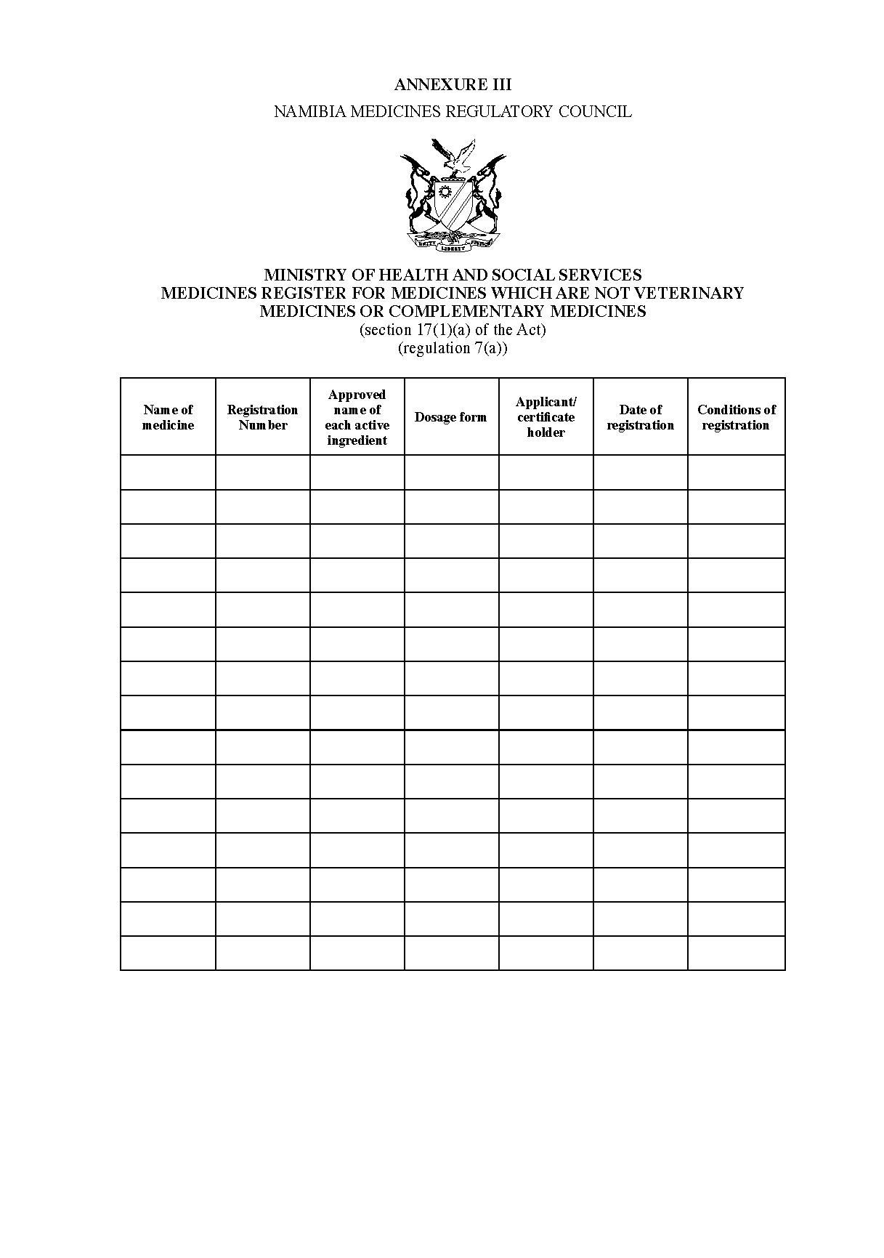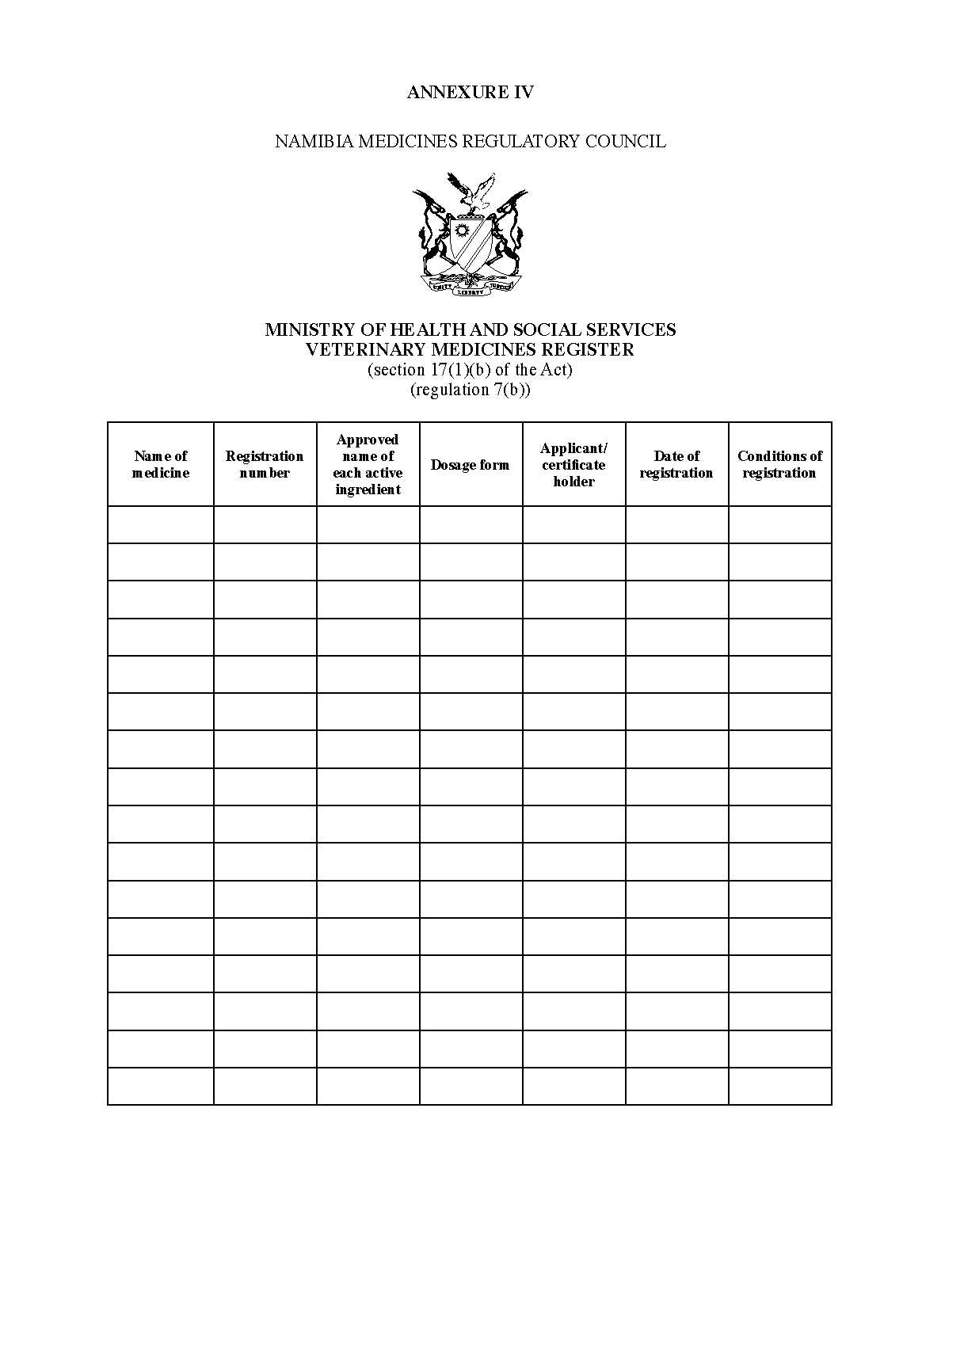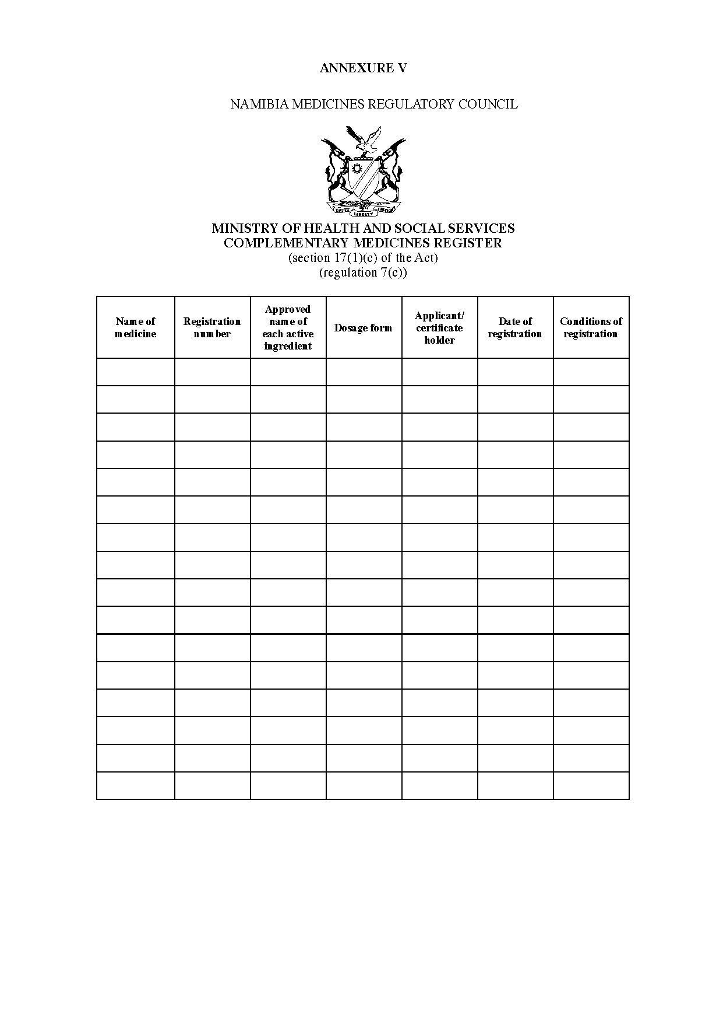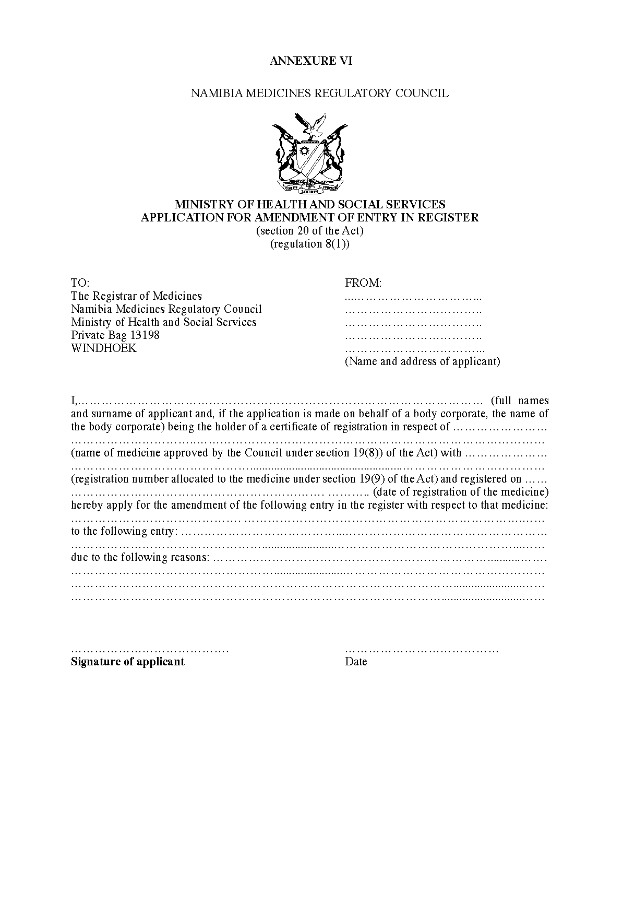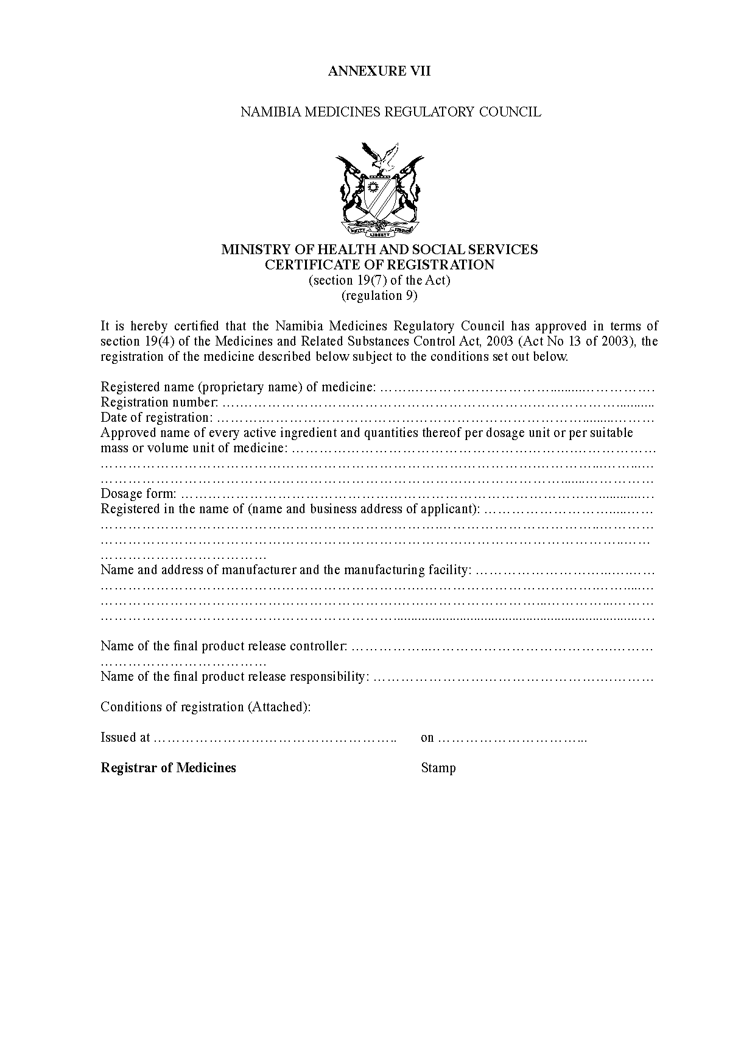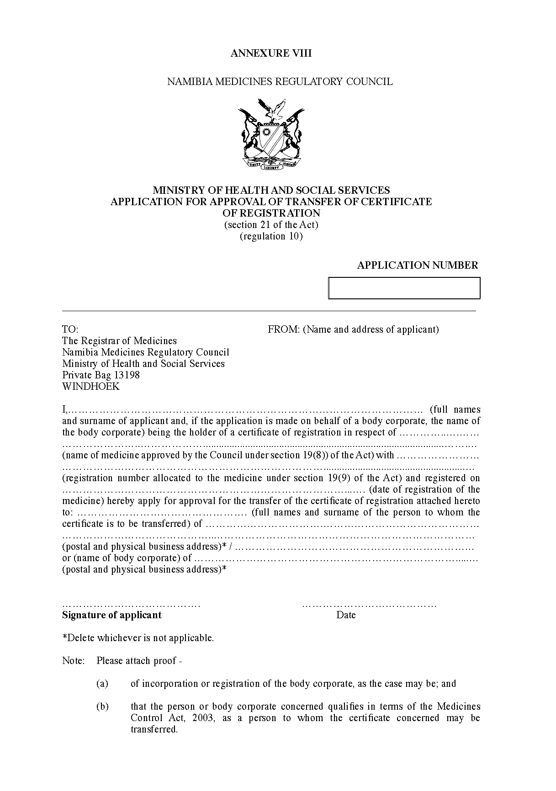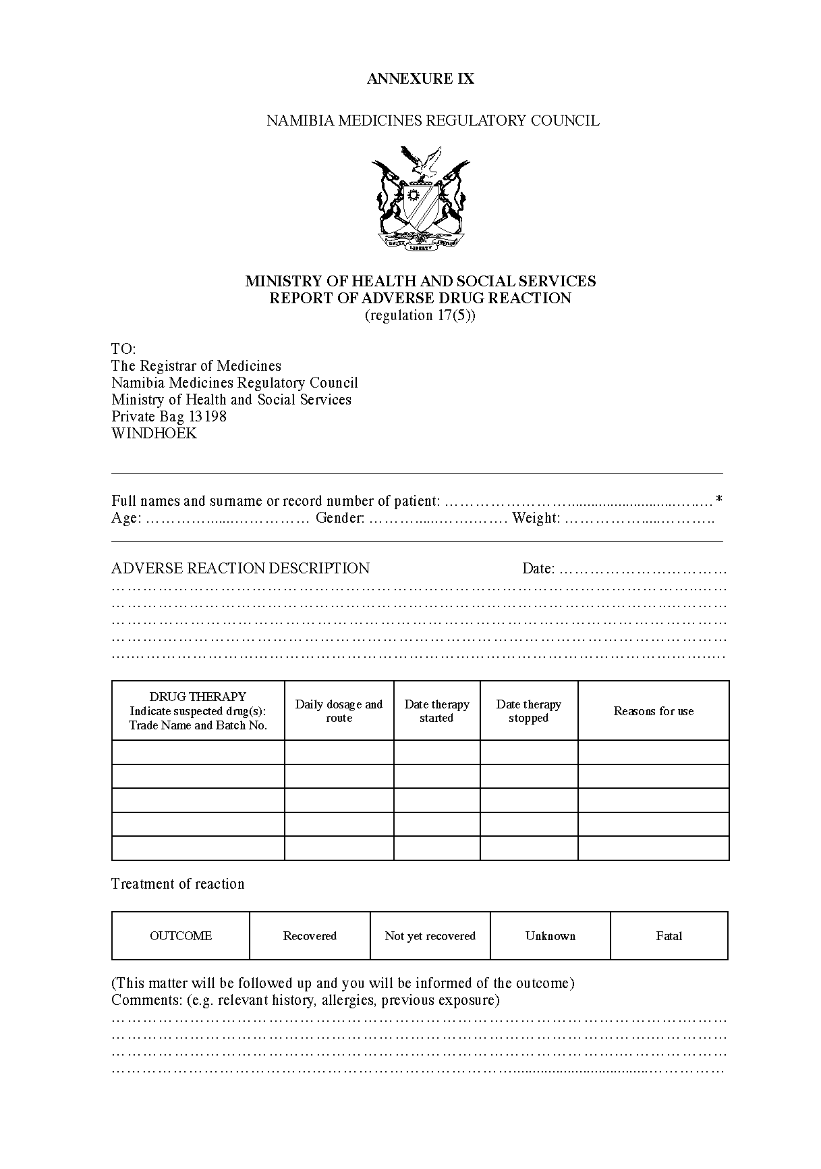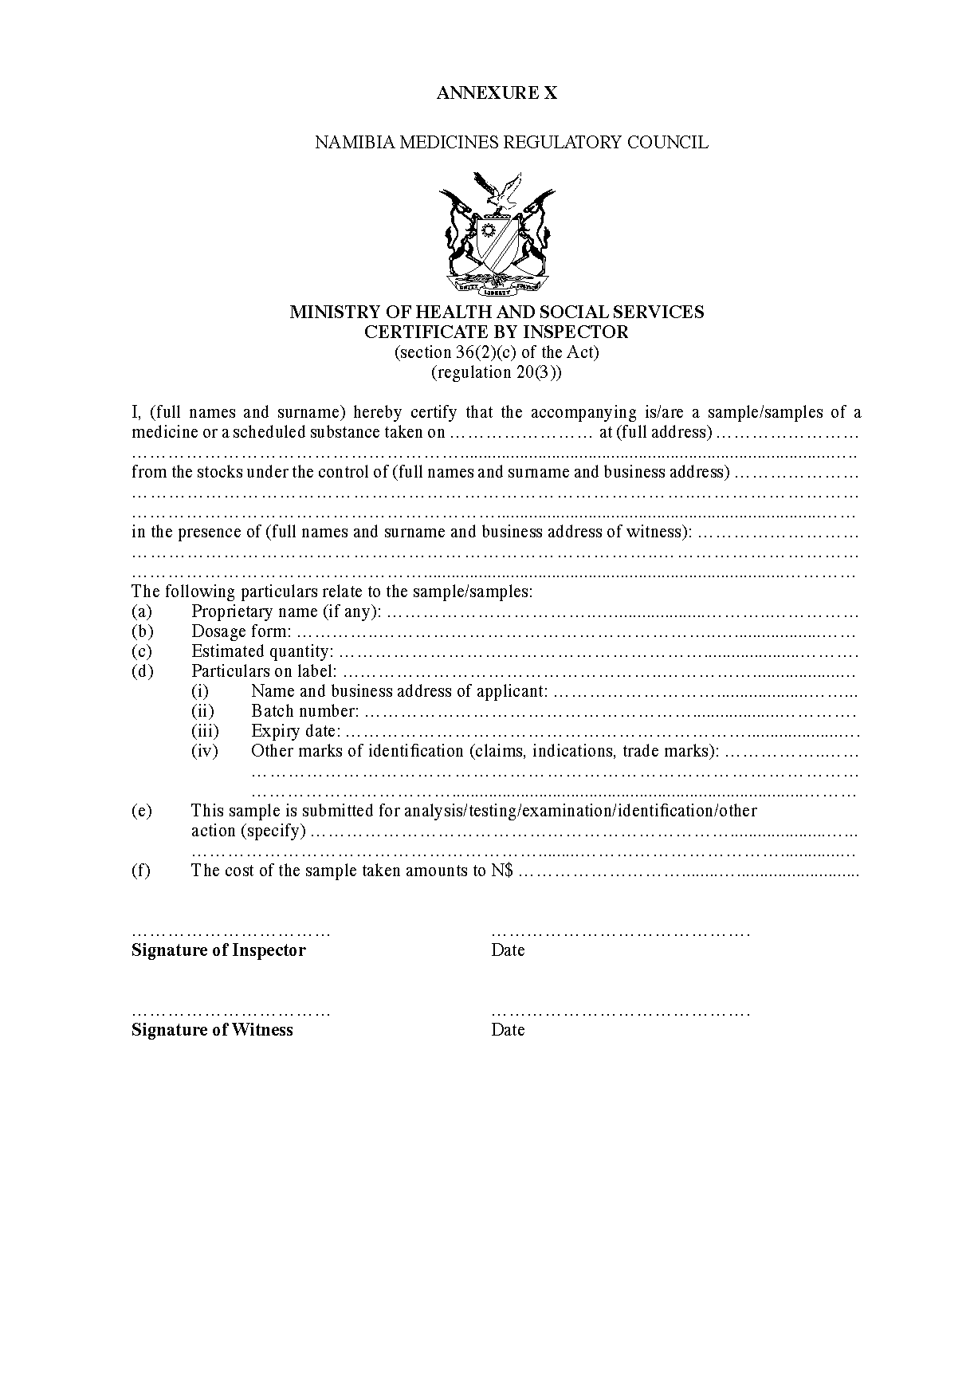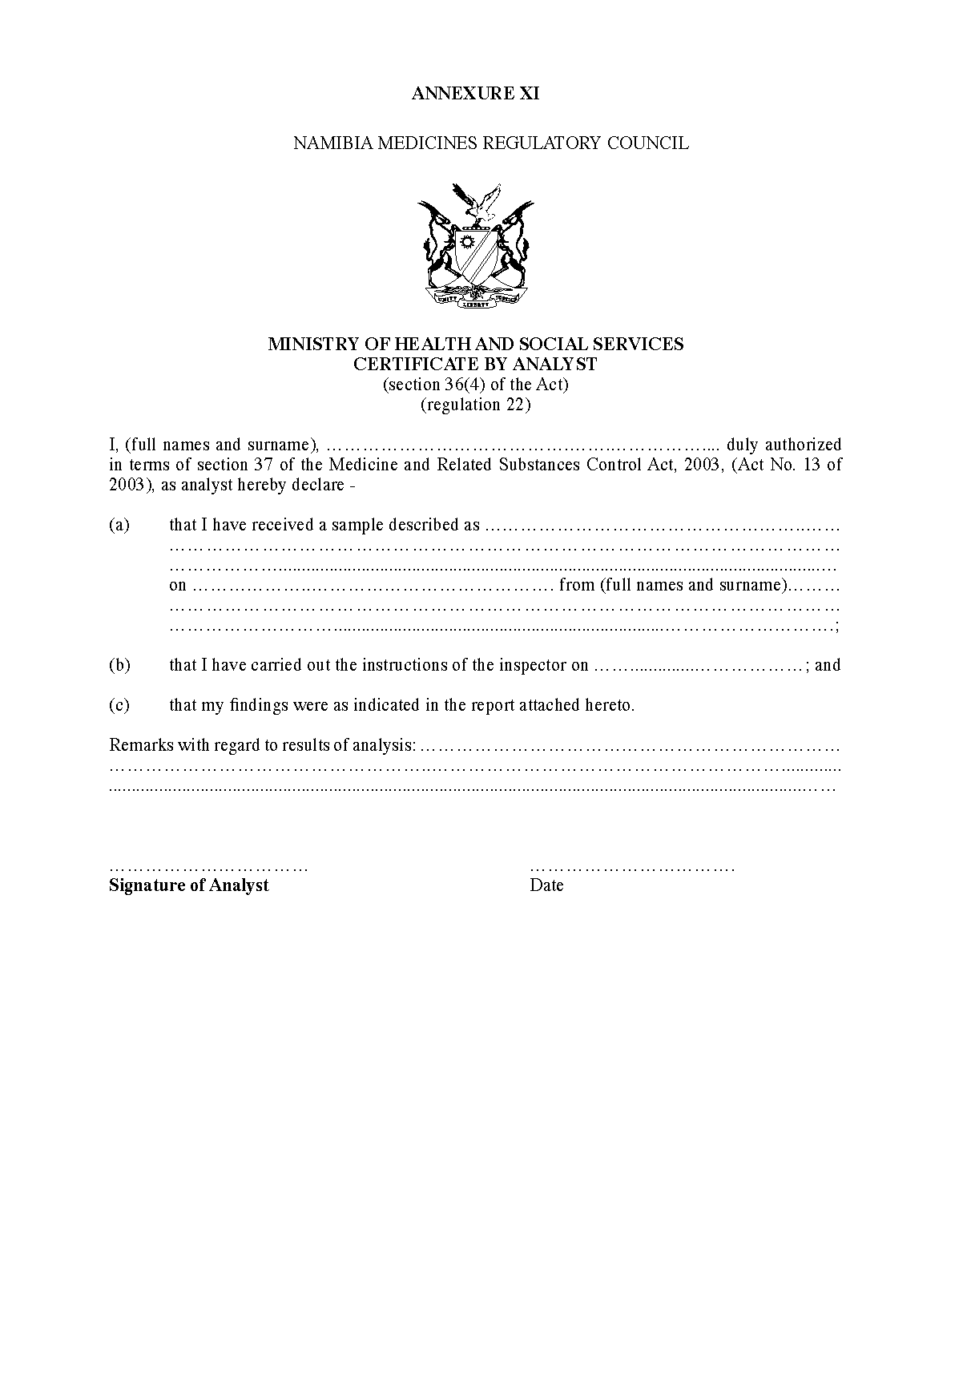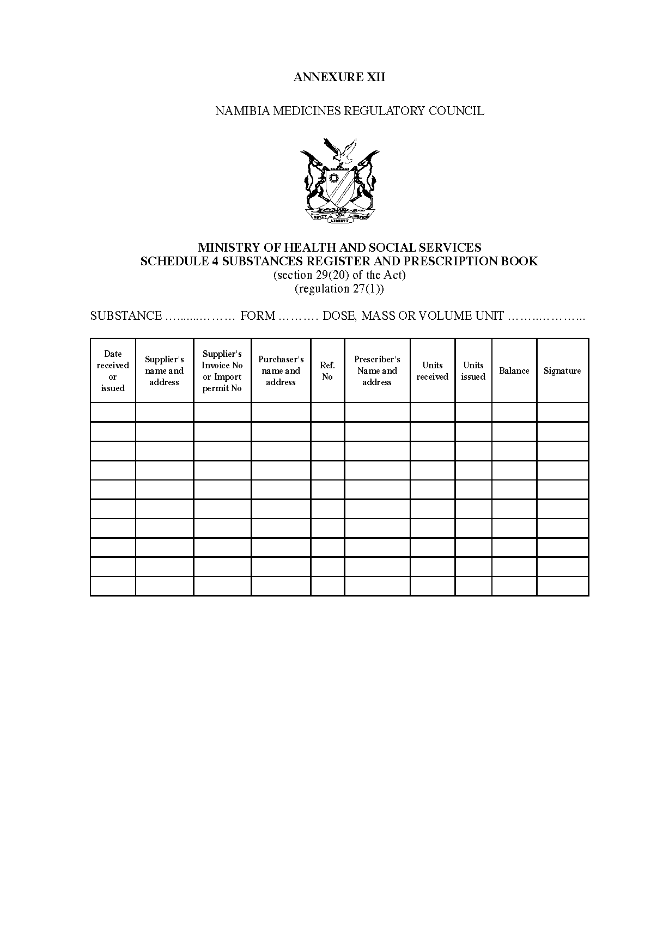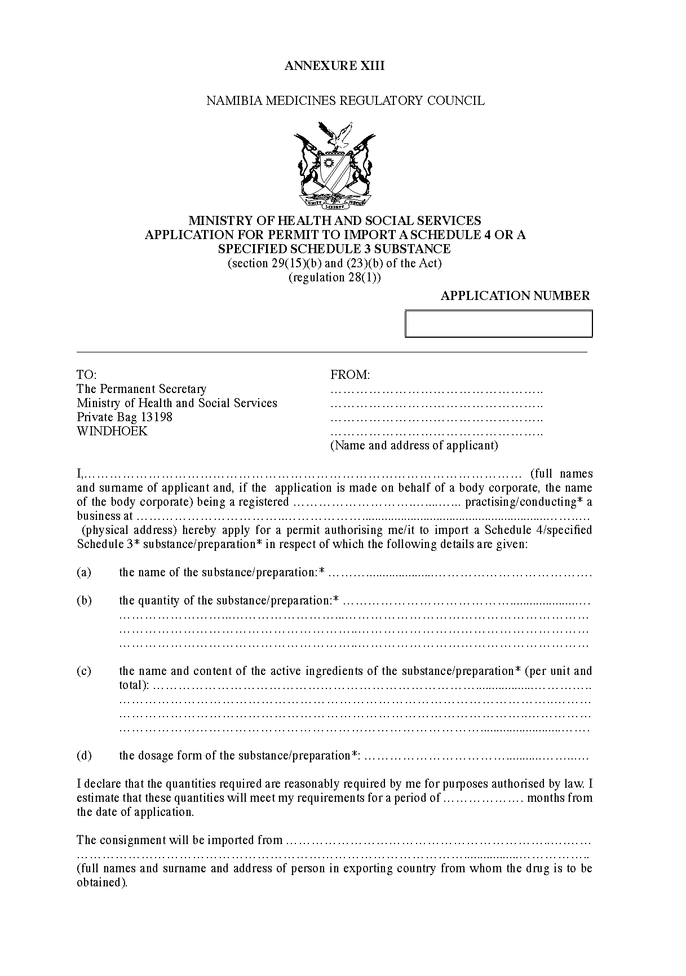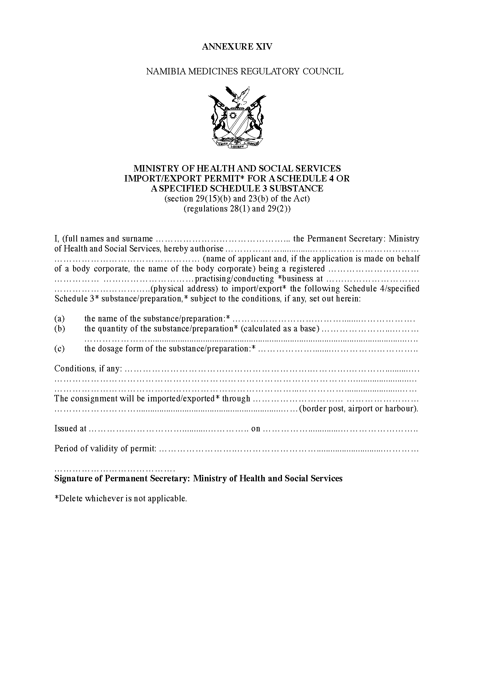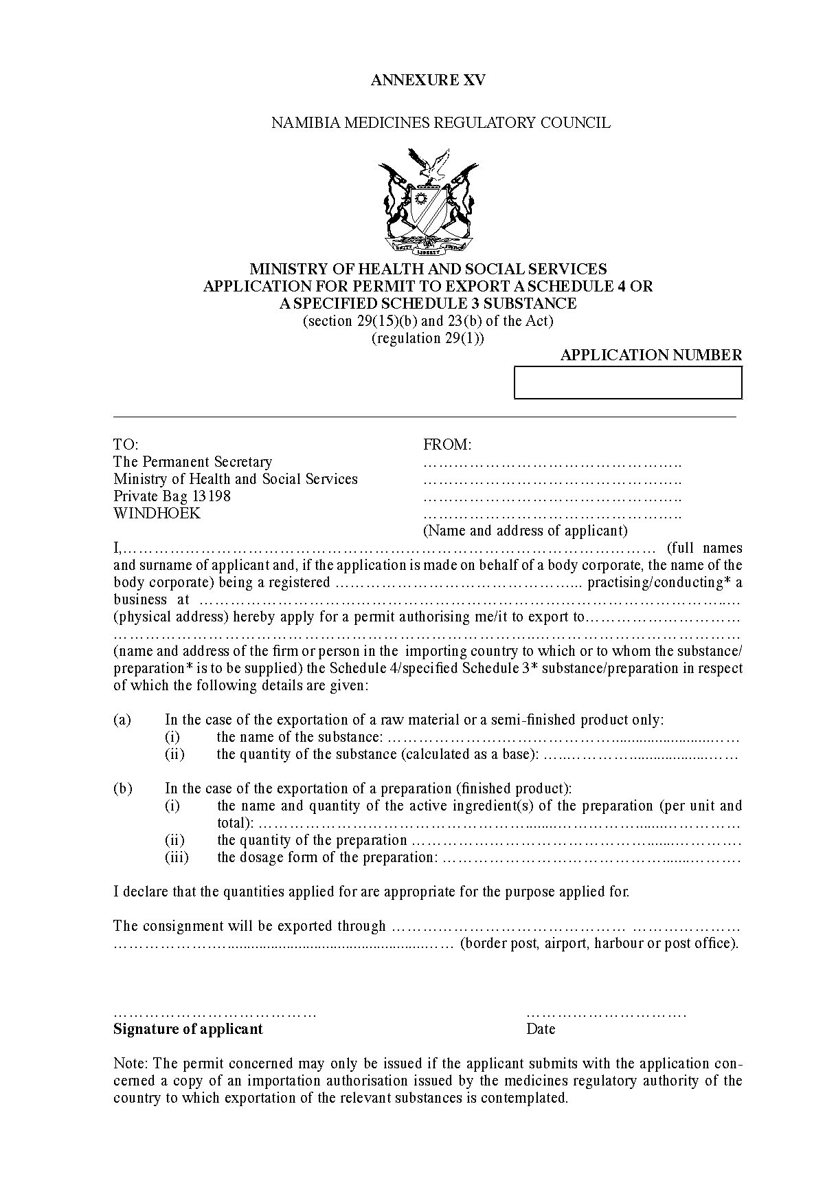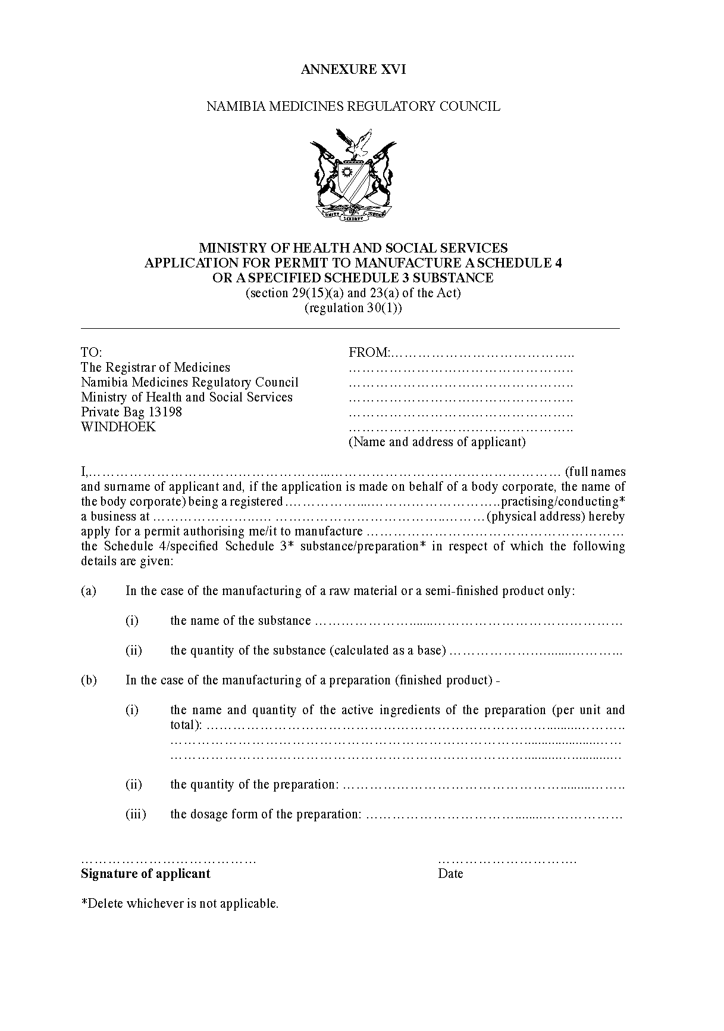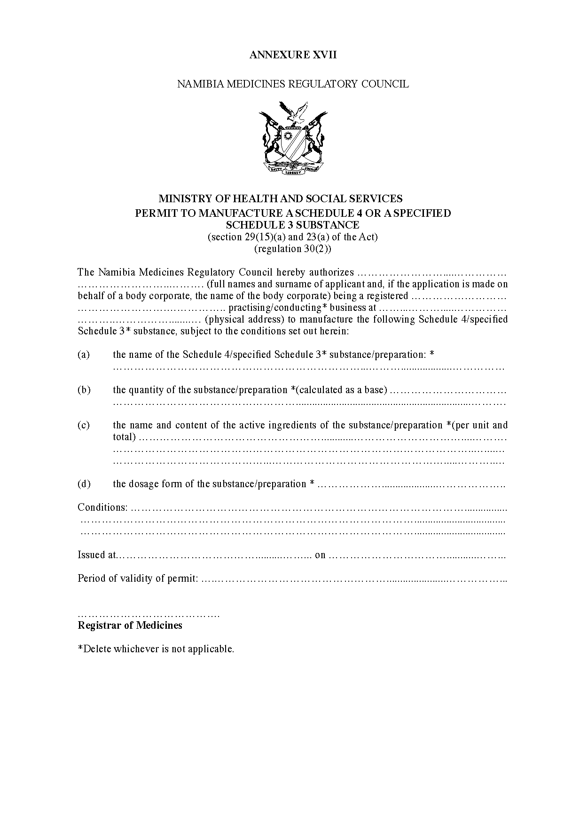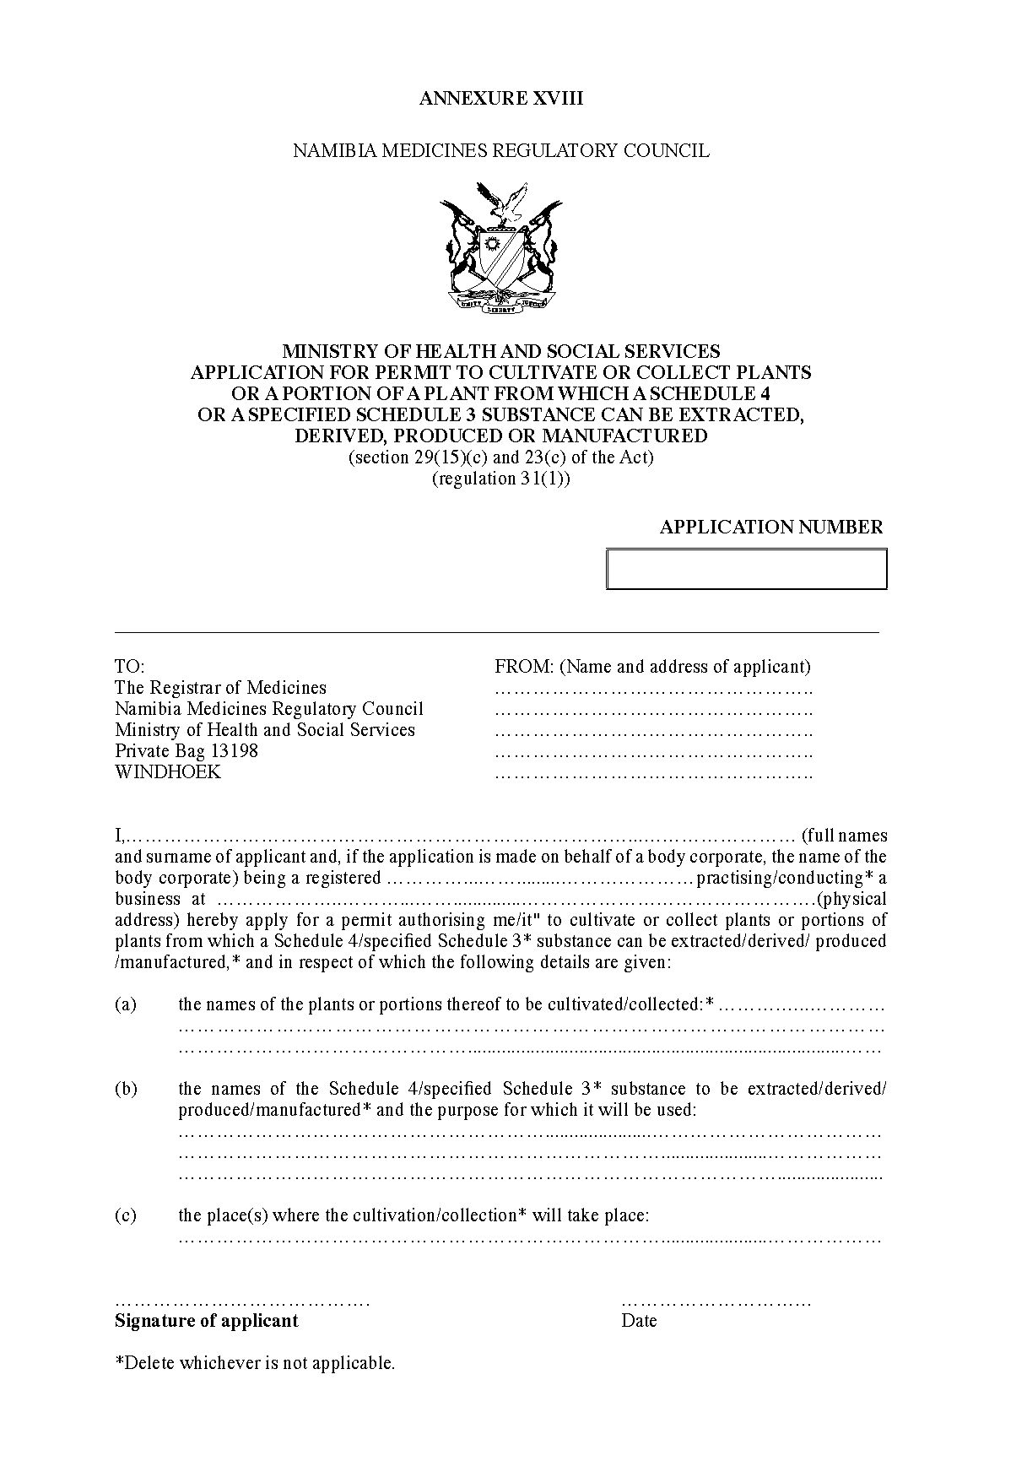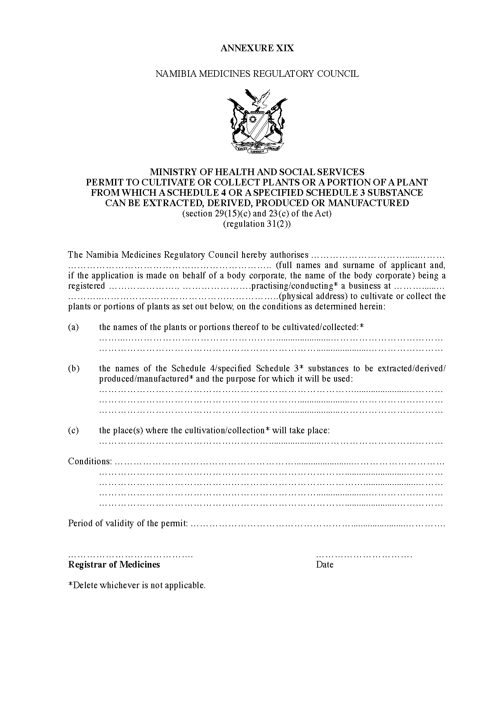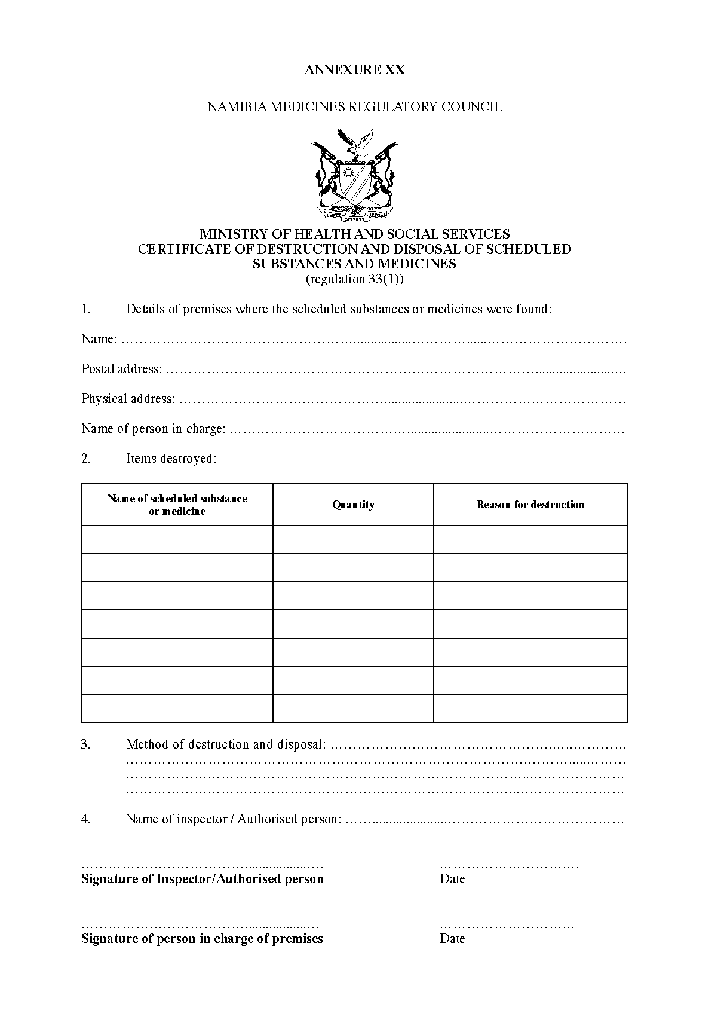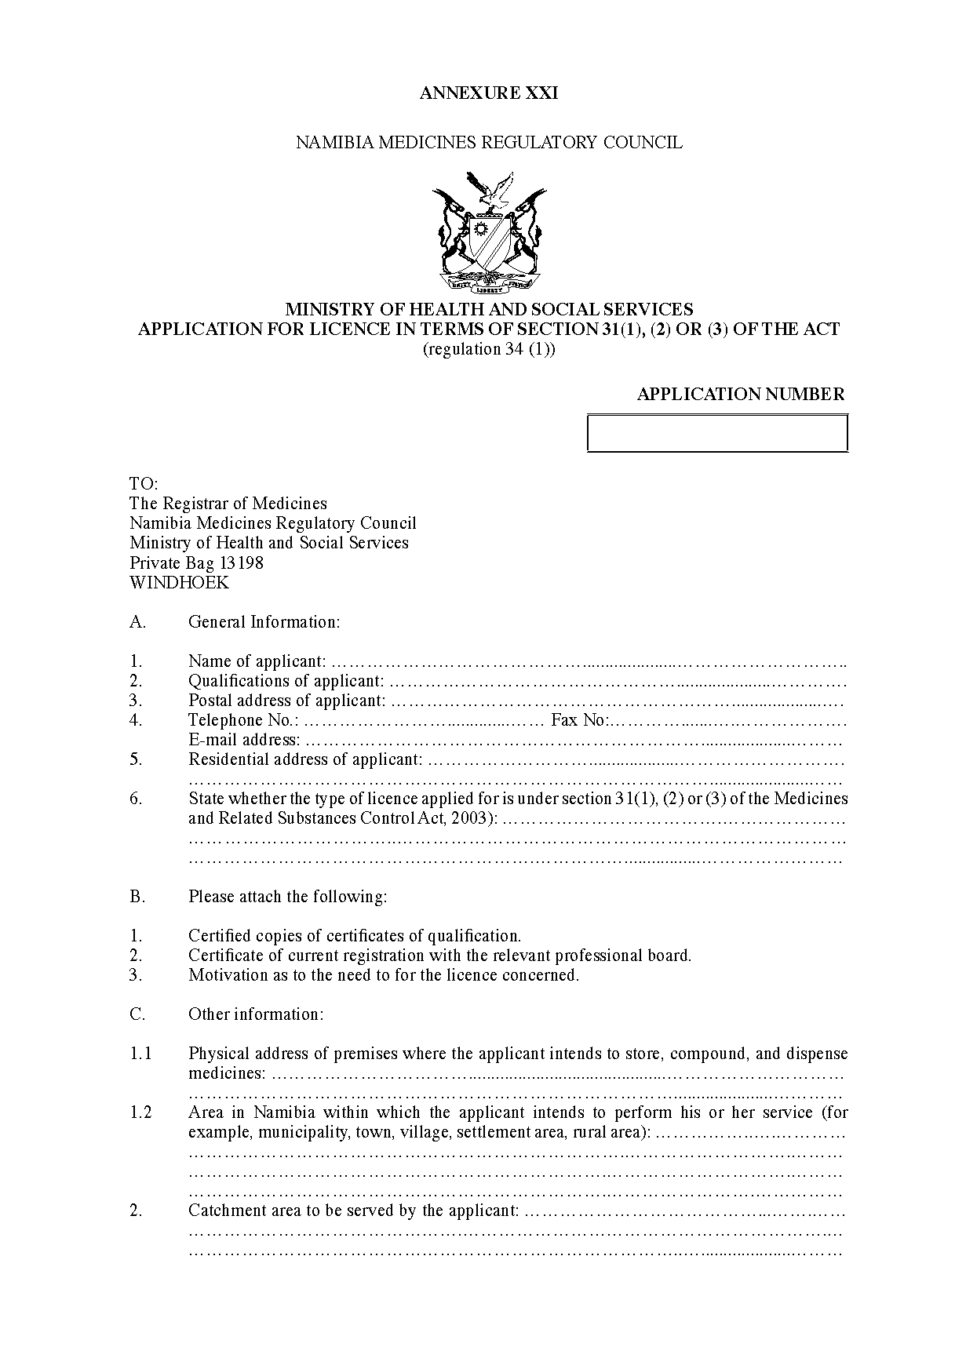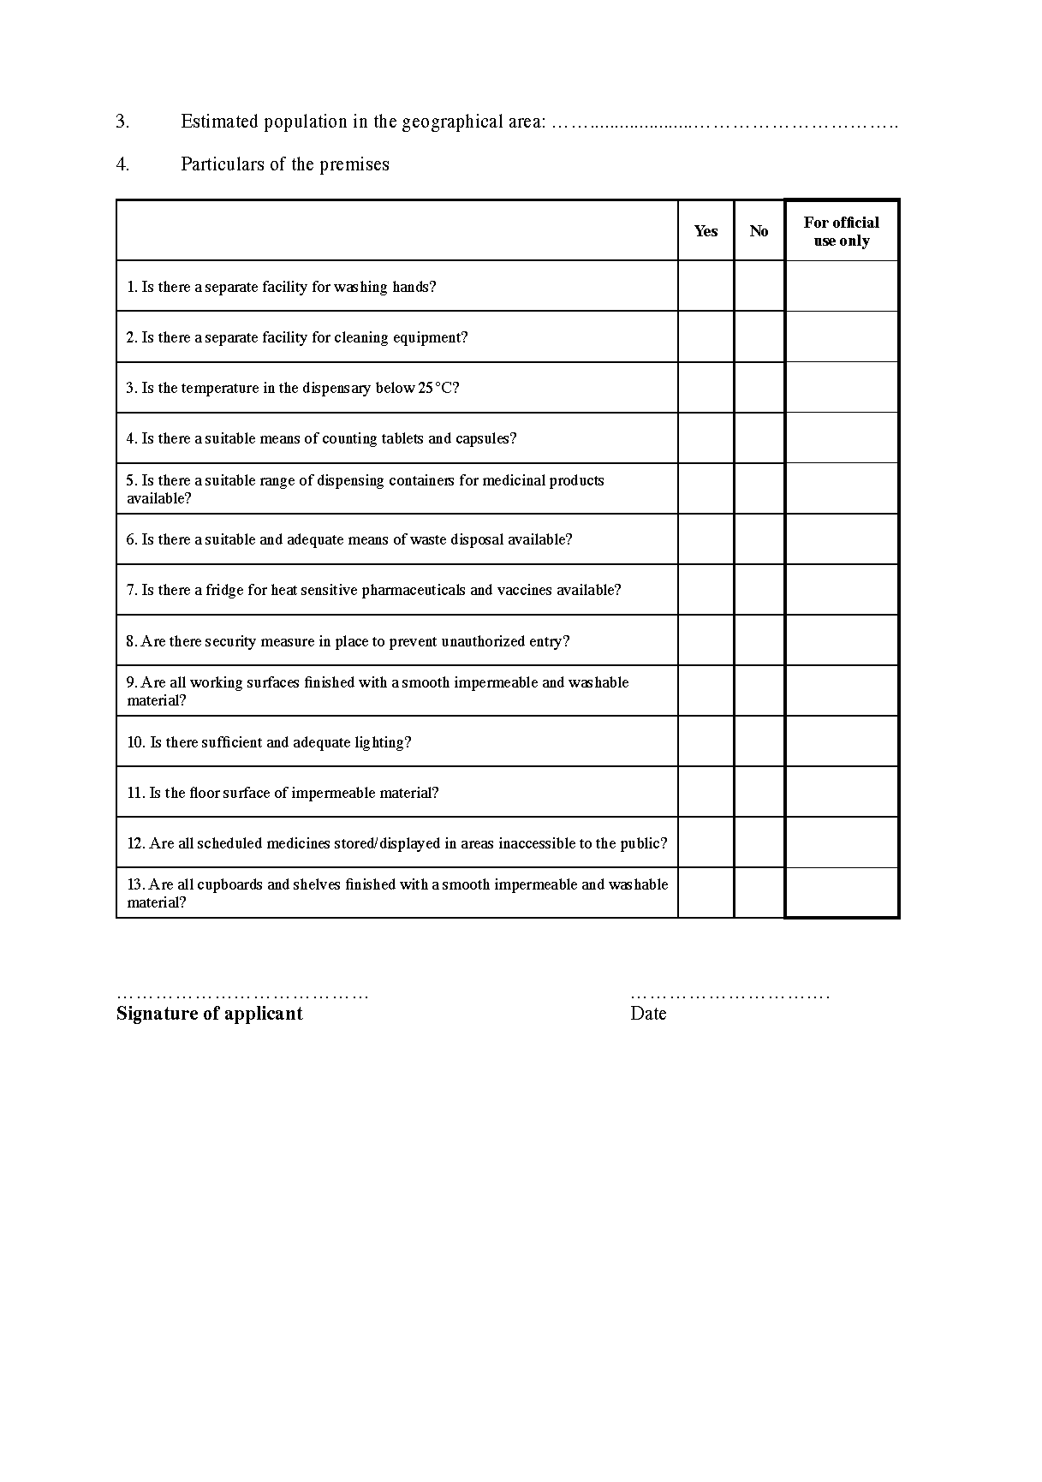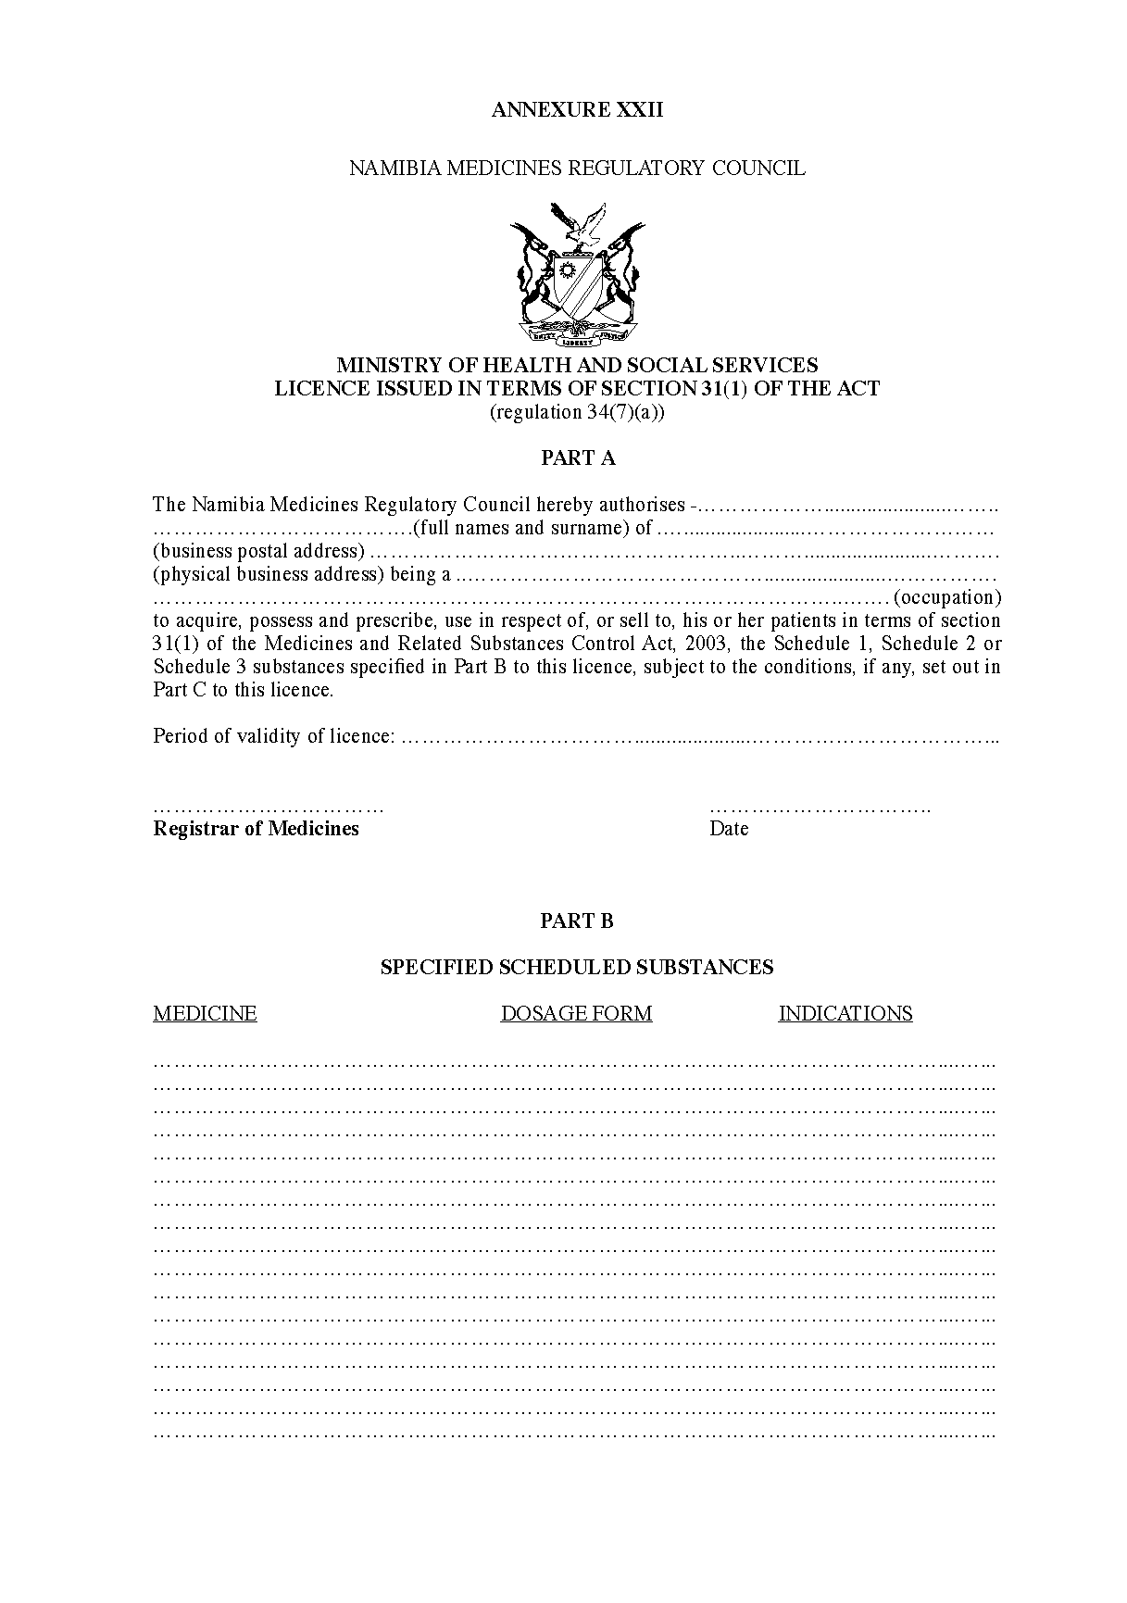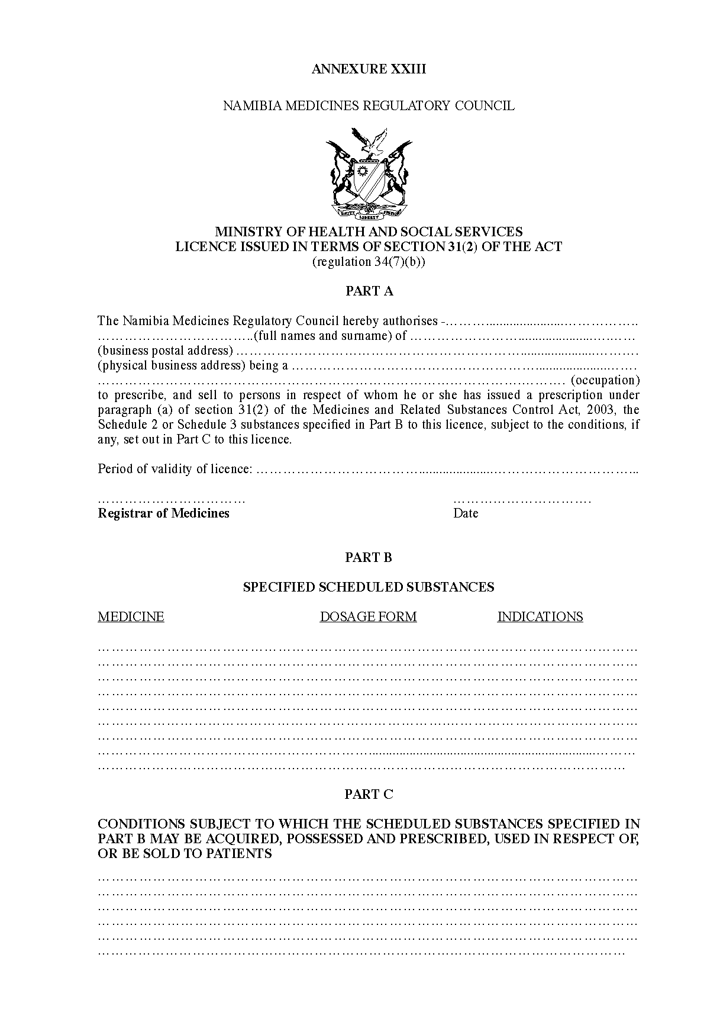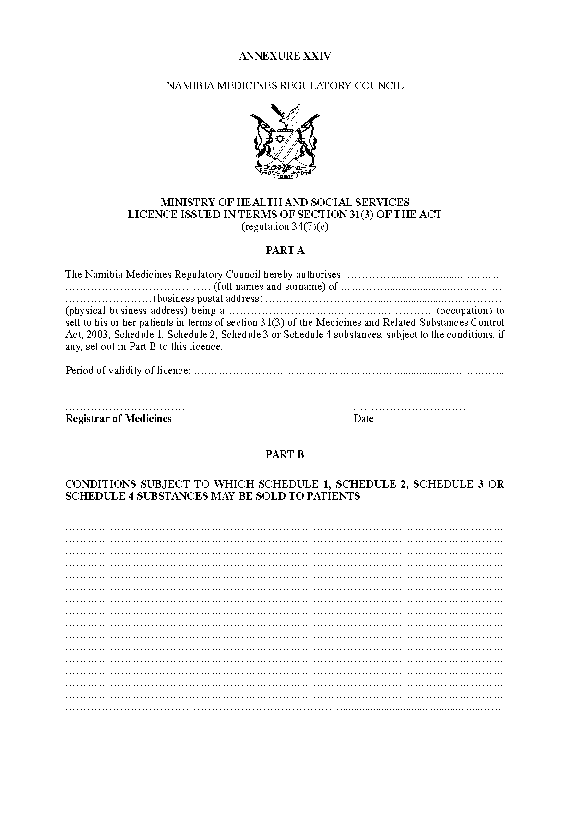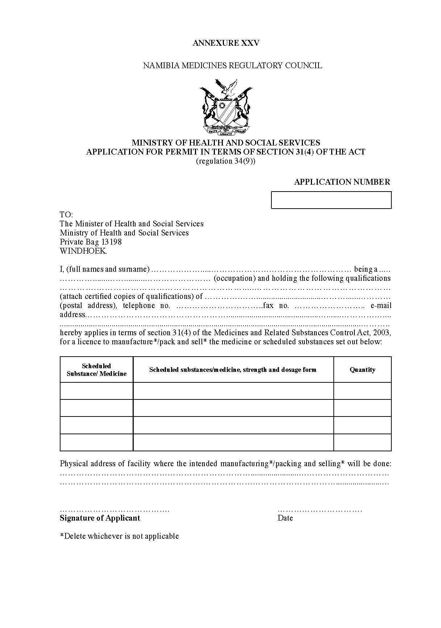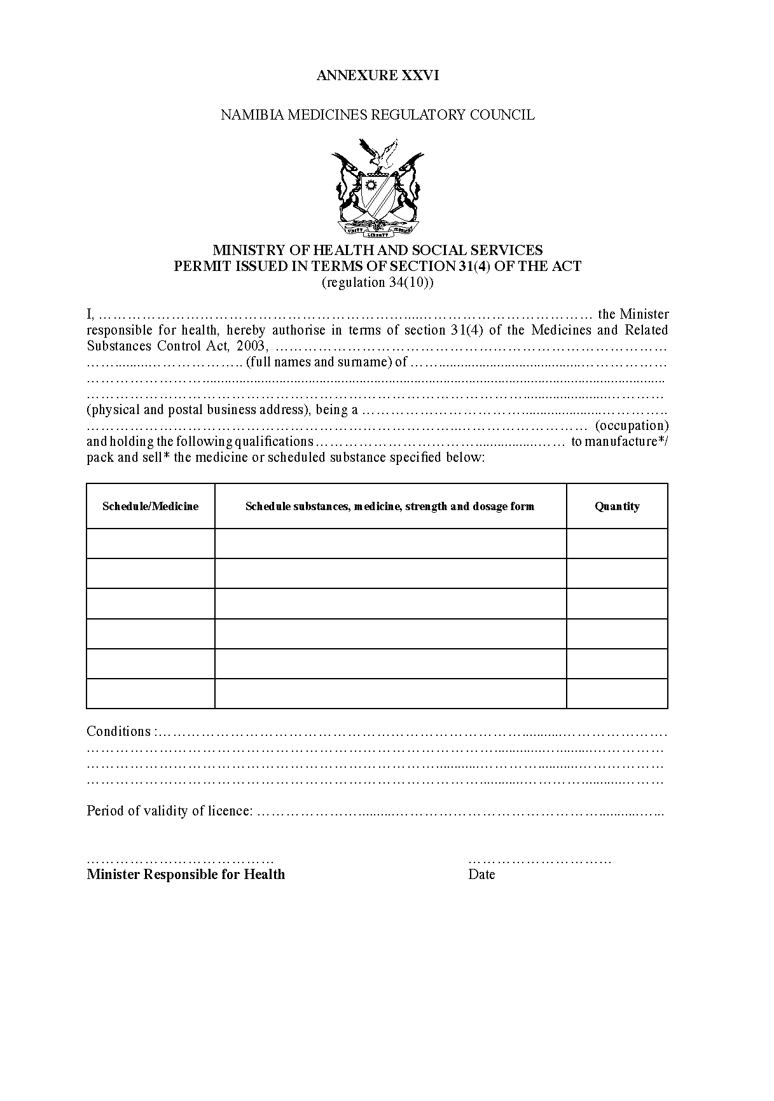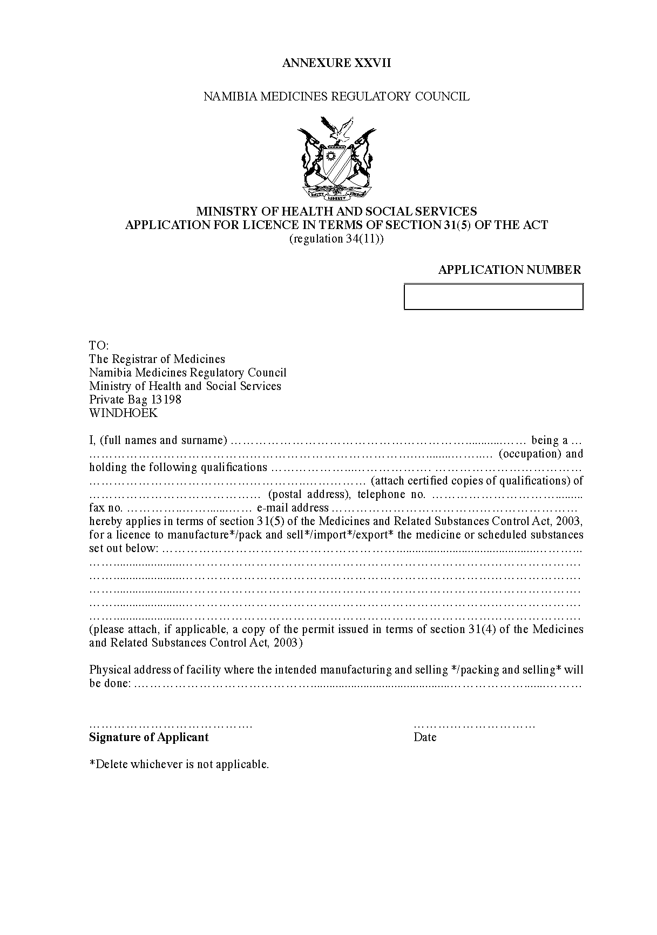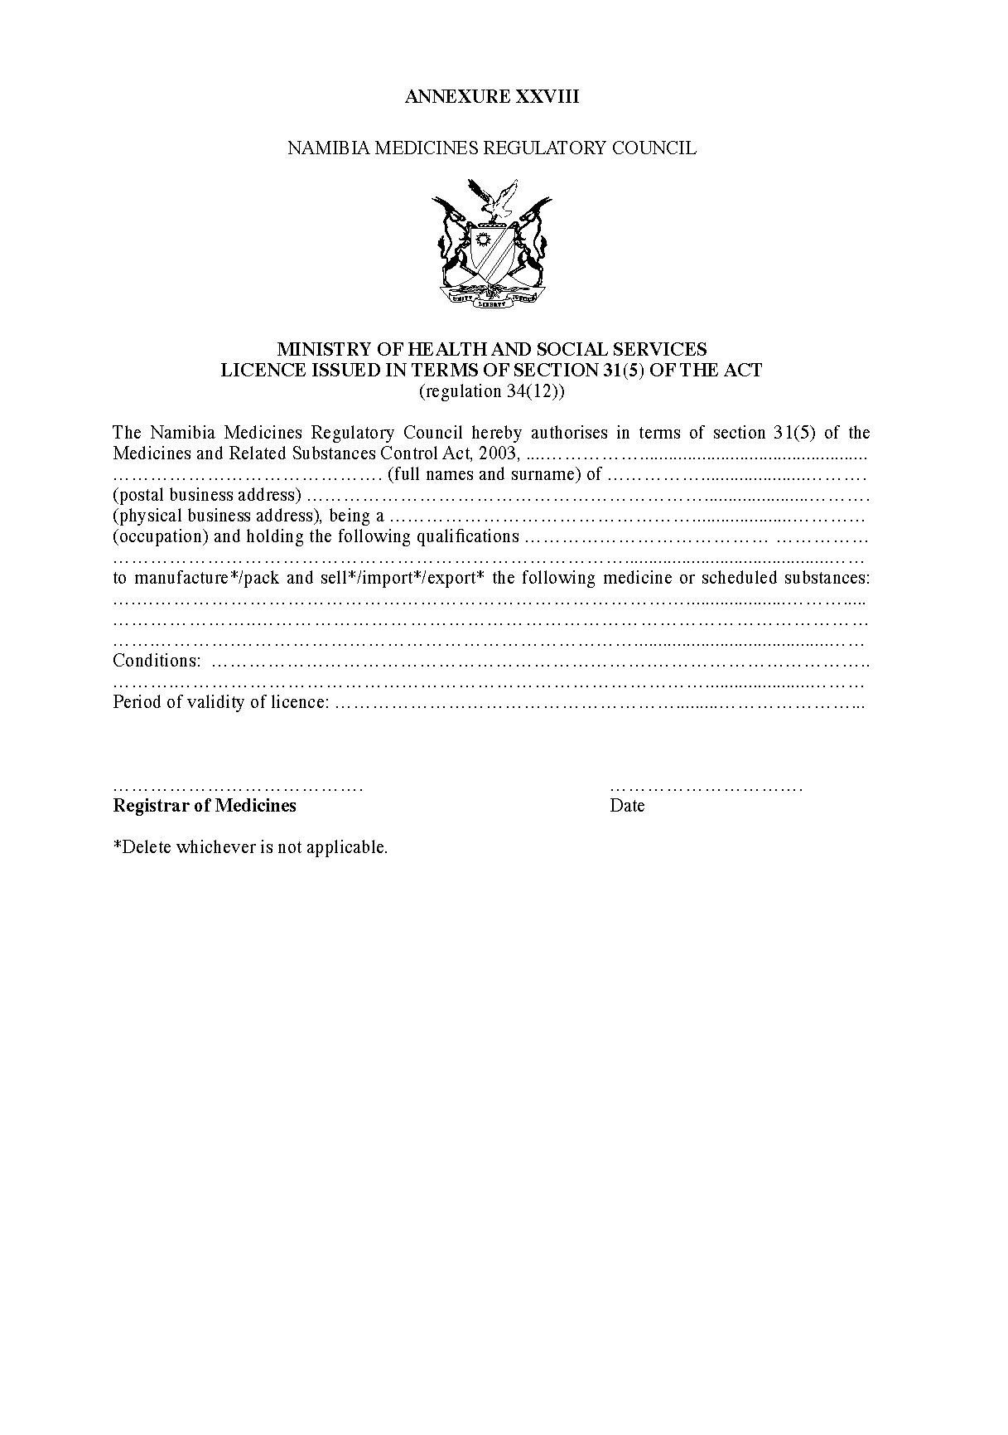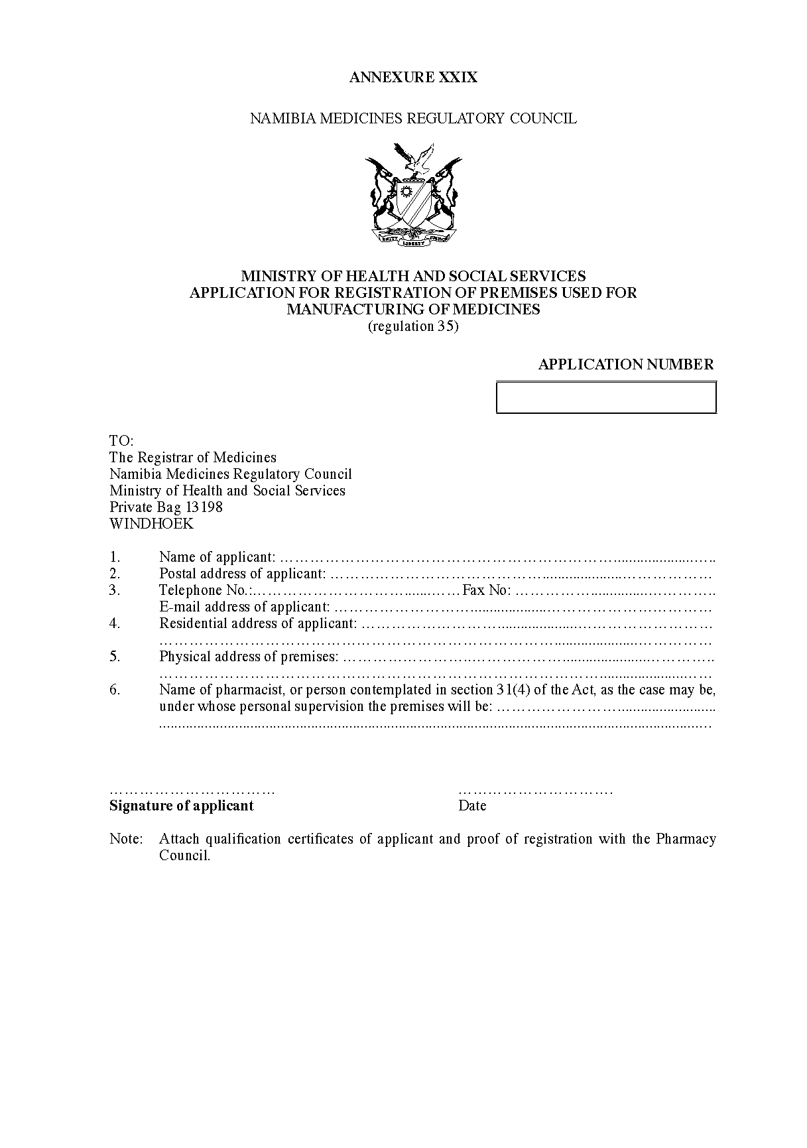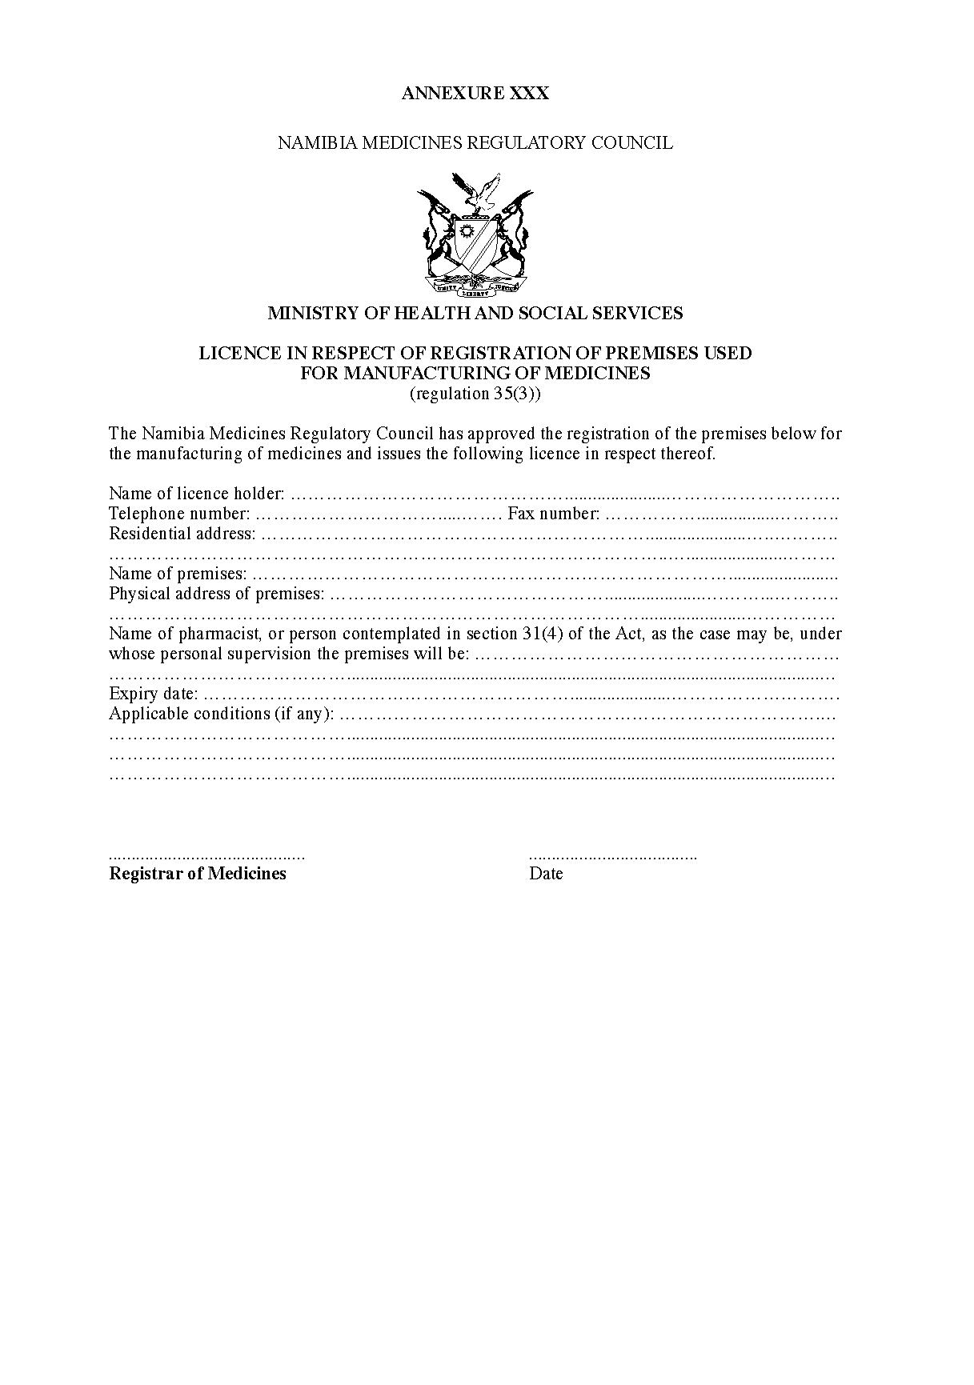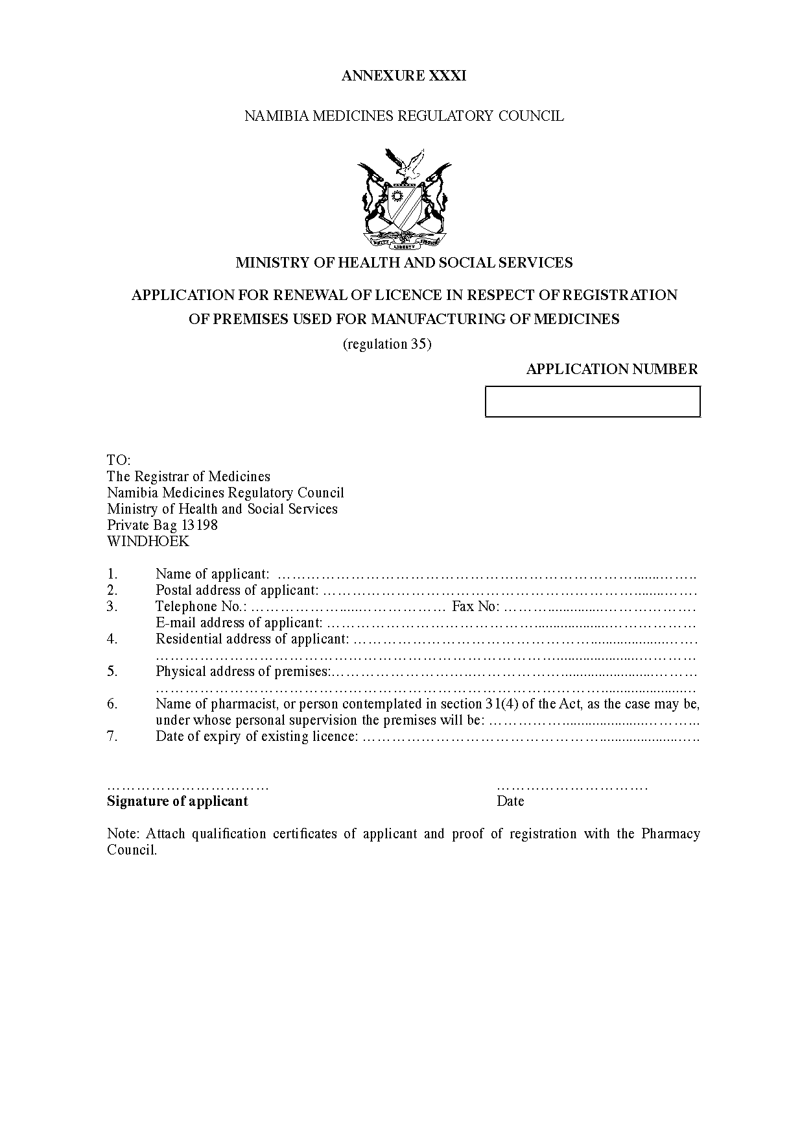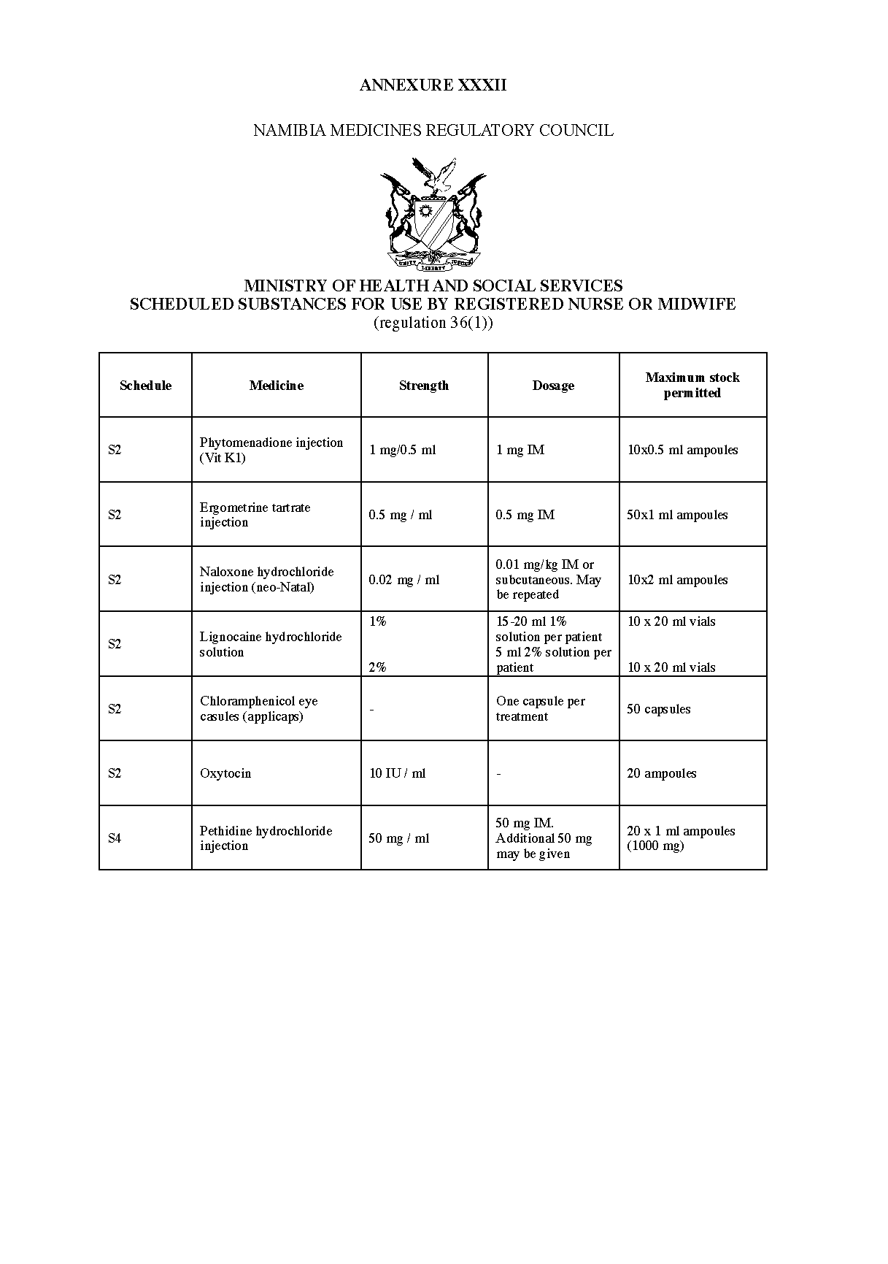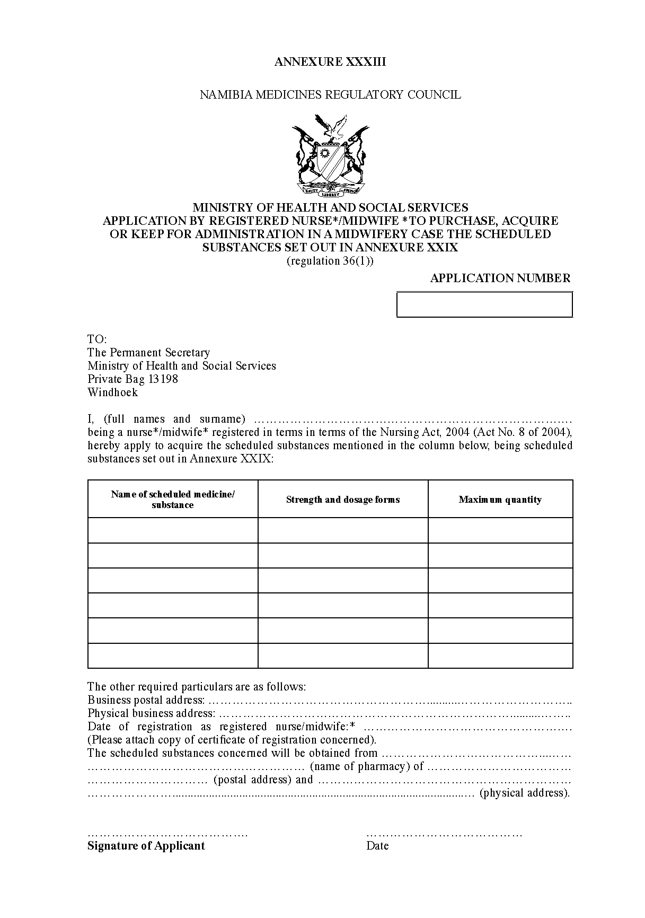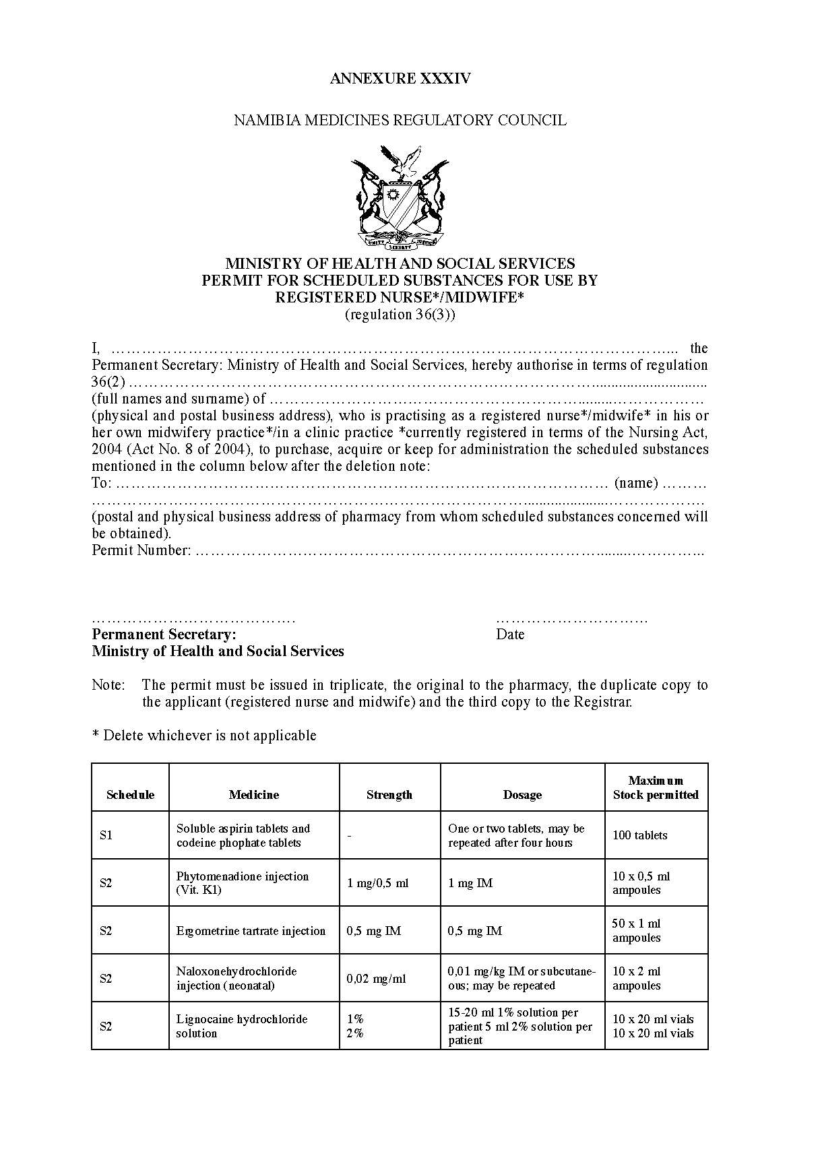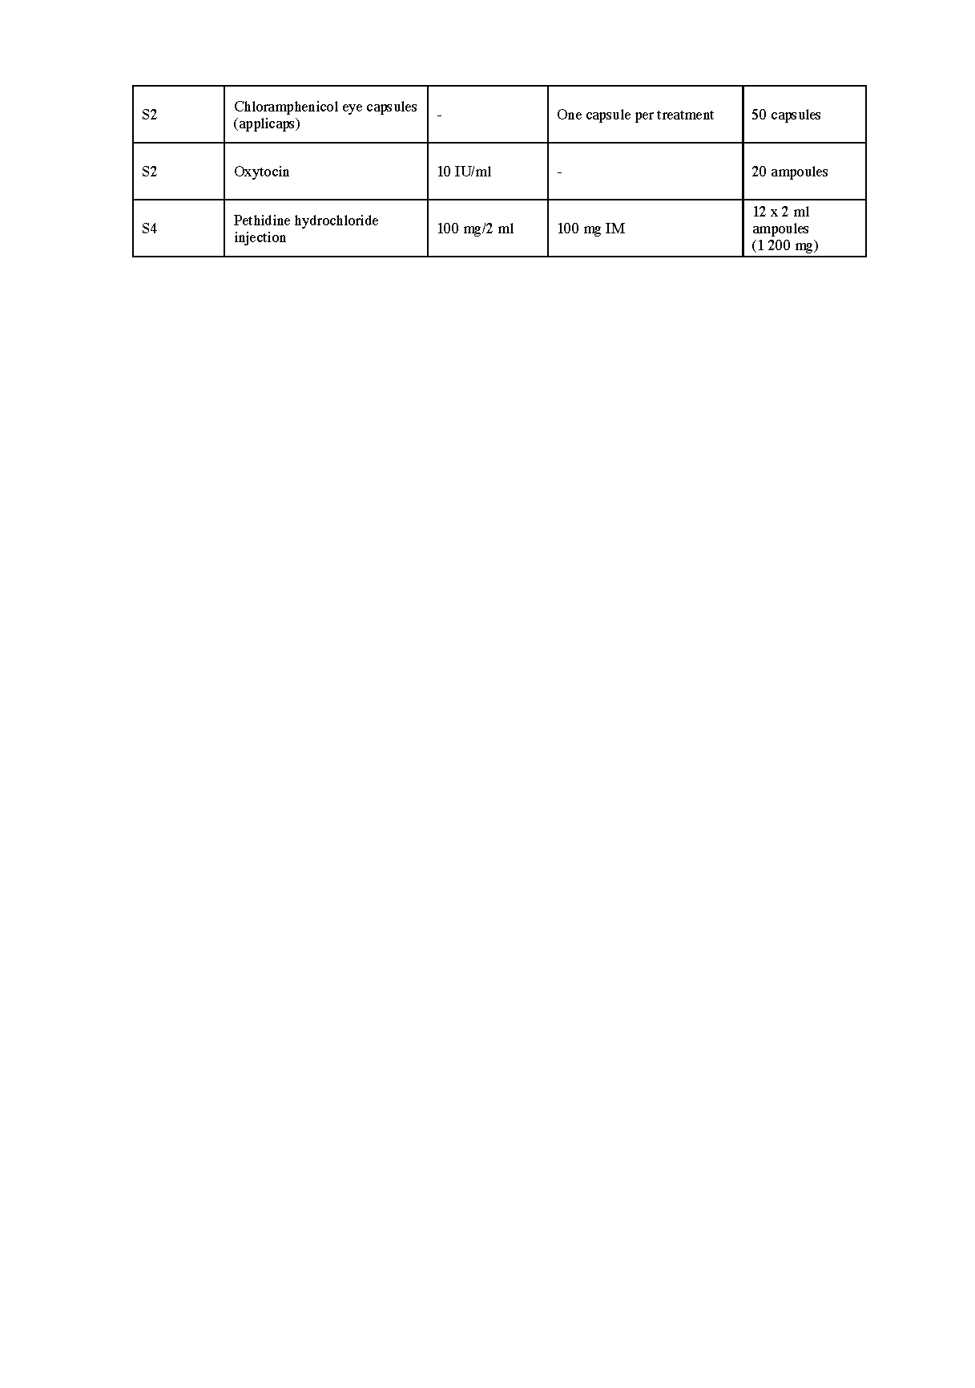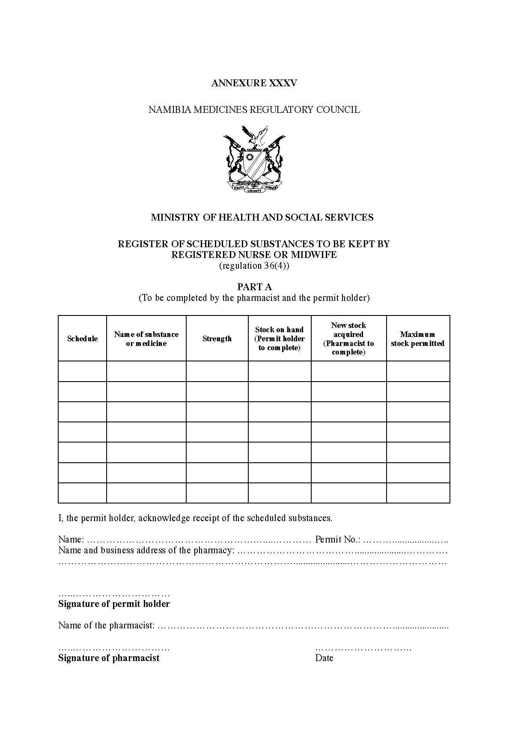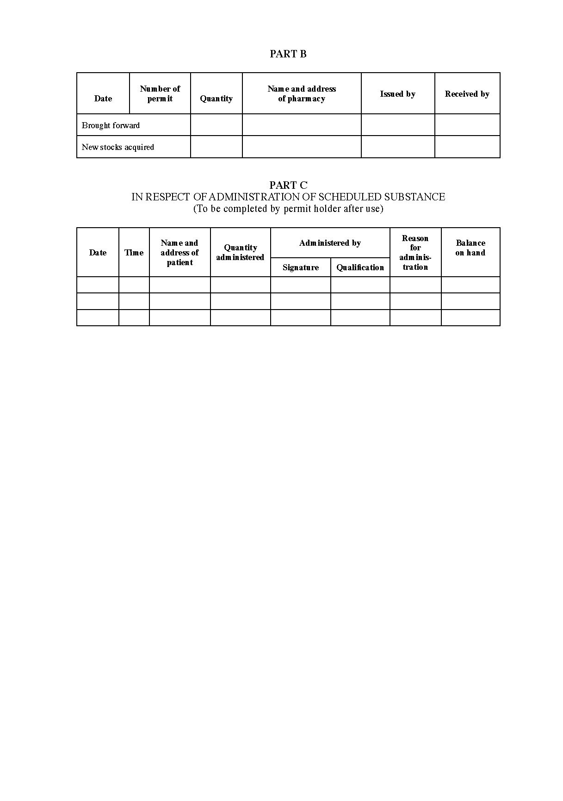

[Annexure XXXVI substituted by GN 202/2019]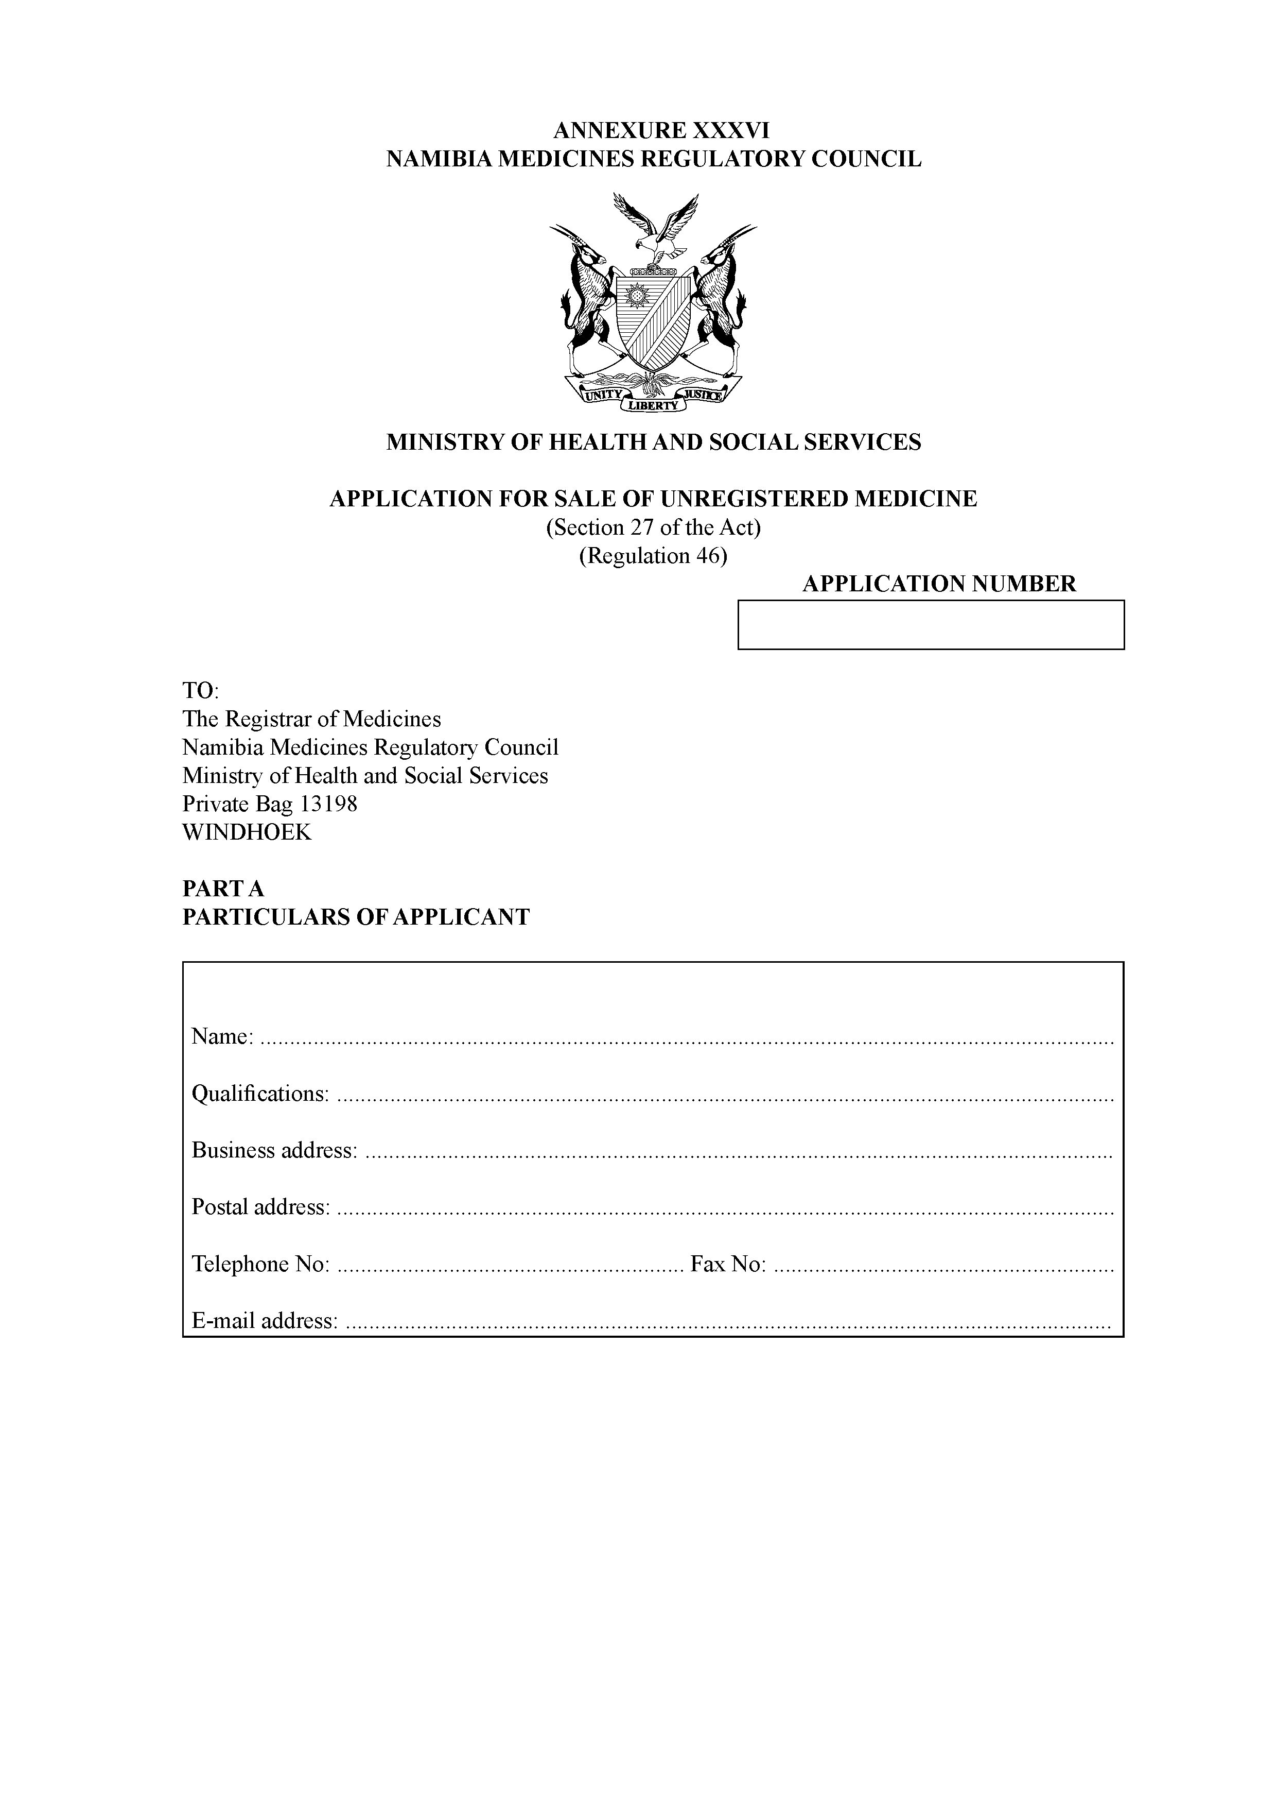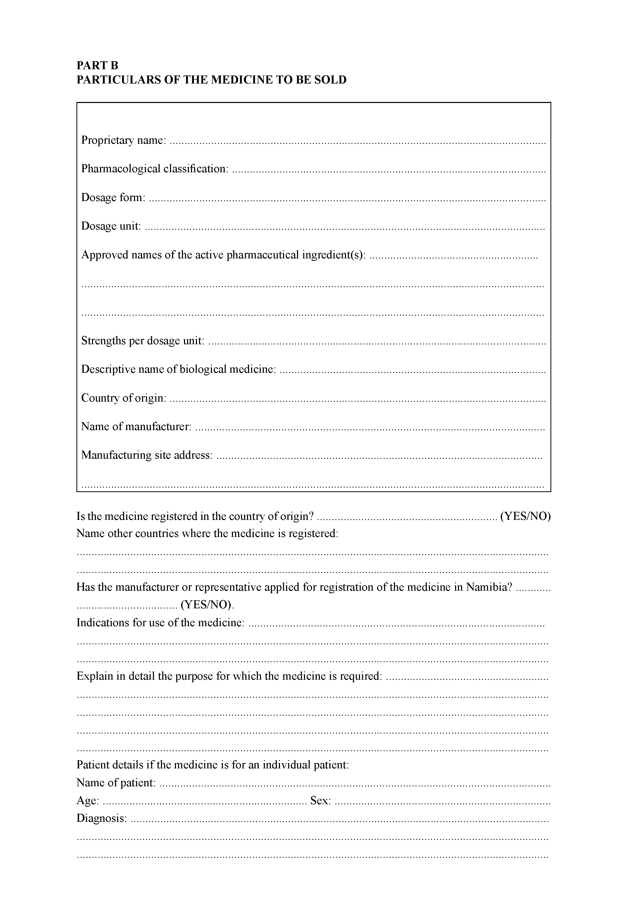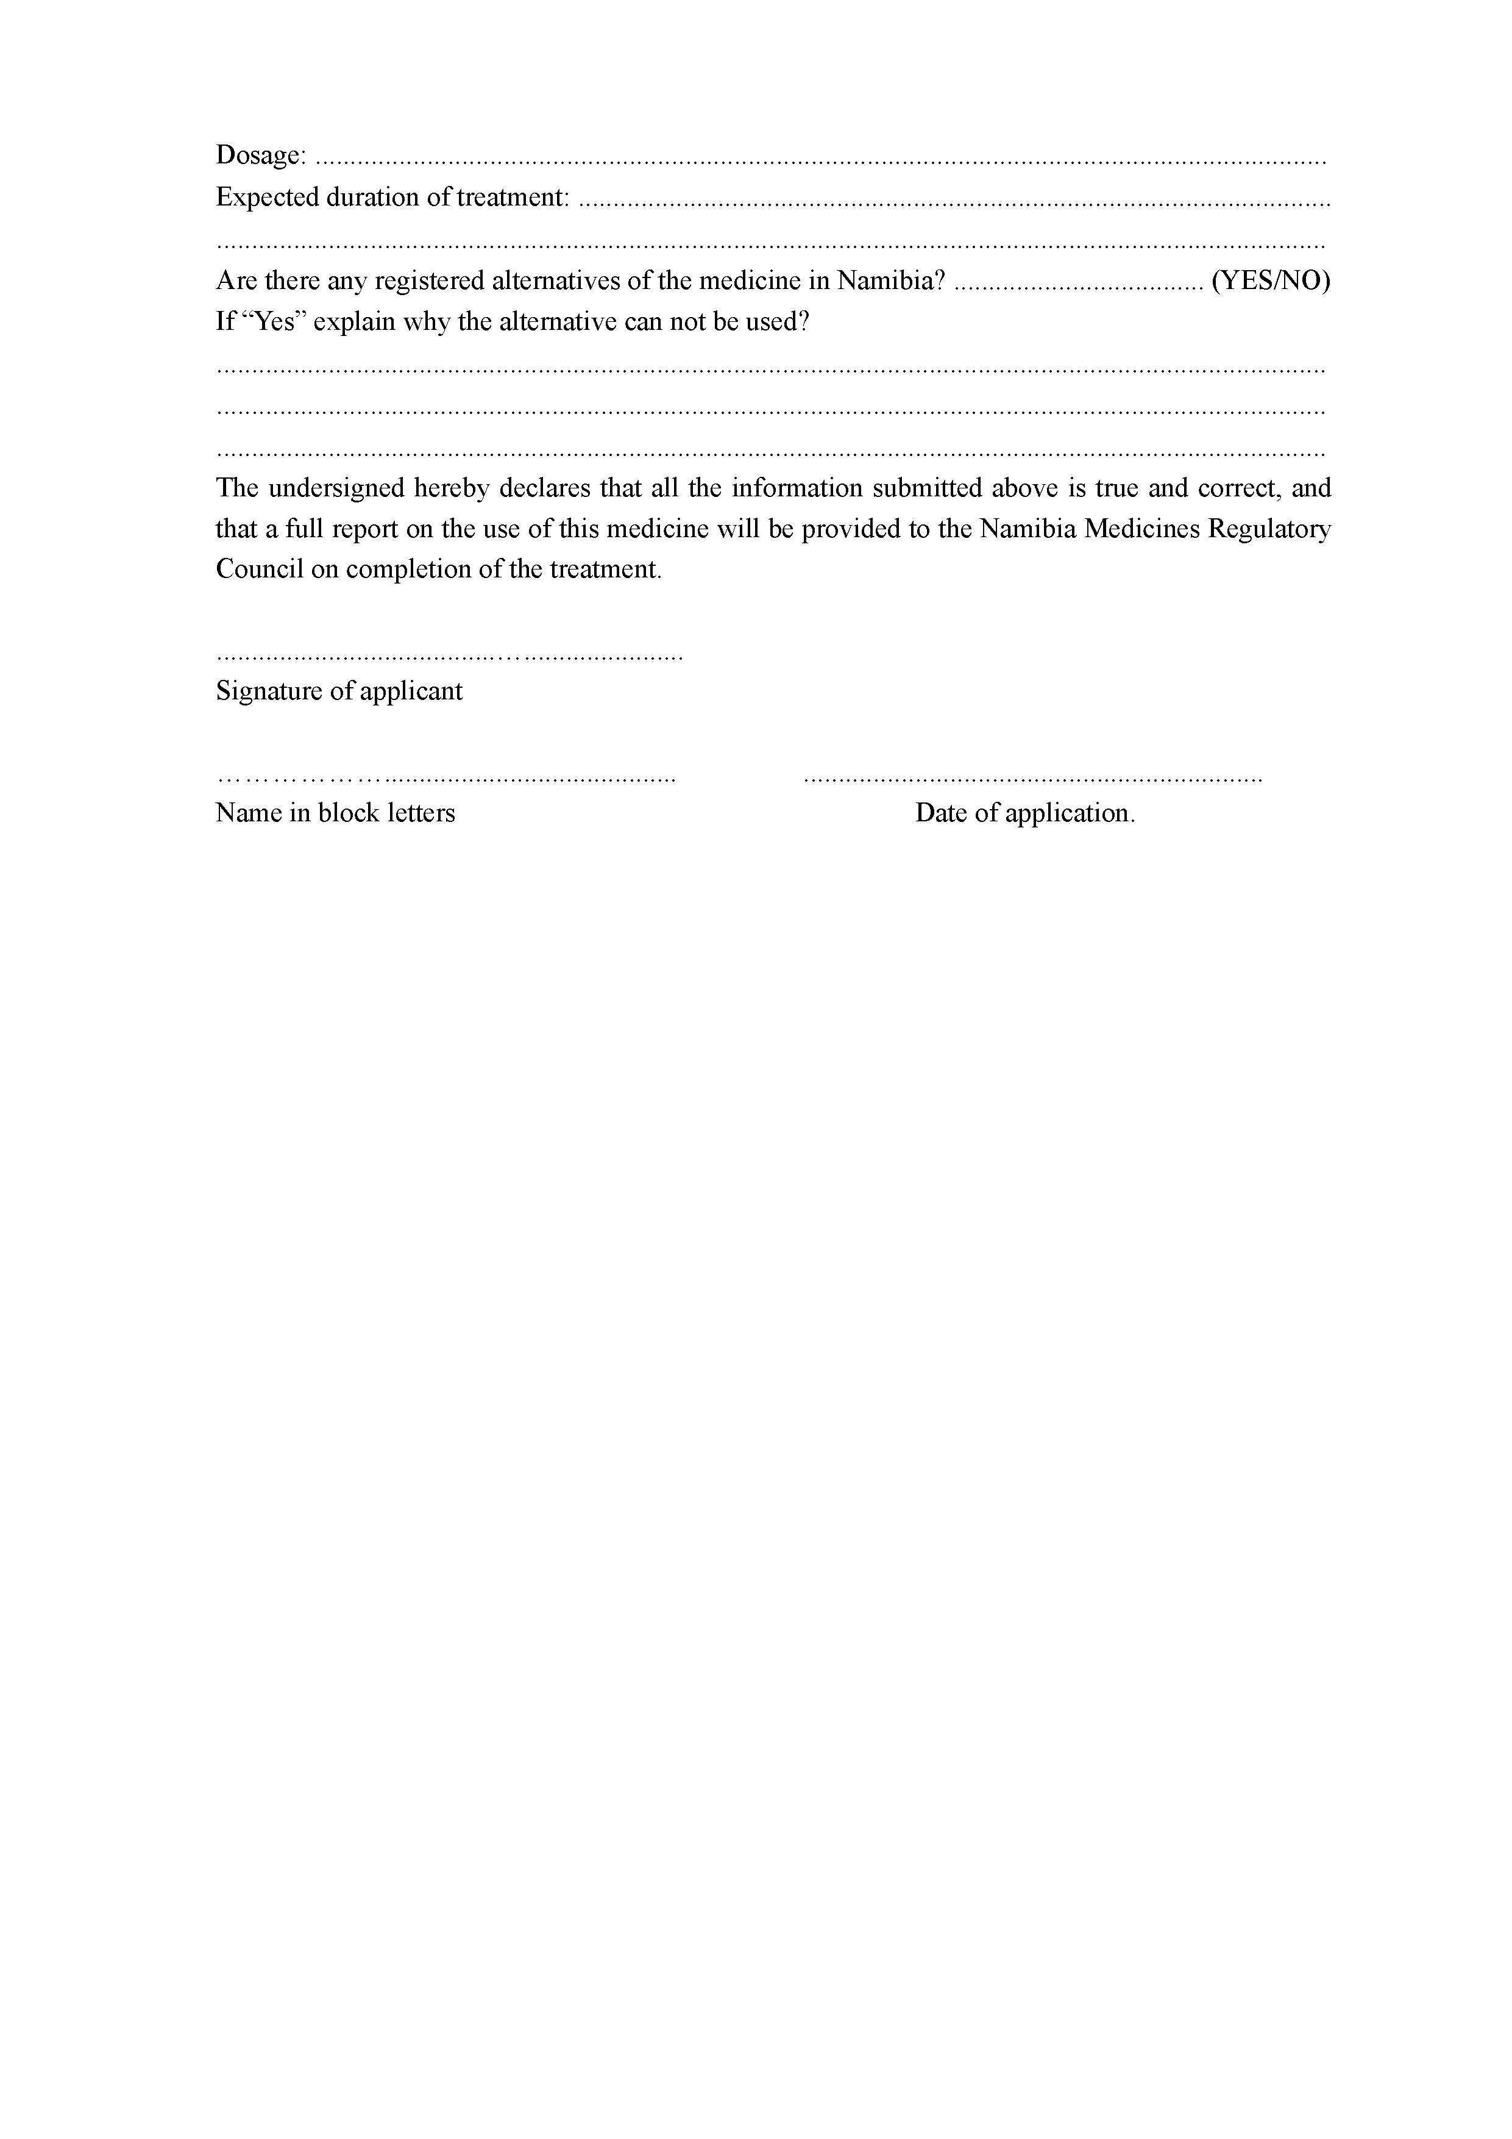

[Annexure XXXVI(A) inserted by GN 202/2019]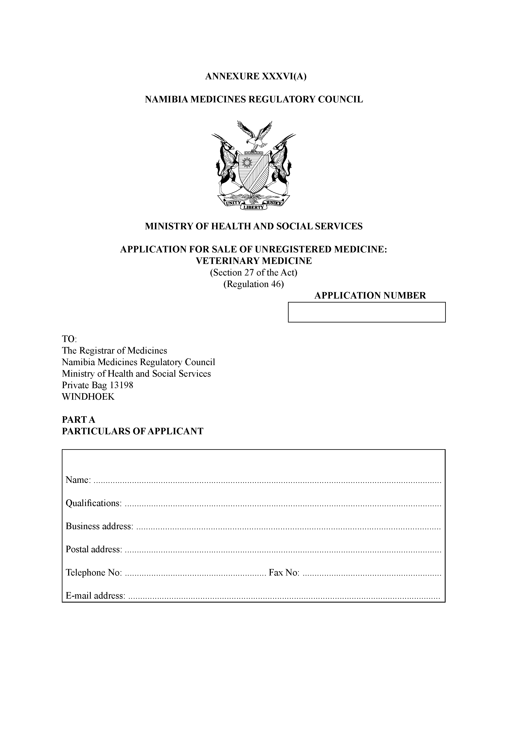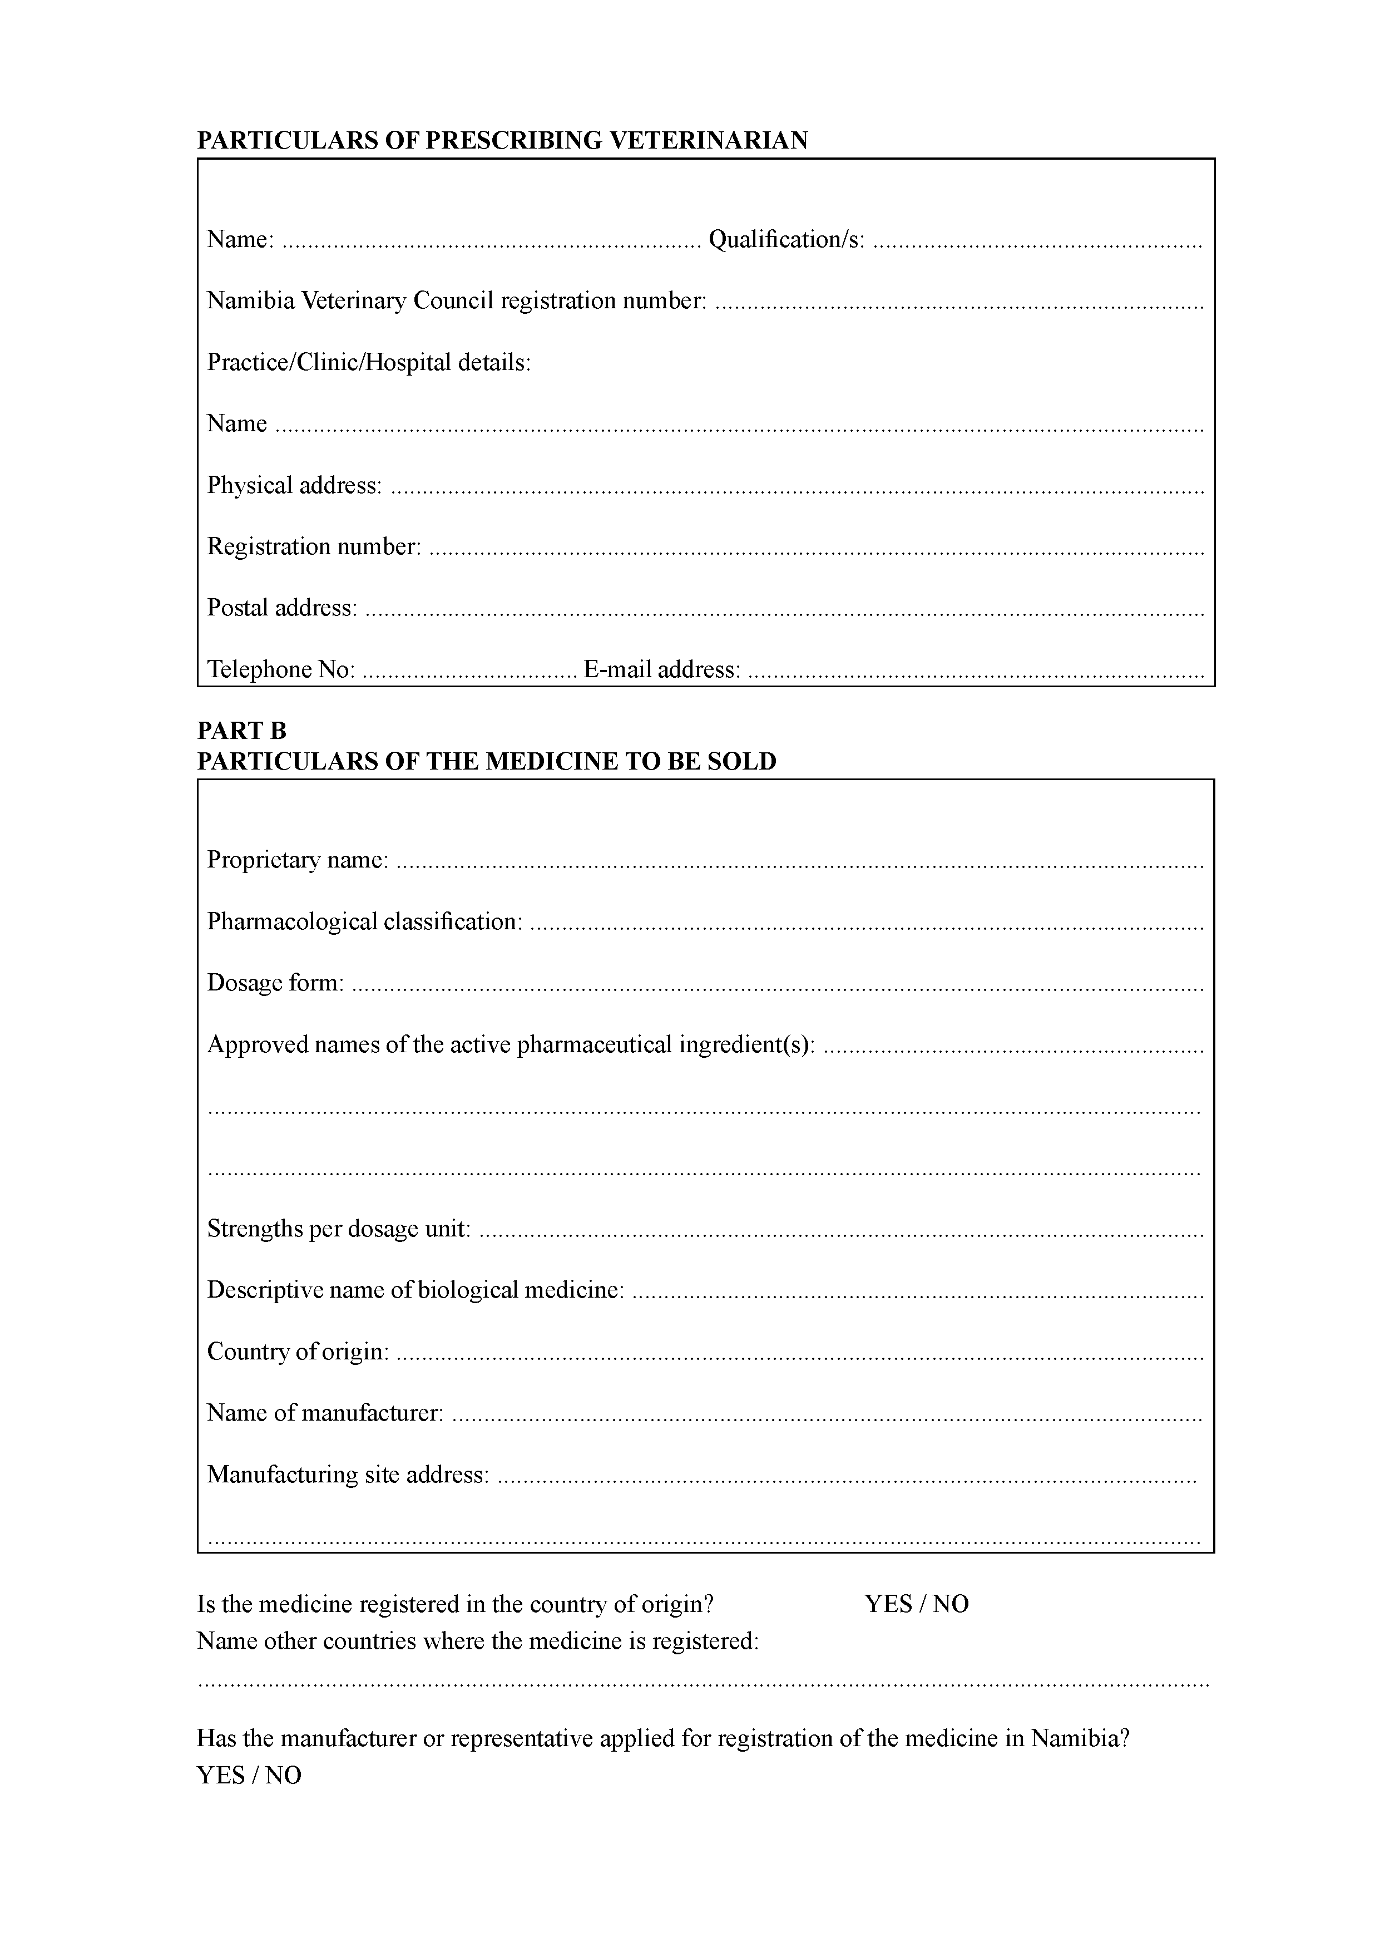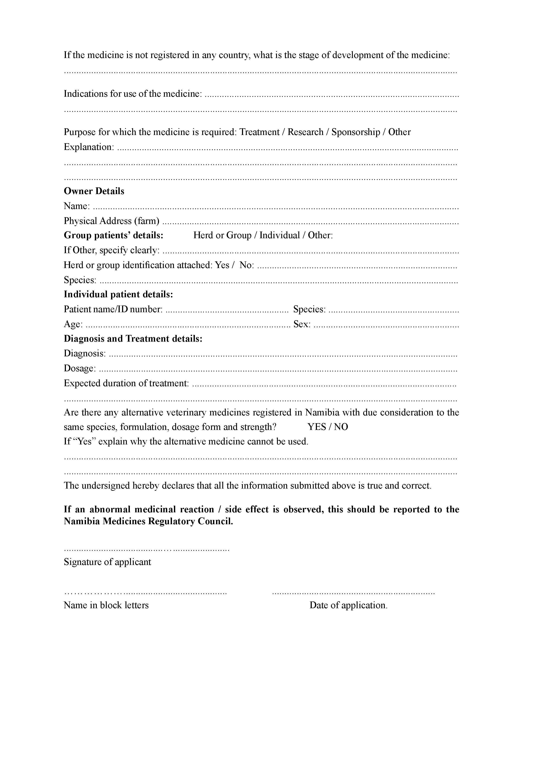

[Annexure XXXVII substituted by GN 202/2019]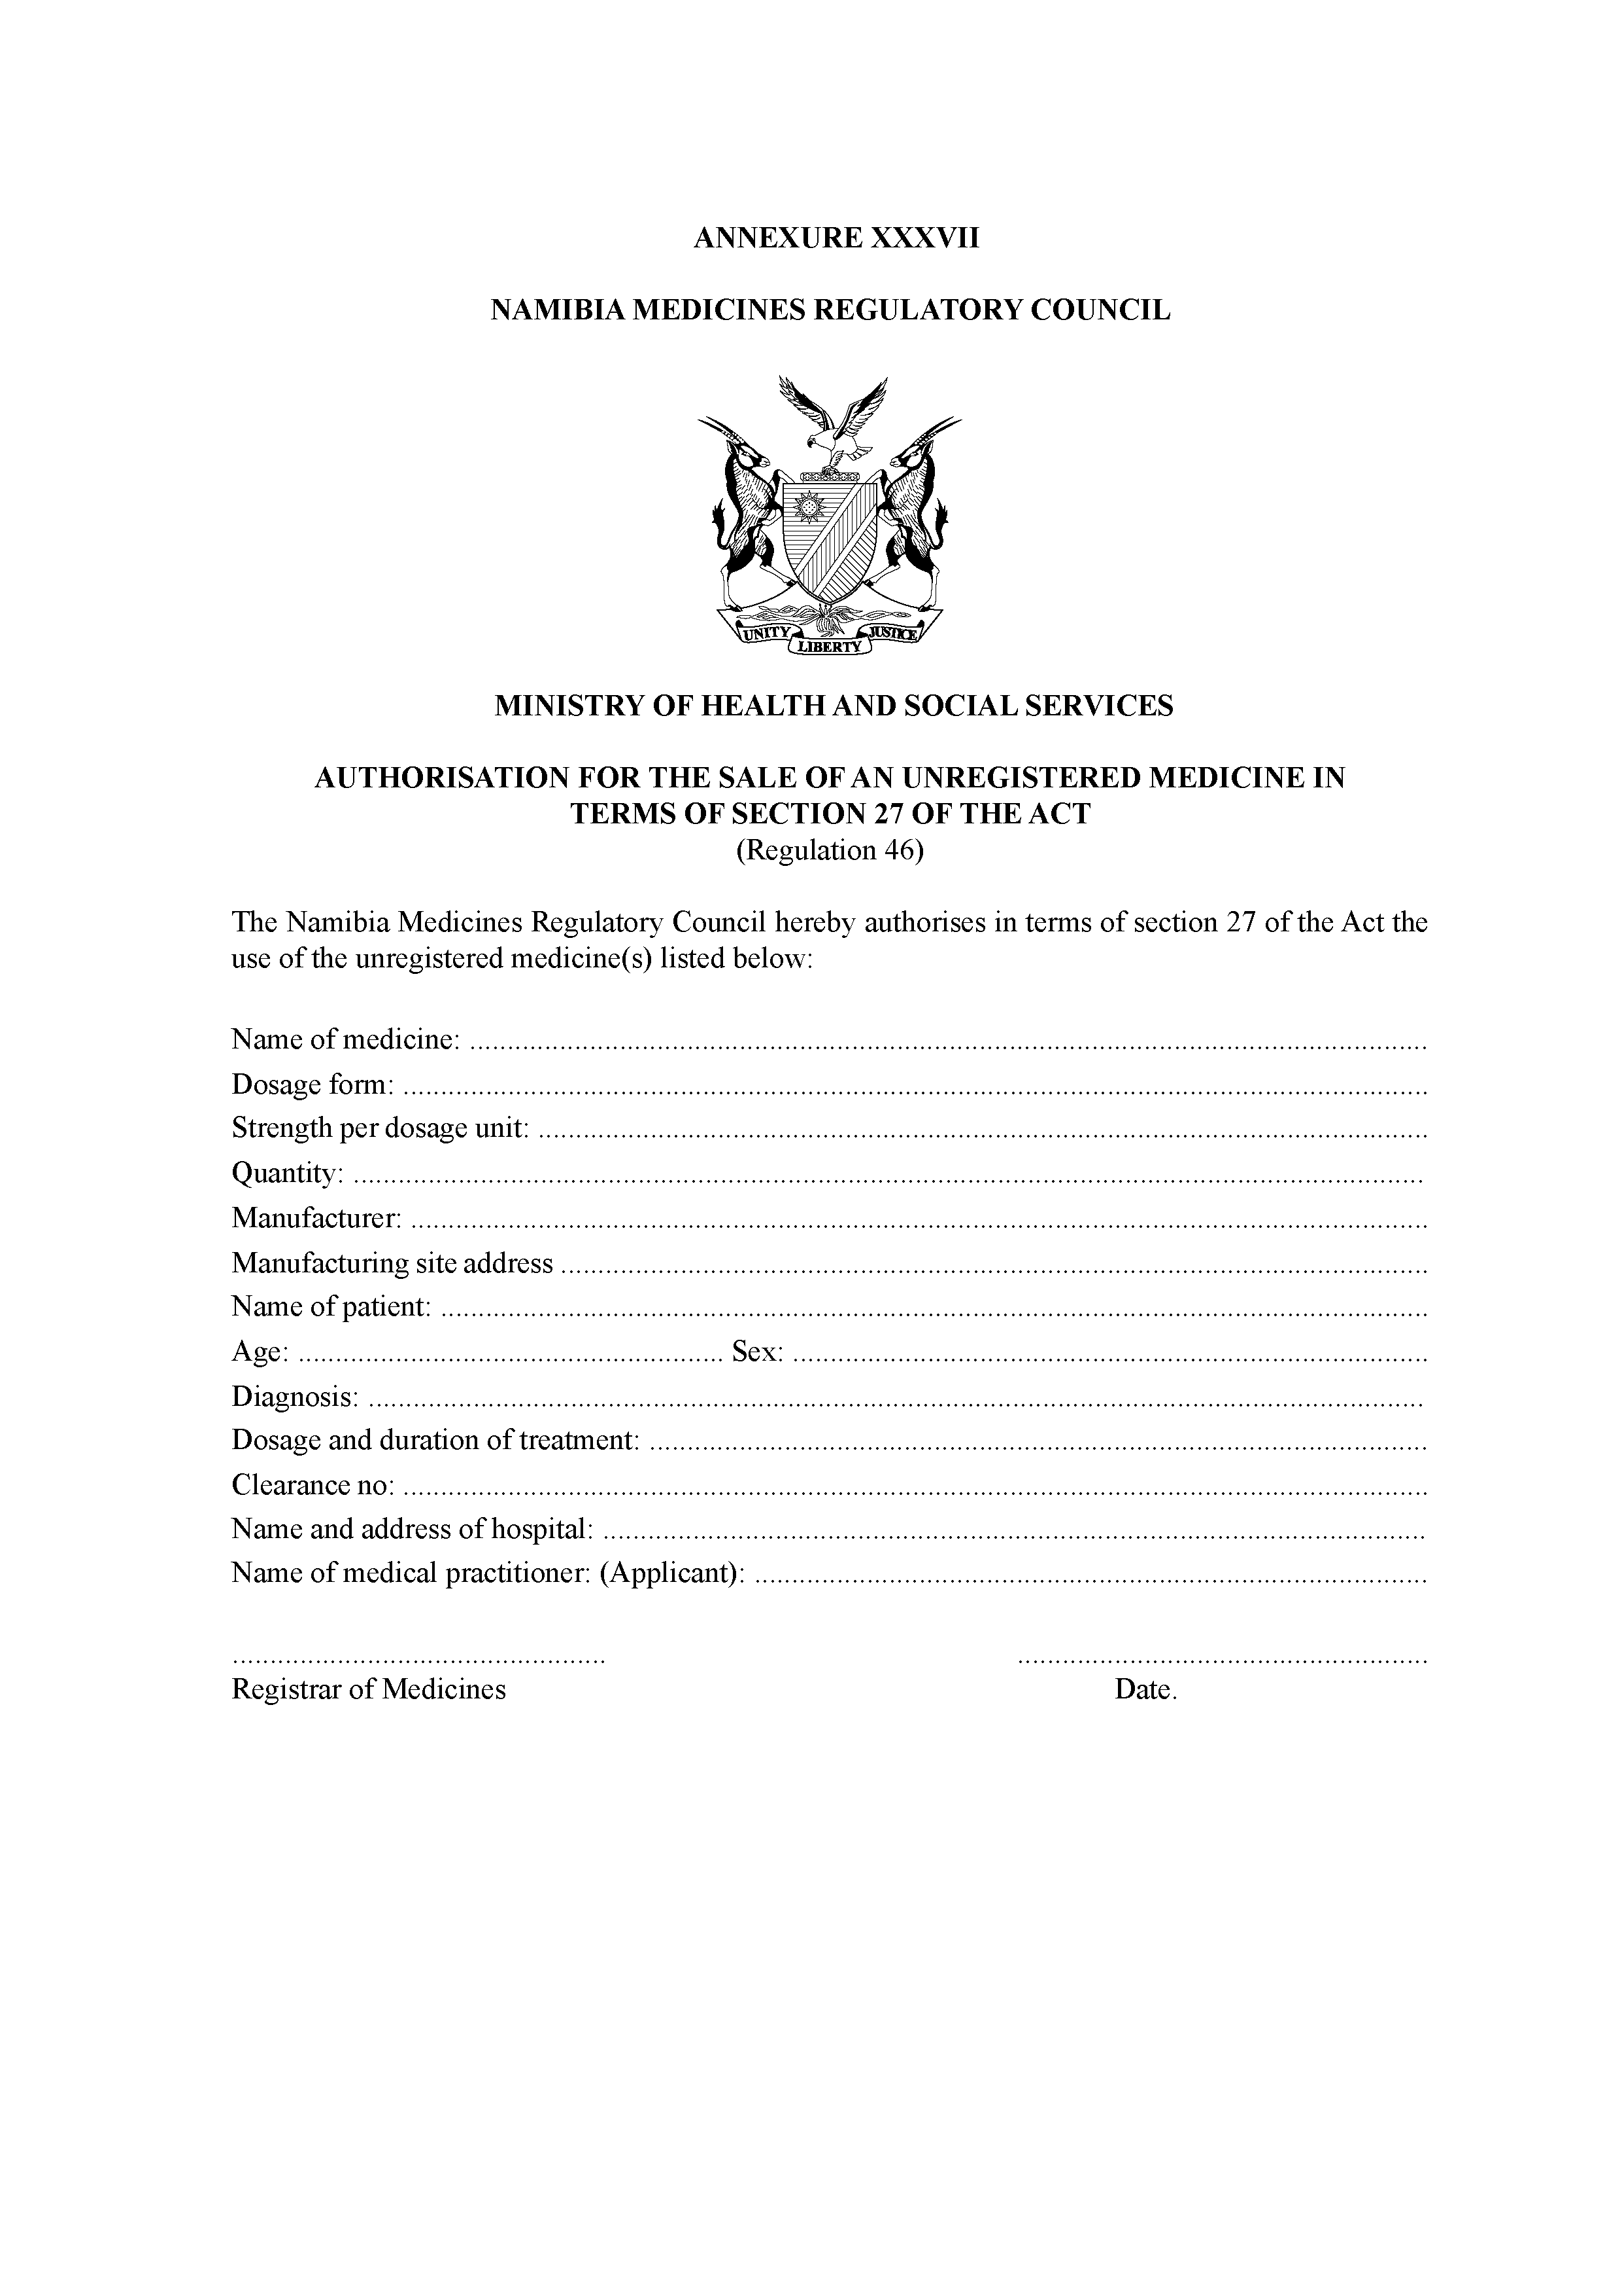

[Annexure XXXVII(A) inserted by GN 202/2019]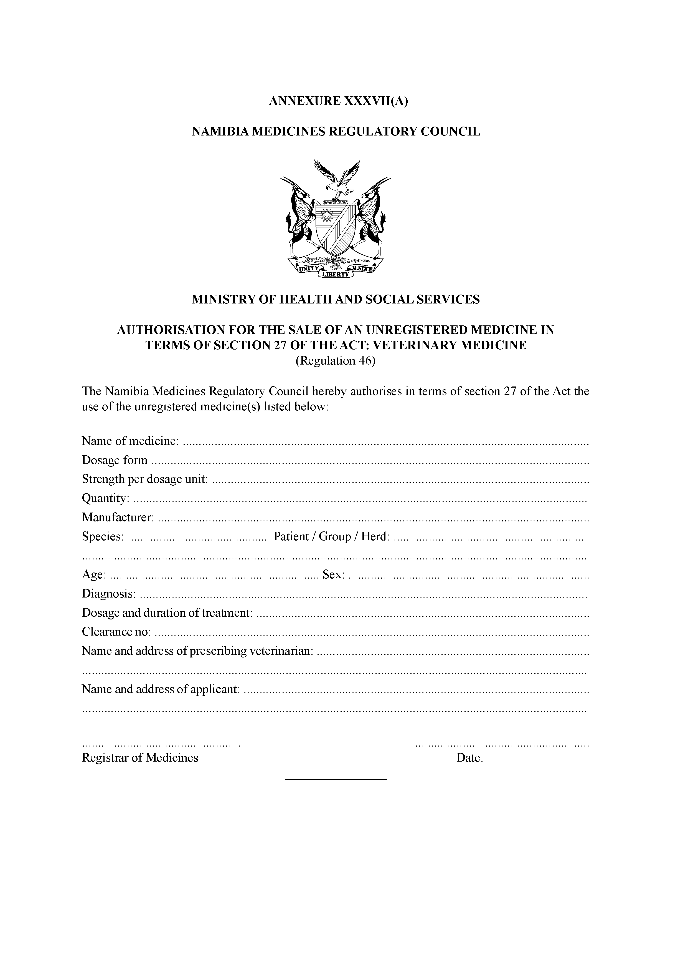

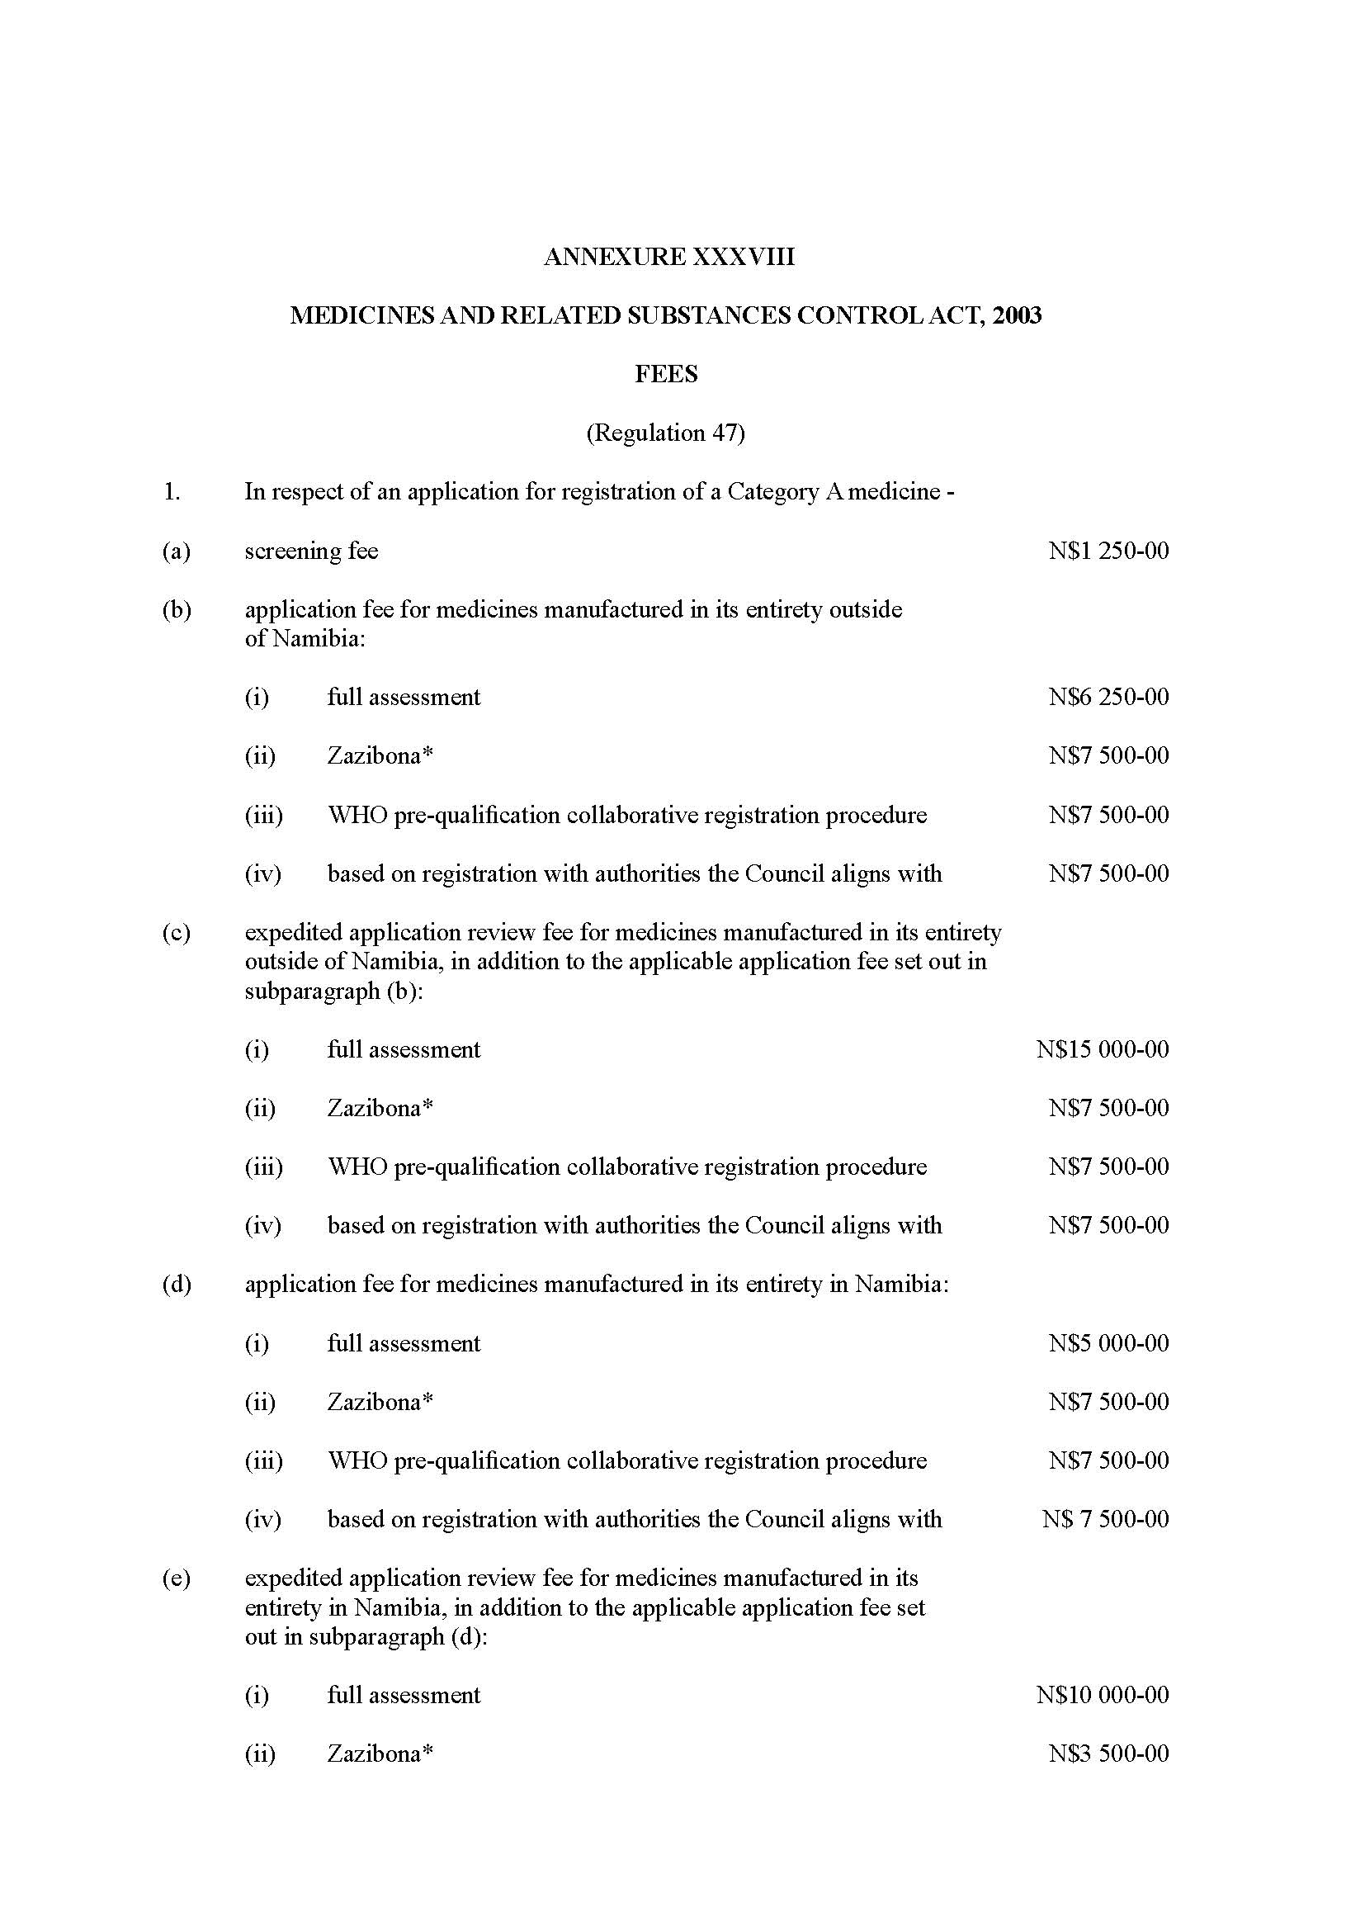

[Annexure XXXVIII substituted by GN 316/2015 and by GN 178/2021]

