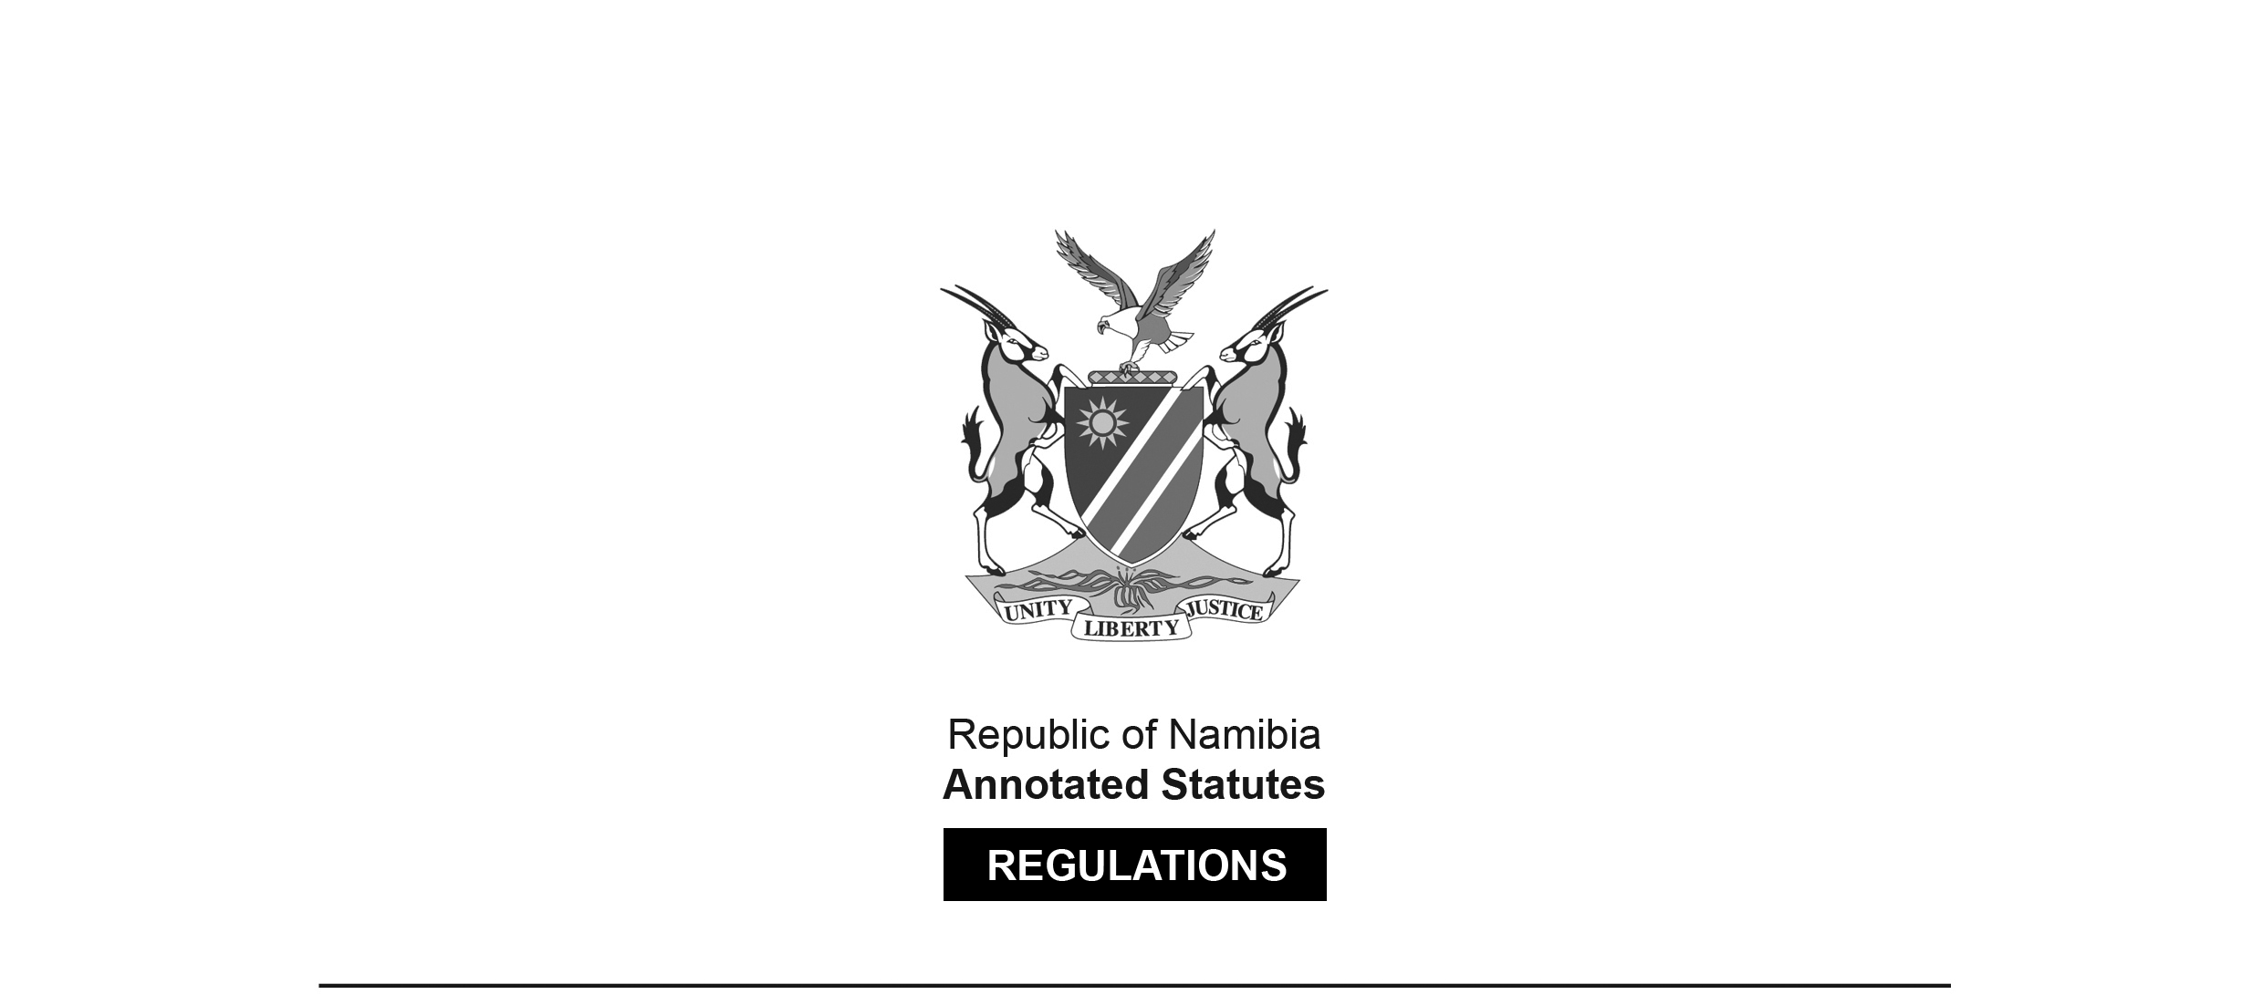

REGULATIONS MADE IN TERMS OF

Medical and Dental Act 10 of 2004

section 59

**Regulations relating to Scope of Practice of a Dentist**

Government Notice 34 of 2017

(GG 6249)

came into force on date of publication: 27 February 2017

The Government Notice which publishes these regulations notes that they were   
made on the recommendation of the Medical and Dental Council of Namibia.

**ARRANGEMENT OF REGULATIONS**

1. Definitions

2. Scope of practice of a dentist

**Definitions**

**1.** In these regulations, unless the context otherwise indicates, a word or expression defined in the Act has that meaning, and -

“dental intern” means a person who has completed the required qualification for a dentist, in terms of this Act, and is registered as such by the Council;

“dental student” means a person approved and registered by Council for admission to the required course of study a Bachelors Degree in Dentistry;

“dentist” means a health professional who is qualified and clinically capable of providing dental care services to individuals and families;

“medicine” means -

(a) a substance or a mixture of substances prepared and used or purported to be suitable for use or manufactured or sold for use in -

(i) the diagnosis, treatment, mitigation, modification or prevention of a disease, abnormal physical or mental state, or the symptoms thereof, in humans or animals; or

(ii) restoring, correcting or modifying any somatic, mental or organic function in humans or animals, whether or not administered by or through a medical device;

(b) a veterinary medicine; or

(c) a complementary medicine;

“patient” means any person being treated by a dentist at the request of that person, his or her legal guardian or any other person who provides care for that patient; and

“the Act” means the Medical and Dental Act, 2004 (Act No. 10 of 2004).

**Scope of practice of a dentist**

**2.** (1) The following acts are regarded to be the acts which fall within the scope of practice of a dentist and relating to -

(a) studying, diagnosing and treatment of diseases, disorders and conditions affecting the oral cavity, maxillofacial area and their associated structures;

(b) preventing or curing of such diseases, disorders or conditions through dental or surgical procedures; and

(c) educating and counselling of a patient.

(2) When practicing the profession, a dentist may -

(a) examine physically or clinically the oral, maxillofacial and related structures of a patient;

(b) diagnose the diseases, disorders, injuries or conditions of the oral, maxillofacial and related structures of the human body, including -

(i) determining the relevance of systemic conditions; and

(ii) giving advice on those conditions;

(c) advise a patient on his or her oral and dental health status;

(d) perform dental procedures on a patient, including the fitting or supplying of a dental prosthesis or appliance;

(e) perform aesthetic or cosmetic procedures on a patient pertaining to the oral and peri-oral area;

(f) prescribe medicines aimed at managing the oral and dental health of a patient, including the prevention and treatment of diseases and the rehabilitation of the patient; and

(g) provide information to a patient to enable that patient to improve and maintain his or her oral and dental health.

(3) The provisions of subregulation (1) may not be construed as prohibiting -

(a) a person registered under any legislation regulating dentistry from performing any act specified in accordance with the provisions of such legislation;

(b) a dental intern, working at an institution recognized by the council, from performing a function or issuing a certificate or other document which in terms of any legislation is required to be performed or issued by a dentist;

(c) a dental student from performing an act under the direct and immediate supervision of a dentist in the course of training such student;

(d) a dentist from performing an act falling within the scope of dentistry or using any name, title, description or symbol normally associated with such practitioners profession; or

(e) a person from performing an act in the course of bona fide research at any institution approved for that purpose by the Minister.

(4) Despite sub regulation (2), a dentist may perform any procedure under any specialty or additional qualification registered in his or her name.

[“Sub regulation” appears as two words in subregulation (4)   
but as one word “subregulation” elsewhere in these regulations.]

(5) This regulation may not be construed as prohibiting a dentist from employing a dental technician, dental therapist or an oral hygienist registered under the Act, or the Allied Health Professions Act, 2004 (Act No. 7 of 2004).