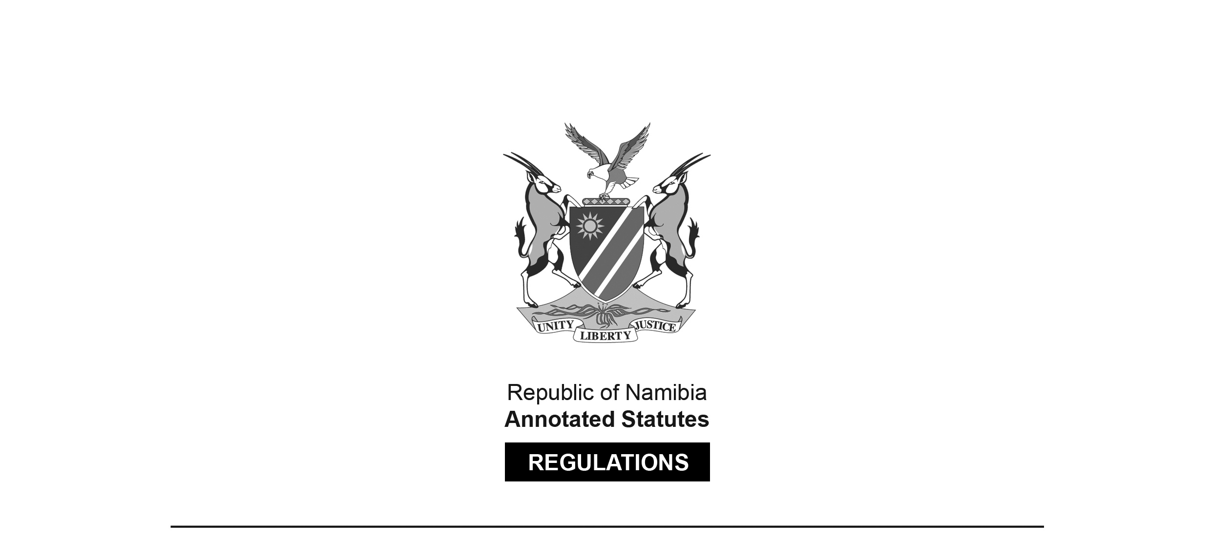
REGULATIONS MADE IN TERMS OF

Marine Resources Act 27 of 2000
section 61(1)

Regulations to Reduce Incidental By-Catch of Seabirds
in the Hake Demersal Longline Vessels
Government Notice 270 of 2015
(GG 5877)
came into force on date of publication: 19 November 2015

as amended by

Government Notice 68 of 2016 (GG 5990)
came into force on date of publication: 15 April 2016

ARRANGEMENT OF REGULATIONS

1. Definitions
2. Deployment of bird scaring lines
3. Bird scaring line design
4. Streamer design
5. Broken or damaged lines
6. Offences and penalties

Definitions

1. In these regulations, any expression to which a meaning has been assigned in the Act bears that meaning and, unless the context otherwise indicates -

“bird scaring line” means long lines attached to a high point on the stern of a vessel to which streamers are attached which interferes with birds attempting to reach the baited longline or trawl net below;

“demersal” means on or near the bottom of the sea, on or near the continental shelf, on or near the continental slope and along the continental line, depending on the depth range of the sea territory concerned;

“hawser rope” means the nautical term for a thick cable or rope used in mooring or towing a vessel;

“kernmantle” means braided or sheathed rope constructed with its interior core protected by woven exterior sheath;

“long line” means fishing using a long line, called the main line, with baited hooks attached at intervals by means of branch line called snoods. A snood is a short length of line attached to the main line using a clip or swivel, with the hook at the other end; and

[definition of ‘long line” inserted by GN 68/2016;
the word “and” at the end appears to be in error]

“port side” and “starboard” means nautical terms referring to the left and right sides respectively of a vessel as perceived by a person on board facing the front of the vessel;

“streamers” means strands of brightly coloured line attached to bird scaring lines at regular spaced intervals;

“swivel” means a connection allowing the connected object to rotate horizontally or vertically freely; “the Act” means the Marine Resources Act, Act No. 27 of 2000;

“towed device” means either a road cone with a buoy placed inside or a 10 meter length of double folded hawser rope with floats attached for buoyancy;

[definitions of “trawling”, “trawl net” and “trawl warps” deleted by GN 68/2016]

“winches” means the machines used for hoisting up the longline catch;

[definition of “winches” substituted by GN 68/2016;
the semicolon at the end should be a full stop]

Deployment of bird scaring lines

2. (1) A person may not engage a longline vessel in fishing operations without deployment of at least one bird scaring line on each line set during fishing operations at all times and the line must be -

(a) deployed immediately after the first longline anchor enters the water and before any hooks are set;

(b) deployed in such a manner that it flies above the hook line;

(c) retrieved only after the last hook has been set; and

(d) attached to the stern of the vessel above and outside of the hook line setting station at least eight metres above the sea surface.

(2) If a vessel operator attaches a second bird scaring line, the lines must be attached to the port and starboard side at the stern of the vessel.

[subregulation (2) substituted by GN 68/2016]

(3) A towed device capable of maintaining tension on the top line must be attached to the seaward end of the bird scaring line.

(4) A person may not engage in fishing activities without a spare set of two bird scaring lines carried on board a vessel at all times as to be deployed in the event of loss or damage to an already deployed line.

(5) No fishing activities may take place without at least one bird scaring line deployed in a manner compliant with these regulations.

(6) A person may not allow a demersal longline vessel to leave port without a functional bird scaring line manufactured in terms of the requirements referred to in regulations 3 and 4.

[subregulation (6) substituted by GN 68/2016]

(7) As from 30 November 2015 after the end of the grace period no person may allow a longline vessel to sail without a full set of bird scaring lines nor fish without at least one bird scaring line deployed as per these regulations.

Bird scaring line design

3. (1) All bird scaring lines must comply with the following requirements -

(a) the topline must be a minimum of 150 metres long consisting of braided cord with a minimum diameter of six millimetres;

(b) the topline must have an additional length of a minimum of two metres to a maximum of four metres for the purpose of attachment;

(c) the topline above the water must be a strong line of high visibility yellow or orange; and

(d) a towed device capable of maintaining tension must be attached to the end of the topline to the seaward end of the bird scaring line by means of a large 80 gram barrel swivel.

[Subregulation (1) is the only subregulation in regulation 3.]

Streamer design

4. (1) All bird scaring lines must have streamers attached that comply with the following requirements and -

(a) must be made from high visibility yellow soft plastic or rubber tubing three to five millimetres in diameter;

(b) must be long enough to reach the water in calm weather conditions;

(c) a minimum of 28 paired streamers must be securely attached to the topline at five metre intervals with the first streamer no further than 10 metres from the vessel stern and the last no less than 10 metres from the towed device point of attachment; and

(d) the first five paired sets of streamers must be at least 4 metres in length.

[Subregulation (1) is the only subregulation in regulation 4.]

Broken or damaged lines

5. (1) All broken or damaged bird scaring lines must be retained by the vessel operator being the owner, the lessee, the charterer, the master or an employee and available for presentation to fisheries inspectors or fisheries observers on request.

(2) All broken or damaged bird scaring lines must be replaced by the vessel operator being the owner, the lessee, the charterer, the master or an employee as soon as the vessel docks and before it sails again.

Offences and penalties

6. Any person, who being the owner, lessee, charterer, master or employee of a hake demersal trawler vessel -

(a) uses such vessel to execute fishing operations; or

(b) allows it to be so used;

in contravention or fails to comply with regulations 2, 3, 4 or 5, commits an offence and liable on conviction to a fine not exceeding N$ 500 000 or to imprisonment not exceeding a period of 10 years or to both such fine and such imprisonment

[GN 68/2016 directs that the expression “demersal longline” be substituted for the expression “trawling line” in regulation 6. However, the expression “trawling line” does not appear in this regulation. It appears that the intention may have been to substitute the expression “demersal longline” for the expression “demersal trawler”. There is no full stop at the end of regulation 6.]

