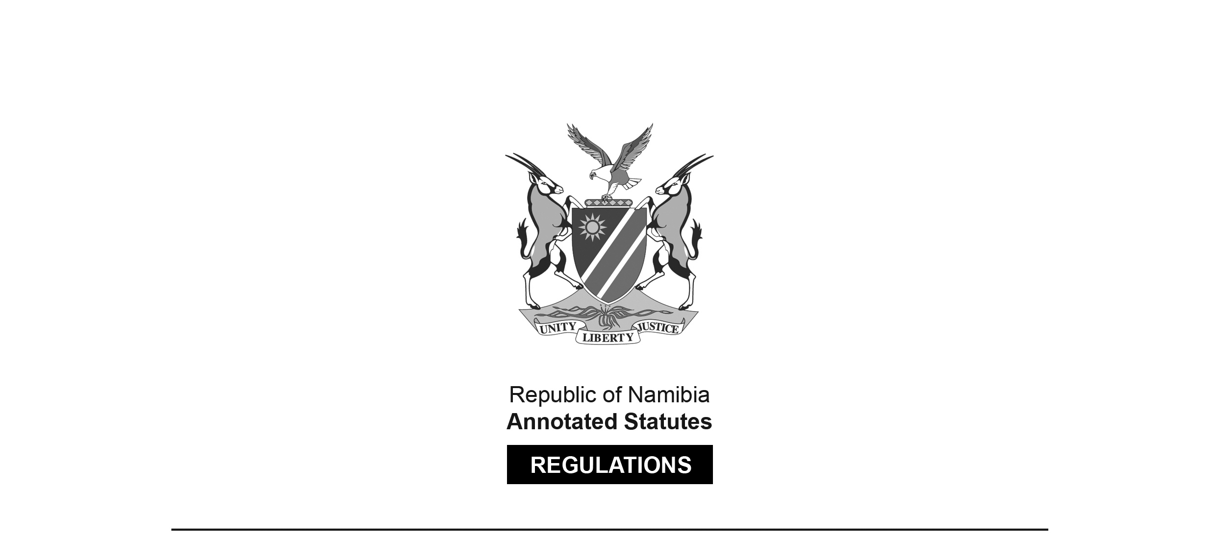

REGULATIONS MADE IN TERMS OF

Marine Resources Act 27 of 2000

section 61(1)

Regulations to Reduce Incidental By-Catch of Seabirds   
in the Hake Demersal Trawl Vessels

Government Notice 269 of 2015

(GG 5877)

came into force on date of publication: 19 November 2015

ARRANGEMENT OF REGULATIONS

1. Definitions

2. Deployment of bird scaring lines

3. Bird scaring line design

4. Streamer lines

5. Offences and penalties

**Definitions**

**1.** In these regulations, any expression to which a meaning has been assigned in the Act bears that meaning and, unless the context otherwise indicates -

“bird scaring line” means long lines attached to a high point on the stern of a vessel to which streamers are attached which interfere with birds attempting to reach the baited longline or trawl net below;

“demersal” means on or near the bottom of the sea, on or near the continental shelf, on or near the continental slope and along the continental line, depending on the depth range of the sea territory concerned;

“hawser rope” means the nautical term for a thick cable or rope used in mooring or towing a vessel;

“kernmantle” means a braided or sheathed rope constructed with its interior core protected by woven exterior sheath;

“port side” and “starboard” means nautical terms referring to the left and right sides respectively of a vessel as perceived by a person on board facing the front of the vessel;

“streamers” means strands of brightly coloured line attached to bird scaring lines at regular spaced intervals;

“swivel” means a connection allowing the connected object to freely rotate horizontally or vertically; “the Act” means the Marine Resources Act, 2000 (Act No. 27 of 2000);

“towed device” means either a road cone with a buoy placed inside or a 10 metre length of double folded hawser rope with floats attached for buoyancy;

“trawling” means fishing with a trawl net that is towed along at a given depth below the surface;

“trawl net” means a funnel shaped net with a closed off tail;

“trawl warps” means cables attached to the trawl net employed to direct fish; and

“winches” means machines used for hoisting up the trawled catch.

**Deployment of bird scaring lines**

**2.** (1) A person may not engage in fishing operations without deployment of two bird scaring lines at all times when the trawl doors enter the water and the winches start hauling.

(2) A person may not allow a trawler to leave port without two functional bird scaring lines manufactured in terms of the requirements referred to in regulations 3 and 4.

(3) Bird scaring lines must be -

(a) deployed immediately after the trawl doors enter the water;

(b) retrieved immediately before the winches start hauling or if the vessel comes to a stop;

(c) attached to the vessel above and outside the trawl warps at least eight metres above the surface in calm weather conditions;

(d) attached to a towed device on the topline; and

(e) attached to the star board side and the port side of the vessel respectively.

(4) A spare set of two bird scaring lines must be carried on board a vessel at all times to be deployed in the event of loss or damage to an already deployed line.

(5) Bird scaring lines may be deployed and retrieved from the fishing deck by the use of an additional rope which is attached from the aft deck to the top line between the first and second set of streamers.

(6) A person may not discard offal from the vessel during the shooting of gear from the period when the net enters the water up until the doors are deployed.

(7) In the event of breakage of a bird scaring line during fishing operations, the remaining functional line must be deployed by the person in charge of the vessel on the side where offal discard takes place.

(8) All broken or damaged bird scaring lines must be retained by the vessel operator and available for presentation to fisheries inspectors or fisheries observers on request.

(9) The vessel operator being the owner, the lessee, the charterer or the master must replace all broken or damaged bird scaring lines as soon as the vessel docks and before it sails again.

(10) As from 30 November 2015 a person may not sail a trawl vessel without two full sets of bird scaring lines nor fish without one set of two lines deployed as in accordance with these regulations.

**Bird scaring line design**

**3.** (1) All bird scaring lines must comply with the following requirements set out in subregulation (2) and regulation 4.

(2) The topline must -

(a) be a minimum of 30 metres long consisting of kermantle rope with a minimum diameter of 9 to 12 millimeters;

(b) have an additional length of a minimum of two metres to a maximum of four metres for the purpose of attachment;

(c) be a strong line of high visibility yellow or orange above the water; and

(d) be attached to a towed device capable of maintaining tension at the end of the topline to the seaward end of the bird scaring line by means of a large 80 gram barrel swivel.

**Streamer lines**

**4.** (1) Streamers attached to bird scaring lines must be -

(a) made from high visibility yellow plastic hose 10 to 16 millimeters in diameter; and

(b) long enough to reach the water in calm weather conditions.

(2) A minimum of six paired streamers must be securely attached to the bird scaring line at two metre intervals with the first streamer no further than two metres from the vessel stern and the last no less than 10 metres from the towed device point of attachment.

**Offences and penalties**

**5.** Any person who being the owner, the lessee, the charterer or the master or an employee of a hake demersal trawler vessel -

(a) uses such vessel to execute fishing operations; or

(b) allows it to be so used;

in contravention or fails to comply with regulations 2, 3 or 4, commits an offence and is liable on conviction to a fine not exceeding N$ 500 000 or to imprisonment not exceeding a period of 10 years or to both such fine and such imprisonment.