REGULATIONS MADE IN TERMS OF

Legal Practitioners Act 15 of 1995
section 81(1)

Candidate Legal Practitioners Regulations
Government Notice 228 of 1995
(GG 1207)
came into force on date of publication: 1 December 1995

The Government Notice which publishes these regulations notes that they
were made after consultation with the Board for Legal Education. All of the
amendments to the regulations also state that they were made after
consultation with the Board for Legal Education.

as amended by

Government Notice 58 of 1997 (GG 1528)
came into force on date of publication: 1 April 1997
Government Notice 67 of 1997 (GG 1537)
came into force on date of publication: 15 April 1997
Government Notice 8 of 1999 (GG 2025)
came into force on date of publication: 15 January 1999
Government Notice 8 of 2011 (GG 4649)
came into force on date of publication: 15 February 2011

ARRANGEMENT OF REGULATIONS

PART I
INTRODUCTORY

1. Definitions
2. Admission as a legal practitioner

PART II
REGISTRATION

3. Announcement of commencement of course of post-graduate study
4. Application for registration as a candidate legal practitioner
5. Register of candidate legal practitioners
6. Reregistration

PART III
TRAINING PROGRAMME

7. Syllabus
8. Contract of attachment
9. Keeping of diary
10. Assessment of diary
11. Candidate’s duty to take care of diary
12. Evaluation of candidate’s performance upon loss or damage of diary or defacement of entries
13. Attendance at classes

PART IV
EXAMINATION

14. Holding of Legal Practitioners’ Qualifying Examination
15. Composition of Legal Practitioners’ Qualifying Examination
16. Requirements of the Legal Practitioners’ Qualifying Examination
17. Notice
18. Conduct of Legal Practitioners’ Qualifying Examination
19. Results of Legal Practitioners’ Qualifying Examination
20. Scripts of Legal Practitioners’ Qualifying Examination
21. [deleted by GN 8/1999]
22. Disciplinary action against candidate legal practitioners

PART V
GENERAL

23. Lodgement of documents and papers
24. Extension and abridgment of time

Annexure 1: Application for registration as a candidate legal practitioner
Annexure 2: Certificate of registration
Annexure 3: Contract of attachment
Annexure 4: Notice of intention to sit the legal practitioners’ qualifying examination
Annexure 5: Application for exemption from the whole or part of the legal practitioners’ qualifying examination
Annexure 6: Registration and Tuition Fees

PART I

INTRODUCTORY

Definitions

1. In these Regulations any word or expression to which a meaning has been assigned in the Legal Practitioners Act, 1995 (Act 15 of 1995) shall bear that meaning and, unless the context otherwise requires -

“Act” means the Legal Practitioners Act, 1995 (Act 15 of 1995);

“Board” means the Board for Legal Education established by section 8 of the Act;

“candidate” means a candidate legal practitioner as defined in section 1 of the Act;

“diary” means a candidate’s diary referred to in regulation 9;

“prinicipal”, in relation to a candidate, means the legal practitioner to whom the candidate is attached for practical legal training for the purposes of section 5(2) of the Act;

[The word “principal” is misspelt in the Government Gazette, as reproduced above.]

“Programme Director” means the person designated to supervise and co-ordinate the course of post-graduate study at the Centre;

“secretary” means the secretary to the Board;

Admission as a legal practitioner

2. Subject to the provisions of the Act, a person wishing to qualify to be admitted as a legal practitioner under the Act, shall comply with the provisions of these regulations.

PART II

REGISTRATION

Announcement of commencement of course of post-graduate study

3. At least six weeks before the commencement of every course of post graduate-study at the Centre, the Board shall cause to be published, once in the Gazette and once a week during three consecutive weeks in at least two daily newspapers circulating in Namibia, a notice announcing the date of the commencement of such course and inviting interested persons to apply for registration as candidate legal practitioners.

Application for registration as a candidate legal practitioner

4. (1) Any person wishing to be registered as a candidate shall, before or on the date of commencement of the course of post-graduate study as announced under regulation 3, or such later date as the Board, after consultation with the Programme-Director, may allow in a particular case, make application for registration to the Board by duly completing Form JTC/1, as set out in Annexure 1, and lodging the completed form with the Board, together with the qualification s which in his or her submission entitles him or her to registration in accordance with section 5(l)(a) or (c) of the Act

(2) The Board may by seven days’ notice in writing require an applicant to attend personally before the Board and may reject the application if the applicant fails to attend.

(3) If the Board is satisfied that the applicant -

(a) holds a degree or equivalent qualification in law referred to in paragraph (a) or paragraph (c) of subsection (1) of section 5 of the Act;

(b) has, in a case of a person holding a degree or equivalent qualification referred to in the said paragraph (c), complied with the provisions of subparagraph (i) of that paragraph; and

(c) is of good character and a fit and proper person to be registered as a candidate,

the Board shall, upon payment of the registration and tuition fees prescribed in Annexure 6, issue to the applicant a certificate of registration in the form set out in Annexure 2.

(4) The Board shall reject an applicant’s application if it is not satisfied with respect to the matters mentioned in subregulation (3).

(5) An applicant who is dissatisfied with a decision of the Board rejecting his or her application for registration as a candidate, may -

(a) within 14 days after the decision of the Board is communicated to him or her, request the Board in writing to furnish him or her with its reasons in writing for that decision within 30 days after receiving such request;

(b) within 30 days after having been furnished with the Board’s reasons in accordance with paragraph (a), or after the expiration of the period within which those reasons should have been furnished, appeal to the Court against that decision.

(6) Upon hearing an appeal in terms of subregulation (5), the Court may

(a) confirm the decision of the Board;

(b) set aside the decision of the Board and order that the applicant be registered as a candidate; or

(c) make such other order as it thinks fit,

and make such order as to costs as the Court may consider fair.

(7) The rules applicable in respect of the noting and prosecution of an appeal against the finding of a magistrate’s court in a civil suit shall mutatis mutandis be applicable in respect of the noting and prosecution of an appeal in terms of subregulation (5), but subject to the provisions of that subregulation relating to the period within which the appeal shall be noted.

Register of candidate legal practitioners

5. The Board shall maintain a register in which it shall cause to be recorded with respect to every person registered as a candiate under regulation 4(3) -

[The word “candidate” is misspelt in the Government Gazette, as reproduced above.]

(a) the full name, date of birth, nationality and physical and postal addresses of the candidate;

(b) the date of issue of the certificate of registration to the candidate; and

(c) the name of the practising legal practitioner under whom the candidate shall undergo practical training as required by section 5(2) of the Act, and the name of the law firm or institution, if any, in which such legal practitioner practises.

Reregistration

6. (1) A certificate of registration issued by the Board under regulation 4(3) shall lapse if the person to whom it has been issued does not commence his or her attendance of the course of post-graduate study at the Centre within three months of the date of issue of such certificate.

(2) A person whose certificate of registration has lapsed in terms of subregulation (1) may re-apply for registration in terms of these regulations.

PART III

TRAINING PROGRAMME

Syllabus

7. The course of post graduate study shall extend for a period of at least nine months, three months of which shall be devoted to compulsory full time lecturing at the Justice Training Centre, and the syllabus of the course shall comprise the following subjects:

(a) Civil Practice and Procedure in the Supreme Court, High Court and the Lower Courts, Legal costs, and Prescription;

(b) Criminal Practice and Procedure in the Namibian Courts;

(c) Motor Accident Law and Motor Vehicle Accident Claims;

(d) Professional Ethics and Conduct, and Techniques in Litigation, including salient rules of Evidence;

(e) Practice, Management and Administration, and Practical Bookkeeping and Accounts;

(f) Wills and Estates;

(g) Practice of Constitutional Law, Human Rights and Practical workings of the Organs of the State and Public Bodies;

(h) Practice of Labour Law and Alternative Dispute Resolution;

(i) Practice and Procedure relating to the law of Insolvency and Trusts;

(j) Practice and Procedure relating to Commercial Transactions and Drafting of Contracts;

(k) Legal Drafting; and

(1) The Law Practice and Procedure of Conveyancing (optional).

[regulation 7 amended by GN 58/1997 and substituted by GN 8/1999]

Contract of attachment

8. (1) Subject to subregulation (2), every candidate shall not later than the date of commencement of his or her attendance of the course of post-graduate study at the Centre, or such later date as the Board, after consultation with the Programme-Director, may approve in a particular case, enter into a contract of attachment with his or her principal in terms whereof such candidate will be attached to such principal for not less than 60 hours per month for the duration of that course.

(2) Notwithstanding subregulation (1), the Board may, if in its opinion good reasons exist, permit a candidate to undergo practical training under attachment to a principal after he or she has passed the Legal Practitioners’ Qualifying Examination.

(3) The contract of attachment shall -

(a) comply substantially with the form of the contract set out in Annexure 3; and

(b) contain the whole agreement entered into between the candidate and his or her principal.

(4) Every principal shall, not later than one month after he or she has concluded a contract of attachment with a candidate -

(a) file the original of such contract with the secretary; and

(b) lodge a copy of such contract with the Law Society.

(5) The Board shall have the right to reject any contract of attachment which, in the opinion of the Board, contains improper or undesirable clauses.

Keeping of diary

9. (1) Every candidate shall, with effect from the commencement of his or her attachment to a principal, and for the duration thereof, keep and maintain a diary for recording details of the practical legal training undergone by him or her under such attachment.

(2) A candidate shall in respect of each working day during the period referred to in subregulation (1), as the Programme-Director may determine, make and keep in the diary in clear and legible handwriting a true and accurate record of the following matters -

(a) the date of the entry;

(b) whether he or she attended at the office of his or her principal or any other place directed by the principal, and if he or she has not done so, his or her reasons therefor;

(c) the duties and tasks assigned to him or her by his or her principal, and if no duties or tasks are assigned, the reasons for such omission;

(d) the manner in and extent to which he or she has performed the duties and tasks assigned to him or her;

(e) the approximate number or hours actually spent by him or her in the execution of the duties and tasks; and

(f) any relevant matter not covered in paragraphs (a), (b), (c), (d) and (e) or any remarks.

(3) A candidate shall ensure that every daily entry in the diary made by him or her in accordance with subregulation (2) is endorsed by his or her principal, or in absence of the principal, by any other legal practitioner under whose control or supervision he or she performed his or her duties and tasks during the principal’s absence.

(4) The Programme-Director shall make available to candidates a sufficient number of diaries at a reasonable cost and no candidate shall use any other type of diary.

Assessment of diary

10. (1) Every candidate shall, at such times as the Programme-Director may determine, which shall be at least once every quarter and at the end of the course, hand over to the Programme Director his or her diary for inspection.

(2) On the receipt of a candidate’s diary, the Programme-Director shall examine the entries and note in the diary any suggestions or comments and thereafter return the diary to the candidate at such time as he or she may think fit.

(3) The Programme-Director shall keep in respect of every candidate a record of a fair summary of his or her suggestions or comments and any remarks recorded in the diary by the principal.

(4) If at the end of the course the Programme-Director is satisfied that -

(a) a candidate has satisfactorily performed the duties and tasks assigned to him or her by his or her principal, he or she shall forthwith make the following entry in the diary of that candidate and inform him or her accordingly -

“Candidate has satisfactorily attended and completed the course of post-graduate study and is recommended to sit the Legal Practitioners’ Qualifying Examination.”;

(b) a candidate has not satisfactorily performed the duties and tasks assigned to him or her by his or her principal, he or she shall forthwith make one of the following entries in the diary of that candidate and inform him or her accordingly -

(i) “Candidate has not attended and completed course of post­graduate study satisfactorily and is not recommended to sit the Legal Practitioners’ Qualifying Examination.”; or

(ii) “Candidate required to perform further duties and tasks at the office of a principal satisfactorily to the Programme-Director before he/she can be recommended to sit the Legal Practitioners’ Qualifying Examination.”:

Provided that a candidate referred to in regulation 8(2), shall be entitled to sit for the Legal Practitioners’ Qualifying Examination if he or she has completed the course of post-graduate study.

(5) A candidate who is dissatisfied with an entry made by the Programme-Director under paragraph (b) of subregulation (4) may, within three days of being informed of the entry, by notice in writing, appeal to the Board against that entry and state the reasons for such appeal.

(6) An appeal referred to in subregulation (5) shall be lodged with the Programme-Director who shall forthwith transmit the appeal, together with that candidate’s diary and any relevant documents and reasons for the entry, to the secretary, and any such appeal shall be considered by the Board within 10 days after the appeal has been lodged.

(7) The Board may request the appellant and the Programme-Director to appear before it, if it thinks fit.

(8) Upon considering the appeal, the Board may -

(a) confirm the entry made by the Programme-Director; or

(b) vary or amend, in any manner it thinks fit, the entry made by the Programme- Director.

Candidate’s duty to take care of diary

11. (1) Every candidate shall be required to take the utmost care of his or her diary in order to prevent its loss or damage or the defacement of the entries therein.

(2) Where the diary of a candidate is lost or damaged or the entries therein are defaced, the candidate shall forthwith make a full report in writing to the Programme-Director explaining the circumstances of the loss, damage or defacement and giving the date of the loss, damage or defacement.

(3) The Programme-Director may require a candidate who has reported the loss or damage of his or her diary or the defacement of the entries therein to keep and maintain a new diary for the unexpired portion of the duration of the course of study.

Evaluation of candidate’s performance upon loss or damage of diary or defacement of entries

12. If the diary of a candidate is lost or damaged or the entries therein are defaced, the Programme-Director may, for the purposes of subregulation (4) of regulation 10, take into account only the summaries kept in respect of the candidate in accordance with the provisions of subregulation (3) of that regulation.

Attendance at classes

13. Every candidate shall attend classes of instruction, as directed by the Programme-Director, in all the subjects specified in regulation 7.

[regulation 13 substituted by GN 8/1999]

PART IV

EXAMINATION

Holding of Legal Practitioners’ Qualifying Examination

14. (1) The Legal Practitioners’ Qualifying Examination shall be held twice in each calendar year on such dates and at such time and place as the Board, after consultation with the Programme-Director, may announce by public notification, but the Board may, if it thinks fit, direct that an additional examination be held in a particular year.

(2) A candidate for the Legal Practitioners’ Qualifying Examination shall be assessed on the basis of continuous assessment, which continuous assessment shall comprise the aggregate of the marks obtained by the candidate in the written assignments done by him or her during the relevant year and the marks obtained in the Mid-Year Examination, in each of the subjects specified in regulation 7.

[subregulation (2) inserted by GN 8/1999]

(3) The marks for the written assignments and the Mid-Year Examination referred to in subsection (2) shall each total 20 percent of the aggregate of the marks in the continuous assessment and the End of the Year Examination.

[subregulation (3) inserted by GN 8/1999]

(4) No person shall be permitted to enter for the Legal Practitioners’ Qualifying Examination or any part thereof unless he or she -

(a) is registered as a candidate in terms of regulation 4;

(b) for the purposes of section 5(3) of the Act, has obtained not less than 80 percent class attendance in each of the subjects specified in regulation 7, except in a case where the Board is satisfied that a candidate was for a good reason unable to attain this level of attendance;

(c) has done his or her written assignments in each of the subjects specified in regulation 7;

(d) has sat the Mid-Year Examination;

(e) has obtained at least 40 percent, based on the aggregate of the marks in the continuous assessment and the End of the Year Examination, in each of the subjects specified in regulation 7; and

(f) has in accordance with section 5(3) of the Act been granted permission to sit that examination.

[subregulation (4) substituted for the original subregulation (2) by GN 8/1999]

Composition of Legal Practitioners’ Qualifying Examination

15. (1) The Legal Practitioners’ Qualifying Examination shall consist of examinations in the subjects specified in regulation 7.

[subregulation (1) substituted by GN 8/1999]

(2) Each examination shall consist of written papers in each of the subjects, and during the writing of a subject, a candidate may be permitted to refer to such texts and statutes as the Programme-Director may direct.

(3) The Board shall appoint -

(a) a lecturer or lecturers, if there are more than one, of a subject as the examiner or examiners of that subject; and

(b) a moderator for each subject.

Requirements of the Legal Practitioners’ Qualifying Examination

16. (1) Subject to regulation 19(3), every candidate for the Legal Practitioners’ Qualifying Examination shall be required to pass in every subject of the examination, except Conveyancing.

[subregulation (1) substituted by GN 8/1999]

(2) Subject to subregulation (3), in any subsequent examination, a candidate shall be required to present himself or herself for only the subject or subjects in which he or she has not passed.

(3) A candidate who has taken and four times retaken the Legal Practitioners’ Qualifying Examination or any part thereof and failed to complete it, shall not be permitted to retake the whole examination or any part thereof within five years of his or her last attempt, unless the Board upon an application of such candidate, has granted its consent therefor.

Notice

17. A candidate wishing to sit the Legal Practitioners’ Qualifying Examination or any part thereof shall, at least four weeks prior to the date of the examination notified by the Board under regulation 14(1) -

(a) give notice of his or her intention to sit the examination to the Board on Form JTC/2, as set out in Annexure 4; and

(b) pay to the secretary the examination fees prescribed in Annexure 6.

Conduct of Legal Practitioners’ Qualifying Examination

18. The Legal Practitioners’ Qualifying Examination shall be conducted in accordance with such instructions as may have been issued by the Board after consultation with the Programme-Director.

Results of Legal Practitioners’ Qualifying Examination

19. (1) The mark to be obtained by a candidate in order to pass any subject in the Legal Practitioners’ Qualifying Examination shall be 50 percent, based on the aggregate of the marks obtained in the End of the Year Examination and the continuous assessment, provided that a sub-minimum of at least 40 percent for each subject is obtained in the End of the Year Examination.

[subregulation (1) substituted by GN 8/1999]

(2) The total mark in each subject in the Legal Practitioners’ Qualifying Examination shall consist of 60 percent representing the mark in the End of the Year Examination and 40 percent representing the mark in the continuous assessment.

[subregulation (2) substituted by GN 8/1999]

(3) The result of a candidate in the Legal Practitioners’ Qualifying Examination shall be graded -

(a) “Distinction” if he or she gets 75 percent or more of the aggregate marks;

(b) “Pass” if he or she gets 50 percent or more of the aggregate marks; and

(c) “Fail” if he or she gets less than 50 percent of the aggregate marks.

[subregulation (3) substituted by GN 8/1999]

(4) The Board shall issue a “Certificate in Law Practice” to any person who is successful at the Legal Practitioners’ Qualifying Examination, and each such certificate shall indicate, in accordance with subregulation (2), the grade with which the candidate has passed.

(5) The final decision as to whether or not a person has gained any of the grades referred to in subregulation (2) shall rest with the Board.

Scripts of Legal Practitioners’ Qualifying Examination

20. Any script written by a candidate for the purpose of the Legal Practitioners’ Qualifying Examination shall be the property of the Board, provided that a candidate may apply in writing to the Director to have sight of such script.

[regulation 20 substituted by GN 8/1999]

***

21.

[regulation 21 deleted by GN 8/1999]

Disciplinary action against candidate legal practitioners

22. (1) If -

(a) in the course of or as a result of any proceedings before the Disciplinary Committee under section 35 of the Act it appears to the Committee that a candidate has been a party to the alleged unprofessional or dishonourable or unworthy conduct of the candidate’s principal which gave rise to the proceedings; or

(b) a complaint is lodged with the Disciplinary Committee by the Council or any person on the conduct of a candidate which would have amounted to unprofessional or dishonourable or unworthy conduct had he or she been a legal practitioner,

the Disciplinary Committee shall enquire into the involvement of the candidate or complaint, as the case may be.

(2) The rules referred to in section 39(1) of the Act shall apply mutatis mutandis to any proceedings under subregulation (1).

PART V

GENERAL

Lodgement of documents and papers

23. Documents and papers required to be lodged with the Board shall personally be delivered and handed over to the secretary or sent to him or her by registered post.

Extension and abridgment of time

24. Subject to the provisions of the Act, the Board may if it thinks fit, extend or abridge any time stipulated by these regulations.

ANNEXURES 1-5

To view content without printing, scroll down.

To print at full scale (A4), double-click the icon below.

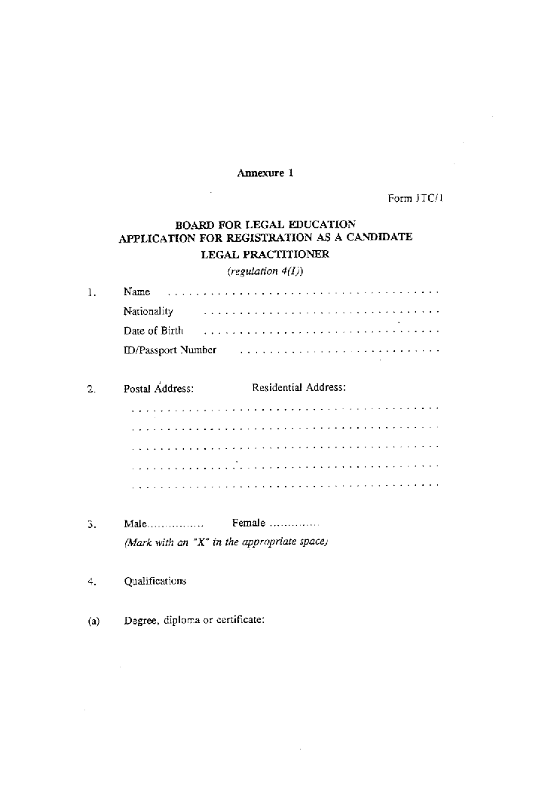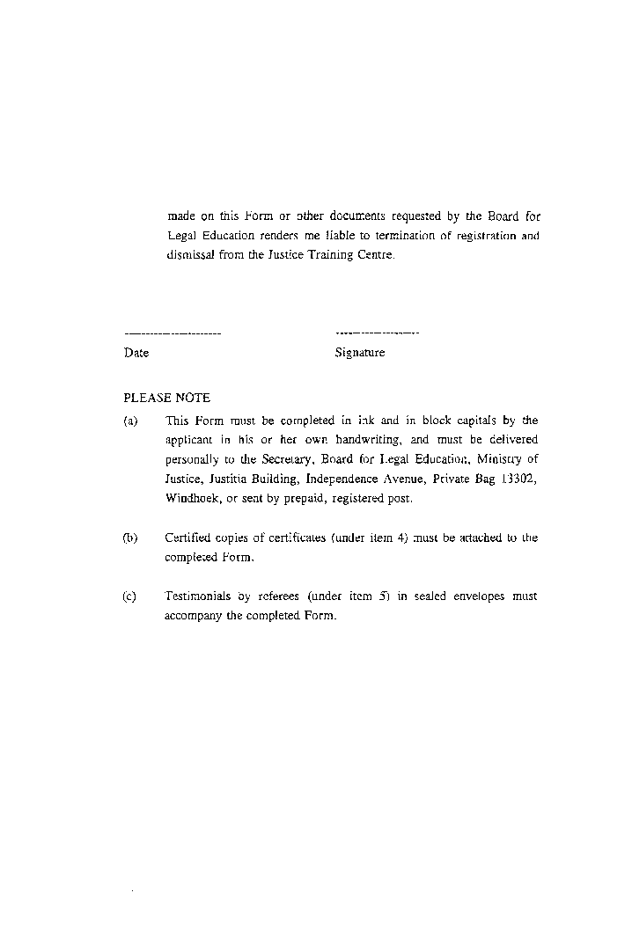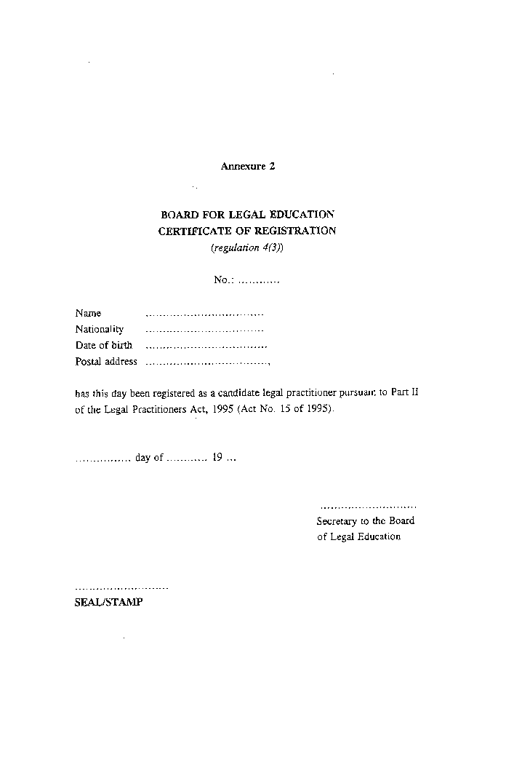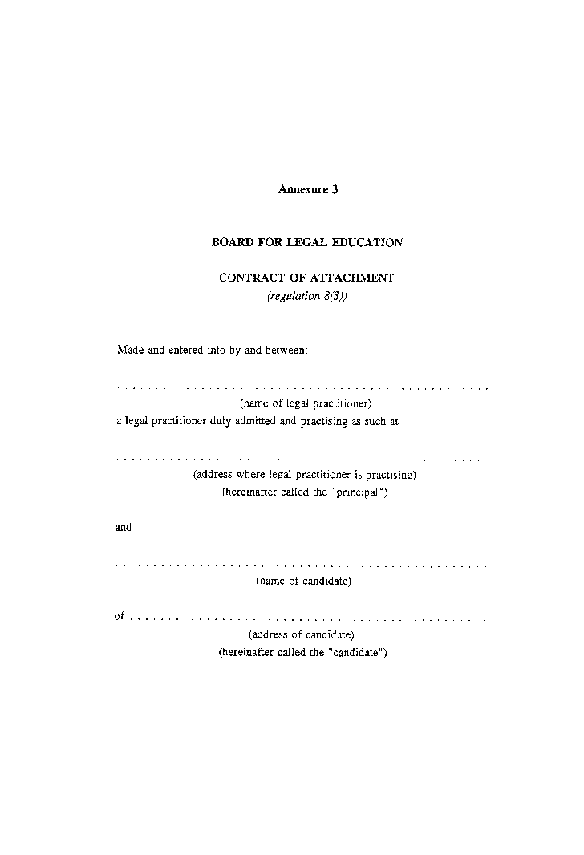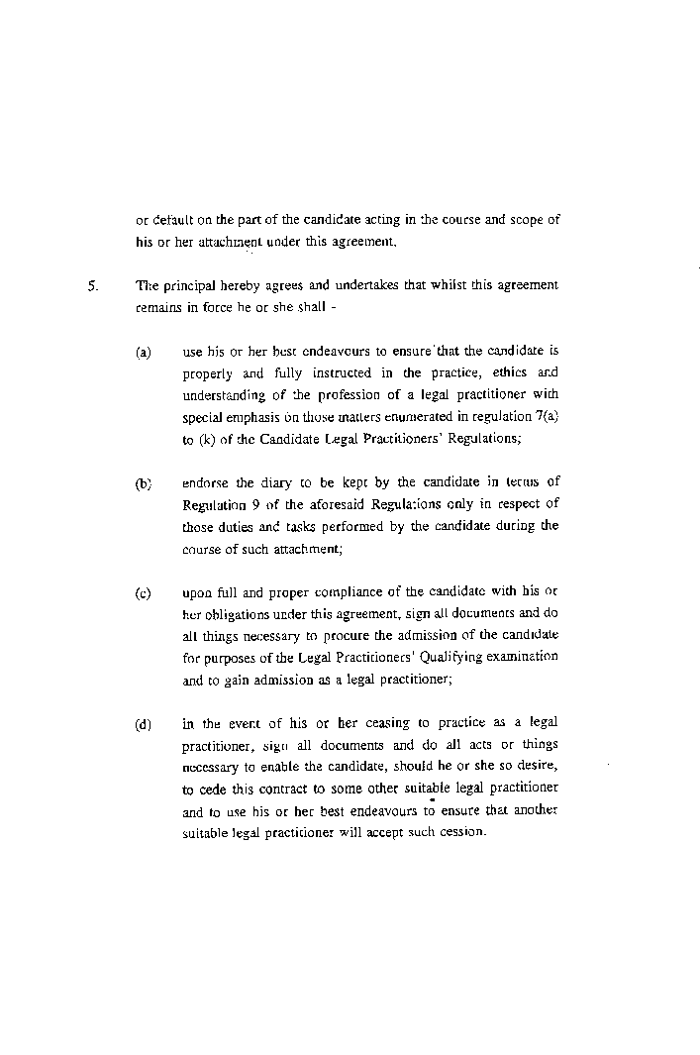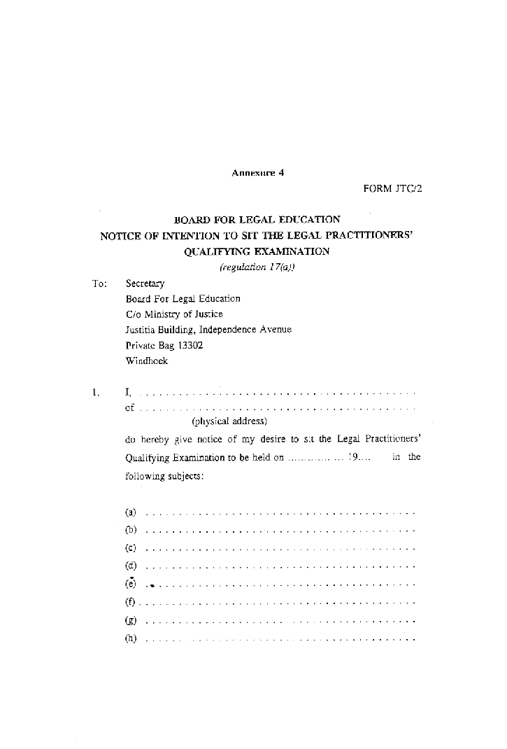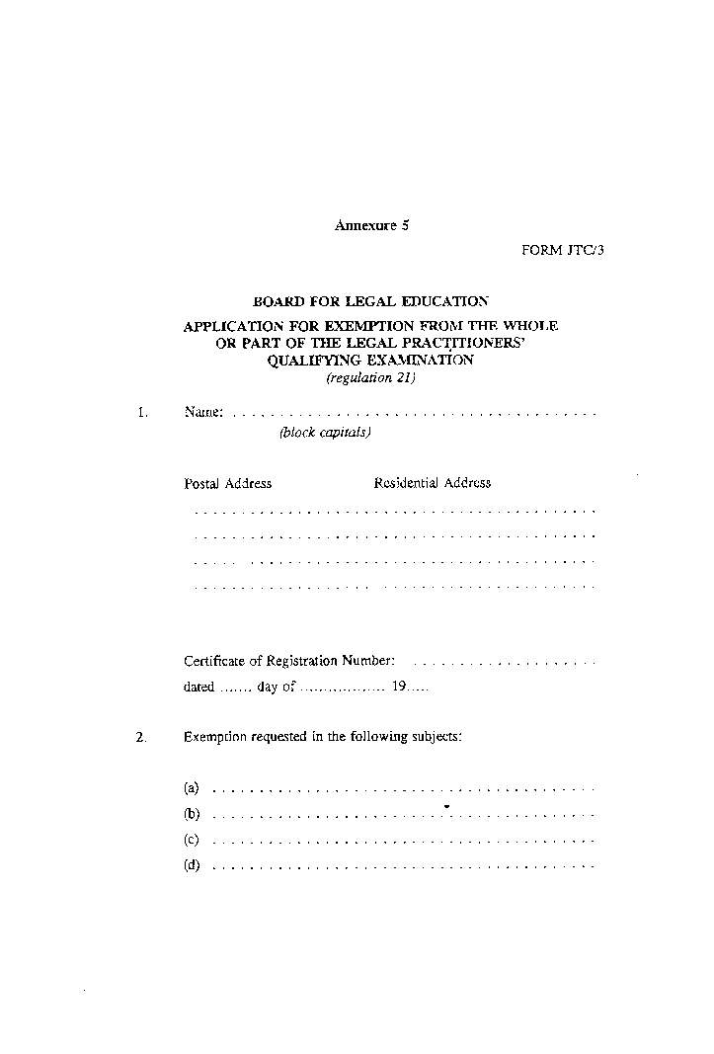

Annexure 6

[Annexure 6 is substituted by GN 67/1997 and by GN 8/2011.]

Registration and Tuition Fees
(Regulation 4(3) and 17(b))

[There is no heading numbered “1.”.]

(a) Enrolment N$700

(b) Tuition Fee (for each subject) N$700

2. Examination Fee, for each subject -

(a) at first sitting N$600

(b) at subsequent sitting N$650.

