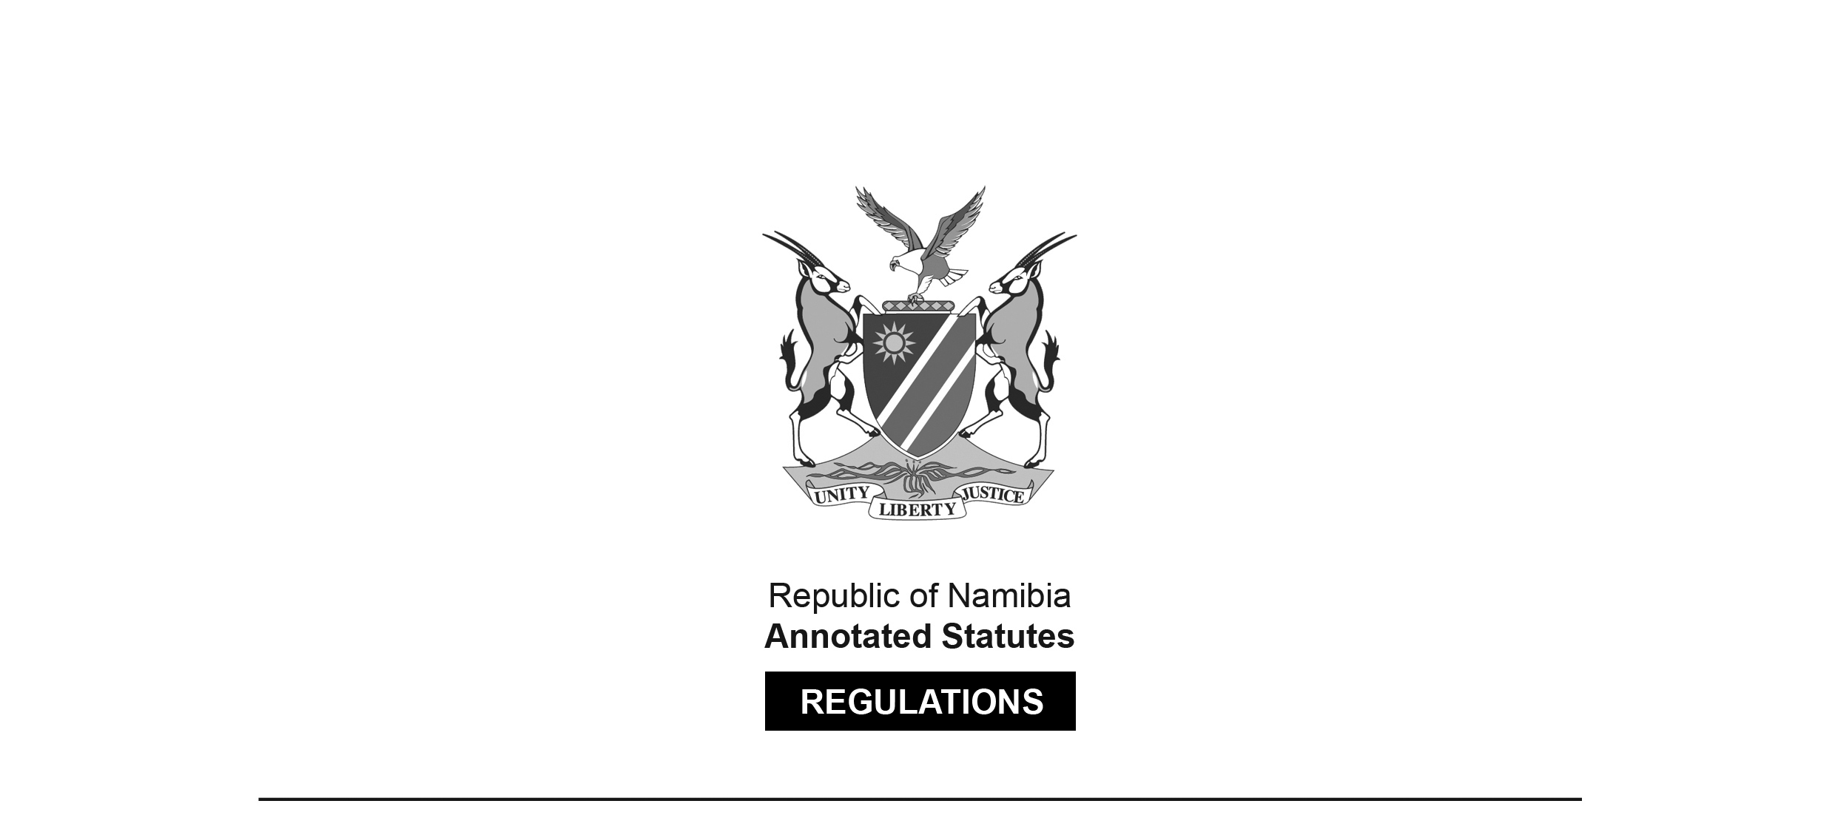

REGULATIONS MADE IN TERMS OF

Labour Act 11 of 2007

section 135

Regulations relating to Domestic Workers

Government Notice 257 of 2017

([GG 6428](http://www.lac.org.na/laws/2017/6428.pdf))

came into force on date of publication: 29 September 2017

The Government Notice which publishes these regulations notes that they were   
made after consultation with the Labour Advisory Council. It also repeals GN 257/2014 (GG 5638).

as supplemented by

Wage Order for Setting Minimum Wage and Supplementary Minimum Conditions of Employment for

Domestic Workers

Government Notice 258 of 2017

([GG 6428](http://www.lac.org.na/laws/2017/6428.pdf))

issued in terms of section 13 of Labour Act 11 of 2007;

came into force on date of publication: 29 September 2017,   
with the exception of paragraph 4 which came into effect from 1 October 2017

with subsequent increases applicable from 1 October 2018

The Government Notice which publishes this wage order notes that it was made   
after considering the report of the Wages Commission. The terms of reference   
of this Wages Commission are contained in GN 28/2017 ([GG 6245](http://www.lac.org.na/laws/2017/6245.pdf)). The Government Notice which publishes this wage order also repeals GN 258/2014 ([GG 5638](http://www.lac.org.na/laws/2014/5638.pdf)).

This Wage Order remains technically in force, but it has been superseded insofar as it relates to minimum wage by the Wage Order in GN 218/2024 ([GG 8409](https://www.lac.org.na/laws/2024/8409.pdf)) which sets a minimum wage for all employees of N$18.00 per hour, with effect from 1 January 2025, but provides gradual steps to this minimum wage for domestic workers and agricultural workers, who will reach the same minimum wage as of 1 January 2027. See GN 218/2024, paragraph 4(4).

ARRANGEMENT OF REGULATIONS

1. Definitions

2. Prohibition of child domestic work

3. Deductions of in-kind contributions

4. Records and returns

Annexure - Form for Submission of Particulars by Employers of Domestic Workers

**Definitions**

**1.** In these Regulations, a word or an expression to which a meaning has been given in the Act has that meaning, and unless the context otherwise indicates -

“domestic work” means work performed in or for a household;

“domestic worker” means any person engaged in domestic work in an employment relationship, including a child-minder, cook, driver, gardener or housekeeper; and

“the Act” means the Labour Act, 2007 (Act No. 11 of 2007).

**Prohibition of child domestic work**

**2.** (1) Domestic work constitutes work-related activities contemplated in section 3(3)(d)(vi) of the Act.

(2) A person must not employ a child under the age of 18 years as a domestic worker.

**Deductions of in-kind contributions**

**3.** For the purposes of section 8(3) of the Act, an employer of a domestic worker must not deduct from the minimum basic wage, determined pursuant to a wage order in terms of section 13 of the Act, the value of in-kind payments or contributions, such as food, clothing or housing.

**Records and returns**

**4.** For the purposes of section 130 of the Act, an employer of a domestic worker must, not later than 30 November every year, submit to the Permanent Secretary of the Ministry or to the Labour Office, a form set out in the Annexure containing the particulars and information required in the form.

**ANNEXURE**

**Form for Submission of Particulars by Employers of Domestic Workers**

To view content without printing, scroll down.

To print at full scale (A4), double-click the icon below.



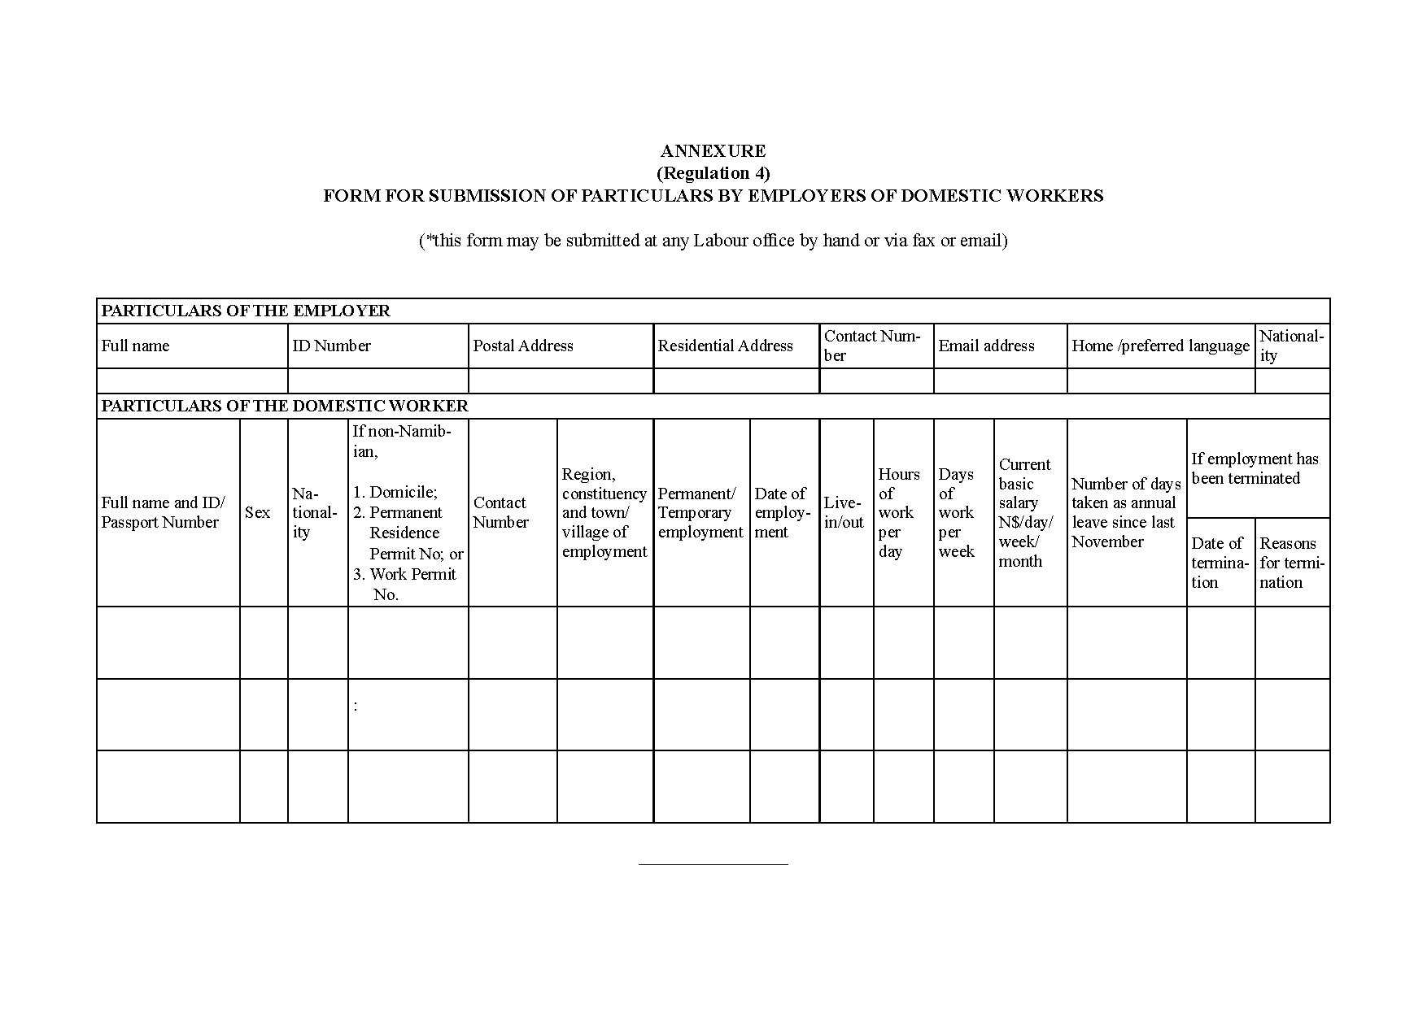

***

Wage Order for Setting Minimum Wage and Supplementary Minimum Conditions of Employment for

Domestic Workers

Government Notice 258 of 2017

(GG 6438)

1. Definitions

2. Application of Order

3. Effect of Order

4. Minimum wage

5. Duty to pay full monetary remuneration

6. Transport allowance

7. Accompanying employer on vacation

8. Provision of food

9. Accommodation for live-in domestic workers

10. Health and safety requirements

11. Freedom of association and trade union access

12. Written contract of employment

13. Code of conduct

14. Review period

15. Tax deductions

ANNEXURE

**Definitions**

**1.** In this Order, a word or an expression to which a meaning has been given in the Act has that meaning and, unless the context otherwise indicates -

“domestic work” means work performed in and for a household;

“domestic worker” means any person engaged in domestic work in an employment relationship, including a child-minder, cook, driver, gardener or housekeeper;

“the Act” means the Labour Act, 2007 (Act No. 11 of 2007);

“the Regulations” means the Regulations Relating to Domestic Workers published in Government Notice No. 257 of 29 September 2017; and

“this Order” means the Wage Order for Setting Minimum Wage and Supplementary Minimum Conditions of Employment for Domestic Workers.

**Application of Order**

**2.** This Order -

(a) applies to all domestic workers, including domestic workers placed with households by a private employment agency contemplated in section 1 of the Employment Services Act, 2011 (Act No. 8 of 2011);

(b) does not apply to domestic workers covered by any collective agreement in the agricultural sector.

**Effect of Order**

**3.** (1) This Order supplements Chapter 3: Basic Conditions of Employment and Chapter 4: Health and Safety Welfare of Employees, in the Act, which are applicable to all employees including domestic workers.

(2) The terms and conditions of employment of the domestic worker must not be less favorable than those set out in this Order and in Chapter 3 of the Act.

(3) Every provision of this Order constitutes a term of any contract of employment of domestic workers, except to the extent that the parties agree to more favourable terms.

**Minimum wage**

**4.** (1) With effect from 1 October 2017 the minimum wage for domestic workers, to whom this Order applies, is -

(a) N$ 1 502.05 per month;

(b) N$ 346.89 per week;

(c) N$ 69.37 per day;

(d) N$ 8.67 per hour; and

(e) N$43.35 per day for part-time domestic workers who work five hours or   
 less in any day other than a Sunday or public holiday.

(2) The minimum overtime pay and minimum pay to be paid to domestic workers for work on Sundays and public holidays are as follows:

(a) N$13.00 per hour for overtime as contemplated in section 17(2) of the Act;

(b) N$17.34 per hour for work on Sundays as contemplated in section 21(5) of the Act;

(c) N$17.34 per hour for work on public holidays as contemplated in section 22(7) of the Act; or

(d) N$86.70 per day for part-time domestic workers who work five hours or less.

(3) With effect from 1 October 2018, the minimum wage referred to in subparagraph (1) must be increased by one percent plus a percentage equal to the average of the increases in the inflation rates, for the categories “Food and Non-Alcoholic Beverages” and “Housing, Water, Electricity, Gas and other fuels”, published by the Namibia Statistics Agency under the Statistics Act, 2011 (Act No. 9 of 2011) for the preceding 12 months from the effective date.

**Duty to pay full monetary remuneration**

**5.** An employer of a domestic worker -

(a) must pay the domestic worker the full amount of the minimum wage contemplated in paragraph 4, or a higher wage agreed upon minus lawful deductions as contemplated in section 12 of the Act; and

(b) may not, pursuant to regulation 3 of the Regulations, deduct from the monetary remuneration contemplated in item (a) the value of in-kind payments or contributions, such as food, clothing or housing.

**Transport allowance**

**6.** Where public transport is available, a live-out domestic worker is entitled, in addition to the basic wage contemplated in paragraph 5, to receive a transport allowance for travel to and from work in an amount that is equivalent to the cost of a round-trip public transport for each day of work, unless the employer provides transport.

**Accompanying employer on vacation**

**7.** If a domestic worker accompanies his or her employer on vacation for the purposes of rendering services to the household, the time spent rendering those services must be treated as working time and all provisions of the Act and of this Order apply.

**Provision of food**

**8.** An employer must, without charge, provide suitable food in reasonable quantity to meet the dietary needs of an employee who is a -

(a) live-in worker; or

(b) live-out worker who is entitled to a meal interval contemplated in section 18 of the Act.

**Accommodation for live-in domestic workers**

**9.** (1) When a domestic worker is required to live at the place of his or her employment, the employer is obliged to provide living quarters without charge to the domestic worker with the following minimum conditions -

(a) a lockable room, with -

(i) a room key;

(ii) good ventilation;

(iii) electricity, if available to the household;

(iv) a bed and mattress;

(v) heat, if such is the prevailing condition in the household; and

(b) access to clean drinking water, toilet and bathing facilities.

(2) The employee is entitled to receive visitors upon reasonable notice and at reasonable intervals or hours, in consultation with the employer.

**Health and safety requirements**

**10.** (1) An employer of a domestic worker must, without charge -

(a) provide to that worker -

(i) a uniform; and

(ii) appropriate and effective personal protective equipment;

(b) replace the uniform and protective equipment contemplated in item (a) at reasonable intervals; and

(c) provide to that worker a health and safety induction and that induction must include at a minimum -

(i) possible hazards relating to the duties of that worker, including potentially dangerous equipment and toxic substances;

(ii) proper use and maintenance of personal protective equipment; and

(iii) safe work techniques relating to domestic work.

(2) An employer who hires a domestic worker must comply with all regulations relating to domestic worker made under section 135 of the Act.

[The phrase “relating to domestic worker” should be “relating to domestic workers” (plural).]

**Freedom of association and trade union access**

**11.** (1) A domestic worker has a right to be member of a trade union.

[The article “a” should appear before the phrase “member of a trade union”.]

(2) An employer of a domestic worker or a person acting in the capacity of that employer may not unreasonably deny access to the premises of the employer for trade-union related activities as contemplated in section 65 of the Act.

**Written contract of employment**

**12.** (1) An employer must, upon hiring a domestic worker -

(a) enter into a written contract, with the domestic worker, on Form DW1 set out in the Annexure which sets out the terms and conditions of employment; and

(c) provide to the domestic worker a copy of the contract contemplated in item (a).

[The subparagraphs are mislettered ni the *Government Gazette*; there is no paragraph (b).]

(2) Before signing the contract contemplated in subparagraph (1), the employer must explain or cause to be explained to the domestic worker, the provisions of the contract in a language that the domestic worker understands.

(3) An employer of a domestic worker must retain copies of the signed contract of employment, contemplated in subparagraph (1) for a period of the most recent five years of employment of the domestic worker by the employer.

**Code of conduct**

**13.** Any code of conduct for domestic work issued under section 137(1)(a) of the Act must be taken into account in interpreting and analysing the provisions of this Order.

**Review period**

**14**. The Wages Commission must review this Order every two years.

**Tax deductions**

**15**. For purposes of deducting tax from the taxable income of a domestic worker pursuant to the Income Tax Act, 1981 (Act No. 24 of 1981), an employer of the domestic worker must register the domestic worker as taxpayer.

ANNEXURE

To view content without printing, scroll down.

To print at full scale (A4), double-click the icon below.



