

REGULATIONS MADE IN TERMS OF

Labour Act 11 of 2007

section 135

Labour General Regulations

Government Notice 261 of 2008

(GG 4151)

came into force on 1 November 2008 (reg 28)

**The Government Notice which issues these regulations repeals the regulations   
published in GN 174/1992 and GN 175/1992 (both published in GG 533)**. These previous regulations were made in terms of the Labour Act 6 of 1992 and deemed to have made in terms of the   
Labour Act 11 of 2007 by Item 2(2) of the Schedule to that Act.

**ARRANGEMENT OF REGULATIONS**

1. Definitions

2. Portion of basic wage that may be paid in-kind and calculation of the value of in-kind payments

3. Written statement of particulars of monetary remuneration

4. Exemption from a wage order

5. Compassionate leave

6. Election of health and safety representatives

7. Change in constitution of registered trade union or registered employers’ organisation

8. Registration of trade union or employers’ organisation

9. Register maintained by registered trade union or registered employers’ organisation

10. Annual return of registered trade union or employers’ organisation

11. Request for recognition of registered trade union as exclusive bargaining agent

12. Notification to registered trade union to acquire majority representation

13. Election of workplace union representatives

14. Request to extend collective agreement to non-parties to the agreement

15. Application for exemption from extension of a collective agreement

16. Notice of commencement of strike or lockout

17. Appointment of conciliators and arbitrators

18. Referral of dispute to conciliation

19. Application to reverse decision of conciliator

20. Referral of dispute to arbitration

21. Request for representation at conciliation or arbitration

22. Application to enforce arbitration award

23. Order to appear before a labour inspector

24. Compliance order

25. Records and returns

26. Application for exemption or variation

27. Proof of service of documents

28. Commencement of regulations

**ANNEXURE 1** Particulars of monetary payments

**ANNEXURE 2** Forms 1- 36

ANNEXURE 3 Records and returns by employers

**Definitions**

**1.** In these regulations, any word or expression to which a meaning has been given in the Act bears that meaning, and unless the context otherwise indicates, “the Act” means the Labour Act, 2007 (Act No. 11 of 2007).

**Portion of basic wage that may be paid in-kind and calculation of the value of in-kind payments**

**2.** (1) The portion of the basic wage that an employer may pay to an employee in-kind is an amount which does not exceed the equivalent of one-third of the employee’s basic wage.

(2) The calculation of the cash equivalent of any payment in-kind must be based on the producers’ prices of the commodities comprising the in-kind payment, or in absence of a producers’ price for any commodity, the average price of the commodity at an agriculture cooperative or wholesalers in the nearest city or town.

**Written statement of particulars of monetary remuneration**

**3.** The written statement of particulars referred to in section 11(3) that must accompany payment of monetary remuneration to an employee must contain the matters set out Annexure 1.

**Exemption from a wage order**

**4.** (1) An application to the Minister for exemption from a wage order in terms of section 14(1) of the Act must be made on Form LM 1 set out in Annexure 2.

(2) The exemption from a wage order referred to in section 14(3) of the Act must be issued on Form LM 2 set out in Annexure 2, and it must be signed by the Minister.

(3) The fee payable to the Permanent Secretary for a copy of an exemption order is N$ 5 per page.

**Compassionate leave**

**5.** (1) An application for compassionate leave in terms of section 25(3) of the Act must be made on a form determined by the employer but the form must substantially correspond to Form LS 3 set out in Annexure 2.

(2) The application for compassionate leave must be made either before the applicant takes leave, or if not possible, immediately upon applicant’s return to work.

(3) An application for compassionate leave must be accompanied by a death certificate of the deceased, in case of death, or a medical certificate, in case of serious illness or, an affidavit of the employee testifying to the death or serious illness, or, in all cases, such other evidence of death or illness as may be acceptable to the employer.

(4) If the applicant cannot make the application before going on leave, the applicant must make reasonable efforts to notify the employer of his or her absence for compassionate reasons and the intended duration of thereof.

**Election of health and safety representatives**

**6.** (1) Whenever it is necessary in terms of section 43 of the Act to conduct an election of a health and safety representative or representatives, the election must be held in the manner prescribed in this regulation.

(2) An election for a health and safety representative must be held at least every two years, or as and when a casual vacancy or vacancies arise.

(3) An election for a health and safety representative must be held in cooperation with the exclusive bargaining agent of the employees, or, if there is none, in cooperation with the employees, and subject to the requirements set out in subregulations (4) to (8).

(4) A committee consisting of two representatives of the exclusive bargaining agent or, if there is none, two employees, and two representatives of the employer must be established to oversee the conduct of the nominations and the election.

(5) Nominations must take place one week before the voting.

(6) An employee may nominate himself or herself or any other employee to stand for election.

(7) The election must be conducted -

(a) at the employer’s premises;

(b) during working hours;

(c) with a minimum disruption of the employer’s operations; and

(d) by secret ballot.

(8) The ballots must be counted immediately after the voting has been concluded, and the committee must, in writing, make the results known to the employer and employees.

(9) If an employer has recognized a registered trade union as the exclusive bargaining representative of any of its employees, the employer and the trade union may agree on the manner in which the election should be conducted, subject to the requirements set out in subregulations (4) to (8).

(10) The trade union must retain records of the ballots cast and the names of the elected representatives for a period of two years from the date of the election.

(11) No later than two months after the election of a health and safety representative, the employer must, through an accredited company or institute, provide training for the health and safety representative in the duties of the position.

**Change in constitution of registered trade union or registered employers’ organization**

**7.** (1) An application to the Labour Commissioner for a change in the constitution of a registered trade union or registered employer’s organisation in terms of section 54(2)(b) of the Act must be made on Form LC 4 set out in Annexure 2 and must be accompanied by two (2) copies of a resolution containing the wording of the change and a certificate signed by the chairperson stating that the resolution was passed in accordance with the constitution.

(2) If the Labour Commissioner approves a change in a constitution of a registered trade union or registered employers’ organisation, the Commissioner must issue a certificate in terms of section 54(4)(b) of the Act on Form LC 5 set out in Annexure 2, and if it is a change of name, a new certificate of registration.

**Registration of trade union or employers’ association**

**8.** (1) An application to the Labour Commissioner for registration of a trade union or employers’ organisation in terms of section 57(1)(a) of the Act must be made on Form LC 6 set out in Annexure 2, and must be accompanied by three certified copies of the constitution of the trade union or employers’ organisation.

(2) If the Labour Commissioner decides to register a trade union or employers’ organisation in terms of section 57(3)(b) of the Act, the Commissioner must issue a certificate of registration on Form LC 7 set out in Annexure 2.

**Register maintained by registered trade unions or registered employers’ organization**

**9.** The register to be maintained by registered trade unions and registered employer organisations in terms of section 60(a) of the Act must be on maintained on Form LC 8 set out in Annexure 2.

**Annual return of registered trade union or employers’ organization**

**10.** The annual return to be submitted to the Labour Commissioner in terms of section 60(e) of the Act must be on Form LC 9, and must be accompanied by a statement of income and expenditure for that year, a balance sheet showing its financial position at the end of the year, and its annual audit report prepared by a registered public accountant and auditor or an auditor approved by the Labour Commissioner.

**Request for recognition of registered trade union as exclusive bargaining agent**

**11.** (1) A request by a registered trade union for recognition in terms of section 64(3) of the Act must be made on Form LC 10 set out in Annexure 2.

(2) Within 30 days after receiving the trade union request for recognition, the employer must, in terms of section 64(5) of the Act, notify the trade union on Form LC 11 set out in Annexure 2, that it recognises the trade union as the exclusive bargaining agent or that refuses to recognize the trade union.

(3) If the employer fails to respond to the trade union’s request within 30 days or fails to recognise the trade union as an exclusive bargaining agent, the trade union may, in terms of section (64)(6) of the Act, refer its request to the Labour Commissioner as a dispute on Form LC 12 set out in Annexure 2.

**Notification to registered trade union to acquire majority representation**

**12.** Notice which must be given in terms of section 64(11) of the Act by an employer to a trade union recognised as an exclusive barganing agent, when the employer considers that the trade union no longer represents the majority of the employees in the bargaining unit, must be given on Form LC 13 set out in Annexure 2.

[The word “bargaining” is misspelt in the *Government Gazette*, as reproduced above.]

**Election of workplace union representatives**

**13.** (1) Where employees who are members of a registered trade union are entitled, in terms of section 67 of the Act, to elect a workplace union representative or representatives, the election must be conducted in the manner set out in this regulation.

(2) On being requested by the registered trade union, the employer must provide facilities that are reasonably necessary for conducting the election.

(3) The registered trade union must assign at least two representatives to supervise the elections.

(4) Nominations of the candidates must take place at least one week before the voting.

(5) The election must be conducted -

(a) at the employer’s premises;

(b) during working hours;

(c) with a minimum disruption of the employer’s operations;

(d) by secret ballot; and

(e) in accordance with the trade union’s constitution.

(6) The employer may observe the election process.

(7) The ballots must be counted immediately after the voting has been concluded, and the union must, in writing, make the results known to the employer and employees.

(8) The trade union must retain records of the ballots cast and the names of the elected workplace union representative or representatives for a period of two years from the date of the election.

**Request to extend collective agreement to non-parties to the agreement**

**14.** (1) A request to the Minister by a registered employers’ organisation and a registered trade union in terms of section 71(2) of the Act that a collective agreement bind non- parties to the agreement must be made on Form LM 14 set out in Annexure 2.

(2) The notice inviting objections to the extension of the collective agreement contemplated in section 71(3)(b) of the Act must be given on Form LM 15 set out in Annexure 2.

(3) A declaration by the Minister extending a collective agreement as contemplated in section 71(5) of the Act must be made on Form LM 16 set out in Annexure 2.

**Application for exemption from extension of collective agreement**

**15.** (1) An application to the Minister for an exemption from an extension of a collective agreement in terms of section 72(1) of the Act must be made on Form LM 17 set out in Annexure 2.

(2) An exemption from a collective agreement contemplated in section 72(2) of the Act must be made on Form LM 18 set out in Annexure 2.

**Notice of commencement of strike or lockout**

**16.** (1) A party referring a dispute to the Labour Commissioner pursuant to section 74(1) of the Act must make the reference on Form LC 21 set out in Annexure 2.

(2) Notice of the commencement of strike or lockout in terms of section 74(1)(d) of the Act by a party to a dispute must be given to the Labour Commissioner and to the other parties to the dispute on Form LC 19 set out in Annexure 2.

**Appointment of conciliators and arbitrators**

**17.** Where the Minister appoints -

(a) a conciliator in terms of sections 82(1) or (2) of the Act, he or she must issue to the conciliator a certificate of appointment on Form LM 20 set out in Annexure 2; or

(b) an arbitrator in terms of sections 85(3) or (4) of the Act, he or she must issue to the arbitrator a certificate of appointment on Form LM 20 set out in Annexure 2.

**Referral of dispute to conciliation**

**18.** (1) A referral of a dispute to conciliation in terms of section 82(7) of the Act must be made to the Labour Commissioner on Form LC 21, and copies must be served on the other parties to the dispute.

(2) If the Labour Commissioner decides to refer the dispute to conciliation, the Commissioner must, in terms of section 82(3) of the Act, designate a conciliator on Form LC 22 set out in Annexure 2, to try to resolve the dispute and issue a notice of conciliation meeting on Form LC 23 set out in Annexure 2.

(3) If the parties resolve their dispute during the conciliation process, the conciliator must issue a certificate of resolved dispute on Form LC 24 set out in Annexure 2.

(4) If the parties are unable to resolve their dispute through the conciliation process, the conciliator must, in terms of section 82(15) of the Act, issue a certificate of unresolved dispute on Form LC 25 set out in Annexure 2.

**Application to reverse decision of a conciliator**

**19.** An application to the Labour Commissioner in terms of section 83(3)(a) of the Act to reverse a decision of a conciliator must be made on Form LC 26 set out in Annexure 2.

**Referral of dispute to arbitration**

**20.** (1) A referral of a dispute to arbitration in terms of section 86(1) of the Act must be made to the Labour Commissioner on Form LC 21 set out in Annexure 2.

(2) If the Labour Commissioner decides to refer the dispute to arbitration, the Commissioner must, in terms of section 85(5) of the Act, designate an arbitrator on Form LC 27 set out in Annexure 2, to try to resolve the dispute and issue a notice of hearing on Form LC 28 set out in Annexure 2.

**Request for representation at conciliation or arbitration**

**21.** A request for representation at conciliation or arbitration proceedings in terms of section 82(13) or 86(13) of the Act, respectively, must be made on Form LC 29 set out in Annexure 2.

**Application to enforce arbitration award**

**22.** An application to a labour inspector to enforce an arbitration award in terms of section 90 of the Act must be made on Form LC 30 set out in Annexure 2.

**Order to appear before a labour inspector**

**23.** The order of a labour inspector in terms of section 125(2)(b) of the Act requiring a party to appear at a specified time, date and place for questioning must be on Form LS 31 set out in Annexure 2.

**Compliance order**

**24.** (1) A compliance order issued by a labour inspector in terms of section 126(1) of the Act must be on Form LS 32 set out in Annexure 2.

(2) On receipt of the compliance order, the party against whom the order is directed must post a full copy of the order on its premises in a location that is fully visible to the affected employees for a period of one year.

(3) A person who fails to comply with subrule (2) commits an offence and is liable to a fine not exceeding N$ 10 000 or to be imprisoned for a period not exceeding two years or to both the fine and imprisonment.

**Records and returns**

**25.** (1) The records that must be kept by an employer as contemplated in section 130(1) of the Act must be kept in the form set out in Annexure 3.

(2) Information to be submitted to the Permanent Secretary as contemplated in section 130(2)(b) of the Act is as set out on Form LP 33 set out in Annexure 2.

**Application for exemption or variation**

**26.** (1) Application to the Minister, in terms of section 139 of the Act, for exemption or variation from any provision of Chapter 3 must be made on Form LM 34 set out in Annexure 2.

(2) If in terms of section 139(2) of the Act, the Minister decides to grant the application, he or she must issue a notice of exemption or variation on Form LM 35 set out in Annexure 2.

**Proof of service of documents**

**27.** Proof of service of documents in respect of conciliation or arbitration proceedings in terms of section 82(8) or 86(3) or any other provision of the Act, must be made in the form of the affidavit of service on Form LG 36 set out in Annexure 2.

**Commencement of regulations**

**28.** These regulations come into operation on 1 November 2008.

ANNEXURE 1

REPUBLIC OF NAMIBIA LABOUR ACT, 2007

(Section 11(3) Regulation 3)

PARTICULARS TO BE INDICATED ON ENVELOPE OR STATEMENT WHEN REMUNERATION IS PAID TO AN EMPLOYEE

**Note:**

“basic wage” means that part of an employee’s remuneration in money including the cash equivalent of payment in-kind, if any, as calculated in terms of section 10 of the Act, paid in respect of work done during the hours ordinarily worked but does not include -

(i) allowances, including travel and subsistence, housing, motor vehicle, transport, and professional allowances, whether or not based on the employee’s basic wage;

(ii) pay for overtime, as defined in section 8 (g);

(iii) additional pay for work on a Sunday or a public holiday;

(iv) additional pay for night work, as required in terms of section 19(1); or

(v) payments in respect of pension, annuity or medical benefits or insurance.

“remuneration’’ means the total value of all payments in money or in kind made or owing to an employee arising from the employment of that employee;

The particulars that must be indicated on an envelope or statement that must accompany remuneration paid to an employee are as follows:

(a) the name and identity number (if any) of employee;

(b) the name postal and business address of employer;

(c) ordinary hourly, daily, weekly, fortnightly or monthly basic wage of employee of employee;

(d) the period in respect of which payment of such basic wage is payable;

(e) the number of hours worked (by category) and the amount paid to the employee in respect of -

(i) his or her basic wage;

(ii) overtime;

(iii) night work;

(iv) work on Sundays;

(v) work on public holidays; and

(vi) any other remuneration or allowances;

(f) amount due for each part of remuneration in addition to basic wage (for example, pension contribution, medical insurance);

(g) the gross amount of remuneration payable to the employee;

(h) the particulars and amount of any deductions from the amount referred to in paragraph (g); and

(i) the nett amount of remuneration payable to the employee.

ANNEXURE 2

FORMS

LM 1 Application for exemption from wage order

LM 2 Exemption from wage order

LS 3 Application for compassionate leave

LC 4 Application for change in constitution of trade union or employers’ organisation

LC 5 Certificate of approval of changes to constitution

LC 6 Application for registration of trade union or employers’ organisation

LC 7 Certificate of registration as trade union or employers’ organisation

LC 8 Register of members of trade union or employers’ organisation

LC 9 Annual return of registered trade union or employers’ organisation

LC 10 Request for recognition as exclusive bargaining unit

LC 11 Notice of recognition or refusal of recognition by employer or employers’ organisation

LC 12 Referral of dispute concerning recognition to Labour Commissioner

LC 13 Notice to trade union to acquire majority representation

LM 14 Request for extension of collective agreement

LM 15 Invitation for objections to extension of collective agreement

LM 16 Declaration of extension of collective agreement

LM 17 Application for exemption from extended collective agreement

LM 18 Exemption from extended collective agreement

LC 19 Notice of industrial action

LM 20 Certificate of appointment as conciliator or arbitrator

LC 21 Referral of dispute to conciliation or arbitration

LC 22 Designation of conciliator

LC 23 Notice of conciliation meeting

LC 24 Certificate of resolved dispute

LC 25 Certificate of unresolved dispute

LC 26 Application to reverse conciliator’s decision

LC 27 Designation of arbitrator

LC 28 Notice of arbitration hearing

LC 29 Request for representation at conciliation or arbitration in terms of section 82(13) or 86(13)

LS 30 Application to labour inspector to enforce arbitration award

LS 31 Order to appear before labour inspector

LS 32 Compliance order of labour inspector

LP 33 Form in which information is submitted to the Permanent Secretary

LM 34 Application for exemption or variation from Chapter 3

LM 35 Declaration of exemption or variation from Chapter 3

LG 36 Proof of service of documents

Forms

To view content without printing, scroll down.

To print at full scale (A4), double-click the icon below.



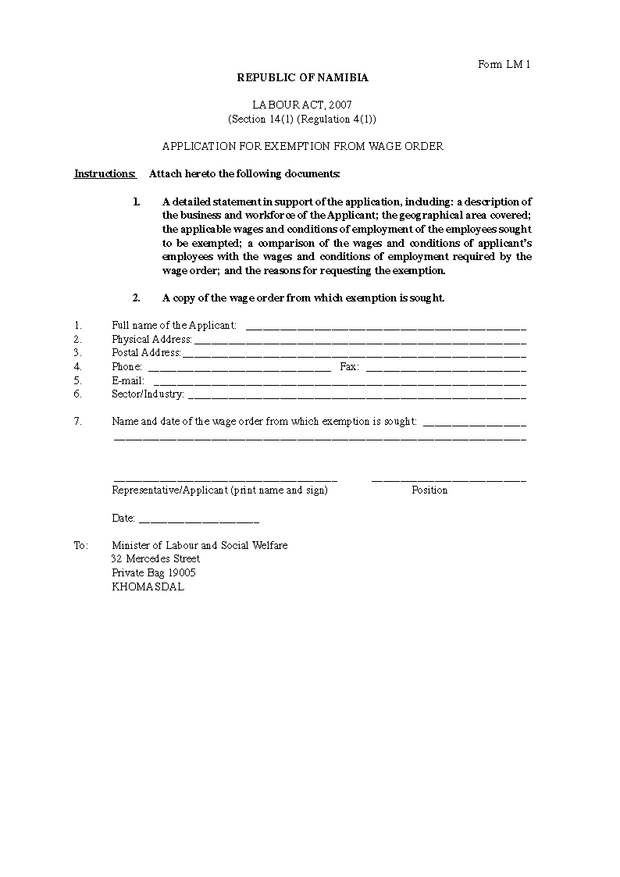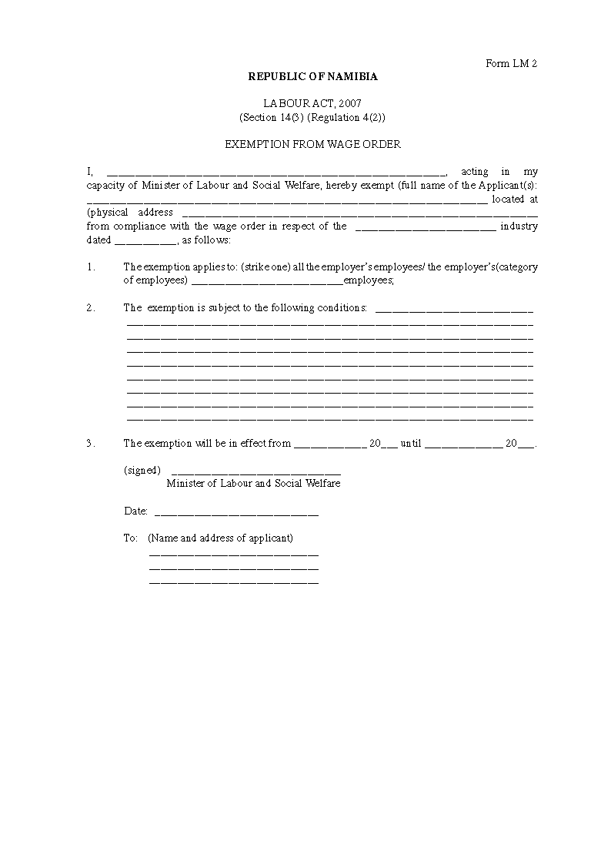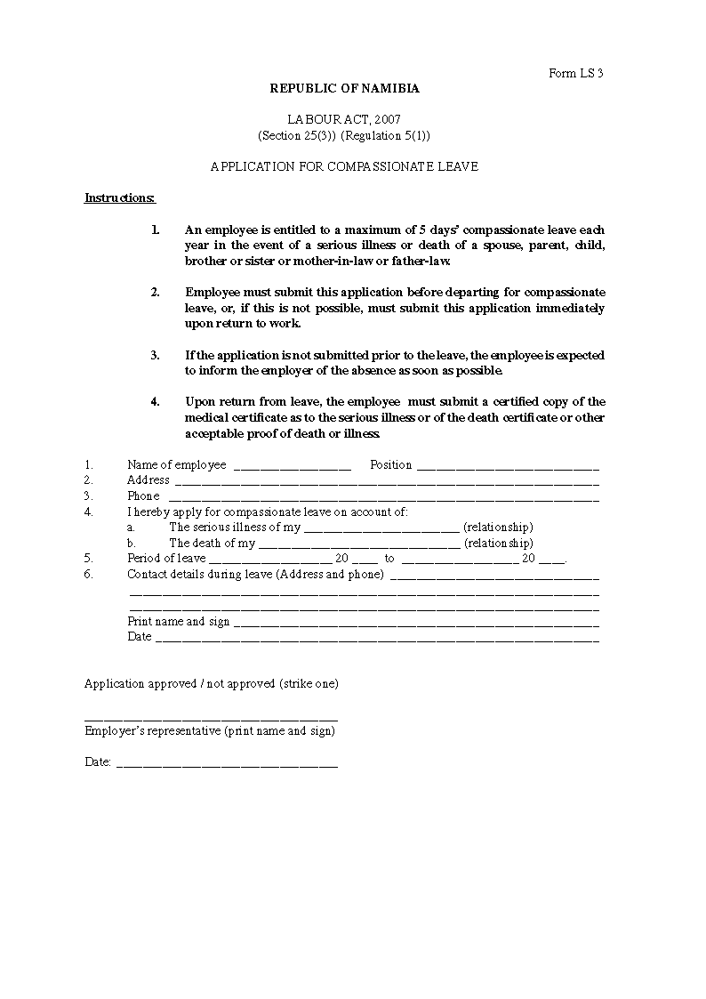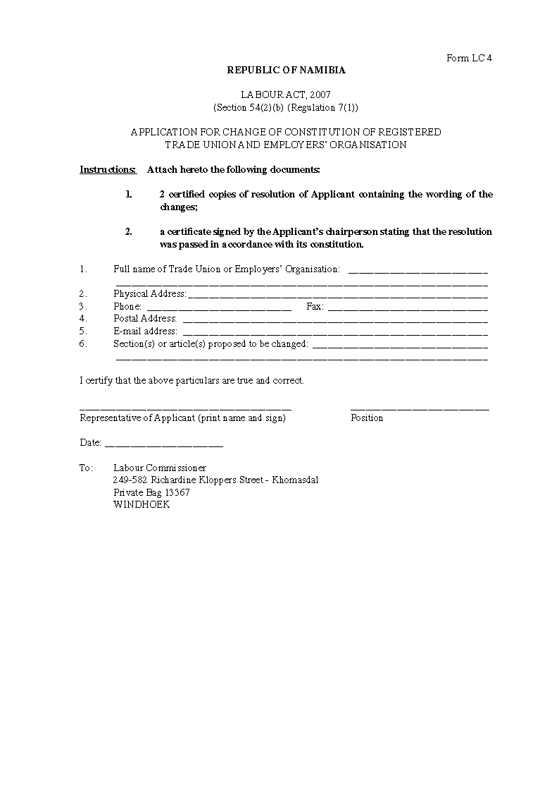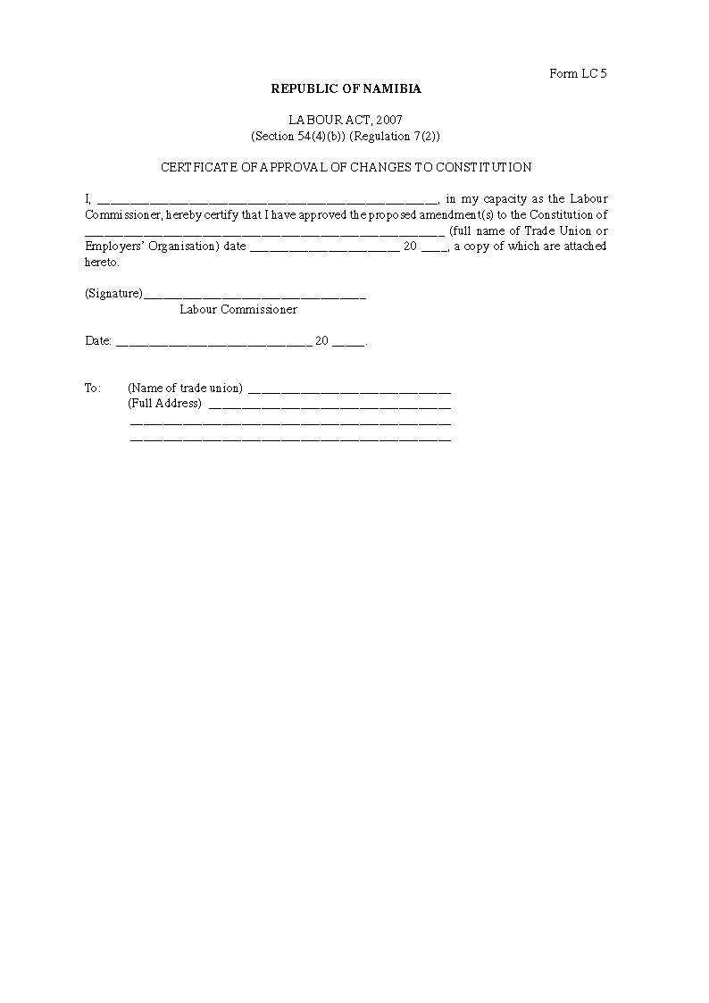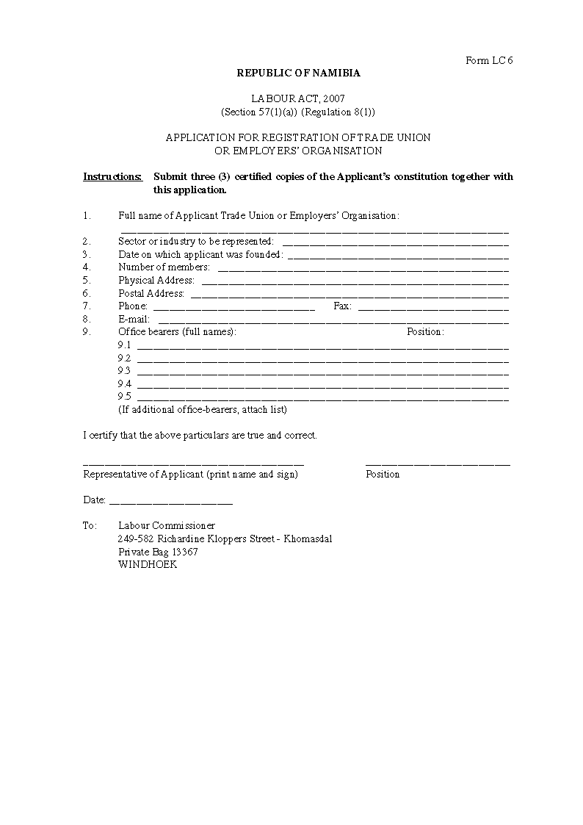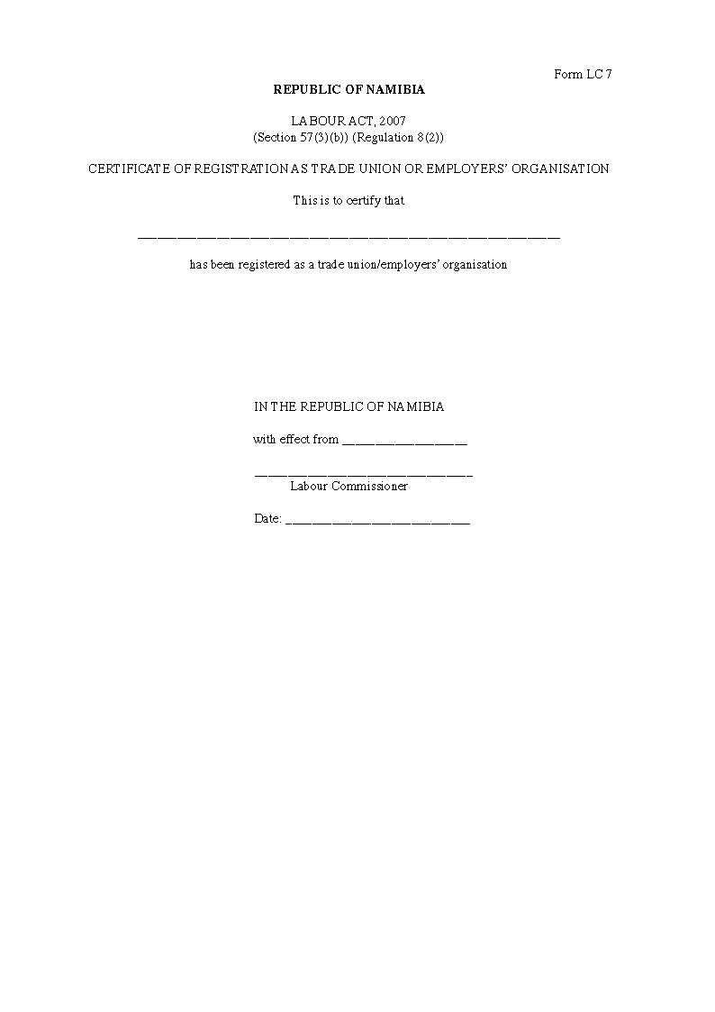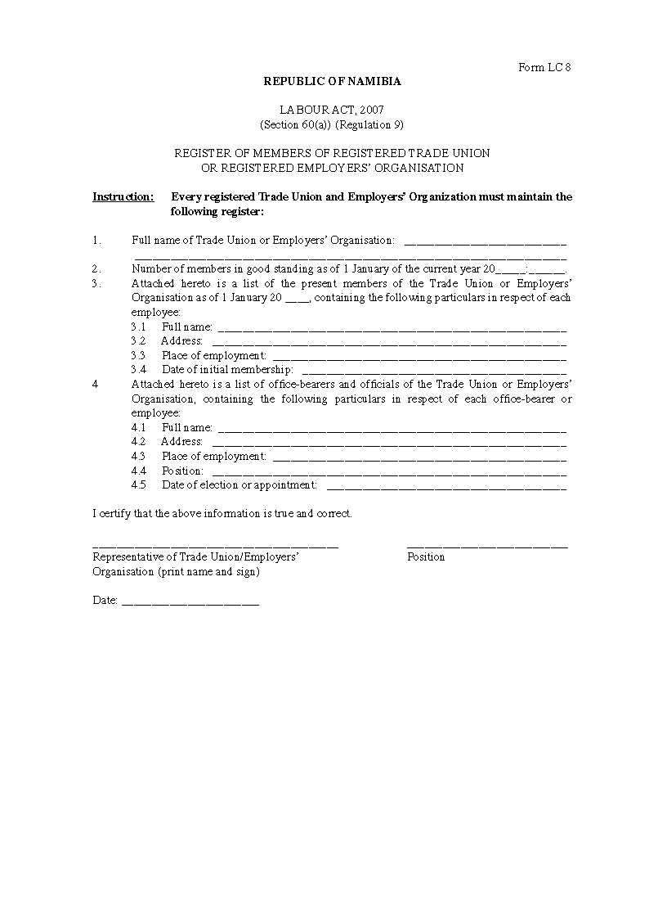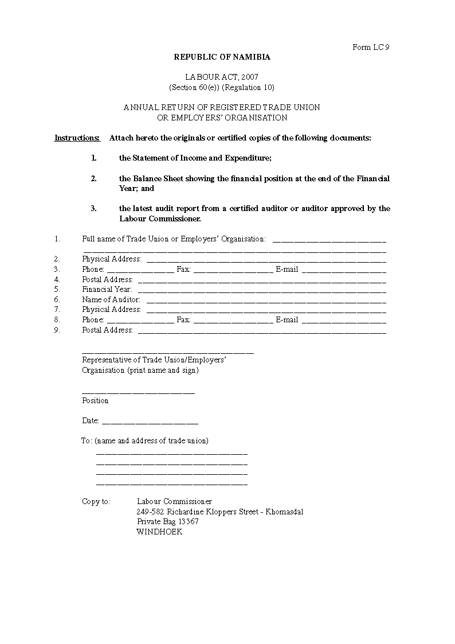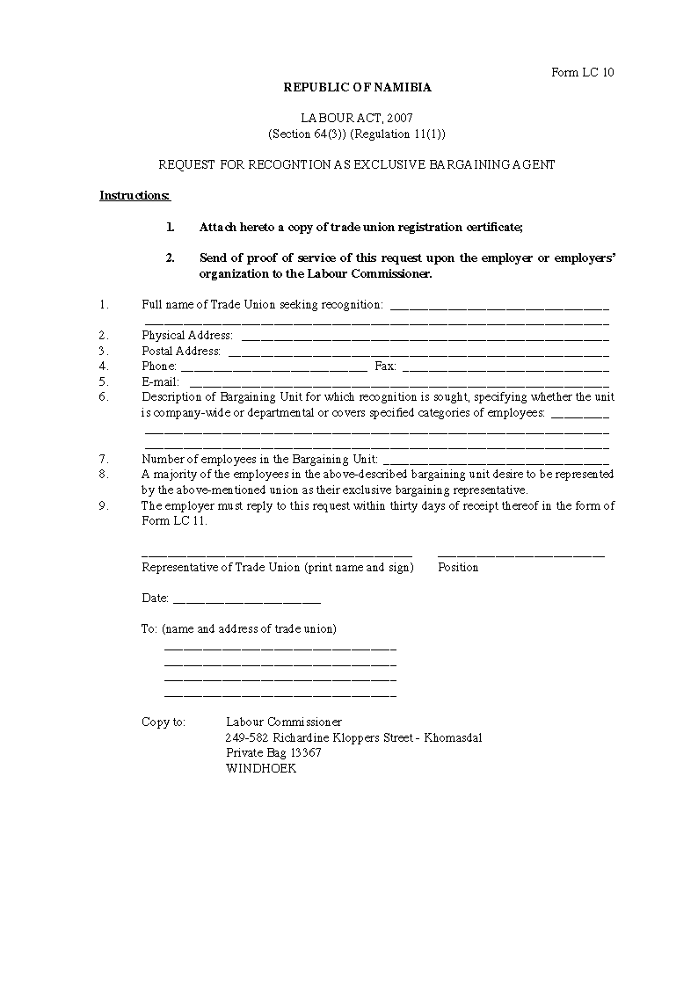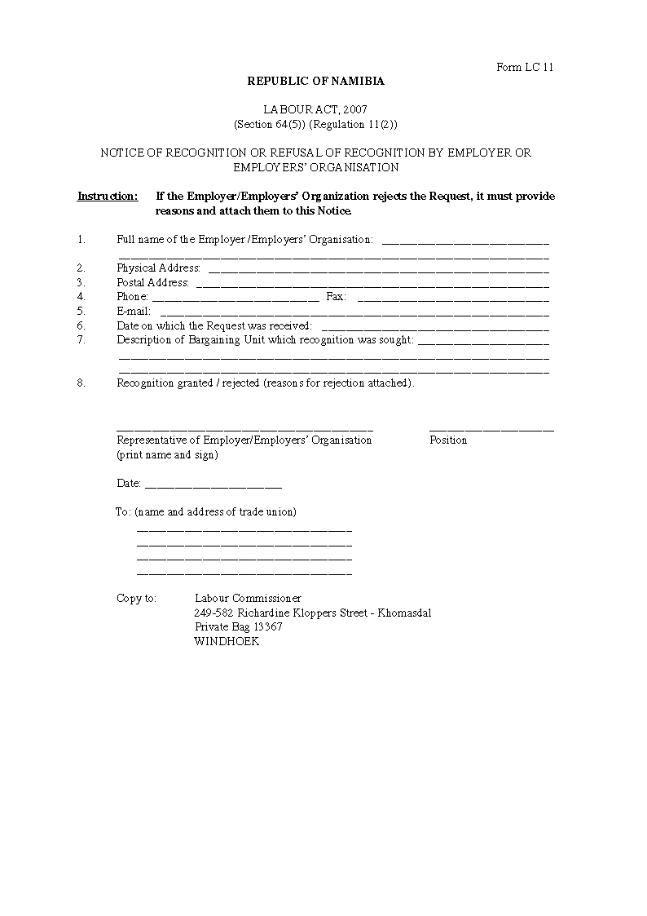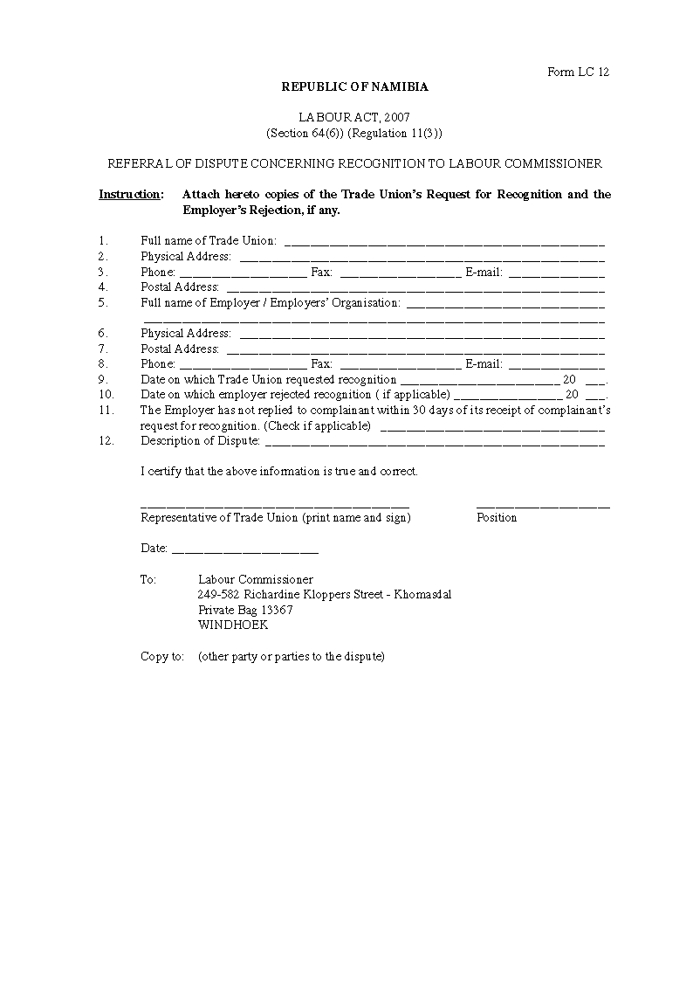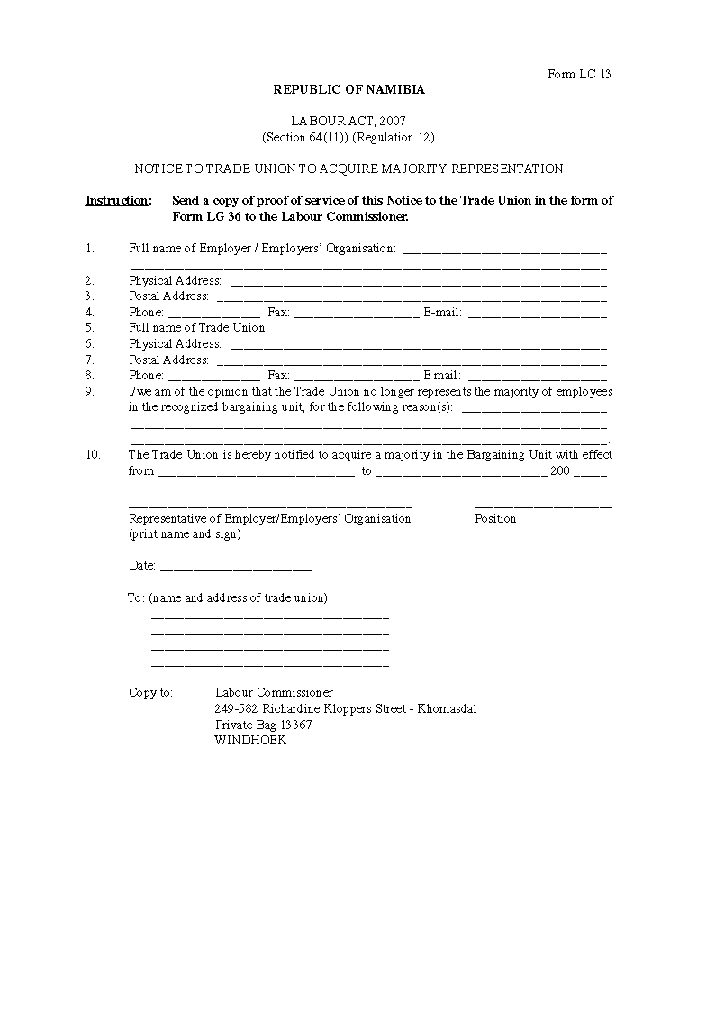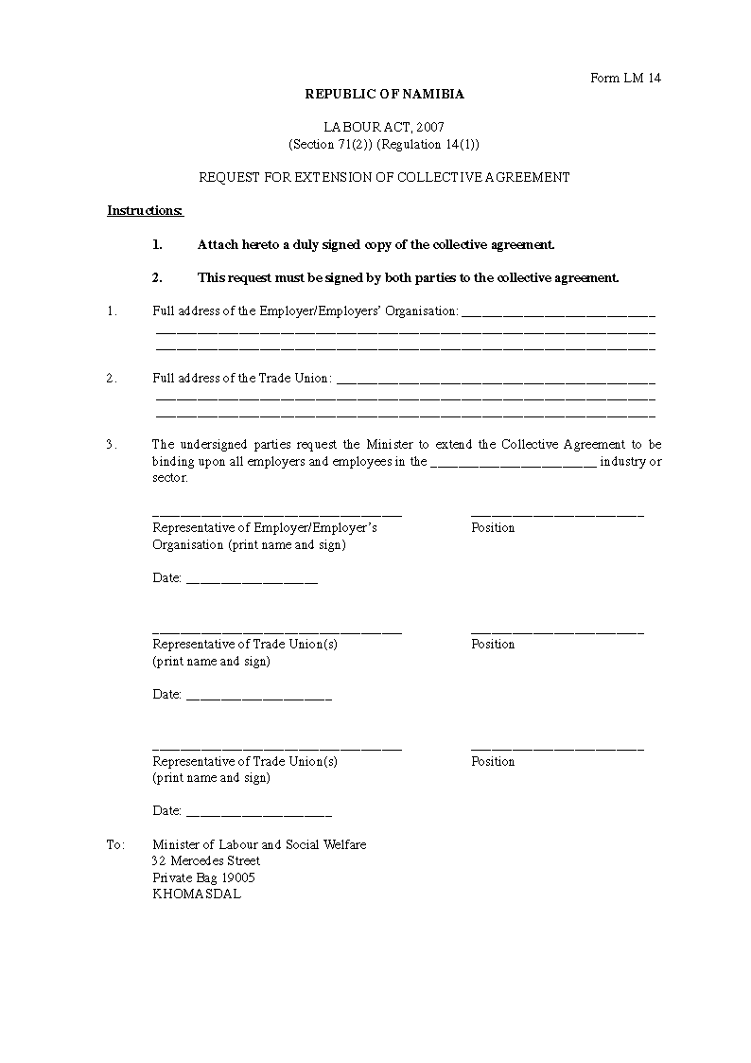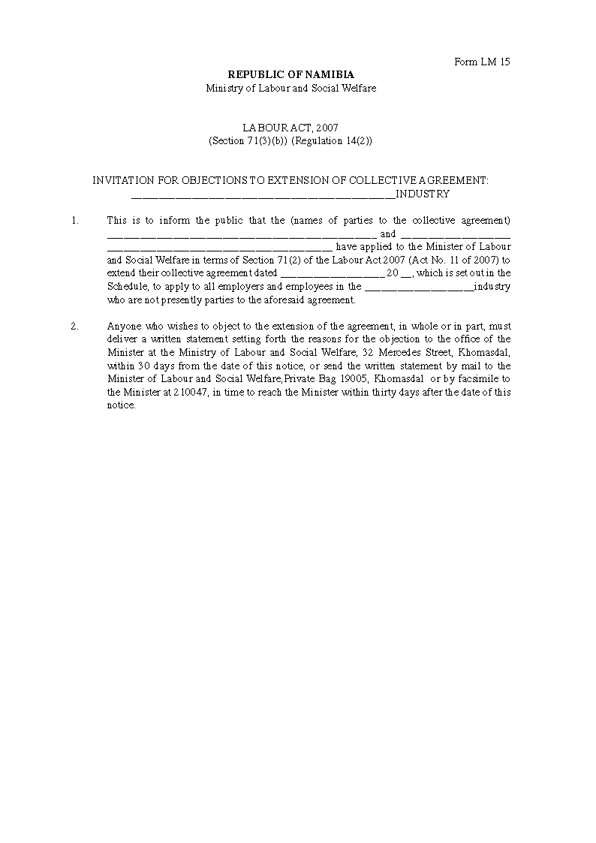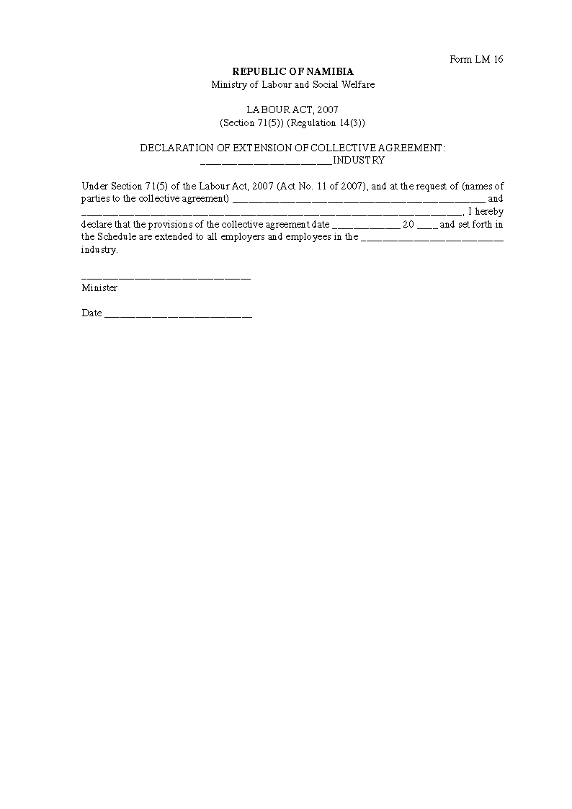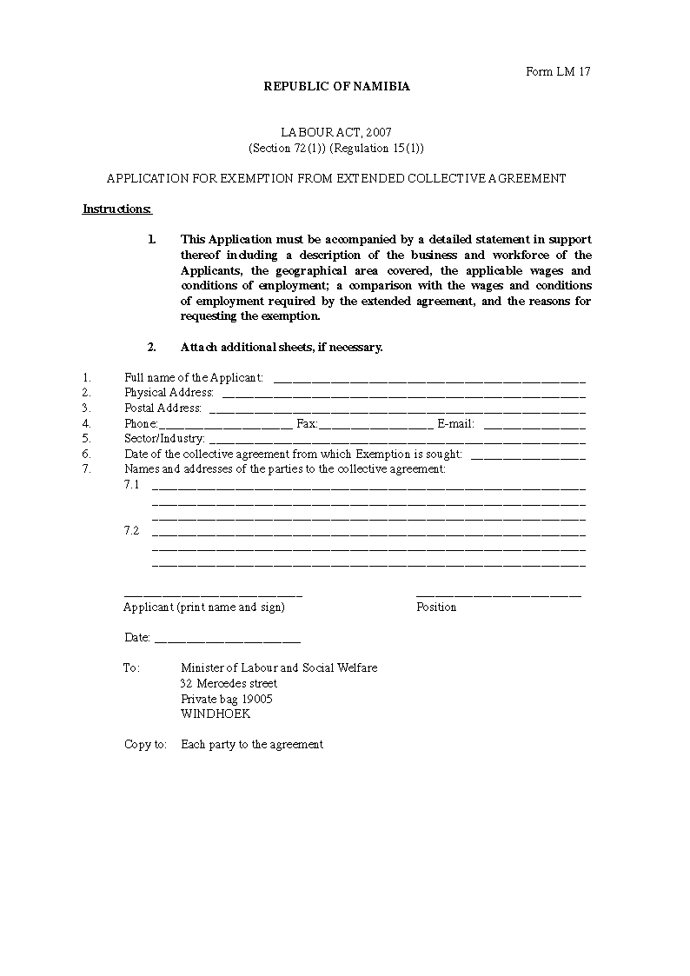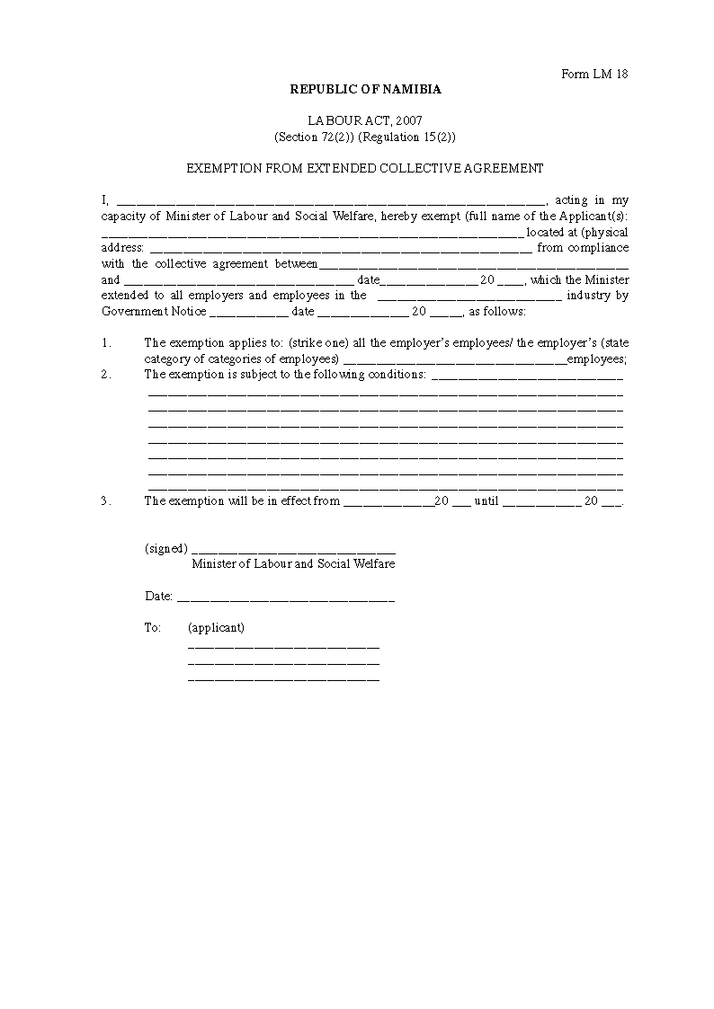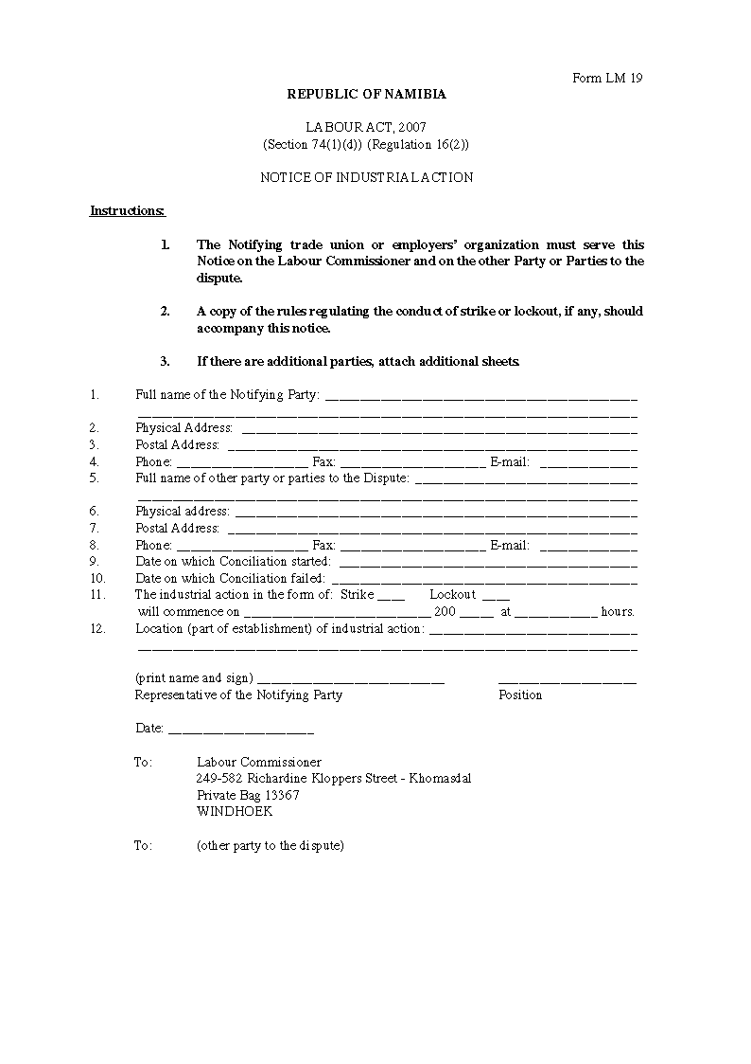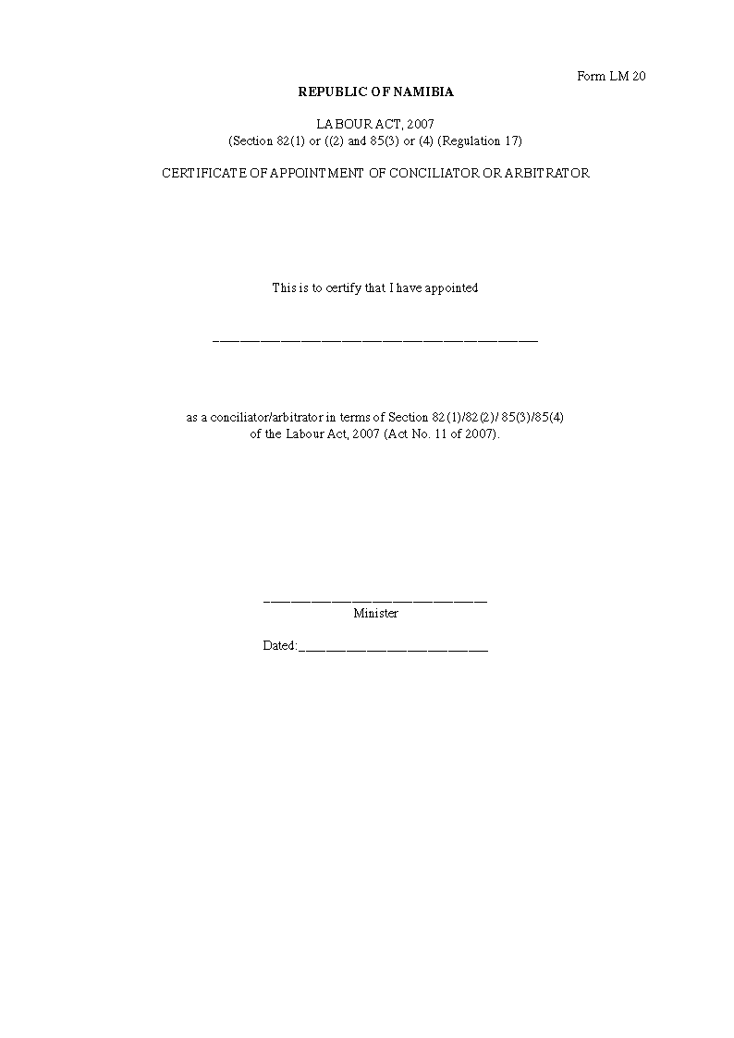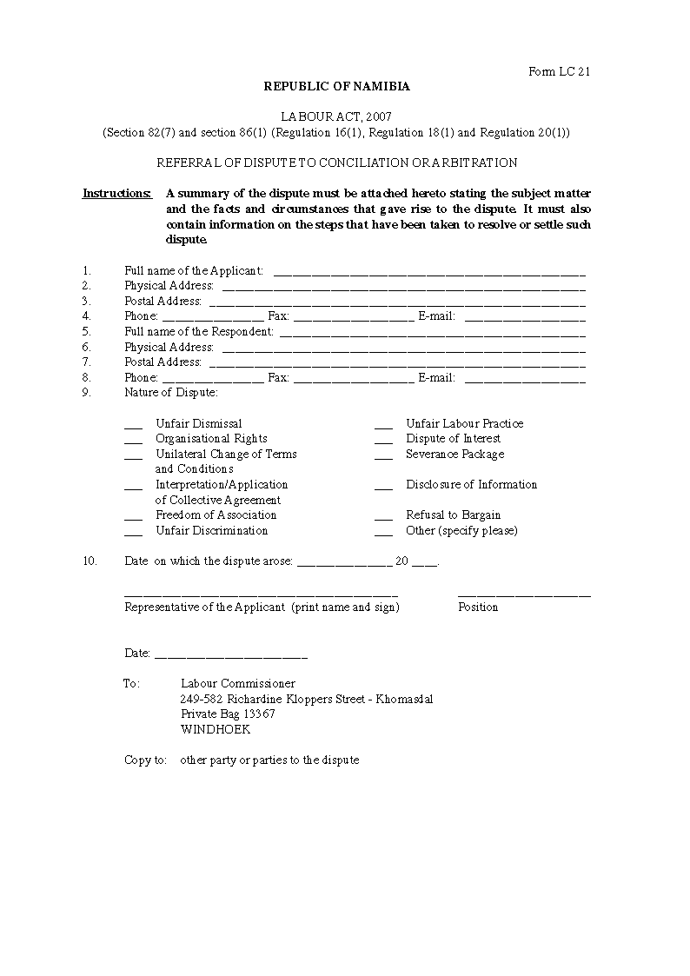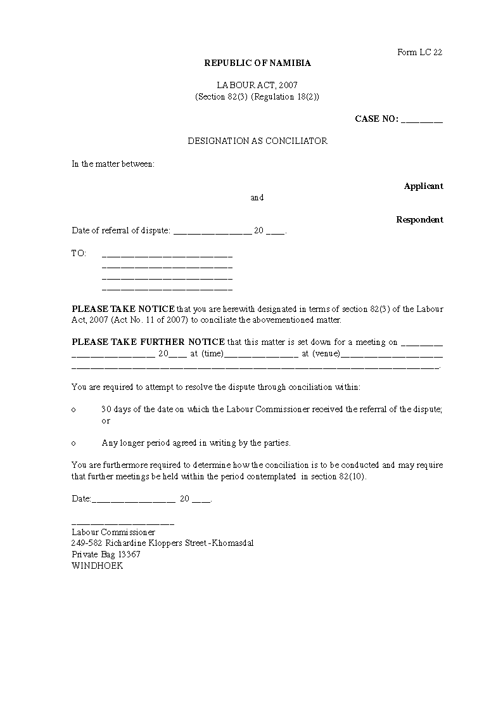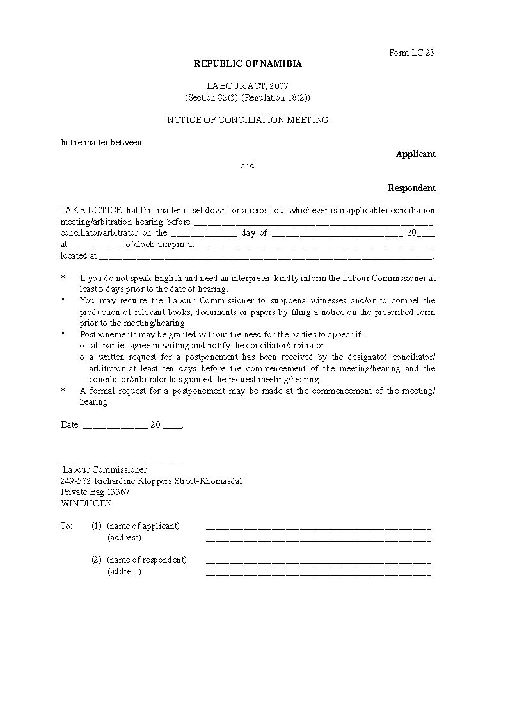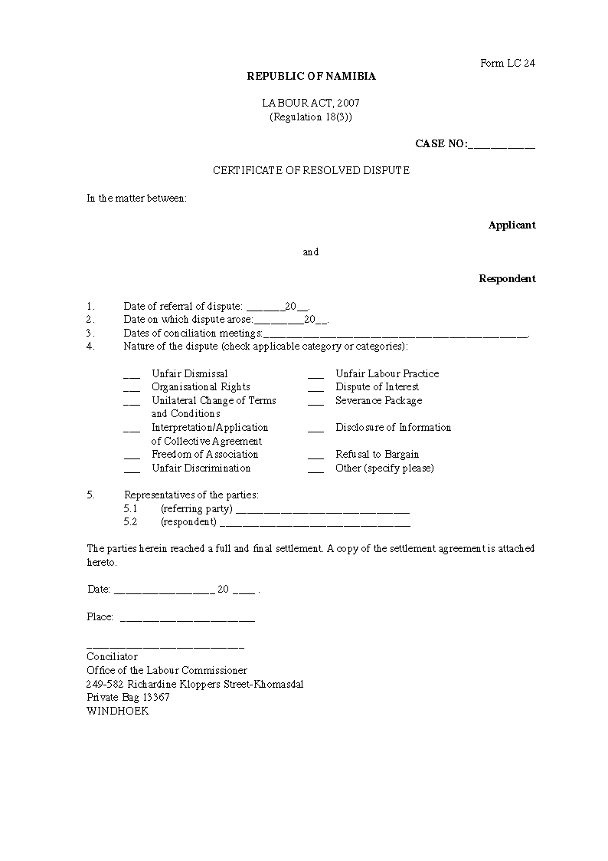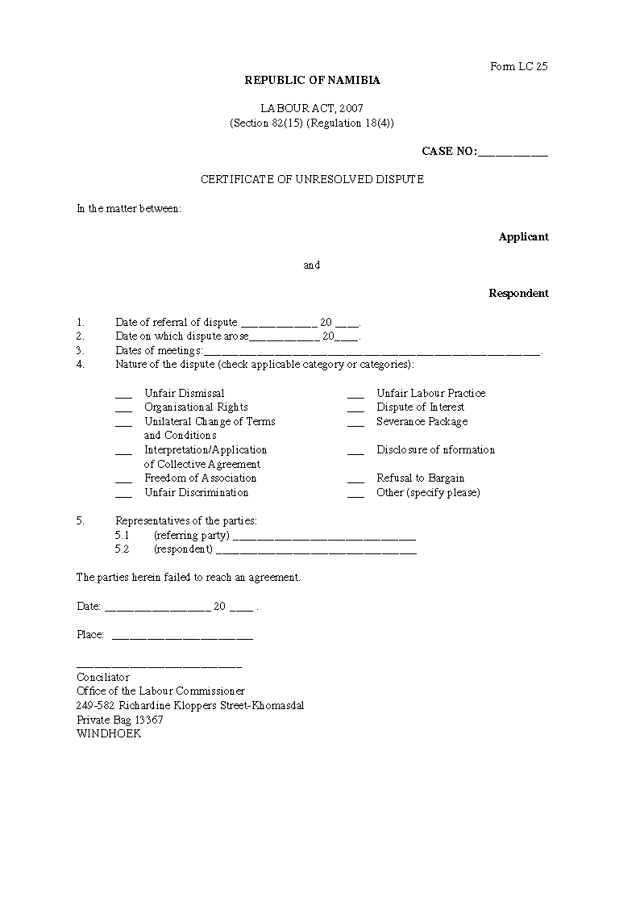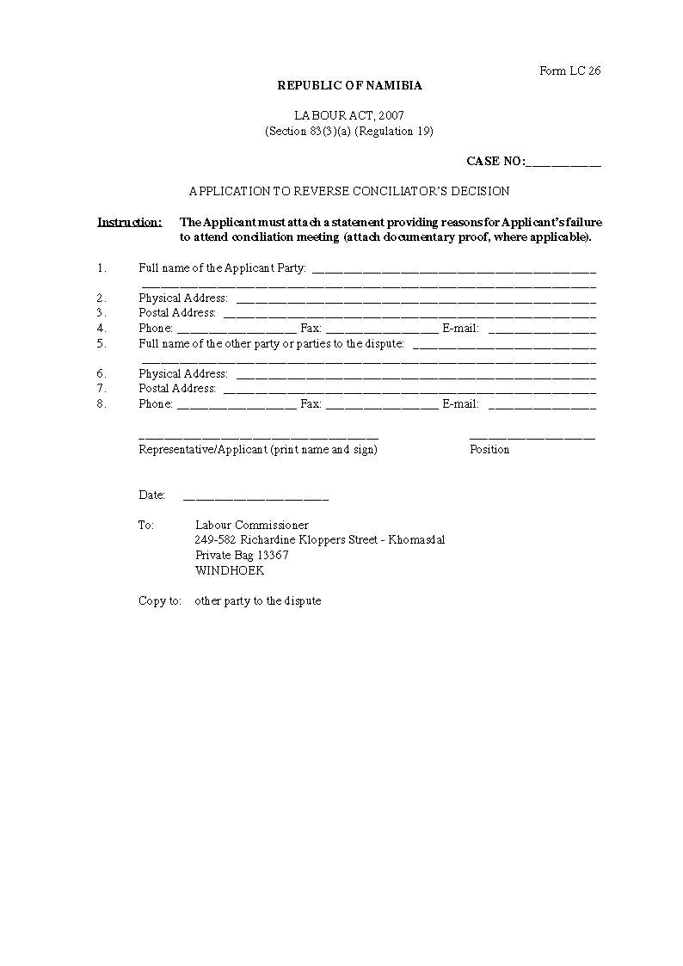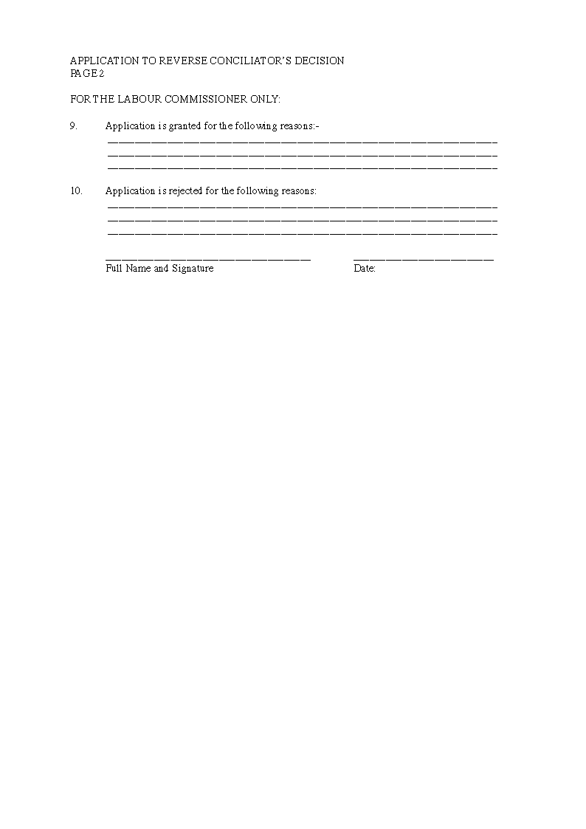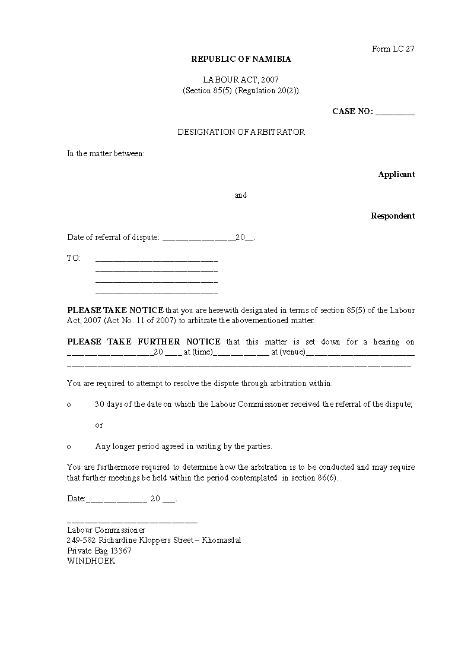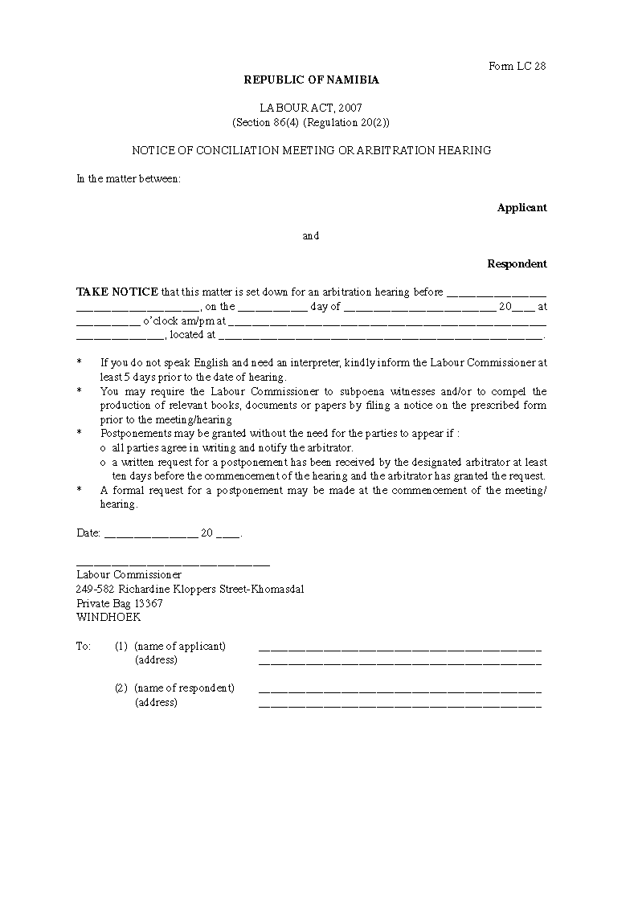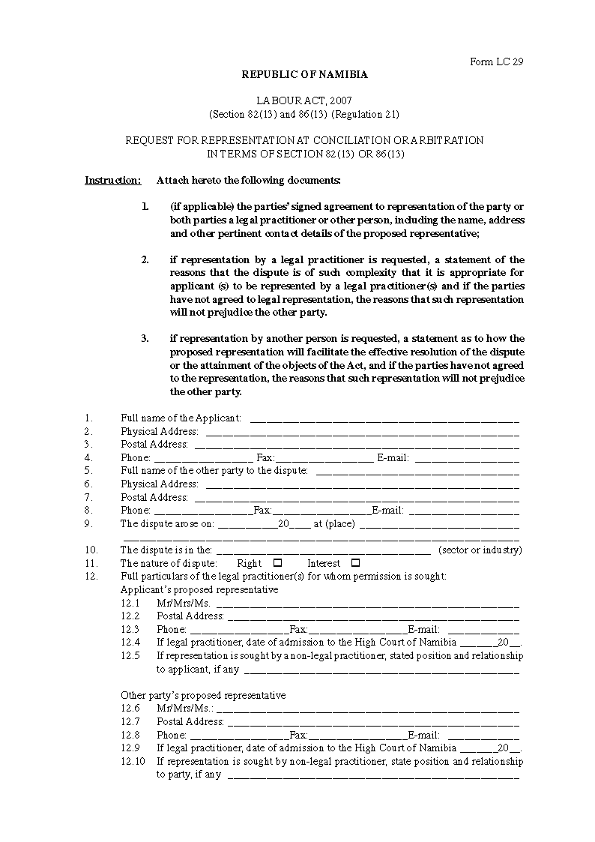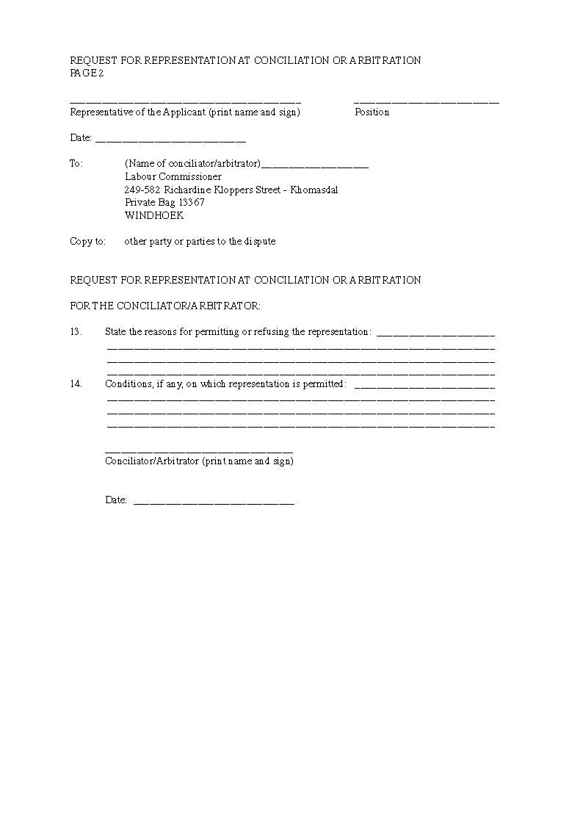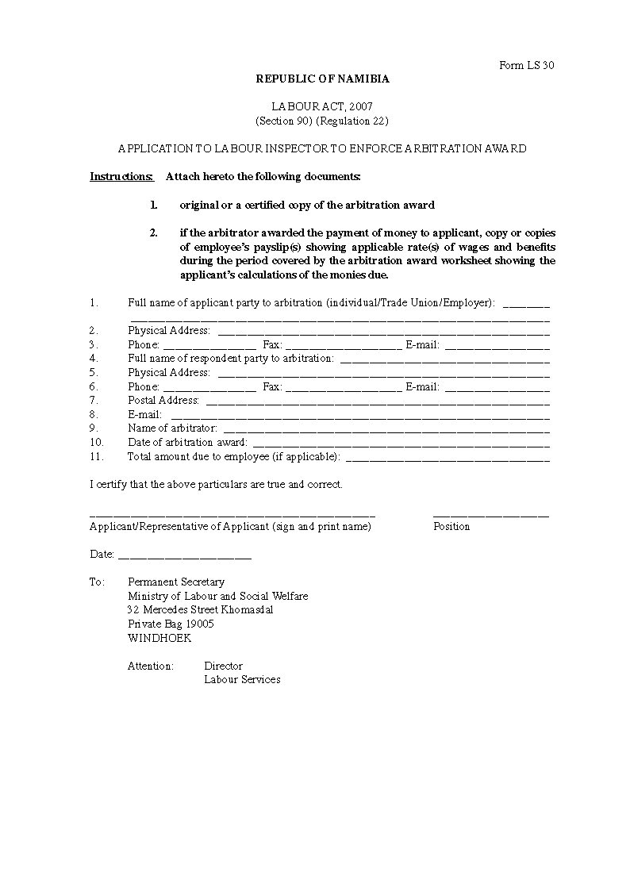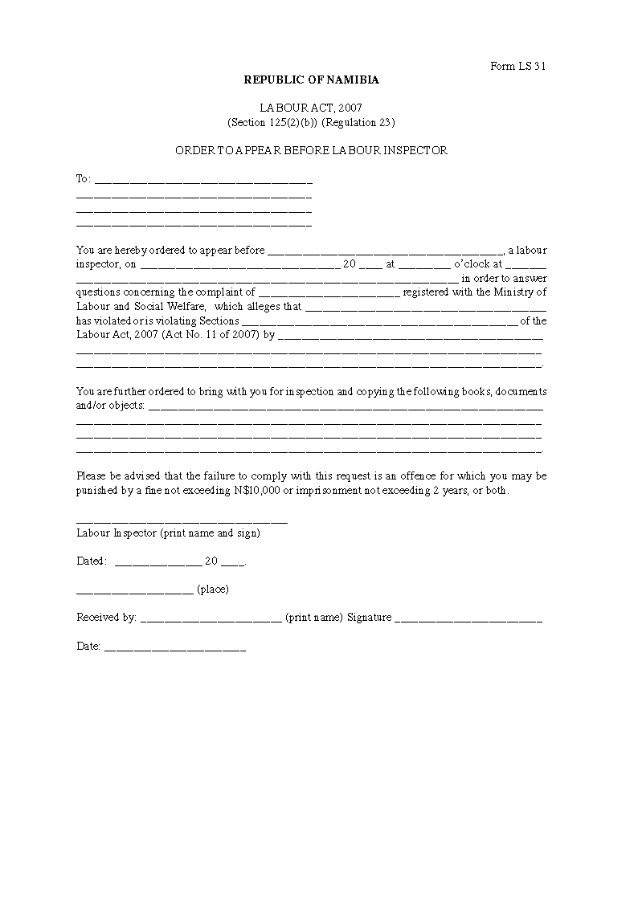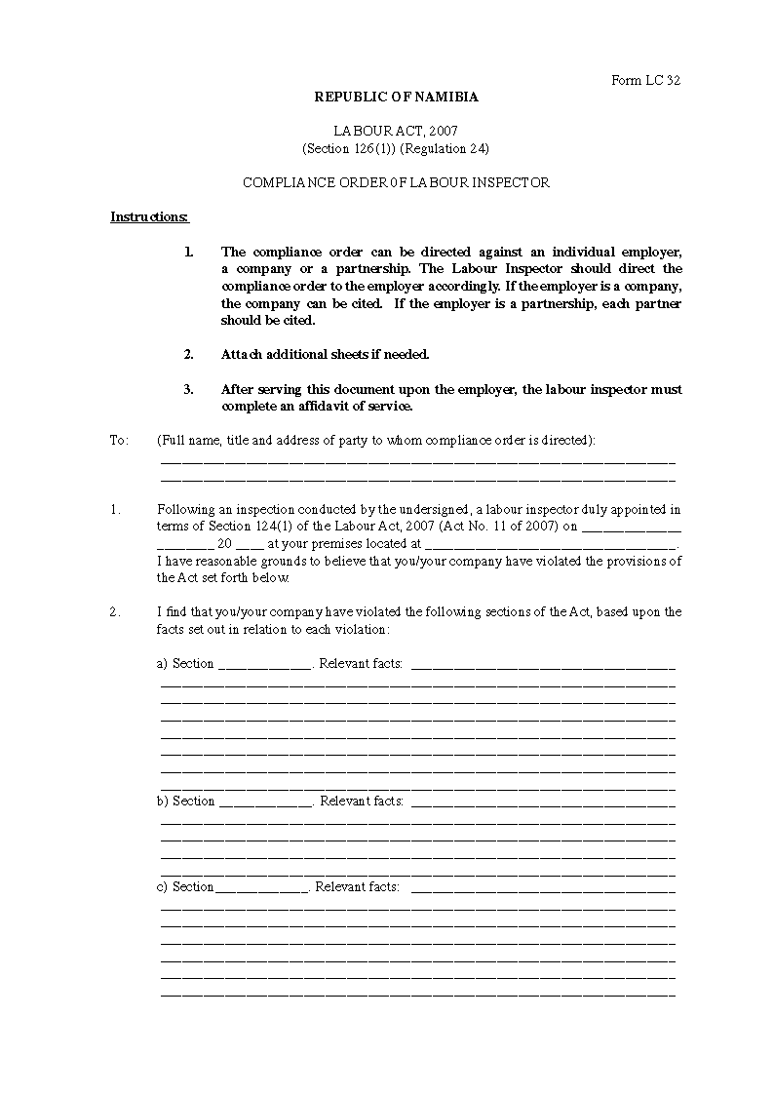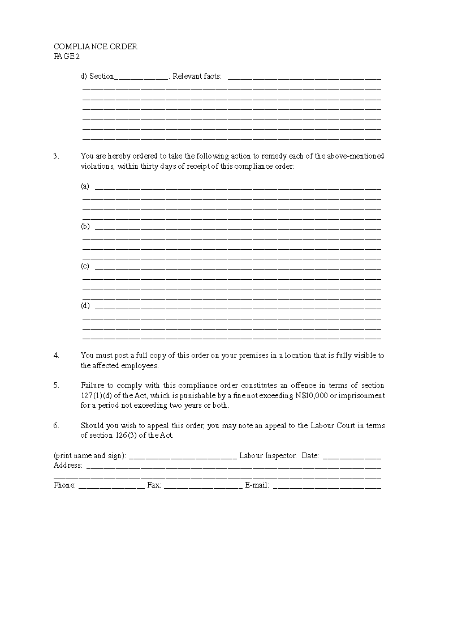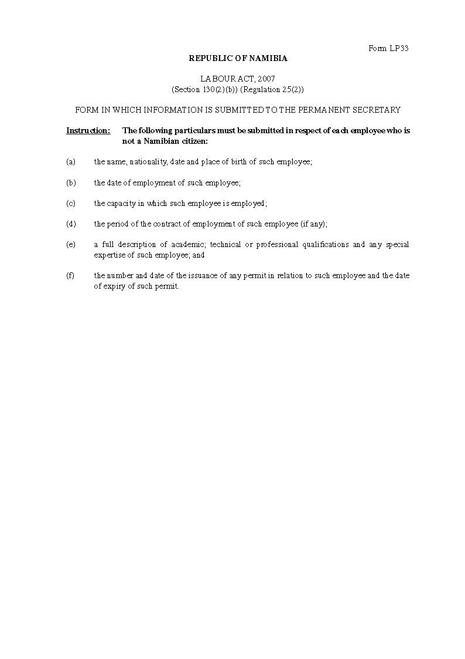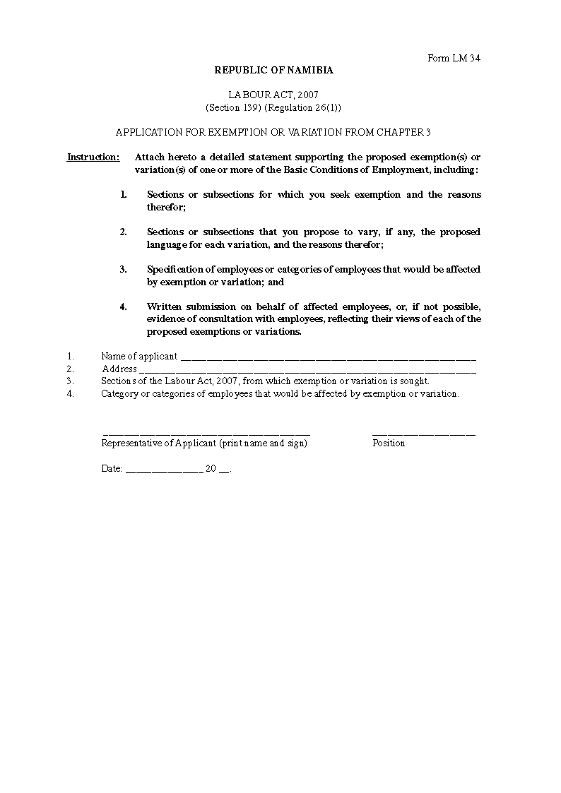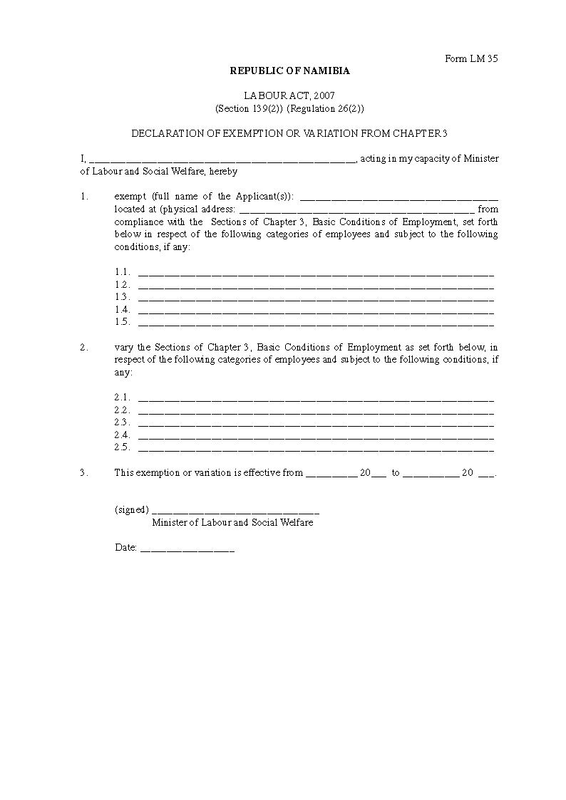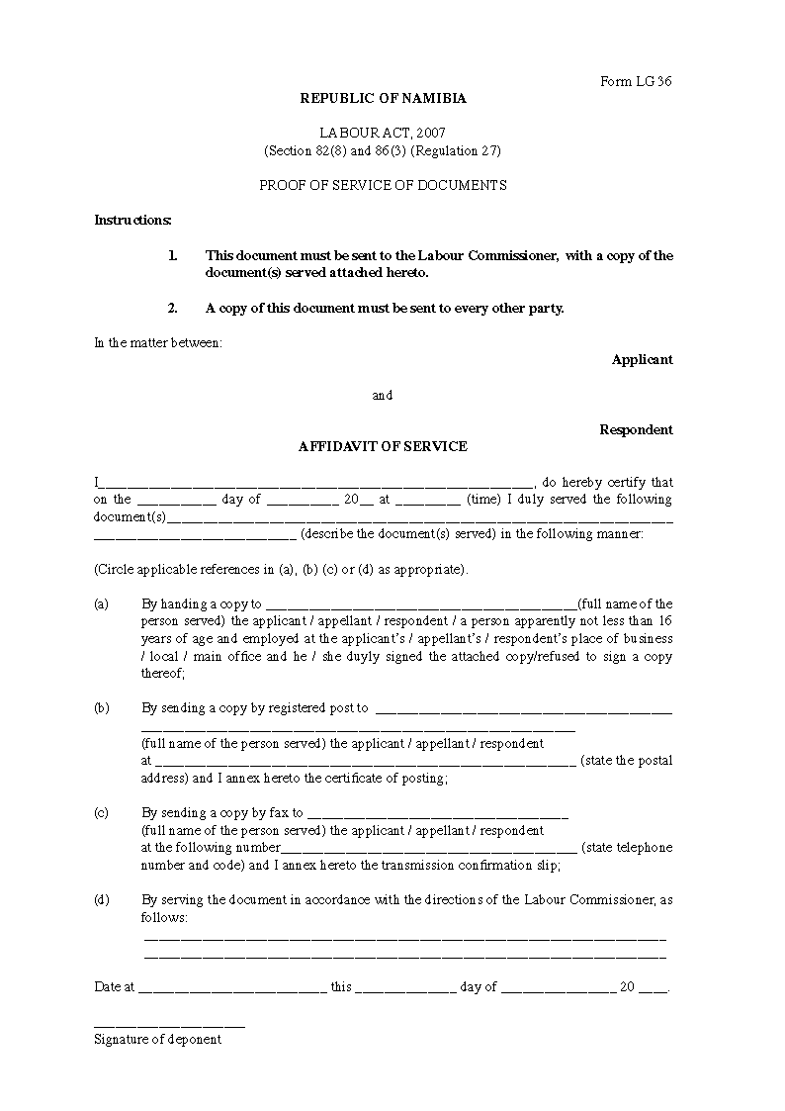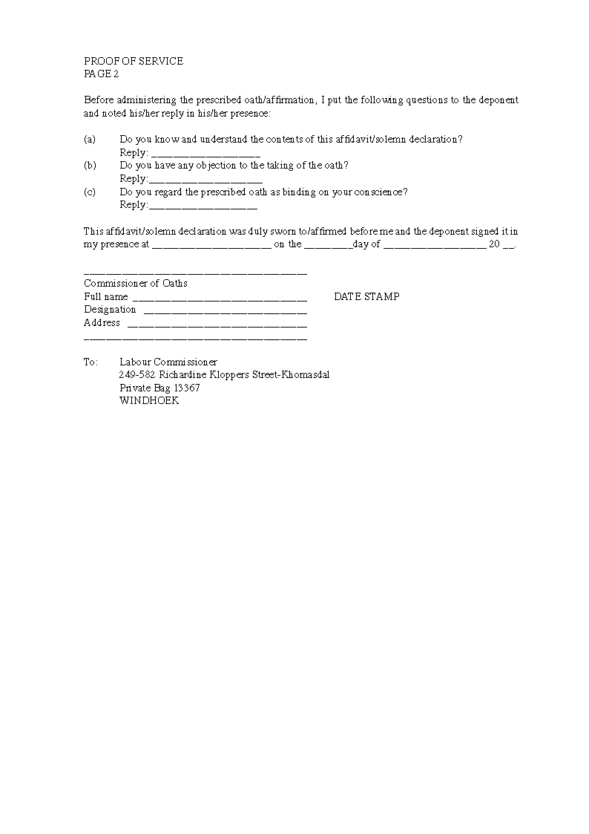

ANNEXURE 3

MINISTRY OF LABOUR AND SOCIAL WELFARE

LABOUR ACT, 2007

(Section 130 (1)) (Regulation 25(1))

RECORDS TO BE KEPT BY EMPLOYERS AT AN ADDRESS IN NAMIBIA

**Note:**

“basic wage” means that part of an employee’s remuneration in money including the cash equivalent of payment in kind, if any, as calculated in terms of section 10, paid in respect of work done during the hours ordinarily worked but does not include -

(i) allowances, including travel and subsistence, housing, motor vehicle, transport, and professional allowances, whether or not based on the employee’s basic wage;

(ii) pay for overtime, as defined in section 8 (g);

(iii) additional pay for work on a Sunday or a public holiday;

(iv) additional pay for night work, as required in terms of section 19(1); or

(v) payments in respect of pension, annuity or medical benefits or insurance.

“remuneration’’ means the total value of all payments in money or in kind made or owing to an employee arising from the employment of that employee;

1. A register must be kept by every employer of every employee in his or her employment containing the following particulars, namely -

(a) the name, age identity number (if any), occupation and sex of an employee;

(b) the date on which the employee commenced employment;

(c) the date of termination of the contract of employment and the reasons for the termination;

(d) the ordinary hourly, daily, weekly fortnightly or monthly basic wage and remuneration of an employee;

(e) the period in respect of which such basic wage and remuneration is payable;

(f) the time (in hours or fractions thereof) per day or per shift worked by the employee during the period referred to in paragraph (c) in respect of -

(i) ordinary working hours;

(ii) overtime;

(iii) night work;

(iv) work on Sundays; and

(v) work on public holidays;

(g) the total number of hours worked by the employee during the period referred to in paragraph (c) in respect of -

(i) ordinary working hours;

(ii) overtime;

(iii) night work;

(iv) work on Sundays; and

(v) work on public holidays;

(h) basic wage or total of basic wage and premium rate for items (ii) to (v) payable to the employee in respect of -

(i) ordinary working hours;

(ii) overtime;

(iii) night work;

(iv) work on Sundays; and

(v) work on public holidays;

(i) amount due for each part of remuneration in addition to basic wage (for example, pension contribution, medical insurance);

(j) the gross amount of remuneration payable to the employee;

(k) the particulars and amount of any deductions from the amount referred to in paragraph (j); and

(l) the nett amount of remuneration payable to employee.

(m) a period of absence, including annual leave, sick leave, compassionate leave or maternity leave taken by the employee.

2. A register relating to the granting of leave must be kept by every employer of every employee in his or her employment containing the following particulars, namely -

(a) the name, occupation and sex of the employee;

(b) the date on which the employee commenced his or her employment;

(c) the period granted in respect of -

(i) annual leave;

(ii) sick leave

(iii) compassionate leave

(iv) maternity leave; and

(v) occasional leave

(d) the date on which such leave commenced;

(e) the date on which such leave ended;

(f) the number of days of such leave with full remuneration granted to the employee; and

(g) the number of days of such leave without remuneration granted to the employee.

3. A register must be kept by every employer of every employee in his or her employment who is not a Namibian citizen containing the following particulars, namely -

(g) the name, nationality, date and place of birth of such employee;

(h) the date of employment of such employee;

(i) the capacity in which such employee is employed;

(j) the period of the contract of employment of such employee (if any);

(k) a full description of academic; technical or professional qualifications and any special expertise of such employee; and

(l) the number and date of the issuance of any permit in relation to such employee and the date of expiry of such permit.

[The paragraphs in Item 3 are numbered (g)-(h), as presented   
above. They should probably be numbered (a)-(f).]