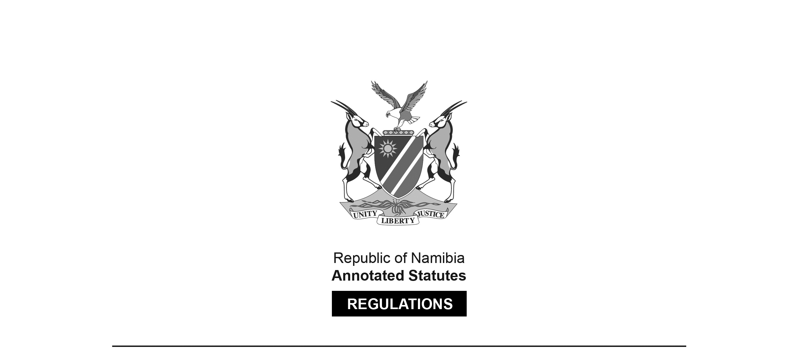

REGULATIONS SURVIVING IN TERMS OF

Labour Act 11 of 2007

schedule, item 2(2)

Regulations relating to the Health and Safety

of Employees at Work

Government Notice 156 of 1997

(GG 1617)

came into force on 31 July 1997 (GN 156/1997)

These regulations were originally made in terms of section 101 of the Labour Act 6 of 1992, which was repealed by the Labour Act 11 of 2007. Pursuant to Item 2(2) in Schedule 1 of the Labour Act 11 of 2007, the regulations are deemed to have been made under that Act. The Government Notice which publishes the regulations notes that they were made by the President, after consultation with the Labour Advisory Council. The administration of these regulations was assigned to   
various ministers by Proc. 10/1997 (GG 1615).

**Arrangement of Regulations**

CHAPTER 1

RIGHTS AND DUTIES OF EMPLOYERS

1. Interpretation

2. Employer’s general duties

3. Employer’s health and safety policy and programme

4. Appointment of supervisors

5. Duties of executive officer

6. Safety officers

7. Duties of employers to persons other than their employees

8. Duties of self-employed persons

9. Duties of designers, manufacturers, importers and suppliers

10. Work-place safety representatives

11. Removal from the work-place

12. Prohibition

13. Offences and penalties

CHAPTER 2

ADMINISTRATION

14. Interpretation

15. Approved codes of practice

16. Incorporation of health and safety standards

17. Health and safety procedures

18. Appointment of approved inspection authorities

19. Registration of factories

20. Commencement of building or construction work

21. Commencement of mine operations

22. Notification of accidents and dangerous occurrences

23. Notification of occupational diseases

24. Posting of notices

25. Keeping of documents

26. Inquiries

27. Confidentiality

28. Offences and penalties

CHAPTER 3

WELFARE AND FACILITIES AT WORK-PLACES

29. Interpretation

30. General conditions of welfare and facilities

31. Condition of rooms and facilities

32. Floor space

33. Ventilation

34. Natural lighting

35. Sanitary conveniences

36. Washing facilities

37. Cleanliness of premises

38. Facilities for safe keeping

39. Change-rooms

40. Rest-rooms and dining-rooms

41. Ergonomic requirements

42. Heating and cooling

43. Fire precautions

44. Usage and storage of volatile flammable substances

45. Smoking and taking of meals

46. Drinking water

47. Offences and penalties

ANNEXURE A

1. FORMS

(1) FORM F.1 Application for Approval of Plans

(2) FORM F.2 Application for Registration of a Factory

(3) FORM F.3 Certificate of Registration of a Factory

(4) FORM F.4 Provisional Factory Permit

(5) FORM F.5 Notification of Accidents or Dangerous Occurrences

2. (1) Notifiable Occupational Diseases

(2) FORM OD.1 Notification of Occupational Diseases

CHAPTER 4

SAFETY OF MACHINERY

PART I

GENERAL SAFETY OF MACHINERY

48. Interpretation

49. Principles of safety integration

50. Responsible person

51. Duties of employer

52. General machinery protection

**A. CONTROLS**

53. Safety and reliability of control systems

54. Control devices

55. Starting devices

56. Stopping devices

57. Failure of the power supply

**B. GUARDS AND PROTECTIVE DEVICES**

58. Choice of protection against risks related to moving parts

59. Required characteristics of guards and protection devices

60. Machinery Maintenance

61. Isolation of energy sources

62. Condition of safety appliances and machinery

63. Clear space

64. Condition of floors

65. Dangerous places

**C. SPECIFIC MACHINERY**

66. Abrasive wheels and machines

67. Machine tools

68. Shears, guillotines and presses

69. Slitting machines and milling machines

70. Feed and discharge openings in machines

71. Rollers and conveyors

72. Washing machines and centrifugal extractors

**D. WELDING, FLAME CUTTING, SOLDERING**

73. Protective clothing, insulation of leads and screening of work-place

74. Ventilation of work area

75. Precautions in hazardous situations

**E. WOODWORKING MACHINERY**

76. Circular saws

77. Band saws and band knives

78. Planing machines

79. Moulding machines

ANNEXURE B

1. FORMS:

(1) FORM C4/F1 Notice to be posted in a conspicuous place

and manner at the work-place by users of

Woodworking Machinery

(2) FORM C4/F2 Notice to be posted in a conspicuous place

and manner at the work-place by users of

Machinery.

**F. GOODS HOISTS**

80. Details of construction

81. Ropes

82. Inspection

83. Prohibition of use of goods hoist for conveyance of persons

84. Control of operation

85. Safety of hoist

86. Cranes and other lifting appliances

87. Lifting-gear and tackle

**G. EXPLOSIVE-POWERED TOOLS**

88. Explosive powered tools

89. Vessels under pressure

90. Elevators and escalators

91. Offences and penalties

PART II

SAFETY RELATING TO MACHINERY

**A. BOILERS**

92. Interpretation

93. Erection and use of boilers without permission prohibited

94. Construction, maintenance and operation of boilers

95. Application for permission to erect or use a boiler

96. Fees

97. Issue of permission to erect and use a boiler

98. Boiler inspection register and log-book

99. Particulars to be marked on boilers

100. Position of boiler

101. Inspection and test of boilers

102. Precautions to be observed in working with boilers

103. Hydraulic test pressure

104. Determination of authorised working gauge pressure

105. Returns

**B. BOILER APPURTENANCES**

106. Water level

107. Water feeding apparatus

108. Economisers

109. Low-water alarms

110. Safety valves

111. Construction of safety valves

112. Steam stop valve

113. Blow-off cocks and pipes

114. Pressure gauges

115. Test-gauge connections

116. Access to valves and fittings

117. Access and inspection openings

118. Requirements for boiler mountings and fittings

119. Offences and Penalties

ANNEXURE C

1. FORMS:

(1) FORM FB.1 Provisional Certificate of Permission to

Work a Steam Boiler

(2) FORM FB.2 Certificate of Permission to Work a Steam

Boiler

(3) FORM FB.3 Application for Permission to Erect and

Work a Steam Boiler

(4) FORM FB.4 Dimension Sheet of Boiler

(5) FORM FB.5 Boiler Inspection Register

PART III

SAFETY OF MACHINERY

120. Interpretation

**A. ELEVATORS**

121. Permission to erect or use elevator required

122. Application for permission to erect or use elevator

123. Issue of permission to erect or use elevator

124. Elevator register and record book

125. Fees

126. Returns

127. Examination and repairs

128. Inspection of elevator

129. Duties of user of an elevator

130. Authorised maximum load

131. Marking of elevator

132. Elevator operators

133. Hatchway enclosure

134. Hatchway landing doors

135. Hatchway door locks and contacts

136. Hatchway safety

137. Guide rails

138. Buffers

139. Access to bottom of hatchway

140. Hatchway separation

141. Hatchway clearances

142. Over travel devices

143. Construction of counterpoise

144. Construction of elevator

145. Elevator doors and gates

146. Retiring cam

147. Alarm, stop-switch and lighting

148. Safety catches

149. Ropes

150. Rope connections

151. Precautions against rope slip

152. Overhead machinery

153. Brakes

154. Speed governor

155. Guards for moving parts

156. Elevator machinery room

157. Electrical installation

158. Goods elevators

**B. ESCALATORS**

159. Permission to erect or use escalator required

160. Application for permission to erect or use escalator

161. Issue of permission to erect or use escalator

162. Escalator inspection register and record book

163. Fees

164. Returns

165. Inspection of escalator

166. Duties of user of escalator

167. Safety devices

168. Brakes

169. Angle of inclination

170. Speed

171. Balustrades

172. Comb plates

173. Lighting

174. Electrical installation

175. Offences and penalties

ANNEXURE D

1. FORMS:

(1) FORM F.E.1 Application to Erect or Use Elevator

(2) FORM F.E.2 Provisional Certificate of Permission to use Elevator

(3) FORM F.E.3 Certificate of Permission to Use Elevator

(4) FORM F.E.4 Elevator/Escalator Inspection Register

(5) FORM F.E.5 Provisional Certificate of Permission to use Escalator

(6) FORM F.E.6 Certificate of Permission to Use Escalator

(7) FORM F.E.7 Application to Erect or Use Escalator

2. Particulars of Ropes to be entered in Elevator Record Book

CHAPTER 5

HAZARDOUS SUBSTANCES

176. Interpretation

177. Transport of hazardous substances

178. Duties of suppliers, manufacturers and importers

179. General preventive measures

180. Safety data sheets

181. Labelling of containers containing hazardous substances

182. Storage of hazardous substances

183. Handling of hazardous waste

184. Notification of the use of carcinogens and other controlled substances

185. Hazardous substances exposure limits

186. Exposure measurements of hazardous substances

187. Biological monitoring

188. Records

189. Respiratory protection

190. Emergency facilities

191. Fire, explosion and toxic hazards

192. Hazardous fumes and lack of oxygen

193. Gas plant

194. Prohibitions

195. Offences and penalties

ANNEXURE E

Schedule 1 (1) FORM F.HS.2 Notice of the Use of Carcinogens

and other Controlled Substances

(2) Occupational Exposure Limits for Airborne Hazardous Substances

(3) Adopted Biological Exposure Determents

Schedule 2 (1) Asbestos Regulations,

(2) Lead Regulations

(3) Silica Regulations

CHAPTER 6

PHYSICAL HAZARDS AND GENERAL PROVISIONS

196. Interpretation

**A.** **PHYSICAL HAZARDS**

197. Noise

198. Vibration

199. Ionizing radiation

200. Non-ionizing radiation

201. Thermal requirements

202. Illumination

203. Windows

204. Ventilation

**B. GENERAL PROVISIONS**

205. Mechanical lifting equipment and manual lifting

206. Safe means of access and safe place of employment

207. Storage

208. Ladders

209. Precautions against flooding

**C. PROTECTIVE EQUIPMENT**

210. Personal protective equipment

211. Eye protection

212. Head protection

213. Protective footwear

214. Safety belts and lanyards

215. Protection against falling

216. Protection from drowning

217. Offences and penalties

ANNEXURE F

1. Use of Eye Protective Equipment

2. Minimum Average Values of Maintained Illuminance

3. (1) Diving Regulations

(2) Noise Regulations

CHAPTER 7

MEDICAL EXAMINATIONS AND EMERGENCY ARRANGEMENTS

218. Interpretation

**A. MEDICAL SURVEILLANCE**

219. Occupational health services

220. Function of occupational health services

221. Duties of employers

222. Organization of occupational health services

223. Registration

224. Professional independence

225. Provision of alternative work

226. Access to medical reports

227. Medical records

**B. FIRST AID AND EMERGENCY ARRANGEMENTS**

228. Application

229. General requirements

230. Additional Requirements

231. First aid station

232. First aid kit, isolated employees

233. First aid attendants

234. Validity of certificate

235. First aid attendants in specified work situation

236. First aid room

237. Transportation of injured employees

238. Reporting and recording of injuries

239. Additional requirements

240. More than one employee at the same site

241. First aid in mining

242. Offences and penalties

ANNEXURE G

1. Qualification of First Aid Attendants

2. Standards of First Aid Services

3. First Aid Supplies and Equipment

CHAPTER 5

CONSTRUCTION SAFETY

243. Interpretation

244. Safety of building work

245. Supervision of building work

246. Scaffolding

247. Gear used in connection with structural work

248. Roof work

249. Demolition and excavation

250. Ladders

251. Ramps, gangways and runs

252. Boatswain’s chairs

253. Scaffold framework

254. Scaffold platforms

255. Suspended scaffolds

256. Trestle scaffolds

257. Offences and penalties

CHAPTER 9

ELECTRICAL SAFETY

258. Interpretation

**A. ELECTRICAL MACHINERY**

259. Fencing and enclosure

260. Notice

261. Safety precautions

262. Switchboards

263. Portable electric tools and lights

**B. MAINTENANCE**

264. Examination and repairs

265. Safety equipment

266. Temporary earthing and isolation

267. Earthing general

**C. INSTALLATION**

268. Transformer or switch-rooms and houses

269. Height of conductors

270. Factors of safety

271. Offences and penalties

ANNEXURE H

FORM E.1 Notice of Commencement of Installation Work.

[Capitalisation is reproduced throughout this set of regulations as it appears in the Government Gazette. Page breaks have been inserted before and after the Appendices which are interspersed with the various Chapters of the regulations, to facilitate printing of lists and forms.   
Obvious formatting errors in respect of margins have been corrected.]

CHAPTER 1

RIGHTS AND DUTIES OF EMPLOYERS

**Interpretation**

**1**. In these regulations, unless the context otherwise indicates, a word or expression defined in the Act bears that meaning, and -

“Chief Inspector” means an inspector appointed under section 3, and holding the position of Chief Inspector of Factories in the Ministry of Labour;

“Chief Executive Officer”, in relation to a body corporate or an enterprise conducted by the state, means the person who is responsible for the overall management and control of the conducting of business of such body corporate or enterprise.

“competent person” means a person certified in writing by an inspector to be competent to perform a specific task, and “competent authority” has a corresponding meaning;

“inspector” means a person appointed as a labour inspector under section 3;

“section” means a section of the Act;

“the Act” means the Labour Act, 1992 (Act 6 of 1992);

“work-place safety committee” means a work-place safety committee established by an employer in terms of section 99;

“work-place safety representative” means an employee elected as such in terms of; and

any duty or function performed by an employer or any other person in terms of these regulations shall, unless otherwise indicated, be performed to the satisfaction of an inspector.

**Employer’s general duties**

**2**. (1) An employer shall -

(a) investigate and identify the hazards attached to any work that is performed or may be performed by any of his or her employees, including the risks or potential risks to the health and safety of employees associated with such work, or to the health and safety of any other person who may be affected by such work;

(b) assess the hazards and risks identified in terms of paragraph (a);

(c) subject to paragraph (d), eliminate the hazards by employing appropriate measures, including the removal of the hazards, or the changing of the organization or schedules of the work performed; or

(d) If it is not reasonably practicable to eliminate the hazards, do all that is reasonably practicable to minimize the hazards, or to reduce the risks caused by the hazards by means of the minimizing -

(i) the effects of the hazard at its source;

(ii) the effects of the hazards on employees; and

(iii) the level and period of exposure of employees to the hazard by means of the arrangement and organization of work.

(2) In complying with paragraph (d) of subregulation (1), an employer shall rely upon the use of personal protective equipment by employees -

(a) only if it is not reasonably practicable to reduce the risks by any other means; or

(b) as a temporary measure while other steps are being taken to eliminate or minimize the hazard concerned.

(3) An employer shall provide every employee in his or her employ, including any person serving an apprenticeship in terms of any law, with training in the tasks that he or she is to perform, including all aspects of health and safety related to such tasks, so as to enable the employee to take reasonable care of his or her own safety and of that of other employees.

(4) If an employee’s job description or the scope of his or her employment is changed in such a manner that he or she will be performing additional tasks, or tasks which will differ from the tasks which he or she previously performed, the employer shall -

(a) in detail inform the employee of all aspects relating to, and train the employee in the performance of, the additional tasks;

(b) instruct the employee in all the aspects of health and safety related to such tasks,

before the employee shall commence performing such tasks.

(5) An employer who has entered into an agreement with a contractor to perform certain tasks shall ensure that such a contractor complies with these regulations.

(6) All safety equipment and facilities, including personal protective equipment and clothing that an employer is required to provide in terms of any provision of the Act or of these regulations, shall be -

(a) appropriate and effective for the purposes for which they are provided;

(b) supplied free of charge;

(c) maintained in an effective or working order and in a clean condition; and

(d) available at each work-place in sufficient quantities to ensure that any employee who is required to use personal protective equipment or clothing, is in a position to use such equipment or clothing.

(7) An employee who is required to use personal protective equipment or clothing shall be thoroughly instructed on the ‘proper use, the maintenance and the limitations of such equipment or clothing.

(8) If necessary, all personal protective equipment and clothing shall be retained on the employer’s premises and shall only be removed from the premises for the purposes of cleaning, repairing, maintenance or modification, as the case may be, when necessary.

(9) No employer shall require or permit any employee to work in a place or in circumstances where the use of safety equipment, clothing or facilities are required by the Act or by these regulations, unless the employee uses the safety equipment, clothing or facility so required.

(10) this regulation do not derogate from any other provision requiring the use by employees in any specific place of particular safety equipment, clothing or facilities.

**Employer’s health and safety policy and programme**

**3**. (1) An employer shall, in consultation with the work-place safety representatives, regularly prepare and review a written policy and programme on the protection of the health and safety of employees.

(2) The health and safety policy contemplated in subregulation (1) shall specify -

(a) the aims and objectives of the policy; and

(b) the general approach, means and measures to be adopted in order to achieve the objectives of the policy.

(3) The health and safety programme of an employer shall in detail specify -

(a) the employer’s health and safety arrangements for the prevention of health and safety risks;

(b) the responsibilities relating to health and safety of persons occupying positions concerning the health and safety programme, or holding supervisory positions;

(c) the programme aimed at improving the working conditions at the work-place, including, but not limited to, health and safety awareness programmes and training programmes; and

(d) the procedures and methods to be adopted to implement the health and safety programme and policy.

**Appointment of supervisors**

**4**. An employer shall ensure that all work is performed under the supervision of a competent supervisor, who shall -

(a) in addition to any other training required in terms of the Act or regulations, be trained to understand the hazards associated with all work he or she has to supervise;

(b) have the duty to ensure that all precautionary measures required in terms of the Act or of these regulations are implemented; and

(c) if required, provide employees under his or her supervision with appropriate training, including instructions relating to the safety in respect of specific work tasks and on the job training,

to the satisfaction of an inspector.

**Duties of Chief Executive Officer**

**5**. (1) The Chief Executive Officer of a corporate body shall ensure that such corporate body complies with the Act and of these regulations.

(2) The Chief Executive Officer contemplated in subregulation (1) may in writing delegate to any person under his or her control any duty contemplated in that subregulation, and such person shall perform such duty on behalf of and subject to the control of the Chief Executive Officer, but the Chief Executive Officer shall not be relieved from any duty so delegated by him or her.

(3) For the purposes of these regulations, the Permanent Secretary of a Ministry is the Chief Executive Officer of that Ministry.

**Safety officers**

**6**. (1) An employer shall, to the satisfaction of an inspector, in relation to the number of employees in his or her employment and in accordance with the safety risk involved for such employees in the execution of their duties -

(a) appoint a safety officer, who may be the Chief Executive Officer; and

(b) shall at the request of the inspector, appoint such additional safety officers as the inspector may determine,

which safety officers shall be required to monitor and evaluate the employer’s compliance with its safety policy, with the Act and with these regulations.

(2) The employer shall, to the satisfaction of an inspector, furnish the safety officer or officers referred to in subregulation (1) with sufficient information, training, facilities and assistance so as to enable him or her or them to perform the functions contemplated in subregulation (1).

(3) The appointment of a safety officer in terms of subregulation (1) shall not derogate from the responsibilities of the Chief Executive Officer in terms of these regulations, or of any person to whom any duty of the Chief Executive Officer has been delegated under regulation 5(2).

(4) The safety officer or officers referred to in this regulation shall be a member of the work-place safety committee and shall take part in all the activities of the committee as a part of his or her duties and functions of employment.

**Duties of employers to persons other than their employees**

**7**. An employer shall conduct his or her undertaking in such a manner as to ensure, as far as is reasonably practicable and to the satisfaction of an inspector, that any person, including a person not in his or her employ, who may be affected by the activities of the employer, are not as a result of such activities exposed to any risks relating to the health or safety of such person.

**Duties of self-employed persons**

**8**. A self-employed person shall conduct his or her undertaking in such a manner as to ensure, as far as is reasonably practicable and to the satisfaction of an inspector, that his or her employees or any other person who may be affected by such person’s activities, are not as a result of such activities exposed to any risk relating to their health or safety.

**Duties of designers, manufacturers, importers and suppliers**

**9**. (1) A person who designs, manufactures, imports or supplies any article for use at a work-place, or makes available a building in which work of any kind is to be undertaken, shall -

(a) ensure that the article or building complies with all prescribed requirements relating to health or safety;

(b) ensure, as far as is reasonably practicable, that the article or building is designed and constructed so as to be safe and without risks to the health of any person when used in a reasonable manner;

(c) take such steps as are reasonably necessary to ensure that adequate information is available with regard to the correct use of the article or building, and the precautions necessary to ensure that the use thereof is safe and without risk to any person’s health;

(d) ensure that any assembly, erection or installation that is required at the work-place can be undertaken safely and without risk to the health of any person when performed in accordance with the manufacturer’s instructions and specifications;

(e) supply an operator’s manual dealing with the assembly, installation, use and maintenance of an article in a language or in languages that is understood by any person who may work with the article; and

(f) refrain from alterations and modifications to such article that could create any new conditions which may be hazardous to the health or safety of any person.

(2) A person who assembles, erects or installs any article for use at a work-place on any premises where the article is to be used by any other person shall, as far as is reasonably practicable, ensure that such article is erected or installed in such a manner that it is safe and without risk to safety or health when used in accordance with the manufacturer’s specifications.

(3) A person who manufactures, imports or supplies any substance for use at a work-place shall -

(a) ensure, as far as is reasonably practicable, that the substance is safe and without risks to the safety or health of any person when used, handled, processed, stored or transported in accordance with the manufacturer’s specifications and in a reasonable manner; and

(b) ensure that a safety data sheet providing the following information relating to the substance is handed or explained to any person who may handle, work with or be exposed to the substance in respect of -

(i) the use of the substance at work;

(ii) the risk associated with the substance relating to the health or safety of any person;

(iii) any restrictions or controls upon the use or storage of the substance, including, but not limited to, exposure limits;

(iv) the safety precautions necessary to ensure that the substance is safe and without risk to health;

(v) procedures to be followed in the case of an accident in connection with, or the excessive exposure to, or any other emergency involving, the substance; and

(vi) the disposal of waste and used containers in which the substance has been stored.

**Work-place safety representatives**

**10**. (1) A work-place safety representative -

(a) shall monthly inspect each place where employees represented by him or her are employed, except a place where the employer and the work-place safety representative have agreed, or an inspector has directed, that inspections be conducted at longer or shorter intervals;

(b) shall not less than once in each period of twelve months, perform a thorough examination of each place where employees represented by him or her are employed;

(c) may be accompanied by a technical adviser during any inspection, investigation or examination in terms of section 99(2)(b)(i) or of these regulations;

(d) shall either personally or with the assistance of another work-place safety representative or a technical adviser, prepare a written record of every inspection, investigation or examination;

(e) shall submit a copy of the written report contemplated in paragraph (d) to the safety officer and to the employer;

(f) shall be entitled to attend any inquiry into an accident or other incident at a place where employees represented by him or her are employed;

(g) shall be entitled to accompany an inspector on any inspection or investigation of a place where employees represented by him or her are employed;

(h) may record in writing any representation made to or by the employer;

(i) shall be entitled to consult with the safety officer, technical experts and inspectors; and

(j) shall be entitled to receive adequate training to participate in the health and safety training of employees.

(2) A safety officer shall -

(a) after considering the written record of an inspection, investigation or examination, endorse the record and state whether or not he or she is in agreement with any of the findings of the work-place safety representative; and

(b) at the request of a work-place safety representative, meet with the representative to discuss any inspection, investigation or examination.

(3) If a work-place safety representative makes a representation in writing to the employer, the employer shall upon the representation -

(a) make an endorsement to the effect that he or she has received it;

(b) state whether or not he or she agrees with the contents of the representation; and

(c) indicate what steps, if any, have been, or will be, taken to address the issue raised in the representation,

and shall thereafter return the representation to the work-place safety representative.

(4) If a work-place safety representative makes a representation in writing to an inspector, the inspector shall in writing respond to the representation, indicating the steps he or she has taken in respect of the representation.

(5) A work-place safety committee shall -

(a) meet not less than once quarterly or at such shorter interval as may be agreed upon with the employer and employees concerned, or as an inspector may direct;

(b) in writing advise to, or communicate with, the employer; and

(c) keep copies of its minutes and retain such copies for a period of five years.

(6) An employer shall -

(a) make a suitable meeting place and suitable facilities, including a room in which to consult with employees, available to the work­ place safety representatives and to a work-place safety committee;

(b) arrange for the release of work -place safety representatives and the members of a work-place safety committee from their normal duties for the purpose of performing any duty specified in section 99(2)(b) of the Labour Act or in subregulation (1), and of attending meetings of the committee, as the case may be; and

(c) respond in writing to the work-place safety committee in respect of any written advice or other communication received from the work­ place safety committee.

**Removal from the work-place**

**11**. (1) An employee who removes himself or herself from any place where he or she is employed when he or she has reasonable cause to believe that his or her health or safety will be endangered at such place -

(a) may seek the assistance of his or her work-place safety representative, who may assist the employee at any meeting held as a result of his or her removal from his or her work-place; or

(b) shall report to either his or her immediate supervisor or to the safety officer stating the reasons for his or her belief that his or her health or safety will be endangered.

(2) If the matter is not resolved in accordance with subregulation (1), the employer shall arrange for a meeting between a senior representative of the employer and the employee, which employee may be assisted by a work-place safety representative, a technical adviser or a trade union representative.

(3) If the matter is not resolved in accordance with the procedures prescribed by subregulation (2), the employer shall notify an inspector, who shall -

(a) after hearing representations from the employer and from the employee or his or her representative, make a decision which shall be final and binding upon the parties concerned; or

(b) by notice in writing, issue an order under section 100(1)(iv), ordering the employer to refrain from carrying out, or to carry out, any action specified in such notice in order to ensure the health and safety of the employee concerned.

(4) If the inspector finds that the employee referred to in subregulation (1) had reasonable cause to believe that his or her safety or health was endangered as contemplated in that subregulation, or if the employer has agreed to take effective measures to ensure the health and safety of the employees -

(a) all work-places where a similar hazard may exist shall be investigated by an inspector and, if necessary, similar effective measures shall be taken; and

(b) the employee concerned shall be entitled to his or her full remuneration for the period from the date that the employee removed himself or herself in accordance with subregulation (1), until -

(i) the date of the inspector’s decision taken in terms of this regulation; or

(ii) if the inspector in terms of subregulation (3) orders the employer to take certain measures, until such measures have been taken.

(5) An employer shall not dismiss or in any other way take disciplinary action against an employee for exercising his or her rights in terms of this regulation and any such action by an employer shall be regarded as unfair in terms of section 45.

**Prohibition**

**12**. An employer shall ensure that no person under the age of 16 years is employed or permitted to work -

(a) at, on or in the immediate vicinity of, any construction site, engineering works, trench or excavation;

(b) at any pulp mill, saw mill or woodworking establishment;

(c) in the immediate vicinity of an industrial processes at any factory;

(d) in any silo, storage bin, vat, hopper, tunnel, shaft, sewer or other confined space;

(e) on the cutting line of any packing plant or the evisceration line of any poultry plant or abattoir;

(f) in any forestry or logging operation;

(g) on any drilling or servicing rig;

(h) as an operator of any heavy, mobile equipment, any crane or other

heavy, hoisting equipment; or

(i) as an operator of a forklift truck or similar mobile equipment within a work-place or in the vicinity of other employees.

(2) An employer shall ensure that no person under the age of 18 years is employed -

(a) underground, or in or at the open-pit face of any mine;

(b) as a radiation worker; or

(c) in any activity for which respiratory protective equipment is required by any regulations made under the Act, except if that work is performed under close and competent supervision to the satisfaction of an inspector.

**Offences and Penalties**

**13**. Any person who contravenes or fails to comply with any provision of regulation 2(1), (2) or (3), 3, 4, 5, 6(1),(2),(3) or (4), 7, 8, 9(1),(2) or (3), 10(1),(2),(3),(4),(5) or (6), 11(1),(2),(3),(4) or (5), or 12(1) or (2) shall be guilty of an offence and on conviction be liable to a fine not exceeding N$ 2000 or to imprisonment for a period not exceeding six months or to both such fine and such imprisonment.

CHAPTER 2

ADMINISTRATION

**Interpretation**

**14**. In this Chapter, unless the context otherwise indicates -

“approved inspection authority” means an inspection authority approved by the Chief Inspector in respect of a particular approved service or activity;

“dangerous occurrence” includes -

(a) the structural failure of a building, structure, temporary false work or concrete form work;

(b) the overturning or major failure of a crane or similar hoisting device;

(c) contact with an uninsulated electrical conductor by any hoisting or excavating equipment, by any vehicle or by any load associated with that equipment or vehicle;

(d) the structural failure of all, or part of, any temporary or permanent support for an excavated shaft, tunnel, caisson, coffer dam, trench or excavation;

(e) the bursting of a grindstone or grinding wheel;

(f) an uncontrolled spill or escape of toxic, corrosive or explosive substances that has, or may have, seriously affected the health and safety of any employee;

(g) any premature detonation or uncontrolled use of explosives; or

(h) the failure of a support system of any suspended platform.

“factory” means any premises or part of a premises on or in which -

(a) an article or part of such an article is made, manufactured, produced, built, assembled, compiled, printed, processed, treated, adapted, repaired, renovated, rebuilt, altered, ornamented, painted (including spray painting), polished, finished, cleaned, dyed, washed, broken­ up, disassembled, sorted, packed or put into a container, heated, chilled, frozen or stored in cold storage;

(b) livestock (including poultry) are slaughtered;

(c) electricity is generated;

(d) photographs, films or videos tapes or audio tapes are developed or processed; or

(e) any activity is conducted which is connected with or is incidental to any one or more of the activities mentioned in paragraphs (a) to (d), but does not include premises on or in which the activities mentioned in those paragraphs are conducted -

(i) by fewer than five persons, except if, in the opinion of an inspector, a high risk substance is used, processed or produced in any manner on the premises, in which case this exception shall not apply;

(ii) inside, and secondary to, a shop conducted solely for the purpose of selling by retail from that shop;

(iii) on a farm by a farmer, including a partnership or group of persons other than a company, solely in connection with products which he or she has produced on the farm operated by him or her, or solely in connection with his or her farming operations;

(iv) solely in connection with consultative professional services;

(v) in respect of facilities used solely for teaching and instruction in primary, secondary or tertiary educational institutions; and

(vi) on a premises used temporarily and solely for carrying out building work or an activity connected therewith:

Provided that the Chief Inspector may, at his or her discretion, determine that a part of a factory shall be considered to be a separate factory, or that two or more factories, having the same employer, shall be considered to be a single factory;

“occupational accident” means an accident arising in the course or as a result of an employee’s employment, and denotes an unexpected, unplanned and unwanted specific event, which disrupts work and results in personal injury, or disease or death of any person, or damage to property, or loss of production, time or money;

“serious injury” means any injury likely to endanger the life of, or cause permanent impairment to, a person; and

“temporary false work” is the temporary structure erected to support wet concrete while the concrete is hardening, for example the ceilings or floors in high rise buildings: Provided that the false work has to carry the full weight of the concrete while wet and is only removed once the concrete has hardened.

**Approved Codes of Practice**

**15**. (1) The Minister may, for the purpose of providing practical guidance concerning any provision of the Act or of these regulations, after consultation with the Labour Advisory Council, approve or issue a code of practice.

(2) A code of practice shall not impose upon any person any duty or obligation in addition to those contained in the Act or in these regulations.

(3) If a person is charged with the contravention of any provision in respect of which a code of practice has been issued -

(a) the code of practice shall be admissible as evidence in any legal proceedings instituted in respect of the contravention of such provision; and

(b) if it is proven that the person failed to comply with the code, or that part of the code relevant to the provision contravened, or that the person failed to comply with the provision by any method other than the method stipulated in the code of practice, such person shall be guilty of the contravention of that provision.

**Incorporation of health and safety standards**

**16**. (1) The Minister may by notice in the *Gazette* and after consultation with the Labour Advisory Council, incorporate in the regulations any health and safety standard, or part of such standard, with a reference to the number, title and year of issue of the health and safety standard and any other particulars required to identify it sufficiently, but need not state the text of the health and safety standard.

(2) Any health and safety standard incorporated under subregulation (1) shall, for the purposes of these regulations and in as far as it is not repugnant to any regulation, be considered to be a regulation.

(3) When any health and safety standard is at any time after its incorporation, amended or substituted by the competent authority, the notice incorporating the standard shall, unless otherwise stated, be considered to refer to the health and safety standard as amended or substituted.

(4) The Minister shall cause a register of particulars of every health and safety standard incorporated in the regulations to be maintained and to supply any person on request with a copy of any such standard.

(5) “Health and safety standard”, for the purposes of this regulation, means a health and safety standard which, in the opinion of the Minister, will promote the attainment of any object of these regulations.

**Health and Safety Procedures**

**17**. (1) If the Minister is satisfied that the Act or these regulations do not adequately provide for the regulation of the health and safety relating to the conducting of an employer’s operations, or any part of such operations, the Minister may direct the employer to, in accordance with subregulation (2), prepare a health and safety procedure which shall adequately provide for the health and safety of the employer’s employees and of any other person which may be affected by any operation conducted by the employer.

(2) The employer shall prepare any health and safety procedure referred to in subregulation (1) in consultation with the work-place safety committee concerned.

(3) The Minister may approve a health and safety procedure as submitted by the employer, or may approve the procedure subject to such changes as he or she may direct the employer to make to the procedure.

(4) A health and safety procedure approved in terms of subregulation (3) shall form part of these regulations in respect of the employer concerned.

**Appointment of approved inspection authorities**

**18**. (1) The Chief Inspector may permit any inspection function, investigation, testing, sampling, analysis or training to be performed by an approved inspection authority with the necessary expertise to the satisfaction of the Chief Inspector.

(2) The Chief Inspector shall develop criteria for the approval of inspection authorities after consultation with the Labour Advisory Council.

(3) Any person who applies to be an inspection authority and whose application is approved, shall be issued with a certificate signed by the Chief Inspector and stating the competencies and the period of time for which such approval has been granted.

(4) No person may perform any activity contemplated in subregulation (1) unless he or she is in possession of a valid certificate issued under subregulation (3), authorizing him or her to perform such activity.

(5) If an approved inspection authority performs any inspection service or other activity contemplated in subregulation (1), it shall provide the employer concerned with a report stating the findings and shall retain a copy of the report for a period of five years, which report may be examined on request by an inspector or a work-place safety representative.

**Registration of Factories**

**19**. (1) No person shall operate a factory which is not registered under these regulations.

(2) An application for the registration of any premises as a factory shall be lodged with an inspector in the form of Form F.2, duly completed, which shall be accompanied by Form F.1, duly completed, together with the prescribed plans and particulars.

(3) All plans submitted shall be accurate prints or drawings in ink on durable material to the satisfaction of the inspector.

(4) Plans submitted shall be drawn according to a scale of -

(a) in the case of site plans, 1 to 500;

(b) in the case of building plans, 1 to 100,

unless an inspector has authorised the submission of plans drawn according to any other scale.

(5) Site plans shall clearly indicate the positions of all buildings on the site, their distance from the site boundaries and the position of any building on neighbouring stands.

(6) Building plans shall clearly indicate -

(a) the position and dimension of all doors, windows, other conveniences, stairs and fire escapes;

(b) each floor separately in plan, elevation and cross section, the floor space of each room, the purpose for which it is to be used and the type of roof; and

(c) complete details of any structural alterations or additions proposed and their relation to the existing building, if any,

to the satisfaction of an inspector.

(7) Subject to subregulation (8), a fee of N$ 50 in uncancelled revenue stamps shall, upon submission of building plans for approval, be paid by the person who submits the plans.

(8) If the floor space of the building concerned exceeds 92,9 square metres, an additional N$ 50 in uncancelled revenue stamps shall be payable in respect of every additional 92,9 square metres, or portion thereof.

(9) A registration certificate shall be on the Form F.3.

(10) A provisional factory permit shall be on the Form F.4.

(11) The fees shall be paid to an inspector in uncancelled revenue stamps -

(a) upon the lodging of an application in terms of subregulation (2): N$ 100;

(b) for the issue of a registration certificate: N$ 100;

(c) for the issue of a provisional factory permit: N$ 50;

(d) for the issue of a duplicate registration certificate or a duplicate provisional permit: N$ 50.

**Commencement of Building or Construction Work**

**20**. (1) A person who intends to commence building or construction work shall give not less than 30 days notice of such intention to the Chief Inspector.

(2) A notice contemplated in subregulation (1) shall include -

(a) the names of the main contractor and of any sub-contractors to be engaged on the work;

(b) the address where the building work is to be carried out;

(c) the nature of the work;

(d) the expected dates of commencement and completion of the building work; and

(e) the total number of employees to be engaged on the work.

**Commencement of Mining Operations**

**21**. (1) Any person who intends to commence any mining operation shall give 30 days notice of such intention to the Minister.

(2) A notice contemplated in subregulation (1) shall include -

(a) the name of the person who is to conduct operations at the mine;

(b) the location of the mine;

(c) the nature of the mining activities;

(d) the date upon which work at the mine is expected to commence; and

(e) the number of employees to be engaged on the mine.

**Notification of Accidents and Dangerous Occurrences**

**22**. (1) In the event of an accident or dangerous occurrence in or in connection with a work-place, including a mine, or if an employee dies, or suffers a serious injury as a result of such an accident or dangerous occurrence, the employer shall -

(a) immediately notify the Chief Inspector through the quickest means available, including by telephone or by fax; and

(b) report the death, injury, accident or dangerous occurrence, as the case may be, to the Chief Inspector in the prescribed form within a period of seven days of such accident or occurrence, or within such shorter period of time as the Chief Inspector may in writing notify the employer.

(2) The employer shall, as soon as it is reasonably practicable, notify the appropriate work-place safety representative of any accident or dangerous occurrence contemplated in subregulation (1).

(3) No person shall, before the arrival of an inspector or without the consent of an inspector, disturb the site at which a fatal accident has occurred, or remove any article or item from the scene of the accident, except if any such action is required to remove or rescue injured or other persons from danger, to prevent a further accident or to remove any deceased person.

(4) An inspector may grant permission to move or disturb any article or item at, or remove it from, the scene of an accident, or to move, disturb or remove any article or item connected with an accident, if this is necessary to allow work to proceed, subject thereto that, before such permission is granted -

(a) photographs or verified drawings showing details of the scene of the accident are taken or made; and

(b) the inspector or the work-place safety representative for the place at which the accident occurred has inspected the site of the accident and has agreed that such items may be moved or removed.

(5) An employer shall notify the Chief Inspector as soon as possible during normal working hours of the date, time, place and nature of any accident which occurred in, at or in the vicinity of a work-place and which caused the death of, or serious bodily injury to, any person.

(6) The employer shall for a period of five years after being notified of an accident or other dangerous occurrence required to be reported in terms of subregulation (1), keep a record of such notification.

(7) The employer shall, in co-operation with the work-place safety representatives, conduct an investigation into any accident or dangerous occurrence required to be reported in terms of subregulation (1) and shall complete a written report on such accident or occurrence, which report shall be submitted to the Chief Inspector and be made available to the work-place safety committee.

**Notification of Occupational Diseases**

**23**. (1) If a medical practitioner finds that any person is suffering from any occupational disease listed in Annexure A.2(1), or of any other disease that he or she believes was caused by that person’s current or past employment, he or she shall immediately and in the form of Form OD.1, report this fact to the Chief Medical Officer of Occupational Health and Safety.

(2) It shall be an unfair dismissal, or unfair disciplinary action, in terms of section 45 by an employer if such employer terminates the services of, or takes disciplinary action against, such employee, as the case may be, by reason of the fact that -

(a) a report in terms of subregulation (1) has been made in respect of such employee; or

(b) such employee has contracted an occupational disease listed in Annexure A.2(1), or any other disease, as a result of his or her past or present employment with such employer.

(3) An employer shall in such form and for such period as the Chief Inspector may determine, maintain a register into which shall be entered all cases of -

(a) occupational diseases listed in Annexure A.2(1); or

(b) all other diseases caused by an employee’s employment,

contracted or diagnosed while in the employment of such employer.

**Posting of notices**

**24**. All notices or documents that an employer is required by the Act or by these regulations to post in a work-place shall, to the satisfaction of an inspector, be posted in the official language and in such other language or languages understood by the majority of employees in the work-place, and in such a manner that the notice can be easily read by the such employees.

**Keeping of Documents**

**25**. (1) An employer shall, in such manner as the Chief Inspector may determine, at the employer’s place of business or work-place, or at a place conveniently accessible to an inspector or to the work-place safety representatives, keep -

(a) a certificate issued under the Act or under these regulations by the Minister or by any official in respect of the work-place, or of any machinery or equipment in the work-place;

(b) a register of occupational accidents, occupational diseases or dangerous occurrences at the work-place, and a copy of every form sent to the Chief Inspector in respect of any such accident or occurrence; and

(c) all other reports, registers and particulars that the employer is required to keep in terms of the Act.

(2) The documents contemplated in subregulation (1) shall be retained and kept available for inspection by an inspector or by a work-place safety representative, for a period of not less than five years from the date of their completion or delivery to the employer.

**Inquiries**

**26**. (1) The Chief Inspector shall direct an inspector to conduct an inquiry into any accident or other occurrence at, or in connection with, a work­ place which caused the death of any person.

(2) The Chief Inspector may direct an inspector to conduct an inquiry into any other accident or occurrence which occurred at or in connection with any working activity, regardless of whether the accident or occurrence resulted in any injury or illness.

(3) An inspector may subpoena any person to appear at an inquiry to give evidence, or to produce any book, document or item which in the opinion of the inspector is relevant to the inquiry.

(4) The purpose of an inquiry shall be -

(a) to investigate the direct and indirect cause of the accident or incident;

(b) to determine liability for the accident or the occurrence with the intent of making a recommendation in regard to the institution of a prosecution or to take other appropriate steps; or

(c) to make any further finding which might serve to prevent similar or related accidents or occurrences in the future.

(5) The presiding inspector may designate any person to lead evidence and to examine any witness giving evidence at an inquiry.

(6) The following persons may participate in an inquiry and may either personally or through a representative put questions to witnesses and inspect any book, document or item presented at the inquiry -

(a) any person who was injured or suffered damages as a result of the incident or accident forming the subject of the inquiry;

(b) the employer or employee, as the case may be, involved in the accident or incident;

(c) any person who the presiding inspector believes could be held responsible for the accident or the incident;

(d) any trade union having members in the work-place or part of the work-place where the accident or incident occurred;

(e) the work-place safety representative for the work-place where the accident or occurrence happened;

(f) the owner or occupier of any premises where the accident or incident occurred;

(g) any person who either designed or manufactured or supplied articles or substances involved in the accident or incident; or

(h) any other person who, in the opinion of the presiding inspector, has an interest in the inquiry.

(7) The Chief Inspector may in writing determine rules in respect of the conducting of an inquiry under this regulation, which rules shall not be in conflict with the Act or with these regulations.

(8) The *viva voce* evidence given at any inquiry shall be under oath and be recorded *verbatim,* and a dossier of all documents submitted at the inquiry shall be compiled.

(9) At the conclusion of an inquiry under this regulation, the presiding officer shall compile a written report on the findings of the inquiry.

(10) The presiding inspector shall, in respect of any accident in which a person was killed or suffered serious injuries, or in respect of any serious incident, submit a copy of the record of the inquiry, together with his or her report and recommendations, if any, to the Prosecutor-General.

(11) Nothing contained in this regulation shall be construed as preventing the institution of criminal proceedings against any person or as preventing any person authorised thereto from issuing a warrant for the arrest of any person, whether or not an inquiry in terms of this regulation has already commenced.

(12) An inspector presiding at any inquiry shall not incur any civil liability by virtue of anything contained in the report compiled in terms of subregulation (9).

(13) This regulation shall not affect any law requiring and regulating inquests or other inquiries in cases of death resulting from causes other than natural causes.

(14) An inquiry in terms of this regulation and an inquest held by a judicial officer in terms of the Inquests Act, 1993 (Act 6 of 1993) may be held jointly as provided by section 26(2) of that Act.

(15) At the joint inquest and inquiry referred to in subregulation (13), the judicial officer concerned shall preside and the Inquests Act, 1993, shall apply to such inquest and inquiry, but the inspector shall submit his or her report to the Prosecutor-General as required by this regulation.

**Confidentiality**

**27.** No person performing any duty or function in terms of the Act or these regulations shall, otherwise than in the performance of his or her duties, reveal any manufacturing or commercial secret which may at any time come to his or her knowledge in the course of the performance of his or her duties.

**Offences and Penalties**

**28**. Any person who -

(a) contravenes or fails to comply with any provision of regulation 18, 19, 20, 21, 22, 23, 24,25 or 27; or

(b) gives false or misleading evidence under oath at an inquiry under regulation 26, knowing such evidence to be false or misleading, or who furnishes the inquiry with false information or forged documents, knowing such information to be false or such documents to be forged,

shall be guilty of an offence and on conviction be liable to a fine not exceeding N$ 2000 or to imprisonment for a period not exceeding six months or to both such fine and such imprisonment.

CHAPTER 3

WELFARE AND FACILITIES AT WORK-PLACES

**Interpretation**

**29**. In this Chapter, unless the context otherwise indicates -

“volatile flammable substances” means all cellulose solutions (including those which contain cellulose acetate, cellulose nitrate or celluloid), petrol, benzine, absolute or pure alcohol, or any liquid or solid which, when evaporating, gives off a flammable vapour, or which readily ignites.

[The word “benzene” is misspelt in the *Government Gazette*, as reproduced above.]

“flammable liquid” means any liquid which produces a vapour that forms an explosive mixture with air, and includes any liquid with a closed-cup flash- point of less than 55 degrees Celsius;

**General Conditions of Welfare and Facilities**

**30**. (1) An employer shall, to the satisfaction of the inspector concerned, provide and maintain -

(a) a work-place and all related facilities in a clean, hygienic and sanitary condition;

(b) adequate space for each employee to work in;

(c) adequate artificial and natural lighting;

(d) ventilation in a working area to achieve a suitable temperature and to remove all substances that may be injurious to health;

(e) sufficient and suitable sanitary conveniences;

(f) an adequate supply of wholesome and cool drinking water;

(g) sufficient and suitable washing facilities and, if necessary, drying facilities;

(h) suitable ergonomic conditions for an employee, including but not limited to seating, arrangement of work station, machinery and equipment, and other aspects of the work environment;

(i) suitable facilities where employees may take their meals;

(j) adequate first aid and other emergency facilities;

(k) adequate fire precautions;

(l) a prohibition on eating and drinking in a place where hazardous substances are present; and

(m) a prohibition on smoking in a place where hazardous or flammable substances are present, or where it may constitute a danger to the health and safety of others.

(2) An inspector may instruct any employer to provide facilities and to take such other steps that the inspector considers reasonable to ensure the health, safety and welfare of employees, and in so doing, an inspector may require an employer to provide facilities that are -

(a) not expressly mentioned in this Chapter; or

(b) in excess of the requirements stipulated in this Chapter,

if the inspector should consider such facilities to be necessary.

**Condition of rooms and facilities**

**31**. (1) An employer shall maintain all rooms and other facilities where work is performed or which are required in terms of these regulations, in a clean, hygienic, safe and leak-free condition, and in a good state of repair.

(2) An inspector may, by notice in writing, direct an employer to take such steps as the inspector considers necessary to enable the employer to comply with this regulation.

**Floor space**

**32**. No employer shall require or permit any person to work inside any building, unless -

(a) not less than four square metres of floor space is allowed for each person so working; and

(b) the ceiling of the room or other work-place in which the person is working, is not less than 270 centimetres from the floor.

**Ventilation**

**33**. (1) No person shall require or permit any person to work inside a building, unless the ventilation of the building is, to the satisfaction of an inspector, adequate and effective, and provision is made for securing and maintaining air movement by cross ventilation or through ventilation, to ensure comfortable working conditions.

(2) If employees are employed in processes which produce or cause heat or steam, or is likely to produce or cause heat or steam, the employer shall, to the satisfaction of an inspector, install and maintain in good condition such hoods, air-channels and fans or other means of counteracting the effects of such heat or steam.

**Natural lighting**

**34**. (1) No employer shall require or permit any person to work in any room in a factory in which the area by means of which effective natural light is emitted into the room, is less than fifteen per cent of the area of the floor of the room.

(2) The doors, except those portions that are made of glass, shall, for the purposes of subregulation (1), not be regarded as a means of obtaining natural light.

(3) The natural lighting referred to in subregulation (1) shall, as far as practicable, be suitably diffused, be of a recognized standard of consistent intensity; and be arranged so as to prevent unnecessary glare.

**Sanitary conveniences**

**35**. (1) If water-borne sewerage is available at the work-place, an employer shall provide water closets approved by the inspector and which are readily accessible to the employees, in the following ratio to employees having to use such water closets -

(a) if the number of employees is less than 75, not less than one water­ closet for every 15 employees, or part thereof, of each sex;

(b) if the number of employees exceeds 75, but is less than 400, not less than one additional water-closet shall be provided for every 25 employees, or part thereof, of each sex, in excess of 75 employees; or

(c) if the number of employees exceeds 400, not less than one additional water closet shall be provided for every 50 employees, or part thereof, of each sex, in excess of 400 employees.

(2) If water-borne sewerage is not available, the number and the type of closets determined by an inspector by notice in writing to the employer, shall be provided by the employer.

(3) An employer who employs five or more male employees shall provide not less than one urinal for every 25 male employees, or part thereof.

(4) The toilets for each sex, and the entrances to such toilets, shall, to the satisfaction of an inspector, be properly separated and clearly marked.

(5) The floor of a closet and of an urinal shall be constructed of impervious material and shall be provided with a proper gradient for effective drainage.

(6) An employer shall, to the satisfaction of an inspector -

(a) make sufficient toilet paper available to employees;

(b) provide a seat to a water closet pan designed to have a seat;

(c) provide toilet soap or a similar cleansing agent to employees; and

(d) provide adequate drying material for the drying of hands by the employees.

(7) An employer shall cause all closets and urinals to be kept clean, in a proper state of repair and in an effective working order.

(8) A lobby, ventilated to external air, shall be provided between any water-closet or urinal and the workroom.

(9) A closet shall be ventilated to the open air.

(10) If an employer employs both male and female employees, all sanitary conveniences provided for females shall be situated in such a manner that they are not ordinarily visible to any male employee while at work.

(11) An employer shall, to the satisfaction of an inspector, ensure that each room in a work-place in which there are closets, urinals, showers or wash­basins -

(a) has a conspicuous sign outside the entrance indicating the sex of the persons for whom the use of the room is intended;

(b) is properly ventilated to open air; and

(c) has the necessary screen walls, partitions or doors in order to ensure privacy.

(12) An employer shall ensure that the water supply to showers or wash­ basins on his or her premises, whether or not such water is obtained from the water supply system of a local authority, is, to the satisfaction of an inspector, suitable and adequate.

**Washing facilities**

**36**. (1) An employer shall, for the benefit of his or her employees, provide adequate and readily accessible washing facilities at or in the work-place in the following ratio to employees having to use such washing facilities -

(a) if the number of employees is less than 75, not less than one wash­basin for every 15 employees, or part thereof, of each sex;

(b) if the number of employees exceeds 75, but is less than 400, not less than one additional wash-basin for every 25 employees, or part thereof, of each sex, in excess of 75 employees;

(c) if the number of employees exceeds 400, not less than one additional wash-basin for every 50 employees, or part thereof, of each sex, in excess of 400 employees.

(2) If the work processes carried on are, in the opinion of an inspector, of such a nature that additional washing facilities are necessary, he may direct the occupier to provide hot and cold running water to wash-basins and showers or baths, and to provide employees with soap and towels, or alternative cleaning and drying facilities, and nail brushes.

(3) The floors of washrooms shall be of impervious material and properly drained.

**Cleanliness of premises**

**37**. (1) All floors in work-places shall have a hard, impervious and level surface, unless it can be shown, to the satisfaction of an inspector, that a floor other than that prescribed by this subregulation, is necessary in order to effectively perform any particular class of work or to conduct any particular process in the work-place.

(2) The employer shall maintain all work-places in a clean state and free from any odour arising from any drain, sanitary convenience or other source.

(3) All dirt and refuse shall be removed from working areas daily, and the floors of a work-place shall be properly cleansed not less than once a week, or more frequently if so determined by an inspector in writing.

(4) Refuse, waste or by-products which are liable to fermentation, putrefaction or chemical changes which may constitute a public nuisance as defined in the Local Authorities Act, 1992 (Act 23 of 1992), shall, to the satisfaction of an inspector, be treated or disposed of without delay.

(5) Storage places or receptacles used for refuse, waste or by-products shall be covered and rendered imperious and shall be situated in such manner and in such position that no over-flow or leakage can poi lute any water supply, or cause a public nuisance as contemplated in subregulation (4).

(6) The surfaces of the internal walls of the factory and of all sanitary conveniences shall be painted or decorated to the satisfaction of an inspector at such intervals as conditions may warrant, having regard to the nature of the work performed on the premises.

**Facilities for safe keeping**

**38**. (1) An employer in a factory shall provide an employee in his or her service, excluding office workers, with a personal lockable facility for safekeeping in which clothes and other personal items belonging to the employee can be stored safely and in a dry and healthy condition.

(2) An employer shall ensure that each employee referred to in sub­ regulation (1), stores his or her clothing and other personal items in his or her facility for safekeeping provided in terms of that subregulation.

**Change-Rooms**

**39**. (1) An employer in a factory shall, to the satisfaction of an inspector, provide and maintain in a good condition separate change-rooms for employees of each sex, which change rooms shall be reasonably accessible and large enough to accommodate all persons employed in the factory at any one time.

(2) An inspector may accept other suitable and satisfactory facilities in the place of the facilities in terms of subregulation (1) provided by an employer fulfilling the requirements of that subregulation.

(3) A change-room shall contain adequate seating in the form of chairs or benches for the maximum number of employees that will use the change­ room at any one time.

(4) An employer of persons engaged in any wet process shall provide facilities for the drying of wet working clothes.

(5) Change-rooms shall be well lighted and ventilated, and the employer shall cause such rooms to be kept clean.

(6) No person shall change or store his or her clothing in a factory, except in a change-room, or in such other facilities, provided in terms of this regulation.

(7) The employer shall not store, or permit to be stored, any goods, tools or materials connected with the factory processes, or waste of any description, in a change-room.

(8) In factories in which -

(a) hides or skins;

(b) wool or mohair;

(c) hazardous substances; or

(d) articles of food and drink,

are manufactured, prepared or handled, the change-rooms shall not communicate directly with any room in which factory processes are conducted.

(9) An employer shall -

(a) provide the windows of a change room with non-transparent glass panes or similar material;

(b) screen the entrance to a change-room in order to afford privacy; and

(c) provide a conspicuous sign at the entrance to a change-room to indicate the sex of the persons for whom the use of the change­ room is intended.

**Rest-rooms and dining-rooms**

**40**. (1) In a factory in which five or more females are employed, the employer shall provide and maintain in good condition, a rest-room having a minimum clear floor space of seven square meters, or such greater area as may be required by an inspector, having regard to the number of females employed.

(2) A female employed in such factory shall be entitled to use the rest­room during any interval in her work.

(3) In any factory in which -

(a) the sanitary conveniences communicate directly with the change-room; or

(b) in the opinion of an inspector, the change-room is not suitable for persons to take a meal therein,

the employer shall provide and maintain in good condition, suitable dining rooms where those employees who do not habitually return to their homes during meal­ intervals may take their meals, unless the rest-room referred to in subregulation(1) or (2) is suitable for such purpose.

(4) An employer referred to in sub-regulation (3) shall provide tables and chairs in a dining-room for the maximum number of employees who may use the dining-room at any one time.

(5) Rest-rooms and dining-rooms shall, to the satisfaction of an inspector, be well lighted and ventilated, and shall be kept clean.

(6) No person shall store, or permit to be stored, any goods, tools or materials connected with the factory processes, or waste of any description, in a rest-room.

(7) In factories in which -

(a) hides or skins;

(b) wool or mohair;

(c) hazardous substances; or

(d) articles of food or drink,

are manufactured, prepared or handled, the rest-rooms and dining-rooms shall not communicate directly with any room in which factory processes are conducted.

**Ergonomic requirements**

**41**. (1) If any employee has in the course of his or her employment reasonable opportunity for sitting down while working, without any form of detriment to his or her work, the employer shall provide and maintain suitable seating for the employee’s use.

(2) If a substantial proportion of any work can be properly performed by an employee while sitting down, the employer shall provide and maintain for each employee doing that work a seat of a design, construction and dimensions suitable for the employee and for the work, as well as, where practicable, a foot­ rest on which the employee can readily and comfortably support his or her feet, if he or she cannot do so without a footrest, and a back rest.

(3) The employer shall provide effective protection for any employee who may be at risk of injury or disease from work that -

(a) takes place in a manner that imposes limitations on motion or action;

(b) is of a repetitive nature;

(c) requires constant or uninterrupted mental effort; or

(d) requires awkward physical effort or a high level of physical effort.

(4) The protection referred to in subregulation (3) shall include, if appropriate -

(a) the provision of equipment or tools designed, constructed, positioned or maintained to reduce the harmful effects of the work;

(b) appropriate operating procedures to reduce the harmful effects of the work; and

(c) any other measures which an inspector may consider appropriate.

**Heating and cooling**

**42**. An employer shall, to the satisfaction of an inspector, when necessary, provide suitable heating or cooling appliances to maintain a reasonable temperature in the workrooms of his or her work-place.

**Fire precautions**

**43**. (1) An employer shall, for the purpose of a fire at the work -place -

(a) submit a plan and system of escape for approval by an inspector;

(b) provide adequate means of escape or escape routes from the factory building for the use by all employees;

(c) a door of a room in which persons are employed, and a door of a passage or staircase serving as a means of exit from such room, shall, while employees are there in the room, be kept clear and unlocked so as to allow for quick and easy egress from the room;

(d) paragraph (c) shall apply to the outer door or entrance by which employees usually enter or leave the building, whether or not such door is used exclusively by the employees of the employer;

(e) staircases and steps leading from one floor to another or to the ground, shall be fitted with substantial hand-rails;

(f) any staircase or passage which is so steep, narrow, winding or otherwise restricted as to be a dangerous means of exit, shall be altered to the satisfaction of an inspector so as to make the staircase or passage safe;

(g) staircases and passages which are intended to be used as fire-escapes, shall be properly marked and lighted to the satisfaction of an inspector; and

(h) all staircases used or intended to be used as fire escapes shall be constructed of suitable non-flammable material and shall be kept clear of any obstruction.

(2) An inspector may require that any door, other than a sliding-door, but including an outer door, be fitted to open outwards from the room, passage, staircase or factory from which it is a means of exit.

(3) An inspector may, having regard to the structure and situation of the premises and the nature of the activities conducted in or on the premises, require the provision of suitable fire-extinguishing appliances which shall be maintained in good working order and positioned in accessible places as instructed by the inspector.

(4) An inspector may direct that audible fire alarms, which are operated by an independent power supply or by other suitable means, be fitted in the work-place and maintained in good order.

(5) In installations using toxic gases for the purpose of fire-fighting, including carbon dioxide installations, an automatic warning device shall be incorporated in the system.

(6) Means of escape and fire escape routes to be used in case of a fire shall be clearly marked.

(7) If an inspector considers it necessary, employees shall be instructed in fire-fighting and the correct use of fire appliances.

**Use and storage of volatile flammable substances**

**44**. (1) this regulation shall apply to all work-places, or to parts of a work-place, in which volatile flammable substances are used or stored, or in which the fumes of volatile flammable substances are generated in sufficient quantities to, in the opinion of an inspector, constitute a serious fire risk.

(2) No volatile flammable substance shall be applied or used, except in a room or cabinet specially constructed for such purpose of a suitable fire-resistant material, or at a safe place in the open air, if an inspector approves the application or use of such substances at such safe place.

(3) A room or cabinet in which volatile flammable substances are applied or used shall have effective inlet and outlet ventilation to remove or extract fumes from the building and to prevent their return, which ventilation shall not be considered effective unless the air of the room or cabinet is replaced at a rate of not less than thirty complete replacements of air per hour.

(4) Ventilation inlets and outlets shall be placed in such a manner so as to ensure the satisfactory and complete extraction of all fumes, and shall be situated as close as practicable to the ceiling level and to the floor level respectively.

(5) No person engaged in applying flammable substances to an article by means of a spraying device operated by compressed air shall be required to work between the article and any ventilating fan or extractor fan, or the opening in respect of such fan.

(6) The ventilation plant shall be kept in full operation during the working period or shift, and for not less than five minutes after the end of such working period or shift.

(7) All ducts, trunks or casings through which flammable fumes pass shall be constructed of fire-resistant materials having a smooth internal surface and, if necessary, be fitted with openings to permit proper cleaning.

(8) Rooms or cabinets referred to in subregulation (2), and all ducts, trunks or casings connected to the ventilation system in a work-place, shall be kept clean and in good state of repair, and if the scraping of any duct, trunk or casing becomes necessary, the scraping shall be done with non-ferrous implements.

(9) All electrical apparatus and equipment which may come into contact with flammable fumes shall, to the satisfaction of an inspector, be flame-proof.

(10) All junction boxes shall be filled with a non-flammable plastic compound to prevent the ingression of flammable gases into such boxes.

(11) No spraying of volatile flammable liquids shall be carried out within six metres of any open-type of electrical apparatus.

(12) All stationary metal tanks used for storing volatile flammable substances, all metal pipes used for the supply of such substances, and all stationary metal vessels in which substances are mixed, shall be effectively earthed by means of electrically conductive material of an adequate cross­ sectional area to the satisfaction of an inspector.

(13) Only that amount of volatile substances required for use in one working day may be taken into, or allowed to remain in, any room or cabinet referred to in subregulation (2).

(14) All drums, cans or other containers used in connection with volatile flammable substances shall be kept securely closed when not in use and, after a drum, can or other container has been emptied, such drum, can or container shall be removed from the premises without delay.

(15) All discarded cotton-waste, cleaning cloths or similar materials shall be removed from the premises daily.

(16) No fire, flame, open light or other agency likely to ignite any volatile substances or their fumes shall be allowed in any room or cabinet in which volatile substances are used or stored.

(17) No person shall smoke or strike a match or cigarette lighter in any part of a work-place if volatile flammable substances are used or stored in such work-place and the employer or occupier shall post, in a conspicuous place, a notice prohibiting smoking in such places.

(18) No employer or occupier shall permit any person to work on any premises on or in which this regulation are not complied with.

**Smoking and taking of meals**

**45**. (1) The employer shall not permit any employee to consume food or drink in any place in a work-place where hazardous substances are present.

(2) The employer shall not permit smoking where hazardous or flammable substances are present or where the smoke may constitute a danger to the health and safety of other persons.

**Drinking water**

**46**. An employer shall -

(a) make available an adequate supply of clean drinking water for the benefit of his or her employees at their work-place, and in a hot environment the water shall be kept cool and easily accessible; and

(b) clearly and conspicuously mark as such, the taps or pipes containing water which is not fit for human consumption.

**Offences and Penalties**

**47**. Any person who contravenes or fails to comply with any provision of regulation 30, 31, 32, 33, 34, 35, 36, 37, 38, 39, 40, 41, 42, 43, 44, 45 or 46 shall be guilty of an offence and on conviction be liable to a fine not exceeding N$ 2000 or to imprisonment for a period not exceeding six months or to both such fine and such imprisonment.

ANNEXURE A

**1**. FORMS

(1) FORM F.1 Application for Approval of Plans.

(2) FORM F.2 Application for Registration of a Factory.

(3) FORM F.3 Certificate of Registration of a Factory.

(4) FORM F.4 Provisional Factory Permit.

(5) FORM F.5 Notification of Accidents and Dangerous Occurrences

**2**. (1) Notifiable Occupational Diseases

(2) FORM OD.l Notification of Occupational Disease

ANNEXURE A

(Forms)

To view content without printing, scroll down.

To print at full scale (A4), double-click the icon below.



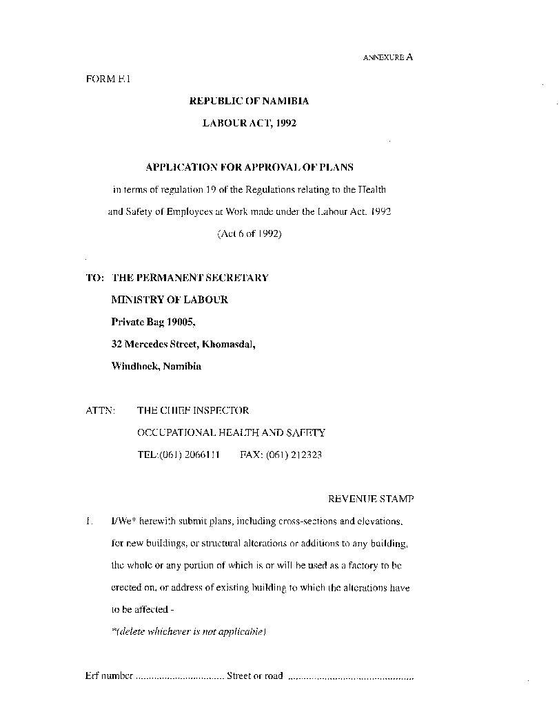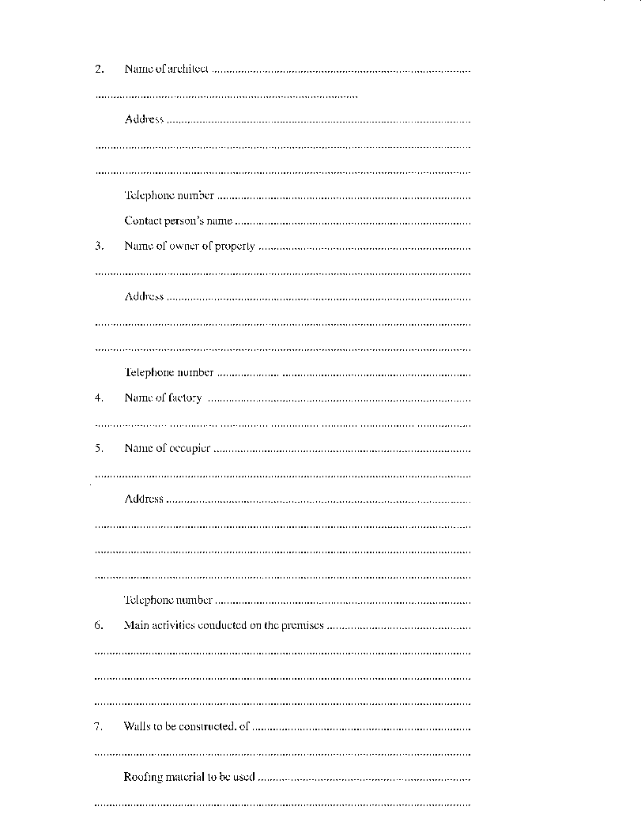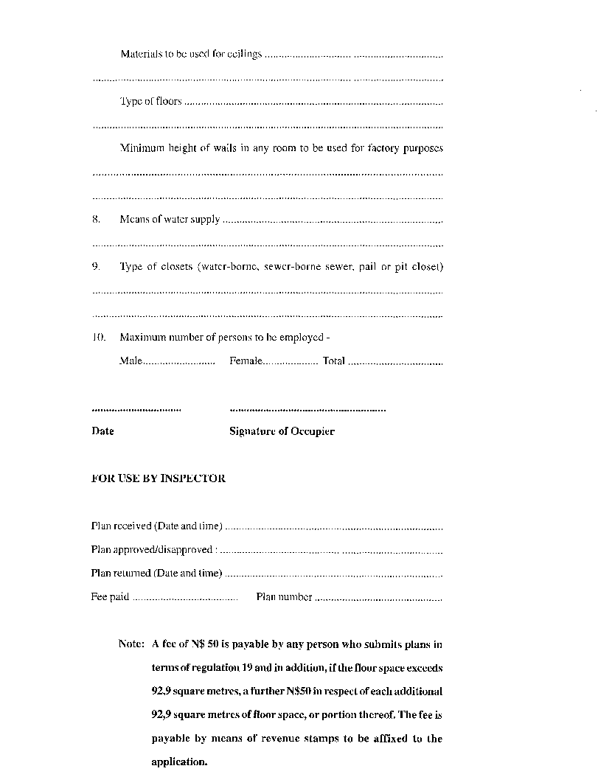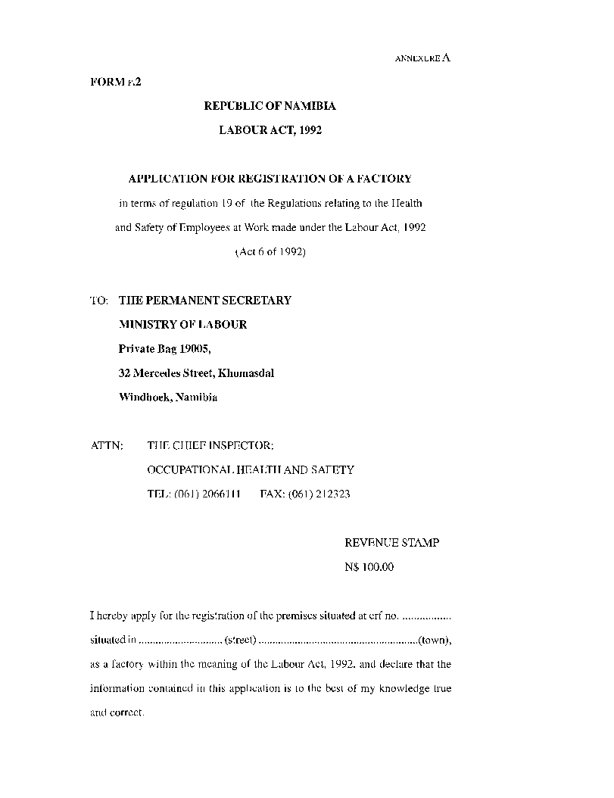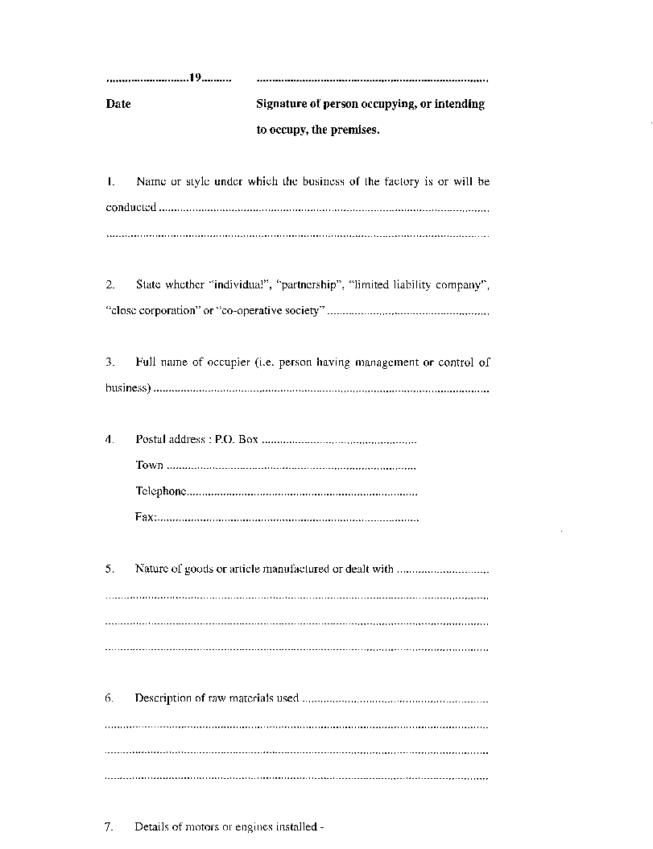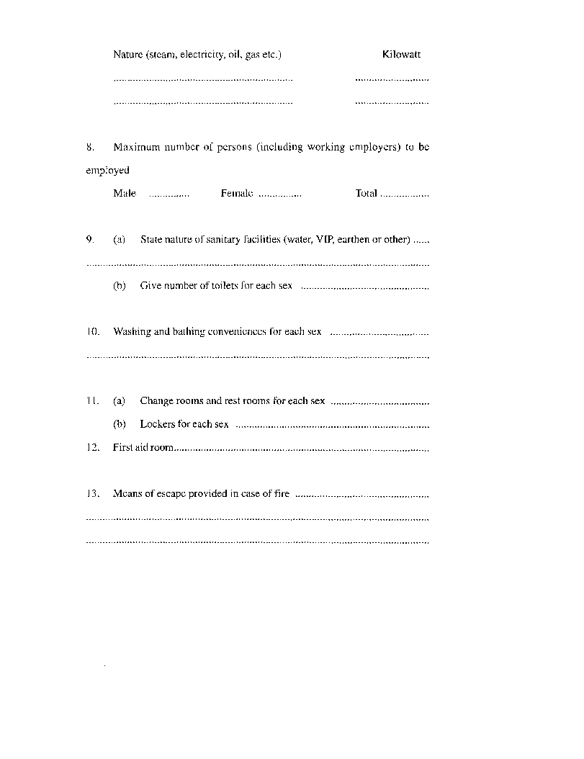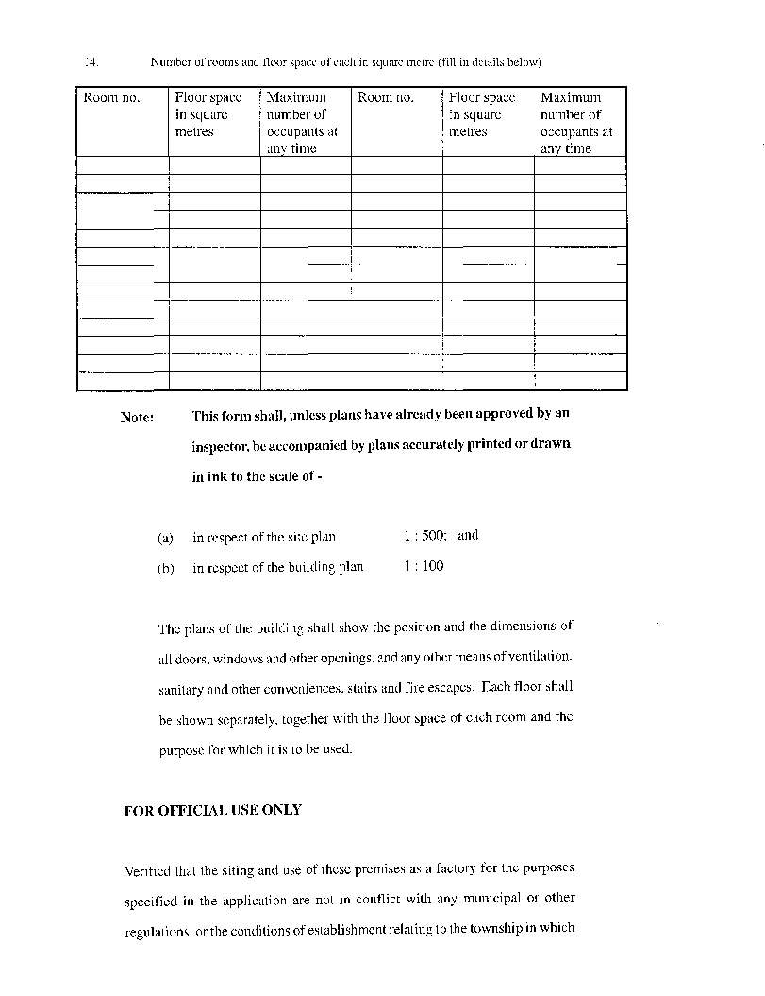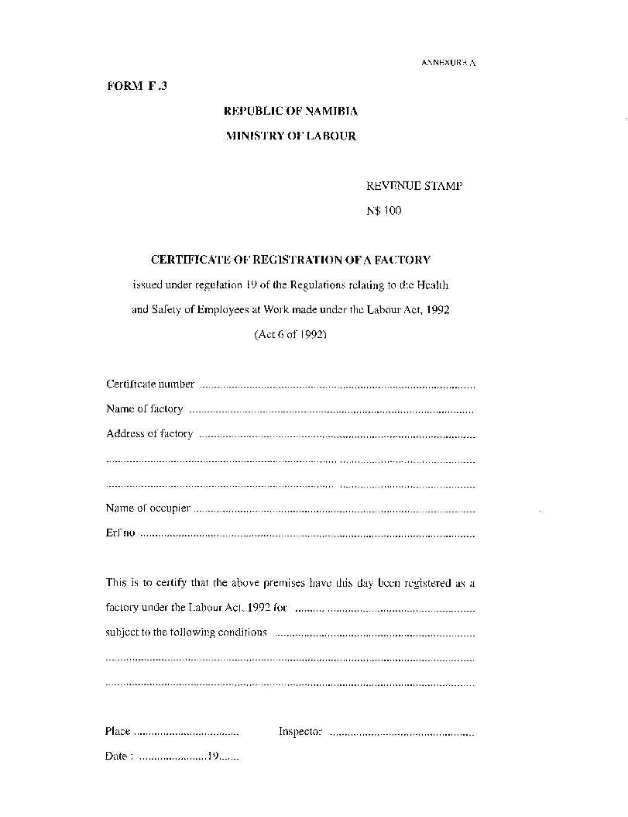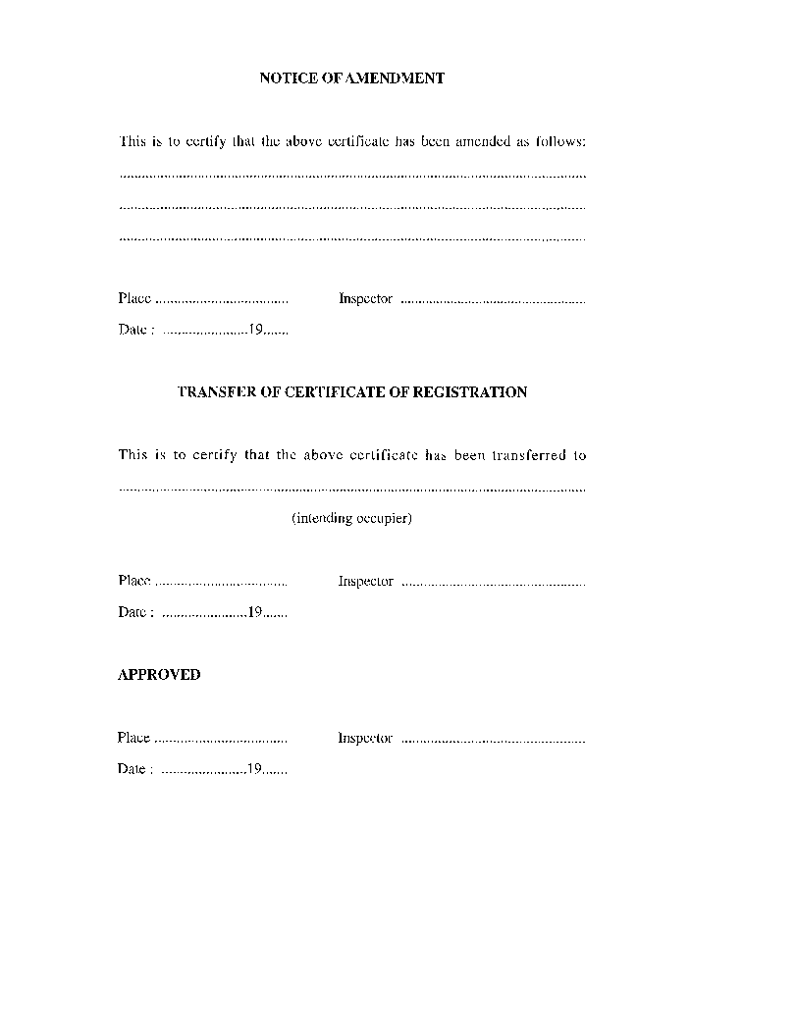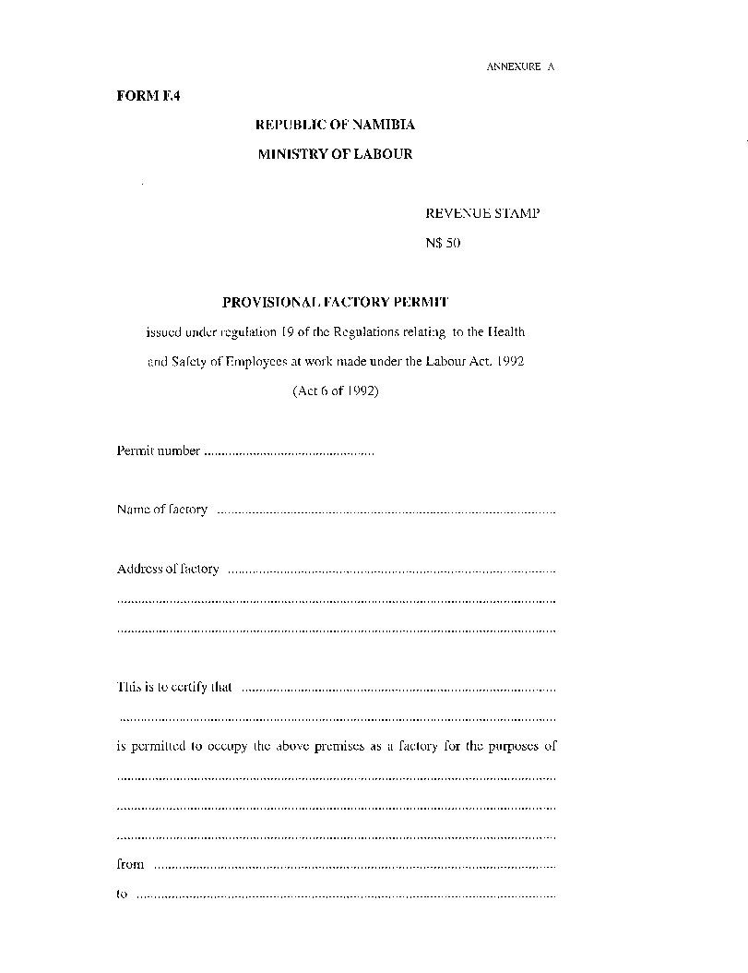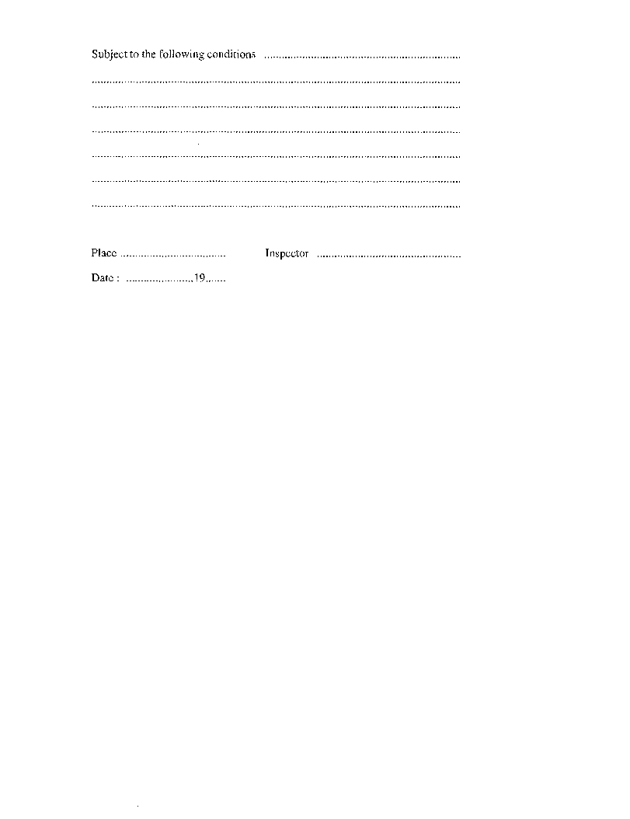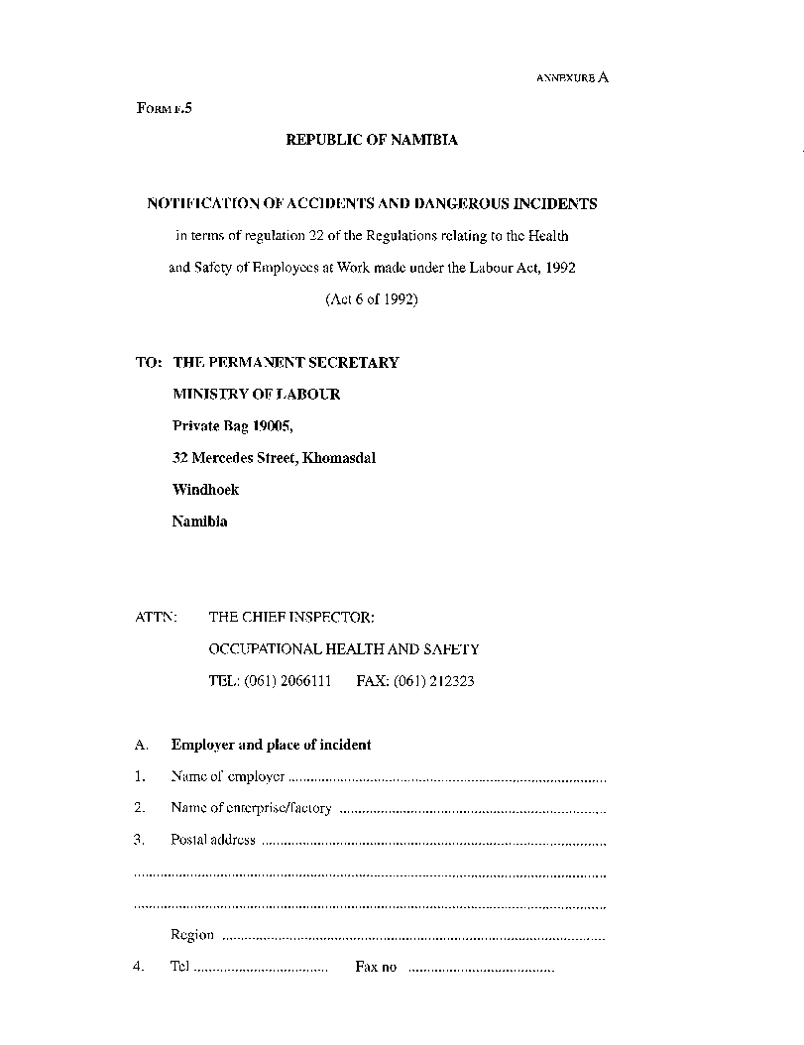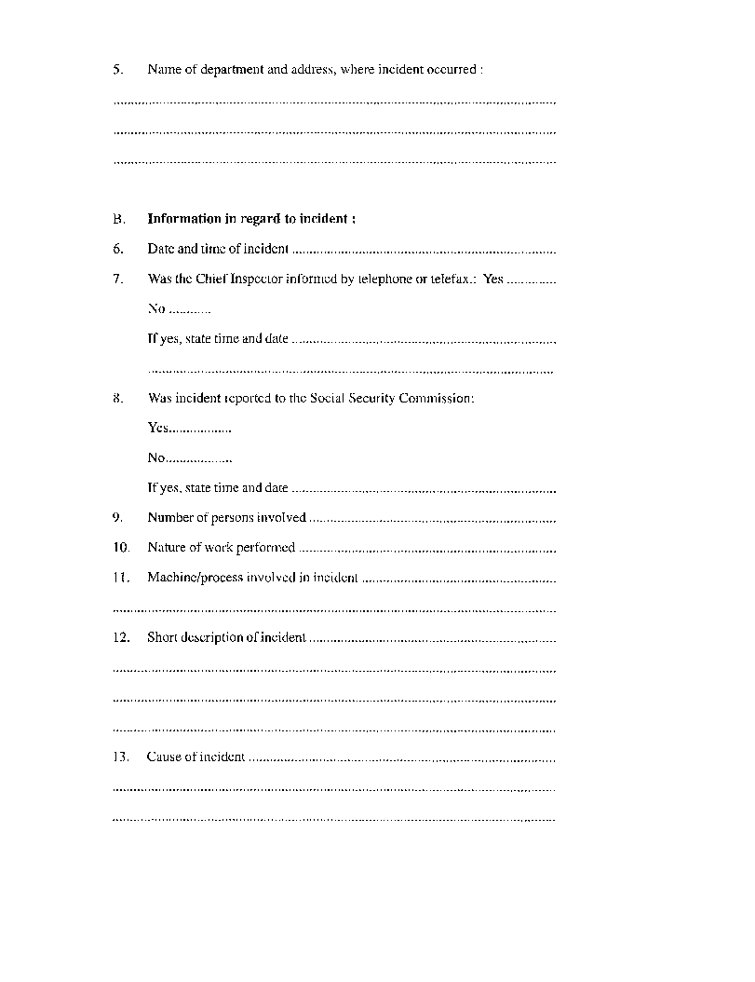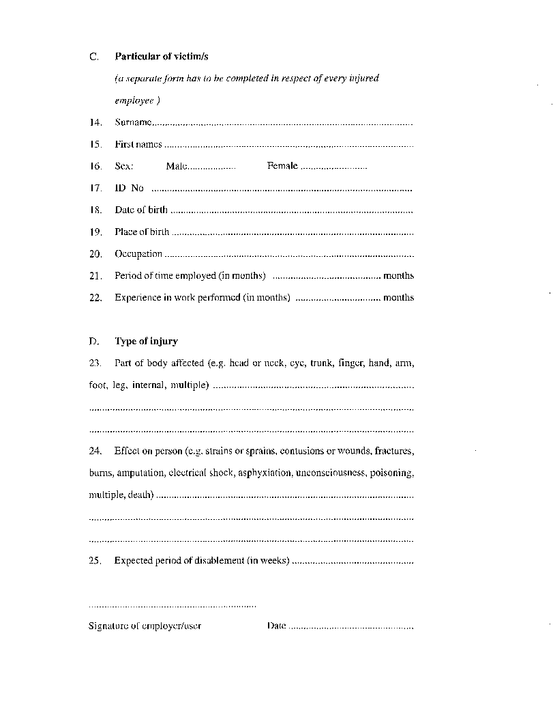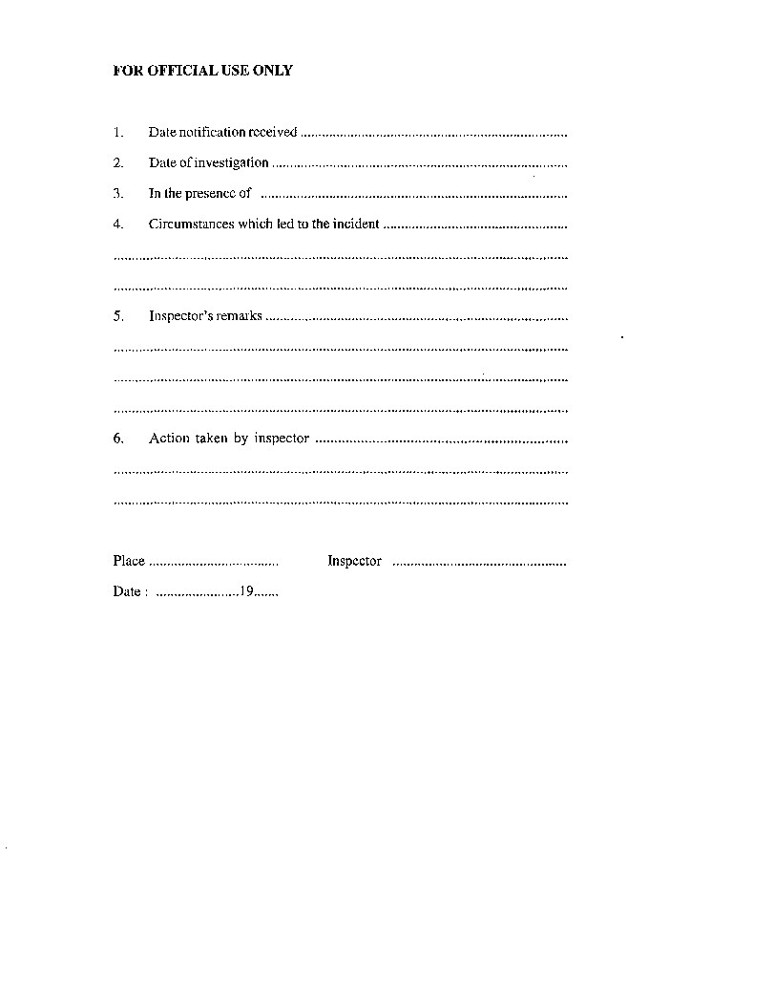

2.(1) NOTIFIABLE OCCUPATIONAL DISEASES

and work involving exposure to risk

(regulation 23)

1. Pneumoconiosis caused by sclerogenic mineral dust (silicosis, asbestosis) and silico-tuberculosis provided that silicosis is an essential factor in causing the resultant incapacity or death or any other form of tuberculosis, and all work involving exposure to the risk concerned.

2. Bronchopulmonary diseases caused by hard-metal dust, and all work involving exposure to the risk concerned.

3. Bronchopulmonary diseases caused by cotton dust (byssinosis), or flax, hemp or sisal dust, and all work involving exposure to the risk concerned.

4. Occupational asthma caused by sensitising agents or irritants both recognised in this regard and inherent in the work process, and all work involving exposure to the risk concerned.

5. Extrinsic allergic alveolitis and its sequelae caused by the inhalation of organic dusts, recognised in this regard and inherent in the work process, and all work involving exposure to the risk concerned.

6. Diseases caused by beryllium or its toxic compounds, and all work involving exposure to the risk concerned.

7. Diseases caused by cadmium or its toxic compounds, and all work involving exposure to the risk concerned.

8. Diseases caused by phosphorus or its toxic compounds, and all work involving exposure to the risk concerned.

9. Diseases caused by chromium or its toxic compounds, and all work involving exposure to the risk concerned.

10. Diseases caused by manganese or its toxic compounds, all work involving exposure to the risk concerned.

11. Diseases caused by arsenic or its toxic compounds, and all work involving exposure to the risk concerned.

12. Diseases caused by mercury or its toxic compounds, and all work involving exposure to the risk concerned.

13. Diseases caused by lead or its toxic compounds, and all work involving exposure to the risk concerned.

14. Diseases caused by fluorine or its toxic compounds, and all work involving exposure to the risk concerned.

15. Diseases caused by carbon disulphide, and all work involving exposure to the risk concerned.

16. Diseases caused by the toxic halogen derivatives of aliphatic or aromatic hydrocarbons, and all work involving exposure to the risk concerned.

17. Diseases caused by benzene or its toxic homologues, and all work involving exposure to the risk concerned.

18. Diseases caused by toxic nitro- and amino-derivatives of benzene or its homologues. All work involving exposure to the risk concerned.

19. Diseases caused by nitroglycerin or other nitric acid esters, and all work involving exposure to the risk concerned.

20. Diseases caused by alcohol, glycols or ketones, and all work involving exposure to the risk concerned.

21. Diseases caused by asphyxiants: Carbon monoxide, hydrogen cyanide or its toxic derivatives, hydrogen sulphide, and all work involving exposure to the risk concerned.

22. Hearing impairment caused by noise, and all work involving exposure to the risk concerned.

23. Diseases caused by vibration (disorders of muscles, tendons, bones, joints, peripheral blood vessels or peripheral nerves), and all work involving exposure to the risk concerned.

24. Diseases caused by work in compressed air, and all work involving exposure to the risk concerned.

25. Diseases caused by ionising radiation, and all work involving exposure to the action of ionising radiation.

26. Skin diseases caused by physical, chemical or biological agents not included under other items, and all work involving exposure to the risk concerned.

27. Primary epitheliomatous cancer of the skin caused by tar, pitch, bitumen, mineral oil, anthracene, or the compounds, products or residues of these substances, and all work involving exposure to the risk concerned.

28. Lung cancer or mesotheliomas caused by asbestos, and all work involving exposure to the risk concerned.

29. Transmissible, infectious or parasitic diseases contracted in an occupation if there is a particular risk of contamination -

(a) health work or laboratory work;

(b) veterinary work;

(c) work involving the handling of animals, of animal carcasses, of parts of such carcasses, or other merchandise which may have been contaminated by animals, animal carcasses, or parts of such carcasses; or

(d) other work carrying a particular risk of contamination.

30. Poisoning caused by any type or pesticide or chemical agent including their mixtures or toxic derivates, and all work involving exposure to pesticides or chemical agents.

31. Diseases caused by hot or cold work environments, and all work involving exposure to the risk concerned.

32. Cancer caused by physical, chemical or biological agents, and all work involving exposure to the risk concerned.

33. Any other disease certified by a medical practitioner as caused by exposure to the risk concerned at work, and all work involving exposure to such risk.

34. Repetitive work, and all work involving exposure to the risk concerned.

**NOTE: In the application of Annexure A. 2(1), the degree and type of exposure shall be taken into account when appropriate.**

ANNEXURE A

(Form OD.1)

To view content without printing, scroll down.

To print at full scale (A4), double-click the icon below.



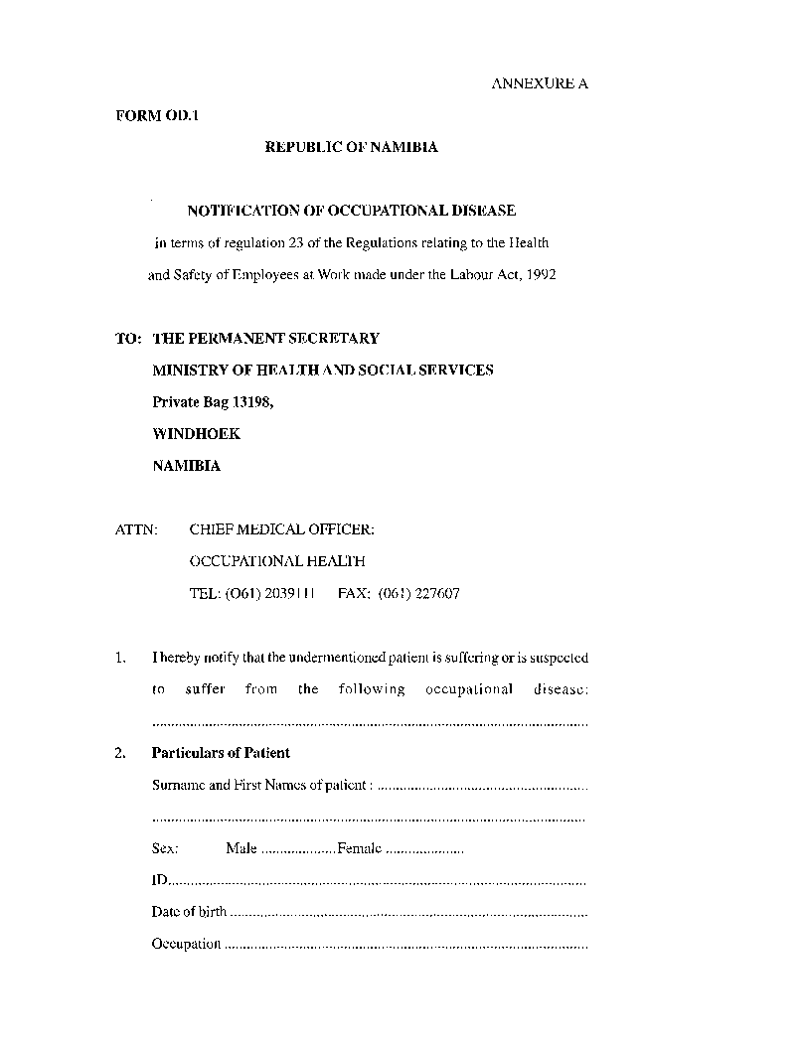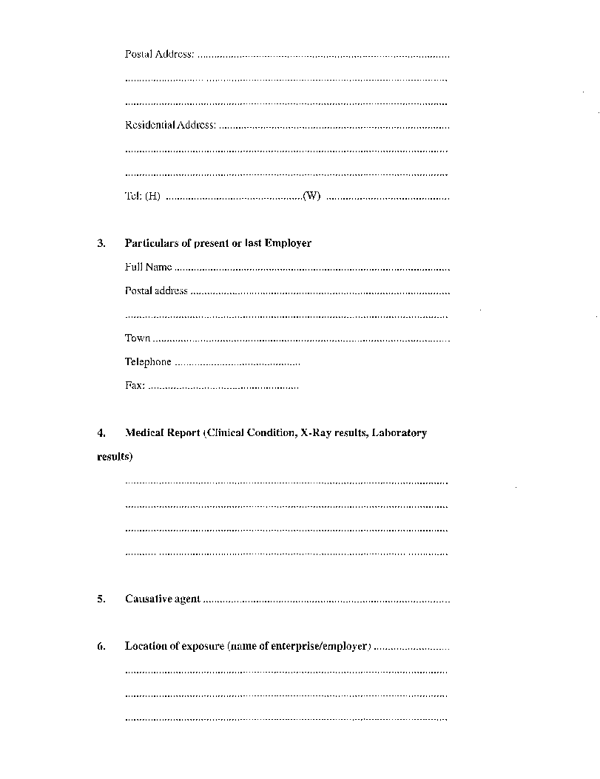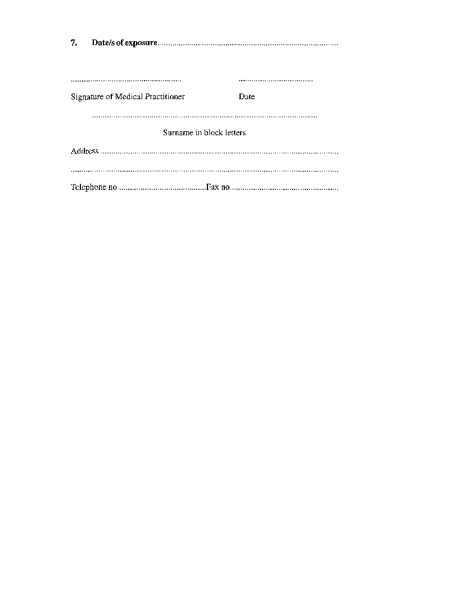

CHAPTER 4

SAFETY OF MACHINERY

PART I

GENERAL SAFETY OF MACHINERY

**Interpretation**

**48**. In this Chapter, unless the context otherwise indicates -

“abrasive wheel” means a wheel, cylinder, disc or cone made of any material which -

(a) contains abrasive particles held together by mineral, metallic or organic bond whether natural or artificial; and

(b) is power-driven and intended for use in any grinding or cutting operation.

“circular saw” means a circular saw working in a bench (including a rack bench) for the purpose of ripping, deep cutting or cross-cutting, but does not include a swing or pendulum saw which is moved towards the material which is to be saw;

“competent person” means a person who -

(a) has, to the satisfaction of the Chief Inspector, served an apprenticeship in an engineering trade which included the operation and maintenance of machinery, or who has had not less than five years practical experience in the operation and maintenance of machinery and who during or subsequent to such period of apprenticeship or practical experiences, as the case may be, has acquired thorough knowledge in maintenance and operation appropriate to the class of machinery of which he or she is required to take charge or which he or she is required to inspect, or in connection with which he or she is required to work; or

(b) has obtained a degree in mechanical or electrical engineering recognized by the Chief Inspector and has not had less than two years post-graduate practical experience in the maintenance and operation of machinery; or

(c) is a registered engineer;

“driving belt” means any belt, band, chain, rope, cord or similar appliance by means of which rotary motion is transmitted from any one part of the transmission machinery to any other part of the transmission machinery;

“elevator” means any lift, hoist or other appliance used for the conveyance of persons and goods by means of a car, cage, cradle or other receptacle in a hatchway on attached guides, but does not include a builder’s hoist or a hoist operated by hand power;

“escalator” means any power-driven inclined continuous stairway with moving steps and hand rails which is intended for the conveyance of persons from one level to another;

“explosive powered tool” means a tool that is activated by an explosive charge and that is used for driving bolts, nails and similar objects for the purpose of attaching materials or objects;

“goods hoist” means an appliance used for the transportation of goods by means of a car, cage, cradle or other receptacle in a hatchway on stationery guides, and in which no persons are allowed to be conveyed;

“hatchway” means a vertical or inclined way in which a goods hoist or elevator is operated;

“lifting tackle” means chain slings, rope slings, rings, hooks, shackles, swivels, spreaders or similar appliances;

“operator” means any person who may operate a machine;

“plane band saw” means a band saw other than a log breakdown saw, the cutting portion of which may run in any plane;

“qualified person” means a person who is able to submit documentary proof that he or she has received a thorough theoretical and practical education and training in engineering to the satisfaction of a competent professional institution recognized by the Chief Inspector, and who has held a position of independent responsibility for the control and supervision of machinery;

“transmission machinery” means -

(a) a shaft, wheel, spur wheel, gear wheel, gear, drum, pulley, coupling, clutch, driving belt, or any other device incidental to the transmission of motion between any driving unit and any other machine or appliance, or between one section or part of the same machine or any other machine; or

(b) any wheel, clutch, gear train, system of fast and loose pulleys, or other device through which any machine receives its motion;

“user” means an occupier or builder, or the person owning or leasing the machinery or appliance; and

“wood working machinery” means any circular saw, plane band saw, planing machine or any other power driven machine used for sawing, shaping, chipping or hogging wood.

**Principles of safety integration**

**49**. (1) All machinery shall be designed, constructed and installed in such a manner that it is safe and suitable for the function for which it is to be used, and that it can be adjusted, used and maintained without putting persons at risk when these operations are carried out under the conditions that could reasonably be anticipated by the manufacturer and user of the machinery.

(2) Measures shall be taken to, as far as reasonably practicable, eliminate the risk of accidents or diseases which may be caused by any machinery during its expected life span, and such measures shall include the regular maintenance and inspection of the machinery.

(3) In selecting the most appropriate methods for manufacture, installation, alteration and maintenance, the following principles shall apply in

the following order -

(a) the elimination or reduction, far as reasonably practicable, of risks by means of the use of inherently safe machinery design and construction;

(b) the use of the most effective safeguards or protective measures in respect of risks that cannot be eliminated;

(c) informing and warning of employees of the residual risks as a result of any limitations in the safeguards and protective measures adopted, and training employees in the effective use and maintenance of any personal protective equipment issued to the employees;

(d) taking into account the intended conditions of use of the machinery, such machinery shall be designed, constructed, installed and maintained in such a manner that the discomfort, fatigue or psychological stress faced by the operator of the machinery is reduced to a minimum by the application of ergonomic principles;

(e) the design, construction and installation of machinery shall take into account the constraints placed on the operator by the use of necessary or required personal protective equipment, including, but not limited to, footwear and gloves; and

(f) machinery shall be supplied with all the essential equipment, accessories and information to enable the adjustment, maintenance and use thereof without risk to the operator thereof or to other employees.

**Responsible persons**

**50**. (1) All machinery in operation in a factory or used in connection with structural work, shall, to the satisfaction of the Chief Inspector, be placed in the charge of a competent person appointed by the user in writing: Provided that -

(a) if such machinery is capable of developing 3000 KW power or more, the person appointed shall be a qualified person;

(b) if upon any premises steam boilers of a rated capacity of 5000 kilograms per hour or more, are used, the Chief Inspector may require that a qualified person shall be placed in charge of such steam boiler; or

(c) in the case of a boiler operating at a pressure not exceeding 550 kilopascals, or a boiler with a capacity of less than 100 litres, the attendant shall be a person who is experienced in his or her duties.

(2) The Chief Inspector may require a user to appoint more than one qualified person in terms of subregulation (1) if, in the opinion of the Chief Inspector, such an appointment is necessary, having regard to the size of the premises and the number of machinery present, and each person so appointed shall be in charge of particular designated machinery.

(3) The qualified person or competent person in charge of machinery shall be responsible for the maintenance in good condition of all safety appliances and devices, and protective guards, and shall stop the working of any machinery, the using of which becomes or appears likely to become dangerous.

(4) The user shall, to the satisfaction of the Chief Inspector, keep a record in writing of the name of a qualified person or a competent person appointed by him or her in terms of this regulation.

**Duties of employer**

**51**. An employer shall -

(a) take all reasonable measures to enforce these regulations and to ensure that they are observed by all persons employed on the premises;

(b) appoint such competent persons (including safety officers and supervisors) as may be necessary to assist him or her in enforcing the compliance with these regulations;

(c) satisfy himself or herself that all provisions affecting the safety of persons are complied with;

(d) cause a person who is required to operate a machine which may cause personal injury, to be fully instructed regarding the possible dangers associated with its operation and the precautions to be taken and safety measures to be observed;

(e) cause all plant fittings, safety appliances, and anything necessary for compliance with these regulations, to be provided and maintained in good order and repair; and

(f) not require or permit an employee to use or operate a machine or part of a machine, if any safety related features, appliances, devices or guards relating to the machine have been rendered inoperative.

**General machinery protection**

**52**. (1) Any dangerous moving part of machinery not specifically referred to in this Part shall, to the satisfaction of an inspector, be securely and effectively enclosed in a protective cover.

(2) Notwithstanding subregulation (1), if it is not possible to guard such machinery or moving parts of machinery by virtue of the nature of the operation, the area around such a machine shall be fenced off and only a competent person shall tend to such a machine.

(3) All guards and fences supplied in terms of this regulation shall be of substantial construction and shall be kept in the required position at all times during the normal operation of the machinery.

(4) Subject to subregulation (2), no person shall enter or be within, or be permitted by the user to so enter or be within, any safety guards or fences while the machinery concerned is in motion or operation.

(5) Safety related features, appliances, devices or guards provided with any machinery shall not be rendered or kept inoperative during the use or operation of the machinery.

**A. CONTROLS**

**Safety and reliability of control systems**

**53**. Control systems shall be designed and constructed in such a way that, to the satisfaction of an inspector -

(a) they are safe and effective;

(b) they shall prevent a dangerous situation arising;

(c) they can withstand the rigors of normal use and negative external factors; and

(d) errors do not lead to dangerous situations.

**Control Devices**

**54**. (1) Control devices shall be -

(a) clearly visible, identifiable and appropriately marked, and appropriate notices posted, if necessary;

(b) positioned for safe operation without hesitation or loss of time, and without ambiguity;

(c) designed so that the movement of the control is consistent with its effect;

(d) located outside the danger zones, except for certain controls if necessary, such as emergency stop controls or consoles for the operating of robots;

(e) positioned so that their operation cannot cause additional risk;

(f) designed or protected so that the desired effect, if a risk is involved, cannot occur without an intentional operation; and

(g) manufactured in such a way as to withstand foreseeable strain; and particular attention shall be paid to emergency stop devices liable to be subjected to considerable strain.

(2) If a control device is designed or constructed to perform several different actions, such as keyboards, the action to be performed shall be clearly displayed and be subject to confirmation, if necessary.

(3) Controls shall be so arranged that their layout, operation and resistance to operation are compatible with the action to be performed, taking into account ergonomic principles and the use of personal protection equipment such as protective footwear or gloves.

(4) Machinery shall be fitted with indicators such as dials, signals or alarms as required for safe operation, and the operator shall be able to read them from the main control position.

(5) The operator shall, from the main control position, be able to see the entire danger zone or zones and shall ensure that no person is in or enters a danger zone while any machinery is in operation.

(6) If the precautions prescribed by subregulation (5) are not possible, the control system shall be designed and constructed in such a way that clearly audible and visible warning signals are given whenever the machinery is about to start, or is in operation, allowing the exposed person sufficient time to leave the danger zone, or the means to take rapid action to prevent the machinery from starting up.

**Starting devices**

**55**. (1) It shall be possible to start machinery only by voluntary operating a control provided for such purpose.

(2) The requirement set out in subregulation (1) shall apply -

(a) when restarting the machinery after a stoppage, whatever the cause of the stoppage; or

(b) when effecting a significant change in the operating conditions of the machinery, such as a change in speed or pressure,

unless such restarting or change in operating conditions takes place without any risk to exposed persons.

**Stopping devices**

**56**. (1) For normal stopping purposes -

(a) each machine shall be fitted with a control device by means of which the machine can be brought safely to a complete stop;

(b) each workstation shall be fitted with a control device to stop some or all of the moving parts of the machinery, depending on the type of hazard, so that the machinery is rendered safe; and

(c) the machinery’s stop control device shall have priority over the start controls: Provided that once the machinery or its dangerous part have stopped, the energy supply to the actuators concerned shall be cut off.

(2) For emergency stopping purposes, each machine shall be fitted with one or more emergency stopping devices which shall reduce the stopping time of the machine to enable actual or impending danger to be averted.

(3) Subregulation (2) shall not apply to -

(a) machines in which an emergency stop device will not lessen the risk involved, either because it will not reduce the stopping time or because it will not enable the special measures required to deal with the risk to be taken; or

(b) hand-held portable machines and hand-guided machines.

(4) The device contemplated in subregulation (1) shall -

(a) have clearly identifiable, clearly visible and readily accessible controls;

(b) stop the dangerous process as quickly as possible, without creating additional hazards; and

(c) if necessary, trigger or permit the triggering of certain safeguard movements.

(5) The emergency stop control shall -

(a) after the machine concerned has stopped -

(i) remain engaged;

(ii) be capable of being disengaged only by an appropriate operation;

(iii) when disengaged, not restart the machinery, but merely permit restarting; and

(b) not trigger the stopping function before being in the engage position.

**Failure of the power supply**

**57**. (1) Any interruption or fluctuation in, or re-establishment after an interruption or fluctuation of, the power supply to the machinery for whatever cause, shall not cause a dangerous situation.

(2) In the event of an occurrence referred to in subregulation (1) -

(a) the machinery shall not be capable of starting unexpectedly;

(b) the machinery shall not be prevented from stopping once the command to stop the machinery has been given;

(c) no moving part of the machinery, or anything loaded onto or held by the machinery, shall fall or be ejected;

(d) automatic or manual stopping of the moving parts of the machinery, whatever they may be, shall not be impeded; and

(e) the protection devices of or on the machinery shall remain fully effective.

**B. GUARDS AND PROTECTIVE DEVICES**

**Choice of protection against risks related to moving parts**

**58**. (1) Protective devices, guards or covers used to protect or safeguard against the risks related to moving parts of machinery, shall be selected and used in accordance with the type of risk involved.

(2) The following guidelines shall be applied when selecting protective devices, guards or covers referred to in subregulation (1) -

(a) relating to moving transmission parts, the devices, guards or covers designed to protect exposed persons against the risks associated with moving transmission parts, such as pulleys, belts, gears, rack and pinions or shafts, shall be either -

(i) attached, complying with regulations 59(1) and (2); or

(ii) movable, complying with regulations 59(1) and (2), or type “A” guards approved by the Chief Inspector, which shall be used if frequent access is foreseen;

(b) relating to moving parts directly involved in the process -

(i) the guards or protection devices designed to protect exposed persons against the risks associated with moving parts contributing to the work, including cutting tools, moving parts of presses, cylinders or parts in the process of being machined, shall -

(aa) if possible, be attached guards complying with regulations 59(1) and (2)(a); or

(bb) if not attached guards, then movable guards complying with regulations 59(1) and (2), or protective devices such as sensing devices, including non-material barriers or sensor mats, remote-held protection devices such as two-hand controls, or protection devices intended to automatically prevent all or part of the operator’s body from encroaching on the danger zone in accordance with regulations 59(1) and (3); or

(ii) if certain moving parts directly involved in the process cannot be made completely or partially inaccessible during operation, owing to operations requiring nearby operator intervention, such parts shall, if technically possible, be fitted with -

(aa) attached guards, complying with regulations 59(1) and (2), preventing access to those sections of the parts that are not used in the process;

(bb) adjustable guards, complying with requirements 59(1) and (5), restricting access to those sections of the moving parts which are used in the process.

**Required characteristics of guards and protection devices**

**59**. (1) Guards and protection devices shall, as general requirements -

(a) be of robust construction;

(b) not give rise to any additional risk;

(c) not be easy to by-pass or render non-operational;

(d) be located at an adequate distance from the danger zone;

(e) cause minimum obstruction to the view of the production process; and

(f) enable essential work to be carried out on installation or maintenance, if possible, without the guard or protection device having to be dismantled.

(2) Attached guards shall be securely held in place, be capable of being removed only by making use of tools and, if possible, be unable to remain in place without being securely attached.

(3) Type A movable guards shall -

(a) when open, as far as possible remain attached to the machinery;

(b) be equipped with a locking device to prevent the moving parts of the machinery which such guards protect against, from moving when such parts are accessible; and

(c) give a stop command whenever they are no longer closed.

(4) Type B movable guards shall be designed and incorporated into the control system so that -

(a) the machinery cannot be start while any moving parts are within the operator’s reach,

(b) the exposed person cannot reach any moving parts of the machinery once the machinery have been started up,

(c) they can be adjusted only by means of an intentional action, such as the use of a tool or key;

(d) the absence or failure of one of their components prevents starting of the machinery, or stops the moving parts of the machinery; and

(e) protection against any risk of ejection is provided by means of an appropriate barrier.

(5) Adjustable guards restricting access to the moving parts of the machinery, shall, if necessary for the work -

(a) be adjustable manually or automatically according to the type of work involved;

(b) be readily adjustable without the use of tools; and

(c) as far as possible reduce the risk of ejection.

(6) Protection devices shall be designed and incorporated into the control system in such a manner that -

(a) the machinery cannot be started while the moving parts of the machinery are within the operator’s reach,

(b) the exposed person cannot reach the moving parts of the machinery once the machinery have been started;

(c) the devices can be adjusted only by means of an intentional action, such as the use of a tool or key; and

(d) the absence or failure of one of their components of the devices prevents starting, or stops the moving parts, of the machinery.

**Machinery maintenance**

**60**. (1) Machinery shall be maintained by means of the adjustment, lubrication and maintenance at points located outside danger zones, which shall make it possible to carry out adjustment, maintenance, repair, cleaning and servicing operations while the machinery is at a standstill.

(2) If subregulation (1) cannot, for technical reasons, be complied with, the operations referred to in that subregulation shall be conducted in any other manner approved by an inspector, which manner shall not create any risk to the operator.

(3) Automated machine components which have to be changed frequently shall be capable of being removed and replaced easily and in safety.

(4) The tasks referred to in subregulation (3) shall be carried out with the necessary technical means such as tools or measuring instruments, in accordance with an operating method specified by the manufacturer.

(5) The manufacturer shall provide stairs, ladders or catwalks to allow safe access to all areas of the machinery used for production, adjustment and maintenance operations.

(6) Parts of the machinery where persons are liable to move about or stand, shall be designed and constructed in such a manner so as to ensure the safety of such persons.

**Isolation of energy sources**

**61**. (1) All machinery shall be fitted with clearly marked isolators to isolate such machinery from all energy sources.

(2) The isolators referred to in subregulation (1) shall be capable of being locked in place if reconnection to the energy source could endanger exposed persons, and in the case of machinery using electricity conducted through a plug capable of being plugged into a circuit, separation from the circuit and locking of the plug is required.

(3) The isolator shall be capable of being locked in place if an operator is unable to ascertain that the energy supply is still cut off at all the power points to which he or she has access.

(4) After the energy supply is cut off, it shall be possible to dissipate normally any energy remaining or stored in the circuits of the machinery concerned without risk to exposed persons.

(5) As an exception to the requirements set out in this regulation, machinery approved by an inspector may remain connected to their energy sources in order to protect information, to light interiors or for such other purpose as the inspector may approve: Provided that steps to the satisfaction of an inspector shall be taken to ensure the safety of the operator or other employees.

**Condition of safety appliances and machinery**

**62**. An employer shall cause all safety appliances, devices or guards to be maintained in good working condition and to be used properly, and shall stop from working any machinery which appears likely to present a danger to its operator or to other persons, or if so instructed by an inspector.

**Clear space**

**63**. A user shall cause sufficient clear and unobstructed space to be maintained around a machine while it is in operation or in motion, to enable the work to be carried on without risk.

**Condition of floors**

**64**. A user shall cause the floor surrounding a machine to be maintained in a good and level condition, as far as practicable free from chips or other loose material, and shall not allow such floor to become slippery.

**Dangerous places**

**65**. A user shall cause all elevator platforms or openings in such platforms or in floors, or any pits, trapholes, manholes or other dangerous places on the premises to be securely fenced.

**C. SPECIFIC MACHINERY**

**Abrasive wheels and machines**

**66**. (1) A user shall cause a power operated grinding machine to be marked in a conspicuous manner and in a conspicuous place on the machine, stating the maximum permitted speed or speeds in revolutions per minute of the stone or grinding wheel or disc concerned.

(2) An abrasive wheel shall -

(a) be suitable for the work for which it is used and be properly mounted;

(b) be provided with a guard -

(i) of such design and construction as to contain as far as is reasonably practicable, a part or fragment of the abrasive wheel in the event of the dislodging, shattering or splintering of the wheel;

(ii) which encloses the whole of the abrasive wheel, except such part thereof as is necessarily exposed for the purpose of any work being done at the abrasive wheel;

(iii) which is maintained in position whenever the abrasive wheel is in motion; and

(iv) which is secured against accidental displacement; and

(c) if its diameter is more than 50 millimetres, bear an inscription indicating its maximum permissible speed in revolutions per minute;

(d) not be operated at a speed in excess of its maximum permissible speed; and

(e) if necessary, be provided with suitable protection flanges of sufficient diameter.

(3) If at any abrasive wheel there is a rest for supporting a worktool, the rest shall at all times while the wheel is in motion be -

(a) properly secured;

(b) adjusted so as to be as close as practicable to the exposed part of the abrasive wheel; and

(c) of substantial construction and properly maintained.

(4) No person shall mount an abrasive wheel unless he or she is competent to carry out such work.

(5) A user shall fit a grinding machine with a transparent shield which shall be kept so adjusted as to protect the employee’s eyes against any material from the grinding machine.

(6) The user shall cause a notice to be displayed in a conspicuous manner and in a conspicuous place at a grinding machine, prohibiting persons from carrying out, inspecting or observing grinding work without wearing or using suitable eye protection.

**Machine tools**

**67**. A user shall cause -

(a) a rotating stock bar which extends beyond the end of a machine to be guarded by means of either a fence or a substantially supported tubular guard covering the projecting stock bar; and

(b) a machine where cutting lubricants are used, to be equipped with suitable splash guards and pans designed and maintained in such a manner so as to prevent contamination of the operator and of his or her clothing by the cutting lubricant.

**Shears, guillotines and presses**

**68**. (1) A user shall cause a shear, guillotine or press to be guarded at the point of operation by means of -

(a) a guard attached to the guillotine which prevents the passage of the operator’s fingers into the danger zone;

(b) a self-adjusting guard which automatically adjusts itself to the thickness of the material being cut;

(c) a manually or automatically operated moving guard which completely encloses the danger zone, so arranged that the working stroke cannot commence unless the guard is closed and the guard cannot open unless the ram or blade is stationary;

(d) a effective two-hand control;

(e) an electronic device which will prevent or arrest an operating stroke when any part of the operator’s body is in the danger zone; or

(f) any other protection approved by an inspector:

Provided that, if more than one operator is required to operate a shear, a guillotine or a press, two-handed controls shall be fitted for each operator, which controls shall be so inter-connected that both hands of each operator shall be engaged simultaneously for the duration of the working stroke.

(2) A user shall cause -

(a) the guards of shears, guillotines and presses referred to in subregulation (1) to be constructed in such a manner so as not to unduly obscure the work process; and

(b) a power operated shear, guillotine or press, which is fed by hand, to be so constructed that inadvertent operation thereof is prevented.

**Slitting machines and milling machines**

**69**. (1) A user shall cause the disc cutter of a slitting machine or of a milling machine to be fitted with a guard enclosing the cutting edges of the disc to a point as close as practicable to the material being cut.

(2) A guard referred to in subregulation (1) may be -

(a) manually adjustable;

(b) so adjusted at all times that the distance between the material being cut and the bottom of the guard does not exceed nine mm; or

(c) a self-adjusting guard which automatically adjusts itself to the thickness of the material being cut.

**Feed and discharge openings in machines**

**70**. (1) A user shall cause any opening in a machine, tank, drum, cylinder or container which is equipped with blades, knives, paddles, mixing arms, beaters or other devices for stirring, blending, mixing, cutting or separating liquids, solids or a combination thereof, to be fitted, wherever practicable, with substantial guards, doors or covers so interlocked as to prevent access to the blades, knives, paddles, mixing arms or other devices whilst these are in motion, or to prevent these being set in motion whilst such guards, doors or covers are not properly in place.

(2) If an inspector is satisfied that the a machine, tank, drum, cylinder or container is safe enough so as not to endanger the safety of any person, subregulation (1) shall be considered to have been complied with.

(3) If for operational reasons, it is not possible to provide guards, doors or covers to the openings referred to in subregulation (1), the user shall cause such openings to be closed by hoppers, chutes or similar devices, which shall be of such a size or extend to such a distance from the level of the openings as to prevent persons from reaching the blades knives, paddles, mixing arms or other devices referred to in that subregulation: Provided that if material can be fed or discharged through gratings, the members of which are so spaced that the blades, knives paddles, mixing arms or other devices cannot be reached by any person, such gratings may, with the approval of an inspector, be fitted instead of hoppers, chutes or similar devices.

**Rollers and conveyors**

**71**. (1) A user shall cause a power operated machine which consists of, or incorporates, two or more rollers rotating in opposite directions; or a roller and the belt of a conveyor, which are less than 75 millimetres apart, to be protected by a guard.

(2) The guard referred to in subregulation (1) shall consist of -

(a) a hopper, chute or spout so constructed that no person can reach into the intake of the rollers;

(b) a attached or self-adjusting guard at the feed side of the rollers with a slot or opening of such a size as to make it impossible to reach the intake of the rollers;

(c) a guard so positioned as to prevent inadvertent contact of the operator’s hands with the intake of the rollers and which will otherwise prevent physical access to the rollers whilst they are in motion, and which is further equipped with a tripping bar which, if operated, will stop the rollers when it is necessary to gain physical access to the rollers; or

(d) a trip bar or cable across the full length of, and not more than 300 millimetres from the intake of the rollers, so arranged as to stop or reverse the rollers when operated:

Provided that if it is not practicable to install any of the devices specified in this regulation, an inspector may permit or require any other effective means of protection to be installed at the intake of the rollers.

**Washing machines and centrifugal extractors**

**72**. A user shall cause all power operated machines of the double cylinder type in which the inner cylinder, drum or basket rotates, to be fitted, if practicable, with a door, lid or cover on the outer cylinder so interlocked that the inner cylinder, drum or basket cannot be put into motion or operation with the door, lid or cover open and that such door, lid or cover cannot be opened whilst the inner cylinder, drum or basket is in motion.

**D. WELDING, FLAME CUTTING AND SOLDERING**

**Protective clothing, insulation of leads and screening of work-place**

**73**. No user shall require or permit the operation of welding or flame cutting to be undertaken unless -

(a) effective protection is provided, and used, for the eyes, and if necessary, for the face, hands, feet, legs and clothes of the operator, against heat, incandescent particles and dangerous radiation;

(b) leads and electrode holders are effectively insulated; and

(c) the portion of the work-place where the welding or flame cutting is done is, if practicable, effectively partitioned off from the rest of the work-place.

**Ventilation of work area**

**74**. No user shall require or permit the operation of welding or flame cutting to be undertaken in a confined space unless -

(a) effective ventilation is available and maintained; or

(b) masks providing or maintaining a supply of fresh air are supplied and used by the operator.

**Precautions in hazardous situations**

**75**. (1) No user shall require or permit electric welding to be undertaken in wet or damp situations, in a closely confined space inside a metal vessel or in general in contact with large masses of metal, unless -

(a) the insulation of the leads of the welding machine is in a sound condition;

(b) the electrode holder of the welding machine is completely insulated to prevent accidental contact with current carrying parts;

(c) the operator is completely insulated by means of boots, gloves or rubber mats; and

(d) not less than one other person who has been properly instructed, remains in attendance during the operation:

Provided that this subregulation shall not apply to a welding process if the maximum voltage to earth does not exceed 24 volts.

(2) No user shall require or permit flame cutting to be undertaken in closely confined spaces unless not less than one other person remains in attendance during the operation.

(3) No user shall require or permit the operation of welding or flame cutting to be undertaken in any elevated position unless suitable railings, safety belts, life lines or other effective means to prevent persons from falling, are provided.

(4) No user shall require or permit welding, flame cutting, soldering and similar work to be undertaken to tubes, tanks, drums, vessels or similar object if these -

(a) are completely closed, unless a rise in internal temperature or pressure is not material to safety;

(b) contain substances which, under the action of heat, may -

(i) ignite or explode; or

(ii) react to form dangerous or poisonous substances,

unless a suitably qualified person has, after examination, certified in writing, that these dangers have been removed by opening or ventilating the tube, tank, drum, vessel or object, or by purging it with water or steam, or by any other effective means.

**E. WOODWORKING MACHINERY**

**Circular saws**

**76**. (1) A user of -

(a) any machinery shall cause a notice in the form of Form C4/F2 in Annexure B; and

(b) woodworking machinery shall cause a notice in the form of Form C4/F1 in Annexure B,

to be posted, to the satisfaction of an inspector, in a conspicuous manner and place in the work-place.

(2) No user shall require or permit any person to operate a power-driven circular saw -

(a) at a speed in excess of the manufacturer’s rated maximum speed in respect of the saw blade, or in the absence of such rating at a speed of more than 3000 revolutions per minute; or

(b) which is in any way damaged, or the teeth of which are not regular or correctly sharpened and set.

(3) The user shall cause a circular saw to be guarded and protected as follows:

(a) Behind and in direct line with the saw there shall be a riving knife, which shall have a smooth surface, shall be strong, rigid and easily adjustable and -

(i) the edge of the knife nearest the saw blade shall be in the form of an arc or a circle;

(ii) the knife shall be maintained as close as practicable to the saw and, having regard to the nature of the work being done at the time, the distance between the front edge of the knife and the teeth of the saw shall not exceed 4 mm; and

(iii) the knife shall extend upwards from the bench table to the top of the saw:

Provided that if the nature of the work is such that this paragraph cannot be complied with, a suitable anti-kick back device shall, to the satisfaction of an inspector, be fitted to the saw;

(b) the part of the saw blade below the bench table shall be effectively covered by a substantial guard;

(c) the part of the saw blade above the table shall be covered by a substantial guard which shall cover the blade at all times and which shall be so arranged as to automatically adjust to the thickness of, and to remain in contact with, the material being cut: Provided that -

(i) if such a guard is impracticable, the part of the saw blade above the bench shall be covered by a strong manually adjustable guard with a side flange, which shall be kept so adjusted as to extend to a point as low as practicable to the cutting point of the saw blade and with the flange extending below the roots of the teeth of the saw blade;

(ii) the guard shall be fitted in such a manner so as to effectively cover the top part of the saw blade in the event of a break­ down of the saw; and

(d) tilting saws and tilting table circular saws shall be so arranged that the adjustment of the riving knife and the guard remains effective irrespective of the position of the saw or table.

(4) A user shall cause a swing saw or pendulum saw which has to be moved towards the material -

(a) to be guarded so that only the cutting portion of the saw is exposed; and

(b) to be automatically kept away from the cutting position by means of a balance weight or other suitable appliance.

(5) A user shall -

(a) cause a portable power-driven circular saw to be fitted with an attached guard above the slide or shoe, which shall cover the blade and shall automatically cover the portion of the saw below the slide or shoe, whilst actual sawing is not taking place;

(b) cause a suitable push stick to be kept available for use at the bench of a circular saw which is fed by hand, to enable the work to be carried out without danger to persons;

(c) provide suitable mechanical apparatus for holding rough timber which is to be slabbed by a circular saw; and

(d) provide an effective guard for the automatic feed rollers of a circular saw.

**Band saws and band knives**

**77**. A user shall cause -

(a) the moving parts of a band saw or a band knife to be completely enclosed, except that part of the blade between the table and the top guide; and

(b) a band saw or a band knife to be fitted with an adjustable guard which shall be adjusted so as to expose only the working portion of the blade.

**Planing machines**

**78**. (1) A user shall fit a planing machine used for overhand planing with a bridge guard capable of covering the full length and breadth of the cutting slot in the bench, and constructed in such a way as to be easily adjustable in a vertical and horizontal direction, and with push sticks for safe holding of small work pieces.

(2) A user shall provide an effective guard for the feed roller of a planning machine used for thicknessing, except for the combined machine used for overhand planing and thicknessing.

**Moulding machines**

**79**. A user shall cause -

(a) the cutter of a vertical spindle moulding machine to be fitted, if practicable, with an effective guard, having regard to the nature of the work which is being performed;

(b) for such work as cannot be performed with an effective guard for the cutter, the wood being moulded on a vertical spindle moulding machine, shall, if practicable, be held in a jig or holder of such construction as to ensure safe working; and

(c) a suitable spike or push stick shall be kept available for use at the bench of a spindle moulding machine.

ANNEXURE B

FORMS:

(1) FORM C4/Fl Notice to be posted in a conspicuous place and manner at the work-

place by users of wood-working machinery.

(2) FORM C4/F2 Notice to be posted in a conspicuous place and manner at the

work-place by users of Machinery.

FORM C4/Fl

REPUBLIC OF NAMIBIA MINISTRY OF LABOUR

NOTICE TO BE POSTED IN A CONSPICUOUS PLACE AND MANNER AT THE WORK-PLACE BY USERS OF WOODWORKING MACHINERY

in terms of regulation 76 of the Regulations relating to the Health and Safety of Employees at Work made under the Labour Act, 1992 (Act 6 of 1992)

1. All exposed parts of machinery such as belts, pulleys, gears and shafts shall be securely guarded or fenced, and no person shall trespass within such guards or fences.

2. The cleaning, oiling, repairing or adjusting of machinery in motion or in operation is prohibited.

3. An employee working with or near moving machinery or machinery with moving parts shall not wear loose over-clothing and is required to wear the cap or net provided by the employer to confine the employee’s hair.

4. Driving-belts shall not be thrown off or put on while the machinery is in motion or in operation.

5. An employee who notices anything which is liable to cause danger to persons shall report it at once to the person in charge.

6. The floors around all machines shall be level and be kept in a good condition and as far as possible clear of all materials and waste.

7. A circular-saw shall be fitted with a guard and riving knife, as prescribed in the *Regulations relating to the Health and Safety of Employees at Work,* and the operator is responsible to ensure that the guard and riving knife are properly adjusted in accordance with the class of work performed.

8. Cylindrical cutter-blocks and bridge-guards shall be fitted to a planing machine which is not mechanically fed and the operator of the machine is responsible for having the bridge-guard properly adjusted both vertically and horizontally to suit the dimensions of the wood being planed.

9. Whenever possible an effective guard shall be used on a spindle moulding machine, but when this is impracticable a further fence or false fence shall be attached to the existing fence, or the wood to be moulded shall be held in a jig or a holder.

10. Persons in charge of woodworking machinery are required to personally instruct all employees working under them, concerning the dangers associated with the operation of such machinery and the safety precautions which shall be observed by all employees.

11. Any accident shall immediately be reported to the employer.

12. Any further information may be obtained from the Chief Safety Inspector, Private Bag 19005, Tel 061-2066111, Windhoek.

FORM C4/F2

REPUBLIC OF NAMIBIA MINISTRY OF LABOUR

NOTICE TO BE POSTED IN A CONSPICUOUS PLACE AND MANNER AT THE WORK-PLACE BY USERS OF MACHINERY

in terms of regulation 76 of the Regulations relating to the Health and Safety of Employees at Work made under the Labour Act, 1992 (Act 6 of 1992)

1. All exposed parts of machinery such as belts, pulleys, gears and shafts shall be securely guarded or fenced off, and no person shall trespass within such guards or fences.

2. An employer is required by law to provide safety devices in connection with machinery wherever possible and it is an offence for any person to interfere with such safety devices or to fail to use them.

3. The cleaning, oiling, repairing or adjusting of machinery in motion or in operation is prohibited.

4. An employee working with or near moving machinery or machinery with moving parts, shall not wear loose over clothing and is required to wear the cap or net provided by the employer to confine the employee’s hair.

5. Driving-belts shall not be thrown off or put on while the machinery is in motion or in operation.

6. Any employee who notices anything unusual in connection with the machinery which may be a danger to any person, shall report it at once to the person in charge.

7. A person in charge of machinery is required to personally warn all employees who work with or near moving machinery or machinery with moving parts, of the danger involved in connection with such machinery and which has to be avoided.

8. No person shall take intoxicating liquor on to premises where machinery is used and no person under the influence of intoxicating liquor or a drug shall be allowed to enter such premises.

9. Any accident shall immediately be reported to the employer.

10. Any further information may be obtained from the Chief Safety Inspector, Private Bag 19005, Tel 061-2066111, Windhoek.

**F. GOODS HOISTS**

**Details of construction**

**80**. A user of a goods hoist shall, to the satisfaction of an inspector, cause -

(a) any part of such goods hoist to be constructed of materials of adequate strength, free from defects and to be maintained in good order and repair;

(b) the hatchway to be enclosed by means of walls or adequate bratticing or grill work to a height of not less than two metres, with a space between members of the bratticing or grill work of not more than 38 millimetres, wherever the hatchway is accessible from adjacent stairways, platforms or floors which are not authorised landings, and the space above the hatchway landing doors shall be similarly enclosed;

(c) a hatchway landing entrance to be provided with a substantial door or gate which shall be fitted with -

(i) a mechanical lock so arranged that the door or gate cannot be opened unless the conveyance is at that landing; and

(ii) a circuit breaker so arranged that the conveyance cannot be moved by power unless the door or gate is closed;

(d) sufficient over-travel space to be provided at the top and at the bottom of the hatchway which will prevent the conveyance striking any part of the hatchway or equipment during normal operation;

(e) a hoist to be fitted with automatic devices which shall be so arranged that the power will be cut off before the conveyance has travelled more than 25 millimetres above the top landing, or more than 25 millimetres below the bottom landing;

(f) a means to be provided which will hold the conveyance with its maximum load in any position in the hatchway when power is not being supplied to the hoisting machinery;

(g) the conveyance to be enclosed on all sides, except the access side, to a height of not less than one comma two five metres above the floor of the conveyance, or if the height of the conveyance is less than one comma two five meters, the sides of the conveyance, except the access side thereof, shall be completely enclosed;

(h) a notice, stating the maximum load which may be carried at any one time by the hoist and prohibiting persons from riding on the hoist, to be displayed at each landing;

(i) the hoist to be marked in a conspicuous place, displaying the name of the manufacturer, the country of origin and the maximum safe working load.

**Ropes**

**81**. (1) No user shall use a rope or chain for supporting a conveyance or a counter-weight of a goods hoist, unless such rope or chain, as the case may be, is, to the satisfaction of an inspector -

(a) of good quality and manufacture, of adequate strength and free from any defect;

(b) in the case of a rope, constructed of steel wire and that the gauge of the wires used on the construction of the rope and the diameter of the rope is suited to the diameter of the drum or sheaf; and

(c) a rope or chain which has a breaking load of not less than six times the maximum working load of the hoist: Provided that when the load is equally shared by two or more ropes or chains, the factor of safety may be calculated with respect to the sum of their breaking loads.

(2) All connections between ropes and drums, conveyances and counter­ weights referred to in subregulation (1) shall be made in such a way as to prevent any accidental disconnection thereof.

**Inspection**

**82**. A user shall cause the entire goods hoist installation to be inspected by a competent person at intervals not exceeding three months, which person shall immediately enter the result of each such examination into a book which shall be kept for this purpose, and shall date and sign such entry.

**Prohibition of use of goods hoist for conveyance of persons**

**83**. No user shall require or permit any person to, and no person shall, ride in or on a goods hoist.

**Control of operation**

**84**. A user shall cause a goods hoist to be controlled from the landings only and no means of control shall be fitted inside, or be accessible from the inside of, such hoist.

**Safety of hoist**

**85**. In the case of a goods hoist which does not operate to the lowest floor of a building, the space underneath the hoist shall, to the satisfaction of an inspector, be partitioned off or the floor of the hoistway suitably reinforced.

**Cranes and other lifting appliances**

**86**. An employer, builder or user shall, to the satisfaction of an inspector, ensure that -

(a) a lifting-appliance and a part of such appliance, including all working gear and all plant or gear used for anchoring or attaching such appliance, is inspected by a competent person before being put into use, and thereafter inspected not less than once every calendar month, and a report of the results of every such inspection is immediately entered into the register and signed by the person so entering the report;

(b) a lifting-appliance is securely supported by a framework, and a part of such framework or other structure, or a mast, beam, pole or other article or plant supporting any part of a lifting-appliance is of good construction and of adequate strength, and manufactured of sound materials, having regard to the nature of the lifting-appliance, its lifting and reaching capacities and the circumstances of its use;

(c) a part of the framework of a crane or winch, including a bearer, is manufactured of metal and securely anchored;

(d) on a stage, gantry or other place where a lifting-appliance with a slewing motion is used, an unobstructed passage-way not less than 600 millimetres wide is maintained between any part of the appliance liable so to move, and any guard-rails, fencing or other nearby fixture: Provided that if at any time it is impracticable to maintain such a passage-way at any place or point, steps are taken to prevent the access by any person to such place or point at such time;

(e) a platform used by a person driving or operating a crane, or used by any signaller -

(i) has sufficient floor area or floor space for such persons to stand or sit on while driving or operating the crane or signal;

(ii) has no, or very small, openings or gaps; and

(iii) is provided with a safe means of access and descent;

(f) any drum or pulley around which the chain or wire rope of any lifting-appliance is carried, is of suitable diameter and construction in relation to the chain or rope used, and that a chain or rope which terminates at the winding drum of a lifting-appliance is bolted or clamped to such drum and that not less than three turns of such chain or rope remain on the drum in any operating position of the appliance;

(g) a crane, crab or winch is fitted with an effective brake or other safety device which will prevent the descent or falling down of the load when suspended, and by means of which the lowering of the load can be effectively controlled;

(h) a lever, handle or wheel provided for controlling the operation of any part of a lifting appliance is provided with a suitable locking device to prevent accidental movement or displacement of the lever, handle or wheel, unless it is so placed or constructed that such accidental movement or displacement shall not cause any danger to any person;

(i) if any person engaged in the examination, repair or lubrication of any lifting-appliance, has to perform such examination, repair or lubrication more than two metres above the floor level, there is provided and maintained a safe means of access to, and descent from, the place where such person has to work;

(j) no mobile lifting appliance is used on a soft or uneven surface or on a slope which is likely to affect the stability of the appliance, unless precautions are taken to ensure its stability;

(k) no stationery crane is used unless it is securely anchored, or weighted down by suitable ballast on the crane structure, so as to ensure stability;

(1) if the stability of a crane is secured by means of removable weights, a diagram or notice indicating the position and mass of such weights, is attached to the crane in a conspicuous place;

(m) a jib-crane travelling on rails is fitted with guards able to remove any loose material from the track;

(n) the rails on which a mobile crane moves -

(i) are adequate and have an even-running surface;

(ii) are joined by fish plates or double chairs and bench;

(iii) are securely attached to sleepers or bears; and

(iv) are fitted with stops or buffers at the end of the tracks:

Provided that the requirements contained in subparagraphs (i) and (ii) shall not apply to an over-head crane on bridge rails, or to any crane if other adequate steps are taken to ensure a proper junction of the rails and to prevent any material variation in their gauge;

(o) on a crane having a derricking jib, there is fitted and maintained an effective interlocking arrangement of sound construction between the derricking clutch and the pawl sustaining the derricking drum, except if -

(i) the hoisting drum is independently driven; or

(ii) the mechanism driving the derricking drum is self-locking;

(p) no crane is used -

(i) otherwise than for direct raising or lowering of a load, except if the stability of the crane is thereby endangered;

(ii) in the case of a crane with a derricking jib, to move a load within a radius which is marked on the crane; or

(iii) in such a manner that any part of it is allowed to approach within two meters of any overhead power line;

(q) no crane which has any structural member made of any material other than metal is used;

(r) a lifting appliance is not operated in any manner other than by a person trained and competent to operate such appliance, except that it shall be permissible for such appliance to be operated by a person who is, for the purpose of training, under the direct supervision of a competent person;

(s) a signal for the movement or stopping of lifting appliance is distinctive in character and so placed that a person to whom it is given is able to hear or see and understand it clearly;

(t) devices or apparatus used for giving sound, colour or light signals are effective and properly maintained, and signal wires are adequately protected from accidental interference;

(u) the safe working-load and means of identification are clearly marked -

(i) upon a crane, crab or winch; and

(ii) upon the pulley-block, gin-wheel, shear-legs or derrick-pawl or mast used in the raising or lowering of any load of one ton or more; and

(v) if a colour code is in force at any structural works or factory, such colour can be applied equally to any crane or lifting-appliance in use in such structural works or factory.

**Lifting-gear and tackle**

**87**. No user shall use or allow the use of any lifting-tackle or lifting­ machine, or any hook, sting, chain or rope which forms part of any lifting-tackle or lifting-machine, unless such equipment, to the satisfaction of an inspector -

(a) is of good construction, sound material, adequate strength, free from patent defects and constructed in accordance with accepted technical standards;

(b) in the case of ropes or chains, has a factor of safety with respect to the maximum permissible load of not less than ten in the case of fibre ropes, six in the case of steel-wire ropes and five in the case of chains, except in the case of double-part spliced endless sling legs and double part endless grommet sling legs made from steel-wire rope, when the factor of safety shall be not less than eight: Provided that, when the load is equally shared by two or more ropes or chains, as the case may be, the factor of safety may be calculated with respect to the sum of their breaking-loads of such ropes or chains;

(c) in the case of steel-wire ropes, is discarded and not used again for lifting purposes if, in any length equal to ten diameters, the total number of visible broken wires exceeds five per cent of the total number of wires, or the rope shows signs of excessive wear, corrosion or any other defect whereby its use has in any way become dangerous;

(d) is inspected at intervals not exceeding three months by a competent person, who shall immediately enter the result of each such inspection in a book kept for this purpose and shall sign such entry; and

(e) when not in use, is stored or protected in such a manner that damage thereto or the deterioration thereof is prevented.

**G. EXPLOSIVE-POWERED TOOLS**

**Explosive powered tools**

**88**. (1) No user, builder or excavator shall require or permit any person to, and no person shall, use an explosive-powered tool -

(a) unless such person has been fully instructed in the operation, maintenance and use of such explosive-powered tool and as to the dangers which may arise from its use;

(b) in the immediate vicinity of any other person, unless adequate precautions are taken to ensure the safety of such other person;

(c) in situations where a flammable or explosive gas, vapour or dust is or may be present; and

(d) unless such person has been supplied with, and uses, suitable eye­ protection.

(2) A user, builder or excavator shall ensure that -

(a) only cartridges suited to the explosive-powered tool and the work to be performed are used;

(b) an explosive-powered tool is cleaned after use and inspected by a competent person not less than once a week when in use;

(c) when not in use, an explosive-powered tool is stored in a safe place inaccessible to unauthorised persons, and that cartridges are stored in suitable metal containers specially kept for such purpose, and which containers shall be kept locked;

(d) no explosive-powered tool is stored in a loaded condition; and

(e) a warning notice is posted at any place where an explosive-powered tool is being used.

(3) No user, builder or excavator shall require or permit any person, and no person shall attempt, to use an explosive-powered tool -

(a) on hard or brittle substances, such as hardened steel, cast iron, marble, tiles and similar substances;

(b) not within 100 millimetres of the edges of masonry or concrete;

(c) in existing holes or on broken-off bolts; or

(d) in or on substances through which the projectile may pass.

(4) No user, builder or excavator shall require or permit any person to, and no person shall, use an explosive-powered tool which is not -

(a) fitted with a substantial guard at the muzzle-end of the tool, which shall be so designed as to effectively guard against flying particles or fragments, or ricocheting projectiles;

(b) constructed in such a manner that it can only be fired with the pressure of the barrel against the material concerned and when the angle of inclination of the barrel of the tool to the material is not more than 15 degrees from a right angle, which pressure shall be such that accidental firing is eliminated as far as possible;

(c) fitted with a device which shall ensure against accidental firing of the tool;

(d) so constructed that, when fired, the recoil of the tool is reduced to a minimum; and

(e) permanently marked with the manufacturer’s name and serial­number.

**Vessels under pressure**

**89**. (1) The user, occupier or person owning or leasing a boiler, pressure vessel, air receiver or other vessel under pressure, shall cause or permit such boiler, receiver or vessel to be used or operated only -

(a) in accordance with a permission issued by an inspector;

(b) if inspected and maintained in accordance with these regulations in regard to boilers and pressure vessels; and

(c) in compliance with these regulations.

(2) The Chief Inspector may, in accordance with regulation 18, approve an inspection authority to perform the inspection duties specified in this regulation.

**Elevators and escalators**

**90**. (1) The user, occupier, builder or person owning or leasing an elevator or escalator, shall cause or permit such elevator or escalator to be used or operated only -

(a) in accordance with a permission issued by an inspector;

(b) if inspected and maintained in accordance with these regulations in regard to elevators and escalators; and

(c) in compliance with these regulations.

(2) The Chief Inspector may, in accordance with regulation 18, approve an inspection authority to perform the inspection duties specified in this regulation.

**Offences and Penalties**

**91**. Any person who contravenes or fails to comply with any provision of regulation 80, 81, 82, 83, 84, 85, 86, 87, 88, 89 or 90, shall be guilty of an offence and on conviction be liable to a fine not exceeding N$ 2000 or to imprisonment for a period not exceeding six months or to both such fine and such imprisonment.

PART II

SAFETY RELATING TO MACHINERY

**A. BOILERS**

**Interpretation**

**92**. In this Part, unless the context otherwise indicates -

“authorised working gauge pressure” means the pressure determined from time to time in terms of regulation 104;

“boiler” means -

(a) any apparatus adopted to continuously convert a liquid into steam, vapour or gas at a pressure higher than that of the atmosphere, if the heat is derived from a source other than steam or the ambient temperature of the atmosphere, and which includes any -

(i) super heater; or

(ii) economizer,

which forms an integral part of the boiler;

(b) any -

(i) super heater; or

(ii) economizer,

which is not an integral part of such apparatus, including any fittings and appurtenances thereof: Provided that if any apparatus consists of a combination of two or more parts, each of which is capable of adoption for use as a separate boiler by the closing of one or more stop-valves or stop-cocks, each such part shall be considered to be a separate boiler: Provided further that, notwithstanding this regulation, “boiler” does not include any steam generator fitted with a standpipe or riser vented directly to the atmosphere, if -

(ab) the cross-sectional dimensions of the ventilator are such as to prevent the development of any pressure within the vessel in excess of that caused by the vertical height of the ventilator in terms of this paragraph, but shall not exceed 50 kilopascals;

(ac) the vertical height of the ventilator above the lowest part of the vessel does not exceed three comma five metres; and

(ad) no valve or other obstruction is inserted into the standpipe or riser so as to prevent the vessel from freely venting into the atmosphere;

“Chief Inspector” means the Chief Inspector appointed under of section 3;

“fee” means a fee imposed by regulation 96;

“form” means a form in Annexure C;

“gauge pressure” means the pressure in excess of that due to the atmosphere;

“hydraulic test pressure” means the pressure mentioned in regulation 103;

“inspector” means an inspector appointed in terms of section 3;

“register” means a boiler inspection register furnished in terms of subregulation (1) of regulation 98; and

“user” means any builder or occupier; or the person owning, leasing or otherwise using a boiler.

**Erection and use of boilers without permission prohibited**

**93**. (1) No person shall erect, or commence with the erection of, a boiler until he or she has received written permission from an inspector to do so.

(2) No person shall use a boiler unless he or she is in possession of -

(a) a valid provisional certificate of permission, issued in such person’s name by an inspector in the form of Form F.B.1 in Annexure C; or

(b) a valid certificate of permission, issued in such person’s name by an inspector in the form of Form F.B.2 in Annexure C,

in respect of the boiler.

(3) No person shall use a boiler otherwise than in accordance with the terms of a provisional certificate of permission or a certificate of permission, as the case may be, referred to in subregulation (2).

(4) Subregulations (1), (2) and (3) shall not apply to the erection or use of any stationary boiler owned by Trans Namib Limited in respect of which a boiler inspector employed by Trans Namib Limited has issued a certificate to the effect that the boiler complies with these regulations as far as they are applicable.

**Construction, maintenance and operation of boilers**

**94**. (1) No user shall use a boiler, or cause or permit a boiler to be used, unless such boiler -

(a) is constructed in accordance with the relevant standard specifications approved by the Chief Inspector;

(b) was manufactured under the supervision of an inspection authority approved in writing by the Chief Inspector;

(c) complies with these regulations; and

(d) is at all times maintained in a safe working condition.

(2) For the purpose of deciding whether or not to approve an inspection authority for the purpose of subregulation (1)(b), the Chief Inspector may require the person seeking such approval to submit such particulars as he or she may consider necessary in respect of the technical equipment and resources of the inspection authority, the extent and qualifications of its personnel and other relevant matters specified by the Chief Inspector.

(3) Any approval granted by the Chief Inspector for the purposes of subregulation (1) may at any time be withdrawn by him or her.

**Application for permission to erect or use a boiler**

**95**. (1) Any person who wishes to erect or use a boiler, whether or not a certificate of permission or a provisional certificate of permission has been granted to any previous user of the boiler, shall submit to an inspector a written application in the form of Form F.B.3 in Annexure C, together with the applicable fee: Provided that this subregulation shall not apply to the re-erection of a boiler by the same user on the same premises as those on which the boiler was previously erected and used in terms of a certificate of permission issued in the name of such user.

(2) In the case of a new boiler, the application form shall, to the satisfaction of the inspector, be accompanied by -

(a) the manufacturer’s complete specifications;

(b) legible, three dimensional drawings specifying and describing the complete boiler and the plating, riveting or welding details in the form of Form FB.4 of Annexure C;

(c) drawings showing the boiler house, if any, and the position of the boiler; and

(d) an inspection certificate issued by the inspection authority, which shall certify -

(i) the standard specification to which the boiler was constructed;

(ii) the results of the physical tests and chemical analysis conducted on the material used in the construction of the boiler;

(iii) details of the hydraulic test;

(iv) that the construction, heat treatment and hydraulic tests were witnessed by the inspection authority;

(v) details of any heat treatment, if required by the standard specification;

(vi) results of any X-ray examination, if required by the standard specification; and

(vii) results of any weld specimen tests, if required by the standard specification.

**Fees**

**96**. (1) The following fees shall be paid by the user of a boiler to an inspector in the form of uncancelled revenue stamps, in respect of -

(a) each provisional certificate of permission to erect or use a steam boiler, or each certificate of permission to erect or use a steam boiler -

(i) for a boiler with a heating surface of up to and including four comma five square metres: N$ 20;

(ii) for a boiler with a heating surface larger than four comma five square metres and up to and including 25 square metres: N$ 30;

(iii) for a boiler with a heating surface larger than 25 square metres and up to and including 75 square metres: N$ 50;

(iv) for a boiler with a heating surface larger than 75 square metres and up to and including 150 square metres: N$ 1 00;

(v) for a boiler with a heating surface larger than 150 square metres and up to and including 500 square metres: N$ 130;

(vi) for a boiler with a heating surface larger than 500 square metres: N$ 160;

(vii) for an electrically heated or electrode boiler: N$ 20;

(b) each completed internal inspection or hydraulic pressure test successfully completed, or an inspection in connection with a dangerous condition due to damage and the need to inspect ensuing repairs subsequent to the issue of a provisional certificate of permission, or a certificate of permission, as the case may be, to erect and use a steam boiler, a fee equivalent to 50 per cent of the fee imposed by paragraph (a) of this subregulation, shall be paid by a user; or

(c) the issuing of a duplicate provisional certificate of permission to erect and use a steam boiler, or certificate of permission to erect and use a steam boiler, or a boiler inspection register lost, defaced or destroyed: N$ 20.

(2) A user shall be liable for payment of the fees imposed by paragraph (b) of subregulation (1), notwithstanding his or her failure to comply with subregulation (2) or (6) of regulation 107.

**Issue of permission to erect and use a boiler**

**97**. (1) On receipt of an application to erect or use a boiler and proof of payment of the appropriate fee, an inspector may grant written permission to erect the boiler, and may after such inspection of the erected boiler as he or she may consider necessary for the purposes of these regulations -

(a) issue a provisional certificate of permission to operate a steam boiler in the form of Form F.B.l in Annexure C, subject to such conditions and valid for such period as the inspector may determine; and

(b) if the inspector is satisfied that -

(i) the boiler may be used safely; and

(ii) these regulations have been complied with, issue a certificate of permission to operate a steam boiler in the form of Form F.B.2 in Annexure C, subject to such conditions as the inspector may specify.

(2) An inspector may amend, suspend or cancel a provisional certificate of permission issued in terms of subregulation (1).

(3) A provisional certificate of permission or a certificate of permission issued in terms of subregulation (1), shall lapse -

(a) on transfer of the ownership, the lease or the use of the boiler concerned; or

(b) if the boiler is a stationary boiler and is removed from the premises concerned,

and the user shall in such a case return the certificate to the inspector within seven days of such occurrence.

(4) If a provisional certificate of permission or a certificate of permission is lost, defaced or destroyed, the user shall, within seven days after the discovery of such occurrence, in writing apply to an inspector for the issue of a duplicate certificate and shall pay to the inspector a fee of N$ 5 in uncancelled revenue stamp in respect of such application.

**Boiler inspection register and log-book**

**98**. (1) The user of a boiler shall be furnished by an inspector, free of charge, with a boiler inspection register in the form of Form F.B.5 in Annexure C, in which reports of all examinations and tests shall be entered by the inspector conducting such examinations and tests.

(2) No entry shall be made in any register by any person other than an inspector.

(3) A user to whom a register has been issued shall -

(a) keep the register in a safe place or in such place as an inspector may direct;

(b) keep in the register the provisional certificate of permission or certificate of permission as the case may be, issued to him or her in terms of regulation 97, in respect of the boiler concerned; and

(c) produce the register when required to do so by an inspector.

(4) If the register is lost, defaced or destroyed, the user shall, within seven days after the discovery of such occurrence, in writing apply to an inspector for the issue of a duplicate register and shall pay to the inspector a fee of N$ 10 in uncancelled revenue stamps in respect of such application.

(5) If a user transfers the ownership, the lease or the use of a boiler to any other person, he or she shall return the register to the inspector within seven days of such transfer.

(6) In addition to a register, a user shall, in respect of each boiler, in a log book maintain a record of the use of the boiler, in which log book shall, without delay, be entered the dates on which the boiler is cleaned or inspected, together with a statement of the condition of the boiler at any such examination and a full report of any alterations or repairs carried out.

(7) Each entry in a log-book referred to in subregulation (6) shall be signed -

(a) by the user; and

(b) by the person who carried out the cleaning, examination, alterations or repairs, as the case may be.

**Particulars to be marked on boilers**

**99**. (1) There shall be stamped on the shell or permanent drum of a boiler, or on a plate permanently attached to the shell or permanent drum, in such a position that it can be seen at all times -

(a) the name of the manufacturer;

(b) the factory number or manufacturing number;

(c) the year of construction;

(d) the intended maximum working pressure in kilopascals; and

(e) the standard specification to which the boiler was constructed.

(2) A soft copper plate, 100 x 60 x 2 millimetres in size, shall be attached to a boiler in a place where the plate can easily been seen, by means of four copper rivets 10 millimetres in diameter, placed in rivet-holes which shall be so countersunk that the rivets are level with the copper plate.

(3) On the copper plate contemplated in subregulation (2), there shall be marked by an inspector in a clear and legible manner -

(a) the official number of the boiler allocated to it by the inspector;

(b) the year when the boiler was first inspected; and

(c) the authorised working gauge pressure.

(4) The heads of the rivets by which the copper plate contemplated in subregulation (2) is attached to the boiler shell, shall be stamped by the inspector with the official stamp.

(5) No person other than an inspector shall remove the copper plate contemplated in subregulation (2), or deface the copper plate or alter the particulars marked thereon.

**Position of boiler**

**100**. (1) A boiler shall be erected in such a manner as to -

(a) facilitate access into all chambers, flues, drums, headers and apertures, if such access is possible; and

(b) leave a clear space of not less than 1 metre between any portion of the boiler and any wall or structure adjacent to the boiler, provided that -

(i) this paragraph shall not apply to any boiler of which masonry forms on integral part; and

(ii) it shall be lawful for lagging or other encasement to occupy not more than 170 millimetres of such clear space.

(2) The highest point of any fitting on top of a boiler shall be at a distance of not less than 1 metre from the ceiling or of the lowest portion of the roof structure above the boiler.

(3) Access to the boiler shall be unobstructed.

(4) No user shall, without the written permission of an inspector, use or cause or permit a stationary boiler to be used in a position other than that in which it is situated on the date of granting of the certificate of permission concerned.

(5) A user who intends to move a stationary boiler shall not less than 14 days in advance, in writing notify an inspector of his or her intention.

**Inspection and test of boilers**

**101**. (1) When an inspector intends to inspect or test a boiler, he or she shall, after consultation with the user, determine the date and time of such examination or test, and shall give not less than seven day’s written notice to the user of the boiler.

(2) Upon receipt of a notification in terms of subregulation (1), the user shall cause all parts of the boiler to be thoroughly cleaned and prepared for examination or testing in accordance with the instructions contained in the notification.

(3) If the examination of a boiler cannot otherwise be properly executed, parts of or the whole of the masonry or other casing surrounding the boiler shall, when so required by the inspector, be removed by the user.

(4) No user shall, except with the written permission of an inspector, encase a boiler, whether in masonry or otherwise, before the boiler had been inspected and tested by an inspector.

(5) When the masonry or other casing of any boiler in use has been removed, either for the purpose of renewal or for repairs to the boiler, and the stoppage of work occasioned by such removal provides sufficient time for the external examination or hydraulic test of the boiler, the user shall not replace such masonry or other casing without the written permission of an inspector.

(6) The user of a boiler shall place at the disposal of the inspector, free of charge, workmen, lights, tools or such other apparatus or equipment as may be required by an inspector for the purpose of an examination or test.

(7) If an inspector has, through failure of the user to comply with subregulation (2) or (6), been unable to inspect or test a boiler on the date notified by the inspector, the user shall within seven days after that date in writing apply to the inspector for a new date and time to be determined for the examination or test, and shall forward, together with such application, the fee imposed by regulation 96.

(8) All boilers shall be inspected and pressure tested at the intervals and in the manner approved by the Chief Inspector.

**Precautions to be observed in working with boilers**

**102**. (1) When a boiler is being emptied and opened for cleaning, repairs or any other purpose, the user shall take every precaution to ensure the safety of all persons employed in such work or in the vicinity of the boiler.

(2) No user shall require or permit any person to enter a boiler or any of its flues until the user has satisfied himself or herself that the boiler or flues are safe for persons to enter and that the steam-stop valve, feed valve, blow-off valve or all other valves or cocks which may be a source of danger are -

(a) blanked off; or

(b) if blanking-off is not practicable, then closed and secured by means of chains and locks;

and no person shall open any such valves while any person is inside the boiler or flues.

(3) No person shall use water on hot flue dust or ashes if danger may arise from such use.

(4) If portable electric lights are used during the cleaning, repair or inspection of a boiler, the user shall ensure that -

(a) the operating voltage of the lamp does not exceed 30 volts;

(b) if the power-supply is derived from a transformer, such transformer has separate windings;

(c) the lamp is fitted with a handle which is robust and made of a non­ hygroscopic, non-conducting material;

(d) all live metal parts of the lamp, and all parts which may become live due to a faulty circuit, are completely protected against accidental contact;

(e) the lamp is protected by means of a substantial guard firmly attached to the insulated handle; and

(f) the cable lead is constructed in such a way that it is capable, as far as is practicable, of withstanding rough usage.

**Hydraulic test pressure**

**103**. (1) The hydraulic test pressure of a boiler -

(a) having an authorised working gauge pressure not exceeding 520 kilopascals, shall be double the authorised working gauge pressure; and

(b) having an authorised working gauge pressure exceeding, 520 kilopascals, shall be arrived at by applying the formula -(1.2 x P) + 400 kilopascals, if P is the authorised working gauge pressure of the boiler in kilopascals.

(2) No test of a boiler shall be regarded as satisfactory until the boiler has withstood the hydraulic test pressure to the satisfaction of an inspector.

**Determination of authorised working gauge pressure**

**104**. (1) An inspector shall -

(a) determine the authorised working gauge pressure for a boiler; and

(b) in writing inform the user of the working gauge pressure so determined.

(2) If, from an examination, it appears to an inspector that a boiler can no longer be operated safely at the authorised working gauge pressure unless renewals or repairs are effected, and the user declines to have such renewals or repairs effected, the inspector may determine a new authorised working gauge pressure at which the boiler may continue to be operated and shall mark the new authorised working gauge pressure on the copper plate referred to in regulation 99(2).

(3) If, from an examination, it appears to an inspector that a boiler is in such a condition that its continued use may cause immediate danger to any person, the inspector may in writing order the use of the boiler to be suspended immediately and the boiler shall after such suspension not be used until the necessary repairs have been effected to the satisfaction of the inspector, and his or her permission to use the boiler has been granted in writing.

(4) No user shall operate, or cause or permit a boiler to be operated, at a pressure exceeding the authorised working gauge pressure referred to in regulation 103.

**Returns**

**105**. (1) The user of a boiler shall immediately in writing notify an inspector when he or she -

(a) permanently ceases to use a boiler;

(b) transfers the ownership, lease or use of a boiler to any other person, in which case he or she shall advise the inspector of the name and address of such other person.

(2) Any person who acquires the ownership, lease or use of a boiler shall immediately in writing notify an inspector of such occurrence and shall state his or her intentions in regard to the use of the boiler.

(3) A user of a boiler shall immediately in writing notify an inspector when a boiler is damaged.

(4) A user who proposes to execute repairs to a boiler, including the general retubing, the renewal of furnaces or flues, the attaching of new plates or patches, or the changing of stays, shall immediately in writing notify an inspector thereof and shall furnish to the inspector such details and drawings of the proposed repairs as may be required by the inspector.

(5) No user shall require or permit, and no person shall execute, repairs to the pressure parts of a boiler without the written approval of an inspector.

**B. BOILER APPURTENANCES**

**Water level**

**106**. The lowest working water level for -

(a) a stationary shell boiler shall be not less than 75 millimetres above the highest part of the flues around or through the boiler;

(b) a portable boiler or a boiler of a locomotive or locomobile, shall be of such a height above the fire line that, even in the case of oscillation of the boiler, the highest part of the surface reached by the fire and heated gases remain sufficiently covered by water; and

(c) a water tube boiler shall be at a level approved by an inspector in writing:

Provided that if it is impossible for the plating of the boiler to become over­ heated, an inspector may approve of portions of the steam space of the boiler being over-lapped by the flues.

(2) A shell boiler shall be fitted with not less than two effective devices for ascertaining the true level of the water in the boiler, one of which shall be a glass water gauge with proper blow-through cocks or valves: Provided that one such device shall be sufficient for a boiler with a total internal capacity of less than 100 litres.

(3) A water tube boiler shall be fitted with not less than two effective devices for ascertaining the true level of the water in the boiler and such devices shall be designed and constructed to the satisfaction of an inspector.

(4) When the device, other than the glass water gauge referred to in subregulation (2), consists of test cocks, the test cocks shall each be separately connected to the boiler and the lowest test cock shall be at the height of the lowest working water level referred to in subregulation (1).

(5) All blow-through cocks and valves shall be fitted with tail pipes, arranged in such a manner as to discharge at a point where the safety of persons will not be jeopardized.

(6) The lowest working level of a boiler referred to in subregulation (1), shall be indicated by a conspicuous mark -

(a) on the water gauge; and

(b) on the boiler shell or masonry.

(7) All water and glass tubular type water gauges shall be fitted with an effective guard constructed in such a manner so as not to obstruct the reading of the gauge.

(8) All water gauges shall be situated and be illuminated in such a manner that the water level in the boiler can at all times be readily observed from the operating floor of the boiler.

**Water feeding apparatus**

**107**. (1) For the purposes of this regulation, two or more boilers combined for joint operation shall be considered to be one boiler.

(2) Subject to this regulation, a boiler shall be fitted with not less than two effective water feeding apparatus, each of which -

(a) shall be capable of supplying the full water feed requirements of the boiler under all operating conditions: Provided that, if more than one feeding apparatus are provided, each one of them shall be capable of, in the event of the other feeding apparatus failing to operate, of fully supplying the water feed requirements of the boiler; and

(b) shall be either -

(i) a power pump; or

(ii) an injector.

(3) Each water feeding apparatus referred to in subregulation (2), shall operate entirely independent from any other water feeding apparatus: Provided that, if a separate feed discharge stop-valve is fitted to each pump or injector, a single feed delivery pipe to a boiler shall be considered adequate.

(4) If a water feeding apparatus consists of a steam-driven pump, the steam shall be supplied to the pump by means of a separate steam supply pipe from the boiler which shall be fitted with -

(a) a stop-valve as close as practicable to the boiler; and

(b) if the steam supply can come from more than one boiler, a non­return valve which shall be placed adjacent to the stop-valve, and between the stop-valve and the feeding apparatus.

(5) A pressure break feed tank shall be installed between the boiler or water feeding apparatus and the water source.

(6) Notwithstanding subregulations (2), (3), and (4), in the case of -

(a) a boiler with a total internal capacity of less than 100 litres, one feeding apparatus shall be sufficient;

(b) an oil, gas or electrically heated boiler fitted with not less than two independent means of automatically isolating the source of heat in the event of a deficiency of water, one feeding apparatus shall be sufficient;

(c) a boiler in which the product of the authorised working gauge pressure in kilopascals and the evaporative capacity in kilograms per hour does not exceed 13000, the water feeding apparatus may consist of a hand operated feed pump which is capable of adequately supplying the boiler with water; or

(d) a boiler in which the product of the authorised working gauge pressure in kilopascals and the evaporative capacity in kilograms per hour does not exceed 6500, one water feeding apparatus capable of adequately supplying the boiler with water shall be sufficient,

to the satisfaction of an inspector.

(7) If the feed delivery pipe enters the boiler, the pipe shall be fitted with a self-acting non-return or check valve and a plug cock or wheel valve which shall be placed between the non-return or check valve and the boiler: Provided that if the feed delivery pipes are duplicated and fitted with an inter­ connecting valve arrangement, an inspector may authorise the use of a combined stop and non-return valve on each feed delivery pipe.

(8) Subregulations (4), (5) and (6) shall not apply to separately fired super­ heaters.

**Economizers**

**108**. If the water-supply to a boiler is fed through an economizer which does not form an integral part of the boiler -

(a) the economizer flue shall be fitted with a by-pass flue; and

(b) an alternative direct-feed supply from the pump shall be fitted to each such boiler.

**Low-water alarms**

**109**. (1) Subject to subregulation (2), a boiler other than an economizer or a separately fired super-heater shall be fitted with a device which shall be -

(a) a steam whistle operated by a float or other means; or

(b) any other device approved by an inspector, by which any deficiency of water is automatically made known independently of any human observation or action:

Provided that an oil, gas or electrically heated boiler shall not be fitted with a fusible plug.

(2) Subregulation (1) shall not apply to an oil, gas or electrically heated boiler which is fitted with a device that automatically isolates the source of heat in the event of a deficiency of water in the boiler.

**Safety valves**

**110**. (1) Subject to subregulation (5), a boiler shall be fitted with not less than two effective safety valves, which shall be so loaded, to the satisfaction of an inspector, that each valve shall lift at or before the boiler reaches the authorised working gauge pressure, and the area of opening for the discharge of steam shall be sufficient in the aggregate to prevent the steam pressure rising more than ten per cent above the authorised working gauge pressure in the event of one of the safety valves failing to operate.

(2) Each safety valve shall be attached directly to the boiler without a stop-valve.

(3) Not less than one of the safety valves on a boiler shall be locked securely and shall be capable of being adjusted only by the user.

(4) The valve to be locked in terms of subregulation (3) shall have an area of not less, and a load not greater, than any of the valves which are not locked.

(5) Notwithstanding subregulation (1), in the case of -

(a) a boiler with a total internal capacity of less than 100 litres;

(b) a boiler in which the product of the authorised working gauge pressure in kilopascals and the evaporative capacity in kilograms per hour does not exceed 6500; or

(c) an oil, gas or electrically heated boiler which is fitted with a device which automatically isolates the fuel or power supply, as the case may be, in the event of the steam pressure reaching the authorised working gauge pressure,

one safety valve which shall be locked securely and shall be capable of being opened only by the user, shall be sufficient.

(6) No person shall place any undue mass on a safety valve or increase the load of a safety valve so as to prevent the valve from lifting at the authorised working gauge pressure.

**Construction of safety valves**

**111**. (1) A safety valve shall be constructed in such a manner that the valve can at any time be easily freed from its seat, and satisfactory provision shall be made to prevent the valve from dislodging in the event of the spring or lever breaking, or any mass being removed accidentally, or due to any other cause.

(2) A safety valve loaded by a mass or spring acting on a lever, shall be constructed in such a manner that the load -

(a) acts only upon the extreme end of the lever at the maximum authorised pressure; and

(b) is securely attached to the lever.

(3) If a safety valve is loaded directly by a spring, the compressing screws shall abut against metal stops, washers or collars at the working load compression.

(4) A safety valve and its components and connections to a boiler shall be constructed of metal of a type approved by an inspector: Provided that an inspector may not approve cast-iron as a metal for this purpose in respect of a valve, component or connection fitted to a boiler with an authorised working gauge pressure of more than 1000 kilopascals.

(5) On each boiler, not less than one safety valve shall be fitted with an easing gear designed in such a manner so as to enable the operator to, from the operating floor of the boiler, lift the valve and hold it off its seat.

**Steam stop-valve**

**112**. (1) A boiler shall be provided with a main steam stop-valve installed as close as practicable to the boiler.

(2) If more than one boiler is connected to the same steam range, a non-return valve which may be of the screw-down type and be combined with the main steam stop-valve, shall be installed between the boiler and the steam range.

(3) All steam-valves, components and connections to a boiler shall be constructed of metal of a type approved by an inspector: Provided that an inspector may not approve cast-iron as a metal, except in respect of valves, components and connections fitted to a boiler with an authorised working gauge pressure of not more than 1000 kilopascals.

(4) No person shall draw steam from a boiler for any purpose other than the operating of the boiler auxiliary apparatus, in any way other than through, or by means of, the main steam stop-valve.

**Blow-off cocks and pipes**

**113**. (1) A boiler shall be fitted with not less than one blow-off cock or valve, placed at the lowest point of, and connected to, the boiler either directly by means of flanges or by means of a flanged pipe.

(2) A blow-off cock or valve and all the fittings connected thereto or in connection therewith shall be constructed of metal of a type approved by an inspector: Provided that an inspector may not approve cast iron as a metal for this purpose.

(3) If a connecting pipe referred to in subregulation (2) is fitted as determined by that subregulation, the pipe shall -

(a) not come into contact with any masonry;

(b) be adjoined by flanges; and

(c) if a flange does not form part of the pipe -

(i) be welded to the flange;

(ii) be passed through the flange and riveted over on the inside, in addition to any screw threads, riveting or any other connection between the flange and the pipe; or

(iii) and in a case where the authorised working gauge pressure is more than 3 500 kilopascals, all flanges shall be welded on, whenever practicable, and stress relieved.

(4) The discharge from a blow-off cock or valve of a boiler shall be conducted into an open or suitable vented tank, drain or sump which is so situated and guarded as to prevent danger to any person by means of a down-flow pipe which shall have such a gradient that the water will be able to flow freely to the tank, drain or sump.

(5) The discharge from the blow-off cocks or valves of a boiler referred to in subregulation (4) shall not be lead into a down-flow pipe connected to another boiler: Provided that an inspector may, if -

(a) each blow-off cock or valve is operated by a key which can be removed only when the blow-off cock or valve is closed and such key is the only key available for all the blow-off cocks or valves connected to the same pipe; or

(b) such other safety measures as the inspector may specify in writing are complied with,

in writing authorise that such down-flow pipe may be so connected to another boiler.

**Pressure gauges**

**114**. (1) A boiler shall, to the satisfaction of an inspector, be fitted with not less than one effective pressure gauge which shall be -

(a) designed to at all times indicate the correct internal pressure of the boiler;

(b) connected to that part of the boiler where the highest vapour pressure occurs;

(c) fitted with a dial graduated to show pressure in kilopascals, and on which the graduation corresponding to the highest authorised working gauge pressure shall be clearly marked with a red line;

(d) so situated, and the dial thereof so illuminated, that the working pressure shown by the gauge can be distinctly read at all times from the operating floor of the boiler; and

(e) capable of being shut of from the boiler by means of a clearly visible stop-cock or valve.

(2) The maximum pressure capable of being registered by the pressure gauge shall be -

(a) not less than the hydraulic test pressure of the boiler; and

(b) not more than double the authorised working gauge pressure.

(3) A pressure gauge shall have a separate direct connection to the boiler, and if the pressure gauge is attached directly to the shell or drum of the boiler, it shall be so attached by means of a siphon or other satiable device causing the steam or vapour not to come into direct contact with the working parts of the instrument.

**Test-gauge connections**

**115**. (1) A boiler which has an authorised working meter pressure of 2800 kilopascals or less, shall be fitted with a device consisting of a cock with a flange 40 millimetres in diameter by five millimetres thick, for the purpose of the attachment of the inspector’s test gauge.

(2) A boiler which has an authorised working meter pressure in excess of 2800 kilopascals, shall be fitted with a device consisting of a valve or cock with a receiving socket in a vertical position for the purpose of the attachment of the inspector’s test-gauge, which receiving socket shall be tapped with a fine metric pipe-thread and shall be fitted with an easily removable screw cap or plug.

(3) The devices referred to in subregulations (1) and (2) shall be placed in such a manner so as to enable the inspector’s test-gauge, the boiler’s test­gauge and the boiler’s pressure-gauge to be read by any person from the same position.

**Access to valves and fittings**

**116**. Suitable railed walks, runways, platforms and staircases or ladders constructed of steel or other fire-resisting material and fitted with non-slip surfaces, shall be installed for access to man-holes and over-head valves and fittings, if so directed by an inspector.

**Access and inspection openings**

**117**. (1) A user shall ensure that a boiler is fitted with -

(a) if required by an inspector, suitable inspection openings, so situated that all internal surfaces, longitudinal seams and circumferential seams may be conveniently inspected and cleaned; and

(b) if the dimensions of the boiler are such so as to permit entry into the boiler by a person, not less than one manhole which shall allow entry into the boiler and which shall be not less than -

(i) in the case of an elliptical hole, 380 millimetres by 280 millimetres; or

(ii) in the case of a circular hole, 380 millimetres,

in diameter: Provided that this paragraph shall not apply to a boiler fitted with removable ends or cover plates which are of sufficient size to permit entry into the boiler by a person.

(2) Notwithstanding subregulation (1), an inspector may, if he or she considers that insufficient inspection openings have been made in a boiler, require a user to provide such additional inspection openings as the inspector may specify.

**Requirements for boiler mountings and fittings**

**118**. All boiler mountings and fittings shall be constructed to a standard specification, approved by an inspector in writing.

**Offences and Penalties**

**119**. Any person who contravenes, or fails to comply with, any provision of regulation 93 to regulation 118, both inclusive, shall be guilty of an offence and on conviction be liable to a fine not exceeding N$ 2000.00 or to imprisonment for a period not exceeding 6 months or to both such fine and such imprisonment.

ANNEXURE C

1. FORMS:

(1) FORM FB.1 Provisional Certificate of Permission to

Work a Steam Boiler

(2) FORM FB.2 Certificate of Permission to Work a Steam

Boiler

(3) FORM FB.3 Application for Permission to Erect and

Work a Steam Boiler

(4) FORM FB.4 Dimension Sheet of Boiler

(5) FORM FB.5 Boiler Inspection Register

ANNEXURE C

(Forms)

To view content without printing, scroll down.

To print at full scale (A4), double-click the icon below.



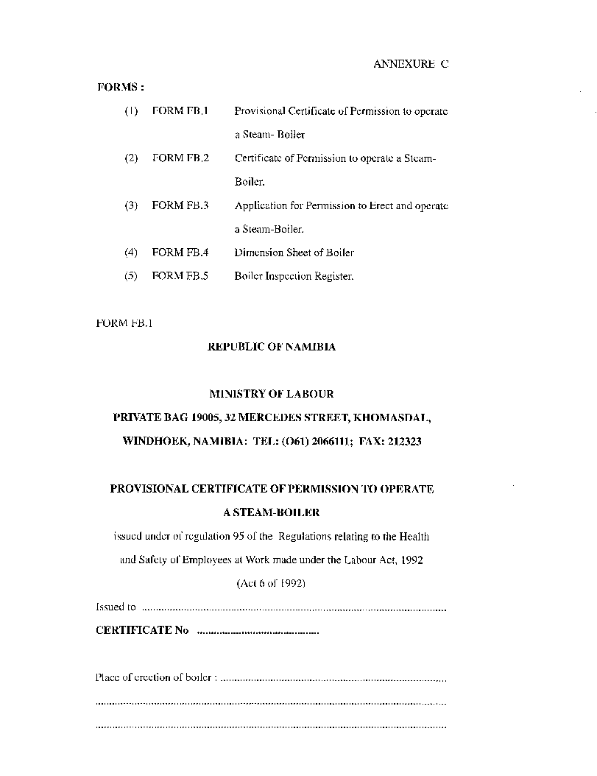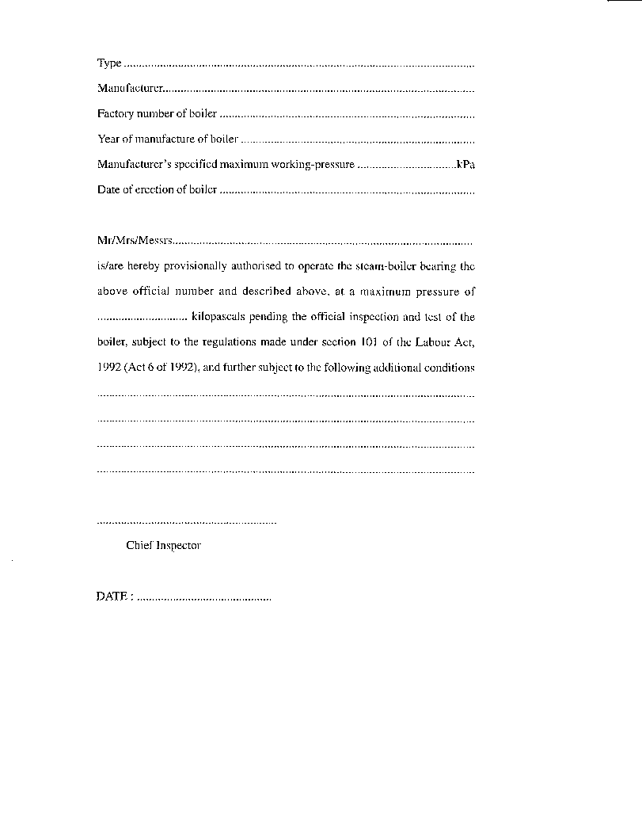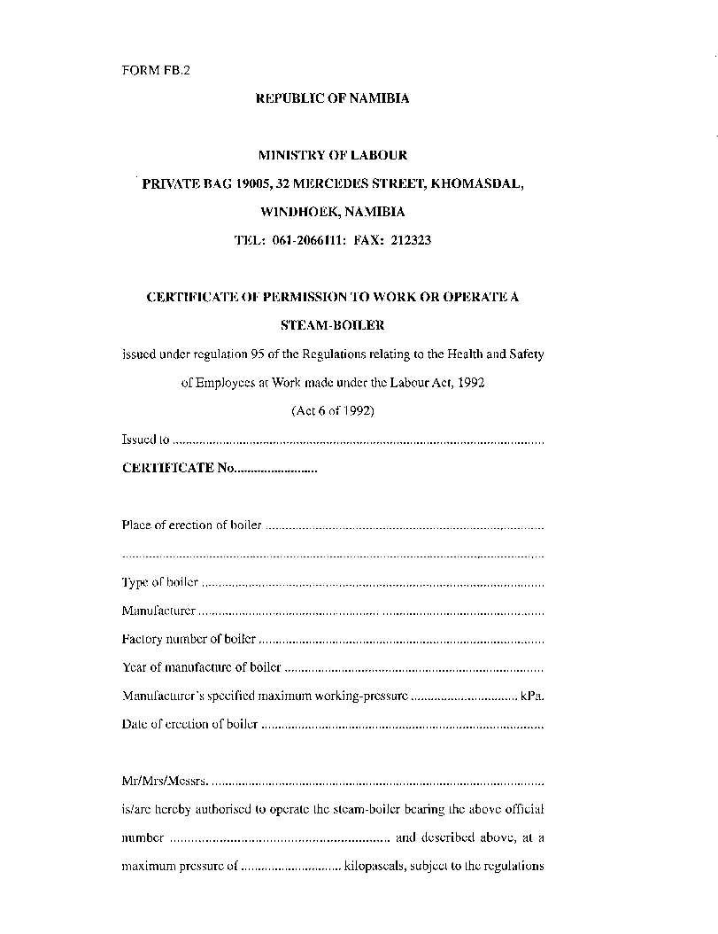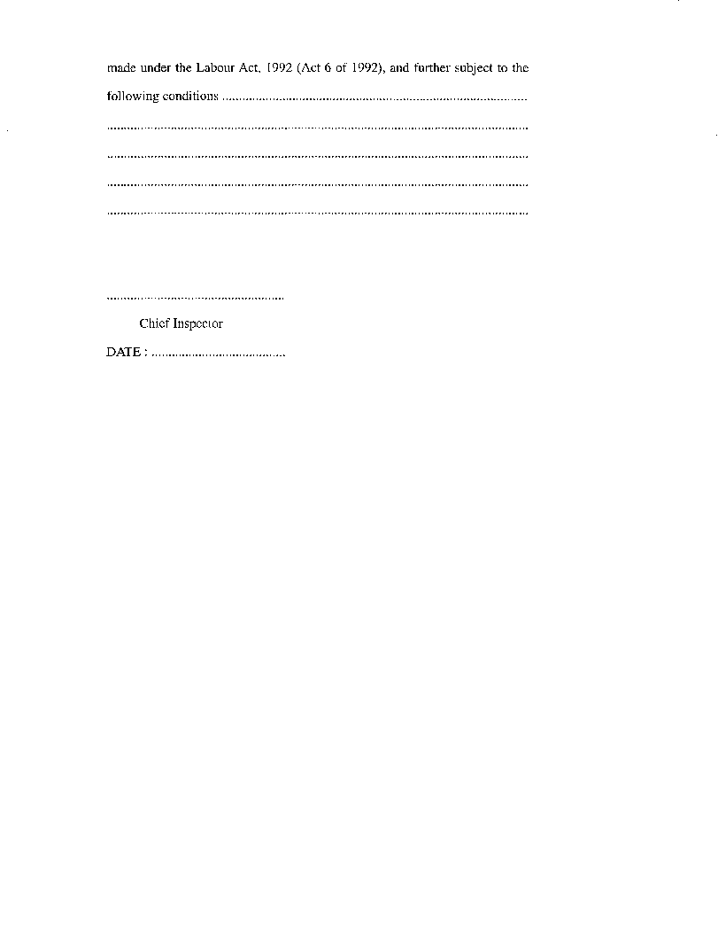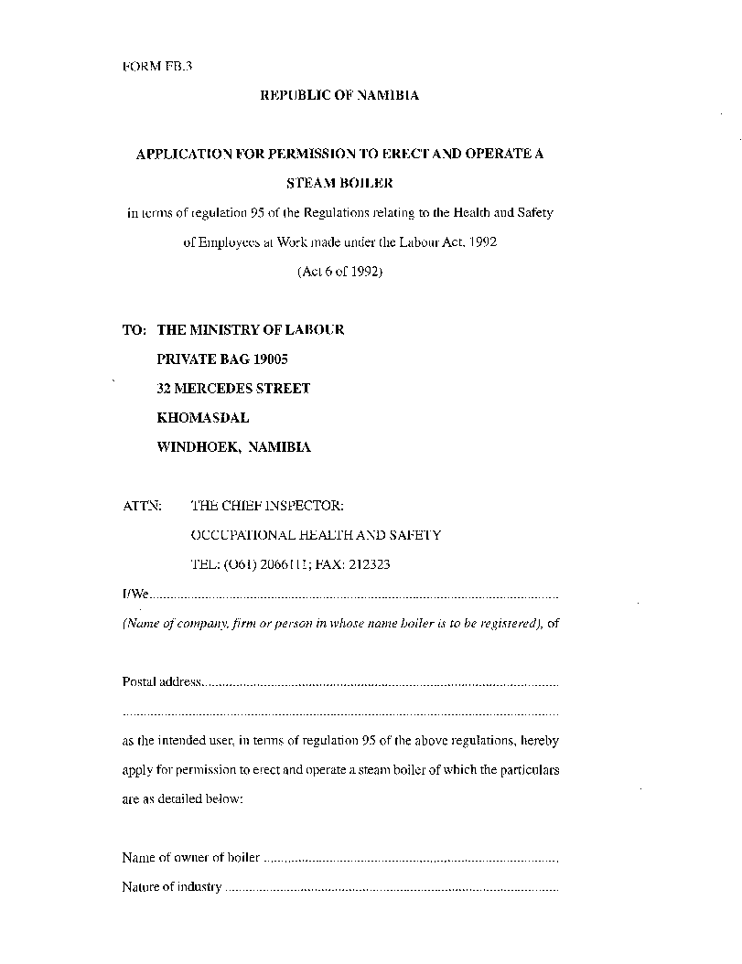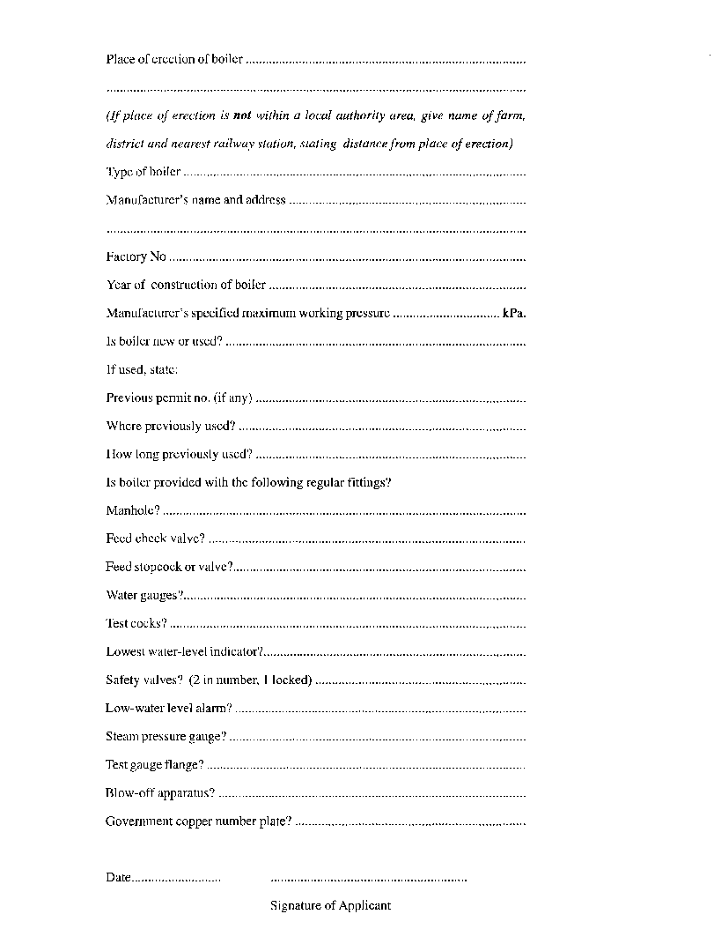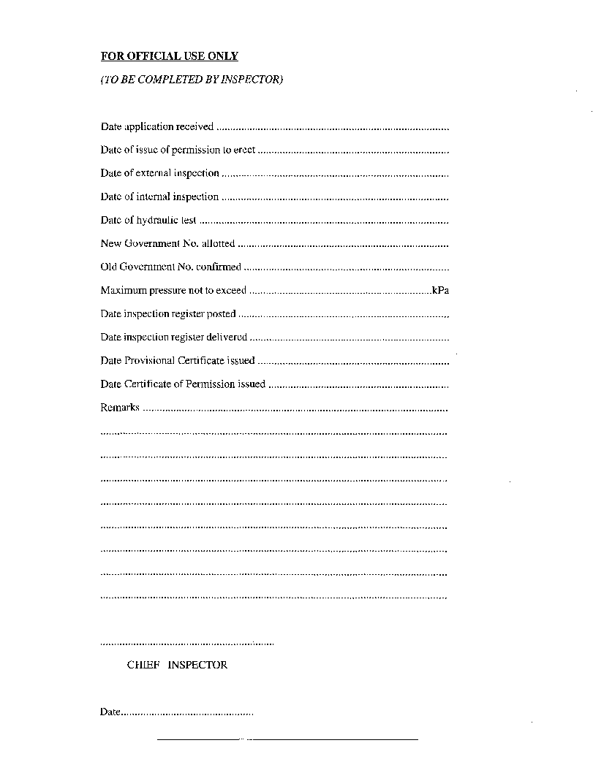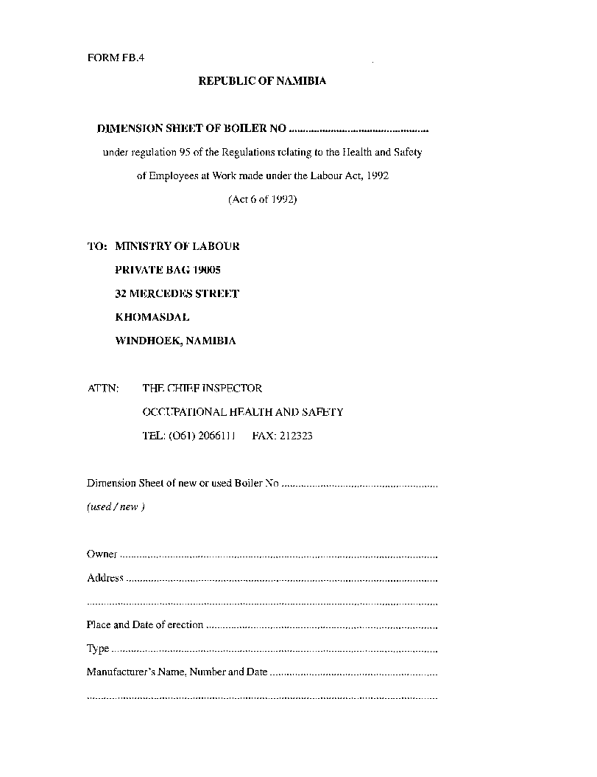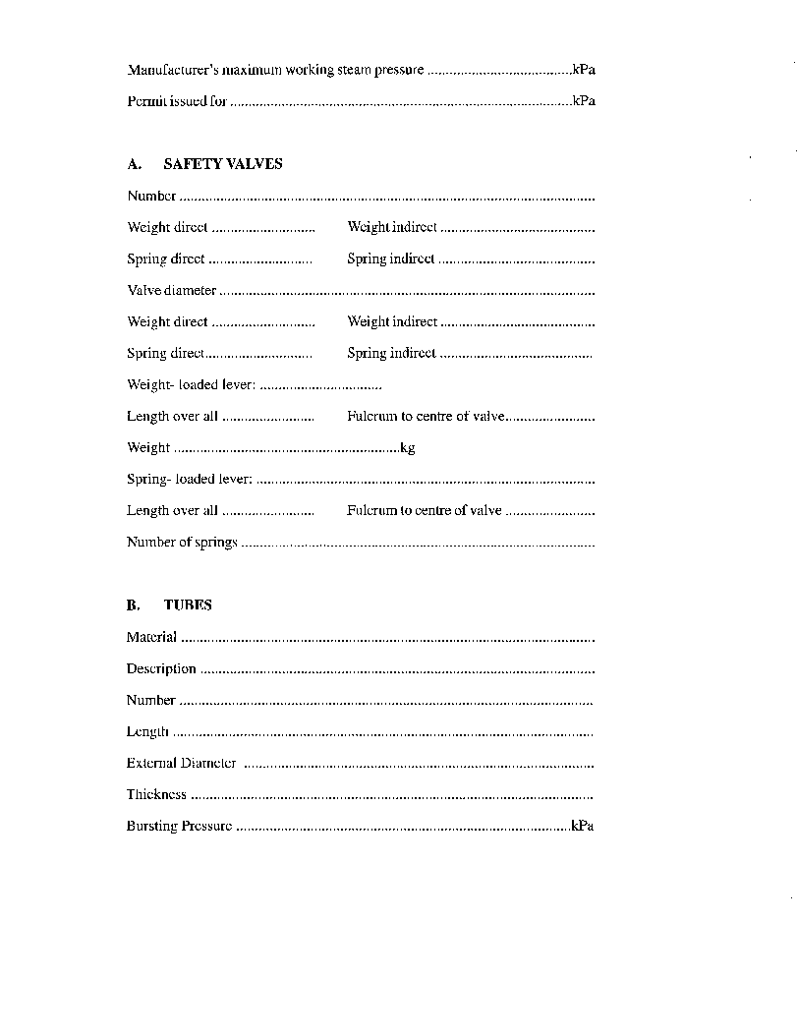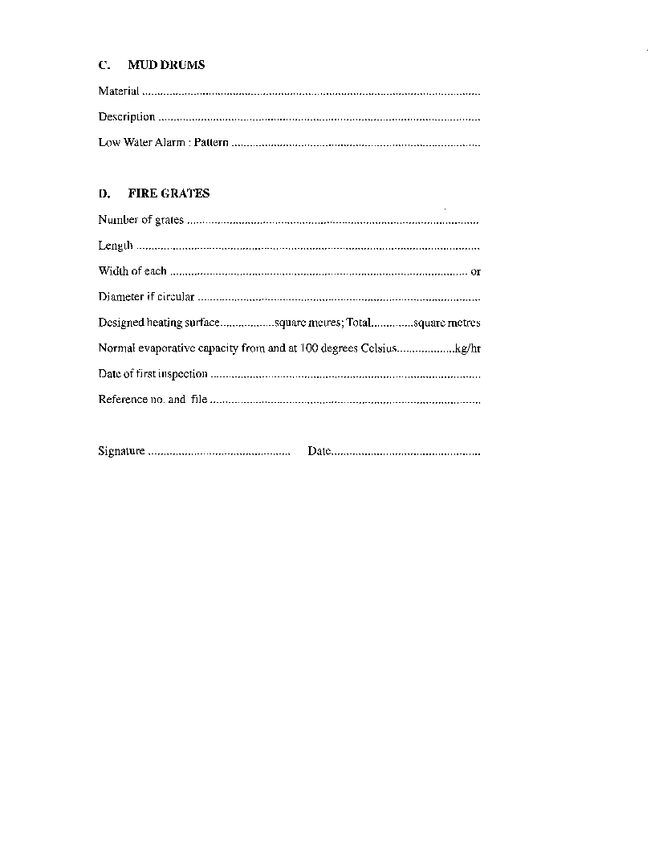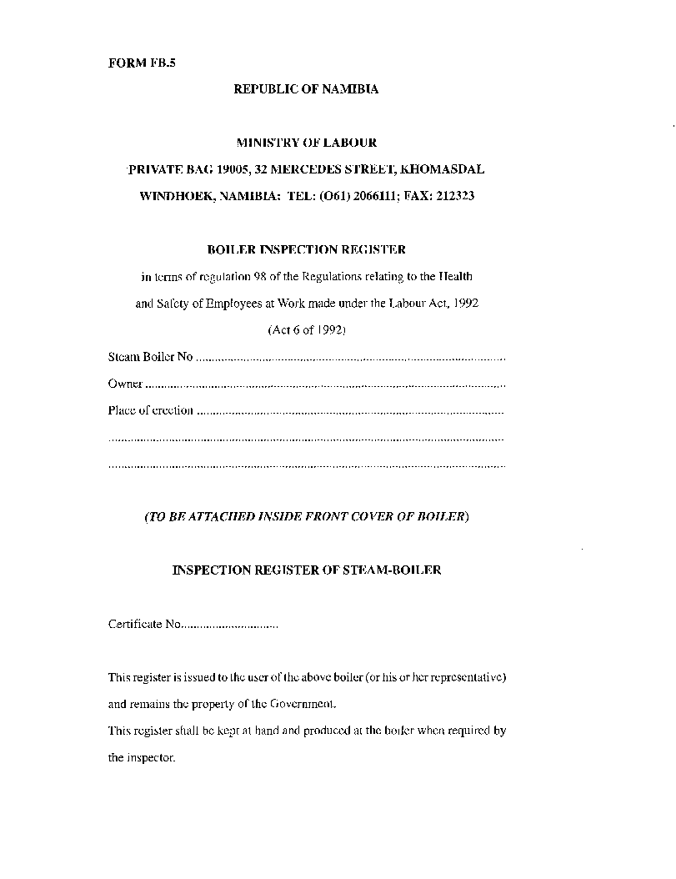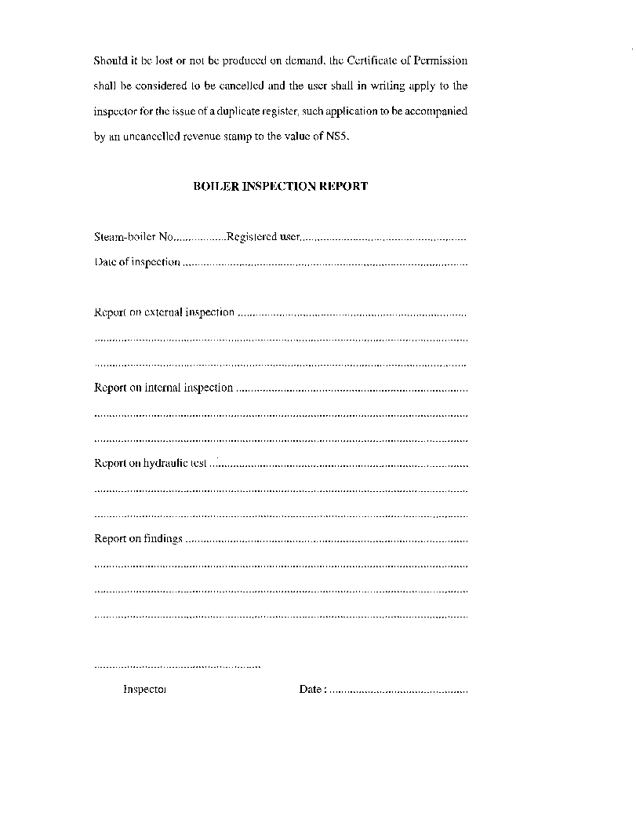

CHAPTER 4

SAFETY OF MACHINERY

PART III

ELEVATORS AND ESCALATORS

**Interpretation**

**120**. In this Part, unless the context otherwise indicates -

“authorised maximum load” means the maximum number of persons or maximum load determined by an inspector in terms of regulation 129;

“elevator” means any elevator, lift, hoist or other appliance used in a building for the raising and lowering of persons by means of a car, cage, cradle or other conveyance in a hatchway on rigid or stationery guides;

“escalator” means a power-driven inclined continuous stairway, incorporating moving steps and handrails intended for the conveyance of persons from one level to another;

“form” means the appropriate form set out in Annexure D;

“goods elevator” means an elevator used solely for the transport of goods and such attendants or operators as are necessary and authorised by an inspector to travel in the elevator, but does not include a hoist operated by hand-power or a hoist in which attendants, operators or other persons never travel;

“hatchway” means any vertical or inclined way in which an elevator or goods elevator is operated;

“landing” means any floor or platform which is an authorised stopping place for the elevator; and

“user” means an occupier of a building, or the person or persons owning or leasing the machinery concerned.

**A. ELEVATORS**

**Permission to erect or use elevator required**

**121**. No user shall erect or use an elevator or cause or permit an elevator to be used-

(a) unless the elevator complies with these regulations; and

(b) otherwise than in accordance with a Provisional Certificate of Permission or a Certificate of Permission, as the case may be, issued by an inspector in respect of such elevator.

**Application for permission to erect or use elevator**

**122**. (1) Any person who wishes to erect or operate an elevator shall, whether or not a Provisional Certificate of Permission or Certificate of Permission has been granted to any previous user of such elevator, apply in the form of Form F.E. 1 for the required permission, which application shall be accompanied by the fee imposed by regulation 125.

(2) In the case of an application for the erection of an elevator, the application form shall, to the satisfaction of the inspector concerned, be accompanied by -

(a) drawings of the machine-room and hatchway to a scale of not less than one to fifty, indicating clearly all dimensions, including doors, windows and other openings;

(b) dimensioned drawings showing the position of the installation;

(c) a diagram showing the complete electrical wiring installation; and

(d) details of the number and size of the hoisting ropes, together with the manufacturer’s specification and test certificate.

**Issue of permission to erect or use elevator**

**123**. (1) On receipt of an application to erect or operate an elevator and the appropriate fee, an inspector may grant written permission to erect the elevator and may, after such inspection of the elevator as he or she may consider necessary for the purposes of these regulations, free of charge -

(a) issue a Provisional Certificate of Permission in the form of. Form F.E.2., subject to such conditions and valid for such period as the inspector may determine and specify in the certificate; or

(b) if he or she is satisfied that -

(i) the elevator may be safely used; and

(ii) these regulations have been complied with;

issue a Certificate of Permission in the form of Form. F.E.3., subject to such conditions as he or she may specify in the certificate.

**Elevator register and record book**

**124**. (1) The user of an elevator shall be supplied by an inspector with a register in the form of Form F.E.4., free of charge.

(2) The register contemplated in subregulation (1) shall be kept in a safe place by the user, and the register shall be available for inspection by an inspector at any reasonable time.

(3) If the register is lost, defaced or destroyed, the user shall in writing apply to an inspector for the issue of a duplicate register, and such application shall be accompanied by the fee imposed by regulation 125.

(4) The user shall, at his or her own costs and to the satisfaction of an inspector, supply a record book, to be known as an Elevator Record Book, in which the user shall enter -

(a) the name of the competent person, or the name of the firm employing such competent person, appointed by the user to carry out the examination prescribed by regulation 127;

(b) the particulars specified in Annexure D. 2(1) in respect of the rope used in operating the elevator; and

(c) a report of an examination in terms of regulation 127, including any repairs or alterations carried out, which shall be signed by the person who made the examination or who carried out the repairs or alterations, as the case may be.

(5) The user shall keep the record book referred to in subregulation (4) at his or her work-place, shall keep it up to date and shall have it available for inspection by an inspector during normal working hours.

**Fees**

**125**. (1) The following fees shall be paid to an inspector in uncancelled revenue stamps, by the user of an elevator -

(a) in respect of each provisional certificate of permission to use an elevator issued, or in respect of each certificate of permission to use an elevator issued, an amount of N$ 50, plus an additional amount of N$ 10 per landing: Provided that if a provisional certificate of permission is issued to permit an elevator to be used, no further fee shall be payable in respect of the subsequent issue of the certificate of permission;

(b) who proposes to extend the number of landings served by an elevator, an amount of N$ 10 in respect of each additional landing to be served: Provided that if an inspection is carried out in connection with such extension, the inspection fees imposed by paragraph (c) of this regulation shall be payable in respect of the entire installation;

(c) of an elevator in respect of each general inspection of an elevator conducted by an inspector subsequent to the issue of a certificate of permission to use the elevator; an amount of N$ 20 per elevator, plus an additional amount of N$ 2 per landing; and

(d) in respect of the issue of a duplicate certificate of permission or a duplicate inspection register; an amount of N$ 1 0.

(2) A user shall be liable for payment of the fees imposed by subregulation (1), irrespective of whether or not the user complies with regulation 127(3) or (4), as the case may be.

**Returns**

**126**. (1) A user of an elevator shall immediately in writing notify an inspector when he or she -

(a) permanently ceases to use an elevator;

(b) transfers the ownership of an elevator to any other person, in which case the user shall in addition advise the inspector of the name and address of such new owner; or

(c) intends to replace, or to effect alterations to, the elevator.

(2) In the circumstances referred to in subregulation (1)(a) or (b), the notification shall be accompanied by the provisional certificate of permission or certificate of permission, and by the register issued to the user in terms of regulation 123 or 124, respectively.

**Examination and repairs**

**127**. (1) The user of an elevator shall, to the satisfaction of an inspector, appoint a competent person, or a firm which employs such a competent person, to inspect -

(a) not less than once a week, the guides and ropes, the engine or motor, the drums and sheaves, and the safety appliances; and

(b) not less than once a month, the entire elevator plant and the fittings and appliances,

of an elevator used by the user.

(2) At the examination referred to in subregulation (1)(b), the ropes supporting the elevator car and the counterpoises shall be thoroughly cleaned by the user for the purpose of ascertaining the extent of the deterioration of the ropes and the number of broken wires per lay, and the estimated amount of wear on the outer wires shall be recorded in the elevator record book referred to in regulation 124.

(3) A report of the result of an examination, or of any repairs or alterations carried out, shall without delay be recorded in the elevator record book, and shall be signed by the person who made the examination or carried out the repairs or alterations, and by the person who made the entry.

(4) If, as a result of an examination, a defect is discovered which is liable to cause danger to any person using the elevator, the person performing the examination shall immediately report the matter to the user, who shall prevent any person from using the elevator until the defect has been rectified.

(5) All reasonable precautions shall be taken by the competent person or persons referred to in subregulation (1) to prevent any other person from using the elevator while it is being operated from the machine-room, and while any examination, service or repair is being conducted on or in respect of the elevator, or while work is being done in the hatchway.

(6) If it is necessary for a landing door or gate to be open while work is in progress on the elevator or in the hatchway, the person performing the work shall ensure that a suitable barrier to prevent accidents is placed across the opening of the hatchway.

**Inspection of elevator**

**128**. (1) Elevators shall be inspected by an inspector at such intervals of time as the inspector may determine, and the result of such an inspection shall be entered by the inspector into the register referred to in regulation 124(1).

(2) When an inspector intends to conduct an inspection of an elevator, he or she shall, after consultation with the user, determine the date and time for the inspection and in writing notify the user of such date of intended inspection so determined not less than seven days before such intended date of inspection, and the user shall immediately pay to the inspector the inspection fee imposed by regulation 125 in respect of such inspection.

(3) Upon receipt of such notification, the user shall cause all ropes and machinery to be thoroughly cleaned and prepared for inspection to the satisfaction of the inspector.

(4) Upon the date of the intended inspection and at the time notified in terms of subregulation (2), the user of an elevator shall place at the disposal of the inspector, free of charge, such workmen, lights, tools, instruments and equipment as may be required by an inspector for the purpose of performing the intended inspection.

(5) If an inspector has, through failure of the user to comply with subregulation (3) or (4), been unable to inspect an elevator on the day or at the time notified in terms of subregulation (2), the user shall within seven days after such date in writing apply to the inspector for a new date and time to be determined for an inspection and shall, together with such application, forward the fee imposed by regulation 125.

(6) No inspection fee paid in terms of this regulation shall, irrespective of whether the inspection is conducted, not be refunded to the user.

**Duties of user of an elevator**

**129**. (1) The user of an elevator shall, to the satisfaction of an inspector -

(a) take any reasonable precaution to ensure the safety of any person using the elevator;

(b) cause all safety devices to be maintained in good working condition and to be used properly and correctly;

(c) stop the operation of the elevator if it is in any way defective or if its use appears to have become, or is likely to become, dangerous; and

(d) cause all landings and stair approaches to elevators to be adequately illuminated at all times while the elevator is available for use.

(2) In the case of elevators used for the conveyance of persons, the user or the person appointed by the user in terms of regulation 127 shall report, in writing, to an inspector any -

(a) fracture of, or defect in, any essential part of the elevator, including suspension ropes attached to the conveyance, the counterpoise or drum, or any sheaves, shafts, axles or bearings, brakes, safety catches or over-winding prevention devices, or the failure of any such part to work properly or effectively;

(b) jamming of the conveyance in the hatchway, or any occurrence which may have over-strained or stretched a suspension rope; or

(c) premature or untimely operation of a safety catch or an over-winding prevention device.

[Some text has been omitted in the *Government Gazette* here. The heading and initial portion of regulation 130, :Authorised maximum load”, has been omitted.]

in a goods elevator, shall be determined by the inspector and recorded on the provisional certificate of permission or on the certificate of permission concerned, as the case may be.

(2) A user shall not cause or permit the maximum authorised load in respect of persons or goods to be exceeded at any point in time.

**Marking of elevator**

**131**. (1) The user of an elevator shall, to the satisfaction of an inspector, cause a suitable notice containing the following particulars to be attached in a conspicuous place inside the elevator -

(a) the name of the manufacturer of the elevator;

(b) the maximum -

(i) load in kilograms; and

(ii) number of persons,

which the elevator may carry at any time.

**Elevator operators**

**132**. (1) An elevator, other than an automatic elevator controlled by means of push-buttons, shall be in the charge of, or be operated by, a person who is not::,less than 17 years of age and who has, to the satisfaction of an inspector -

(a) received not less than one week’s training from a competent operator;

(b) been suitably instructed in the operation of an elevator, and in the dangers attached thereto; and

(c) subsequent to the training and instructions in terms of paragraphs (a) and (b) been certified in writing by an inspector to be a competent operator of an elevator.

(2) No person other than a competent operator contemplated in subregulation (1), and in this regulation referred to as an “operator”, shall operate an elevator.

(3) No operator shall absent himself or herself from the elevator during the period he or she is in charge of the elevator, unless he or she has ensured that the elevator cannot be operated by an unauthorised person during such period of absence.

(4) An operator shall be responsible for the locking of all doors or gates at a landing before the elevator is moved from such landing.

(5) An operator shall cease to use an elevator when any defect in or pertaining to the elevator is found, which defect may endanger the life of, or may cause injuries to, any person.

(6) When an inspector is satisfied that an operator is, for any reason, incompetent or unable to continue to operate an elevator effectively, the inspector shall, by notice in writing, notify the user to relieve such operator from duty, and such operator shall immediately cease to operate such elevator.

**Hatchway enclosure**

**133**. (1) If a hatchway of an elevator is not enclosed by walls -

(a) access to the hatchway by means of adjacent stairways, platforms or floors which are not authorised landings, shall be prevented by means of adequate bratticing or grille-work to a height of not less than two comma one metres; and

(b) the entire space of each hatchway landing door shall be closed by similar bratticing or grille-work,

to the satisfaction of an inspector.

(2) The bratticing or grille-work referred to in subregulation (1) shall be constructed in such a manner that the space between any two members thereof shall not measure more than 40 millimetres.

(3) All bratticing or grille-work installed in accordance with the requirements of this regulation shall be maintained by the user in good order and repair.

**Hatchway landing doors**

**134**. (1) The entrance to a hatchway at a landing shall be fitted with a substantial door or gate of not less than one comma eight metres in height.

(2) In the case of an elevator erected after the date of commencement of these regulations, an entrance referred to in subregulation (1) shall be fitted with a substantial door or shutter-type gate, the inner surfaces of which, when closed, are as nearly as practicable level with the inside of the hatchway.

(3) When it has become necessary, through wear or through any other cause, to replace a landing door or gate of an elevator, such door or gate shall, if practicable, be replaced with a door or a shutter-type gate, the inner surface of which, when closed, shall, to the satisfaction of an inspector, as near as practicable, be level with the inside of the hatchway.

(4) A vertical sliding door shall not be permitted as a landing door or gate.

(5) No person shall attach any door to a hatchway, except to or at an authorised landing, unless -

(a) permitted or required to do so in writing by an inspector; or

(b) authorised in terms of regulation 141.

(6) If a landing door is mechanically coupled to an elevator door or gate for opening or closing purposes -

(a) a device shall be installed which automatically retracts the door if it is obstructed in any way during closing; and

(b) the door shall be adjusted in such a manner that the force with which it closes shall not be able to cause injury to any person.

(7) All lattice-type gates shall be fitted with full-length mid bars or pickets spaced in such a manner that the opening between any two vertical members does not exceed 50 millimetres.

**Hatchway door locks and contacts**

**135**. (1) Subject to this regulation, a hatchway landing entrance to an automatic elevator shall be fitted with -

(a) a mechanical lock which operates in conjunction with an electrical circuit-breaker, so arranged that -

(i) the elevator cannot be moved by means of electrical power unless all landing doors are closed and locked; and

(ii) no landing door can be opened unless the elevator is at rest at that landing; and

(b) subject to subregulation (3), a circuit-breaker so installed that the elevator cannot be moved by power unless all landing doors or gates are closed,

which devices shall be constructed, situated or screened in such a manner so as to inaccessible to unauthorised persons.

(2) The circuit-breakers referred to in subregulation (1)(a) and (b) shall be separate control circuits.

(3) If the elevator door or gate is mechanically coupled to the landing door or gate for opening and closing purposes, subregulation (1)(b) shall not apply.

(4) A hatchway landing entrance to an elevator controlled by an operator shall be fitted with -

(a) a substantial mechanical lock which cannot be opened from outside unless the elevator is at rest at such landing; and

(b) a circuit-breaker so arranged that the elevator cannot be moved by means of electrical power unless all the doors and gates are closed,

which devices shall be constructed, situated or screened in such a manner as to be inaccessible to unauthorised persons.

(5) Notwithstanding subregulation (1), (2), (3) or (4), an installation may, subject to regulation 145(3), open the landing doors of an elevator before the elevator comes to rest at a landing.

(6) All doors or gates opening to an elevator hatchway shall be kept locked when not in use.

**Hatchway safety**

**136**. (1) Any projection, protrusion or overhang in a hatchway, including door lintels if a door is not level with the hatchway, shall be rendered safe by a bevelled approach on the hatchway side opposite to the opening of the elevator.

(2) A bevel shall be at an angle of not less than 70 degrees to the horizontal, and the surface thereof shall be covered with smooth sheet metal.

(3) No user shall require or permit any piping, ducting, wiring, or any other equipment which does not form part of the elevator installation, to be placed in a hatchway, or require or permit a hatchway to be used for any purpose other than for the purpose of the operation of the elevator.

**Guide rails**

**137**. (1) Elevators and counter-weights shall be guided by rigid guide rails of substantial construction to the satisfaction of an inspector, which guide rails shall be securely attached to the hatchway.

(2) The hatchway construction, guide-rails and guide-rail attachments shall be such as to safely withstand the application of the elevator safety catches with the maximum authorised load, as well as any other force resulting from the normal operation of the elevator.

(3) The bottom ends of the guide-rails shall rest on a secure foundation and shall be firmly anchored in that position.

(4) The guide-rails shall not be attached to the ceiling of the hatchway, and a clear space shall be left between the top end of the guide-rails and the ceiling.

(5) No wooden guide-rails shall be used if the speed of the elevator exceeds 30 metres per minute.

(6) No cast-iron or hollow guide-rails shall be installed.

(7) Counterpoise runways shall be enclosed by bratticing from a point 300 millimetres above the floor of the hatchway to a point not less than two comma one metres above the floor of the hatchway, except if compensating chains or ropes attached to the counterpoise prevent such bratticing.

**Buffers**

**138**. (1) An elevator operating at a speed of -

(a) up to and including 100 metres per minute, shall be provided with spring, air or hydraulic buffers;

(b) more than I 00 metres per minute, shall be provided with hydraulic buffers; placed at the bottom of the hatchway and arranged symmetrically with reference to the centres of the elevator and the counterpoise:

Provided that if such buffers may be attached to the elevator or counterpoise.

**Access to bottom of hatchway**

**139**. (1) If any door allows access to the bottom of a hatchway, such door shall operate a circuit-breaker which shall prevent the elevator from working or moving while such door is open.

(2) If no access door is fitted to give access to the bottom of a hatchway and if the floor of the hatchway is more than one comma five metres below the bottom landing, a permanently attached metal ladder shall be installed to give access to the bottom of a hatchway from the bottom landing.

(3) A manually operated switch or switches which shall immobilize the elevator shall be fitted within reach of the bottom of the hatchway and of the bottom landing.

**Hatchway separation**

**140**. If two or more elevators operate in the same hatchway, the portion of the bottom of the hatchway situated beneath one elevator shall be separated from any other portion of the bottom of the hatchway situated beneath any other elevator, by means of a wall or bratticing to a height of not less than two comma one metres above the floor of the hatchway.

**Hatchway clearances**

**141**. (1) There shall be a clear space of not less than 600 millimetres between the bottom of the hatchway and the lowest point on the underside of the elevator when the elevator rests on its fully compressed buffer: Provided that guide-shoes or rollers, safety catch assemblies, aprons and guards shall not be taken into consideration when determining the lowest point of the elevator.

(2) When an elevator is at rest on its fully compressed buffer, no part of the elevator or of any equipment attached to the elevator shall come into contact with any part of the floor of the hatchway or any part of the equipment in the hatchway.

(3) When an elevator is at rest at the lowest landing, there shall be a clear space of not less than 300 millimetres between the buffer striking plate and the face to the fully extended buffer.

(4) When an elevator is at the top landing, there shall be a clear space above the elevator cross-head, which space shall permit the elevator to travel a distance of not less than 900 millimetres beyond the top landing without the elevator or any of its attachments coming into contact with any part of the hatchway or with any equipment located in the hatchway.

(5) When an elevator rests on the fully compressed buffers, a clear space shall be provided above the counterpoise so that the counterpoise or any of its attachments shall not touch any part of the hatchway or any equipment located therein.

(6) The clearance between the elevator and the hatchway enclosure or any portion of the hatchway enclosure shall in no case be less than 25 millimetres, except if at the entrance side of the elevator, the clearance between the elevator sill and the landing sill is not less than 12 millimetres and not more than 30 millimetres.

(7) The clearance between -

(a) the elevator and the counterpoise shall be not less than 50 millimetres: Provided that, if a counterpoise screen is installed, the clearance between the screen and -

(i) the elevator shall not be less than 25 millimetres;

(ii) (aa) the counterpoise; or

(bb) the hatchway enclosure,

shall be not less than 20 millimetres; and

(b) the counterpoise and the hatchway enclosure shall be not less than 20 millimetres.

(8) When an automatic elevator is at rest at a landing, the distance between the leading edge of the elevator door or gate when closed and the landing door or gate shall not be more than 100 millimetres: Provided that, in the case of elevators which were installed prior to the commencement date of these regulations, this subregulation shall be considered to have been complied with if the landing doors or gates are fitted with devices to prevent persons from standing in the space between the elevator doors or gates, and the landing doors or gates, when closed.

**Over travel devices**

**142**. (1) An elevator hatchway shall be provided with automatic devices at the top and at the bottom, so arranged that the power-supply to the elevator shall be cut off before the elevator reaches a point 300 millimetres above the top landing or a point 300 millimetres below the bottom landing.

(2) In electric elevators, the devices contemplated in subregulation (1) shall be so arranged that the power supply to the elevator shall be cut off independently of any other operating device, so as to prevent any movement of the elevator in any direction after it has reached any of the points contemplated in that subregulation.

**Construction of counterpoise**

**143**. (1) A counterpoise shall -

(a) have all its sections bolted together securely or otherwise secured against becoming detached from one another;

(b) be so situated that it cannot fall upon any part of the elevator or machinery; and

(c) be suspended in the guides in such a manner that it may travel freely without danger of becoming detached.

(2) In the case of a hatchway not extending to the lowest floor of the building and the space under the hatchway is accessible to persons at any time, the counterpoise shall be fitted with:-

(a) safety catches; and

(b) a circuit-breaker so arranged that it shall automatically break the circuit controlling the power-supply to the elevator when the safety catches come into operation.

**Construction of elevator**

**144**. An elevator shall, to the satisfaction of an inspector, be of a sturdy construction, be enclosed on all sides in which there are not entrances, and the top of the elevator shall be covered by a sturdy roof.

**Elevator doors and gates**

**145**. (1) Subject to subregulation (3), an elevator shall be fitted with a door or gate which, to the satisfaction of an inspector, operates an electrical circuit-breaker, so arranged that the elevator cannot be moved by any electrical power when such door or gate is open: Provided that -

(a) no elevator erected after the commencement date of these regulations shall be fitted with a lattice-type gate; and

(b) if it has become necessary, through wear or any other cause, to replace a lattice-type gate on any elevator, such gate shall, if practicable, be replaced by a door.

(2) The door or gate of an automatic elevator shall -

(a) open and close automatically; and

(b) unless mechanically coupled to a landing door, not start to close until the landing door or gate is closed.

(3) Notwithstanding subregulation (1), the door of an elevator may commence to open before the elevator comes to rest at a landing, if the elevator is fitted with an automatic levelling device which is automatically operated in conjunction with devices which cause the door to commence to open as soon as the elevator enters the levelling zone: Provided that -

(a) the levelling zone shall not exceed 400 millimetres above or below a landing;

(b) the speed of the elevator within the levelling zone shall not exceed 12 metres per minute;

(c) a elevator apron plate of not less than 450 millimetres is fitted; and

(d) if there is a bevelled approach in accordance with regulation 136, the bevelling shall not be less than 450 millimetres.

(4) All lattice-type gates shall be fitted with full-length midbars or pickets so spaced that the opening between any two vertical members does not exceed 50 millimetres.

(5) If two or more elevators operate in the same hatchway and escape- doors are fitted in the elevators, such escape-doors shall be fitted with circuit- breakers so arranged as to render inoperative the driving motor of the elevator of which the door has been opened.

**Retiring cam**

**146**. An automatic elevator which serves more than two floors shall be fitted with a retiring cam so arranged that the manually operated landing door or gate cannot be opened unless the elevator is at rest at a landing.

**Alarm, stop-switch and lighting**

**147**. (1) Elevators shall be fitted with:-

(a) a push-button or switch inside the elevator, marked “ALARM”, by means of which a bell may be sounded;

(b) an emergency stop-switch fitted on top of the elevator as near to the point of suspension as practicable, for use during service or inspection;

(c) electric lighting inside the elevator, consisting of not less than two bulbs or tubes, wired in parallel, which shall be switched on at all times when the elevator is available for use or is being serviced; and

(d) a suitable fitting at the top and bottom of the elevator, to which a light can be attached when repairs, examinations or inspections are being conducted: Provided that a watertight light fitting may be attached in the hatchway below the lowest landing instead of at the bottom of the elevator.

(2) The size and type of the alarm bell referred to in subregulation (1)(a) and the place at which it is installed shall be subject to approval by an inspector, and, if the bell is electrically operated, it shall be supplied with power from a circuit other than the power supply of the elevator driving machinery.

**Safety catches**

**148**. (1) An elevator shall be fitted with sufficient and effective safety catches which shall, if the elevator is static, be capable of holding the elevator, together with twice the maximum load, stationary in any position in the hatchway.

(2) An inspector may from time to time require a running test of the safety catches without any load.

(3) In estimating the maximum load for passenger elevators, 70 kilograms shall be allowed for each person.

(4) In cases where the safety catches are operated through shafts, all the levers and safety catches shall be keyed to the shafts.

(5) No elevator which has a speed in excess of 70 metres per minute shall be fitted with the cam or instantaneous grip-type of safety catch.

(6) An accessible switch shall, in a position approved by an inspector, be fitted on the elevator, so arranged as to automatically break the circuit controlling the power-supply to the elevator when the safety catches come into operation.

**Ropes**

**149**. (1) No ropes shall be used for supporting an elevator or counterpoise unless such ropes are, to the satisfaction of an inspector, of good quality and manufacture, free from any defect and of adequate strength to support the weight of the elevator or counterpoise, as the case may be.

(2) An elevator or counterpoise operated by ropes shall, to the satisfaction of an inspector, be suspended by not less than two ropes of equal diameter and strength.

(3) The diameter of the wires used in the construction of the rope shall, to the satisfaction of an inspector, be suited to the diameter of the drum upon which the rope is wounded, and the diameter of the drum shall be equal to not less than 40 times the diameter of the rope.

(4) No rope shall be used for supporting an elevator or counterpoise if the estimated aggregate breaking load of all the ropes supporting such elevator or counterpoise has become reduced to less than ten times the maximum static load of the elevator or counterpoise, as the case may be.

(5) Before a rope of an elevator is replaced, full particulars of the construction of the new rope, as required by this regulation, shall be supplied to an inspector.

(6) All ropes used for supporting an elevator or counterpoise shall be replaced after a maximum of ten years’ service.

**Rope connections**

**150**. (1) The connections between a rope and a drum, or a counterpoise or an elevator shall be designed in such a manner so as to prevent accidental disconnection of the rope, and shall have a breaking strength which shall be not less than equal to the breaking load of the ropes to which they are attached.

(2) The ends of each rope shall be attached to the drum, to the counterpoise or to the elevator by means of independent connections, and appropriate appliances shall be fitted in such a manner that such appliances shall automatically distribute the load equally between the ropes.

(3) If hoisting ropes are secured to any structure in the hatchway, they shall be anchored to the machine-carrying beams or to suitable rolled-steel sections specially supplied or installed for such purpose.

(4) All rope connections shall be replaced when the ropes are replaced: Provided that, unless they are broken, no rope connections need to be replaced at intervals of less than five years.

**Precautions against rope slip**

**151**. If an elevator rope is not rigidly attached to the drum, the rope shall be attached in such a manner that there can be no dangerous slipping of the rope on the drum under any working conditions.

**Overhead machinery**

**152**. (1) All overhead machinery shall, to the satisfaction of an inspector, be erected -

(a) on reinforced-concrete platforms of satisfactory design and adequate strength to support the total maximum load of or relating to the elevator; or

(b) on rolled-steel joists having sufficient strength to carry the total maximum load contemplated in paragraph (a) and with-ends resting upon walls or pillows of adequate strength.

(2) The elevator driving machinery shall be secured in position and shall have sufficient power to lift a load equal to one comma five times the authorised maximum load of the elevator, cradle or other receptacle.

**Brakes**

**153**. (1) The elevator driving machine of an elevator propelled by a motor or an engine, shall be fitted with an effective brake designed in such a manner as to hold the elevator at rest in any position in the hatchway when loaded up to one comma five times its authorised maximum load.

(2) An electrically propelled elevator shall be adjusted in such a manner that, during normal operation of the elevator, the brake of the elevator is not released before power has been applied to the driving motor.

(3) The brake of the elevator shall be constructed in such a manner that the brake applies automatically when the elevator driving machinery is not in operation or when any stopping device or other electrical protective device comes into operation.

**Speed governor**

**154**. (1) An elevator suspended by ropes shall be equipped with a speed governor to operate the safety catches: Provided that broken-rope safety devices may continue to be used if installed prior to the commencement date of these regulations.

(2) If the counterpoise of an elevator is also fitted with safety catches, a separate speed governor or broken-rope safety device to operate the safety catches shall be provide for the counterpoise.

(3) A speed governor shall be set to trip at a speed equal to not less than one comma five times, or equal to not more than one comma four times, the rated speed of the elevator.

(4) If a speed governor is installed for a counterpoise, the governor shall be set to trip at speeds greater than, but not more than 10 per cent above, the speed at which the elevator governor is set to trip in terms of subregulation (3).

(5) In the case of hydraulic, steam or electric elevators in which the driving machinery is not governed effectively, a effective speed safety device approved by an inspector, shall be fitted to control the motion of the driving machinery within safe limits.

[The “a” in the phrase “a effective speed safety device” in subregulation (5)   
should be “an” in order to be grammatically correct.]

**Guards for moving parts**

**155**. The moving parts of elevator machinery that an inspector may deter ne shall be fitted with effective protection guards.

**Elevator machinery room**

**156**. (1) The size of an elevator machinery room shall be adequate for the proper maintenance of the machinery installed in the room, and there shall be a clear space of not less than 600 millimetres on not less than three sides of each machine.

(2) The height of the machinery room shall be not less than two comma one metres, measured from the floor to the underside of the lowest portion of the ceiling or of the building structure.

(3) Natural light shall be supplied in a machinery room by means of openings in the walls or roof of the room, the area of which openings shall be equal to not Jess than ten per cent of the floor area of such room, and such natural light shall be supplemented by artificial illumination with a strength of not less than 160 lux, which artificial light shall be connected to a circuit other than that of the power-supply to the elevator.

(4) A machinery room shall be ventilated by means of air bricks, louvers or other means, in addition to windows which can open and close, and which air bricks, louvers or other means shall in total have an area equal to not less than ten per cent of the floor area of the room.

(5) No underground machinery room shall be used without the written authority of the Chief Inspector.

(6) Access to a machinery room shall be by means of stairs constructed of non-flammable material: Provided that in the case of an elevator in use prior to the commencement date of these regulations, and if it is impracticable to construct stairs, the Chief Inspector may grant written authorisation for the use of metal cat-ladders, not exceeding two comma five metres in length as a means of access to a machinery room.

(7) An approach to a machinery room shall be unobstructed and adequately illuminated.

(8) A machinery room shall be kept locked unless inspections are being made or work in connection with the operation of the elevator is in progress, and a key shall be kept available on the premises and be in the possession of a person authorised thereto by an inspector.

(9) The motor of each elevator shall be distinctly marked so as to indicate the upward and downward movement of the elevator.

(10) In a machinery room in which the machinery of more than one elevator is installed, the machinery of each elevator shall be distinctly marked with a distinguishing mark which shall differ from the mark allotted to the machinery of any other elevator in such room.

(11) No machinery room shall be used as a store-room for any goods or materials other than oil, grease, tools and such materials as are required for the maintenance of the elevator.

**Electrical Installations**

**157**. (1) The electrical wiring of an elevator, except the trailing cables, shall be in conduits or ducting approved by an inspector: Provided that an inspector may authorise the use of suitably sheathed cables.

(2) The electrical installation of an elevator, except for the light circuit, shall be fitted with a main switch in the elevator machinery room, which shall be placed in an easily accessible position as close as practicable to the entrance to the machinery room.

(3) Electric motors of elevators operated by polyphase alternating electric current shall be fitted with a reverse phase relay or other equivalent protection to prevent the reversal of the driving motor through the reversal of the phases.

(4) All accessible exposed metallic portions of the elevator installation which, though normally not forming part of an electrical circuit, may become electrically charged, shall be suitably grounded.

**Goods elevators**

**158**. (1) A goods elevator operated in a hatchway within the same enclosure as an elevator shall, subject to subregulation (2), comply with these regulations relating to the construction and use of elevators.

(2) Notwithstanding subregulation (1), regulations 131 and 145(2) shall not apply to a goods elevator.

(3) A goods elevator shall, to the satisfaction of an inspector, comply with the following requirements -

(a) a notice containing the following particulars shall in a conspicuous place be attached to the goods elevator -

(i) the name of the manufacturer;

(ii) the maximum mass of goods which may be conveyed at any one time; and

(iii) the maximum number of attendants who may be conveyed at any one time;

(b) the goods elevator shall be of a sturdy construction with a strong roof fitted over that portion of the elevator occupied by the operator when the goods elevator is in operation;

(c) the goods elevator shall be fitted with effective safety catches and in addition thereto, if the speed of the driving machinery is not governed, with an effective speed controlling device;

(d) the goods elevator shall be fitted with gates or doors: Provided that in the case of elevators used to carry motor vehicles or other bulky goods, the use of bars instead of gates may be authorised by an inspector;

(e) the gates, doors or bars of a goods elevator shall be fitted with circuit breakers approved by an inspector;

(f) a hatchway door or gate of an automatic goods elevator shall be fitted with a circuit-breaker so arranged that the elevator cannot be moved when any landing door or gate is unlocked, and that no door or gate can be opened, or can remain open unless the elevator is at the landing; and

(g) rails fitted to the floor of the elevator shall be level with the floor.

**B. ESCALATORS**

**Permission to erect or use escalator required**

**159**. (1) No person shall commence with the erection of an escalator until he or she has, subject to regulation 160, received the written permission issued by an inspector to erect such escalator.

(2) No person shall use an escalator, or cause or permit an escalator to be used -

(a) unless such person is in possession of a valid Provisional Certificate of Permission, issued in his or her name by an inspector in the form of Form F.E.5, or of a valid Certificate of Permission, as the case may be, issued in his or her name by an inspector in the form of Form. F.E.6, in respect of the escalator;

(b) unless the escalator complies with these regulations; and

(c) otherwise than in accordance with the conditions contained in the Provisional Certificate of Permission or Certificate of Permission, as the case may be, referred to in subparagraph (a).

**Application for permission to erect or use an escalator**

**160**. (1) Any person who wishes to erect or use an escalator shall, whether or not a Provisional Certificate of Permission or Certificate of Permission has been issued to any previous user of such escalator, apply in the form of Form F.E.7 for the required permission, and shall, together with such application, submit the application fee imposed by regulation 163.

(2) The application shall be accompanied by specifications and legible dimensioned drawings showing the position of the installation, and a diagram showing the complete electrical wiring of the installation.

**Issue of permission to erect or use escalator**

**161**. (1) On receipt of an application to erect or operate an escalator, as the case may be, and of the appropriate fee payable in terms of regulation 160, an inspector may grant written permission to erect or operate the escalator and may, after such inspection of the escalator as he or she may consider necessary -

(a) issue a Provisional Certificate of Permission in the form of form F.E.5, subject to such conditions, and valid for such period, as the inspector may determine and specify in the Certificate; or

(b) if the inspector is satisfied that -

(i) the escalator may safely be used; and

(ii) these regulations have been complied with,

issue a Certificate of Permission in the form of Form F.E.6, subject to such conditions as the inspector may determine and specify in the Certificate.

(2) A user shall cause to be displayed in a conspicuous place, or in such place as an inspector may direct, a suitable lockable frame with a sheet glass panel, in which frame the Provisional Certificate of Permission or Certificate of Permission, as the case may be, shall be exhibited.

(3) If the Provisional Certificate of Permission or Certificate of Permission, as the case may be, is lost, defaced or destroyed, the user shall, not later than seven days after the discovery of such occurrence, in writing apply to an inspector for the issue of a duplicate certificate.

(4) The application contemplated in subregulation (3) shall be accompanied by the applicable fee imposed by regulation 163.

**Escalator inspection register and record book**

**162**. (1) The user of an escalator shall be supplied by an inspector with a register in the form of Form. F.E.4, free of charge.

(2) The register shall be kept in a safe place by the user and shall be available to an inspector at all reasonable times during normal working hours.

(3) If the register is lost, defaced or destroyed, the user shall in writing apply to an inspector for the issue of duplicate register and shall, together with such application, pay the applicable fee imposed by regulation 163.

(4) A user shall, at his or her own costs, provide a book to be known as the escalator record book, in which he or she shall enter or cause to be entered -

(a) the name of the competent person, or the name of the firm employing such competent person, appointed by the user to conduct the inspections prescribed by regulation 165; and

(b) a comprehensive report of every inspection conducted in terms of regulation 165, including any repairs or alterations carried out, which report shall be signed by the person who conducted the inspection or effected the repairs or the alterations.

**Fees**

**163**. (1) The following fees shall be paid in uncancelled revenue stamps -

(a) by the user of an escalator for each Certificate of Permission to use an escalator, or Provisional Certificate of Permission, an amount of N$ 70: Provided that if a Provisional Certificate of Permission has been issued, no further fees shall be payable for the subsequent issue of the Certificate of Permission;

(b) by the user of an escalator of an escalator in respect of each general inspection of the escalator conducted by an inspector subsequent to the issue of the Certificate of Permission or a Provisional Certificate of Permission, an amount of N$ 40; and

(c) by a user for the issue of a duplicate Certificate of Permission or a duplicate Provisional Certificate of Permission, or a duplicate inspection register, an amount of N$ 10.

(2) A user shall, whether or not he or she fails to comply with regulation 165(5) or (6), be liable to payment of the fees applicable prescribed by subregulation (1) of this regulation.

**Returns**

**164**. (1) The user of an escalator shall immediately notify an inspector in writing, when -

(a) he or she ceases permanently to use the escalator for which he or she is the holder of a Certificate of Permission or a Provisional Certificate of Permission, as the case may be;

(b) transfers the ownership of the said escalator to any other person, in which case he or she shall in addition advise the inspector of the name and address of the new owner; or

(c) he or she intends to replace, or to effect alterations to, the escalator.

(2) In the case of a notification in terms of subregulation (1)(a) or (b), the notification shall be accompanied by the Provisional Certificate of Permission or Certificate of Permission, as the case may be, and the register issued to the user in terms of regulations 161 and 162 respectively.

**Inspection of escalator**

**165**. (1) A user shall appoint a competent person, or a firm which employs such a competent person, to, not less than once a week, inspect the entire escalator plant, including all safety devices thereof.

(2) If, as a result of an inspection in terms of subregulation (1), any defect is discovered which may endanger any person using the escalator, the person conducting the inspection shall immediately report the matter to the user, who shall prevent any person from using the escalator until the defect has been repaired or rectified.

(3) No user shall require or permit any person to use, and adequate precautions to the satisfaction of an inspector shall be taken by the user to prevent any person from using, the escalator whilst any inspection, service or repair is being conducted; and during such period all pits, trap-holes and openings in doors shall be barricaded.

(4) When an inspector intends to conduct an inspection of an escalator, he or she shall, after consultation with the user, but subject to subregulation (1), determine the date and time of such an inspection and in writing notify the user of such date of inspection not less than two days before the date of such intended inspection.

(5) Upon receipt of a notification in terms of subregulation (4), the user shall cause the machinery to be thoroughly cleaned and prepared for inspection on the date and at the time so notified.

(6) On the date and at the time notified in terms of subregulation (4), the user of an escalator shall, free of charge, place at the disposal of an inspector such workmen, lights, tools, instruments and other equipment as may be required by the ipspector for the purpose of making the inspection.

(7) If an inspector has, through the failure of the user to comply with subregulation (5) or (6), been unable to inspect an escalator on the date or at the time notified in terms of subregulation (4), the user shall, subject to subregulation (1), within two days after such date, in writing apply to the inspector for a new date of inspection to be determined, and shall, together with such application, submit the inspection fee imposed by regulation 163.

(8) A user shall not allow an escalator which has not been inspected in terms of subregulation (1), to be in operation or to be used by any person.

**Duties of user of escalator**

**166**. (1) The user of an escalator shall -

(a) take all reasonable precautions to ensure the safety of persons conveyed by the escalator;

(b) maintain the escalator and all its safety devices in a good condition and state of repair;

(c) stop the working of an escalator if its use appears to have become, or is likely to be, dangerous; and.

(d) have such escalator inspected in terms of regulation 165.

**Safety devices**

**167**. (1) An escalator shall be fitted with -

(a) a speed governor which shall be so designed as to intercept the power-supply in the event of the escalator exceeding its rated speed by more than 20 per cent;

(b) an emergency stop-button switch, distinctly marked and situated in a readily accessible position, at the top and bottom landings of the escalator;

(c) a device which shall automatically isolate the power-supply in the event of a step-chain breaking, and if no automatic chain-tensioning is provided, if excessive sag or tension occurs in the step-chain; and

(d) if the driving motor is operated by polyphase alternating electric current, a reverse phase relay, or equivalent protective device, which shall prevent the reversal of the phases.

(2) If the power drive or driving machine of the escalator is connected to the main driving shaft of the escalator by means of a driving chain, a brake shall be provided on the main driving shaft, and a device shall be fitted to the main driving chain which shall bring the brake into operation in the event of the driving-chain breaking.

**Brake on escalator**

**168**. The power drive or driving machine of a escalator shall be fitted with an effective brake which shall -

(a) be capable of stopping and holding the fully loaded escalator; and

(b) operate when any safety device comes into operation.

**Angle of inclination**

**169**. The angle of inclination of an escalator shall not be more than 35 degrees to the horizontal.

**Speed of escalator**

**170**. No person shall permit an escalator to operate at a speed of more than 50 metres per minute.

**Balustrades**

**171**. (1) Substantial balustrades, free form projections on the step side, shall be provided on both sides of the steps of an escalator.

(2) Every such balustrade shall be equipped with a handrail which shall -

(a) move in the same direction and at the same speed as the escalator steps; and

(b) be so constructed as to prevent injury to persons using the escalator.

**Comb plates**

**172**. An approach to and exit from an escalator shall be provided with easily removable and adjustable comb plates which shall be kept correctly adjusted.

**Lighting**

**173**. An approach to and exit from, and the steps of, an escalator shall be adequately illuminated while the escalator is in operation.

**Electrical installation**

**174**. (1) The electrical installation of an escalator shall be fitted with a suitably placed main switch which shall be inaccessible to unauthorised persons.

(2) The wiring of an escalator shall be in conduits or ducting approved by an inspector: Provided that an inspector may authorise the use of suitable sheathed cables.

(3) All accessible exposed metallic portions of an escalator installation shall be electrically earthed.

**Offences and Penalties**

**175**. Any person who contravenes, or fails to comply with, any provision of regulation 121, 124, 126, 127, 128, 129, 130, 131,132, 159, 162, 164, 165, 166, or who uses or operates, or permits any other person to use or operate, any elevator, goods elevator or escalator in contravention of, or not in accordance with, these regulations, shall be guilty of an offence and on conviction be liable to a fine not exceeding N$ 2000 or to imprisonment for a period not exceeding six months or to both such fine and such imprisonment.

ANNEXURE D

1. FORMS:

(1) FORM F.E.l Application to Erect or Use Elevator.

(2) FORMF.E.2 Provisional Certificate of Permission to Use Elevator.

(3) FORMF.E.3 Certificate of Permission to Use Elevator.

(4) FORMF.E.4 Elevator/Escalator Inspection Register.

(5) FORM F.E.5 Provisional Certificate of Permission to Use Escalator.

(6) FORMF.E.6 Certificate of Permission to Use Escalator.

(7) FORMF.E.7 Application to Erect or Use Escalator.

2. Particulars of Ropes to be entered in Elevator Record Book.

ANNEXURE D

To view content without printing, scroll down.

To print at full scale (A4), double-click the icon below.



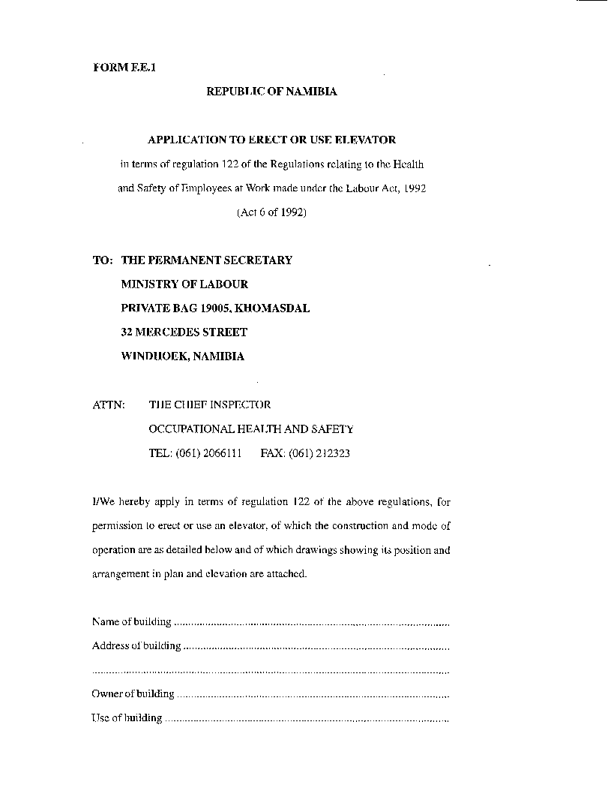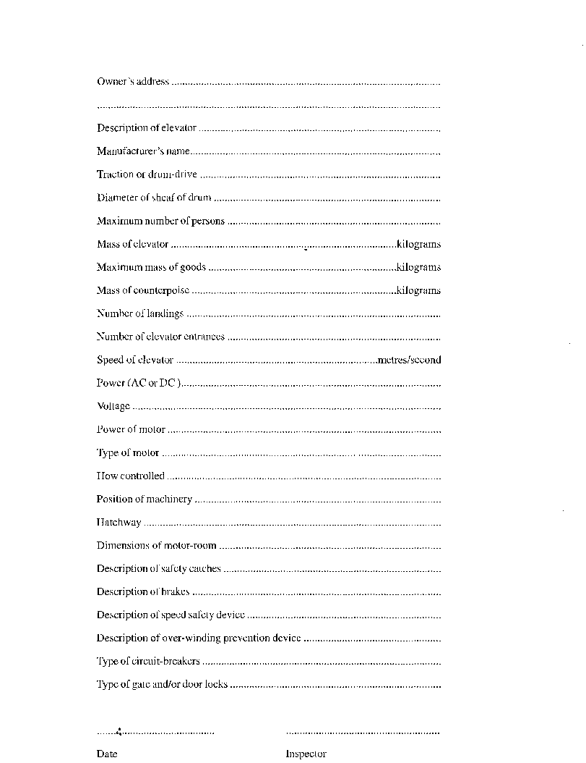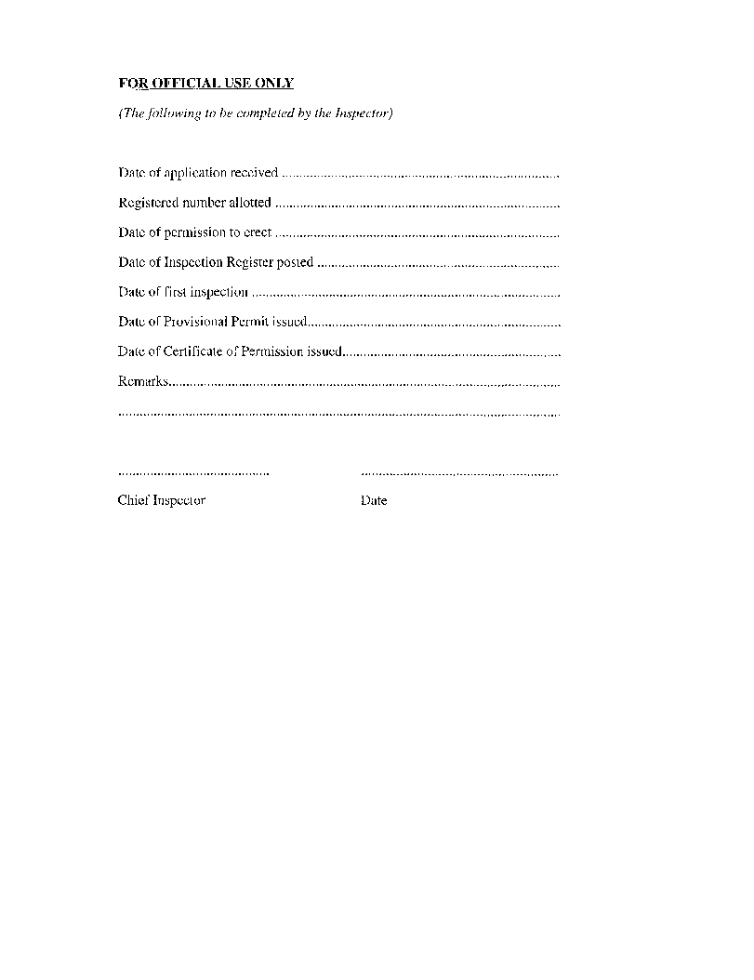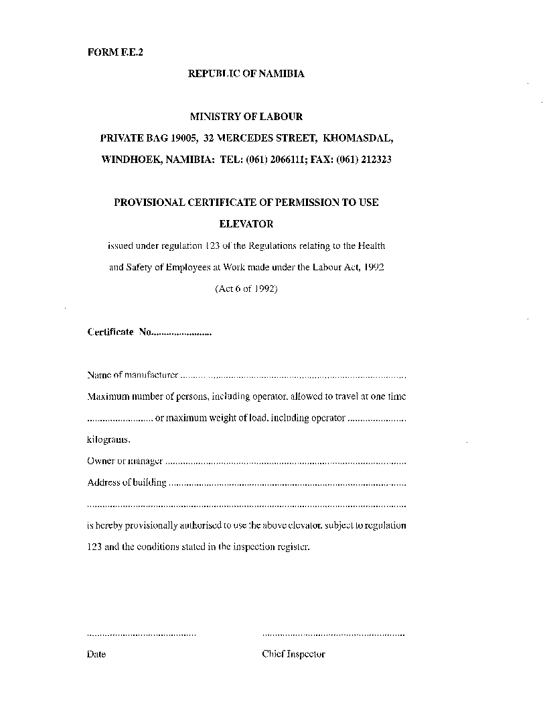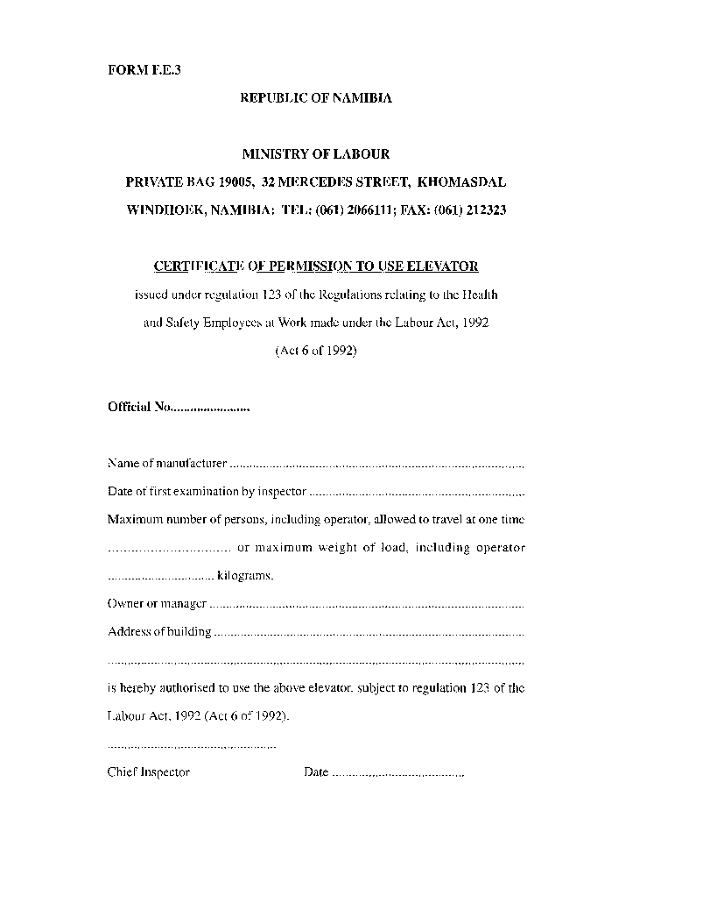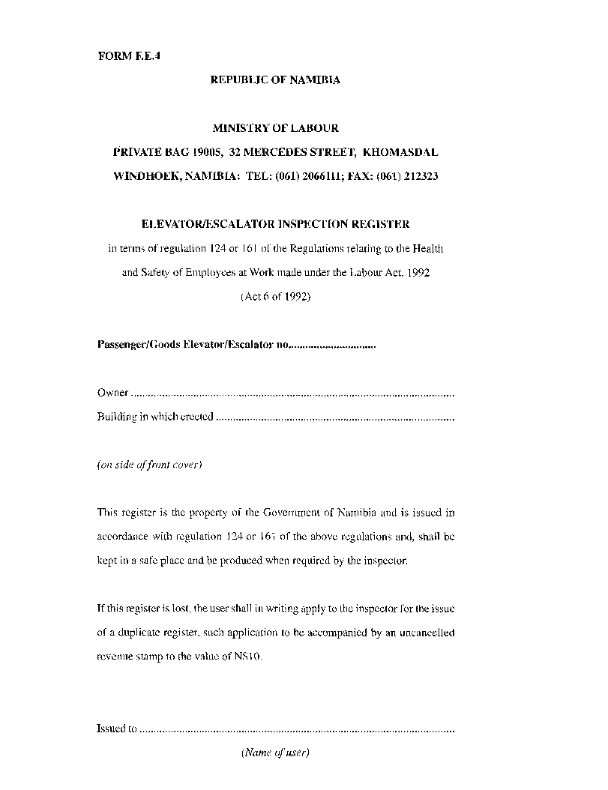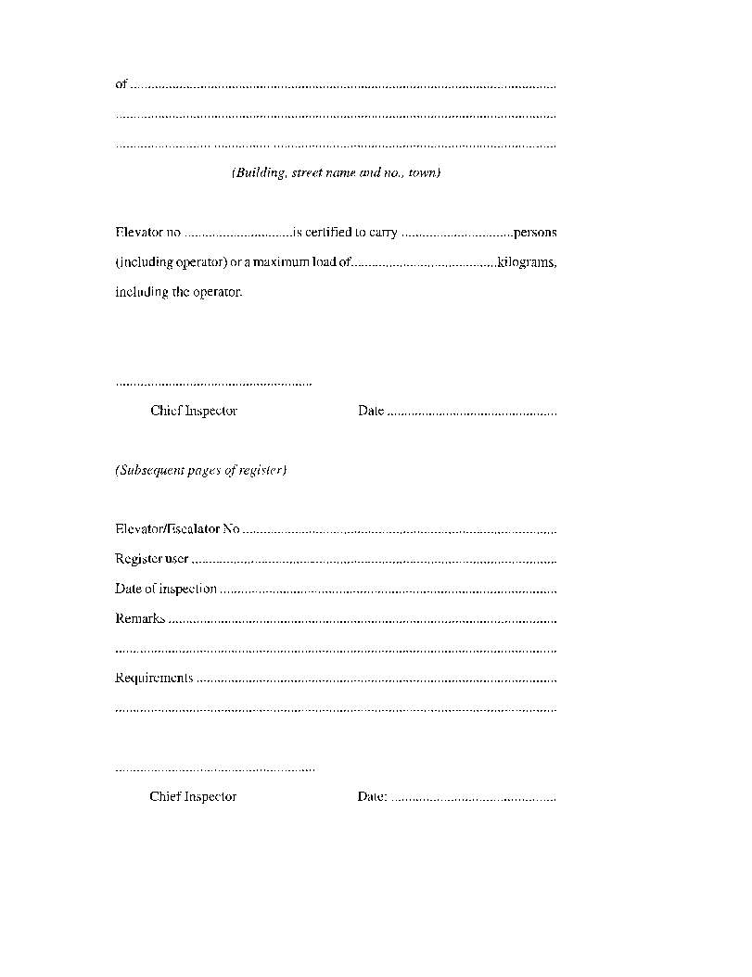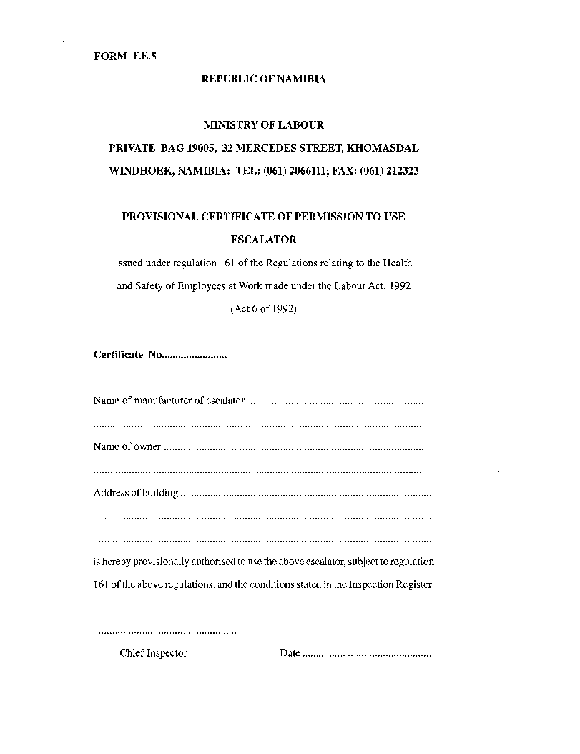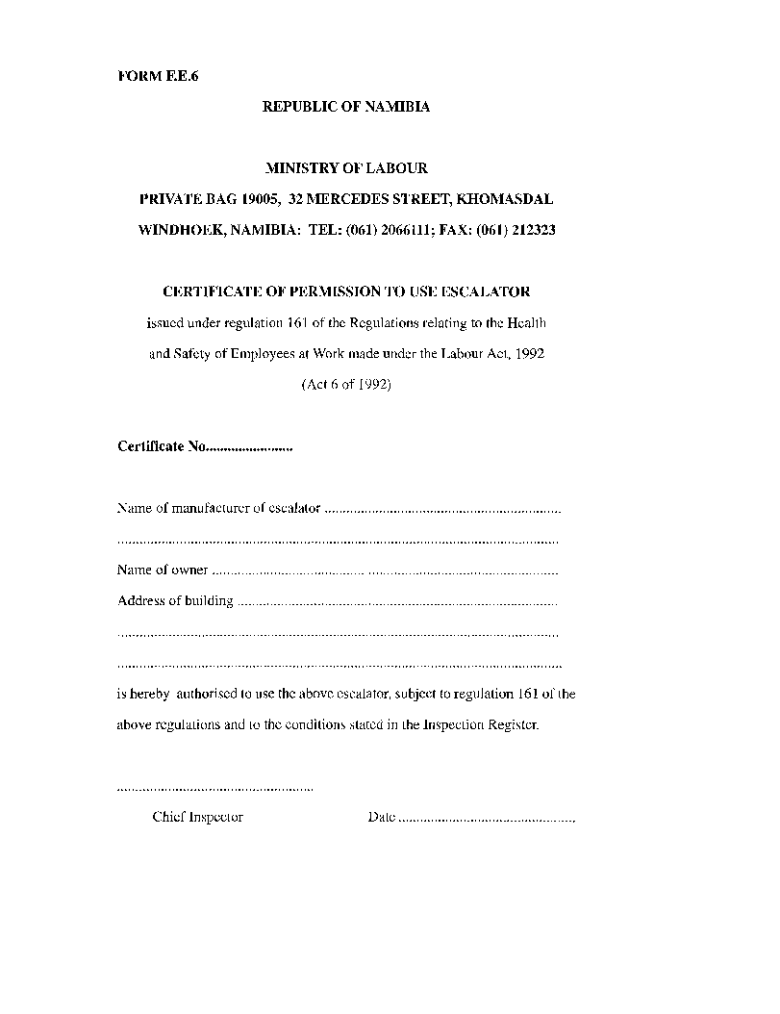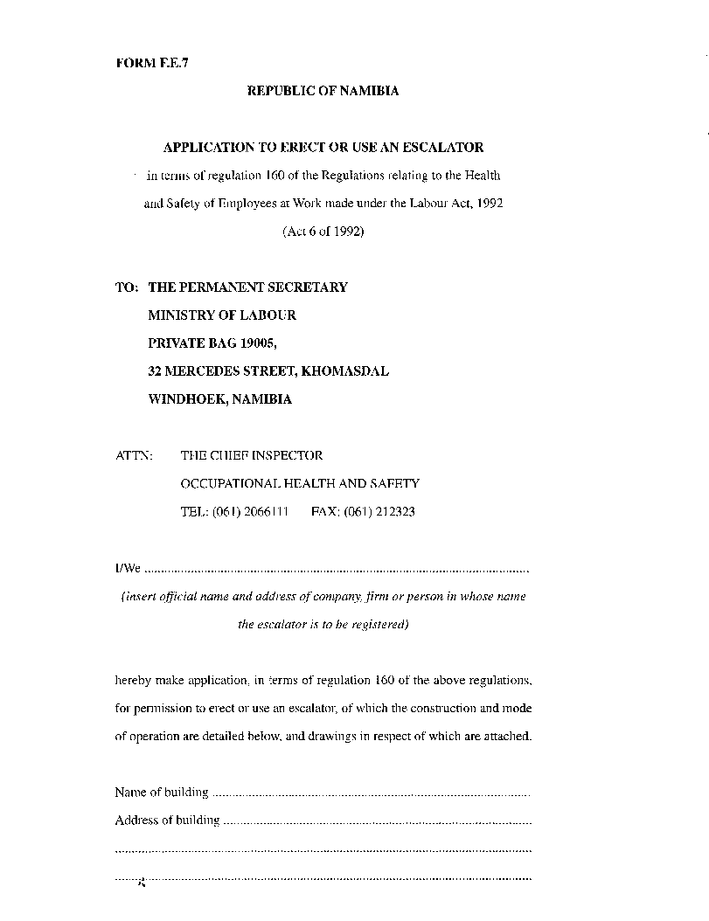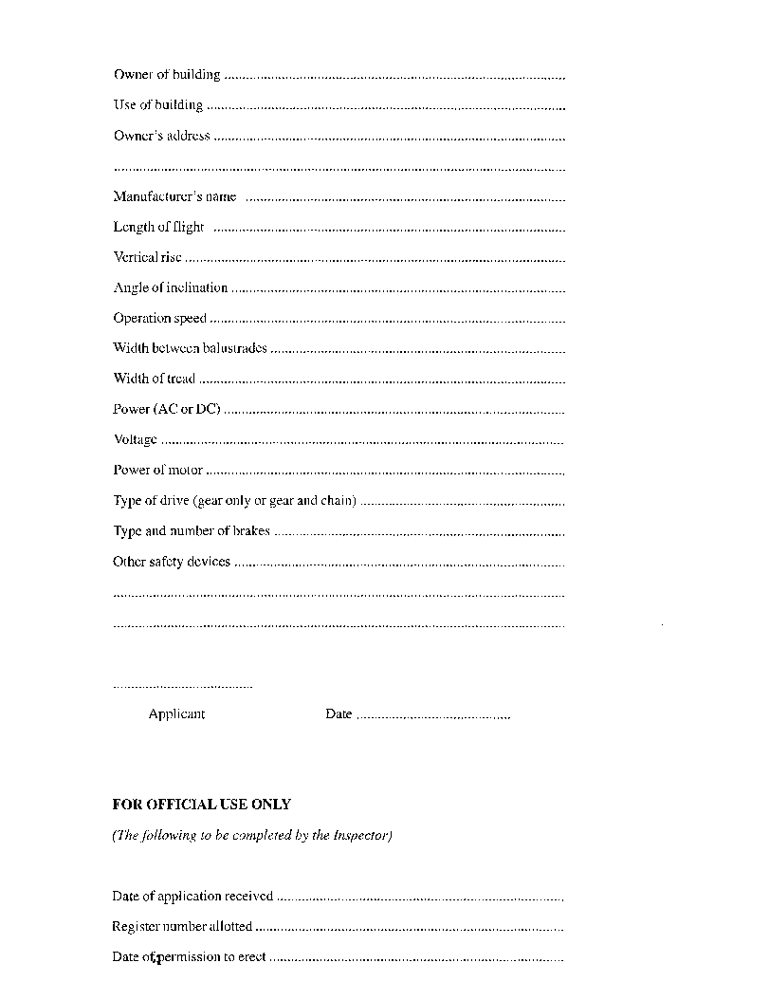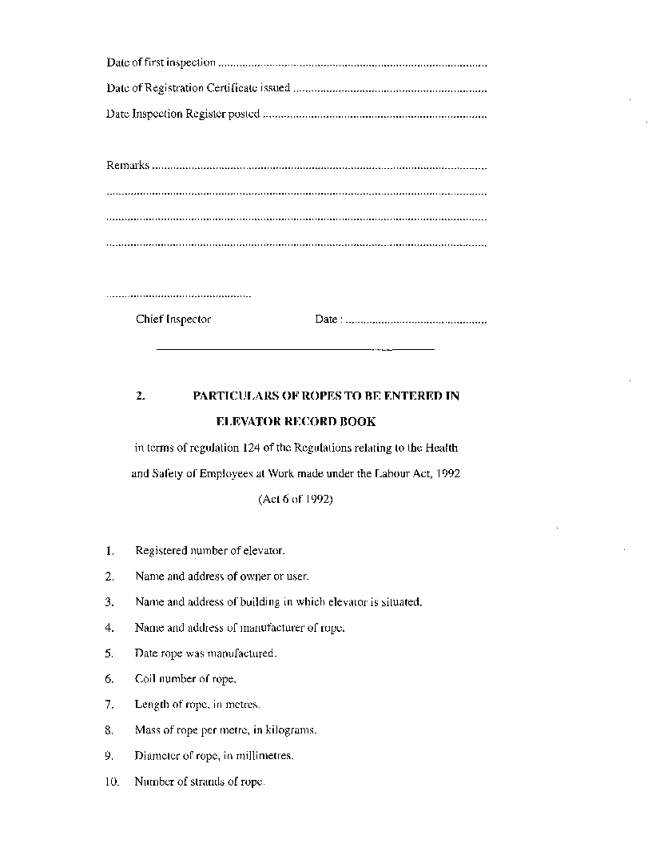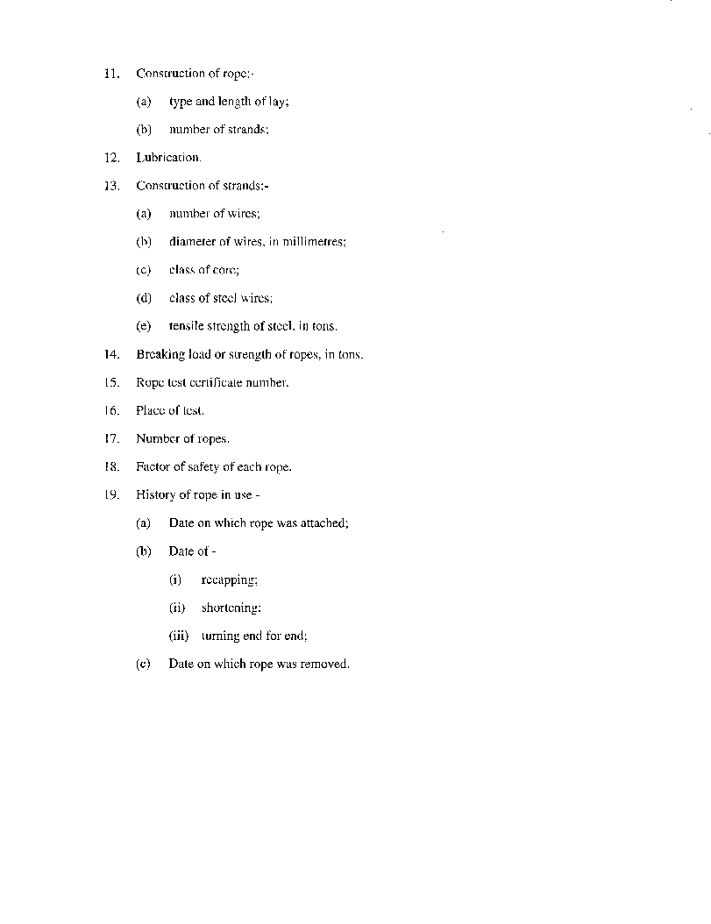

CHAPTER 5

HAZARDOUS SUBSTANCES

**Interpretation of terms**

**176**. In this Chapter, unless the context otherwise indicates -

“biological exposure index” or “BEl” means a reference value intended as a guideline for the evaluation of potential health hazards as listed from time to time by notice in the *Gazette* by the Chief Medical Officer for Occupational Health;

“biological monitoring” means the assessment of the overall exposure to hazardous substances in the work-place through measurement of the appropriate determinants in biological specimen collected from the exposed person;

“carcinogenic” means a substance which, if it is inhaled or ingested, or if it penetrates the skin, may induce cancer in man, or increase its incidence;

“corrosive substance” means a substance which may on contact with living tissues destroy such tissues;

“engineering controls” means controls that isolate or remove the hazard from the work-place by means of engineering methods;

“gas” means any gaseous substance, whether in its gaseous or liquid state.

“harmful substance” means a substance which, if it is inhaled or ingested, or if it pen trates the skin, may involve limited health risks;

“hazardous substance” means any toxic, harmful, corrosive or irritant substance, which is-

(a) a substance for which an occupational exposure limit is prescribed and any other substance not so listed which by reason of its characteristic properties create a risk to the health of any person;

(b) a human pathogen;

(c) dust of any kind, if present at a substantial concentration in air;

(d) any other substance arising in the course of work to which a person may be exposed and which may create a risk to the health of such person, which risk is comparable to the risk to health caused by substances to which paragraph (a), (b) or (c) applies;

(e) any mixture of such substances; or

(f) any other substance which the Minister may, on the recommendation of the Chief Medical Officer of Occupational Health, by notice in the *Gazette* declare a hazardous substance for the purpose of these regulations;

“human pathogen” means an organism liable to cause any human disease;

“intake” includes inhalation, ingestion or absorption in any other way through the skin or mucous membranes:

“irritant” means a non-corrosive substance which, through immediate, prolonged

or repeated contact with the skin or mucous membrane, can cause inflammation;

“medical surveillance” means regular health evaluations by an occupational health practitioner which may include physical examinations or biological tests;

“monitoring” means the planning, conducting and recording of the results of a measurement programme;

“mutagenic” means a substance which, if it is inhaled or ingested, or if it penetrates the skin, may involve a risk of heritable genetic defects;

“occupational exposure limit” or “OEL” means the maximum occupational exposure limit for hazardous substances in the work-place, and which limit shall not be exceeded at any time, as determined by the Chief Medical Officer for Occupational Health;

“occupational health practitioner” means a person registered or authorised to practise as a medical practitioner under the Medical and Dental Professions Act, 1993 (Act 21 of 1993), and who holds a qualification in occupational medicine or equivalent recognized by and registered with the Medical Board of Namibia;

“properly used” means used with reasonable care and with due regard to any information or advice made available by the designer, manufacturer, importer, seller or supplier, as the case may be;

“reasonably practicable” includes having regard, *inter alia,* to considerations of risk, feasibility, time, effort, cost and surrounding circumstances and conditions;

“respiratory protective equipment” means a device which is worn at least over the mouth and nose to prevent the inhalation of contaminated air, and which is of a type, or conforms to a standard, approved by the Chief Inspector;

“respirator zone” means an area where the concentration of an airborne hazardous substance exceeds the occupational exposure limit for such substance;

“substance” means any natural or artificial substance, whether in solid or liquid form or in the form of a gas or vapour, or a combination thereof, and includes any human pathogen;

“teratogenic” means a substance which, if it is inhaled or ingested, or if it penetrates the skin, may involve a risk of subsequent non-heritable birth defects in offspring; and

“time-weighted average value” or “TWA” means the maximum time-weighted concentration of a hazardous substance to which a person may be exposed for a normal eight-hour work day or a 40-hour work week.

**Transport of hazardous substances**

**177**. The supplier and transporter of hazardous substances shall ensure that the marking, labelling and storage of hazardous substances for safe transport, especially the labelling of the transport vehicle and the storage of the hazardous substances during transport, shall be in accordance with existing legislation, or if such legislation is not in place, in accordance with the recommendations on the transport of hazardous substances or dangerous goods made by the United Nations.

**Duties of suppliers, manufacturers and importers**

**178**. (1) Suppliers, manufacturers and importers of equipment shall ensure that machinery, process plants, instruments and vehicles are designed in such a manner and supplied to the user with such information, that their operation and use contribute as little as possible to the contamination of the work environment, and that they present, as far as reasonably practicable, no health hazard to employees during production operations, maintenance work and other activities.

(2) Suppliers of hazardous substances, whether manufacturers, importers or distributors of hazardous substances shall ensure that -

(a) the classification of all hazardous substances are based on their characteristics, including toxic, chemical, physical, corrosive and irritant properties; and their allergenic and sensitising effects, carcinogenic effects, teratogenic and mutagenic effects, as well as their effects on the reproductive system: Provided that for the purpose of this subregulation a classification done in accordance with the International Programme on Chemical Safety (WHO/IPCS), the International Labour Organization or the International Occupational Safety and Health Information Centre shall be acceptable;

(b) the containers of all hazardous substances are clearly marked to indicate the contents of such containers in order to enable persons handling the containers or using the substances, to easily recognize the substances when receiving or using them;

(c) the containers of all hazardous substances are labelled in a uniform manner with a legible and durable label, easily understandable by employees and other persons, in a size that is clearly visible, and the label shall contain the following information relating to the substances:

(i) trade name;

(ii) identity of substance;

(iii) identification of the batch

(iv) the classification of substance(s);

(v) hazard symbol;

(vi) nature of the special risks associated with the use of the substance;

(vii) safety precautions;

(viii) first aid treatment;

(ix) name address and telephone number of the supplier; and

(x) a statement that a product or chemical safety data sheet, as the case may be, giving additional information, is available from the employer; and

(d) chemical safety data sheets for all hazardous chemical substances are prepared and provided to every employer using such substances: Provided that the chemical safety data sheets shall contain essential health and safety information, including -

(i) chemical product and company identification (including trade or common name of the chemical and details of the supplier or manufacturer);

(ii) information on the composition of ingredients (in a way that clearly identifies them for the purpose of conducting a hazard evaluation);

(iii) hazards identification;

(iv) applicable first-aid and antidotes;

(v) fire-fighting measures;

(vi) protective measures in case of accidental release;

(vii) handling and storage;

(viii) exposure control relating to employee protection (including possible methods of monitoring work-place exposure);

(ix) physical and chemical properties;

(x) stability and reactivity;

(xi) toxicological information (including the potential routes of entry into the body and the possibility of synergism with other chemicals or hazards encountered at work);

(xii) ecological information;

(xiii) manner of disposal;

(xiv) transport information;

(xv) regulatory information;

(xvi) other information (including the date of preparation of the chemical safety data sheet),

as the case may be: Provided that for the purpose of this paragraph, chemical safety data sheets prepared in accordance with the International Programme on Chemical Safety (WHO/IPCS), the International Labour Organization or the International Occupational Safety and Health Information Centre database data sheets shall be acceptable.

**General preventive measures**

**179**. (1) General preventive measures, including administrative and technical measures, shall, to the satisfaction of an inspector, be taken to prevent or reduce the contamination of the work environment to the lowest possible level, or, if appropriate, at least to the levels specified by the exposure limits established by these regulations.

(2) Whenever possible, hazardous substances shall be replaced by harmless or less harmful substances.

(3) Operations likely to result in contamination of the work environment by hazardous substances, shall be isolated from the remainder of the premises so as to reduce the number of people exposed.

(4) Processes involving a significant risk of exposure to highly hazardous substances shall as far as reasonably practicable be performed within an enclosed system, so as to prevent any contact between the hazardous substance and persons.

(5) The direct contact with hazardous substances shall as far as reasonably practicable be avoided by the use of automatic processes or by remote control systems.

(6) Only employees duly authorised by the employer concerned and, to the satisfaction of an inspector, adequately trained for such purpose, shall participate in operations concerning hazardous substances: Provided that the training of such employees shall be upgraded at adequate intervals.

(7) If circumstances make it necessary for an employee to enter an atmosphere contaminated by a harmful concentration of a hazardous substance, the employee shall be made fully aware of these hazards and shall be given appropriate protective equipment to wear.

**Safety Data Sheets**

**180**. (1) An employer shall furnish his or her employees who are handling or using hazardous substances, and the work-place safety representatives, with a safety data sheet for employees, and such safety data sheet shall include the information specified in regulation 178(2), and be available in respect of a product used at work containing hazardous substances.

(2) A copy of the safety data sheet for each different product shall be forwarded to the Chief Medical Officer of Occupational Health.

**Labelling of containers containing hazardous substances**

**181**. An employer shall ensure that all containers containing hazardous substances, including pesticides, which are stored, handled or used at the work­ place, whether temporarily or permanently, are properly labelled according to regulations pertaining to the classification, marking and labelling of hazardous substances.

**Storage of hazardous substances**

**182**. (1) Hazardous substances shall at any time be stored in such a manner that they do not create a risk to the health and safety of employees or other persons, nor any risk of contamination of the environment, due to seeping, leaking, fire or accidental release.

(2) Areas designated for storage of hazardous substances shall be isolated from other activities and be clearly marked with appropriate warning signs.

(3) Smoking, eating and drinking shall be prohibited in areas contemplated in subregulation (2), and, as far as possible, only authorised persons shall enter such areas.

(4) Substances which by means of a reacting with each other on contact can create a dangerous situation such as an explosion, a fire or the formation of a third hazardous substance, shall be stored and handled separately in such a manner that no unintentional contact can occur.

(5) Hazardous substances shall be stored in such a way that they are not exposed to heat, radiation or moisture which can give rise to an increased risk of a dangerous situation referred to in subregulation (4).

(6) Hazardous substances which during storage can give rise to contamination of the work environment, shall, as far as reasonably practicable, be stored in securely sealed containers to prevent contamination.

(7) Containers intended for storage of hazardous substances shall be constructed from such materials and be of such shape and strength, that they will not create a risk of contamination by such hazardous substances.

(8) Hazardous substances shall not be stored in containers which by means of their appearance can be mistaken for containers containing harmless substances.

(9) Inflammable and explosive substances shall be labelled, stored and handled taking into account the risks associated with such substances.

(10) Radioactive substance shall be stored separately from other chemicals and be safely locked away, allowing access thereto trained and authorised personnel only.

(11) The storage and use of radioactive substances referred to in subregulation (10) shall not cause any risk of the substance entering the body of any employee, or that any employee is exposed to radiation.

**Handling of hazardous waste**

**183**. (1) Hazardous waste and deposits shall be removed at intervals and by methods appropriate to the type of hazard which they constitute.

(2) Contaminants collected shall be disposed of without risk to the health of any person or to the environment, and according to applicable statutory provisions and regulations.

**Notification of the use of carcinogens and other controlled substances**

**184**. (1) No substance listed in Annexure E as a hazardous or carcinogenic substance, or any product containing such substance, shall be imported, mixed, produced, used or otherwise handled, without the written permission of the Chief Medical Officer for Occupational Health, who shall, in the form of Form F.H.S.I. be notified of such intended importation, mixing, production, use or handling.

(2) The Chief Medical Officer of Occupational Health may, upon receipt of a notification in terms of subregulation (1) and subject to any other law, in writing authorise the importation, mixing, production, use or handling of such substance, if he or she is satisfied that all prescribed and other preventive measures have or will be taken.

**Hazardous Substance Exposure Limits**

**185**. (1) The concentration of airborne contaminants in the breathing zone of an employee shall be below the “Occupational Exposure Limits” specified in Annexure E.

(2) The concentration of biological determinants, when applicable, as a means of controlling exposure to hazardous substances in the work environment, shall be below the “Adopted Biological Exposure Determinants” as specified in Annexure E.

**Exposure Measurements of Hazardous Substances**

**186**. (1) The employer shall ensure that adequate measurements of exposure to hazardous substances are performed in order to determine the compliance with the prescribed exposure limits to hazardous substances.

(2) If the exposure to hazardous substances are measured, both normal working conditions and conditions involving the highest levels of exposure shall be taken into consideration.

[The verb “are” in the phrase “If the exposure to hazardous substances   
are measured” should be “is” to be grammatically correct.]

(3) All relevant data from the measurement of concentrations of contaminants in the work environment shall be systematically recorded as soon as possible, and shall be accessible to employees and work-place safety representatives.

(4) In the event of the monitoring of the work environment disclosing levels of exposure in excess of the exposure limits, the employer shall notify the Chief Medical Officer of Occupational Health and inform employees of the causes of the excess and of the action to be taken: Provided that the necessary technical, administrative or organisational remedial action to prevent further excess exposure of employees shall be taken without delay.

(5) Exposure measurements shall, to the satisfaction of an inspector, be conducted by trained and authorised personnel with adequate instruments, which shall be properly calibrated and maintained.

(6) An employer shall, to the satisfaction of an inspector, establish a work-place safety committee consisting of such members and having such powers, duties and functions as the Chief Inspector may determine.

**Biological Monitoring**

**187**. (1) If the exposure of employees to hazardous substances can, in the opinion of an inspector, be best assessed if based on biological exposure indices, the employer shall ensure that the relevant biological monitoring is performed by an experienced medical practitioner registered or authorised to practise as such under the Medical and Dental Professions Act, 1993 (Act 21 of 1993).

(2) All relevant statistical data from biological monitoring shall, without violation of the employees right to medical confidentiality, be systematically recorded as soon as possible, and shall be accessible to the employee concerned and, in a statistical form, to the work-place safety representatives.

(3) In the event of biological monitoring disclosing contamination levels in the work environment in excess of the exposure limits referred to in regulation 186, the employer shall notify the Chief Medical Officer of Occupational Health and inform employees of the causes of the excess and the action to be taken: Provided that the necessary technical, administrative or organizational remedial action to prevent further excess exposure shall be taken without delay.

**Records**

**188**. An employer shall -

(a) subject to paragraphs (e) or (t), as the case may be, keep records of the results of all assessments, air monitoring and biological monitoring done in terms of regulation 186 or 187, as the case may be;

(b) make the records contemplated in paragraph (a), excluding personal medical records, available to an inspector for inspection;

(c) allow a medical practitioner referred to in regulation 187(1) or the employee concerned to, upon a written request made by the employee, peruse the records with respect to that particular employee:

(d) make the records of all assessments and air monitoring available for perusal by the work-place safety representatives and the work­ place safety committees;

(e) keep all records of assessments and air monitoring referred to in paragraph (a) for a period of three years;

(f) keep all biological monitoring records referred to in paragraph (a) for a period of 30 years; and

(g) if the employer concerned ceases to operate, or if an employee leaves the service of an employer, all records concerning employees, or concerning the employee who has left the service, as the case may be, shall immediately be forwarded to the Chief Medical Officer of Occupational Health.

**Respiratory protection**

**189**. (1) Occupational diseases caused by breathing air contaminated with hazardous dust, gases, fumes or vapours shall be prevented primarily by the substitution of such hazardous substances and by minimizing atmospheric contamination through engineering, technical or administrative control measures: Provided that if effective administrative, technical or engineering control measures are not feasible, or while such measures are not in place, an appropriate respirator shall be used by an employee pursuant to the requirements specified in subregulations (2) to (6).

(2) Respirators referred to in subregulation (1) shall be selected in accordance with the hazards to which the employee is exposed: Provided that the preliminary selection of respirators shall be made in accordance with regulation 2 and in consultation with the Chief Medical Officer of Occupational Health.

(3) The user of a respirator shall, to the satisfaction of an inspector, be instructed and trained by an adequately trained person in the proper use of a respirator and shall be made aware of the limitations of respirators.

(4) Respirators shall, to the satisfaction of an inspector, be inspected regularly and be properly maintained, and worn or deteriorated parts of respirators shall be replaced regularly.

(5) Respirators for emergency use, such as self contained breathing apparatus, shall be thoroughly inspected not less than once a month and after each use.

[The word “self-contained” in subregulation (5) should be hyphenated.]

(6) A person shall not be assigned to tasks requiring continuous or frequent use of respirators, unless it has been determined, and confirmed in writing by a medical practitioner referred to in regulation 187(1) that such person is physically able to perform such work and to use the equipment concerned.

(7) In a work-place with a toxic or oxygen deficient atmosphere where the failure of a respirator may cause harm to an employee, not less than one additional person shall be present in the work-place, and he or she shall be ready and able to assist such employee in the case of an emergency.

**Emergency facilities**

**190**. (1) An employer shall, in a work-place where hazardous substances or toxic, corrosive or similar substances are used, handled, processed or manufactured, to the satisfaction of an inspector, provide -

(a) adequate first aid equipment; and

(b) a first aid attendant adequately trained in the first aid procedures which are necessary for the treatment of injuries which may result from such activities, including the acute detrimental effects of exposure to such substances and the emergency procedures which are necessary in the case of leakage or dumping of such substances.

(2) Suitable first aid washing facilities, including an eye-wash fountain and a shower which shall be able to sustain ample flushing with clean water for not less than 15minutes, shall be provided in the immediate vicinity of the work area for immediate emergency use by an employee contaminated by any hazardous substance, and employees shall be trained in the use of such facilities.

(3) An employer shall in a work-places where toxic, corrosive, irritant, flammable or similar substances are used, handled, processed or manufactured, in consultation with the work-place safety representatives -

(a) prepare and regularly review written plans and procedures which may be activated or implemented in the event of a major accident or catastrophe involving any such a substance, stating the general approach, and the means, precautions and measures, to be adopted, in order to ensure a sufficient, suitable and effective response to such accident or catastrophe; and

(b) adequately inform and regularly train all relevant employees in relation to, and in accordance with, the plans and procedures referred to in paragraph (a).

**Fire, explosion and toxic hazards**

**191**. (1) If any process in a work-place may cause dust, gas, fumes or vapour of such a nature and to such an extent that it may cause an explosion on ignition, the owner of the work-place shall take all practicable steps, to the satisfaction of an inspector, by means of -

(a) the removal of all sources of possible ignition;

(b) the prevention of the accumulation of such dust, gas, fumes or vapour; and

(c) ensuring that the concentration of the accumulated substance is not to such an extent that it shall, on ignition, cause an explosion,

in order to prevent such an explosion to occur.

[The phrase “prevent…to occur” should be   
“prevent…from occurring” to be grammatically correct.]

(2) In a work-place where dust, gas, fumes or vapour is present and which may explode on ignition, all practicable steps shall be taken to restrict the spreading of such substances and the effects of such an explosion by the provision of chokes, baffles and vents, or other equally effective appliances or measures, unless the plant is so constructed as to withstand the pressure likely to be caused by such an explosion, without any harm to, or to the health or safety of, any employee or other person.

(3) If any part of a plant contains explosive or flammable gas, fumes or vapours under pressure which is greater than atmospheric pressure, such part of the plant shall not be opened, except in accordance with the following precautions:

(a) Before opening any part of such plant, any flow of the gas, fumes or vapours to such part of the plant shall be effectively stopped by means of stop-valves or other effective measures and such part of the plant shall be reliably depressurised by means of a release valve; and

(b) after the opening a part of the plant referred to in paragraph (a), no explosive or flammable gas, fumes or vapours shall be allowed to enter such part of the plant until all fastenings and attachments have been secured and checked, and the release valve closed.

(4) No plant, tank or vessel which contains or has at any time contained any explosive or flammable substance, shall be subjected to -

(a) any welding, brazing or soldering operation;

(b) any cutting operation which involves the application of heat; or

(c) any operation involving the application of heat for the purpose of taking apart or removing the plant, tank or vessel, or any part thereof, until all practicable steps have been taken to remove the substance and fumes: Provided that if any plant, tank or vessel has been subjected to such operation, no explosive or flammable substance shall be allowed to enter the plant, tank or vessel until the metal has cooled sufficiently so as not to present any risk of igniting the substance or fumes.

(5) A plant, tank or vessel which contains or has contained a substance which, when exposed to heat or to high temperatures, may produce a toxic gas, fume or vapour, shall not be so exposed to heat or to a high temperature, unless all practicable steps have been taken to remove such substance from the plant, tank or vessel.

**Hazardous fumes and lack of oxygen**

**192**. (1) Subregulations (2) to (7) apply to the work performed in any confined space inside any vessel, tank, pit or similar object, in which hazardous fumes may be present.

(2) A confined space in which work is to be performed shall be provided with an emergency exit, such as a manhole, which may be rectangular, oval or circular in shape, and which shall -

(a) if rectangular, be not less than 450 millimetres long and 400 millimetres wide; or

(b) if oval or circular, be not less than 450 millimetres in diameter:

Provided that in the case of tank wagons or other mobile plant, if rectangular, be not less than 400 millimetres long and 350 millimetres wide, or if oval or circular, be no,t less than 400 millimetres in diameter.

(3) Subject to subregulation (4), no person shall, and no person shall require, instruct or direct any other person to, enter or remain in any confined space for any purpose, without, to the satisfaction of an inspector -

(a) wearing a suitable breathing apparatus (which shall not include a respirator); and

(b) being in possession of an authorization in writing given by a competent person:

Provided that, when an unconscious person is removed from a confined space, effective safety measures shall be employed, which measures shall *inter alia* include a belt tied around the waist of the person removing the unconscious person, with one end of a rope securely attached to such belt and the other end of the rope under the control of another person outside the confined space, which other person outside the confined space shall, during the performance of the work inside the confined space, from outside the confined space continuously keep the person inside the confined space under surveillance.

(4) Subregulation (3) shall not apply for a specified period which has been certified in writing by a competent person to the satisfaction of an inspector, as being a safe period of time for entry into the confined space without breathing apparatus: Provided that any person entering or remaining in the confined space shall be warned when such safe period will expire.

(5) A confined space shall not be certified under subregulation (4) as a safe place, unless -

(a) effective steps have been taken to prevent any inflow of hazardous fumes into such confined space;

(b) all sludge or other deposits which may cause hazardous fumes has been removed and the confined space contains no other material which may cause hazardous fumes; and

(c) the confined space has been adequately ventilated and tested for hazardous fumes, and has an adequate fresh air supply for the purpose of breathing.

(6) A sufficient supply of suitable breathing apparatus, belts and ropes, and of suitable reviving apparatus shall be kept readily available: Provided that the breathing apparatus, belts and ropes shall, to the satisfaction of an inspector, be properly maintained and be thoroughly inspected by a competent person, not less than once every three months and immediately after the use thereof: Provided further that the report on these inspections shall be kept available for inspection by an inspector as long as the equipment is in use.

(7) A sufficient number of employees shall, to the satisfaction of an inspector, be trained and shall regularly practise to use the apparatus specified in subregulation (6) and in methods of resuscitation.

(8) No person shall enter or remain in a confined space if the oxygen content of the air in such space is so low as to be dangerous, unless -

(a) he or she is wearing a suitable breathing apparatus; or

(b) the space has been and remains adequately ventilated, and a competent person has tested and certified in writing that it as safe for a person to enter without using breathing apparatus.

[The word “as” in the paragraph above should be “is”.]

**Gas Plant**

**193**. (1) All gas plants, which shall include any installation, apparatus or machine used for the manufacture or storage of gas, and any pipes or appliances used for or in the conducting or carrying of gas to the work-place where such gas is to be used, shall, to the satisfaction of an inspector, be of good construction, manufactured of sound material, be of adequate strength and free from any defect, and shall be tested and properly maintained by a competent person.

(2) The filling of any cylinder or container with gas shall not be allowed on any premises, except under the direct supervision of a competent person.

(3) A gas cylinder for corrosive gases shall be filled only after it has been inspected or tested by a competent person not less than once every two years, and a gas cylinder for any other kind of gas shall be filled only after it has been inspected or tested by a competent person not less than once every five years, and the result of such inspections or tests shall be kept available for inspection by an inspector during the life span of the cylinder concerned.

**Prohibitions**

**194**. No person shall -

(a) require or permit a female employee who is pregnant, or who is likely to be pregnant, to work in a respirator zone where any hazardous chemical substances, including -

(i) lead in a form in which it can be inhaled, ingested or otherwise absorbed;

(ii) organic mercury compounds;

(iii) polybromophenylene (PBB) and polychlorobiphenylene (PCB);

(iv) arsenic;

(v) cadmium;

(vi) carbon disulphide;

(vii) estrogenic compounds;

(viii) aromatic chlorinated hydrocarbons;

(ix) organophosphate pesticides; or

(x) nicotine,

are used;

(b) use compressed air to remove particles of hazardous substances from any surface or from any person, or require or permit any other person to use compressed air to remove such particles from any surface or person; or

(c) smoke, eat, drink or keep food or beverages in a respirator zone, or require or permit any other person to smoke, eat, drink or keep food or beverages in such zone.

**Offences and penalties**

**195**. Any person who contravenes, or fails to comply with, any provision of regulation 177, 178,179, 180, 181, 182, 183, 184, 185, 186, 187, 188, 189, 190, 191, 192, 193 or 194, shall be guilty of an offence and on conviction be liable to a fine not exceeding N$ 2000 or to imprisonment for a period not exceeding 6 months or to both such fine and such imprisonment.

ANNEXURE E

Schedule 1. (1) FORM F.HS.1 Notification of the use of Carcinogens or other Controlled Substances

(2) Occupational Exposure Limits for Airborne Hazardous Substances.

(3) Biological Exposure Limits for Hazardous Substances.

Schedule 2. (1) Asbestos Regulations.

(2) Lead Regulations.

(3) Silica Regulations.

ANNEXURE E

(Form F.HS.1)

To view content without printing, scroll down.

To print at full scale (A4), double-click the icon below.



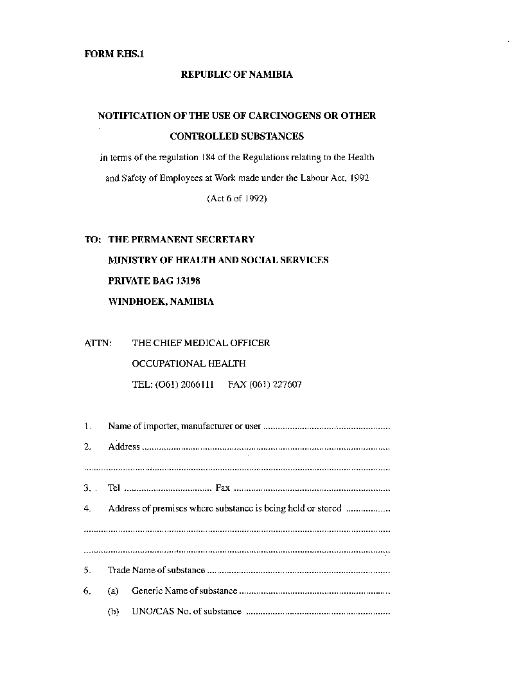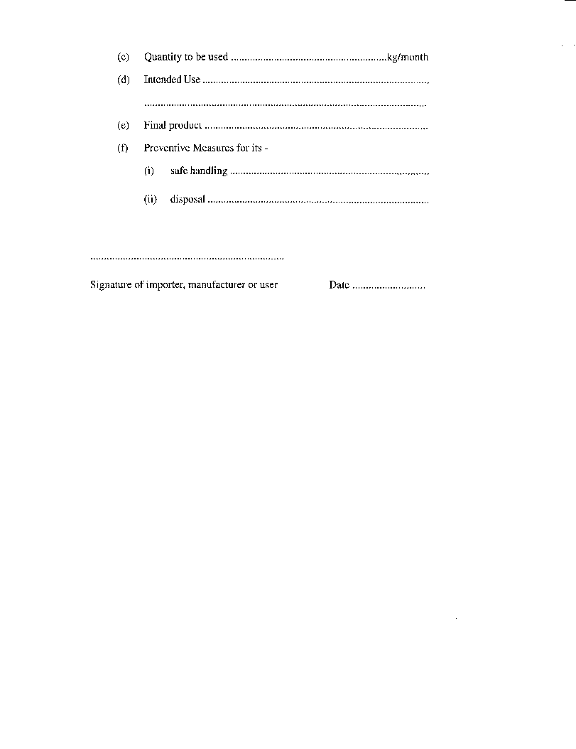

SCHEDULE 1(2)

OCCUPATIONAL EXPOSURE LIMITS FOR

AIRBORNE HAZARDOUS SUBSTANCES

made under the Labour Act 1992 (Act 6 of 1992),

(section 101, regulation 185(1))

**1**. The national Occupational Exposure Limits or Threshold Limit Values (TLVs) are adopted to assist in the control of airborne concentrations of hazardous substances in the work environment. The standards are guidelines for good practices. Serious impairment of health is not believed likely as a result of exposure to the limit concentration, but due to the wide variation of individual susceptibility, a small percentage of employees may experience discomfort due to exposure to some substances at concentrations at or below the exposure limit. Some employees may even be affected more seriously due to an aggravation of an existing condition, or due to genetic factors, age, personal habits (smoking, alcohol, or other drugs), medication taken or previous exposure.

**2**. The national standards are based on the assumption of an eight­ hour shift exposure, work of normal intensity, normal climatic conditions and an exposure-free period of 16 hours following the shift. Increased absorption by reason of working overtime or of increased breathing rates due to heavy physical work, adverse climatic conditions at the work-place such as excessive heat or humidity, or work at high altitude, requires adjustment of the adopted occupational exposure limits.

**3**. These limits should be interpreted only by persons trained in the field of occupational hygiene, and concentrations of all airborne contaminants should be maintained as low as practical.

**4**. Exposure to carcinogens must be restricted to a minimum. Employees exposed to Al carcinogens (confirmed human carcinogens) without a time weighted average concentration (TWA) should be properly equipped to eliminate to the fullest extent possible all exposure to the carcinogen. For Al carcinogens with a TWA, and for A2 and A3 carcinogens, employees’ exposure by all routes should be carefully controlled to levels as low as reasonably achievable below the TWA.

**Abbreviations**

**5**. In this Schedule the following abbreviations have the meanings specified opposite thereto:

Al Confirmed human carcinogen;

A2 Suspected human carcinogen;

A3 Animal carcinogen. The agent is not likely to cause cancer in humans, except under uncommon or unlikely routes or levels of exposure.

SK Skin absorption. This may be a significant source of exposure;

STEL Short term exposure limit (15 minute average)

TWA Time weighted average concentration of an hour workday and a 40 hour workweek

mg/m3 milligrams per cubic metre (at 25 degrees Celsius and 760 mm Hg)

p.p.m. parts per million (at 25 degrees Celsius and 760 mm Hg)

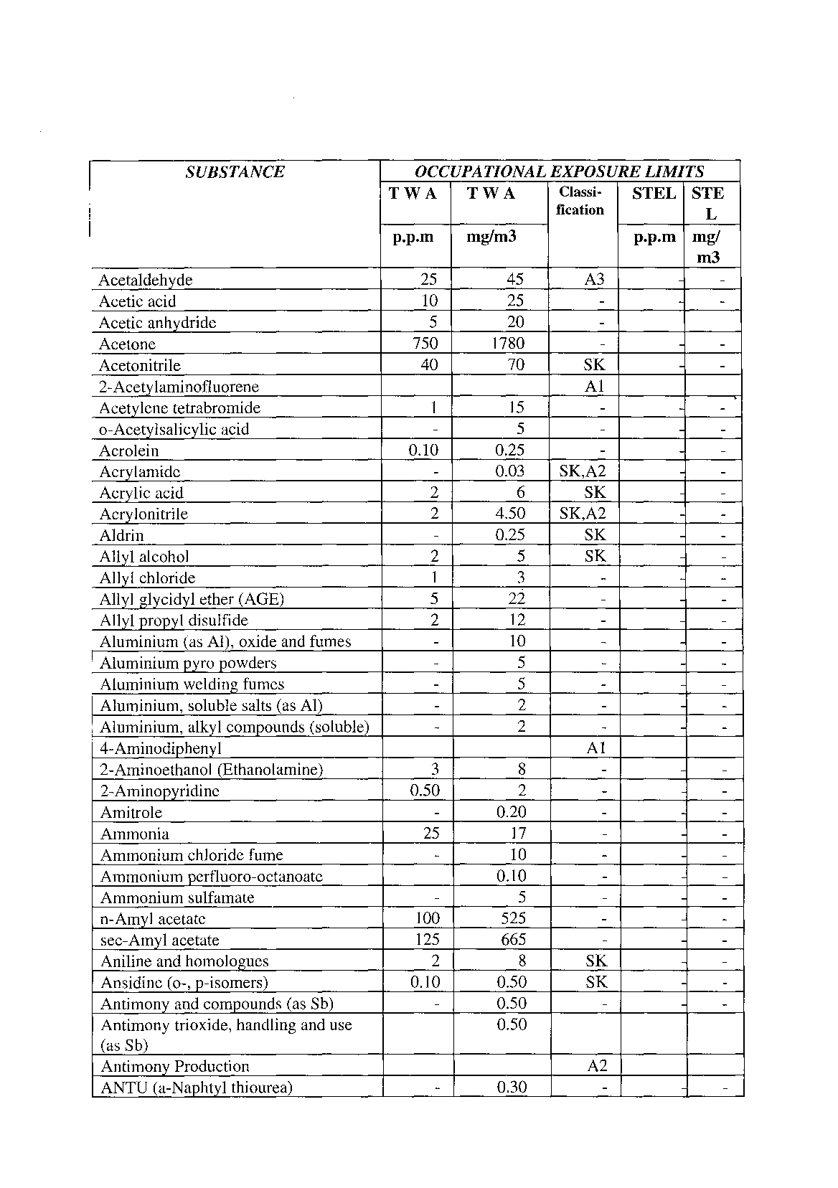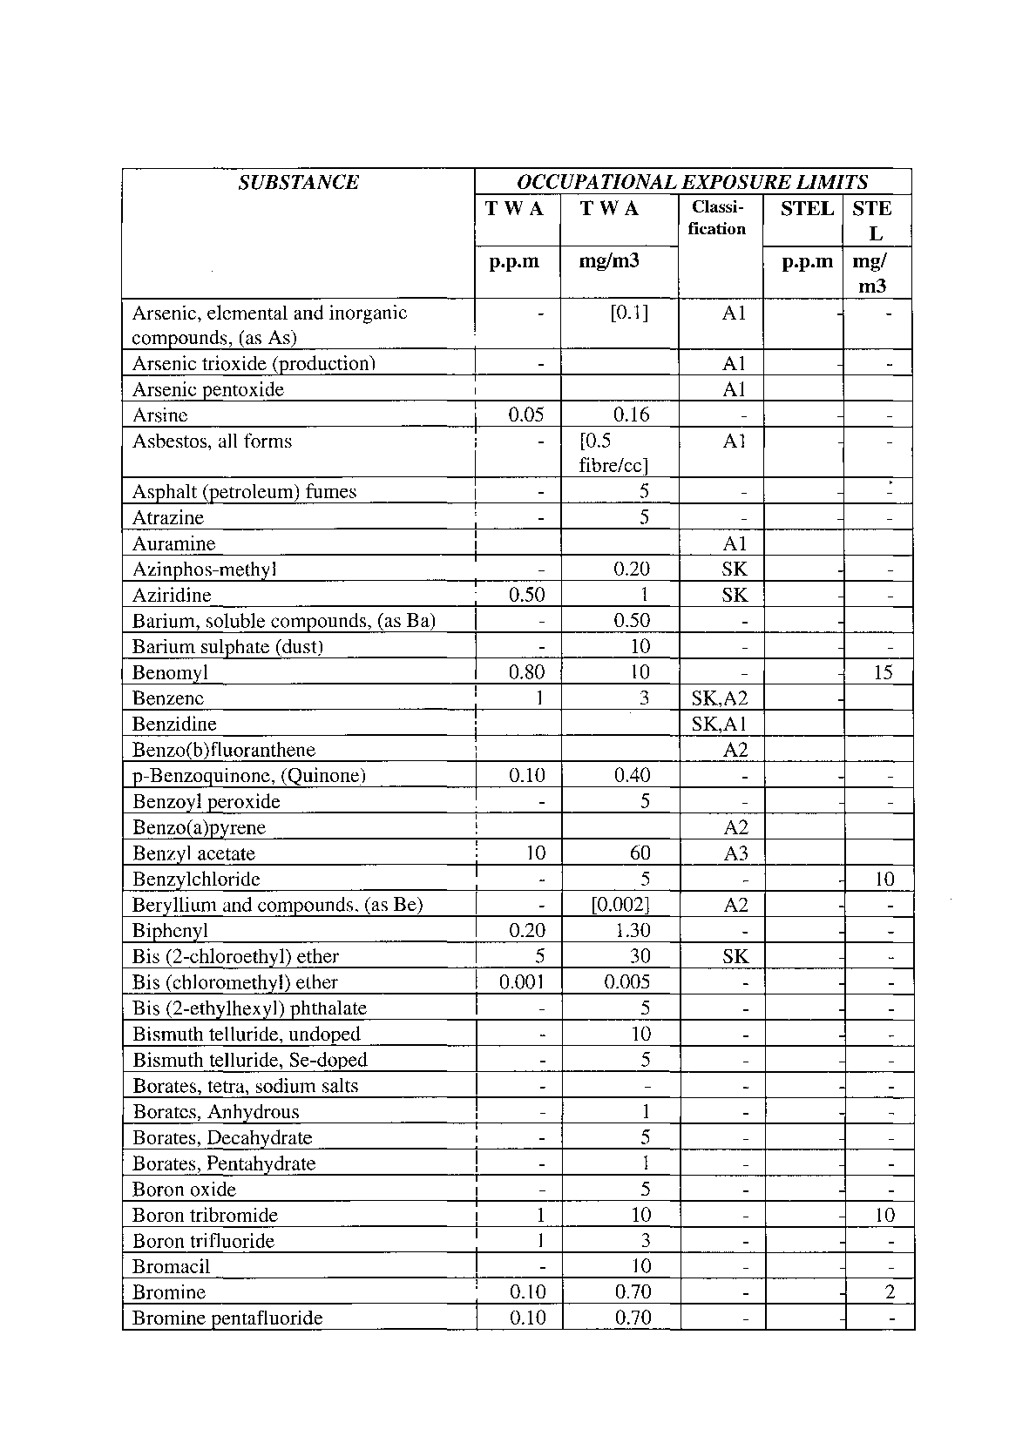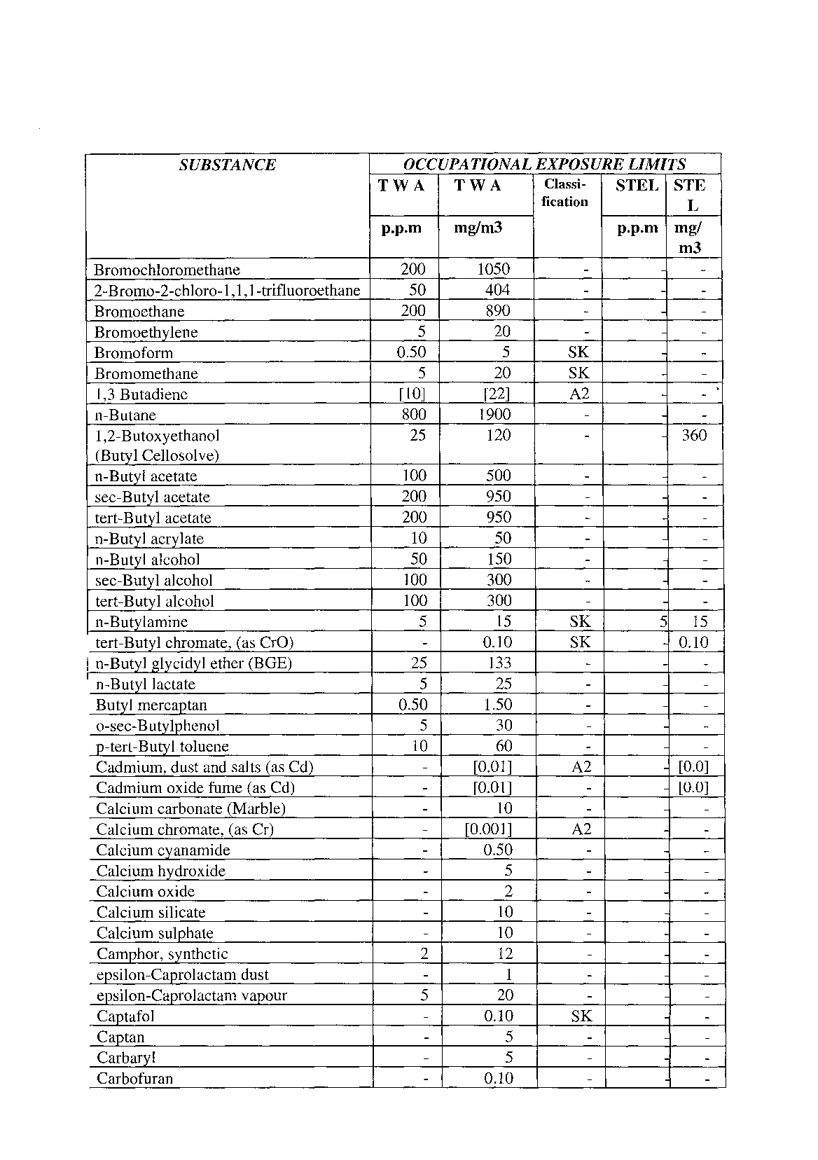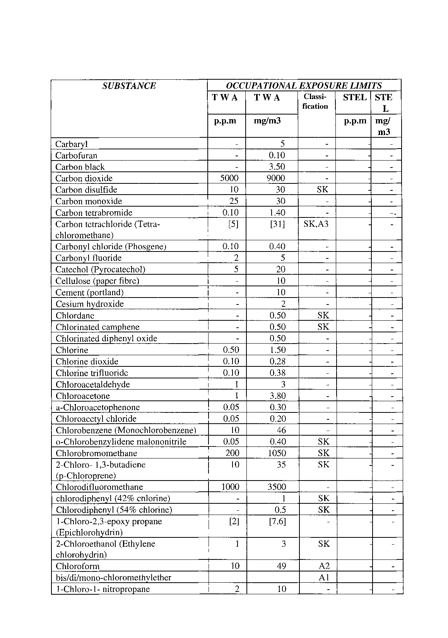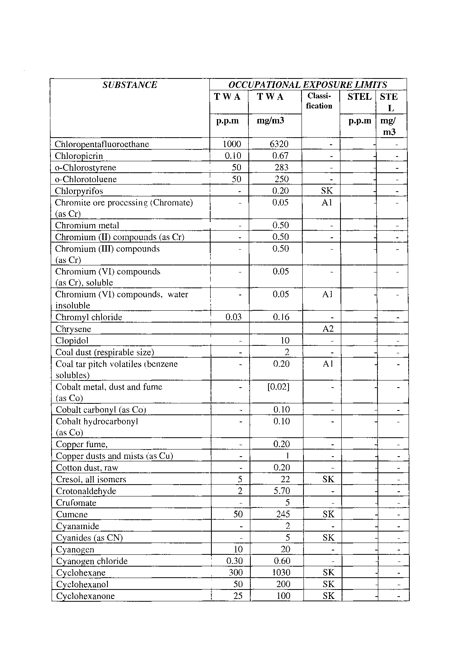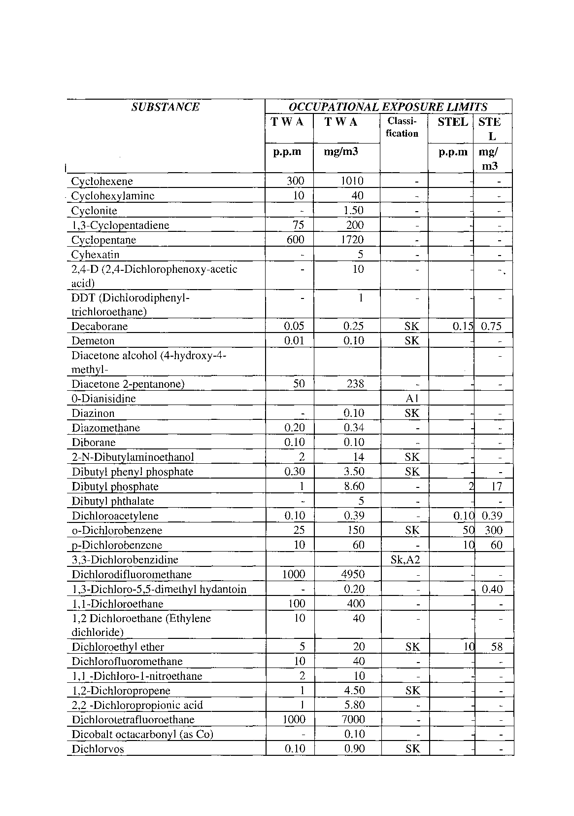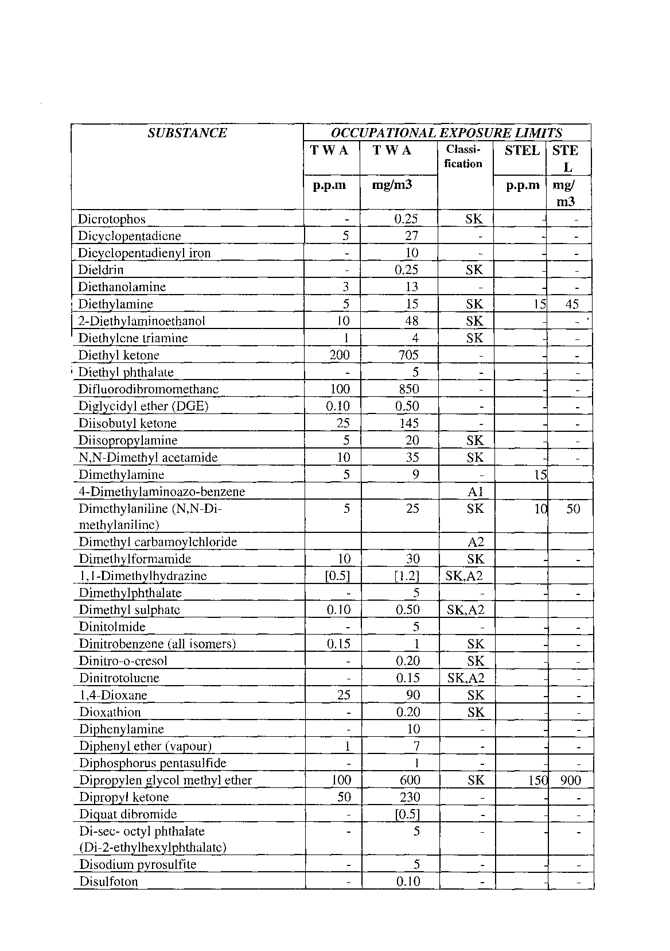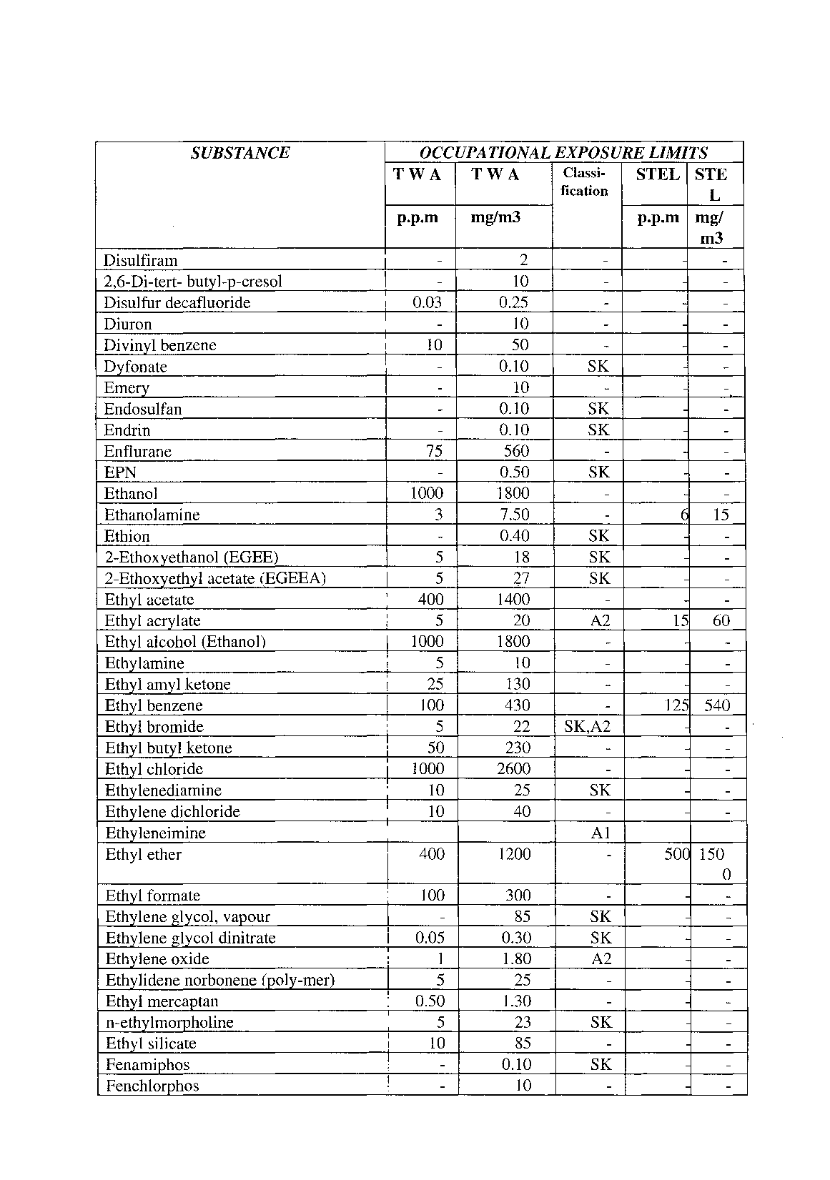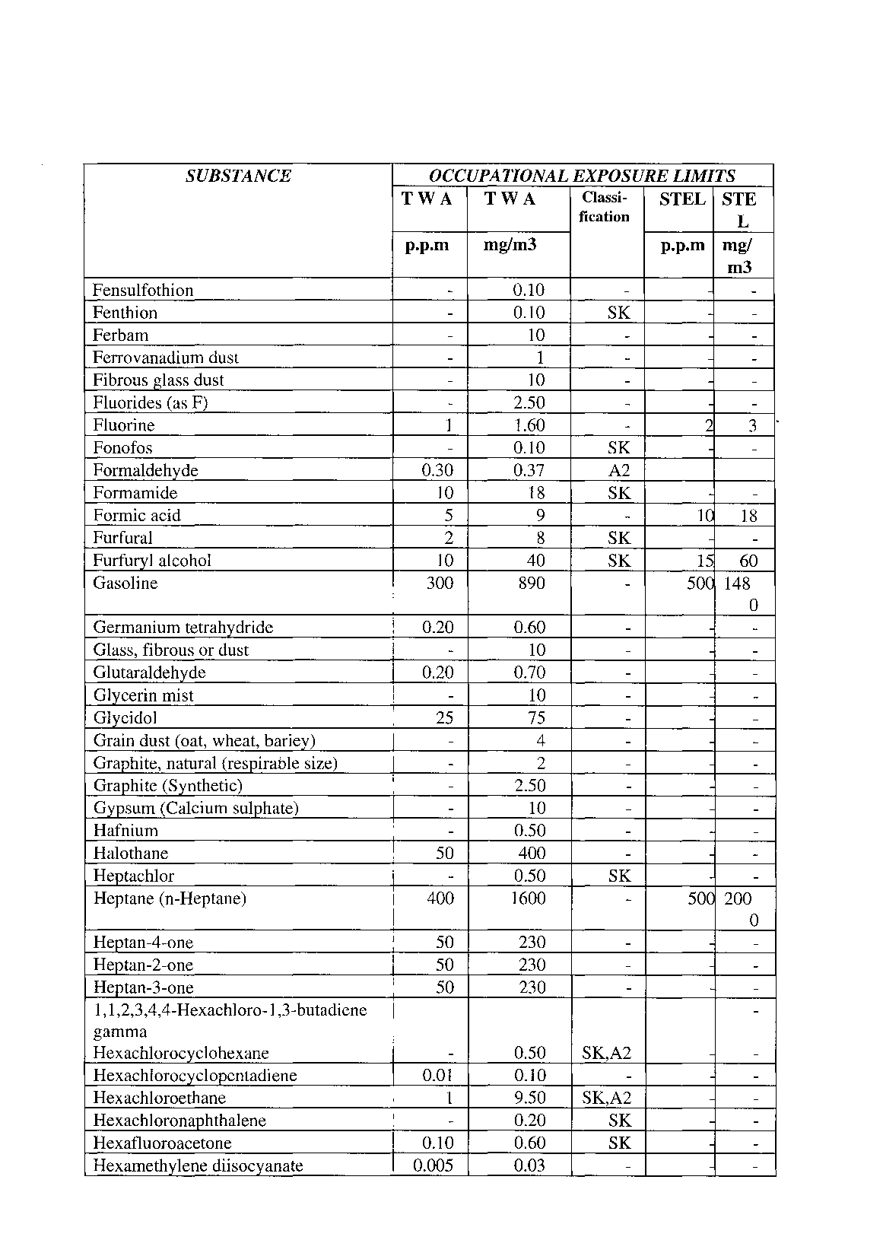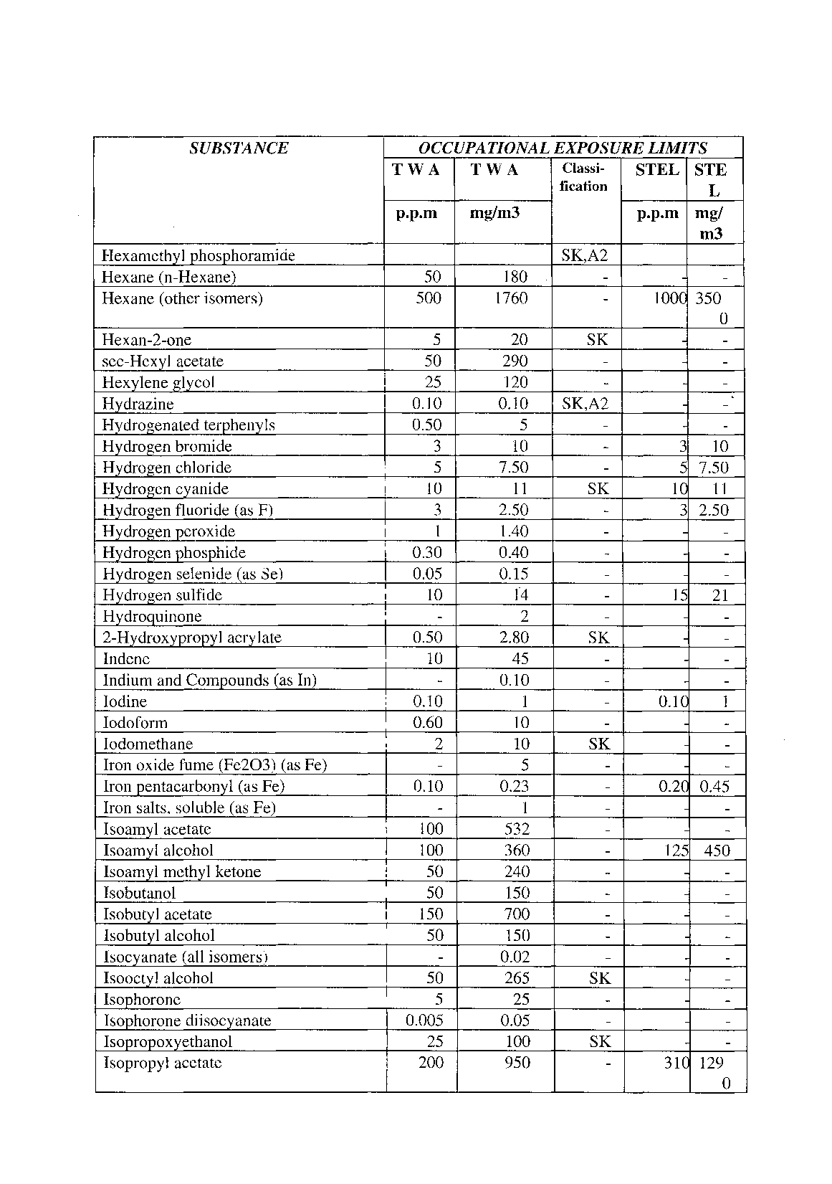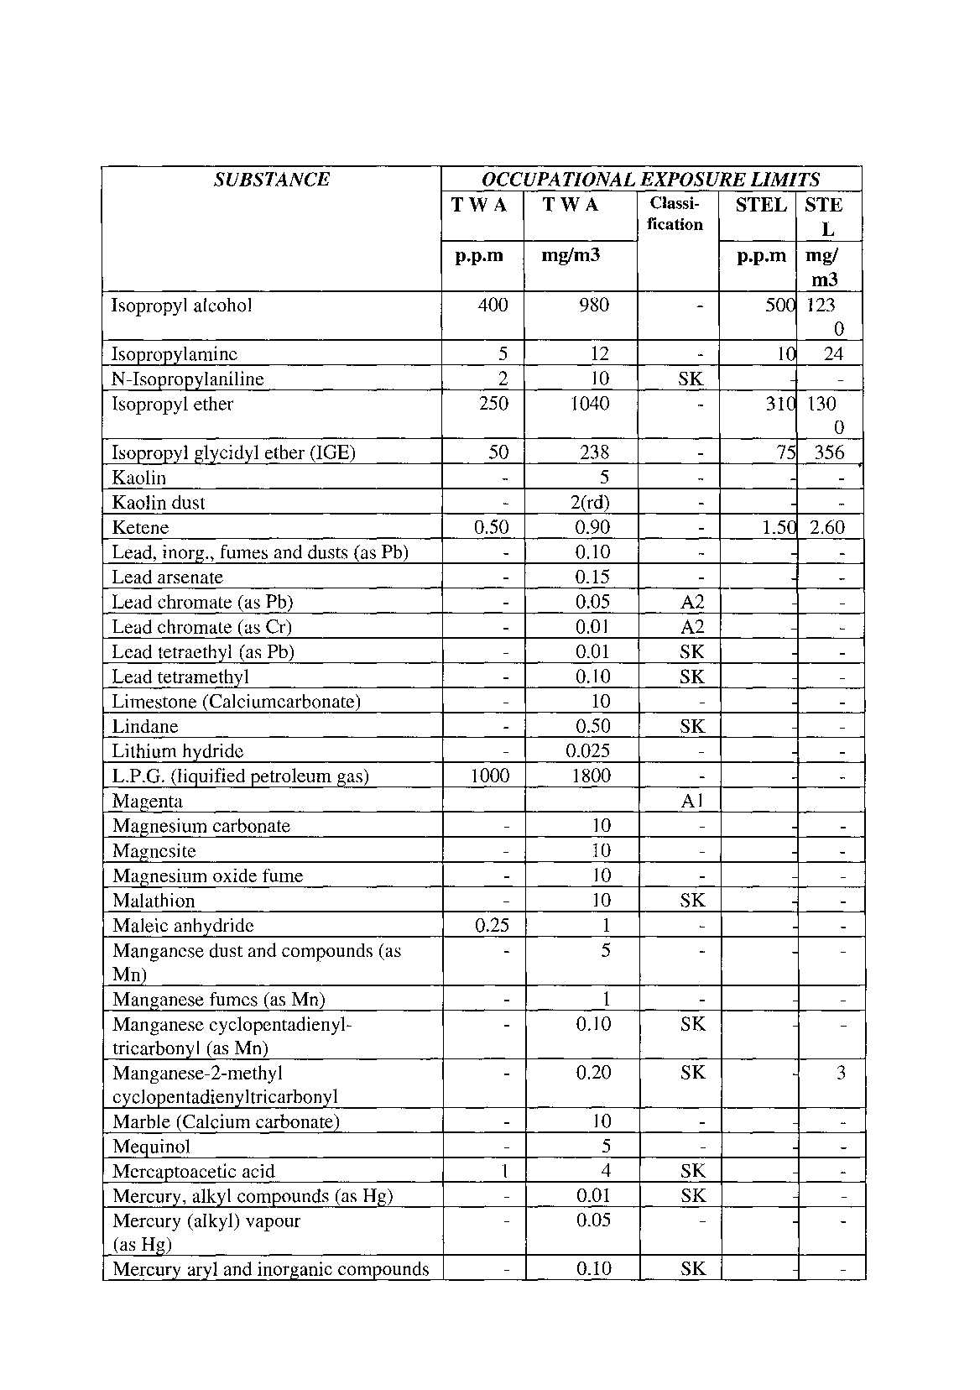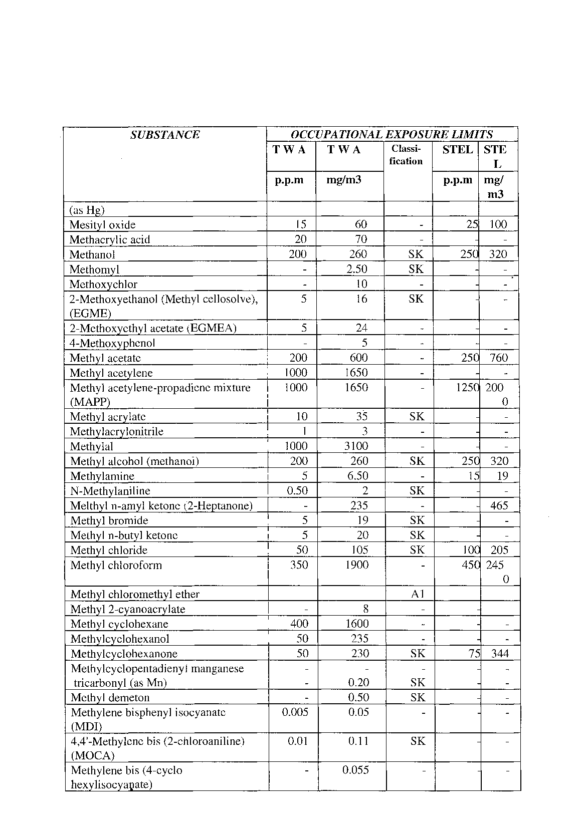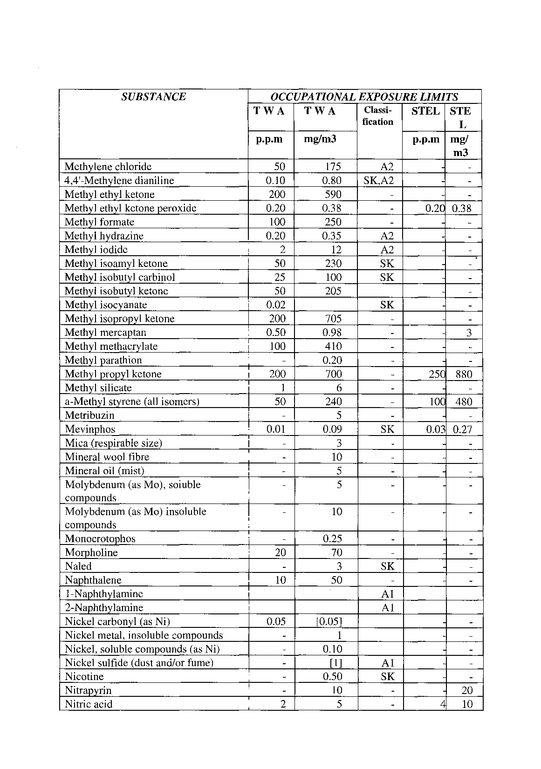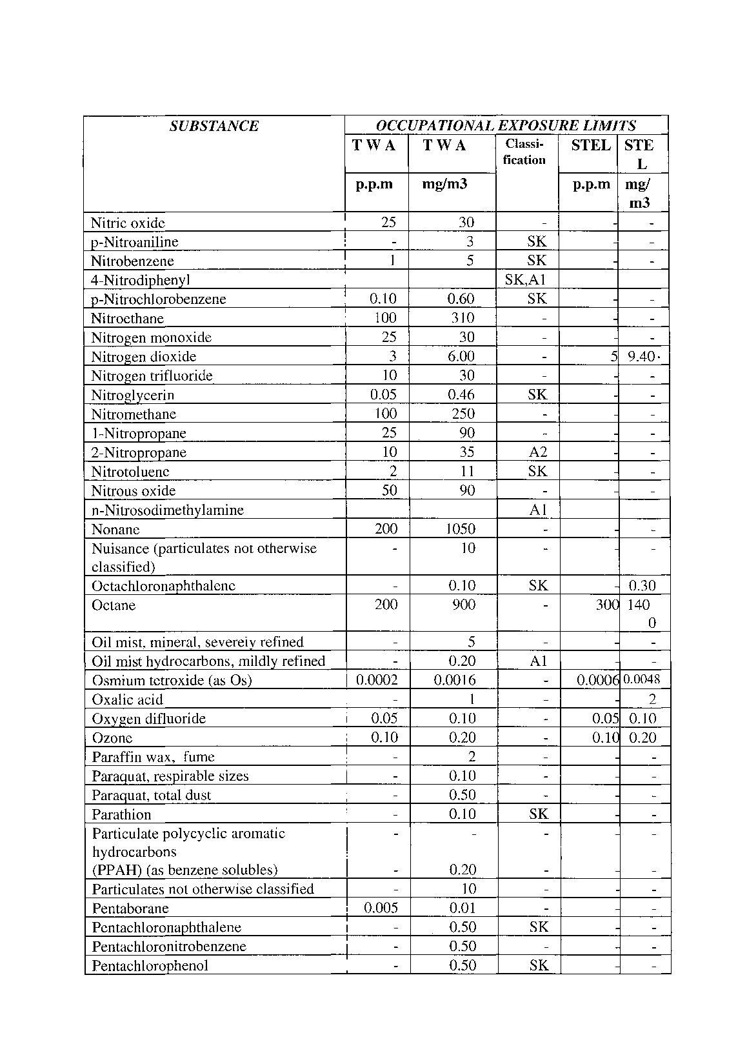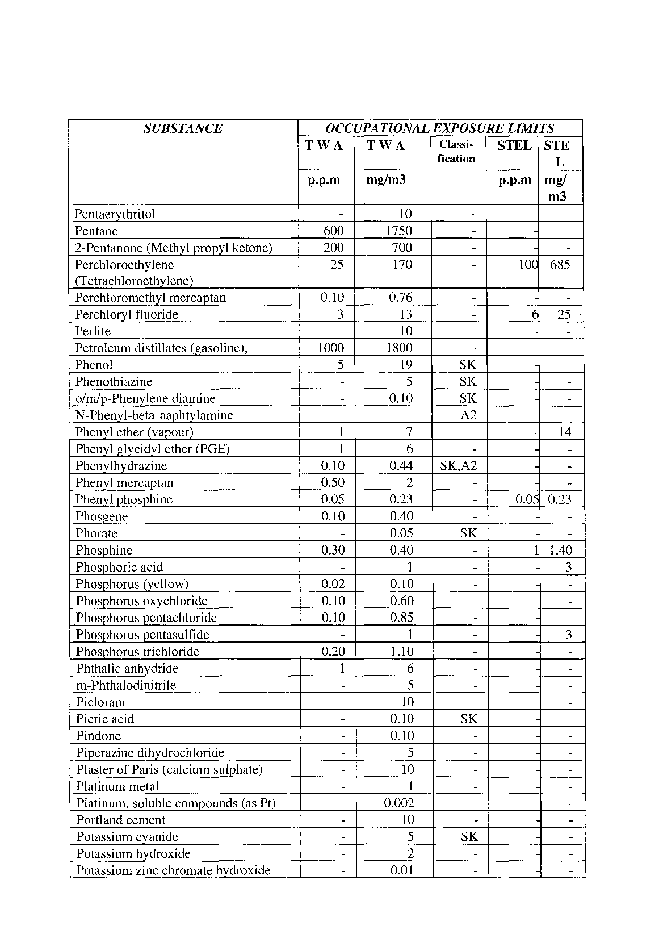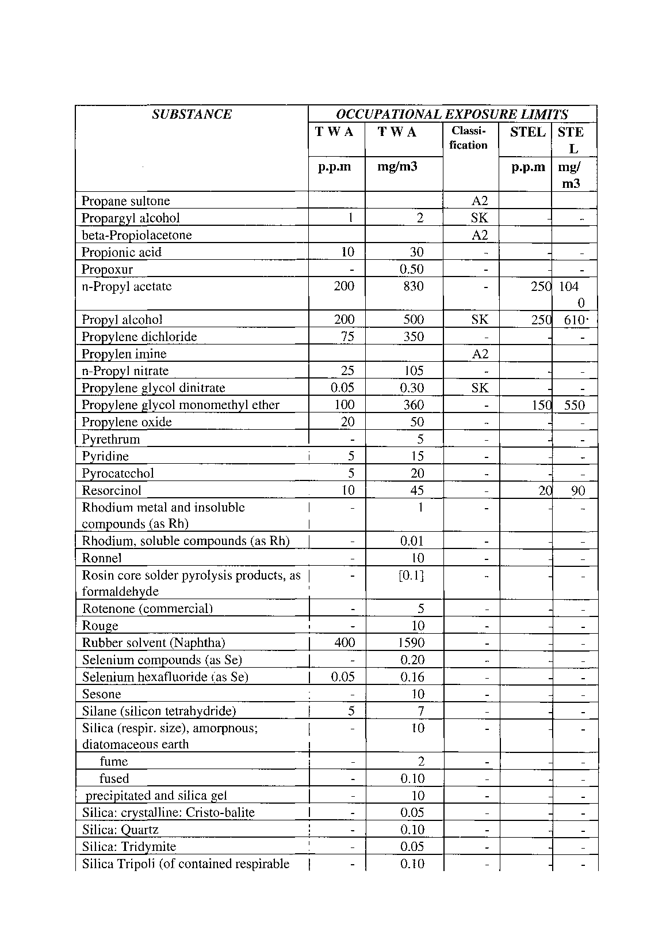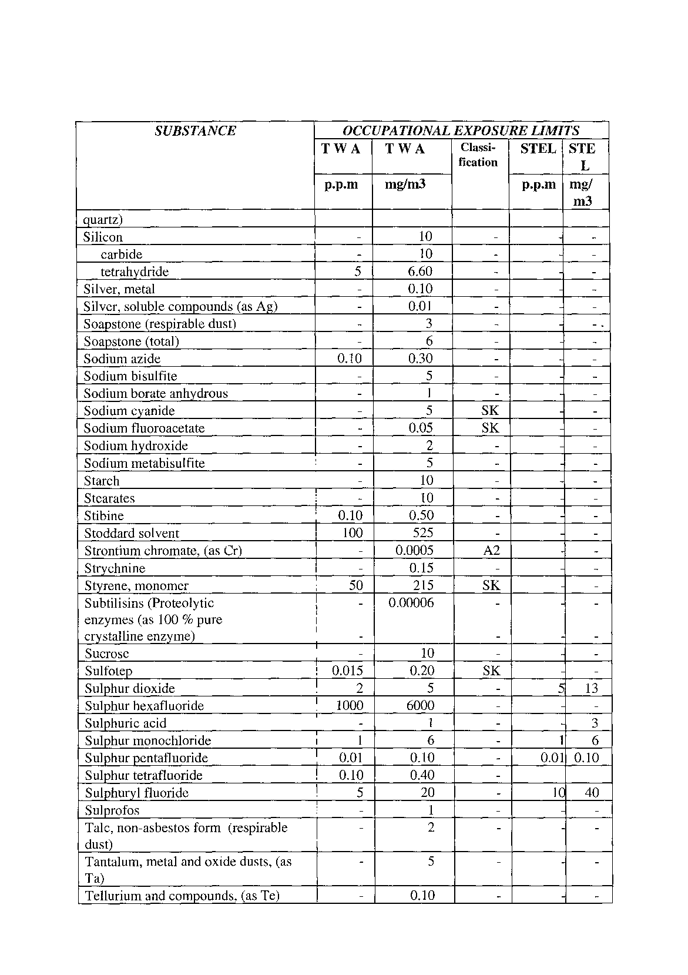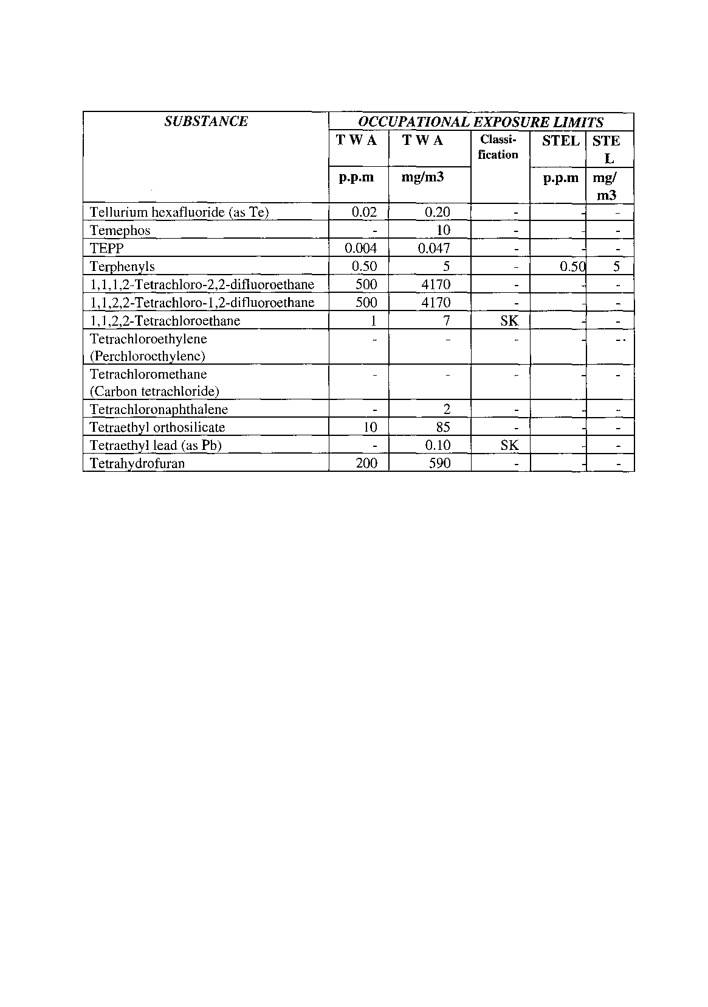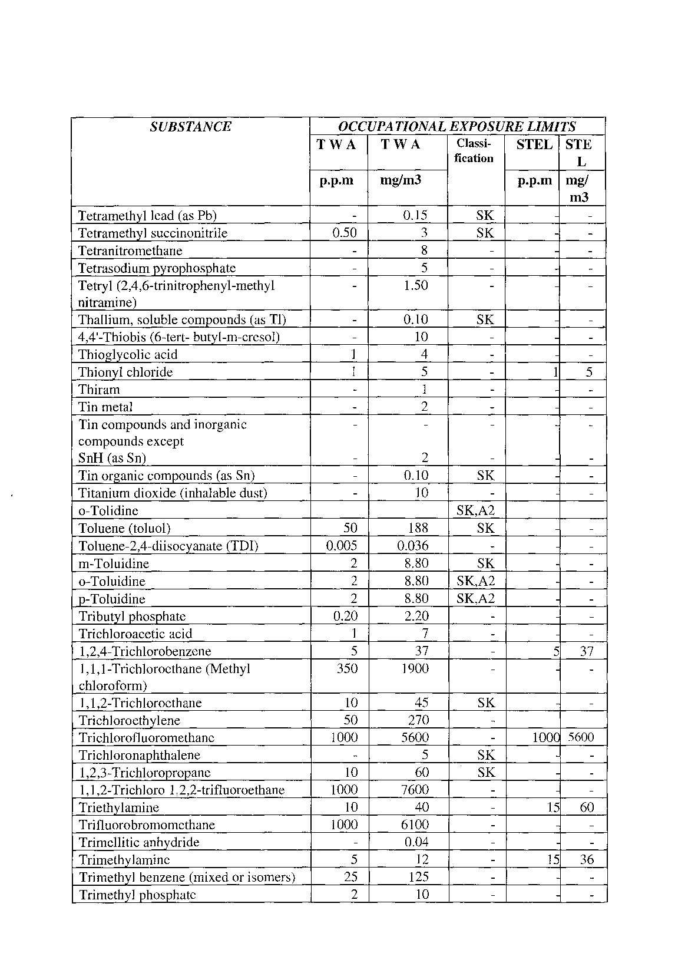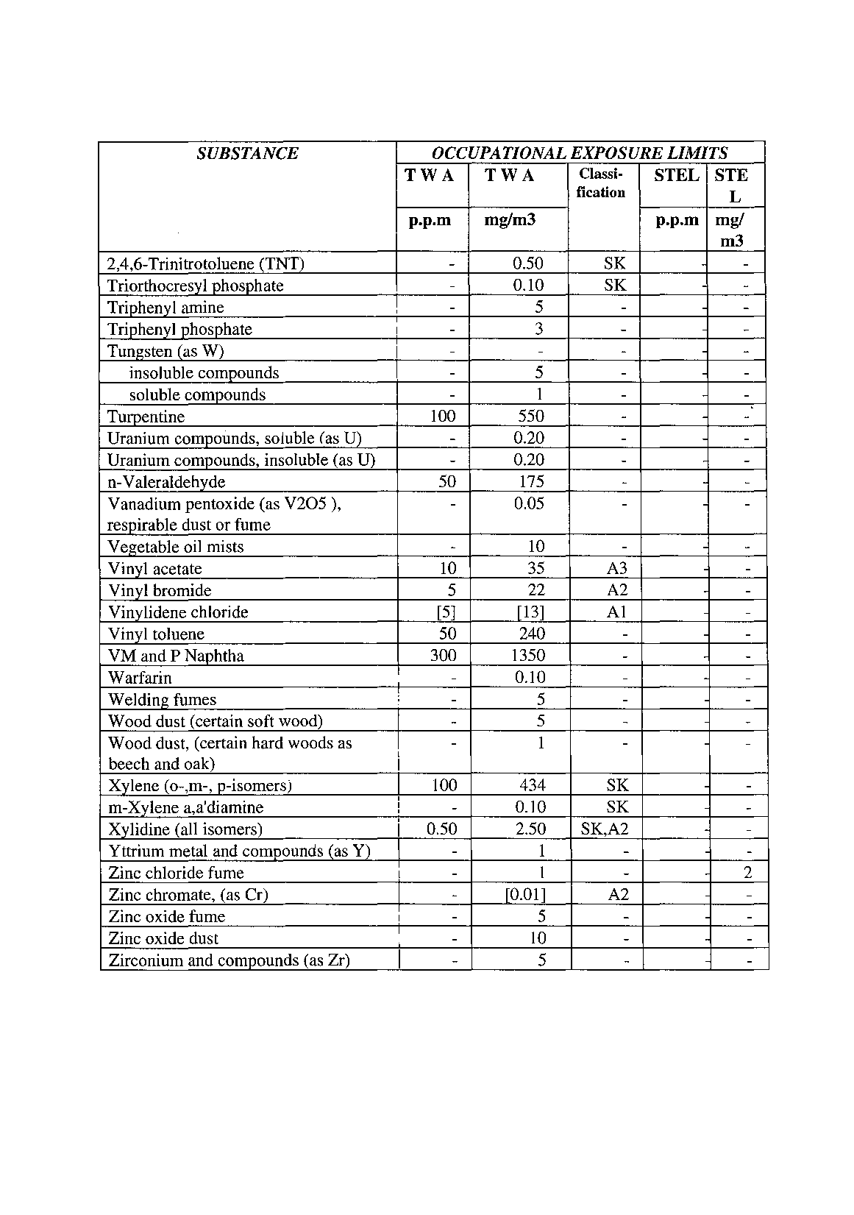

**1.(3) ADOPTED BIOLOGICAL EXPOSURE DETERMINANTS**

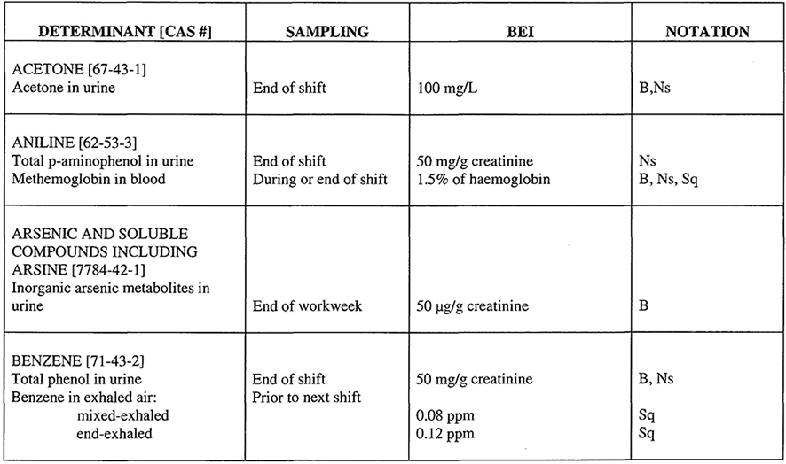

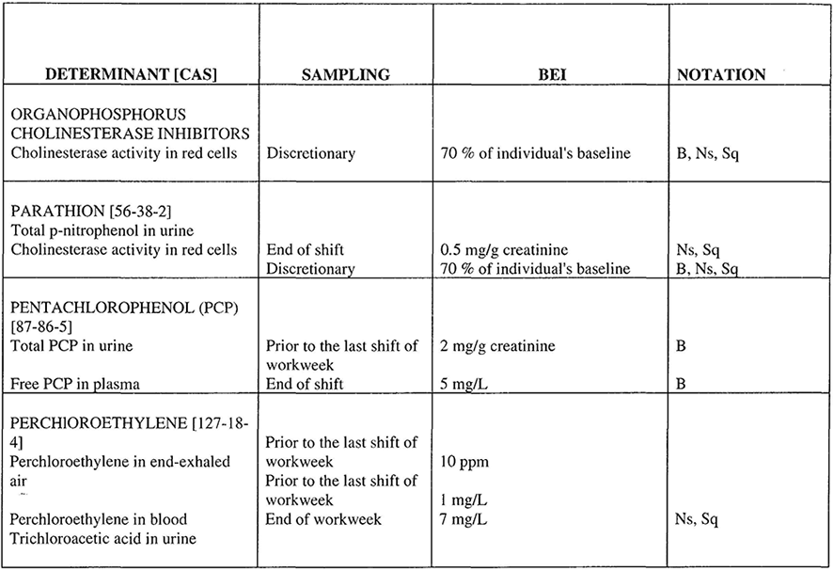

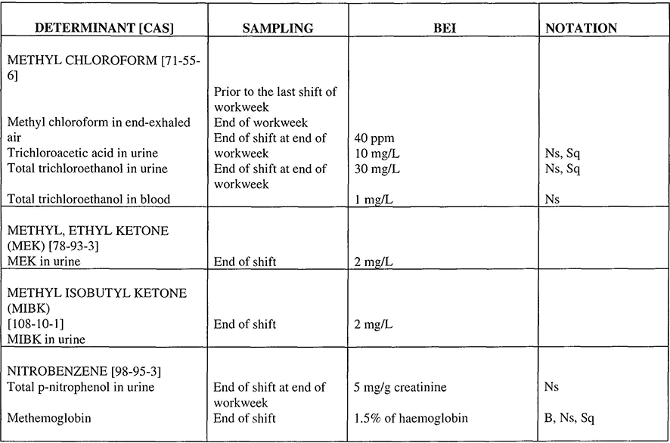

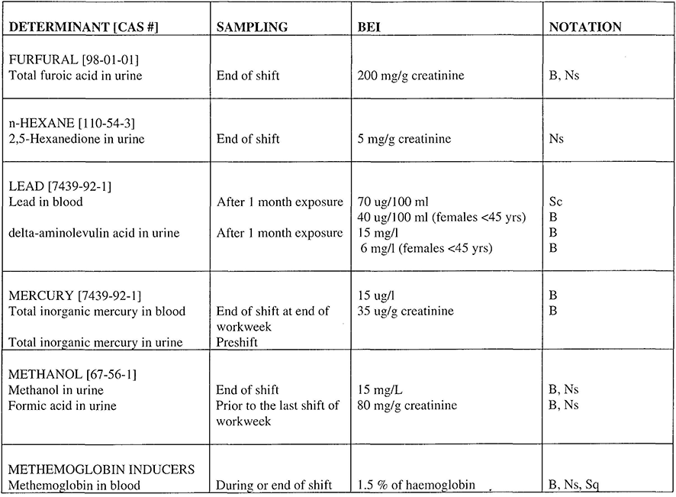

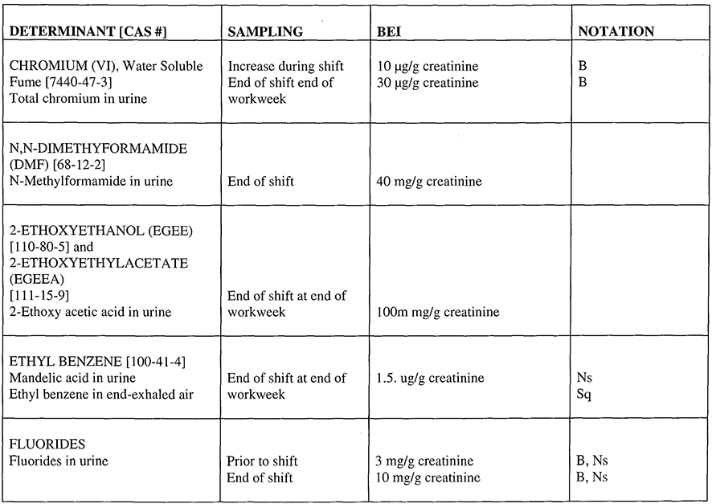

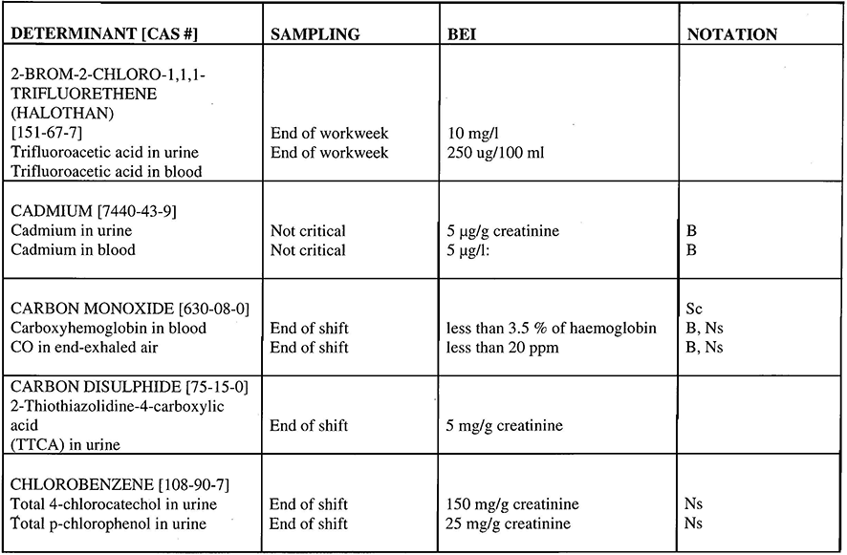

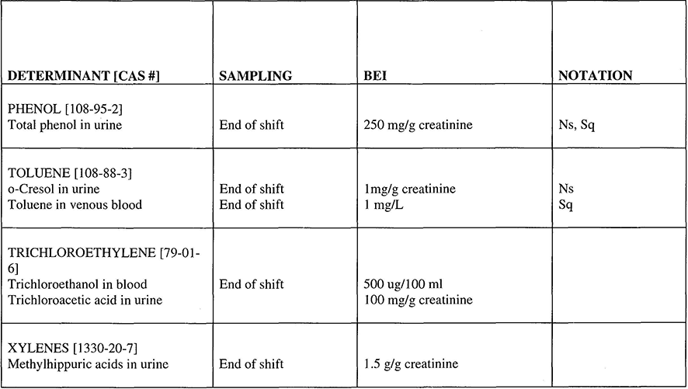

**NOTES:**

[Notes (1) and (2) are repeated (in part) in the *Government Gazette*;   
the repeated text has been omitted here.]

**(1) “B” means, that the determinant is usually present in a significant amount in biological specimens collected from subjects who have not been occupationally exposed. Such background levels are included in the BEl value.**

**(2) “Ns” means that the determinant is non-specific, since it is observed after exposure to some other chemicals. These non-specific tests are preferred because they are easy to use and usually offer a better correlation with exposure than specific tests. In such instances, a BEl for a specific, less quantitative biological determinant is recommended as a confirmatory test.**

**(3) “Sc” means that an identifiable population group might have an increased susceptibility to the effect of the substance, thus leaving it unprotected by the recommended BEl.**

**(4) “Sq” means that the biological determinant is an indicator of exposure to the substance, but the quantitative interpretation of the measurement is semi-quantitative. These biological determinants shall be used as a screening test, if a quantitative test is not practical or as a confirmatory test, if the quantitative test is not specific and the origin of the determinant is in question.**

2.(1) ASBESTOS REGULATIONS

made under the Labour Act, 1992 (Act 6 of 1992)

**Interpretation**

**1**. In this Schedule, unless the context otherwise indicates -

“action level for asbestos” means a time-weighted average concentration of regulated asbestos fibres in the work-place, which is equal to 50 per cent of the prescribed occupational exposure limit for asbestos;

“AIA RTM1” means the method of determining the concentration of airborne regulated asbestos fibres specified in the publication *“Reference Method for the Determination of Airborne Asbestos Fibre Concentrations at Work-places by Light Microscopy (Membrane Filter Method)”,* published by the Asbestos International Association as *Recommended Technical Method No. 1 (RTMJ),* January 1982;

“asbestos” means any of the fibrous mineral silicates belonging to rock-forming minerals of the serpentine group, including chrysotile, and the amphibole group, including actinolite, amosite, anthophylite, crocidolite or tremolite, or any mixture containing one or more of these minerals;

“asbestos dust” means airborne particles or settled particles consisting of or containing asbestos which are liable to become airborne in the working environment;

“asbestos fibre (regulated)” means a particle of asbestos with a length-to-diameter

ratio greater than three to one, and with a length greater than five micrometers and a diameter of less than three micrometers;

“asbestos process” means any processing or use of asbestos in raw mineral form, or materials containing asbestos, and includes -

(a) the sawing, cutting, sanding or spraying of asbestos-containing materials;

(b) the repair or maintenance of asbestos surfaces;

(c) the cleaning or disposal of asbestos materials;

(d) the mixing or application of asbestos shorts, cements, grouts, putties or similar compounds;

(e) the storing or conveyance of materials containing asbestos; or

(f) the demolition of buildings or structures containing asbestos;

“amphibole group” means actinolite, amosite, anthophylite, crocidolite, tremolite or any mixture containing one or more of these minerals;

“equivalent eight hour exposure value” or “E8hEV” means the time weighted average exposure of an employee in any 24 hour period to a substance or level of a physical agent for a period of 8 hours, and if the period of exposure is more than or less than eight hours, the exposure is calculated by multiplying the measured concentration by a factor equal to the period of exposure in hours, divided by 8 hours;

“exposure limit” means the prescribed maximum time-weighted average concentration of a substance or level of a physical agent to which a person may be exposed without the likelihood of injurious effect, and which is measured in accordance with approved safety standards;

“exposure limit for asbestos” means an exposure limit for asbestos as prescribed by the competent authority, but not exceeding one regulated asbestos fibre per millilitre of air, measured in accordance with AIA RTM1 or an equivalent measure;

“intake” includes inhalation, ingestion or being otherwise absorbed through the skin or mucous membranes;

“medical surveillance” means regular occupational health evaluation by an occupational health practitioner which may include both clinical and biological examinations and tests;

“respiratory protective equipment” means a device which is worn over not less than the mouth and nose to prevent the inhalation of air which is not safe, and which is of a type, or conforming to a standard, approved by the Chief Inspector;

“respirator zone” means an area where the concentration of airborne asbestos is equal or exceeds the prescribed occupational exposure limit for airborne asbestos; and

“time weighted average” means the average of representative measurements taken over a period of time and calculated in accordance with the AIA RTM1, or an equivalent measure.

**Scope of Application**

**2**. (1) This Schedule shall apply to employers who use or process asbestos in raw mineral form or who process materials containing asbestos.

(2) Paragraphs 3 and 7 of this Schedule shall not apply to employers who only occasionally and incidentally to their main activity process materials containing asbestos: Provided that, if the question arises as to whether the activities of any particular employer in fact constitutes such occasional and incidental processing, the decision of the Chief Inspector shall be decisive.

**Notification of Asbestos Processing**

**3**. No employer shall use or process asbestos in raw mineral form or process materials containing asbestos as a regular activity of the enterprise unless he or she has notified the Chief Medical Officer of Occupational Health in writing thereof prior to the commencement of such use or processing.

**Exposure to Asbestos**

**4**. Subject to paragraph 12 of this Schedule, no employer shall require or permit any employee to work in an environment in which he or she is exposed to an E8hEV of regulated asbestos fibres equal to or in excess of the exposure limit for asbestos prescribed by the competent authority.

**Education and Training**

**5**. (1) No employer shall permit or require any employee to use or process asbestos in raw mineral form or process materials containing asbestos unless the employee is, to the satisfaction of an inspector, thoroughly informed about the dangers of asbestos and trained in the handling of asbestos prior to the commencement of his or her employment, and periodically thereafter, with regard to -

(a) the contents of these regulations;

(b) the likely sources of dust which may contain regulated asbestos fibres at his or her work-place;

(c) the potential dangers to health of exposure to asbestos;

(d) the risks associated with exposure to asbestos coupled with smoking;

(e) the precautions, as provided by the employer in compliance with these regulations, to be taken to protect himself or herself against the effects of asbestos, including the wearing and use of adequate protective clothing and respiratory protective equipment; and

(f) the proper use and maintenance and the limitations of all safety equipment and facilities provided.

**Duties of Employees**

**6**. (1) An employee who works with asbestos or material containing asbestos shall abide by any instructions given to him or her by or on behalf of his or her employer in compliance with these regulations and in regard to -

(a) the prevention of asbestos dust from being released into the environment;

(b) the wearing and use of personal protective equipment and clothing as prescribed by these, or any other, regulations;

(c) the wearing of personal samplers, when necessary, to measure personal exposure to asbestos; and

(d) the disposal of waste material containing asbestos and the cleaning of any premises at which asbestos or material containing asbestos has been used, handled or processed.

(2) If two or more employees simultaneously undertake activities at a work-place involving asbestos processes, they shall co-operate in order to comply with these regulations, without diminishing in any way whatsoever the responsibility of each one of them to comply with such regulations.

**Measuring of Exposure**

**7**. (1) An employer shall ensure that the concentrations of regulated asbestos fibres in the air to which employees are, or are likely to be, exposed at any work-place, are measured in accordance with this regulation.

(2) An employer shall ensure that the measurements contemplated in subparagraph (1) are -

(a) taken at a time determined after consultation with the work-place safety representative and work-place safety committee, if any, established for such work-place in terms of regulation 186;

(b) taken by an approved inspection authority or by a person whose ability to do such measurements is readily verifiable by an approved inspection authority;

(c) taken in accordance with AIA RTM 1 or equivalent;

(d) representative of the personal exposure of employees to regulated asbestos fibres in the work-place, in accordance with subparagraph (3); and

(e) verified in accordance with subparagraph (4), if such measurements have been carried out by a person who is not an approved inspection authority.

(3) In order to comply with subparagraph (2)(d), the employer shall institute and record in writing a planned programme of measurement of the exposure of employees to regulated asbestos fibres as follows:

(a) The total number of potentially exposed employees shall be divided into groups of employees doing identical or similar tasks in the same work-place;

(b) groups performing similar tasks in different buildings or rooms or during different shifts shall be dealt with separately;

(c) the exposure of not less than one in every ten or less employees per group shall be regarded as representative of such group;

(d) the employees whose exposure are to be determined, shall be selected at random;

(e) measurements shall be taken not less than once per month during each shift: Provided that the frequency of measurement may be decreased -

(i) if all the measurements for a particular group in four consecutive months are less than the action level for asbestos, measurements may be taken not less than once every 12 months; and

(ii) if all the measurements for a particular group in four consecutive months are equal to or more than the action level for asbestos, but less than the exposure limit for asbestos, measurements may be taken not less than once every six months: Provided that when a measurement taken in terms of subparagraph (i) is equal to or more than the action level for asbestos, or if a measurement taken in terms of this subparagraph is in excess of the exposure limit for asbestos, or if a substantial change in the operating is effected at such work-place, the monthly measurement for the particular group shall be resumed, in which case the provisions to this subparagraph shall again apply.

(4) In order to comply with subparagraph (2)(e), the employer concerned shall obtain the services of an approved inspection authority which shall, at intervals not exceeding six months or, having regard to subparagraph (3)(e)(i), at intervals not exceeding 12 months, as the case may be -

(a) by examining the measurement and analysis equipment of the employer and questioning the person referred to in subparagraph (2)(b), verify whether the measurement programme of the employer complies with this regulation;

(b) take the measurements prescribed by subparagraph (2) or (3) for any one shift; and

(c) enter the results of the enquiry and measurements contemplated in paragraphs (a) and (b) respectively, in the record referred to in subparagraph (5)(c), and in writing report such results to the Chief Medical Officer of Occupational Health.

(5) An employer shall -

(a) from time to time display the latest results of the measurements taken in terms of subparagraph (3) in a conspicuous place in the work-place concerned;

(b) annually, before 30 March of every year, furnish the Chief Medical Officer of Occupational Health with a return of the results of the measurements taken in compliance with this regulation;

(c) keep a record, which shall be open for inspection by an inspector, of all measurements taken in compliance with this regulation; and

(d) retain the record contemplated in paragraph (c) for a period of three years.

**Exposure records**

**8**. An employer shall -

(a) keep a record book into which he or she shall enter the names of all employees exposed to asbestos during the course of their employment, indicating the nature and duration of the work and the exposure to which they have been subjected: Provided that entries shall be made in the record only on the basis of the results of measurements obtained in compliance with paragraph 7;

(b) allow a registered medical practitioner to peruse the record with respect to a particular employee upon the written request of such an employee;

(c) keep a copy of the record available for inspection by an inspector; and

(d) keep and maintain the record for a period of 30 years after the termination of the employment of any such employee.

**Zoned areas**

**9**. (1) An employer shall ensure that any work-place where work has to be carried out using materials containing asbestos, is, as far as is practicable, in an isolated or screened-off part of such work -place, which is specifically set aside for that purpose in order to prevent the escape of asbestos dust to any other part of the work-place and is zoned as -

(a) an asbestos area, where the concentration of regulated asbestos fibres in the atmosphere in such area is, or is likely to be, less than the exposure limit for asbestos; or

(b) a respirator zone, where the concentration of regulated asbestos fibres in the air of that area is, or is likely to be, such that the exposure of employees working in that area is equal to, or exceeds the exposure limit for, asbestos.

(2) Asbestos areas and respirator zones shall be clearly and separately demarcated and identified by notices indicating -

(a) that the area is an asbestos area or a respirator zone, as the case may be, and

(b) that protective clothing shall be worn by employees who are in the area or zone, and in the case of a respirator zone, that respiratory protective equipment shall be worn in addition to the protective clothes.

(3) No person may enter or remain in a zoned area unless he or she has been authorised by a competent person to enter such area or to remain therein.

(4) Asbestos materials removed from a work-place shall be placed in impervious receptacles, sealed and clearly labelled “Asbestos”, or labelled as determined by an inspector.

**Prohibition**

**10**. (1) No asbestos of the amphibole group, including, but not limited to, actinolite, amosite, anthophylite, crocidolite or tremolite, or any mixture containing one or more of such minerals, shall be used in any asbestos process.

(2) No person shall apply asbestos by means of a spraying or similar process of repair, or permit any other person to apply asbestos by means of any such process.

(3) No person shall, or shall require or permit any other person to, use working or cleaning methods which release asbestos fibre containing dust into the atmosphere, including any method employing compressed air to remove asbestos dust, or any dry sweeping or dry cutting of asbestos.

(4) No person shall smoke, eat or drink in any area which has been zoned in terms of paragraph 9(1)(a) or (b).

(5) No employer shall permit any person under the age of 18 years to work in any place where asbestos dust is likely to be released into the atmosphere.

**Labelling and Information**

**11**. No person shall sell any article which contains asbestos and which is likely to undergo a process of adaptation, before or after the sale, whereby asbestos fibres will be released into the atmosphere, unless such article is clearly labelled with a warning label -

(a) as prescribed by these regulations or determined by the competent authority, and is accompanied by a safety data sheet in accordance with regulations 178 and 180;

(b) containing instructions on the handling, stacking, cutting, machining, drilling and disposal of such article; and

(c) indicating the working tools to be used in such adaptation.

**Personal protective equipment**

**12**. (1) An employer shall, in circumstances where it is not reasonably practicable to ensure by means of engineering controls that the exposure limit to asbestos is below or equal to the prescribed limits by the competent authority, ensure that each employee who may be exposed to asbestos is provided with and uses -

(a) approved respiratory protective equipment, which is of such a nature and capacity that it will reduce the concentration of regulated asbestos fibres in the atmosphere inhaled by the employee to a level which is below the prescribed exposure limit; and

(b) adequate protective coveralls and headgear which, when worn, will protect the employee against asbestos dust, and such protective clothing shall be disposed of after use, or shall be kept, maintained and be cleaned in a safe manner by the employer after each time it has been used.

(2) The protective clothing and equipment referred to in subparagraph (1) shall not be worn outside the work-place and shall not be taken home by the employee.

(3) An employer shall -

(a) ensure that no respiratory protective equipment or protective clothing is reissued for use by any other person, unless it has been thoroughly cleaned and properly serviced in accordance with the directions of the manufacturer or supplier and of these regulations and, in the case of respiratory protective equipment, also be disinfected;

(b) provide containers and storage facilities for protective equipment and clothing when it is not in use;

(c) provide the prescribed washing and toilet facilities adjacent to a separate change-room for the sole use of those employees who work in an asbestos area or respiratory zone; and

(d) provide an employee with two separate lockers, which shall be situated as far apart as is practically possible, and which lockers shall be clearly labelled “protective clothing” and “personal clothing” respectively, and shall ensure that such clothing is kept separately in the appropriate locker: Provided that an employer who uses or processes asbestos in raw mineral form, shall provide such lockers in separate change rooms.

(4) An employer shall make provisions for the laundering of protective clothing -

(a) if such clothing is laundered on the premises, care shall be taken to prevent the emission of asbestos dust during handling, transport and laundering; or

(b) if such clothing is sent for laundering to a laundry outside the premises -

(i) the clothing shall be packed in securely closed and dust proof containers, clearly marked as containing asbestos­ contaminated clothing; and

(ii) the launderer shall fully understand the precautions necessary for handling asbestos-contaminated clothing.

**Control of Exposure**

**13**. (1) An employer shall -

(a) as far as reasonably practicable control the exposure of persons to asbestos dust in the working environment;

(b) equip and maintain buildings, installations, machinery and work-places, and organize work in such a way that the working environment is contaminated as little as possible by asbestos dust; and

(c) ensure that such exposure of employees is limited as far as is reasonably practicable, but limited to at least the exposure limit for asbestos.

(2) An employer shall, as far as practicable, ensure that -

(a) all work-places are maintained in a clean state and are free from asbestos dust and waste and, whenever asbestos is accidentally spilt, or asbestos dust is accidentally released into the atmosphere of the work-place, that remedial measures are taken immediately before work is resumed;

(b) cleaning is conducted by means of appropriate vacuum cleaning equipment with a filtration efficiency of not less than 99 per cent for regulated asbestos fibre, or in such other manner that asbestos dust neither escapes nor is released into the atmosphere to such an extent that it contaminates any work-place or the environment, and that employees undertaking such cleaning are wearing appropriate protective clothing and respiratory protective equipment, and no other persons are present unless they also wear protective clothing and respiratory protective equipment; and

(c) if the use of vacuum cleaning equipment is impracticable, all surfaces are damped and employees undertaking such cleaning are wearing appropriate protective clothing and respiratory protective equipment.

(3) An employer shall ensure that -

(a) a surface containing asbestos is kept in good condition and any repairs or sealing necessary to prevent the breaking off of asbestos or the release of asbestos dust is done immediately;

(b) no asbestos surface is disturbed for the purpose of maintenance, replacement, removal or repair unless such surface is thoroughly damped or an equivalent method approved by an inspector is applied; or

(c) if it is not practicable to apply exhaust ventilation methods, effective means are to be used to capture, at the source thereof, any dust created by the disturbance.

**Demolition**

**14**. Any person engaged in the demolition or alteration of any structure containing asbestos lagging or insulation shall -

(a) before the commencement of such work, ensure that -

(i) all asbestos and materials containing asbestos liable to become airborne are identified;

(ii) a plan of work is drawn up, describing the measures necessary to ensure the safety and health of the persons at that work­ place; and

(iii) a copy of such plan of work is submitted to the Chief Medical Officer of Occupational Health for approval not less than 30 days prior to the commencement of any such work: Provided that an inspector, at his or her discretion, may allow a shorter period of time for such work: Provided further that an inspector may approve standardized procedures for routine alteration or repairs;

(b) during and after the completion of such work ensure that -

(i) all asbestos and asbestos containing materials are handled and disposed of in a safe manner;

(ii) all employees exposed or likely to be exposed are issued with appropriate protective equipment; and

(iii) after completion of such work the premises and structure are thoroughly checked to ensure that all asbestos waste has been removed.

**Disposal of asbestos waste**

**15**. (1) An employer shall ensure that -

(a) asbestos waste or dust produced in any work-place is cleaned away promptly each day by means of vacuum cleaning equipment to prevent the escape of asbestos dust into the atmosphere, or, if vacuum cleaning is not practicable, by the damping method in accordance with paragraph 13;

(b) all collected asbestos dust, swarf and other asbestos wastes are placed in effective containers, which are properly sealed to prevent the escape of dust during handling, and are marked in accordance with paragraph 11;

(c) all vehicles, reusable receptacles and covers which have been in contact with asbestos waste, are cleaned in accordance with these regulations;

(d) all waste is disposed of only on sites specifically designated for such purpose by the competent authorities;

(e) written instructions and appropriate training are given to the drivers of vehicles carrying asbestos waste relating to the action to be taken for the cleaning up of such waste in the event of accidental spillage of waste;

(f) an employee engaged in the cleaning of asbestos waste or dust is provided with and wears personal protective equipment as required by these regulations; and

(g) all employees engaged in the disposal of asbestos wastes are adequately instructed in the safe means of handling such wastes and of their proper disposal in a manner that will not create a hazard to any person at the disposal site.

**Medical Surveillance**

**16**. (1) An employer shall ensure that any employee exposed to asbestos fibre shall, to the satisfaction of the Chief Medical Officer of Occupational Health, receive a pre-employment medical examination and, depending on the level of exposure, follow-up examinations within a period of three years.

(2) The employer shall arrange for, and pay the full costs pertaining to the medical examination contemplated in subparagraph (1), which examination shall include -

(a) a comprehensive physical examination with special attention to the lungs (chest X-rays to be evaluated according to the International Labour Organization V/C classification);

(b) lung-function tests including forced vital capacity and forced expiratory volume at one second; and

(c) any further medical procedures that are necessary for the diagnosis of an asbestos-related disease.

(3) The findings of the medical examination described in subparagraph (2) shall be furnished by the appointed occupational health practitioner to the employee concerned and, upon the written request of the employee, to a designated medical practitioner, but shall otherwise be kept by the occupational health practitioner in confidence except -

(a) with respect to the Chief Medical Officer of Occupational Health;

(b) if otherwise required by law; or

(c) with the informed consent of the employee.

**Offences and Penalties**

**17**. Any person who contravenes or fails to comply with any provision of paragraph 3, 4, 5, 6, 7, 8, 9, 10, 11, 12, 13, 14,15 or 16, shall be guilty of an offence and on conviction be liable to a fine not exceeding N$ 2000 or to imprisonment for a period not exceeding 6 months or to both such fine and such imprisonment.

2.(2) LEAD REGULATIONS

made under the Labour Act, 1992 (Act 6 of 1992)

**Interpretation**

**1**. In this Schedule, unless the context otherwise indicates -

“approved inspection authority” means an inspection authority approved by the Chief Medical Officer of Occupational Health with respect to -

(a) the monitoring of lead concentrations in the atmosphere; or

(b) the analysis of lead in the blood or urine of an employee, or equivalent determinants in biological specimen;

“equivalent eight hour exposure value” (E8hEV), means the time-weighted average exposure of an employee during any 24 hour period, to a substance or level of a physical agent for a period of eight hours, and if the period of exposure is more than or less than eight hours, the exposure as calculated by multiplying the measured concentration by a factor equal to the period of exposure in hours, divided by eight;

“exposure limit” means the prescribed maximum time-weighted average concentration of a substance or level of a physical agent to which a person may be exposed without the likelihood of an injurious effect, and which is measured in accordance with safety standards approved by the Chief Inspector;

“exposure limit for lead, other than that for tetra-ethyl lead”, means an exposure limit determined by the competent authority but not more than 0,10 mg lead per cubic metre of air, measured in accordance with standards approved by the Chief Inspector;

“exposure limit for lead in the case of tetra-ethyl lead”, means an exposure limit prescribed by the competent authority but not more than 0,07 mg lead per cubic metre of air, measured in accordance with safety standards approved by the Chief Inspector;

“intake” includes inhalation, ingestion or absorption through the skin or mucous membranes;

“lead” means lead, lead alloys or lead compounds which can be inhaled, ingested or otherwise absorbed by persons, including the discharge from the exhaust system of a vehicle on a road;

“lead area” means an area where the concentration of airborne lead is such that the exposure of employees working in that area is less than, or is equal to, the exposure limit for lead;

“lead paint” means any paint, paste, spray, stopping, filling or other material used in painting, which, when treated, yields to an aqueous of hydrochloric acid, a quantity of soluble lead compound exceeding, when calculated as lead monoxide, five per cent of the dry weight of the portion taken for analysis;

“medical surveillance” means regular occupational health evaluation by an occupational health practitioner which may include both clinical and biological examinations and tests;

“monitoring” means the planning, carrying out and recording of a measurement programme;

“respiratory protective equipment” means a device which is worn over not less than the mouth and nose to prevent the inhalation of air which is not safe, and which equipment is of a type, or conforming to a standard, approved by the Chief Inspector; and

“respirator zone” means an area where the concentration of airborne lead is equal to or exceeds the prescribed occupational exposure limit for airborne lead;

**Application**

**2**. (1) Subject to subparagraphs (2) and (3), these regulations shall apply to an employer at a work-place where lead is produced, processed, used, handled or stored in a form in which it can be inhaled, ingested or absorbed by an employee.

(2) These regulations shall not apply to an employer at a work-place where -

(a) the exposure to lead is equal to, or less than, 50 per cent of the occupational exposure limit, except if there is a substantial risk that lead can be absorbed or ingested by an employee; and

(b) only occasionally and incidentally to the main activity at such work­ place, materials containing lead are processed and no substantial adverse change is likely to occur in the work practice that may lead to an increase in the exposure to lead: Provided that if the question arises as to whether the activities of any particular employer in fact constitutes such occasional and incidental processing, the decision of the Chief Medical Officer of Occupational Health shall be decisive.

(3) Paragraphs 6 and 7 shall not apply to an employer in building work or in the application or removing of lead paint.

**Exposure to Airborne Lead**

**3**. Subject to paragraph 12, no employer shall require or permit any employee to work in an environment in which he or she is exposed to lead equal to, or in excess of, the exposure limits for lead.

**Education and Training**

**4**. An employer contemplated in paragraph 2 shall ensure that an employee exposed to lead is adequately and comprehensively informed and trained at the commencement of his or her employment, and periodically thereafter at intervals as may be recommended by the work-place safety committee, and if no work-place safety committee has been established, by the work-place safety representative, with regard to -

(a) the contents of these regulations;

(b) the potential sources of airborne lead at the work-place;

(c) the potential risks to health caused by exposure to lead;

(d) the recognition of any symptoms of lead absorption;

(e) the precautions to be taken by an employee to protect himself or herself against the health risks associated with the exposure to lead, including the wearing and use of protective clothing and respiratory protective equipment;

(f) the correct use, maintenance and limitations of use of safety equipment and facilities provided;

(g) the need for medical surveillance and biological monitoring; and

(h) the importance of good personal hygiene.

**Assessment of exposure to lead**

**5**. (1) An employer contemplated in paragraph 2 shall -

(a) cause an exposure assessment to be made at intervals not exceeding two years, to determine whether any employee is exposed to the intake of lead;

(b) inform the work-place safety committee in writing of the arrangements made for the assessment; and

(c) ensure that the results of such assessment are made available to the work-place safety committee or the work-place safety representative, as the case may be, who may then comment on such results.

(2) In making the assessment in terms of subparagraph (1), the employer shall take into account -

(a) the methods and procedures used or to be used in the processing of, the use of, the handling of or the storage of the lead concerned;

(b) the extent or potential extent of the exposure of an employee to the intake of lead; and

(c) the measures and procedures necessary to control or minimise such exposure.

(3) If the assessment made in accordance with subparagraph (2) indicates that an employee is likely to be exposed to the intake of lead, the employer shall ensure that the concentration of airborne lead at such work-place is measured by an approved inspection authority or by a person whose ability to do such measurements is confirmed in writing by an inspector, using static sampling in accordance with the safety standards approved by the Chief Inspector, and the employer shall ensure that a area where -

[The word “a” in phrase “a area” should be “an”.]

(a) the concentration of airborne lead is equal to, or exceeds, 50 per cent of the exposure limit for lead, but is less than or equal to such exposure limit, is demarcated and identified by a conspicuous notice, to the satisfaction of an inspector, as a lead area; or

(b) the concentration of airborne lead is more than the exposure limit for lead, is demarcated and identified by a conspicuous notice, to the satisfaction of an inspector, as a respirator zone.

(4) If a change is made in a process involving lead, or in the methods and procedures in the use, handling or processing of lead, the employer shall cause a further assessment to be made immediately, and subparagraphs (1), (2) and (3) shall apply.

**Duties of Employees**

**6**. (1) An employee who is exposed to lead shall abide by any instruction given by or on behalf of the employer in terms of these regulations and in regard to -

(a) the prevention of lead being released into the environment;

(b) the wearing and use of personal protective equipment and clothing as prescribed by these regulations;

(c) the wearing of samplers when necessary to measure personal exposure to airborne lead;

(d) the reporting during normal working hours for such medical examination or test as may be required in terms of paragraph 8;

(e) the disposal of waste material containing lead and the cleaning of any site at which lead or material containing lead has been used, handled or processed; and

(f) the adherence to instructions regarding environmental, housekeeping and personal hygiene practices.

(2) If two or more employees simultaneously undertake activities at a work-place involving lead processes, they shall co-operate in order to comply with these regulations, without diminishing in any way whatsoever the responsibility of each one of them to individually comply with such regulations.

**Airborne Lead**

**7**. (1) An employer shall ensure that the measurement of exposure to airborne lead of employees working in a lead area or respirator zone is -

(a) conducted in accordance with these regulations;

(b) conducted only after the work-place safety representative or work­ place safety committee concerned, as the case may be, has been informed of, and afforded the opportunity to comment on, the arrangements;

(c) conducted by a competent authority or by a person approved by a competent authority;

(d) conducted in accordance with the safety standard determined by the Chief Inspector;

(e) representative of the exposure of employees to airborne lead in the work-place, in accordance with subparagraph (2); and

(f) verified in accordance with subparagraph (3), if such measurements are carried out by a person who is not an approved inspection authority.

(2) In order to comply with subparagraph (1) (e), the employer shall establish a programme of measurement and keep a record of the exposure of his or her employees to airborne lead in accordance with the following procedure:

(a) The total number of -

(i) potentially exposed employees in a respirator zone shall be divided into groups doing identical or similar tasks in the same zone; and

(ii) the total number of potentially exposed employees in lead areas shall be divided into groups doing identical or similar tasks in the same area;

(b) groups performing similar tasks in different buildings or rooms, or during different shifts, shall be dealt with separately;

(c) group exposure shall be determined by personal sampling: Provided that static sampling procedures approved by a competent authority may be resorted to in case of a lead area;

(d) the average exposure of not less than ten per cent of the employees per group shall be regarded as representative for that group;

(e) the employees whose exposures are to be determined shall be selected at random; and

(f) representative measurements shall be carried out not less than once per month during each shift: Provided that the frequency of these measurements may be decreased if the average monthly measurement for a particular group over four consecutive months is less than or equal to 0,5 mg per cubic metre, in which case such measurements may then be carried out in accordance with the static measurement procedure not less than once every six months: Provided further that, whenever the average monthly measurement for a group exceeds 0,5 mg per cubic metre, or a substantial change in the operating procedure is effected at such work-place, monthly measurements for that group shall be resumed, in which case this paragraph shall again apply.

(3) In order to comply with subparagraph (1)(f), the employer shall obtain the services of a competent authority who shall, at intervals not exceeding 12 months -

(a) verify, by examining the measurement and analysis equipment of the employer and questioning the person referred to in subparagraph (1)(c), whether the measurement programme of the employer complies with this regulation;

(b) carry out the measurements prescribed by subparagraphs (1) and (2) for any one shift; and

(c) enter the results of the investigation and measurements referred to in paragraph s(a) and (b) respectively, in the record required by paragraph 9.

**Medical surveillance, including biological monitoring**

**8**. (1) An employer shall ensure that an employee is under medical surveillance if -

(a) the employee is employed in a respirator zone or lead area; or

(b) the appointed occupational health practitioner certifies that the employee should be under medical surveillance.

(2) In order to comply with subparagraph (1), the employer shall ensure that -

(a) an initial medical examination is carried out immediately before or within 14 days after a person commences employment, which examination comprises -

(i) an evaluation of the employee’s medical and occupational history;

(ii) clinical examinations; and

(iii) analyses of the employee’s blood lead, full blood count and other relevant biological tests at the discretion of the appointed occupational health practitioner: Provided that the measurement of blood lead concentrations shall be repeated during the third and the sixth month after the commencement of employment;

(b) after the expiry of the first six month period of employment, biological monitoring is carried out periodically which shall consist of -

(i) measurement of blood lead concentration and haemoglobin including haematocrit for employees exposed to lead, other than tetra-alkyl lead, at intervals as prescribed in the table below: Provided that in the case of females who are capable of procreation all such measurements are carried out at three monthly intervals;

|  |  |
| --- | --- |
| Blood Lead (ug/100 ml) | Maximum interval between Examinations |
| …………………………………………………………………………………… | |
| under 40 | 12 months |
| 40-59 | 6 months |
| 60-70 | 3 months |
| 70 and over | at the occupational health practitioner’s discretion |

(ii) clinical examinations or other relevant biological tests at the discretion of the occupational health practitioner.

(3) If the blood lead concentration of any employee is equal or greater than 70 ug/100ml, the employer shall have the test repeated, and if the result of the repeat test is equal to or greater than 70 ug/1 00ml corrected for the haematocrit value, the employer shall be certified as temporarily unfit for work which exposes him or her to lead by the appointed occupational health practitioner: Provided that the appointed occupational health practitioner may certify as unfit for work an employee whose blood lead level is less than 70 ug/100ml, if the results of other biological tests or clinical assessments indicate the need for the employee to be so certified.

(4) The employer shall ensure that a women who is capable of procreation and who is employed in work which exposes her to lead, is -

(a) suspended temporarily from such work when her blood lead concentration exceeds 40 ug/1 00 ml or if she becomes pregnant; and

(b) not be permitted to return to work which will expose her to lead unless her blood lead concentration is less than 35 ug/100 ml.

(5) The employer shall ensure that no employee certified as unfit for work which exposes him or her to lead, returns to any work which so exposes him or her to lead -

(a) until the appointed occupational health practitioner certifies in writing that the employee is fit for such work; and

(b) the blood lead concentration is less than 70 ug/100ml for employees to whom subparagraph (4) does not apply.

(6) In the case of work-place related exposure to tetra-alkyl lead, the Chief Medical Officer of Occupational Health may request any other appropriate clinical and biological examinations for the purpose of adequate medical surveillance.

**Records**

**9**. (1) An employer shall -

(a) keep record of the results of assessments, air monitoring, biological monitoring and medical surveillance reports in terms of paragraphs 6, 7 and 8 respectively;

(b) make such records available for inspection to the competent authorities or if required by law;

(c) allow an employee or a registered medical practitioner, upon the written request of such employee, to peruse the records with respect to that particular employee; and

(d) make the records of all assessments and air monitoring, including statistical data on medical surveillance under observation of medical confidentiality, available for perusal by the work-place safety representative or work-place safety committees.

(2) The employer shall keep all records of assessments and air monitoring for a minimum period of three years.

(3) The employer shall keep all biological monitoring and medical surveillance records and results of biological tests, for a minimum period of 30 years after termination of employment.

**Control of exposure to lead**

**10**. (1) The employer shall control the exposure of employees to lead in the working environment by applying the following measures, if appropriate -

(a) lead and materials containing lead is used at the work-place which are liable to release lead, shall be limited to the satisfaction of an inspector;

(b) the number of employees who will be exposed to or will likely be exposed to airborne lead arising from the use, handling or processing of lead or materials containing lead shall be limited to the satisfaction of an inspector;

(c) engineering methods for the control of airborne lead emissions shall receive priority attention, which shall include -

(i) process separation, automation or enclosure;

(ii) local exhaust ventilation of process, equipment and tools for the prevention of airborne lead emissions;

(iii) use of damping methods if appropriate; and

(iv) separate work-places for different processes;

(d) emissions to atmosphere shall comply with the provisions prescribed by the competent authority in regard to atmospheric pollution prevention control;

(e) the employer shall establish appropriate work procedures which employees have to follow, if materials are used or processes are carried out which could give rise to airborne lead emissions in the working environment, and such procedures shall include written instructions by the employer for -

(i) the use and maintenance of process machinery, installations, equipment, tools and local extraction and ventilation systems;

(ii) the damping of lead, lead products and materials containing lead at work-places before and during processing, handling, using, cleaning, stripping or removal, if appropriate;

(iii) the regular cleaning of machinery and work areas by vacuum cleaners where practicable, or by a wet sweeper;

(iv) the correct use of personal protective equipment; and

(v) a control system whereby changes in work procedures or processes that may indicate the need for early corrective action, can be readily identified.

**Cleanliness of premises and plant**

**11**. (1) The employer shall as far as practicable ensure that -

(a) all work-places are kept in a clean state and free of lead waste, and when lead is accidentally spilt or airborne lead is accidentally released into the work-place, corrective measures be taken immediately and before any work is continued;

(b) cleaning is carried out by means of vacuum-cleaning equipment with a filtration efficiency of not less than 99 per cent for particles 1 micrometer in size, or by some other means that does not allow lead dust to either escape nor be released into the air in such a manner that it contaminates any work-place or the environment;

(c) the vacuum-cleaning equipment is regularly serviced and all its external surfaces are kept in a clean state and free from visible lead dust; and

(d) if the use of vacuum-cleaning equipment is impracticable, surfaces which are to be cleaned shall be dampened and employees undertaking such cleaning shall wear appropriate protective clothing and respiratory protective equipment.

**Personal Protective Equipment**

**12**. (1) The employer shall, in circumstances where it is not reasonably practicable to, by engineering control, ensure that the exposure of an employee is below or equal to the exposure limit for lead, provide such employee with protective equipment, respiratory or other, which shall reduce the concentration of lead inhaled or ingested by the employee to a level which is below the exposure limit for lead.

(2) The employer shall provide and maintain in good condition appropriate protective clothing for employees who are employed in a respirator zone or a lead area, taking into account the hazards and effects of the lead compounds to which they are exposed.

(3) No employer shall require or permit any person to enter or remain in an area demarcated in accordance with these regulations unless such person wears the prescribed protective clothing, and in the case of a respirator zone also adequate respiratory protective equipment.

(4) The employer shall -

(a) ensure that personal protective equipment and clothing are properly maintained and used by employees;

(b) ensure that no respiratory protective equipment or protective clothing is re-issued for use by another person unless it has been thoroughly cleaned and serviced in accordance with the instructions of the manufacturer, and in the case of respiratory protective equipment, also disinfected;

(c) provide containers or storage facilities for protective equipment and protective clothing when not in use;

(d) provide employees who work in lead areas or respirator zones with washing facilities and changing facilities which are designed in such a manner that the changing facilities are separated into a “clean change-room” and a “dirty change-room” at the washing facilities: Provided that the facilities are in accordance with prescribed requirements;

(e) provide each such employee with adequate facilities for the safe­ keeping of personal clothing in the “clean change-room” and contaminated protective equipment in the “dirty change-room”; and

(f) ensure that all protective clothing in use is stored only in the place provided for such purpose.

(5) The employer shall make adequate arrangements for the laundering of protective clothing -

(a) if such clothing is laundered on the premises, care shall be taken to prevent the emission of lead dust during handling, transport and laundering;

(b) if such clothing is sent outside the premises to a laundry for cleaning purposes, the clothing shall be packed in dust-proof containers, and such containers shall be tightly closed and clearly identified as containing lead-contaminated clothing; and

(c) the employer shall ensure that the contractor doing the laundry is fully informed of the requirements of these regulations and understands the precautions necessary for the handling of lead­ contaminated clothing.

(6) An employer shall ensure that no person removes dirty or contaminated protective clothing or equipment from the premises, except for the purpose of cleaning, and further subject to subparagraph (5) (b) and (c).

**Prohibitions**

**13**. (1) No person shall use compressed air to blow away particles of lead, or material containing lead, from any surface or require or permit any other person to use compressed air to blow away particles of lead from any surface.

(2) No person shall smoke, eat, drink or keep food or beverages in a lead area or respirator zone, or require or permit any other person to smoke, eat, drink or keep food or beverages in such an area or zone.

(3) Lead paint shall not be -

(a) used for the interior painting of buildings;

(b) scraped or rubbed down from a surface by a dry process; or

(c) removed by burning or any chemical process.

(4) No person under the age of 18 years shall work or be permitted to work in a lead area or a respirator zone.

**Processing of lead**

**14**. An employer who processes lead or materials containing lead, shall ensure that -

(a) if work has to be carried out to any great extent on lead or materials containing lead, such work is done in an isolated part of the work­ place specifically set aside for such purpose and which has been zoned in terms of paragraph 5(4); and

(b) such work is done only with tools specially designed to minimize the creation of airborne lead or with tools fitted with extraction and filtration equipment.

**Packaging, transport and storage**

**15**. The employer shall, as far as is reasonably practicable, ensure that -

(a) all lead materials in storage, in transit or distributed are properly contained and are controlled to prevent the spread of contamination by lead from the place where work is being carried out; and

(b) the containers or the vehicles in which such materials are transported are clearly marked, identifying the contents as lead in terms of the relevant regulations.

**Disposal of lead waste**

**16**. The employer shall -

(a) as far as possible, recycle all waste which contains lead, but not into any non-lead production processes;

(b) ensure that all collected lead dust, swarf and other waste is placed into containers which will prevent the escape of lead dust during handling;

(c) ensure that all lead sludge, not to be recycled, is placed in properly sealed containers to prevent spillage;

(d) ensure that all such waste is disposed of only on sites specifically designated for such purpose in such a manner that it does not cause a hazard inside or outside the premises;

(e) ensure that all employees occupied in the collection, transportation and disposal of lead waste and who may be at risk of exposure to lead, are provided with suitable protective clothing and with respiratory protective equipment;

(f) ensure that all vehicles, re-usable containers or covers which have been in contact with lead waste are cleaned in accordance with these regulations;

(g) give written instructions and appropriate training to the drivers of vehicles carrying such waste, on the actions to be taken in the event of the spillage of lead waste; and

(h) if the services of a waste disposal contractor is used, incorporate a provision into the contract that the contractor shall comply with these regulations.

**Offences and Penalties**

**17**. Any person who contravenes or fails to comply with any provision of paragraph 3, 4, 5, 6, 7, 8, 9, 10, 11, 12, 13, 14, 15 or 16 shall be guilty of an offence and on conviction be liable to a fine not exceeding N$ 2000 or to imprisonment for a period not exceeding six months or to both such fine and such imprisonment.

2.(3) SILICA REGULATIONS

made under the Labour Act, 1992 (Act 6 of 1992)

**Silica Processes and Abrasive Blasting**

**Interpretation**

**1**. In this Schedule, unless the context otherwise indicates -

“abrasive blasting” means the cleaning, smoothing or removing of a part of the surface of any article by the use, as an abrasive, of silica containing sand or any other mineral sand, metal shot, grit or other material propelled by compressed air, by steam or by a wheel, and blasting has a corresponding meaning;

“blasting chamber” means a blasting enclosure into which employees enter;

“blasting enclosure” means a chamber, barrel, cabinet or other similar enclosure designed for the purpose of blasting articles;

“cleaning of castings” means, if it is done as an incidental or supplemental process in connection with the making of metal castings, the freeing of the castings from adherent sand or other substance containing one per cent or more uncombined silica, and includes the removal of cores and the general smoothing of the castings where such freeing is done, but does not include the freeing of castings from scale formed during annealing or heat treatment;

“sandblasting” means the process of projecting sand by means of compressed air, by steam or by a wheel;

“silica” (S1O2) means any crystalline silica such as quartz cristobalite, tridyhite, tripoly and amorphous silica such as diatomaceous earth, precipitated silica, silica gel;

1

“silica flour” means the ground material produced by the milling of siliceous rocks or other siliceous substances including diatomite;

“silica process” means a silica process in terms of paragraph 2;

“uncombined silica” means crystalline silica which is not chemically combined with any other element or compound;

“use of a parting material” means the application of a material to the surface of a pattern or of a mould, to facilitate the separation of the pattern from a mould, or the separation of parts of the mould.

**Application**

**2**. These regulations apply if employees are employed in any of the following silica processes -

(a) sandblasting;

(b) the cleaning of castings;

(c) the blasting, grinding or dressing of any surface containing one per cent or more uncombined silica, including the engraving or abrasive cleaning of gravestones, buildings or structures;

(d) the cutting, crushing, drilling, getting, grinding, milling, mining, quarrying, sieving, splitting or other mechanical manipulation of gravel or other siliceous stone or rock containing five per cent or more uncombined silica;

(e) any process in which silica flour is used;

(f) the manufacture of bricks containing silica and the dismantling or repair of refractory linings of furnaces containing silica; and

(g) any process which the Chief Medical Officer of Occupational Health has reason to believe creates a risk to the heath of employees by silica dust.

**Control of silica dust**

**3**. (1) An employer shall ensure that where any silica process is conducted, except the process of abrasive blasting, the entry of dust into the atmosphere is prevented, as far as is reasonably practicable, by the provision of -

(a) total or partial enclosure of the process;

(b) effective, local exhaust ventilation;

(c) jets or sprays of water, or any other suitable damping agent; or

(d) any other method that the competent authority considers suitable.

(2) An employer shall ensure that -

(a) enclosure apparatus and exhaust-ventilation equipment provided in terms of subparagraph (1) is -

(i) maintained;

(ii) inspected daily when in use; and

(iii) certified by a competent person not less than once each year; and

(b) no air discharged from any ventilation system provided in terms of subparagraph (1) is recirculated in the work-place unless it is passed through an effective dust removal system, approved by the competent authority, equipped with a device that will provide a warning to employees when the system is not working effectively.

(3) If it is not practicable to prevent the entry into the air of dust from a silica process, the employer shall, -

(a) if it is practicable, provide for the isolation of employees from the air containing the dust; and

(b) refrain to create any condition which may result in exposure of employees to such dust.

(4) If the protective measures prescribed in subparagraphs (1) and (3) are not practicable, the employer shall -

(a) in the case of all cleaning and maintenance work, for the use by each employee who may be exposed to dust from a silica process, provide -

(i) approved respiratory protective equipment; and

(ii) protective coveralls and headgear, which will when worn exclude the dust, and maintain and clean such protective clothing in a safe manner; and

(b) not permit an employee to perform work for which respiratory protective equipment and clothing is provided, unless the employee is fully instructed in the need for, and the proper use of, such equipment and clothing.

(5) An employer shall ensure that all work areas where dust from a silica process may accumulate, are regularly cleaned using vacuum methods or, where vacuum methods are not practicable, damp methods.

(6) An employer shall ensure that no silica flour is used -

(a) for any purpose for which a less hazardous substance may be substituted; and

(b) in the manufacture of scouring powder or abrasive soaps, or as an abrasive in any process.

(7) An employer shall warn an employee, who in the course of his or her employment is likely to be engaged in a silica process, of the dangers to health the inhalation of dust containing silica can cause.

**Prohibition**

**4**. An employer shall ensure that no person under the age of 18 years is employed or permitted to work -

(a) underground or at the open-pit face of any mine

(b) in a silica process;

(c) in any cleaning or maintenance work likely to involve exposure to dust from a silica process; except if such work is conducted under close and competent supervision; or

(d) in any activity for which respiratory protective equipment is required by any regulation, except if such work is conducted under close and competent supervision.

**Abrasive blasting**

**5**. (1) An employer shall ensure -

(a) as far as is practicable, that no blasting of articles which are likely to give rise to dust containing uncombined silica is done other than in a blasting enclosure;

(b) that no sand or other substance containing more than one per cent by weight of uncombined silica is used for blasting in any blasting enclosure; and

(c) that no work is performed in a blasting enclosure except -

(i) blasting and work immediately incidental to blasting; and

(ii) the cleaning and repairing of the enclosure and of the plant and appliances situated in the enclosure.

(2) An employer shall ensure that a prescribed blasting enclosure is -

(a) constructed, operated and maintained to prevent the escape of dust;

(b) provided with an effective dust-extraction system, which is kept in continuous operation when the blasting enclosure is in use, whether or not blasting is actually taking place, and, in the case of a blasting chamber, is in operation when any employee is inside the chamber; and

(c) provided with effective apparatus for separating the abrasive from the dust, as far as practicable, and that the abrasive is not re­ introduced into the blasting apparatus until the abrasive has been so separated.

(3) An employer shall ensure that -

(a) a prescribed blasting enclosure is inspected daily when in use for the purpose of blasting;

(b) the enclosure, the apparatus pertaining to it and the ventilating plant associated with it are thoroughly inspected and tested once per month by a competent person, who shall record the results of those examinations and tests; and

(c) all defects identified in terms of this regulation are immediately remedied.

(4) An employer shall ensure that no sandblasting is done -

(a) outside a blasting enclosure, to any article which it is reasonably practicable to introduce into a blasting enclosure; and

(b) inside any building, structure or confined space, without the written permission of an inspector and in accordance with any conditions that he or she may specify.

(5) An employer of employees who engage in sandblasting, and a self­employed sandblaster, shall register annually with the Chief Medical Officer of Occupational Health.

(6) An employer shall provide and maintain -

(a) for the use by an employee exposed to abrasive materials during blasting operations, an approved abrasive blasting hood supplied with air of a volume of not less than 170 litres per minute at a pressure of not more than 140 kilopascals, which air shall be clean and at a reasonable temperature; and

(b) for the use by an employee who may be exposed to dust resulting from a blasting operation, a suitable respirator approved by a an inspector for protection against silica.

(7) An employer shall provide suitable gauntlets and coveralls for the use by employees -

(a) while performing blasting; or

(b) when necessary to protect the employees against abrasive materials or dust from blasting operations;

and shall provide for the separate storage, regular cleaning and maintenance of such gauntlets and coveralls.

(8) An employer shall ensure that all practicable measures are taken to prevent the inhalation of silica dust by an employee, or its dissemination into the air at the place of employment, during the cleaning or maintenance of any blasting apparatus or enclosure, or ventilating or separating plant, and its surroundings.

**Medical examinations**

**6**. (1) Any employee regularly employed in, or in connection with, a silica process shall be medically examined at the commencement of employment and thereafter every year or every three years, as determined by an inspector in writing, taking into account the level of exposure.

(2) The employer shall arrange for, and pay the full cost pertaining to, the medical examination, which shall include -

(a) a comprehensive physical examination with special attention to the lungs (chest X-rays to be evaluated according to the International Labour Organization V/C- classification);

(b) lung-functioning tests, including forced vital capacity and forced expiratory volume at one second; and

(c) any further medical procedures, as may be determined by the Chief Medical Officer of Occupational Health, which are necessary for the diagnosis of a silica related disease.

(3) The findings of the medical examination described in subregulation (2) shall be given by the medical practitioner to the employee and, upon the request of the employee, to a designated medical practitioner, but shall otherwise be kept by the examining medical practitioner in confidence except -

(a) with respect to the chief occupational medical officer;

(b) if otherwise required by law; or

(c) with the informed consent of the employee concerned.

**Record keeping**

**7**. An employer shall -

(a) keep a record into which he or she shall enter the names of all employees engaged in a silica process during the course of their employment, indicating -

(i) the nature and duration of the work performed;

(ii) the exposure to which they have been subjected; and

(iii) the date of all medical examinations;

(b) keep a copy of the certificate of fitness of the employee relating to a silica process;

(c) allow a registered medical practitioner to peruse the record with respect to a particular employee, upon the written request of such employee;

(d) keep a copy of the record available for inspection by an inspector; and

(e) keep and maintain the record for a period of 30 years after the termination of the employment of the employee concerned.

**Notification of a silica process**

**8**. An employer who employees any employee, or any self-employed person engaged in a silica process, shall annually register with the Chief Medical Officer of Occupational Health.

**Offences and Penalties**

**9**. Any person who contravenes, or who fails to comply with, any provision of paragraph 2, 3, 4, 5, 6, 7 or 8 of this Schedule shall be guilty of an offence and on conviction be liable to a fine not exceeding N$ 2000 or to imprisonment for a period not exceeding six months or to both such fine and such imprisonment.

CHAPTER 6

PHYSICAL HAZARDS AND GENERAL PROVISIONS

**Interpretation**

**196**. In this Chapter, unless the context otherwise indicates -

“acclimatized” means physiologically adapted to a particular thermal environment and work rate;

“attenuation” means the proven capability of hearing protectors to reduce the equivalent of the noise level to which the user is exposed;

“buoyant apparatus” means a device which is capable of supporting the weight in the water of any employee who may use it and which is constructed in such a manner that it-

(a) is stable when floating on either side;

(b) has no projections that can prevent it from sliding easily over the side of a boat or ship; and

(c) requires no adjustment before it is used;

“db (A)” means the sound pressure level in decibels measured on the A scale of a sound level meter;

“directional luminaire” means a luminaire from which the light radiation is confined to a well defined narrow beam;

[The word “well-defined” should be hyphenated.]

“exposure limit” means a value defined in Schedule 1.(2);

“hearing protectors” means ear muffs or ear plugs of a type approved by the Chief Inspector;

“heat-stroke” means a pathological condition arising from thermo-regulatory failure of the human body;

“illuminance” means the intensity of light falling on a surface measured in lux;

“lanyard” means a rope going over a pulley used for lifting building material with a bucket;

“lifejacket” means approved personal protective equipment capable of supporting a person with the head above water in a face-up position without the direct effort of the person wearing it.

“luminaire” means a light fitting which supports a lamp and provides it with electrical connections;

“noise zone” means an area where the equivalent noise level is equal to or exceeds 85 db (A).

“respiratory protective equipment” means a device, approved by the Chief Inspector, which is worn over both the mouth and nose to prevent the inhalation of contaminated air;

“time weighted average” means the average of a number of representative measurements that are taken over a period of time and that are calculated as follows:

Time Weighted Average =

x1t1 + x2t2 +x3t3 + ... xntn

t1 + t2 +t3 ... + tn

where x1, x 2 are the observed measurements during the corresponding periods t1, t2, in minutes, and t1 + t2 + t3 ... = tn is the total time in minutes over which the measurements are taken;

“WBGT index” means a number which characterizes the thermal conditions in the environment to which that number applies, and is calculated by adding seven tenths of the reading in degrees Celsius obtained with a naturally ventilated wet-bulb thermometer to one fifth of the reading in degrees Celsius obtained with a globe thermometer, and adding that sum to one tenth of the reading in degrees Celsius obtained with a dry-bulb thermometer (alternatively, the index may be obtained by using an electronically integrating direct reading instrument which has been designed, built and calibrated for that particular purpose);

“working plane” means a horizontal plane at the level were work is performed.

**A. PHYSICAL HAZARDS**

**Noise**

**197**. (1) Subject to subregulations (2) and (3), no employer shall require or permit an employee to work in an environment in which he or she is exposed to an equivalent noise level equal to or exceeding 85 db (A).

(2) If the equivalent noise level to which employees are exposed in any work-place is equal to, or exceeds, 85 db (A), the employer shall reduce the level to below 85 db (A) or, if this is not practicable, he or she shall reduce the level to as low as is practicable and take all reasonable steps to the satisfaction of an inspector, to isolate the source of the noise: Provided that if the equivalent noise level to which employees are exposed is such that the attenuation of the hearing protectors to be provided in terms of subregulation (6) does not reduce the said noise level to below 85 db (A), the employer concerned shall limit the time during which the employees work in that noise zone in such a way that they are not exposed to an equivalent noise level of more than or equal to 85 db (A).

(3) If the equivalent noise level in any work-place cannot practicably be reduced to below 85 db (A), the employer in such work-place shall -

(a) demarcate the boundaries of all noise zones in such work-place by posting up notices to that effect in conspicuous places along such boundaries and at all exits from, and entrances to, any room where the whole of such room constitutes a noise zone; and

(b) prohibit any person from entering a noise zone unless such person wears hearing protectors.

(4) In the case of building work where it is impracticable to comply with subregulation (3)(a) owing to the nature or extent of the premises, the employer shall display notices to that effect at all exits from, and all entrances to, such premises, or where this is not practicable, display such notices in a conspicuous place as close as possible to the actual work-place or in such place as an inspector may direct.

(5) If an inspector is of the opinion that an employer has omitted or failed to reduce the noise level in a noise zone to as low as is practicable, or to isolate the source of the noise, he or she may, by notice in writing, require such employer to take such further steps as such inspector considers reasonable and practicable for the purpose of protecting the hearing of employees entering or working in such noise zone.

(6) An employer shall, free of charge and to the satisfaction of an inspector, provide adequate hearing protectors to each employee who works in, or to any person who is required or permitted to enter, a noise zone, and no person shall work in or enter such noise zone unless he or she wears such hearing protectors in the correct manner.

(7) The hearing protectors which an employer shall provide in terms of subregulation (6) shall be -

(a) for the sole use of the employee or person: Provided that if an inspector is satisfied that the employer has taken adequate precautionary measures to ensure that the common use of hearing protectors will not result in the spreading of infections or contagious diseases, he or she may, in writing, authorise the common use of hearing protectors;

(b) maintained by the employer in an effective and hygienic condition at all times; and

(c) stored, when not in use, in a clean, dust free container provided by the employer.

(8) An employer shall properly instruct any employee who is required to wear hearing protectors in the use of such protectors and inform him or her of the noise zones where the wearing of such protectors are compulsory.

(9) These regulations should be read with Schedule 3(2) of Annexure F to Chapter 6.

**Vibration**

**198**. (1) In any work-place where persons are employed in any process involving exposure to vibration which may constitute a danger to their health, effective means shall, to the satisfaction of an inspector and as far as is reasonably practicable, be provided for the reduction of such vibration within the work­place.

(2) The primary objective in reducing the exposure to vibration is the prevention of vibration at the source thereof, and the secondary objective is the prevention or reduction of the transmission of the vibration to the employee by introducing, for example, suspended seats or handles: Provided that if these means are not reasonably practicable or while they are being implemented, the exposure shall be diminished by reducing the time of exposure, or if applicable, by the wearing of personal protective equipment to the satisfaction of an inspector.

**Ionizing radiation**

**199**. (1) Effective measures, to the satisfaction of an inspector and as far as is practicable, shall be taken to restrict the extent to which employees may be exposed to ionizing radiation in the course of their employment.

(2) No employee shall expose himself or herself to ionizing radiation to a greater extent than is necessary for the purposes of his or her work.

(3) All sources of ionizing radiation shall, to the satisfaction of an inspector and if practicable, be adequately shielded.

(4) An employee liable to be exposed to ionizing radiation shall be informed about the hazard and the exposure level, and be provided with appropriate instructions concerning the hazards involved and the precautions to be observed.

(5) The employer shall do everything that is practicable to prevent the inhalation or ingestion by an employee of any radioactive substance and to prevent the contamination of the body or of the clothing of an employee by any radioactive substance.

(6) An employee exposed to ionizing radiation shall be medically examined free of charge at intervals of not more than six months or in accordance with existing legislation, or as the Chief Inspector may direct.

(7) No employer shall require or permit a female employee who is pregnant, or who is likely to be pregnant, to work in an environment where she is liable to be exposed to ionizing radiation.

**Non-ionizing radiation**

**200**. (1) If in any work-place persons are employed in any process involving exposure to ultra violet, infra-red or any other non-ionizing radiation which may constitute a danger to their health, effective means shall, to the satisfaction of an inspector and as far as is reasonably practicable, be provided for the reduction of such non-ionizing radiation within the work-place.

(2) Any employee liable to be exposed to non-ionizing radiation shall be provided with appropriate instructions concerning the hazards involved and the precautions to be observed.

**Thermal requirements**

**201**. (1) Subject to subregulation (2), no employer shall require or permit an employee to work in an environment in which the time-weighted average dry-bulb temperature taken over a period of four hours is less than six degrees Celsius, unless the employer has taken reasonable measures, to the satisfaction of an inspector, to protect such employee against the cold and further takes all precautions necessary for the safety of such employee: Provided that, where outdoor work is performed, the employer shall take such measures and such precautions in an environment in which the actual dry-bulb temperature is less than six degrees Celsius at any time.

(2) No employer shall require or permit an employee to work in a refrigerated environment in which the actual dry-bulb temperature is below 0 degrees Celsius unless -

(a) the maximum exposure of the employee does not exceed the periods as indicated in the following table:

|  |  |
| --- | --- |
| TEMPERATURE (Celsius) | MAXIMUM EXPOSURE |
| 0 to - 18 degrees | No limit |
| Lower than -18 but not lower than -34 degrees | Maximum 8 hour shift interrupted by a one degrees hour break and not less than two tea breaks of not less than twenty minutes each in a comfortably warm environment. The maximum continuous exposure during each hour shall be less than 50 minutes. After every exposure to a low-temperature, not less than ten minutes shall be spent, under supervision, in a comfortably warm environment. |
| Lower than -34 but not lower than -57 degrees | The maximum permissible exposure shall be two periods of 30 minutes each, not less than four hours apart. Total low-temperature exposure shall not be more than one hour per day. |
| Lower than -57 degrees | The maximum permissible exposure shall be five minutes during any eight hour period. |

(b) the employee is to the satisfaction of an inspector, provided with the following protective clothing -

(i) a nylon freezer suit or equivalent and, if the temperature is below -34 degrees Celsius, such suit or equivalent shall be of double layer;

(ii) a woollen Balaclava or equivalent;

(iii) fur-lined leather gloves or equivalent;

(iv) waterproof outer gloves with knitted woollen or equivalent inners as well as a waterproof apron, if wet or thawing substances are handled;

(v) woollen socks; and

(vi) waterproof industrial boots or equivalent:

Provided that an employee who works in a low-temperature area in which the temperature is not lower than -18 degrees Celsius for periods not exceeding five minutes in every hour, needs only be provided with warm overall, gloves and shoes, or equivalent;

(c) the employee is, beforehand and thereafter, at intervals not exceeding one hour, certified fit to work in such environment by a registered occupational health practitioner or by a registered nurse according to a protocol prescribed by such practitioner, and such employee is issued with a certificate to that effect; and

(d) all the clothing worn by the employee is dry prior to entering the low-temperature area.

(3) If hand-held tools which vibrate are used at an actual dry-bulb temperature below six degrees Celsius, the employer shall provide an employee operating such tools with lined gloves, and shall ensure that he or she wears them.

(4) If the time-weighted average WBGT index, determined over a period of one hour, exceeds 30 in the environment in which an employee works, the employer of such employee shall -

(a) if practicable, reduce such index to below 30; or

(b) if it is not practicable to reduce such index to below 30, and if hard manual labour is performed -

(i) have an employee, at intervals not exceeding one year, certified fit to work in such environment by the appointed occupational health practitioner, and such employee shall, if found fit to work in such environment, be issued with a certificate to that effect by such occupational health practitioner;

(ii) ensure that any such employee is acclimatized to such working environment before he or she is required or permitted to work in such environment;

(iii) inform any such employee of the need to ingest not less than 500 millilitres of water every hour, and for such purpose to provide cool and clean potable water;

(iv) train any such employee in the precautions to be taken to avoid acute heat strain or heat-stroke; and

(v) provide the means whereby any such employee can receive prompt first-aid treatment in the event of acute heat strain or heat-stroke:

Provided that, if the question arises as to whether any particular type of work does in fact constitute hard manual labour, the decision of an inspector shall be decisive.

**Illumination**

**202**. (1) An employer shall cause a work-place in his or her undertaking to be illuminated in accordance with the illuminance values specified in Annexure F 2.(1) of these regulations: Provided that if specialized illumination is necessary for the performance of any particular type of work, irrespective of whether such type of work is listed in such Annexure or not, the employer of the employees who perform such work shall ensure that all tasks requiring specialized illumination are listed and that such specialized illumination is available to, and is used by, such employees.

(2) With respect to the illumination to be provided in terms of subregulation (1), the employers shall ensure that -

(a) the average illuminance, if specialized illumination is required in terms of subregulation (1) at any floor level in a work-place within five metres of a task, is not less than one fifth of the average illuminance on that task;

(b) glare in any work-place is reduced to a level that does not impair the vision of an employee;

(c) illumination on rotating machinery is such that the hazard of stroboscopic effect is eliminated; and

(d) all sources of illumination are kept clean and free of obstructions and, when defective, are replaced or repaired immediately.

(4) With a view to the emergency evacuation of an indoor work-places without natural illumination or in which persons normally work at night, an employer shall in such work-places provide emergency sources of illumination with a capacity of not less than 0,5 lux at floor level to enable employees to evacuate such work-places: Provided that if it is necessary to stop machinery or shut down plant or processes before evacuating the work-place, or where dangerous materials are present or dangerous processes are carried out, the illuminance shall be not less than 20 lux.

(5) An employer shall ensure that the emergency sources of illumination referred to in subregulation (4) -

(a) are capable of being activated within 15 seconds of the failure of the illumination referred to in subregulation (1);

(b) will last long enough to ensure the safe evacuation of all indoor work-places;

(c) are kept in good working order and tested for effective operation at intervals of not more than three months; and

(d) if directional lights are installed, these are mounted at a height of not less than two metres above floor level and are not aimed between ten degrees above and 45 degrees below the horizontal line on which they are installed.

(6) An employer engaged in building work shall cause all rooms, stairways, passageways, gangways, basements and other places where danger may exist through lack of natural light, to be illuminated in accordance with the illuminance values specified in Schedule 2. (1).

**Windows**

**203**. (1) In order to effect visual contact with areas outside a work­ place where employees work the majority of their shift, and if the room in which such employees work has a floor area of less than 100 square metres, the employer of such employees shall cause such room to be provided with windows in such a way that -

(a) the total glazed area of such windows is equal to not less than three­fifths of the square root of the floor area of the room, both areas measured in square metres;

(b) the window sills are not higher and the window heads are not lower than one and one-half metres above the floor level of the room; and

(c) such windows are glazed with transparent material.

(2) Unless an inspector otherwise directs, subregulation (1) shall not apply under conditions where natural light will have an adverse effect on the process or the materials used in a room, or if the process in a room has to be conducted under critical conditions of light, temperature, humidity or air movement, or if the judgement of texture or colour in a room has to be done under conditions of constant illumination quality and intensity, or where, for reasons of safety, privacy or security, compliance with the intended provisions becomes impracticable.

(3) If the penetration of direct sunlight into any work-place may pose a threat to the safety of persons in such work-place, the employer concerned shall ensure that such work-place is screened to avoid such penetration of light, but retaining, as far as is practicable, outside visual contact.

**Ventilation**

**204**. (1) An employer shall ensure that a work-place in his or her undertaking is ventilated either by natural or by mechanical means in such a way that -

(a) an employee does not breath air which may endanger his or her health or safety;

(b) the time-weighted average concentration of carbon dioxide in the air, taken over an eight-hour period, does not exceed one half per cent by volume of air;

(c) the carbon dioxide content of the air does not at any time exceed three per cent by volume of air;

(d) the prescribed exposure limits for airborne substances in the air are not exceeded; and

(e) the concentration in the air of any explosive or flammable gas, vapour or dust does not exceed the lower explosive limit for such gas, vapour or dust.

(2) If the measures prescribed by subregulation (1) are not practicable, or if there is a danger of unsafe air in the breathing zone of an employee, the employer shall provide any such employee with, and ensure that he or she correctly uses, respiratory protective equipment of a type that reduces the exposure of the employee to a safe level, and the employer shall further inform such employee of the dangers pertaining to, and the precautionary measures against, excessive exposure.

**B. GENERAL PROVISIONS**

**Mechanical lifting equipment and manual lifting**

**205**. (1) An employer shall ensure, as far as reasonably practicable, that suitable mechanical equipment is provided and used for the handling of heavy and bulky loads.

(2) If the use of mechanical equipment is not reasonably practicable, the employer shall, to the satisfaction of an inspector and as far as reasonably practicable, adapt heavy or bulky loads to facilitate lifting, holding or transporting by an employee, or to otherwise minimize the manual handling required.

(3) No employer shall require an employee to engage in the manual lifting, holding or transporting of any load which by reason of its weight, size or shape, or by any combination of these, or by reason of the frequency, speed or manner in which it is undertaken, is likely to be injurious or detrimental to the employee’s health or safety.

(4) No employee shall be required to lift, carry or move loads exceeding 50 kilograms for a male employee and 25 kilograms for a female employee: Provided that a male employee may agree to undertake manual handling of heavier loads, if he is examined by a registered and qualified occupational health practitioner and considered to be fit for heavy manual handling, and he has received specific training in manual lifting of loads.

**Safe means of access and safe place of employment**

**206**. (1) There shall, as far as is reasonably practicable, be provided and maintained safe means of access to every place in or at which any person has to work at any time, and every such place shall, as far as is reasonably practicable, be made and kept safe for any person working there.

(2) If any person is to work at a place that is elevated more than two metres above the floor level, guard-rails or other safety measures shall be provided as far as is reasonably practicable, to protect such person from falling from the elevated place where such person has to work: Provided that the guard-rail at the place where such person has to work, shall have a horizontal top member that is not less than 1100 millimetres above the toe board of such place, a horizontal intermediate member spaced midway between the horizontal top member and the toe board, and a toe board not less than 100 millimetres high: Provided further that the guard-rail shall be supported by vertical members not more than three metres apart and be capable of supporting employees who may fall against it: Provided further that the guard-rail or part of it can be substituted by an attached structural part providing, to the satisfaction of an inspector, similar and effective protection against a person falling from the place where he or she is working.

(3) All floors, steps, stairs, passages and gangways shall, to the satisfaction of an inspector, be of adequate width, of sound construction and be properly maintained, and shall be kept free from any obstruction.

(4) The surfaces of the steps, stairs, passages and gangways referred to in subregulation (3) shall be manufactured of slip-resistant material and be kept free from any substance likely to cause a person to slip.

(5) An access way and a work platform shall be -

(a) strong enough to withstand any traffic which it may be subjected to; and

(b) not less than 600 millimetres wide,

and an access way and a stairway leading to a platform, which is situated more than half a metre above the floor level of the work -place, shall be equipped with a guard-rail on all open sides.

(4) An opening in a floor or another place, whether temporary or permanent, through which a person may fall or in or by means of which a person may injure himself or herself, shall be provided with an effective guard-rail to prevent such a fall or injury.

[This subregulation should be numbered (6).]

(5) An opening in a floor used for raising or lowering goods or materials, whether by means of mechanical power or otherwise, shall be effectively fenced with a guard-rail complying with the specifications contained in subregulation (2): Provided that a portion of the guard-rail may consist of a gate which may be opened during such raising or lowering, if other measures, to the satisfaction of an inspector, are taken to prevent injuries to persons while the gate is open.

[This subregulation should be numbered (7).]

(6) Protective covering, guard-rails or similar precautions, approved by an inspector, shall be provided to prevent an employee from falling into any attached vessel, sump or pit, the edge of which is less than one metre above the adjoining floor or platform.

[This subregulation should be numbered (8).]

**Storage**

**207**. (1) All goods, articles or substances shall be stored or stacked -

(a) in such a manner that it shall ensure the stability of the stack, and shall prevent any stacked object from falling, or the stack from collapsing;

(b) in such manner as not to interfere with the adequate distribution of natural or artificial light, the proper operation of machines or other equipment, the unobstructed use of passageways or traffic lanes, and the effective functioning of sprinkler systems and the use of other fire extinguishing equipment;

(c) on firm foundations not liable to give way and in such manner as not to overload any floor:

Provided that if pallets or storage shelves are used, they shall be designed and constructed of adequate strength and maintained in good order.

(2) No goods, articles or substances shall be stored or stacked against a wall or partition unless the wall or partition is of sufficient strength to withstand the pressure caused by such stacking.

(3) The storage area and the stored goods shall, to the satisfaction of an inspector, be adequately labelled and marked, unless it is self-evident what goods are stored.

**Ladders**

**208**. (1) An employer shall ensure that a ladder is constructed of appropriate material and is suitable for the purpose for which it is used, and -

(a) is fitted with non-skid devices at the bottom ends, and hooks or similar devices at the upper ends, of the stiles, which shall ensure the stability of the ladder during normal use; or

(b) is lashed, held or secured in such a manner whilst being used so as to ensure the stability of the ladder under all conditions and at all times.

(2) No employer shall provide a ladder, or permit it to be used, -

(a) if the ladder -

(i) has rungs attached to the stiles only by means of nails, screws or spikes; or

(ii) has rungs which have not been properly let into the stiles:

Provided that in the case of welded ladders or ladders of which the rungs are bolted or riveted to the stiles, the rungs need not be let into the stiles; or

(b) has damaged stiles, or damaged or missing rungs.

(3) No employer shall permit that -

(a) a ladder which is required to be leaned against an object for support be used if such ladder is longer than 9 metres; and

(b) except with the approval of an inspector, the reach of a ladder be extended by attaching together two or more ladders:

Provided that this subregulation shall not apply to extension of free-standing ladders.

(4) In the case of wooden ladders, the employer shall ensure that -

(a) the ladders are constructed of straight grained wood, free from defects and with the grain running in the length of the stiles and rungs; and

(b) the ladders are not painted or covered in any manner, unless it has been established by an inspector that there are no cracks or other inherent weaknesses in the ladder: Provided that the ladders may be treated with oil or covered with clear varnish or wood preservative.

(5) If work is done by a person standing on or working from a ladder, the employer shall -

(a) take special precautionary measures to prevent articles from falling off the ladder; and

(b) provide suitable sheaths or receptacles on the ladder in which hand tools or other items shall be kept when not being used.

(6) An employer shall ensure that a ladder which exceeds five metres in length and is attached to a vertical structure, and which ladder has an inclination to the horizontal level of 75 degrees or more -

(a) has its rungs not less than 150 millimetres away from the structure to which the ladder is attached; and

(b) is provided with a cage which -

(i) extends from a point not exceeding two comma five metres from the lower level to a height of not less than one metre above the top level served by the ladder; and

(ii) shall afford firm support along its whole length for the back of the person climbing the ladder, and for which purpose no part of the cage shall be more than 700 millimetres away from the level or the rungs:

Provided that any attached ladder longer than ten metres shall be provided with platforms, which platforms shall be spaced not more than six metres apart and be suitable for persons to rest on.

**Precautions against flooding**

**209**. An employer shall make arrangements to be immediately informed of any imminent flooding of his or her premises from any constructions for conserving water, or from any other source, or which may cause water to converge or accumulate on his or her premises, and shall, prior to the erection of such a construction, give notice in writing to all persons situated in the danger zone below such construction, of the possibility of flooding owing to such construction.

C. PROTECTIVE EQUIPMENT

**Personal protective equipment**

**210**. (1) If it is not reasonably practicable to protect the safety and health of employees by means of the appropriate designing of the work-place and the work processes, or by means of the application of suitable work practices or administrative controls in accordance with the employers general duties concerning risk assessment and priorities in improving the working conditions, or while other technical or similar means for protection are being implemented, an employer shall ensure that an employee wears or uses, to the satisfaction of an inspector, suitable and adequate personal protective equipment.

(2) If personal protective equipment referred to in subregulation (1), is required to be provided to employees in terms of these regulations, the employer shall ensure that -

(a) the personal protective equipment is available at a work-site prior to the commencement of the work at such site;

(b) an employee is made aware of the location of the personal protective equipment on a work-site and is instructed in the proper use of such equipment; and

(c) the personal protective equipment is maintained by the employer in a good condition and state of repair.

(3) An employee shall return to the employer any personal protective equipment, unless it is disposable, issued to him or her in terms of these regulations when such equipment is or becomes defective or otherwise does not fulfil the function for which it was intended and issued.

(4) An employer shall immediately replace or repair any personal protective equipment returned to him or her in terms of subregulation (3), and issue to the employee such replaced or repaired equipment.

**Eye protection**

**211**. (1) An employer shall, to the satisfaction of an inspector, provide adequate, suitable and properly fitting goggles, face shields or other eye protective equipment to an employee who -

(a) handles or is exposed to any material or chemical substance which is likely to injure or irritate the eyes; or

(b) is engaged in any work listed in “Annexure F 1. (1): Eye Protection”, or in which there is a risk of injury to his or her eyes from flying objects or particles, or light or heat rays.

(2) An employer shall ensure that no employee performs, and no employee shall perform, electric arc welding if another employee or person may be exposed to radiation from the arc, unless such other employee or person is, to the satisfaction of an inspector, wearing suitable eye protection or is protected from the radiation by a suitable screen.

**Head protection**

**212**. Subject to subregulation (2), an employer shall at any -

(a) mine;

(b) place where a logging operation is in progress;

(c) construction site;

(d) demolition site; or

(e) any other work-place where there is a risk of injury to the head of an employee,

provide an approved safety hat for each employee, and shall require the employee to wear such hat.

**Protective footwear**

**213**. (1) An employer shall, to the extent that is reasonably practicable and to the satisfaction of an inspector, ensure that -

(a) an employee wears footwear appropriate to the risks associated with such employee’s work-place and occupation; and

(b) an employee who may be exposed to a risk from any heavy or falling object, or may tread on any sharp object, wears appropriate safety footwear.

(2) For the purposes of subregulation (1)(b), any part of a mine, any place where a logging operation is in progress, any construction site or any demolition site is considered to be a place where the employee is exposed to a risk.

(3) An employer shall, to the satisfaction of an inspector, at a work­place -

(a) if there is a substantial risk of a crushing injury to a foot of an employee, provide outer foot guards; and

(b) if the feet of an employee may be endangered by hot, corrosive or poisonous substances, provide suitable and adequate footwear.

**Safety belts and lanyards**

**214**. If these regulations require the use of a safety belt or lanyard by an employee, the employer shall ensure that -

(a) the safety belt or lanyard is approved by, and maintained to the satisfaction of, an inspector;

(b) all metal parts of the safety belt or lanyard are of drop-forged steel 17,8 kilo-newtons proof tested; and

(c) a protective thimble is used whenever a rope or strap is connected to an eye or ring used in a safety belt or lanyard.

**Protection against falling**

**215**. (1) An employer shall ensure that an employee who may fall from any platform or other elevated place where he or she is performing any duty, is protected by means of the installation of -

(a) a guard-rail;

(b) a safety net; or

(c) and the use by an employee of -

(i) a fall-arresting device;

(ii) a lifeline, lanyard and safety belt; or

(iii) an alternative means of protection acceptable to the inspector.

(2) Subregulation (1) shall only apply in situations in which it is possible for an employee to fall -

(a) a vertical distance of more than -

(i) two metres, in the case of a temporary installation; or

(ii) nought comma five metres in the case of a permanent installation;

(b) into any substance or material; or

(c) on any machinery in operation.

**Protection from Drowning**

**216**. (1) The employer of any employee who is required to work at a place from which he or she could fall into water or other fluids and drown, and which place is not guarded by a guard-rail, shall ensure that -

(a) the employee is provided with a life jacket and is required to wear such jacket when working at such place;

(b) that at the worksite are rescue personnel and equipment consisting of -

(i) a suitable boat equipped with a boat hook that is available at all times for rescue purposes;

(ii) a buoyant apparatus attached to a nylon rope that is not less than nine millimetres in diameter and not less than 15 metres in length; and

(iii) a sufficient number of employees who are available at all times to implement rescue procedures;

(c) the employee is provided with a safety belt and lifeline and is required to wear it; or

(d) a safety net is installed capable of safely catching the employee, should he or she fall from the place where he or she is working.

(2) An employer shall ensure that a life jacket is provided to each employee who is transported by boat and that each employee wears the life jacket at any time when he or she is in the boat.

**Offences and Penalties**

**217**. Any person who contravenes or fails to comply with any provision of regulation 197, 198, 199, 200, 201, 202, 203, 204, 205, 206, 207, 208, 209, 210, 11, 212, 213, 214, 215 or 216, shall be guilty of an offence and on conviction be liable to a fine not exceeding N$ 2000 or to imprisonment for a period not exceeding six months or to both such fine and such imprisonment.

ANNEXURE F

Schedule 1. Processes in which eye protectors or shields are to be used.

Schedule 2. Minimum average values of maintained illuminance.

Schedule 3. (1) Diving Regulations

(2) Noise Regulations

Schedule 1. PROCESSES IN RESPECT OF WHICH EYE PROTECTORS OR SHIELDS SHALL BE PROVIDED TO EMPLOYEES

(regulation 211)

Eye protectors or shields shall be provided to an employee when he or she is involved in any of the following processes, if there is, in the course of such process, a reasonably foreseeable risk of injury to the eyes of any person engaged in such work:

1. The blasting or erosion of concrete by means of shot or other abrasive materials provided by compressed air.

2. The cleaning of buildings or structures by means of shot or other abrasive materials propelled by compressed air.

3. Cleaning by means of high-pressure water jets.

4. The striking of masonry nails by means of a hammer or other hand tool or by means of a power driven portable tool.

5. Any work carried out with a hand-held cartridge operated tool, including the operation of loading and unloading live cartridges into such a tool, and the handling of such a tool for the purpose of maintenance, repair or examination when the tool is loaded with a live cartridge.

6. The chipping of metal, and the chipping, knocking out, cutting out or cutting off of cold rivets, bolts, nuts, lugs, pins, collars, or similar articles from any structure or plant, or from any part of any structure or plant, by means of a hammer, chisel, punch or similar hand tool, or by means of a power driven portable tool.

7. The chipping or scouring of paint, scale, slag, rust or other corrosion from the surface of metal or other hard materials by means of a hand held tool or by means of a power driven portable tool or by applying articles of metal or such materials to a power driven tool.

8. The use of a power driven high-speed metal cutting saw or an abrasive cutting-off wheel or disc.

9. The pouring or skimming of molten metal into foundries.

10. The handling in open vessels, or the manipulation of acids, alkalis or dangerous corrosive materials, whether in liquid or solid form, and other substances which are similarly injurious to the eyes.

11. The driving of bolts, pins, collars or similar articles into or onto any structure or plant by means of a hammer, chisel, punch or similar hand held tool, or by means of a power portable tool.

12. The injection, under pressure, of liquids or solutions into buildings or structures.

13. The breaking up of metal by means of a hammer, whether power driven or not, or by means of a tup.

14. The breaking, cutting, cutting into, dressing, carving or drilling by means of a power driven portable tool or by means of a hammer, chisel, pick or similar hand tool, other than a trowel, of any -

(a) glass, hard plastics, concrete, fired clay, plaster, slag or stone (whether natural or artificial), or any similar material;

(b) articles consisting wholly or partly of any of the substances referred to in paragraph (a);

(c) stonework, brickwork or block-work; or

(d) bricks, tiles or blocks (except blocks made of wood).

15. The use of compressed air for the purpose of removing swarf, dust, dirt or other particles.

16. Work at a furnace containing molten metal, and the pouring or skimming of molten metal in places other than foundries.

17. Processes in foundries.

18. The operation of coiling wire, and operations connected therewith.

19. The cutting of wire or metal strapping under tension.

20. Work in the manufacturing and the processing of glass.

21. Any process involving the use of an exposed electric arc or an exposed stream of arc plasma.

22. The welding of metals by means of apparatus to which oxygen or any flammable gas or vapour is supplied under pressure.

23. The cutting, drilling, cleaning, surface conditioning or spraying of material by means of apparatus (not being apparatus mechanically driven by compressed air) to which air, oxygen or any flammable gas or vapour is supplied under pressure, excluding any such process elsewhere specified.

24. Any process involving the use of an instrument which produces light amplification by the stimulated emission of radiation.

25. Truing or dressing of an abrasive wheel.

26. Work with drop hammers, horizontal forging machines and forging presses, other than hydraulic presses, used in any manufacturing process.

27. The dry grinding of materials or articles by means of applying them by hand to a wheel, disc or band which in any such case is power driven, or by means of a power driven portable tool.

28. The fettling of metal castings, involving the removal of metal, including runners, gates and risers, and the removal of any other material during the course of such fettling.

29. The machining of metals, including any dry grinding process not elsewhere specified.

30. The welding of metals by an electric resistance process or a submerged electric arc.

**Schedule 2.(1) MINIMUM AVERAGE VALUES OF**

**MAINTAINED ILLUMINANCE**

**(measured on the working pane unless otherwise indicated)**

(regulation 202)

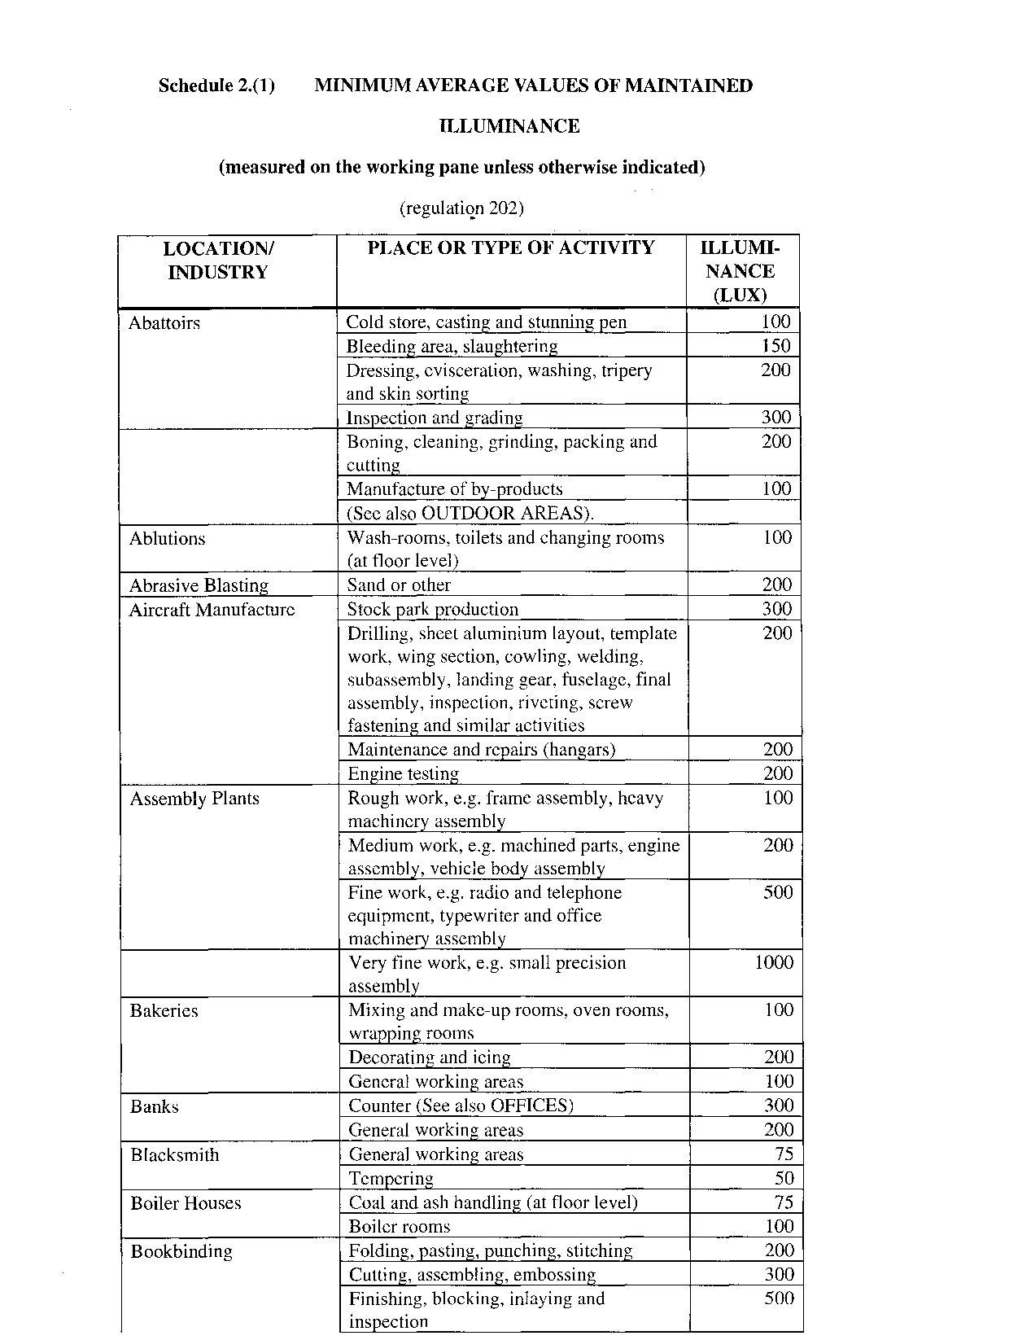

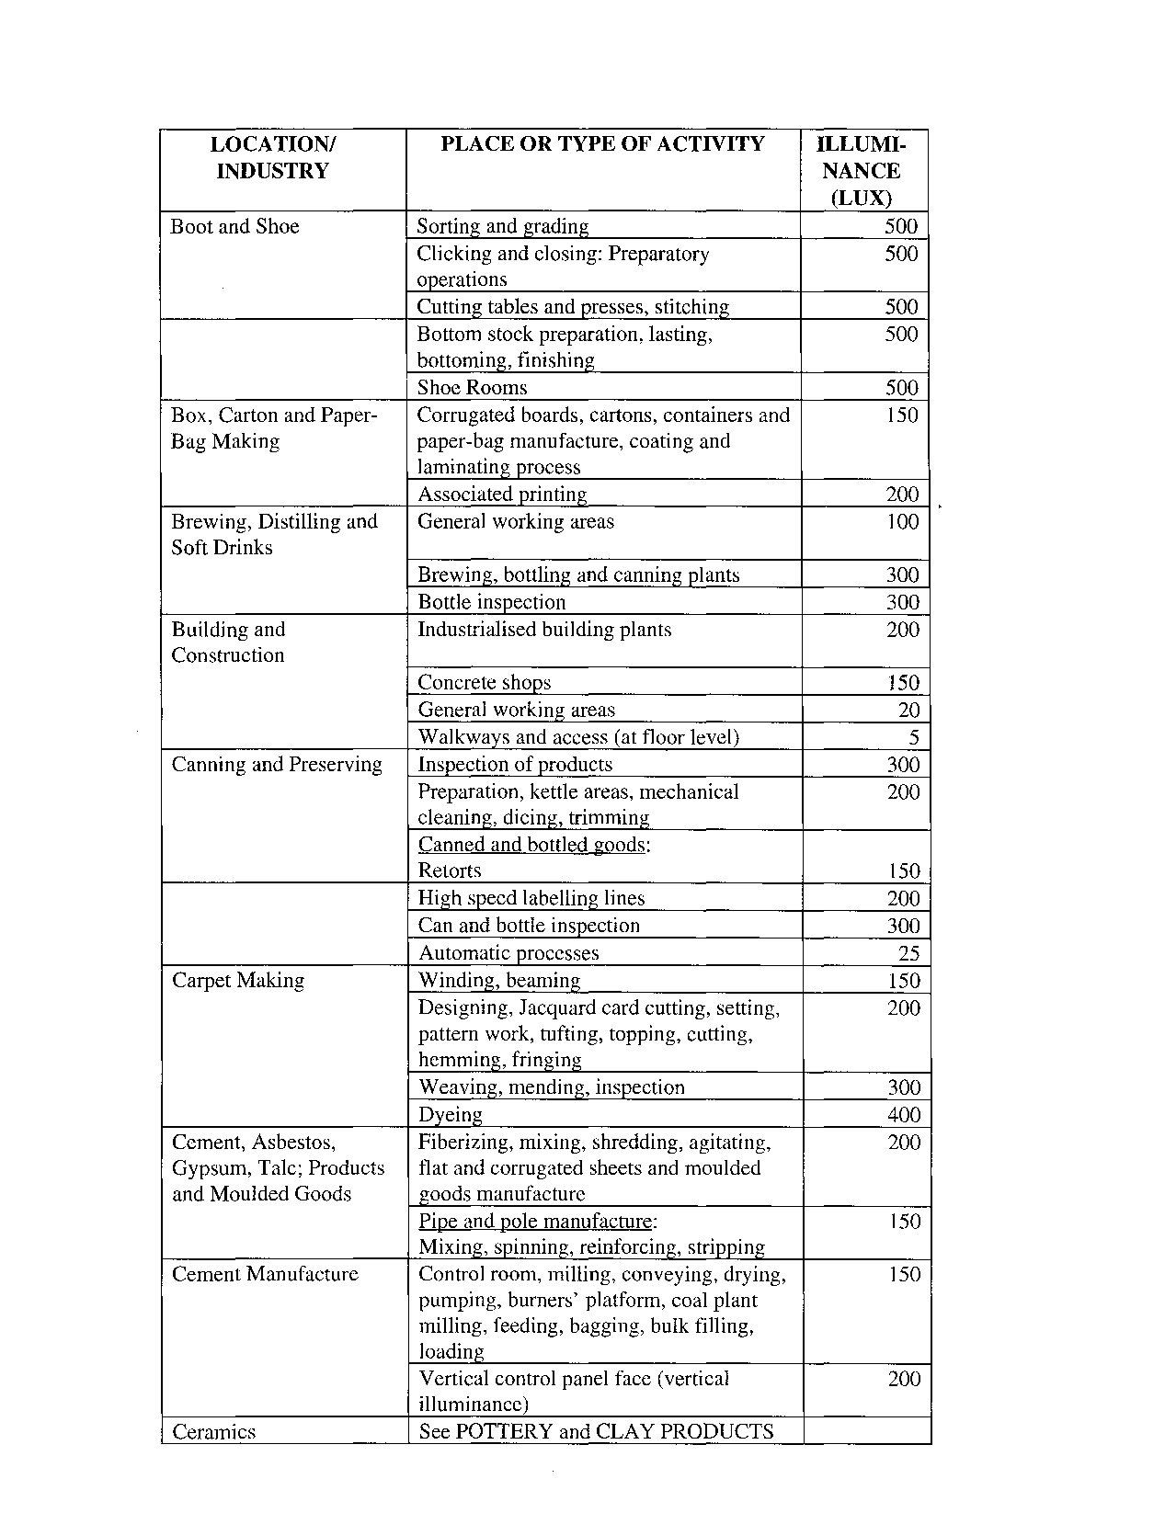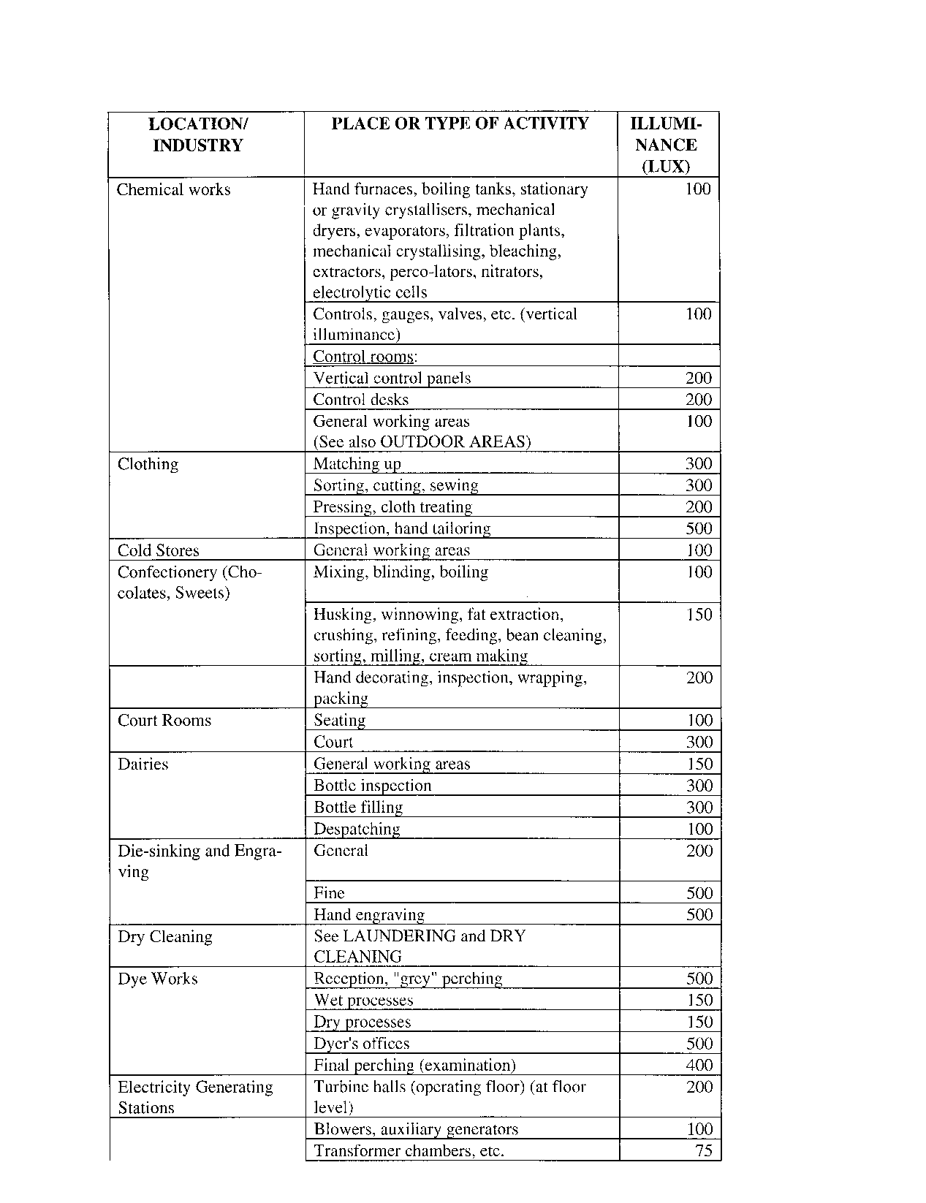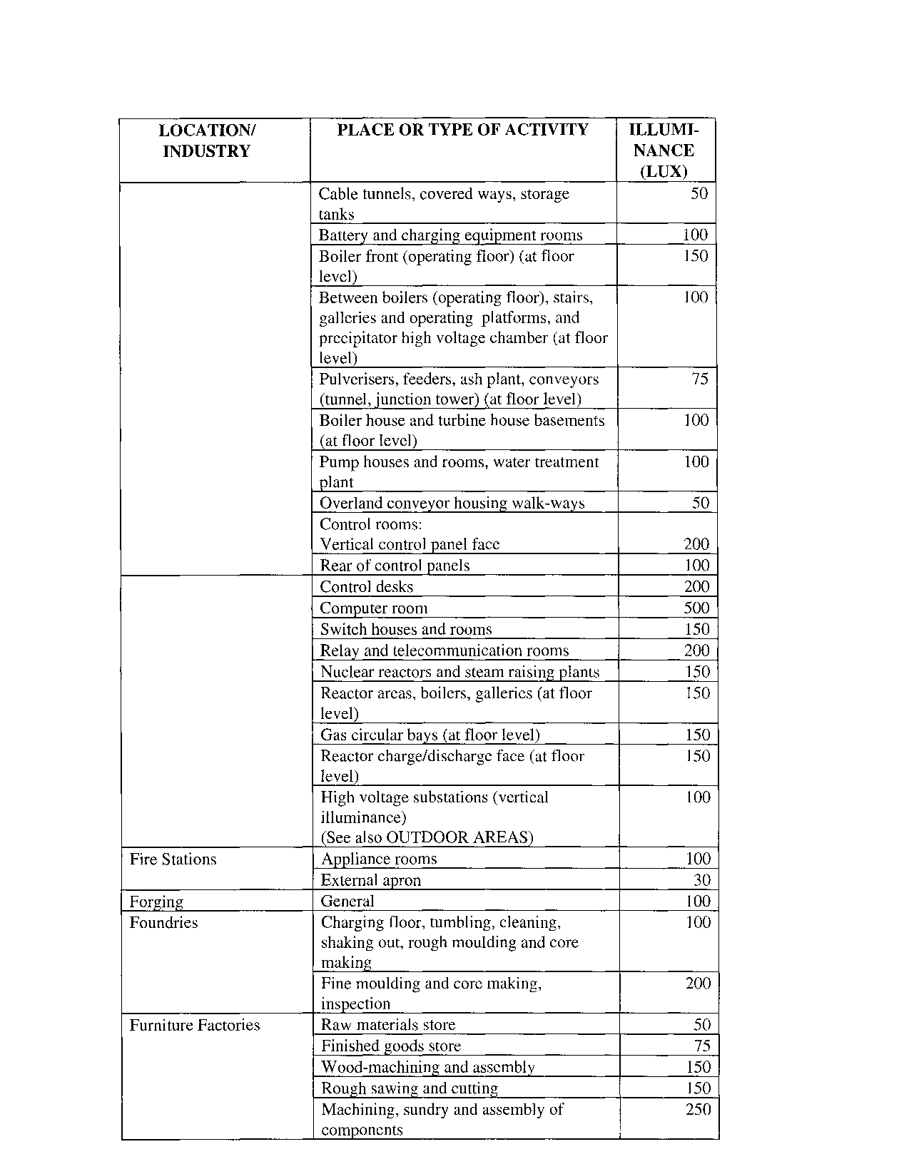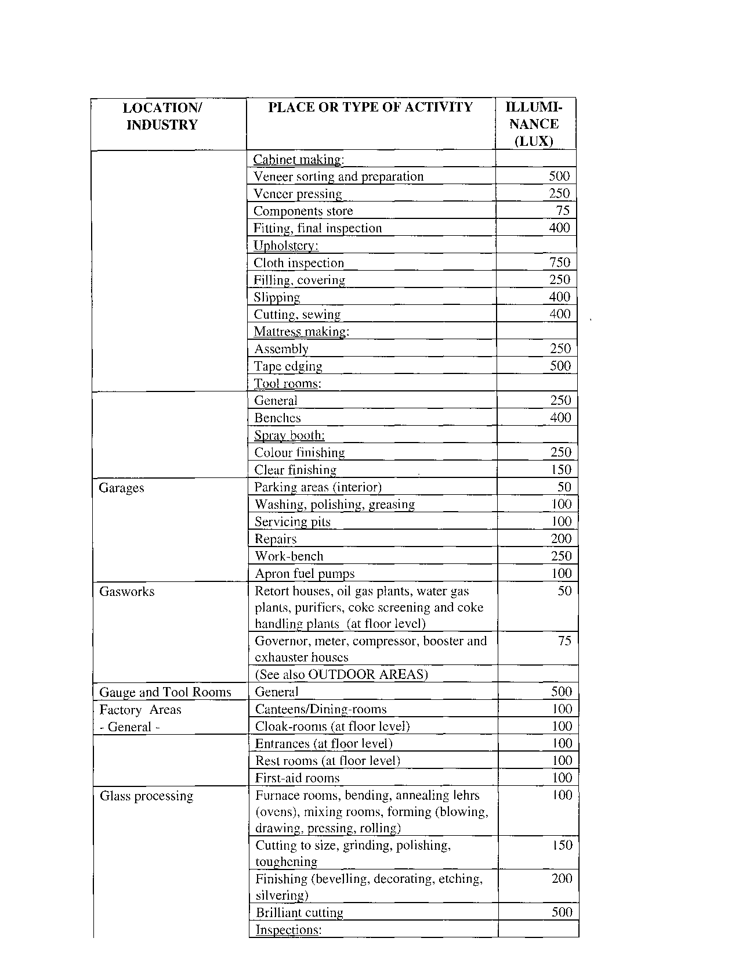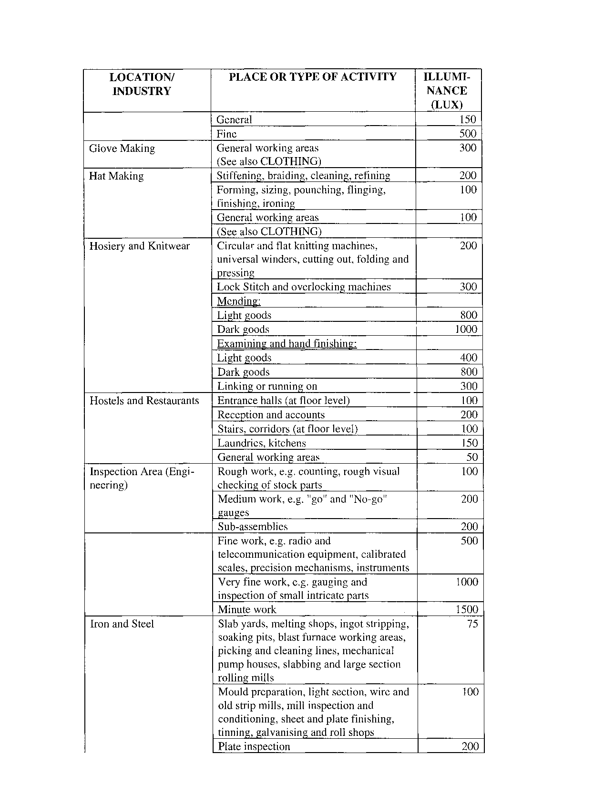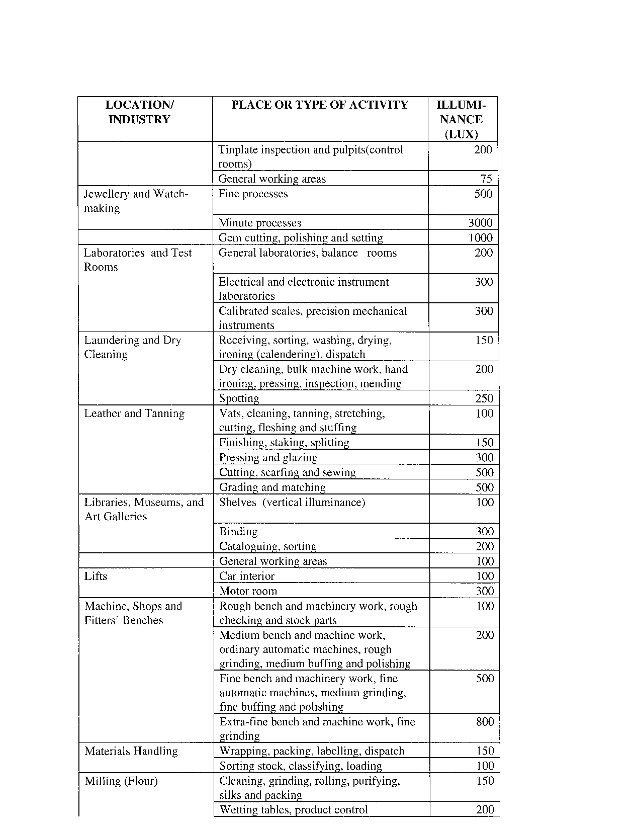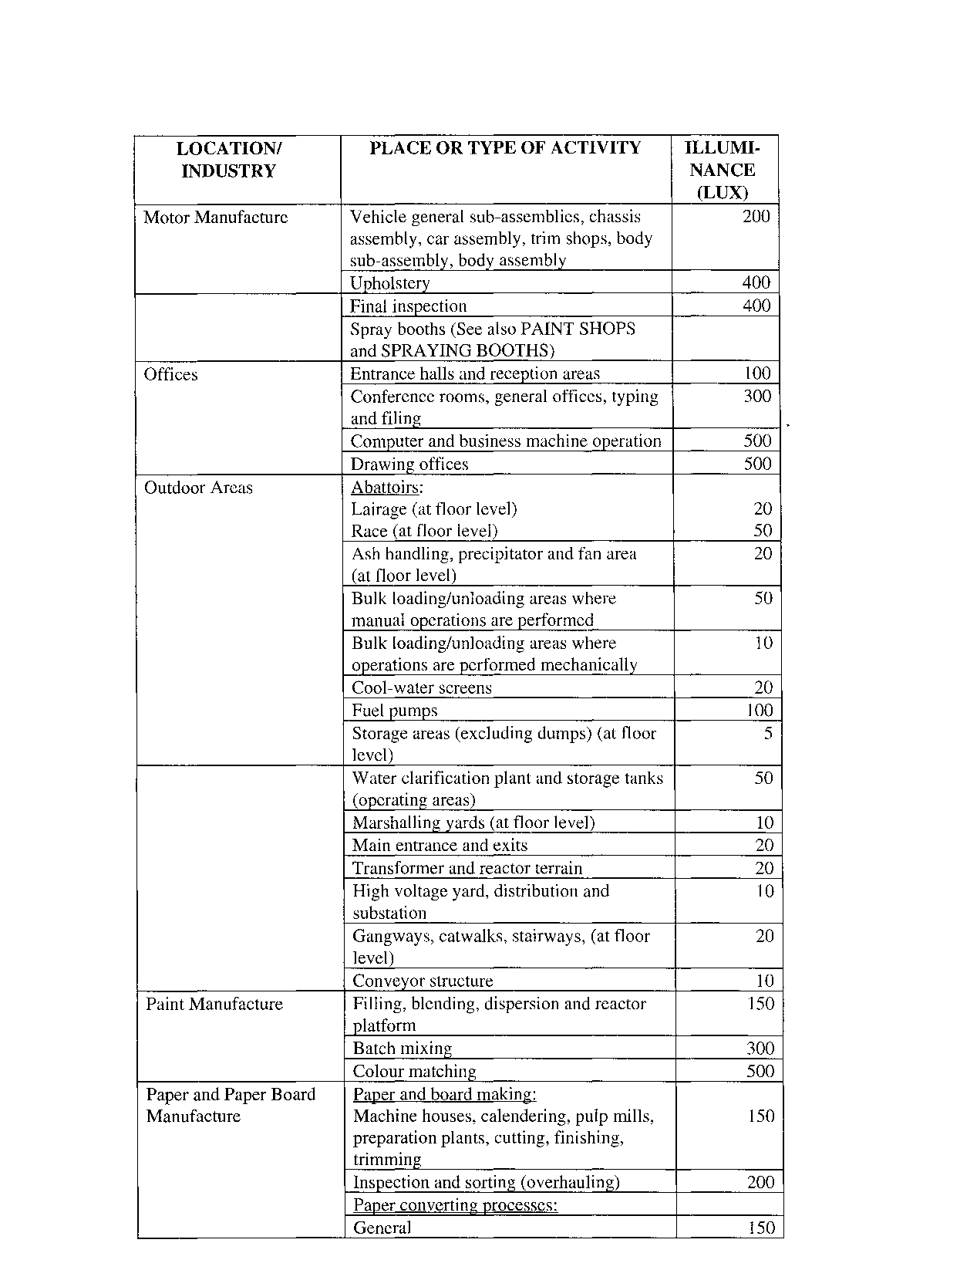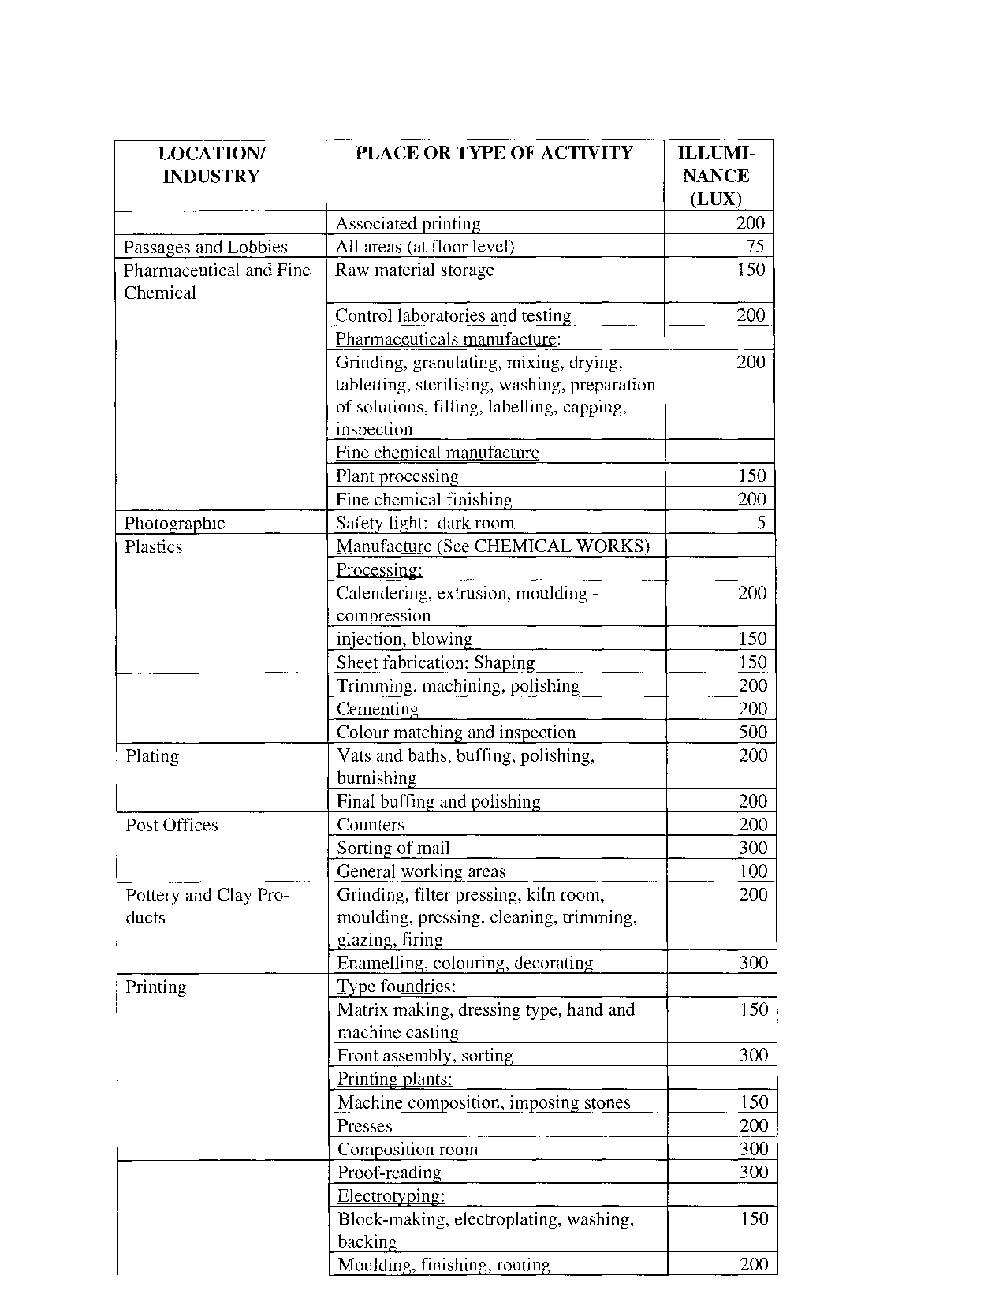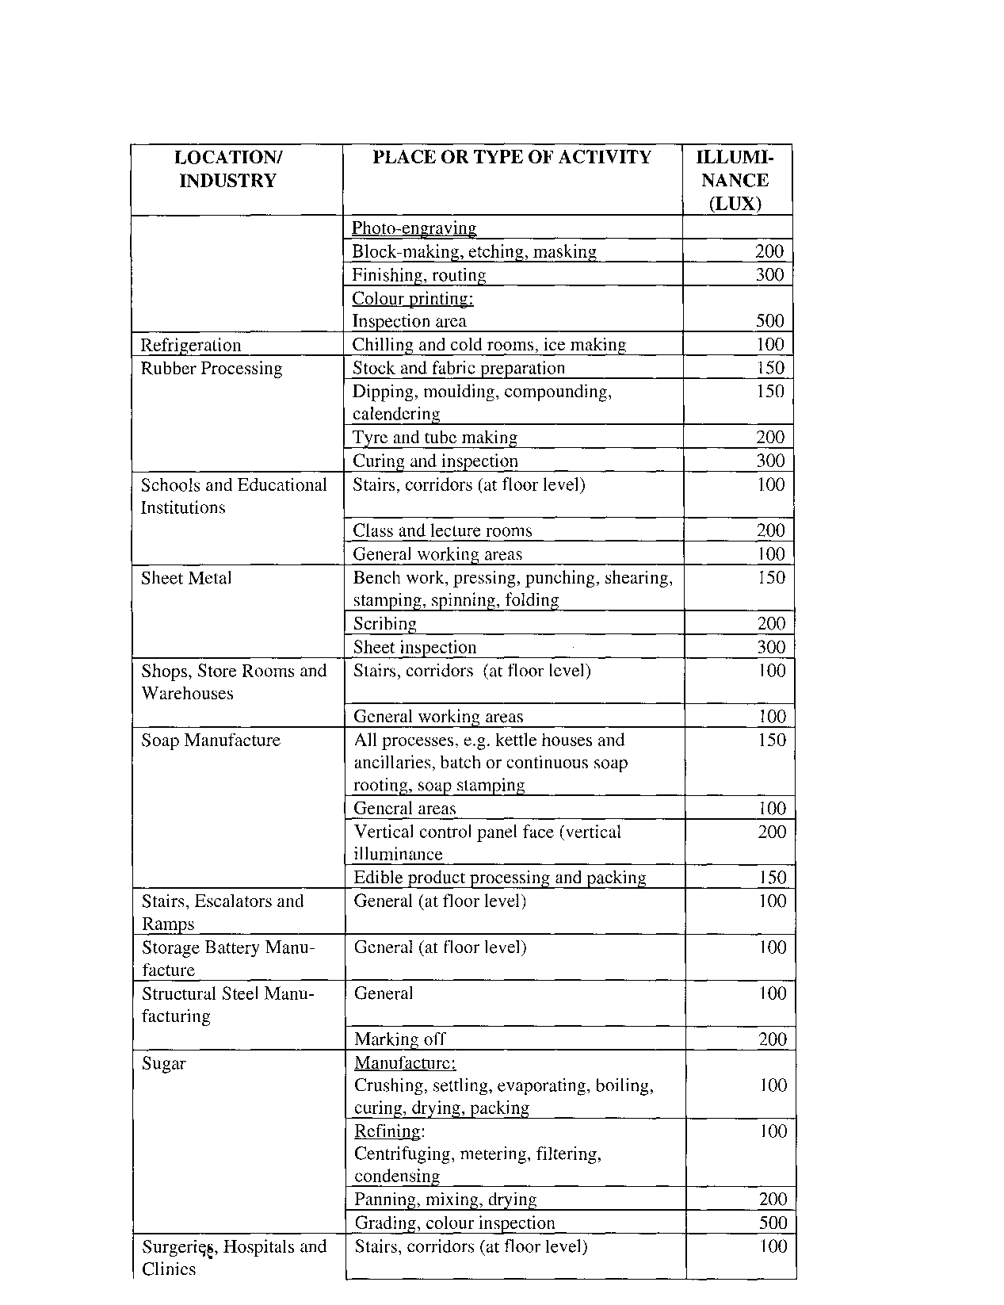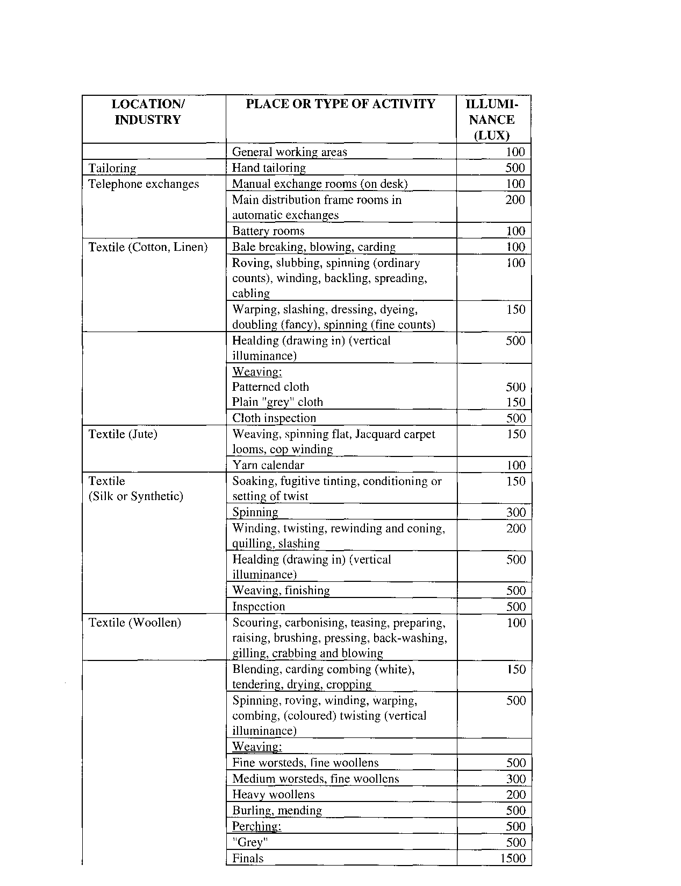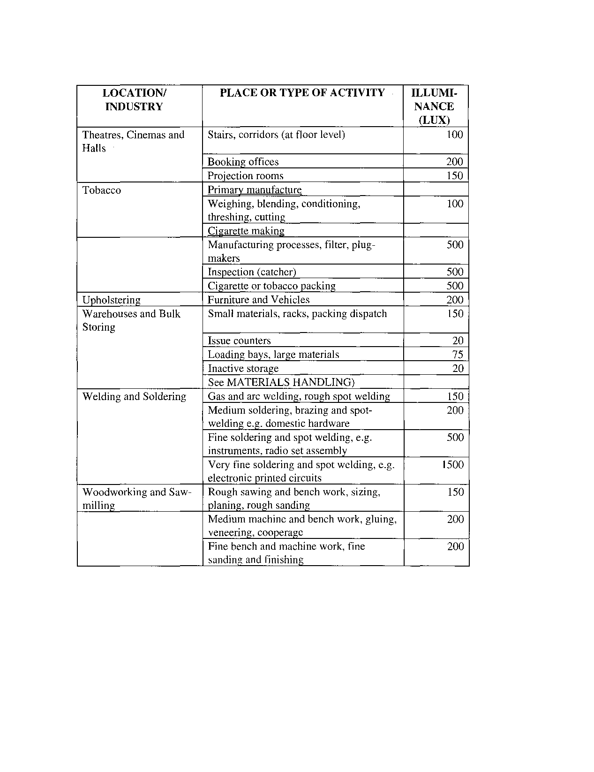

Schedule 3(1)

DIVING REGULATIONS

**Interpretation of terms**

**1**. In this Annexure, unless the context otherwise indicates -

“air” means respirable air and includes pure compressed air;

“approved inspection authority” means an inspection authority approved by the Chief Inspector for the verification, surveillance and certification of the design, construction, manufacture, test, inspection and repair of compression chambers and bells;

“bell” means a compartment either at ambient pressure (open bell) or pressurized (closed bell) by means of which a diver can be transported to and from the underwater work-site, which allows the diver access to the surrounding environment, and which is capable of being used as a refuge during diving operations;

“bottom time” means the total elapsed time, measured in minutes, from the time a descending diver leaves the surface of the water towards the underwater working place until such time the diver begins his or her final ascent;

“breathing mixture” means a respirable mixture of different gases that provides adequate oxygen to support life and does not cause detrimental physiological effects, such as excessive breathing resistance or impairment of neurological function;

“buddy line” means a line not exceeding five metres in length and with a breaking strength of not less than 500 N, which is used to securely connect two divers to each other during a dive;

“class I diver” means a diver who has been trained in all aspects of mixed gases, saturation and bell diving to a depth of not less than 100 metres;

“class II diver” means a diver trained in all aspects of air diving using scuba and surface air supply diving equipment to a depth not exceeding 50 metres;

“class III diver” means a diver trained in all aspects of air diving using scuba and surface air supply diving equipment to a depth not exceeding 30 metres without the use of a surface compression chamber;

“class IV diver” means a diver trained in all aspects of air diving using scuba to a depth not exceeding 30 metres, without the use of a surface compression chamber;

“compression chamber” means a pressure vessel for human occupation having internal dimensions sufficient to accommodate not less than one diver lying in a horizontal position as well as one other person, and which allows the entry or exit of personnel while the occupants are under pressure;

“compression chamber dive” means the simulation of an actual dive to specific depths by using a compression chamber;

“council” means the Council for Diving Operations (Hypobaric Operations) established in terms of these regulations;

“decompression stop” means a pause, calculated with the aid of decompression tables, which must be observed at a specific depth below the surface of the water during a diver’s ascent from the underwater working place, in order to release excess nitrogen or other inert gases absorbed by his or her body, and in respect of a compression chamber dive it has a corresponding meaning;

“designated medical practitioner” means a medical practitioner registered or authorised as such under the Medical and Dental Professions Act, 1993 (Act 21 of 1993), and designated under paragraph 4 as a medical practitioner able to establish whether or not a diver is fit to dive;

“dive” means a dive performed by a diver from the control point on the surface of the water to any point under the surface of the water, and back to the control point;

“diver” means an employee or a self-employed person, who performs underwater work, and who is registered as a diver in terms of this Annexure;

“divers logbook” means the logbook in the form set out in Appendix 1;

“diving mode” means a dive requiring scuba, surface-supplied air, or surface­ supplied mixed gases equipment, with related procedures and techniques;

“diving operation” means all activities of a diving team when prepararing for, during and after a dive;

[The word “preparing” is misspelt in the *Government Gazette*, as reproduced above.]

“diving operations record” means the record contemplated in paragraph 7 (2) (q);

“diving stage” means a suspended platform designed to carry one or more divers and used for lowering divers into the water and bringing them to the surface when underwater decompression is undertaken or standard diving dress is used;

“diving supervisor” means a person authorised as such in writing by the Chief Inspector, who has complete responsibility for a diving operation, including responsibility for the health and safety of all diving personnel, and who is registered as a diving supervisor in terms of these regulations;

“diving team” means the divers, standby divers, and diver support personnel involved in a diving operation, including the diving supervisor, line attendant, life-support technician and such other persons as are necessary to operate any machinery or equipment which may be required before, during and after a dive;

“diving time” means the time in minutes which elapses from the time when a diver dives from the surface of the water until he or she is again exposed to atmospheric pressure after a dive;

“dressed in” means fully equipped to dive and ready to enter the water, with all life support and communications equipment tested and at hand, but not necessarily with the helmet, face plate or face mask in place;

“gas” means any pure gas or mixture of gases, other than air, suitable for underwater breathing;

“in-date diver” means a diver who is the holder of a valid medical certificate of fitness in which he or she is certified fit to dive;

“learner diver” means any person registered as a learner diver in terms of this Annexure;

“life-line” means a line, or something similar, not less than ten millimetres in diameter and with a minimum breaking strength of 5 kN, one end of which is attached at the control point on the surface of the water to a substantial anchorage, and the other end of which is secured to the diver during a dive;

“life-support technician” means a person trained, to the satisfaction of the Chief Inspector, in the physics, physiology and medical aspects of supporting life in high pressure environments;

“line-attendant” means a person trained, to the satisfaction of the Chief Inspector, in the use of diving signals, life lines, service telephones and other service cables;

“medical certificate of fitness” means a certificate issued by a designated medical practitioner in terms of these regulations;

“medical examination” means a medical examination of a diver or a learner diver conducted by a designated medical practitioner;

“saturation dive” means a dive executed by a diver whose tissues are saturated with the inert gas in the breathing mixture so as to allow an extension of bottom time without additional decompression;

“scuba” means self-contained underwater breathing apparatus in which the supply of breathing mixture carried by the diver is independent of any other source;

“shot line” means a line of not less than 15 millimetres in diameter with a minimum breaking strength of 5 kN, one end of which is attached at the control point on the surface of the water and which extends to the underwater working place where the other end is attached or anchored, and along which the diver has to dive to the underwater working place and along which he or she has to return to the surface of the water;

“standard diving dress” means a heavy weight surface-supplied diving outfit for deep diving;

“stand-by diver” means an in-date diver who is fully qualified to dive to the maximum depth required by the particular diving operation with the aid of the diving equipment in use in the event of an emergency, and who is not prevented from diving by an excess of inert gas in his or her system;

“therapeutic recompression” means treatment of a diver for decompression sickness, usually in a hyperbaric chamber, in accordance with approved procedures;

“warning signal” means -

(a) by day, “flag A” as defined in the International Code of Signals; and

(b) by night, the lights as prescribed by the International Regulations for Preventing Collisions at Sea, 1983.

**Application of this Annexure**

**2**. (1) This Annexure shall apply to all, and to all persons engaged in, diving operations in, or the territorial waters of, Namibia.

(2) These regulations shall not apply to persons who do not use underwater breathing apparatus or a snorkel type apparatus.

**Training of divers**

**3**. (1) No person shall train another person to dive unless he or she has been approved as a training organization in terms of subparagraph (2).

(2) Any person who has at his or her disposal such staff, plant, equipment and other ancillary facilities as to enable him or her to offer the curriculum of instruction and training for learner divers determined by the council, may in writing apply to the Chief Inspector for approval as a training organization to train learner divers, and the Chief Inspector may, in consultation with the council, approve such application, subject to such conditions as he or she may impose.

(3) A learner diver shall -

(a) undergo underwater diving training for the periods prescribed in subparagraph (5) and in accordance with the curriculum and conditions of training determined by the council; and

(b) while diving, be under the personal supervision of a diving supervisor and be accompanied by a person registered as a diver in terms of paragraph 14: Provided that if the diving supervisor is satisfied that the learner diver is sufficiently experienced, the learner diver may be permitted to undertake dives, unaccompanied, to a diving depth of not more than 20 metres.

(4) A diving supervisor shall ensure that a learner diver, within 24 hours of completion of a dive performed by such learner diver, enters full particulars of such dive in the learner diver’s logbook and sign the entry, and the diving supervisor shall thereafter countersign the entry.

(5) A learner diver shall undergo underwater diving training of not less than -

(a) 35 hours bottom time, to depths not exceeding 50 metres, so as to qualify for registration as a class II diver;

(b) 20 hours bottom time, to depths not exceeding 30 metres, so as to qualify for registration as a class III diver;

(c) 15 hours bottom time, to depths not exceeding 30 metres, so as to qualify for registration as a class IV diver;

(6) No person shall be trained as a class I diver unless he or she has since his or her registration as a class II diver undergone not less than 50 hours of bottom time in diving operations, not less than 15 hours of which were undergone at depths greater than 20 metres.

(7) In order to qualify for registration as a class I diver, a diver shall undergo underwater diving training of not less than 50 hours bottom time at depths of up to not Jess than 100 metres below the surface.

(8) No person shall be registered as a class I, II, III, or IV diver unless he or she has attained a satisfactory standard of competence in respect of the additional matters set out in Appendix 2.

**Designated medical practitioners, medical examinations and medical certificates of fitness**

**4**. (1) The Chief Medical Officer of Occupational Health may designate medical practitioners to undertake the medical examination of divers or prospective divers: Provided that only medical practitioners who have completed a course in underwater medicine recognized by the Medical Board established by the Medical and Dental Professions Act, 1993 (Act 21 of 1993), shall be so designated.

(2) A designation in terms of subparagraph (1) shall lapse after a period of four years, unless the designated medical practitioner concerned, before the expiry of such period, furnishes proof that he or she has completed a refresher course in underwater medicine recognized by the Medical Board.

(3) A designated medical practitioner shall, if so requested by the Chief Medical Officer of Occupational Health -

(a) conduct a medical examination, including such tests as determined by the Chief Medical Officer of Occupational Health; and

(b) issue a medical certificate of fitness to the diver or learner diver based on the results of the medical examination, or endorse such certificate subsequent to each medical re-examination prescribed by subparagraph (4).

(4) A diver shall report for a medical examination by a designated medical practitioner not less than once every 12 months and the designated medical practitioner shall examine the diver in respect of such aspects as determined by the Chief Medical Officer of Occupational Health:Provided that when an examination of a specialized nature is required, the designated medical practitioner need not personally perform such examination.

(5) A medical certificate of fitness shall indicate -

(a) the name and the identity number of the person to whom it relates;

(b) the date of the medical examination;

(c) the date of any X-ray examination performed for the purpose of this Annexure;

(d) whether the person is considered medically fit to dive;

(e) any limitation on the diving or compression for which the person is considered fit;

(f) the period not exceeding 12 months for which the person is considered fit;

(g) the name, address and telephone number, and the registration number with the Medical Board of Namibia -

(i) of the designated medical practitioner issuing the certificate, as well as the year during which he or she last attended a course in underwater medicine; and

(ii) of the medical practitioner who performed the examination of a specialized nature contemplated in subparagraph (4); and

(h) the signature of the medical practitioner issuing the certificate.

(6) If, on account of indisposition or injury, a diver has been unfit to dive for a period of 14 days or more, he or she shall not participate in diving, and no person shall require or permit him or her to participate in diving, unless he or she furnishes the employer with a medical certificate indicating the nature of his or her indisposition or injury and in which certificate a medical practitioner certifies that the diver has recovered from such indisposition or injury: Provided that if in the opinion of the diving supervisor the indisposition or injury of a diver is of such a nature as to make an examination by a designated medical practitioner desirable, such diver shall not participate in diving work until a designated medical practitioner has certified that he or she is fit for diving.

(7) If the medical examination of a diver is required in terms of this paragraph, his or her employer shall be responsible for the arrangements and costs connected with such examination.

(8) If a medical certificate of fitness is lost or destroyed, the learner diver or diver concerned shall re-submit himself or herself for a medical examination in terms of subparagraph (3).

**Diving supervisor**

**5**. (1) Unless an employer is a diving supervisor and personally takes charge of all diving operations performed by him or her, he or she shall in writing designate one or more persons to exercising control of the employer’s diving operations and shall ensure that this Annexure are complied with.

(2) A diving supervisor or a person designated under subparagraph (1) shall -

(a) at any time be available to deal with emergencies at the site where diving operations are carried out;

(b) not dive while he or she is supervising other divers;

(c) if another supervisor is not available when he or she has to dive for purposes of inspection and planning, ensure that a diver acts as supervisor for the duration of the dive; or

(d) not act as a standby diver unless another supervisor is available to take charge of the diving operation: Provided that he or she may act as a standby diver for diving operations undertaken to a depth of not more than 30 metres, or for dives not requiring decompression stops.

**Operations manual**

**6**. (1) An employer shall ensure that an operations manual is made available to each diving team at the diving location before commencement of a diving operation.

(2) An operations manual shall contain provisions for the safety and health of employees, including -

(a) the assignments and responsibilities of each diving team member in respect of each diving mode used;

(b) safety procedures and checklists for each diving mode used;

(c) procedures and checklists for the use, checking and maintenance of equipment for each diving mode used;

(d) emergency procedures in the case of -

(i) fire;

(ii) equipment failure; or

(iii) adverse changes in environmental conditions;

(e) procedures for -

(i) emergency signalling;

(ii) emergency assistance under water and on the surface;

(iii) decompression, including therapeutic recompression and decompression, and the availability of compression chambers for such purposes;

(iv) first aid;

(v) obtaining medical assistance with specific reference to the need for consultation with a designated medical practitioner, if decompression sickness should occur;

(vi) requesting assistance from emergency services, including advance liaison with such services, if appropriate;

(vii) emergency evacuation of the work-site; and

(viii) the provision of emergency supplies.

**Control of diving operations**

**7**. (1) Prior to commencing diving operations, an employer shall ensure that -

(a) the personnel necessary for rendering assistance to a diver, as well as those members of the personnel who may be required in case of an emergency, are on standby and that all equipment which may be required for use in case of an emergency, is ready for immediate use;

(b) persons who have been trained to operate compression chambers take charge of such chambers and remain on duty while such chambers are in use and are available while diving operations are in progress;

(c) a diver who participates in a dive, is provided with all the necessary diving equipment in order to safeguard his or her health and safety;

(d) a diver who participates in a dive, is, according to his or her logbook, qualified in the use of the diving equipment concerned;

(e) all diving equipment used for any diving operation is checked and tested before use by the diving team in order to determine whether it is in good working order;

(f) the maximum bottom time of a dive, the decompression schedule and the technique to be used in any diving operation are made known to and are understood by the diving team; and

(g) the diving team has been systematically and thoroughly informed and trained with regard to the procedures to be followed in the case of emergency.

(2) During the performance of diving operations, the employer shall ensure that -

(a) strict discipline is continuously maintained, that the diving operations are conducted safely and meticulously in accordance with the directions contained in this Annexure and with the instructions of the diving supervisor, and that the bottom time and decompression schedule referred to in subparagraph (1)(t), are strictly adhered to;

(b) in respect of any dive exceeding ten metres, the following persons are, and shall remain, on duty at the control point on the surface of the water:

(i) A standby diver ready to dive: Provided that if two divers are in the water at the same time and are near enough to each other to communicate with, and to render assistance to, each other in the case of an emergency, the one diver may be considered to be a standby diver in respect of the other: Provided further that if a diving bell is used, the standby diver shall descend in the bell to the depth from which work is carried out and shall remain in the bell so as to be able to immediately render assistance to the diver working from the bell;

(ii) a line attendant, if a line is used;

(iii) such other persons as are necessary, to the satisfaction of the diving supervisor, to operate any machinery or other equipment which may be required during the diving operation;

(iv) not less than one person who is qualified to render first-aid and who has a thorough knowledge of the first-aid treatment to be applied, and the equipment to be used, in the case of a drowning or of decompression sickness, or any other ailment associated with diving operations; and

(v) a person who has qualified as a life support technician when saturation or bell diving is undertaken;

(c) only in-date divers participate in diving;

(d) no diver who on account of indisposition or physical or mental infirmity considers himself or herself unfit to participate in diving, or who is considered unfit by the diving supervisor to dive, to participate in any diving operation, or to be permitted or required to participate in any diving;

(e) life-lines, buddy-lines and surface-markers are used: Provided that if the diving supervisor considers the use of such equipment hazardous or impracticable, he or she may dispense with the use thereof;

(f) a shot line is used when the diver is not lowered to the underwater working place by means of a diving bell, unless the use of a shot line is impracticable;

(g) each diver is able to communicate with the surface control point, except if a buddy line is used as contemplated in paragraph (e), in which case not less than one of the divers shall be able to communicate with the surface control point;

(h) for diving to or at a depth exceeding 50 metres, a diving stage is used, except when a bell is provided: Provided that a bell shall be used for all diving operations at a depth exceeding 70 metres, except when a diver uses a standard diving dress or dives in a physically confined space: Provided further that a closed bell shall be used for all diving operations at a depth exceeding 100 metres;

(i) no diver undertakes a dive -

(i) in contravention of any condition or restriction imposed on him or her by this Annexure; and

(ii) unless he or she is fully conversant with such machinery or the use of such tools and equipment as may be required in the performance of his or her work underwater;

(j) no diver undertakes a dive to a depth greater than that for which the equipment he or she uses is suitable;

(k) no diver dives to a depth greater that for which he or she is qualified: Provided that a class III or IV diver may undertake dives to a depth not exceeding 50 metres if the decompression time does not exceed 20 minutes;

(1) no diver uses air for any diving operation at a depth exceeding 50 metres, except if such use is for therapeutic or training purposes in a compression chamber;

(m) for all diving modes, a sufficient supply of the appropriate breathing mixture is readily available at the required pressure to provide for all the activities of the diving team for the duration of the diving operation;

(n) all reasonable steps are taken to ensure that pure air is supplied to divers and that such air complies with international recognized standards;

(o) if a diving operation is to be carried out at night -

(i) a lamp or other device is attached to the diver to indicate his or her position when he or she is on the surface, and

(ii) the place on the surface or the bell from which the diving is carried out, is illuminated: Provided that if such illumination is undesirable, it may be switched off during the diving operation;

(p) depth measuring devices are used and, if reasonable, such devices are suitable for monitoring from the surface;

(q) a record of every diving operation performed is kept, indicating the names of the divers, the diving times, bottom times, depths, decompression schedules, breathing mixtures, and diving equipment used, and any decompression sickness or other incident relevant to the health and safety of the divers that occurred during the diving operation;

(r) the information contemplated in paragraph (q) is entered in the diving operations record within 24 hours of completion of the diving operation, is available to an inspector on request and is kept for a period of two years after the last entry;

(s) every diver, within 24 hours of completion of a dive, enters full particulars of the dive in his or her diver’s logbook, and that the entry is signed by the diver and countersigned by the diving supervisor;

(t) the appropriate warning signals are given and the appropriate signs are prominently displayed while diving is in progress:

(u) a boat is kept readily available for rescue purposes, if the possibility exists that the diver may, during the course of a dive, surface away from the control point; and

(v) all other reasonable safety measures are taken which, in the opinion of the diving supervisor, may be necessary for the safe execution of any particular diving operation, and that the safety measures are strictly adhered to.

**Decompression**

**8**. An employer shall ensure that -

(a) no articles likely to cause a fire or an explosion are taken into, or stored in, a compression chamber;

(b) a diver does not perform, or is required to perform, a dive unless decompression is performed in accordance with the techniques, decompression tables and decompression times determined by the diving supervisor;

(c) a complete copy of the decompression tables contemplated in subparagraph (b), together with the relevant explanatory procedures are available for the information of the diving team on the site where diving operations are being performed: Provided that abstracts from the decompression tables may be made available for the information of the diving team: Provided further that the employer shall produce the appropriate identifiable decompression tables when required to do so by an inspector; and

(d) a record, which shall be open for inspection by an inspector, is kept of all incidents of decompression illness, and shall ensure that all such cases are investigated.

**Compression chambers and bells**

**9**. (1) No person shall use, or permit the use of, any compression chamber or bell unless he or she is in possession of a certificate of construction issued by the manufacturer in which certificate it is certified that the compression chamber or bell has been designed, constructed and tested in accordance with internationally recognized standards and that the relevant code of practice has been approved by the approved inspection authority: Provided that such certificate of construction shall be countersigned by the approved inspection authority as evidence that the design of such vessel has been verified and that it has been constructed and tested in accordance with the relevant code of practice.

(2) An employer shall ensure that a compression chamber -

(a) has an uncontaminated supply of breathing mixture, sufficient for one complete therapeutic compression treatment, available in storage cylinders or other suitable vessels at the compression chamber;

(b) is equipped with pressure relief devices to prevent the internal pressure in any compartment from rising in excess of ten per cent above the maximum intended working pressure, and which are designed to automatically close when the internal pressure returns to the intended working pressure after pressure relief;

(c) is equipped with a breathing point for each occupant for ready use during a compression operation as well as suitable means for avoiding oxygen build-up in the chamber;

(d) is provided with portholes of sufficient size to enable any person which may be in the chamber to be observed from outside;

(e) is equipped for adequate humidity control, heating, cooling and illumination of the interior;

(f) is equipped with the necessary valves, gauges and other fittings to indicate and control the internal pressures of each compartment from outside the chamber;

(g) is provided with a two-way radio communication system between persons outside and persons inside the chamber; and

(h) is designed to limit the risk of the outbreak of fire, and has fire extinguishing equipment on board.

(3) An employer shall ensure that a compression chamber -

(a) has a design pressure rating equivalent to the maximum depth of the diving operation;

(b) is designed to prevent opening under pressure and, if necessary, is equipped with interlocks for this purpose;

(c) is equipped for operating all installed locking devices from both sides of a closed hatch;

(d) is so designed that, if a closed bell is used, a person can transfer under pressure from the compression chamber to the bell, or from the bell to the compression chamber; and

(e) is fitted with adequate equipment and reserve facilities to maintain, and to supply, the correct breathing mixture in respect of or to every person inside the chamber.

(4) An employer shall ensure that a closed diving bell -

(a) is equipped in such a manner that a diver is able to enter and leave the bell without difficulty;

(b) is equipped with doors which act as pressure seals and which may be opened from either side;

(c) is equipped with such valves, gauges and other fittings made of suitable materials, as are necessary to indicate and control the pressure within the bell and to indicate to the occupants and to the diving supervisor the external pressure on the bell;

(d) is fitted with equipment and reserve facilities which are adequate for supplying the correct breathing mixture to persons inside, or working from, the bell;

(e) is fitted with an oral communication system which enables contact to be maintained between a diver who leaves the bell, a person remaining inside the bell and the place on the surface from which the diving operation is conducted;

(f) is fitted with equipment for lighting and heating the bell;

(g) contains adequate first aid facilities and is fitted with lifting equipment by which an unconscious or injured diver can be hoisted into the bell by a person inside the bell;

(h) has the necessary equipment so that -

(i) signals can be sent through the water in such a manner that the bell can easily be located in an emergency; and

(ii) the lives of persons trapped inside the bell can be sustained for not less than 24 hours;

(i) is used in conjunction with lifting gear which enables the bell to, without excessive lateral, vertical rotational movement, be lowered to the depth from which the diving operations are to be conducted, or to be maintained in its position, or to be raised; and

(j) is provided with equipment by which it can be brought to the surface without using the main lifting gear: Provided that if such equipment involves the shedding of weights, such weights shall be capable of being shed by a person inside the bell and the equipment shall be so designed as to prevent accidental shedding of such weights.

(5) An employer shall, in consultation with the manufacturer or supplier of the compression chamber or bell, formulate a scheme for the systematic inspection and testing of the compression chamber or bell, so as to ensure proper maintenance thereof as provided for in the Lloyds Register of Shipping Rules and Regulations for the Construction and Classification of Submersibles and Diving Systems.

(6) Before conducting any repair to a compression chamber or a bell, the employer shall consult the manufacturer or supplier and conduct such repairs only under the supervision of the manufacturer’s or supplier’s representative, or of a competent authority.

(7) The manager shall not use the repaired compression chamber or bell unless he or she is in possession of a certificate issued by the manufacturer, supplier or competent authority certifying that after executing the repairs, the compression chamber or bell, as the case may be, has been tested in every respect and considered fit for use as a compression chamber or bell, as the case may be, as provided for in the Lloyds Register of Shipping Rules and Regulations for the Construction and Classification of Submersibles and Diving Systems.

**Plant and equipment**

**10**. (1) An employer shall ensure that -

(a) all diving equipment or machinery which is used in connection with any diving operation or underwater work, is maintained in good working order and is used properly and in accordance with the manufacturer’s instructions;

(b) plant and equipment necessary for divers to safely enter and leave the water is available during diving operations;

(c) a compression chamber with all necessary ancillary equipment is available for immediate use whenever diving takes place -

(i) at a depth exceeding 50 metres;

(ii) at a depth exceeding ten metres but not exceeding 50 metres, if the routine decompression time exceeds 20 minutes; or

(iii) at a depth exceeding ten metres but not exceeding 50 metres, if the routine decompression time is 20 minutes or less, and effective arrangements have not been made for a diver requiring therapeutic recompression to be brought to a suitable chamber within two hours from the time when the need for recompression is identified;

(2) When diving operations are conducted at depths exceeding 100 metres, the employer shall submit to the council -

(a) the qualifications and experience of the divers and members of the diving team; and

(b) particulars of the equipment and machinery intended to be deployed for the diving operations.

(3) The diving operations shall be undertaken only under such conditions as the council may specify.

**Council for diving operations (hypobaric operations)**

**11**. (1) The Minister shall, in consultation with the Labour Advisory Council, establish a council to be known as the Council for Diving Operations, and shall in writing appoint as members of the council -

(a) one person, who shall be the chairperson of the council;

(b) one person nominated by the Minister of Health and Social Services, which person shall be a medical practitioner;

(c) one person nominated by the Minister of Mines and Energy,

which appointments shall be made subject to the Public Service Act, 1995 (Act 13 of 1995), if the person so appointed is a member of the Public Service;

(d) one person nominated by the employers’ organizations;

(e) one person nominated by the trade unions; and

(f) two -

(i) diving supervisors; and

(ii) divers,

nominated by the council:

Provided that the Minister may, subject to such conditions as he or she may determine, authorise the council to co-opt persons who have knowledge of the matters dealt with by the council, to assist the council in its activities.

(2) The Minister shall appoint the members of the council for such period as he or she may, at the time of appointment, determine: Provided that the Minister may at any time withdraw the appointment of a member and appoint a new member in the place of the member whose appointment has been withdrawn.

(3) The council shall, at the request of the Minister -

(a) make recommendations and submit reports to the Minister regarding any matter to which these regulations relate;

(b) advise on the registration of training organizations;

(c) formulate and implement a curriculum of training and instructions;

(d) designate persons to prepare the examination papers for the examinations for divers and diving supervisors required by the council, and to mark the answers;

(e) designate persons to moderate the examination papers referred to in paragraph (d);

(f) make rules for the conduct of examinations, and syllabi for such examinations, as circumstances may require;

(g) advise the Minister regarding any matter referred to the council by the Minister;

(h) perform such other functions as may be requested by the Minister; and

(i) conduct its work in accordance with the instructions and rules of conduct determined by the Minister.

(4) A person affected by any decision of the council may appeal against such decision to the Minister, who may -

(a) dismiss the appeal and confirm the decision of the council; or

(b) allow the appeal and -

(i) refer the matter back to the council with instructions to further investigate or reconsider the issue, and make a decision; or

(ii) make a decision replacing the decision of the council.

(5) An appeal to the Minister in terms of subparagraph (4) shall be made in writing and shall -

(a) be lodged with the Minister and with the chairperson of the council within a period of 30 days after the decision taken by the council and which is appealed against;

(b) state the full names and physical address of the appellant;

(c) set out in full the decision taken by the council against which is appealed, and the date of such decision;

(d) clearly and specifically state the grounds upon which the appeal is based; and

(e) be signed by the appellant.

**Rules, syllabi and examinations**

**12**. The persons designated in terms of regulation 11 (3) (d) shall not less than three months before an examination is conducted, inform the Minister in writing of the place and time of such examination.

**Registration as learner diver**

**13**. Any person who satisfies the council that -

(a) he or she has reached the age of 18 years;

(b) he or she is in possession of a valid medical certificate of fitness acceptable to the council, in which he or she is certified as medically fit to participate in diving;

(c) if he or she is a minor, he or she has the written consent of his or her parent or guardian to register as a learner diver; and

(d) he or she has been admitted to an approved diving school,

shall be registered as a learner diver by the council and be furnished with a certificate of registration which certificate shall be valid for a period of one year and which may be renewed by the council, at its discretion, for further periods of one year at a time.

**Registration as a diver**

**14**. Any person who satisfies the council that -

(a) he or she has received appropriate training in diving operations with an organization approved for diver training as contemplated in paragraph 3;

(b) he or she has passed the relevant examination for divers; and

(c) he or she is in possession of a valid medical certificate of fitness acceptable to the council, in which he or she is certified fit to participate in diving,

shall be registered as a class I, II, III or IV diver, as the case may be, and the council shall furnish him or her with a certificate of registration subject to such conditions or restrictions as the council may consider necessary.

**Registration as a diving supervisor**

**15**. Any person who satisfies the council that -

(a) he or she has acquired not less than two years’ experience in all aspects of diving operations after having been registered as either a class I or a class II diver, or not less than one year’s of such experience after having been registered as either a class III or a class IV diver; and

(b) he or she has passed the relevant examination for diving supervisors,

shall be registered by the council as a class I, II, III or IV diving supervisor, as the case may be, and the council shall furnish such person with a certificate of registration subject to such conditions or restrictions as he or she may consider necessary.

**Applications**

**16**. Application for the registration as a learner diver, a diver or a diving supervisor, as the case may be, or for the re-issue of a certificate referred to in paragraph 15 that has been lost, damaged or destroyed, shall be made to, and in the form and manner determined by, the council.

**Fees payable**

**17**. The fees payable in respect of the registration as a learner diver, a · diver or a diving supervisor, as the case may be, or for the re-issue of any certificate referred to in paragraph 15, shall from time to time be determined by the Minister, in consultation with the Minister of Finance, by notice in the *Gazette.*

**Underwater Mining**

**18**. A manager of a mine where underwater mining is conducted, shall, to the satisfaction of the council, determine a procedure for the safe conduct of diving operations, detailing the procedure to be followed and precautions to be taken to ensure the safety and health of employees engaged in diving operations in accordance with this Annexure.

**Offences and penalties**

**19**. Any person who contravenes, or fails to comply with, any provision of paragraph 3, 4, 5, 6, 7, 8, 9, 10 or 18, shall be guilty of an on conviction be liable to a fine not exceeding N$ 2000 or to imprisonment for a period not exceeding six months or to both such fine and such imprisonment.

APPENDIX 1

To view content without printing, scroll down.

To print at full scale (A4), double-click the icon below.



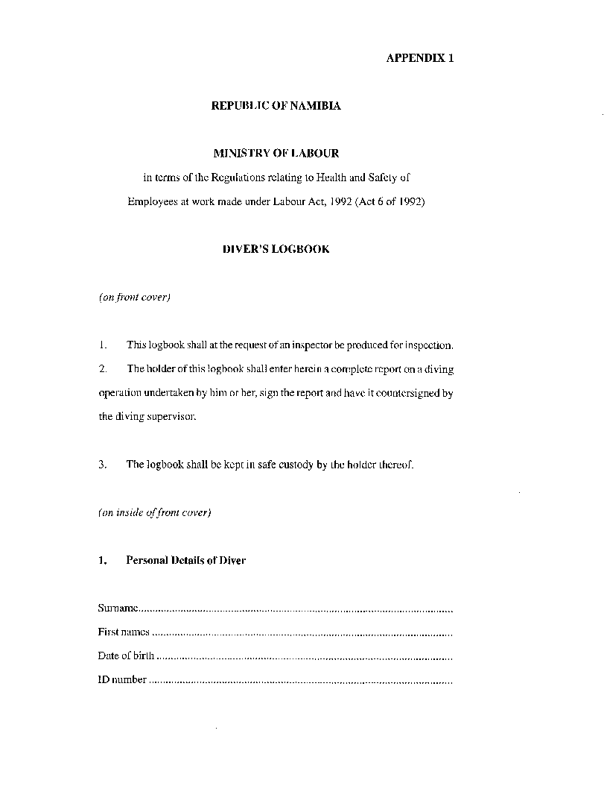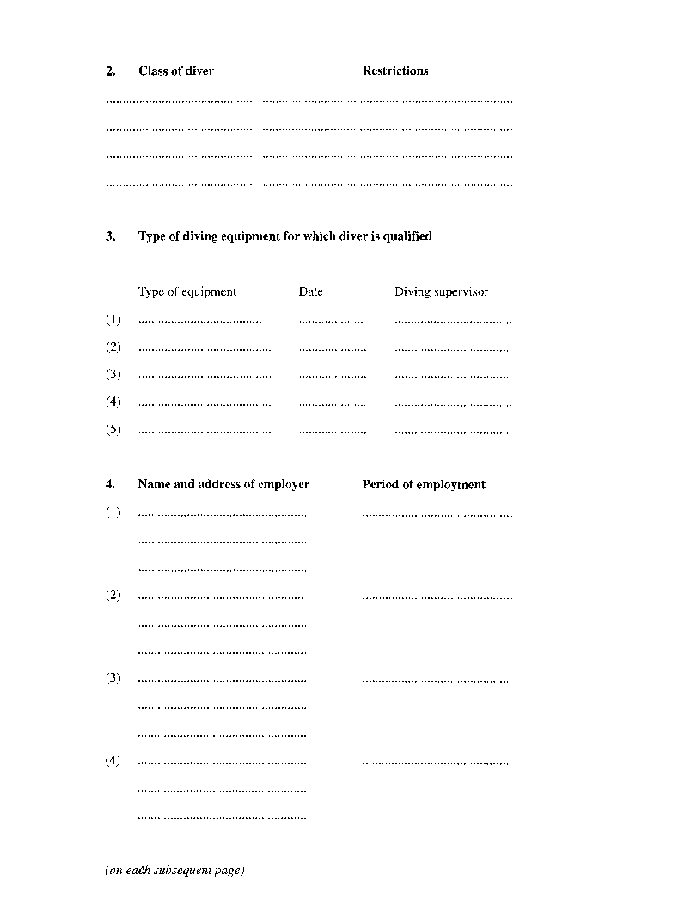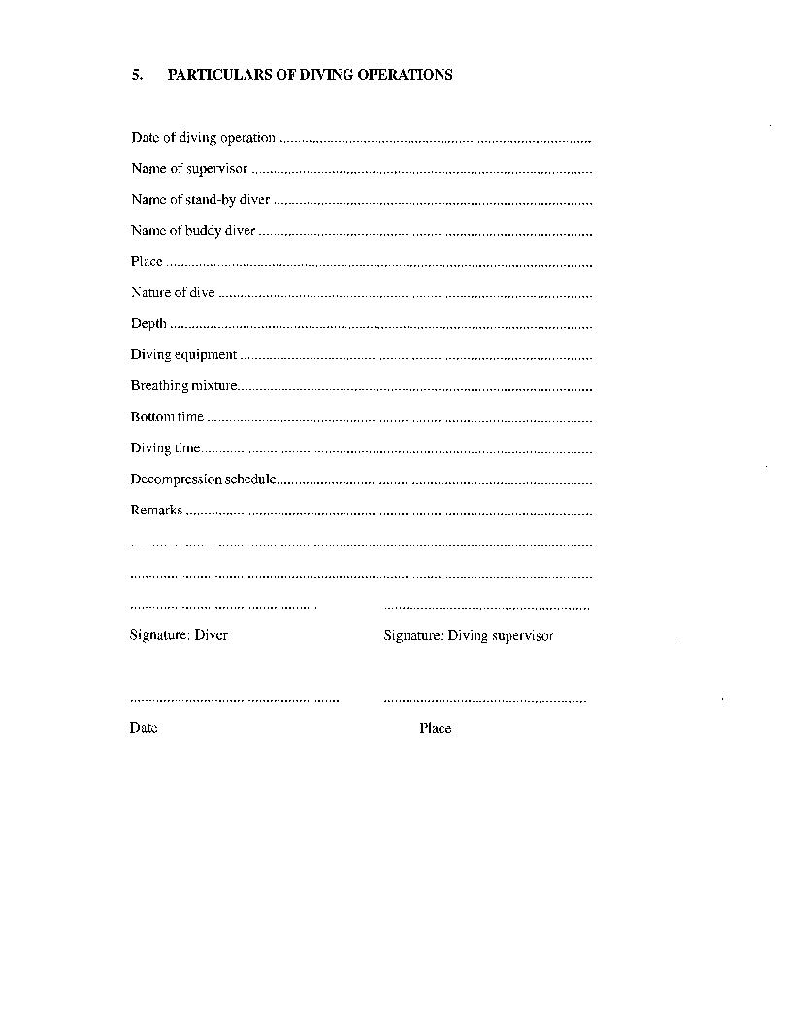

APPENDIX 2

ADDITIONAL MATTERS RELATING TO SATISFACTORY   
STANDARD OF COMPETENCE

(Diving Regulations)

1. Additional matters in respect of which a CLASS I diver has to attain a satisfactory standard of competence are the following:

(a) The theory of mixed gases, saturation and bell diving;

(b) gases and gas systems;

(c) diving safely and competently to depths exceeding 50 metre from a diving bell;

(d) the use of diver communication systems appropriate to mixed gas, saturation and bell diving;

(e) diving bell operation, lock-out and re-entry procedures, transferring to surface compression chamber, recompression on mixed gas, decompression and decompression tables appropriate to mixed gas, saturation and bell diving;

(f) emergency procedures for mixed gas, saturation and bell diving;

(g) first aid appropriate to emergencies arising in mixed gas, saturation and bell diving;

(h) relevant legislation and guidance; and

(i) appropriate practical training for deep diving.

2. Matters in respect of which a class II diver has to attain a satisfactory standard of competence are the following:

(a) The theory of air diving;

(b) the use of scuba and surface supplied diving equipment;

(c) diving safely and competently in various conditions not exceeding 50 metres in depth, including the safe use of hand tools, powered tools and equipment;

(d) the use of diver communication systems appropriate to air diving;

(e) emergency procedures for air diving;

(f) surface compression chamber operations, therapeutic recompression, decompression and decompression tables appropriate to air diving;

(g) first aid appropriate to emergencies arising in air diving;

(h) relevant legislation and guidance; and

(i) appropriate practical training for commercial diving.

3. Matters in respect of which a CLASS III diver has to attain a satisfactory standard of competence are the following:

(a) The theory of air diving;

(b) the use of surface supplied diving equipment;

(c) the use of scuba;

(d) diving safely and competently in various conditions at depths not exceeding 30 metres;

(e) the use of diver communication systems appropriate to air diving;

(f) emergency procedures for air diving;

(g) therapeutic recompression, decompression and decompression tables appropriate to air diving;

(h) first aid appropriate to emergencies arising in air diving;

(i) relevant legislation and guidance; and

(j) appropriate practical training for scientific and limited scope diving.

4. Matters in respect of which a CLASS VI diver has to attain a satisfactory standard of competence are those matters specified for a class III diver, EXCEPT the use of surface supplied diving equipment.

ANNEXURE F

Schedule 3(2)

NOISE REGULATIONS

(Regulation 197)

**Interpretation**

**1**. In this schedule, unless the context otherwise indicates -

“attenuation” means the proven capability of hearing protectors to reduce the equivalent noise level to which the user is exposed;

“db(A)” means the sound pressure level in decibels measured on the A scale of a sound level meter;

“hearing protectors” means ear muffs or ear plugs of a type approved by the Chief Medical Officer of Occupational Health, or an approved inspection authority; and

“noise zone” means an area where the equivalent noise level is equal to or exceeds 85 dB(A).

**Reduction of noise**

**2**. (1) The primary objective in the reducing exposure of any person to noise shall be the prevention of noise at the source, and the secondary objective shall be the prevention or reduction of the transmission of the noise to the employee, including the use of insulation, isolation, enclosure, relocation of noise sources, use of noise absorbing material around noise sources, use of noise absorbing material around noise source, on walls and on ceilings.

(2) If the noise reducing measures contemplated in subparagraph (1) are not reasonably practicable, or before such measures are implemented, the exposure to the noise shall be decreased to a noise level not exceeding 85 dB(A) by means of red ng the period of time of exposure, or by the use of personal protective equipment.

(3) Manufacturers, importers and suppliers of ear protective equipment shall, when providing the equipment concerned, provide full information concerning the attenuation afforded by the personal ear protective equipment marketed by them.

(4) The employer shall ensure that, at a place of employment, all reasonable practicable means are used to reduce noise levels in any area where an employee may be required to work.

**Monitoring of noise levels**

**3**. (1) An employer shall ensure, at a place of employment -

(a) that within three years from the commencement date of these regulations, the noise level is measured in an area where employees are required to work; and it is suspected that the noise level in such area may exceed 85 dB(A), and that the sources of the noise are evaluated by a competent person in conjunction with the work-place safety representatives and the work-place safety committee, and that such findings are documented;

(b) that noise levels which exceed, or which are suspected to exceed, 85 dB(A) are measured regularly at intervals not exceeding three years, and if there is reason to believe that substantial changes in noise levels documented in terms of subparagraph (a) have occurred, that the noise level be measured, evaluated and documented in accordance with that subparagraph;

(c) that the findings in terms of subparagraphs (a) and (b) are evaluated by the employer in conjunction with the work-place safety representative and the work-place safety committee, and if in the opinion of the employer it is not reasonably practicable to reduce the noise level, or to separate an employee from the noise, that the reasons for the employer’s opinion are documented and readily available for inspection by an inspector;

(d) that any area in which measurements show noise levels in excess of 85 dB(A) is clearly marked and that notices specifying the range of noise levels measured, be displayed in conspicuous places; and

(e) that in any area where the noise level may exceed 85 dB(A), effective means are provided to protect employees from any harmful effects caused by the noise, and that such means are documented so as to be readily available for inspection by an inspector.

(2) An employer shall not request or permit an employee to enter any area -

(a) in which the noise level is 115 dB(A) or above, without such employee wearing appropriate ear protection equipment; or

(b) under any circumstances in which the noise level is 140 dB(A) or above, measured at peak sound pressure level.

**Abatement of noise levels**

**4**. If an inspector has reason to believe that an employer has not taken all reasonably practicable means to reduce noise levels which frequently exceed 85 dB(A), the inspector may require the employer, within a specified period of time, to obtain a competent opinion with respect to means of abating the noise.

**Personal protective devices**

**5**. (1) If equipment is used in temporary locations or in similar situations where compliance with paragraph 3 is not reasonably practicable, the employer shall provide, free of charge, suitable ear protective devices for employees likely to be regularly exposed to noise levels in excess of 85 dB(A).

(2) If ear protective devices are provided to employees by an employer, the kind of ear protective devices to be so provided shall be jointly decided on by the employer, the work-place safety representative and the work-place safety committee.

(3) If an inspector has reason to believe that the type of ear protective devices provided to an employee by an employer in terms of subparagraph (2) is unsuitable for use by the employee concerned, the inspector may in writing require the employer to provide the employee with alternative protectors approved by the inspector.

(4) Notwithstanding any provision in these regulations to the contrary, an employer shall, if so notified in writing by the Chief Medical Officer of Occupational Health, provide an employee with an additional ear protective device as the Chief Medical Officer of Occupational Health may specify in the notice.

(5) An employee shall wear ear protective devices necessary to comply with this regulation.

(6) An employer shall, at the request of an employee or group of employees regularly exposed to noise which is considered by an inspector as irritating or annoying, or which may contribute to an accident, provide suitable ear protective devices.

(7) An ear protective device provided in terms of these regulations shall reduce the noise level received into the ear to less than 85 dB(A).

**Medical surveillance**

**6**. (1) An employee regularly employed in an area in which measurements show noise levels in excess of 85 dB(A) should be medically examined on the commencement of employment and after having recovered from a disease involving the ears, and thereafter, depending on the noise level, not less than every three years.

(2) The employer shall arrange for, and pay the costs relating to, the medical examinations of an employee, which examinations shall include -

(a) examinations of the ears (drums, Weber test);

(b) audiometry, including air and bone convection for the frequencies 500 - 8000 Hz.

**Record keeping**

**7**. (1) An employer shall -

(a) keep records of the methods used and the results of sound level assessments and medical surveillance reports required by paragraphs 3 and 6 respectively;

(b) make the records referred to in subparagraph (a) available for inspection by an inspector or an authorised person;

(c) allow an employee or a registered medical practitioner, upon the written request by an employee, to peruse the records with respect to that particular employee; and

(d) make the records of all sound level assessments, including statistical data on medical surveillance, subject to medical confidentiality, available for perusal by the work-place safety representative or the work-place safety committee.

(2) The employer shall keep all records of sound level assessments contemplated in paragraph (1)(a) for a minimum period of five years.

(3) The employer shall ensure that all medical surveillance records contemplated in paragraph (1)(a) are kept for a period of 30 years after termination of employment.

**Prohibition**

**8**. No pregnant employee shall be employed in any area where the noise level is in excess of 85 dB(A).

**Education and training**

**9**. An employer shall ensure that an employee exposed to noise levels exceeding 85 dB(A) is adequately and comprehensively informed and trained at the commencement of his or her employment, and periodically thereafter at intervals as may be recommended by the work-place safety committee, and where no work-place safety committee has been established, by the work-place safety representative, with regard to -

(a) the contents of these regulations;

(b) the potential health risks relating to exposure to noise;

(c) the precautions to be taken by an employee to protect himself or herself against the health risks associated with the exposure to noise, including the wearing or use of personal protective equipment;

(d) the correct use, maintenance and limitations of use of personal protective devices provided; and

(e) the need for medical surveillance.

**Offences and penalties**

**10**. Any person who contravenes, or who fails to comply with, any provision of paragraph 2, 3, 4, 5, 6, 7, 8 or 9 of this Schedule, shall be guilty of an offence and on conviction be liable to a fine not exceeding N$ 2 000 or to imprisonment for a period not exceeding six months or to both such fine and such imprisonment.

CHAPTER 7

MEDICAL EXAMINATIONS AND EMERGENCY ARRANGEMENTS

FIRST AID AND EMERGENCY ARRANGEMENTS

**Interpretation**

**218**. In this Chapter, unless the context otherwise indicates -

“class A qualification” means a certificate, issued by a competent authority, after successful completion of a first aid training course and a cardiopulmonary

resuscitation training course, certifying that the person concerned -

(a) meets with the minimum requirements for course duration and content contained in Annexure G(1)(a) and

(b) qualifies to perform the services contained in Annexure G(2)(a);

“class B qualification” means a certificate issued by a competent authority, after successful completion of a first aid training course and a cardiopulmonary resuscitation course, certifying that: the person concerned -

(a) meets with the minimum requirements for course duration and content contained in Annexure G(1)(b) and

(b) qualifies to perform the services contained in Annexure G(2)(b);

“close”, in relation to a work-place or work-site, means a work-place or work­ site that requires not more than 30 minutes of travel time from a hospital or health facility under normal travel conditions using the available means of transportation;

“distant” in relation to a work-place or work-site, means a work-place or work­ site that requires more than 30 minutes, but less than two hours of travel time from a hospital or medical facility under normal travel conditions, using the available means of transportation;

“first aid” means immediate assistance given in case of injury or acute physical distress until medical aid has been obtained;

“first aid attendant” means the holder of a valid -

(a) class A qualification;

(b) class B qualification;

(c) emergency licence; or

(d) licence, certificate or other qualification that, in the opinion of the Chief Medical Officer of Occupational Health is superior to one or more of those described in paragraphs (a), (b) and (c);

“health facility” means a hospital or health facility in terms of the Hospitals and Health Facilities Act, 1994 (Act 36 of 1994);

“high-risk work” means work regularly involving any -

(a) building construction;

(b) drilling for gas, oil and minerals;

(c) service for gas and oil wells and power tong services;

(d) logging;

(e) saw milling;

(f) iron and steel processing and manufacturing;

(g) road construction and earthwork;

(h) local and provincial hauling and trucking;

(i) mining and smelting;

(j) exploration drilling, shaft sinking, quarrying and crushing of rocks;

(k) manufacturing of concrete block, brick, artificial stone and other clay and cement products; or

(1) any other activities defined by the Chief Inspector in consultation with the Chief Medical Officer of Occupational Health and the work­ place safety representative;

“isolated”, in relation to a work-place or work-site, means a work-place or work-site-

(a) which is situated more than two hours of travel time from a hospital or health facility under normal travel conditions using the available means of surface transportation; or

(b) in respect of which transport by aircraft is the normal mode of transport;

“low-risk work” means work of an administrative, professional or clerical nature that does not require substantial physical exertion or exposure to potentially hazardous conditions, work processes or substances;

“medical surveillance” means regular occupational health evaluations by an occupational health practitioner which may include physical examinations and biolq ical tests;

“occupational health nurse” means a registered nurse trained in clinical diagnosis and treatment with additional relevant post-graduate training in accordance with the requirements determined by the Nursing Board established by the Nursing Professions Act, 1993 (Act 30 of 1993); and

“occupational health practitioner” means a registered medical practitioner who holds a post-graduate qualification in occupational medicine or equivalent recognized by the Medical Board.

**A. MEDICAL SURVEILLANCE**

**Occupational health services**

**219**. (1) The Minister may, in consultation with the Minister of Health and Social Services and with the Labour Advisory Council, having regarded the type of work, the hazards and the number of employees employed at a work- place, designate a work-place or a class of work-place as requiring organized occupational health services or targeted medical surveillance of a general or specific nature, or in case of non-availability of occupational health services, as requiring enterprise based occupational health services.

(2) The Chief Medical Officer of Occupational Health may conduct, or arrange for the conduction by a registered occupational health practitioner of, any medical examination of employees at a specific work-place that the officer considers necessary for the purposes of these regulations.

**Function of occupational health services**

**20**. Without derogating from the responsibility of each employer for the health and safety of his or her employees, and with due regard to the obligation of the employees to co-operate with their employer on matters of occupational health and safety, “occupational health services” comprise the functions of -

(a) the surveillance, by means of visits to the work-place, of the factors in the working environment which may affect employees’ health, including physical, chemical and biological hazards, psychological factors, the lay-out and safety of existing and to be purchased machinery, other equipment and workstations, work methods, organization of the work and personal protective devices;

(b) the providing of employees with the necessary information and training relating to health hazards arising from work and the working environment, and advising the employer and employees how to avoid such hazards;

(c) the examining of the health of the employee prior to the commencement of his or her employment in order to ensure that he or she is healthy and fit for the work to be performed (pre­ employment medical examination);

(d) the examining of the health of an employee, periodically after the commencement of employment, if the employee is exposed to occupational health hazards;

(e) the surveillance of the occupational hygiene and the hygiene of sanitary installations, and all other facilities relating to the welfare of the employees of the undertaking;

(f) the record keeping on employees’ health, compilation and periodic review of statistics concerning health conditions in the undertaking;

(g) the organizing and providing for first-aid and emergency arrangements; and

(h) the supervision of applicable working conditions for disabled employees, including the direction of the employee to medical care or rehabilitation, if necessary.

**Duties of employer**

**221**. (1) The medical surveillance as specified in regulation 219, shall be conducted at the expense of the employer, and shall be conducted during working hours, without loss in pay to the employee being examined.

(2) The employer shall provide suitable facilities at the work-place for the surveillance referred to in subregulation (2), and shall facilitate the performance of the examinations.

**Organization of occupational health services**

**222**. Occupational health services may be organized as a service for a single undertaking or as service common to a number of undertakings or through institutions independent of the undertaking, as appropriate.

**Registration**

**223**. (1) Occupational health clinics shall be registered under the Hospitals and Health Facilities Act, 1994 (Act 36 of 1994).

(2) Occupational health clinics referred to in subregulation (1) shall meet the minimum requirements for such registration and any other requirements determined by the Chief Medical Officer of Occupational Health, necessary for the performance of adequate medical surveillance.

**Professional independence**

**224**. (1) Occupational health practitioners and occupational health nurses, shall maintain full professional independence and observe the rules of confidentiality in the execution of their functions.

(2) Occupational health professionals shall under no circumstances allow their judgement and statements to be influenced by any conflict of interest, in particular when advising the employer, the employees or their representatives at the work-place on occupational hazards and situations which present evidence of danger to health or safety.

**Provision of alternative work**

**225**. When the authorised occupational health practitioner has stated, in writing, that an employee is exposed to a hazard which is, or which can be detrimental to, his or her health, and which exposure cannot be eliminated by improved working conditions or use of personal protective equipment, the employer shall, to the satisfaction of the authorised occupational health practitioner, provide, without loss of pay to the employee, suitable temporary or permanent alternative work to such employee.

**Access to medical reports**

**226**. If an employee or self-employed person is or has been attended by a medical practitioner, or is or has been a patient of a health facility, the medical practitioner or the person in charge of the health facility shall upon the written request, of the Chief Medical Officer of Occupational Health, furnish such Chief Medical Officer of Occupational Health, free of charge, with such reports concerning the condition of the employee or self-employed person as the Chief Medical Officer of Occupational Health may require for the purposes of these regulations.

**Medical Records**

**227**. (1) Individual medical data and the results of medical examinations or surveillances shall be recorded in confidential medical files which shall be kept secured under the responsibility of the occupational health practitioner or the occupational health nurse for a period of ten years;

(2) The employer and the work-place safety representatives are entitled to obtain only such information which -

(a) the occupational health personnel have acquired due to the nature of their position; and

(b) which is significant with regard to the employee’s health and with regard to the improvement of the conditions of the work-place.

(3) Health data on employees shall, if disclosed, be disclosed in such a form that the employee’s privacy will be safeguarded.

(4) Confidential information may be communicated only with informed consent, in writing, by the employee concerned.

**B. FIRST AID AND EMERGENCY ARRANGEMENTS**

**Application**

**228**. Regulations 231 to 238 shall not apply to -

(a) an enclosed work-place or work-site where the work performed is entirely low-risk work; or

(b) any hospital or health facility where a registered medical practitioner or a registered nurse is always readily available.

**General requirements**

**229**. The employer shall -

(a) ensure that provision is made for the prompt and effective administration of first aid, including the provision of competent personnel, supplies, equipment and facilities specified in these regulations for each work-place or work-site; and

(b) in consultation with the work-place safety representative and work­ place safety committee, if one exists -

(i) review these regulations;

(ii) if these regulations are not adequate to meet any specific hazard at a place of employment, provide additional suitable personnel, supplies, equipment and facilities that are appropriate to combat the hazard; and

(iii) ensure that, if an employee may be entrapped or incapacitated in a situation that may be dangerous to any person involved in the rescue operation -

(aa) an effective, written procedure for the rescue of that employee is developed in advance; and

(bb) suitable personnel and rescue equipment are provided.

**Additional requirements**

**230**. If, in the opinion of the Chief Medical Officer of Occupational Health, first aid and emergency procedure arrangements at a work-place or at a work-site are inadequate, he or she may, by notice in writing, require the employer to make additional provisions to meet the requirements of the Chief Medical Officer of Occupational Health.

**First aid unit or station**

**231**. (1) The employer shall provide and maintain at and for use at a work-site a readily accessible first aid unit or station that contains -

(a) a first aid box made of durable material (strong plastic or metal or equal), marked with a green cross on white background, fitted with straps and/or a handle, containing the supplies and equipment specified in Annexure G(3)(a);

(b) any other supplies or equipment required by these regulations, and

(c) a suitable first aid manual.

(2) If there are not less than five employees at a distant or isolated work-site, the employer shall, in addition to the requirements of subparagraph (1), provide and make readily accessible at such work-site -

(a) two blankets;

(b) a stretcher; and

(c) a set of splints for the upper and lower extremities or equivalent;

(3) At a work-place where a first aid attendant is required in terms of regulation 233, the employer shall provide the additional first aid supplies specified in -

(a) Annexure G(3)(b), if a first aid attendant with a class A qualification is required; or

(b) Annexure G(3)(c), if a first aid attendant with a class B qualification, or any health professional, is required.

(4) The employer shall ensure that -

(a) all supplies and equipment required in terms of these regulations are protected and kept in a clean and dry state;

(b) no supplies, equipment or materials, other than supplies and equipment for first aid, are kept in the first aid box contemplated in subregulation (1)(a);

(c) the location of each first aid unit or station at a work-place is clearly and conspicuously identified; and

(d) at each first aid unit, there is prominently displayed a list with the names of first aid attendants and of an appropriate emergency procedure that includes -

(i) an emergency telephone list or other instructions for reaching the nearest fire department, police, ambulance, registered medical practitioner and hospital or clinic services; and

(ii) any written rescue procedure required pursuant to regulation 229.

**First aid kit for isolated employees**

**232**. If access to a first aid unit or station, or other medical facility, is not readily available to an employee, the employer shall provide a first aid kit containing, as a minimum, the supplies and equipment specified in Annexure G(3)(d), to -

(a) any group of employees at an isolated work-site; and

(b) any group of employees whom the employer transport at, to or from work.

**First aid attendants**

**233**. (1) An employer shall -

(a) if there are ten or more employees working at a work-place at any time, ensure that not less than one first aid attendant possessing the credentials specified in subregulation (2), is readily available and accessible to such employees at any time; and

(b) if there are 100 or more employees working at a work-place in any shift, ensure that not less than two first aid attendants possessing the credentials specified in regulations 218(1) and (2), and 234 are readily available and accessible at all times.

(2) Within two years after the date of commencement of these regulations, an employer shall -

(a) take all reasonably practicable steps to implement the requirements of this regulation; and

(b) comply with the requirements of this regulation to the highest degree possible.

(3) No employer shall assign duties to a first aid attendant that will interfere with the prompt and adequate rendering of first aid by the attendant.

**Validity of certificate**

**234**. (1) No certificate issued by a competent authority is valid for the purposes of these regulations, unless such certificate specifies -

(a) the duration and contents of the course for which the certificate is issued; and

(b) the date of issue of the certificate.

(2) A competent authority may specify -

(a) a period not exceeding three years for which the certificate concerned is valid; and

(b) the conditions relating to the renewal of a certificate.

(3) Any certificate which does not specify a period of validity shall be valid for a period of three years from the date of issue.

(4) If the Chief Medical Officer of Occupational Health has reason to believe that a competent authority issuing a certificate in respect of all or part of a class A qualification or a class B qualification, as the case may be, does not adequately present the training courses for that qualification, the Chief Medical Officer of Occupational Health may for the purposes of these regulations, and after 30 days written notice to such competent authority and to the holder of such certificate, cancel any certificate issued by such competent authority, and may reinstate such certificate only if the competent authority is satisfied that the training course had been presented adequately.

**First aid attendants in specified work situation**

**235**. If an employee works at a work-site on exposed energized high voltage electrical conductors, the employer shall ensure that not less than one employee who is trained by a competent authority to provide artificial resuscitation or control of haemorrhages, and to render any other life-saving first aid that is appropriate for the nature of the work performed at the work-site, is readily available at the work-site at all times.

**First aid room**

**236**. If there are at any time 100 or more employees at a distant or isolated place of employment, the employer shall -

(a) provide a suitable facility for the purposes of administering first aid and medical examinations, and providing a sheltered resting place for persons who are injured; and

(b) ensure that the facility is -

(i) of adequate size, clean and provided with adequate lighting, ventilation, water and sanitation;

(ii) equipped with -

(aa) the first aid supplies and equipment required in terms of regulation 231; and

(bb) a cot or a bed equipped with a mattress and pillows;

(iii) readily accessible to employees;

(iv) under the control of a first aid attendant who is readily available for first aid duties; and

(v) used only for the purposes specified in paragraph (a).

**Transportation of injured employees**

**237**. (1) The employer shall -

(a) ensure that -

(i) a suitable means of transportation for injured employees is readily available; or

(ii) an ambulance service is available within a period of 30 minutes of travel time from the ambulance base to the work­ site, under normal travel conditions within the applicable speed limits; and

(b) provide a means of summoning the ambulance service, or a means of transportation contemplated in paragraph (a).

(2) If an employee -

(a) is seriously injured; or

(b) in the opinion of a first aid attendant, requires to be accompanied by a person able to apply the necessary first aids during transportation,

the employer shall ensure that the injured employee is accompanied by a competent person during transportation.

**Reporting and recording of injuries**

**238**. The employer shall ensure that -

(a) each first aid box or first aid room is provided with a first aid register;

(b) all particulars of -

(i) each first aid treatment administered to an employee while at work; and

(ii) each case referred for medical attention,

are recorded in the first aid register;

(c) each first aid register is readily available for inspection by the inspector and the work-place safety representative; and

(d) each first aid register no longer in use, is retained at the work-place for a period of five years from the date on which it so ceased to be in use.

**Additional requirements**

**239**. If the employer provides lodging for employees at or near an isolated place of employment, the employer shall, notwithstanding any other provision of these regulations, provide first aid services, supplies, equipment and facilities in terms of these regulations, based on the total number of employees at or near such place of employment, whether or not all of them are working at any point in time.

**More than one employer at the same site**

**240**. (1) If more than one employer has employees at the same work­place -

(a) two or more of the employers may enter into a written agreement relating to the provision of first aid facilities; or

(b) the Chief Medical Officer of Occupational Health may, by notice in writing, require all of the employers referred to in subparagraph (a), to collectively provide first aid attendants, supplies, equipment, facilities and transportation for injured employees, as required by these regulations.

(2) For the purpose of any provision of these regulations in which requirements are determined by the number of employees of an employer, the total number of employees of all employers at the work-place referred to in subregulation (1) shall, for the purposes of that subregulation, be considered to be the number of employees of such employer.

**First Aid in mining**

**241**. (1) At a mine there shall, to the satisfaction of the Chief Inspector, be provided and maintained in good order a first aid unit or station on the surface.

(a) The first aid unit or station shall be -

(i) used only for first aid, medical examinations and ambulance work;

(ii) adequately ventilated, lighted and kept in a clean condition;

(iii) equipped with stretchers, medical and surgical appliances, remedies for treating employees suffering from exposure to noxious gases or fumes, or from burns, shock or similar injuries; and

(iv) be controlled by a qualified nurse or a person who has undergone an approved course of training in first aid and life saving techniques;

(b) not less than one person qualified in first aid and life saving techniques who shall always be readily available at the first aid unit or station during working hours and who shall have access to a registered medical practitioner in case of an emergency;

(c) an ambulance or other suitable vehicle for the transportation of injured employees to a hospital, which ambulance or other vehicle shall be kept readily available at the first aid unit or station; and

(d) the first aid supplies and equipment, stretchers, medical and surgical appliances and remedies, and the ambulance or other suitable vehicle, shall be maintained to the satisfaction of an inspector.

(2) First aid units or stations, in addition to a first aid unit or station on the surface, shall, where the operations are spread out over a large area or are otherwise considered necessary by an inspector, be provided at suitable locations on surface and in underground workings.

(3) A first aid unit or station shall be under the control of a person qualified in first aid and life saving techniques, and who shall be readily available during working hours.

(4) A first aid station shall contain -

(a) one stretcher with not less than two clean blankets;

(b) one first aid kit; and

(c) if practicable, a telephone which can be used to inform the manager, without delay, of an accident which may need the attention of a registered medical practitioner or a registered nurse.

(5) A sufficient number of persons employed on the surface, in open cast workings or in underground workings, shall undergo a first aid training course and shall hold approved first aid certificates, or hold equivalent qualifications to the satisfaction of an inspector.

(6) A list of persons qualified in first aid shall be displayed in a conspicuous place on a notice board at the first aid units or stations.

(7) A person who suffers an injury, or who has been exposed to smoke, blasting fumes or other noxious gases, shall report for examination or treatment at the first aid unit or station before leaving the mine, even if the injury or suspected gassing has been attended to earlier at a first aid station.

(8) A record in writing of all injuries shall be maintained at a first aid unit or station in such form as the Chief Medical Officer of Occupational Health may determine.

(9) The employer shall, having regard to the operations conducted at the mine, in consultation with the work-place safety representative and the work­ place safety committee, where applicable, determine a procedure for obtaining immediate medical or other assistance in the event of an emergency at the mine requiring such assistance.

**Offences and Penalties**

**242**. Any person who contravenes or fails to comply with any provision of regulation 220, 221, 223, 224, 225, 226, 227, 229, 230, 231, 232, 233, 235, 236, 237, 238, 239, 240 or 241, shall be guilty of an offence and on conviction be liable to a fine not exceeding N$ 2000 or to imprisonment for a period not exceeding six months or to both such fine and such imprisonment.

ANNEXURE G

(1) **Qualification of First Aid Attendants**

(a) Minimum Requirements for Class A Qualification

(b) Minimum Requirements for Class B Qualification

(2) **Standards of First Aid Services**

(a) First Aid Services Authorised by Class A Qualification

(b) First Aid Services Authorised by Class B Qualification

(3) **First Aid Supplies and Equipment**

(a) Required Minimum Contents of First Aid Box

(b) Additional Minimum Supplies and Equipment - Class A Qualification

(c) Additional Minimum Supplies and Equipment - Class B Qualification

(d) Required Minimum Contents of First Aid Kit

(1)(a) QUALIFICATIONS OF FIRST AID ATTENDANTS

MINIMUM REQUIREMENTS FOR CLASS A QUALIFICATION

(regulation 218(6))

**A. First Aid Training Course:**

1. **Course Duration**: 14-16 hours

2. **Course Contents**:

* Medico-legal aspects of first aid Responsibilities of the first aid attendant
* Knowledge of the ambulance system
* Basic anatomy and physiology: how the body systems work
* Patients assessment: primary and secondary surveys
* Assessment and monitoring of basic vital signs
* Respiratory emergencies: respiratory system review, management of airways
* Chest injuries: pneumothorax, flail chest, sucking chest wound
* Circulatory emergencies: Circulatory system review, heart attack, stroke
* Bleeding: wounds, control of bleeding and bandaging
* Shock: kinds and recognition of signs and symptoms
* Abdominal injuries: system review by quadrant
* Head, spine and pelvis injuries
* Medical emergencies: epilepsy, diabetes
* Assessment and treatment of burns
* Assessment and treatment of poisoning and acute effects of abused drugs
* Problems of heat and cold
* Emotional problems
* Immobilization spinal injuries
* Movement of casualty
* Situation simulations, reporting on the patient to a higher level trained personnel
* Understanding of and familiarity with the relevant occupational health and safety regulations

**B. Cardiopulmonary Resuscitation Training Course:**

3. **Course Duration**: 4-6 hours

4. **Course Contents**:

* Risk factors
* Signals and actions of heart attack
* Airway obstruction: prevention, causes, recognition
* One rescuer cardiopulmonary resuscitation (adult)
* Conscious and unconscious obstructed airways (adult)
* Turning and recovery.

(1)(b) QUALIFICATIONS OF FIRST AID ATTENDANTS

MINIMUM REQUIREMENTS FOR CLASS B QUALIFICATION

(regulation 218 (6))

**A. First Aid Training Course:**

1. **Course Duration**: 60-70 hours

It is recommended that the review and practice time shall be not less than 20 hours.

2. **Course Contents**:

* Roles and responsibility: knowledge of emergency medical system, the place of the first aid attendant in the system, other skill levels in the system-
* The different phases of emergency medical care
* Adequate training in the use of first aid equipment
* Medico-legal aspects of first aid
* Anatomy and physiology appropriate to the course
* Primary and secondary survey
* Assessment and monitoring of vital signs
* Bleeding: wounds, control of bleeding and bandaging
* Management of airways and equipment use
* Assessment and treatment of common medical emergencies
* Assessment and treatment of shock
* Trauma to head, spine, chest, abdomen, pelvis and extremities
* Environmental emergencies
* Crisis intervention: provision of psychological support
* First on the scene management skills
* Assessment and treatment of burns
* Obstetrics: emergency delivery and post-partum haemorrhage
* Assessment and treatment of persons with acute effects of poisoning and abuse of drugs
* Assessment and treatment of an acute abdomen
* Record keeping: preservation of information necessary for subsequent action
* Understanding and familiarity with the relevant occupational health and safety regulations

**B. Cardiopulmonary Resuscitation Training Course:**

3. **Course Duration**: 8-10 hours

4. **Course Contents**:

* Risk factors
* Signals and actions of heart attack
* Airway obstruction: prevention, causes, recognition
* One rescuer cardiopulmonary resuscitation (adult)
* Two rescuer cardiopulmonary resuscitation (adult)
* Conscious and unconscious obstructed airways (adult)
* Mouth-to-mask resuscitation
* Spinal injuries
* Turning and recovery.

(2) STANDARDS OF FIRST AID SERVICES

(2)(a): FIRST AID SERVICES AUTHORISED BY A CLASS A QUALIFICATION

(regulation 218 (1))

1. Primary and secondary assessment

2. Cardiopulmonary resuscitation

3. Bandaging and splinting

4. Monitoring vital signs

5. Basic management of medical emergencies

6. Spine immobilization

7. Any other services for which the person has acquired additional training from a competent authority.

(2)(b): FIRST AID SERVICES AUTHORISED BY A CLASS B QUALIFICATION

(regulation 218 (2))

1. Primary and secondary assessment

2. Cardiopulmonary resuscitation while moving a patient

3. Bandaging and splinting

4. Monitoring vital signs

5. Basic management of medical emergencies

6. Airways management, the use of suction devices and bag-valve mask

7. Proper procedures and conditions for the administration of oxygen

8. Use of spinal immobilization devices

9. Psychological support measures

10. Any other services for which the person has acquired additional training from a competent authority.

(3) FIRST AID SUPPLIES AND EQUIPMENT

(regulation 231)

**A. Recommended Minimum Contents of First Aid Box**

Amounts or quantities of the following supplies and equipment adequate for the expected emergencies contained in a well-marked container:

(1) An approved wound cleaner/antiseptic (100ml)

(2) Swabs for cleaning wounds

(3) Cotton wool for padding (100 g)

(4) Sterile gauze (minimum quantity= 10)

(5) 1 Pair of forceps (for splinters),

(6) 1 Pair of scissors, minimum size (100 mm),

(7) 1 Set of safety pins

(8) 4 Triangular bandages

(9) 4 Roller bandages (75 millimetres x 5 metres)

(10) 4 Roller bandages (100 millimetres x 5 metres)

(11) 1 Roll of elastic adhesive (25 millimetres x 3 metres)

(12) 1 Non-allergic adhesive strip (25 millimetres x 3 metres)

(13) 1 Packet of adhesive dressing strips (minimum quantity: 10 assorted sizes)

(14) 4 First aid dressings (75 millimetres x 100 millimetres)

(15) 4 First aid dressings (180 millimetres x 200 millimetres)

(16) 1 Pad with shield or tape for eye

(17) Disposable latex gloves, 2 pairs large and 2 pairs medium size

(18) CPR mouth pieces or similar device

**B. Additional Supplies and Equipment - Class A Qualification**

(1) Bag: hot water or hot pack

(2) Bag: ice or cold water

(3) Bandage: elastic: 5-centimetre and 10-centimetre width

(4) Sterile burn sheet

**C. Additional Supplies and Equipment - Class B Qualification**

(1) Bag: hot water or hot pack

(2) Bag: ice or cold water

(3) Bandage: elastic: 5-centimetre and 10-centimetre width

(4) Sterile burn sheet

(5) Stethoscope with a bell

(6) Sphygmomanometer

(7) Thermometer

(8) Emergency Resuscitator, if there is a possibility of the release of toxic gases

(9) Short and long spine boards with adequate restraining straps and medium and large extrication cervical collars, if there are potential causes for spinal injury

(10) Any other first aid supplies and equipment that are appropriate to the dangers and other circumstances of the work-place and commensurate with the training of the first aid attendant.

**D. Required Minimum Content of First Aid Kit**

Amounts or quantities of the following supplies and equipment adequate for the expected emergencies contained in a well-marked container:

(1) An approved wound cleaner/antiseptic (100ml)

(2) Swabs for cleaning wounds

(3) Cotton wool for padding (100 g)

(4) Sterile gauze (minimum quantity 10)

(5) 1 Pair of forceps (for splinters)

(6) 1 Pair of scissors, minimum size 100 mm

(7) 1 set of safety pins

(8) 4 Triangular bandages

(9) 4 Roller bandages (75 millimetres x 5 metres)

(10) 4 Roller bandages (100 millimetres x 5 metres)

(11) 1 Roll of elastic adhesive (25 millimetres x 3 metres)

(12) 1 Non-allergic adhesive strip (25 millimetres x 3 metres)

(13) 1 Packet of adhesive dressing strips (minimum quantity: 10 assorted sizes)

(14) 4 First aid dressings (75 millimetres x 100 millimetres)

(15) 4 First aid dressings (180 millimetres x 200 millimetres)

(16) Pad with shield or tape for eye

(17) Disposable latex gloves, 2 pairs large and 2 pairs medium size

(18) CPR mouth pieces or similar device

(19) 1 Sterile burn sheet

(20) 2 Straight splints or equivalent

(21) 2 tourniquets or equivalent

CHAPTER 8

CONSTRUCTION SAFETY

**Interpretation**

**243**. In this Chapter, unless the context otherwise indicates -

“boatswain’s chair” means a suspended platform seat intended for supporting one person in elevated positions in connection with building work;

“building work” means any work in connection with -

(a) the erection, maintenance, alteration, renovation, repair, demolition or dismantling of, or addition to, a building;

(b) the installation, erection or dismantling of machinery;

(c) the construction, maintenance, demolition or dismantling of any bridge, dam, canal, road, railway, street, runway, sewer or water reticulation system, or work on any similar project; or

(d) the moving of earth, clearing of land or making of an excavation or work on any similar project;

“putlog scaffold” means a scaffold supported by a single row of standards and the structure in connection with which it is being used; and

“trestle scaffold” means a working platform supported by trestles, stepladders, tripods or the like.

**Safety of Building Work**

**244**. (1) An employer who performs building work shall ensure that all plant and machinery, and every part thereof, can be used in a safe manner, and is of good construction, manufactured of suitable and sound material of adequate strength, for the purpose for which it is used.

(2) An employer who performs building work shall ensure, as far as is reasonably practicable, that the work undertaken by him or her can be performed according to the ergonomic principles.

**Supervision of Building Work**

**245**. (1) An employer who performs building work shall in writing designate a full-time employee with the duty of supervising the performance of such building work: Provided that such a designation shall not be required if the employer himself or herself has the experience contemplated in subregulation (2) and personally supervises work that is performed.

(2) An employee contemplated in subregulation (1) shall be a person who has had not less than two years experience in supervising the type of building work contemplated in that subregulation.

(3) An employer may designate one or more subordinate employees to assist the designated employee contemplated in subregulation (1), and every such subordinate employee shall, to an extent which shall be clearly defined by the employer in his or her letter of designation, have the same duties as the designated employee: Provided that the designation of any such subordinate employee shall not relieve the designated employee referred to in subregulation (1) of any personal accountability for failing in his or her supervisory duties contemplated in this regulation.

(4) If an employer has not designated any subordinate employee as contemplated in subregulation (3) or, in the opinion of an inspector, has not designated a sufficient number of such subordinate employees, an inspector may require the employer to designate the number of subordinate employees determined by the inspector within such period of time as the inspector may determine, and subregulation (3) shall apply in respect of such subordinate employees so designated.

**Scaffolding**

**246**. (1) If work cannot be safely done on or from the ground level, or from or in any part of the building or other permanent structure, the employer shall provide and maintain a safe and suitable scaffold for the purposes of the performance of such work, or make other equally safe and suitable provision for such purpose to the satisfaction of an inspector.

(2) No person employed as a builder or in the building trade, shall perform structural work except on scaffolding erected in terms of subregulation (1), if such work cannot be performed in safety otherwise than on scaffolding.

(3) No builder shall require or permit any scaffolding to be constructed, dismantled or altered substantially, except -

(a) under the supervision of a competent person; and

(b) by competent employees possessing adequate experience in the construction or removal of scaffolding.

(4) No builder shall require or permit a crane to be installed on scaffolding until a competent person has conducted tests on such scaffolding and has in writing certified that the scaffolding is suitably constructed and stable enough to bear the weight of the crane.

(5) A builder shall cause all scaffolding in connection with structural work undertaken by him or her to be inspected by a competent person whenever any additions or alterations to such scaffolding have been made.

**Gear Used in Connection with Structural Work**

**247**. (1) No builder shall require or allow a person employed as a builder in respect of construction work, to use in connection with such work any gear which, to the satisfaction of an inspector, is not of adequate strength, free from patent defects and in good working order.

(2) No employee referred to in subregulation (1) shall, in connection with such construction work, use any gear which is not, to the satisfaction of an inspector, of adequate strength, free from patent defects and in good working order.

(3) A builder shall cause all hoisting machines and tackle to be inspected and adequately tested by an inspector before being put into use, and a chain, ring, hook, shackle, swivel, pulley block, lever, claw and dog used in connection therewith, to be periodically inspected by competent and responsible persons.

**Roof work**

**248**. (1) An employer shall, in terms of regulation 215, provide protection for employees against falling from the roof or from any place while engaged in roof work.

(2) An employer shall provide, and cause to be used, suitable roof­ ladders or duck-boards or crawling-boards for persons required to work on any roof that has a pitch steeper than one to four, or has a slippery surface, or that is covered or is to be covered with material through which a person could fall: Provided that suitable safety belts attached to the structure or any similar effective equipment may be used in place of roof-ladders, duck-boards or crawling-boards on pitched roofs, if such safety belts can prevent an employee from falling through the roof.

**Demolition and excavation**

**249**. (1) An employer who shall, in respect of any work in connection with the demolition of a structure or the making of an excavation -

(a) with regard to a structure being demolished, ensure that -

(i) no floor, roof or other part of the structure is overloaded with debris or material as to render it unsafe;

(ii) all practicable precautions are taken to avoid the danger of the structure collapsing when any part of the framing of a framed or partly framed building is removed, or when reinforced concrete is cut; and

(iii) precautions are taken in the form of adequate shoring or such other means as may be necessary to prevent the accidental collapse of any part of the structure, or of any adjoining structure;

(b) not require or permit any person to, and no person shall, work under unsupported overhanging material or in an excavation which is more than one comma five metres deep and which has not been adequately shored or braced, if there is a danger of the overhanging material or the sides of the excavation collapsing;

(c) ensure that any support, shoring or bracing contemplated in paragraph (b), is designed and constructed so that it is strong enough to support the overhanging material or the sides of the excavation in question;

(d) if the stability of an adjoining building, structure or road is likely to be affected by demolition work on a building or by excavations, ensure the stability of such building, structure or road and the safety of persons;

(e) ascertain, as far as is practicable, the location and nature of electricity, water, gas or other services which may in some way be affected by the work to be performed, and shall before the commencement of work which may in this way affect any such service, take such steps as may be necessary under the circumstances to secure the safety of all persons involved;

(f) cause convenient and safe means of access to be provided to an excavation in which persons are required to work and which is more than one comma five metres deep: Provided that, in the case of an excavation which is more than 50 metres in length, a safe means of access shall be provided at intervals of not more than 50 metres;

(g) cause an excavation which is more than one comma five metres deep, including all bracing and shoring, to be inspected by a competent person to determine the safety thereof, immediately before every shift and before the commencement of any work after rain has fallen, to ensure the safety of persons; and

(h) cause an excavation which is accessible to the public or which is adjacent to public roads or thoroughfares, or whereby the safety of persons may be endangered, to be adequately protected by a barrier or fence not less than one metre high and as close to the excavation as is practicable, which barrier shall at night or when visibility is limited, be lit up with red warning lights or any other clearly visible boundary indicators.

(2) The demolition of a plant or a structure containing asbestos, the removal of asbestos from machinery, buildings or structures, or other work which may cause asbestos to become airborne, shall be undertaken only by employers, contractors or persons approved by the Chief Inspector as qualified to carry out such work in accordance with the related health and safety regulations: Provided that before commencing with demolition work, the employer shall identify all possible sources of asbestos.

(3) The employer referred to in subregulation (2) shall, prior to the removal of asbestos from a work-place, draw up a plan according to which the work has to be done, without risking the safety and health of the employees involved and any other person, including -

(a) the provision of all necessary protection to employees;

(b) measures to limit the release of asbestos dust into the air; and

(c) the safe disposal of waste containing asbestos.

**Ladders**

**250**. The provisions of regulation 208 shall *mutatis mutandis* apply.

**Ramps, gangways and runs**

**251**. An employer shall, to the satisfaction of an inspector, ensure that every ramp, gangway and run -

(a) is constructed in accordance with accepted technical standards;

(b) has a safety factor of not less than two with respect to the load it is expected to carry: Provided that if a ramp is designed for use by vehicles, the design of the ramp makes sufficient provision for the load on the ramp as a result of the turning, braking and acceleration of such vehicles;

(c) has an inclination to the horizontal level of not more than 34 degrees, or one vertical to one and a half horizontal;

(d) the inclination of which renders additional foothold necessary, but in every case where the inclination is more than 14 degrees or one vertical to four horizontal, is provided with stepping laths which -

(i) are placed at suitable intervals, and

(ii) extend the full width of the ramp:

Provided that the stepping laths may be interrupted over a distance not exceeding 230 millimetres to facilitate the movement of barrows; and

(e) which is higher than two metres and is provided on both sides with -

(i) substantial guard rails which are not less than 900 millimetres, but not exceeding 100 millimetres in height; and

(ii) toe-boards which are not less than 150 millimetres high and so attached that no open space exists between the toe-board and the ramp.

**Boatswain’s chairs**

**252**. An employer shall ensure that a boatswain’s chair or similar device is securely suspended and is so constructed as to prevent any occupant from falling from such chair.

**Scaffold framework**

**253**. (1) An employer shall, to the satisfaction of an inspector, ensure that -

(a) scaffold standards are properly attached, are secured vertically on firm foundations and to prevent displacement: Provided that putlog scaffolds shall incline slightly towards the structure;

(b) steel scaffold standards with “heavy”, “medium”, “light” or “very light” platform loading which shall not exceed 320, 240, 160 and 80 kilogram per square metre respectively, are spaced not more than one comma eight metres, two metres, two comma five metres and three metres apart respectively;

(c) wooden scaffold standards are spaced not more than three metres apart;

(d) ledgers are spaced vertically not more than two comma one metres apart,

(e) putlogs or transoms -

(i) which do not support a platform, are spaced at the same distances as the distances prescribed in paragraph (b) or (c), as the case may be, in respect of scaffold standards;

(ii) which support a platform, are spaced not more than one comma two five metres apart, if the platform is constructed of solid timber boards; and

(f) any part of a wooden scaffold frame has a diameter of not less than 75 millimetres.

(2) No employer shall use a scaffold, or permit it to be used unless such scaffold, to the satisfaction of an inspector -

(a) is securely and effectively braced to ensure stability in all directions;

(b) is secured at suitable vertical and horizontal distances to the structure to which work is being done, unless it is designed to be completely free-standing;

(c) is so constructed that it has a throughout factor of safety of not less than two; and

(d) is inspected not less than once a week, and every time after any turbulent weather or if so instructed by an inspector, by a person who has adequate experience in the erection and maintenance of scaffolds, and all findings are recorded in a register or report book.

(3) An employer shall ensure that -

(a) a scaffold with a supporting wooden framework does not exceed a height of ten metres; and

(b) a scaffold is erected, altered or dismantled by or under the supervision of a person who has had the necessary training and experience of such work and who has been appointed by the employer in writing for this purpose.

**Scaffold platforms**

**254**. (1) An employer shall ensure that -

(a) any plank or board of a solid wooden scaffold platform is not less than 275 millimetres wide and not less than 38 millimetres thick;

(b) any plank or board which forms part of a scaffold platform is supported at distances not exceeding one comma two five metres and its ends are projected not less than 70 millimetres and not more than 200 millimetres beyond the last prop;

(c) every plank or board of a scaffold platform is firmly secured to prevent its displacement; and

(d) a platform is so constructed as to prevent materials and tools from falling through openings in the platform.

(2) An employer shall ensure that a scaffold platform -

(a) with “heavy”, “medium”, “light” or “very light” platform loading as referred to in regulation 253(1)(b) is not less than 1125 millimetres and not more than 1150 millimetres, not less than 900 millimetres and not more than 1150 millimetres, and not less than 675 millimetres and not more than 1150 millimetres wide, respectively: Provided that if a platform is used only as a gangway, a platform width of 450 millimetres shall be sufficient;

(b) which is more than two metres above the ground is on all sides, except the side facing the structure, provided with -

(i) substantial guard rails of not less than 900 millimetres and not exceeding 1000 millimetres in height; and

(ii) toe-boards which are not less than 150 millimetres high from the level of the scaffold platform and so attached that no open space exists between the toe-boards and the scaffold platform: Provided that if the toe-board are constructed of timber, they shall be not less than 25 millimetres thick;

(c) is more than 75 millimetres from the structure: Provided that if employees have to sit to perform their work, this distance shall be increased to more than 300 millimetres; and

(d) is kept free of waste, projecting nails or any other obstructions, and is kept in a non-slip state.

(3) No employer shall require or permit that a working platform which is higher than 600 millimetres, to be supported on a scaffold platform, and shall provide an additional guard rail of not less than 900 millimetres, and not exceeding 1000 millimetres in height above every such working platform.

(4) An employer shall ensure that convenient and safe access is provided to a scaffold platform, and if the access is a ladder, the ladder shall project not less than 900 millimetres beyond the top of the platform.

**Suspended scaffolds**

**255**. (1) An employer shall ensure that the outriggers of each suspended scaffold, to the satisfaction of an inspector -

(a) are constructed of steel or a material of similar strength and have a factor of safety of not less than four with respect to the load it is to carry;

(b) have an overhang of not more than one comma eight metres beyond the edge of the structure and are of such length that the counteracting length can be anchored securely;

(c) are, otherwise than by means of weights at the inner-ends, properly propped, suitably spaced and firmly anchored: Provided that an inspector may grant permission that outriggers may be anchored by means of weights; and

(d) are provided with stop or other effective devices at the outer-ends to prevent the displacement of ropes.

(2) An employer shall ensure that the working platform of a suspended scaffold is suspended by -

(a) pulley-blocks, sheaves, winches or hoists of the correct size in respect of the ropes being used;

(b) not less than two independent steel wire ropes in the case of a working platform which is not wider than 912 millimetres, and not less than four independent steel wire ropes in the case of a working platform which is wider than 912 millimetres; and

(c) steel wire ropes of which the factor of safety is not less than ten with respect to the maximum load which each rope is to carry.

(3) An employer shall, to the satisfaction of an inspector, ensure that -

(a) the hand or power-driven machinery used for the lifting or lowering of the working platform of a suspended scaffold is constructed and maintained in such a manner that an uncontrolled movement of the working platform in any direction cannot occur;

(b) the machinery referred to in subregulation (4) is so situated that it is easily accessible for inspection;

(c) the rope connections to the outriggers are vertically above the connection to the working platform; and

(d) in the case of a working platform suspended by two ropes only, the connections of the ropes to the working platform are of such height above the level of the working platform as to ensure the stability of the working platform.

(4) An employer shall ensure that, to the satisfaction of an inspector, the working platform of a suspended scaffold -

(a) is not less than 450 millimetres wide, but not exceeding one comma eight metres;

(b) is suspended as near as possible to the structure to which work is being done and, except when light work is being done, is secured at every working position to prevent horizontal movement between the working platform and the structure;

(c) is on all sides, except the side facing the structure, provided with substantial guard rails of not less than 900 millimetres, and not exceeding 1000 millimetres in height above the level of the working platform: Provided that in the case of a working platform suspended by two ropes only, the guard rails shall be on all sides; and

(d) is on all sides provided with toe-boards of not less than 150 millimetres from the level of the working platform and so attached that no open space exists between the toe-boards and the working platform: Provided that if the toe-boards are constructed of timber, they shall be not less than 25 millimetres thick.

**Trestle scaffolds**

**256**. (1) No employer shall use a trestle scaffold, or permit it to be used, unless, to the satisfaction of an inspector -

(a) the scaffold is constructed of appropriate material; and

(b) all reasonable precautionary measures have been taken to prevent the unexpected spreading of its supporting legs when it is in use.

(2) No employer shall use a trestle scaffold or permit it to be used, if it -

(a) is higher than three metres; or

(b) consists of more than two tiers.

**Offences and Penalties**

**257**. Any person who contravenes or fails to comply with any provision of regulation 244, 245, 246, 247, 248, 249, 250, 251, 252, 253, 254, 255 or 256, shall be guilty of an offence and on conviction be liable to a fine not exceeding N$ 2000 or to imprisonment for a period not exceeding six months or to both such fine and such imprisonment.

CHAPTER 9

ELECTRICAL SAFETY

**Interpretation**

**258**. In this Chapter, unless the context otherwise indicates -

“circuit” means an arrangement of conductors for the purpose of carrying electrical energy;

“conduct” means any bar, pin, tube, socket, wire or line used for conducting electrical energy;

“earthed” and “connected with earth” means connected with the general mass of earth in such a manner as will ensure at all times an immediate and effective discharge of electrical energy, and cognate expressions shall be construed accordingly;

“extra low voltage” means a normal operating voltage not exceeding 30 volts;

“important telegraph lines” means telegraph or telephone junction or trunk lines;

“insulation” means non-conducting material enclosing, surrounding or supporting electrical conductors, or parts of electrical equipment which may become live;

“live” means charged with electrical energy;

“metal parts” or “metal work” means any metal part other than a conductor and it’s associated live parts, or an earth conductor;

“user” means an occupier or builder, or the person or persons owning or using the machinery or electrical apparatus; and

“voltage” means the difference in electrical potential between any two conductors or between a conductor and the earth

**A. ELECTRICAL MACHINERY**

**Fencing and enclosures**

**259**. A user shall cause all electricity generating plants, transformers, or switching or linking apparatus, when situated in any factory or structural works, to, to the satisfaction of an inspector, be properly fenced off or enclosed.

**Notice**

**260**. (1) A user shall cause the following notices to be exhibited at suitable places within electric generating stations and at all premises and structural sites where electrical apparatus are installed -

(a) a notice prohibiting any unauthorised person from handling or interfering with electrical apparatus;

(b) a notice containing directions as to procedure in case of fire; and

(c) a notice forbidding interference with switches whilst any person is working on or with associated electrical apparatus during maintenance, repair or similar operations.

(2) Notices prohibiting unauthorised persons from entering any premises referred to in subregulation (1), shall be posted at all designated entrances to such premises.

**Safety precautions**

**261**. (1) A user shall cause all electrical machinery, apparatus and conductors to be so installed, operated, maintained and identified so as to prevent danger to persons, and to be protected in such manner that no injuries can be caused to any person by inadvertent contact with any portion thereof.

(2) Sockets, plugs, extension cords and other electrical equipment, which is in daily use, shall be kept in good condition of repair and replaced immediately when found to be damaged.

(3) Use of electrical machines or apparatus, designed to be connected to a circuit by means of a plug to a socket, when such machines or apparatus are connected to such circuit by means of extension cords with damaged plugs or socket connections, or without appropriate plugs, is strictly prohibited.

**Switchboards**

**262**. A user shall cause all switch-boards to have at the back thereof a clear space of not less than one comma two metres, and this space shall be kept closed and locked except for the purpose of inspection, alterations or repairs, and shall not be obstructed in any manner: Provided that this provision shall not apply in the case of switchboards -

(a) if the backs of such switchboards are accessible only through an opening in the wall or partition against which they are placed, if such openings are kept closed and locked;

(b) which have no uninsulated conductors accessible from the back;

(c) with low pressure; or

(d) of which the switch gear consists of a totally enclosed construction.

**Portable electric tools and lights**

**263**. (1) No user shall permit the use of, and no person shall use, a portable electric tool if the operating voltage of such tool exceeds 50 volts, unless -

(a) it is connected to a source of electricity supply incorporating an earth leakage protection device of a type and construction approved by the Chief Inspector;

(b) it is connected to the source of electricity supply through the interposition between each tool and the source, of an individual double wound isolating transformer, the secondary winding of which is not earthed at any point and which is constructed in accordance with a code approved by the Chief Inspector, and the screen or core whereof is earthed;

(c) it is connected to a source of high frequency electricity supply derived from a generator which is used solely for the purpose of supplying power to such portable electric tool as approved by the Chief Inspector; or

(d) it is constructed with double insulation in accordance with a code approved by the Chief Inspector.

(2) No user shall require or permit any person to, and no person shall, use a portable electric light unless, to the satisfaction of an inspector -

(a) the light is fitted with a handle which is robust and made of non­ hygroscopic, non-conducting material;

(b) all live metal parts or parts which may become alive due to a circuit fault, are completely guarded so as to prevent danger through accidental contact;

(c) the lamp is protected by means of a substantial guard firmly attached to the insulated handle; and

(d) the cable lead-in is such that rough usage can be withstood without failure or damage to the insulation.

(3) In wet or damp situations in closely confined spaces or inside metal vessels, or if such wetness or dampness is in contact with large masses of metal, no portable electric light shall be used unless, in addition to the requirements contained in subregulation (2), the operating voltage of the lamp does not exceed 30 volts: Provided that if the power supply is derived from a transformer, such transformer shall have separate windings, and the extra low voltage winding shall not be earthed, but the transformer screen or core shall be earthed.

**B. MAINTENANCE**

**Examination and repairs**

**264**. A user shall not permit any examination, repairs or alterations necessitating the dangerous approach to, or the handling of electrical apparatus, to be carried out while such apparatus is alive, unless such work is done by or under the constant supervision of a competent person.

**Safety equipment**

**265**. A user shall, to the satisfaction of an inspector and free of charge, provide and maintain in good condition suitable rubber mats, gloves or gauntlets, safety belts and such other protective equipment as may be necessary to prevent accidents, for the use of employees engaged in examinations, repairs or alterations necessitating the handling of live mains or electrical apparatus, or which are performed or conducted in dangerous situations.

**Temporary earthing and isolation**

**266**. (1) Whenever work is to be conducted on any electrical apparatus which has been disconnected from all sources of supply, but which is liable to acquire or retain an electrical charge, the user shall, to the satisfaction of an inspector, cause adequate precautions to be taken to discharge such electrical apparatus before it is handled, and to prevent any conductor or electrical apparatus from being electrically charged while persons are working in the vicinity thereof.

(2) No electrical apparatus shall be reconnected to a supply of electrical energy after an examination thereof, an adjustment thereto, repairs thereto or any alteration thereof has been undertaken, unless such work has been undertaken by a qualified or competent person.

**Earthing, general**

**267**. A user shall cause all accessible metallic portions of electrical plant or apparatus which, though normally not forming part of an electrical circuit, may accidentally become alive, to be protected by an insulating covering or by other effective means, or to be connected to earth by a conductor of adequate cross-section area: Provided that this requirement shall not apply to -

(a) metal in earth-free situations, other than runs of metal conduit and close-fitting metal sheathing and armouring of cables;

(b) short isolated lengths of heavy-gauge metal conduit used for mechanical protection of metal-sheathed or tough rubber protected cables, where such cables are not used in the secondary circuits of luminous-discharge tube lighting installations;

(c) short unexposed isolated lengths of metal conduit used for the mechanical protection of insulated wiring passing through floors, walls, partitions or ceilings;

(d) the metal work of attached electrical equipment, if such metal work is more than two comma four metres above the floor and is neither situated in any position likely to become damp, nor in a lift shaft or near running machinery, or in contact with a wall, ceiling or other support constructed of or covered with conducting material;

(e) metal parts of electrical apparatus, if such parts are enclosed or shrouded by insulating material so that such metal parts cannot be touched;

(f) cleats, clips, saddles, clamps, or other devices for attaching conduits and cables;

(g) lamp-caps;

(h) shades, reflectors, and guards, supported on holders, or light fittings of non-conducting material; or

(i) metal parts on, or screws in or through, non-conducting materials separated by such material from current carrying parts and from earth non-current carrying parts, in such a way that during normal usage they cannot become alive or come into contact with earthed parts.

**C. INSTALLATION**

**Transformer- or switch-rooms and houses**

**268**. (1) A user shall, to the satisfaction of an inspector, cause all transformer and switch houses -

(a) to be of a size sufficient to provide clear working space for operating or maintenance personnel, and to be sufficiently ventilated so as to maintain the equipment at a safe operating temperature;

(b) to be constructed so as to be vermin proof, leakage proof, seepage proof and protected against flooding;

(c) to be supplied with natural light where possible, and with artificial illumination, the intensity whereof shall not be less than 300 lux, which shall be controlled by a switch adjacent to the entrance so as to prevent danger to persons and to enable all equipment to be clearly distinguished, and all instruments, labels and notices to be easily read;

(d) to be so constructed that no windows are within easy reach of bare conductors or exposed live parts of electrical apparatus;

(e) to have doors opening outwards and which can be readily opened from the inside; and

(f) to be provided with adequate fire extinguishing appliances suitable for use on electrical equipment, which appliances shall be maintained in good working order.

(2) A user shall cause all cable ducts in transformer and switch houses to be covered with suitable non-slip material.

(3) No person other than a competent person shall enter, or shall be required or permitted by the user to enter, a transformer or switch house unless all alive conductors which are not adequately insulated against inadvertent contact, are properly screened off: Provided that the competent person may be assisted by any other person acting under his or her immediate supervision.

(4) No person shall commence with installation work which would require a new electricity supply or an increase in electricity supply capacity unless the supplier has been notified thereof on Form E1, Annexure H: Provided that the supplier may waive this requirement in respect of such types of works as he or she may specify.

**Height of conductors**

**269**. (1) The minimum height of electric conductors and other wires from the ground, except in the case of electric trolley wires and overhead service mains, shall be as follows -

(a) within all urban areas:-

(i) five comma four nine metres, except if otherwise specified;

(ii) at all railway crossings, six comma one metres from the rail;

(iii) at crossings of existing and projected telegraph routes, the clearance specified by the competent authority; Provided that:-

(aa) at points where projected important telegraph lines are to be crossed, the supplier shall not be required to provide a greater clearance above the ground than eight comma two three five metres, plus the minimum outdoor earth clearance applicable to the supply line;

(bb) at points where projected unimportant telegraph lines constructed of bare wire are to be crossed, the supplier shall not be required to provide a greater clearance above the ground than seven comma one seven metres, plus the minimum outdoor earth clearance applicable to the supply line, if all parts of the crossing and adjacent spans of the supply line have factors of safety of 50 per cent in excess of those laid down in these regulations for standard construction; or

(cc) at points where projected unimportant telegraph lines constructed of covered wire are to be crossed, the supplier shall not be required to provide a greater clearance above the ground than six comma six metres, plus the minimum outdoor earth clearance applicable to the supply line; and

(b) in areas other than urban areas -

(i) four comma eight metres, except if otherwise specified;

(ii) six comma one metres from the rails at a railway or tramway crossing; or

(iii) five comma four nine metres at all proclaimed road crossings.

(2) At any point in areas other urban areas where railways or proclaimed roads or important telegraph lines or power lines are crossed by a power line -

(a) the crossing shall be as near as possible at right angles;

(b) the span shall be as short as possible and be supported as near as possible on either side of the railway, tramway, road, telegraph line or power line, and the conductors shall be attached in such a manner that, in case of breakage further away, the portion of the conductors over the railway, tramway, road, telegraph line or power line shall not sag;

(c) a device shall be provided to ensure that in the event of a live conductor falling it shall be earthed;

(d) there shall be provided duplicate insulators supporting duplicate conductors tied at intervals not exceeding one comma five two five metres; or

(e) such other means as may be approved by an inspector shall be provided.

(3) For the purpose of this regulation “minimum outdoor earth clearance” applicable to high tension power routes shall be as follows:

|  |  |
| --- | --- |
| Voltage of High Tension Power Route  (Kilo-Volts) | Minimum Outdoor Earth Clearance  (millimetres) |
| 6.6  11  22  33  44  66  88  110  132  165  220 | 150mm  200mm  300mm  380mm  460mm  685mm  840mm  1070mm  1220mm  1600mm  2135mm |

(4) This regulation shall not apply to conductors which were erected in accordance with any regulation in force at the time of erection thereof.

**Factors of safety**

**270**. (1) In the design of an overhead electrical line, the following minimum factors of safety shall apply to each support and shall refer to the breaking load of the structure:

|  |  |
| --- | --- |
| **MATERIAL FACTOR OF SAFETY** | |
| ____________________________________________________________________ | |
| Iron or steel | 2.5 |
| Wood | 3.5 |
| Reinforced concrete | 3.5 |

(2) The factors of safety referred to in subregulation (1), shall apply on the assumption that a line conductor cable or wire carried by the supports is at a temperature of five comma five degrees Celsius and that, together with the supports, it is subjected to a wind pressure at right angles to the line equivalent to 1195 pascal per square metre.

(3) In the case of lattice structures, the area for calculating the stress shall be one and one half times the projected area of one side: Provided that in the case of round poles, conductors or earth wires, the area shall be taken at zero comma six of the projected area.

(4) The factor of safety of a line conductor shall be not less than two.

(5) The factor determined by subregulation (4) shall be based on the breaking load or strength of the conductor and shall be calculated on the assumption that the line conductor is at a temperature of five comma five degrees Celsius, and that it is simultaneously subjected to a wind pressure at right angles to the line equivalent to 1195 pascal per square metre on zero comma six of the projected area of the conductor.

(6) No supplier shall permit a power line to be less than 15,22 metres from any explosives magazine: Provided that an inspector may require such distance to be increased where the span between the supports of the power line is greater than 30,5 metres.

**Offences and Penalties**

**271**. Any person who contravenes or fails to comply with any provision of any regulation 259, 260, 261, 262, 263, 264, 265, 266, 267, 268, 269 or 270, shall be guilty of an offence and on conviction be liable to a fine not exceeding N$ 2000 or to imprisonment for a period not exceeding six months or to both such fine and such imprisonment.

ANNEXURE H

FORM E.1 Notice of Commencement of Installation Work.

ANNEXURE H

(Form E.1)

To view content without printing, scroll down.

To print at full scale (A4), double-click the icon below.



