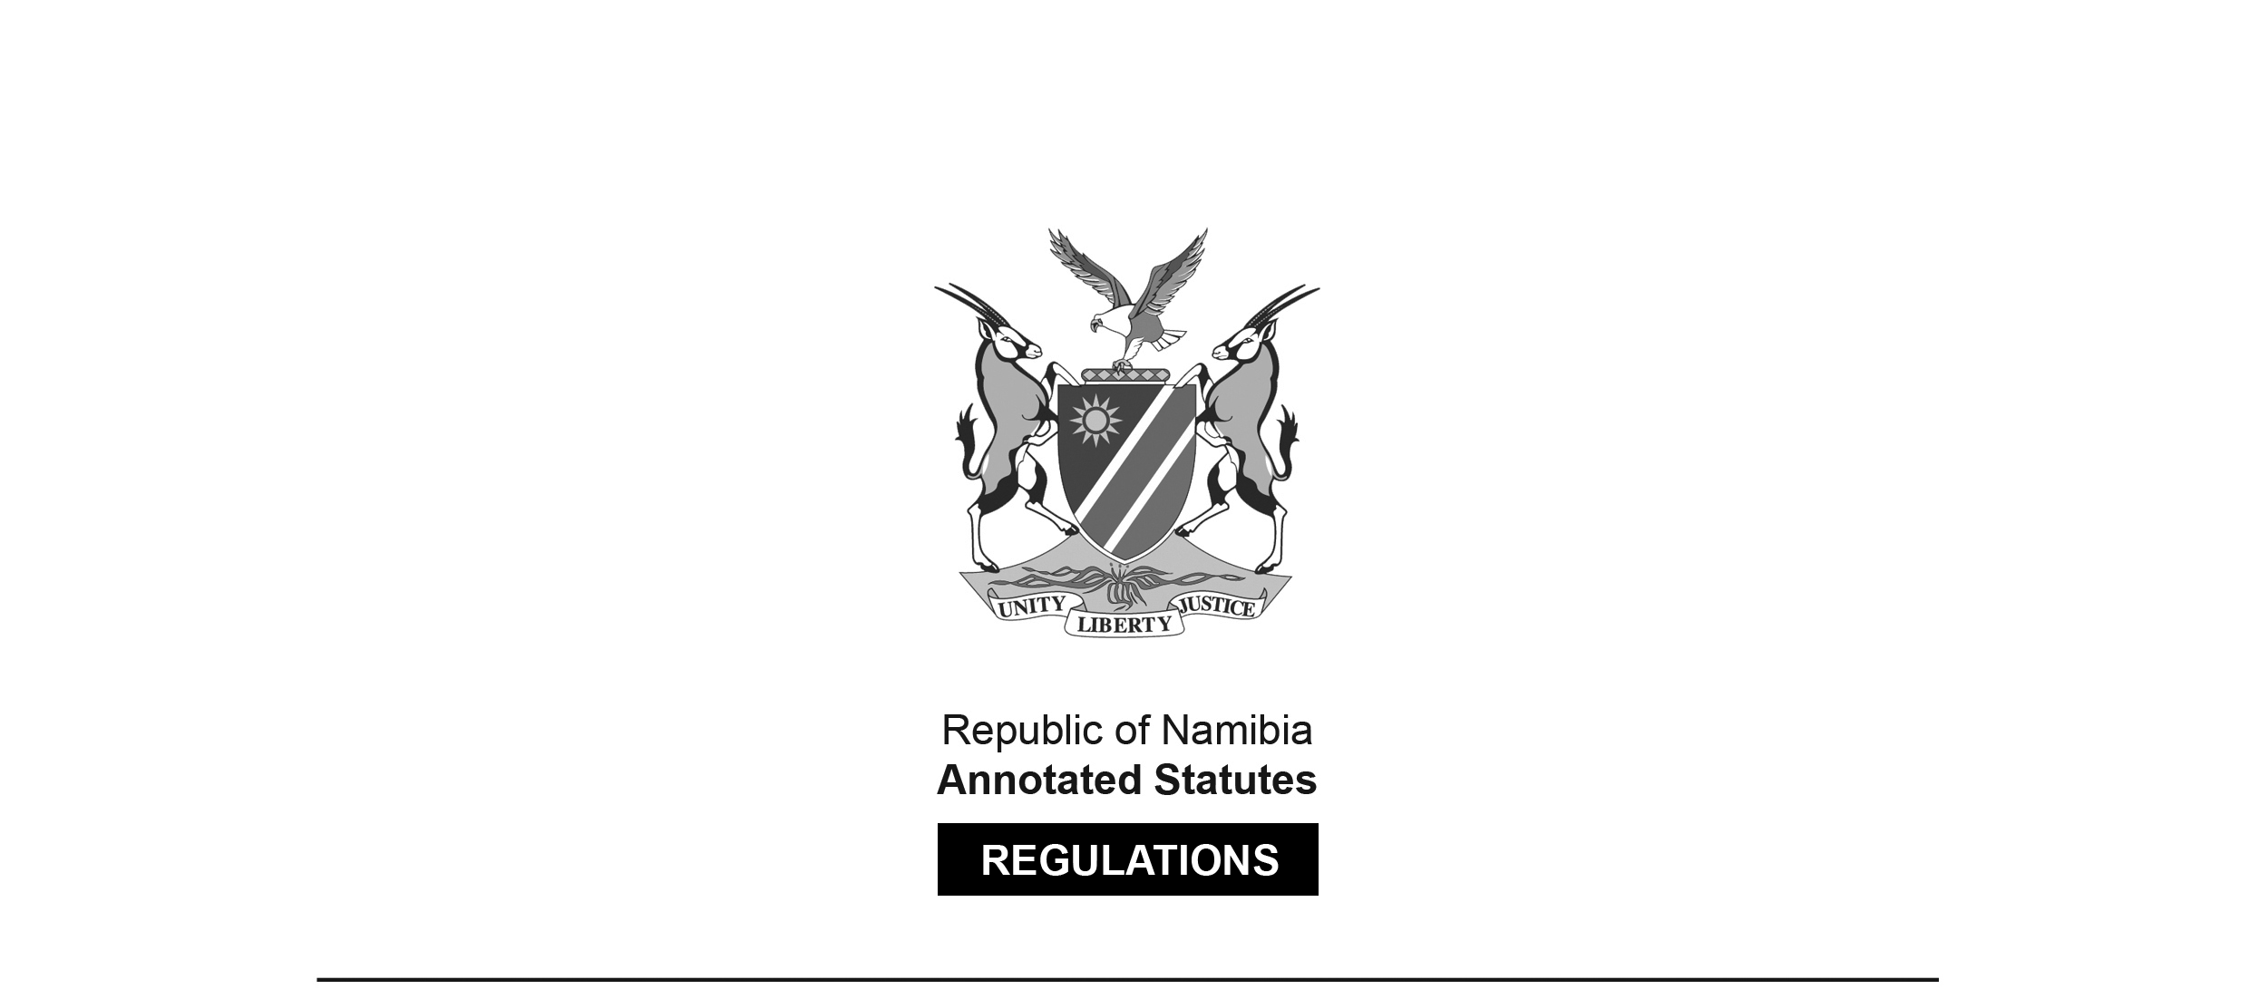
REGULATIONS MADE IN TERMS OF

Immigration Control Act 7 of 1993
section 58

Immigration Regulations
Government Notice 134 of 1994
(GG 895)
came into force on date of publication: 29 July 1994

The Government Notice which issues these regulations repeals the regulations
published in RSA GN R.337/1964, RSA GN R.289/1964, RSA GN R.1711/1967, RSA GN
R.82/1969, RSA GN R.3933/1969, RSA GN R.878/1970 and RSA GN R.1350/1972.

as amended by

Government Notice 82 of 2008 (GG 4029)
came into force on date of publication: 15 April 2008
Government Notice 133 of 2010 (GG 4514)
came into force on date of publication: 1 July 2010
Government Notice 145 of 2014 (GG 5556)
came into force on date of publication: 8 September 2014
Government Notice 138 of 2018 (GG 6647)
came into force on date of publication: 13 July 2018
Government Notice 8 of 2020 (GG 7099)
came into force on date of publication: 21 January 2020
Government Notice 153 of 2021 (GG 7583)
came into force on date of publication: 19 July 2021
GN 153/2021 incorrectly states that the regulations were previously amended by GN 82/2008 of
15 July 2008, whereas the date of publication of that notice was actually 15 April 2008.
Government Notice 327 of 2023 (GG 8225)
came into force on date of publication: 29 September 2023

ARRANGEMENT
PRELIMINARY

1. Interpretation

PART I
ENTRY INTO NAMIBIA

2. Declaration by persons seeking to enter Namibia
2A. Port of entry
[regulation 2A inserted by GN 8/2020]
3. Order in which persons entering Namibia are to be dealt with
4. Evidence by persons seeking to enter Namibia
5. Visitors to Namibia
6. Guarantees
7. Requirements for married persons and children
8. Medical Examination

PART II
PERMANENT RESIDENCE AND VISAS

9. Application for permanent residence permit
10. Cancellation of permit
11. Application for visa
12. Loss or destruction of documents

PART III
PROHIBITED IMMIGRANTS AND PERMITS

13. Contagious infections or viruses or diseases
[heading of regulation 13 substituted by GN 133/2010]
14. Detention after criminal proceedings

PART IV
GENERAL

15. Returns by employers regarding employees or by educational institutions regarding students
16. Records of persons provided with lodging
17. Employment permits
18. Student’s permits
19. Removal of prohibited immigrants from Namibia
20. Summonsing of witnesses by tribunal
21. Powers and duties of Chief of Immigration and immigration officers
22. Prevention of entry by, or tracing, identification or removal of prohibited immigrants
23. Medical examinations
24. Fees payable for visas, permits and certificates
[heading of regulation 24 substituted by GN 138/2018]
25. Provisional permits to enter Namibia
26. Certificate of identity
27. Warrants for removal
28. Refusal of entry into Namibia
29. Fees payable in respect of permits on certificates
[The word “on” in this heading should be “or”, as it appears in the text of the regulations below.]

PART V
FORMS

[Annexure AF: BORDER POSTS AND PORTS OF ENTRY INTO NAMIBIA,
inserted by GN 8/2020, appears after the various forms.]

Interpretation

1. In these regulations, unless the context otherwise indicates, an expression in the Act has a corresponding meaning, and -

“commencement” means the commencement date of these regulations;

“employment” means engagement in any occupation, whether the person concerned is self-employed or employed by another person;

“form” means the appropriate form prescribed for use by the Ministry;

“occupation” means work or any other activity for gain, and includes a profession;

“resident” means any person who is lawfully in Namibia otherwise than for the purpose of -

(a) making a temporary visit; or

(b) journeying through Namibia in direct transit from one country to another;

“returning resident” means a resident of Namibia returning to Namibia after a temporary absence from Namibia and who has not lost his or her domicile in Namibia, and includes the holder of a Namibian passport;

“section” means a section of the Act; and

“the Act” means the Immigration Control Act, 1993 (Act 7 of 1993).

PART I
ENTRY INTO NAMIBIA

Declaration by persons seeking to enter Namibia

2. (1) A person entering Namibia, including a returning resident, shall make a declaration in the form of Annexure ‘A’ (‘Arrival Form’), to be completed in the declarant’s own handwriting and signed by him or her in the presence of an immigration officer.

(2) A person entering Namibia who is suspected of being a prohibited immigrant shall make a declaration in the form of Annexure ‘B’, to be completed in the declarant’s own handwriting and signed by him or her in the presence of an immigration officer.

(3) If a person is unable to complete the declaration referred to in subregulation (1) or (2), an immigration officer may question such a person, if necessary through an interpreter, and may complete the declaration or cause it to be completed on behalf of such person and shall thereupon require such person to sign or thumbprint it.

(4) A visitor’s entry permit shall be imprinted in the passport of the person entering Namibia, in the form of Annexure ‘C’.

(5) Subregulation (1) does not apply to a returning resident who is a Namibian citizen or a permanent resident of Namibia, except where the electronic border management system is not functioning at the time of processing the person’s entry into Namibia.

[subregulation (5) inserted by GN 8/2020]

Port of entry

2A. A person wishing to enter into Namibia in terms of section 6, must enter at any port listed in “Annexure AF” and present himself or herself to an immigration officer on duty at that port.

[regulation 2A inserted by GN 8/2020]

Order in which persons entering Namibia are to be dealt with

3. An immigration officer in the exercise of his or her functions under section 7 of the Act, may determine the sequence in which he or she will examine persons seeking to enter Namibia, and for that purpose may give directions to such persons.

Evidence by person seeking to enter Namibia

4. Any person other than -

(a) a Namibian citizen;

(b) a returning resident; or

(c) a person who is a holder of a valid permit issued in terms of the Act or any law repealed by the Act which authorises him or her to enter Namibia,

shall produce to the immigration officer -

(i) evidence that he or she is on a temporary visit to Namibia for a stated period. including evidence, if the immigration officer so requires, that -

(aa) he or she is permanently resident in any country other than Namibia and intends to return thereto;

(bb) he or she possesses sufficient means available in Namibia for his or her maintenance and the maintenance of any of his or her dependants who accompany him or her for the period of the visit and to meet the cost of returning to his or her country of permanent residence; and

(cc) he or she will be re-admitted to his or her country of domicile or country of last permanent residence at the expiration of his or her visit to Namibia; and

(ii) any other relevant information which the immigration officer may require, including a report by a medical practitioner after a medical examination in accordance with section 8(l)(e),

in order to satisfy the immigration officer that such person is not a prohibited immigrant in terms of section 39.

Visitors to Namibia

5. (1) Any person who has entered Namibia as a visitor and who for any reason desires to remain in Namibia for a period longer than the period for which his or her visitor’s entry permit was granted shall report in person to an immigration officer and shall, notwithstanding that he or she is already in Namibia, submit to any inquiry, examination or test
which the immigration officer concerned may require, including -

(a) the producing of a valid travel document;

(b) the making of an application for the extension of his or her visitor’s entry permit in the form of Annexure “D”;

(c) the producing of documentary or other evidence relative to his or her claim to enter and remain in Namibia; and

(d) the submitting to a medical examination in accordance with section 8(1)(e).

(2) An immigration officer may issue an extension of a visitor entry permit in the form of Annexure C1 to a person who has complied with the requirements of subregulation (1).

(3) No visitor shall engage in any employment in Namibia unless he or she has been issued with an employment permit referred to in section 27(1).

[regulation 5 substituted by GN 327/2023]

Guarantees

6. (1) For the purposes of -

(a) section 11(2)(a);

(b) section 27(4)(a);

(c) section 38(3)(a);

(d) section 29(3)(a); and

(e) section 42(3)(a),

guarantees shall be in the form of Annexure ‘E’.

(2) A guarantee referred to in subregulation (1) shall be furnished -

(a) by the employer of the person concerned or by such other person as may be approved by the Chief of Immigration; and

(b) for a period not exceeding two years from the date of entry into Namibia of the person in respect of whom the guarantee is given or if such person is already within Namibia, for a period of two years calculated from the date upon which the guarantee is given.

(3) The Chief of Immigration may, from the date of expiry of a guarantee referred to in subregulation (1), require a further guarantee to be lodged for a period not exceeding two years, calculated from the date of expiry of the previous guarantee.

Requirements for married persons and children

7. (1) In the case of an application by a married person or in respect of a dependent child to enter or remain in Namibia, an immigration officer may require the production of a duly authenticated marriage certificate or birth certificate, as the case may be.

(2) If no copy of a marriage or birth certificate referred to in subregulation (1) can be produced the immigration officer may -

(a) require a certificate under the hand of a person competent to furnish such a certificate stating that to his or her personal knowledge the parties were married on a date or in circumstances stated or that the child was born on a date or at a place set out and of parents named in such certificate, as the case may be; or

(b) require a certificate under the hand of a person competent to furnish such a certificate stating that he or she has taken sworn testimony or other evidence as to the circumstances and date of the marriage or the date of birth or parentage of the child, as the case may be, and that such testimony and evidence is attached to the certificate together with such person’s findings thereon.

(3) An immigration officer may require any certificate mentioned in this regulation to be supplemented by satisfactory evidence as to the identity of the person or persons referred to in the certificate or as to the lawful custody of any child, and may in case of doubt require such further evidence as may be necessary to satisfy him or her that the spouse or child who is the subject of the application is the spouse or child referred to in the certificate and is not a prohibited immigrant, or is in the lawful custody of the person referred to in the application, as the case may be.

Medical Examination

8. The medical examination of any person conducted under section 8(l)(e) shall take place as soon as practicable after the arrival or discovery of such person in Namibia, and a report as to the result of such examination shall be submitted to the immigration officer concerned in such form as such immigration officer may determine.

PART II
PERMANENT RESIDENCE AND VISAS

Application for permanent residence permit

9. (1) An application for a permanent residence permit shall be in the form of Annexure “F” or “G”, whichever may be applicable.

(2) A permanent residence permit shall be issued in the form of Annexure “H”.

Cancellation of permits

10. (1) If a permit issued in terms of the Act is cancelled under the provisions of section 36, the board shall cause written notice of the cancellation to be served on the holder of the permit and shall state in such notice the provisions of the Act in terms of which it was cancelled and the date from which the cancellation shall take effect.

(2) The holder of the permit referred to in subregulation (1) shall leave Namibia on or before the date the cancellation shall take effect or such later date as the Chief of Immigration may determine and by notice in writing notify the person concerned.

Application for visa

11. An application for a visa shall be in the form of Annexure “I” and a visa shall be issued in the form of Annexure “J” or shall be entered into the passport of the applicant in the form of Annexure “K”.

Loss or destruction of documents

12. If any permit or document issued under the Act or these regulations is lost or destroyed, the Chief of Immigration or the Board, as the case may be, may upon application by the holder thereof, issue a copy of such document or permit.

PART III
PROHIBITED IMMIGRANTS AND PERMITS

Contagious infections or viruses or diseases

13. Any contagious infection or virus or disease (air born or transmitted through casual contact) that exists or may develop from time to time that is declared a Public Health Emergency of International Concern (PHEIC) and which warrants restriction of international travel and mobility as per the International Health Regulations adopted by the Fifty-Eight World Health Assembly (2005) to which Namibia is a party, including any amendment to which Namibia becomes a party, is regarded as contagious for the purposes of paragraph (e) of subsection (2) of section 39 of the Act.

[Regulation 13 is substituted by GN 133/2010 and amended by GN 145/2014. GN 145/2014 erroneously amends the original version of Regulation 13, ignoring the subsequent
substitution by GN 133/2010. The original version was as follows:

“Prescribed Diseases
13. For the purposes of paragraph (e) of subsection (2) of section 39, the following diseases or viruses shall be regarded as contagious -
(a) tuberculosis, or any other contagious lung disease;
(b) trachoma, or any other chronic eye infection;
(c) frambesia, yaws, scabies or any other contagious bacterial or other skin disease;
(d) syphilis, or any other venereal disease;
(e) leprosy; and
(f) acquired immune deficiency syndrome virus (aids virus).”

GN 145/2014 directs that Regulation 13 be amended “by the addition after paragraph (f) of
the following paragraph: ‘(g) ebola.’.” The import of this error is not clear.]

Detention after criminal proceedings

14. If a prohibited immigrant who has arrived in Namibia or person who is being detained in accordance with the provisions of section 42 of the Act is arrested upon a criminal charge, he or she shall be handed over to the custody of an immigration officer at the conclusion of the criminal proceedings or at the expiration of any sentence of imprisonment imposed upon such person, as the case may be, and shall thereafter be detained under and subject in all respects to the provisions of the Act and these regulations.

PART IV
GENERAL

Returns by employers regarding employees or by educational institutions regarding students

15. Returns under section 31 by employers regarding employees or by educational institutions regarding students, as the case may be, shall be in the form of Annexure “L”.

Records of persons provided with lodging

16. (1) For the purposes of section 32(1), the occupier of any of the following classes of premises shall keep a register contemplated by that section:

(a) Hotels;

(b) caravan parks;

(c) guest farms and lodges; and

(d) game parks and farms.

(2) The following particulars shall in respect of every person provided with lodging or sleeping accommodation on or in any premises prescribed by subregulation (1), be entered in the register contemplated by section 32(1):

(a) Surname;

(b) maiden name (if applicable);

(c) first names (in full);

(d) identity number;

(e) country of present residence;

(f) citizenship;

(g) sex;

(h) present residential address;

(i) telephone number (residence);

(j) occupation or profession;

(k) name and address of employer; and

(1) telephone number (business).

Employment permits

17. (1) An application for the granting of an employment permit referred to in section 27 shall be in the form of Annexure “M” and the representations by the prospective employer shall be in the form of Annexure “N”.

(2) An employment permit referred to in subregulation (1) shall be issued in the form of Annexure “0”, or may be entered in the passport of the permit holder in the form of Annexure “P”.

(3) An application for the renewal of an employment permit shall be in the form of Annexure “D” and shall be submitted to the Chief of Immigration not less than 60 days prior to the expiry of the existing employment permit.

Students’ permits

18. (1) An application for the granting of a student’s permit referred to in section 28 shall be in the form of Annexure “R”.

(2) A student’s permit referred to in subregulation (1) shall be issued in the form of Annexure “S”, or may be entered in the passport of the permit holder in the form of Annexure “T”.

(3) An application for the renewal of a student’s permit shall be in the form of Annexure “D” and shall be submitted to the Chief of Immigration not less than 60 days prior to the expiry of the existing student’s permit.

Removal of prohibited immigrants from Namibia

19. (1) A notice in terms of section 44(4) shall be in the form of Annexure “U” and shall be served by an immigration officer upon the person in respect of whom the application has been made.

(2) The immigration officer shall obtain a written acknowledgement of receipt from the person upon whom he or she has served the notice.

(3) If the person concerned refuses to sign such an acknowledgement, the immigration officer shall furnish the tribunal with an affidavit in which he or she certifies that he or she has served the notice upon the person named in the affidavit.

Summonsing of witnesses by tribunal

20. For the purposes of section 45(1), a summons to appear before a tribunal as a witness to give evidence or to produce documents, shall be substantially in the form of Annexure ‘V’, shall be signed by any member of such tribunal and shall be served personally upon the witness concerned by the immigration officer referred to in section 44(3), or in the same manner as it would have been served if it were a subpoena issued by a magistrate’s court.

Powers and duties of Chief of Immigration and immigration officers

21. The Chief of Immigration and immigration officers shall, in addition to any powers and duties they may have in terms of the Act, have the following powers and duties:

(a) The powers and duties of Chief of Immigration shall be to control, subject to the general direction of the Minister, the entry, residence and departure of non-Namibian citizens by -

(a) enforcement of relevant Immigration laws;

(b) executing immigration control functions through immigration officers at ports of entry and departure;

(c) generally to exercise such functions relating to immigration as may be imposed upon him or her by the Minister from time to time.

(b) The powers and duties of immigration officers shall be -

(a) to ensure that persons entering, immigrating or leaving the country comply with the relevant legal provisions;

(b) to ensure that persons entering or leaving the country follow the proper procedures;

(c) to ensure that persons entering the country are in possession of valid documents and that such persons are not prohibited immigrants;

(d) to ensure that persons seeking to enter the country meet the basic immigration requirements provided for in the Act;

(e) generally to perform such other duties and functions relating to immigration as may be imposed upon them by the Chief of Immigration from time to time.

[Subparagraphs such as those under paragraphs (a) and (b) would normally
be numbered with lower-case Roman numerals: (i), (ii) and so forth.]

Prevention of entry by, and tracing, identification or removal of prohibited immigrants

22. The procedures for the prevention of entry by and tracing, identification or removal of prohibited immigrants shall be as determined by the Minister from time to time.

Medical examinations and returns by Master of ship

23. (1) The medical examination of any person contemplated by paragraph (e) of subsection (1) of section 8 -

(a) who has arrived in Namibia by ship shall take place either on such ship or at such other place determined by the immigration officer concerned as soon as possible after the arrival of the ship; or

(b) other than a person referred to in paragraph (a), or of any person found in Namibia and suspected to be a prohibited immigrant in consequence of the provisions of paragraph (e) of section 39(2), shall take place at a place determined by the immigration officer concerned, as soon as possible after such person has applied for permission to enter Namibia or was found in Namibia.

(2) The medical practitioner performing a medical examination referred to in subregulation (1) shall as soon as possible after the completion of such medical examination furnish a report thereon to the immigration officer concerned in such form as the Chief of Immigration may determine.

(3) A return by a medical officer or master in terms of section 15(1)(d) shall be in the form of Annexure ‘W’.

Fees payable for visas, permits and certificates

24. (1) A handling fee of N$ 80.00 must be paid at the submission of an application for visa, permit or certificate.

[The article “a” or “any” should appear before the phrase “visa, permit or certificate”.]

(2) The following fees are payable by the holder of a passport in respect of –

Visa, Permit, Certificate or Appeal |  | Fee (N$)
Visa on Arrival | Per visa (limited to 90 days) | 1200.00
Holiday / Visitors visa and other visas  (This fee is not payable in respect of countries that have visa exemption agreements with Namibia) | Per visa (limited to 90 days) | 600.00
Short term Employment Permit (“work visa”) | Per visa (limited to 90 days) | 1100.00
Employment Permit | Per year | 2600.00
Student’s Permit:  Primary and Secondary Education  (excluding students who are in possession of permits contemplated in section 27(5) of the Act) | Per year | 1600.00
Temporary Residence Permit (TRP) issued in terms of Section 28(4) of the Act for the accompanying spouse and dependent children only | Per year | 1600.00
Student’s Permit: Tertiary Education | Per year | 2200.00
Permanent Resident Permit | - | 20 000.00
Temporary Residence Permit (TRP) issued in terms of Section 27(5) of the Act for the accompanying spouse and dependent children only | Per year | 1600.00
Certificate of Identity | Per year | 1600.00
Appeal (appeals in respect of visa, permit and certifi- cate of identity applications) | Per appeal | 200.00

and are payable upon the granting of the visa, permit or certificate concerned and before the
issuing thereof.

[Regulation 24 is substituted by GN 82/2008, GN 138/2018 and by GN 153/2021.
Note that there is some overlap and contradiction between
the current version of this regulation and regulation 29.]

Provisional permits to enter Namibia

25. (1) A provisional permit to enter Namibia referred to in section 11(1) shall substantially be in the form of Annexure “X”.

[The subregulation number “(1)” appears to be in error as there are no additional subregulations.]

Certificate of identity

26. (1) An application for the granting of a certificate of identity referred to in section 38 shall be in the form of Annexure ‘Y’ and shall be lodged with the Chief of Immigration.

(2) A certificate of identity referred to in section 38 shall be issued by the Chief of Immigration substantially in the form of Annexure “Z”.

Warrants for removal

27. (1) A warrant for the removal of a prohibited immigrant from Namibia in accordance with section 44(9) shall be substantially in the form of Annexure “AB”.

(2) A warrant for the removal of a person from Namibia in accordance with section 49 shall be substantially in the form of Annexure “AC”.

(3) A warrant for the removal from Namibia of a person in accordance with section 50 shall be substantially in the form of Annexure “AD”.

Refusal of entry into Namibia

28. A notice by an immigration officer to any person refusing such person entry into Namibia in accordance with the provisions of section 10 shall be substantially in the form of Annexure “AE”.

Fees payable in respect of permits or certificates

29. (1) The following fees are payable in respect of -

(a) application for

(i) a permanent residence permit (form “F”);

(ii) a permanent residence permit (spouse, dependent child or parent- form “G”);

(iii) an employment permit (form “M”);

(iv) a study permit (form “R”);

(v) a renewal of an employment or study permit (form “D”)

N$80, payable with the submission of the application;

(b) the issue of

Type of Permit | 7-12  Months | 24  Months | 36  Months
Employment Permit  (1st Application or Extension) | N$1 395 | N$2 790 | N$4 185
Study Permit (Basic Education) | N$1 050 | N$2 100 | N$3 250
Study Permit (Tertiary Education) | N$1 395 | N$2 790 | N$4 185
Permanent Residence Permit .............................. N$12 173

and are payable before the issue of the permit concerned.

[Regulation 29 is substituted by GN 82/2008.
Note that there is some overlap and contradiction between
this regulation and the current version of regulation 24.]

PART V
FORMS

INDEX TO FORMS

1. Annexure “A”: Arrival Form (Sections 8 and 29/ Regulation 2)

2. Annexure “B”: Application for Visitor’s Entry Permit (Suspected) Prohibited Immigrant) (Sections 8 and 29 / Regulation 2)

[The closing bracket after the word “Suspected” is superfluous.]

3. Annexure “C”: Visitor’s Entry Permit (Section 9 and 29 / Regulation 2)

4. Annexure “D”: Application for Renewal of Employment Permit, Student’s Permit or Visitor’s Entry Permit (Sections 27, 28, 29 / Regulation 17, 18, 4)

5. Annexure “E”: Guarantee (Sections 11, 27, 28, 29, 42 / Regulation 6)

6. Annexure “F” Application for a Permanent Residence Permit (Section 26 / Regulation 9)

7. Annexure “G”: Application for a Permanent Residence Permit (Spouse, Dependent Child, Parent) (Section 26 / Regulation 9)

8. Annexure “H”: Permanent Residence Permit (Section 26 / Regulation 9)

[Annexure H is substituted by GN 138/2018.]

9. Annexure “I”: Application for Visa (Sections 12 and 13 / Regulation 11)

[Annexure I is amended by GN 133/2010 and by GN 138/2018.]

10. Annexure “J”: Visa for Republic of Namibia (Section 12 / Regulation 11)

11. Annexure “K”: Visa for the Republic of Namibia (Imprint in Passport) (Section 12 Regulation 11)

12. Annexure “L”: Return by Employer/Educational Institution: Employees/Students who are not Namibian Citizens (Section 31 / Regulation 15)

13. Annexure “M”: Application for an Employment Permit (Section 27 / Regulation 17)

14. Annexure “N”: Annexure to Application for Employment Permit (Representation by Prospective Employer) (Section 27 / Regulation 17)

15. Annexure “O”: Employment Permit (Section 27 / Regulation 17)

16. Annexure “P”: Employment Permit (Imprint in Passport) (Section 27 / Regulation 17)

[There is no Annexure “Q”.]

17. Annexure “R”: Application for a Student’s Permit (Section 28 / Regulation 18)

18. Annexure “S”: Student’s Permit (Section 28 / Regulation 18)

19. Annexure “T”: Student’s Permit (Imprint in Passport) (Section 28 / Regulation 18)

20. Annexure “U”: Notice of Application for Authorization to remove Prohibited Immigrant from Namibia (Section 44 / Regulation 19)

21. Annexure “V”: Summons to appear before an Immigration Tribunal as a Witness (Section 45 / Regulation 19)

22. Annexure “W”: Return by Medical Officer or Master (Section 15 / Regulation 23)

23. Annexure “X”: Provisional permit to enter Namibia (Section 11 / Regulation 25)

24. Annexure “Y”: Application for a Certificate of Identity (Section 38 / Regulation 26)

25. Annexure “Z”: Certificate of Identity (Section 38 / Regulation 26)

[There is no Annexure “AA”.]

26. Annexure “AB”: Removal Warrant (Section 44 / Regulation 27)

27. Annexure “AC”: Removal Warrant (Section 49 / Regulation 27)

28. Annexure “AD”: Removal Warrant (Section 50 / Regulation 27)

29. Annexure “AE”: Notice to Person Refused Entry into Namibia (Section 10 / Regulation 28)

ANNEXURES

To view content without printing, scroll down.

To print at full scale (A4), double-click the icon below.

[Annexure C1 is inserted after Annexure C by GN 327/2023.]

[Annexure H is substituted by GN 138/2018.]

[Annexure I is amended by GN 133/2010 and by GN 138/2018.]

[Annexure AF is inserted by GN 8/2020.
There is no PDF icon for this annexure; it appears below the other Annexures.]

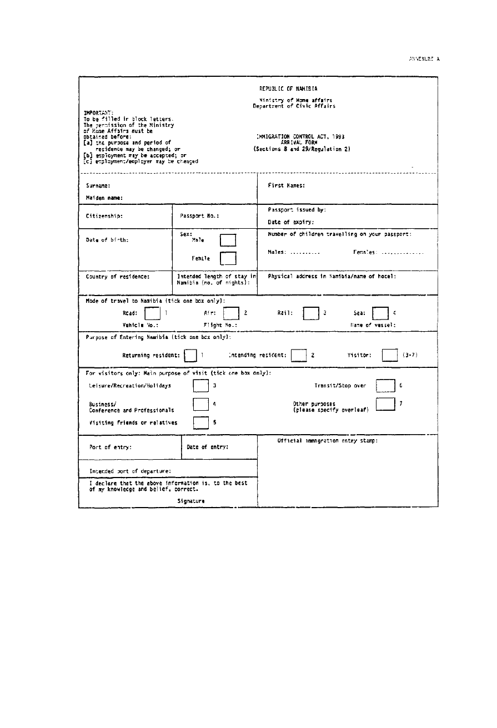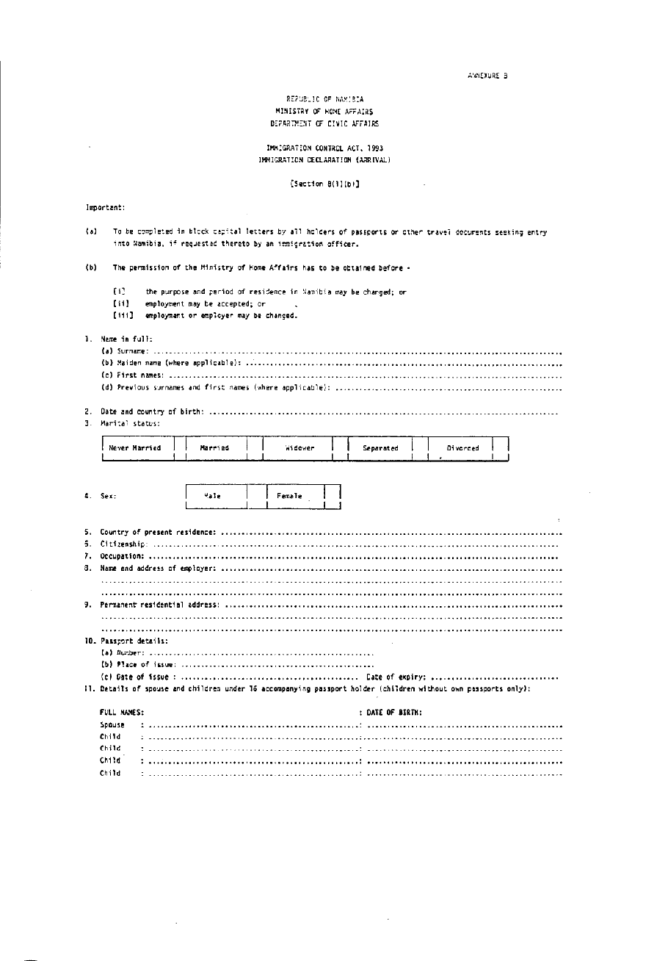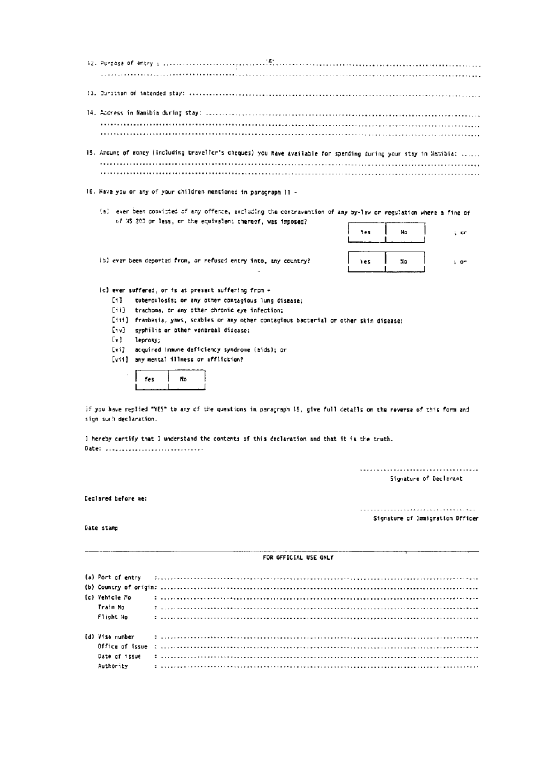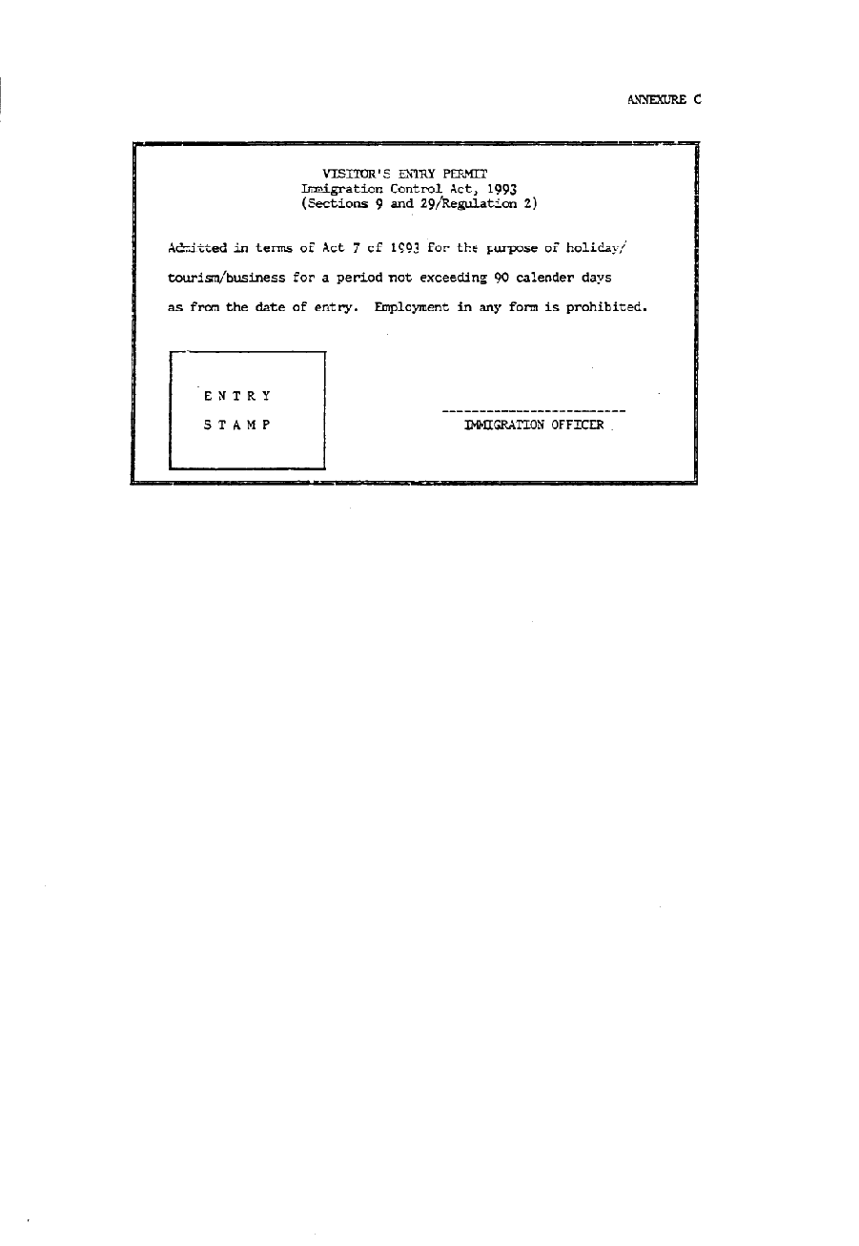

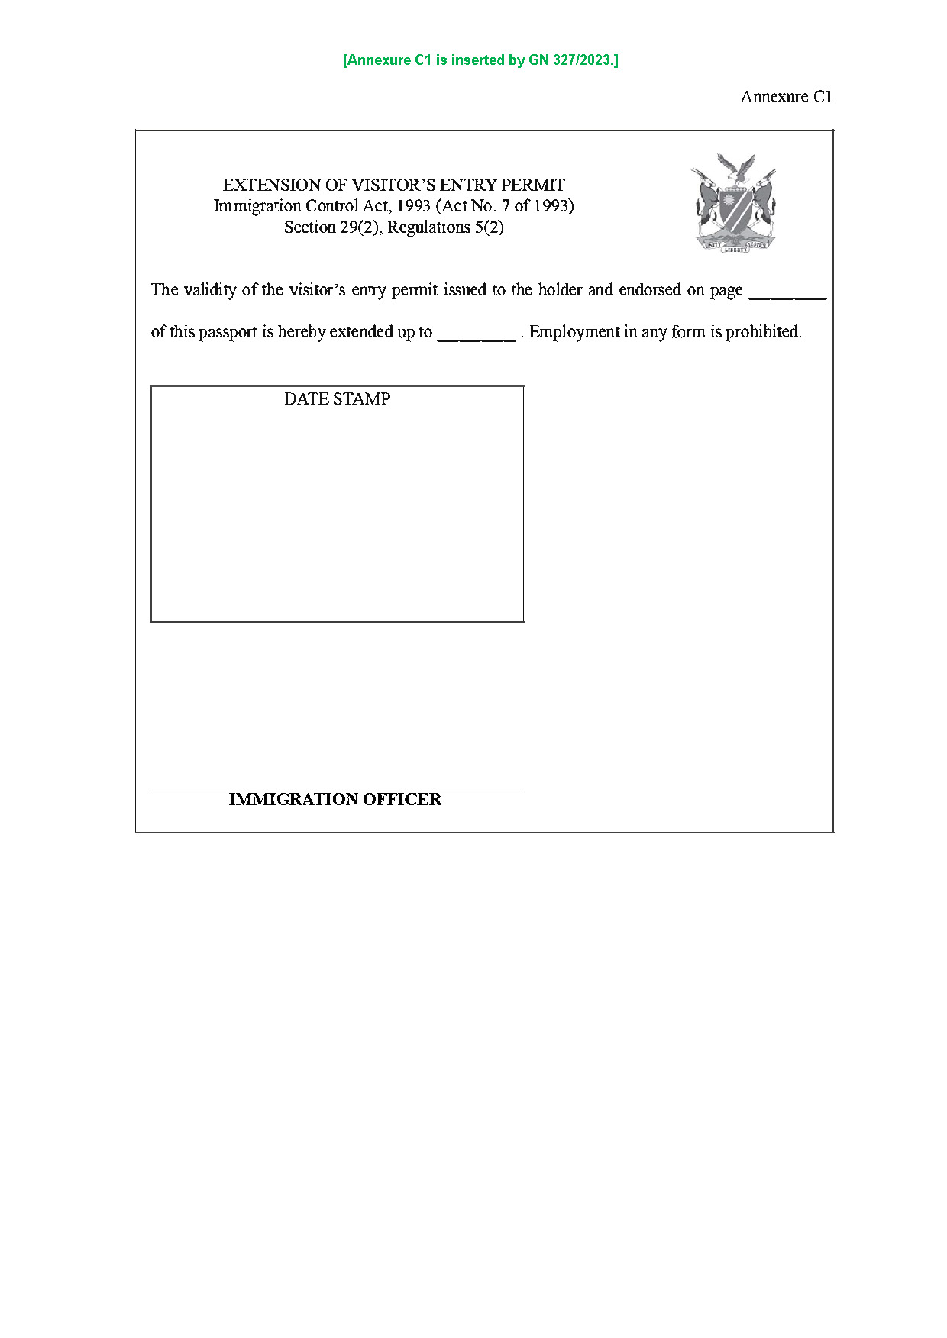
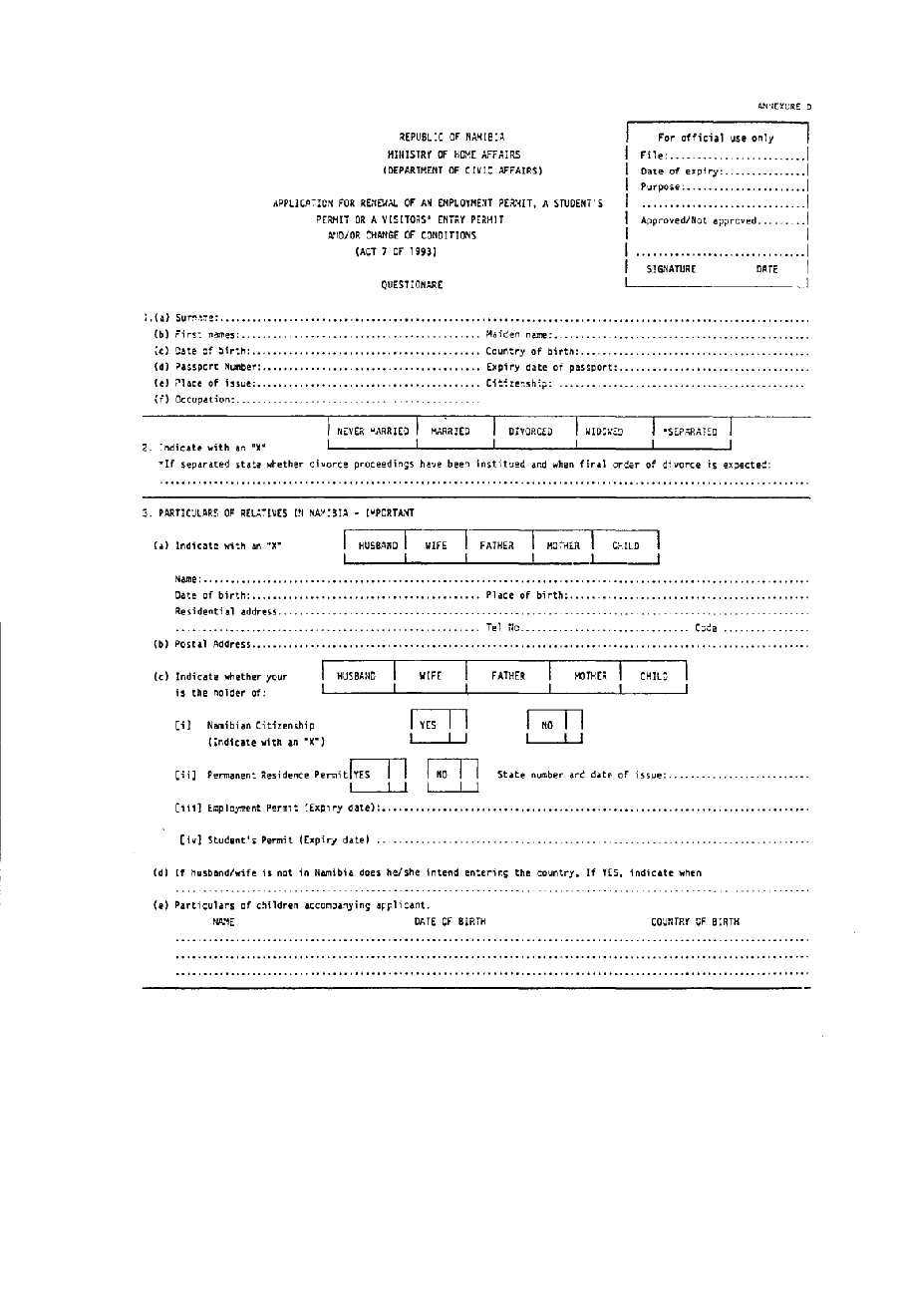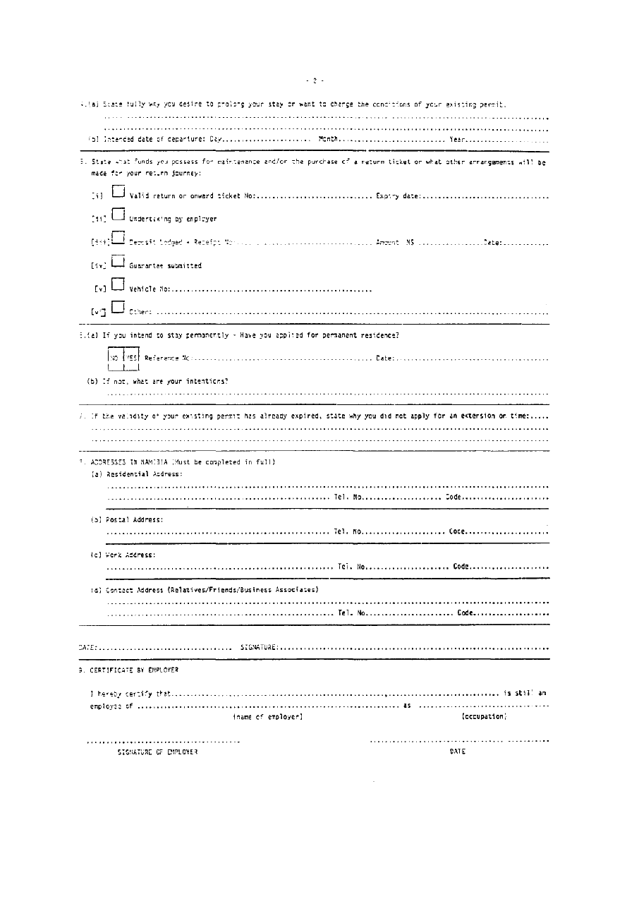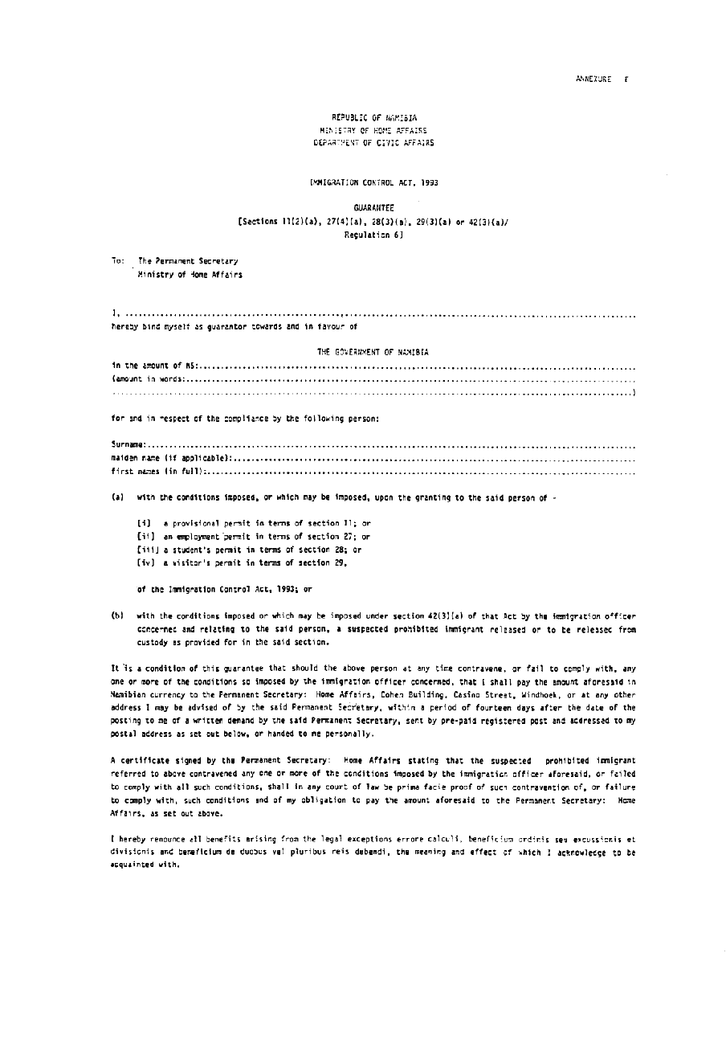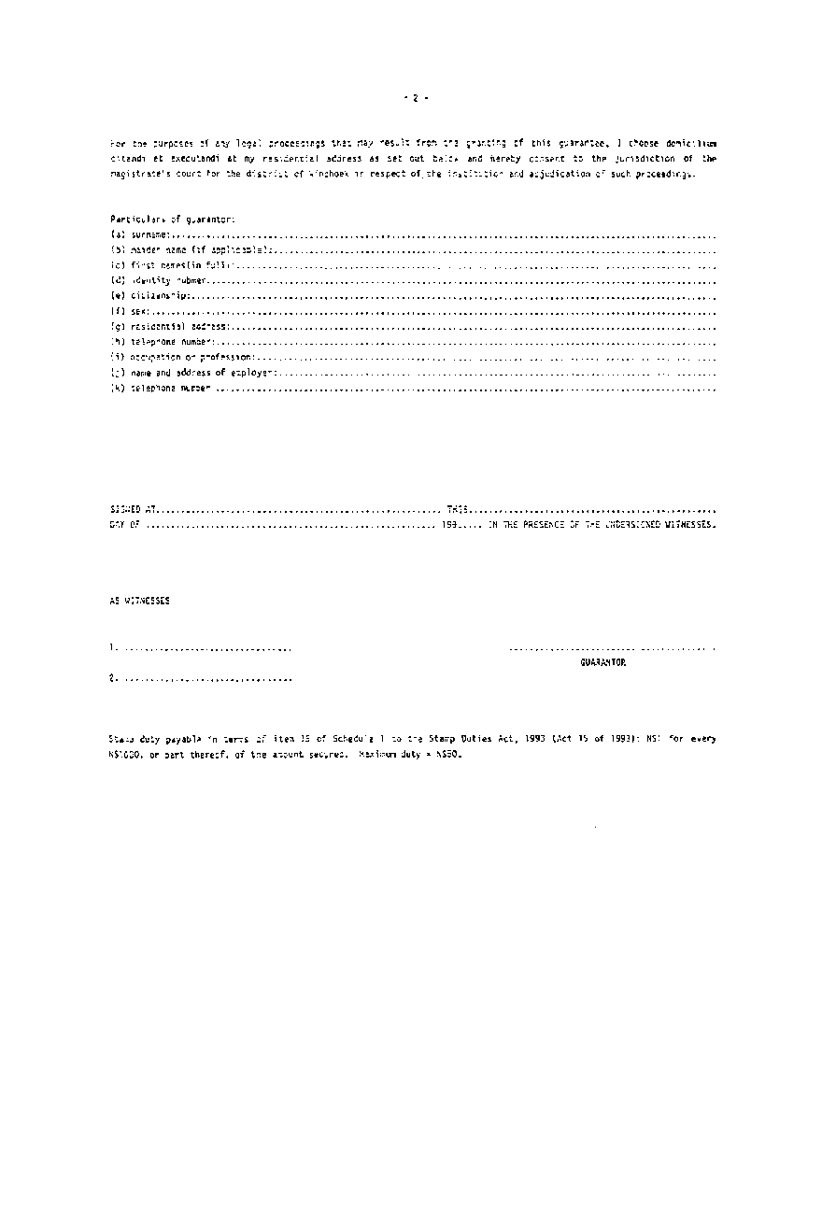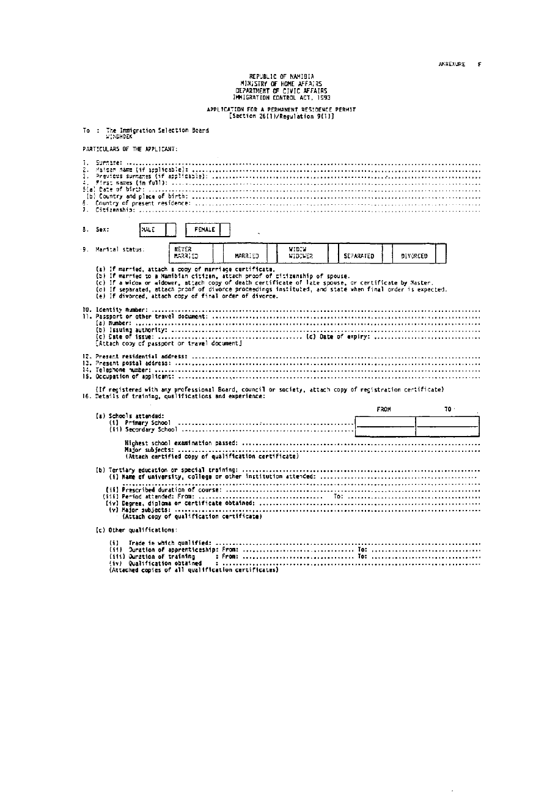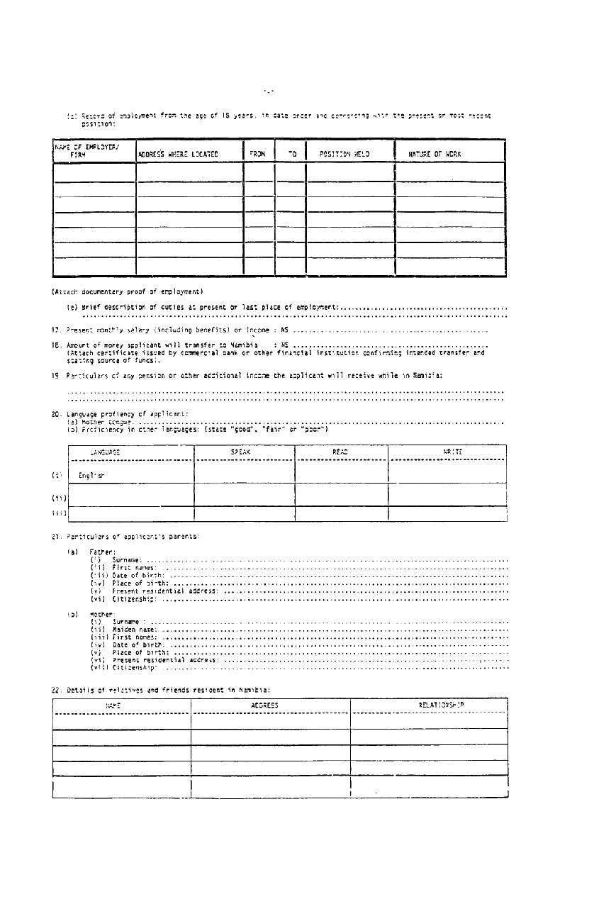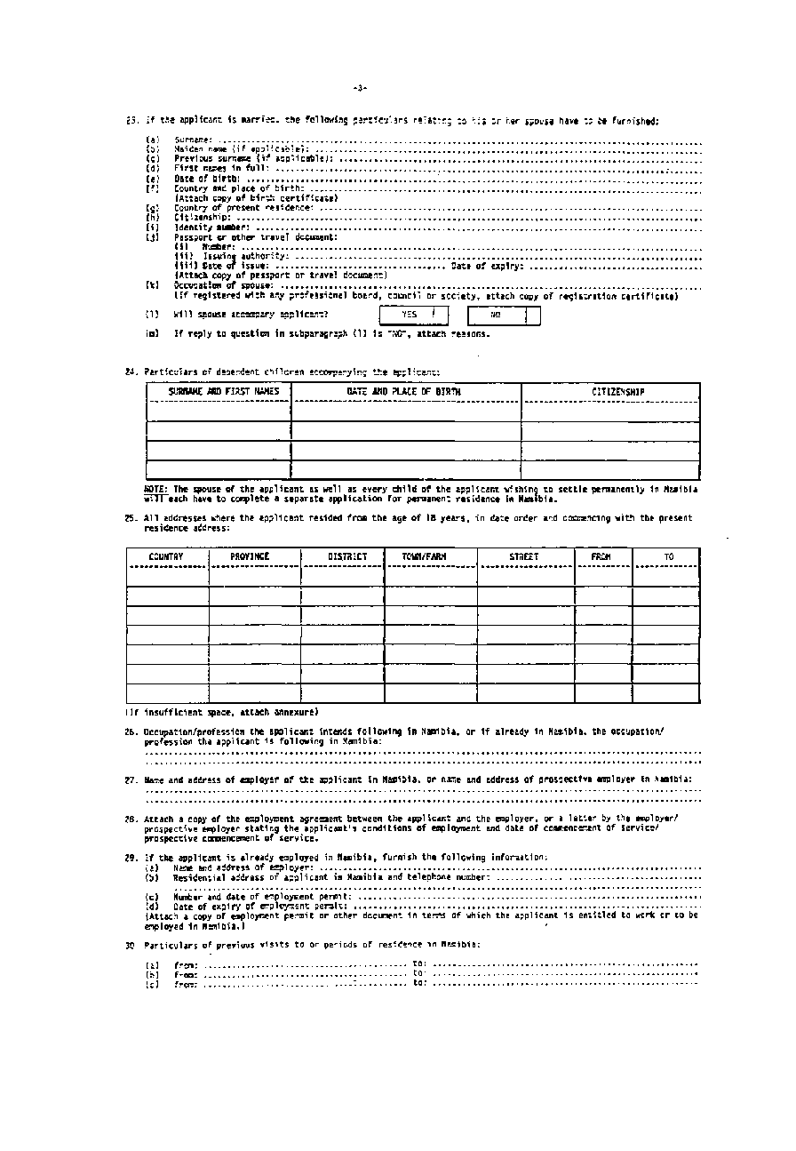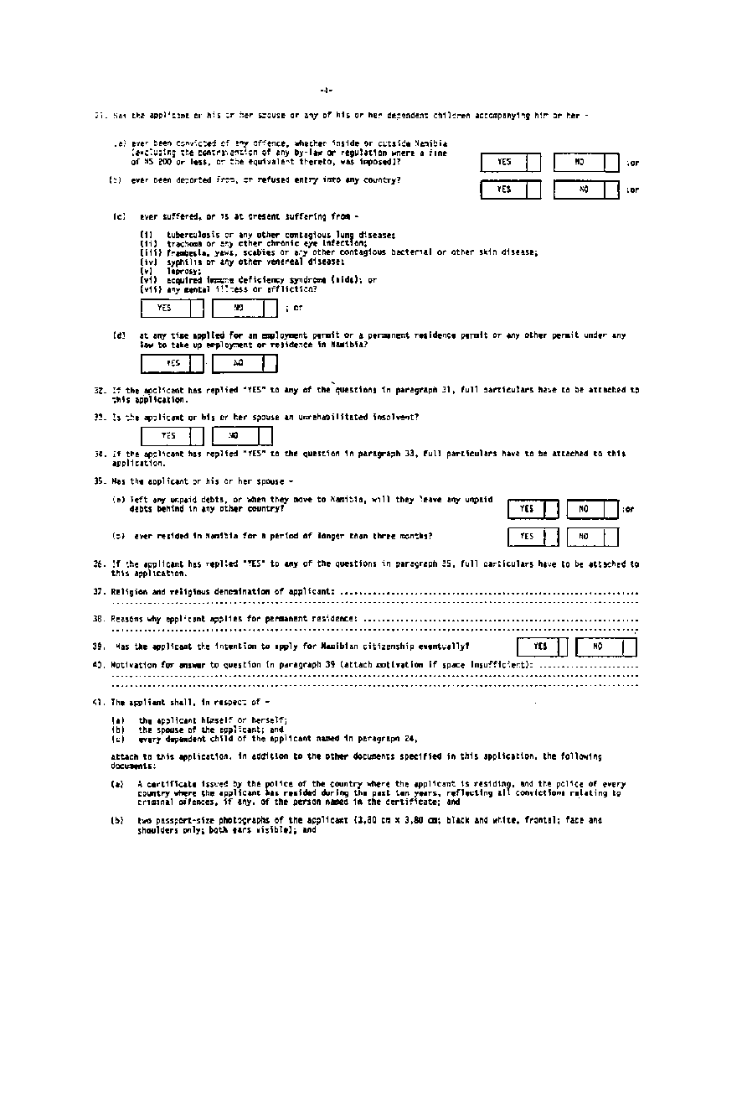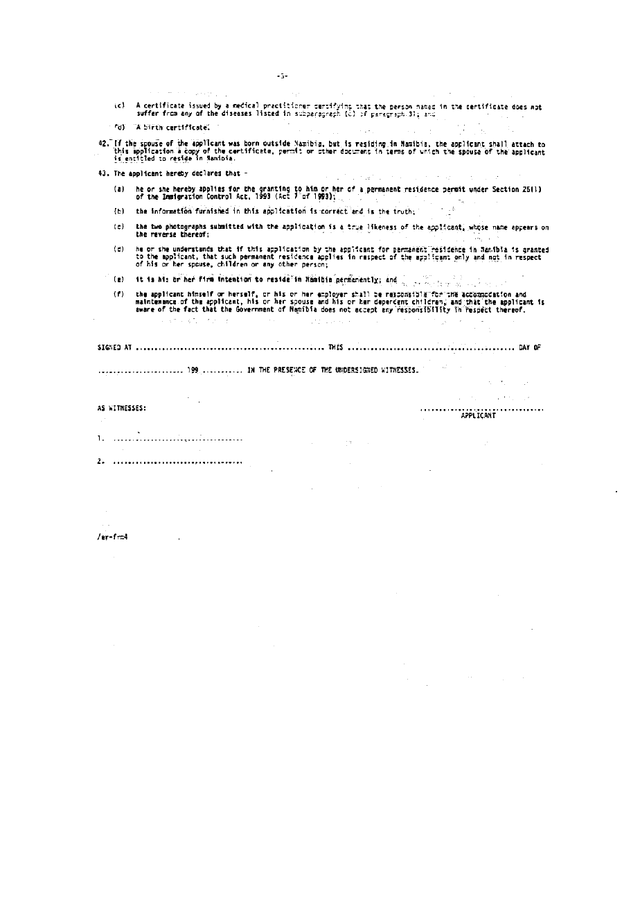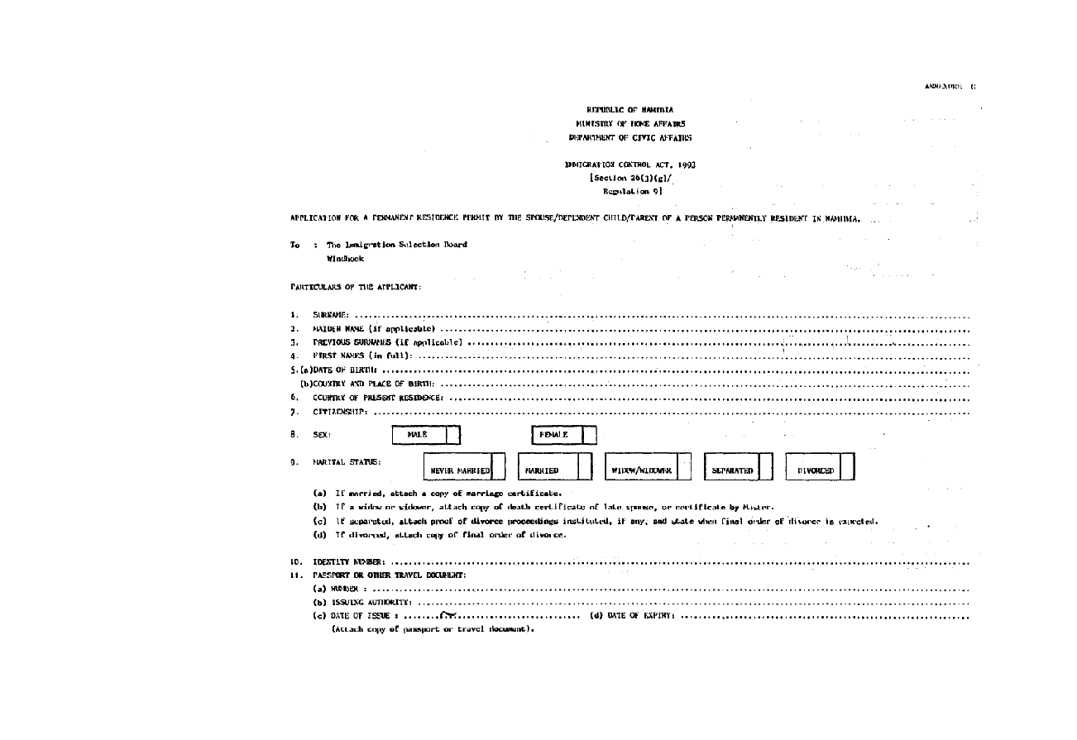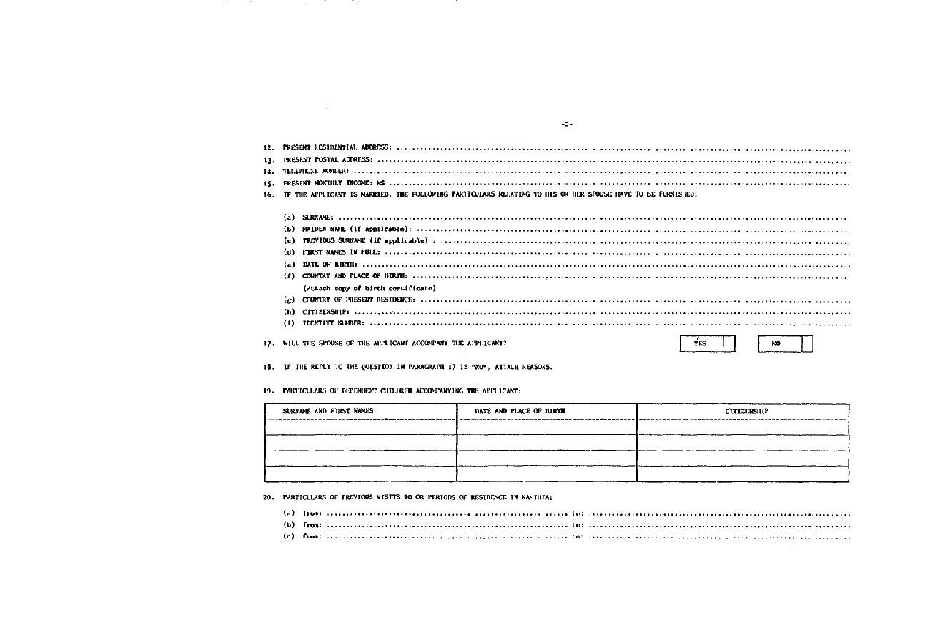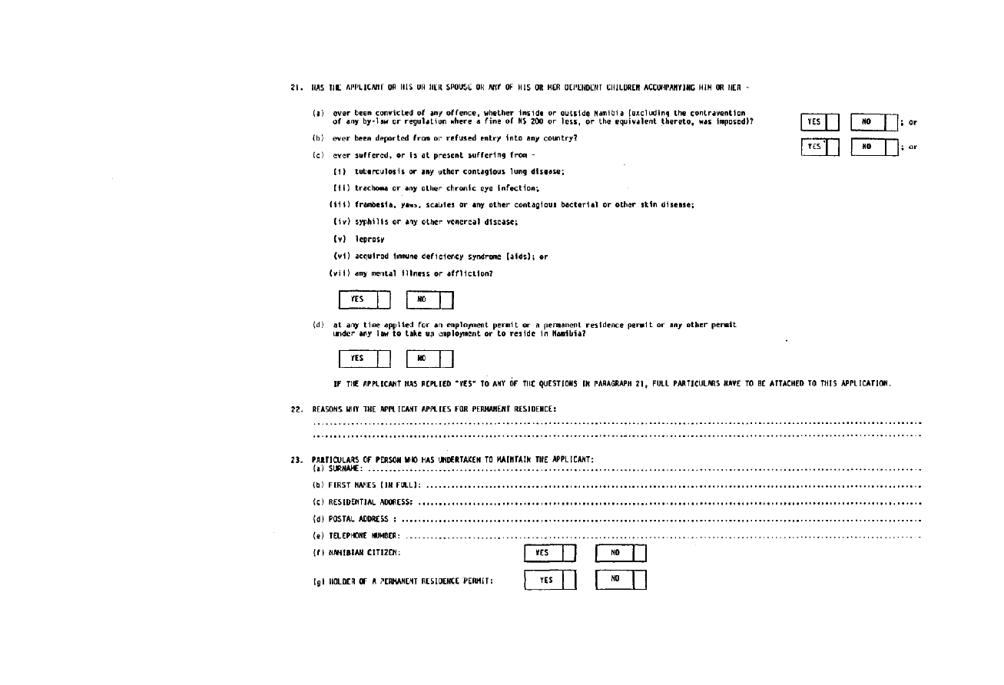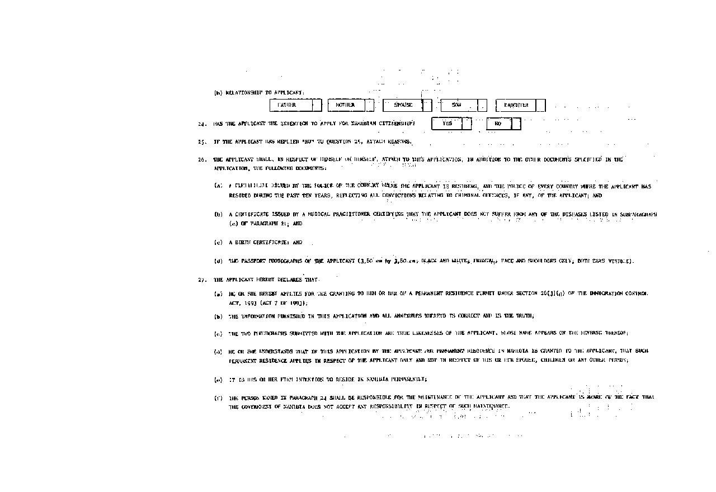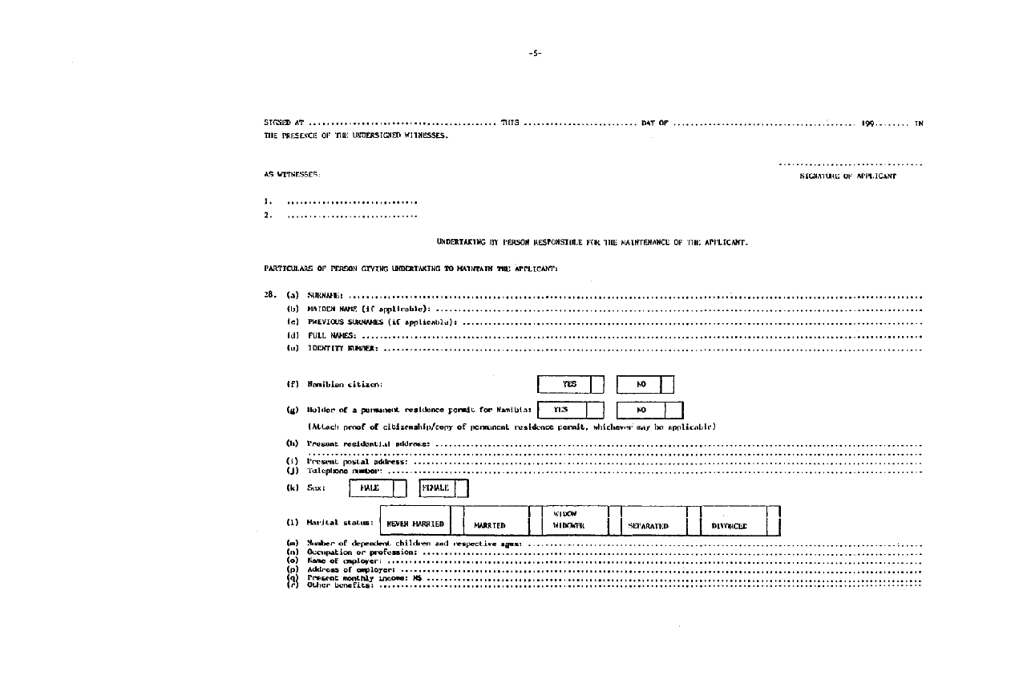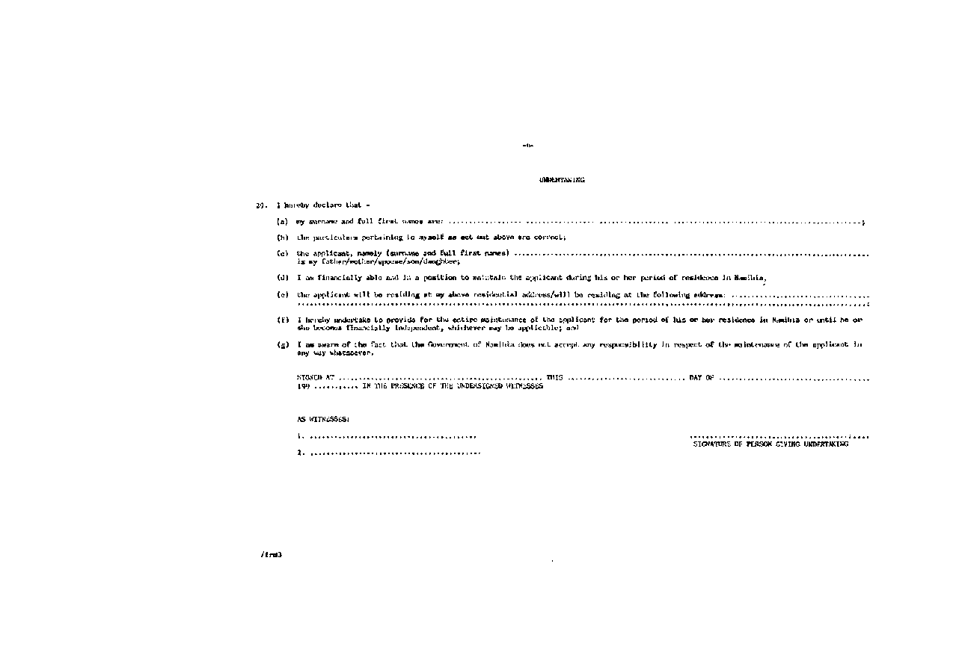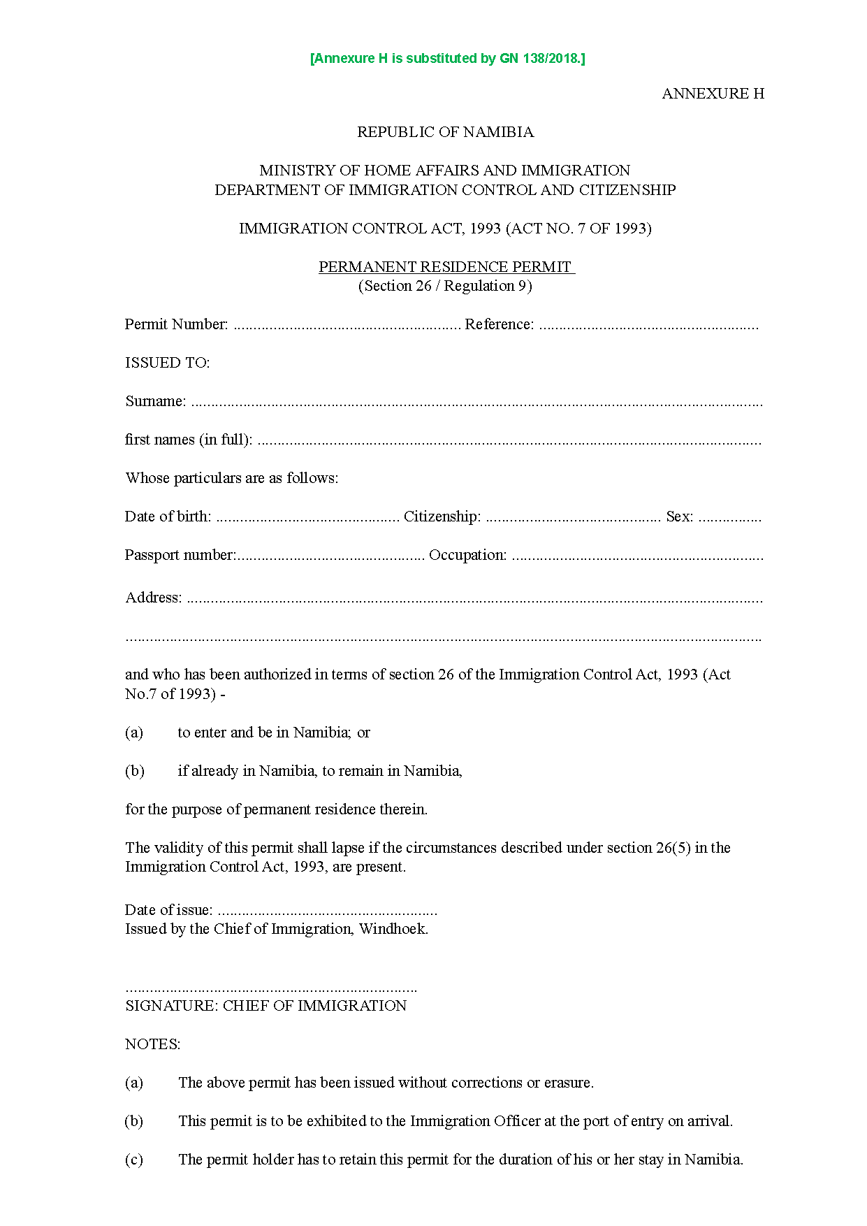

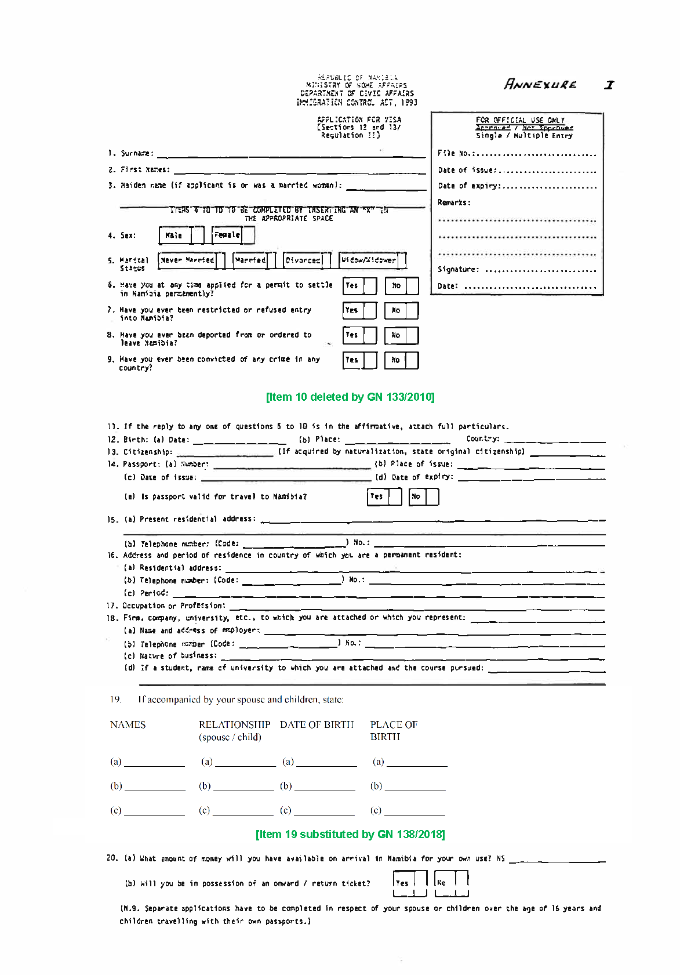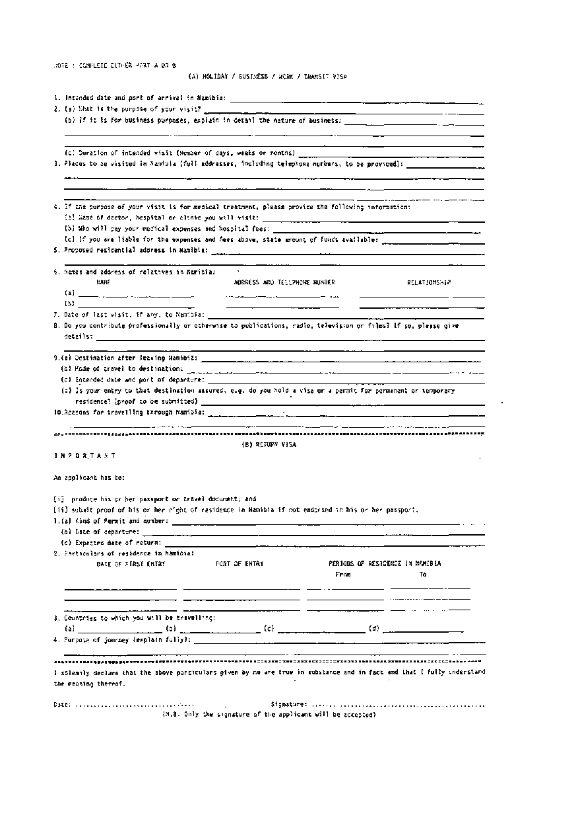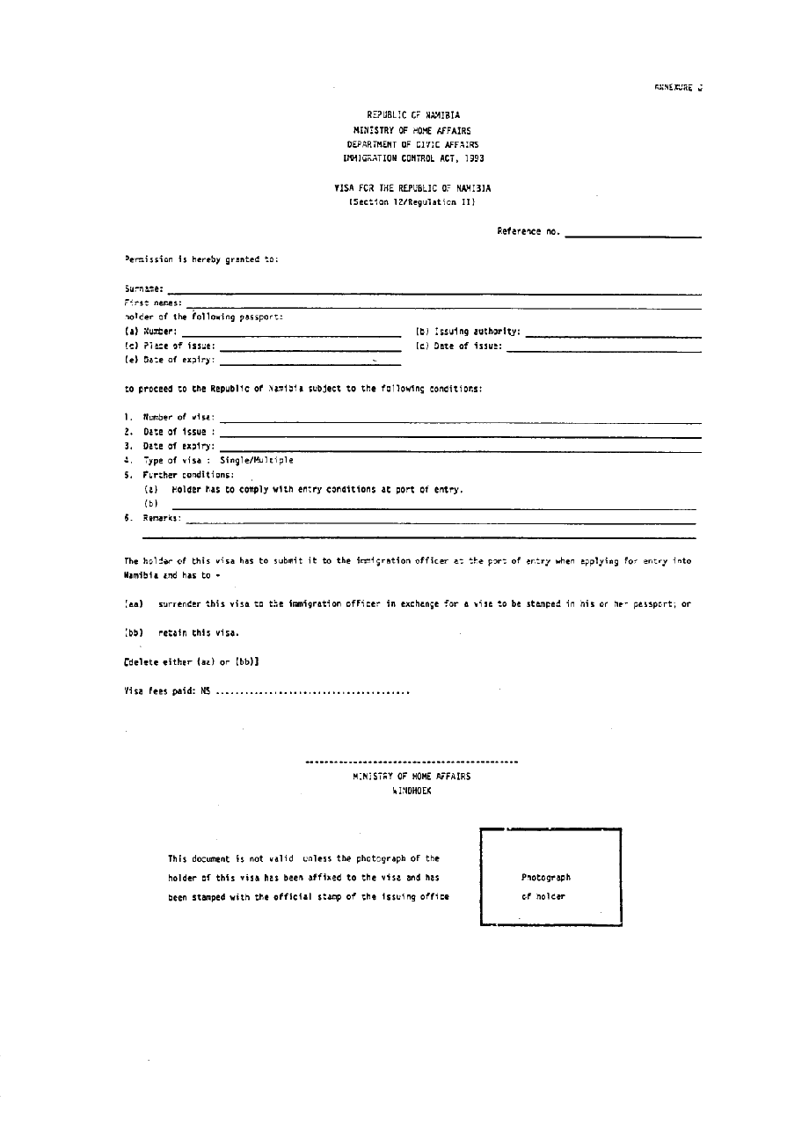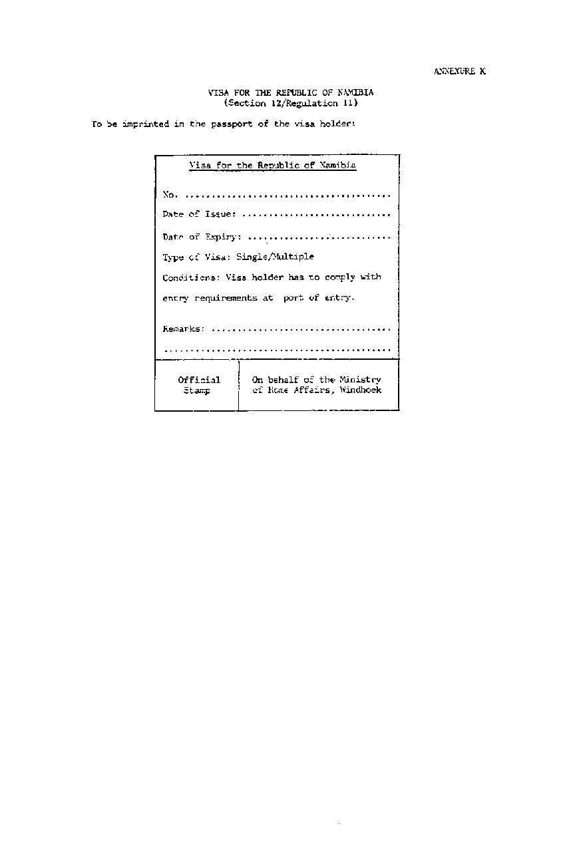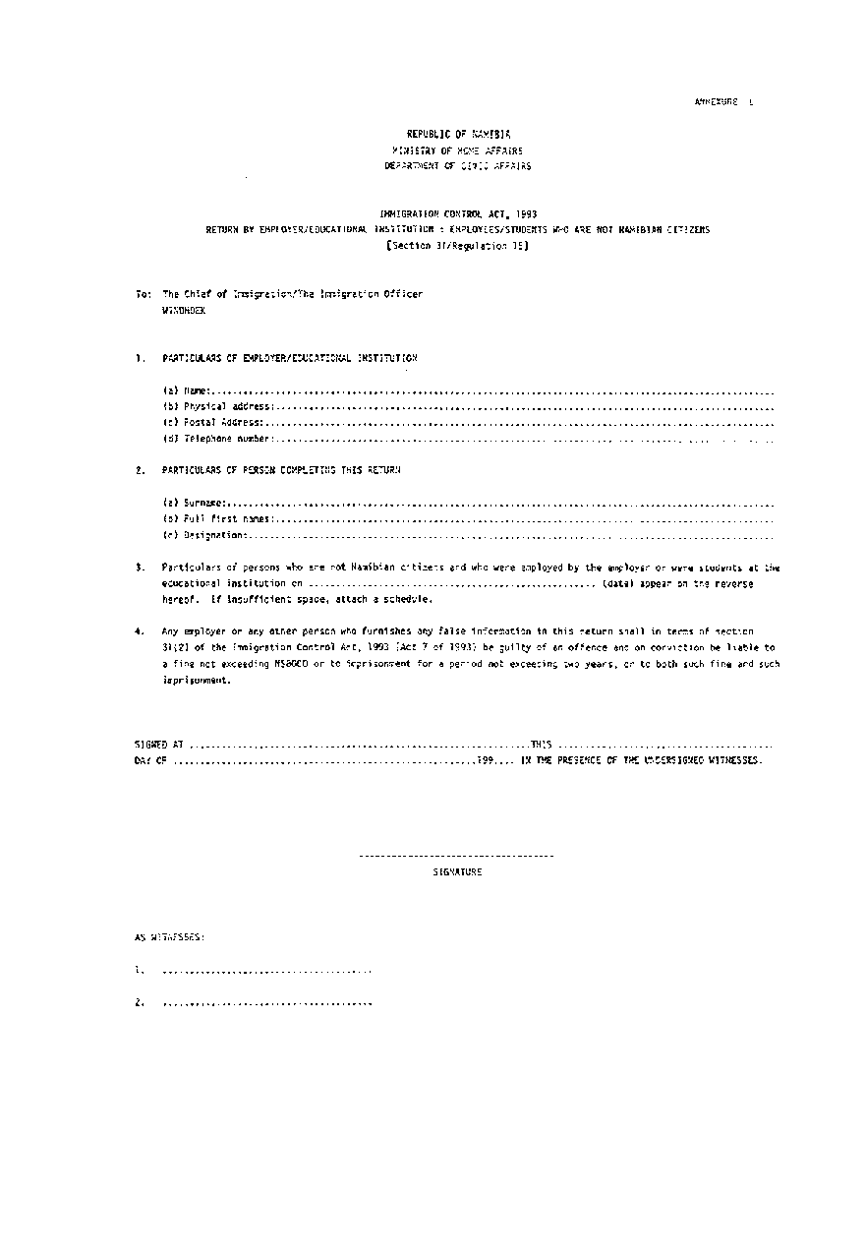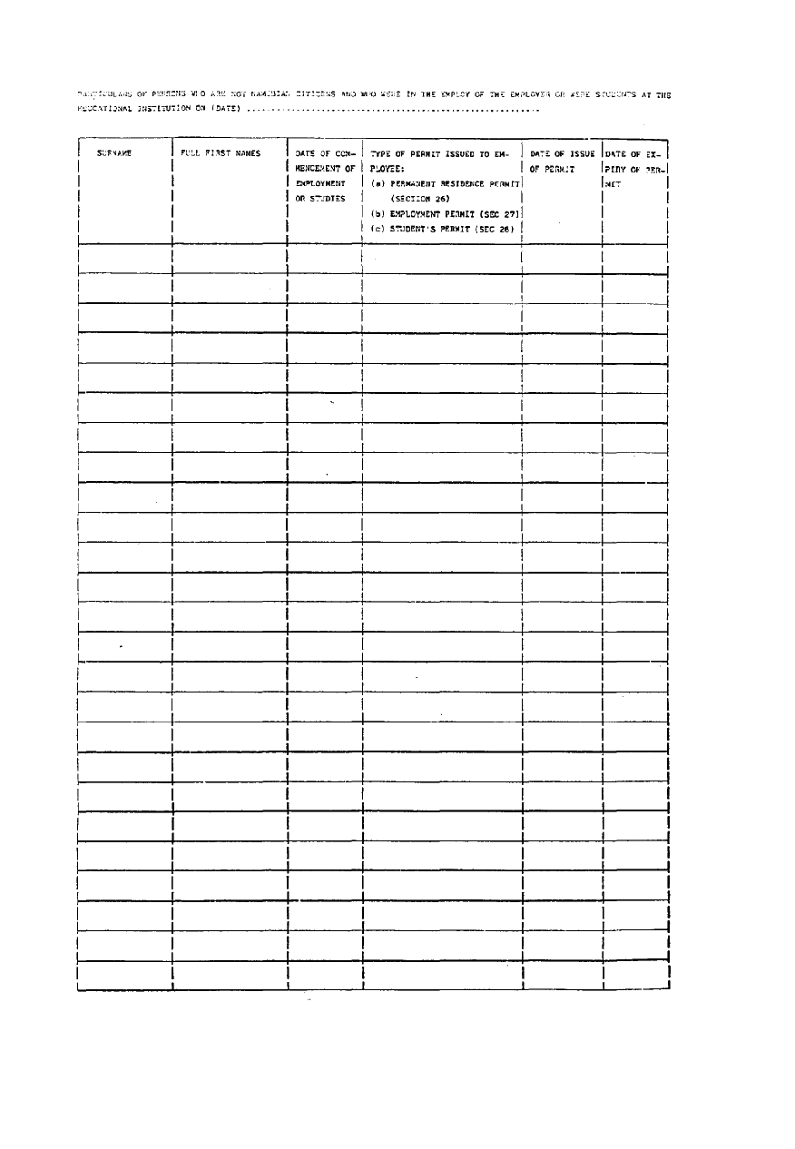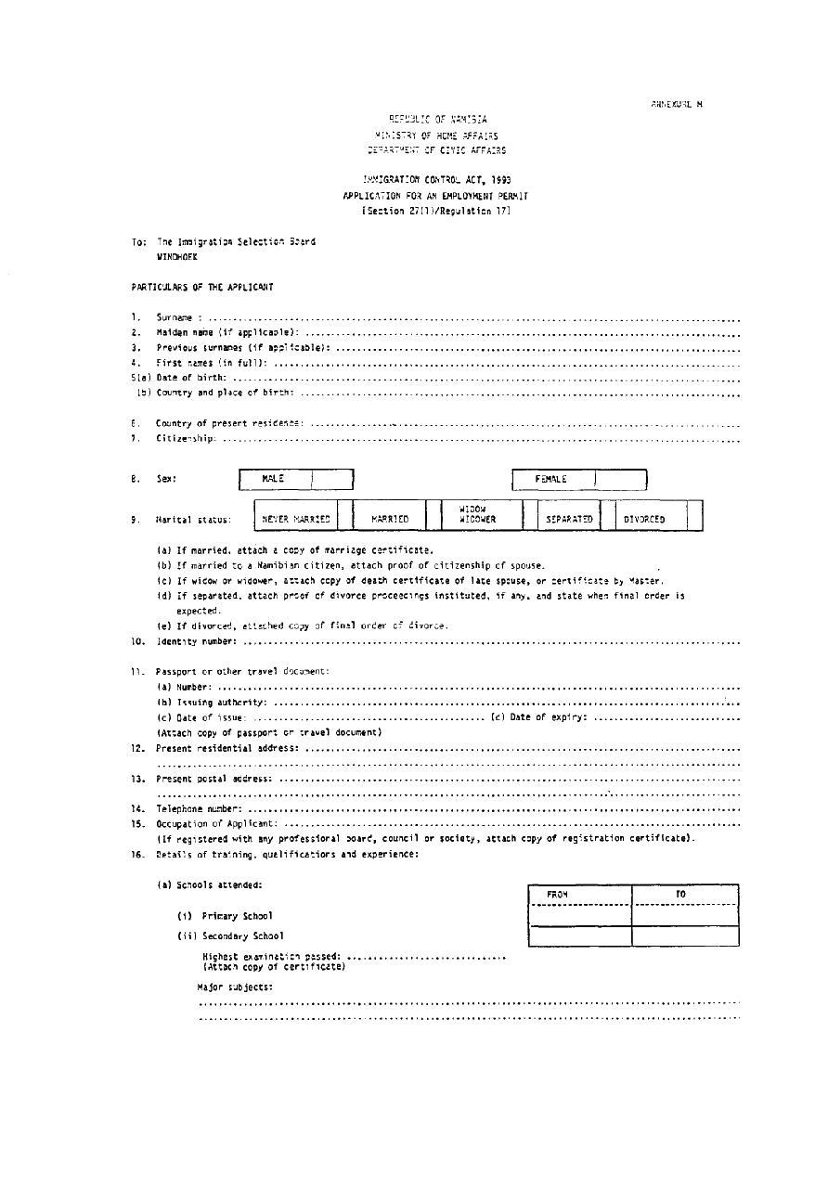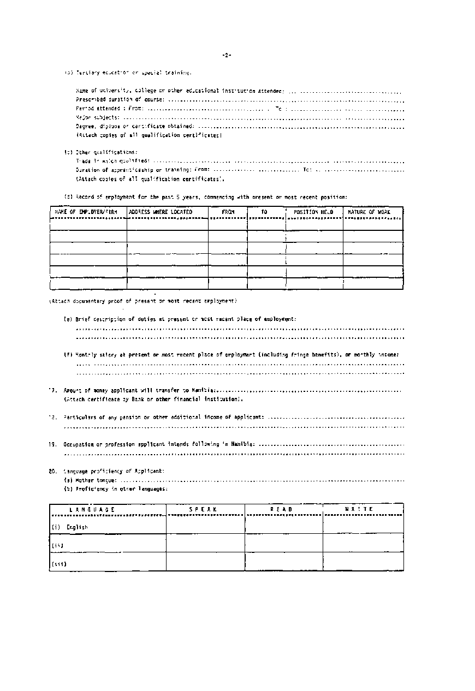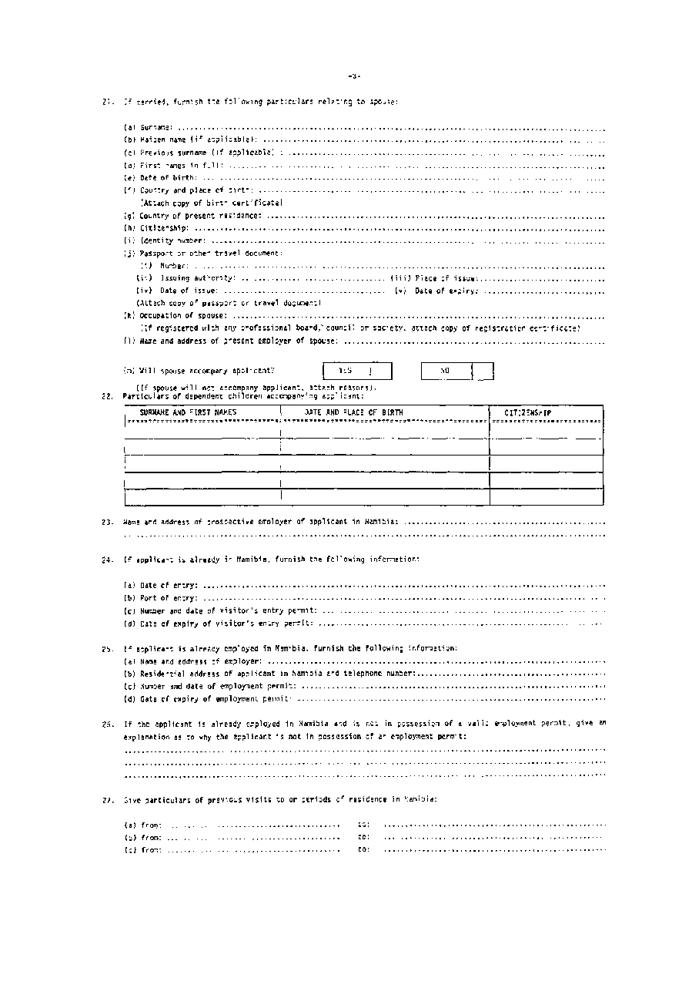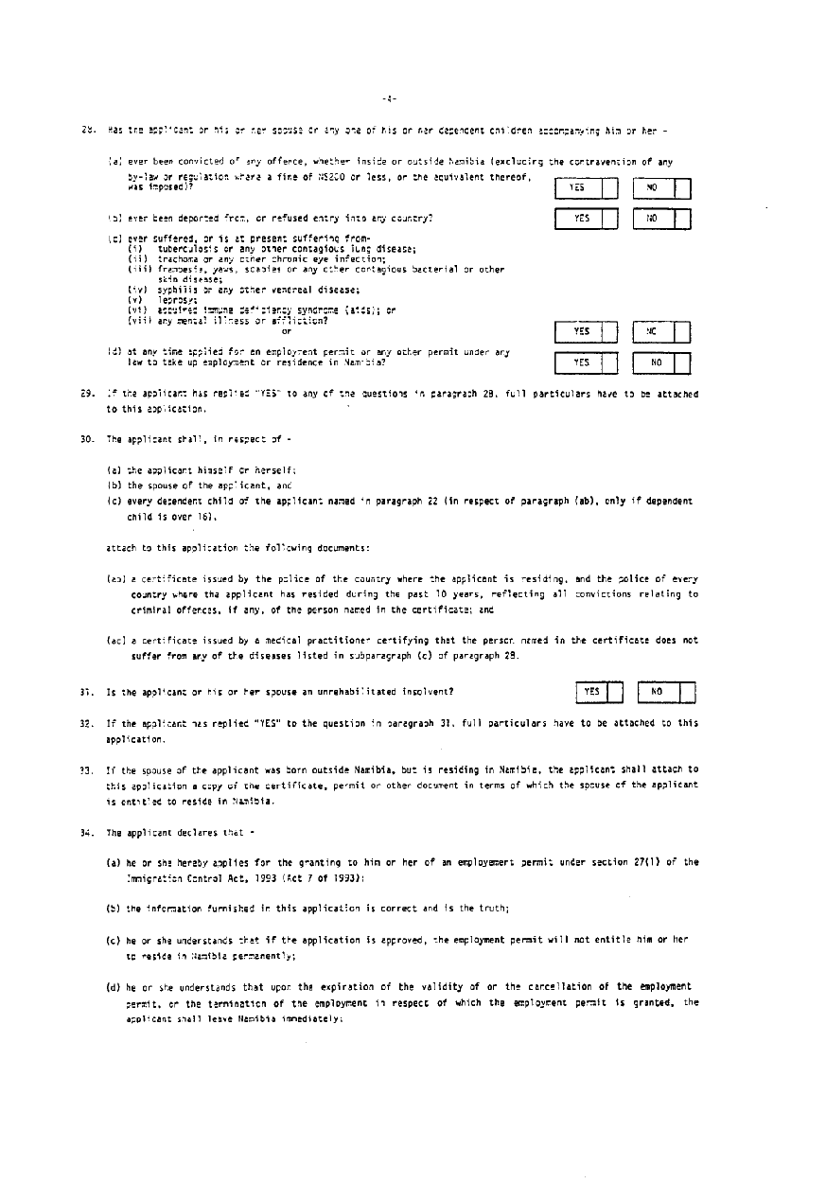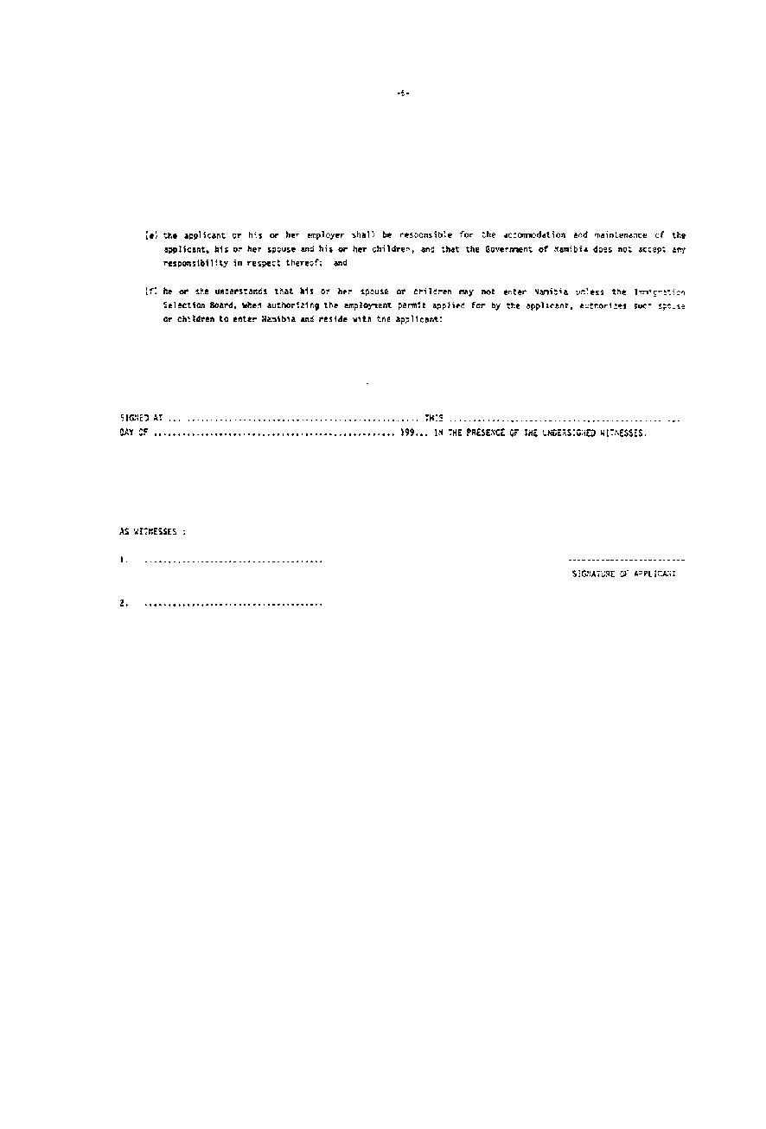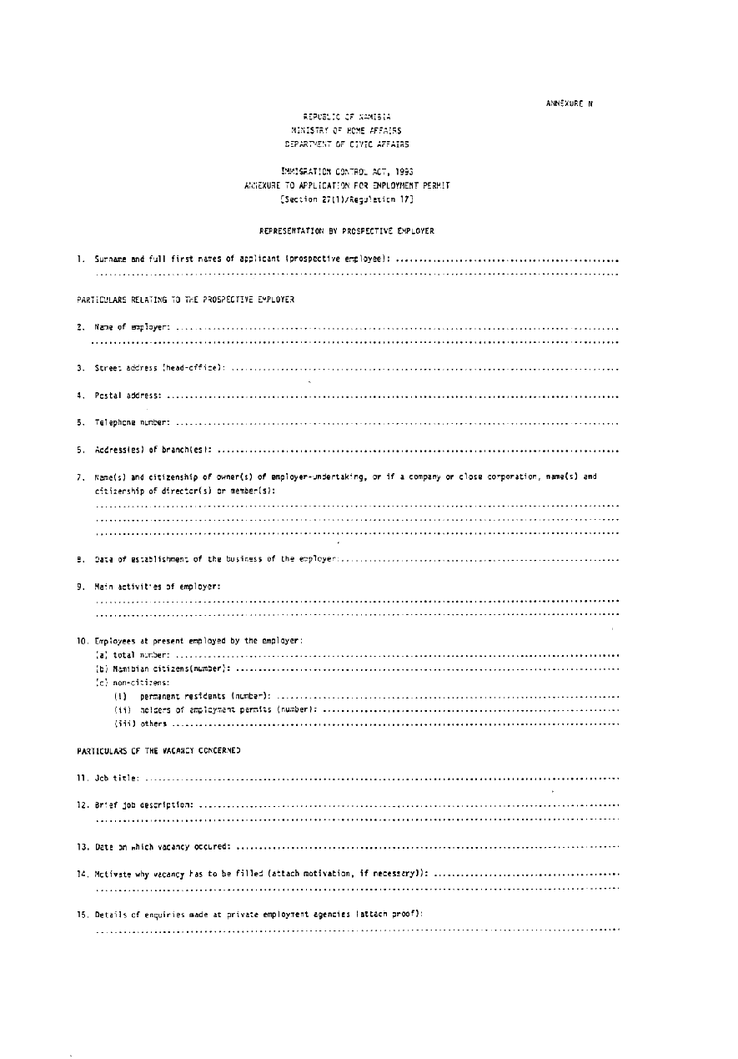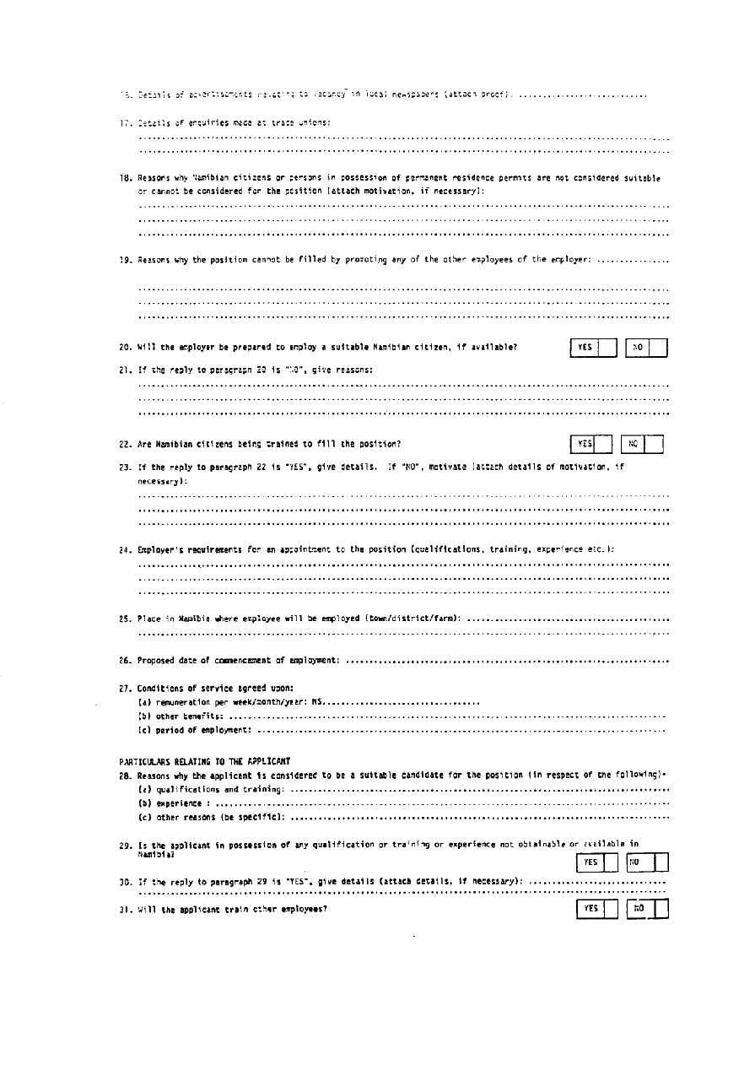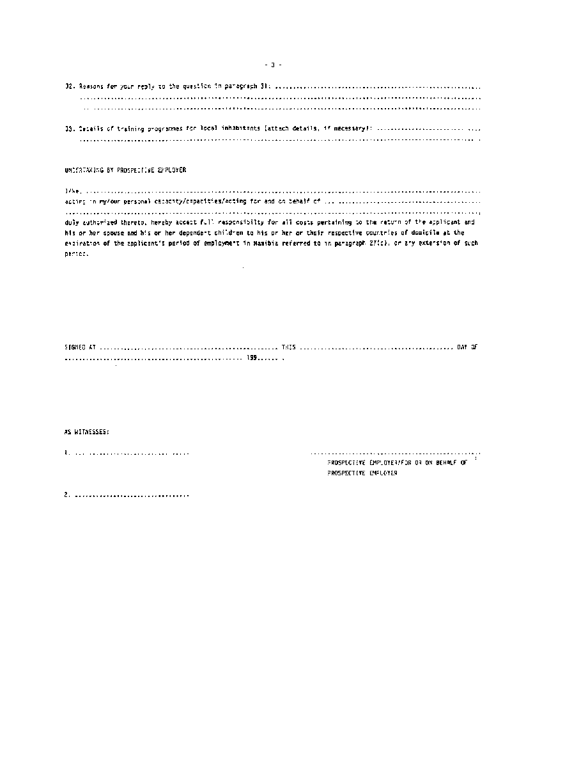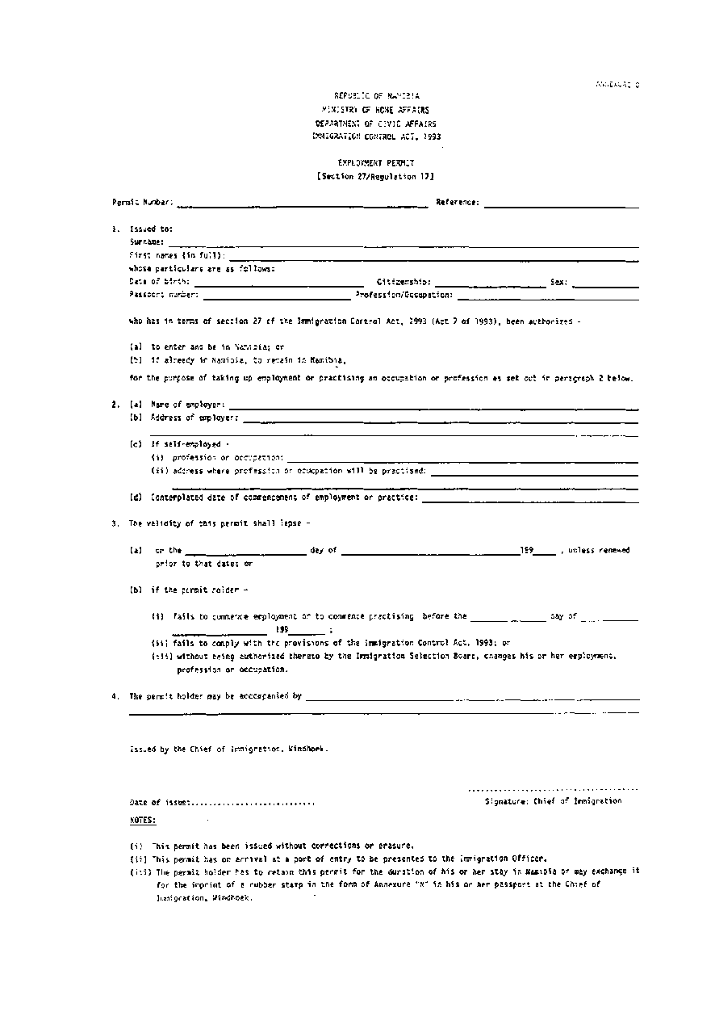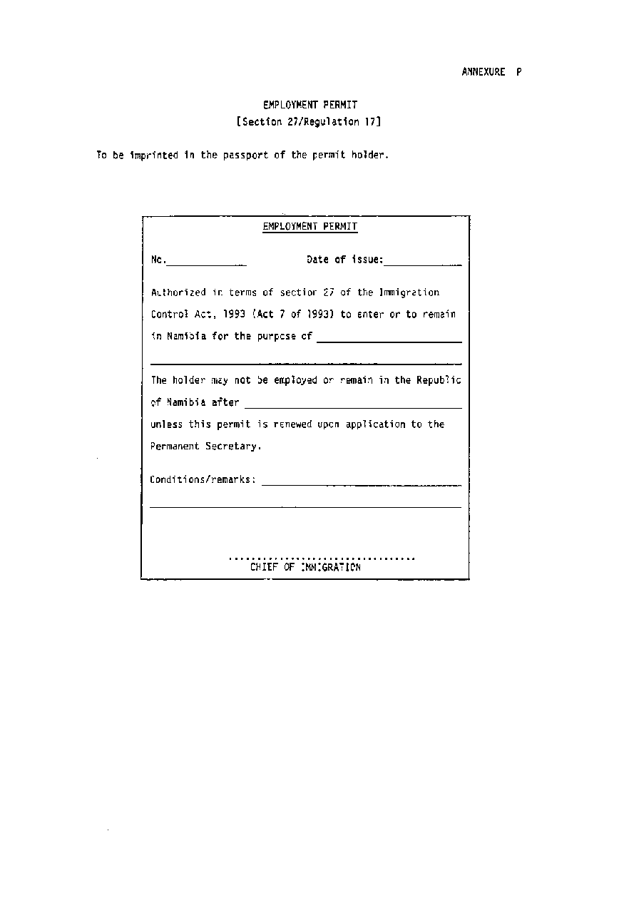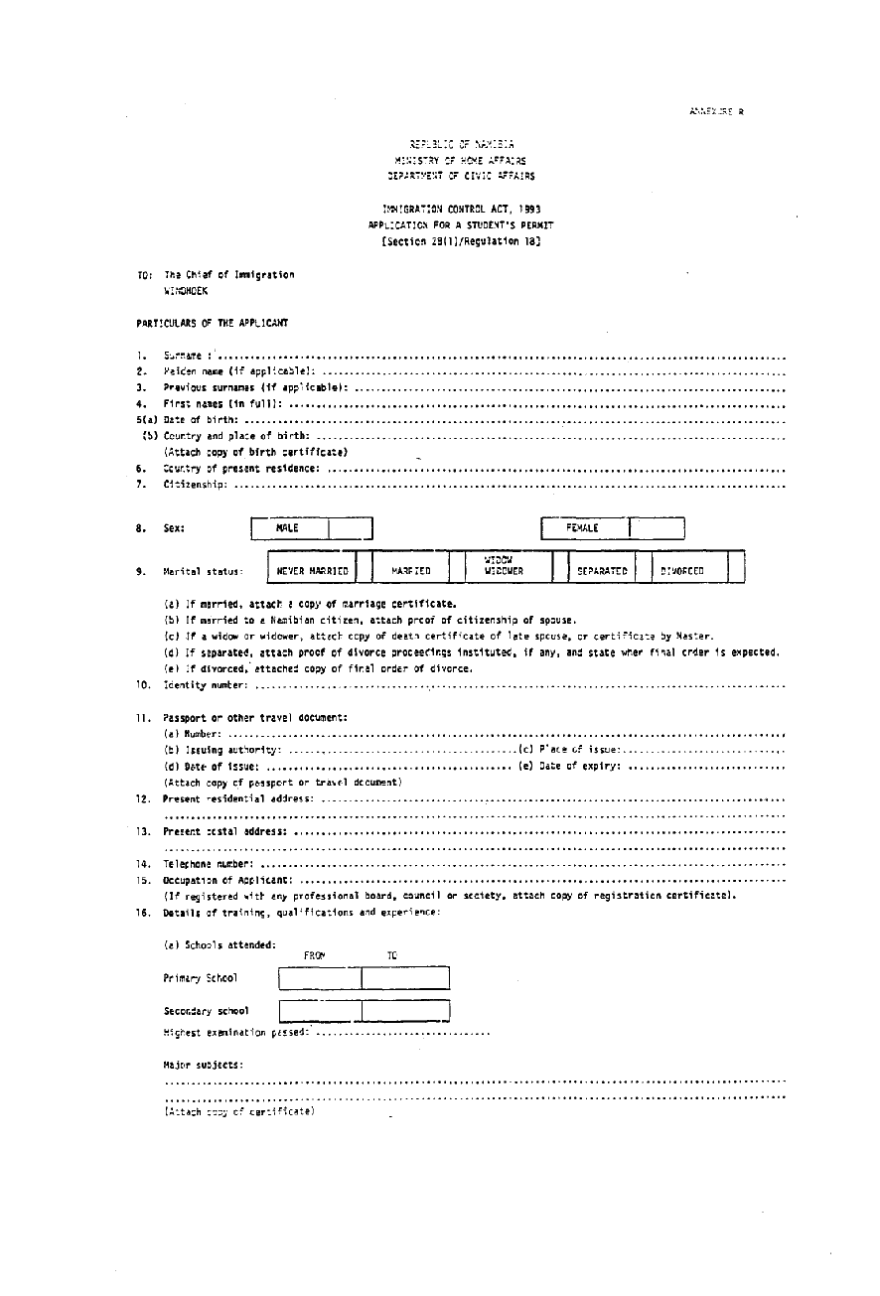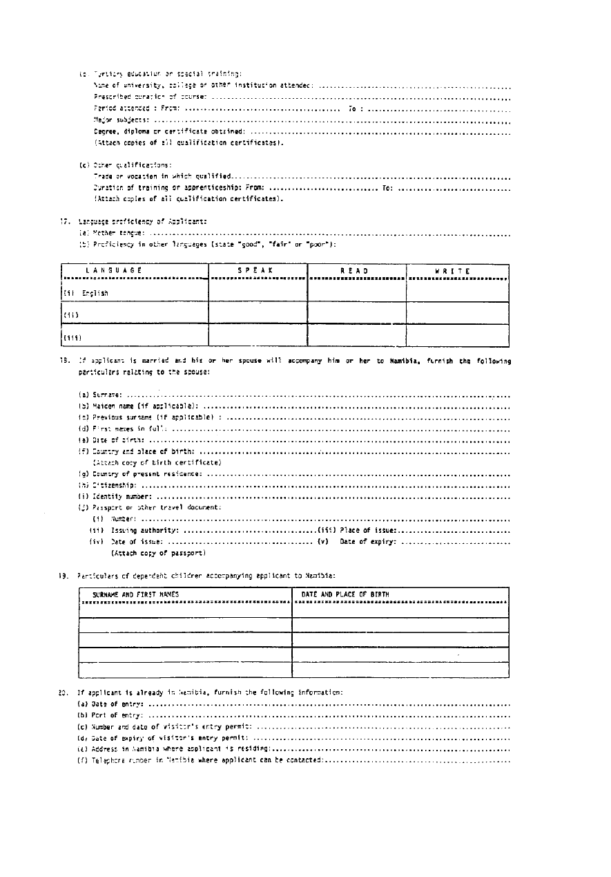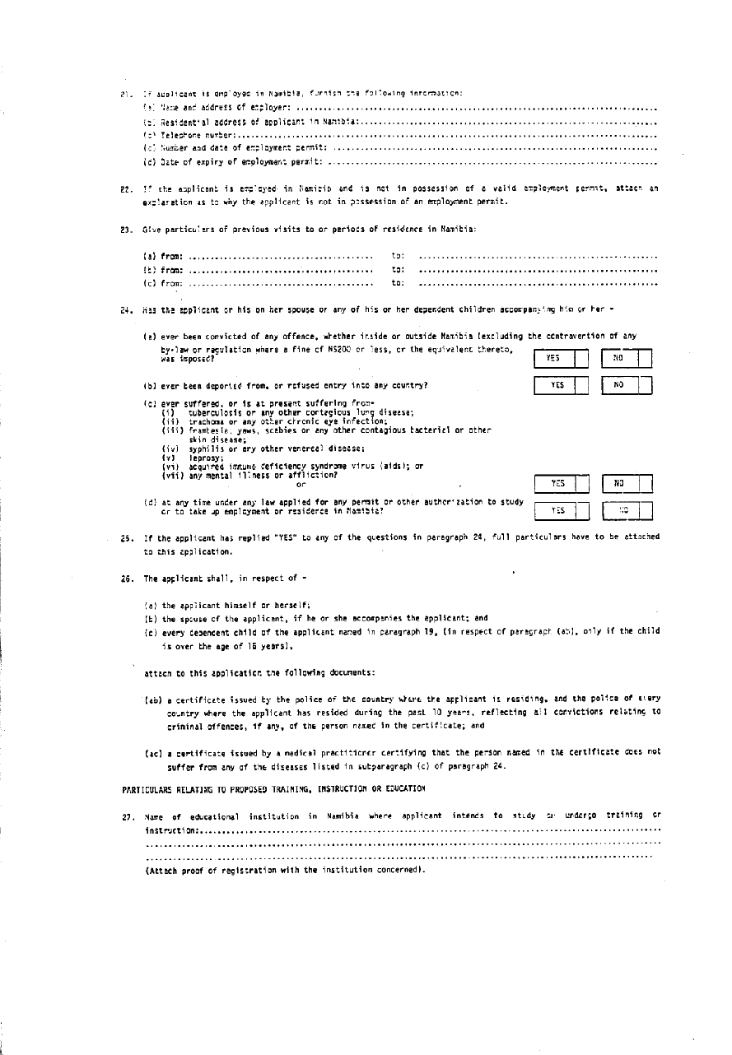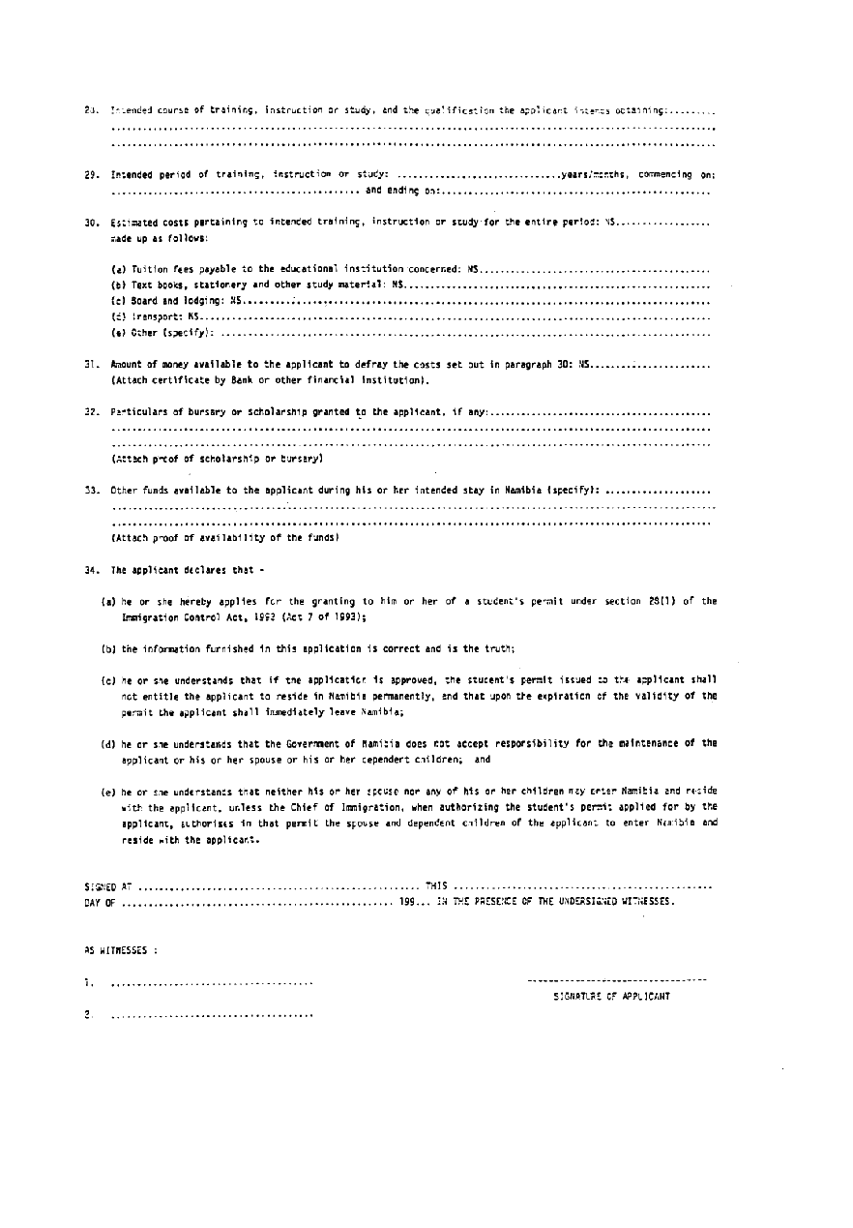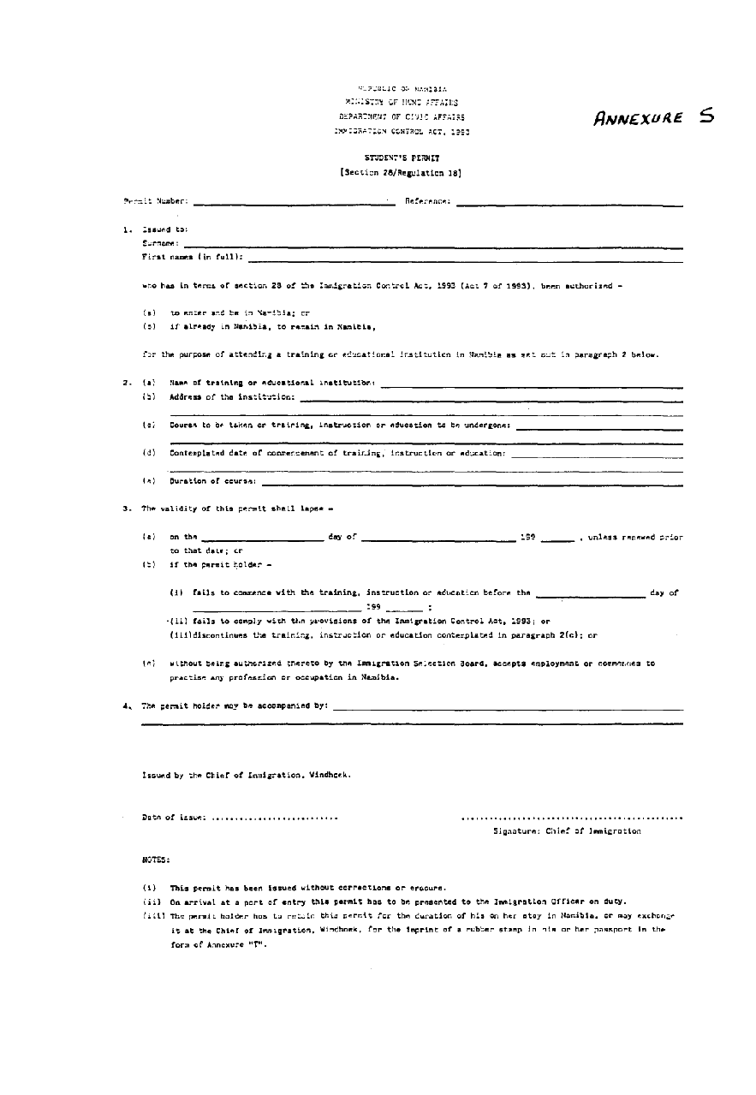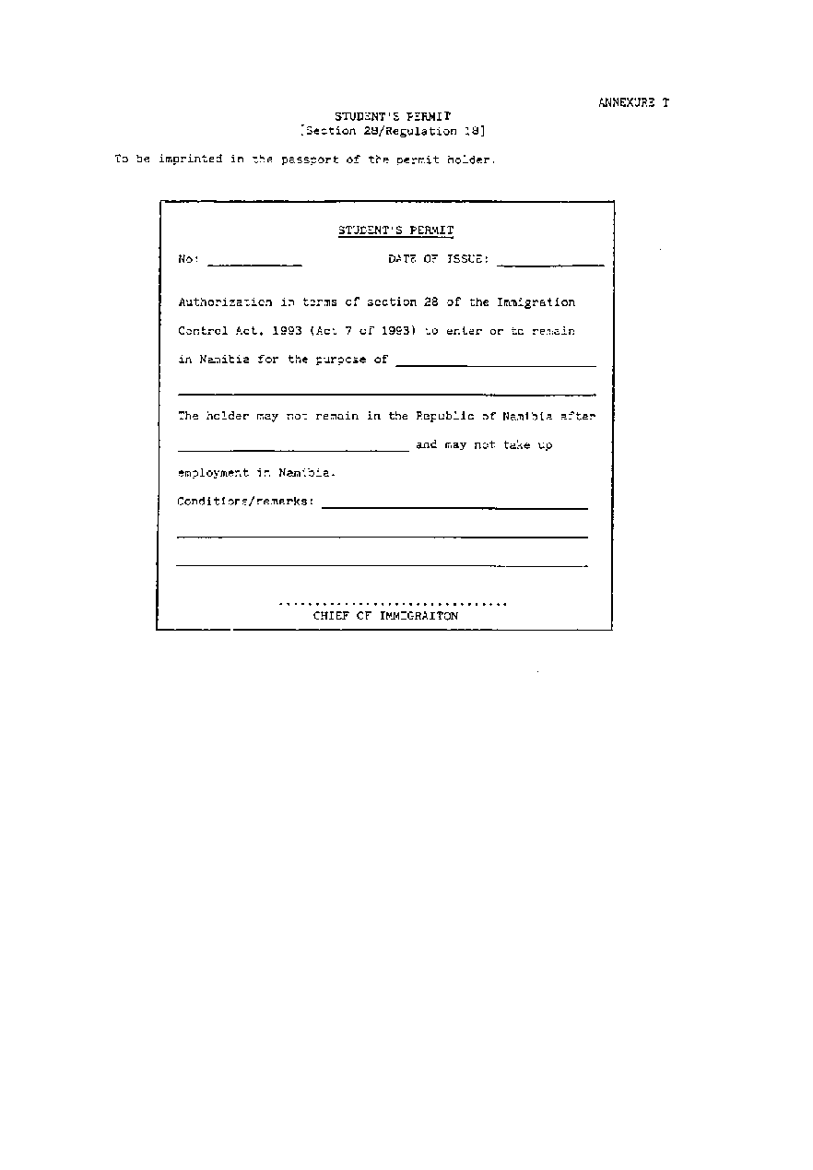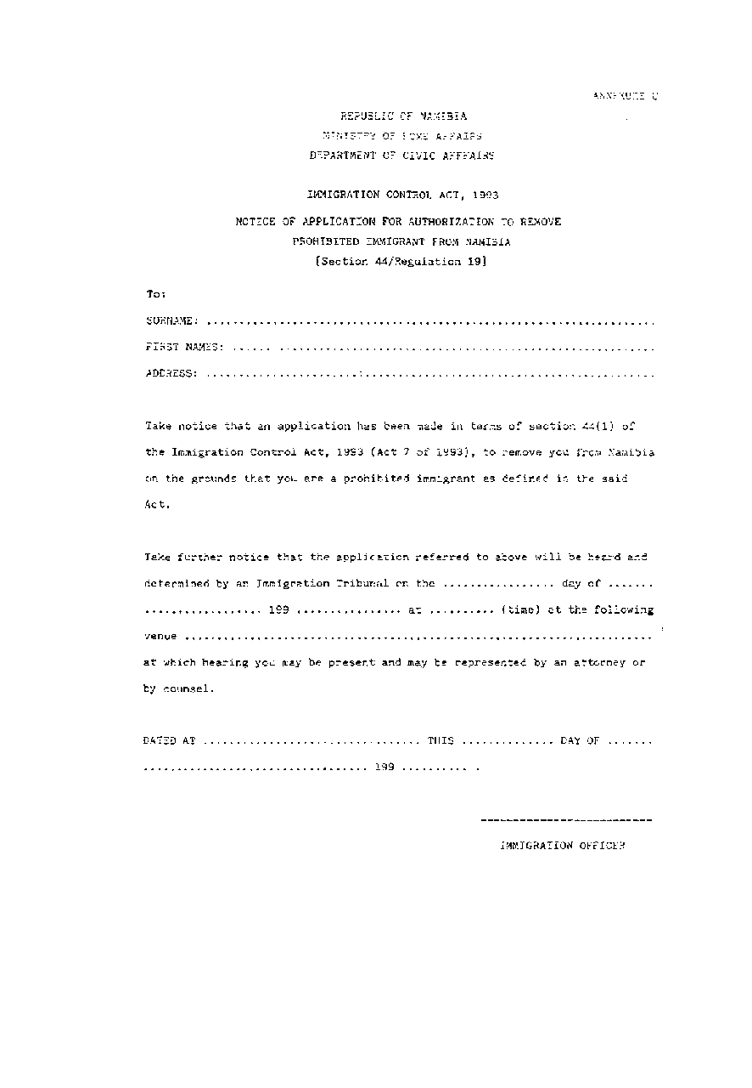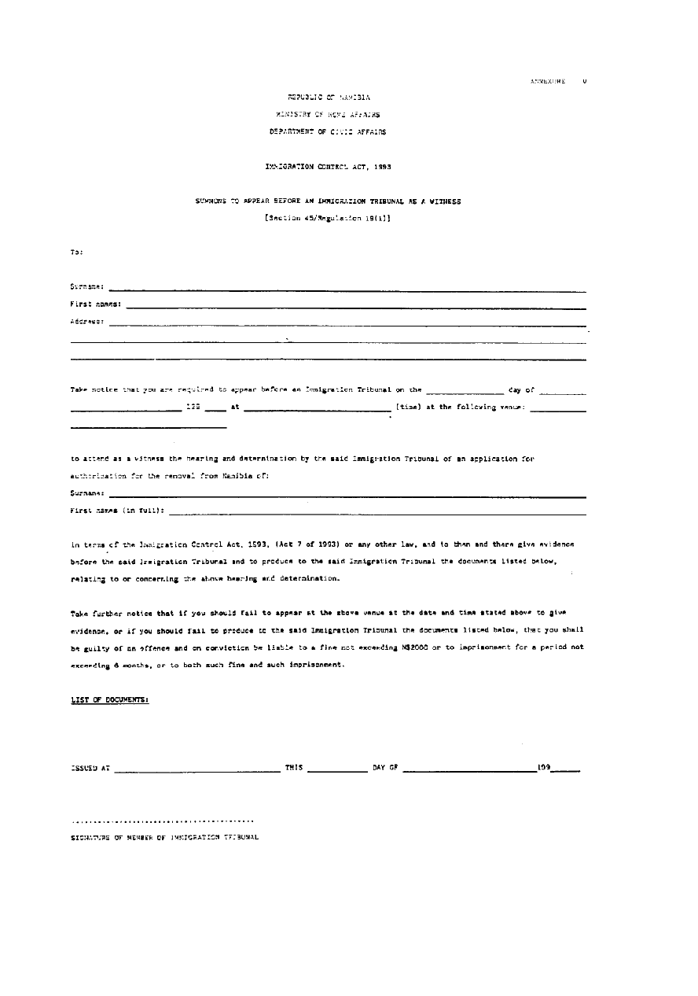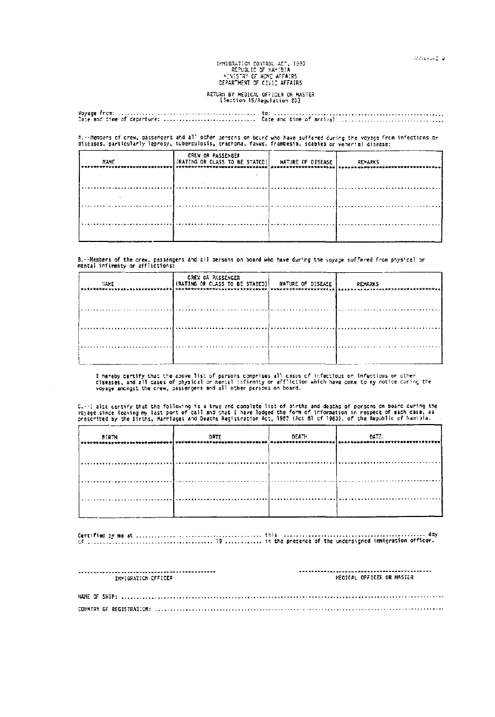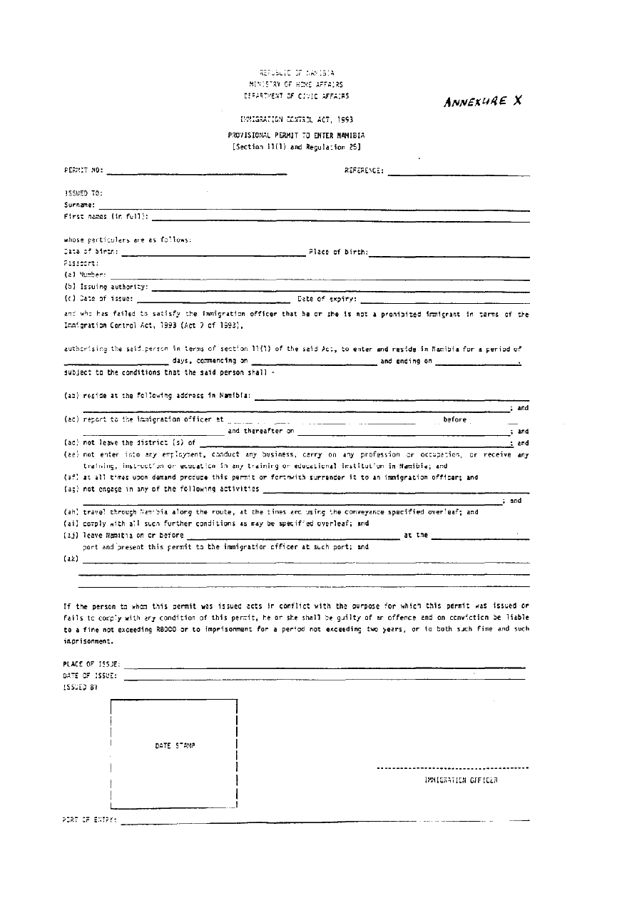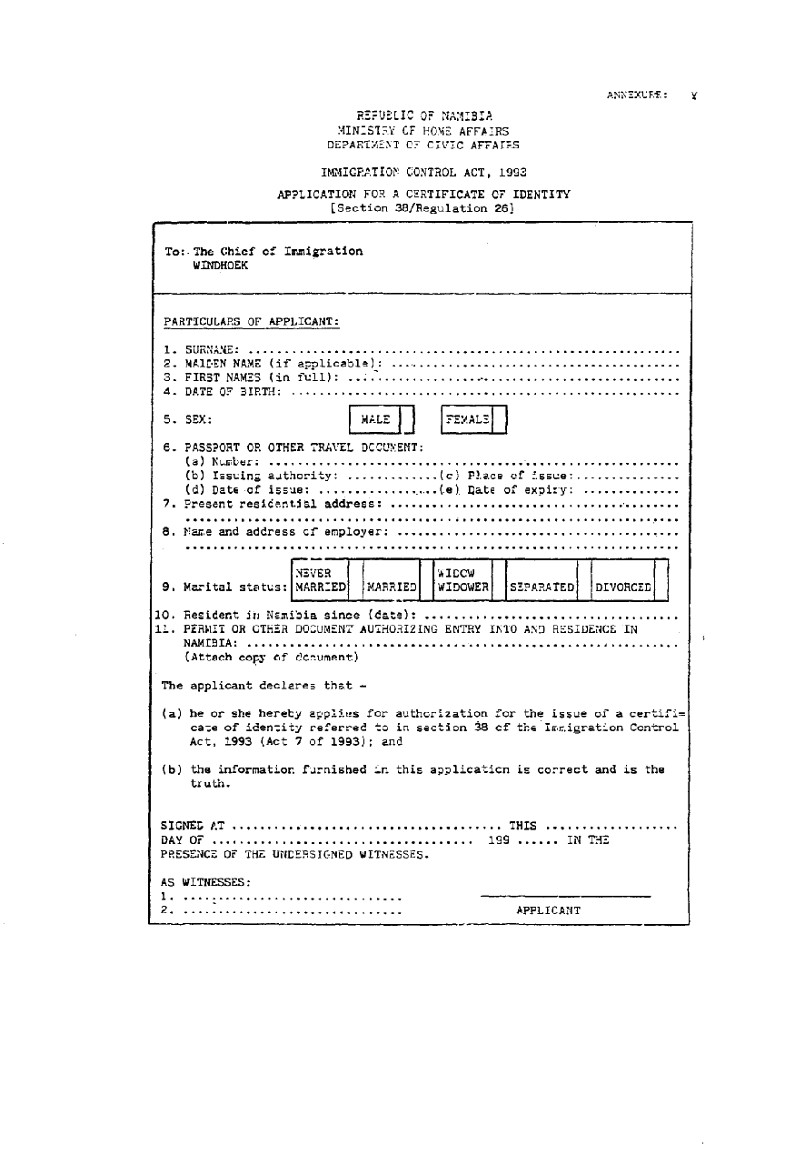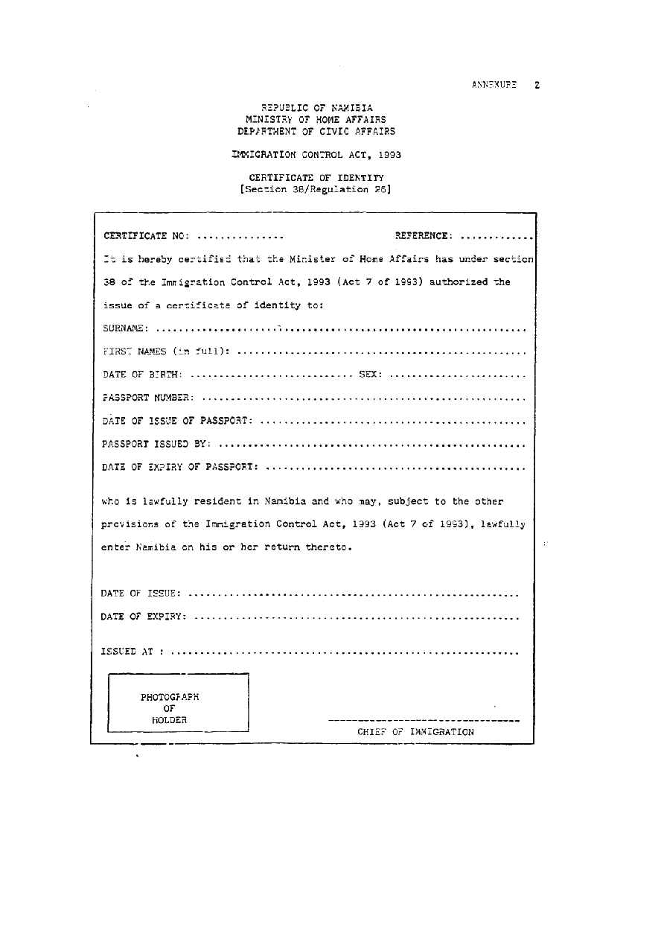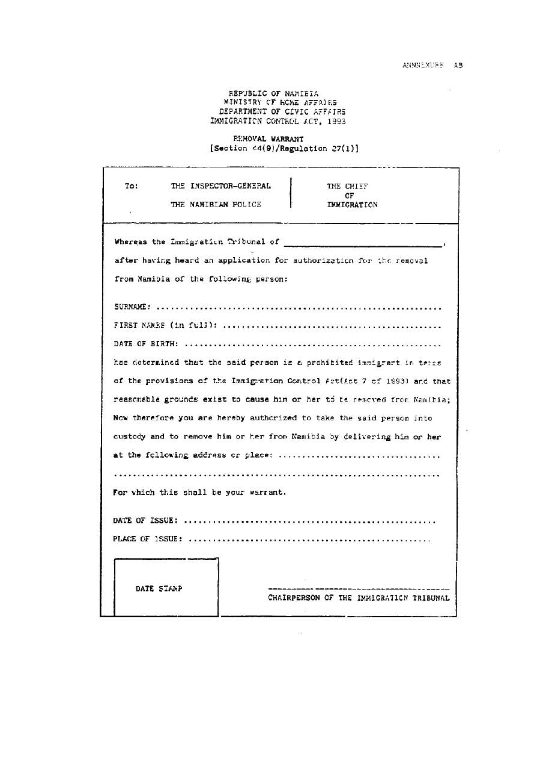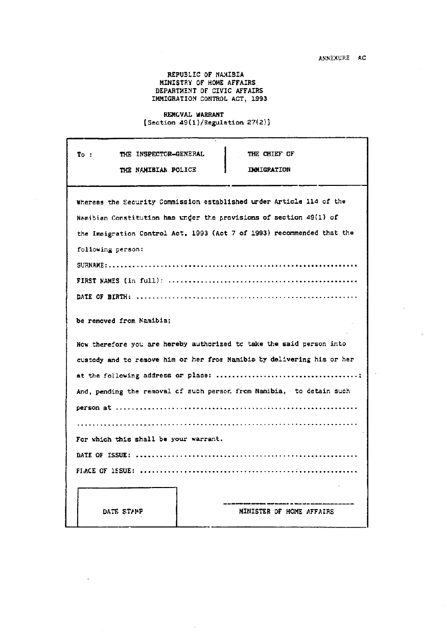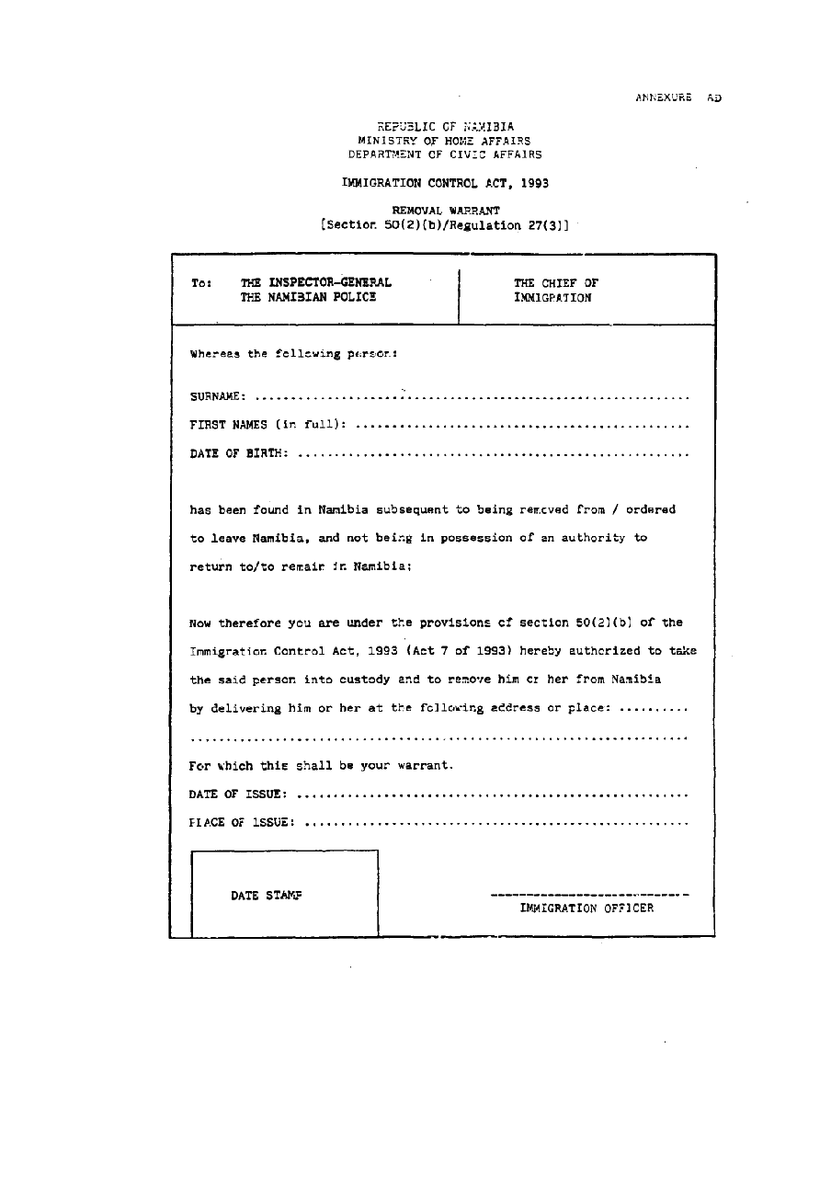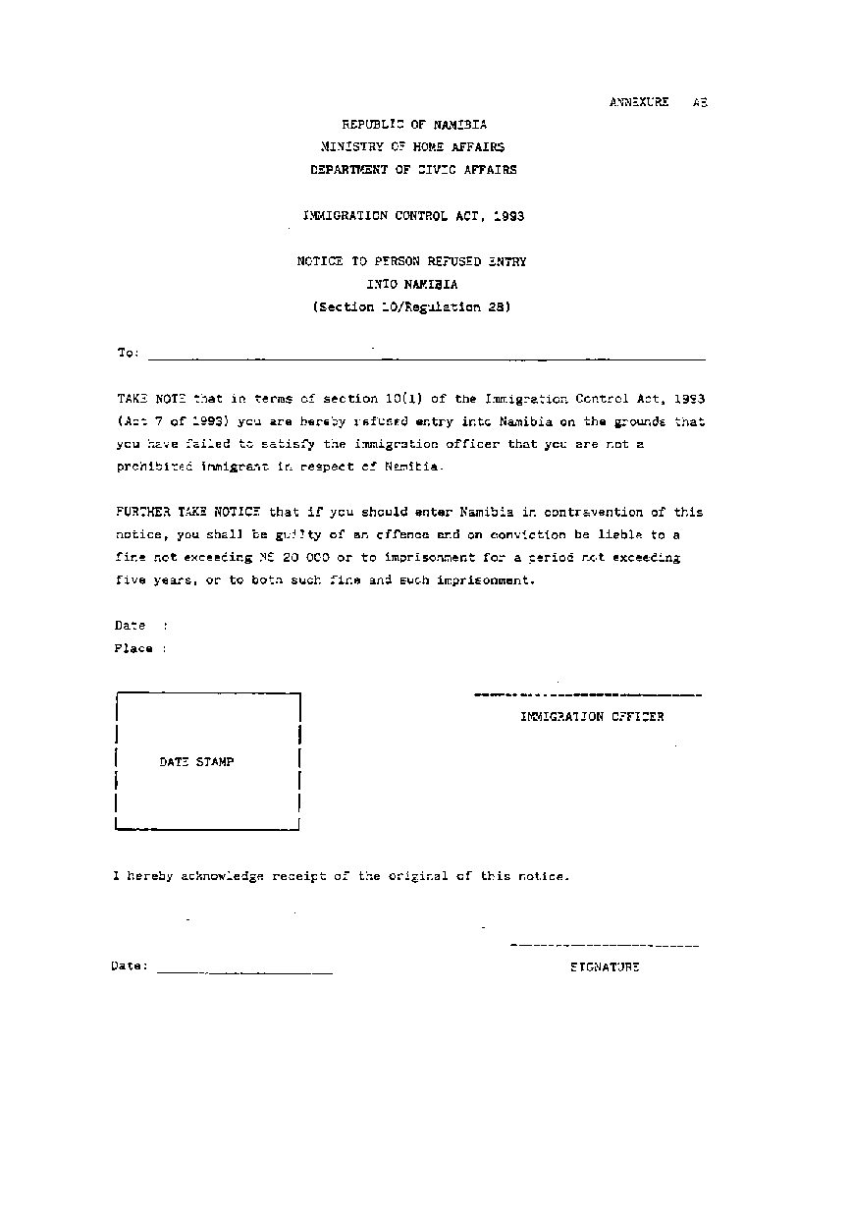
[Annexure AF inserted by GN 8/2020]

Annexure AF

BORDER POSTS AND PORTS OF ENTRY INTO NAMIBIA
(Section 6 /Regulation 2A)

1. Erongo Region

(a) Walvis Bay Airport
(b) Walvis Bay Harbour

2. Kavango East Region

(a) Mohembo Border Post
(b) Rundu Airport
(c) Sarusungu Border Post

3. Kavango West Region

(a) Katwitwi Border Post
(b) Nkurenkuru Border Post

4. //Kharas Region

(a) Ariamsvlei Border Post
(b) Keetmanshoop Airport
(c) Klein Manasse Border Post
(d) Lüderitz Airport
(e) Lüderitz Harbour
(f) Mata-Mata Border Post
(g) Noordoewer Border Post
(h) Oranjemund Airport
(i) Oranjemund Border Post
(j) Senderlings Drift Border Post
(k) Veloorsdrift Border Post

5. Khomas Region

(a) Eros Airport
(b) Hosea Kutako International Airport

6. Ohangwena Region

Oshikango Border Post

7. Omaheke Region

(a) Gobabis Airport
(b) Trans-Kalahari Border Post

8. Omusati Region

(a) Omahenene Border Post
(b) Omuvelo waKashamane Border Post
(c) Ruacana Border Post

9. Oshana Region

Ondangwa Airport

10. Otjozondjupa Region

(a) Dobe Border Post
(b) Grootfontein Airport

11. Zambezi Region

(a) Impalila Island Border Post
(b) Kasika Border Post
(c) Katima Mulilo Border Post
(d) Luhonono Border Post
(e) Mpacha Airport
(f) Ngoma Border Post
(g) Singalamwe Border Post

