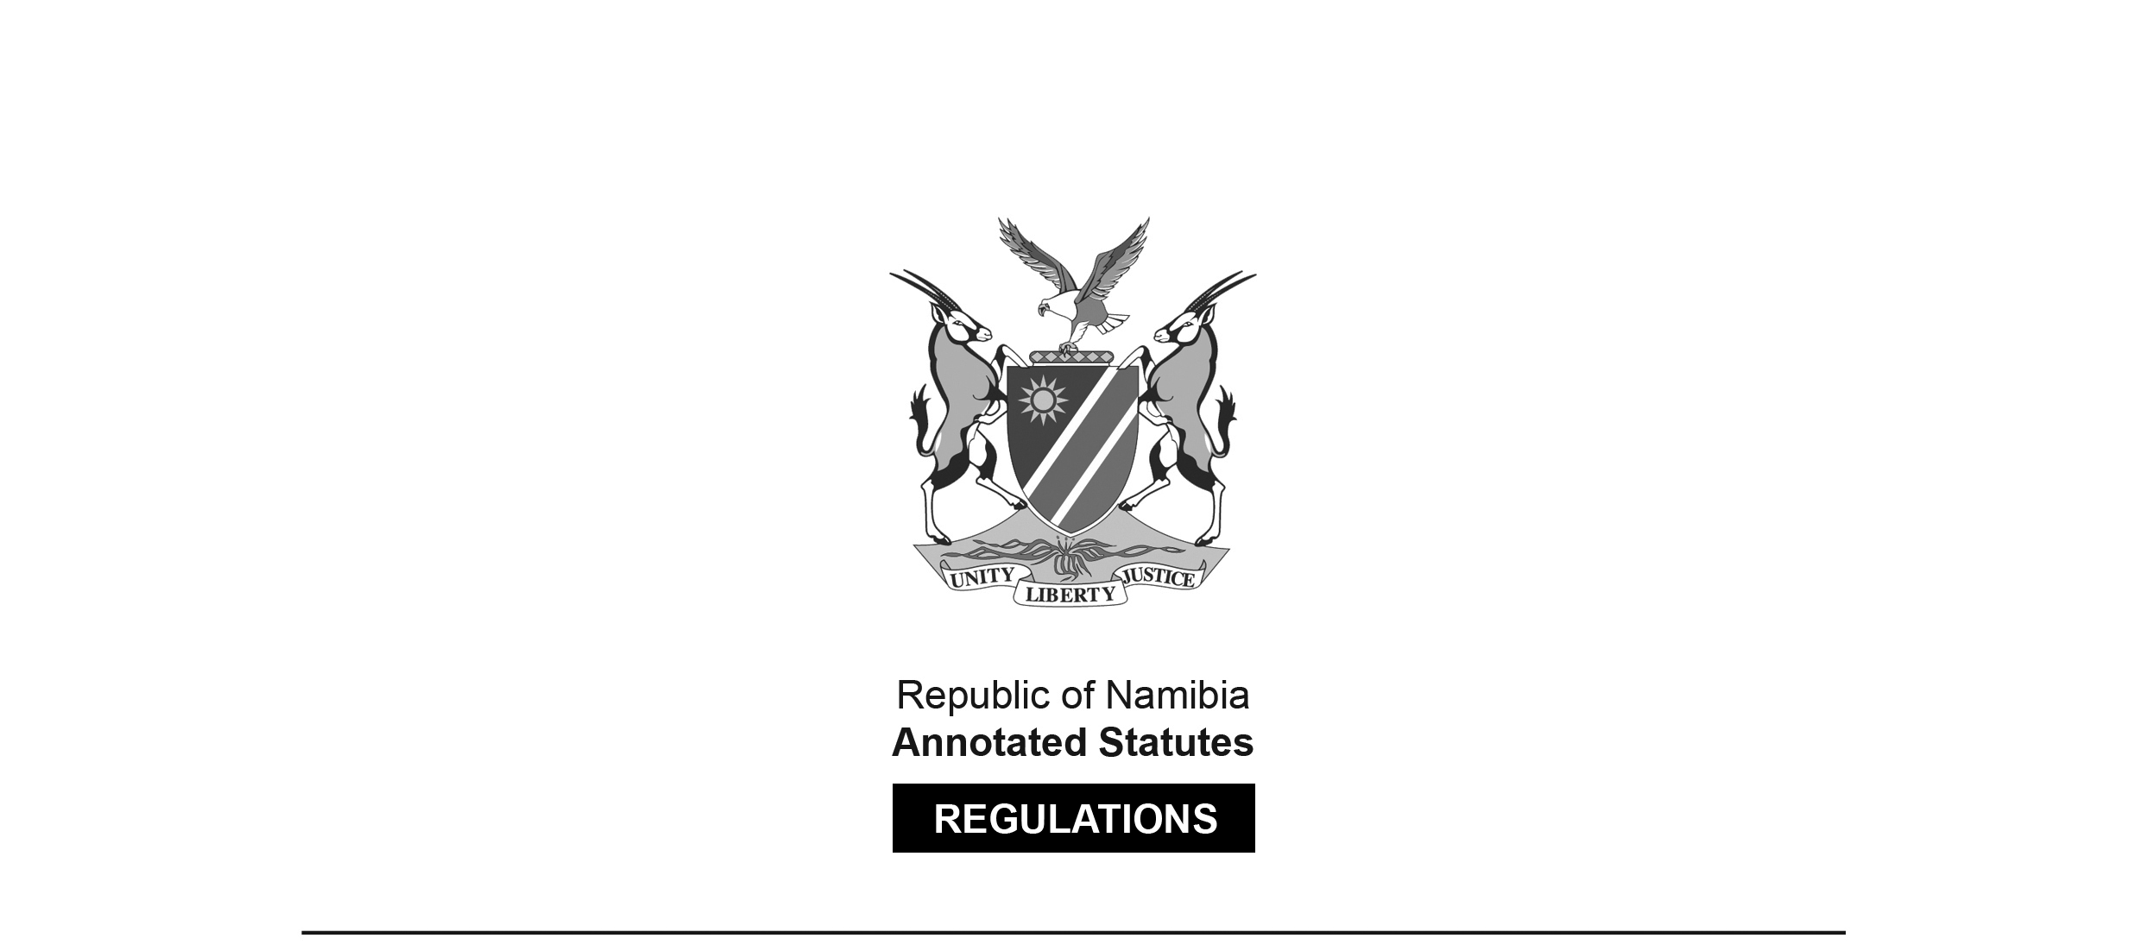
REGULATIONS MADE IN TERMS OF

Hospitals and Health Facilities Act 36 of 1994
section 38

Classification of State Hospitals and State Facilities
Government Notice 184 of 2001
(GG 2609)
came into force on date of publication: 7 September 2001

ARRANGEMENT OF REGULATIONS

[These regulations have no numbers.]

CLASS A (National hospital)
CLASS B (Intermediate/Regional Referral hospitals)
CLASS C (District hospitals)
CLASS D (Health centers)
CLASS E (Clinics)
CLASS F (Outreach mobile)

For the purposes of the Act, State hospitals and State facilities are classified as follows:

CLASS A (National hospital)

Windhoek Central Hospital

CLASS B (Intermediate/Regional Referral hospitals)

Kavango Region:
Rundu hospital (including Primary Health Care Facility)

Khomas Region:
Katutura hospital

Oshana Region:
Oshakati hospital (including Primary Health Care Facility)

CLASS C (District hospitals)

Caprivi Region:
Katima Mulilo hospital

Erongo Region:
Omaruru hospital (Ozondje and Maternity)
Swakopmund hospital
Usakos hospital
Walvis Bay hospital

Hardap Region:
Mariental hospital
Rehoboth St. Mary (Roman Catholic Mission)

Karas Region:
Karasburg hospital
Keetmanshoop hospital
Lüderitz hospital

Kavango Region:
Andara (Roman Catholic Mission)
Nankudu hospital
Nyangana (Roman Catholic Mission)

Kunene Region:
Khorixas hospital
Opuwo hospital
Outjo hospital

Ohangwena Region:
Eenhana hospital
Engela hospital
Kongo hospital

Omaheke Region:
Gobabis hospital

Omusati Region:
Okahao hospital
Oshikuku (Roman Catholic Mission)
Outapi
Tsandi

Oshikoto Region:
Onandjokwe (Lutheran Medical Mission)
Tsumeb hospital

Otjozondjupa Region:
Grootfontein hospital
Okahandja hospital
Okakarara hospital
Otjiwarango hospital

CLASS D (Health centers)

Caprivi Region:
Bukalo
Sangwali
Sibbinda

Erongo Region:
Karibib
Kuisebmund

Hardap Region:
Aranos
Maltahöhe
Rehoboth

Karas Region:
Aroab (Roman Catholic Mission)
Bethanien

Kavango Region:
Bunya (Roman Catholic Mission)
Mpungu
Mupini
Nkarapamwe
Nkurenkuru (Lutheran Medical Mission)
Rupara
Sambyu (Roman Catholic Mission)
Tondoro (Roman Catholic Mission)

Khomas Region:
Katutura
Khomasdal

Ohangwena Region:
Odibo (Anglican Diocese of Namibia)

Omaheke Region:
Otjinene

Omusati Region:
Elim
Indira Ghandi/Onemanja
Mahenene
Okalongo
Omona Wa Tjihozu
Onesi

Oshana Region:
Okatana (Roman Catholic Mission)
Ondangwa (Oluno)
Ongwediwa
Ou Nick (Oshakati)

Oshikoto Region:
Okankolo
Onayena
Onyaanya

Otjozondjupa Region:
Mangetti Dune

CLASS E (Clinics)
Caprivi Region:
Batubaja
Chinchimane
Choi
Ibbu
Impalila
Isize
Itomba
Kabbe
Kanono
Kasheshe
Linyanti
Lisikili
Lusese
Mafuta
Masokotwane
Mavuluma
Mbalasinte
Muyako
Ngoma
Ngwezi
Sachona
Schuckmannsburg
Sesheke

Erongo Region:
Arandis
Coastal Health (Kuisebmund)
Hakaseb
Henties Bay
Naraville
Okombahe
Omatjete
Otjimbingwe
Spitskoppe
Tamariskia
Tubusis
Uis
Utuseb
Walvis bay [Bay]

Hardap Region:
Aranos
Gibeon
Goehas
Hoachanas
Kalkrand
Klein Aub
Maltahöhe
Mariental
Rietoog
Schlip
Stampriet

Karas Region:
Ariamsvlei
Aus
Aussenkehr
Berseba
Daan Viljoen (Keetmanshoop)
Gabis (Roman Catholic Mission)
Keetmanshoop (Tseiblaagte/Kronlein)
Köes
Noordoewer
Tses
Warmbad

Kavango Region:
Baramansoni
Dcwatjinga
Divundu
Gcaruha
Kaisosi
Kandjara
Kangongo
Kapako
Kapupahedi
Katere
Katjinakatji
Karukuta
Kayengona
Mabushe
Mangetti
Mashara
Mayara (Roman Catholic Mission)
Mbambi (Lutheran Medical Mission)(Nankudu)
Mbambi (Roman Catholic Mission)(Nyangana)
Mbiro
Mile 10
Mile 30
Mupara (Lutheran Medical Mission)
Mutjiku
Muveve
Ncaute
Ncuncuni
Ndama
Ndonga
Nepara
Nzinze
Old Bagani (Roman Catholic Mission)
Omega
Sauyemwa Shadikongoro Sharukwe (Rundu)
Shinyungwe (Roman Catholic Mission)
Sikarosompo (Lutheran Medical Mission)
Takwasa
Yinsu

Khomas Region:
Baumgartsbrunn
Donkerdoek
Dordabis
Groot Aub
Hakahana
Maxwilili
Okuryangava
Robert Mugabe
Wanaheda

Kunene Region:
Anichab
Anker
Bergsig
Epupa
Erwee
Etanga
Etoto
Fransfontein
Kamanjab
Ohandungu
Okangwati
Okaukuejo
Orumana
Otjimuhaka
Oruvandje
Otjiu
Otjondeka
Sesfontein
Terrace Bay

Ohangwena Region:
Edundja
Ekoka
Endola
Epembe
Epinga
Eudafano
Ohangwena
Ohaukelo
Ohaulushu
Okambembe
Okatope
Olukula
Omundaungilo
Omungwelume
Onambutu
Onamukulo
Onangolo
Ondobe
Onekwaya
Ongenga
Ongha
Ongulayanetanga
Oshandi
Oshikunde

Omaheke Region:
Aminius
Blouberg
Eiseb
Epako
Epukiro Pos 3
Korridor
Leonardville
Omitara
Onderombapa
Rietfontein/Talismanus
Sendingplaas
Witvlei

Omusati Region:
Amarika
Anamulenge (Roman Catholic Mission)
Eengolo
Epoko
Etilyasa
Eunda
Iipanda
Yaamiti
Iilateko (Roman Catholic Mission)
Odimbwa
Ogongo
Okando
Okathitu
Okatseidhi
Olupandu
Oluteyi
Olutsiidhi
Omagalanga
Omuthitugwonyama
Omutundungu
Onaanda
Onamandongo
Onamatanga
Onawa
Ongulumbashe
Onheleiwa
Onkani
Oshaala
Osheetekela
Oshitudha
Otamanzi
Othika
Ruacana
St. Benedictus (Roman Catholic Mission)
Uutsathima

Oshana Region:
Ehafo
Eheke (Lutheran Medical Mission)
Ekamba
Eluwa
Enkono
Okaku (Lutheran Medical Mission)
Okaukamasheshe
Omupundja
Onamutayi
Uukwiyuushona

Oshikoto Region:
Amilema (Lutheran Medical Mission)
Ndamono (Lutheran Medical Mission)
Olukonda (Lutheran Medical Mission)
Omuntele (Lutheran Medical Mission)
Omuthiya (Lutheran Medical Mission)
Onakazizi
Onamishu
Onanke
Onkumbula (Lutheran Medical Mission)
Ontananga (Lutheran Medical Mission)
Onyuulae
Oshigambo
Oshivelo
Tsintsabis
Tsumeb

Otjozondjupa Region:
Coblenz
Garn
Grootfontein
Kalkveld
Kornbat
Okahandja
Okamatapati
Okarondu
Okandjatu
Omatako
Orwetoveni
Osire
Otavi
Otjituuo
Ovitoto
Tsumkwe

CLASS F (OUT REACH MOBILE)

