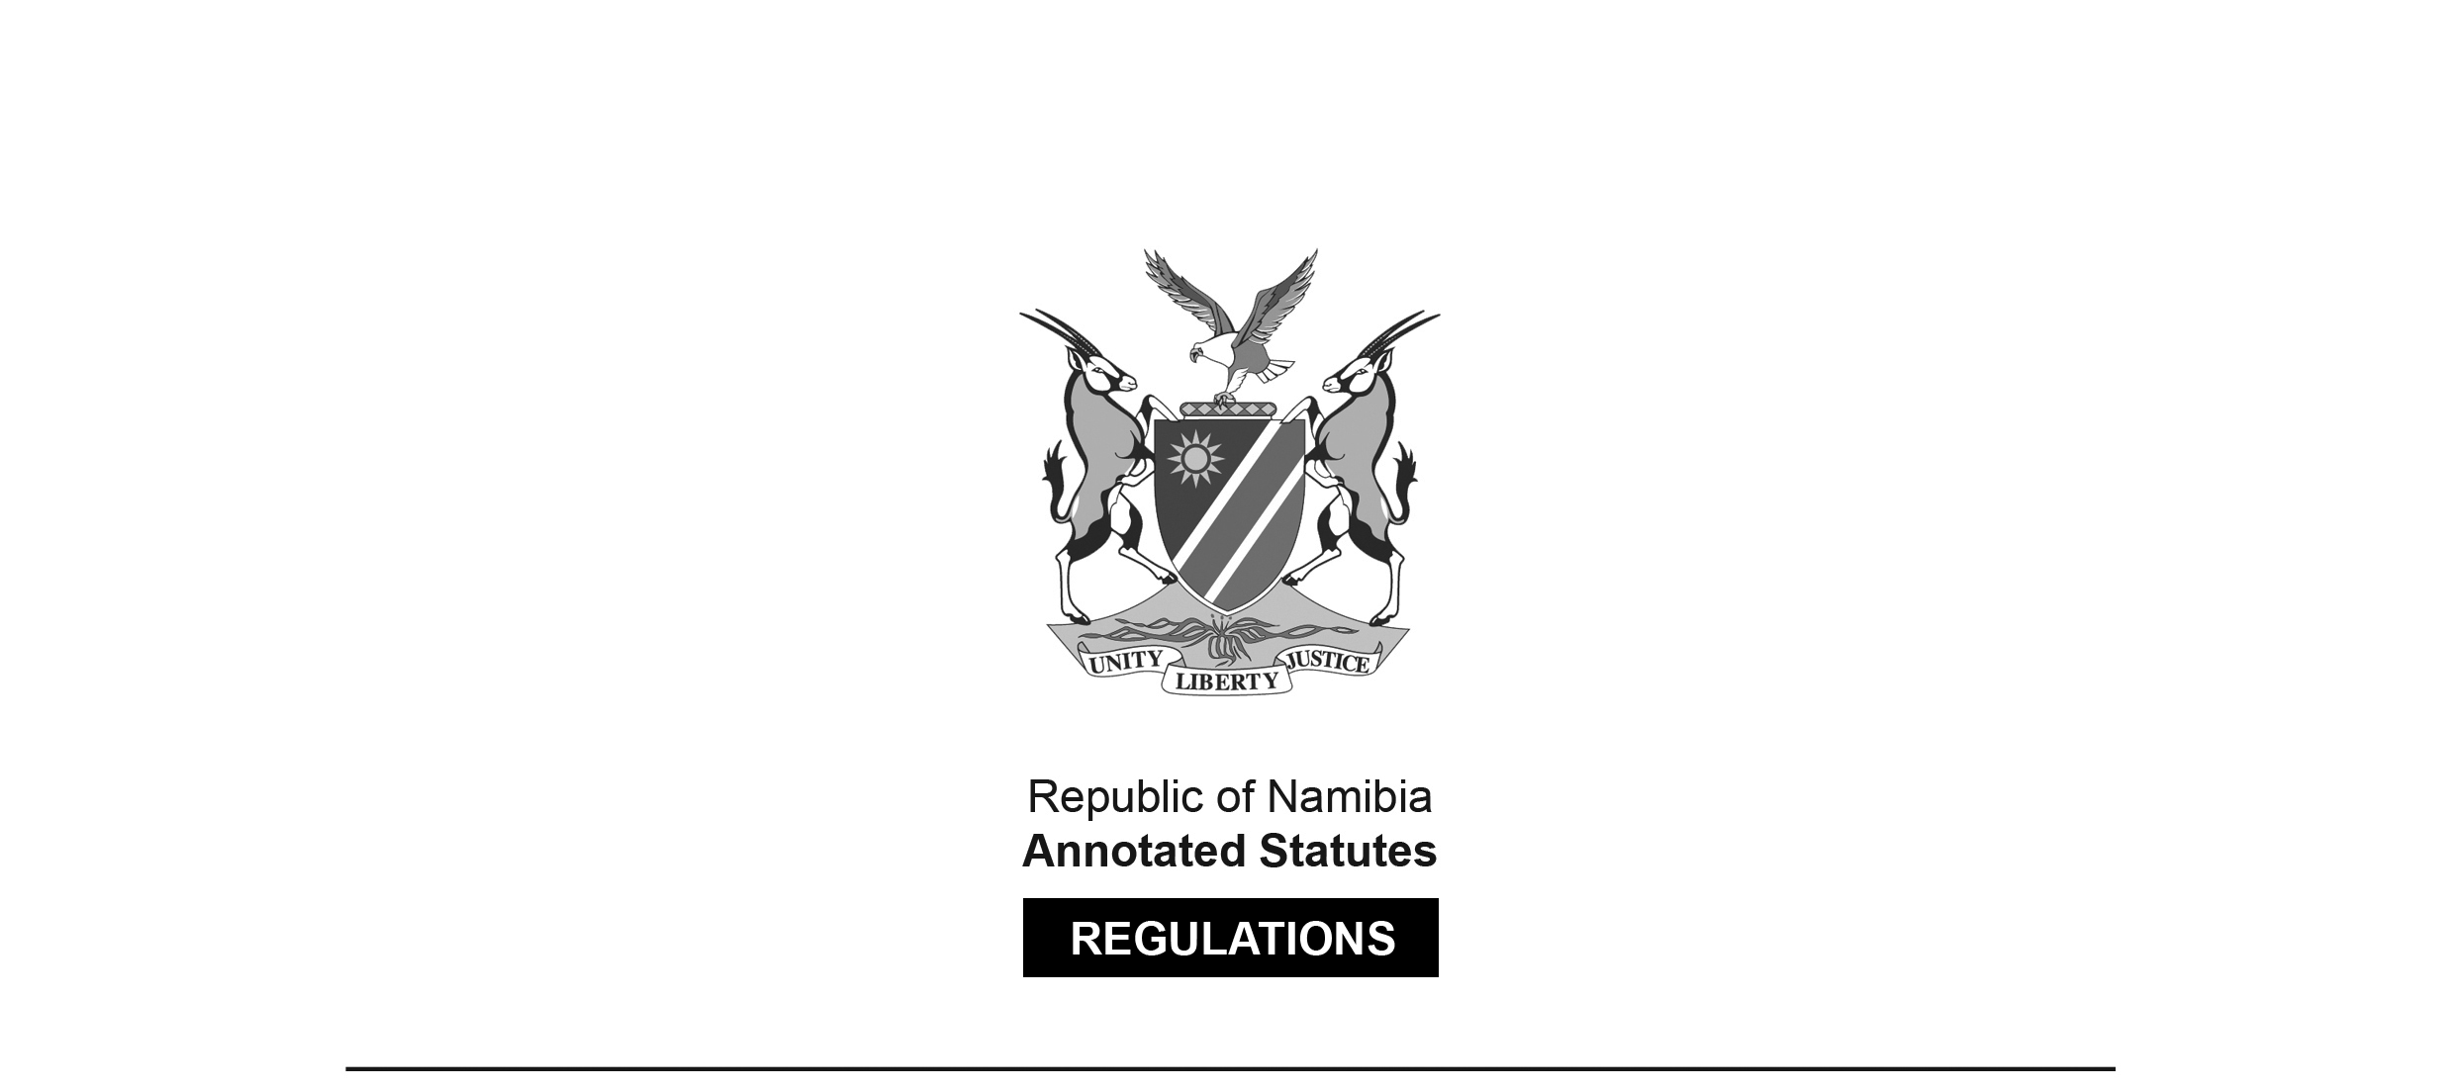
REGULATIONS SURVIVING IN TERMS OF

Health Professions Act 16 of 2024
section 95(10)

Regulations relating to Minimum Requirements of Study for Registration as Medical Biological Scientist
Government Notice 49 of 2011
(GG 4699)
came into force on date of publication: 28 April 2011

These regulations were made in terms of section 59 read with section 18(1) of the Medical and Dental Act 10 of 2004, which was repealed by the Health Professions Act 16 of 2024.
Pursuant to section 95(10) of the Health Professions Act 16 of 2024,
they are deemed to have been made under that Act.

The Government Notice which publishes these regulations notes that they were
made on the recommendation of the Medical and Dental Council of Namibia.

ARRANGEMENT OF REGULATIONS

1. Definitions
2. Minimum qualifications required for registration as a medical biological scientist
3. Recognition of qualification by Council

Definitions

1. In these regulations, unless the context otherwise indicates, a word or expression defined in the Act has that meaning, and -

“the Act” means the Medical and Dental Act, 2004 (Act No. 10 of 2004).

[The Medical and Dental Act 10 of 2004
has been replaced by the Health Professions Act 16 of 2024.]

Minimum qualifications required for registration as a medical biological scientist

2. (1) The minimum qualification, referred to in section 18(1) of the Act, required for the registration by the Council of a person as a medical biological scientist under section 20 of the Act, subject to the other provisions thereof, is any one of the following qualifications:

Educational Institution or  Examining Authority | Qualification
University of Limpopo  formerly Medical University of  South Africa | Bachelor of Science (Honours)  Bachelor of Science (Medical)  (Honours)
University of Limpopo  formerly University of the North  South Africa | Bachelor of Science in Medical  Science
North-West University  formerly Potchefstroom  University for Christian  Higher Education,  South Africa | Honours Bachelor of Science  Bachelor of Science Honours in  Biology
Rhodes University,  South Africa | Bachelor of Science with Honours
University of Cape Town  South Africa | Bachelor of Science in  Medicine (Honours)  Bachelor of Science Honours
University of KwaZulu-Natal  Formerly University of  Durban-Westville  South Africa | Honours Bachelor of Science  Honours Bachelor of Medical  Science
University of Kwazulu-Natal  Formerly University of  Natal  South Africa | Bachelor of Science Honours  Bachelor of Medical Science  (Honours)
University of the Free State  formerly University of  the Orange Free State  South Africa | Bachelor of Science Honours  Honours Baccalaureus in Medical  Sciences
Nelson Mandela  Metropolitan University  formerly University of Port Elisabeth  South Africa | Baccalaureus Scientiae Honores
University of Pretoria  South Africa | Baccalaureus Scientiae Honores in  Natural Science and Medical Science
University of Stellenbosch  South Africa | Honours Bachelor of Science in  Natural Science and Medical Science
Walter Sisulu University  for Technology  formerly University of Transkei  South Africa | Honours Bachelor of Science  Bachelor of Science (Medicine)  (Honours)
University of Venda  South Africa | Honours Bachelor of Science
University of Western Cape  South Africa | Honours Baccalaureus Scientiae
University of the Witwatersrand  South Africa | Bachelor of Science with Honours in  Natural Science and Medical Science

Subject to subregulation (2) of this regulation and to regulation 3, a person who is not the holder of any of the qualifications prescribed by subregulation (1), but is the holder of a Bachelor of Medical Science (Honours) Degree obtained at an educational institution after the full time education, tuition and training for a period of four years, may be registered, subject to compliance with the other requirements prescribed by or under the Act, as a medical biological scientist.

(3) A qualification prescribed by subregulation (2) must include, to the satisfaction of the Council, education, tuition and training in -

(a) Genetics;

(b) Anatomy;

(c) Microbiology;

(d) Physiology;

(e) Haematology;

(f) Anatomical Pathology;

(g) Virology;

(h) Radiation Biology;

(i) Pharmacology;

(j) Medical Biochemistry; and

(k) Medical Entomology.

Recognition of qualification by Council

3. The Council may recognise, for the purpose of the registration of a person as a medical biological scientist, a qualification prescribed by subregulation (2) of regulation 2, if -

(a) the educational institution at which that person obtained that qualification is approved by the Council;

(b) the registration authority responsible for the registration of a person to practise as a medical biological scientist in the country in which that person obtained the qualification, recognises that qualification for registration to practise as a medical biological scientist in that country; and

(c) that person complies with the other requirements for registration as a medical biological scientist prescribed by or under the Act.

