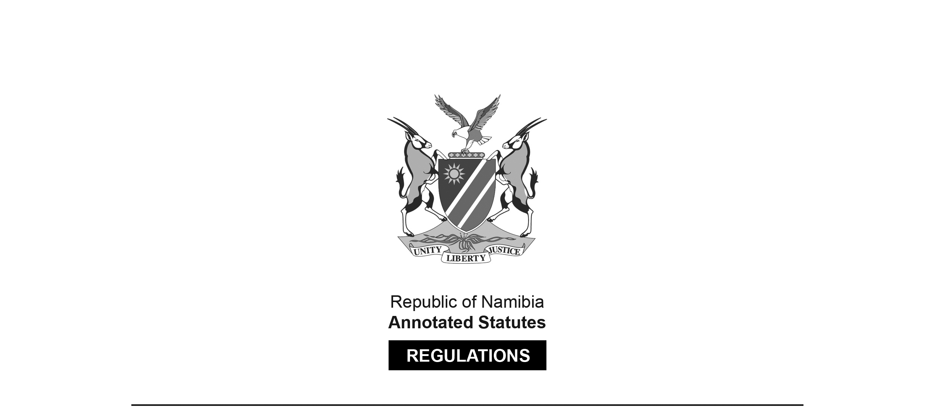

REGULATIONS SURVIVING IN TERMS OF

Health Professions Act 16 of 2024

section 95(10)

Regulations relating to the Scope of Practice of Audiologist,  
Speech Therapist, Speech Therapist and Audiologist

Government Notice 162 of 2023

([GG 8102](http://www.lac.org.na/laws/2023/8102.pdf))

came into force on date of publication: 2 June 2023

These regulations were made in terms of section 55(1) of the Allied Health Professions Act 7 of 2004, which was repealed by the Health Professions Act 16 of 2024. Pursuant to section 95(10) of the Health Professions Act 16 of 2024, they are deemed to have been made under that Act.

The Government Notice which publishes these regulations notes that they were made   
on the recommendation of the Allied Health Professions Council of Namibia.

ARRANGEMENT OF REGULATIONS

1. Definitions

2. Scope of practice of audiologist

3. Scope of speech therapist

[The heading of this regulation in the text below is   
“Scope of practice of speech therapist”.]

4. Scope of speech therapist and audiologist

[The heading of this regulation in the text below is   
“Scope of practice of speech therapist and audiologist”.]

**Definitions**

**1.** In these regulations a word or an expression that is defined in the Act has that meaning and, unless the context indicates otherwise -

“audiologist” means a person who is registered as such under the Act;

“registered person” means a person registered in terms of the Social Work and Psychology Act, 2004 (Act No. 6 of 2004), Allied Health Professions Act, 2004 (Act No. 7 of 2004), Nursing Act, 2004 (Act No. 8 of 2004), Pharmacy Act, 2004 (Act No. 9 of 2004) or Medical and Dental Act, 2004 (Act No. 10 of 2004);

[All of these Acts have been replaced by the Health Professions Act 16 of 2024.]

“speech therapist” means a person who is registered as such under the Act;

“speech therapist and audiologist” means a person who is registered as such under the Act; and

“the Act” means the Allied Health Professions Act, 2004 (Act No. 7 of 2004).

[The Allied Health Professions Act 7 of 2004 has been   
replaced by the Health Professions Act 16 of 2024.]

**Scope of practice of audiologist**

**2.** The following acts are regarded as acts falling within the scope of practice of an audiologist -

(a) hearing, auditory and vestibular functions that includes -

[The verb “includes” should be “include” to accord with the subject “functions”.]

(i) assessing and diagnosing dysfunction in hearing, auditory function and vestibular related balance disorders;

(ii) delivering audiologic habitation or rehabilitation services including -

(aa) selecting, fitting, verification and dispensing of hearing aids and other assistive devices;

(bb) assessing and follow-up services for persons with cochlear implants and middle ear implantable devices; and

(cc) providing a comprehensive programme of diagnostic, therapeutic services, devices, counselling, and other management strategies.

(iii) diagnosing of vestibular disorders and management of vestibular rehabilitation; and

(iv) providing advise on the development of products and instrumentation related to the measurement and management of auditory or balance function;

[The word “advise” should be “advice”.]

(b) advising on healthy lifestyle practices that prevent hearing and balance problems that includes -

[The verb “includes” should be “include” to accord with the subject “practices”.]

(i) reducing exposure to loud sounds; and

(ii) ear care;

(c) providing of clinical services that includes -

[The verb “includes” should be “include” to accord with the subject “services”.]

(i) preventing of hearing loss and auditory dysfunction and vestibular dysfunction;

(ii) identification and screening;

(iii) assessing and evaluating;

(iv) consulting;

(v) diagnosing;

(vi) managing;

(vii) counselling;

(viii) collaborating;

(ix) record keeping and report writing; and

(x) referral where an audiologist upon identifying that a patient suffers from medical conditions such as otitis media (ear infection) can refer this person to another registered person;

(d) preventing of hearing loss by -

(i) protecting of hearing function by designing, implementing and coordinating occupational, school and community hearing conservation and identification programmes;

(ii) participating in noise measurement and acoustic environment to improve accessibility and to promote hearing wellness;

(iii) presenting primary prevention information to risk groups; and

(iv) providing early identification and early intervention services;

(e) identification relating to the hearing, auditory and vestibular disorders and the methods used to identify such disorders which include -

(i) identifying dysfunction in hearing, and in the auditory and vestibular systems;

(ii) supervising, implementing and follow-up of new-born and school hearing programmes;

(iii) screening for speech, language, cognitive communication disorders, or preferred communication modalities that may affect education, health, development or communication and may result in recommendations for rescreening or comprehensive speech-language pathology assessment or in referral for other examinations or services;

(iv) identifying of populations and individuals with or at risk for hearing loss and other auditory dysfunction, balance impairments, tinnitus, and association communication impairments as well as those with normal hearing; and

(v) collaborating with speech therapists, identification of populations and individuals at risk for developing speech-language and communication impairments;

(f) assessment which includes -

(i) conducting and interpreting behavioural, electroacoustic, or electrophysiologic methods to assess hearing, auditory function, balance and related systems;

(ii) measuring and interpreting of sensory and motor evoked potentials, electromyography, and other electrodiagnostic tests for purposes of neurophysiologic intra-operative monitoring and cranial nerve assessment;

(iii) evaluating and managing of children and adults with auditory-related processing disorders;

(iv) performance of otoscopy for appropriate audiologic management or to provide basis for medical referral;

[The article “a” appears to have been omitted before the word “basis”.]

(v) managing obstruction of the external ear canal and of amplification devices; and

(vi) preparing of a report including interpreting data, summarising findings, generating recommendations and developing an audiologic treatment and management plan;

(g) habilitation or rehabilitation and referring to the methods used to assist with the learning and relearning of skills where the patient has some developmental challenges and this includes -

(i) evaluating, selecting, verification, fitting and dispensing hearing assistive technology device including hearing aids;

[The word “device” should be “devices” to fit the sentence structure.]

(ii) assessing of candidacy of persons with hearing loss for cochlear implants and provision of fitting, mapping, and audiologic rehabilitation to optimise device use;

(iii) developing appropriate for various diverse cultures and various ethnic groups and languages, audiologic rehabitative management plan including, when appropriate -

[The word “appropriate” following the word “developing”   
appears to be either superfluous or misplaced.]

(aa) recommending for fitting and dispensing, and educating the consumer and family or caregivers in the use of and adjustment to sensory aids, hearing assistive devices, alerting systems, and captioning devices;

(bb) counselling relating to psychological or social aspects of hearing loss, and other auditory dysfunction, and professes to enhance communication competence;

(cc) language assessment, training and consulting concerning environmental modifications to facilitate the development of receptive and expressive communication;

(dd) evaluating and modifying of audiologic management plan; and

(ee) providing of comprehensive audiologic rehabilitation services, including management procedures from speech and language habilitation or rehabilitation including but not exclusive to speechreading, auditory training, communication strategies, manual communication and counselling for psychosocial adjustment for persons with hearing loss or other auditory dysfunction and their families or caregivers;

(iv) consulting and providing of vestibular and balance rehabilitation therapy to persons with vestibular and balance impairments;

(v) assessing and non-medical management of tinnitus using biofeedback, behavioural management, technology, and counselling;

(vi) participating in the development of individualised education programmes for school-age children or individualised family service plan for children from birth to 36 months old;

(vii) providing of in-service programmes for school personnel, in planning educational programmes and accessibility for learners with hearing loss and auditory dysfunction; and

(viii) measuring of noise-levels and provision of recommendation for environmental modifications in order to reduce the noise level.

[The word “recommendation” should be “recommendations” to fit the sentence structure.]

**Scope of practice of speech therapist**

**3.** The following acts are regarded as acts falling within the scope of practice of speech therapy -

(a) communication and swallowing which includes -

(i) addressing communication and swallowing disorder in the following areas -

(aa) speech sound production: articulation, apraxia of speech, dysarthria and dyskinesia;

(bb) resonance;

(cc) voice: phonation quality, pitch, loudness and respiration;

(dd) fluency: stuttering and cluttering;

(ee) language which includes: phonology, morphology, syntax, semantics, pragmatics, literacy, pre-linguistic communication and paralinguistic communication;

(ff) cognition: attention, memory, sequencing, and executive functioning; and

(gg) feeding and swallowing: oral, pharyngeal, laryngeal components or facial myology (including tongue thrust), and oral-motor function; and

(ii) diagnosing, assessing, and treating communication and swallowing disorders, advocating for healthy lifestyle practices to prevent communication and swallowing disorders, educating the public about communication and swallowing disorders, administering and managing clinical and academic programs;

(b) clinical services which include -

(i) screening persons for hearing loss or middle ear pathology using conventional pure-tone air conduction methods (including otoscopic inspection), otoacoustic emissions screening, or screening tympanometry;

(ii) using instrumentation (video fluoroscopy, trans-nasal endoscopy, trans-oral stroboscopy, nasometry, computer technology) to observe, collect data and measure parameters of communication and swallowing or other upper aerodigestive functions;

(iii) providing intervention and support services for persons diagnosed with speech and language disorders;

(iv) providing intervention and support services for persons diagnosed with auditory processing disorders;

(v) addressing behaviours that affect communication and swallowing;

(vi) providing speech therapy services to patients and their families or caregivers;

(vii) providing speech therapy services to modify or enhance communication performance;

(viii) developing, selecting and prescribing multimodal augmentative and alternative communication systems, including unaided strategies;

(ix) selecting, fitting and establishing effective use of prosthetic or adaptive devices for communication and swallowing;

(x) counselling patients, their families, co-workers, educators and other persons in the community regarding acceptance, adaptation, and decision making about communication and swallowing;

(xi) serving as case managers, service delivery coordinators, and members of collaborative teams;

(xii) documenting the provision of services in accordance with accepted procedures appropriate for the practice setting;

(xiii) assisting with appropriate educational placement;

(xiv) providing referrals and information to other registered persons, agencies, and consumer organisations; using data to guide clinical decision-making and determine the effectiveness of services; and

(xv) making service delivery decisions across the lifespan.

**Scope of practice of speech therapist and audiologist**

**4.** Speech therapists and audiologists must carry out the acts of speech therapists and audiologists as set out in these regulations.