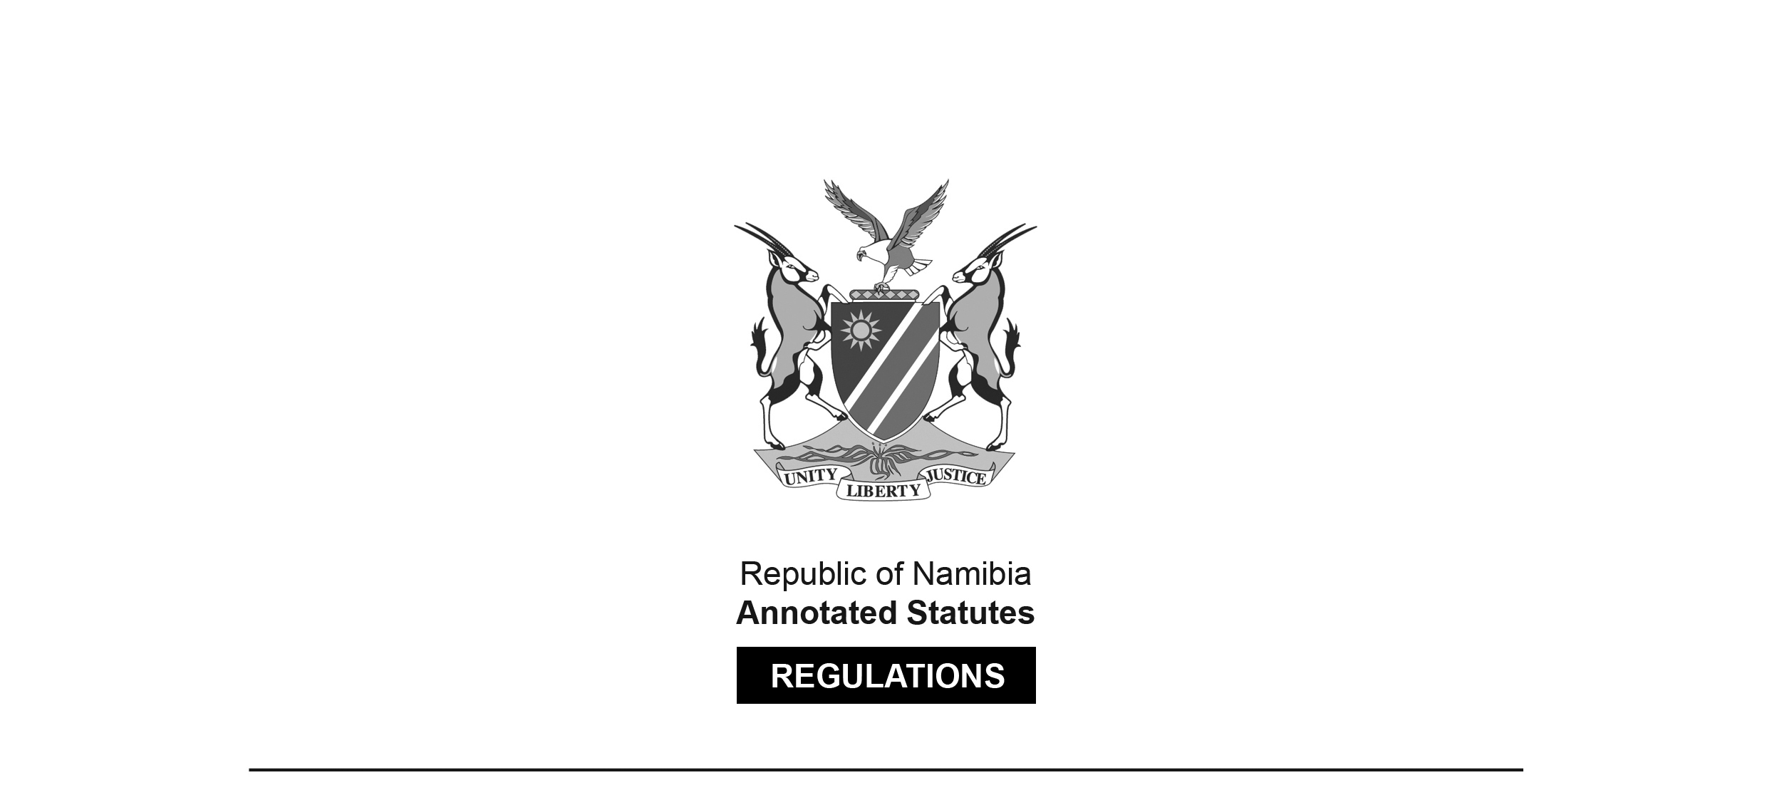

REGULATIONS SURVIVING IN TERMS OF

Health Professions Act 16 of 2024

section 95(10)

Regulations relating to Scope of Practice of Osteopath

Government Notice 89 of 2014

([GG 8028](http://www.lac.org.na/laws/2023/8028.pdf))

came into force on date of publication: 9 July 2014

These regulations were made in terms of section 55 of the Allied Health Professions Act 7 of 2004, which was repealed by the Health Professions Act 16 of 2024. Pursuant to section 95(10) of the Health Professions Act 16 of 2024, they are deemed to have been made under that Act.

The Government Notice which publishes these regulations notes that they were made   
on the recommendation of the Allied Health Professions Council of Namibia. It also repeals   
the regulations contained in GN 89/2014 ([GG 5502](http://www.lac.org.na/laws/2014/5502.pdf)).

ARRANGEMENT OF REGULATIONS

1. Definitions

2. Scope of practice of osteopath

3. Substances to be used by osteopath

4. Manufacture, preparation, storage or display of remedy or substance

5. Assessment of condition and treatment of patient

**Definitions**

**1.** In these regulations a word or expression defined in the Act has that meaning, and unless the context indicates otherwise -

“massage” means the mobilisation of soft tissue;

“medicine” means medicine as defined in the Medicines and Related Substances Control Act, 2003 (Act No.13 of 2003);

“scheduled substance” means a scheduled substance as defined in the Medicines and Related Substances Control Act, 2003 (Act No.13 of 2003);

“substance” means anything whether alone or in combination in its original state, natural state, compounded form, manipulated form or prepared form used for the treatment of a disease; and

“the Act” means the Allied Health Professions Act, 2004 (Act No. 7 of 2004).

[The Allied Health Professions Act 7 of 2004 has been   
replaced by the Health Professions Act 16 of 2024.]

**Scope of practice of osteopath**

**2.** (1) Osteopathy is the utilisation of manual therapy with the required knowledge in anatomy, neurology and physiology to effect changes to the human body, to cause a state of health and well-being in the patient and to palliate symptoms with the focus on the elimination of causative factors.

(2) An osteopath, in the conducting of his or her practice, must -

(a) examine a patient physically or mentally;

(b) diagnose, treat or prevent a physical or mental defect, illness or deficiency in a patient by -

(i) taking the patient’s case history;

(ii) conducting physical examinations of the patient; and

(iii) referring the patient for laboratory testing and specialised imaging; or

(c) treat or prevent a physical or physiological illness, disorder or deficiency related to musculoskeletal, visceral and neurological conditions in a person by means of -

(i) manipulation;

(ii) neuro-muscular reflex therapy;

(iii) massage therapy;

(iv) immobilisation therapy;

(v) exercise therapy;

(vi) electrotherapy;

(vii) traction therapy;

(viii) thermal therapy;

(ix) hydrotherapy;

(x) vibration therapy;

(xi) acupressure therapy;

(xii) dietary advice; or

(xiii) advice and supply of dietary supplements.

**Substances to be used by osteopath**

**3.** Subject to the Medicines and Related Substances Control Act, 2003 (Act No. 13of 2003), an osteopath may have in his or her possession, under his or her control or supply to a patient -

(a) vitamins, excluding substances containing an injectable form of vitamin A;

(b) nutritional supplements;

(c) homoeopathic preparations, herbal preparations or proprietary medicines already prepared and packed that may be sold in a health shop or pharmacy; or

(d) minerals or mineral supplements, excluding -

(i) scheduled substances; and

(ii) substances that may exclusively be prepared by a homeopath or pharmacist registered under the Pharmacy Act, 2004 (Act No. 9 of 2004).

[The Pharmacy Act 9 of 2004 has been replaced by the Health Professions Act 16 of 2024.]

**Manufacture, preparation, storage or display of remedy or substance**

**4.** An osteopath may not manufacture, prepare, store or display a remedy or substance in the consultation room that is used -

(a) to consult, examine or treat a patient; or

(b) as a waiting room.

**Assessment of condition and treatment of patient**

**5.** (1) The assessment of the condition of a patient and the treatment of the patient by the osteopath includes the -

(a) taking and recording of the patient’s case history;

(b) performing of a physical examination including posture assessment, active movement and passive movement of the patient;

(c) assessment and palpation of the integumentary, musculoskeletal, visceral, neurological, cardiovascular, endocrine and myofascial structures;

(d) special testing of orthopaedic and neurological examinations; and

(e) consultation and referral of the patient to a person registered under the -

(i) Medical and Dental Act, 2004 (Act No. 10 of 2004);

(ii) Social Work and Psychology Act, 2004 (Act No. 6 of 2004);

(iii) Nursing Act, 2004 (Act No. 8 of 2004);

(iv) Pharmacy Act, 2004 (Act No. 9 of 2004); or

(v) Act.

[All of these Acts have been replaced by the Health Professions Act 16 of 2024.]

(2) An osteopath must promote and maintain the health of a patient by -

(a) determining and preparing a suitable patient specific treatment protocol;

(b) maintaining comprehensive case records regarding the conditions, progress and actions performed in connection with the patient;

(c) attending to the hygiene and physical comfort of the patient and providing reassurance to the patient;

(d) promoting lifestyle changes of the patient which includes exercise, rest and sleep to assist in the rehabilitation of the patient;

(e) offering specific suggestions and recommendations of self-care and health maintenance activities including, self-massage, movement, self-administered hydrotherapy applications, stress reduction techniques, stress management techniques and stretching activities;

(f) educating the patient to attain optimal health; and

(g) delivering emergency first aid treatment to the patient, including cardiopulmonary resuscitation, if necessary.