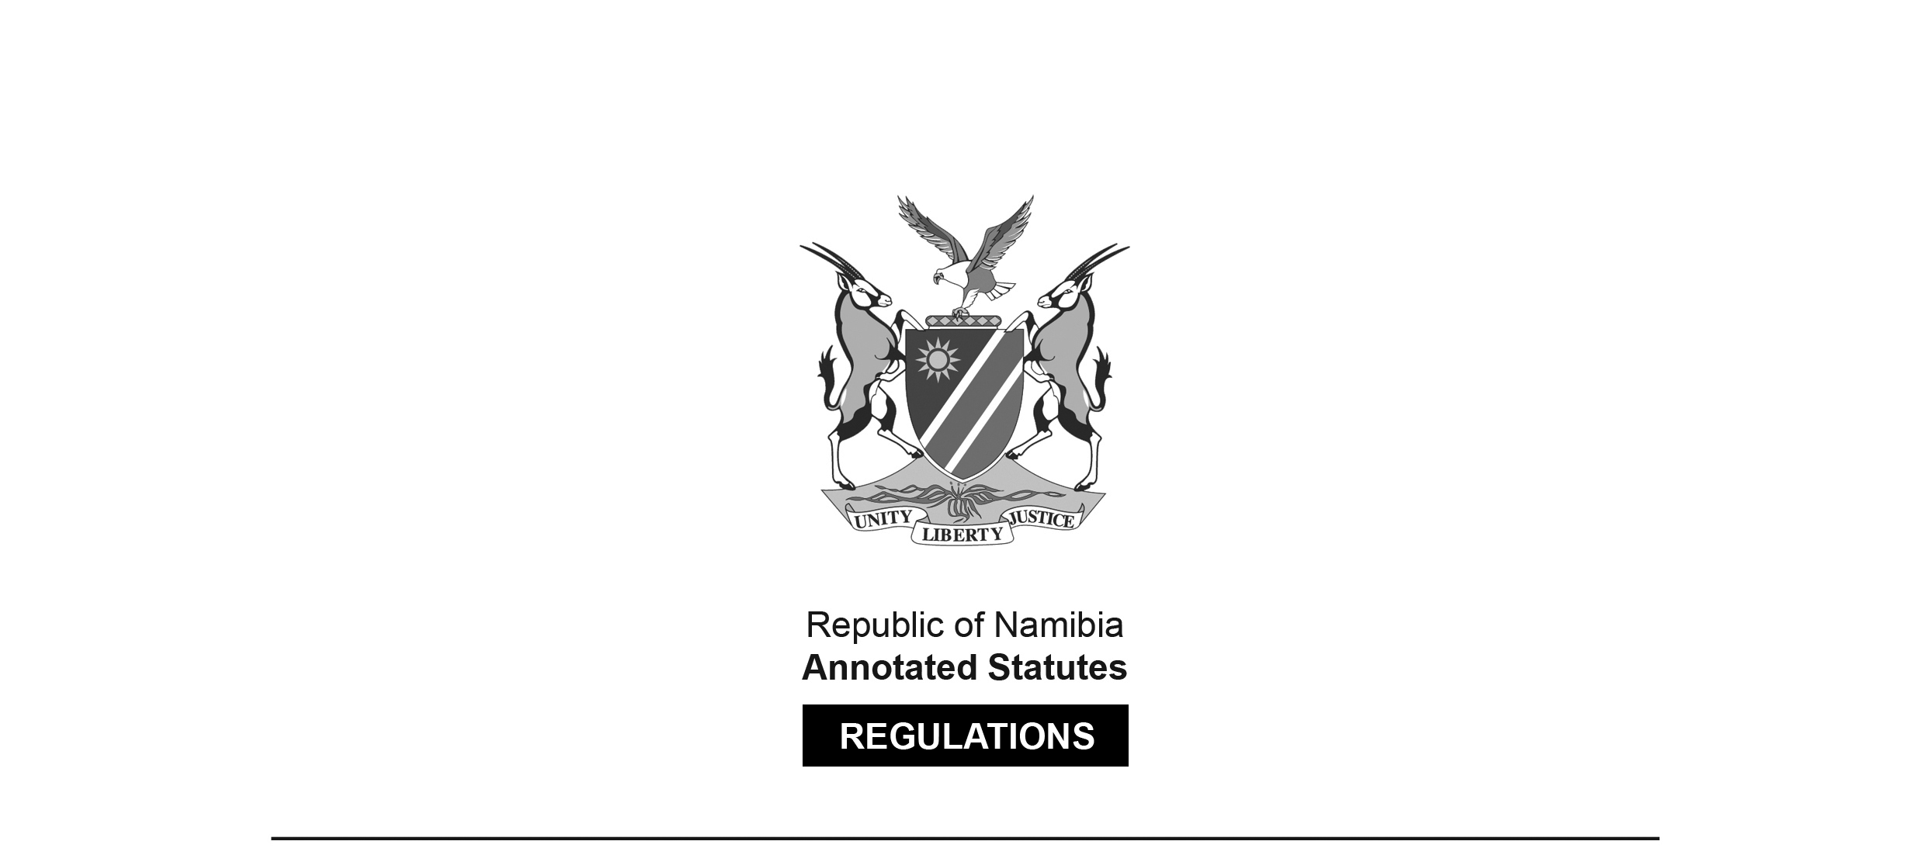

REGULATIONS SURVIVING IN TERMS OF

Health Professions Act 16 of 2024

section 95(10)

Regulations relating to Scope of Practice of a Naturopath

Government Notice 351 of 2022

([GG 7951](http://www.lac.org.na/laws/2022/7951.pdf))

came into force on date of publication: 10 November 2022

These regulations were made in terms of section 55 of the Allied Health Professions Act 7 of 2004, which was repealed by the Health Professions Act 16 of 2024. Pursuant to section 95(10) of the Health Professions Act 16 of 2024, they are deemed to have been made under that Act.

The Government Notice which publishes these regulations notes that they were made   
on the recommendation of the Allied Health Professions Council of Namibia.   
It also repeals the regulations contained in GN 90/ 2014 ([GG 5503](http://www.lac.org.na/laws/2014/5503.pdf)).

ARRANGEMENT OF REGULATIONS

1. Definitions

2. Scope of practice of naturopath

3. Substances which naturopaths may use

4. Manufacturing, preparing, storing or displaying of remedies or substances

5. Assessment, evaluation and treatment of patient’s condition

**Definitions**

**1.** In these regulations, a word or an expression to which a meaning has been assigned in the Act bears that meaning and unless the context otherwise indicates -

“complementary medicine” means complementary medicine as defined in the Medicines and Related Substances Control Act;

“compounding” means the combining or mixing of substances or complementary medicine;

“dispense”, in relation to a complementary medicine, means to select, prepare, compound, count out or measure from a bulk supply, dissolve, supply the complementary medicine in an appropriate container and label the container, and provide information and instructions to ensure the safe and effective use of the complementary medicine, but does not include the actual administration of the complementary medicine;

“massage” means the mobilisation of soft tissue;

“medicine” means medicine as defined in the Medicines and Related Substances Control Act;

“Medicines and Related Substances Control Act” means the Medicines and Related Substances

Control Act, 2003 (Act No. 13 of 2003);

“Naturopathy” means a system of healing, treating diseases and promoting health in which neither

surgical nor medical agents are used, but which is based on the use of -

(a) non-toxic natural substances, other than medicines; and

(b) the human body’s inherent biological healing mechanisms to self-heal,

for the treatment of a disease;

“patient” means a person seeking treatment or treated by a naturopath;

“pharmacist” means a person registered as such in terms of the Pharmacy Act, 2004 (Act No. 9 of 2004);

**[The Pharmacy Act 9 of 2004 has been replaced by the Health Professions Act 16 of 2024.]**

“scheduled substance” means a scheduled substance as defined in the Medicines and Related

Substances Control Act;

“substance” means anything which, whether alone or in combination in either its original or natural state or in a compounded, is manipulated or in a prepared form which can be used for the treatment of a disease; and

[This definition is unclear. The definition in the previous regulations was as follows:

“‘substance’ means anything which, whether alone or in combination in either its original or natural state or in a compounded, manipulated or prepared form, can be used for the treatment of a disease;”.]

“the Act” means the Allied Health Professions Act, 2004 (Act No. 7 of 2004).

[The Allied Health Professions Act 7 of 2004 has been   
replaced by the Health Professions Act 16 of 2024.]

**Scope of practice of naturopath**

**2.** (1) A naturopath, in the conducting of his or her practice, may -

(a) examine a patient physically or mentally;

(b) diagnose, treat or prevent a physical or mental defect, illness or deficiency in a patient by the use of -

(i) case history taking;

(ii) physical examination;

(iii) interpretation of laboratory tests and specialised imaging; or

(c) prescribe or dispense complementary medicine to a patient.

(2) A naturopath, in the conducting of his or her practice, may treat or prevent any physical or mental defect, illness or deficiency in a patient by means of -

(a) light therapy;

(b) hydrotherapy;

(c) thermal therapy;

(d) acupressure therapy;

(e) acupuncture, but only if the naturopath is also registered as an acupuncturist;

(f) electrotherapy;

(g) massage therapy;

(h) exercise therapy;

(i) vibration therapy;

(j) reflex therapy;

(k) dietary advice and dietary supplementation; and

(l) advising on, and supplying of, complementary medicines and natural substances as treatment for any disease.

**Substances which naturopaths may use**

**3.** Subject to the Medicines and Related Substances Control Act, a naturopath may have in his or her possession, under his or her control, or supply to a patient -

(a) vitamins, excluding substances containing an injectable form of vitamin A;

(b) nutritional supplements;

(c) over the counter homoeopathic and herbal substances other than scheduled substances;

(d) minerals and mineral supplements, excluding scheduled substances and -

(i) substances which may exclusively be prepared by a pharmacist as prescribed under the Pharmacy Act, 2004; or

(ii) substances which may exclusively be prepared by a homoeopath.

(2) Subject to the provisions of the Medicines and Related Substances Control Act, a naturopath may have in his or her possession, under his or her control, or supply to a patient the following biochemical tissue salt:

(a) calcarea fluorica;

(b) calcarea phosphorica;

(c) calcarea sulphuricum;

(d) ferrum phosphoricum;

(e) kali muriaticum;

(f) kali phosphoricum;

(g) kali sulphuricum;

(h) magnesia phosphorica;

(i) natrium muriaticum;

(j) natrium phosphoricum;

(k) natrium suiphuricum;

(l) silicae;

(m) kalium arsenicosum;

(n) kalium bromatum;

(o) kalium iodatum;

(p) kalium aluminium sulphuricum;

(q) lithium muriaticum;

(r) manganum sulphuricum;

(s) cuprum arsenicosum;

(t) zincum muriaticum;

(u) calcium carbonicum;

(v) natrium bicarbonicum;

(w) arsenum iodatum; or

(x) calcium sulfuratum.

**Manufacturing, preparing, storing or displaying of remedies or substances**

**4.** A naturopath may not manufacture, prepare, store or display any remedies or substances in the section of his consulting room which is used -

(a) for the consultation, examination or treatment of patients; or

(b) as a waiting room.

**Assessment, evaluation and treatment of patient’s condition**

**5.** (1) The assessment, evaluation and treatment of a patient’s condition may include -

(a) assessing the patient’s health history and interviewing the patient;

(b) observing the posture and movement of the patient;

(c) conducting a full physical examination;

(d) determining and preparing a suitable patient-specific treatment protocol; and

(e) maintaining comprehensive case records regarding the condition, progress, and all actions performed in connection with the patient.

(2) The promotion and maintenance of the health of a patient may include -

(a) attention to hygiene and physical comfort of the patient;

(b) the promotion of lifestyle changes that may include nutritional advice, exercise, rest and sleep with a view to assist in the rehabilitation of the patient;

(c) the offering of specific suggestions and recommendations of self-care and health maintenance activities including self-massage, movement, self-administered hydrotherapy applications, stress reduction and stress management techniques and stretching activities;

(d) education leading to the attainment of optimal health for the patient;

(e) delivery of emergency first aid treatment including cardiopulmonary resuscitation, if necessary; and

(f) consultation with, or referral of the patient to, any other person registered under the Medical and Dental Act, 2004 (Act No. 10 of 2004), Pharmacy Act, 2004 (Act No. 9 of 2004), Social Work and Psychology Act, 2004 (Act No. 6 of 2004), or the Nursing Act, 2004 (Act No. 8 of 2004).

[All of these Acts have been replaced by the Health Professions Act 16 of 2024.]