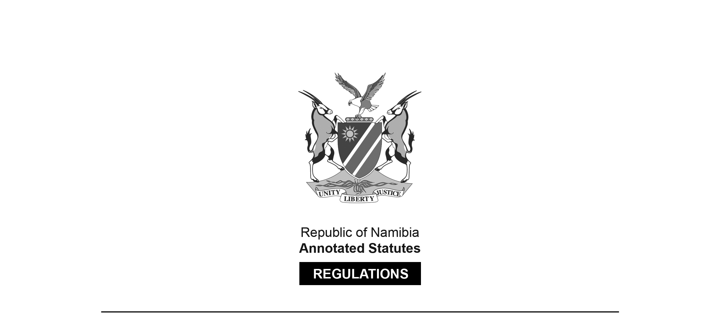

REGULATIONS SURVIVING IN TERMS OF

Health Professions Act 16 of 2024

section 95(10)

Regulations relating to the Scope of Practice of   
Dental Technologist and Dental Technician

Government Notice 10 of 2022

([GG 7728](http://www.lac.org.na/laws/2022/7728.pdf))

came into force on date of publication: 21 January 2022

These regulations were made in terms of section 55 of the Allied Health Professions Act 7 of 2004, which was repealed by the Health Professions Act 16 of 2024. Pursuant to section 95(10) of the Health Professions Act 16 of 2024, they are deemed to have been made under that Act.

The Government Notice which publishes these regulations notes that they

were made on the recommendation of the Allied Health Professions Council of Namibia

ARRANGEMENT OF REGULATIONS

1. Definitions

2. Scope of practice of a dental technician

3. Scope of practice of dental technologist

**Definitions**

**1.** In these regulations a word or an expression to which a meaning has been given in the Act has that meaning, and unless the context otherwise indicates -

“dental laboratory” means a health facility where a dentist, dental technician or dental technologist perform acts pertaining to the manufacturing of dental prosthesis as defined in the Hospitals and Health Facilities Act, 1994;

[The plural of “dental prosthesis” is “dental prostheses”. Note that it is the term   
“health facility” that is defined in the Hospitals and Health Facilities Act, 1994,   
and not the term “dental prosthesis”.]

“dental technician” means a person registered as a dental technician in terms of Section 21 of the Act;

[The word “section” should not be capitalised.]

“dental technologist” means a person registered as a dental technologist in terms of Section 21 of the Act;

[The word “section” should not be capitalised.]

“dentist” means a person registered as a dentist in terms of the Medical and Dental Act, 2004 (Act No. 10 of 2004);

[The Medical and Dental Act 10 of 2004 has been   
replaced by the Health Professions Act 16 of 2024.]

“dental cases” means an appliance, artificial teeth, crowns bridges, orthodontic appliance, including records, markings or measurements that relate to dentistry;

[This definition is reproduced as it appears in the *Government Gazette*. It appears that a phrase such as “cases involving” may have been omitted after the word “means”.

A comma appears to have been omitted between the words “crowns” and “bridges”.

The term “orthodontic appliance” should be either “an orthodontic appliance”   
or “orthodontic appliances”, and the phrase should be preceded by the word “or”.]

“registered person” means a person registered in terms of the Social Work and Psychology Act, 2004 (Act No. 6 of 2004), Allied Health Professions Act, 2004 (Act No. 7 of 2004), Nursing Act, 2004 (Act No. 8 of 2004), Pharmacy Act, 2004 (Act No. 9 of 2004), or Medical and Dental Act, 2004 (Act No. 10 of 2004);

[All of these Acts have been replaced by the Health Professions Act 16 of 2024.]

“medical device” means a medical device as defined in the Medicines and Related Substances Control Act, 2003 (Act No. 13 of 2003); and

“the Act” means the Allied Health Professions Act, 2004 (Act No. 7 of 2004).

[The Allied Health Professions Act 7 of 2004 has been   
replaced by the Health Professions Act 16 of 2024.]

**Scope of practice of a dental technician**

**2.** (1) A dental technician may, in consultation with a dental technologist, perform the following functions in a dental laboratory -

(a) carrying out infection control procedures to prevent physical, chemical or microbiological contamination in the dental laboratory;

(b) selecting appropriate materials for the designing, manufacturing or repairing of fixed and removable custom made medical devices;

(c) designing, planning and manufacturing a range of custom made, fixed or removable medical devices as per a prescription by a dentist;

(d) repairing and modifying, fixed or removable custom made medical devices on the instruction of a dentist;

[The comma after the phrase “repairing and modifying” is superfluous.]

(e) carrying out shade taking as prescribed by a dentist;

(f) reviewing dental cases and determining the appropriate action to be taken; and

(g) carrying out implant frame assessments in consultation with a dentist;

[Paragraph (g) should end with a full stop rather than a semicolon,   
as it is the last paragraph in subregulation (1) in the *Government Gazette*.]

(2) A dental technician may assist a dentist with -

(a) taking impressions;

(b) recording facebows;

(c) carrying out intra-oral and extra-oral tracing;

(d) recording occlusal registrations;

(e) carrying out intra-oral scanning for computer aided design or computer aided manufacturing; and

(f) fitting attachments at chairside.

**Scope of practice of dental technologist**

**3.** (1) A dental technologist may perform the following functions in a dental laboratory -

(a) carrying out infection control procedures to prevent physical, chemical or microbiological contamination in a dental laboratory;

(b) selecting appropriate materials for the designing, manufacturing or repairing of fixed or removable custom-made medical devices;

(c) designing, planning and manufacturing a range of custom made fixed or removable custom made medical devices according to a written prescription or verbal instruction by a dentist;

(d) repairing and modifying fixed or removable custom made medical devices on the instruction of a dentist;

(e) carrying out shade taking if requested by a dentist;

(f) reviewing dental cases and determining the appropriate action to be taken;

(g) working with a dentist on treatment planning and designing of custom made medical devices for a specific patient;

(h) making appropriate referrals to other registered persons for examination or treatment;

(i) carrying out implant frame assessments in consultation with a dentist; and

(j) assisting dentists to fit attachments at chairside.

(2) A dental technologist may assist a dentist with -

(a) taking impressions;

(b) recording facebows;

(c) carrying out intra-oral and extra-oral tracing;

(d) recording occlusal registrations; and

(e) carrying out intra-oral scanning for computer aided design or computer aided manufacturing.