REGULATIONS SURVIVING IN TERMS OF

Health Professions Act 16 of 2024

section 95(10)

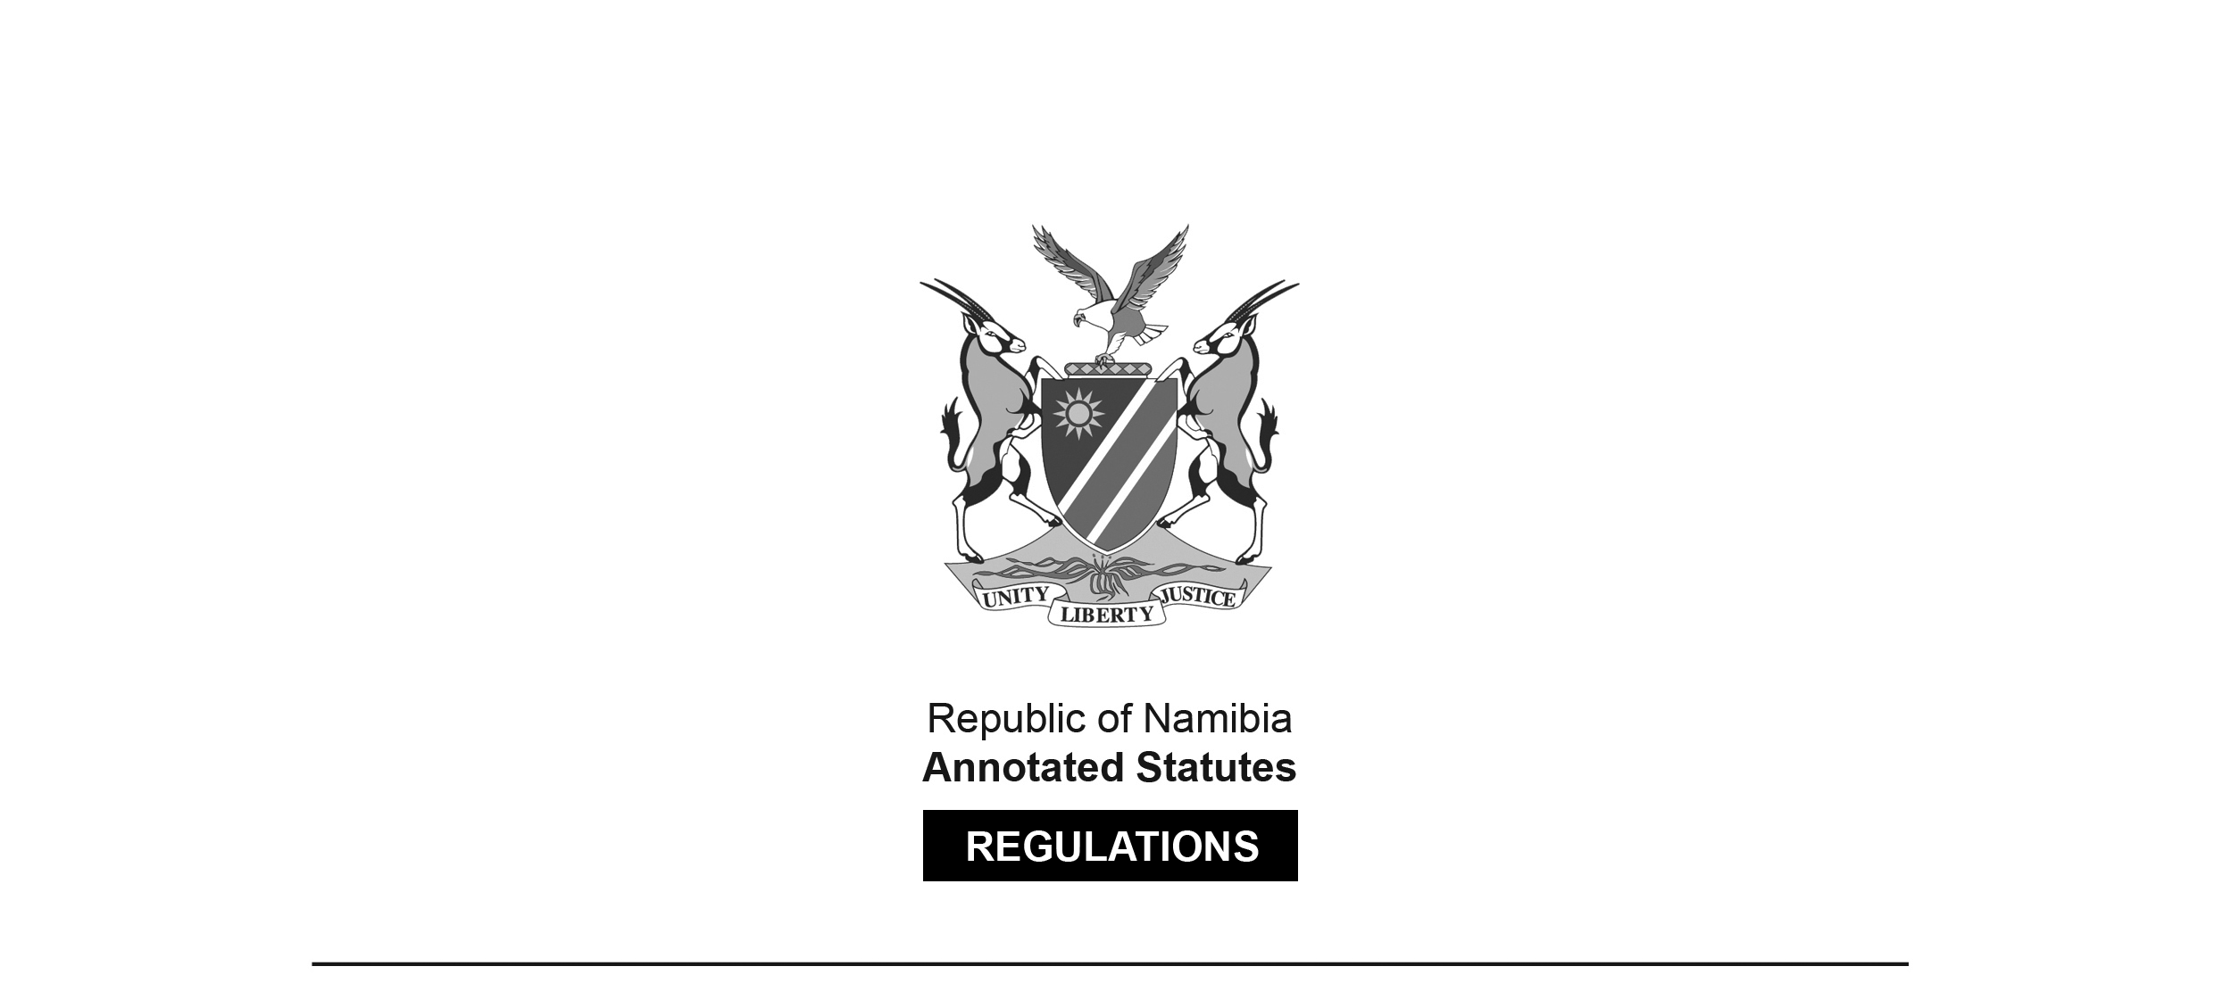

Regulations relating to   
Scope of Practice of Hearing Aid Acoustician

Government Notice 10 of 2021

([GG 7453](http://www.lac.org.na/laws/2021/7453.pdf))

came into force on date of publication: 4 February 2021

These regulations were made in terms of section 55 of the Allied Health Professions Act 7 of 2004, which was repealed by the Health Professions Act 16 of 2024. Pursuant to section 95(10) of the Health Professions Act 16 of 2024, they are deemed to have been made under that Act.

The Government Notice which publishes these regulations notes that they were   
made on the recommendation of the Allied Health Professions Council of Namibia.

**ARRANGEMENT OF REGULATIONS**

1. Definitions

2. Scope of practice of hearing aid acoustician

**Definitions**

**1.** In these regulations, a word or expression defined in the Act has that meaning, and unless the context otherwise indicates -

“health practitioner” means a person registered or enrolled under the -

(a) Social Work and Psychology Act, 2004 (Act No. 6 of 2004);

(b) Allied Health Professions Act 2004 (Act No. 7 of 2004);

(c) Nursing Act, 2004 (Act No. 8 of 2004);

(d) Pharmacy Act, 2004 (Act No. 9 of 2004); or

(e) Medical and Dental Act, 2004 (Act No. 10 of 2004);

[These statutes have all been replaced by the Health Professions Act 16 of 2024.]

“hearing aid” means an electronic or other device for amplifying sound to the ear of a hearing- impaired person;

“hearing screening” means the assessment, which includes otoscopic examination, screening tympanometry and performing an air conduction pure tone sweep at 500, 1000, 2000 and 4000 Hz at 20dBHL in either ear in an acoustically appropriate screening environment, of potential hearing loss; and

“the Act” means the Allied Health Professions Act, 2004 (Act No. 7 of 2004).

[The Allied Health Professions Act 7 of 2004 has been   
replaced by the Health Professions Act 16 of 2024.]

**Scope of practice of hearing aid acoustician**

**2.** (1) The scope of practice pertaining to a hearing aid acoustician is -

(a) the conducting of -

(i) otoscopic examination;

(ii) pure tone air conduction;

(iii) pure tone bone conduction hearing tests;

(iv) speech hearing tests;

(v) tympanometry screening;

(vi) comfortable and uncomfortable loudness levels test;

(vii) subjective loudness tests;

(viii) speech mapping; and

(ix) *in-situ* measurements,

to determine the presence of hearing loss and where such hearing loss is detected, a hearing aid acoustician may determine whether to fit a hearing aid or if a referral to another practitioner is necessary;

(b) selecting, fitting, repairing and dispensing of hearing aids;

(c) taking of ear mould impressions and the manufacturing of ear moulds;

(d) evaluating the effectiveness of hearing aid fittings by means of an assessment and *in-situ* measurements in the ear; and

(e) hearing screening.

(2) A hearing aid acoustician may -

(a) refer patients to another health practitioner for examining or treatment; and

(b) fit hearing aids on children under the age of seven years, if such practitioner has undergone the necessary training and assessment requirements and has registered an additional qualification in paediatric acoustics.