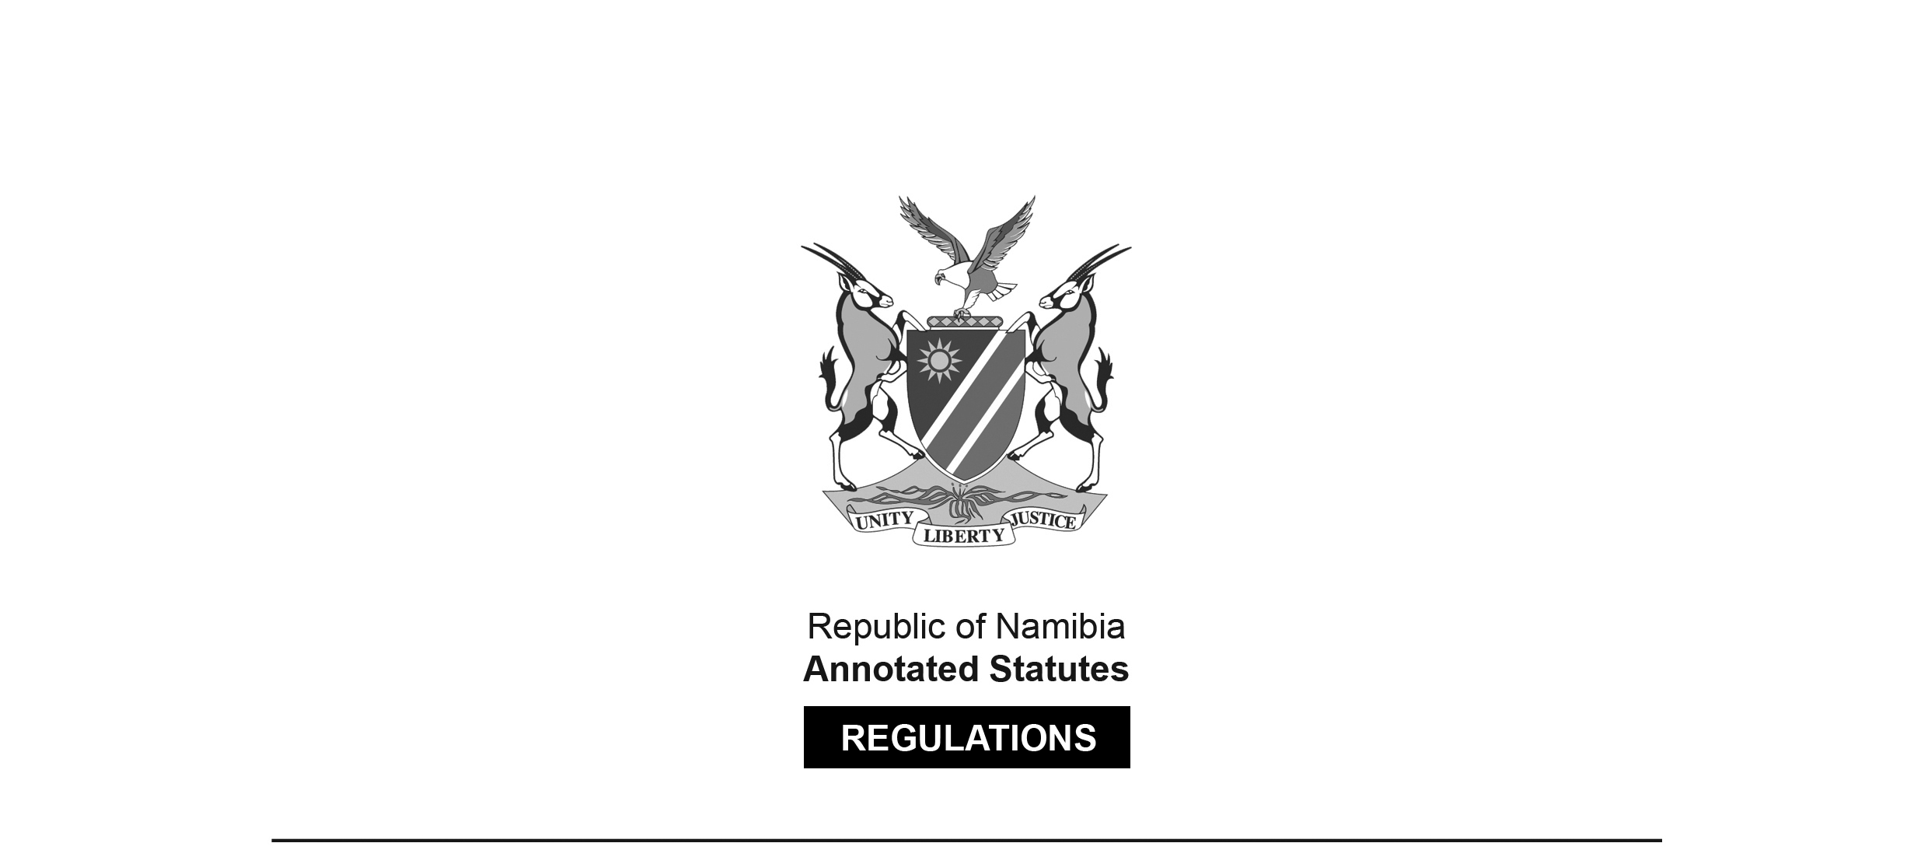

REGULATIONS SURVIVING IN TERMS OF

Health Professions Act 16 of 2024

section 95(10)

Regulations relating to the Scope of Practice of   
Clinical Technologists

Government Notice 385 of 2019

([GG 7073](http://www.lac.org.na/laws/2019/7073.pdf))

came into force on date of publication: 6 December 2019

These regulations were made in terms of section 55(1) of the Allied Health Professions Act 7 of 2004, which was repealed by the Health Professions Act 16 of 2024. Pursuant to section 95(10) of the Health Professions Act 16 of 2024, they are deemed to have been made under that Act.

The Government Notice which publishes these regulations notes that they were made   
on the recommendation of the Allied Health Professions Council of Namibia.

ARRANGEMENT OF REGULATIONS

1. Definitions

2. Scope of practice of clinical technologist

3. Scope of practice of clinical technologist for cardiology

4. Scope of practice of clinical technologist for cardiovascular perfusion

5. Scope of practice of clinical technologist for critical care

6. Scope of practice of clinical technologist for nephrology

7. Scope of practice of clinical technologist for neurophysiology

8. Scope of practice of clinical technologist for pulmonology

9. Scope of practice of clinical technologist for reproductive biology

10. Non-clinical responsibilities of a clinical technologist

[These regulations mix UK and US spellings.]

**Definitions**

**1.** In these regulations, a word or expressions to which a meaning has been assigned in the Act has that meaning, and unless the context indicates otherwise -

[The plural word “expressions” should be the singular word “expression”.]

“clinical technologist” means a person registered as a clinical technologist in terms of section 18 of the Act in any of the following fields -

(a) cardiology;

(b) cardiovascular perfusion;

(c) critical care;

(d) nephrology;

(e) neurophysiology;

(f) pulmonology; or

(g) reproductive biology;

“medical practitioner” means a person registered as a medical practitioner in terms of the Medical and Dental Act, 2004 (Act No. 10 of 2004);

**[The** Medical and Dental Act **10 of 2004   
has been replaced by the Health Professions Act 16 of 2024.]**

“medicine” means medicine as defined in section 1 of the Medicines and Related Substances Control Act, 2003 (Act No. 13 of 2003);

“scope of practice” means the parameters within which a clinical technologist must practice his or her profession; and

“the Act” means the Allied Health Professions Act, 2004 (Act No. 7 of 2004).

**[****The Allied Health Professions Act 7 of 2004   
has been replaced by the Health Professions Act 16 of 2024.]**

**Scope of practice of clinical technologist**

**2.** (1) The scope of practice of a clinical technologist includes procedures, acts and processes for which the person has received education and clinical experience and which he or she has demonstrated competency.

(2) Clinical technologists with a national diploma must practice under supervision of a medical practitioner or a clinical technologist with a degree in any of the fields referred to in regulation 1.

(3) The following acts fall within the scope of practice of a clinical technologist -

(a) performing of clinical investigative procedures with the aid of appropriate apparatus and techniques;

(b) performing of corrective and therapeutic procedures in collaboration with a medical practitioner; and

(c) per elective specialization dispensing and administering medicine as set out in a prescription by a medical practitioner.

(4) A clinical technologist may not prescribe medicine.

**Scope of practice of clinical technologist for cardiology**

**3.** (1) A clinical technologist for cardiology performs non-invasive special procedures and provides assistance to a medical practitioner in the handling of electronic apparatus used during invasive procedures for the purpose of obtaining data in order to support or confirm a diagnosis or to identify a specific cardiac disease.

(2) The following acts fall within the scope of practice of a clinical technologist for cardiology -

(a) conducting and analyzing complex and sophisticated tests including the following advanced clinical technology procedures;

(b) resting electrocardiogram 12 lead;

(c) exercise stress test;

(d) 24 hours or 48 hours ambulatory blood pressure monitoring;

(e) 24 hours or 48 hours holter monitoring;

[The term “Holter” is usually capitalised.]

(f) cardiac catherisation procedures;

[The word “catheterisation” is misspelt in the   
*Government Gazette*, as reproduced above.]

(g) electro physiology studies;

(h) temporary and permanent pacemakers;

(i) cardioversion and defibrillation;

(j) echocardiography;

(k) intra-aortic balloon pump;

(l) left ventricular assist therapy;

(m) setting up pressure transducers;

(n) drug administration and management of side effects;

(o) activating clotting time testing; and

(p) blood gas testing.

**Scope of practice of clinical technologist for cardiovascular perfusion**

**4.** (1) A clinical technologist for cardiovascular perfusion uses extra-corporeal apparatus to support or take over a patient’s circulatory and respiratory function temporarily.

(2) The following acts fall within the scope of practice of a clinical technologist for cardiovascular perfusion -

(a) cardiopulmonary bypass for adult, pediatric and neonatal patients;

(b) cardiopulmonary bypass for congenital and acquired cardiovascular disorders;

(c) extracorporeal circulatory support for renal, neurological, hepatic and vascular surgery;

(d) extracorporeal resuscitation;

(e) extracorporeal circulation for long term support of failing respiratory and cardiac function;

(f) anticoagulation and hemostasis monitoring, analysis and intervention;

(g) thermal regulation;

(h) blood gas and blood chemistry monitoring, analysis and intervention;

(i) physiological monitoring, analysis and intervention;

(j) administration of blood components, pharmaceuticals and anesthetic agents;

(k) intra-aortic balloon counter pulsation;

(l) external counter pulsation;

(m) transportation of extracorporeal supported patients;

(n) periodic flow augmentation therapy;

(o) autotransfusion;

(p) phlebotomy;

(q) hemostasis monitoring and analysis;

(r) isolated limb and organ perfusion;

(s) thermogenic lavage;

(t) therapeutic hyperthermia;

(u) therapeutic hypothermia; and

(v) intravascular membrane oxygenation.

**Scope of practice of clinical technologist for critical care**

**5.** (1) A clinical technologist for critical care supports the medical practitioner in the handling of life-support equipment in critical care situations.

(2) The following acts fall within the scope of practice of a clinical technologist for critical care -

(a) basic resting electrocardiogram;

(b) basic and advanced cardiac life support and automated external defibrillation;

(c) spirometry measurement;

(d) activating clotting time testing;

(e) respiratory rate measurement;

(f) blood gas sampling, measurement and interpretation;

(g) mask and nasal cannula oxygen therapy;

(h) setting up of pressure transducers, ventilators and infusion devices;

(i) phlebotomy;

(j) quality control of life support equipment;

(k) drug administration and management of side effects;

(l) invasive haemodynamic monitoring;

(m) set up equipment for intrahospital transportation for critically ill patients, non- invasive haemodynamic monitoring and monitoring of an anesthetized patient;

(n) handling of infusion devises and medicine;

(o) preparation of intensive care unit medicine;

(p) assist with bronchoscopy and right heart catheterization;

(q) monitor intra-aortic balloon pump;

(r) assist with acute haemodialisis and continuous renal replacement therapy;

[The word “haemodialysis” is misspelt in the *Government Gazette*, as reproduced above.]

(s) autologous blood recovery;

(t) determine blood flow;

(u) cell saving;

(v) cardioversion; and

(w) metabolic studies.

**Scope of practice of clinical technologist for nephrology**

**6.** (1) A clinical technologist for nephrology performs extra-corporeal procedures in the field of nephrology and apheresis with appropriate apparatus.

(2) The following acts fall within the scope of practice of a clinical technologist for nephrology -

(a) continuous veno-venous haemodialysis;

(b) peritoneal dialysis;

(c) administer blood transfusion;

(d) exchange transfusion;

(e) pediatric haemodialysis;

(f) apheresis;

(g) plasma filtration;

(h) haemoperfusion;

(i) haemofiltration and hemodiafiltration;

(j) plasmapheresis;

(k) slow continuous ultrafiltration;

(l) stem cell harvesting;

(m) slow low efficiency daily dialysis;

(n) drug administration and management of side effects; and

(o) water analysis and quality control.

**Scope of practice of clinical technologist for neurophysiology**

**7.** (1) A clinical technologist for neurophysiology performs electrophysiological procedures and tests on the brain, nervous system and muscular systems of a patient.

(2) The following acts fall within the scope of practice of a clinical technologist for neurophysiology -

(a) electroencephalography;

(b) multi sleep latency test;

(c) polysomnography;

(d) nerve conduction studies;

(e) electromyography;

(f) transcranial dopplers;

(g) evoke potentials;

(h) long term monitoring video studies;

(i) brain mapping;

(j) memory testing and WADA testing;

(k) drug administration and management of side effects; and

(l) intraoperative neurophysiology monitoring.

**Scope of practice of clinical technologist for pulmonology**

**8.** (1) A clinical technologist for pulmonology performs lung function examinations with the aid of electronic and computerized equipment in order to support and confirm diagnosis of respiratory disease.

(2) The following acts fall within the scope of practice of a clinical technologist for pulmonology -

(a) spirometry measurement;

(b) blood gas testing and analysis;

(c) setting up of pressure transducers, ventilators and infusion devices;

(d) non-provocative nebulization;

(e) phlebotomy;

(f) assist with bronchoscopy procedures;

(g) MIP and MEP measurements;

(h) plethysmography;

(i) diffusion measurement;

(j) histamine challenge;

(k) neurological and respiratory polysomnography;

(l) lung compliance, exercise, shunt and endurance studies;

(m) skin prick test; and

(n) drug administration and management of side effects.

**Scope of practice of clinical technologist for reproductive biology**

**9.** (1) A clinical technologist for reproductive biology evaluates and determines the extent, nature and degree of infertility in couples with a view to a diagnosis by a medical practitioner and the performance of procedures to attain a successful pregnancy.

(2) The following acts fall within the scope of practice of a clinical technologist for reproductive biology -

(a) perform wash procedures;

(b) perform blood processing;

(c) perform serum concentration;

(d) perform diagnostic semen processing;

(e) perform oocyte retrieval;

(f) perform sperm aspiration and processing;

(g) perform insemination procedure;

(h) perform fertilization evaluation;

(i) perform cleaning and preparing oocytes;

(j) perform embryo culture and transfer;

(k) perform cryopreservation and set incubators;

(l) prepare culture media and observe laboratory safety;

(m) recognise sperm morphology;

(n) assisted reproductive techniques;

(o) collection and preparation of semen samples;

(p) aspiration techniques;

(q) evaluation of oocytes and embryos;

(r) insemination of oocytes;

(s) embryo transfers;

(t) quality control of culture medium;

(u) flushing of embryos;

(v) preparation of culture medium;

(w) sperm tests;

(x) freezing procedures of sperm and embryos; and

(y) processing of blood and preparation of serum concentrations.

**Non-clinical responsibilities of a clinical technologist**

**10.** Clinical technologists may -

(a) establish, teach and manage educational programs for new and current clinical technologists, other healthcare providers and consumers;

(b) manage technical, fiscal, workflow and human resources aspects of clinical technology operations;

(c) manage quality control; and

(d) maintain regulatory compliance.