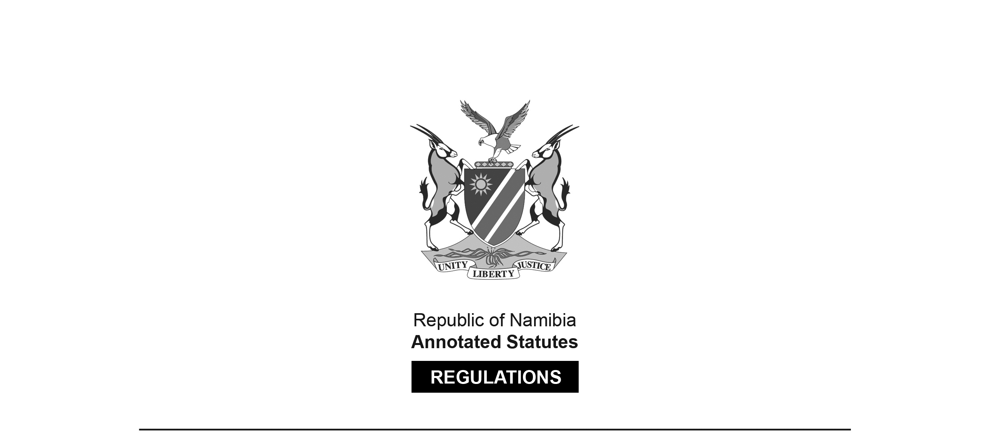

REGULATIONS SURVIVING IN TERMS OF

Health Professions Act 16 of 2024

section 95(10)

Maximum Fine that Council or   
Professional Conduct Committee May Impose

Government Notice 62 of 2018

([GG 6564](http://www.lac.org.na/laws/2018/6564.pdf))

came into force on date of publication: 8 April 2018

These regulations were made in terms of section 59 read with section 41(1)(d) of the Medical and Dental Act 10 of 2004, which was repealed by the Health Professions Act 16 of 2024.   
Pursuant to section 95(10) of the Health Professions Act 16 of 2024,   
they are deemed to have been made under that Act.

The Government Notice which publishes these regulations notes that they were   
made on the recommendation of the Medical and Dental Council of Namibia.   
It also repeals GN 23/2018 ([GG 6527](http://www.lac.org.na/laws/2018/6527.pdf)), which in turn repealed GN 155/2014 ([GG 5559](http://www.lac.org.na/laws/2014/5559.pdf)).

Note that GG 6527 was initially numbered incorrectly as GG 6528.   
A corrected version was subsequently issued.

ARRANGEMENT OF REGULATIONS

1. Definitions

2. Maximum fine that may be imposed by Council or professional conduct committee

**Definitions**

**1.** In these regulations a word or expression to which a meaning has been assigned in the Act has that meaning and, unless the context indicates otherwise -

“the Act” means the Medical and Dental Act, 2004 (Act No. 10 of 2004).

**[The** Medical and Dental Act **10 of 2004   
has been replaced by the Health Professions Act 16 of 2024.]**

**Maximum fine that may be imposed by Council or professional conduct committee**

**2.** Under section 41(1)(d) of the Act, the Council or the professional conduct committee may impose a fine not exceeding the amount of N$200,000.00 per charge.