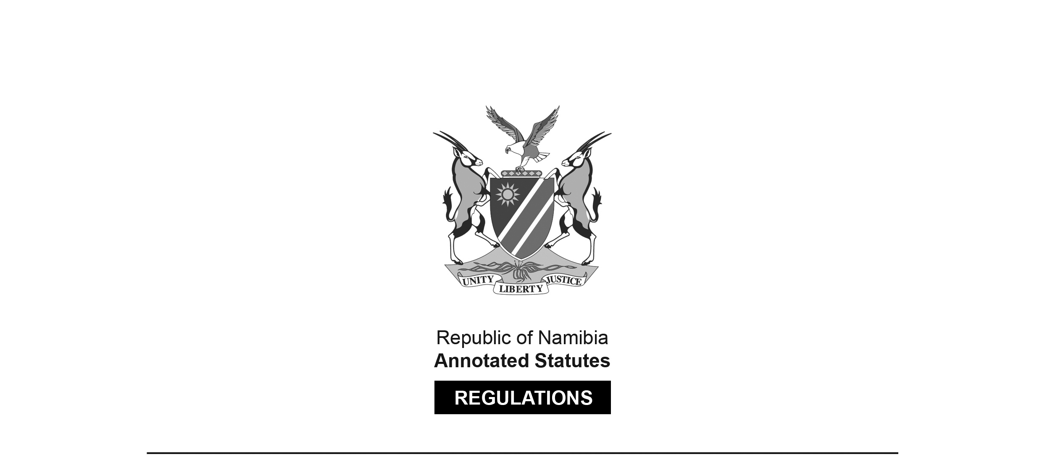

REGULATIONS SURVIVING IN TERMS OF

Health Professions Act 16 of 2024

section 95(10)

Maximum Fine that Council or   
Professional Conduct Committee May Impose

Government Notice 21 of 2018

([GG 6527](http://www.lac.org.na/laws/2018/6527.pdf))

came into force on date of publication: 15 February 2018

Note that GG 6527 was initially numbered incorrectly as GG 6528.   
A corrected version was subsequently issued.

These regulations were made in terms of section 59 read with section 42(1)(d) of the   
Nursing Act 8 of 2004, which was repealed by the Health Professions Act 16 of 2024.   
Pursuant to section 95(10) of the Health Professions Act 16 of 2024,   
they are deemed to have been made under that Act.

The Government Notice which publishes these regulations notes that they   
were made on the recommendation of the Nursing Council of Namibia.  
It also repeals GN 156/2014 ([GG 5559](http://www.lac.org.na/laws/2014/5559.pdf)).

ARRANGEMENT OF REGULATIONS

1. Definitions

2. Maximum fine that may be imposed by Council or professional conduct committee

**Definitions**

**1.** In these regulations a word or expression to which a meaning has been assigned in the Act has that meaning and, unless the context indicates otherwise -

“the Act” means the Nursing Act, 2004 (Act No. 8 of 2004).

**[The Nursing** Act **8 of 2004 has been replaced by the Health Professions Act 16 of 2024.]**

**Maximum fine that may be imposed by Council or professional conduct committee**

**2.** Under section 42(1)(d) of the Act, the Council or the professional conduct committee may impose a fine not exceeding the amount of N$200,000.00 per charge.