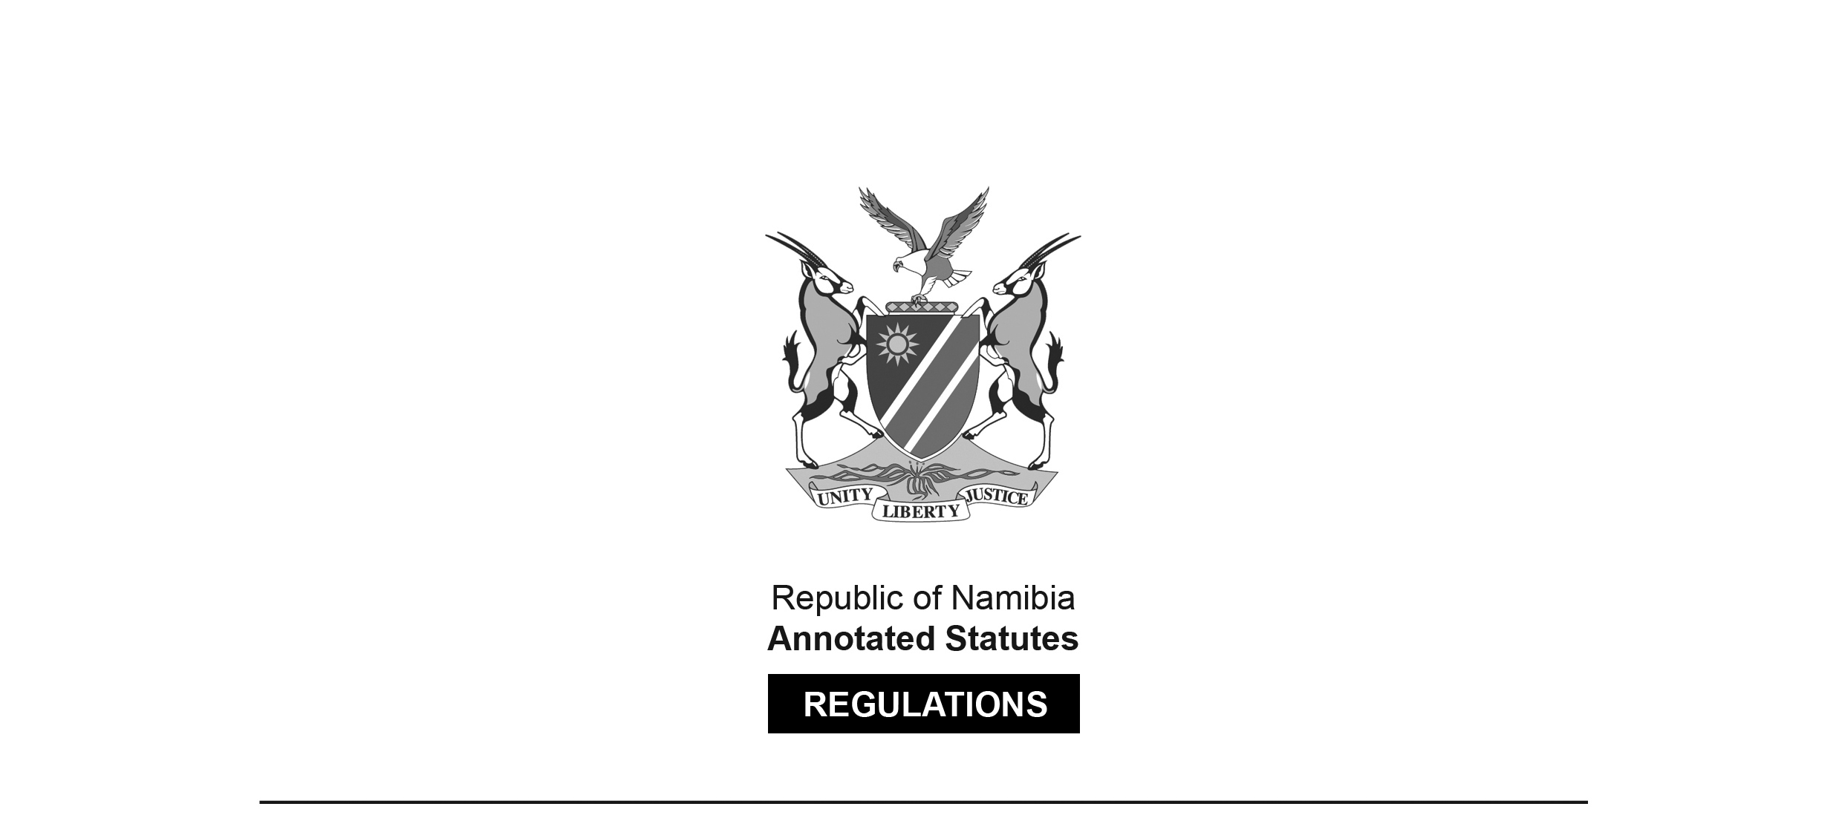

REGULATIONS SURVIVING IN TERMS OF

Health Professions Act 16 of 2024

section 95(10)

Regulations relating to Practical Training of

Medical Students and Dental Students

Government Notice 279 of 2017

([GG 6444](http://www.lac.org.na/laws/2017/6444.pdf))

came into force on date of publication: 17 October 2017

These regulations were made in terms of section 59(1)(d) of the Medical and Dental Act 10 of 2004, which was repealed by the Health Professions Act 16 of 2024. Pursuant to section 95(10) of the Health Professions Act 16 of 2024, they are deemed to have been made under that Act.

The Government Notice which publishes these regulations notes that they were   
made on the recommendation of the Medical and Dental Council of Namibia.

ARRANGEMENT OF REGULATIONS

PART 1

PRELIMINARY

1. Definitions

PART 2

APPLICATION FOR PRACTICAL TRAINING BY MEDICAL STUDENTS AND DENTAL STUDENTS

2. Application for practical training by medical students or dental students

3. Practical training

4. Period of practical training

5. Practical training agreement

6. Reports by approved facility

7. Commencement or termination of practical training

8. Completion of practical training

PART 3

REGISTERS

9. Register of medical students and dental students for practical training

10. Removal of name from register

PART 4

GENERAL

11. Language of forms and documents

12. Offences

PART 1

PRELIMINARY

**Definitions**

**1.** In these regulations a word or an expression to which a meaning has been given in the Act has that meaning, and unless the context otherwise indicates -

“applicant” means a medical student or dental student making an application in accordance with these regulations;

“approved facility” means private practice, hospital, clinic or other health facilities as defined in section 1 of the Hospitals and Health Facilities Act, 1994 (Act No. 36 of 1994) approved by the Council for the purposes of training medical students or dental students;

“certified” means certified as a true copy of the original by a commissioner of oaths appointed under section 5, or designated under section 6, of the Justices of Peace and Commissioners of Oath Act, 1963 (Act No. 16 of 1963);

“medical student or dental student” means a medical student or dental student -

(a) who has successfully completed and obtained a medical or dental qualification from an educational institution and the qualification entitles the student to be registered as a medical practitioner or dentist; and

(b) whose application to be registered as a medical intern or dental intern has been refused by the Council;

“Medicine and Related Substances Control Act” means the Medicine and Related Substances Control Act, 2003 (Act No. 13 of 2003); and

“the Act” means the Medical and Dental Act, 2004 (Act No. 10 of 2004).

**[The** Medical and Dental Act **10 of 2004   
has been replaced by the Health Professions Act 16 of 2024.]**

PART 2

APPLICATION FOR PRACTICAL TRAINING BY MEDICAL STUDENTS

AND DENTAL STUDENTS

**Application for practical training by medical students or dental students**

**2.** (1) A medical student or dental student whose application for registration as a medical intern or dental intern is refused under the regulations relating to the registration of medical interns or dental interns must apply to the Council for him or her to undergo practical training in accordance with these regulations before the medical student or dental student is registered as an intern.

(2) For the purposes of the practical training referred to in subregulation (1), a medical student or dental student must -

(a) make an application in a form determined by the Council; and

(b) submit the application referred to in paragraph (a) to the registrar.

(3) An application referred to in subregulation (2) is accompanied by -

(a) a certified copy of the identity document or passport of an applicant;

(b) a certified copy of the qualification which entitles the applicant to be registered as a medical practitioner or dentist; and

(c) proof of payment of the application fees.

(4) The Council must consider the application made under subregulation (2) and may grant or refuse the application.

(5) If the application made under subregulation (2) is granted under subregulation (4), the Council must issue to the applicant a certificate of registration in the form that the Council determines.

(6) The Council may require the applicant to furnish proof of proficiency in the English language in a manner determined by the Council.

(7) If the Council refuse the application under subregulation (4), the Council must inform the applicant of its decision and reasons for the refusal.

**Practical training**

**3.** (1) A medical student or a dental student contemplated in regulation 2(1) must complete a practical training at an approved facility under the supervision of a registered person at that approved facility before he or she is registered as a medical intern or dental intern.

(2) During the period of practical training and under the supervision of a registered person, a medical student or a dental student may -

(a) physically examine a person or perform any other diagnostic act and issue a document which is required in the performance of such act; or

(b) subject to the Medicine and Related Substances Control Act -

(i) treat, care for and administer medicine to a person; or

(ii) issue and sign a prescription with regard to any medicine.

(3) A medical student or dental student is subject to all the rules of professional conduct applicable to a medical practitioner or a dentist during his or her term of practical training.

(4) The Council must furnish a medical student or dental student with a copy of the professional conduct rules referred to in subregulation (3) before the student commences his or her practical training.

**Period of practical training**

**4.** (1) A medical student or dental student must complete practical training for a period of not more than 12 months and in accordance with a practical training program approved by the Council.

(2) If the period for practical training referred to in subregulation (1) is interrupted at any time, the practical training must consist of periods which when added together are not more than 12 months in aggregate.

(3) Subject to subregulation (4), if a medical student or a dental student fails to comply with subregulation (1) or (2), his or her registration as a medical student or dental student for purposes of these regulations is considered to have been cancelled.

(4) Unless the Council otherwise determines, on good cause shown, any practical training completed by a medical student or dental student -

(a) under a practical training agreement in respect of which the Council has withdrawn its approval in accordance with regulation 5(3); or

(b) in contravention of subregulation (1) or (2),

is null and void.

**Practical training agreement**

**5.** (1) A medical student or dental student must enter into a written practical training agreement with an approved facility at which he or she must complete the practical training.

(2) A practical training agreement referred to in subregulation (1) -

(a) is in the form and contain the particulars that the Council determines; and

[The verb “contain” should be “contains” to be grammatically correct.]

(b) provides for practical training in the main areas and disciplines that in the opinion of the Council is adequate and satisfactory for the purposes of the practical training.

[The verb “is” should be “are” to be grammatically correct.]

(3) If the Council at any time during the period of practical training referred to in regulation 4 considers the practical training provided by an approved facility to be inadequate or unsatisfactory, the Council may withdraw its approval of the practical training agreement granted under subregulation (4) by means of a written notice to the approved facility and the medical student or dental student, after having afforded them an opportunity to be heard.

(4) Before a person commences his or her practical training at an approved facility, he or she must -

(a) obtain from the Council a written approval of practical training agreement entered into under subregulation (1); and

(b) register with the Council as a medical student or dental student in accordance with these regulations.

**Reports by approved facility**

**6.** (1) An approved facility with whom a medical student or a dental student has entered into a practical training agreement contemplated in regulation 5 must, during the practical training, submit to the Council a written progress report on the practical training of the medical student or dental student every six months in the form and containing the particulars that the Council determines.

(2) Despite subregulation (1) -

(a) the Council may at any time and in writing require an approved facility to submit to the Council, within the period determined by the Council, a written progress report on the practical training undertaken by a medical student or dental student; and

(b) an approved facility must report to the Council in writing as soon as practicable any failure by a medical student or a dental student to comply with a standard of medical, dental or patient care acceptable to, or required by, the Council, or failure to comply with the practical training agreement.

**Commencement or termination of practical training**

**7.** (1) A medical student or a dental student must in writing -

(a) notify the Council as soon as he or she commences with his or her practical training;

(b) furnish the Council with the name and business address including the telephone number and the other particulars, that the Council may require, of the approved facility where he or she has commenced with practical training;

(c) notify the Council if he or she, for any reason, has terminated his or her practical training with the approved facility referred to in paragraph (b), within 30 days from the date of termination; or

(d) notify the Council if he or she intends to terminate his or her practical training with the approved facility referred to in paragraph (b) and to commence the practical training with any other approved facility at least 30 days before the date of the intended termination.

(2) If any personal details or other particulars of a medical student or dental student change the medical student or dental student must give written notice to the Council of that change within 30 days from the date of the change.

(3) The Council must on receipt of a termination notice referred to in subregulation (1)(c) withdraw the registration certificate issued to the medical student or dental student under regulation 2(5).

**Completion of practical training**

**8.** (1) On the completion of the practical training undertaken by a medical student or dental student in accordance with these regulations, the approved facility must issue to the medical student or dental student a certificate of completion in the form and containing the particulars determine by the Council.

[The word “determine” should be “determined”.]

(2) A medical student or dental student must, after having received the certificate referred to in subregulation (1), submit the certificate to the Council as proof that he or she has completed the practical training.

(3) The Council may not register a medical student or dental student as a medical intern or dental intern unless he or she has submitted to the Council the certificate of completion issued under subregulation (1).

PART 3

REGISTERS

**Register of medical students and dental students for practical training**

**9.** The register of medical students or dental students established and kept in accordance with subsection (2) of section 23 of the Act must, in addition to the particulars specified by subsection (3) of that section, contain particulars of any change in any of the particulars recorded in the register.

**Removal of name from register**

**10.** (1) If -

(a) any report contemplated in regulation 6 contains an allegation that -

(i) the medical student or dental student is failing to comply with a standard of medical, dental or patient care acceptable to, or required by, the Council; or

(ii) the medical student or dental student is failing to comply with the practical training agreement; or

(b) the Council becomes aware of any other allegation that reflects, in the opinion of the Council, negatively on the medical student or dental student or on any aspect of the practical training,

the Council may, subject to subregulation (2), cancel the registration of the medical student or dental student and remove the name of the medical student or dental student from the register.

(2) Before the Council cancel the registration of a medical student or a dental student and remove the name of the student from the register under subregulation (1), the Council must afford the student and the approved facility an opportunity to be heard on the matter.

(3) If the Council decide to cancel the registration of the medical student or dental student under subregulation (1), the Council must inform the approved facility and the medical students or dental students in writing, at least 30 days before the intended cancellation of the registration as a medical student or dental student and the removal of the name from the register, and the written notice must be delivered to the medical student or dental student and approved facility in person.

PART 4

GENERAL

**Language of forms and documents**

**11.** (1) Subject to subregulation (2), any form or document required to be submitted to the Council in terms of these regulations must be in the English language.

(2) Any form or document referred to in subregulation (1) which is not in the English language must be accompanied by a sworn translation of that form or document into the English language and which translation is acceptable by the Council.

**Offences**

**12.** A person who -

(a) is not registered as a medical student or dental student under these regulations and who obtains or attempts to obtain practical experience or exposure in Namibia; or

(b) contravenes or fails to comply with these regulations,

commits an offence and on conviction is liable to a fine not exceeding N$4 000 or imprisonment for a period not exceeding 12 months or to both such fine and such imprisonment.