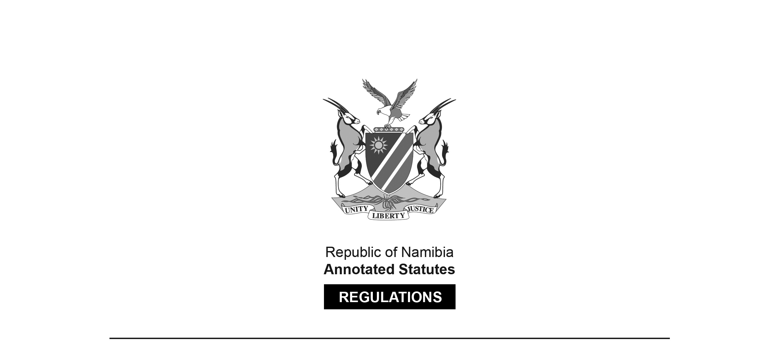

REGULATIONS SURVIVING IN TERMS OF

Health Professions Act 16 of 2024

section 95(10)

**Regulations relating to Scope of Practice of a Dentist**

Government Notice 34 of 2017

([GG 6249](http://www.lac.org.na/laws/2017/6249.pdf))

came into force on date of publication: 27 February 2017

These regulations were made in terms of section 59 of the Medical and Dental Act 10 of 2004, which was repealed by the Health Professions Act 16 of 2024. Pursuant to section 95(10) of the Health Professions Act 16 of 2024, they are deemed to have been made under that Act.

The Government Notice which publishes these regulations notes that they were   
made on the recommendation of the Medical and Dental Council of Namibia.

**ARRANGEMENT OF REGULATIONS**

1. Definitions

2. Scope of practice of a dentist

**Definitions**

**1.** In these regulations, unless the context otherwise indicates, a word or expression defined in the Act has that meaning, and -

“dental intern” means a person who has completed the required qualification for a dentist, in terms of this Act, and is registered as such by the Council;

“dental student” means a person approved and registered by Council for admission to the required course of study a Bachelors Degree in Dentistry;

“dentist” means a health professional who is qualified and clinically capable of providing dental care services to individuals and families;

“medicine” means -

(a) a substance or a mixture of substances prepared and used or purported to be suitable for use or manufactured or sold for use in -

(i) the diagnosis, treatment, mitigation, modification or prevention of a disease, abnormal physical or mental state, or the symptoms thereof, in humans or animals; or

(ii) restoring, correcting or modifying any somatic, mental or organic function in humans or animals, whether or not administered by or through a medical device;

(b) a veterinary medicine; or

(c) a complementary medicine;

“patient” means any person being treated by a dentist at the request of that person, his or her legal guardian or any other person who provides care for that patient; and

“the Act” means the Medical and Dental Act, 2004 (Act No. 10 of 2004).

**[The** Medical and Dental Act **10 of 2004   
has been replaced by the Health Professions Act 16 of 2024.]**

**Scope of practice of a dentist**

**2.** (1) The following acts are regarded to be the acts which fall within the scope of practice of a dentist and relating to -

(a) studying, diagnosing and treatment of diseases, disorders and conditions affecting the oral cavity, maxillofacial area and their associated structures;

(b) preventing or curing of such diseases, disorders or conditions through dental or surgical procedures; and

(c) educating and counselling of a patient.

(2) When practicing the profession, a dentist may -

(a) examine physically or clinically the oral, maxillofacial and related structures of a patient;

(b) diagnose the diseases, disorders, injuries or conditions of the oral, maxillofacial and related structures of the human body, including -

(i) determining the relevance of systemic conditions; and

(ii) giving advice on those conditions;

(c) advise a patient on his or her oral and dental health status;

(d) perform dental procedures on a patient, including the fitting or supplying of a dental prosthesis or appliance;

(e) perform aesthetic or cosmetic procedures on a patient pertaining to the oral and peri-oral area;

(f) prescribe medicines aimed at managing the oral and dental health of a patient, including the prevention and treatment of diseases and the rehabilitation of the patient; and

(g) provide information to a patient to enable that patient to improve and maintain his or her oral and dental health.

(3) The provisions of subregulation (1) may not be construed as prohibiting -

(a) a person registered under any legislation regulating dentistry from performing any act specified in accordance with the provisions of such legislation;

(b) a dental intern, working at an institution recognized by the council, from performing a function or issuing a certificate or other document which in terms of any legislation is required to be performed or issued by a dentist;

(c) a dental student from performing an act under the direct and immediate supervision of a dentist in the course of training such student;

(d) a dentist from performing an act falling within the scope of dentistry or using any name, title, description or symbol normally associated with such practitioners profession; or

(e) a person from performing an act in the course of bona fide research at any institution approved for that purpose by the Minister.

(4) Despite sub regulation (2), a dentist may perform any procedure under any specialty or additional qualification registered in his or her name.

[“Sub regulation” appears as two words in subregulation (4)   
but as one word “subregulation” elsewhere in these regulations.]

(5) This regulation may not be construed as prohibiting a dentist from employing a dental technician, dental therapist or an oral hygienist registered under the Act, or the Allied Health Professions Act, 2004 (Act No. 7 of 2004).

**[****The Allied Health Professions Act 7 of 2004   
has been replaced by the Health Professions Act 16 of 2024.]**