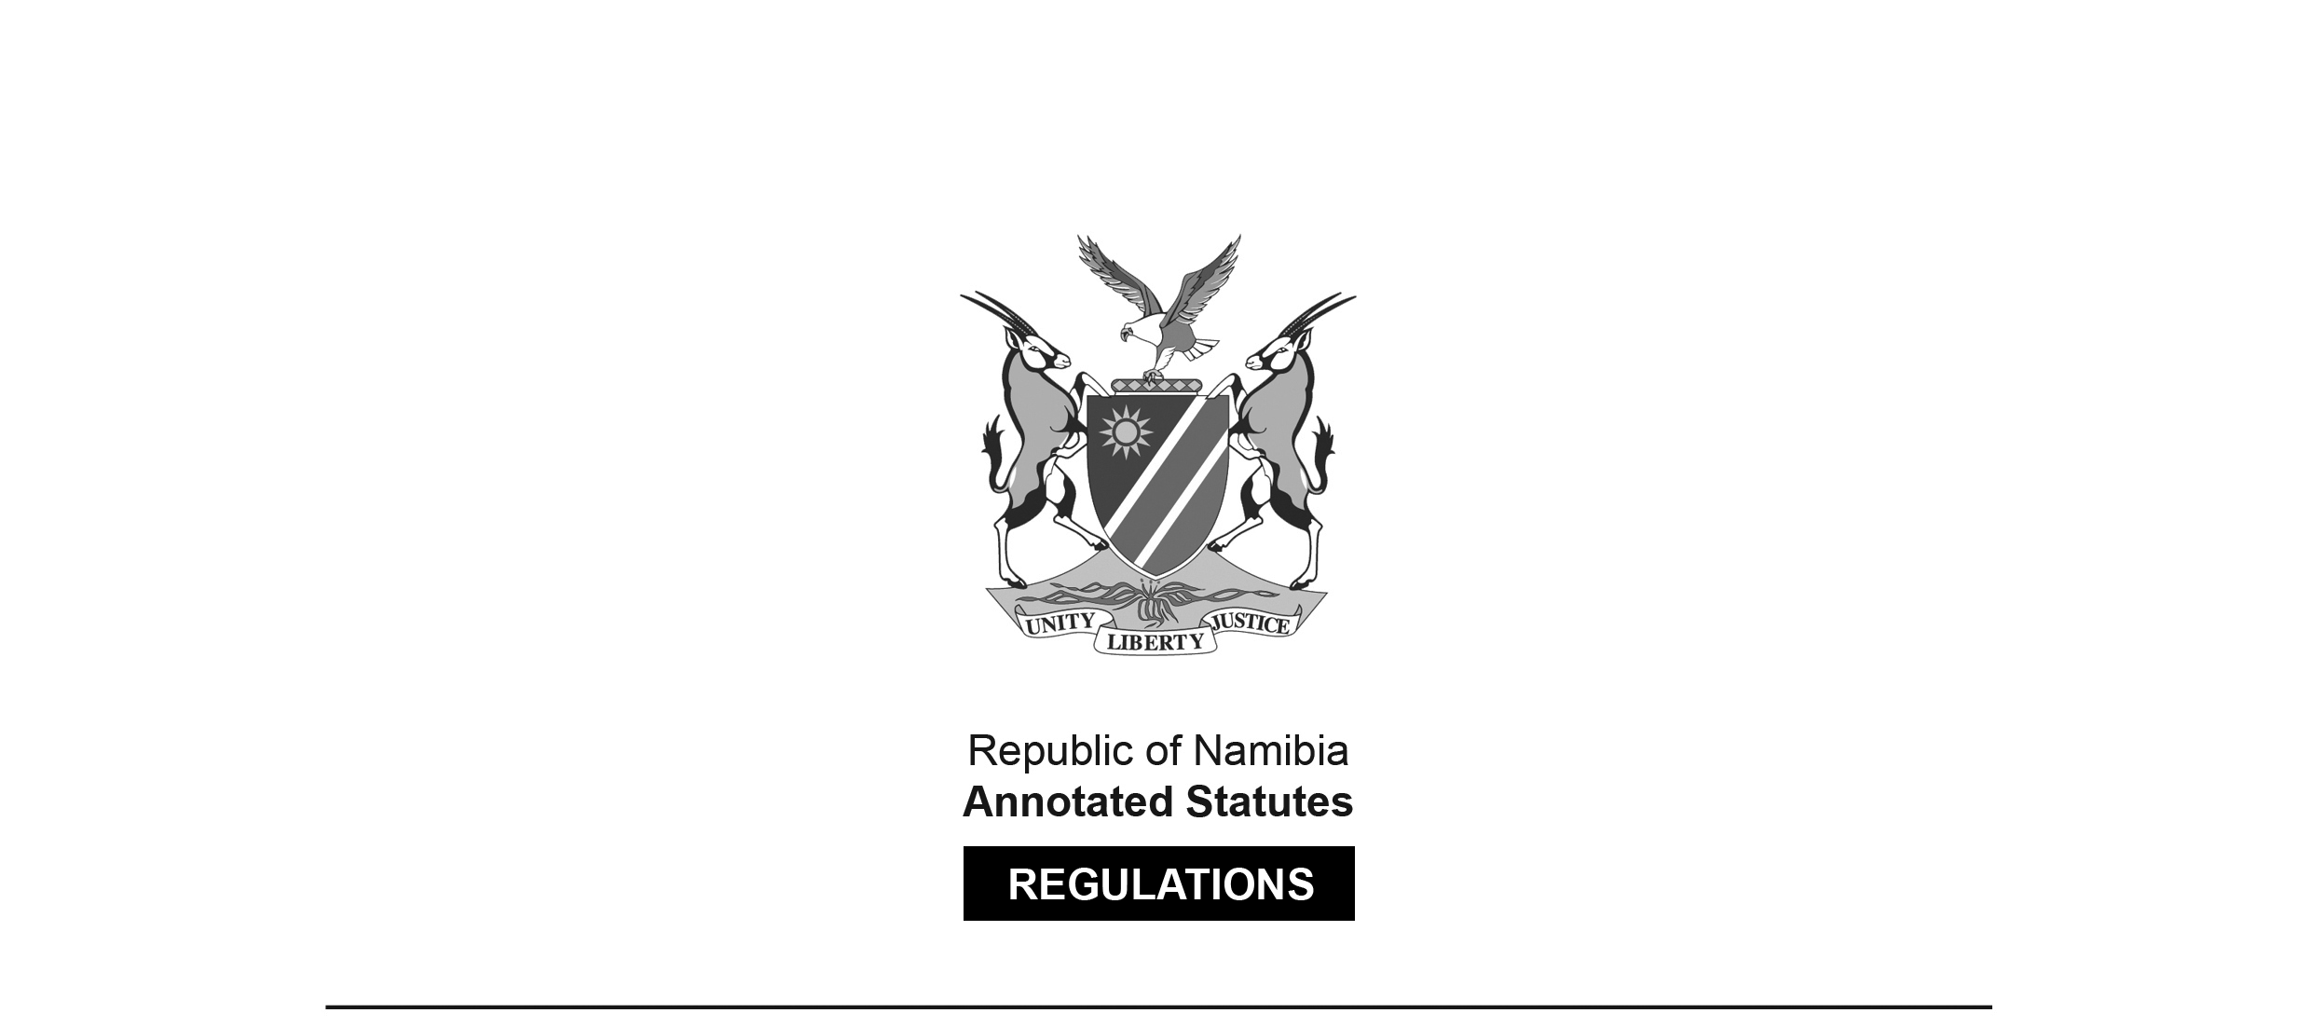

REGULATIONS SURVIVING IN TERMS OF

Health Professions Act 16 of 2024

section 95(10)

Regulations relating to the

Scope of Practice of a Nutritionist

Government Notice 208 of 2016

([GG 6114](http://www.lac.org.na/laws/2016/6114.pdf))

came into force on date of publication: 1 September 2016

These regulations were made in terms of section 55(1)(n) of the Allied Health Professions Act 7 of 2004, which was repealed by the Health Professions Act 16 of 2024. Pursuant to section 95(10) of the Health Professions Act 16 of 2024, they are deemed to have been made under that Act.

The Government Notice which publishes these regulations notes that they were made   
on the recommendation of the Allied Health Professions Council of Namibia.

**ARRANGEMENT OF REGULATIONS**

1. Definitions

2. Scope of practice of nutritionist

3. Acts pertaining to nutritionist in the conducting practice

**Definitions**

**1.** In these regulations a word or expression that has been defined in the Act has that meaning, and unless the context otherwise indicates “the Act” means the Allied Health Professions Act, 2004 (Act No. 7 of 2004).

**[****The Allied Health Professions Act 7 of 2004   
has been replaced by the Health Professions Act 16 of 2024.]**

**Scope of practice of nutritionist**

**2.** (1) A nutritionist is responsible for the promotion of nutritional health and well- being and prevention of nutrition-related disorders or ill-health of groups, communities or populations through sustainable and equitable improvements in the food and nutrition system.

(2) The key concepts used in the delineation of the functions of the nutritionist are wellness, primary prevention and in the Namibian context the use of the term nutritionist would imply a community nutritionist or public health nutritionist.

**Acts pertaining to nutritionist in the conducting practice**

**3.** The acts that constitute the conducting of the practice of the profession of a nutritionist are as follows:

(a) utilizing a comprehensive body of knowledge of principles of nutritional sciences to supply safe food in an ethical, responsible manner to communities or population groups during the different stages of the life cycle of healthy individuals;

(b) assessing the nutritional situation of groups, communities and populations using relevant methodologies;

(c) applying communication skills to mobilize communities or populations to change their behaviour to food or nutrition in order to prevent diseases and to improve quality of life;

(d) applying nutrition policies, strategies and guidelines;

(e) planning and executing an effective food service system based on specified needs in health;

(f) conceptualising, planning, implementing, monitoring, evaluating and documenting appropriate nutrition policies, strategies and guidelines;

(g) managing human, financial and other resources to ensure optimal and equitable delivery of nutrition services at primary health care and country population level;

(h) identifying, implementing and communicating relevant nutrition-related research;

(i) applying critical and creative thinking in working effectively with the community and stakeholders in contributing to the personal, social and economic development of society in an ethical and professional manner;

(j) assessing and managing food safety;

(k) dealing with relevant legislation and public policies related to food supply;

(1) identifying socio-economic, occupational, age, cultural and religion related factors in communities and populations, which can negatively influence a healthy lifestyle;

(m) using evidence based theory and practice to plan, develop, implement and evaluate appropriate programmes and strategies on how to address these factors and associated causes;

(n) contributing to formulation and implementation of nutrition policies at local, regional or national level;

(o) identifying research areas based on scientific literature and public health needs by -

(i) developing hypotheses;

(ii) executing research with appropriate methods; and

(iii) designing protocols to test hypotheses;

(p) processing research by -

(i) analyzing and interpreting results, and

(ii) communicating results to fellow scientists and practitioners, and the target population through appropriate channels;

(q) conducting and participating in operational and applied research related to food, health, nutrition and nutrition programmes;

(r) mediating in nutrition matters between authorities at various levels of health, education, social service systems, and others systems such as finance;

(s) liaising with other role players in relevant settings such as education or social services, dietetic services, regarding for example food quality, safety, socioeconomic circumstances, etc;

(t) collaborating with members of food industry to ensure their compliance with dietary guidelines, food regulations and other legislative frameworks, and objectives of local food and nutrition policy; and

(u) not being involved in illness management such as therapeutic interventions in individual patients or communities.