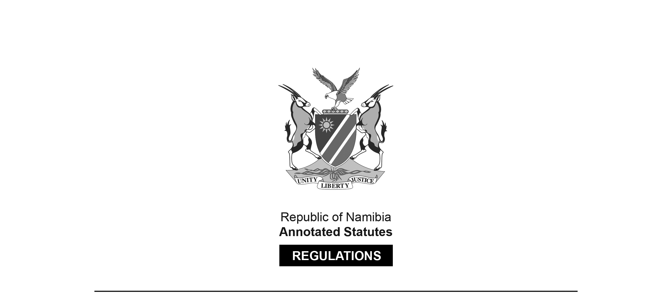

REGULATIONS SURVIVING IN TERMS OF

Health Professions Act 16 of 2024

section 95(10)

Regulations relating to Scope of Practice of   
Environmental Health Practitioner Assistant

Government Notice 142 of 2014

([GG 5553](http://www.lac.org.na/laws/2014/5553.pdf))

came into force on date of publication: 8 September 2014

These regulations were made in terms of section 55 of the Allied Health Professions Act 7 of 2004, which was repealed by the Health Professions Act 16 of 2024. Pursuant to section 95(10) of the Health Professions Act 16 of 2024, they are deemed to have been made under that Act.

The Government Notice which publishes these regulations notes that they were made   
on the recommendation of the Allied Health Professions Council of Namibia.

ARRANGEMENT OF REGULATIONS

1. Definitions

2. Scope of practice of environmental health practitioner assistant

**Definitions**

**1.** In these regulations any word or expression to which a meaning has been given in the Act has the same meaning and unless the context otherwise indicates -

“the Act” means the Allied Health Professions Act, 2004 (Act No. 7 of 2004).

**[****The Allied Health Professions Act 7 of 2004   
has been replaced by the Health Professions Act 16 of 2024.]**

**Scope of practice of environmental health practitioner assistant**

**2.** (1) An environmental health practitioner assistant must practice his or her profession under the supervision of an environmental health practitioner.

(2) The acts pertaining to the scope of practice of an environmental health practitioner assistant, performed within the area of his or her jurisdiction and on the instructions of an environmental health practitioner, are relating to -

(a) water services is -

(i) the collecting of water samples for laboratory analysis;

(ii) the conducting of field tests relating to public and community water supply in residential areas and informal settlements to determine the requirements relating to the supply of water and sanitation in those areas; and

(iii) the provision of health education to the public on the proper and safe usage of water and waste water disposal;

(b) food safety control -

(i) the assisting in the sampling of foodstuffs sold by informal traders for microbiological and chemical purposes;

(ii) the collecting of preliminary food and milk cholera swabs;

(iii) cooking oil indicator samples for non-forensic analysis;

(iv) conducting of health education programmes for food handlers, including personal hygiene, sanitising of food contact surfaces and cleaning procedures and methods;

(v) the prevention of food contamination from any source including soil, water, air, plants, animals and humans;

(vi) assisting in food borne illness investigations;

(vii) conducting of surveys of both formal and informal food trading enterprises for statistical purposes; and

(viii) assisting in the seizure, removal, safekeeping and proper disposal of unsafe foodstuffs;

(c) vector control -

(i) in the conducting of regular surveys and monitoring programmes, including the trapping and poisoning of rodents and the submitting of rodent carcasses for laboratory identification;

(ii) ensuring the effective destruction and control of rodents, cockroaches, bedbugs, fleas, flies, mosquitoes and other vermin by means of the correct and appropriate selection of chemicals, materials and equipment; and

(iii) the conducting of ditching and other vector control programmes;

(d) health education, promotion and community development in identifying of specific community health project needs and requirements, including assisting in -

(i) the planning, organising and implementing of projects;

(ii) the training of specific target groups in the communities and implementing of programmes to train persons for the purpose of acting as trainers in the community;

(iii) the arranging of joint programmes and campaigns with other Ministries and Departments in the Ministry and communities including clean up campaigns, ditching of drains and tuberculosis campaigns;

(iv) convening and attending of meetings in communities for purposes of informing the communities of the activities of the Social Work Department of the Ministry;

(v) delivering of health education talks at clinics, schools and workplaces and in communities including talks on tuberculosis, human immunodeficiency virus, the acquired immune deficiency syndrome, cholera, typhoid, diarrhoea and other environmental health related diseases; and

(vi) providing health education in respect of health related problems in communities including bad odour, flies and disposal of waste;

(e) communicable disease control which is -

(i) the assisting with the co-ordination of the district communicable disease surveillance programme in hospitals and health facilities;

(ii) conducting of investigations into infectious disease and epidemic notifications, identifying and referring persons who made contact with tuberculosis patients, including suspected cases of tuberculosis;

(iii) at clinics, the assisting with the following up of defaulter patients at health facilities, the advising of environmental health related infectious disease patients, their relatives, employers and coworkers relating to health education;

[The requisite hyphen is missing from the word “co-workers”.]

(iv) initiating and creating awareness of “Directly Observed Treatment of Tuberculosis, and liaising with community leaders, traditional health practitioners, church organisations and volunteers to encourage implementation and the education of volunteers;

(v) assisting with all animal bite investigations in liaison with State veterinarians, district surgeons, hospitals and clinics, including the affixing of anti-rabies posters at strategic points; and

(vi) collecting of specimens in all cases of notifiable diseases for laboratory testing and the conducting of rabies certificate surveys;

(f) environmental pollution control which is -

(i) the assisting in the investigation of environmental pollution complaints relating to air, water, soil and noise;

(ii) the conducting of field surveys to determine the impact of pollution on communities;

(iii) disseminating of information relating to pollution to industries and communities;

(iv) assisting in the taking of soil, air and dust samples for analysis in laboratories;

(v) conducting of surveys of fumigating entities, premises where chemicals are manufactured, transported or stored;

(vi) the furnishing of information to communities regarding the safe use of paraffin; and

(vii) the inspection of the measures employed for the prevention of air, water and soil pollution, including radiation hazard prevention and control;

(g) research and development relating to health, are the inspection of all matters pertaining to the identification, design and conduct of research incidental to environmental health, including the development of new methods and technologies for environmental health practice;

(h) occupational health and safety, are the inspection of building, (including the assessment of the health and safety risks that all employees occupying, as well as the public visiting, those buildings, are exposed to, and to determine whether the buildings comply with the “Regulations relating to health and safety of employees at work” published under Government Notice No. 156 of 1 August 1997; and

(i) industrial, commercial and housing developments and development programmes, which is -

(i) the inspection of building plans for safety, health, adequacy of lighting, ventilation, space and amenities; and

(ii) the orientation and aesthetics including accessibility to sanitary services;

(j) waste management, including in cemeteries and crematoria, is the inspection of the handling, storage, transportation and disposal of industrial, domestic and commercial solid and other waste, including waste, effluents and sludge from health and veterinary care facilities;

(k) port health is -

(i) the inspection of the safety and hygiene of road, air and sea-going vessels, including all matters pertaining to the transportation of foodstuffs;

(ii) the prevention of disease importation; and

(iii) the occurring of general accidents and the management of hazardous substances; and

(l) any other matter or condition incidental to or of environmental health significance which if unattended could compromise the quality of public and environmental health,

and to report to the environmental health practitioner who supervises him or her the results of his or her research and other actions prescribed by these regulations, including recommendations for the rectification of any shortcomings that he or she is aware of during such inspections and actions and the promotion of healthy lifestyles and the education of all persons relating to such lifestyles.